BANKING CUSTOMER DATA ANALYSIS
A Data Cleaning, EDA & Business Insights Project

Submitted By
Diganta Mandal

Acknowledgement
I would like to express my sincere gratitude to everyone who supported and guided me throughout this project. This project on Banking Customer Data Analysis has been a valuable learning experience, helping me strengthen my skills in data cleaning, exploratory data analysis, and data visualization using Python.
I am thankful for the guidance and resources that helped me understand real-world banking data challenges — from handling missing values to identifying meaningful business patterns. I also acknowledge the open-source Python community, whose libraries such as Pandas, NumPy, and Matplotlib made this analysis possible.
Finally, I would like to thank my mentors, peers, and family for their continuous encouragement and support during the completion of this project.

Abstract
This project presents a comprehensive analysis of a simulated Indian banking customer dataset comprising 10,200 records and 27 attributes, covering demographic, financial, and risk-related information. The primary objective is to clean the raw dataset, address data quality issues such as missing values and duplicate records, and derive actionable business insights through exploratory data analysis (EDA) and visualization.
The analysis is carried out entirely using Python, leveraging Pandas for data manipulation, NumPy for numerical computation, and Matplotlib for visualization — without relying on external BI tools. Key areas of investigation include customer segmentation by loyalty tier, risk weighting and demographics; credit risk assessment through loan-to-income and debt exposure analysis; state and city-wise banking performance; customer profitability; and gender-based financial behavior.
The findings reveal that approximately 40% of customers fall into a higher risk category, nearly 1 in 5 customers exhibit at least one credit red flag, and income and deposit patterns vary meaningfully across states and loyalty tiers. These insights can help the bank make informed decisions regarding credit policy, customer relationship management, and branch expansion strategy.

Introduction
Banks generate massive volumes of customer data every day, capturing information related to income, savings, loans, credit card usage, and demographic profiles. Extracting meaningful insights from this data is essential for effective decision-making — whether it involves identifying high-value customers, managing credit risk, or planning geographic expansion.
This project works with a dataset of 10,200 Indian bank customers containing information such as age, state, city, occupation, income, loyalty classification, risk weighting, deposits, loans, and account balances. Like most real-world datasets, it contains missing values, duplicate entries, and inconsistencies that must be resolved before any reliable analysis can be performed.
The project follows a structured data analytics workflow: understanding the data, cleaning and validating it, exploring it visually, and finally translating the findings into business insights. The entire pipeline was built using only core Python data libraries — Pandas, NumPy, and Matplotlib — making it lightweight, transparent, and easy to reproduce.

Objectives
The key objectives of this project are:
- To identify and handle data quality issues such as missing values, duplicate records, and invalid entries in the banking dataset.
- To segment customers based on income, loyalty classification, risk weighting, gender, and geographic location.
- To analyze credit risk by examining the relationship between loans, income, and credit card balances, and to flag high-risk customers.
- To evaluate state-wise and city-wise banking performance in terms of deposits, loans, and business lending.
- To assess overall bank revenue composition and monitor loan exposure across the customer portfolio.
- To identify high-value and profitable customers using deposits, loans, and balance information.
- To study customer demographics and gender-based financial behavior.
- To present the findings through clear, well-labeled visualizations that support business decision-making.

Dataset Description
The dataset used in this project, indian_bank_customers_10000_enhanced.csv, contains records of 10,200 bank customers with 27 attributes covering demographic, financial, and risk-related information.

Key Columns
Column | Description
Client ID, Name | Unique customer identifier and name
Age, Gender, Occupation | Demographic attributes
State, City | Geographic location of the customer
Loyalty Classification | Silver / Gold / Platinum / Jade tier
Risk Weighting | Risk score from 1 (Very Low) to 5 (Very High)
Estimated Income | Customer's estimated annual income (INR)
Bank Loans, Bank Deposits | Loan and deposit balances (INR)
Credit Card Balance | Outstanding credit card balance (INR)
Checking / Saving / Foreign Currency Accounts | Account balances by type (INR)
Business Lending, Properties Owned | Business lending amount and property count

Prior to cleaning, the raw dataset contained 10,200 rows, including 200 exact duplicate records and missing values in the Occupation (509), Estimated Income (509), Credit Card Balance (514), and Business Lending (507) columns.

Data Cleaning
Real-world banking data is rarely analysis-ready. Before performing any exploratory analysis, the dataset was cleaned and validated using the following steps:
- Detected NULL values across all 27 columns using df.isnull().sum().
- Removed 200 exact duplicate rows using drop_duplicates().
- Validated the Age column, restricting records to a realistic adult range of 18–100 years.
- Filled missing Occupation values with the label 'Unknown' rather than dropping the records.
- Imputed missing Estimated Income and Credit Card Balance values using the column median, which is robust to outliers.
- Filled missing Business Lending values with 0, assuming retail customers without recorded business lending simply have none.
After cleaning, the dataset was reduced from 10,200 to 10,000 verified, analysis-ready records with zero remaining NULL values, and was exported as clean_bank_customers.csv for use in all subsequent analysis.
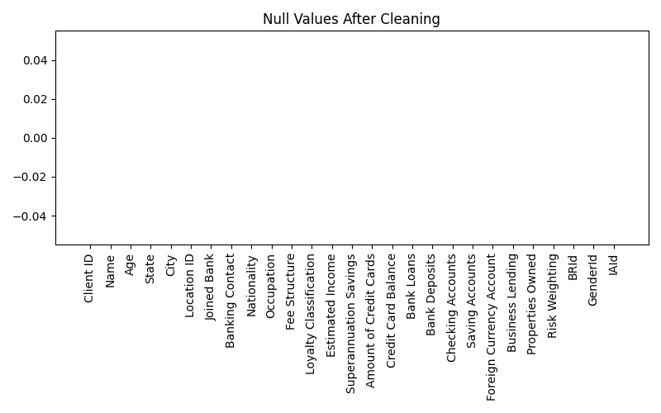
Figure 1: Column-wise NULL value check after the cleaning process.

Methodology
The project followed a standard data analytics pipeline, implemented in a single Jupyter Notebook (banking_analysis.ipynb) using only Pandas, NumPy, and Matplotlib:
- Data Loading — Import the raw CSV file into a Pandas DataFrame.
- Data Cleaning — Detect and resolve missing values, duplicates, and invalid entries (detailed in the previous section).
- Feature Engineering — Derive new fields such as Age Group, Total Balance, Loan-to-Income Ratio, and Profitability Score.
- Segmentation — Group customers by Loyalty Classification, Risk Weighting, Gender, and State to identify meaningful sub-populations.
- Exploratory Data Analysis — Use bar charts, box plots, scatter plots, pie charts, and a heatmap to visualize patterns and relationships.
- Insight Generation — Translate visual patterns into business-relevant conclusions (e.g., identifying risky or high-value customers).

Exploratory Data Analysis (EDA)
This section presents the key exploratory analyses performed on the cleaned dataset, covering customer segmentation, credit risk, and demographic patterns.

Customer Segmentation
Customers were grouped by Loyalty Classification and Risk Weighting to understand how the customer base is distributed.
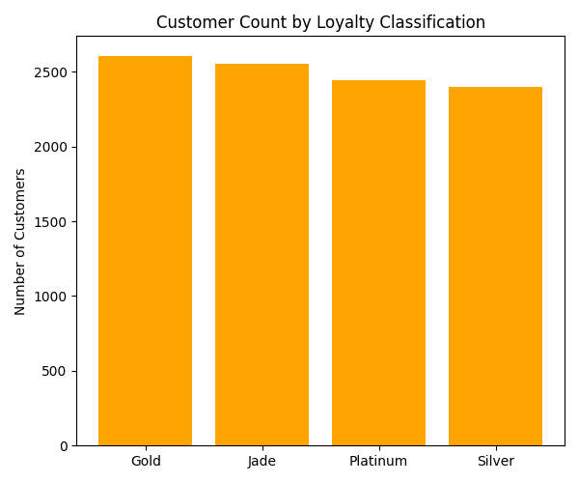
Figure 2: Customer count by Loyalty Classification.
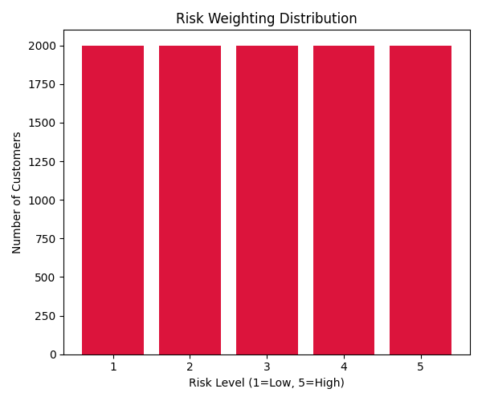
Figure 3: Distribution of customers across risk levels (1 = Low, 5 = High).
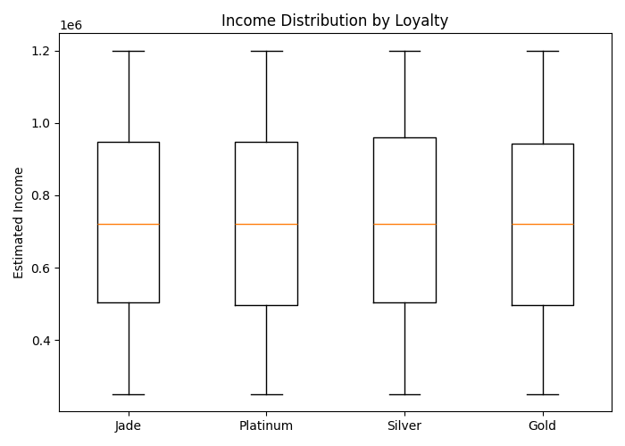
Figure 4: Income distribution across loyalty tiers, showing spread and outliers.
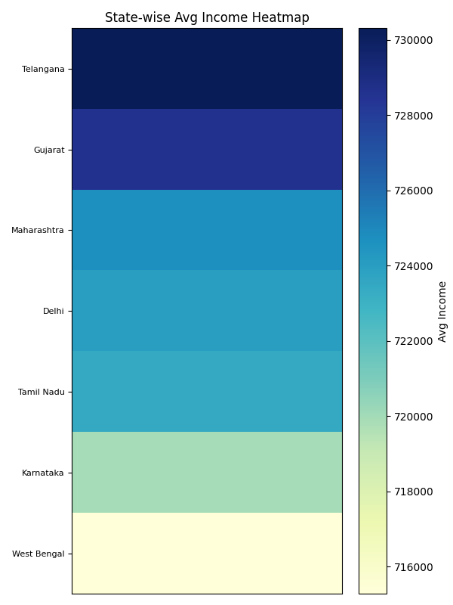
Figure 5: State-wise average income heatmap.

Credit Risk Analysis
Bank Loans were compared against Estimated Income (colored by risk level) to visually identify risk clusters, and credit card balances were analyzed across risk categories.
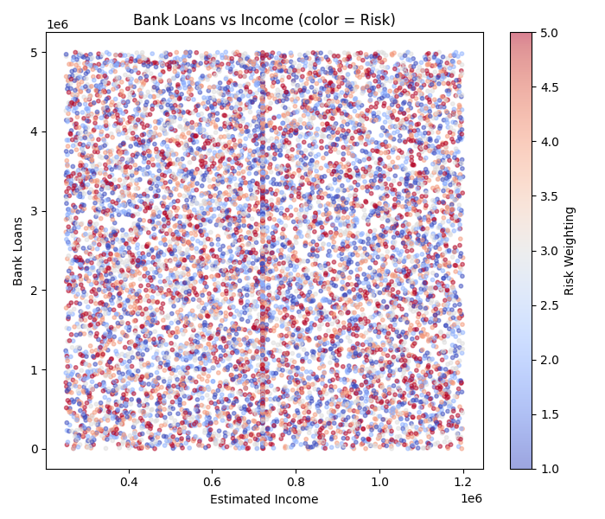
Figure 6: Bank Loans vs Estimated Income, colored by risk weighting.
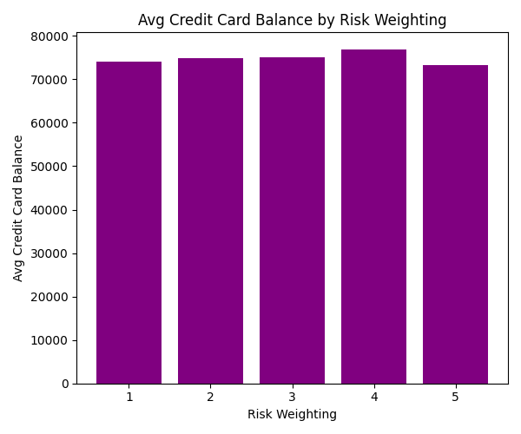
Figure 7: Average Credit Card Balance by risk weighting.

State & City-wise Performance
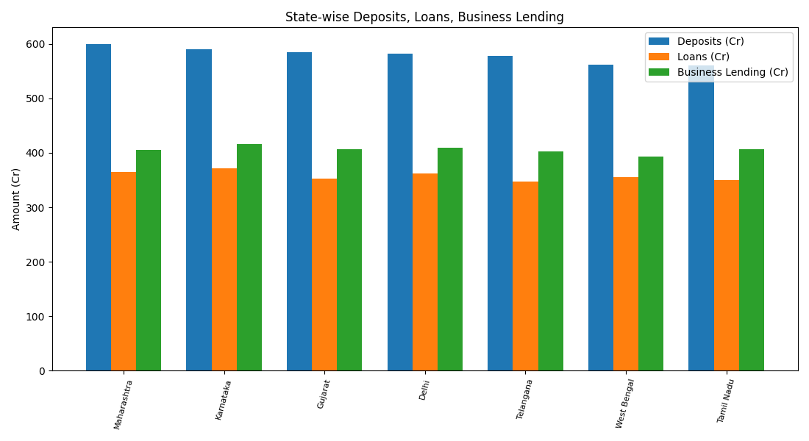
Figure 8: State-wise Deposits, Loans, and Business Lending (in INR Crores).
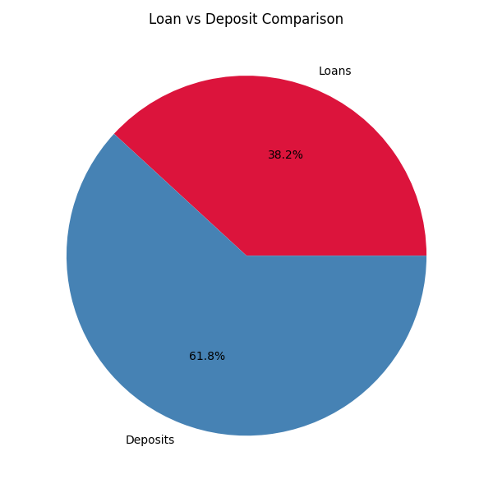
Figure 9: Overall composition of Loans vs Deposits across the bank's portfolio.

Customer Profitability
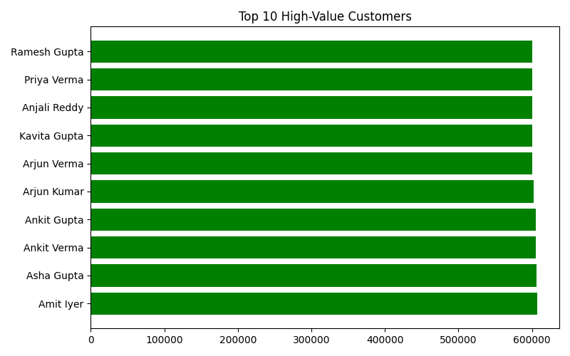
Figure 10: Top 10 customers ranked by profitability score.

Branch Expansion Potential
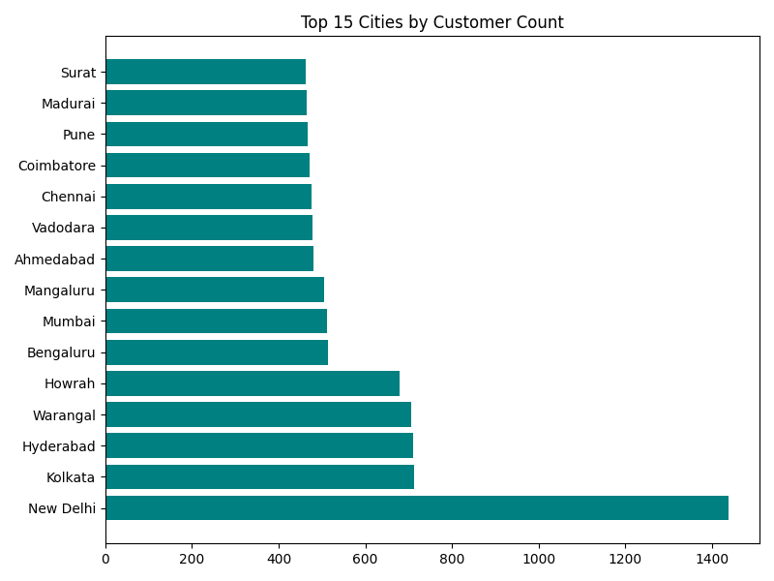
Figure 11: Top 15 cities ranked by customer count — candidates for branch expansion.

Customer Demographics
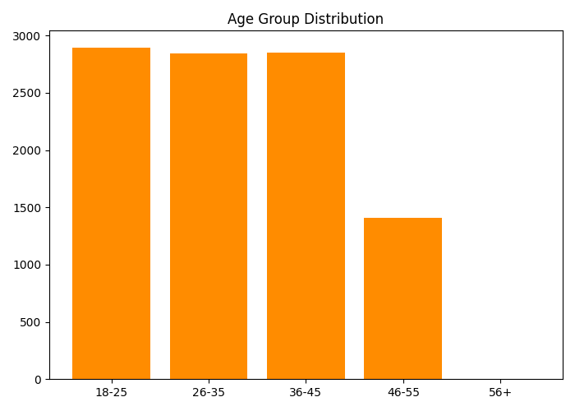
Figure 12: Distribution of customers across age groups.
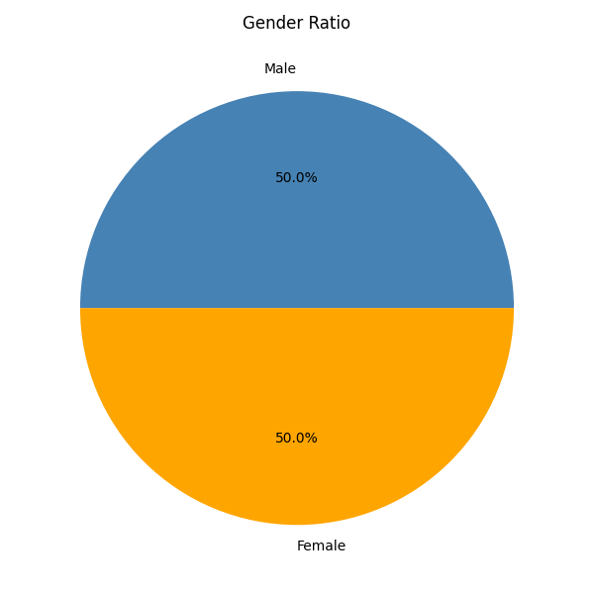
Figure 13: Overall gender ratio of the customer base.

Gender-based Financial Behavior
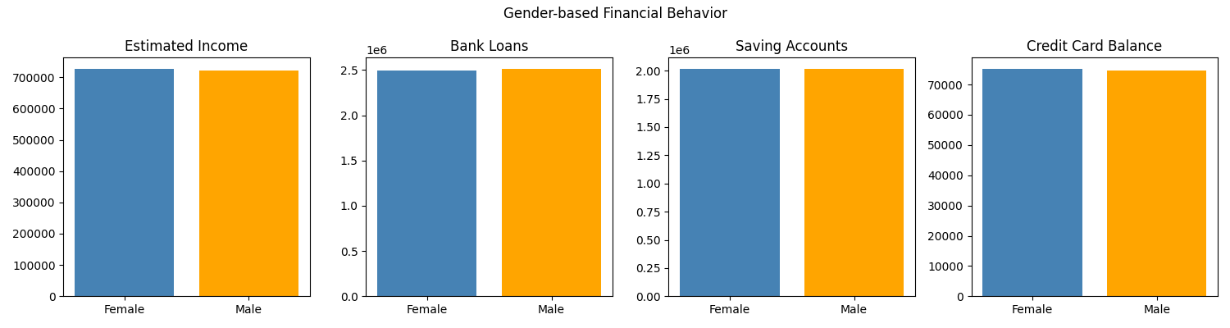
Figure 14: Comparison of average income, loans, savings, and credit card balance by gender.

Dashboard Screenshots
All charts generated during the analysis are consolidated here as a quick visual reference. Each chart is saved as a standalone PNG file in the project's charts folder and is also embedded with context in the EDA section above.
File | Chart
chart1_null_values.png | NULL values after cleaning
chart2_loyalty_count.png | Customer count by loyalty tier
chart3_risk_distribution.png | Risk weighting distribution
chart4_income_boxplot.png | Income distribution by loyalty
chart5_state_income_heatmap.png | State-wise average income heatmap
chart6_loans_vs_income.png | Bank loans vs income (by risk)
chart7_ccbalance_by_risk.png | Avg credit card balance by risk
chart8_state_metrics.png | State-wise deposits, loans, business lending
chart9_loan_vs_deposit.png | Loan vs deposit composition
chart10_top10_customers.png | Top 10 high-value customers
chart11_top_cities.png | Top 15 cities by customer count
chart12_age_distribution.png | Age group distribution
chart13_gender_ratio.png | Gender ratio
chart14_gender_behavior.png | Gender-based financial behavior

Business Insights
- Around 40% of the customer base (4,000 out of 10,000 customers) falls into the High or Very High risk category, indicating a substantial portion of the loan portfolio requires closer credit monitoring.
- Approximately 1,871 customers were flagged with at least one credit red flag — either a high loan combined with low income, or multiple properties combined with high debt — representing priority candidates for credit review.
- 998 customers qualify as high-value (top income quartile with low risk weighting), representing an attractive segment for premium product cross-selling and relationship banking.
- 1,260 customers fall into the low-profit segment (low income combined with below-median deposits), suggesting limited near-term revenue potential unless engagement strategies improve.
- The bank's total deposit base (~₹4,058 Cr) comfortably exceeds its total loan exposure (~₹2,504 Cr), indicating a healthy, deposit-funded balance sheet.
- Business lending (~₹2,841 Cr) forms a significant share of the bank's overall lending activity, alongside retail bank loans.
- Higher-risk customers tend to carry noticeably higher average credit card balances, reinforcing risk weighting as a meaningful indicator of credit exposure.
- Certain states and cities show materially higher average income and deposit concentration, highlighting clear priority targets for branch expansion and marketing focus.
- Income, loan, and savings patterns differ between male and female customers, which can inform more tailored financial product design and marketing.

Conclusion
This project successfully demonstrates a complete, end-to-end banking data analytics workflow — from raw, imperfect data to clean, structured insights — using only core Python libraries. The data cleaning process resolved all missing values and duplicate records, producing a reliable foundation of 10,000 customer records for analysis.
The exploratory analysis revealed meaningful patterns across customer segments, credit risk, geography, and demographics. Notably, a significant share of customers carry elevated risk, while a smaller, well-defined segment of high-value customers offers strong profitability potential. These findings provide the bank with a data-driven basis for credit risk management, customer relationship strategy, and geographic expansion planning.

Future Scope
- Integrate the cleaned dataset into an interactive BI tool (e.g., Power BI or Tableau) to enable dynamic filtering and drill-down analysis.
- Apply machine learning models (e.g., logistic regression, random forest) to predict credit default risk rather than relying on static risk weighting alone.
- Incorporate an actual GIS/mapping library (e.g., GeoPandas) to build a true choropleth map for the branch expansion analysis, replacing the current bubble-chart approximation.
- Extend the revenue model with real interest rate and fee-income data to replace the current illustrative profitability score with an accounting-grade metric.
- Automate the pipeline to refresh cleaned data and dashboards on a scheduled basis as new customer data becomes available.
- Build a customer churn/attrition model to complement the current profitability and risk segmentation.

References
- Pandas Documentation — https://pandas.pydata.org/docs/
- NumPy Documentation — https://numpy.org/doc/
- Matplotlib Documentation — https://matplotlib.org/stable/contents.html
- Project Dataset: indian_bank_customers_10000_enhanced.csv
- Project Requirement Document: Banking.pdf

