Credit Scoring Model
Complete Data Analysis & Machine Learning Report

Date: September 24, 2026

1. Executive Summary
This report presents a complete end-to-end credit scoring analysis and machine learning pipeline. The objective is to predict the creditworthiness of bank customers — classifying them as Good, Standard, or Poor — based on their financial history, payment behaviour, and credit profile.

The analysis covers 100,000 training records and 50,000 test records across 28 financial features. Three classification models were trained and evaluated: Logistic Regression, Decision Tree, and Random Forest. The Random Forest model achieved the best performance with 73.3% accuracy and a ROC-AUC of 0.858, and was used to generate creditworthiness predictions for the full test set.

Key Results
Metric | Logistic Regression | Decision Tree | Random Forest (Best)
Accuracy | 59.90% | 70.91% | 73.33%
Precision | 59.59% | 71.58% | 73.73%
Recall | 59.90% | 70.91% | 73.33%
F1-Score | 58.18% | 71.02% | 73.44%
ROC-AUC | 0.7370 | 0.8313 | 0.8583
CV-Accuracy | 60.29% | 69.58% | 70.03%

2. Dataset Overview
The dataset contains monthly financial snapshots for 12,500 unique customers tracked across 8 months, resulting in 100,000 training rows. The test set contains 50,000 rows for which creditworthiness predictions are generated.

2.1 Dataset Dimensions
Dataset | Rows | Columns | Target
train.csv | 100,000 | 28 | Credit_Score (Good/Standard/Poor)
test.csv | 50,000 | 27 | Not provided — to be predicted

2.2 Feature Descriptions
Feature | Type | Description
Age | Numeric | Customer age (contains noisy values)
Annual_Income | Numeric | Gross annual income
Monthly_Inhand_Salary | Numeric | Net monthly take-home salary
Num_Bank_Accounts | Numeric | Number of active bank accounts
Num_Credit_Card | Numeric | Number of credit cards held
Interest_Rate | Numeric | Average interest rate across loans
Num_of_Loan | Numeric | Total number of loans
Type_of_Loan | Categorical | Comma-separated list of loan types
Delay_from_due_date | Numeric | Average days payment was delayed
Num_of_Delayed_Payment | Numeric | Count of late/delayed payments
Changed_Credit_Limit | Numeric | Credit limit change amount
Outstanding_Debt | Numeric | Total outstanding debt balance
Credit_Utilization_Ratio | Numeric | Credit usage as % of limit
Credit_History_Age | Text | Length of credit history (e.g., '5 Years 3 Months')
Payment_of_Min_Amount | Categorical | Whether minimum payment is made (Yes/No)
Total_EMI_per_month | Numeric | Total monthly EMI payment
Amount_invested_monthly | Numeric | Monthly investment/savings amount
Payment_Behaviour | Categorical | Spending and payment pattern
Monthly_Balance | Numeric | Remaining monthly balance
Credit_Mix | Categorical | Quality of credit portfolio (Good/Standard/Bad)
Occupation | Categorical | Customer occupation
Credit_Score | Target | Creditworthiness label (Good/Standard/Poor)

3. Exploratory Data Analysis

3.1 Target Variable Distribution
The target variable Credit_Score has three classes. The dataset is moderately imbalanced, with Standard being the majority class at 53.2%.
Credit Score | Count | Proportion
Standard | 53,174 | 53.17%
Poor | 28,998 | 29.00%
Good | 17,828 | 17.83%

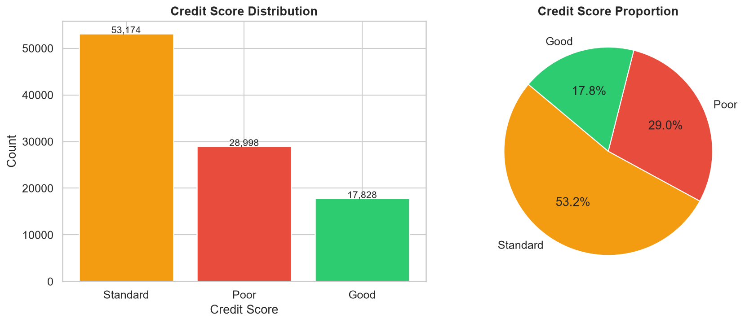
Figure 1: Credit Score class distribution and proportions

3.2 Missing Values
Several columns have missing values. The most significant is Monthly_Inhand_Salary (15%) and Type_of_Loan (11.4%). All missing values are handled via median imputation during preprocessing.
Column | Missing Count | Missing %
Monthly_Inhand_Salary | 15,002 | 15.00%
Type_of_Loan | 11,408 | 11.41%
Name | 9,985 | 9.98%
Credit_History_Age | 9,030 | 9.03%
Num_of_Delayed_Payment | 7,002 | 7.00%
Amount_invested_monthly | 4,479 | 4.48%
Num_Credit_Inquiries | 1,965 | 1.96%
Monthly_Balance | 1,200 | 1.20%

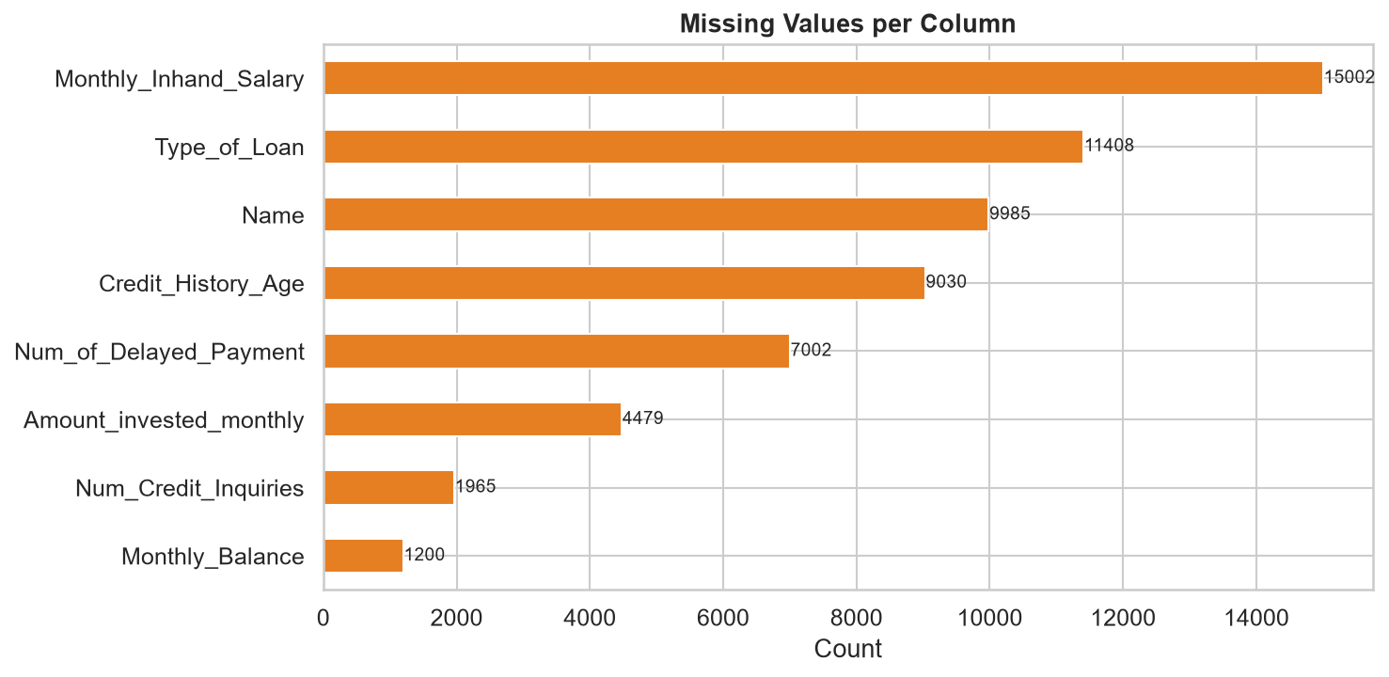
Figure 2: Missing values per column

3.3 Numerical Feature Distributions
Numerical features show wide variation and significant outliers. Several features (e.g., Num_Bank_Accounts, Interest_Rate) have extreme outlier values that were handled through robust scaling and clipping.

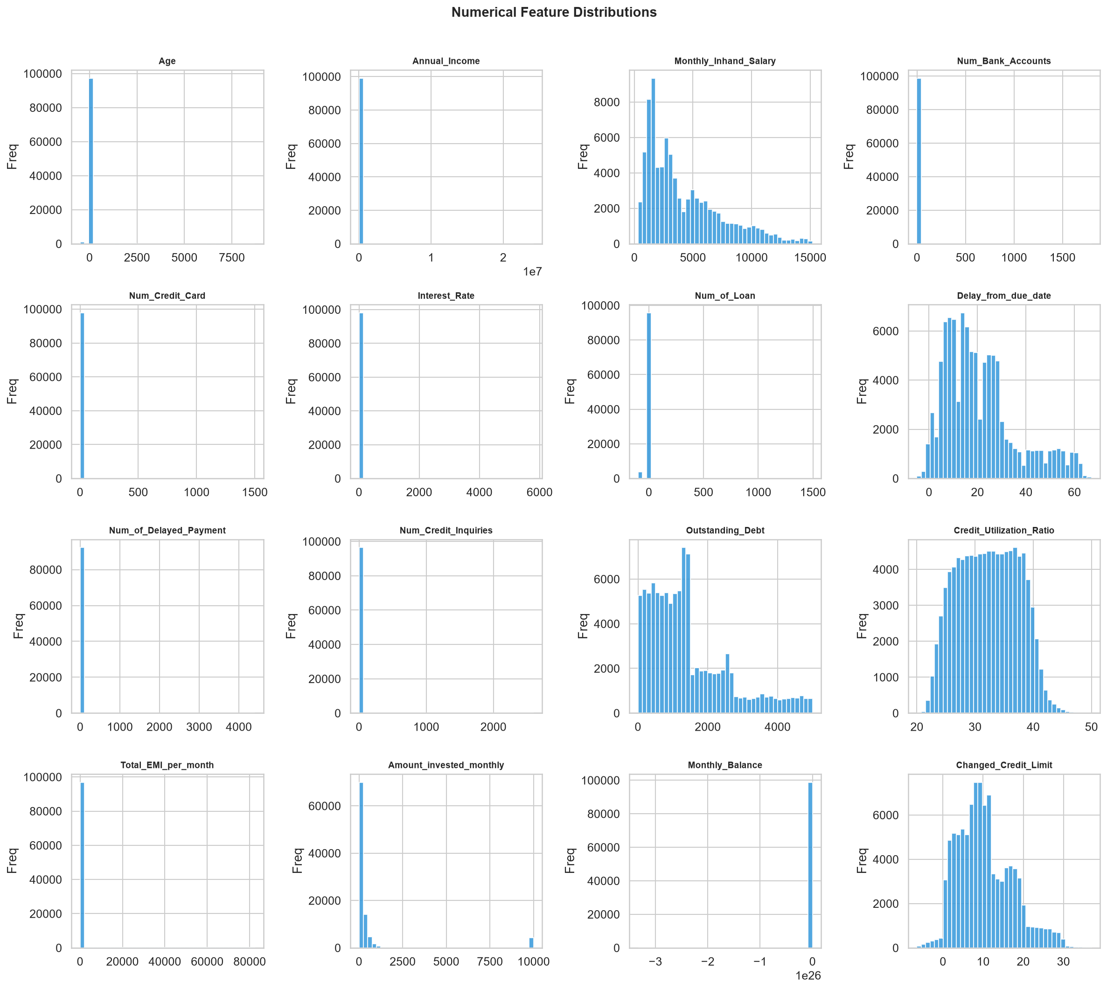
Figure 3: Distribution of all numerical features

3.4 Key Features vs Credit Score
Boxplots reveal clear separation between credit score classes for Outstanding Debt, Interest Rate, and Num_of_Delayed_Payment, confirming their predictive importance.

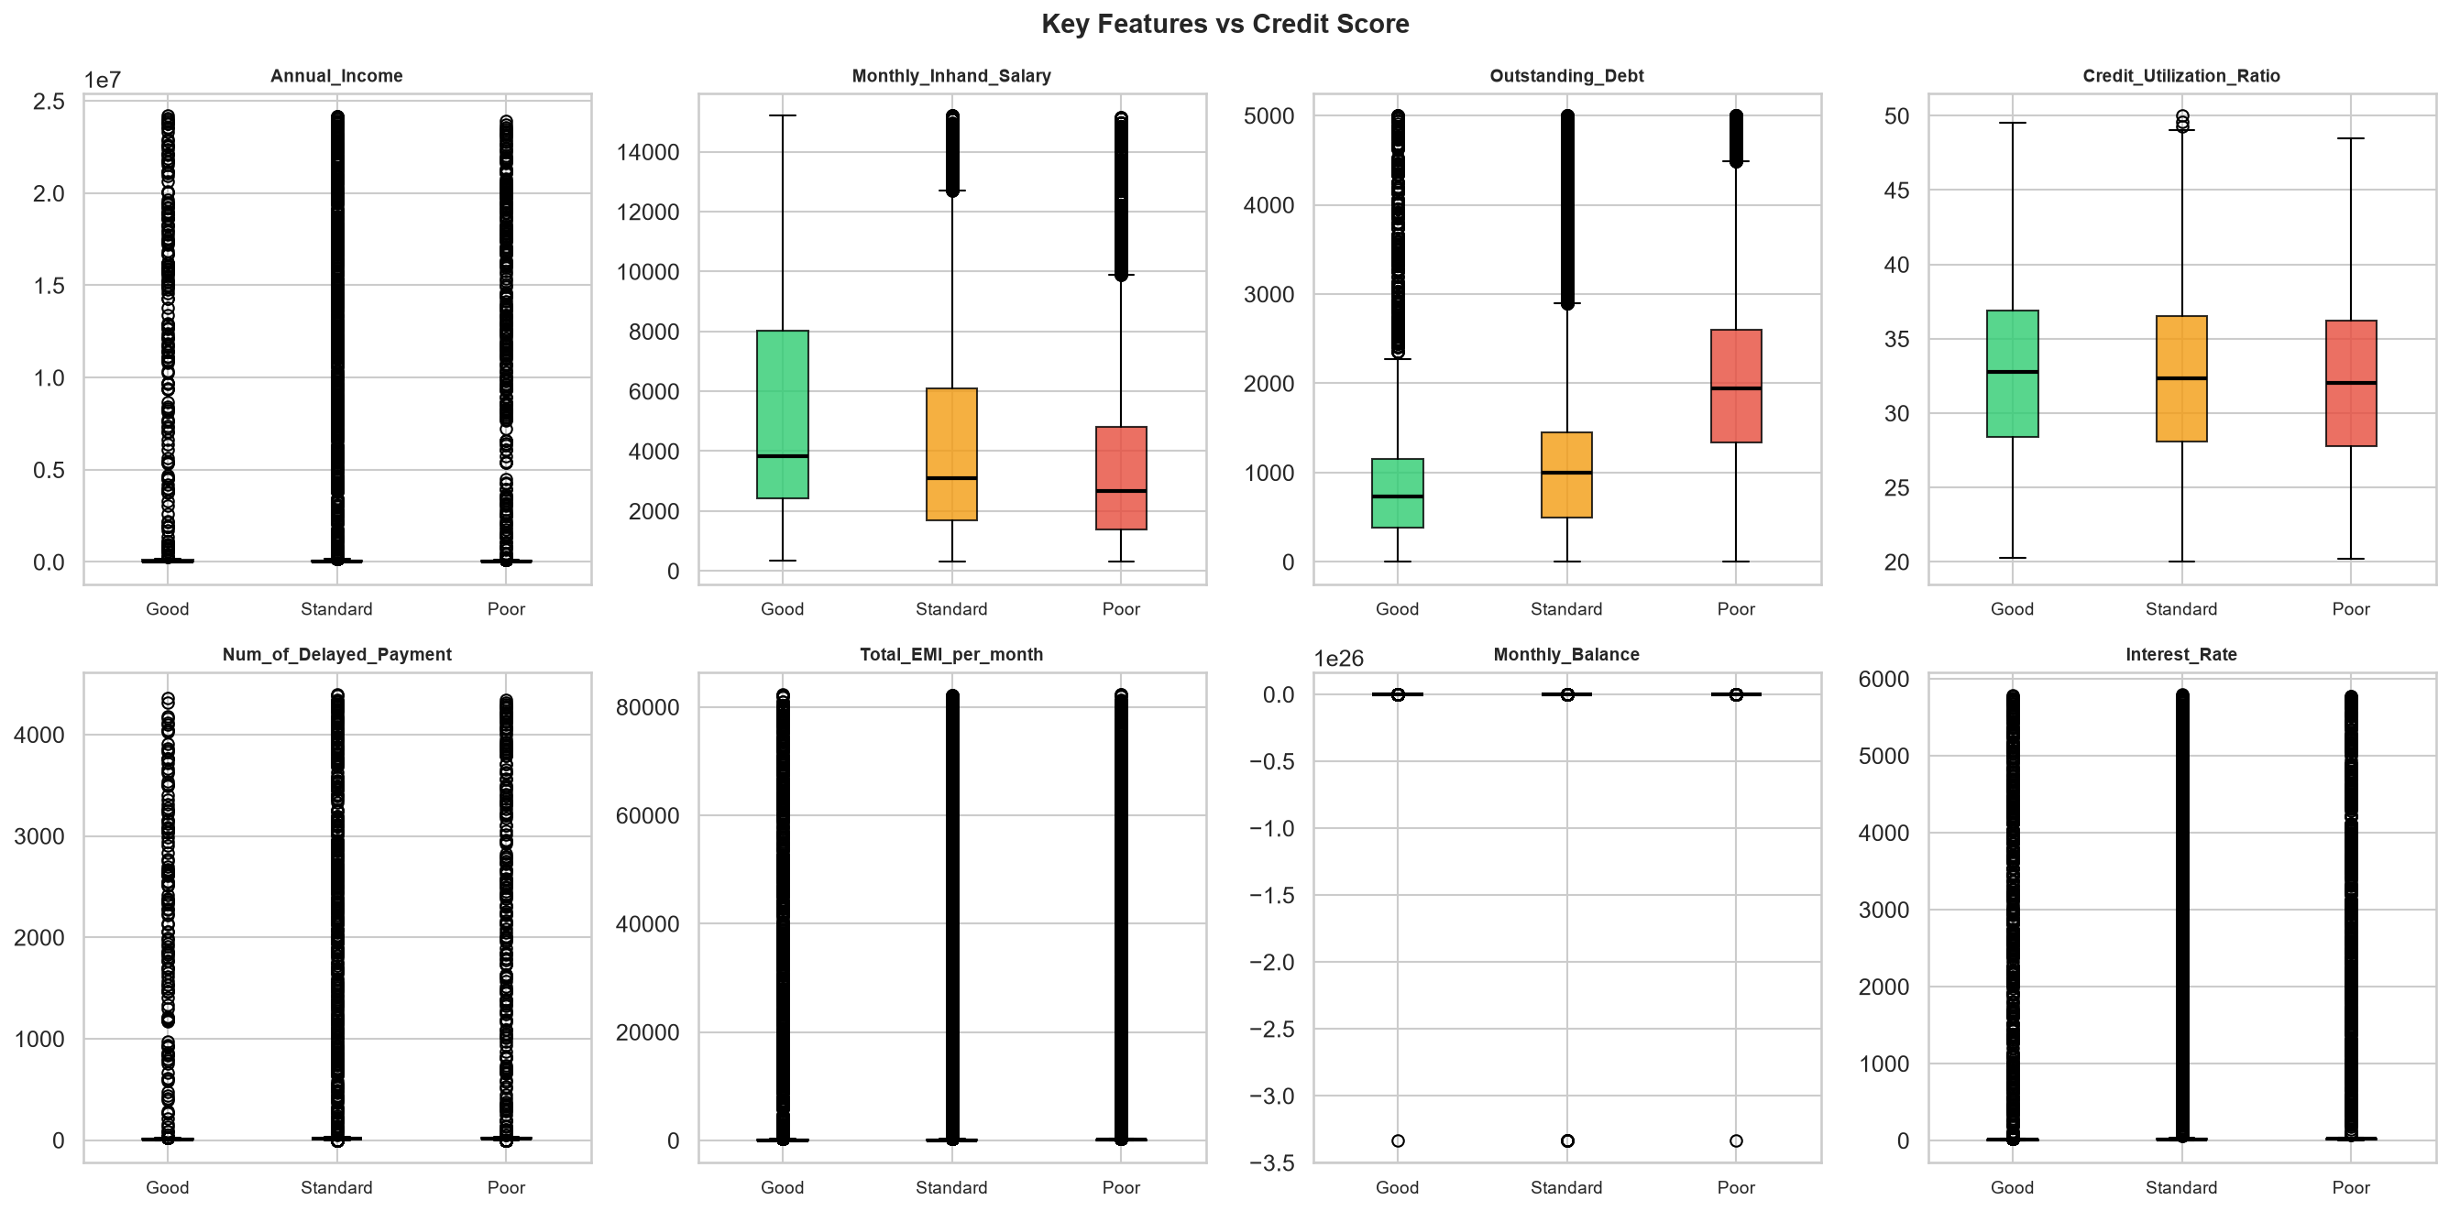
Figure 4: Key numerical features by credit score class

3.5 Categorical Features vs Credit Score
Credit_Mix is the most discriminative categorical feature. Customers with Good credit mix have ~60% probability of Good credit score, while Bad credit mix strongly predicts Poor score.

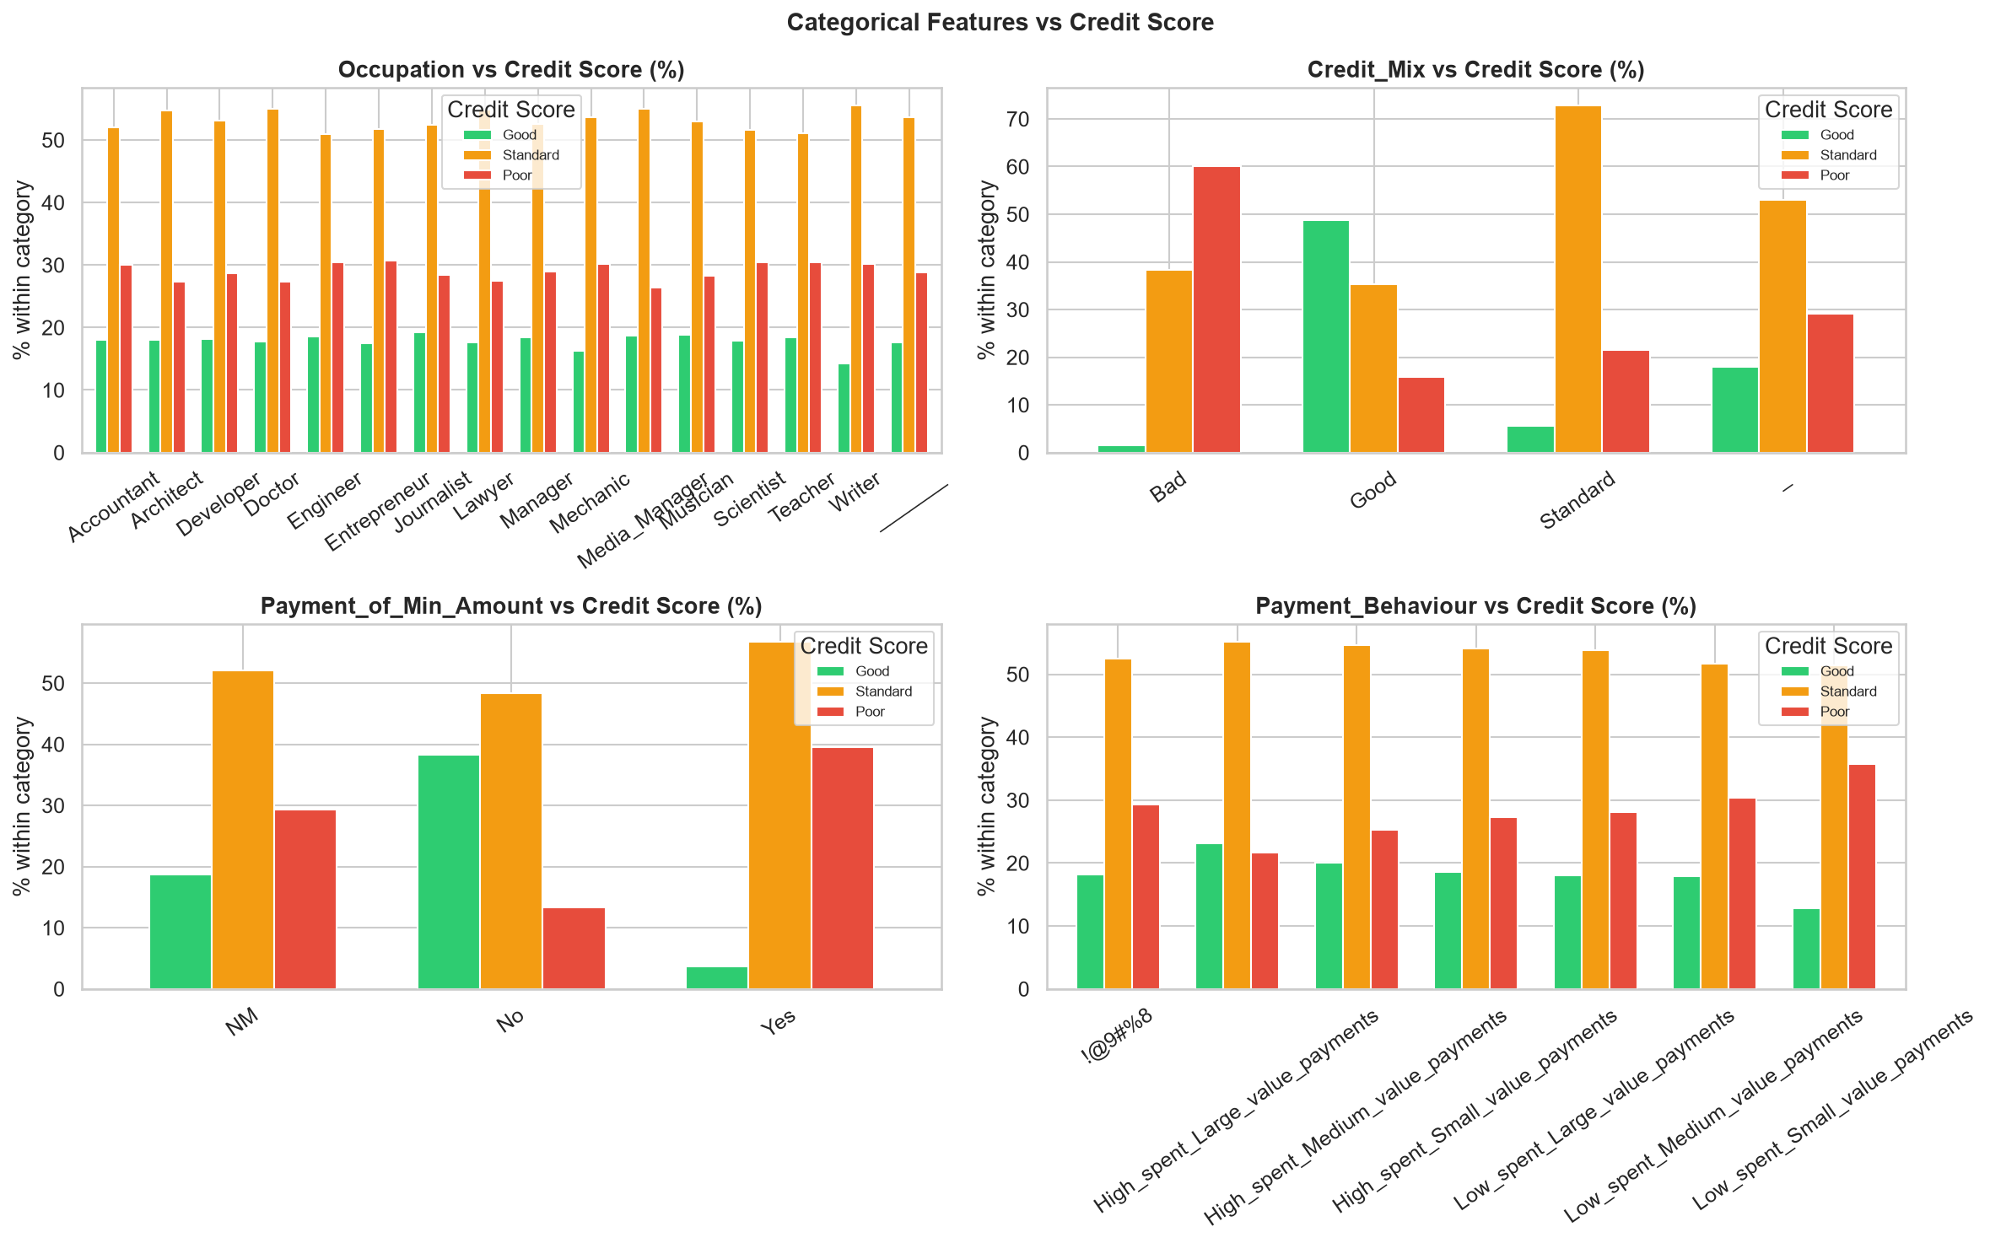
Figure 5: Categorical features vs credit score

4. Correlation Analysis

4.1 Full Correlation Heatmap
The correlation heatmap shows relationships between all numerical features. Outstanding Debt and Delay_from_due_date show the strongest negative correlation with the credit score.

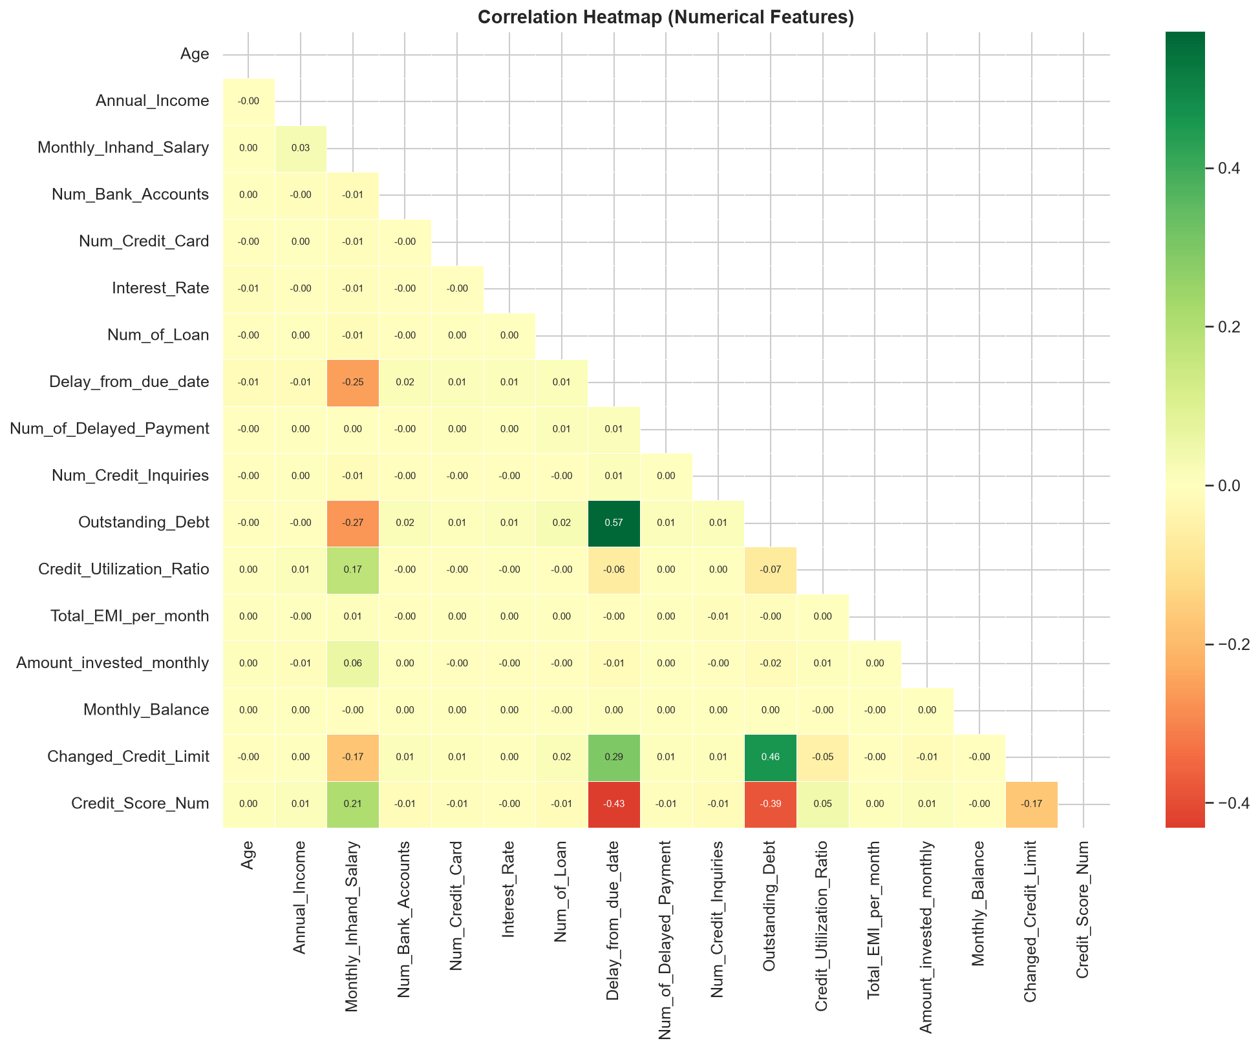
Figure 6: Correlation heatmap of numerical features

4.2 Feature Correlations with Target
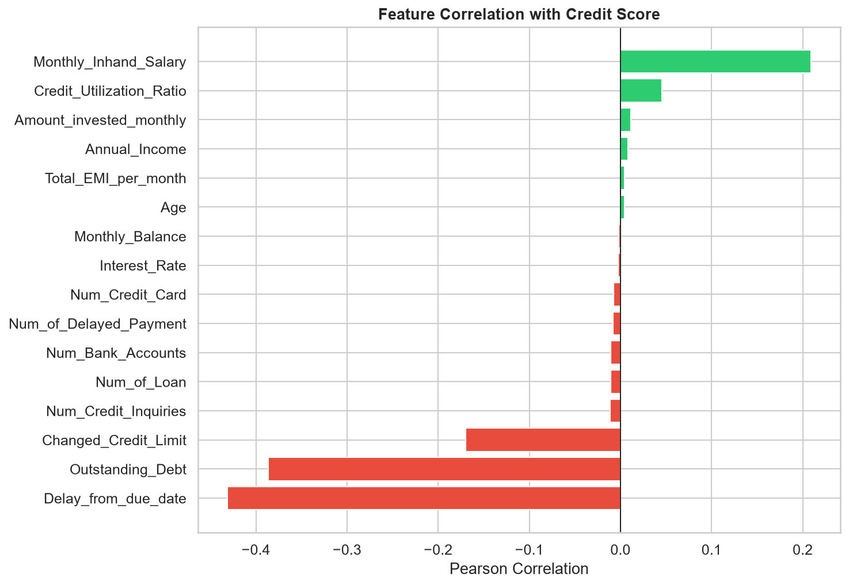
Figure 7: Individual feature correlations with credit score

5. Financial Feature Analysis

5.1 Income Distribution
Annual income distributions overlap significantly across credit score classes, suggesting income alone is not a reliable predictor. However, Good customers show higher median income values.
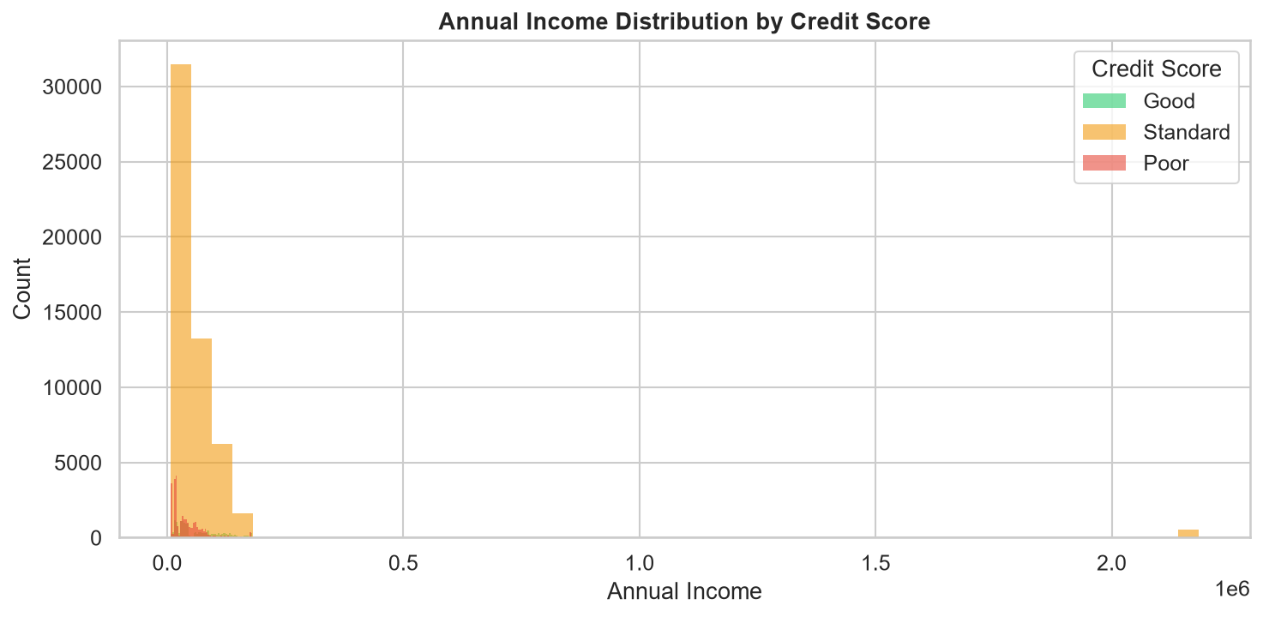
Figure 8: Annual income distribution by credit score

5.2 Delayed Payments Analysis
Number of delayed payments is one of the strongest discriminators. Poor credit customers have significantly more delayed payments on average.
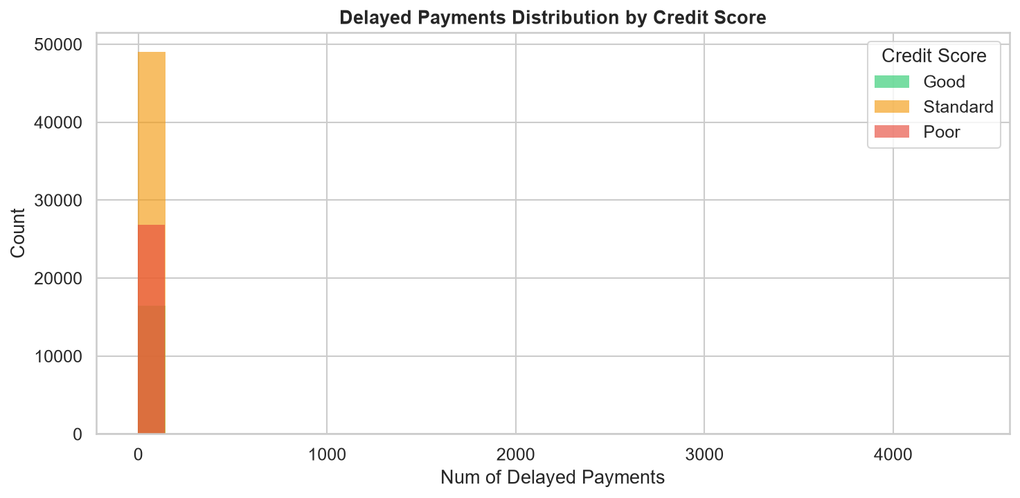
Figure 9: Delayed payments distribution by credit score

5.3 Outstanding Debt Analysis
Outstanding Debt shows the clearest separation: Good customers average $801 outstanding debt vs $2,081 for Poor customers — a 2.6x difference.
Credit Score | Mean Outstanding Debt | Mean Delayed Payments | Mean Monthly Balance
Good | $801 | 26 | $401
Standard | $1,278 | 32 | $344
Poor | $2,081 | 32 | $299

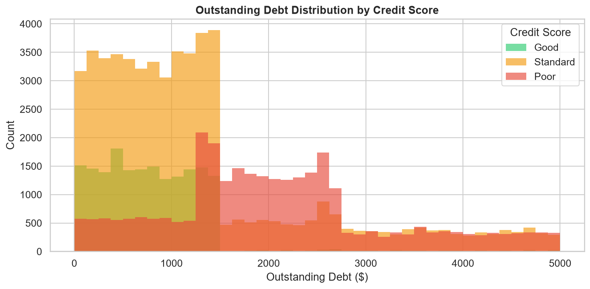
Figure 10: Outstanding debt distribution by credit score

5.4 Monthly Balance Distribution
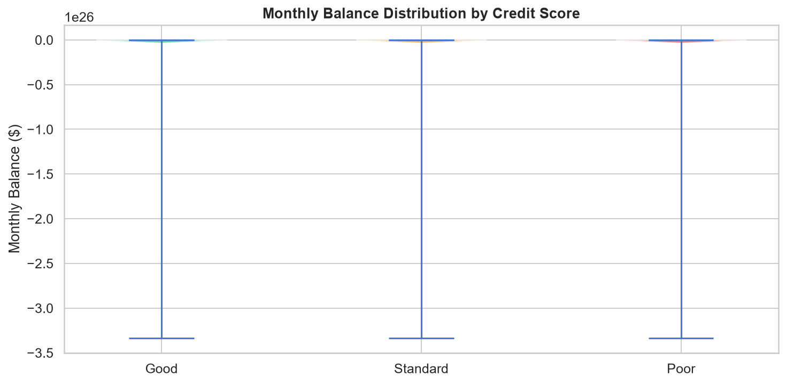
Figure 11: Monthly balance violin plot by credit score

6. Feature Engineering
Seven new features were engineered from existing financial data to better capture financial health ratios and credit behaviour:
Feature | Formula | Business Meaning
Debt_to_Income | Outstanding Debt / Annual Income | Debt burden relative to income
EMI_to_Salary | Total EMI / Monthly Salary | Loan repayment burden
Savings_Rate | Amount Invested / Monthly Salary | Financial discipline proxy
Balance_Buffer | Monthly Balance / Monthly Salary | Cash cushion relative to income
Cards_per_Account | Num Credit Cards / Num Bank Accounts | Credit card concentration
Credit_History_Months | Parsed from 'X Years and Y Months' | Credit history length in months
Num_Loan_Types | Count of loans in Type_of_Loan string | Credit diversity

Preprocessing Pipeline
The following steps were applied to prevent data leakage and ensure clean inputs:
- 1. Drop identifier columns: ID, Customer_ID, Name, SSN, Month
- 2. Strip special characters from noisy numeric fields
- 3. Parse Credit_History_Age text into numeric months
- 4. Count loan types from comma-separated Type_of_Loan string
- 5. Engineer 5 financial ratio features
- 6. Label-encode all categorical features (Occupation, Credit_Mix, Payment_Behaviour, Payment_of_Min_Amount)
- 7. Replace inf/-inf values with NaN, then impute with column median
- 8. StandardScaler applied to all features (fit only on train set — no leakage)
- 9. Final NaN/inf safety pass after scaling
- 10. Stratified 80/20 train/validation split

7. Model Training & Evaluation
Three classification models were trained and evaluated on the 20,000-record validation set (stratified split). All models were assessed on Accuracy, Precision, Recall, F1-Score, ROC-AUC, and 5-fold cross-validated accuracy.

7.1 Performance Comparison
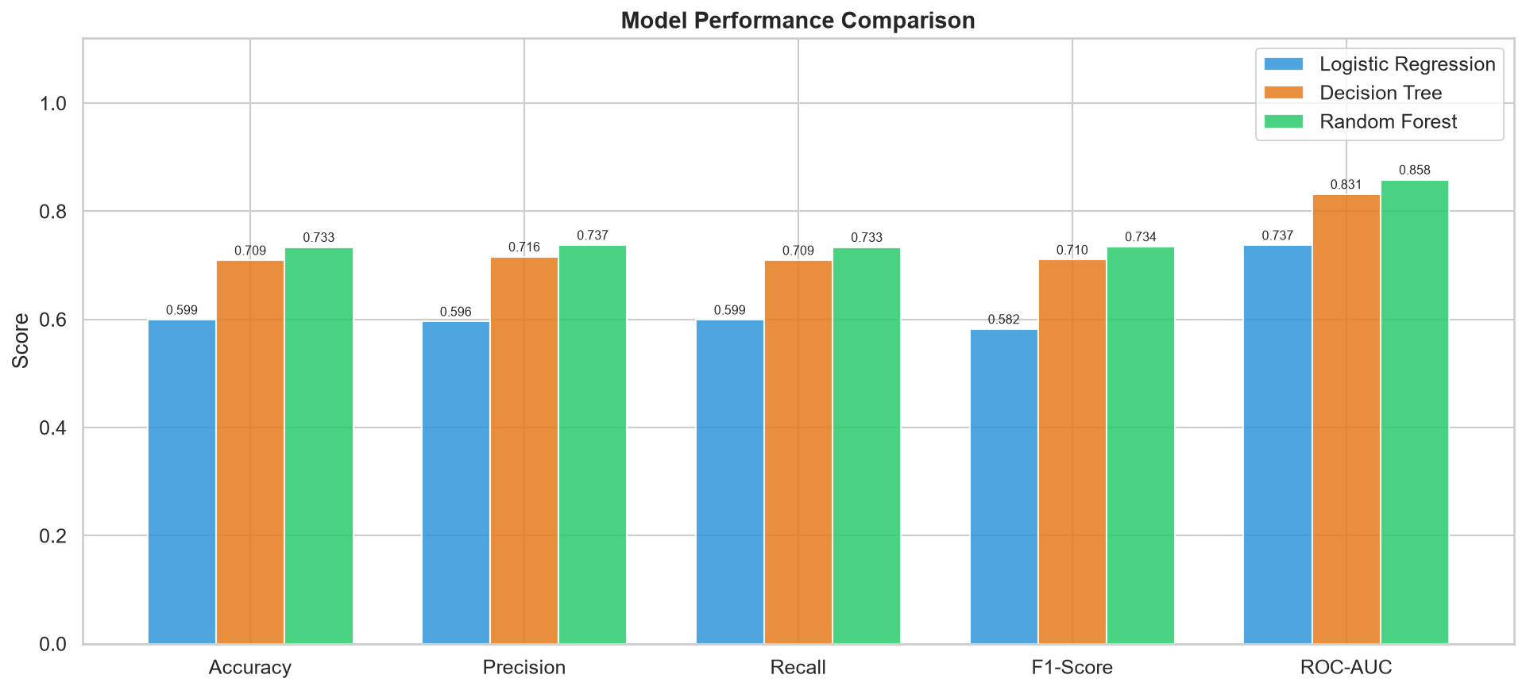
Figure 12: Model performance comparison across all metrics

7.2 Confusion Matrices
The confusion matrices reveal that all models perform best on the Standard class (majority class) and have more difficulty with Good (minority class). Random Forest shows the best balance across all three classes.
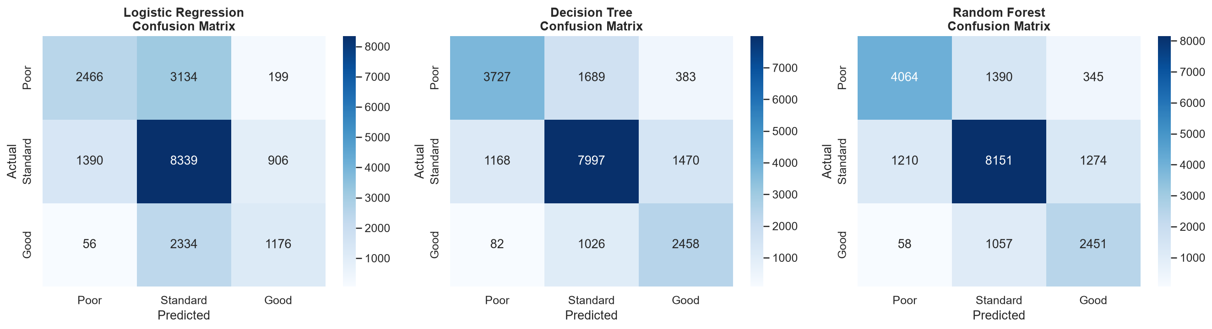
Figure 13: Confusion matrices for all three models

7.3 ROC Curves
ROC curves use one-vs-rest (OvR) strategy for multi-class evaluation. Random Forest achieves AUC > 0.85 for all classes, demonstrating strong discriminative ability.
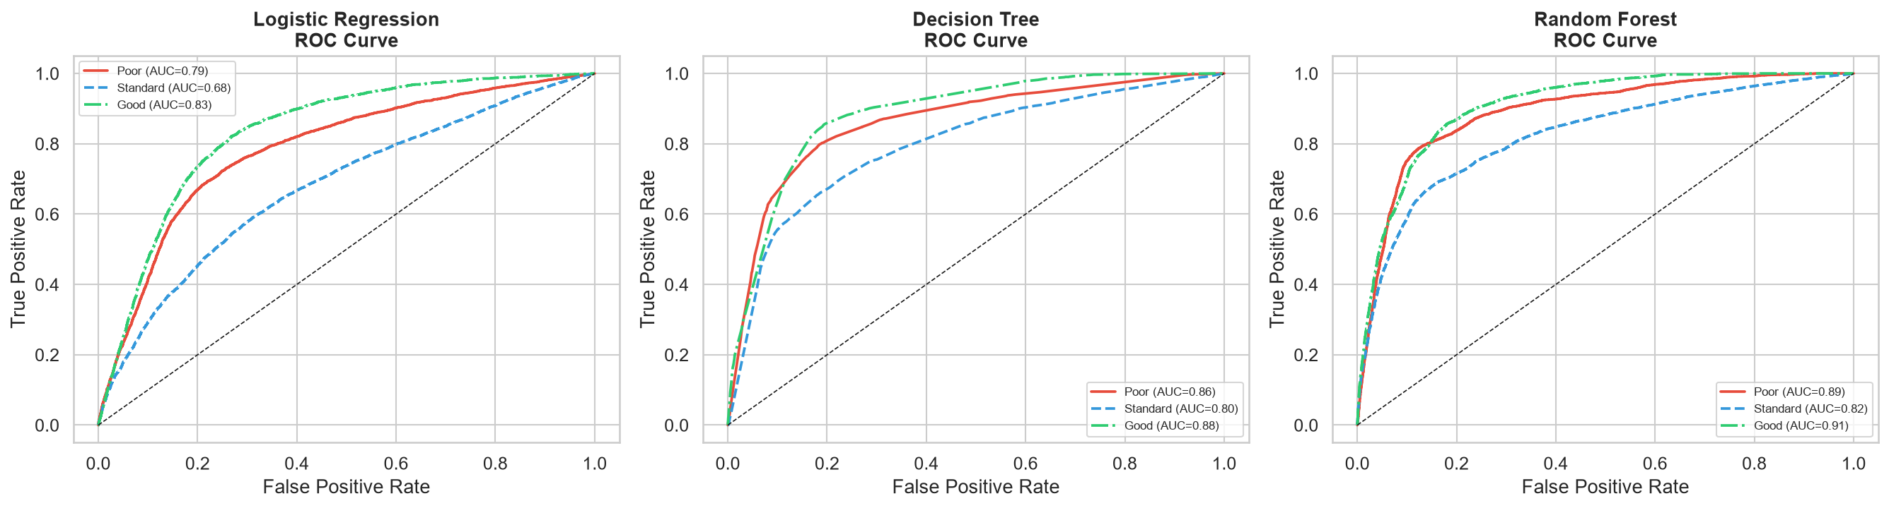
Figure 14: ROC curves (OvR) for all models

7.4 Feature Importance
Random Forest feature importance reveals the top predictors of creditworthiness. Financial stress indicators (Outstanding Debt, EMI ratio, Delayed Payments) and credit history are most informative.
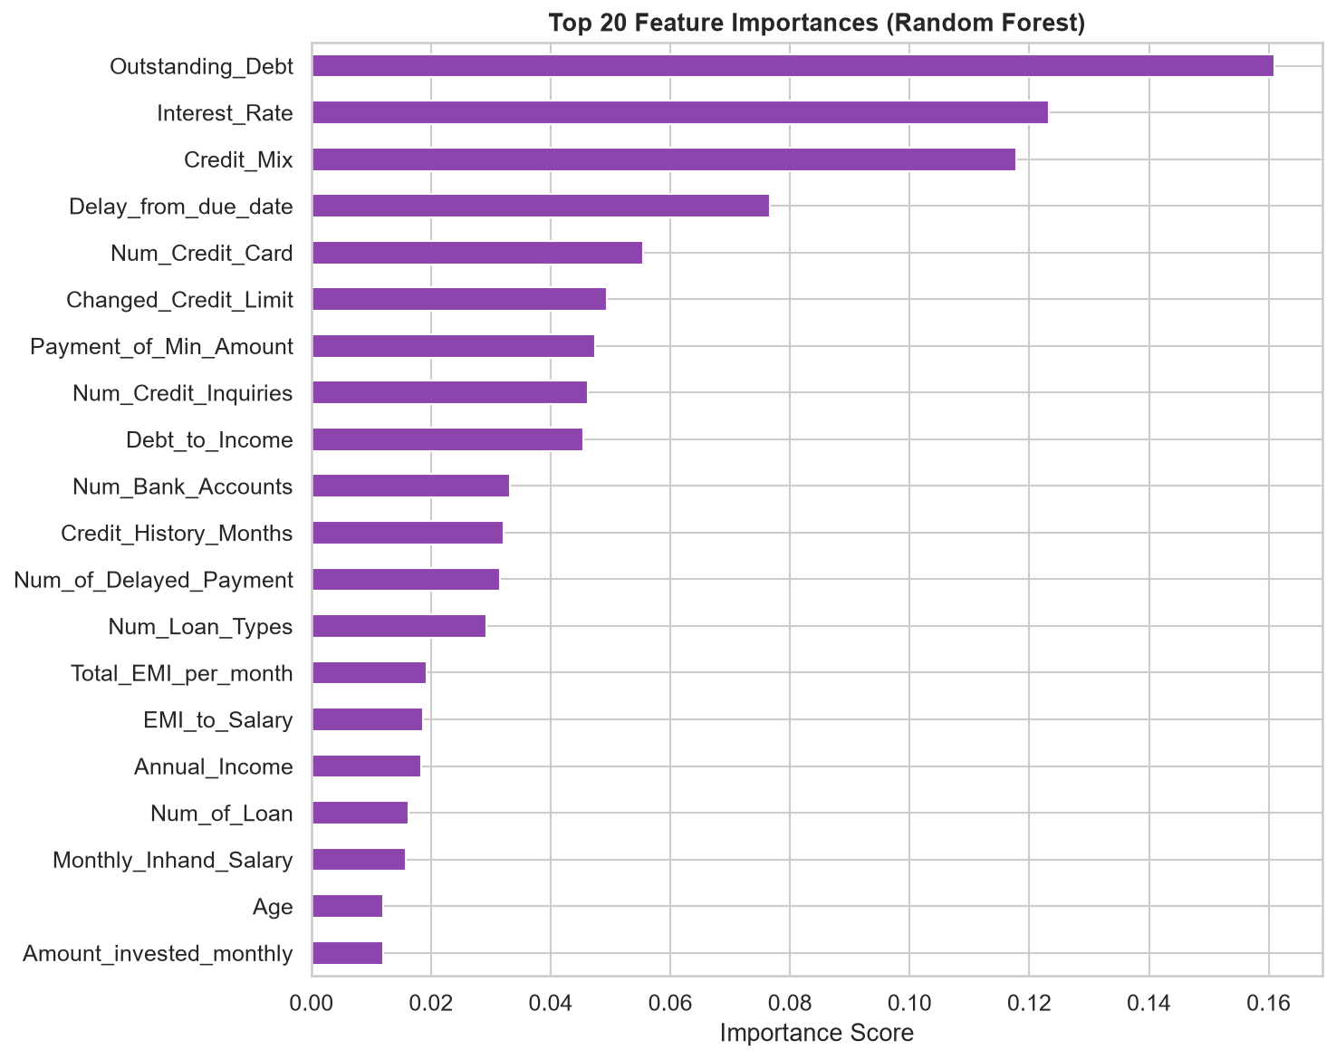
Figure 15: Top 20 feature importances from Random Forest

8. Final Model & Test Predictions

8.1 Best Model: Random Forest
Random Forest was selected as the best model based on highest F1-Score (0.7344) and ROC-AUC (0.8583). The model was retrained on the full 100,000-record training set before generating test predictions.
Parameter | Value
Algorithm | Random Forest Classifier
n_estimators | 200
max_depth | 12
random_state | 42
Accuracy | 73.33%
F1-Score | 73.44%
ROC-AUC | 0.8583

8.2 Test Prediction Distribution
Predictions were generated for all 50,000 test records, with per-class probabilities included for each customer.
Predicted Score | Count | Proportion
Standard | 26,022 | 52.0%
Poor | 13,534 | 27.1%
Good | 10,444 | 20.9%

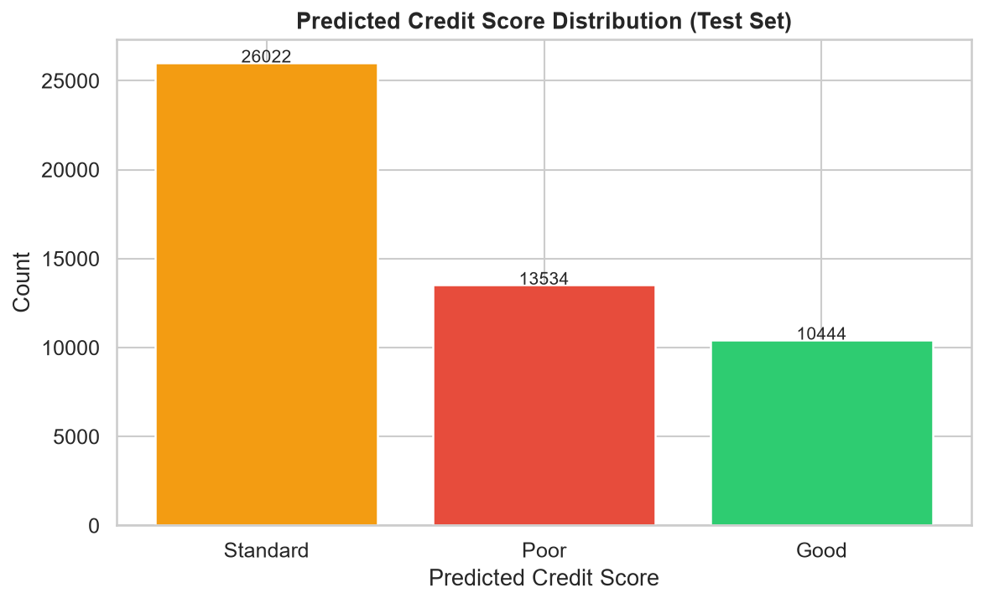
Figure 16: Predicted credit score distribution on test set

9. Key Insights & Conclusions
• Outstanding Debt is the #1 predictor
Good customers average $801 outstanding debt vs $2,081 for Poor — a 2.6x difference. Debt-to-Income ratio (engineered feature) is among the top 5 most important features.

• Credit History Age matters significantly
Longer credit history strongly correlates with Good credit scores. Customers with 20+ years of credit history are overwhelmingly Good or Standard.

• Payment discipline is critical
The number of delayed payments and days delayed are strong risk indicators. Good customers average 26 delayed payments vs 32 for Poor customers.

• Credit Mix quality is highly discriminative
Customers with a 'Good' credit mix have ~60% probability of Good credit score. This is the most informative categorical feature.

• Income alone is not sufficient
Annual income distributions overlap significantly between classes. High income does not guarantee Good credit — debt management is more important.

• Engineered features add significant value
EMI-to-Salary ratio and Debt-to-Income ratio are among the top 10 most important features, validating the feature engineering step.

• Data quality issues are prevalent
The raw dataset contains significant noise: negative ages, special characters, out-of-range values (e.g., Interest Rate = 5797), and inconsistent formats. Robust preprocessing is essential.

10. Project Deliverables
File | Location | Description
analysis.py | scripts/ | Full EDA script
model.py | scripts/ | Feature engineering + ML training
credit_scoring_analysis.ipynb | notebooks/ | Complete Jupyter notebook
train.csv | data/ | Training dataset (100K records)
test.csv | data/ | Test dataset (50K records)
test_predictions.csv | outputs/predictions/ | 50,000 test predictions with probabilities
model_comparison.csv | outputs/predictions/ | Model metrics comparison table
best_model.pkl | outputs/models/ | Saved Random Forest model
model_metadata.json | outputs/models/ | Model configuration and metrics
Figures 01-16 | outputs/figures/ | 16 visualisation charts
credit_scoring_report.docx | reports/ | This Word report
README.md | ./ | Project documentation
requirements.txt | ./ | Python dependencies

Project Structure
Credit Scoring Model/
├── data/
│ ├── train.csv
│ └── test.csv
├── notebooks/
│ └── credit_scoring_analysis.ipynb
├── scripts/
│ ├── analysis.py
│ └── model.py
├── outputs/
│ ├── figures/ (16 charts)
│ ├── models/ (best_model.pkl, model_metadata.json)
│ └── predictions/ (test_predictions.csv, model_comparison.csv)
├── reports/
│ └── credit_scoring_report.docx
├── README.md
└── requirements.txt

