1. Select user();

**Dumping data for query result**

| user() |
| --- |
| root@localhost |

1. select user from mysql.user;

**Dumping data for table user**

| user |
| --- |
| root |
| root |
|  |
| pma |
| root |

3.

CREATE USER 'test1'@'localhost';

CREATE USER 'test2'@'localhost';

CREATE USER 'test3'@'localhost';

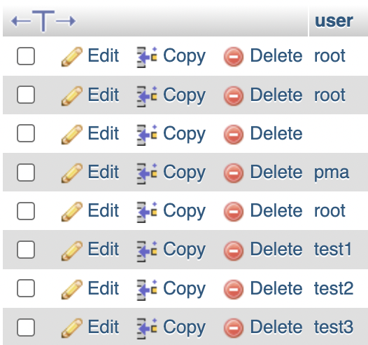

4. GRANT SELECT, UPDATE ON Organisation.Employee TO 'test1'@'localhost';



5.

CREATE VIEW Employeev AS SELECT firstname, lastname FROM Organisation.Employee;

GRANT SELECT ON Organisation.Employeev TO 'test2'@'localhost';

6. GRANT ALL PRIVILEGES ON *.* TO 'test3'@'localhost' WITH GRANT OPTION;

7.

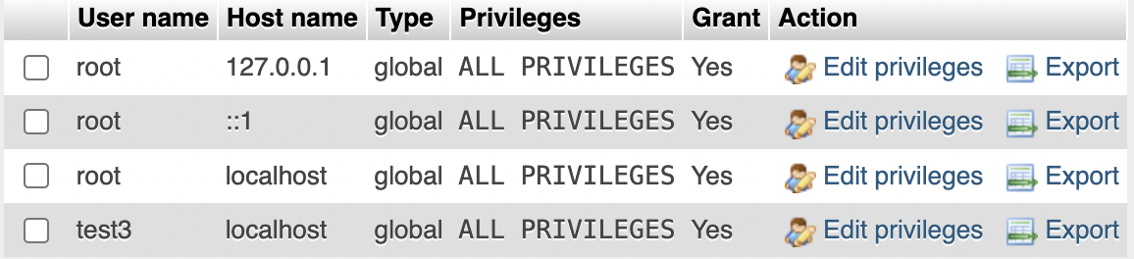

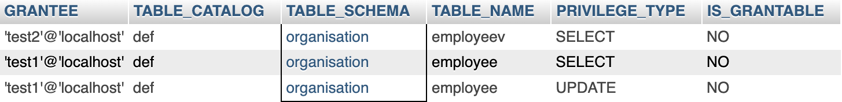

8. CREATE INDEX emp_id_index ON Employee(emp_id);

