1. DELIMITER $$

CREATE PROCEDURE getdetails()

BEGIN

SELECT * FROM employee;

END $$

DELIMITER;

call getdetails();

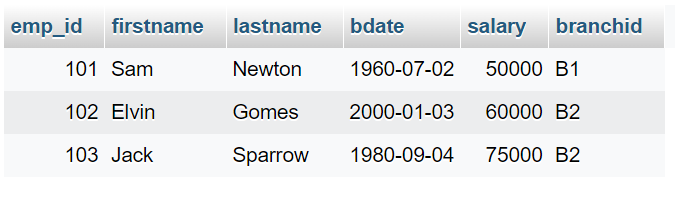

1. DELIMITER $$

CREATE PROCEDURE getdetails2(IN empid INT)

BEGIN

SELECT * FROM employee WHERE emp_id = empid;

END $$

DELIMITER

call getdetails2(103);

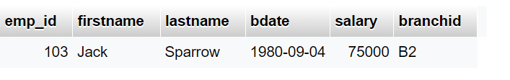

1. DELIMITER $$

CREATE PROCEDURE getclientdetails(IN clientid varchar(5))

BEGIN

SELECT client.branchid, COUNT(employee.emp_id) FROM client JOIN employee ON client.branchid = employee.branchid WHERE client.client_id = clientid;

END $$

DELIMITER

call getclientdetails('C2')

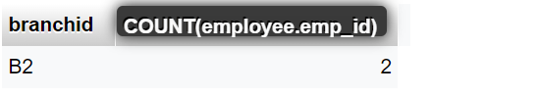



DELIMITER $$

CREATE PROCEDURE UpdateSalaryAndClients(IN empId INT)

BEGIN

SELECT

e.emp_id,

e.salary,

COUNT(w.client_id) AS numClients,

e.salary * (1 + (e.salary > 74000 AND COUNT(w.client_id) >= 1) * 0.01

+ (e.salary BETWEEN 49000 AND 61000 AND COUNT(w.client_id) > 2) * 0.02

+ (e.salary > 49000 AND COUNT(w.client_id) > 2) * 0.05) AS increasedSalary

FROM

employee e

JOIN

workswith w ON e.emp_id = w.emp_id

WHERE

e.emp_id = empId

GROUP BY

e.emp_id;

END $$

DELIMITER ;

call UpdateSalaryAndClients(103);

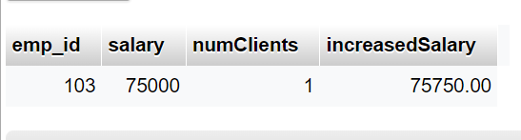

1. DELIMITER $$

CREATE PROCEDURE UpdateAllSalariesAndClients()

BEGIN

SELECT

e.emp_id,

e.salary,

COUNT(w.client_id) AS numClients,

e.salary * (1 + (e.salary > 74000 AND COUNT(w.client_id) >= 1) * 0.01

+ (e.salary BETWEEN 49000 AND 61000 AND COUNT(w.client_id) > 2) * 0.02

+ (e.salary > 49000 AND COUNT(w.client_id) > 2) * 0.05) AS increasedSalary

FROM

employee e

JOIN

workswith w ON e.emp_id = w.emp_id

GROUP BY

e.emp_id;

END $$

DELIMITER ;

call UpdateAllSalariesAndClients();

