1 Exercise
A good way to start it’s make blink an internal led in the board of the Arduino.
#define PIN_13 13 // Pin 13 has an LED connected on most Arduino
#define DELAY_TIME 1000 // 1 sec

void setup() {
pinMode(PIN_13,OUTPUT); // Initialize the digital pin as output
}

void loop() {
// Turn the LED on (HIGH is the voltage level)
digitalWrite(PIN_13,HIGH);
delay(DELAY_TIME); // Wait for a second
digitalWrite(PIN_13,LOW); // Turn off the LED
delay(DELAY_TIME); // Wait for a second
}

2 Exercise

Let’s do the same but with an external LED. The position of the LED and the resistance are important.
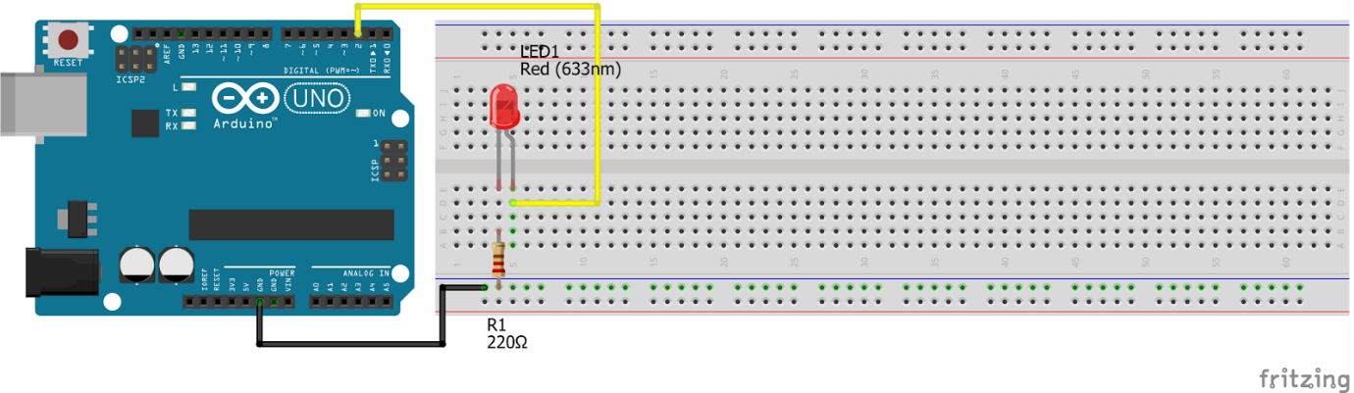
#define PIN_2 2
#define DELAY_TIME 1000 // 1 sec

void setup(){
pinMode(PIN_2, OUTPUT); // Initialize the digital pin as output
}

void loop() {
digitalWrite(PIN_2, HIGH); // Turn the LED on (HIGH is the voltage level)
delay(DELAY_TIME); // Wait for a second
digitalWrite(PIN_2, LOW); // Turn of the LED
delay(DELAY_TIME); // Wait for a second
}

Exercise 3
Now we are going to make blink two LEDs with different period.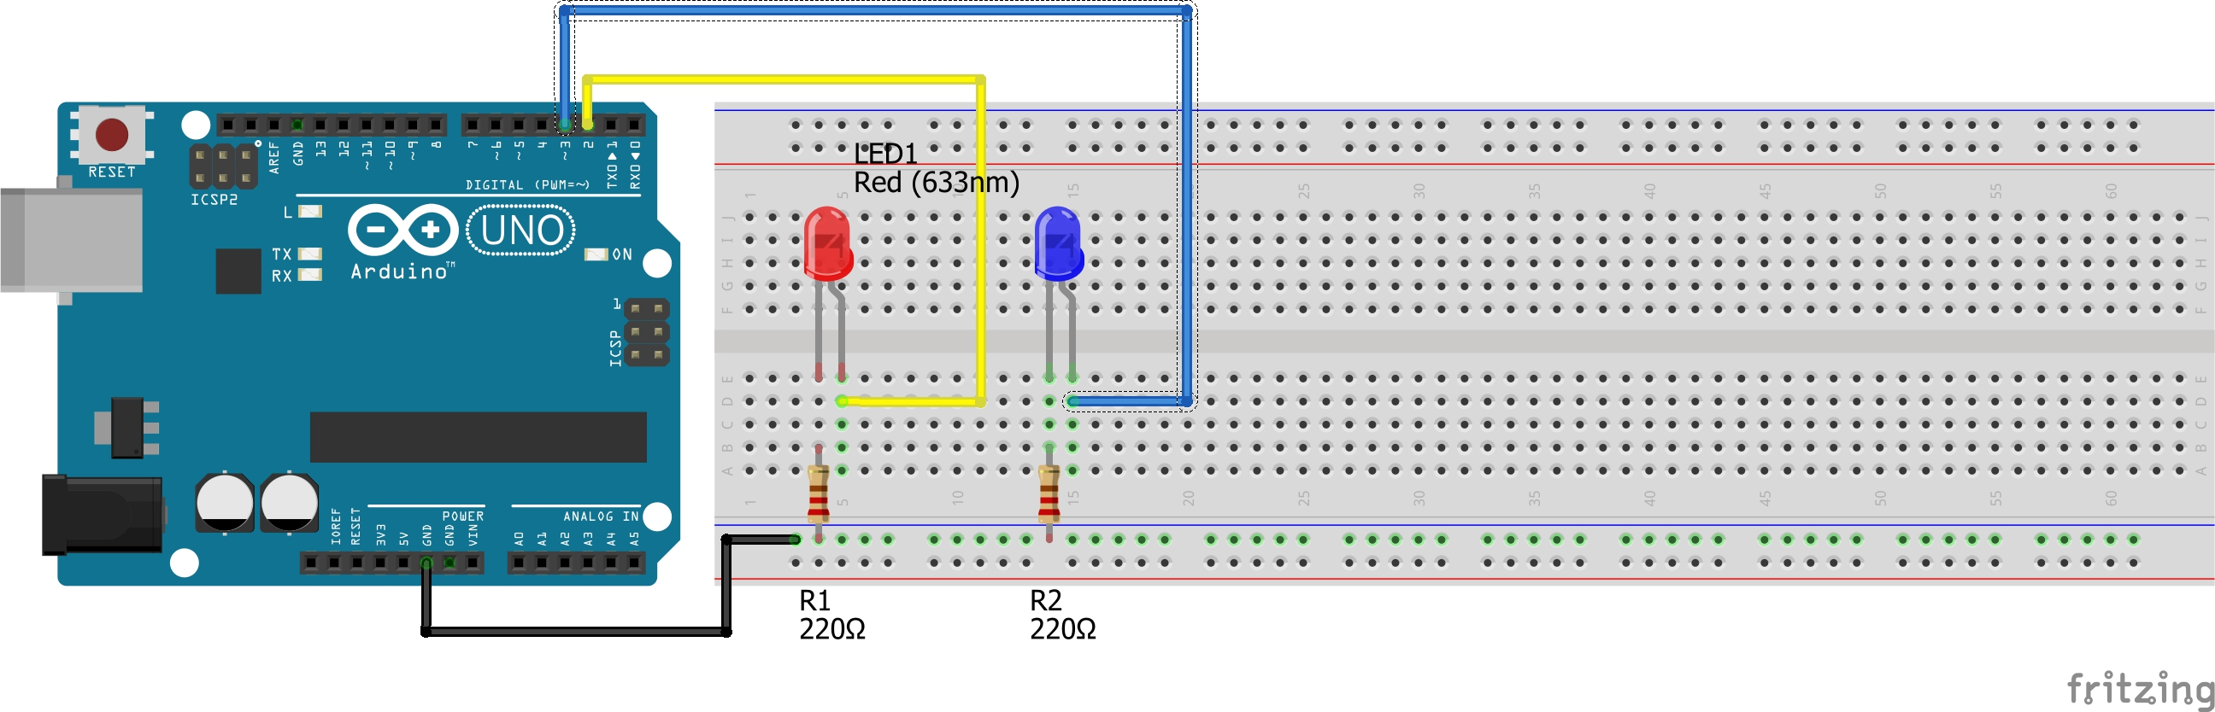
#define LED_1 2 // Plug the LED 1 in the PIN 2
#define LED_2 3 // Plug the LED 2 in the PIN 3
#define DELAY_TIME_LED_1 1000 // 1 sec
#define DELAY_TIME_LED_2 600 // 0,6 sec

// Create variables to save the state of the LED
byte led_1_state = LOW;
byte led_2_state = LOW;

/* Blink with 2 LEDs with different periods it isn't as simple as before,
* we need to know when we have to blink and for that we need to save the
* time. To do that we need 'unsigned long' variables because it's
* the return type of 'millis()' that give us the current time in
* milliseconds
*/
unsigned long led_1_next_blink, led_2_next_blink;

void setup() {
pinMode(LED_1, OUTPUT); // Initialize the digital pin as output
pinMode(LED_2, OUTPUT);
// This is our start point
led_1_next_blink = led_2_next_blink = millis();
}

// We need to create a function to wait
unsigned long wait_timing(unsigned long next_time_ms){
// Save the current time in the variable t
unsigned long t = millis();
/* We check if we already pass the dead line time.
* If not we wait the restant time left.
* Else we don't need to wait.
*/
if(t < next_time_ms){
delay(next_time_ms - t);
// We save again the current time after wait
t = millis();
}
// This return is the current time
return t;
}

void loop() {

/* This is a loop so the first iteration led_1_next_blink will
* be the same than led_2_next_blink
* because we initialize with the same value at the setup()
* but the rest of iterations (may) will be different.
* So we ask with min(value1,value2) who its the next and call our
* function wait_timing(value)
*/
unsigned long current_ms =
wait_timing(min(led_1_next_blink,led_2_next_blink));

// We ask if we was waiting for the LED_1
if(current_ms >= led_1_next_blink){
// We need to add the delay time of the LED_1
// for the next blink
led_1_next_blink = current_ms + DELAY_TIME_LED_1;
// If the current state is LOW change it to HIGH in another
// case change it to LOW
led_1_state = (led_1_state == LOW ? HIGH : LOW);
// Change the output of the LED_1
digitalWrite(LED_1,led_1_state);
}
// We ask if we was waiting for the LED_2
if(current_ms >= led_2_next_blink){
// We need to add the delay time of the LED_2 for the next
//blink
led_2_next_blink = current_ms + DELAY_TIME_LED_2;
// If the current state is LOW change it to HIGH in another
// case change it to LOW
led_2_state = (led_2_state == LOW ? HIGH : LOW);
// Change the output of the LED_2
digitalWrite(LED_2,led_2_state);
}
}

Exercise 4
Let’s play with a button! If we push the button, then the LED turn ON.
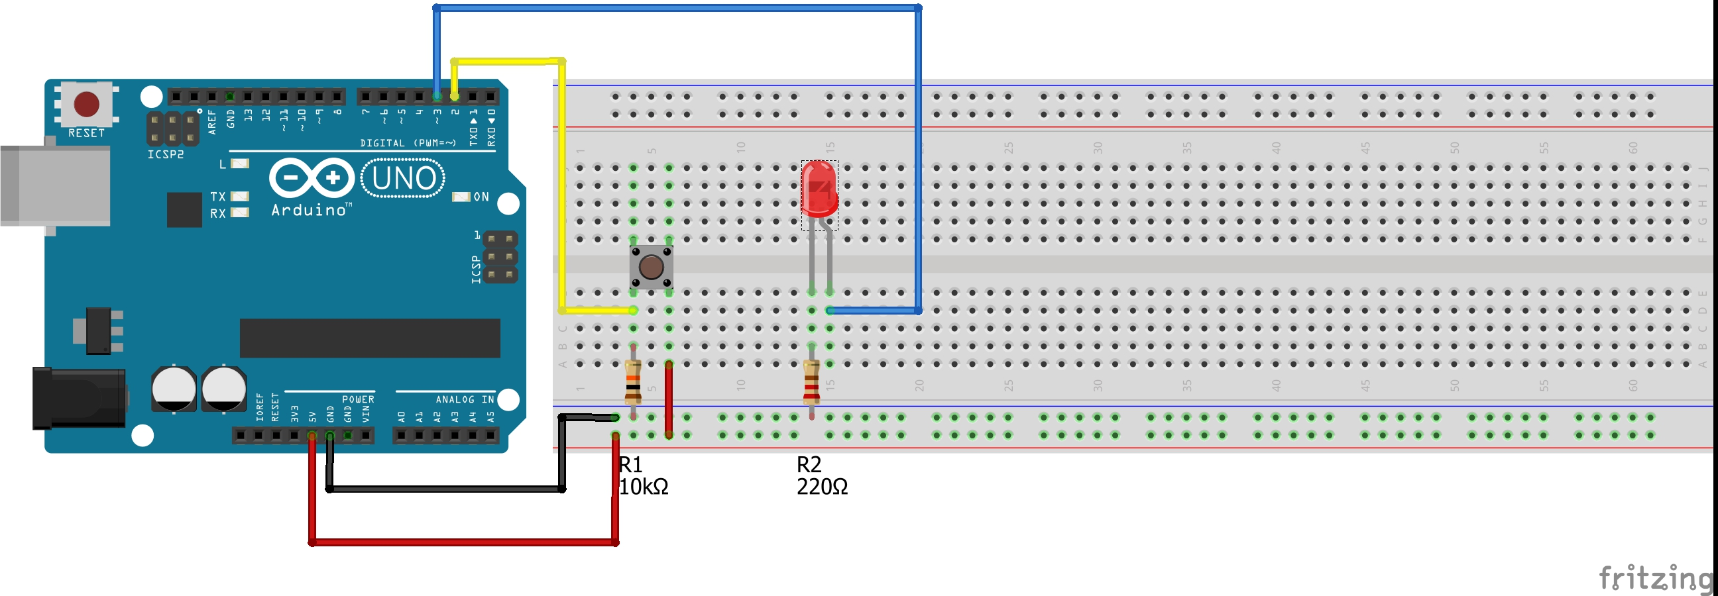
#define BUTTON 2 // Plug the wire of button in the PIN 2
#define LED_1 3 // Plug the LED 1 in the PIN 3

void setup() {
pinMode(BUTTON, INPUT); // Initialize the digital pin as input
pinMode(LED_1, OUTPUT); // Initialize the digital pin as output
}

void loop() {
// Save the state in the variable button_state
int button_state = digitalRead(BUTTON);
// If the button is press then light the LED
digitalWrite(LED_1,button_state);
}

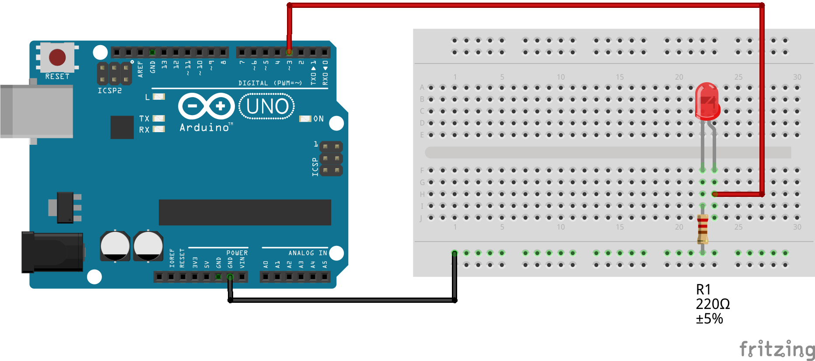
Exercise 5
Let’s practice with analogical signals (PWN)
#define LED_1 3 //Plug the LED 1 in the PIN 3
#define INCREASE_TIME 200 // 0.2 sec

void setup() {
pinMode(LED_1, OUTPUT); // Initialize the PWN pin as output
}

void loop() {
// Increase the light of the LED
for(int i=0; i<=255; i=i+10){
analogWrite(LED_1,i);
delay(INCREASE_TIME);
}
// Decrease the light of the LED
for(int i=255; i>=0; i=i-10){
analogWrite(LED_1,i);
delay(INCREASE_TIME);
}
}

