Laboratorio 09

1. Crear un procedimiento  
   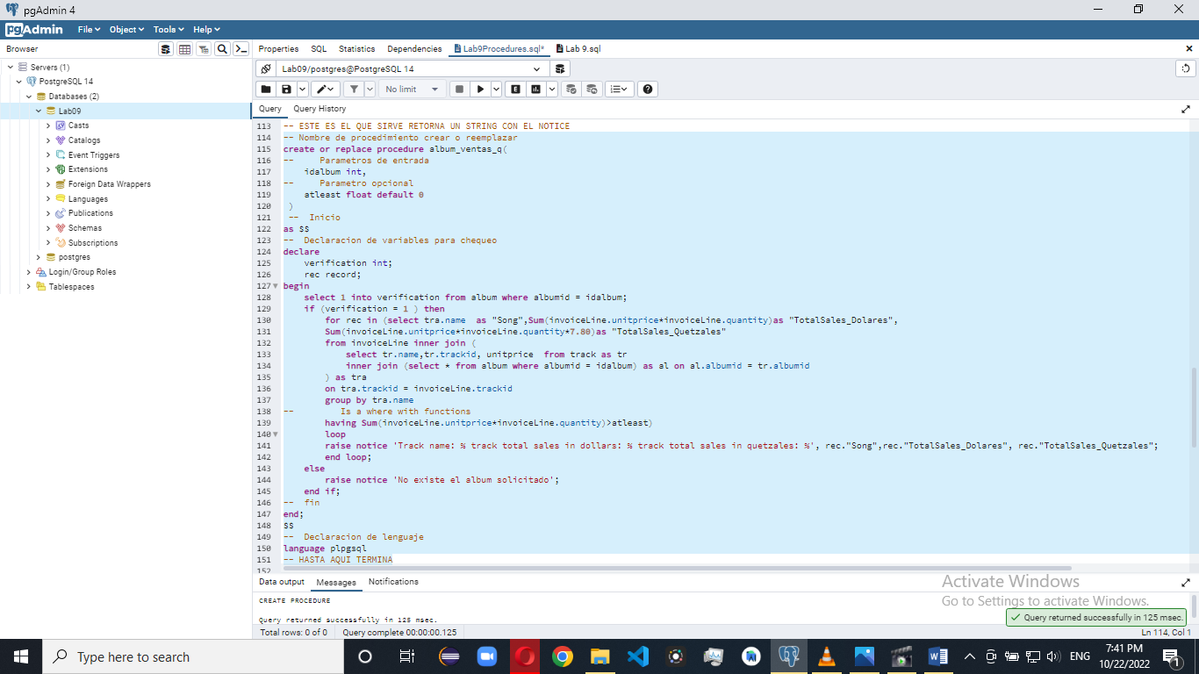  
   El procedimiento funciona  
   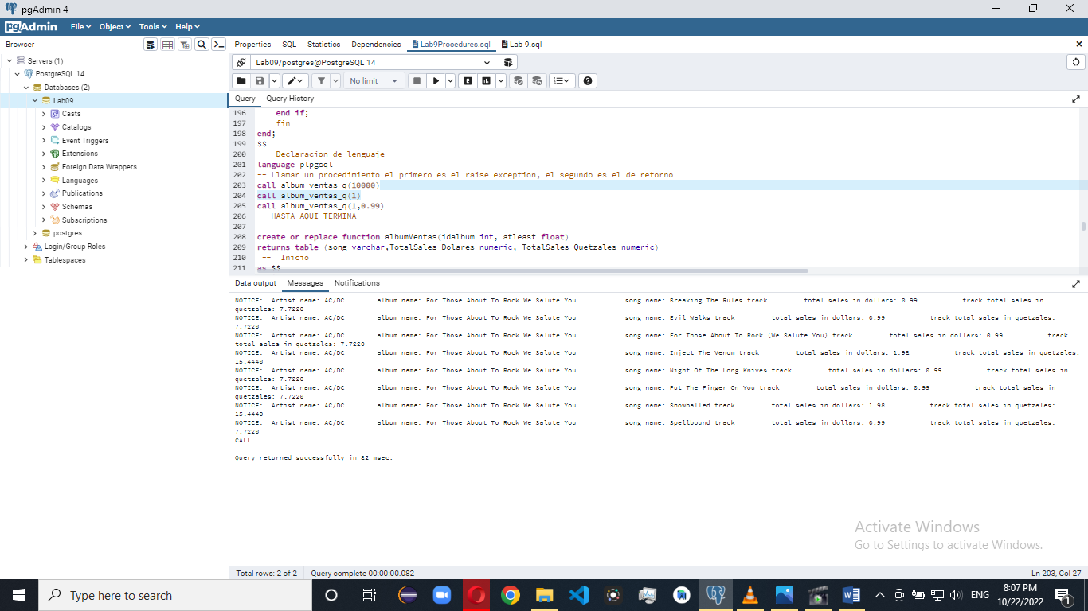  
   El procedimiento lanza la excepción  
   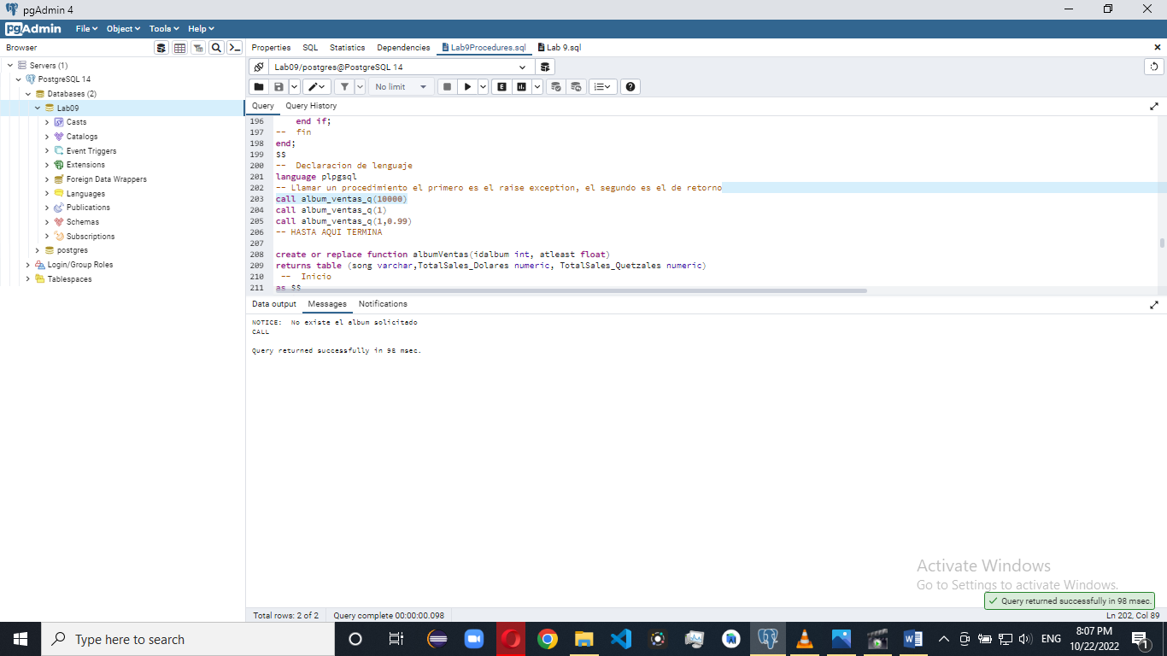  
   El procedimiento funciona con el argumento opcional  
   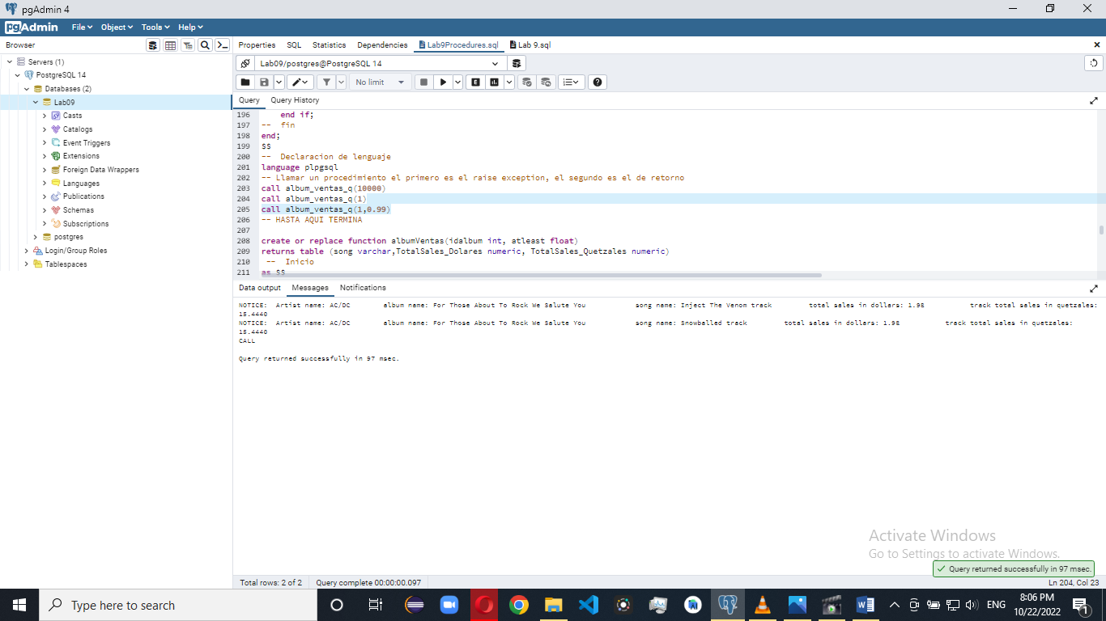
2. Creación del procedimiento  
   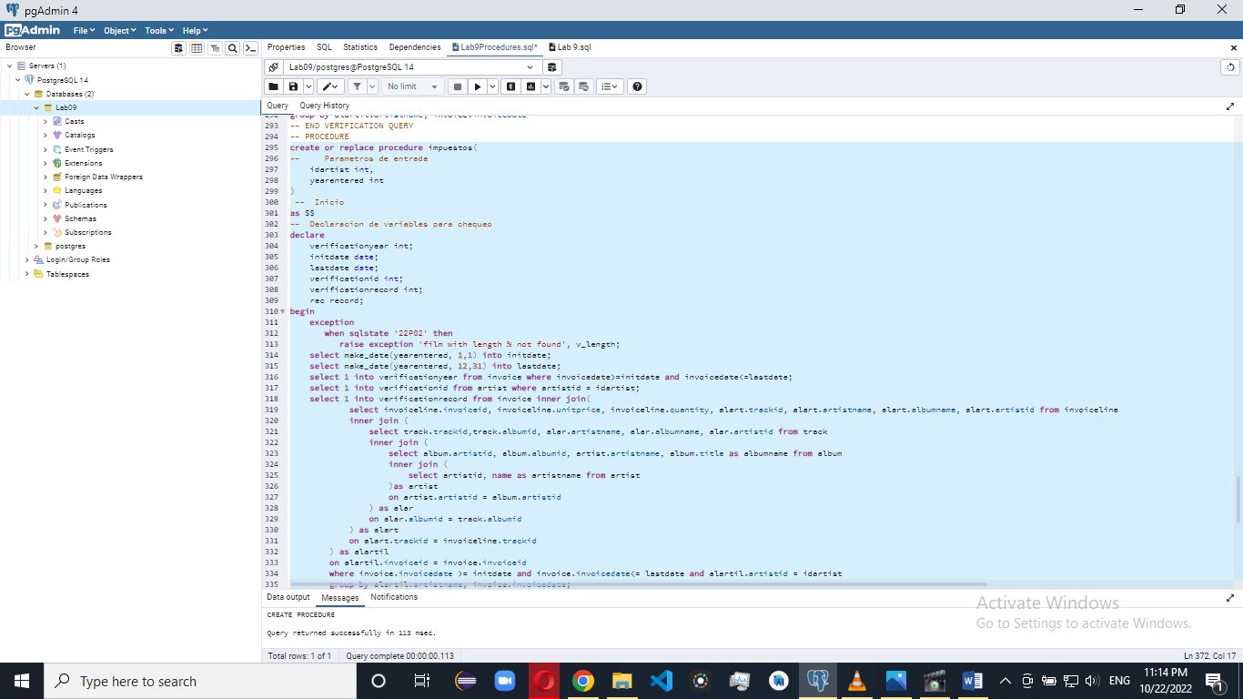  
   Ejecución de un error de procedimiento con un registro invalido de   
   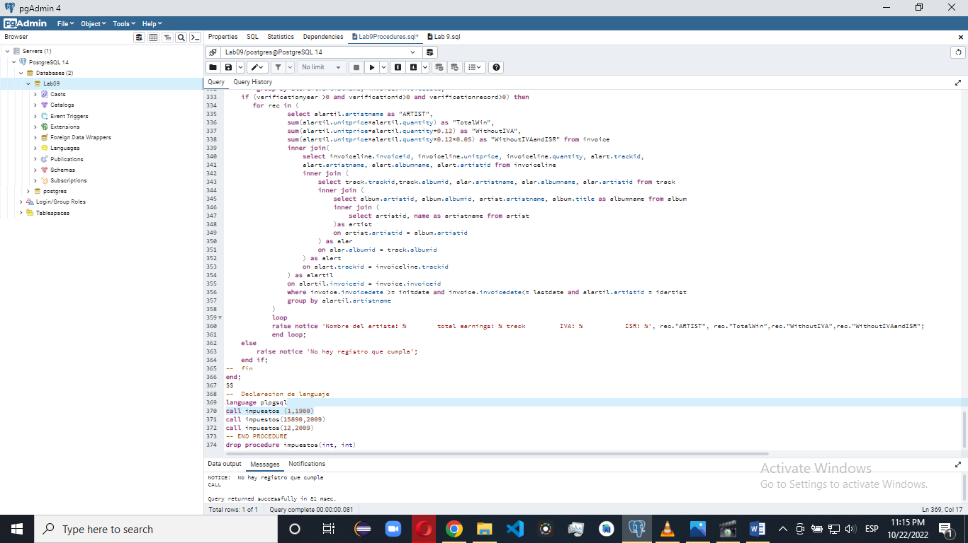
3. Crear la tabla de tendencia.  
   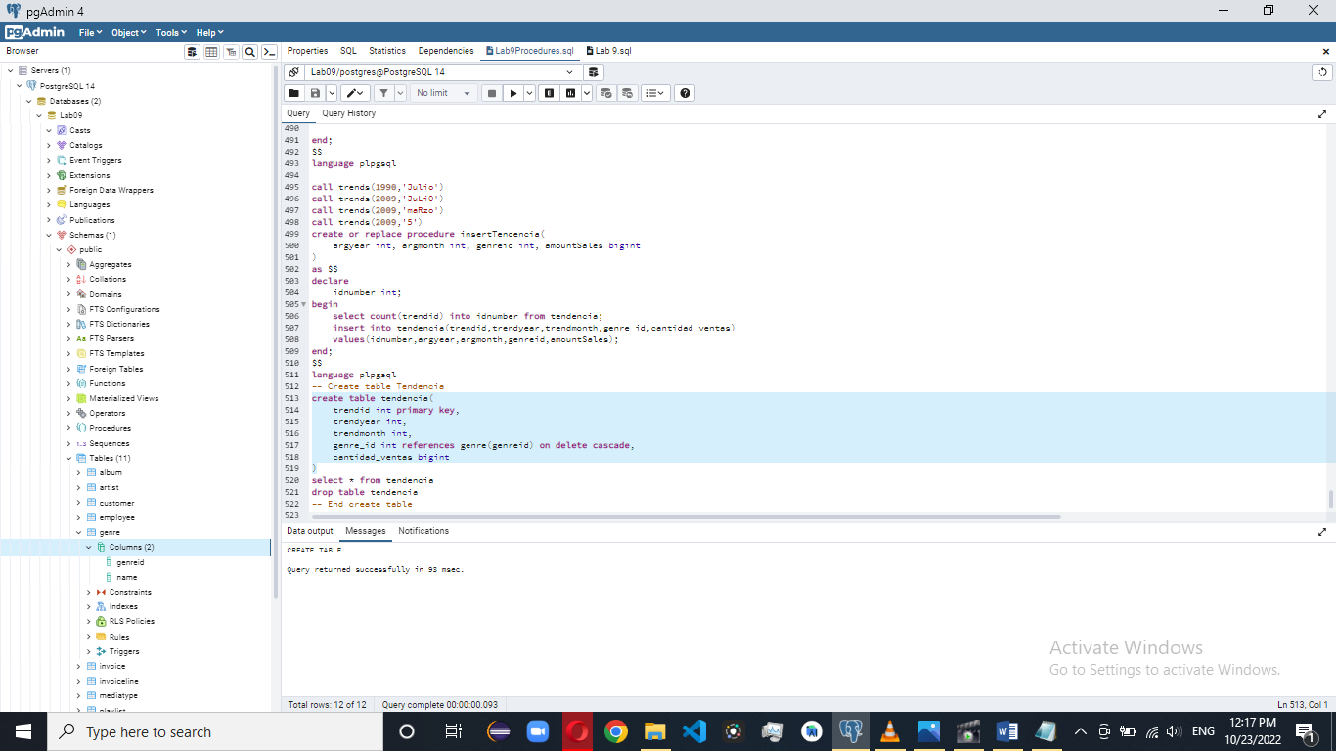  
     
   Crear procedimiento para la inserción de datos en la tabla de tendencia, nótese que se autogenera la llave primaria.  
     
   Crear procedimiento para obtener la cantidad de ventas generada según el genero basado en un mes y año ingresados.  
   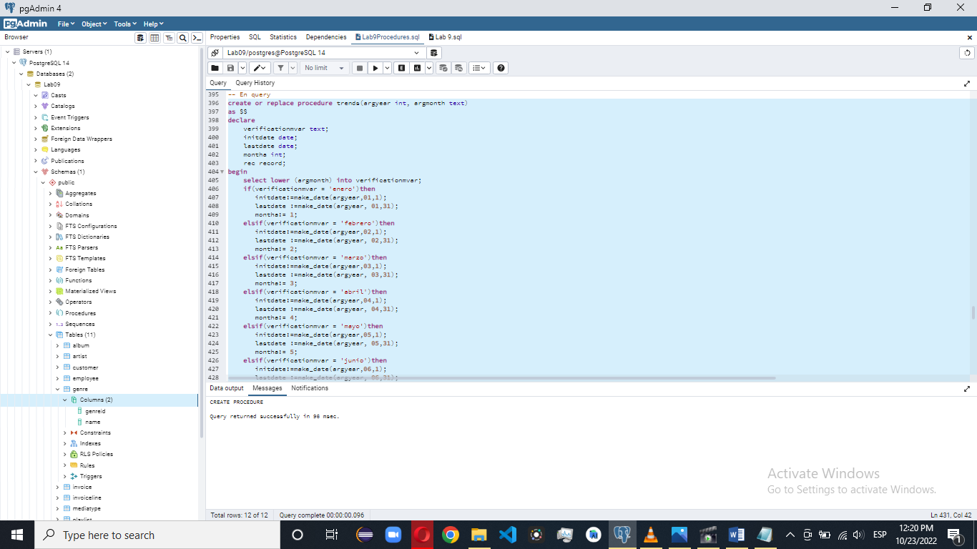  
   Pruebas de que funciona  
   Error de año invalido  
   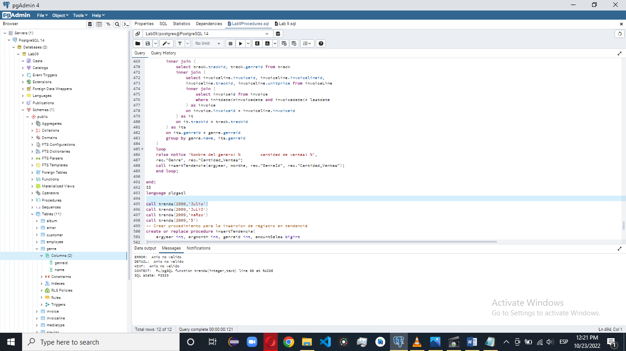

Error de mes ingresado invalido  
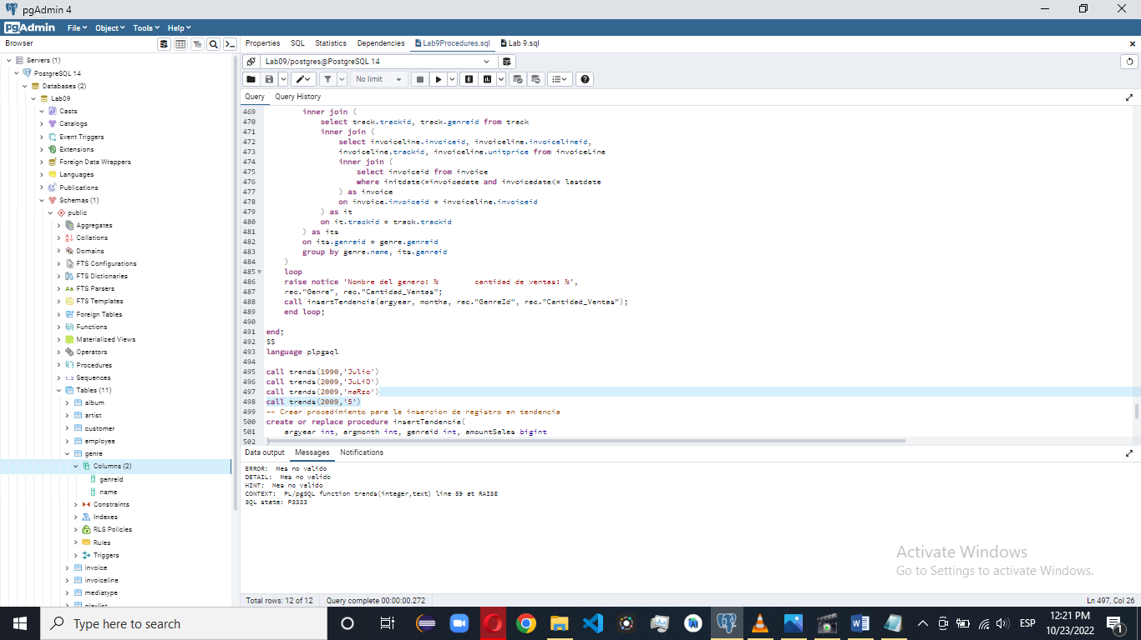

Inserción e ingreso de procedimiento valido  
  
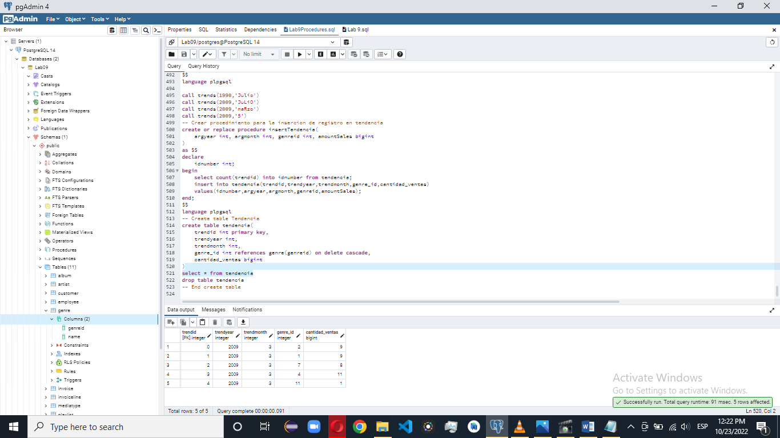  
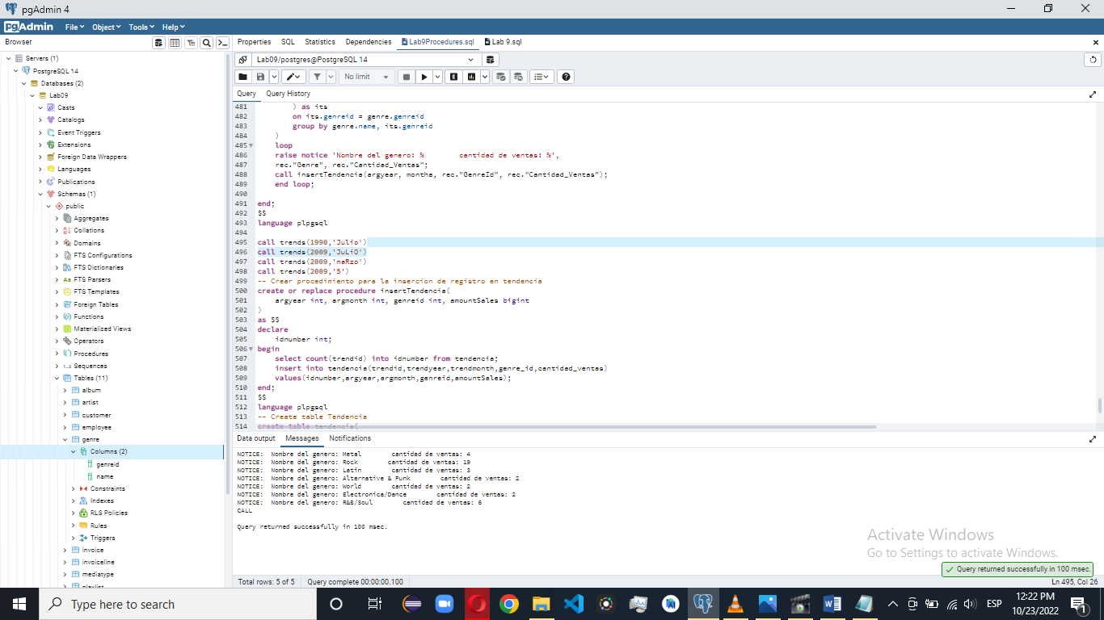  
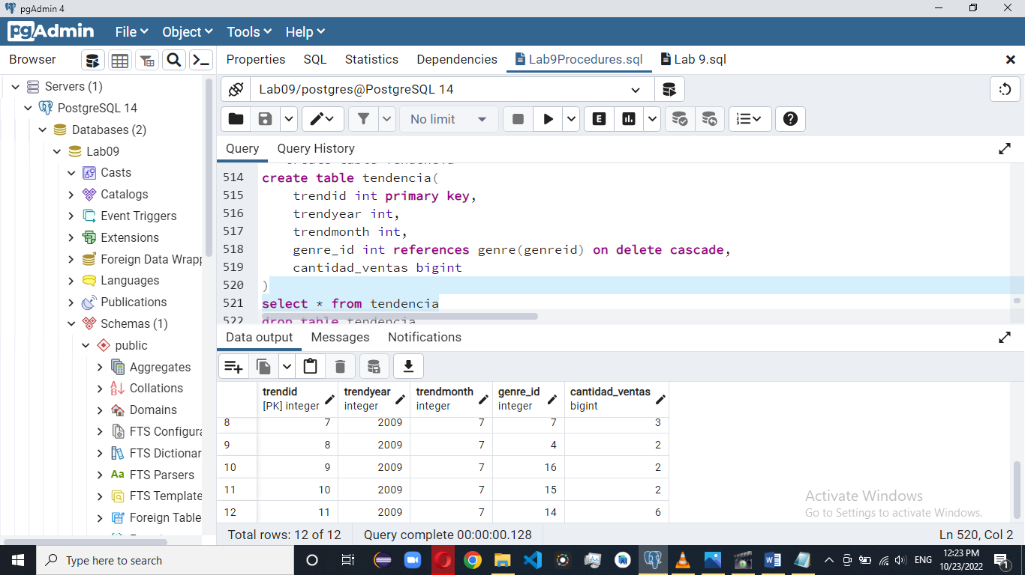  
Sql instrucciones  
-- Nombre de procedimiento crear o reemplazar

create or replace procedure album_ventas_q(

-- Parametros de entrada

idalbum int,

-- Parametro opcional

atleast float default 0

)

-- Inicio

as $$

-- Declaracion de variables para chequeo

declare

verification int;

begin

select 1 into verification from album where albumid = idalbum;

if (verification = 1 ) then

select tra.name as Song,Sum(invoiceLine.unitprice*invoiceLine.quantity)as TotalSales_Dolares,

Sum(invoiceLine.unitprice*invoiceLine.quantity*7.80)as TotalSales_Quetzales

from invoiceLine inner join (

select tr.name,tr.trackid, unitprice from track as tr

inner join (select * from album where albumid = idalbum) as al on al.albumid = tr.albumid

) as tra

on tra.trackid = invoiceLine.trackid

group by tra.name

-- Is a where with functions

having Sum(invoiceLine.unitprice*invoiceLine.quantity)>atleast;

commit;

else

raise notice 'No existe el album solicitado';

end if;

-- fin

end;

$$

-- Declaracion de lenguaje

language plpgsql

-- Nombre de procedimiento crear o reemplazar

create or replace procedure album_ventas_q(

-- Parametros de entrada

idalbum int,

-- Parametro opcional

atleast float default 0

)

-- Inicio

as $$

-- Declaracion de variables para chequeo

declare

verification int;

begin

select 1 into verification from album where albumid = idalbum;

if (verification = 1 ) then

perform tra.name as Song,Sum(invoiceLine.unitprice*invoiceLine.quantity)as TotalSales_Dolares,

Sum(invoiceLine.unitprice*invoiceLine.quantity*7.80)as TotalSales_Quetzales

from invoiceLine inner join (

select tr.name,tr.trackid, unitprice from track as tr

inner join (select * from album where albumid = idalbum) as al on al.albumid = tr.albumid

) as tra

on tra.trackid = invoiceLine.trackid

group by tra.name

-- Is a where with functions

having Sum(invoiceLine.unitprice*invoiceLine.quantity)>atleast;

commit;

else

raise notice 'No existe el album solicitado';

end if;

-- fin

end;

$$

-- Declaracion de lenguaje

language plpgsql

-- Nombre de procedimiento crear o reemplazar

create or replace procedure album_ventas_q(

-- Parametros de entrada

idalbum int,

-- Parametro opcional

atleast float default 0

)

-- Inicio

as $$

-- Declaracion de variables para chequeo

declare

verification int;

begin

select 1 into verification from album where albumid = idalbum;

if (verification = 1 ) then

perform tra.name as Song,Sum(invoiceLine.unitprice*invoiceLine.quantity)as TotalSales_Dolares,

Sum(invoiceLine.unitprice*invoiceLine.quantity*7.80)as TotalSales_Quetzales

from invoiceLine inner join (

select tr.name,tr.trackid, unitprice from track as tr

inner join (select * from album where albumid = idalbum) as al on al.albumid = tr.albumid

) as tra

on tra.trackid = invoiceLine.trackid

group by tra.name

-- Is a where with functions

having Sum(invoiceLine.unitprice*invoiceLine.quantity)>atleast;

commit;

else

raise notice 'No existe el album solicitado';

end if;

-- fin

end;

$$

-- Declaracion de lenguaje

language plpgsql

-- ESTE ES EL QUE SIRVE RETORNA UN STRING CON EL NOTICE

-- Nombre de procedimiento crear o reemplazar

create or replace procedure album_ventas_q(

-- Parametros de entrada

idalbum int,

-- Parametro opcional

atleast float default 0

)

-- Inicio

as $$

-- Declaracion de variables para chequeo

declare

verification int;

rec record;

begin

select 1 into verification from album where albumid = idalbum;

if (verification = 1 ) then

for rec in (select tra.name as "Song",Sum(invoiceLine.unitprice*invoiceLine.quantity)as "TotalSales_Dolares",

Sum(invoiceLine.unitprice*invoiceLine.quantity*7.80)as "TotalSales_Quetzales"

from invoiceLine inner join (

select tr.name,tr.trackid, unitprice from track as tr

inner join (select * from album where albumid = idalbum) as al on al.albumid = tr.albumid

) as tra

on tra.trackid = invoiceLine.trackid

group by tra.name

-- Is a where with functions

having Sum(invoiceLine.unitprice*invoiceLine.quantity)>atleast)

loop

raise notice 'Track name: % track total sales in dollars: % track total sales in quetzales: %', rec."Song",rec."TotalSales_Dolares", rec."TotalSales_Quetzales";

end loop;

else

raise notice 'No existe el album solicitado';

end if;

-- fin

end;

$$

-- Declaracion de lenguaje

language plpgsql

-- Llamar un procedimiento el primero es el raise exception, el segundo es el de retorno

call album_ventas_q(10000)

call album_ventas_q(1)

call album_ventas_q(1,0.99)

-- HASTA AQUI TERMINA

-- ESTE ES EL QUE SIRVE RETORNA UN STRING CON EL NOTICE ESTE ES EL FINAL

-- Nombre de procedimiento crear o reemplazar

create or replace procedure album_ventas_q(

-- Parametros de entrada

idalbum int,

-- Parametro opcional

atleast float default 0

)

-- Inicio

as $$

-- Declaracion de variables para chequeo

declare

verification int;

rec record;

begin

select 1 into verification from album where albumid = idalbum;

if (verification = 1 ) then

for rec in (

select tra.ArtistName as "Artist", tra.AlbumName as "Album", tra.TrackName as "Song",

Sum(invoiceLine.unitprice*invoiceLine.quantity)as "TotalSales_Dolares",

Sum(invoiceLine.unitprice*invoiceLine.quantity*7.80)as "TotalSales_Quetzales" from invoiceLine inner join (

select al.name as ArtistName, al.title as AlbumName, tr.name as TrackName, tr.trackid, unitprice from track as tr inner join (

select album.albumid, album.title, artist.name from album

inner join (

select name, artistid from artist

) as artist

on artist.artistid = album.artistid

where albumid = idalbum

) as al on al.albumid = tr.albumid

) as tra

on tra.trackid = invoiceLine.trackid

group by tra.ArtistName, tra.AlbumName, tra.TrackName

having Sum(invoiceLine.unitprice*invoiceLine.quantity)>atleast

)

loop

raise notice 'Artist name: % album name: % song name: % track total sales in dollars: % track total sales in quetzales: %', rec."Artist", rec."Album",rec."Song",rec."TotalSales_Dolares", rec."TotalSales_Quetzales";

end loop;

else

raise notice 'No existe el album solicitado';

end if;

-- fin

end;

$$

-- Declaracion de lenguaje

language plpgsql

-- Llamar un procedimiento el primero es el raise exception, el segundo es el de retorno

call album_ventas_q(10000)

call album_ventas_q(1)

call album_ventas_q(1,0.99)

-- HASTA AQUI TERMINA

create or replace function albumVentas(idalbum int, atleast float)

returns table (song varchar,TotalSales_Dolares numeric, TotalSales_Quetzales numeric)

-- Inicio

as $$

begin

return query select tra.name as Song,Sum(invoiceLine.unitprice*invoiceLine.quantity)as TotalSales_Dolares,

Sum(invoiceLine.unitprice*invoiceLine.quantity*7.80)as TotalSales_Quetzales

from invoiceLine inner join (

select tr.name,tr.trackid, unitprice from track as tr

inner join (select * from album where albumid = idalbum) as al on al.albumid = tr.albumid

) as tra

on tra.trackid = invoiceLine.trackid

group by tra.name

-- Is a where with functions

having Sum(invoiceLine.unitprice*invoiceLine.quantity)>atleast;

end;

$$

-- Declaracion de lenguaje

language plpgsql

-- Llamar una funcion

select album_ventas_q(10000)

-- Eliminar un procedimiento

drop procedure album_ventas_q(int, float)

-- Eliminar una funcion

drop function album_ventas_q(int,float)

drop function albumVentas(int,float)

-- Query

select tra.ArtistName, tra.AlbumName, tra.TrackName as Song,

Sum(invoiceLine.unitprice*invoiceLine.quantity)as TotalSales_Dolares,

Sum(invoiceLine.unitprice*invoiceLine.quantity*7.80)as TotalSales_Quetzales from invoiceLine inner join (

select al.name as ArtistName, al.title as AlbumName, tr.name as TrackName, tr.trackid, unitprice from track as tr inner join (

select album.albumid, album.title, artist.name from album

inner join (

select name, artistid from artist

) as artist

on artist.artistid = album.artistid

where albumid = 1

) as al on al.albumid = tr.albumid

) as tra

on tra.trackid = invoiceLine.trackid

group by tra.ArtistName, tra.AlbumName, tra.TrackName

having Sum(invoiceLine.unitprice*invoiceLine.quantity)>0.99

-- Query end

-- INIT THE SECOND PART

-- Query

select alartil.artistname as ARTIST, sum(alartil.unitprice*alartil.quantity) as TotalWin,sum(alartil.unitprice*alartil.quantity*0.12) as WithoutIVA, sum(alartil.unitprice*alartil.quantity*0.12*0.05) as WithoutIVAandISR from invoice

inner join(

select invoiceline.invoiceid, invoiceline.unitprice, invoiceline.quantity, alart.trackid, alart.artistname, alart.albumname, alart.artistid from invoiceline

inner join (

select track.trackid,track.albumid, alar.artistname, alar.albumname, alar.artistid from track

inner join (

select album.artistid, album.albumid, artist.artistname, album.title as albumname from album

inner join (

select artistid, name as artistname from artist

)as artist

on artist.artistid = album.artistid

) as alar

on alar.albumid = track.albumid

) as alart

on alart.trackid = invoiceline.trackid

) as alartil

on alartil.invoiceid = invoice.invoiceid

where invoice.invoicedate >= '2009-01-01'and invoice.invoicedate<= '2009-12-31'and alartil.artistid = '12'

group by alartil.artistname

-- END QUERY

-- VERIFICATION QUERY

select alartil.artistname as ARTIST, invoice.invoicedate as DATE from invoice

inner join(

select invoiceline.invoiceid, invoiceline.unitprice, invoiceline.quantity, alart.trackid, alart.artistname, alart.albumname, alart.artistid from invoiceline

inner join (

select track.trackid,track.albumid, alar.artistname, alar.albumname, alar.artistid from track

inner join (

select album.artistid, album.albumid, artist.artistname, album.title as albumname from album

inner join (

select artistid, name as artistname from artist

)as artist

on artist.artistid = album.artistid

) as alar

on alar.albumid = track.albumid

) as alart

on alart.trackid = invoiceline.trackid

) as alartil

on alartil.invoiceid = invoice.invoiceid

where invoice.invoicedate >= '2009-01-01'and invoice.invoicedate<= '2009-12-31'and alartil.artistid = '12'

group by alartil.artistname, invoice.invoicedate

-- END VERIFICATION QUERY

-- PROCEDURE

create or replace procedure impuestos(

-- Parametros de entrada

idartist int,

yearentered int

)

-- Inicio

as $$

-- Declaracion de variables para chequeo

declare

verificationyear int;

initdate date;

lastdate date;

verificationid int;

verificationrecord int;

rec record;

begin

select make_date(yearentered, 1,1) into initdate;

select make_date(yearentered, 12,31) into lastdate;

select 1 into verificationyear from invoice where invoicedate>=initdate and invoicedate<=lastdate;

select 1 into verificationid from artist where artistid = idartist;

select 1 into verificationrecord from invoice inner join(

select invoiceline.invoiceid, invoiceline.unitprice, invoiceline.quantity, alart.trackid, alart.artistname, alart.albumname, alart.artistid from invoiceline

inner join (

select track.trackid,track.albumid, alar.artistname, alar.albumname, alar.artistid from track

inner join (

select album.artistid, album.albumid, artist.artistname, album.title as albumname from album

inner join (

select artistid, name as artistname from artist

)as artist

on artist.artistid = album.artistid

) as alar

on alar.albumid = track.albumid

) as alart

on alart.trackid = invoiceline.trackid

) as alartil

on alartil.invoiceid = invoice.invoiceid

where invoice.invoicedate >= initdate and invoice.invoicedate<= lastdate and alartil.artistid = idartist

group by alartil.artistname, invoice.invoicedate;

if (verificationyear >0 and verificationid>0 and verificationrecord>0) then

for rec in (

select alartil.artistname as "ARTIST",

sum(alartil.unitprice*alartil.quantity) as "TotalWin",

sum(alartil.unitprice*alartil.quantity*0.12) as "WithoutIVA",

sum(alartil.unitprice*alartil.quantity*0.12*0.05) as "WithoutIVAandISR" from invoice

inner join(

select invoiceline.invoiceid, invoiceline.unitprice, invoiceline.quantity, alart.trackid,

alart.artistname, alart.albumname, alart.artistid from invoiceline

inner join (

select track.trackid,track.albumid, alar.artistname, alar.albumname, alar.artistid from track

inner join (

select album.artistid, album.albumid, artist.artistname, album.title as albumname from album

inner join (

select artistid, name as artistname from artist

)as artist

on artist.artistid = album.artistid

) as alar

on alar.albumid = track.albumid

) as alart

on alart.trackid = invoiceline.trackid

) as alartil

on alartil.invoiceid = invoice.invoiceid

where invoice.invoicedate >= initdate and invoice.invoicedate<= lastdate and alartil.artistid = idartist

group by alartil.artistname

)

loop

raise notice 'Nombre del artista: % total earnings: % track IVA: % ISR: %', rec."ARTIST", rec."TotalWin",rec."WithoutIVA",rec."WithoutIVAandISR";

end loop;

else

raise notice 'No hay registro que cumpla';

end if;

-- fin

end;

$$

-- Declaracion de lenguaje

language plpgsql

call impuestos (1,1900)

call impuestos(15890,2009)

call impuestos(12,2009)

-- END PROCEDURE

drop procedure impuestos(int, int)

-- END SECOND PART

-- INIT THIRD PART

-- Query

select genre.name,count(genre.name) from genre

inner join (

select track.trackid, track.genreid from track

inner join (

select invoiceline.invoiceid, invoiceline.invoicelineid,

invoiceline.trackid, invoiceline.unitprice from invoiceLine

inner join (

select invoiceid from invoice where '2009-01-01'<=invoicedate and invoicedate<= '2009-01-31'

) as invoice

on invoice.invoiceid = invoiceline.invoiceid

) as it

on it.trackid = track.trackid

) as its

on its.genreid = genre.genreid

group by genre.name

-- En query

create or replace procedure trends(argyear int, argmonth text)

as $$

declare

verificationmvar text;

initdate date;

lastdate date;

montha int;

rec record;

begin

select lower (argmonth) into verificationmvar;

if(verificationmvar = 'enero')then

initdate:=make_date(argyear,01,1);

lastdate :=make_date(argyear, 01,31);

montha:= 1;

elsif(verificationmvar = 'febrero')then

initdate:=make_date(argyear,02,1);

lastdate :=make_date(argyear, 02,31);

montha:= 2;

elsif(verificationmvar = 'marzo')then

initdate:=make_date(argyear,03,1);

lastdate :=make_date(argyear, 03,31);

montha:= 3;

elsif(verificationmvar = 'abril')then

initdate:=make_date(argyear,04,1);

lastdate :=make_date(argyear, 04,31);

montha:= 4;

elsif(verificationmvar = 'mayo')then

initdate:=make_date(argyear,05,1);

lastdate :=make_date(argyear, 05,31);

montha:= 5;

elsif(verificationmvar = 'junio')then

initdate:=make_date(argyear,06,1);

lastdate :=make_date(argyear, 06,31);

montha:= 6;

elsif(verificationmvar = 'julio')then

initdate:=make_date(argyear,07,1);

lastdate :=make_date(argyear, 07,31);

montha:= 7;

elsif(verificationmvar = 'agosto')then

initdate:=make_date(argyear,08,1);

lastdate :=make_date(argyear, 08,31);

montha:= 8;

elsif(verificationmvar = 'septiembre')then

initdate:=make_date(argyear,09,1);

lastdate :=make_date(argyear,09,31);

montha:= 9;

elsif(verificationmvar = 'octubre')then

initdate:=make_date(argyear,10,1);

lastdate :=make_date(argyear, 10,31);

montha:= 10;

elsif(verificationmvar = 'noviembre')then

initdate:=make_date(argyear,11,1);

lastdate :=make_date(argyear, 11,31);

montha:= 11;

elsif(verificationmvar = 'diciembre')then

initdate:=make_date(argyear,12,1);

lastdate :=make_date(argyear, 12,31);

montha:= 12;

else

raise exception using message = 'Mes no valido',

detail = 'Mes no valido',

hint = 'Mes no valido',

errcode = 'P3333';

end if;

if (2000<=argyear and argyear<=2016) then

else

raise exception using message = 'Anio no valido' ,

detail = 'Anio no valido' ,

hint = 'Anio no valido' ,

errcode = 'P3333';

end if;

for rec in (

select genre.name as "Genre",count(genre.name) as "Cantidad_Ventas", its.genreid as "GenreId" from genre

inner join (

select track.trackid, track.genreid from track

inner join (

select invoiceline.invoiceid, invoiceline.invoicelineid,

invoiceline.trackid, invoiceline.unitprice from invoiceLine

inner join (

select invoiceid from invoice

where initdate<=invoicedate and invoicedate<= lastdate

) as invoice

on invoice.invoiceid = invoiceline.invoiceid

) as it

on it.trackid = track.trackid

) as its

on its.genreid = genre.genreid

group by genre.name, its.genreid

)

loop

raise notice 'Nombre del genero: % cantidad de ventas: %',

rec."Genre", rec."Cantidad_Ventas";

call insertTendencia(argyear, montha, rec."GenreId", rec."Cantidad_Ventas");

end loop;

end;

$$

language plpgsql

call trends(1990,'Julio')

call trends(2009,'JuLiO')

call trends(2009,'maRzo')

call trends(2009,'5')

-- Crear procedimiento para la insercion de registro en tendencia

create or replace procedure insertTendencia(

argyear int, argmonth int, genreid int, amountSales bigint

)

as $$

declare

idnumber int;

begin

select count(trendid) into idnumber from tendencia;

insert into tendencia(trendid,trendyear,trendmonth,genre_id,cantidad_ventas)

values(idnumber,argyear,argmonth,genreid,amountSales);

end;

$$

language plpgsql

-- Create table Tendencia

create table tendencia(

trendid int primary key,

trendyear int,

trendmonth int,

genre_id int references genre(genreid) on delete cascade,

cantidad_ventas bigint

)

select * from tendencia

drop table tendencia

-- End create table