Part 1 - The Main Menu:
Here is the main menu.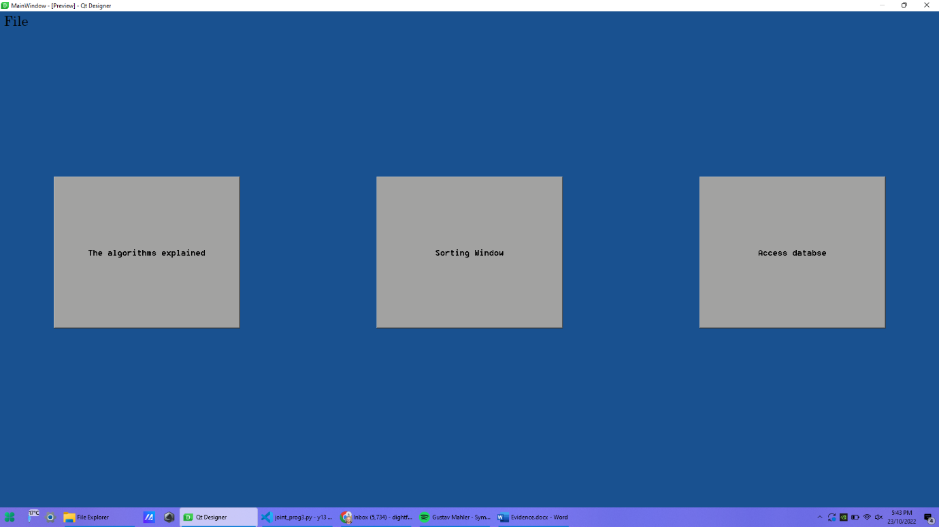

I designed it in designer.exe. 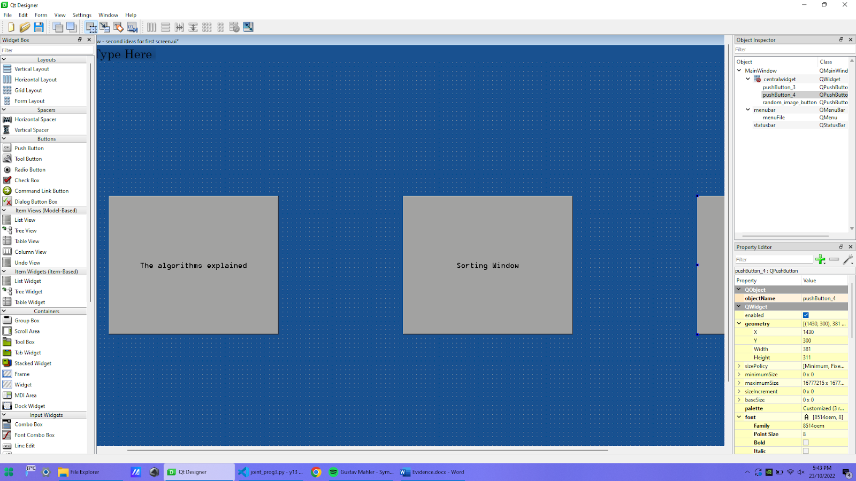

Getting from designer to python:

Launching the Game:
To launch the program, I use first have to create two windows, one for my options of window called widget, and the other for my sorting screen called w2.
When I code “window”.show() this will display the screen when the code is run.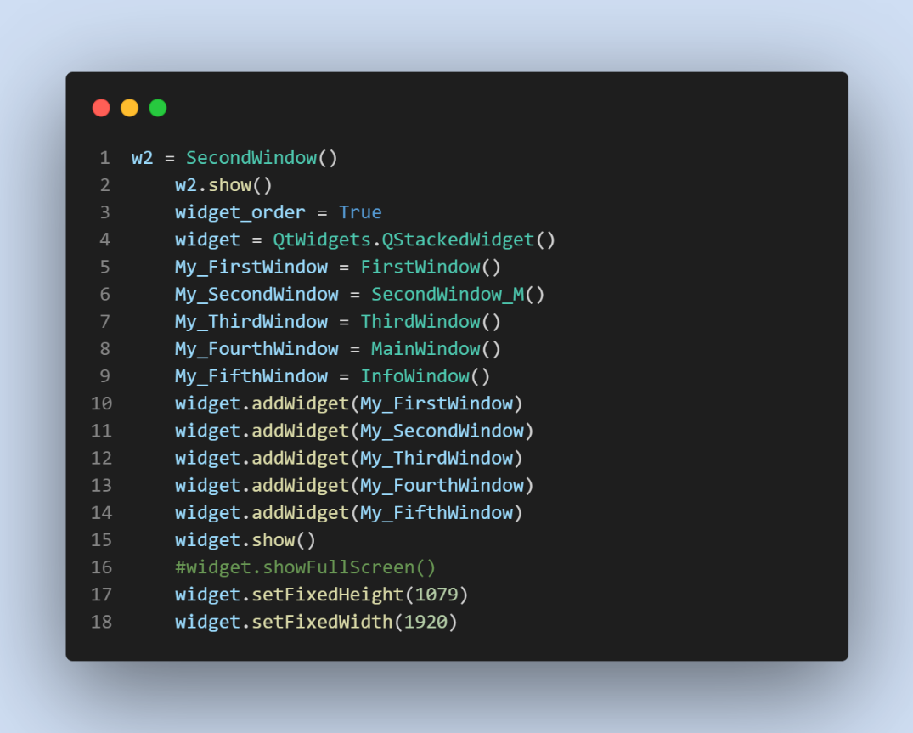
Where it says addWidget this is where I add all the windows, I want to be able to iterate through in widget, think of widget as a list, with whatever index you are current on being displayed. The windows can be traversed using the line “widget.setCurrentIndex(widget.currentIndex()-4)”.

Now that the main window is displayed, I need to connect my other windows to the button. 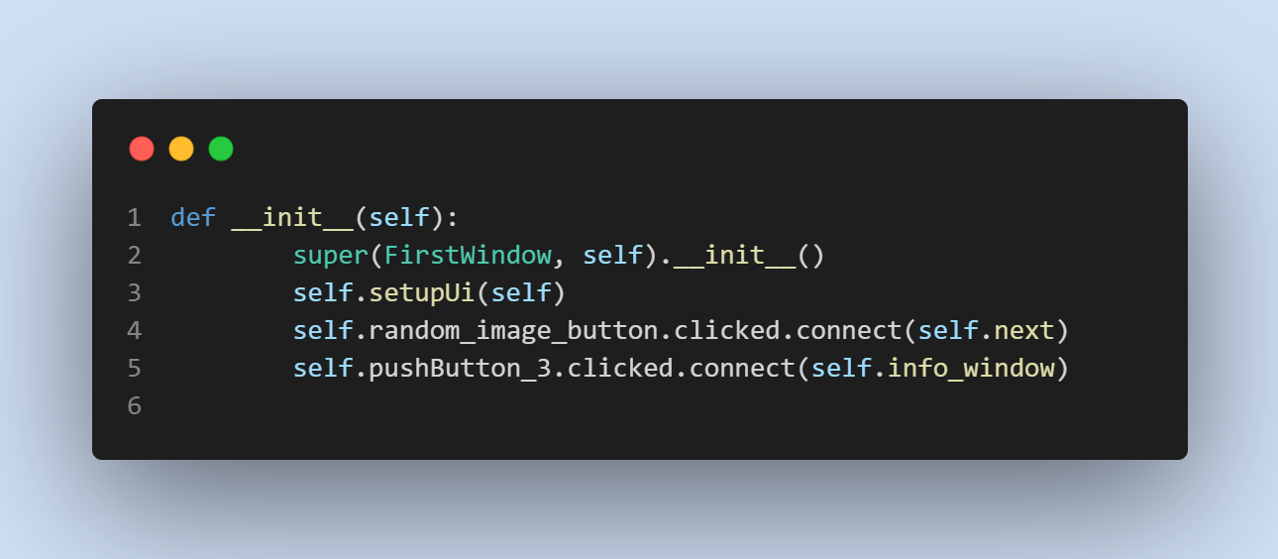These processes are defined in the initialise part of the Main Window class, this is so that they can be executed any time that the Main Window is open.
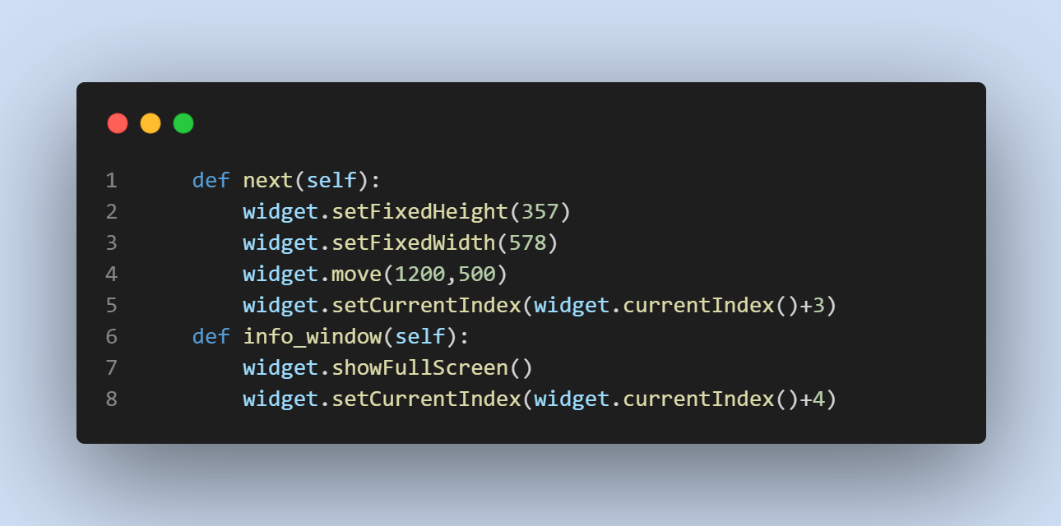
The next function will move the programme onto the control panel window, which is the centre of the programme where the user will be spending the most time. We get there by indexing + 3, this is because the control panel is 4th in the list and so + 3 needs to be added to the Widget’s index get there and display the control panel window.
The info_window will move the Widget onto the last item of the Widget, the information window.

Part 2 – The SQL Database

In this program I used SQLite3 for my database, I choose it as it is simple and easy to use. I have two tables in my database. One called Algorithms and another called Runs. Algorithms is a list of all the algorithms corresponding to a numbered ID of them all. Algorithms is in a separate table, at is the only data that I can be sure of every time and know the number of how many there are. For example, there could be 100 different resolutions and it would be very in efficient to have an ID for all possible combos of resolution. The primary key of this table is the Algorithm ID.
The second table is full of all the runs that have been uploaded to the database. The fields are Run ID, which is the primary key; Resolution; How many Pixels grouped Together; Time taken and Algorithm ID. The latter is a foreign key from the Algorithms table. This means that the tables have cross table parameterisation, as there is a parameter linking the two of them. It also means that the tables are in Second Normal form, as all the values are dependent on the run ID, as they are not set data by the program rather created by the parameters in the unique run, represented to the run ID.
The reason I have a foreign key is so that it formalises the relations and makes sure whenever someone enters a record into the table Runs, the Algorithm Id they entered has a corresponding Id from the Algorithms. This stops them entering an algorithm that does not exist.

The SQL:
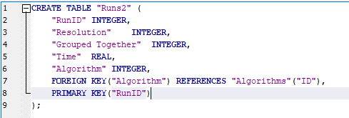
This is the SQL I created to create up the Runs table. First setting the name of the table and then setting all the fields and their data types. Next I set the foreign key to algorithm which is ID from the Algorithms database as seen below. Finally, I have also defined the primary key as the Run ID.

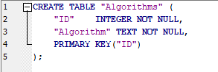
This is the SQL I created to create the Algorithms table. First again setting the name and then the field names and their corresponding data types. Again setting the ID to the primary key so that it can be a foreign key in the Algorithms database and relate back to the algorithm name.

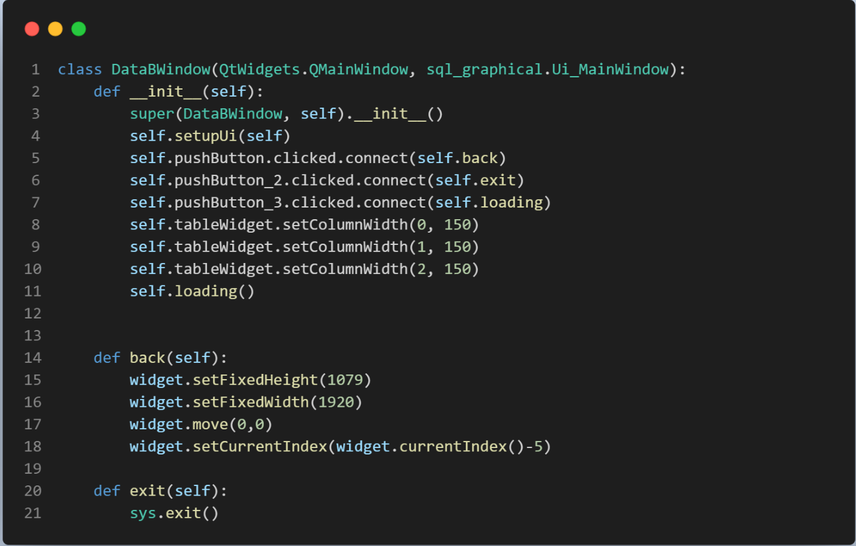
Setting it up:
This is the set up for the database class. First buttons are connected to a function by being clicked on. The size for the window is also defined.
The first function is the back function. This simply changes the screen back to the main screen by traversing the widget index. (The widget has a list of all the window screens)

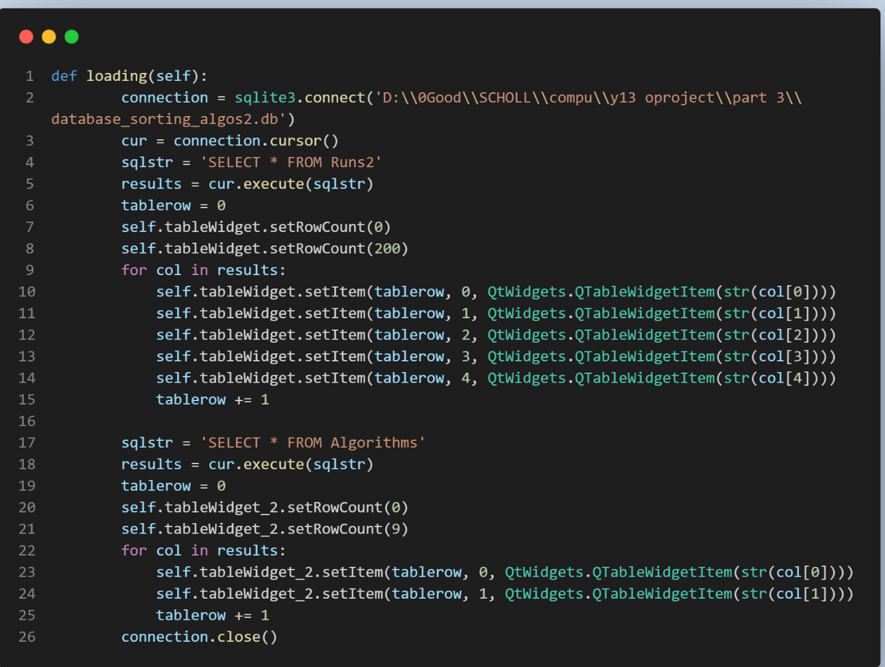
This is the main function for setting up the database. Its purpose it to display the database in the database screen, accessible by the main page. First it makes a connection with the database, then performs an SQL query, retrieving all the values in the Runs2 database.
It then sets the length of the table widget.
Next the program iterates through results (a list of lists of the results from a query of all the values in the Runs database) and as the data is already in the right order, I just need to iterate thought the variable col which is the array. It looks like this (1, 1024, 25, 2.07534, 1) so where the first item (1) is for the Run Id and so on. I also increment table row by 1 each time to move down the rows for adding new data, so that it is all in separate rows and no re writes occur. The number after table row is the column that that data will be entered into, in the database, in this case as the database query results are in order so are these numbers.
The same process is done for the second table, except this time there is as defined 9 algorithms so there is a set row value of 9. But the same process of iterating through the list of lists applies here.
The connection is then closed.
This function is run at the start of the program to retrieve all the data, but also when the show updates button is pushed. This will show any updates to the database whilst the program is running.

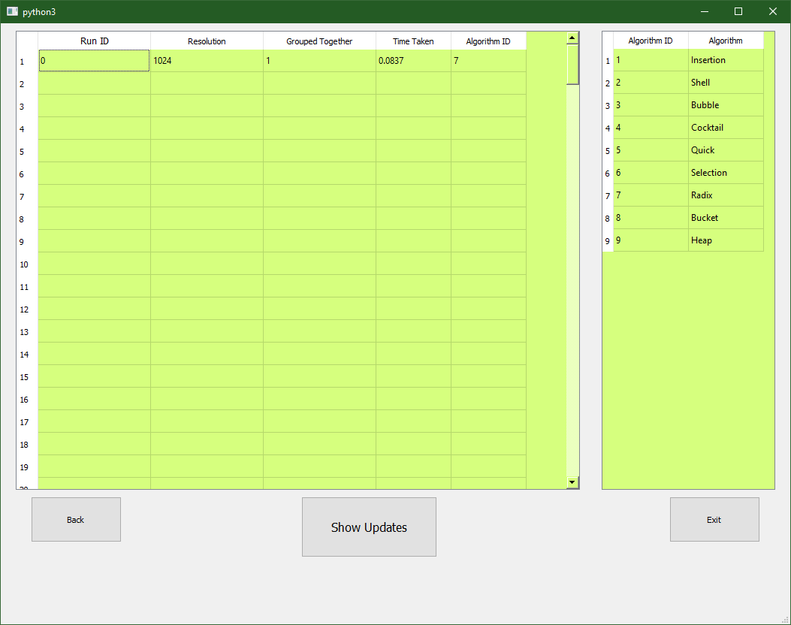
This is the screen for the database when it is shown. You can clearly see the two tables and how they are linked. And when looking at it, you can read what algorithm is being used in the runs, in this case Radix Sort for the first Run.
Uploading Data:
Data can be uploaded to the database; this is gone into further detail in the Upload to database section under part 3.

Part 3 – The Sorting Window
This is the sorting window of the program. At the start of the program, it is a blank white screen, this is because no images have been selected. When they are selected in either window, when the continue button is pressed it will be displayed on the screen.
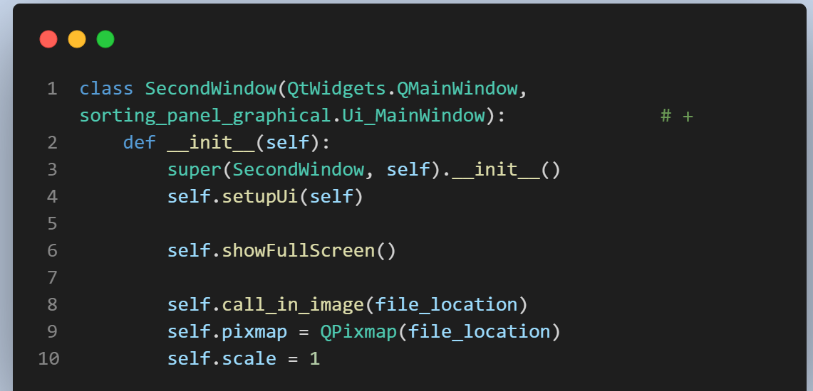
The class is called Sorting Window, however w2 is a variable set to it, this is so that the class can be passed into function in other files. This means that in another file, for example the display randomized image file, it can access this class and use the function, seen below, that will display the file passed in onto the screen.
In line 1, the class name is defined, it is also linked to the graphical python file “sorting_ panel_graphical”.
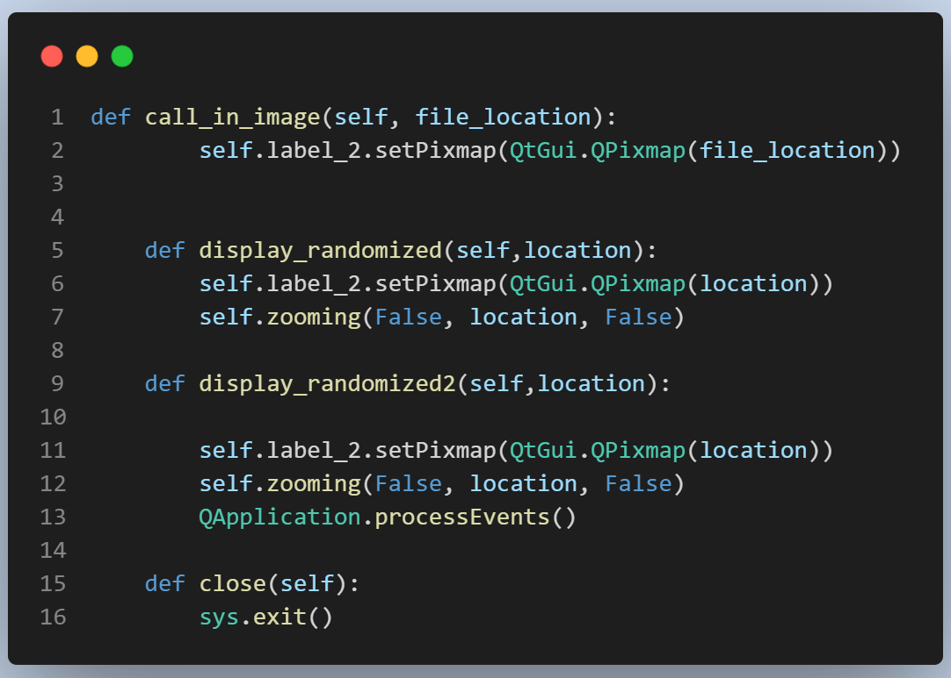
This is the first function of the sorting window class, it defines all the variables needed such as scale and pixmap, these will be covered later. It also calls a method called show full screen, what this does is set the size of the window to full screen so that the top bar, which would normally contain features like minimize and close, Is hidden. It then calls the function called call_in_iamge, passing in file location, this is the default file, simply a blank white picture.
As seen on the right, call in image sets the passed in image to be displayed on the sorting window screen. This function is used initially in the __init__
The next function is display randomized; this is used in the choosing image windows in which the file is passed in. However, as the function although from another class, is still in the same file, does not need the processEvents function line. This is why there is another function for it.
The processEvents function, in the last function, is needed because the main thread is busy sorting the file, in the sorting algorithm page. This function will change the threads focus to displaying the image on the sorting screen, once it is done it then goes back to the sorting algorithm.
The close function simply closes the program.
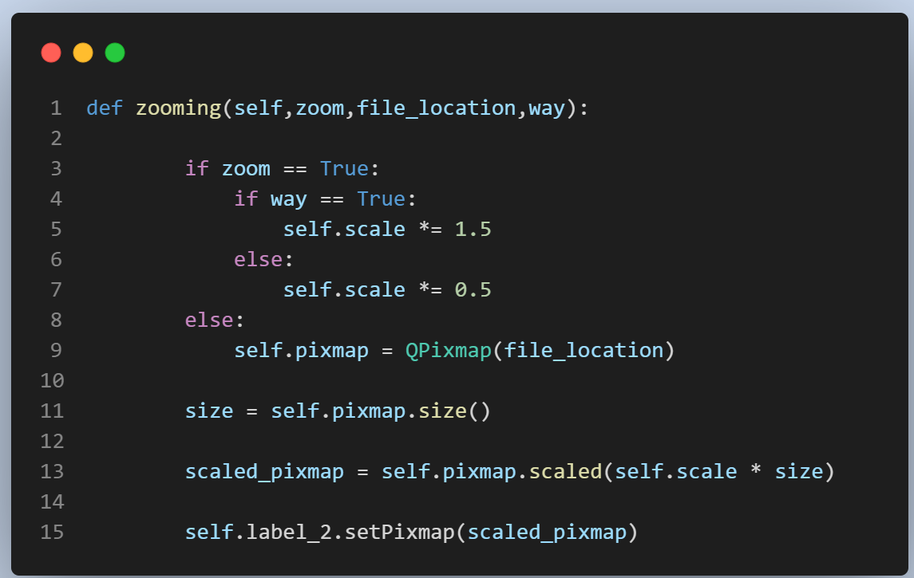
There is also a zooming function this is fully covered in the zoom In/out section under the control panel section.
Briefly it takes a set variable zoom and changes the size of the file to the scale variable. This variable can be changed with the zoom buttons accordingly.

Part 3 – The Control Panel

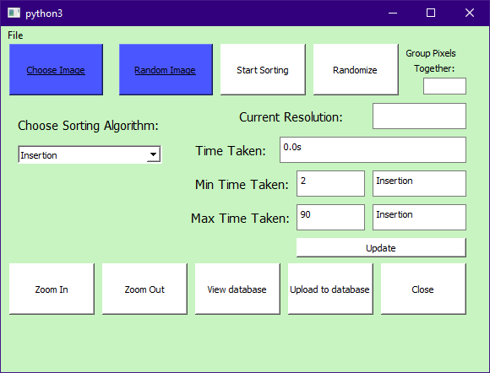This is what the control panel looks like. It has eleven interactive features and six display features.

Getting the Image
The two blue buttons are coloured so that the client is directed towards them first as they are to be used first. They are buttons that link to windows below. The Choose Image button is Part 4 and Random Image button is Part 5. When the image has been chosen and the window has been turned back to the control panel, 2 pieces of information are received, the Resolution which is displayed in the Current Resolution box and the image file name, this can then be used by the randomize and Sorting processes.
The details on these two buttons linked classes and window is below.
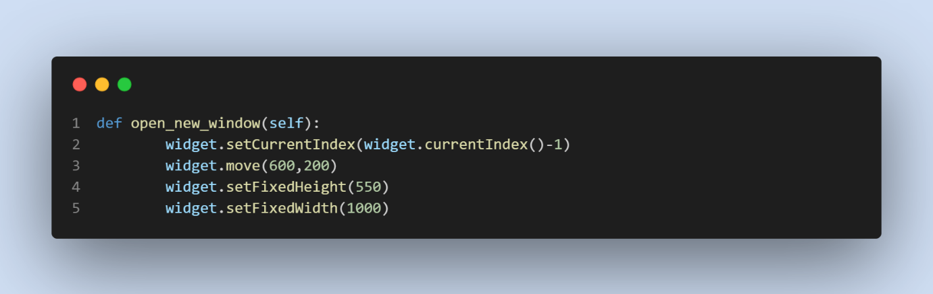This is the simple code that moves the widget onto one of the choosing image window, it also changes the height and width of the window so that it is now of the correct size of that window.
This is how the resolution is displayed. First it accesses a function in the randomize image file called resolution finder, this will return the resolution of an image that is passed into it.
Then it formats the resolution into a easy to understand format.
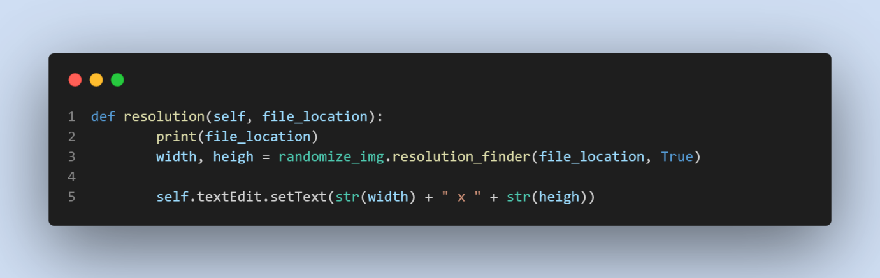
This function uses a library called PIL, this allows for image manipulation. In this library there is an in-built function called size, this return the size of the image given passes into it. “Wid, hgt” is used due to the way “img.size” returns the integers, it returns the two integers this in two separate variables meaning you need to have two variables to equal “img.size” . If the parameter Which file is true then the width and height will be returned without formatting, this is what the function above uses as it formats it a specific way after. However, in the randomizing stage of the program it needs it formatted differently so it sets the second parameter to false and it is formatted in the function so that the width and height are strings and are split by a comma.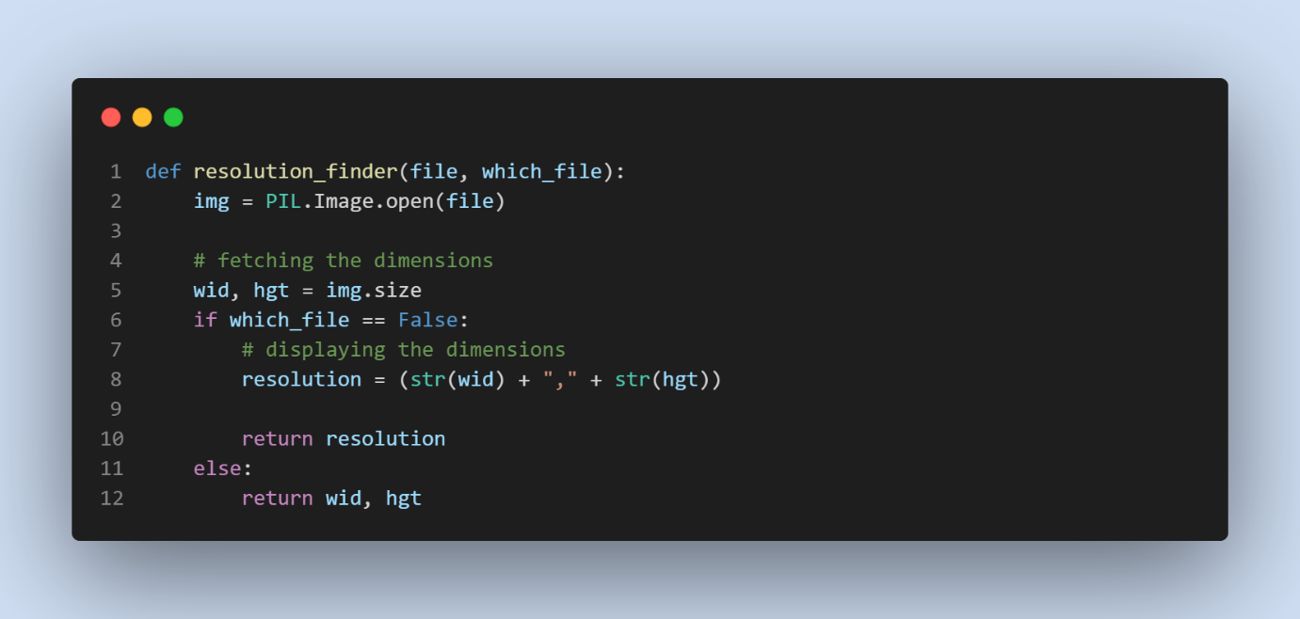

Zoom In/Out
The Zoom in and out buttons simply enlarge and shrink the image. The zoom in button is useful as certain small images are hard to see when they are sorting, so being able to zoom in is especially useful.
This is the code for zooming in and out. There are three variables passed into the function, zoom, file_location and way. Zoom is a variable that tell decides if the image is to be zoomed in/out or not. If it is False, then the reason this function is called, so that self.pixmap can be set to the image location. This is then later used if the image did want to be zoomed in or out. If this variable were not set then the current image would not be zoomed, rather the default Pixmap image would be, which is a blank white image. The only time when zoom is false, and the function is ran is when the program is displaying the new image in the Sorting Window. Therefore, the Pixmap is set to the new image, straight after it is displayed on the screen, the reason this is done in the zooming function and not another is because the zooming function is the only function that needs the Pixmap.
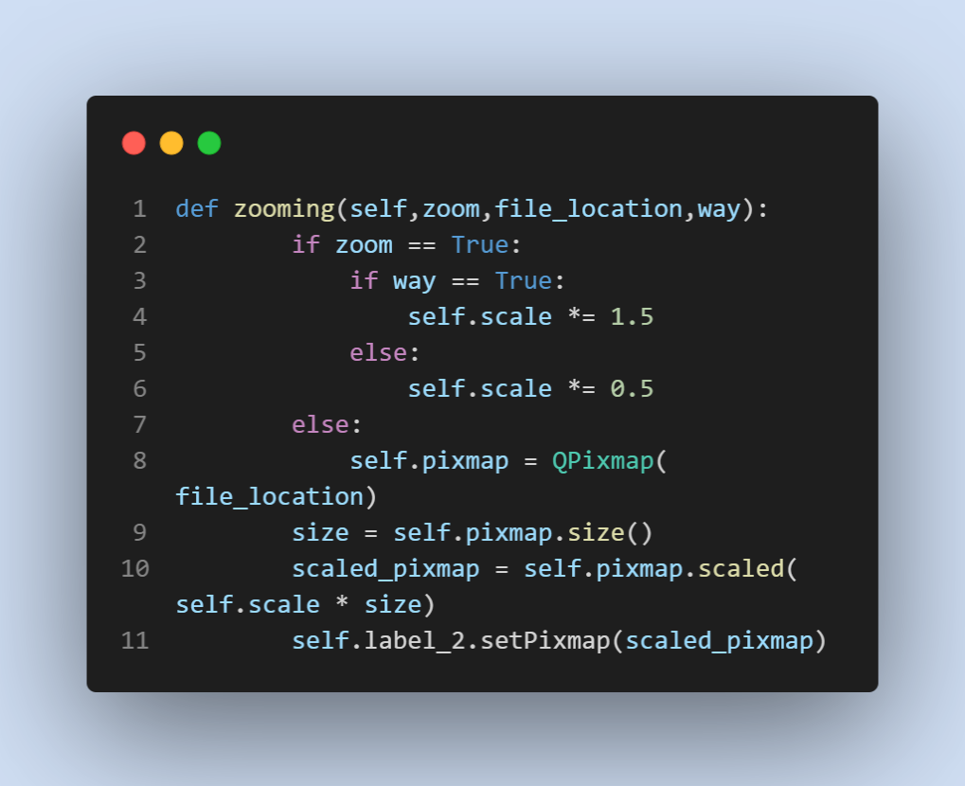File_location is the file name of the current image that is displayed. Pixmap is set to QPixmap of the image, allowing for in built features in PyQt5 to be executed. In this case it is the scaled function. This uses the current size of the image, with 1 being normal and 2 being double the normal size, it can enlarge or shrink the image by multiplying the scale of the image by 0.5 or 1.5. The former decreasing the size and later increasing it. Whether the image is zoomed in or zoomed out depends on the final parameter, which is Way, this sets self.scale to be small or large. If you pressed the zoom in button way would be true, meaning that scale would be set to 1.5 and if you pressed zoom out, way would be false, and scale would be 0.5.

Randomize
When the image is selected and displayed on the screen, the client then will randomise this, but before that they can choose to group pixels together.
Grouping pixels together is an option the user can choose for many reasons: 1) when sorting it takes a significantly shorted amount of time, making it a more usable and efficient program for much larger images. 2) It is much easier for the user to see the different group of pixels move around the screen; rather than it be a singular follow pixel they are trying to follow which at times is hard.
As you can see below 5 is chosen for how man pixels are to be grouped together, and this is then displayed on the left. The Un randomized image was a rainbow with white stripes separating the colours.

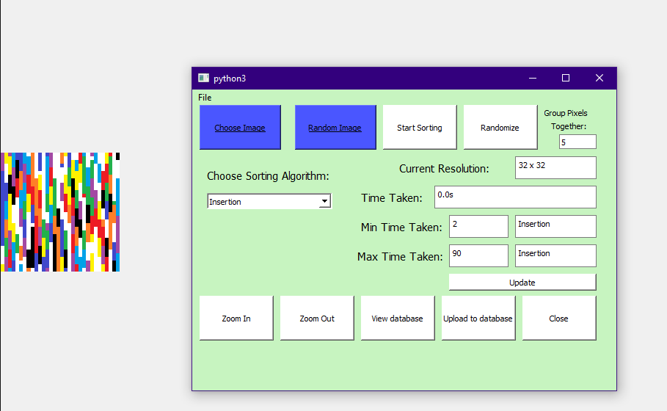
Here is the code for the function that the randomize buttons calls when pressed. First it makes the variable grouped_together equal to 0 if there has been no input for it. This means that if you leave it blank it will randomize with no grouping of the pixels. Next the file location of the image is retrieved from the text file where it is stored. Finally, the function runner from the file randomize image is called, with the variables file location and the number of pixels grouped together as an integer, being passed in as parameters. “w2” is also passed in, this is the class Second Window, which is the window of the screen where the image is displayed. This is passed in so that when the image is randomized it can be then displayed on that window from another file by simply calling (The main file) join_prog3.w2(). 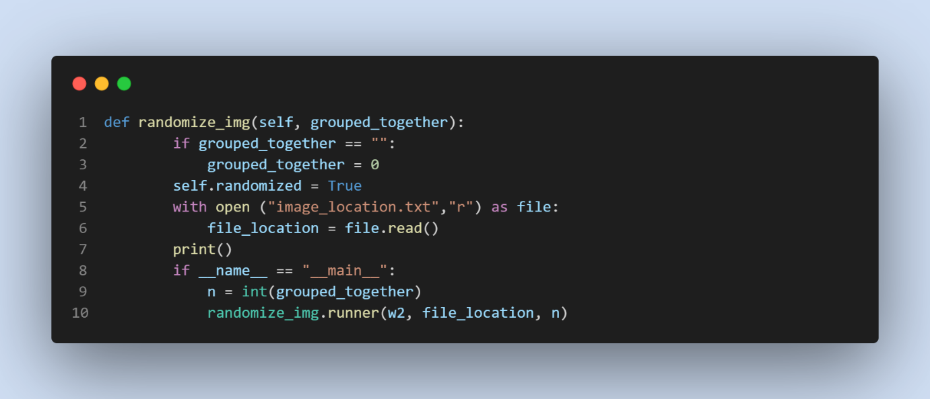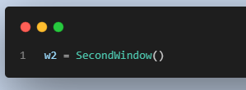

Below is the code for the runner function. The purpose of this function is to get all the RGB values from the dictionary and their index into a dictionary, randomize it, and then turn that into another file which is called “original file name”_randomized. It does this by calling in many other functions to do certain asks like get the RGB values, these functions are also used by other parts of the code, why it is so important to have self-contained functions so that code can be re-used.
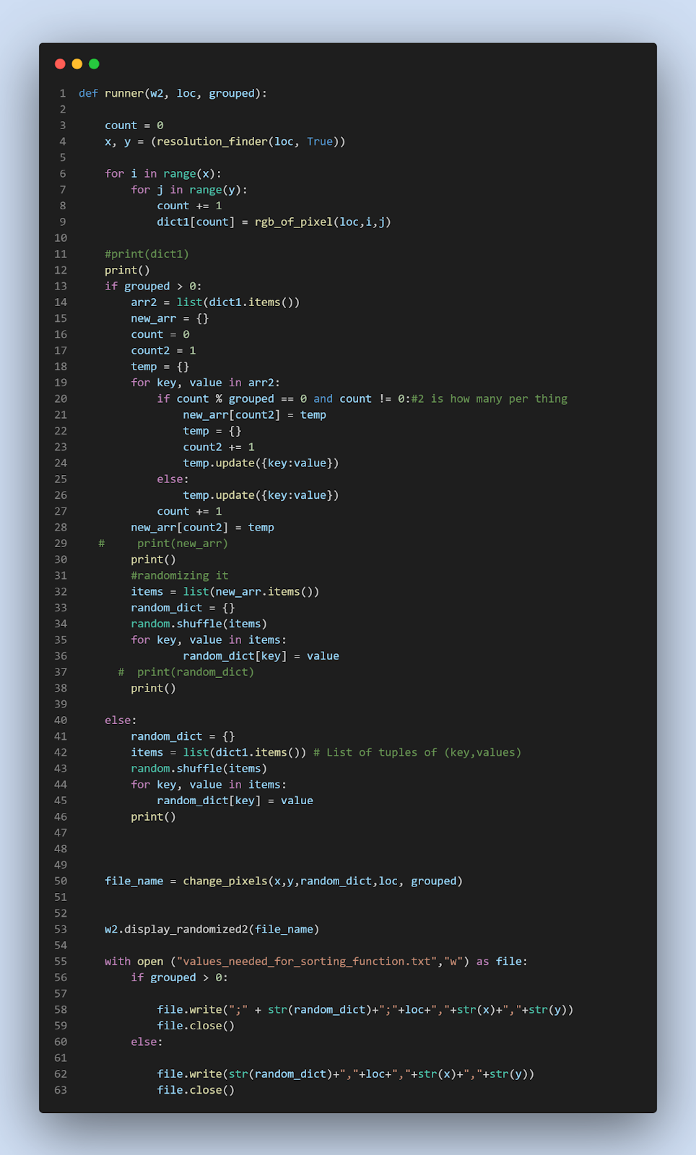
On line 4 the function resolution finder is called, with the location of the file passed in, but also False. It is used to get the resolution of the image. It uses a library called PIL, this allows image manipulation. In this library there is an in-built function called size, this return the size of the image given passes into it. “Wid, hgt” is used due to the way “img.size” returns the integers, it returns the two integers this in two separate variables meaning you need two catch them both. This is then returned to equal x, y
The resolution id then needed so that the next stage can know how big the image is so that it can call all those pixels’ RGB values.
There is then two for loops so that all the indexes of the pixels are passed through, so in x direction 1, all the y values are passed through, meaning that the image is randomized vertically. For each pixel index, the function rgb_of_pixels is then called.
This function (as seen below) again uses the Pillow library and from that library uses Image, this allows us to open the image and convert it all to binary, giving us a large array, I then traverse this array to the position I want and set R,G,B equal to the request, returning a variable which is a tuple. This is then appended to the dictionary as the item with the count as the key. This dictionary is the original dictionary values of the image.
The function then splits off into two directions, one if you have grouped the pixels together and one if you have not. If you have not, then the next step is making a list equal to the dictionary’s key and item, and then shuffling this list. Then a new dictionary is created so that all these values are then appended to it, so that this randomized data is now again in dictionary format.
If you did group, the pixels together then it will start with the same process of turning the dictionary data into a list and rather than appending each couple back to a dictionary it will then append a group off *how many pixels grouped together integer e.g., 6* items to a temporary dictionary, and then make that dictionary the item in the final dictionary. It does this by using modulus and having a count that increases every iteration of the for loop by one. Then there is an if else statement where if count % grouped (this is the how many pixels grouped together integer ) is equal to 0, i.e., it is a multiple, then it will append the temporary dictionary to the final array, with a count number that is only added by 1 every time there is a multiple (meaning it will be the correct number of iterations so far where there have been a multiple) being the key.
This means there will be a final dictionary with pixel RGBs and their index in groups of the specified grouping in dictionaries with keys of corresponding order to the original unsorted image, e.g. {1: {1: (237, 28, 36), 2: (237, 28, 36), 3: (237, 28, 36), 4: (237, 28, 36), 5: (237, 28, 36)}, 2: {6: (237, 28, 36), 7: (237, 28, 36), 8: (237, 28, 36), 9: (237, 28, 36), 10: (237, 28, 36)}} This is then randomized using the same method as before.
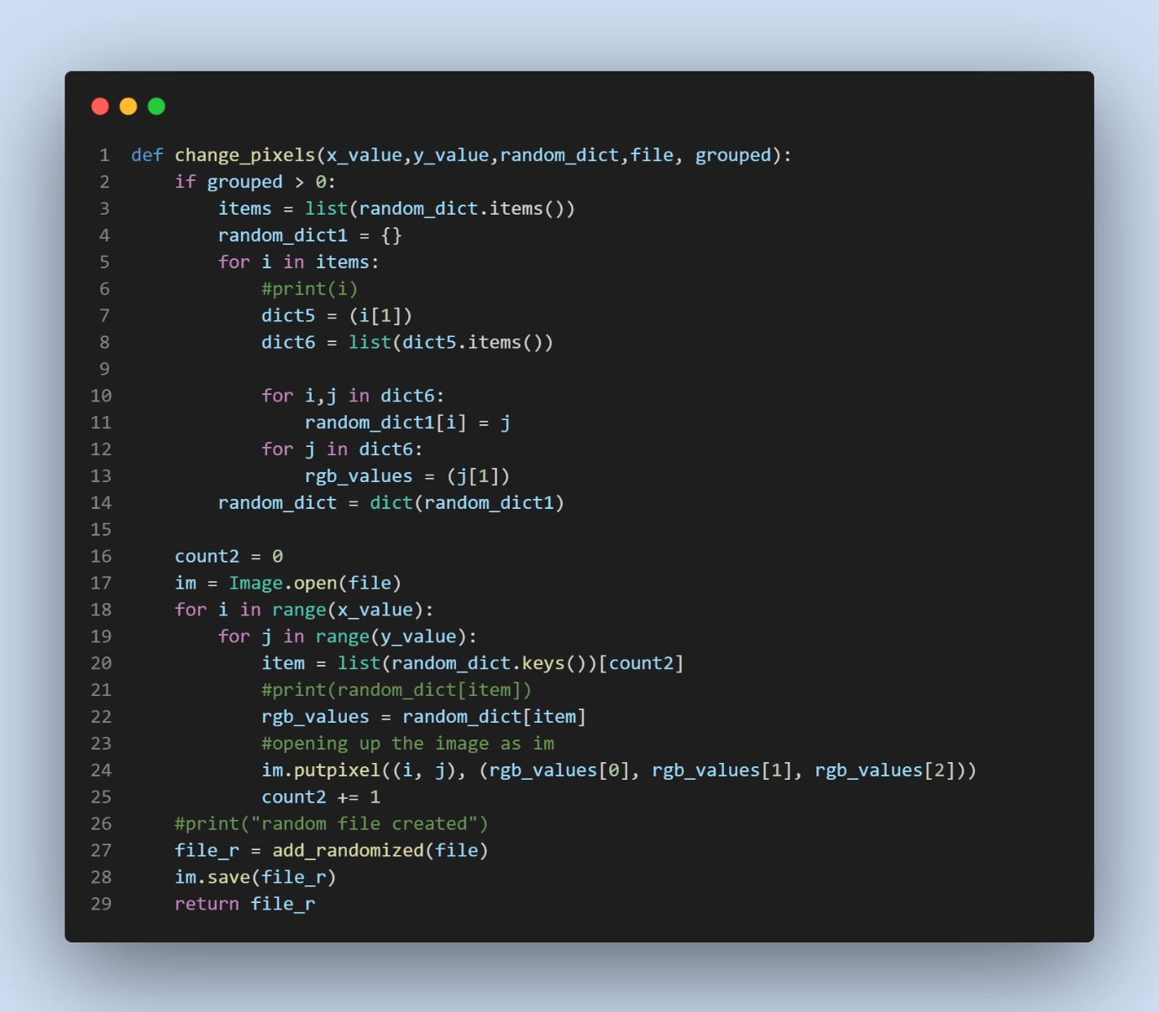
Next the randomized dictionary is then turned into another image, using the change_pixels function. This function first sees if what dictionary is being passed in is the grouped version or not, it does this by checking whether the grouped value is above 0 or not. If it is then the dictionary simply reverses the process of the joined dictionaries turning it into its original form where there is no items that are dictionaries, but rather still having original pixels in groups of 6 for example. It does this by creating a new list that is made up off all the data of the dictionary. And then appends each of these times to a new dictionary called random_dict.
Next the image is opened and the same process of creating an image is done, where all indexes of the pixels are iterated through, however this time the RGB values are getting in order as seen from the count2 variable, this is of course because it is the randomized image version. Then the in-built function from the library, places them into place in the new image. This file is then saved and then returned.
Now in the original function this image is displayed on the screen. But after this the file “values_needed_for_sorting_function.txt” has the random dictionary, the file location and the resolution appended to it.

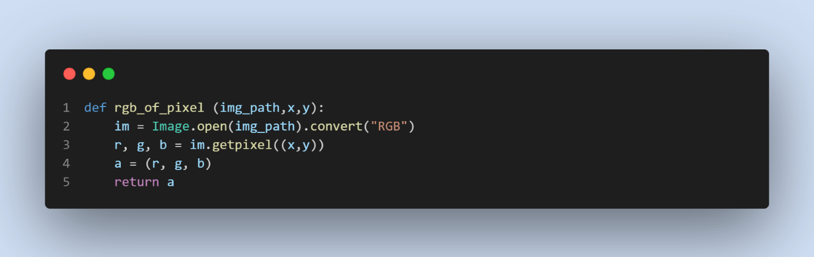

Start Sorting
The picture is below
This is the button linked to the actual sorting part of the algorithm. When the button is pressed, the program checks that the image has been randomized first, this is to catch errors. If the file is randomized the current algorithm selected in the combo box is, then made into a variable to be used in the sorting algorithm function.
To sort the image, it will first get all the data it needs to be passed into other files’ functions. These include the dictionary of the index of that pixel in the original image and its corresponding RGB value, the location of that file, the height, and the width of the image. The sorting algorithm selected and the number of pixels that have been chosen to be grouped together.

The variables are then sent off to a file called randomize_img where the variables are then passed into a function called connecting_randomDict_to_sort_algo. This data is then processed and sent off to the file that is the algorithm chosen. Where every time what is passed in is an array and what is returned is also an array. This is so that the files contents can be used by other programs.
The data is then sent off to a file called creating_images_in_sorting_stage and is passed into its only function - creating_image. This turns the dictionary that is passed into it (dictionary of the index of that pixel in the original image and its corresponding RGB value) into a file that is then passed into a function in the original file which then displays it on the screen.
This is the first function for sorting the randomized image. First it turns a possible empty input of how many pixels are grouped together to 0.
Next it checks that the image has been randomized and that the file is main, something needed in case of recursion. Next it gets the current algorithm selected from the combo box. Then it opens up the text file that we previously saves all our data too. It then has an if statement on line 11 to see if the data was appended with a grouped dictionary or not, and such there will need to be different code for the different layouts.
If the pixels are grouped, then the file is read and searched using regular expression for the data between the first and second “;”. This is the dictionary. Next, I save a variable as this length and then remove that length from the string. This then allows me to search for the file location as otherwise if I searched for the first ; the one before the dictionary would come up so the data could not be split. Now as the file location is first, I can get this data by searching for the data between a “;” and a comma. These semi-colons and commas were decided by me to use to split up the data when I initially appended it. The same process is repeated where the length is removed from the string and the string is searched for the length and width. These x and y values. The function “connecting_randomDict_to_sort_algo” from the file “randomize image” is then called with these data passed in.
However, if the pixels aren’t grouped, the data is formatted differently and so needs to be acquired differently. First the string contents is gotten and then the first regular expression search is carried out, where the string is searched for between the first { and }. The same process is then carried out where the data is gotten. And again, the data is passed into the function.

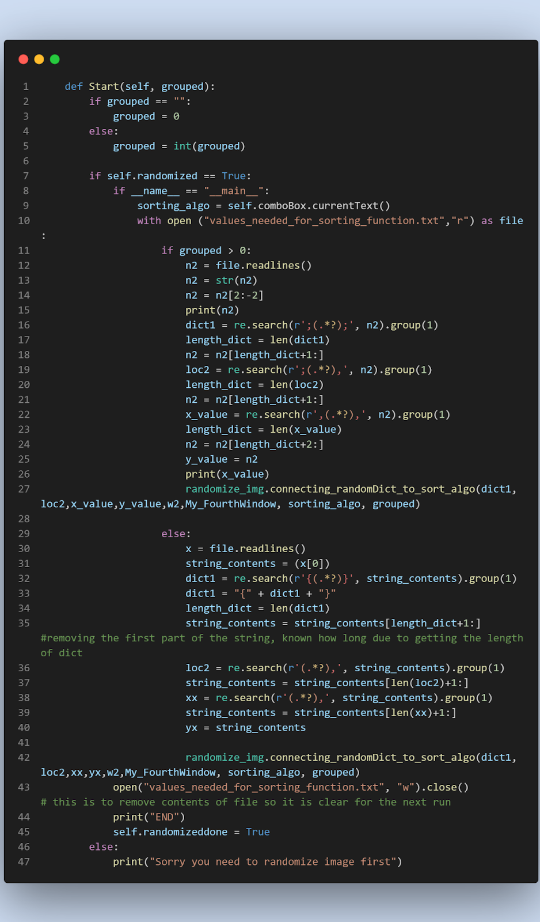

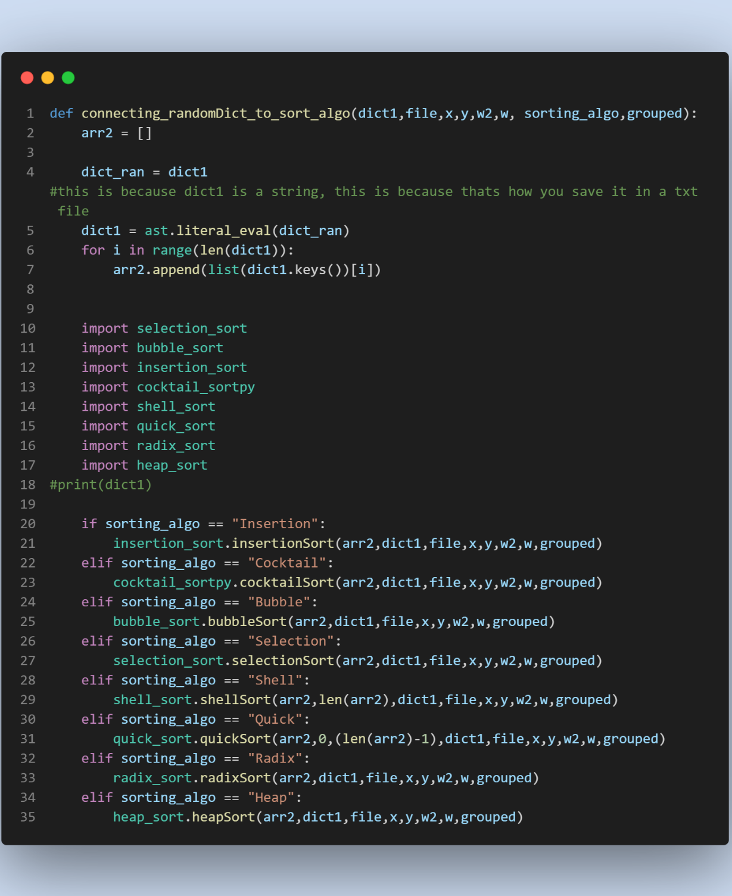
The function “connecting_randomDict_to_sort_algo” as seen on the right is simply a function that sends the data to the correct file depending on what sorting algorithm has been chosen.
Next, all the keys of the random dictionary are appended to the array. This will be an array of all the indexes of all the pixels of the random dictionary. This is done by evaluating the dictionary using ast.literal_eval() in line 5. So that it can be a dictionary not a string, as it was saved as a string in the text file. It needs to be a dictionary so that it can be iterated through, and all the keys can be appended to the array.
Next all the Sorting algorithm files are imported so that their functions can be further referenced. Next there are multiple if statements to select the correct function for that sorting algorithm, each with their own different requirements, for

example. Shell sort needs the length of the list as well. Quick sort needs the length minus one passed in.
Below is an example of what one of the sorting algorithms looks like and what it does, this is Insertion sort. The rest can be seen in coding techniques used.
First the time is started, this needs to be first as it is for how long the sorting algorithm takes. Next there is a for loop to iterate through the items of the list, a variable currentValue is set equal to the current item in the list of the current index. Then there is a while loop where the condition is that the (current index -1) item in the array is greater than the current value. It will move the current item left by setting it’s index to its current minus one and decrease the current position by 1 each time so that it matches the items index. This is done until it is not less than the current item left of it.
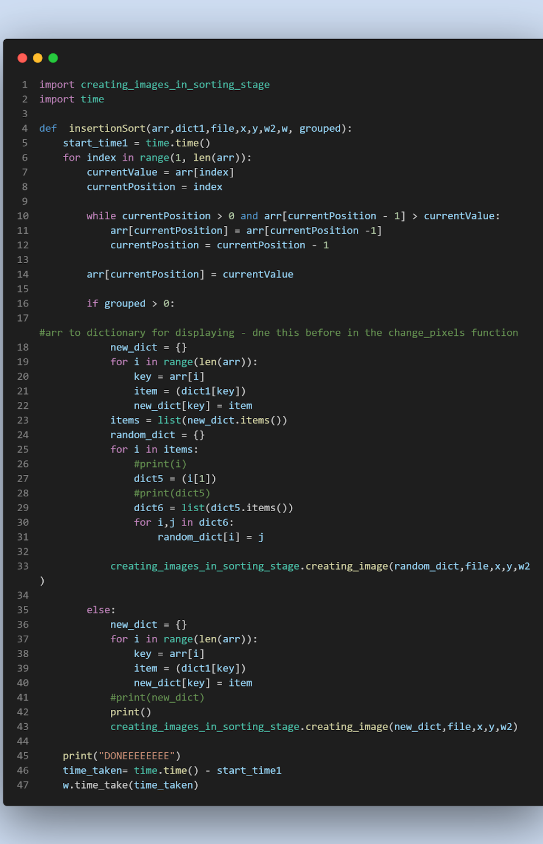
*number of pixels grouped together*) items to sort.
It is then split from this format into the original style where there is a count and its referencing RGB value, e.g. {15: (237, 28, 36), 16: (237, 28, 36), 17: (237, 28, 36), 18: (237, 28, 36), 19: (237, 28, 36), 63: (237, 28, 36), 64: (237, 28, 36)}. This is then passed into the function creating_image in the file creating_images_in_sorting_stage along with the file location, resolution, and the sorting window class object.
If the pixels are not grouped together then simply a dictionary is created in the same method – by referencing the randomized dictionary for the corresponding RGB value. It is then also sent off to the function creating_image in the file creating_images_in_sorting_stage along with the file location, resolution, and the sorting window class object.
This is done for all items of the list, however as the list becomes more sorted then in some cases the while loop will never be true so, it gradually decreases its time spend on each pass of the for loop.
Next it checks if the pixels are grouped or not, If they are then it will create a dictionary of the same format where the item is a dictionary of *the number of pixels grouped together*, with the keys and item of the dictionary being their ordered keys and corresponding RGB values, e.g. {1: {15: (237, 28, 36), 16: (237, 28, 36), 17: (237, 28, 36), 18: (237, 28, 36), 19: (237, 28, 36)}, 2 : { 63: (237, 28, 36), 64: (237, 28, 36) …
This is done by creating a new dictionary, having the key as a count that increments by 1 each iteration of the for loop, for as long as the length of the array. Then to get the dictionary for the item, the original randomized dictionary is referenced to find the corresponding RGB value, and its original key, they are then placed in this dictionary. The reason it takes such less time to sort with pixels grouped together is because once they are grouped together, they are never separated, this is why we can reference the randomized or original dictionary for their key, as they are never changed. However, they simply go round in groups, these groups of pixels are then randomized and subsequently sorted back, meaning there is (*number of total pixels* /

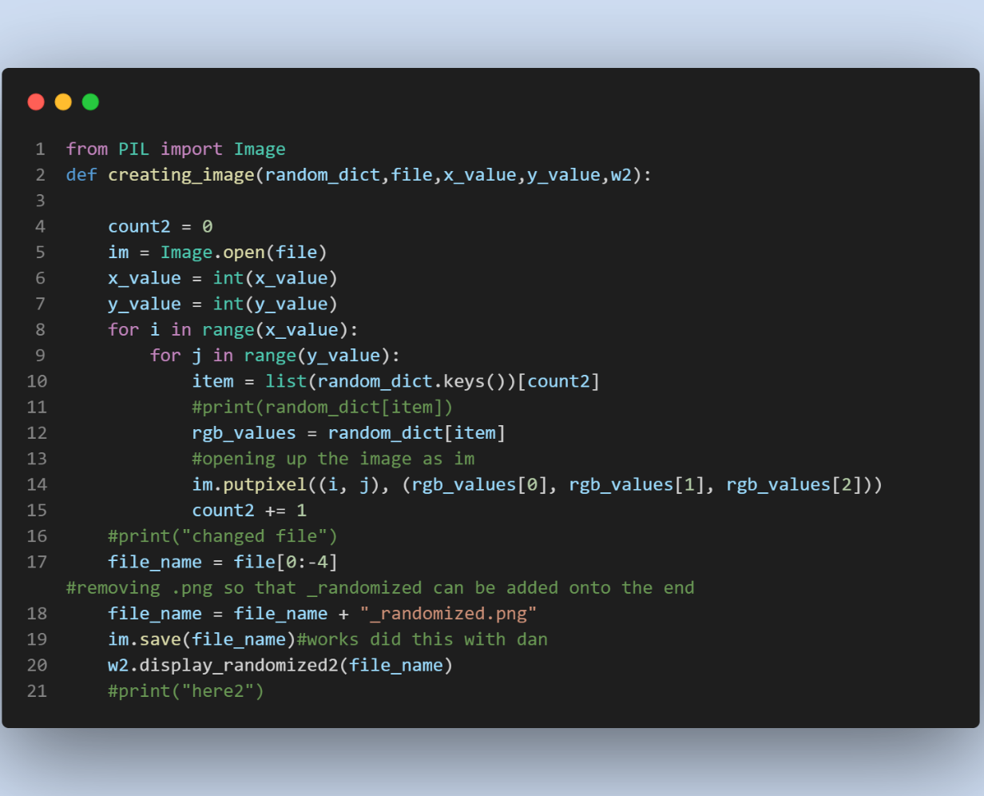
The creating_images_in_sorting_stage function is seen here on the right; this functions purpose is to turn the dictionary into an image to be displayed on the sorting screen.
It does this by iterating through all of the pixels, where the RGB values are gotten from the random dictionary list. Then the in-built function from the library, places them into place in the new image. This file is then saved however its extension is removed, either PNG or jpg and “_randomized.png” is appended to the end, to show it is the randomized version. It is then saved. Then the function from the sorting window class is called with the file name
being passed in. It will do all this (create new images) every time there is a change in the array, once it is sorted, the sorted image will be the displayed, the time is stopped and displayed onto the control panel. These are why w and w2 are passed in, so that you can reference functions from them so you can display data on the control panel or the sorting window.

Time Taken:
This is a text edit that is displayed on the control panel. As soon as the sorting of the array linked to the image starts, a clock is started, when the sorting is finished it is stopped and the result Is capped at 6 sig figures and then displayed. The Time taken is used by the SQL database as it is the variable that defines how good the algorithm was for that image size.
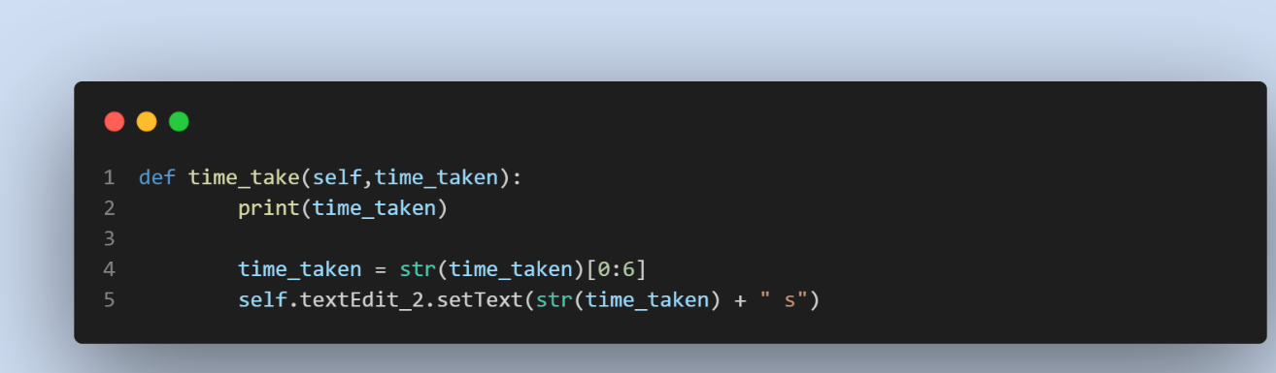
The code to set the text edit to the time taken is relatively simple. First the time is set to “0.0s” as seen above. Then the function is called when the sorting algorithm is finished, and the time taken there is passed in. Then it is formatted by only displaying the first 6 figures of the time. A “s” is also added to the end to indicate that the time is in seconds.

Min/Max Time Taken
These values are the fastest and slowest times that an algorithm has taken for a certain resolution. They are displayed in two boxes with the algorithm shown next to it. If you want to update the Times shown then you simply change the algorithm selected in the combo box and press the update button, the new values will now update for that certain algorithm.
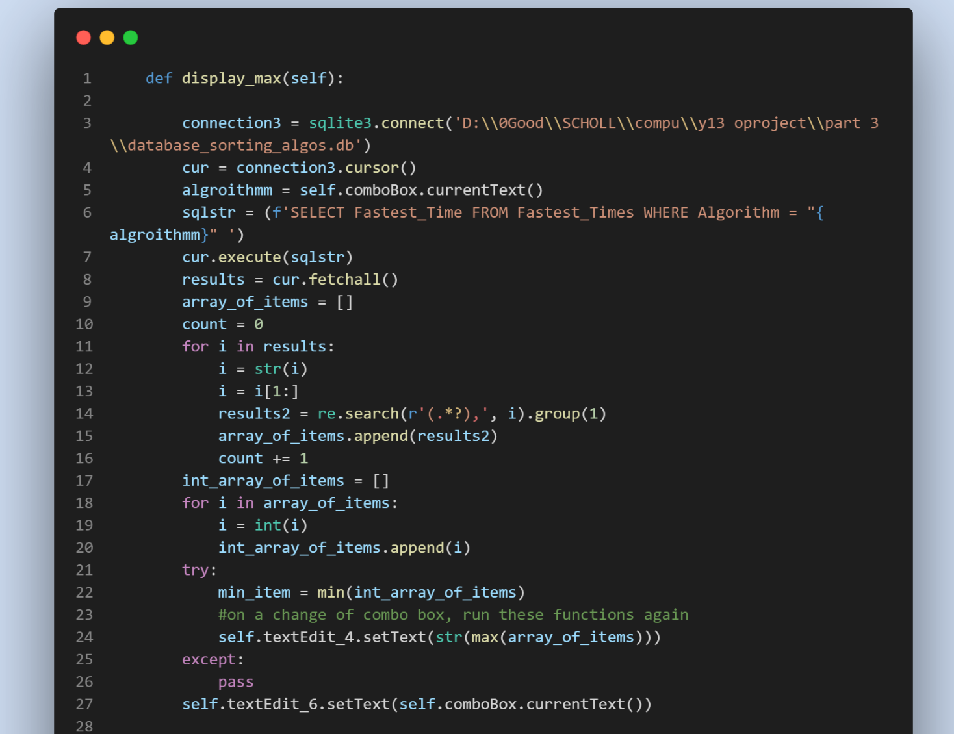

This is the code for the maximum times taken. First it starts a connection with the database where the table is and then sets up a cursor. It then has an SQL query command where it requests the items in the column of “Fastest_times” where the algorithm name is the one currently selected in the combo box. This variable is defined a line above. It then appends all these values into the array called results. Then there is a for loop where each item has the first character removed, and then I perform regular expression on the strings, where the characters from the start )as represented by the absence of a character between the “’ ‘ ” and the “(” ) to the first occurrence of a ). This gives me just the number which I then append to my new array. I then have a second for loop which simply turns all the items to integers, this is because regular expression can not be performed on an integer. I then have a try and except, this is because if there are no items that are in the “Fastest_times” column where the algorithm is the same as the combo box selected algorithm, then it will return an error. Inside the try, is simply finding the smallest item in the list and then displaying it in the correct textEdit.
This code is the same for the minimum times as well.

View Database
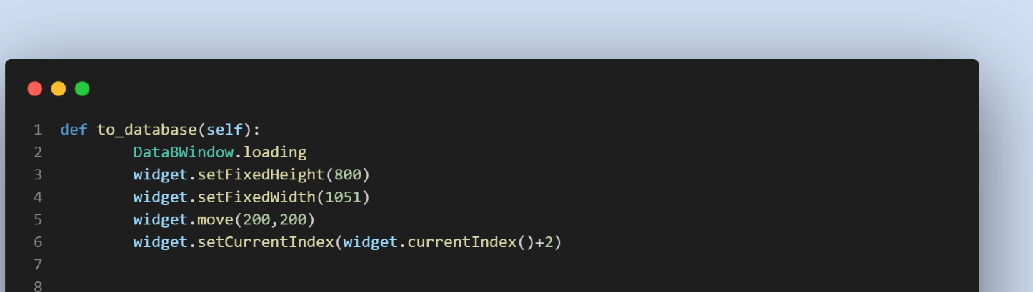
If the user wanted to view the database of all records, then they can simply press the view database button, this will move the widget window forward two, onto the database screen as seen above. When they are on the database page they then press the show updates button to see the new records that have been added to the database whilst the program is running. The function above is connected to the button “View Database”, this simply moves the widget window two places in the array to the database window, it also changes the size and location of the window so that it is correct for the database screen.

Upload to Database

The second button “Upload to Database” will add the current results of the sort that has just taken place. It will add the time, sorting algorithm, size of image and how many pixels were grouped together. The database used is SQLite3. There is also error catching to make sure that the user has completed a sort before adding data to the database.
This function allows the current sort and its corresponding data to be uploaded to the database. First it checks that the image has actually been sorted, it does this by seeing if that variable is True, it is false until the sort has finished. Next a connection is established with the SQLite database and a cursor is created, which is used to communicate with the database via the established connection.
Next there is a query to the database to retrieve all Run Ids from the Runs table. This is needed so that the most recent Run Id can be found so that the program can add one to it so that it is ready to be uploaded as the current Run Id. There is a list of integers surrounded by brackets and commas I.e. [(1,), (2,), (3,), (4,), (5,)]. So the next part lines 11 to 17 is a way of finding the last integer, by iterating forwards in a for loop but using the values as negatives so that the array is traversed backwards, shown in line 13. I then use a try and expect to see if doing a mathematical calculation is possible, if it is then I know that the value is an integer and is the last one. Meaning I can then add one to it, in line 19, for my Run ID.
Next the resolution is got from the text edit, it also manipulated using regular expression into the width and height, these are then multiplied together to give the data size.
The time is then gotten from the text Edit that displays it and converted into a string. The number of pixels is then gotten from the grouped together box, it is also turned into a string so that it can be inputted into the database.
The algorithm Id is also gotten from the Runs table in the database, by inputting the algorithm used variable (gotten from the selection box) as a “WHERE” parameter in an aggregate SQL SELECT query. This is used to gain the Id of the corresponding algorithm inputted.
Using a complex SQL command, the variables are inputted into the database by a commit command. Using f strings where parameters hold the variables the variables can be put into the SQL command where they normally would not be allowed to go.
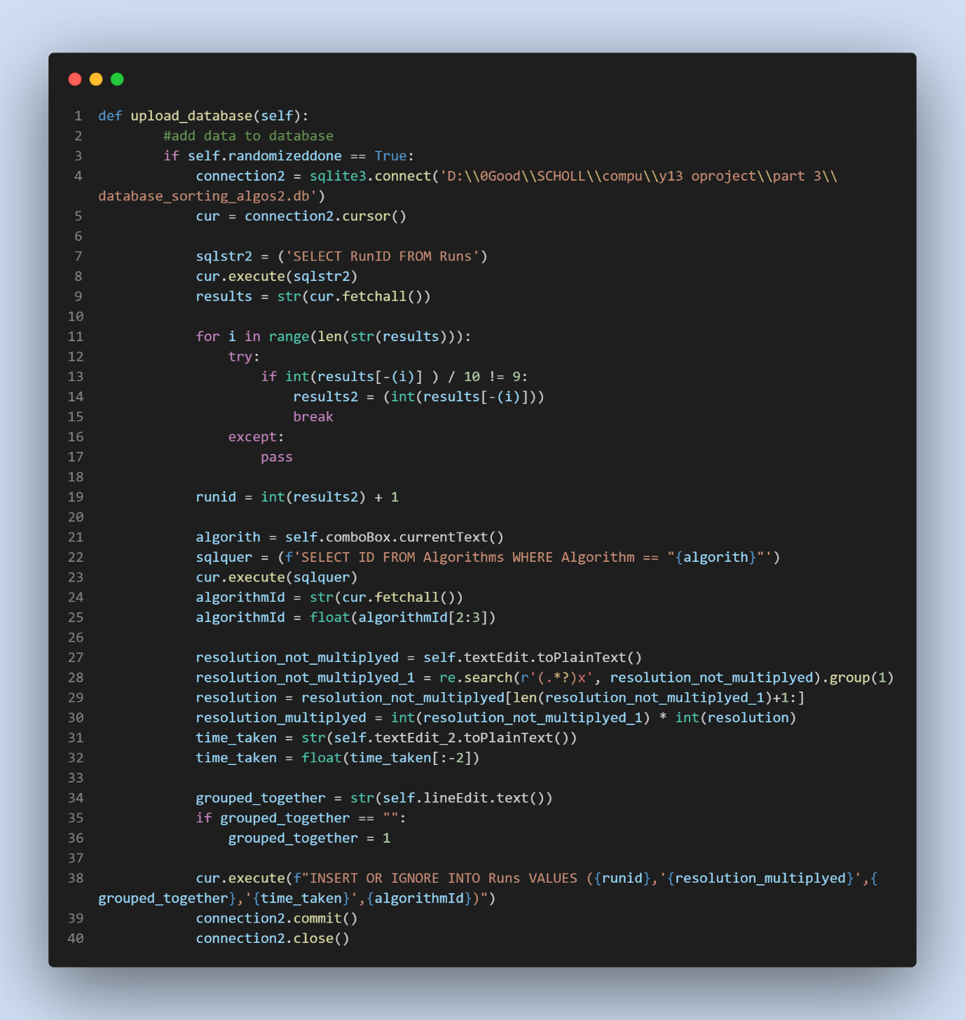

Close
This button simply closes all screen of the program. 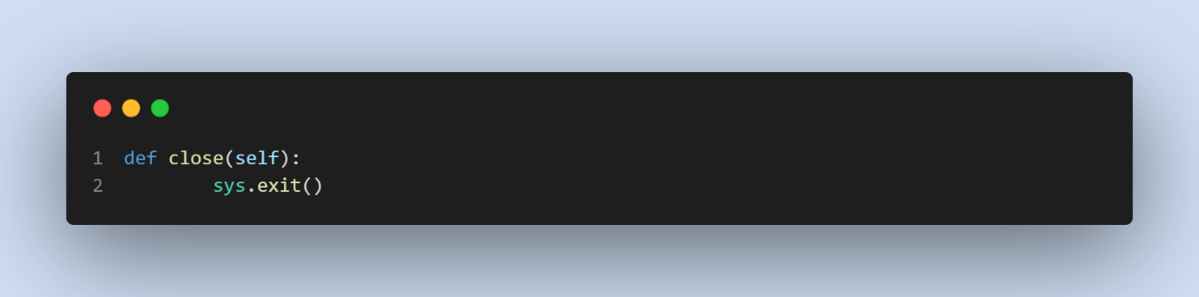
This is the simple code that closes the program, this is because sys is the QApplication, the main body of the PyQt5 code, and if you exit is then the whole program stops.

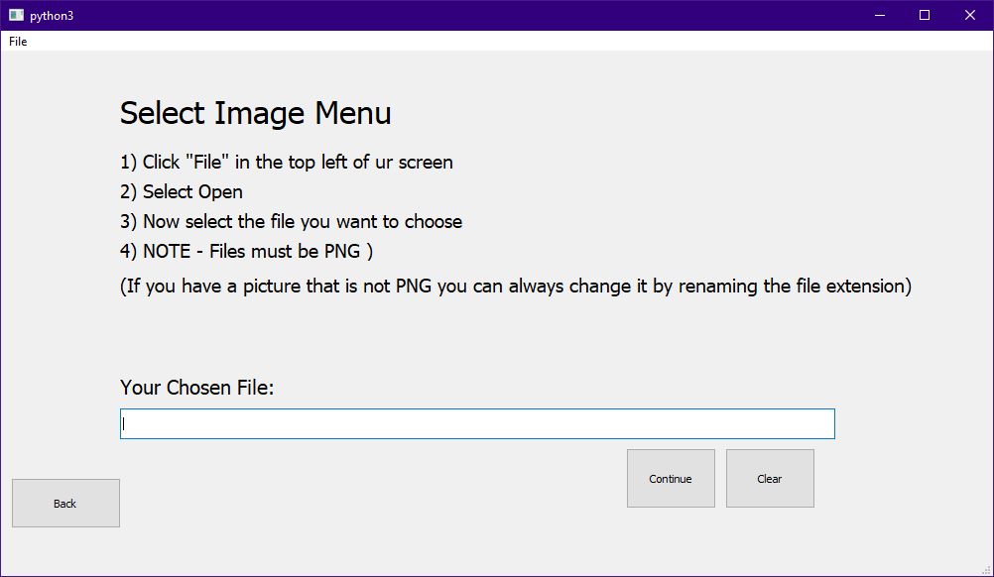
Part 4 – Choose own Image
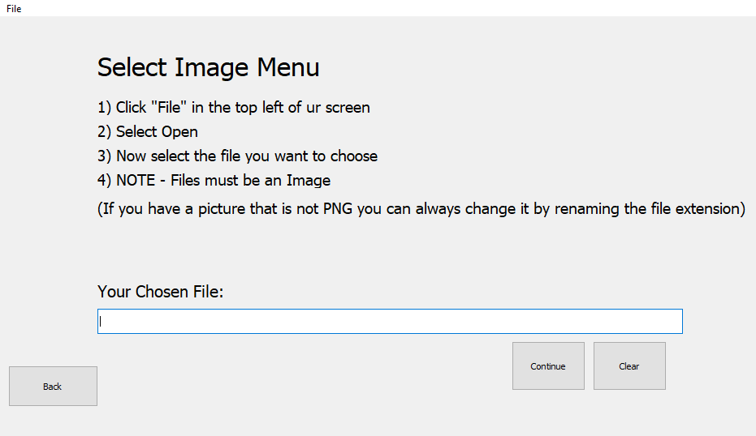
This what the menu for choose your own image menu looks like. It has instructions on how to use the window, where users are directed to the top right and asked to select an image file off their computer, when they click open it will then appear in the “Your Chosen File:” box.
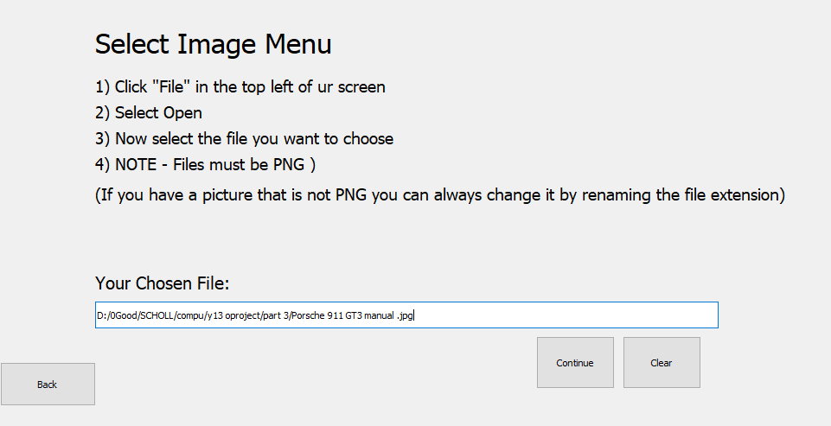
The user then has the option to go back, clear or continue. If continue is pressed then the image will be displayed in the Sorting Window.
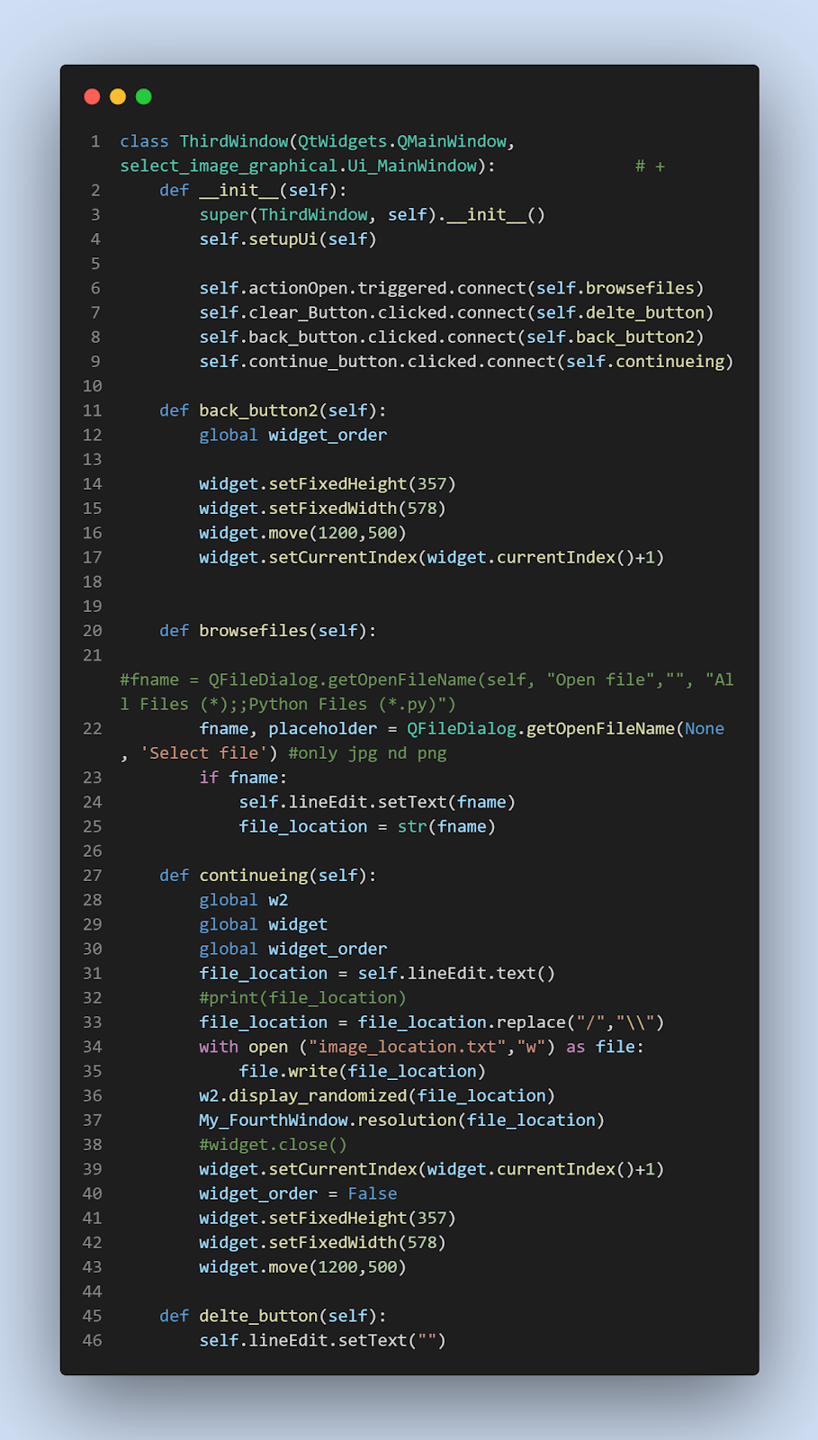
This is the code for the choose your own image window. All the button definitions are defined in the __init__ function.
The first function called back_button 2, is simply the button that allows the user to get back to the control panel, it does this by adding one to the Widget index. It also changes the height and width of the window so that it is now of the size of the control panel. It also moves it so that it is not in the way of any image.
The second function called browsefiles, is the function that is connected to the open button under the file directory. It opens up the file explorer using an inbuilt function methof in PyQt5, the fname is the variable that the file name will be set too. This is all so that the user can choose the file they wish to use. Then when open is clicked it will then set the text of the lineEdit to the file name (this is then used and passed to the control panel to be used) as seen above.
The Continuing function as said above moves the displayed window onto the control window and also saves the image location to a text file called image_location. It does this by getting the contents of the text file and replacing the single forward slash, that is retrieved from the LineEdit, and replacing it with the backslashes that are used in python when opening files.
It will then call the “Sorting Window” Window variable called w2, this allows it to access function from inside the sorting window class. In this case it calls the display_randomized file which simply displays the file that is passed into it, in the sorting window. It then uses the same method and access the resolution function from the Main Window class. This function access a function from the Randomize_img file, which return the image of the file passed into it. It will then display this given resolution in the control panel.

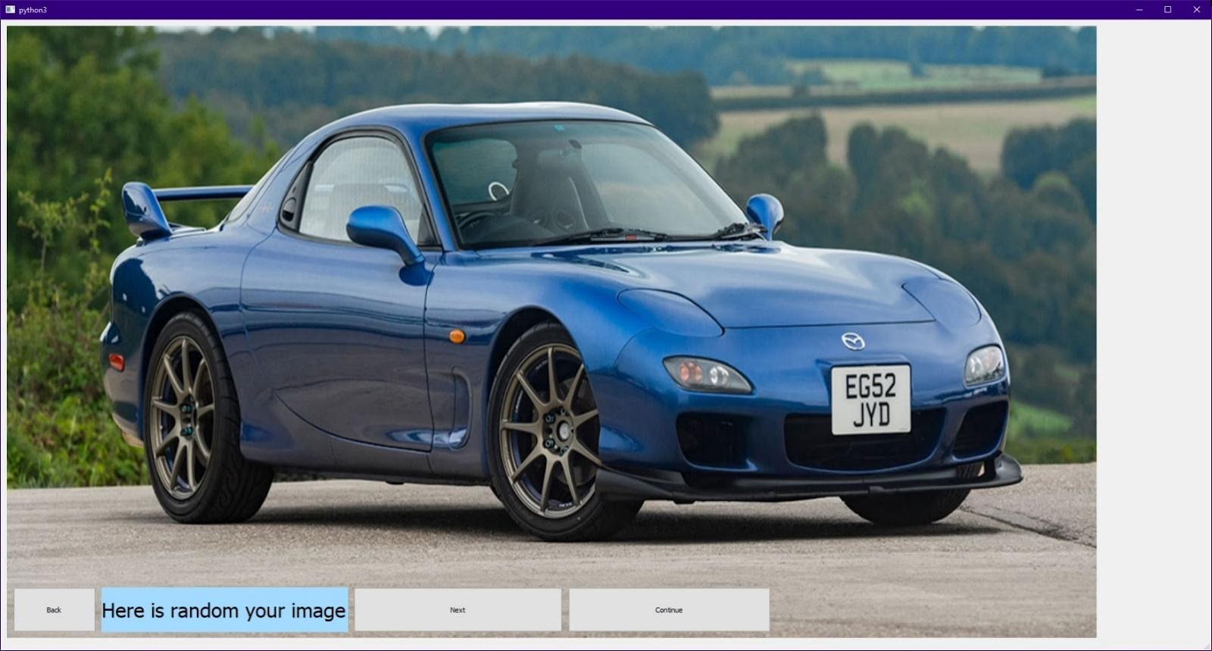
Part 5 – Select Random Image

Below is what the menu for what the Select Random Image menu looks like. The user will then choose what image they want to be displayed in the sorting window and subsequently randomized and sorted.
The user will press the “Next” button to traverse through the images that are given, then when they have the picture they want, they press the “Continue” button to then move onto the control panel and sorting window stage.
To help with speeds of randomizing because of how large the resolution of some of the images is, they are pre-sorted this means that the images have already been randomized and so when the user clicks randomize the result will instantly be displayed rather than the program having to go through and randomize the pixels, which will take a lot longer. This is the benefit of using a random image, it will have already of been sorted.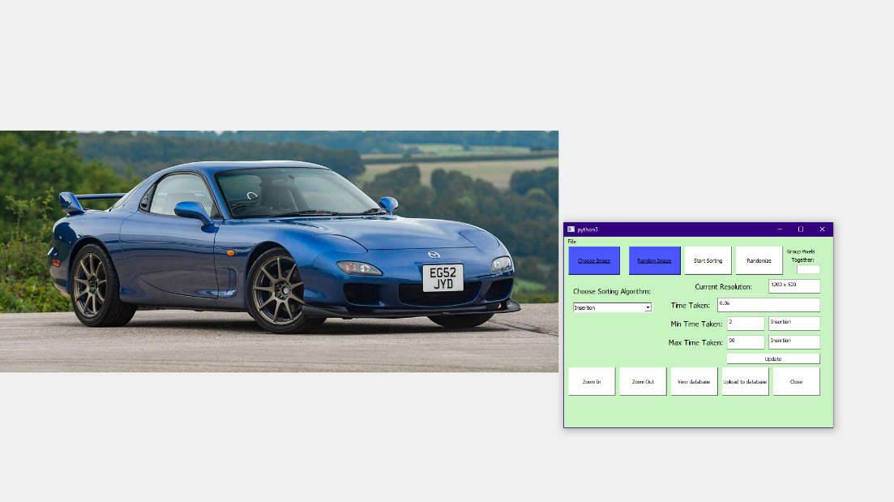
However, the pre randomized images have only been done for single pixel randomization rather than grouped randomization, this is because there are too many different combinations and so would take up too storage space.
There is also the option like in every window to go back to the previous slide.
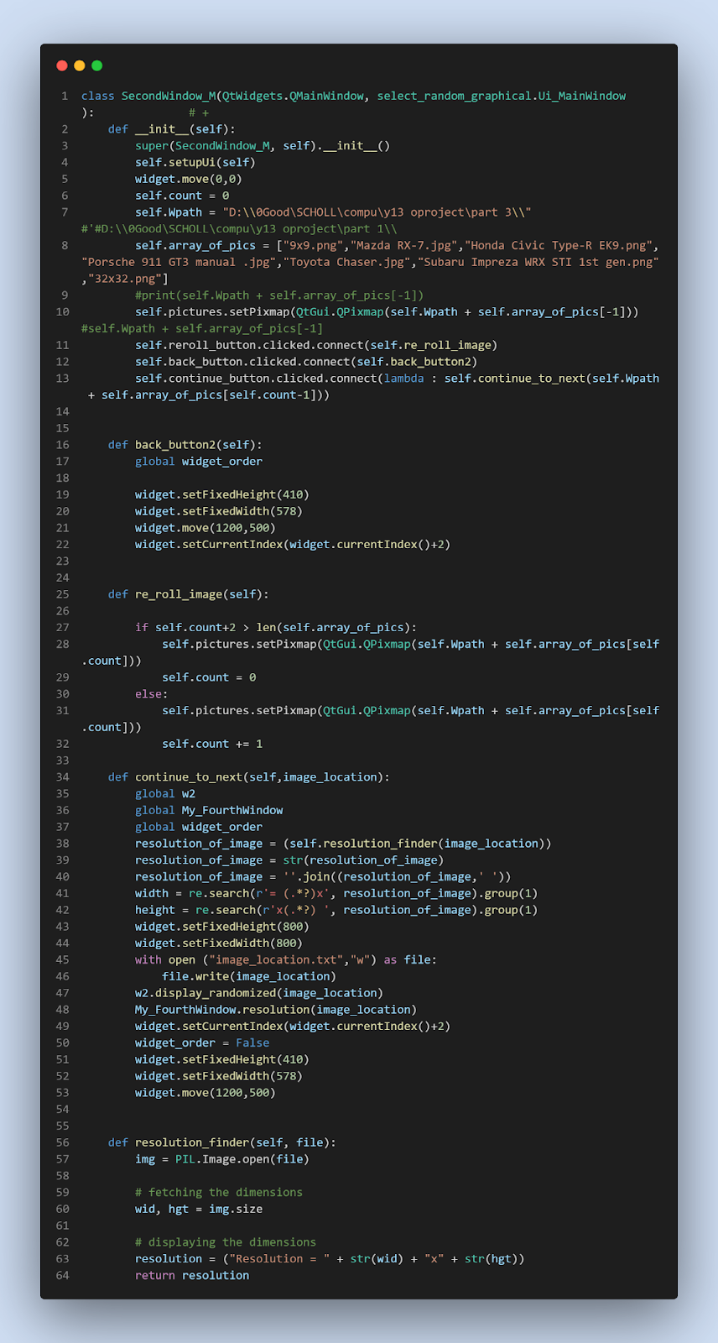
This is the code for this window.
In the __init__ function all the variables and button definitions are defined but also the images that are to be chosen from in the gallery. The current image pixmap is selected by joining the default path location and the last item of the array.
The function “back button” simply allows the user to get back to the control panel, it does this by adding two to the Widget index. It also changes the height and width of the window so that it is now of the size of the control panel. It also moves it so that it is not in the way of any image.
The second function is re_roll_image, this moves the picture displayed onto the next in the array or file names. There is a count variable used to determine which picture it is on, so that it knows when it is at the end. When it gets to the last file name it then goes back to the start and resets the count.
The third function then moves the widget index onto the control panel and passes the image and resolution into it. So that they can be displayed. But before that it saves the image location into the text file so that it can be used by the Sorting and Randomizing functions. This is so that those functions know what image is currently displayed.
The fourth function is used to get the resolution of the image so that it can be displayed in the control panel. It uses a library called PIL, this allows image manipulation. In this library there is an in-built function called size, this return the size of the image given passes into it. “Wid, hgt” is used due to the way “img.size” returns the integers, it returns the two integers this in two separate variables meaning you need two catch them both. There then is further formatting done so that the width and height are displayed correctly.

Part 6 - The Information Window:
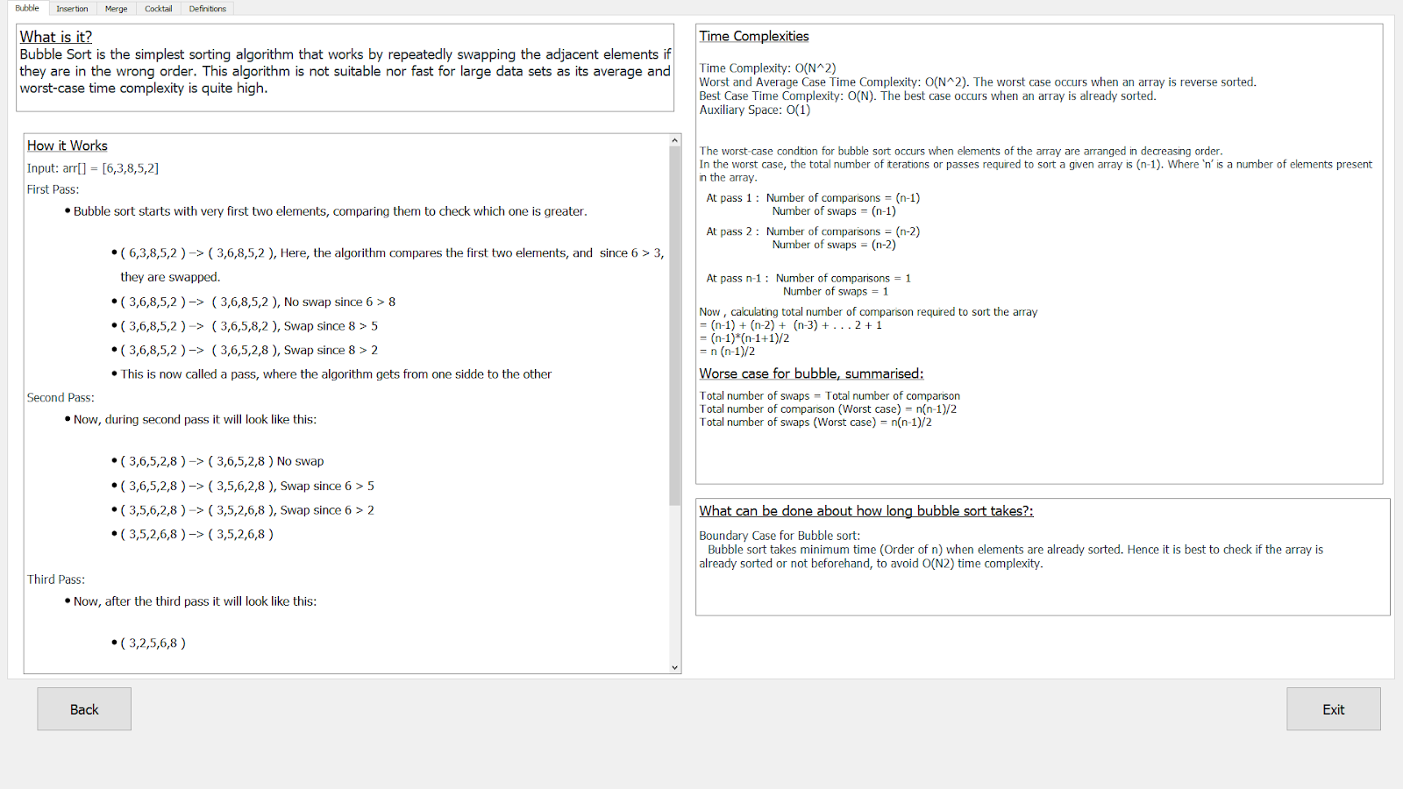
This is what the information window looks like. It is split up into sections, of sorting algorithms, with bubble being first. The page is then split even further into different sections, this is so it is easy for the user to navigate and understand. In The top left there is an introduction of the algorithm, below it an example of how it works and what steps it takes. On the right is the time complexity of the algorithm, this is how long the algorithm will take in the best, worse, and average case, depending on the size of the list. There are also buttons for you to go back to the main Window or exit the program entirely.
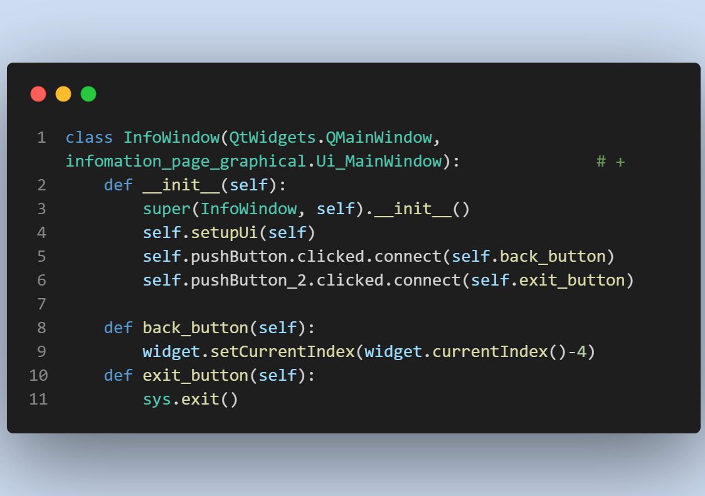

This is the simple code for displaying the Information window. All the pyqt5 code of what is displayed (the graphical) is in another file and is imported in, this file is called Indomation_page_graphical and as you can see is called into the class, meaning all attributes and variables in that file can be accessed and used. It is displayed as it is connected to the Ui_MainWindow, meaning that the graphical file of the information window is displayed and linked with the logic code as displayed above.
As you can see on the right the graphical file is very long, as everything you see has to be coded from the words to the location in the window to the font to the buttons.

Part 7 – Creating Images in the sorting stage:

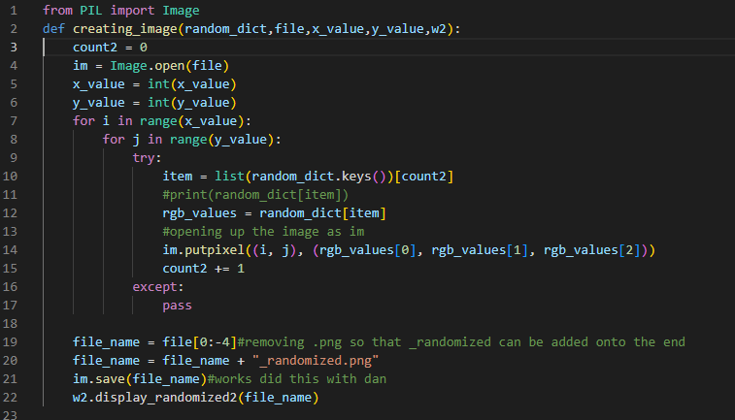
This is the file that will turn the dictionary passed in from the sorting algorithm file, to a image and pass it into the function in the sorting window class that will display it on the screen.
This code is a function named creating_image that takes five arguments. Random_dict: A dictionary containing RGB values, where the keys are the pixel positions (tuples of x, y coordinates) and the values are lists of three integers representing the R, G, and B values for that pixel.
file: The name of an image file in PNG format.
x_value and y_value: Integers representing the width and height of the image.
w2: The class variable so that it can reference the class in another file to access a function from it so it can display the image on the sorting screen.
The function first opens the image file using the Image.open method from the PIL (Python Imaging Library) module. It then loops through each pixel (using two for loops to cover x and y axis) in the image and sets the pixel colour using the put pixel method of the im object, which is the image opened from the file. The pixel colour is taken from the random_dict dictionary, where the keys are the pixel positions, and the values are the RGB values.
After all the pixels have been processed, the function saves the modified image to a new file with the same name as the original file but with "_randomized.png" appended to it. The file is then displayed by calling the display randomized function which is in the sorting window class. See below.
This is done after every single change to an array for every sorting algorithm.

Complex Algorithms:

Sorting Algorithms:
Below is pictures of code and an explanation of how all the sorting algorithms work.

Cocktail sort, also known as bidirectional or shaker sort, is a variation of the bubble sort algorithm that moves in both directions (left to right, and then right to left) through the list to sort the elements.

Here's the general algorithm for cocktail sort:

Set two pointers, one at the start of the list and the other at the end.
Loop through the list, swapping elements if they are in the wrong order, moving the start pointer one step to the right and the end pointer one step to the left.
If no swaps were made during the first pass, the list is considered sorted.
Repeat the process until the list is sorted.
The idea behind the cocktail sort is that it can move larger elements towards the end of the list more quickly than the traditional bubble sort, and it also moves smaller elements towards the beginning of the list more quickly. This makes the cocktail sort more efficient than the bubble sort, although it still has a worst-case time complexity of O(n^2).

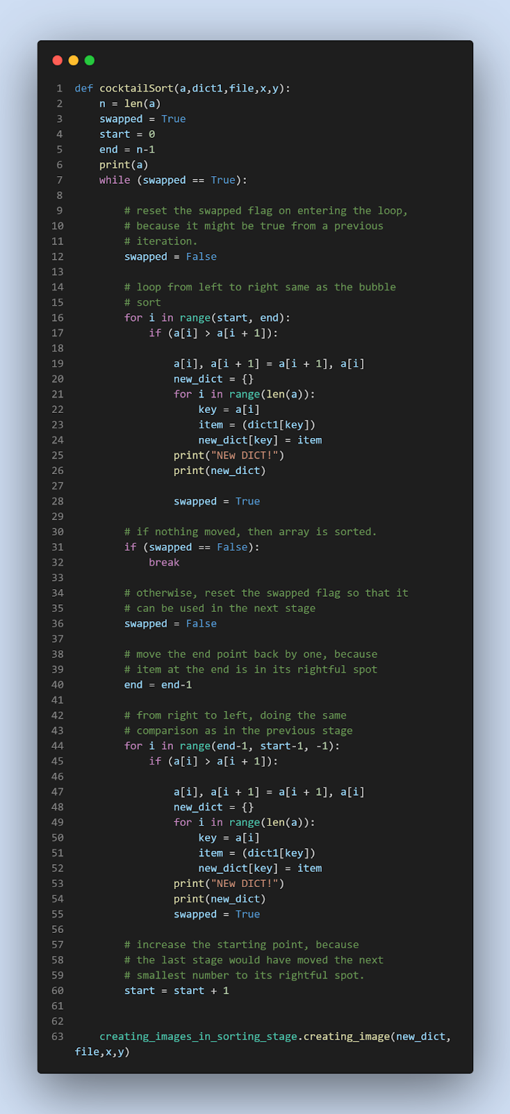 Heap sort is a comparison-based sorting algorithm that works by turning the input list into a binary heap data structure, and then repeatedly extracting the maximum element from the heap and moving that to the end of the sorted list.

Here's the general algorithm for heap sort:

Build a max heap from the input list.
Swap the first and last elements of the heap.
Replace the first element with the last element and move it downwards in the heap until it satisfies the heap property.
Repeat steps 2 and 3 until the heap is empty.
The time complexity of heap sort is O(n log n), making it more efficient than the O(n^2) algorithms like bubble sort and selection sort for large data sets. However, it has a high constant factor due to the overhead of maintaining the heap, so it may not be the best choice for small data sets or in environments with limited memory.
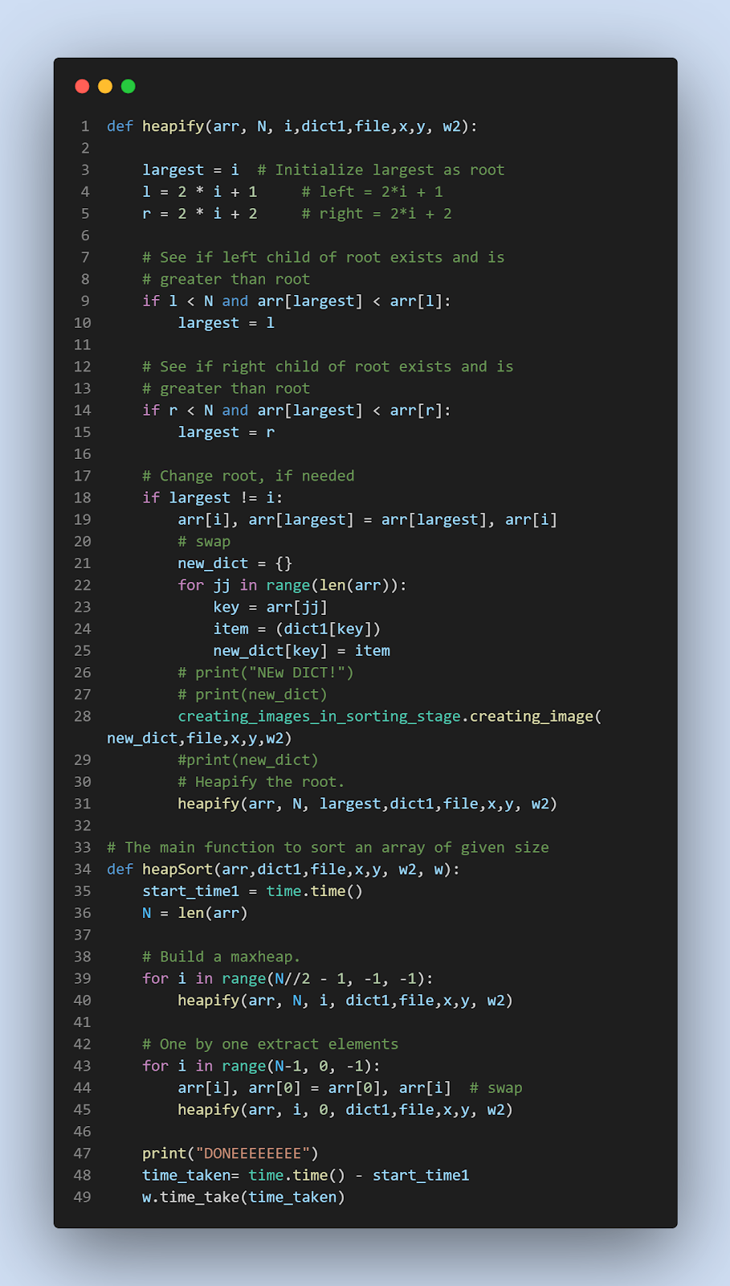 Quick sort is a divide-and-conquer, comparison-based sorting algorithm that works by selecting a "pivot" element from the array and partitioning the other elements into two sub-arrays, according to whether they are less than or greater than the pivot. The sub-arrays are then sorted recursively.

Here's the general algorithm for quick sort:

Select a pivot element from the array.
Partition the other elements into two sub-arrays, according to whether they are less than or greater than the pivot.
Recursively sort the sub-arrays.
Combine the sorted sub-arrays and the pivot to obtain the fully sorted array.
The time complexity of quick sort is O(n log n) on average, making it more efficient than O(n^2) algorithms like bubble sort and selection sort for large data sets. However, the worst-case time complexity of quick sort is O(n^2) if the pivot is chosen poorly, so it is important to choose a good pivot selection strategy to ensure good performance. Quick sort is also typically faster than other O(n log n) algorithms like merge sort and heap sort in practice, due to its smaller constant factors and good cache performance.

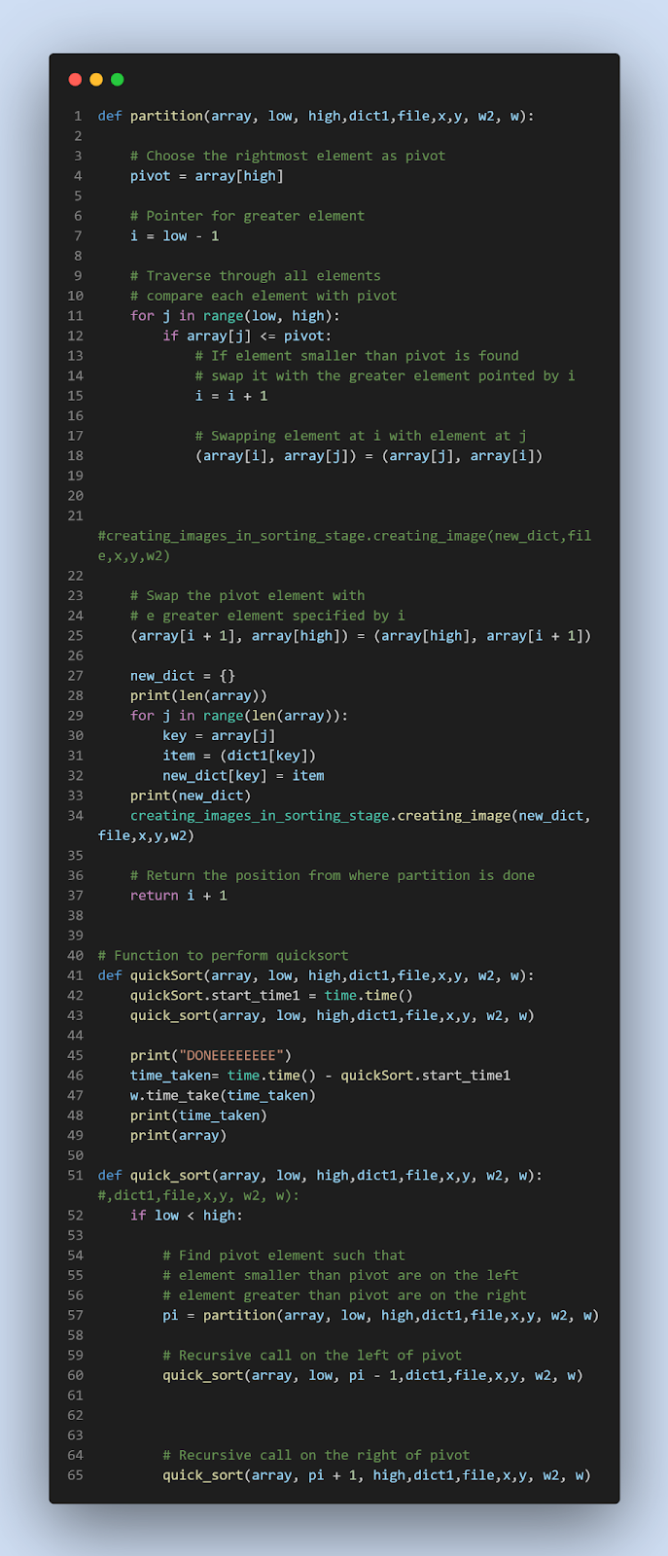 Radix sort is a non-comparative integer sorting algorithm that sorts data with integer keys by grouping the keys by individual digits that share the same significant position and value. It does this starting from the least-significant digit to the most-significant digit.

Here's the general algorithm for radix sort:

Determine the number of digits in the largest key.
For each digit, starting from the least significant digit, use a stable sorting algorithm, such as counting sort, to sort the keys based on the value of the current digit.
After sorting by each digit, the keys are fully sorted.
Radix sort is efficient for sorting large numbers of integers, especially when the integers have a small range of possible values compared to the size of the list being sorted. The time complexity of radix sort is O(w*n), where w is the number of digits in the largest key and n is the number of keys being sorted. This makes radix sort faster than O(n log n) algorithms for large data sets when the integers have a small number of digits.
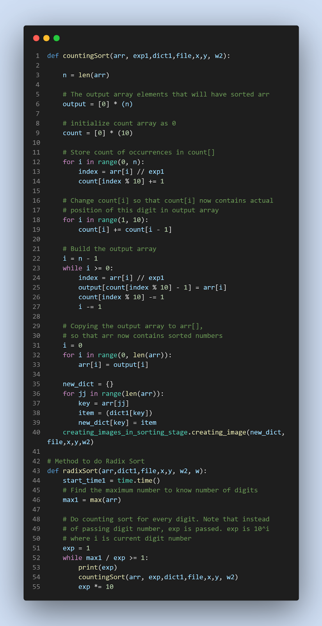 Selection sort is a simple sorting algorithm that works by repeatedly finding the minimum element from the unsorted part of the array and swapping it with the first element of the unsorted part. This process continues until all elements are sorted.

Here's the general algorithm for selection sort:

Set the minimum element to the first unsorted element.
Loop through the unsorted part of the array and compare each element with the current minimum element.
If a new minimum element is found, set it as the new minimum.
After the end of the loop, swap the minimum element with the first unsorted element.
Repeat the process starting from step 1 with the next unsorted part of the array.
Selection sort has a time complexity of O(n^2) in the worst case scenario, making it inefficient for large data sets.

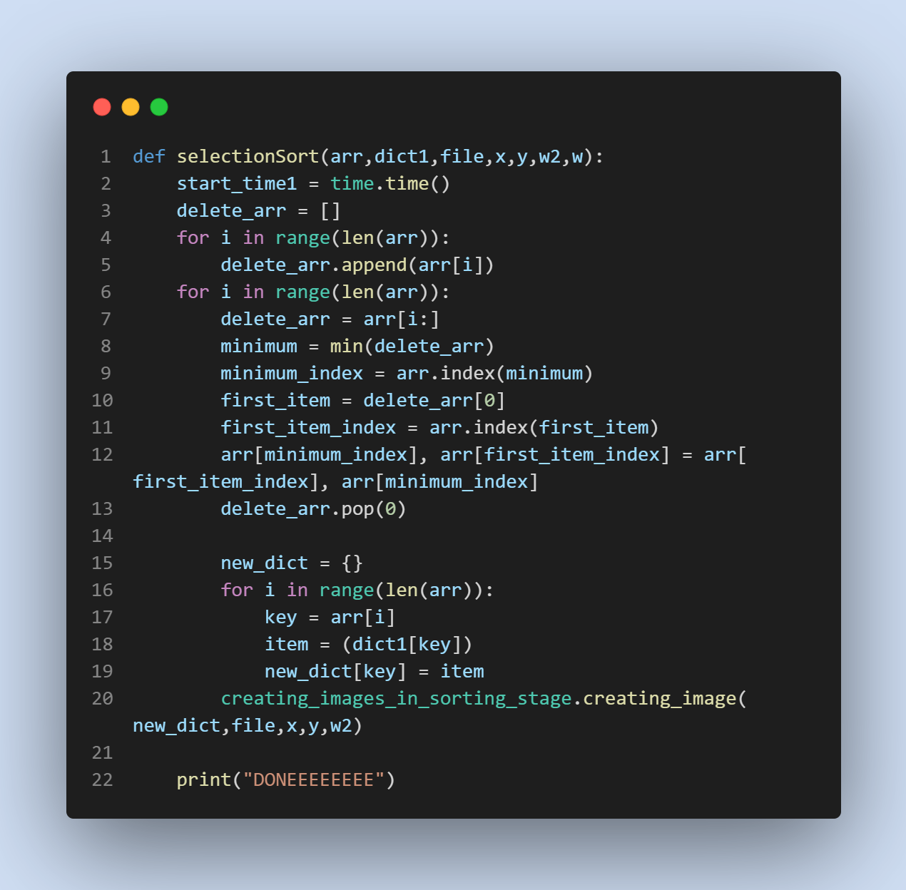 Shell sort is a variation of insertion sort that works by comparing elements separated by a gap, which is initially a large value, and then reducing the gap as the sort progresses. The idea behind shell sort is to move elements that are far apart to their approximate final position more quickly than a simple insertion sort, and then make the list gradually more sorted with smaller and smaller gaps.

Here's the general algorithm for shell sort:

Initialize the gap value to a large value such as n/2, where n is the number of elements being sorted.
Loop through the list with the current gap value, comparing elements separated by the gap, and swapping them if they are in the wrong order.
After the end of the loop, reduce the gap value to a smaller value, such as n/4.
Repeat the process starting from step 2 with the new gap value, until the gap value is 1.
Perform a final pass with the gap value of 1 to sort the list completely using a simple insertion sort.
The time complexity of shell sort is O(n^1.5) on average, making it more efficient than O(n^2) algorithms like bubble sort and selection sort for large data sets, but slower than O(n log n) algorithms like quick sort and merge sort. The exact time complexity of shell sort depends on the gap sequence used, and there are many possible gap sequences with different trade-offs between performance and ease of implementation.
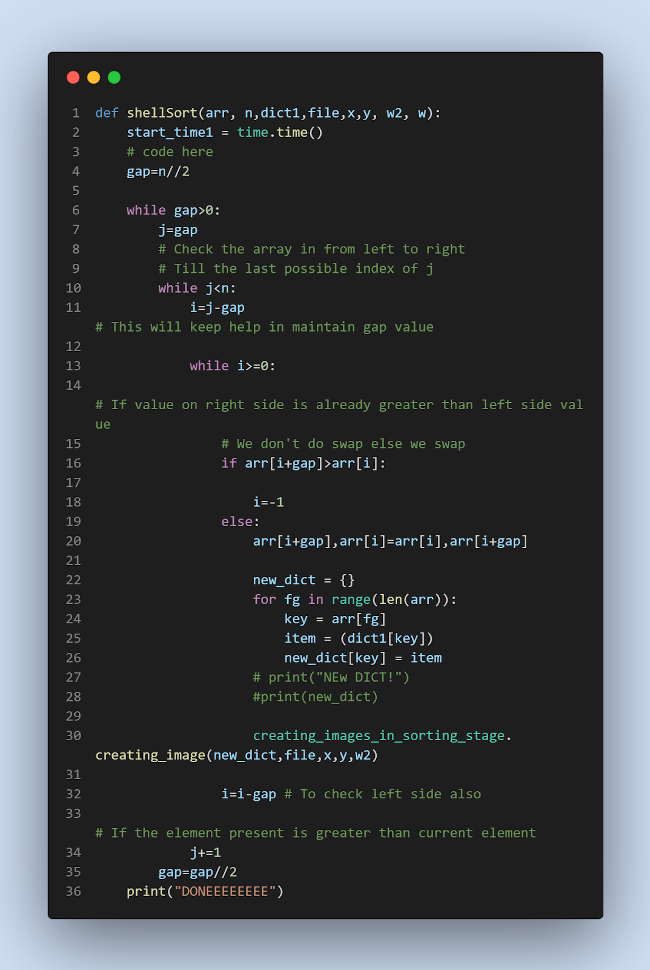 Bubble sort is a simple comparison-based sorting algorithm that repeatedly steps through the list, compares adjacent elements and swaps them if they are in the wrong order. The algorithm repeatedly steps through the list until no swaps are needed, indicating that the list is sorted.

Here's the general algorithm for bubble sort:

Repeat the following steps until the list is sorted:
a. Loop through the list, comparing adjacent elements.
b. If an adjacent pair of elements is in the wrong order, swap them.
After the end of the loop, the largest elements have "bubbled up" to the end of the list and the list is partially sorted.
Repeat the process starting from step 1, ignoring the already sorted elements at the end of the list.
The time complexity of bubble sort is O(n^2), where n is the number of elements being sorted, making it inefficient for large data sets. Bubble sort is very easy to understand and implement, and it is often used to introduce students to the concept of sorting algorithms, but it is not commonly used in practical applications because of its slow performance.
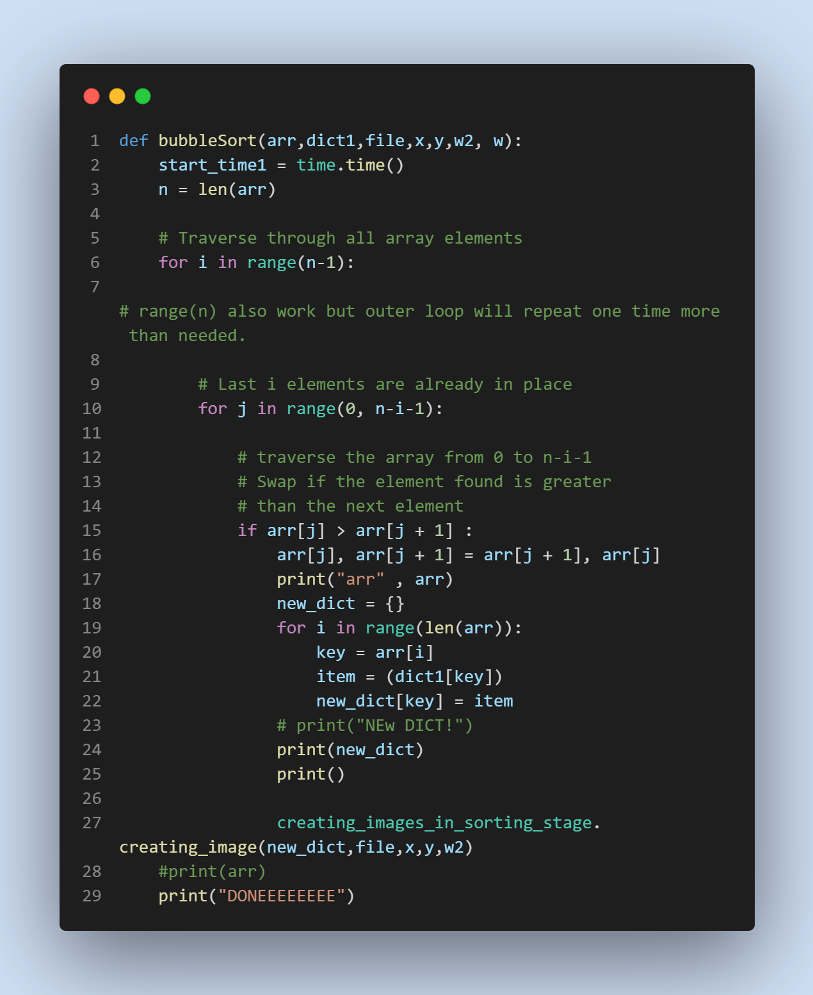

Insertion sort is a simple comparison-based sorting algorithm that builds up the final sorted list one item at a time. It is much less efficient than O(n log n) algorithms like quick sort or merge sort, but it is efficient for small data sets or for partially sorted data.

Here's the general algorithm for insertion sort:

Start with an empty "sorted" list.
Repeat the following steps for each element in the list:
a. Pick an element from the "unsorted" portion of the list.
b. Compare the element to each item in the sorted portion of the list, starting from the right and moving towards the left, until you find an element that is smaller than it.
c. Insert the element in the appropriate position in the sorted portion of the list, to the right of the element that is smaller and to the left of the element that is larger (if there is one).
After the end of the loop, the list is fully sorted.
The time complexity of insertion sort is O(n^2), where n is the number of elements being sorted, making it inefficient for large data sets. However, insertion sort is a very stable sorting algorithm, meaning that it maintains the relative order of equal elements, and it is efficient for partially sorted data, because it takes advantage of the partially sorted list to sort the data more quickly. Additionally, insertion sort is easy to understand and implement, and it is often used as a simple reference implementation for sorting algorithms.

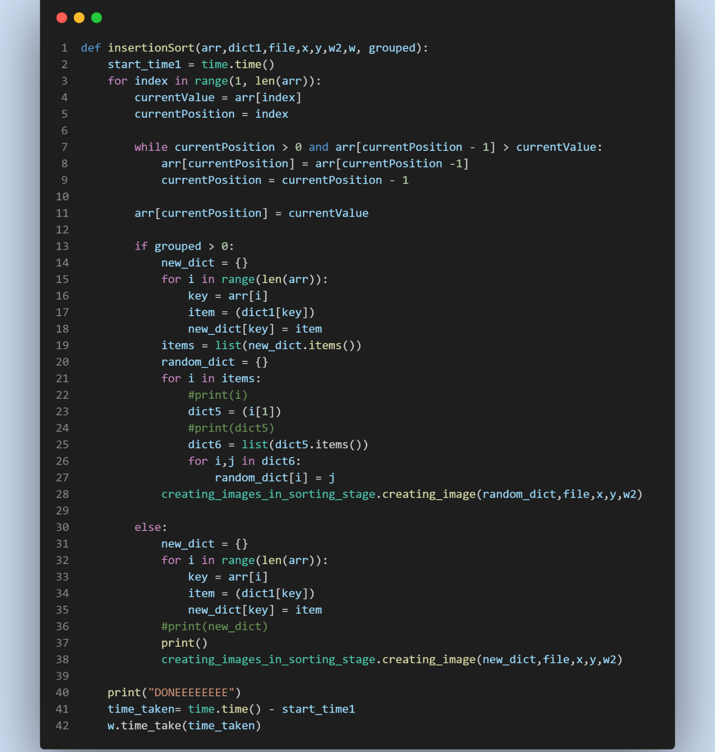

Bucket sort is a sorting algorithm that works by distributing the elements of a list into a number of "buckets," sorting each bucket individually, and then concatenating the sorted buckets back into the final sorted list. Bucket sort is most efficient when the elements being sorted have a natural order and are uniformly distributed over a range.

Here's the general algorithm for bucket sort:

Determine the number of buckets and the range of values that each bucket should hold.
Create an empty list of buckets.
Loop through the elements of the list, placing each element into the appropriate bucket based on its value.
Sort each non-empty bucket individually, using any sorting algorithm (for example, insertion sort).
Concatenate the sorted buckets back into the final sorted list.
The time complexity of bucket sort depends on the distribution of the elements and the sorting algorithm used for each bucket, but it is typically O(n) in the best case, where n is the number of elements being sorted, and O(n^2) in the worst case, where the elements are not uniformly distributed. Bucket sort is efficient for small data sets and for data sets with a uniform distribution, but it can be inefficient for large data sets or for data sets with a non-uniform distribution. Additionally, bucket sort requires a good understanding of the distribution of the data to choose the appropriate number of buckets and the range of values for each bucket.

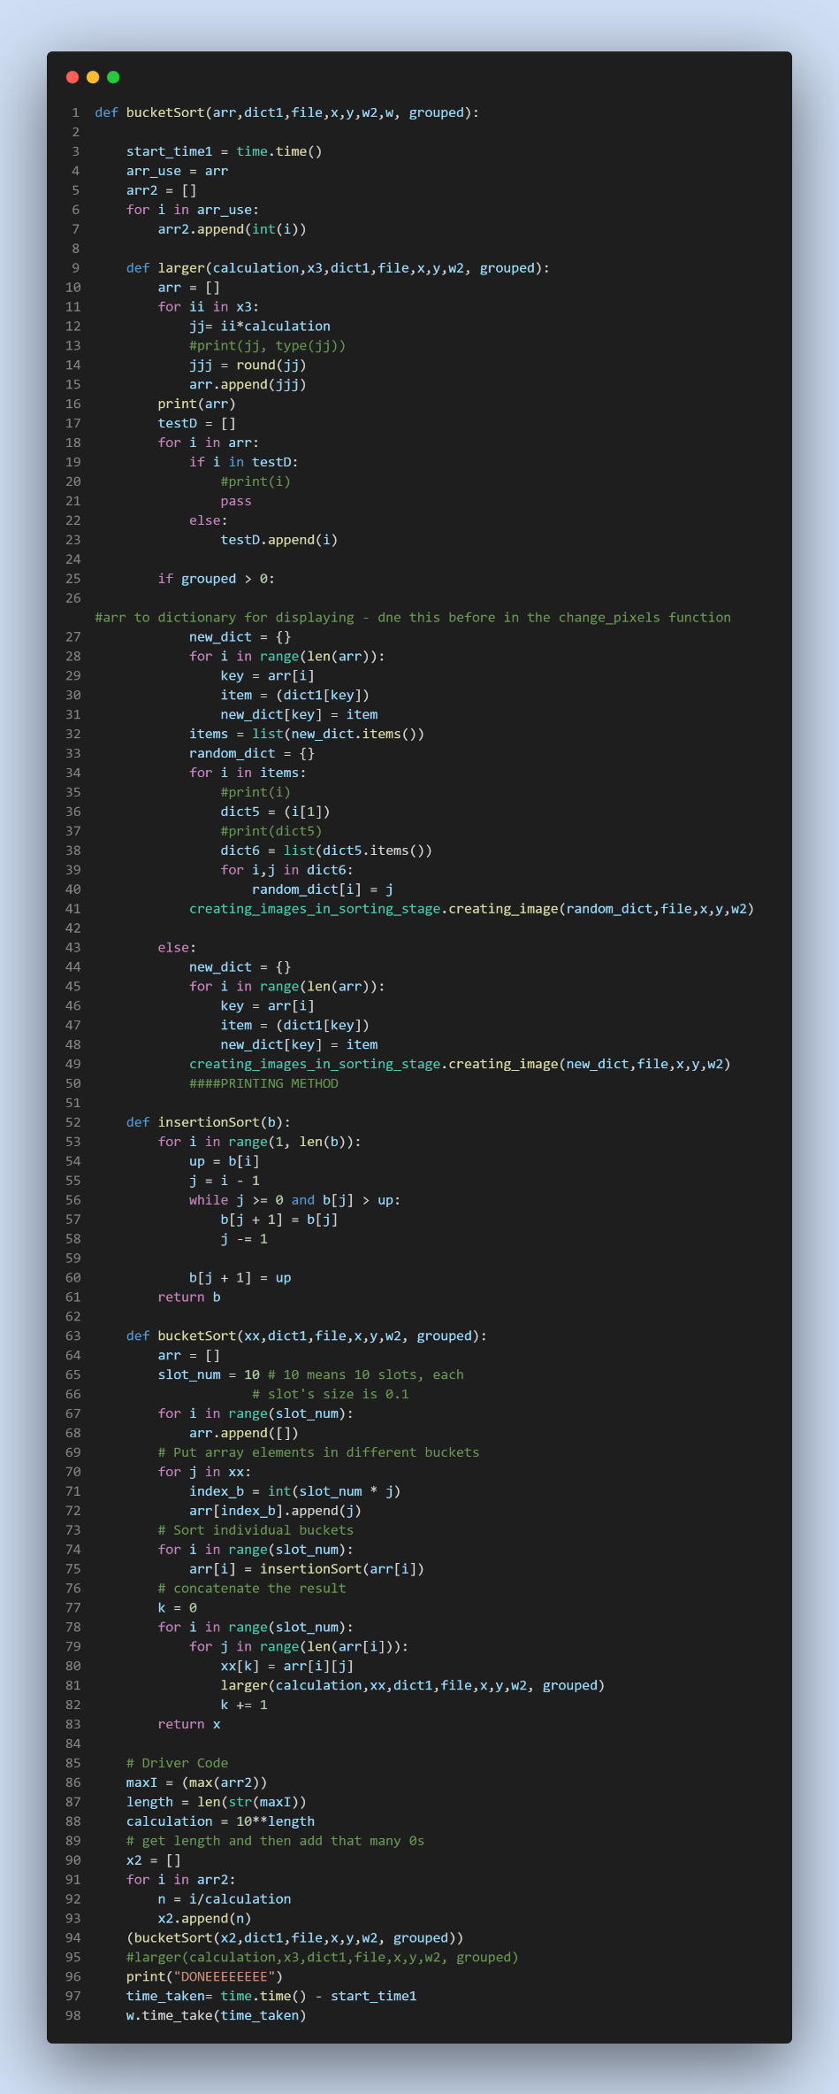

Connecting from the sorting algorithm to creating images file:
This is the design that allows for connection of all the sorting algorithms with the creating images file. It takes the random dictionary, array of the current indexes, file name, x and y values, and the w2 class and passes them into the creating image file. It will do this every single time there is a change to the array so that for every update of the array, there can a new image created and displayed on the sorting screen for the client to see. As the program runs very fast and efficient it looks like a seamless transition of pixels rather than a change of picture each time the pixels change. This was the ingenious design I came up with to make the program extremely efficient. Rather than moving around thousands of pixels, which would mean a it would be extremely slow and inefficient. As the program would need to move many pixels each one requiring a different variable. Meaning the file size would be massive and you could also only have a set image size. 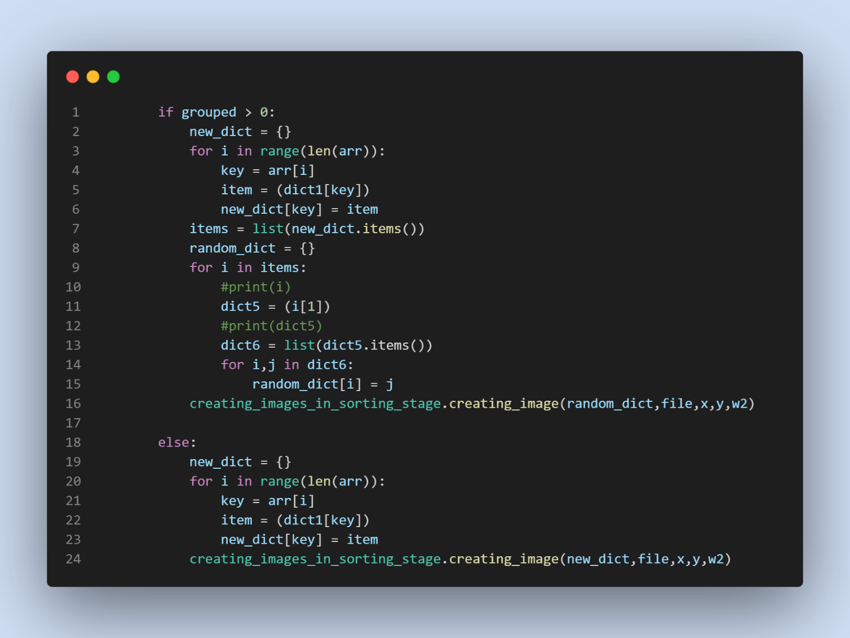This is the code, first it checks if the pixels are grouped together. If they are not, it will turn the array into a dictionary. The key in the dictionary is the index values in the array (the array is referenced using [i] which means it iterates through in order) and the item being the RGB value from the original dictionary. This is found from referencing the original dictionary with all the corresponding RGB values to the indexes. Except now the dictionary is in a different order. This dictionary is then passed to the creating images file, which will iterate through the dictionary and create a whole new image with the RGB values placing them in the order that they are in the dictionary passed in.
If the pixels are grouped together, after the dictionary is created, in this case being a dictionary of dictionaries, the top dictionary of the indexes of the number of grouped pixels will be removed, so that it leaves behind the correct order of the pixels.
{97: {481: (255, 255, 255), 482: (255, 255, 255), 483: (255, 255, 255), 484: (255, 255, 255), 485: (255, 255, 255)}, 135: {671: (63, 72, 204),
{481: (255, 255, 255), 482: (255, 255, 255), 483: (255, 255, 255), 484: (255, 255, 255), 485: (255, 255, 255), 671: (63, 72, 204),
The first dictionary shows that the 97th group of grouped pixels was next to the 135th. However, we want this joined together without the indication of the group number, so we remove the key from the first dictionary.
When done this dictionary will be passed into the same creating images file, if it was not grouped, with the same parameters. Keeping the same parameters is important as it means you don’t have to accommodate the function receiving the data for the different parameters.

Regular Expression:
I use regular expression many times in my program, mostly to remove unnecessary characters in a list that has come from a string, for example when retrieving the algorithm name from the SQL database it is formatted so that it looks like this “ [('Radix',)] ”. As the algorithm will be in the same place each time I can search between the first and second occurrence of apostrophises.
First, we import the library re, then we call the search function from the re library, then the pattern being searched for is defined by the regular expression r"'(.*?)'".
R is a raw string, meaning that backslashes are not treated as escape characters.
' matches a single quote character.
( and ) defines a capturing group, which allows you to extract the text matched by the group.
.*? matches any character (.) zero or more times (*), as few times as possible (?). The .*? expression is therefore a non-greedy match for any character between the two single quotes.
' matches the closing single quote character.
Finally, the .group(1) method is used to extract the text matched by the first capturing group in the regular expression, which is the text matched by .*?. So, the code is effectively searching for the first occurrence of a string enclosed in single quotes and returning the string without the quotes.
This will then leave us with the algorithm to be displayed in the text box.

Creating an image from RGB values:
This is the code I wrote that will turn a dictionary of RGB values with their corresponding index values, where the index is starting from the left, working down.

This code is a function named creating_image that takes five arguments. Random_dict: A dictionary containing RGB values, where the keys are the pixel positions (tuples of x, y coordinates) and the values are lists of three integers representing the R, G, and B values for that pixel.
file: The name of an image file in PNG format.
x_value and y_value: Integers representing the width and height of the image.
w2: The class variable so that it can reference the class in another file to access a function from it so it can display the image on the sorting screen.
The function first opens the image file using the Image.open method from the PIL (Python Imaging Library) module. It then loops through each pixel in the image and sets the pixel colour using the put pixel method of the im object, which is the image opened from the file. The pixel colour is taken from the random_dict dictionary, where the keys are the pixel positions, and the values are the RGB values. The RGB values are then gotten from the large dictionary, where the item is a list of three RGB values. The values are then gotten from the list using the [x] method.
After all the pixels have been processed, the function saves the modified image to a new file with the same name as the original file but with "_randomized.png" appended to it. The file is then displayed by calling the display randomized function which is in the sorting window class. See below.
This is done after every single change to an array for every sorting algorithm.

Tree Traversal:
In my program I used a heap sort a heap sort uses binary tree traversal.
The tree is created from the array, where the root will be the first item in the array, and the left child will be index 1 and the right child will be index 2. Then the next line will follow with the furthest most left child being index 4 and so on horizontally through the child nodes with incrementing indexes by 1. This is how it is laid out in the array in the program.

Heapify is the function that traverses the binary tree. It also uses recursion to call the function again, it will do this until the binary tree is a max heap. A max heap is a complete binary tree data structure where each parent node is greater than or equal to its children nodes. The value of the parent node is said to be the maximum value in the subtree rooted at that node. In other words, the largest value in the heap is stored at the root node.
The property of a max heap is that, its value is greater than or equal to the values of its children. This is called the "heap property".
In a max heap, the parent-child relationships follow a specific order, the child nodes are usually organized in a left-to-right order, so that the left child of a node is guaranteed to have a smaller index in the array than its right child.
A max heap can be implemented as an array, where the parent-child relationships are determined by the indices of the elements. The children of an element at index i are stored at indices 2i + 1 (left child) and 2i + 2 (right child), and the parent of an element at index i can be found at index (i - 1) // 2.

In the heap sort Heap sort is a sorting algorithm that uses a binary heap data structure to sort an array of elements. The binary heap is either a max-heap or a min-heap, depending on the sorting order desired.
A binary heap is a complete binary tree that satisfies the heap property, where the value of each node is greater than or equal to (max-heap) or less than or equal to (min-heap) the values of its children.
Binary tree traversal is used in heap sort to access the elements of the binary heap and arrange them in the desired order.
There are two main binary tree traversal algorithms used in heap sort:
Level-order traversal. This traversal visits all the nodes at the same level of the binary tree before moving to the next level. In a heap sort, level-order traversal is used to build the initial binary heap.

In-order traversal. This traversal visits the nodes of the binary tree in a specific order, either in pre-order (visit the root node first, then its left subtree, then its right subtree), in-order (visit the left subtree first, then the root node, then the right subtree), or post-order (visit the left subtree first, then the right subtree, then the root node). In a heap sort, in-order traversal is used to extract the elements of the binary heap in the desired order.
As discussed, the heap sort also uses a max-heap. The largest element is always at the root node. To sort an array in ascending order, the root node is removed, and the last node is moved to the root. The binary heap is then reconstructed to remove the top parent, and then re constructed using the heapify function to get the tree as a max heap. The process is repeated until all elements have been removed.
The array will be in ascending order sorted.

How important parts of the program work:
The main parts of the program are choosing a picture, then randomizing it, then sorting it back using a chosen algorithm. This is how it works.
- Choose your image via the two options
- This will be then passed into the sorting window class, via the display randomized function.
- Next press randomized, this will make a dictionary of all the RGB to their index values using, the functions shown above.
- Resolution_finder() finds out how many pixels there in that image, this is then passed onto rgb_of_pixel(). This will then iterate through the pixels, getting the RGB values of each pixel. However, on its own it doesn’t know how big it is, so it uses the resolution from Resolution_finder() to know how many times to iterate through. For if it asks for a pixel location that doesn’t exist and error will occur. It will append all of these values and their index, this is just a count variable, so it will append the count as the index for each of the pixels.
- Now the dictionary is randomized
- Then a new image is created, this is done by simply iterating through the value of each dictionary item (in this case it is the RGB value) and placing it in the position, then iterating through an image of the same size as before, placing all these pixels in their now random place.
- Now select what sorting algorithm you want; this will decide what file and corresponding function is called.
- Next it will turn all the dictionary’s keys into its an array, this is the sent off to the sorting algorithm where each item a change occurs it calls a function creating_image(), this will relate the items of the array to the original ordered dictionary.
- Then a new array is created off all the RGB values, by referencing their respected index (e.g 324 is now in the first position. Using the ordered array, we can see that originally this value was 40,34,134, however as it is now at the start of the new array. It will start with [40,34,134] and so one for each value in the sorting array).
- Repeat steps 8 and 9 and eventually the array will be sorted, and a sorted version of the picture will be once again printed.

