DIGICHEM LAB

Website Content User Manual
A step-by-step guide for adding, editing, and maintaining website content
- Home Page
- About Page
- Lab & Facilities Page
- Research Page
- Project Page
- Team Page
- Publication Page
- Collaboration Page
- Contact us

Home page
This manual explains how to update the text, links, and buttons on the Home page of the DigiChem Lab website (the file named index.html, script.js, style.css).

1. Top Announcement Bar
This is the thin scrolling strip at the very top of the page, above the logo, used for short announcements.

Edit the Announcement Message
Find this in the code:
<div class="top-bar">
<p>🚀 Recent Updates: Congratulations Aarti Gawali for Successfully Defending PhD Viva </p>
</div>
- Edit only the sentence between <p> and </p>. You can keep or change the 🚀 symbol at the start.
⚠ Important: Keep this message short — very long text can wrap awkwardly on mobile phone screens.

2. Navigation Bar
This is the main bar containing the DigiChem logo and name, the page menu (Home, About, Research, Innovation, Impact, Leadership, Collaboration), and the "Menu ▾" dropdown linking to other pages.

Edit the In-Page Main Menu Links (Home / About / Research / Innovation / Impact / Leadership / Collaboration)
Find this in the code:
<div class="nav-links">
<a href="#home">Home</a>
<a href="#about">About</a>
<a href="#research">Research</a>
<a href="#innovation">Innovation</a>
<a href="#impact">Impact</a>
<a href="#leadership">Leadership</a>
<a href="#cta">Collaboration</a>
</div>
- Edit only the visible word between > and < in each link (e.g. Home, Research).

⚠ Important: Do not change the part in quotes after href= (e.g. #home, #research). That part tells the page which section to jump to, and must stay the same unless a developer also renames that section.

Add, Remove, or Rename a Dropdown "Menu ▾" Link
Find this in the code:
<div class="dropdown-content">
<a href="about.html">About</a>
<a href="research.html">Research</a>
<a href="projects.html">Projects</a>
<a href="team.html">Our Team</a>
<a href="facilities.html">Lab Facilities & Tools</a>
<a href="publications.html">Publication</a>
<a href="collaboration.html">Collaboration</a>
<a href="contact_us.html">Contact us</a>
</div>

• To RENAME a link, change only the text between > and < (>About<).
• To REMOVE a link, delete its whole line (from <a to </a>).
• To ADD a link, copy an existing line, paste it as a new line, then change the page name in quotes and the
visible text.

Important: The text in quotes after href= (e.g. research.html) must exactly match the real file name of the page you are linking to, including capital/lowercase letters.

3. Hero Banner
The hero banner is the large opening section with the animated background, main heading, tagline, and three buttons.

How to Edit the Hero Heading and Tagline
Find this in the code:
<h1>DigiChem Lab</h1>
<h3>AI-Driven Research in Computational Chemistry, Spectral Intelligence & Chemical Data Science</h3>
<p>Bridging Chemistry, Computation, and Artificial Intelligence for Real-World Impact</p>

- Edit the text between <h1> and </h1> to update the main title.
- Edit the text between <h3> and </h3> to update the tagline.
- Edit the text between <p> and </p> to update the short description underneath.

Edit the Hero Buttons (Explore Research / View Projects / Collaborate With Us)
Find this in the code:
<div class="buttons">
<a href="research.html"><button class="secondary explore-btn">Explore Research</button></a>
<a href="projects.html"><button class="secondary projects-btn">View Projects</button></a>
<a href="collaboration.html"><button class="secondary collaborate-btn">Collaborate With Us</button></a>
</div>

- Edit the button label text found between <button ...> and </button>.
- To point a button at a different page, change the file name in quotes after href= (e.g. research.html).
- To ADD a button, copy one whole line (from <a href=...> to </a>), paste it as a new line inside the <div class="buttons">...</div> block, then change its link and text.

Important: The page name after href= must exactly match a real file in the website folder (e.g. research.html, projects.html, collaboration.html).

4. About Section
This section gives a short introduction to the lab, directly below the hero banner.

Edit the About Heading and Paragraph
Find this in the code:
<h2>About</h2>
<p style="text-align: center; max-width: 1000px; margin: 0 auto; font-size: 1.3rem; color: #334155;">The DigiChem Lab at the University of Mumbai focuses on integrating Computational Chemistry, Artificial Intelligence and data-driven approaches to solve complex chemical problems. Our work combines theoretical understanding with modern computational tools to develop efficient, scalable and intelligent solutions for chemical analysis and research. We develop cutting-edge platforms such as Spectral Hub which simplifies complex spectral data analysis and Q-Nebula which is an AI-powered quantum chemistry environment for molecular modelling and prediction. By combining chemometrics, quantum mechanics and machine learning, we aim to empower researchers, industries and academic institutions with intelligent tools that accelerate innovation and decision-making in chemistry.
</p>
- Edit the word About between <h2> and </h2> to update the heading.
- Edit the paragraph text (the long sentence after the style="..."> part) to update the description. Leave the style="..." part untouched.

Important: The whole paragraph must stay between one opening <p ...> and one closing </p> — do not insert a closing tag in the middle of your new text.

5. Research Areas Section
This section shows four cards describing the lab's research areas, each with an icon, a title, and a short description.

Edit a Research Area Card
Find this in the code:
<div class="research-cards">
<div class="research-card" data-aos="zoom-in" data-aos-delay="100">
<i class="fas fa-microchip"></i>
<h3>Computational Chemistry</h3>
<p>Quantum chemical modeling of molecular systems and reaction mechanisms</p>
</div>
- Edit the title between <h3> and </h3>, and the description between <p> and </p>.
- There are four of these cards in a row (Computational Chemistry, AI in Chemistry, Spectral Intelligence, Process Automation) — find the one you want to edit by its title.

Add or Remove a Research Area Card
Find this in the code:
<div class="research-cards">
<div class="research-card" ...> ... </div> (Computational Chemistry)
<div class="research-card" ...> ... </div> (AI in Chemistry)
<div class="research-card" ...> ... </div> (Spectral Intelligence)
<div class="research-card" ...> ... </div> (Process Automation)
</div>
- To REMOVE a card, delete its entire block, starting at <div class="research-card" ...> and ending at the matching </div>.
- To ADD a card, copy one whole card block, paste it just before the final </div> that closes research-cards, then edit its icon, title and description.
Important: Always copy a complete card block (from <div class="research-card" to its closing </div>) — copying only part of it will break the layout. Leave the icon line (<i class="fas ..."></i>) in place; see Section 12 (Working with Icons) if you also want to change the picture.

6. Key Innovation Section
This section highlights two platforms — Spectral-Hub and Q-Nebula — each with an introduction and a row of feature cards.

Edit the Spectral-Hub Introduction
Find this in the code:
<h2>Key Innovation</h2>
<!-- NEW TITLE BELOW KEY INNOVATION -->
<h3 class="innovation-title">Spectral-Hub</h3>
<p class="innovation-para">
We are developing <strong class="gradient-text">Spectral-Hub</strong>, an AI-powered platform that transforms spectral data into real-time chemical insights.
</p>
- Edit Key Innovation between the <h2> tags to update the section heading.
- Edit Spectral-Hub between the <h3> tags to rename the platform title.
- Edit the sentence inside the <p class="innovation-para"> tag to update the introduction — you may keep the highlighted Spectral-Hub name inside <strong class="gradient-text">...</strong> or move it to match your new sentence.
- To add new sub branch card of spectral hub copy whole code of one card block <div class="inno………………..</br></p></div> edit title, descriptions, pointers etc.

Edit the Q-Nebula Introduction
Find this in the code:
<h3 class="innovation-title qnebula-title">Q-Nebula</h3>

<p class="innovation-para">
<strong class="gradient-text">Q-Nebula</strong>, AI-Powered Quantum Chemistry Platform, Q-Nebula is a cloud-enabled computational chemistry platform that integrates quantum mechanical calculations with AI/ML models to deliver faster and more scalable molecular insights.
</p>
- Edit Q-Nebula between the <h3> tags to rename the platform title.
- Edit the sentence inside the <p class="innovation-para"> tag to update the introduction.

Edit a Q-Nebula Feature Card (Q-Core / Q-Intellect)
Find this in the code:
<div class="innovation-card" data-aos="fade-right">
<i class="fa-solid fa-atom"></i>
<h3>
<span class="dark-text">Q</span>-<span class="blue-text">Core</span>
</h3>
<p>High-accuracy simulations for:- </br></p>
<p>1. Molecular structure optimization </br></p>
<p>2. Energy calculations (HOMO-LUMO, band gaps) </br></p>
<p>3. Reaction pathway analysis </br></p>
</div>

- Edit each line's text between <p> and </br></p>.
- To add new sub branch card of Q-nebula copy whole block <div class="inno………………..</br></p></div> edit title, descriptions, pointers etc.

Important: There are two of these cards (Q-Core, Q-Intellect) — find the right one by its title before editing.

7. Impact Section
This section shows four short cards describing the lab's real-world impact, each with an icon and one line of text.

Edit an Impact Card
Find this in the code:
<div class="impact-card" data-aos="flip-left">
<i class="fa-solid fa-bolt"></i>
<p>Faster and more efficient chemical analysis</p>
</div>
- Edit the sentence between <p> and </p>.
- There are four of these cards — find the one you want to edit by its current text.

Add or Remove an Impact Card
Find this in the code:
<div class="impact-cards"> ... four <div class="impact-card">...</div> blocks ... </div>

- To REMOVE a card, delete its entire block, starting at <div class="impact-card" ...> and ending at the matching </div>.
- To ADD a card, copy one whole card block, paste it just before the final </div> that closes impact-cards, then edit its icon and text.
Important: Always copy a complete card block — copying only part of it will break the layout.

8. Leadership Section
This section introduces the lab's leader and links through to the full Team page.

Edit the Leadership Card (Name, Title, Department)
Find this in the code:
<section id="leadership" class="section">
<h2 data-aos="fade-up">Leadership</h2>
<div class="leadership-card" data-aos="flip-up">
<i class="fas fa-chalkboard-user" style="font-size: 3rem; color: #0f4c81; margin-bottom: 1rem;"></i>
<h3>Dr.Purav Badani</h3>
<p>Associate Professor</p>
<p>Department of Chemistry</p>
<p>University of Mumbai</p>

</div>
- Edit each detail line (role, department, university) between its own <p> and </p> tags.
- Add extra line by copying <p……</p> and changing the text between the tags.

Important: Leave the icon line (<i class="fas fa-chalkboard-user" ...></i>) untouched unless you are following the icon instructions.

Edit the Team Summary Text and "View Full Team" Button
Find this in the code:
<div style="text-align: center; margin-top: 3rem;" data-aos="fade-up">
<p style="font-weight: 500;">Our lab consists of passionate researchers and students working across computational chemistry, AI, and spectroscopy.</p>
<a href="team.html"><button class="primary team-view-btn">View Full Team <i class="fas fa-arrow-right"></i></button></a>
</div>
- Edit the sentence between <p style="font-weight: 500;"> and </p>.

9. Footer
This is the dark strip at the very bottom of the page showing the copyright line.

Edit the Footer Copyright Text
Find this in the code:
<footer>
<p>© 2026 DigiChem Lab | University of Mumbai | Pioneering AI in Chemical Sciences</p>
</footer>
- Edit the text between <p> and </p>.
- Keep the © symbol at the start if you want to keep showing a copyright year.

About Page
This manual explains how to update the text, links, and buttons on the About page of the DigiChem Lab website (the file named about.html).

1. How to Edit the Hero Heading
The hero banner is the dark blue strip directly under the navigation bar showing the large page heading "About".
Find this in the code:
<section id="about" class="hero">
<h1>About</h1>
</section>

- Edit only the word About between <h1> and </h1>.
Before | <h1>About</h1>
After | <h1>About Our Lab</h1>

2. Overview Section
This is the introductory paragraph that appears just below the hero banner, under the heading "Overview".

Edit the Overview Heading and Paragraph
Find this in the code:
<div class="about-overview">
<h2 class="overview-heading">Overview</h2>
<p>The DigiChem Lab is a research group at the University of Mumbai dedicated to advancing chemical science through computational and AI-driven approaches. The lab focuses on solving complex chemical problems using a combination of theoretical chemistry, data science, and machine learning.</p>
</div>
- Edit the word Overview between <h2> and </h2> to update the heading.
- Edit the sentence between <p> and </p> to update the paragraph text.

Important: Keep the whole paragraph inside the <p> and </p> tags on one continuous block — do not add a </p> in the middle of your new sentence.

3. The In-Page Menu Links (About / Vision & Mission / Founder / Team)
Location 1 — Desktop menu:
<div class="nav-links" id="navLinksDesktop">
<a href="#about" class="nav-link">About</a>
<a href="#vm" class="nav-link">Vision &amp; Mission</a>
<a href="#founder" class="nav-link">Founder</a>
<a href="#team" class="nav-link">Team</a>
</div>
Location 2 — Mobile menu (same 4 links, further down the file):
<div class="nav-row2" id="navLinksMobile">
<a href="#about" class="nav-link">About</a>
<a href="#vm" class="nav-link">Vision &amp; Mission</a>
<a href="#founder" class="nav-link">Founder</a>
<a href="#team" class="nav-link">Team</a>
</div>
- Edit only the visible word between > and < in each link (e.g. About, Team).
- This menu appears twice in the file. Once for computer screens and once for phone screens — so update the same word in BOTH places to keep them matching.
Before | <a href="#founder" class="nav-link">Founder</a>
After | <a href="#founder" class="nav-link">Our Founder</a>

Important: Do not change the part in quotes after href= (e.g. #about, #founder). That part tells the page which section to jump to, and must stay the same unless a developer also renames that section.

4. Add, Remove, or Rename a Dropdown "Menu ▾" Link
Find this in the code:
<div class="dropdown-content">
<a href="index.html">Home</a>
<a href="research.html">Research</a>
<a href="projects.html">Projects</a>
<a href="team.html">Our Team</a>
<a href="facilities.html">Lab Facilities &amp; Tools</a>
<a href="publications.html">Publication</a>
<a href="collaboration.html">Collaboration</a>
<a href="contact_us.html">Contact Us</a>
</div>

• To RENAME a link, change only the text between > and <.
• To REMOVE a link, delete its whole line (from <a to </a>).
• To ADD a link, copy an existing line, paste it as a new line, then change the page name in quotes and the visible text.
Before | <a href="publications.html">Publication</a>
After | <a href="publications.html">Publications and Papers</a>

Important: The text in quotes after href= (e.g. research.html) must exactly match the real file name of the page you are linking to, including capital/lowercase letters.

5. Vision & Mission Cards
This section shows two side-by-side cards: a "Vision" card with a paragraph, and a "Mission" card with a bullet list.

Edit the Vision Card Text
Find this in the code:
<div class="card-title">Vision</div>
<p class="body-txt" style="margin-top:10px;">To transform chemical research by integrating artificial intelligence and computational methods into mainstream scientific workflows.</p>
- Edit Vision between the <div class="card-title">Vision</div> tags to rename the card title.
- Change the sentence inside the <p class="body-txt" style="margin-top:10px;">To transform chemical……</p> tag to update the vision statement.

Add, Remove, or Edit a Mission Card
Find this in the code:
<div class="card-title">Mission</div>
<ul class="list">
<li>Develop AI-driven tools for chemical analysis</li>
<li>Advance research in computational chemistry</li>
<li>Bridge academia and industry through technology</li>
<li>Train students in modern digital research techniques</li>
</ul>

• To EDIT a bullet point, change the text between <li> and </li>.
• To REMOVE a bullet point, delete the entire line (from <li> to </li>).
• To ADD a bullet point, copy an existing <li>...</li> line, paste it as a new line just before </ul>, and change the wording.
Important: Every bullet line must start with <li> and end with </li>. The list overall must stay between <ul class="list"> and </ul>.

6. Founder / Principal Investigator Section
This section introduces the lab's founder, with a photo, name, role, list of qualifications, and a short biography.

Change the Section Label
Find this in the code:
<div class="founder-heading scroll-reveal sr-up">Founder / Principal Investigator</div>
- Edit the text between the opening <div ...> and closing </div>.

How to Add a Qualification (Degree & Detail)
Find this in the code:
<ul class="qual-list">
- Copy any existing <li>...</li> block, paste it below, and replace the degree and description.

Important: Do not edit the <svg>...</svg> code. It displays the icon.

How to edit the Founder's Biography
Find this in the code:
<p class="bio">Dr. Badani's research focuses on understanding reaction mechanisms and developing AI-based tools for chemical analysis.</p>

- Change the sentence between <p class="bio"> and </p>.

7.Team Overview Section
This is the closing section of the About page, with a short description and a button linking to the full Team page.

How to Change the Team Section Heading
Find this in the code:
<div class="team-h scroll-reveal sr-up">Team Overview</div>

- Change the text between the opening <div ...> and closing </div>.

How to Edit the Team Description and "View Full Team" Button
Find this in the code:
<p class="team-desc">The lab includes postgraduate and research students working on interdisciplinary problems at the intersection of chemistry and computation.</p>

- Change the description sentence between <p class="team-desc"> ……….. </p>.
Important: The button automatically adds an arrow (→) after the text — you do not need to type one yourself.

Facilities Page
This manual explains how to update the text, links, buttons, and cards on the Lab Facilities & Tools page of the DigiChem Lab website (the file named facilities.html).

1. “Menu ▾” Dropdown Links
Clicking the dark blue “Menu ▾” button in the top-right corner opens a list of links to every page on the website.

Add, Remove, or Rename a Menu Link
Find this in the code:
<div class="dropdown-content">
<a href="index.html">Home</a>
<a href="about.html">About</a>
<a href="research.html">Research</a>
<a href="projects.html">Projects</a>
<a href="team.html">Our Team</a>
<a href="publications.html">Publication</a>
<a href="collaboration.html">Collaboration</a>
<a href="contact_us.html">Contact us</a>
</div>

- To RENAME a link, change only the visible words between > and < (for example, change >Our Team< to >Meet the Team<).
- To REMOVE a link, delete its entire line, from <a to </a>.
- To ADD a link, copy an existing line, paste it as a new line in the same list, then change the page file name in quotes and the visible text.

Important: This same list appears near-identically at the top of every page on the site. For the menu to look and work the same everywhere, repeat the same change in each page file.

2. The In-Page Menu Links (Software / Infrastructure)
Below the logo, this page has two shortcut buttons — Software and Infrastructure — that jump the visitor straight down to that section of the page. On phones, an identical pair of buttons appears in a strip above the logo instead.

Rename, Delete, Add In-Page Button (Desktop Version)
Find this in the code:
<div class="nav-buttons">
<a href="#software-section" class="nav-btn" onclick="popBtn(this); smoothScrollTo('software-section'); return false;">
<svg viewBox="0 0 16 16" fill="none" stroke="currentColor" stroke-width="2">
<rect x="1" y="3" width="14" height="10" rx="2"/>
<path d="M4 7h2M4 10h5"/>
</svg>
<span>Software</span>
</a>
<a href="#infra-section" class="nav-btn" onclick="popBtn(this); smoothScrollTo('infra-section'); return false;">
<svg viewBox="0 0 16 16" fill="none" stroke="currentColor" stroke-width="2">
<rect x="1" y="2" width="14" height="4" rx="1"/>
<rect x="1" y="9" width="14" height="4" rx="1"/>
<circle cx="13" cy="4" r="0.8" fill="currentColor" stroke="none"/>
<circle cx="13" cy="11" r="0.8" fill="currentColor" stroke="none"/>
</svg>
<span>Infrastructure</span>
</a>
</div>
- Edit only the visible word inside <span>...</span> (Software or Infrastructure) to change the label shown on the button.
- Leave the <svg>...</svg> icon code, the href, and the onclick text untouched — they make the button jump to the right part of the page.
- To Add another In-Page Button Copy one whole button block and paste it right after the last one <a href="#software-section" class <span>Software</span></a> Paste this just before the closing </div> of <div class="nav-buttons">.
What to change in your new block:
- #New -section → change to whatever id your new section will have
- smoothScrollTo('hardware-section') → must match that same id exactly
- <span>Hardware</span> → the label people will see on the button
- You can safely reuse the same <svg>...</svg> icon shown above, or swap in the other icon style already used for Infrastructure — either works, since the icon is just decorative
- To Remove a In-Page Buttone, delete block of existing Button from <a href="#software-section"….<span>Software</span></a>

Rename delete, Add In-Page Button (Mobile Version)
Find this in the code:
<div class="nav-row2">
<a href="#software-section" class="nav-btn" onclick="popBtn(this); smoothScrollTo('software-section'); return false;">
<svg viewBox="0 0 16 16" fill="none" stroke="currentColor" stroke-width="2">
<rect x="1" y="3" width="14" height="10" rx="2"/>
<path d="M4 7h2M4 10h5"/>
</svg>
Software
</a>
<a href="#infra-section" class="nav-btn" onclick="popBtn(this); smoothScrollTo('infra-section'); return false;">
<svg viewBox="0 0 16 16" fill="none" stroke="currentColor" stroke-width="2">
<rect x="1" y="2" width="14" height="4" rx="1"/>
<rect x="1" y="9" width="14" height="4" rx="1"/>
<circle cx="13" cy="4" r="0.8" fill="currentColor" stroke="none"/>
<circle cx="13" cy="11" r="0.8" fill="currentColor" stroke="none"/>
</svg>
Infrastructure
</a>
</div>

- Edit only the visible word inside</svg>Software</a> (Software or Infrastructure) to change the label shown on the button.
- Leave the <svg>...</svg> icon code, the href, and the onclick text untouched — they make the button jump to the right part of the page.
- To Add another In-Page Button Copy one whole button block<a href="#software-section" class <span>Software</span></a> Paste this just before the closing </div> of <div class="nav-buttons">. and paste it right after the last one
What to change in your new block:

- #New -section → change to whatever id your new section will have
- smoothScrollTo('hardware-section') → must match that same id exactly
- </svg>Hardware</a> → the label people will see on the button

- You can safely reuse the same <svg>...</svg> icon shown above, or swap in the other icon style already used for Infrastructure — either works, since the icon is just decorative
- To Remove In-Page Buttone, delete block of existing Button from <a href="#software-section"….<span>Software</span></a>
Important: This mobile strip repeats the same two buttons. Always update both the desktop version (nav-buttons) and this mobile version (nav-row2) together, using the exact same wording, so the page looks consistent on every device.

3. Category Section Headings (Software / Infrastructure)
The card area is split into two labelled groups — SOFTWARE and INFRASTRUCTURE — each shown as a label between two thin lines.

Rename the “Software” Category Label
Find this in the code:
<div class="facility-group" id="software-section">
<div class="group-divider">
<div class="group-divider-line"></div>
<span class="group-divider-label">Software</span>
<div class="group-divider-line"></div>
</div>
- Edit only the word Software between <span class="group-divider-label"> and </span>.

Rename, edit, the “Infrastructure” Category Label
Find this in the code:
<div class="facility-group" id="infra-section">
<div class="group-divider">
<div class="group-divider-line"></div>
<span class="group-divider-label">Infrastructure</span>
<div class="group-divider-line"></div>
</div>
- Edit only the word Infrastructure between <span class="group-divider-label"> and </span>.

Important: If you rename a category, the two quick-jump buttons in Section 3 still say “Software” / “Infrastructure” — update their labels too, so the button text matches the section it jumps to.

4. Facility Cards (Software / Infrastructure Tools)
Each category (Software, Infrastructure) shows a row of cards. Every card has an icon, a title, a short description, and sometimes a small row of tags underneath.

Edit a Facility Card Software/Infrastructure (Title, Description, Icon)
Find this in the code:
<div class="cards-grid">
<div class="facility-card">
<i class="fas fa-atom card-icon"></i>
<h3>Quantum Chemistry Tools</h3>
<p>Industry-standard software for DFT and semi-empirical calculations across complex molecular systems.</p>
<div class="card-tags"><span class="card-tag">Gaussian</span><span class="card-tag">ORCA</span></div>
</div>
- Edit the title between <h3> and </h3>.
- Edit the description between <p> and </p>.
- To change the icon picture, replace only fa-atom (keep the fas and card-icon parts unchanged) with another icon name — browse free icon names at fontawesome.com/search and copy the short name shown there (for example fa-flask).
- There are six of these cards on the page (three under Software, three under Infrastructure) — find the one you want to edit by its current title.
- To REMOVE a card, delete its entire block, starting at <div class="facility-card"> and ending at its matching closing </div>.
- To ADD a card, copy one whole card block (from <div class="facility-card"> to </div>), paste it just before the final </div> that closes cards-grid, then edit its icon, title and description.

Important: Each of the two groups (Software and Infrastructure) has its own separate <div class="cards-grid">...</div> block. Make sure you copy or delete inside the correct group.

Add, Remove, or Edit Card Tags (small labels like “Gaussian”, “Orca”)
Find this in the code:
<div class="card-tags"><span class="card-tag">Gaussian</span><span class="card-tag">ORCA</span></div>
</div>
- To rename a tag, edit the word between <span class="card-tag"> and </span>.
- To remove a tag, delete its whole <span class="card-tag">...</span> block.
- To add a tag, copy one <span class="card-tag">...</span> block, paste it right after another one inside the same card-tags line, then change its word.
- Some cards currently show no tags at all — their line simply reads <div class="card-tags"></div>. Add tags to these the same way, right between the two arrows.

Important: Keep tag names short (one or two words) — the pill-shaped label is designed for brief text like a software name.

5. Add a New Facility Category (e.g. “Hardware”)
If you need a whole new group of cards beyond Software and Infrastructure, you can duplicate an entire category block.

Duplicate a Category to Create a New One
Find this in the code:
<div class="facilities-box" data-aos="fade-up">
<div class="facility-group" id="software-section"> ... </div> (Software group — 3 cards, see Section 6–7)
<div class="facility-group" id="infra-section"> ... </div> (Infrastructure group — 3 cards, see Section 6–7)
</div>
- Copy one whole facility-group block, starting at <div class="facility-group" id="..."> and ending at its matching closing </div>.
- Paste it just before the final </div> that closes facilities-box.
- Inside your new block, change the id="..." value to a new short name with no spaces (for example id="hardware-section").
- Change the label text inside <span class="group-divider-label">...</span> to your new category name (for example Hardware).
- Edit or replace the card blocks inside your new group as described in Section 7.

Important: If you want a quick-jump button for the new category, copy one button block from Section 3 (both the desktop and mobile versions), point its href and the text inside smoothScrollTo(...) at your new id, and update its visible label.
Every id="..." value on the page must be unique — never reuse software-section or infra-section for a new group.

Research & Project Page
A Non-Technical Guide for Routine Updates & Form Configurations
This comprehensive guide details instructions on how to perform routine adjustments to your website's Research, Project, and Contact Us pages. The code snippets provided below consist of standard HTML and basic JavaScript logic. They can be modified effortlessly using a simple text editor such as Notepad, TextEdit, or Visual Studio Code.

1. General Maintenance: Navigation Links & Sections

How to Update or Add Navigation Links
Each webpage contains a top-level navigational structure (commonly structured within <nav> or <ul> HTML tags). To modify links or include a newly created page in the main menu, search for the following navigation block near the top of your file:
<!-- Look for your website navigation block -->
<ul class="nav-links">
<li><a href="index.html">Home</a></li>
<li><a href="research.html">Research</a></li>
<li><a href="project.html">Projects</a></li>
<li><a href="contact.html">Contact Us</a></li>
<!-- ADD A NEW NAVIGATION LINK HERE -->
<li><a href="newpage.html">New Page Name</a></li>
</ul>

- href="your-page.html": Specifies the target filename or destination URL.
- New Page Name: The visitor-facing title displayed directly on the navigation menu.

How to Edit Static Text Inside Page Sections
To update informational descriptions, text paragraphs, or headers inside any section, seek out the copy housed within header tags (<h1> through <h3>) or paragraph tags (<p>):
<section id="about-intro">
<!-- To change a title, modify the text between <h2> and </h2> -->
<h2>Welcome to Digichemlab</h2>
<!-- To change description text, modify the text between <p> and </p> -->
<p>Change this text to update the introduction paragraphs on your page.</p>
</section>

2. Adding Sections to Research & Project Pages
When populating additional records or entries into research.html or project.html, mirror the existing element blocks closely to preserve visual symmetry.

Adding a New Entry in research.html
Locate the primary historical container or wrapper layout and insert a new content item at the bottom of the list:
<!-- Find the container of your research posts -->
<div class="research-container">
<!-- Existing content remains here... -->
<!-- COPY AND PASTE THIS BLOCK TO ADD A NEW RESEARCH TOPIC -->
<div class="research-card">
<h3 class="research-title">New Research Project Title</h3>
<p class="research-date">Published: July 2026</p>
<p class="research-description">
Provide an explicit overview of the new research scope here. Keep your format uniform with prior entries.
</p>
<a href="#" class="read-more-btn">Read Full Paper</a>
</div>
<!-- END OF NEW RESEARCH TOPIC BLOCK -->
</div>

Adding a New Entry in project.html
To build a new placeholder slot for projects without disrupting grid alignments, use this structural format:
<!-- Find the container listing all your projects -->
<div class="projects-grid">
<!-- Existing projects remain here... -->
<!-- COPY AND PASTE THIS BLOCK TO ADD A NEW PROJECT -->
<div class="project-box">
<img src="assets/images/project-thumb.jpg" alt="Project Thumbnail Name">
<h3 class="project-heading">New Project Title</h3>
<p class="project-details">
Write details regarding the new project, its objectives, and key outcomes here.
</p>
<span class="project-status">Status: Active</span>
</div>
<!-- END OF NEW PROJECT BLOCK -->
</div>

Contact Page

1. Updating the Contact Us Page, Google Sheet, & EmailJS
If you desire to introduce a completely new input field (e.g., adding an "Organization Type" or "Country" input box) to the public contact form, synchronization must be established across three separate components: the HTML form structure, your Google Apps Script handler, and your EmailJS transactional template.

Step A: Modify contact.html (Form Implementation)
Isolate the specific <form> selector block inside your contact page, and weave in your new field block between the pre-existing elements:
<form id="contactForm">
<!-- Existing Field Example -->
<div class="form-group">
<label for="name">Name</label>
<input type="text" id="name" name="name" required>
</div>
<!-- 1. INSERT YOUR NEW SECTION/INPUT BOX HERE -->
<div class="form-group">
<label for="orgType">Organization Type</label>
<input type="text" id="orgType" name="orgType" placeholder="e.g. University, Corporate">
</div>
<!-- Existing Field Example -->
<div class="form-group">
<label for="message">Message</label><br>
<textarea id="message" name="message" required></textarea>
</div>
<button type="submit">Submit</button>
</form>

Note: Take notice of the name="orgType" attribute. This exact case-sensitive identifier represents the backend link. It must be spelled identically across your spreadsheet scripts and tracking configurations.

Step B: Update Google Sheet Apps Script
To safely capture incoming information from this new element inside your spreadsheets, register the added field mapping within your spreadsheet's underlying macro script environment:
- 1. Open your connected tracking Google Spreadsheet.
- 2. Select Extensions from the primary toolkit header, then click Apps Script.
- 3. Locate your doPost(e) logic and expand the data parsing array to catch the new object property:
function doPost(e) {
try {
const sheet = SpreadsheetApp.getActiveSpreadsheet().getActiveSheet();
const lastRow = sheet.getLastRow();
let newIdNumber = lastRow;
let formattedNumber = String(newIdNumber).padStart(2, '0');
let uniqueId = "DCL_" + formattedNumber;
const data = JSON.parse(e.postData.contents);
// --- EXTRACT EXISTING DATA ---
const name = data.name || "";
const email = data.email || "";
const organization = data.organization || "";
const phone = data.phone || "";
// 2. ADD YOUR NEW BOX DATA FETCHING HERE (Must match HTML name property)
const orgType = data.orgType || "";
const subject = data.subject || "";
const message = data.message || "";
const timestamp = new Date();
// 3. UPDATE THIS SECTION TO APPEND THE NEW DATA TO A SHEET COLUMN
sheet.appendRow([
uniqueId,
name,
email,
organization,
orgType, // <-- Inserted variable into rows alignment
phone,
subject,
message,
timestamp
]);
return ContentService
.createTextOutput(JSON.stringify({ status: "success", id: uniqueId }))
.setMimeType(ContentService.MimeType.JSON);
} catch (error) {
return ContentService
.createTextOutput(JSON.stringify({ status: "error", message: error.message }))
.setMimeType(ContentService.MimeType.JSON);
}
}

Important Spreadsheet Metric: Ensure you manually insert a new text column title inside Row 1 of your visual Google Spreadsheet dashboard (e.g., adding "Organization Type" as a column header) so that it matches up nicely with the append positions designated inside the script row structure.

Step C: Update EmailJS Template
Finally, update EmailJS so the new data field is included in notification emails sent to your inbox:
- 1. Log into your personal EmailJS Dashboard.
- 2. Navigate to Email Templates and edit your website's form submission notification layout.
- 3. Inside the rich text formatting block, add a double curly bracket variable tag referencing your field's exact form name attribute:
Hello Admin,
You have received a new contact submission:
Name: {{name}}
Email: {{email}}
Organization: {{organization}}
New Added Box Info:
Organization Type: {{orgType}} <-- ADD THIS VARIABLE TO YOUR EMAIL PATTERN
Message:
{{message}}

- 4. Click Save inside the platform editor. Your extended contact form pipeline is now configured, integrated, and fully functional!

Teams Page
- To change the photo
- Push the new photo to the GitHub repository
- And remove redundant and unnecessary photos
- In code make changes in <div class="container"> <div class="card"> <div class="inner"> <div class="front"><img src="Shruti.jpeg" alt="Shruti Sonavane"> then again push the changed code in repo.
- To change name
- In code make changes in <div class="container"> <div class="card"> <div class="inner"> <div class="front"> <h3>Shruti Sonavane</h3> <p>Computational Chemistry</p>then again push the changed code in the repo.

- To edit the backside details
- In code make changes in <div class="container"> <div class="card"> <div class="inner"> <div class="back"> <div class="back"> <p>Driving high-precision quantum chemical simulations to model molecular structures, energies, and reaction pathways.</p>then again push the changed code in the repo.

- To add more sections
- In <div class="page-wrapper"> add section in this format
<div class="section">
<h2>Leadership</h2>
<div class="container">
<div class="card">
<div class="inner">
<div class="front">
<img src="Purav Sir.jpeg" alt="Dr. Purav Badani">
<h3>Dr. Purav Badani</h3>
<p>Principal Investigator</p>
</div>
<div class="back">
<p>Leading Digital Chemistry Lab at the intersection of quantum chemistry, AI and data science to drive next-generation chemical innovation</p>
</div>
</div>
</div>
</div>
</div>

- To add more cards
- Add more cards adding such division code inside “section”
<div class="card">
<div class="inner">
<div class="front">
<img src="Purav Sir.jpeg" alt="Dr. Purav Badani">
<h3>Dr. Purav Badani</h3>
<p>Principal Investigator</p>
</div>
<div class="back">
<p>Leading Digital Chemistry Lab at the intersection of quantum chemistry, AI and data science to drive next-generation chemical innovation</p>
</div>
</div>
</div>
</div>
</div>

Publications Page
- Add more publications by

- According to the number of published publications on scholarly update the number over here.

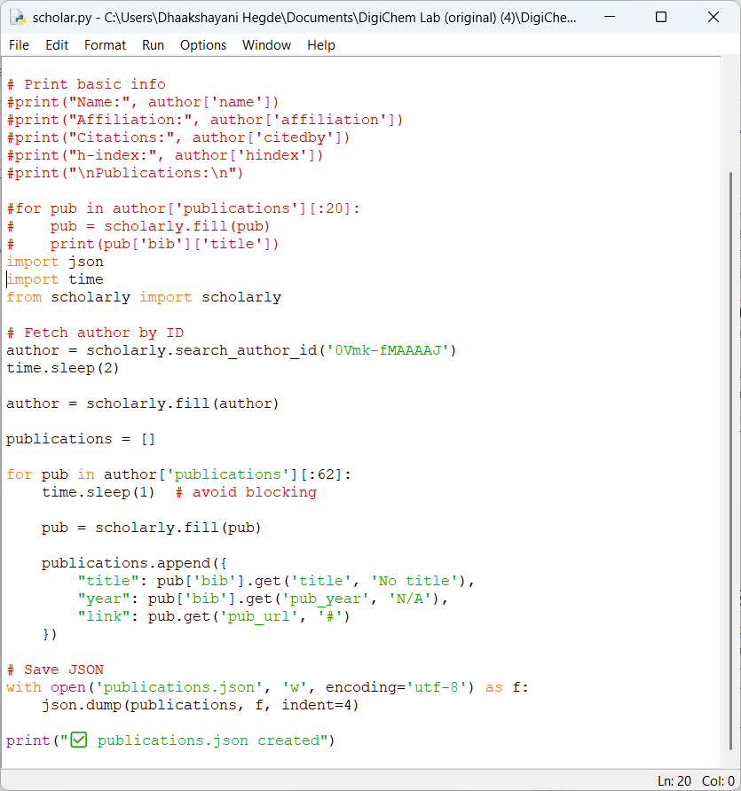
Update here

- Running Python code locally on your system (sometimes it may not run, so you might have to run again)
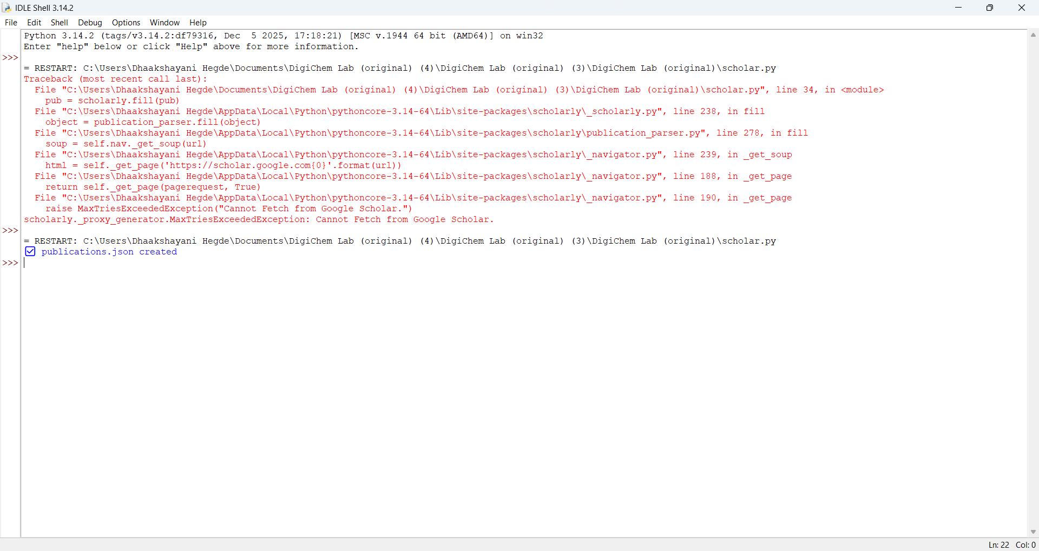
- Remove the previously updated JSON file from the repo
- Then push the newly generated JSON file (which you got from running python file)
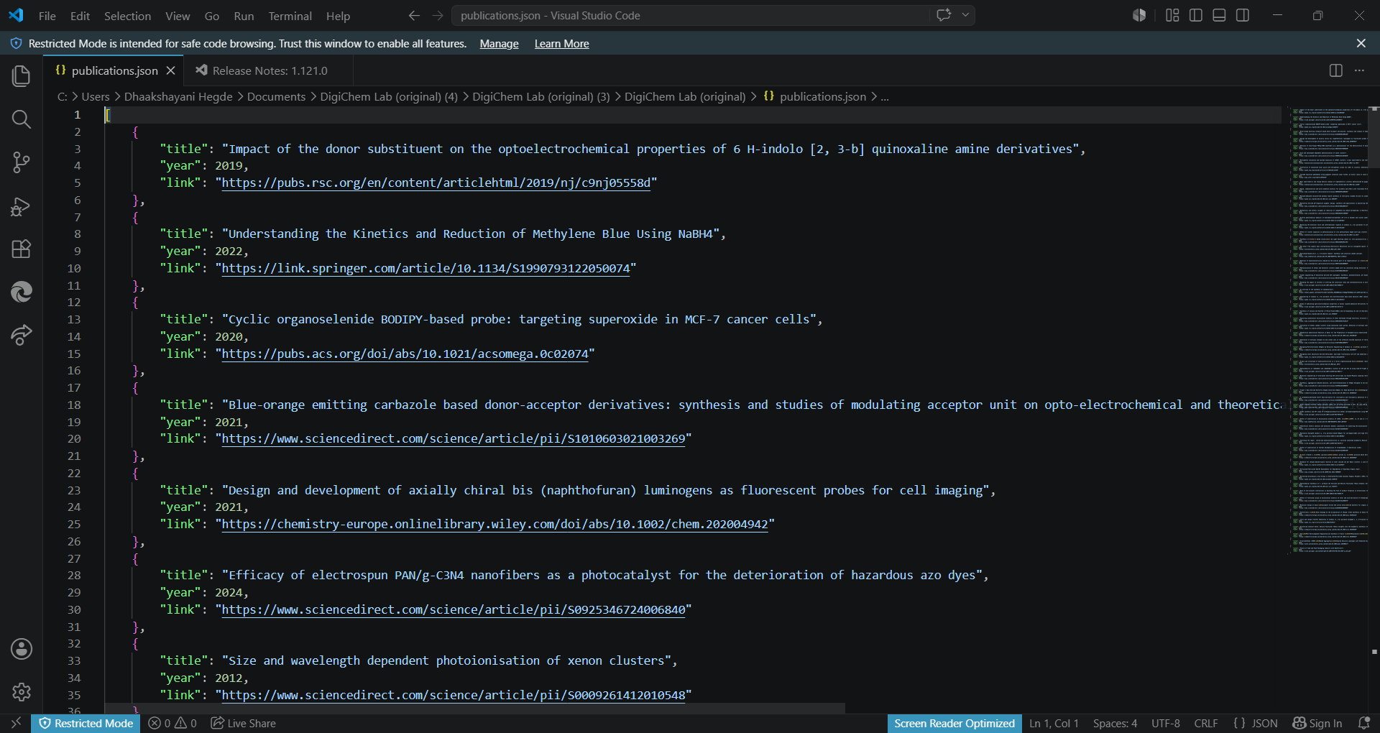

Collaboration Page
This manual explains how to update the text, links, buttons, and cards on the Collaboration page of the DigiChem Lab website (the file named collaboration.html, collaboration.css, collaboration.js).

1. Navigation Menu
This is the bar at the very top of the page containing the DigiChem logo and the "Menu ▾" dropdown, which lets visitors jump to any other page on the site.

Add, Remove, or Rename a Menu Link
File: collaboration.html
Find this in the code:
<div class="dropdown">
<button class="dropbtn">Menu ▾</button>
<div class="dropdown-content">
<a href="index.html">Home</a>
<a href="about.html">About</a>
<a href="research.html">Research</a>
<a href="projects.html">Projects</a>
<a href="team.html">Our Team</a>
<a href="facilities.html">Lab Facilities & Tools</a>
<a href="publications.html">Publication</a>
<a href="contact_us.html">Contact Us</a>
</div>
</div>
- To RENAME a link, change only the visible words between > and < (for example, Our Team).
- To REMOVE a link, delete its entire line, from <a to </a>.
- To ADD a link, copy an existing line, paste it as a new line, then change the page file name in quotes and the visible words.

2. Collaboration Cards
There are three cards on this page — Academic Research, Industry Collaboration, and Student Opportunities — each with a number, an icon, a small tag, a title, and a short description.

Edit a Card's Tag, Title, or Description Text
Find this in the code:
Each card has its own tag, title, and description. Search for the wording you want to change:
<span class="card-tag">Research</span>
<h2 class="card-title">Academic Research</h2>
<p class="card-desc">Joint research projects in computational chemistry and
AI — working at the frontier of scientific discovery.</p>
Card 2 (light blue):
<span class="card-tag">Industry</span>
<h2 class="card-title">Industry Collaboration</h2>
<p class="card-desc">Applications in spectral analysis, chemical data
processing, and automation — bridging science and enterprise.</p>
Card 3 (navy):
<span class="card-tag">Students</span>
<h2 class="card-title">Student Opportunities</h2>
<p class="card-desc">Internships, research projects, and thesis work —
empowering the next generation of researchers and innovators.</p>
- Tag (small label): edit the text between <span class="card-tag"> and </span>.
- Title: edit the text between <h2 class="card-title"> and </h2>.
- Description: edit the text between <p class="card-desc"> and </p>.

Add a New Card
Find this in the code:
Find one complete card block to use as a template — the entire section from <div class="card card-white"...> down to its closing </div>:
<div class="card card-white" onclick="ripple(this)">
<div class="card-shimmer"></div>
<div class="card-deco card-deco-1"></div>
<div class="card-deco card-deco-2"></div>
<div class="card-num">01</div>
<div class="icon-wrap">
<svg viewBox="0 0 24 24" ...> ... </svg>
</div>
<span class="card-tag">Research</span>
<h2 class="card-title">Academic Research</h2>
<p class="card-desc">Joint research projects in computational
chemistry and AI...</p>
</div>
- Select and copy one entire card block (from its opening <div class="card ..."> to its matching closing </div>).
- Paste the copy directly after the last card's closing </div>, but still inside the outer <div class="cards"> ... </div> wrapper.
- In your new card, update the number, the tag, the title, and the description text as shown in Tasks 3.1 and 3.2.
- Leave the icon (the <svg>...</svg> block) as it is, unless you are also completing Task 3.5.

3. “Start a Conversation” Enquiry Form
Clicking the call-to-action button opens a pop-up window (a "modal") containing an enquiry form. Visitors fill this in and it is emailed to the lab.

Edit the Form Window Title
Find this in the code:
<div class="email-modal-header">
<h3>Start a Conversation</h3>
<button class="email-modal-close" onclick="closeEmailModal()">&times;</button>
</div>
- Edit only the text between <h3> and </h3>.

4. Email Delivery Settings
This setting controls where enquiry form submissions are delivered

Reference Only EmailJS Connection Codes
File: collaboration.js
Find this in the code:

const EMAILJS_CONFIG = {
publicKey: '7WbiGKQP6WXStFQQT',
serviceID: 'service_zp09wna8y',
templateID: 'template_q5q7b8k'
};

emailjs.init({ publicKey: EMAILJS_CONFIG.publicKey });

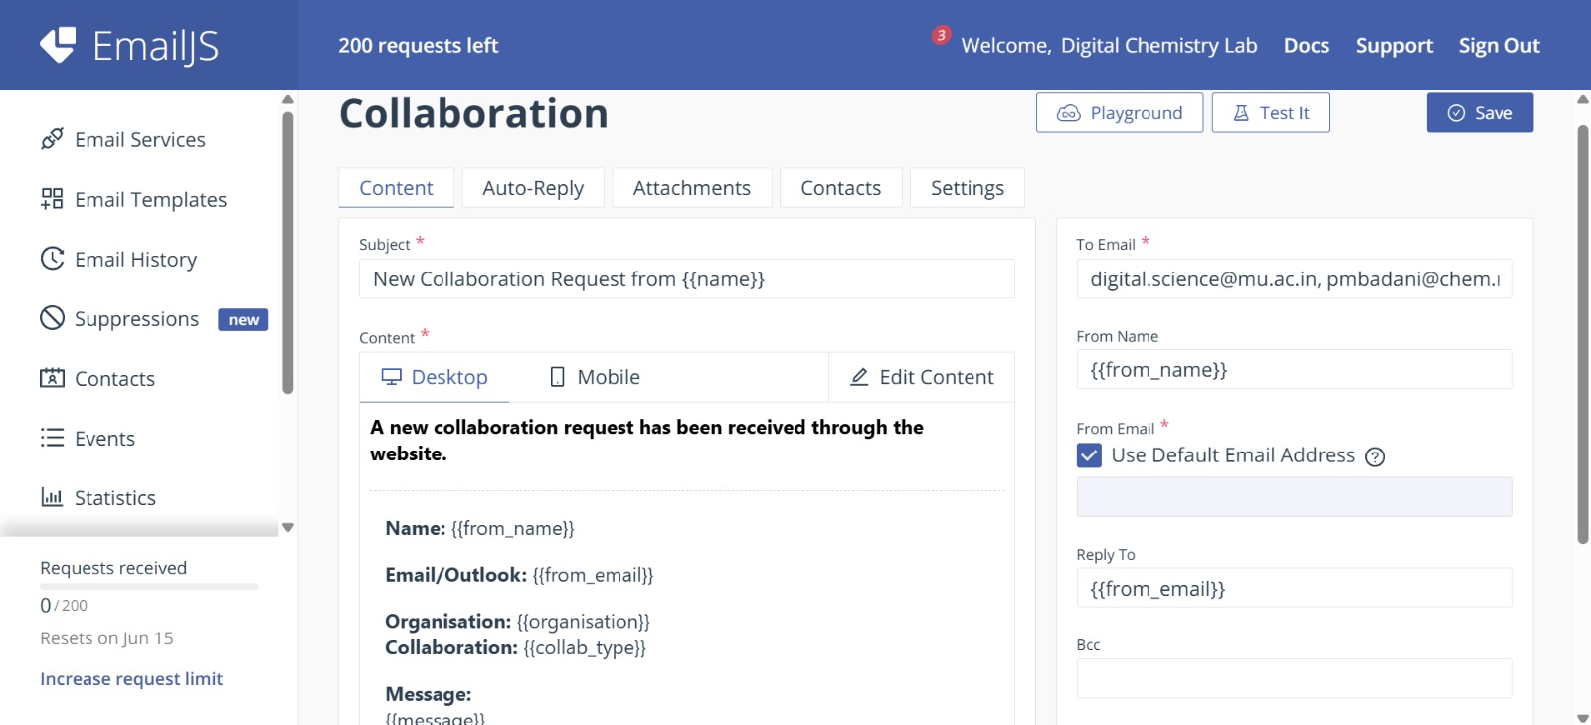
IMPORTANT: Do NOT edit these three codes. They connect the enquiry form to the email delivery service (EmailJS). Changing or deleting even one character will silently stop all Collaboration form enquiries from being delivered — visitors will still see a “Sent” confirmation, but the lab will never receive the message.

