Have you ever wondered how financial systems adjust to market dynamics and consumer behavior in real time? They process vast amounts of data and using robust rules engines make critical decisions without the end user ever noticing. The rules engine use semantics similar to if/then statements found in your favorite programing language to evaluate data against predetermined conditions before arriving at a decision. Each transaction must flow through a set of complex rules and conditional checks before an action can be taken.

Lets look at a simple example. If Sarah is purchasing an item which costs less than $100 and the date of the transaction is today and she has been a customer of her credit card provider for longer than 5 years, then the system is authorized to offer Sarah a 15% discount on her purchase.

Traditionally, the rules guiding the decision process were hardcoded in the software, making it difficult to quickly adopt to changing business needs. More recent systems use configuration files to provide some level customization but made the system more difficult to maintain at scale.

The main components involved in the rule engine framework could be depicted as per the below diagram

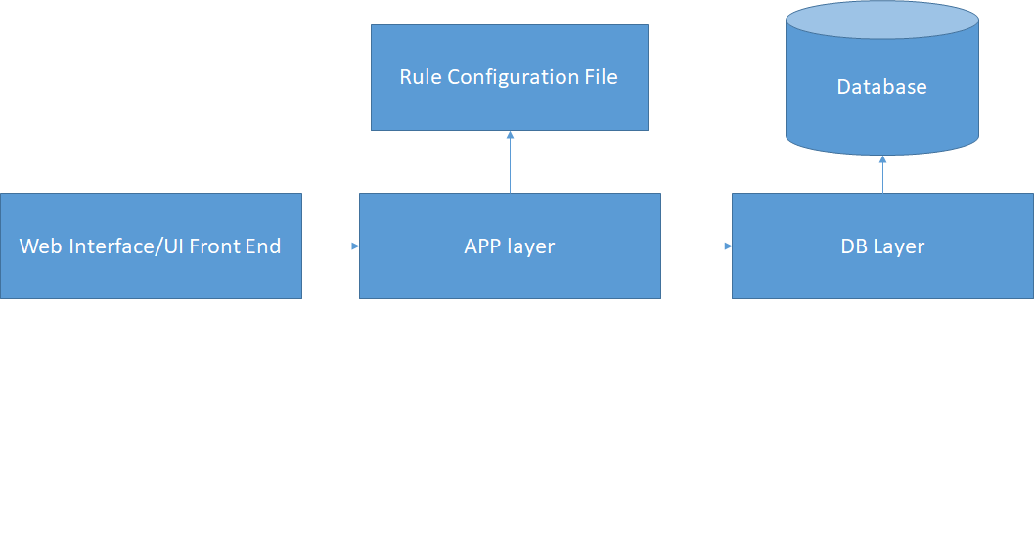

The Main steps and flow involved as per the above framework are depicted below

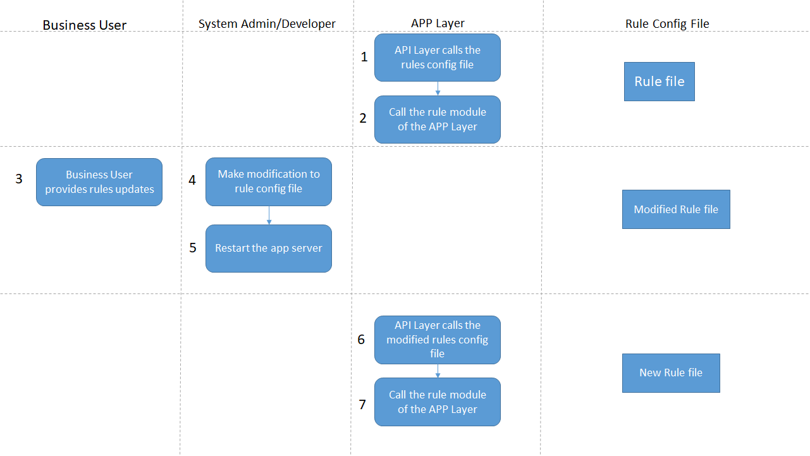

To improve these systems system designers developed rule engine frameworks that allow for better flexibility, shorter deployment cycles and simpler manageability at scale. The following diagram shows a simple rules engine design. Rules are defined by the business and implemented by engineers using a set of tools provided by the rule engine framework. The engineers and analysts continuously update and optimizes these rules to yield the best outcome for the customer and the business.

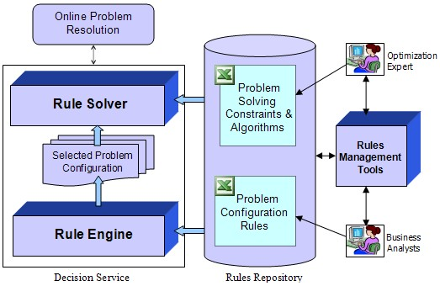

The following diagram shows how rules are created and executed by the framework.

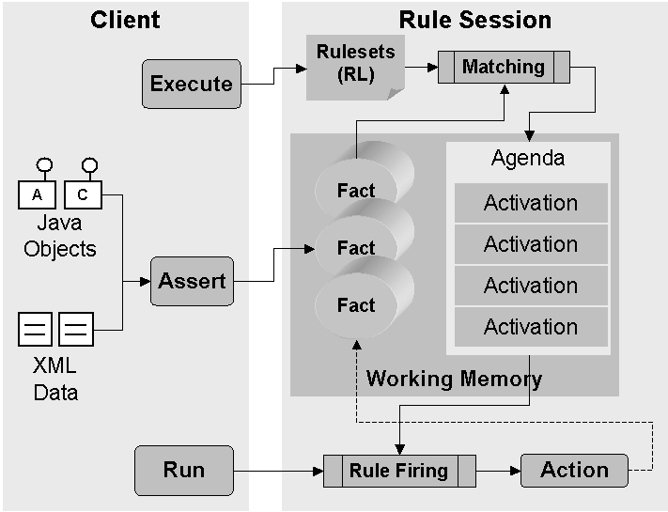

1. An Engineer using a rule authoring tool creates a rule object comprised of relevant business and technical parameters getting inputs from Data Model. Business Analyst uses the Rules authoring tool to create rules on these objects .
2. Rules that have been created and are published and stored in a central repository.
3. Rules rarely stand alone. Typically rules will be chained together in a dependency hierarchy that enable the user to describe complex business conditions.
4. Rules may be staged either client or server side. Each has its own set of pros and cons, but the industry is moving toward server side hosting due to flexibility and cost savings.
5. The rules engine would execute the flow, including its dependencies and associated parameters.

Lets elaborate the same using credit card credit check rules example as below with a process flow

The perquisite step is to identify the Model Objects, which are called the Rule Objects needed to execute the rules. In the credit card example case it would the Credit Card, Account, Customer, Transaction objects. And then create rules on these objects. Lets create a simple rule for credit card.

General Rule object template would be like this

Object Name{

Object field1:

Object field2:

Etc ……

}

In this case as it is CreditCard we can name it as CreditCard Object

CreditCard{

CreditCardName:

CreditCardExpDate:

CreditCardLocation:

CreditCardPoints:

}

The object parameters would have comparison values for these fields and rules could be and /or of these fields comparison.

For example Rule 1 could be like this CreditCard.Location == India and CreditCard.Points ==100 then Discount Value is 10%.

Then next rule could be CreditCard.ExpDate < Nov 2025 and CreditCard.Location in Bangalore then Discount is 10%

Rule flow chart could be as below

For example

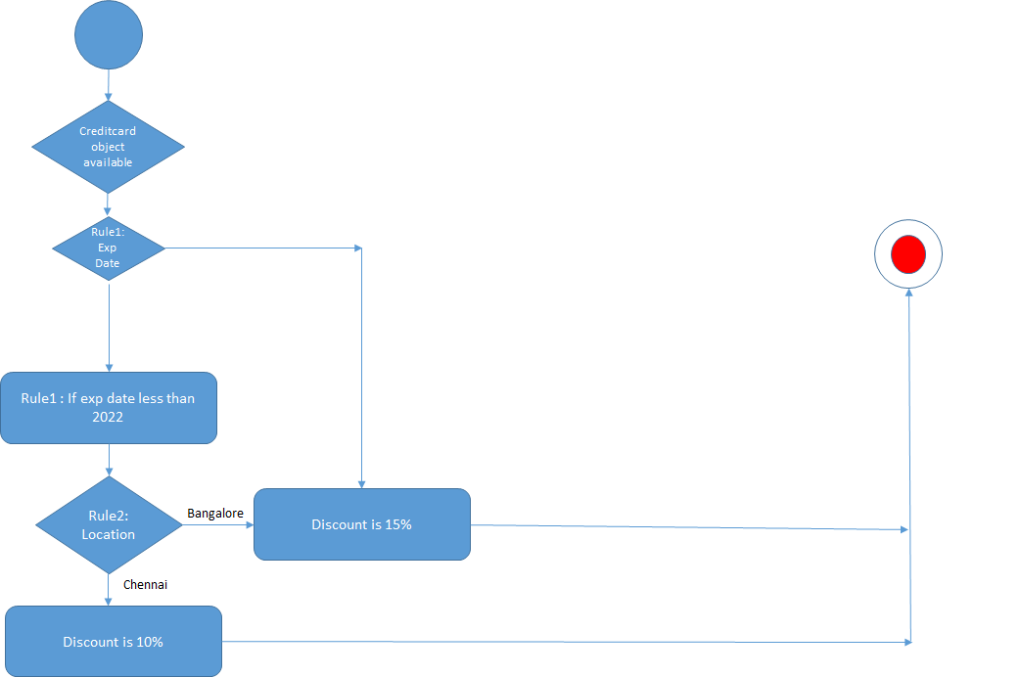

The diagram above demonstrates how to arrive at a decision whether a grower is covered by the Produce Rule. There are several conditional rules that determine the outcome. A rules engine will encode the questions at each step as rules with a binary, true or false, outcome that will lead to the next rule until a decision is made.

So, what’s wrong with this design? All of the rules, parameters and dependencies are hardcoded making it very difficult to maintain and adopt to new business requirements.

# A decoupled rules engine

To overcome these challenges, we need to decouple the execution engine from the rule definition, dependencies and configuration parameters.

The most critical features in Decoupled Rule engine as MVP are

1. Robust Rule Authorization and Rule Editing
2. Rich Business interface with workflow management
3. Intelligent Rule engine to apply the filter and predicates or skip conditions.
4. Rule versioning/history and Rule Maintenance
5. Rule Execution – Simple and Complex Rules ( Rule chaining )

As Building a Rule engine is a Product by itself, this blog provides a high level overview of the above points and an implementation and framework example for Simple Rule Execution.

Combining the advantages of Decoupled Rule Engine, let’s see how that can be achieved by using the server less technologies on AWS.

The below steps provide guideline and a high level framework for Rule Authoring and Rule Execution

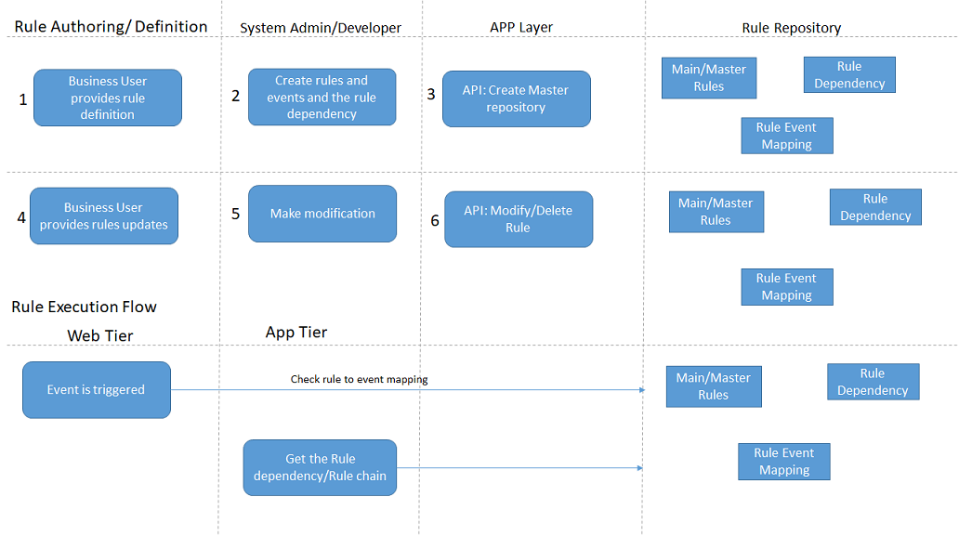

The below is an architecture to implement the execution of Simple Rule Execution

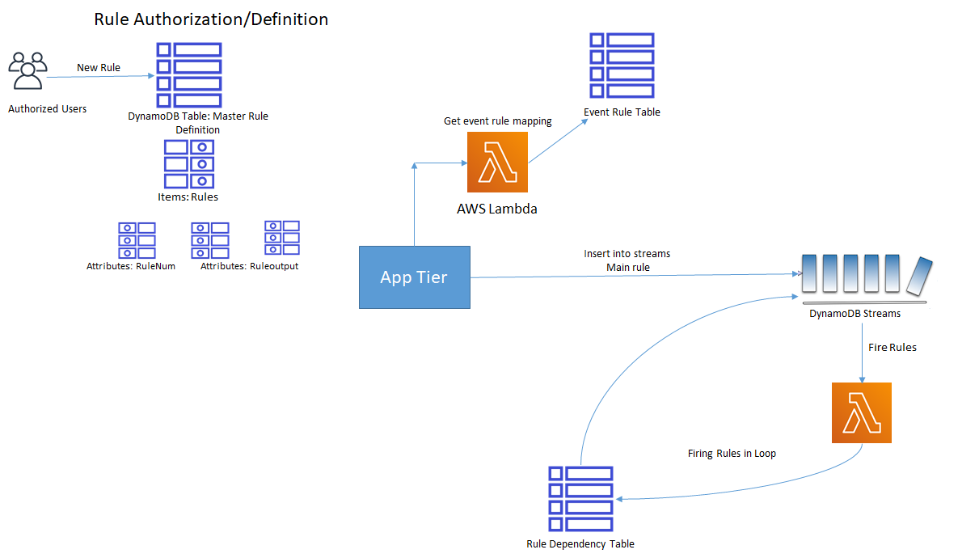

We chose to use Amazon DynamoDB, a fully managed and highly scalable key/value store, to hold our rule definition, dependencies and the results of executing each rule. We also chose to use AWS Lambda, a serverless execution environment giving users choice in programing language and complexity of the rule’s logic. Event generation is mimicked using inserts into the streams table which initiates the Rule execution.

## Executing rules

1. Rule Authorization is done by System Admin, Business user would provide the values and the rules can be created into the Main Rule table by System Admin.
2. Event triggered in the APP layer could be initiation of the rule flow. For example events could be, debit in the account or transfer of amount from account. These could be the types of events. Each of the event could be associated with rule and can trigger a rule flow.
3. The Main rule table consists of all the rules and rule chain/dependency.
4. Based on the event and rule combination, the rule is selected which needs to be triggered. The event in the second step would decide which rule to be executed. This is stubbed using a direct insert into streams table which triggers the entire rule execution flow, which is carried out in the next step.
5. The triggering of the rule happens through insertion into DynamoDB Streams Table.
6. An entry is made into the streams table with the rule number based on the event rule dependency. In this it’s a simple write to table, which can be later integrated and encapsulated as a module to trigger this rule flow.
7. A new stream record is written .
8. New stream record triggers lambda (firerule)
9. The lambda logic is as below

Get the rule number from stream record.

Execute the rule searching in rules table

Output execution in execution table.

Search in dependency and write next entry into streams table.

If there dependency table as stop, don’t write any entry into streams table and write to final output table.

Write to final output table which is streams enabled.

1. Final output stream triggers lambda (sendOutput)

# Setup

The first thing we need to do is setup a few tables in DynamoDB.

## Rules table

Using the AWS CLI create the rules table as follows:

aws dynamodb create-table --table-name RuleTable --attribute-definitions AttributeName=RuleNum,AttributeType=S AttributeName=Code,AttributeType=S AttributeName=Lang,AttributeType=S --key-schema AttributeName=RuleNum,KeyType=HASH AttributeName=Code,KeyType=RANGE --provisioned-throughput ReadCapacityUnits=5,WriteCapacityUnits=5

This table has three attributes, 1) a rule number which is a unique identifier for this rule, 2) function name or URL path which points to a file on Amazon S3 containing rule logic to execute and 3) the programing environment to instantiate on AWS Lambda when executing the rule.

For example:

1 , func1 , nodejs  
2 , func2 , nodejs  
3 , s3://bucket/rules/python/rule3.py , python

## Dependency table

Lets use the AWS CLI again to create a table that will hold the dependencies between the rules

aws dynamodb create-table --table-name DepTable --attribute-definitions AttributeName=RuleNum,AttributeType=S AttributeName=Output,AttributeType=S --key-schema AttributeName=RuleNum,KeyType=HASH AttributeName=Output,KeyType=RANGE --provisioned-throughput ReadCapacityUnits=5,WriteCapacityUnits=5

This table also has three attributes, 1) a rule number representing the rule to execute first, 2) a boolean condition representing the results of executing the rule and 3) the number of the next rule to execute if the condition is met. The next rule to execute may also be a stop keyword that will result in terminating the rule execution.

For example:

1 , success , 2  
1 , failure , 3  
2 , success , stop  
2 , failure , stop  
3 , success , stop

## Streaming table

This is a DynamoDB streams table where the first rule gets inserted and then would trigger the lambda function which can complete the rule cycle by reading from the above dependency table and execute the rule cycle.

Sample entry to stream table could be

3 func1 nodejs

## Results table

The Lambda would record the values for the rules and rules executed into this table. This table would work like an audit table to record the rules output.

1 Executed success

3 Executed failure

4 Rerun success

## Rules execution

Now that the different tables have been created we need to define our AWS Lambda environment that will consume our rules, execute them and update the results back to the results table in DynamoDB.

Create a file on your local machine called *trust-relationship.json* and paste in the following statement:

{

"Version": "2012-10-17",

"Statement": [

{

"Effect": "Allow",

"Principal": {

"Service": "lambda.amazonaws.com"

},

"Action": "sts:AssumeRole"

}

]

}

Execute the following CLI command to create an IAM role for our AWS Lambda function to use.

aws iam create-role --role-name FireRuleLambdaRole --path "/service-role/" --assume-role-policy-document <file://trust-relationship.json>

Next create another file on your local machine called *role-policy.json* and paste in the following IAM policy:

{

"Version": "2012-10-17",

"Statement": [

{

"Effect": "Allow",

"Action": [

"cloudwatch:*",

"dynamodb:*",

"ec2:DescribeSecurityGroups",

"ec2:DescribeSubnets",

"ec2:DescribeVpcs",

"events:*",

"iam:GetPolicy",

"iam:GetPolicyVersion",

"iam:GetRole",

"iam:GetRolePolicy",

"iam:ListAttachedRolePolicies",

"iam:ListRolePolicies",

"iam:ListRoles",

"iam:PassRole",

"kms:ListAliases",

"lambda:*",

"logs:*",

"s3:*",

"tag:GetResources”

],

"Resource": "*"

}

]

}

Then execute the following CLI command to attach the policies to the role we created previously.

aws iam put-role-policy --role-name FireRuleLambdaRole --policy-name FireRuleLambdaRolePolicy --policy-document <file://role-policy.json>

From the AWS Lambda console, create a new function and select **Author from scratch.** Give it a name and select **Nodejs 10.x** as the runtime.

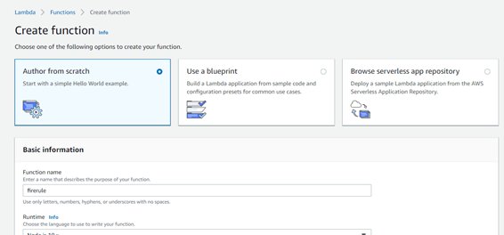

Make sure to also select the execution role **FireRuleLambdaRole** we created in the previous step.

Next you need to configure our Lambda function to trigger when new events are available in our DynamoDB streaming table. In the AWS Lambda console, choose the function you just created and configure a DynamoDB table trigger selecting the streaming table created in the earlier steps.

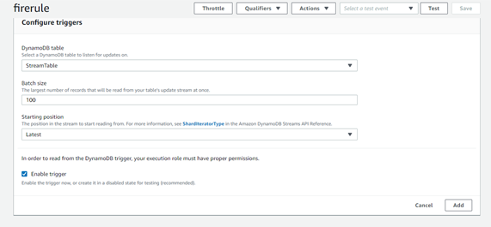

The rule functions can be embedded in a zip and configured as layers . This is one way of bundling the rule modules and calling from lambda.

The sample code snippet is posted using lambda layers

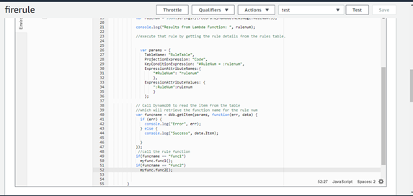

We are now finished with the setup and ready to test our fully decoupled rules engine.

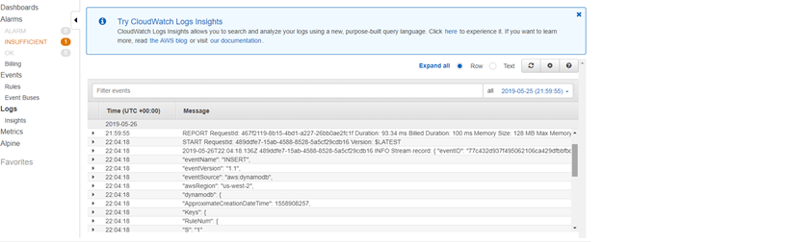

Further additions and consideration to the above architecture

The above decoupled rule engine architecture can be customized to respond both synchronously and asynchronously. Synchronous response is where the event triggered could fire a rule chain and wait for the rules results.

Asynchronous could be where the rule chain is initiated and the event flow isn’t blocked and asynchronously callback once the rule is executed with the output details.

Same architecture can be customized and extended if grouping of rules is needed. This can be executed by breaking the complex rules into simple rules as entries in DynamoDB Table or a single entry into the lambda code as a single rule.

# Conclusion

The above decoupled rule engine architecture tried to provide a high level framework to implement Simple rule execution using AWS Lambda and Dynamo DB on AWS. Using other services and with customizations other Rule Engine features can be implemented on AWS. For example, Business UI can be deployed Elastic Bean Stalk on ECS. Customizations are needed to connect to the Rule Model objects and workflow related setup.

As building the full Rule engine framework is a product by itself, the idea of the blog post was to introduce to the rule engine framework and how to implement a simple flow on AWS.