**Add to my Python Script**

My current script scrapes information from Rightmove’s API (without using a browser).

The additional work I need:

* After reviewing the code, you will see that one of the last steps for each search within each postcode is to select the lowest price property is display its price within the “output” Excel file.
* However, I need the script to select the lowest price property so long as it **DOESN’T** mention any words or phrases from a pre-defined list of words and phrases, stored in the “Words / Phrases” column of the “Banned” sheet of the input workbook.

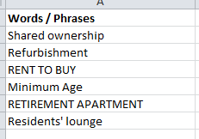

* If a listing does contain any of the words of phrases outlines in the column (as above) then the script will move onto the next lowest priced listing and again search to find these words and phrases. Once it find the the lowest listing that does not contain any of these words o phrases – this will be the listing it exports to the Excel file.

There are three places in each listing that the script must look to ensure none of the words or phrases are mentioned.

1/ Title

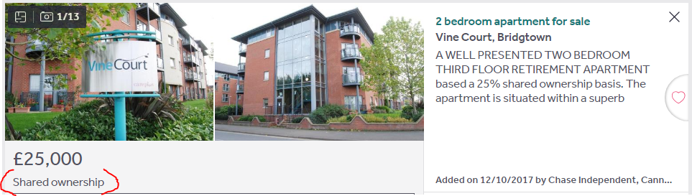

2/ Short description

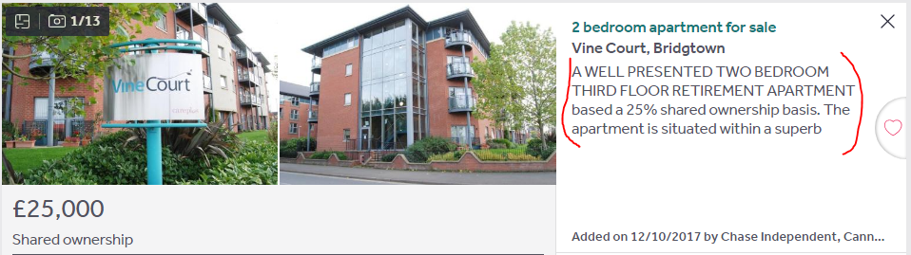

3/ Within the description tab (visible once you open the listing)

