Gruff Introduction Worksheet

Your Name: Ashish Mohapatra

Requires “camera.owl (may be found in Jena installation under …/src-examples/data/

- Display the “camera.owl” file inside Gruff as a graph. You will need to at least follow the instructions in Gruff’s Quick Start (which appears at startup). You may need to view some of the tutorials on the site: http://www.franz.com/agraph/gruff/
  - Use the “Display->Display some Sample Triples” menu item. Wait for it to stabilize (up to a couple minutes). Approximately how long did it take for the graph visualization to stabilize? 1 sec

- Learn how to expand the graph in the graph view and in the table view
  - Graph and Table View are Fully Inter-related
Remove all the nodes from the graph (using the Remove tab).
Add the Class node, using “Display->Display a type from all types”.
Select the Class node with left mouse, then Switch to Table view and use Shift-Left Mouse to select all the properties that use Class for “is Type of”.
How many items use Class for their type? 14
  - Return to the graph view (all the selected nodes should be showing, too). Expand the Graph using right mouse over various items.
What right mouse mechanism is being provided for the top option (Display a Linked Node from Menus)?

Answer Area: Display a Linked Node from Menus

- Learn how to read triples.
  - What items are a sub-class of “Purchaseable Item” (according to information in the Table view)?

Answer Area: Body, Camera, Lens

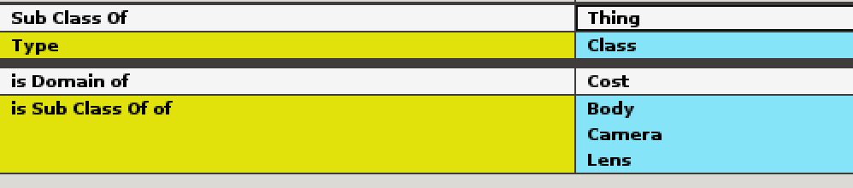

- Develop a hierarchy display
  - Remove all the nodes from the graph. Add the Window node (a class type).
Expand the graph fully down all SubClassOf paths:
On Global Options->Select Current Predicates, then just select:
Sub Class Of
As nodes appear (starting with “Window”), select them and right-click “Display Linked Nodes for the Current Predicate” until no more nodes appear.
  - Rearrange the graph to be hierarchical with “Thing” at the top or left.
  - Either provide a screen capture image in this worksheet (below) or depict the structure below.
Answer Area:
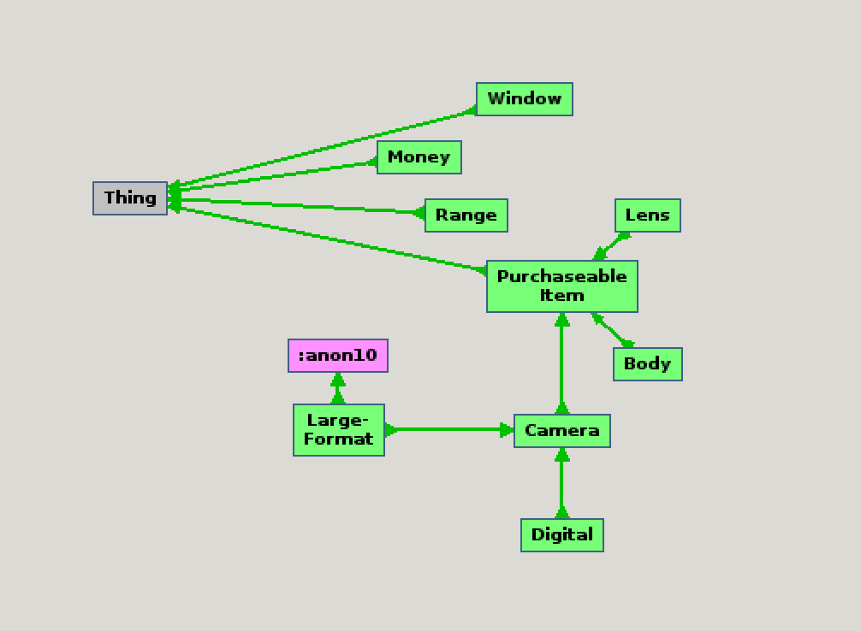

- Other Capabilities (put “X” by each as you do these):
X Double click a box to select and show in Table view
X Backup to prior screen in table view (large arrows near top)
X Use G and T key to swap between graph and table views
X Pin nodes so they don’t move
X Delete a single node with selection, then X
X Read full node or link name on bottom line (copy with ctrl-c)
X Find node on screen using string search
X Redraw graph with Layout->Redo Layout from Scratch (a couple times in a row)

Extra (no credit, not graded)
Are there any classes that do not derive directly (i.e. down a strict ‘SubClassOf’ path from Thing?
If so, what?

Answer : Camera class

