Step 1: Create a Google Form

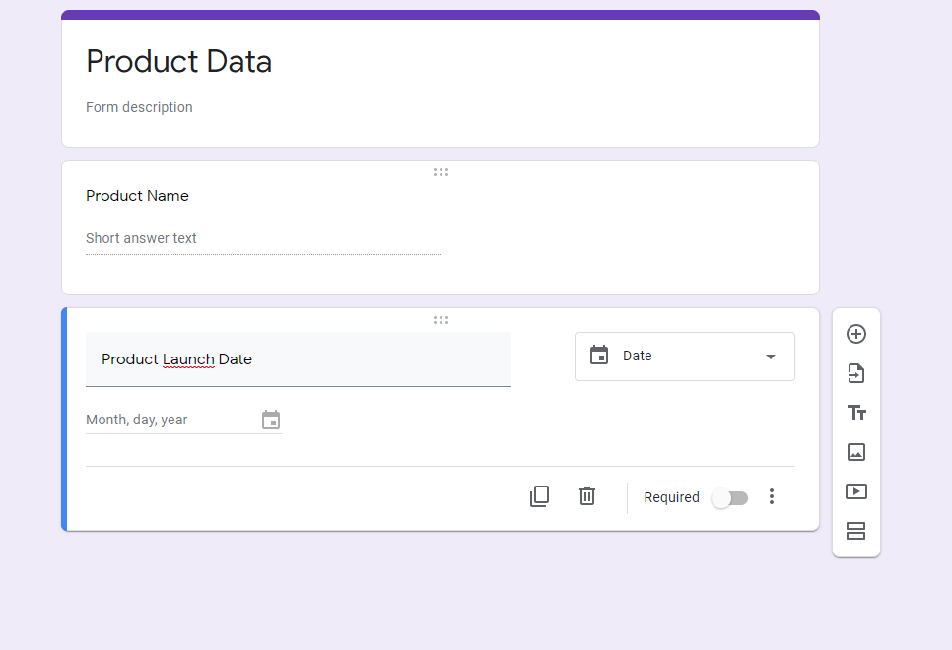

Step 2: Create a Google Sheet to hold the data collected in the Google Form

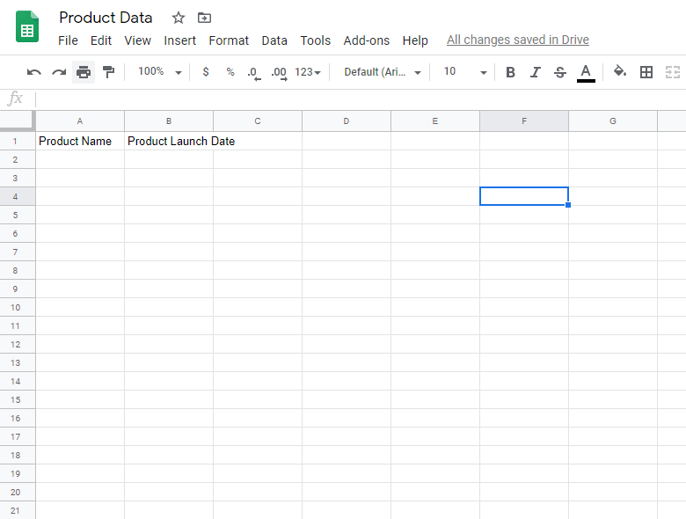

Step 3: Create Scenario in Integromat

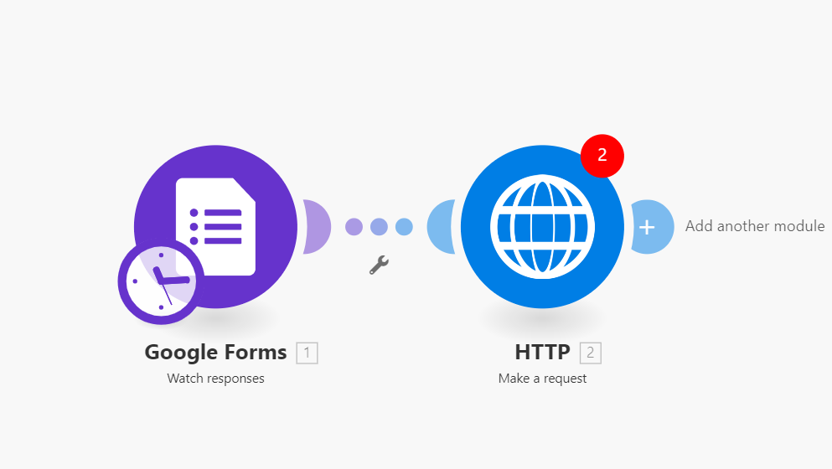

Step 4: Configure Google Form module

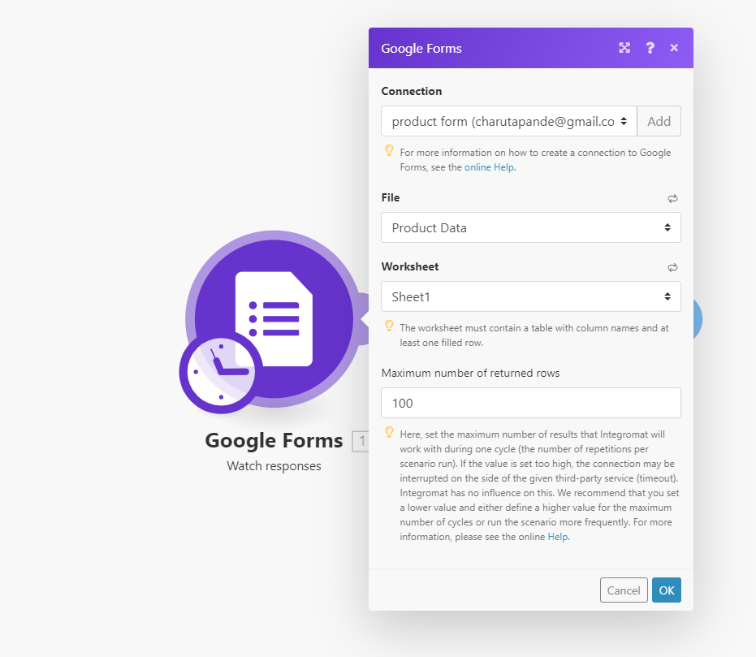

Step 5: Configure HTTP module

Refer: <https://docs.camunda.org/manual/latest/reference/rest/process-definition/post-submit-form/>

url (replace the highlighted part with your app name): https://limmat.herokuapp.com/rest/process-definition/key/Process_test/submit-form

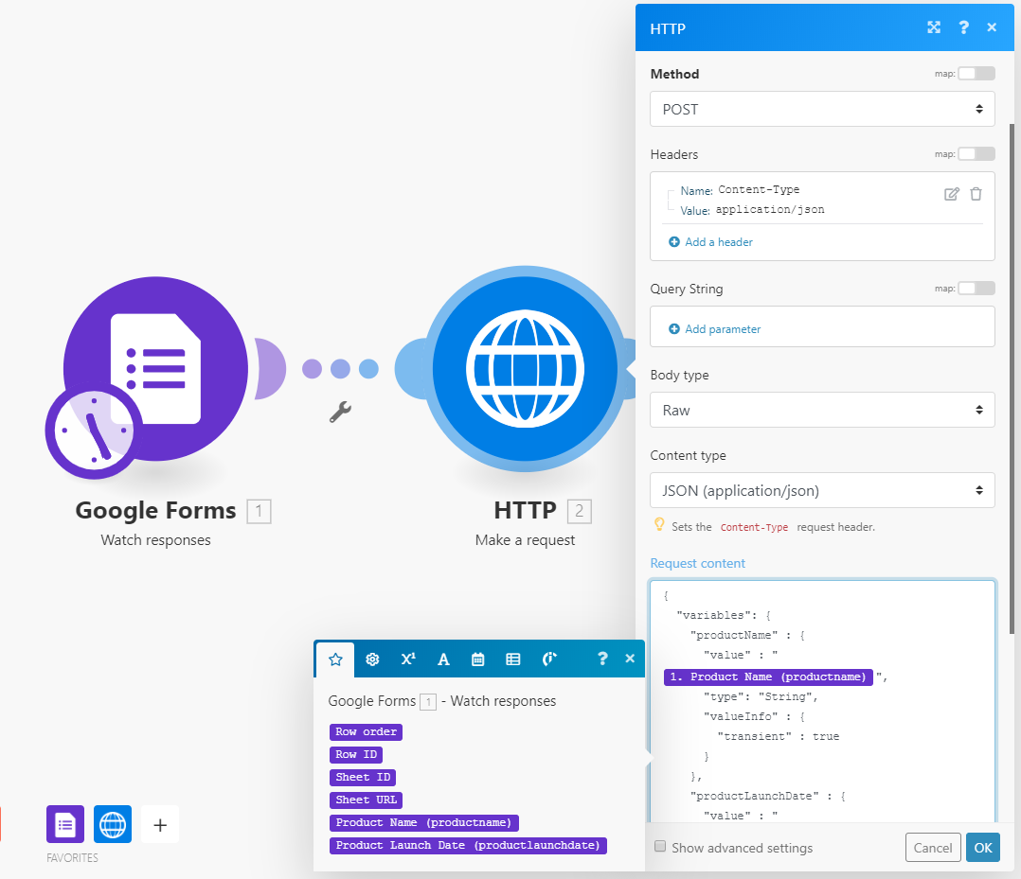

Testing

Step1: Start process using Postman

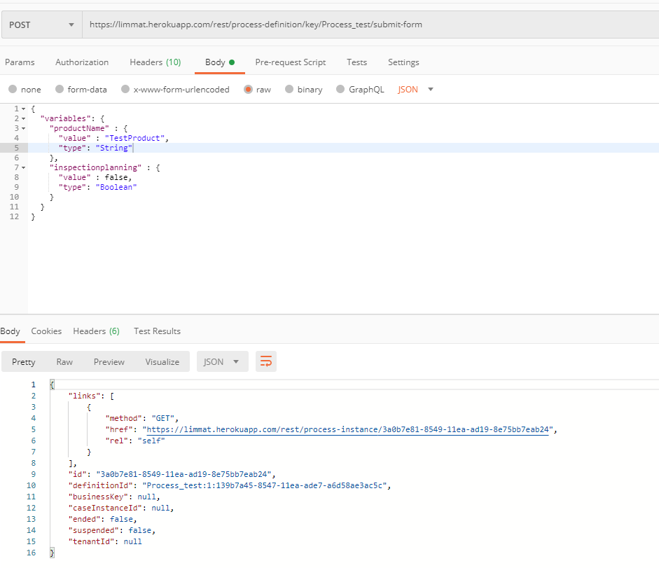

Step 2: Verify variable values in Camunda

