Digitalisation of the Ambulance Process

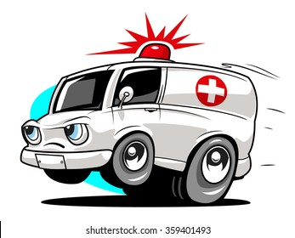

DigiBP AS21, Group project – **Team Echo**

**Jérôme Branny**

**Michèle Curiger**

**Adrian Hadayah**

**Xi Li**

Contents

1 Scenario 3

1.1 Brainstorming 3

1.2 Scenario 3

1.3 User-Centred Design 5

1.4 Benefits 5

2 Process Modelling 6

2.1 BPMN 6

2.2 Task & Roles 6

2.3 DMN 7

2.4 External Services 7

3 Interfaces 8

4 Service Integration 8

5 Decision Automation 10

6 Links To Our Completed Project 11

# Scenario

Create an innovative scenario with user centered design and show the benefits of the digitalization.

## Brainstorming

In OneNote, each of us wrote down our ideas for a process. Then we discussed all the proposed options and took a vote. In the end, the "Emergency Process" convinced everyone unanimously. It is an interesting topic, involves many decisions and has a lot of potential for digitalisation.

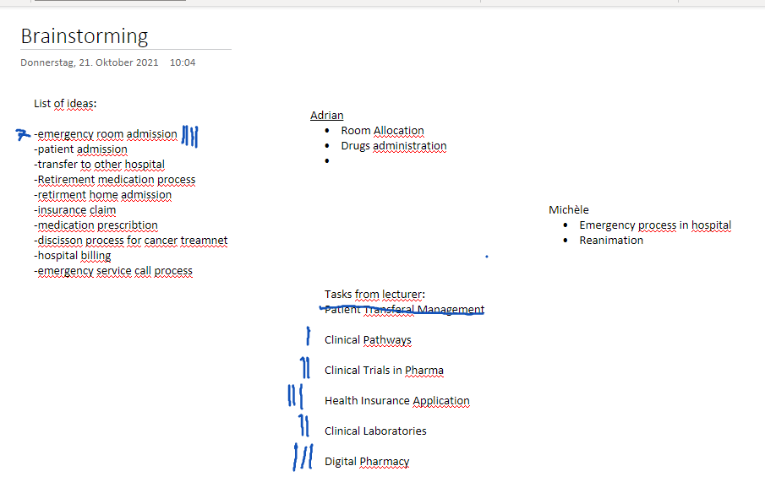

Figure 1 - Brainstorming

## Scenario

The ambulance process concerns the emergency call of an injured person, the pick-up by an ambulance, the triage and the subsequent emergency treatment in hospital.

Figure 2 - Scenario

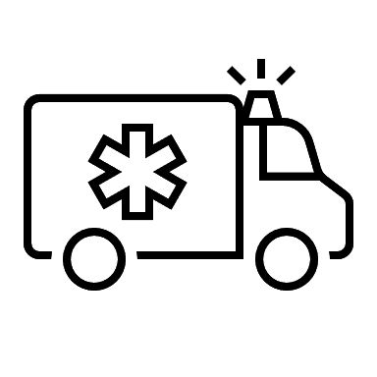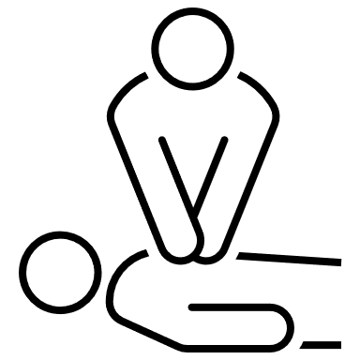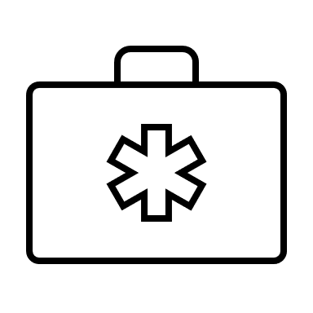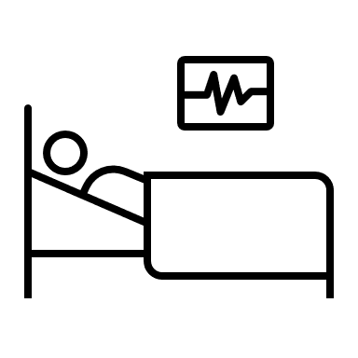

For this scenario we first created a step-by-step draft for the BPMN:

* Start-event: Emergency call
* Task: get patient information: address, symptom, localization, number of injured people
* Decision (DMN): is an ambulance needed at all? If no, terminate process; if yes, continue
* Decision (DMN): which ambulance and how many: according to location/availability (automated)
* Call-Service tells Ambulance if it’s big emergency (blue light) or not (normal driving)
* Paramedic does triage -> Decision first-aid or go back without patient
* Decision: which hospital? → Automate by selecting the correct hospital
  + Check insurance: hospital in the canton you have insurance (depending on severity)
  + Check nearest hospital
  + Check availability
* Drive back to hospital
* Paramedic gives doctor a briefing
* Bring patient to a room
* Get patients data
* Medical checks by experts
* Decision: Treat patient or send home or transfer to specialist hospital
* End-Events
  + Patient accepted for further treatment
  + Patient received exit form
  + Hospital received patient transfer agreement

What could be premature end points?

* The patient dies during the transfer
* The patient dies at the scene
* The patient does not need to go to the hospital
* False alarm

For the BPMN we need 4 lanes: **Patient** (Blackbox), **Paramedic, Doctor** and the local **Emergency Call Centre**.

## User-Centred Design

What can we automate?

* Automate the hospital choice (GPS)
* Automate the priority (how severe is the injury)

## Benefits

The digitisation of the ambulance process has several benefits:

The emergency call centre may be temporarily overloaded and the caller unable to be put through. By automating the call, the caller can order an ambulance without waiting.

A large amount of time is spent on decisions. for example checking where the closest hospital is and checking that has enough capacity. Through automation, a suitable hospital can be found in seconds.

By automating scores (for example the Triage), completeness can be guaranteed. When the paramedic fills in the form, no important information is forgotten and it is automatically sent to the right place.

# Process Modelling

Model the scenario with the appropriate standards and conventions in Camunda.

## BPMN

First, we created a detailed BPMN with different processes. This process was too complex to integrate I Camunda so we hat to cut it down to a smaller one pool process.

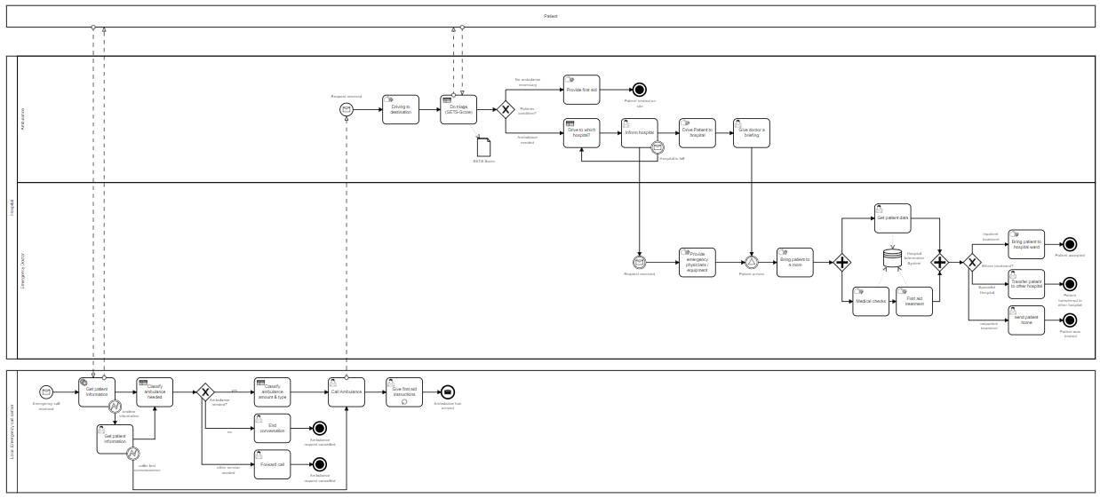After cutting down we had this process left:

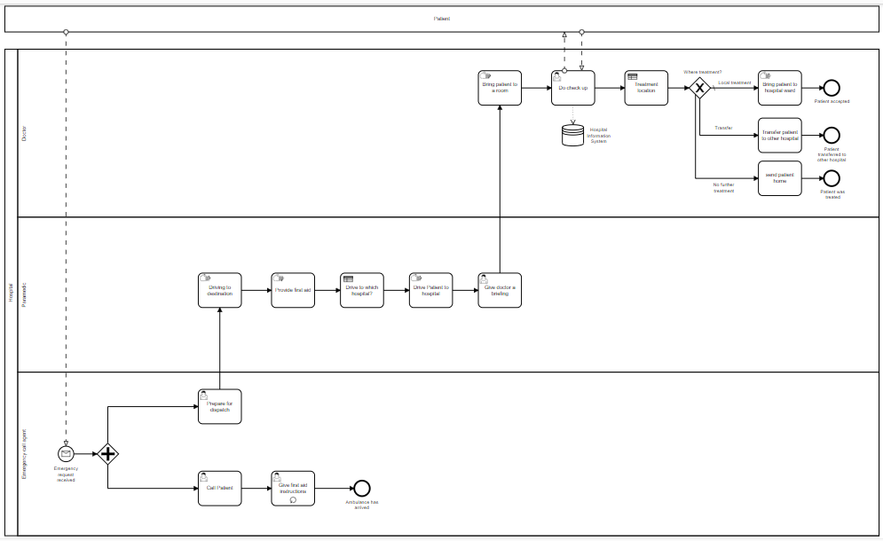

## Task & Roles

* Define and implement service tasks and roles - important
  + Paramedic, 144 Operator, emergency doctor

In this process we have 1 pool with 3 different lanes: emergency call agent, paramedic and doctor. The patient pool is shown as a black box. The process is triggered by using the chatbot.

## DMN

For our process we decided to do two DMNs. The first DMN decides to which hospital the paramedic should drive the patient. The decision is based on the patients age and location of the accident.

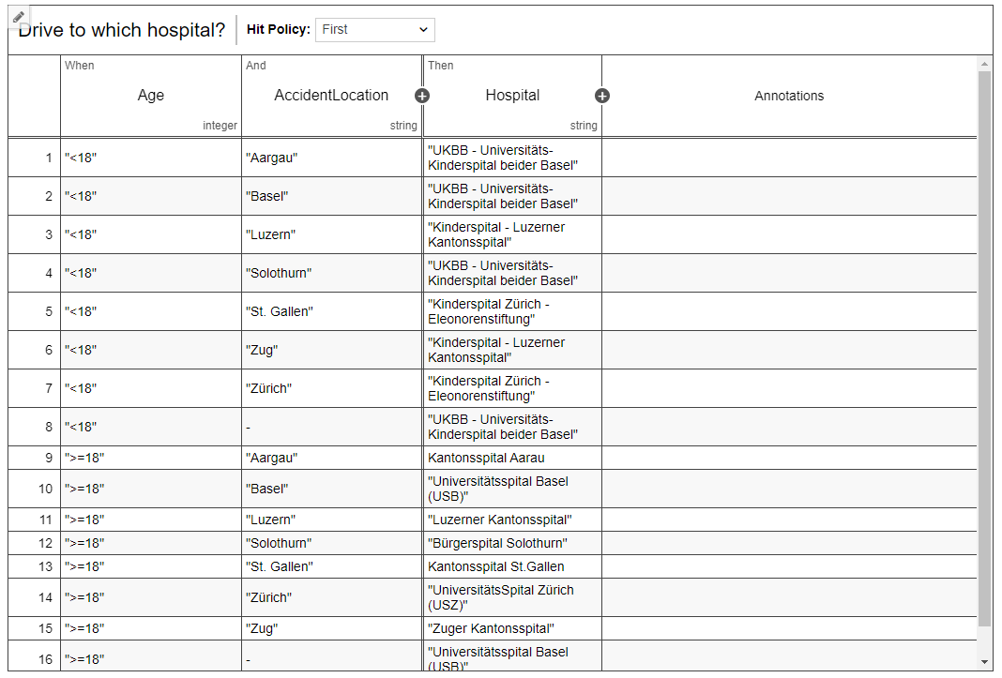

The second DMN is used in the hospital to decide where the treatment should happen. The decision is based on age, if an operation or monitoring is necessary and if we have a specialist in our hospital. There are 3 different output possibilities: local treatment, transfer or send patient home.

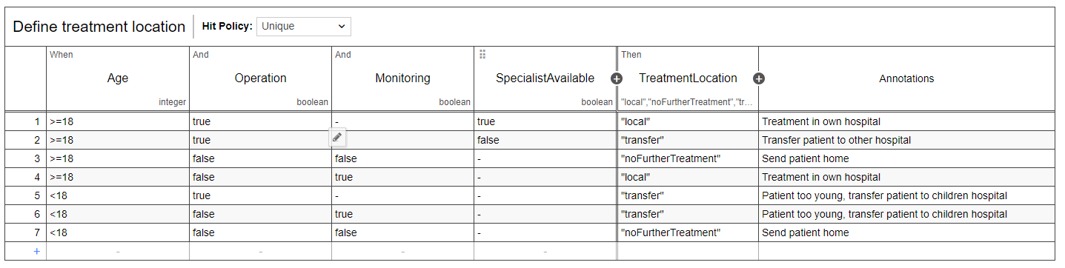

## External Services

* Selection and/or implementation of external services: Integromat, Google Dialogflow, Google Sheets, Google Maps, Appsheet mobile app, website.

# Interfaces

Use task interfaces with roles, forms and chat bot

Website with chatbot integration: <https://sites.google.com/view/digibp-echo>

* Design/Implement appropriate forms
  + Form for every decision (4 Decision Models + Chatbot for the caller)
* Implement forms into process flow (camunda + integromat)
  + Using App instead of a spreadsheet:

Link to use the app in the browser: <https://www.appsheet.com/start/d8319de6-210c-403e-84ba-f66f587d6f6b>

# Service Integration

iSaaS implementation (Integromat)

Tasks:

* Define external services which need to be used (e.g. DialogFLow, DMN,, Integromat)
* Implement external services
* Implement chatbotot with Google Dialogflow
* add severity

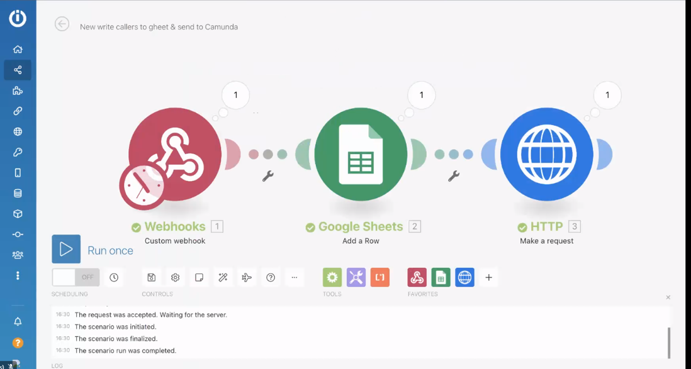

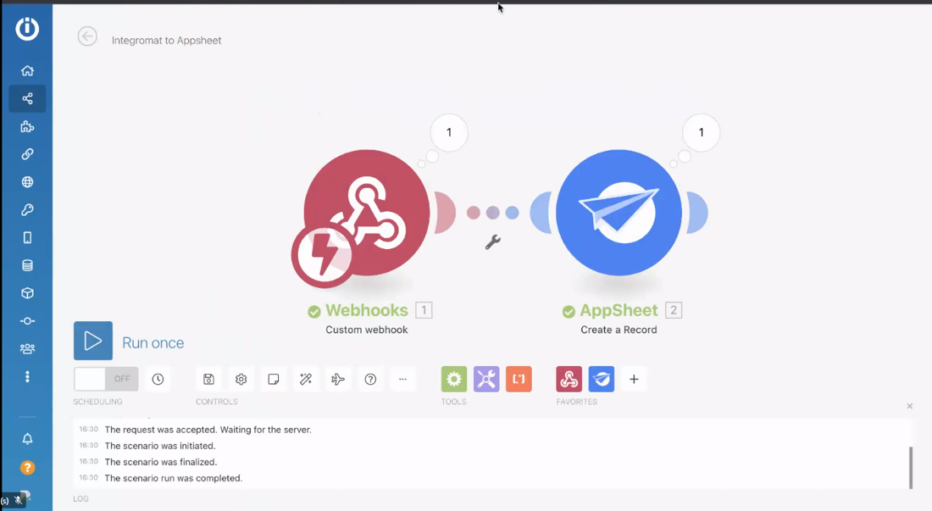

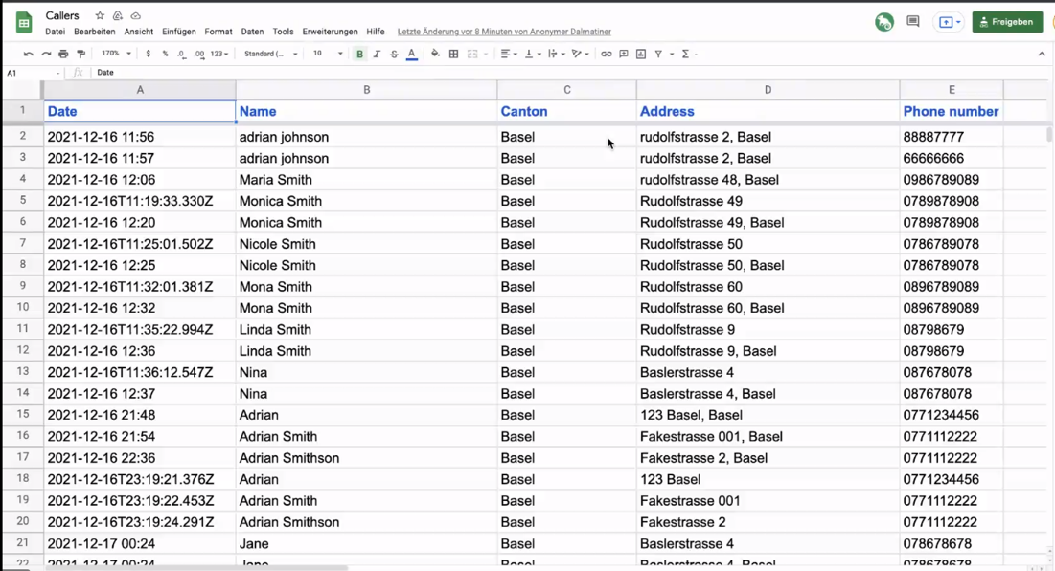

# Decision Automation

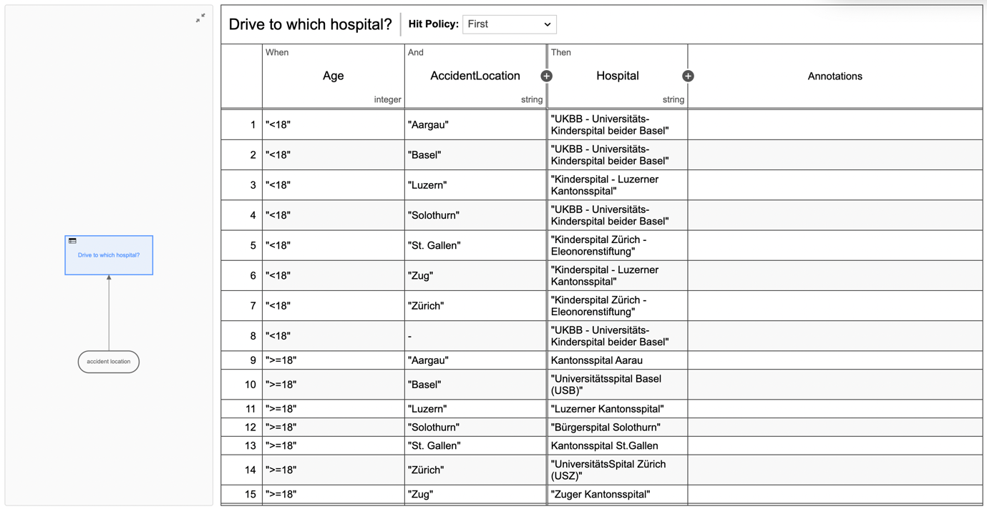

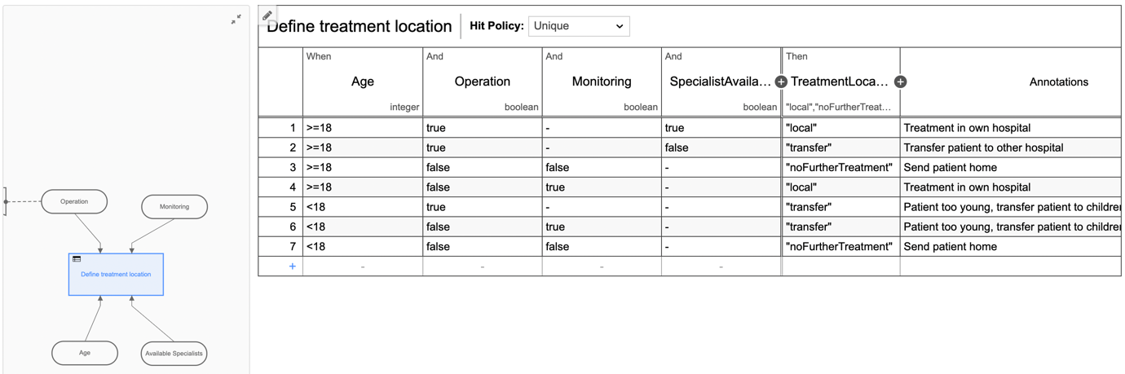

# Links To Our Completed Project

**Our video on SWITCHTube**

https://tube.switch.ch/videos/NBbokyjVC6

**DigiBP-Echo website**

https://sites.google.com/view/digibp-echo)

**Google sheet "Callers"**

https://docs.google.com/spreadsheets/d/1-ItPmNLtE1ge84TAZbSCsejQhcTdEIR421aFEsS-cC4/edit#gid=0

**App "Emergency Manager"**

https://www.appsheet.com/start/d8319de6-210c-403e-84ba-f66f587d6f6b

**Dialogflow**

https://dialogflow.cloud.google.com/#/agent/emergency-call-qhun/intents

**Integromat**

https://www.integromat.com

**DigiBP classroom instance**

https://digibp.herokuapp.com/camunda/app/welcome/default/#!/login)