Please import it as maven project. Check installation guide.

For the connector in the bpmn diagram please configure your URL from the Microsoft Web services for flow.

Got to Website :

https://flow.microsoft.com

Register as a new user.

Create a flow with request,create file (dropbox) and response.

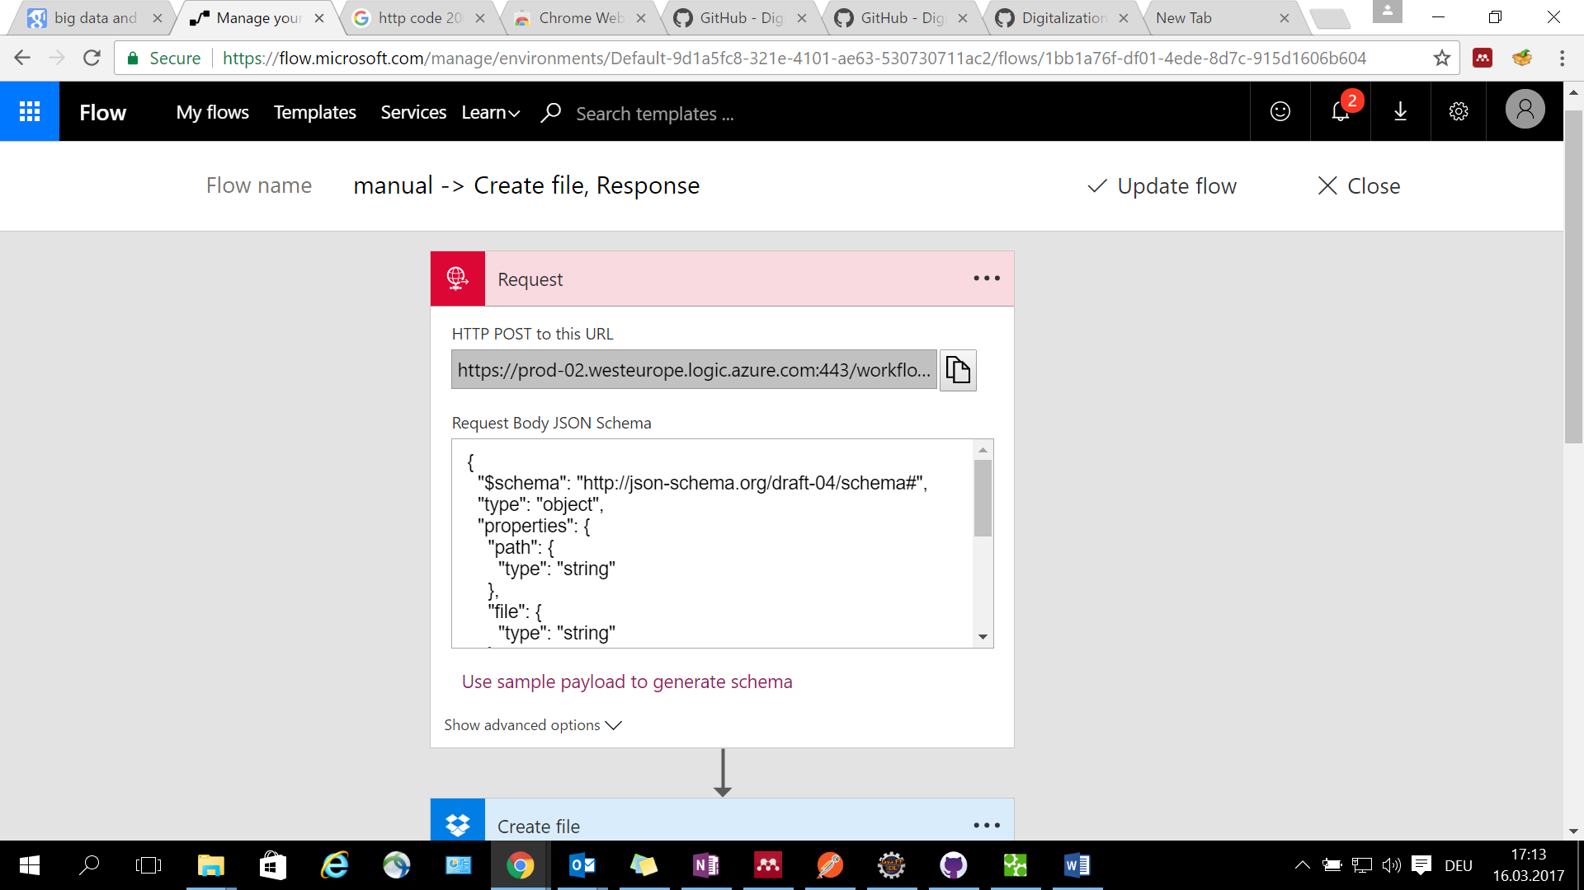

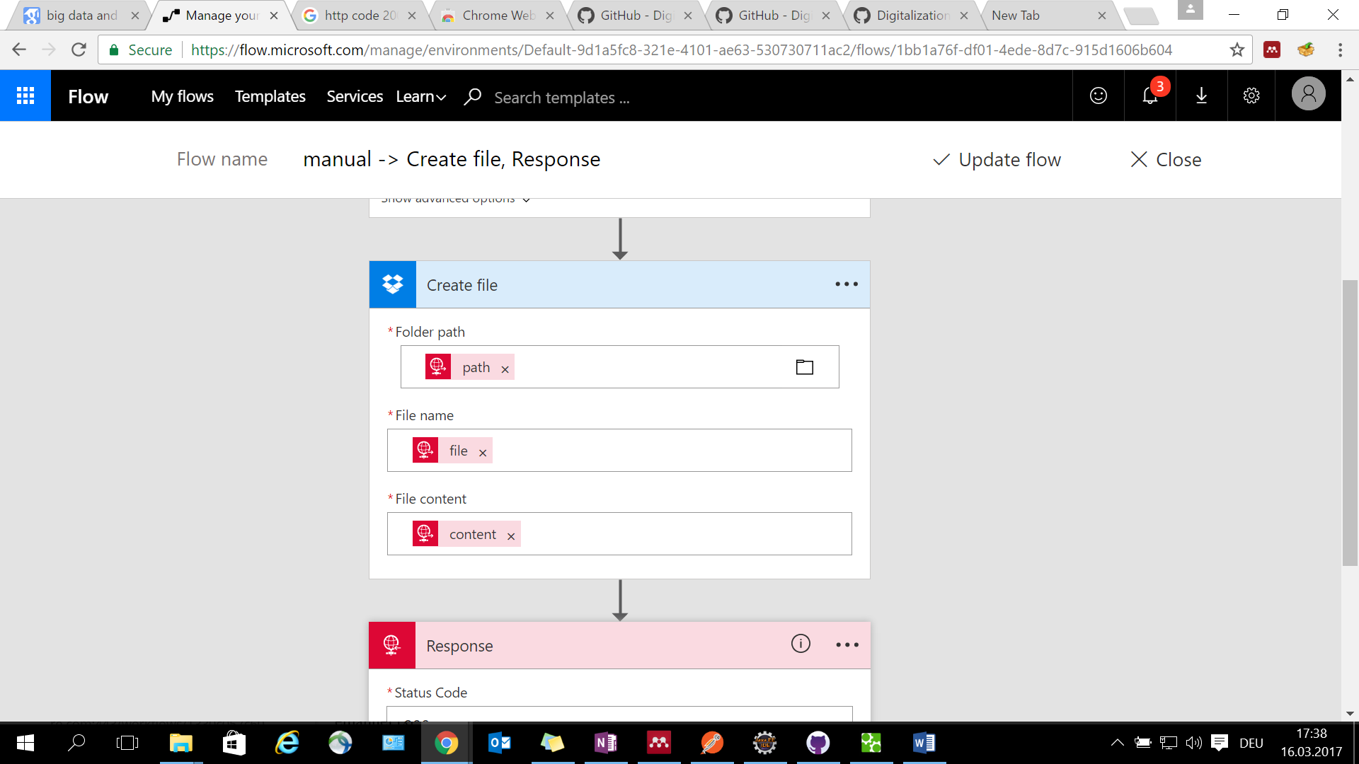

Give access to your flow to your dropbox account

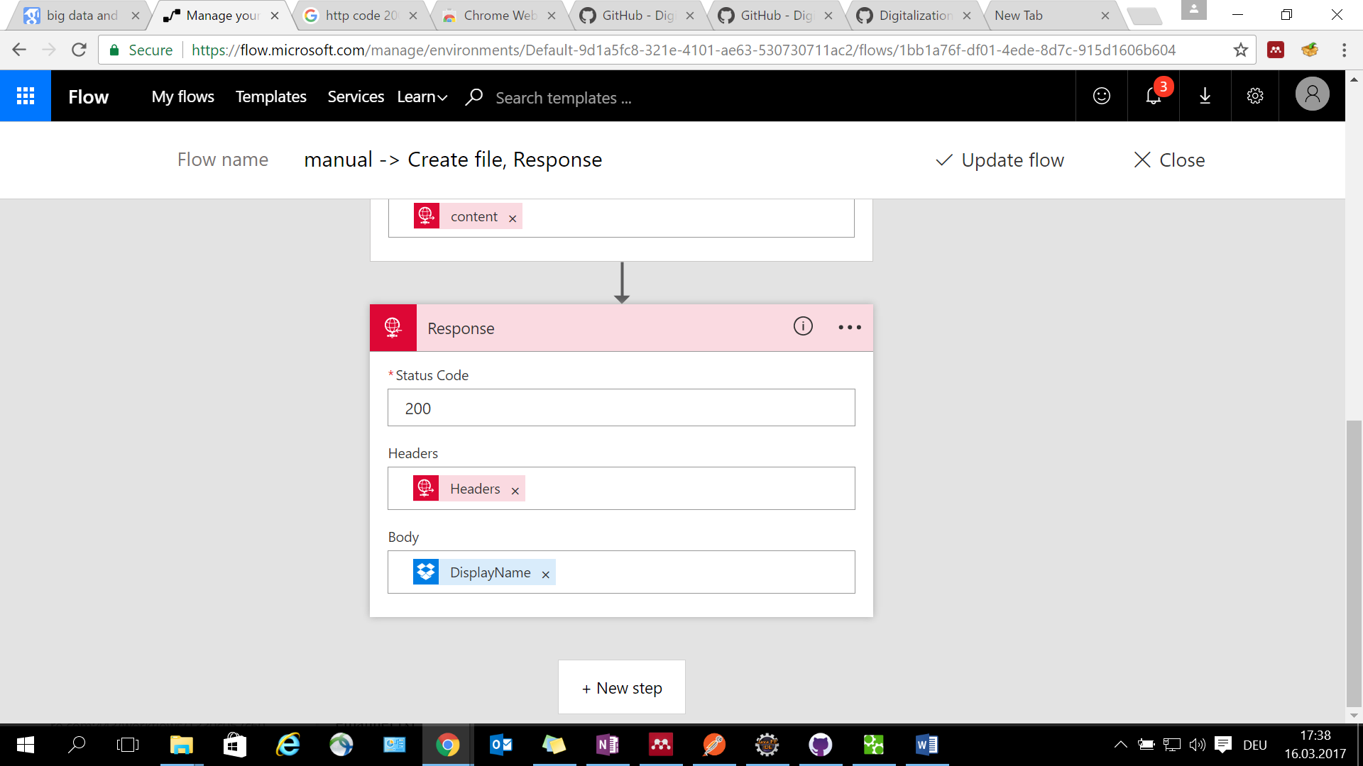

Once you save the flow you get the URL from the request object. Copy that URL and paste it in the URL section of connector of your service in dropbox bpmn diagram file.

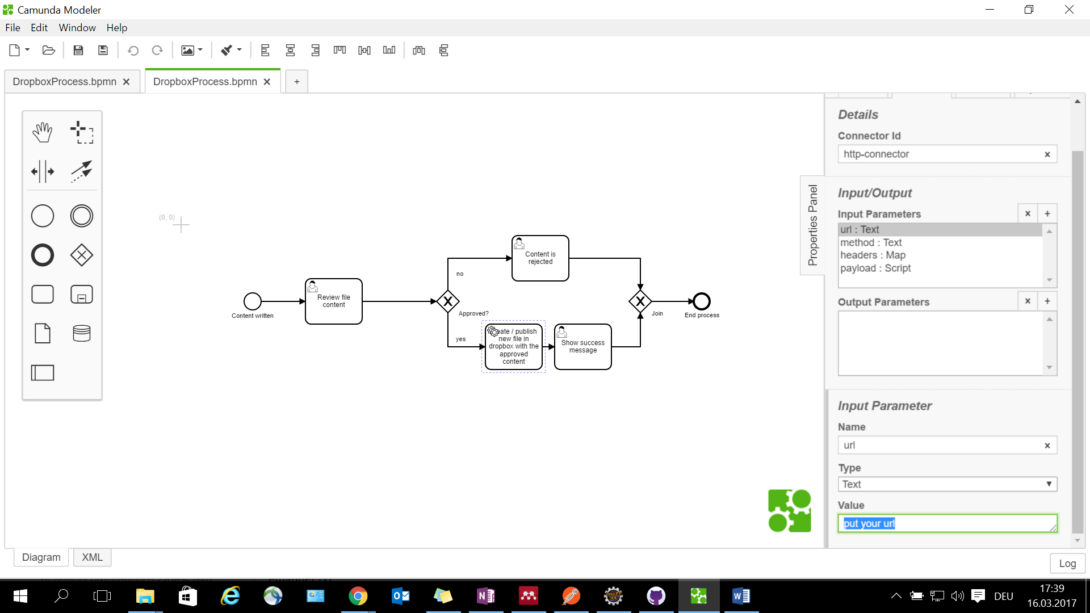

The other parameters are already configured.