This project is part of the course Digitalisation of the Business Processes at the University of Applied Sciences Northwestern Switzerland. In the progress of the course members could choose from a variety of given processes or come up with their own. Our project team has decided to come up with BananaAnalytics, a group that digitalizes analytical processes for audit companies.

# **About**

Originally, the analytical process is done by the audit firm. By automating this process, BananaAnalytics opens a new business because the entire process from the data request until the data delivery can be outsourced now.

As the user stories show xyz are the most inconvenient steps of the current process.

* Argue with user stories

The digitization of business processes, also in the audit business area, brings with it many new challenges and opportunities. The current audit approach and audit processing, e.g. through the use of standard structures, document checks and invoice-specific requirements, are very work-intensive and almost inefficient. In order to achieve the necessary complex regulations both from the point of view of the audit team and for the company to be audited, new support technologies are necessary for an efficient audit process.

To meet the necessary regular requirements, BananaAnalytics offers the right solution for this requirement with new technology for the audit process. BananaAnalytics has bundled the data preparation requirements and implemented a tool to prepare the data more efficiently for the audits.

BananaAnalytics' simple and useful solution controls all the steps through the data analysis process. As a result, most of the manual steps can be automated. The solution allows the use of a mobile analysis solution or the installation directly on the client, without data loss.

* Where did we see the potential to extract the process
* How could we make money with it? (business concept/ Epiq offer)
* Explain outsourcing
* Explain data cube

In this process, the user or applicant can interact with google assistant which can inform on the different types of insurances Digisurance is offering. Furthermore, it is able to guide the user through the process of applying for a new insurance.  
Afterwards, this information is sent into the process where, as a result, a new contract is created with the information provided by the user through the interaction with google assistant. If the information provided by the user resonates with the criteria set for the insurance type selected, the customer will receive his insurance automatically by e-mail.

In cases where additional information is required or further investigation on the applicants' health is needed, for example if the risk level is unclear, the contract is not automatically delivered to the customer but instead the data is transferred to a health specialist. The health specialist then determines if the applicant is accepted for extra insurance coverage or if the risk is too high. If the risk is too high, the customer will only get basic insurance in his contract and is denied for extra insurance.

# **Project Timeline**

The schedule below provides an overview of when which steps were performed.

# **Process Overview**

## As-Is Process

**Painpoints**

* No workflow tool (camunda is a solution), you have no idea where the request actually stands (no possibility to inform Audit in case of questions). With camunda you can draw real time statistics
* Evaluate part is an excel file and each time a new one is generated and you have no idea which one is the most recent one
* Communication is based on emails and before you get an overview, you might need to read 25 emails
* Extraction -> everything fine
* No overview what is requested, what is done, who is doing what
* Everything is done manually, transformation from Excel to Sharepoint

**Automization**

* Request management (it is in one system, with one click you can confirm it or reject it)
* Audit communication (emails can be generated automatically)

The screenshot below shows the current analytical process of audit companies. This process has some major pain points:

1. No workflow tool is in place. This results in not transparent situations, where no one has an actual overview nor over the process itself, neither over tasks performed. An overview what has been requested, what has been done or who is assigned to which task is not available.
2. The request is done by Excel and each adjustment creates an additional Excel. Leading to not having a common point of truth, since the most recent Excel cannot be identified easily.
3. Communication is done by email and is hardly traceable. To find a specific request, several emails have to be reviewed.
4. A lot of tasks are done manually, as for instance the transformation from Excel to Sharepoint.

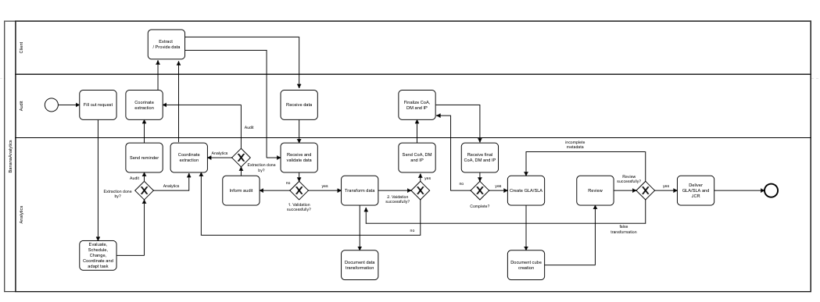

After analyzing the process using SIPOC, the project team came up with a redesigned process involving automated tasks to make the process less time-consuming and more user friendly. Possibilities to automate the process were identified and indicated below.

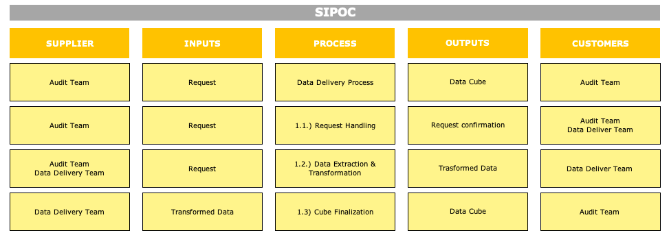

## To-be Process

As we can see in the process below, human interaction is almost completely absent besides a task where a human decision making is needed to assess the necessary risk level in unclear cases. The process is also user friendly as the user only has to provide information at one point and the second time he already receives an insurance offer. A more detailed description of the solution can be found [here.](https://github.com/DigiBP/digibp-jungfrau/wiki/Solution)

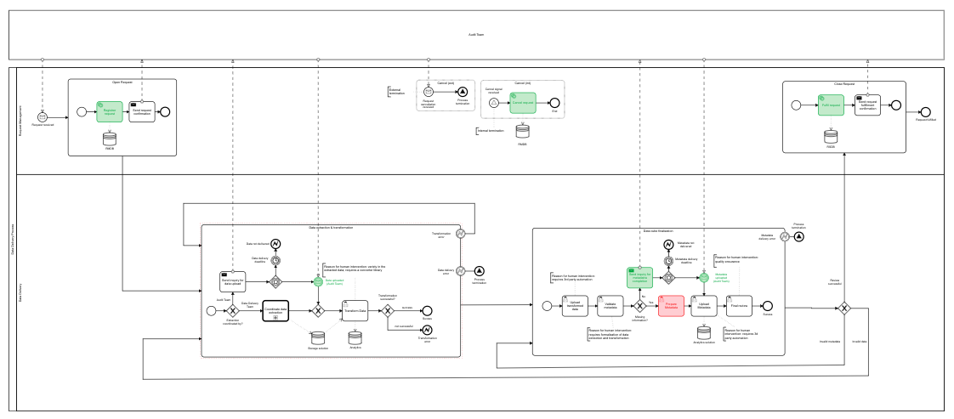

# Solution

# The Big Picture

The to-be process might appear pretty complicated. To easily understand what BananaAnalytics is actually doing, the workflow below illustrates the most important steps of the process.

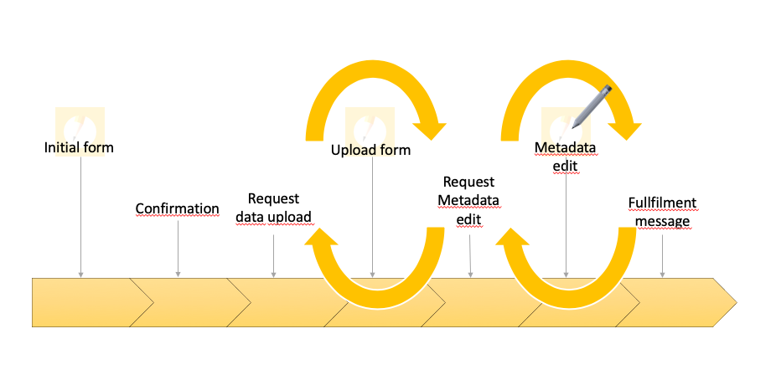

As illustrated in the SIPOC, our solution consists of three main parts:

* What forms
* How are they connected/integrated?
* structure

### Request Handling

The request handling starts with an **initial form** that is submitted by the audit team to BananaAnalytics. Based on this request, the needed data is either gathered from the audit team or directly delivered by the client. The output is the request confirmation transmitted via email.

* Initial Form (jotform or generate form)
* Camunda / Integromat
* Excel
* Dropbox

Consist of the UIX google assistant and an Integromat Instance.

### Data Extraction & Transformation

When it comes to the extraction of the data, the request is evaluated. If all needed data is available and valid, the extraction can take place. Otherwise, the initial form has to be revised.

* Upload form done with jotform and integrated to google drive/dropbox with Integromat

Consist of Camunda

### Data Cube Finalization

Consist of another Integromat Instance and a little mail service called gmail

## Request Handling

Request Form

* JotForm
* 1st page: client information
* 2nd page: product indication
  + what products are required and when is the deadline
* 3rd page: Extraction Information
  + What data needs to be extracted
  + What ERP is used
* 4th page: additional information
* Upload form is done
* Anton played with integration possibilities
* Integration with Integromat/Postman

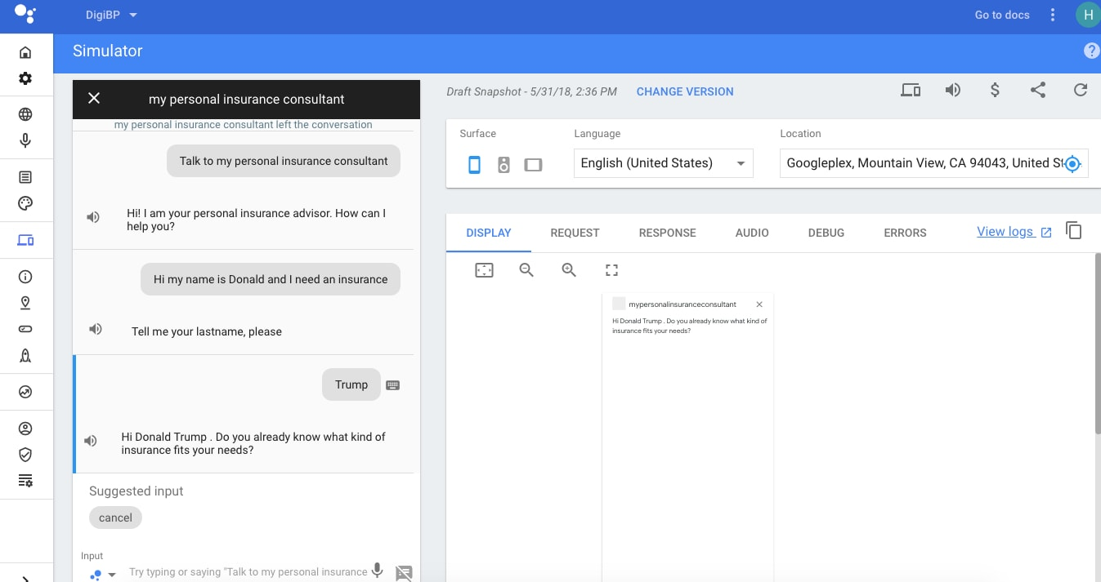

The process is triggered through google assistant which has been created using dialog-flow. Dialog-flow/Google assistant was chosen as it allows natural language processing as well as an easy interaction with the user. By using natural language the user can easily interact with the google assistant and is informed on the different types of insurances which are being offered and can easily apply for a new insurance. When applying for a new insurance google assistant guides the user through a series of questions based on selected choices, collects the required user information and assigns variables to them.  
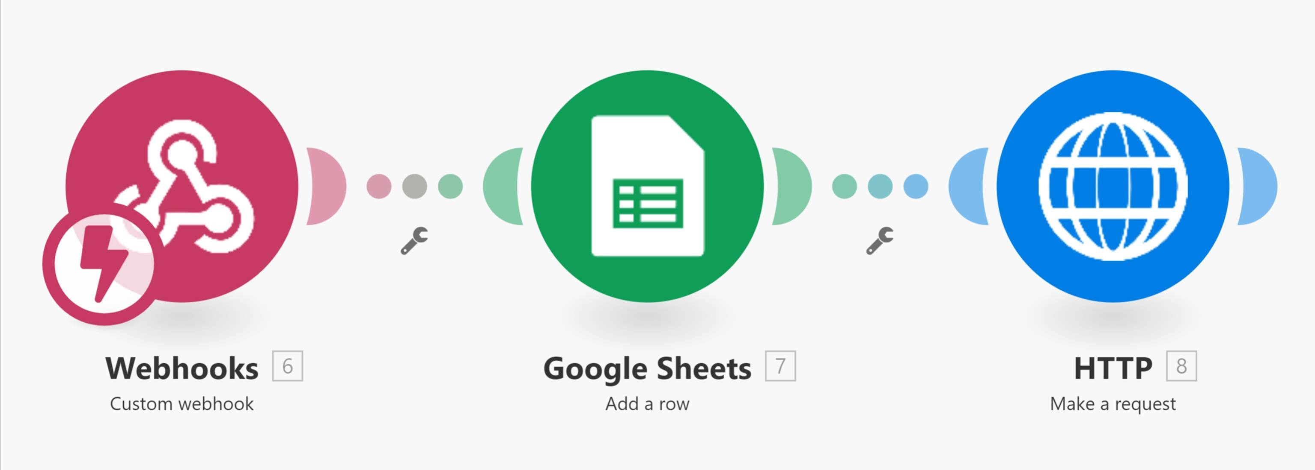  
In this part of the solution, Integromat fetches all variables from google assistant. It then stores these in a google sheet before passing them on to Camunda. The google sheet in this step is not necessary for the process to work but it allows a more efficient debugging of the process and does not produce a noticeable interruption.

## Data Extraction & Transformation

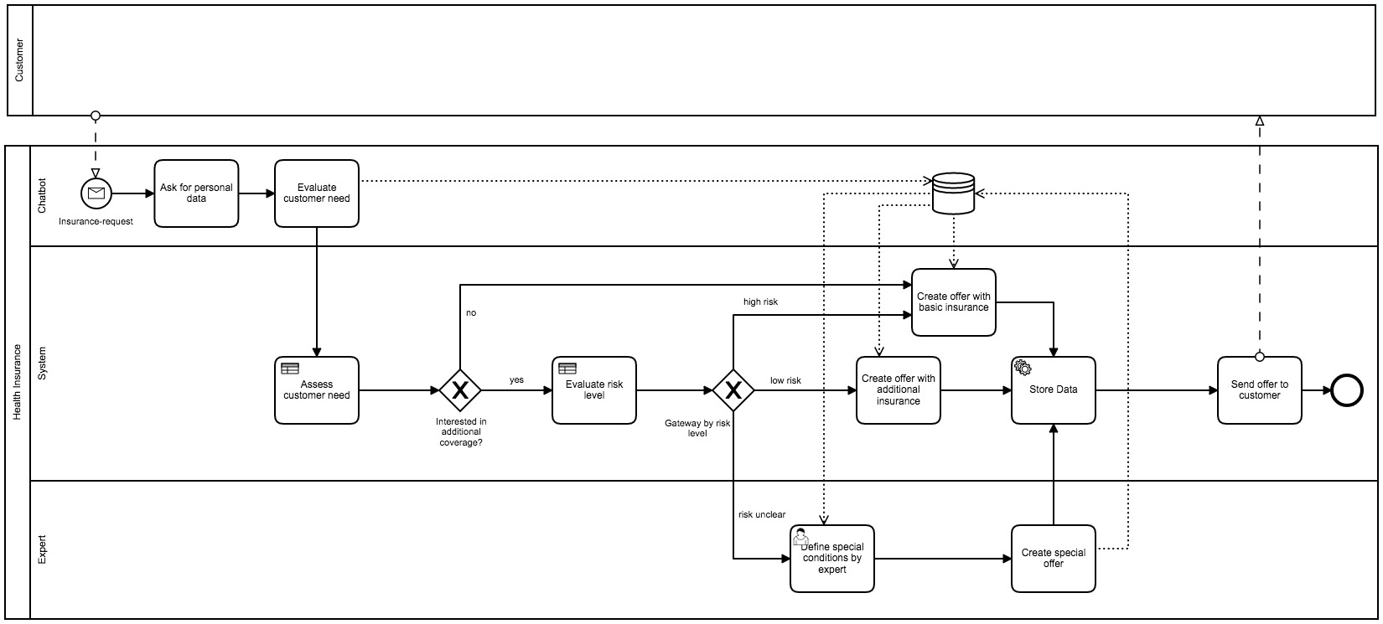  
In Camunda is where all of the magic happens. Through decision tables, logic is applied to the process. Based on the choices of the user and the answers given, Camunda automatically calculates the associated risk class. There are three risk classes in total:

* low risk: The applicant immediately gets his Insurance
* high risk: The applicant gets denied private or semi-private hospitalisation and is offered basic insurance
* unclear risk: The decision is wavered to a professional human who decides in which risk class the applicant falls into.  
  If users apply for basic insurance without any add-ons the applicant is accepted automatically. In all other options the user only is accepted if the right conditions are met which will not result in a higher living risk of the applicant. The output of the process is that the users are either accepted or declined. 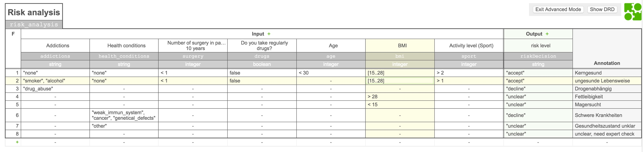

## Data Cube Finalization

A cube consists of:

* balance sheet
* journal entries
  + these can exist of 0 to an undefined number of business units

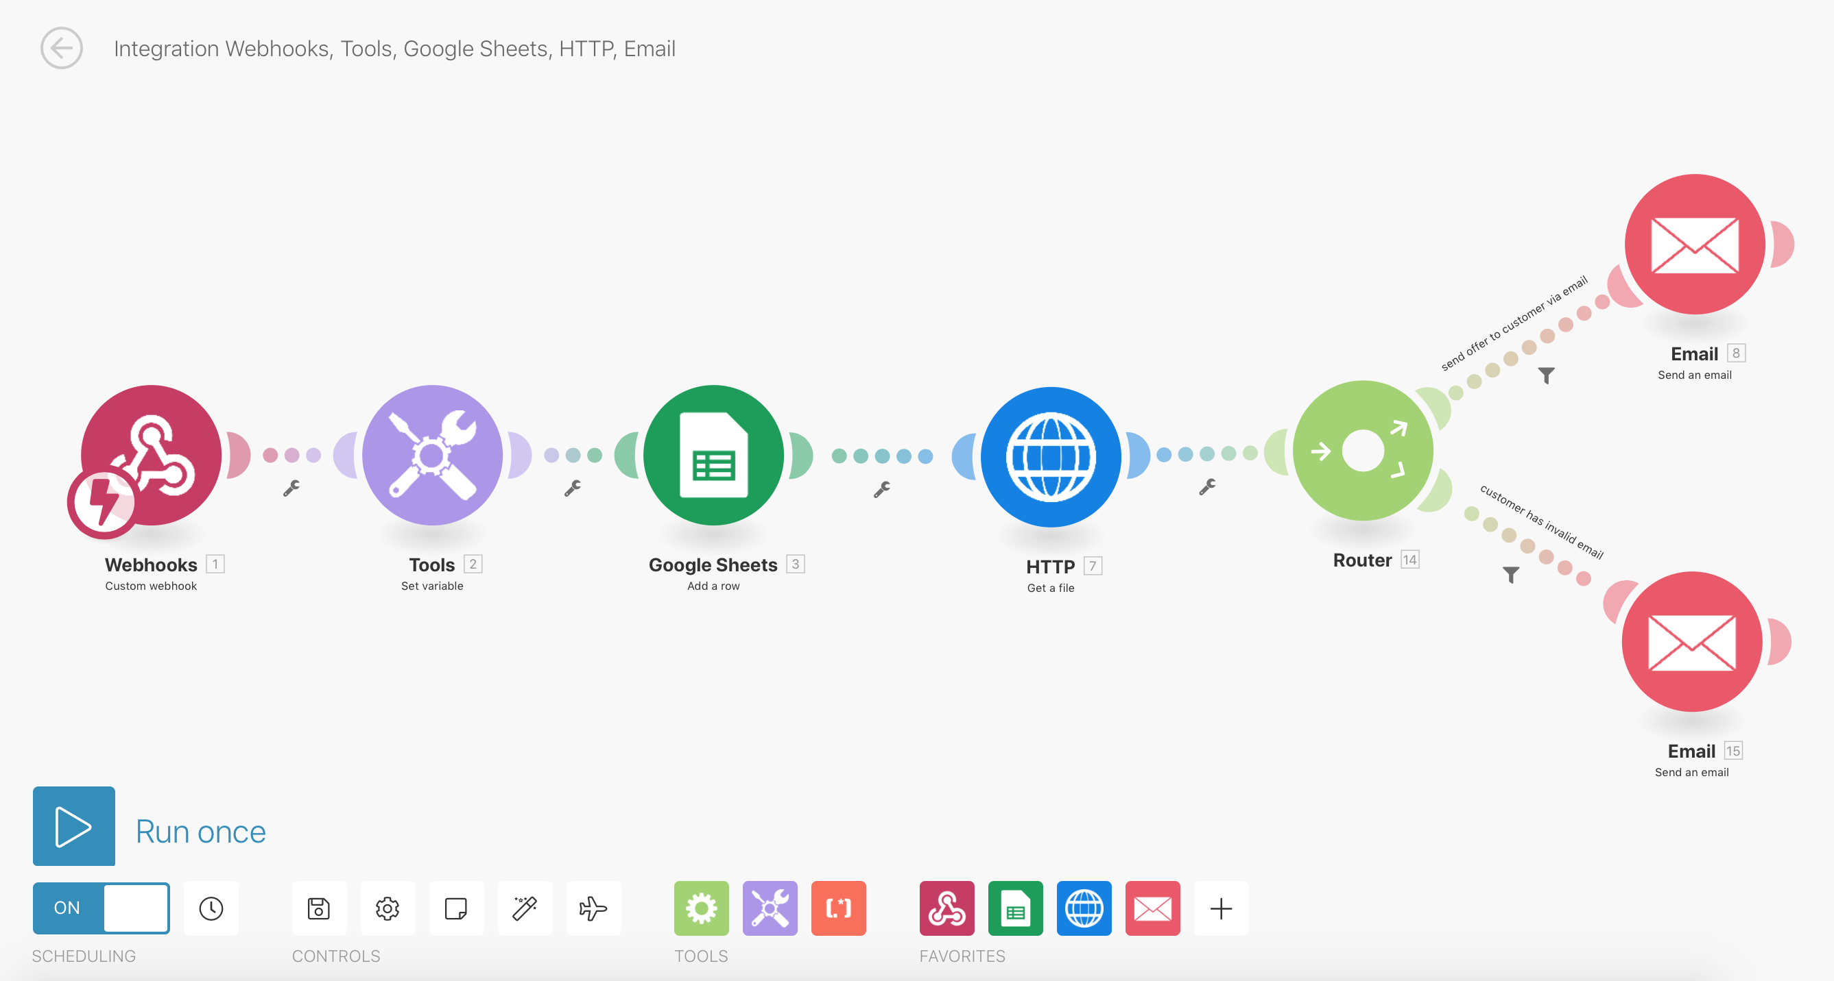  
In this part, a second instance of Integromat fetches the calculated risk class as well as all other user provided information. It then generates a timestamp for each entry and stores it in a database (Google-Sheets). A request to a PHP-Server is then being made with all information to generate the offer in a PDF document, with filled out fields from the information provided. In a last step a mail-service (in this case Gmail) sends the insurance policy offer with the PDF as an attachment to the applicant. Should the provided email-adress of the customer not work, the billing team of DigiSurance is asked to get in touch with the customer. 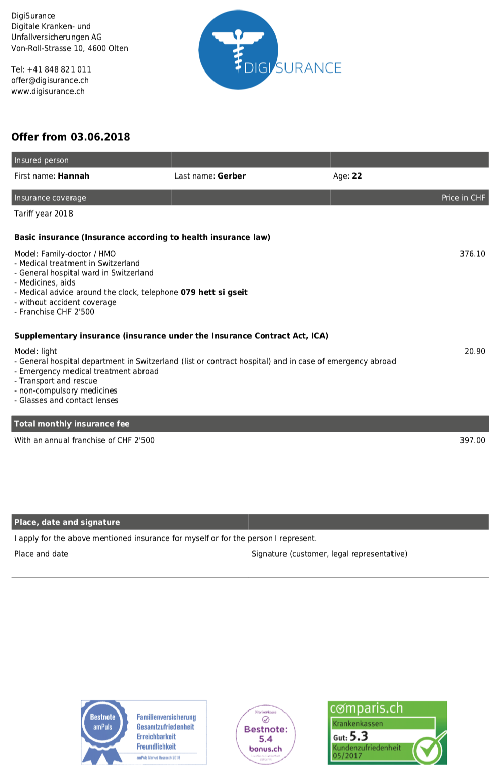

# Project Members

### David Fürer

  
Project Role: Project coordinator and Process owner

### Felix Schenker

  
Project Role: The Researcher

### Anton Lorvi

  
Project Role: The Programmer

### Rahel Wehrli

  
Project Role: Wiki-creator