Date: 19.05.2019, 1st Test Execution

1. Spell mistake, 2. The tabs are moving but I guess styling issue not relevant (Low will not be fixed)

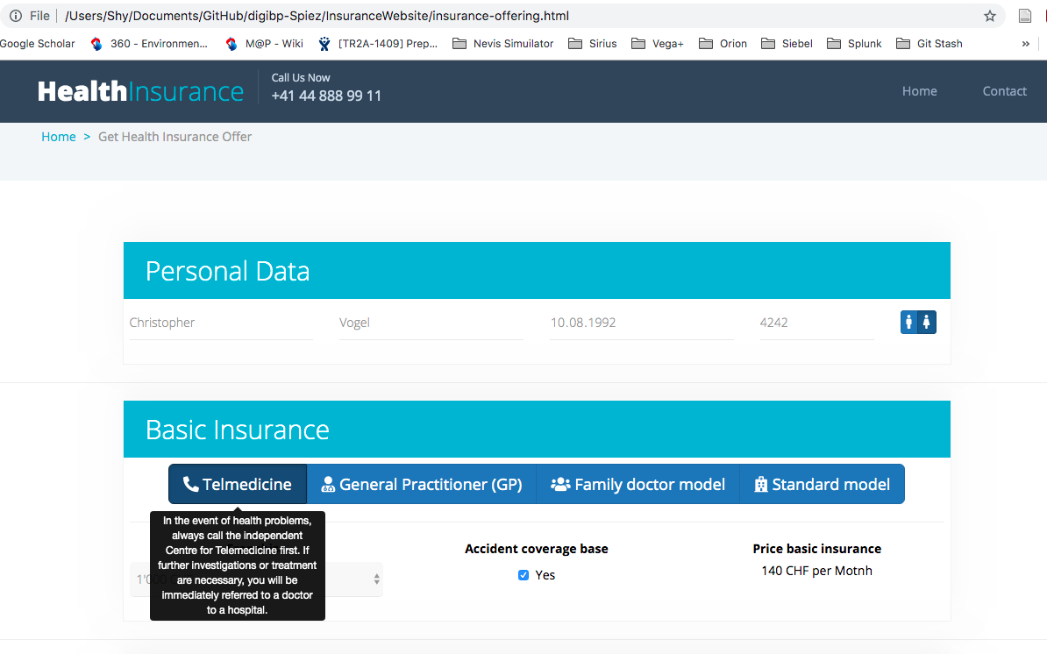

3. Pop up hiding drop down (fixed)

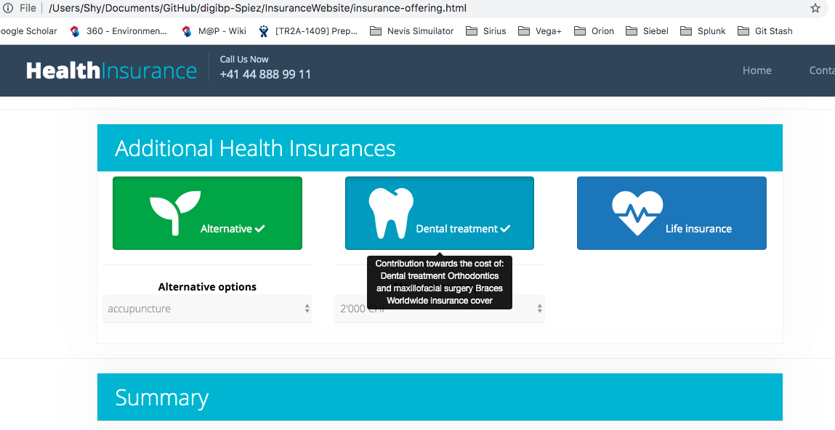

4. Spell check (fixed)

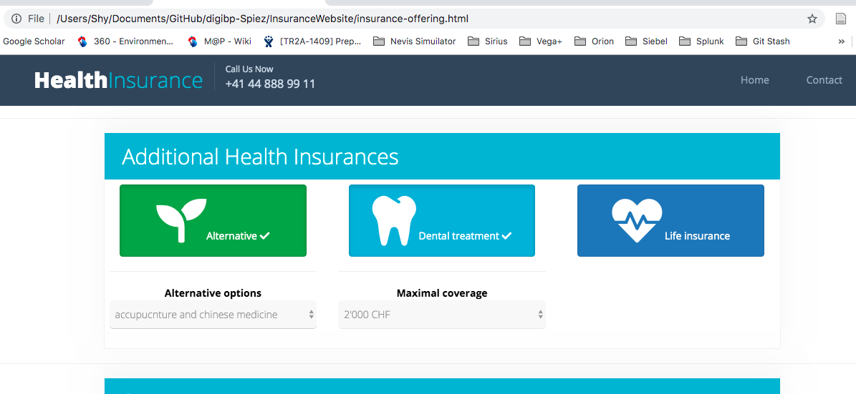

5. Price calculation not updating (fixed)

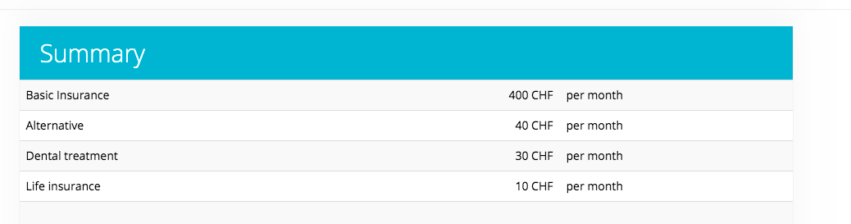

6. Why two times «send application» button? (fixed)

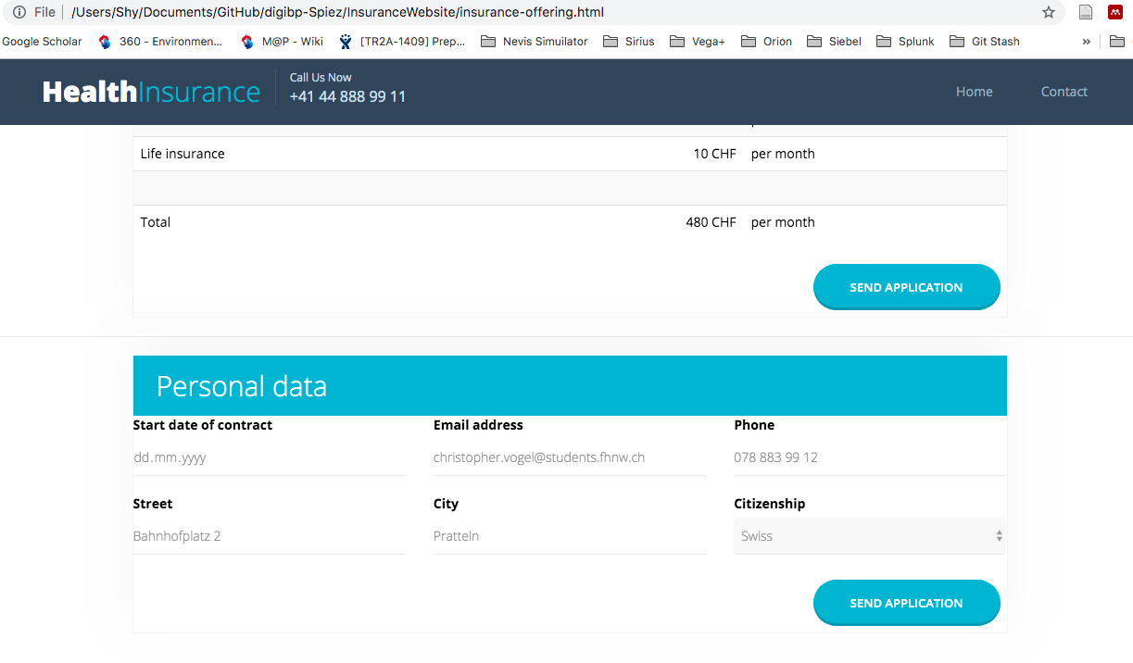

Date: 21.05.2019, 3rd Test Execution

Bug 1: By clicking on Yes sign my contract the status in Excel is updated to “unsigned” instead of “signed”

Bug 2: Typo “immidateley”

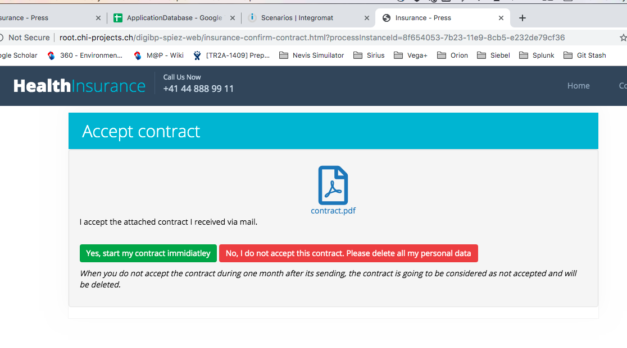

Bug 4: Layout of fields is uneven

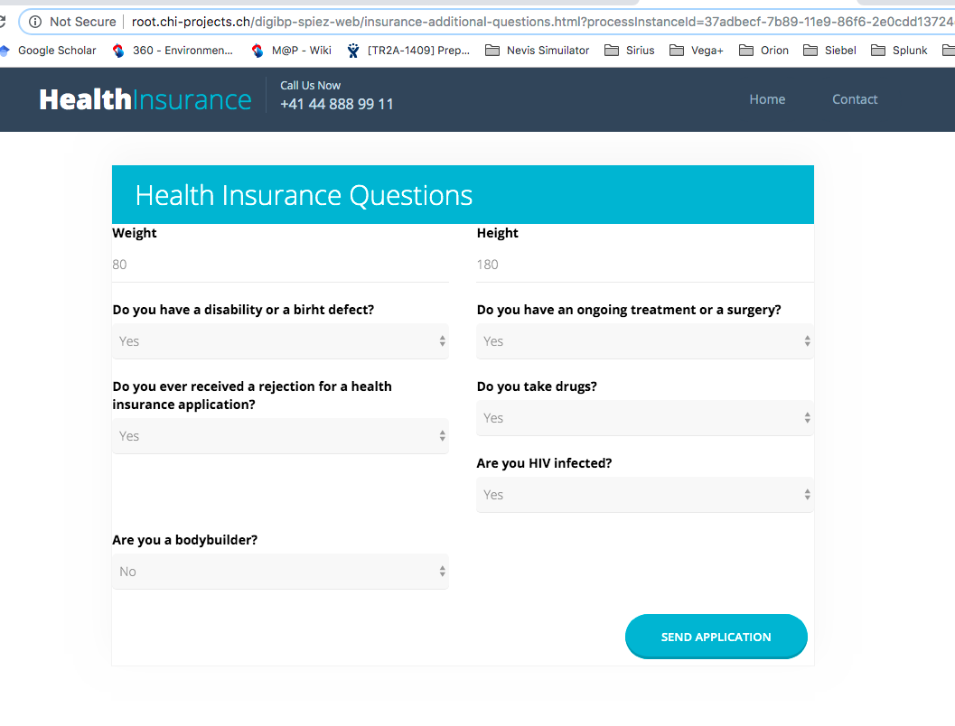

Date: 25.05.2019, 4th Test Execution

Bug 1: By clicking send application by “additional question” and “accept Contract” the timer loop rotates indefinitely

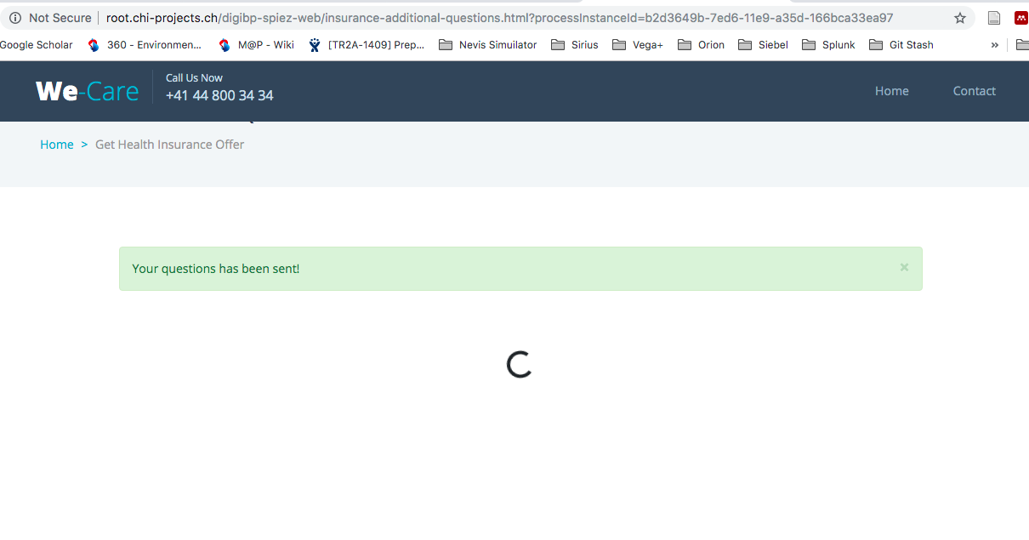

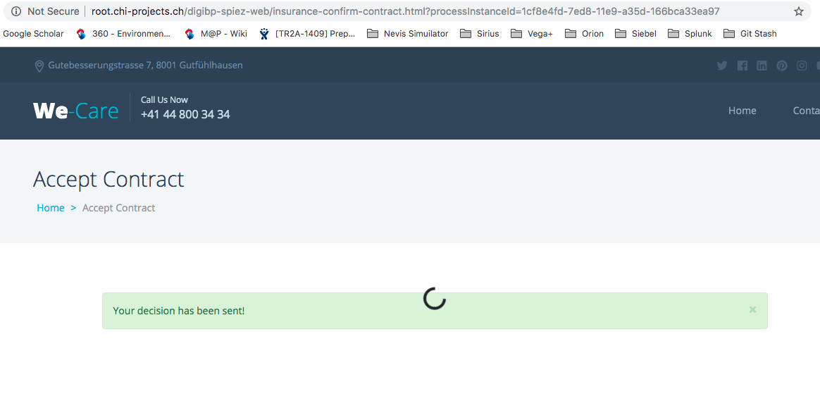

Bug 3: Link in email is broken

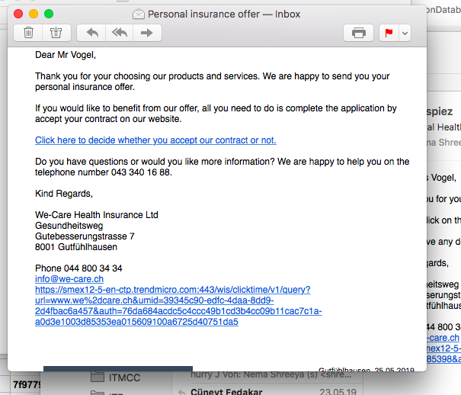

Bug 4: Not able to complete human task as giving error in Camunda modeler atleast for two field “eGender” and “eBaseInsurance”.

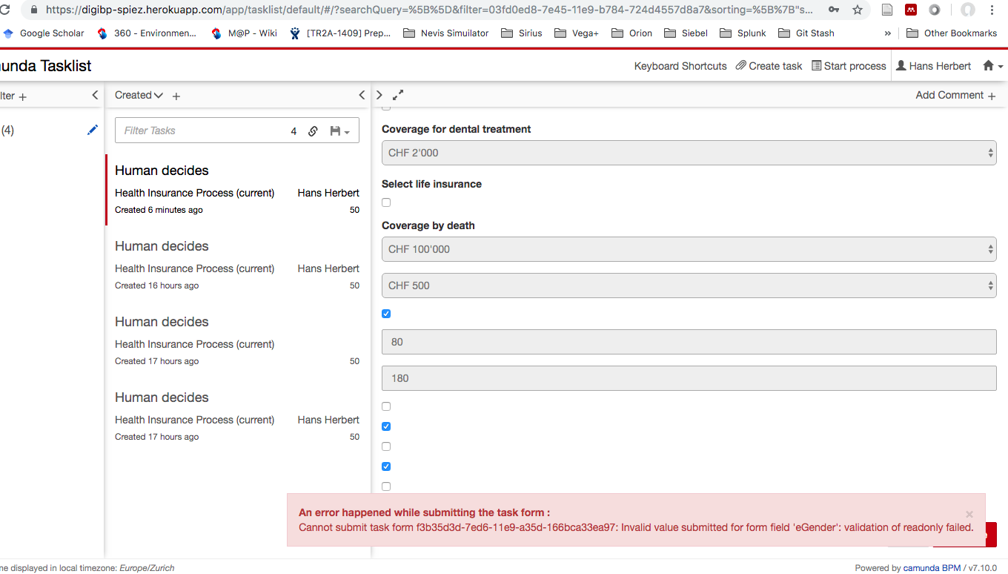

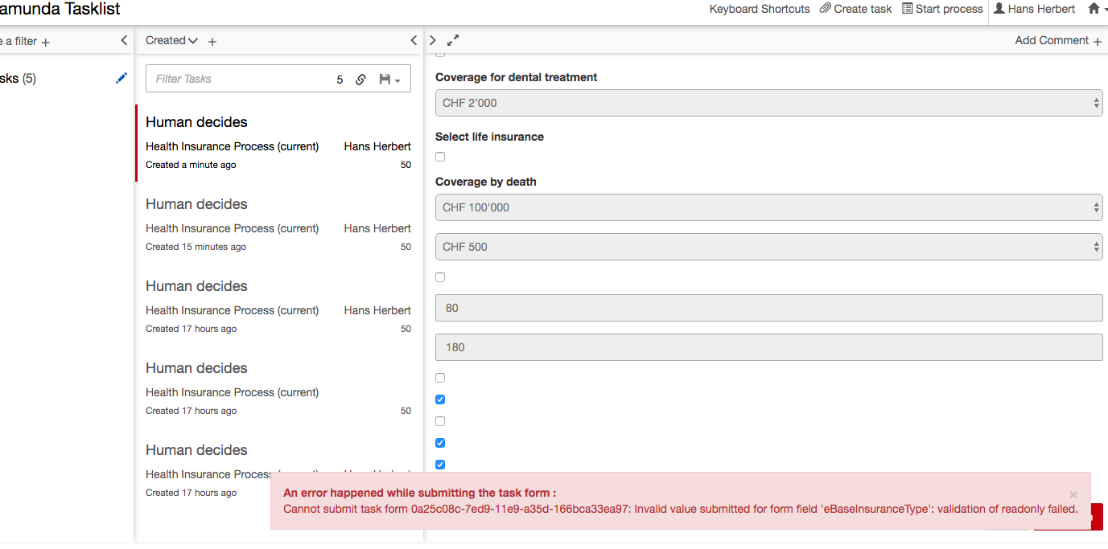

Bug 5: For rejected or accepted case after additional questions, wrong message is shown to user

