Integration

The process starts with a google form filled out by a customer. 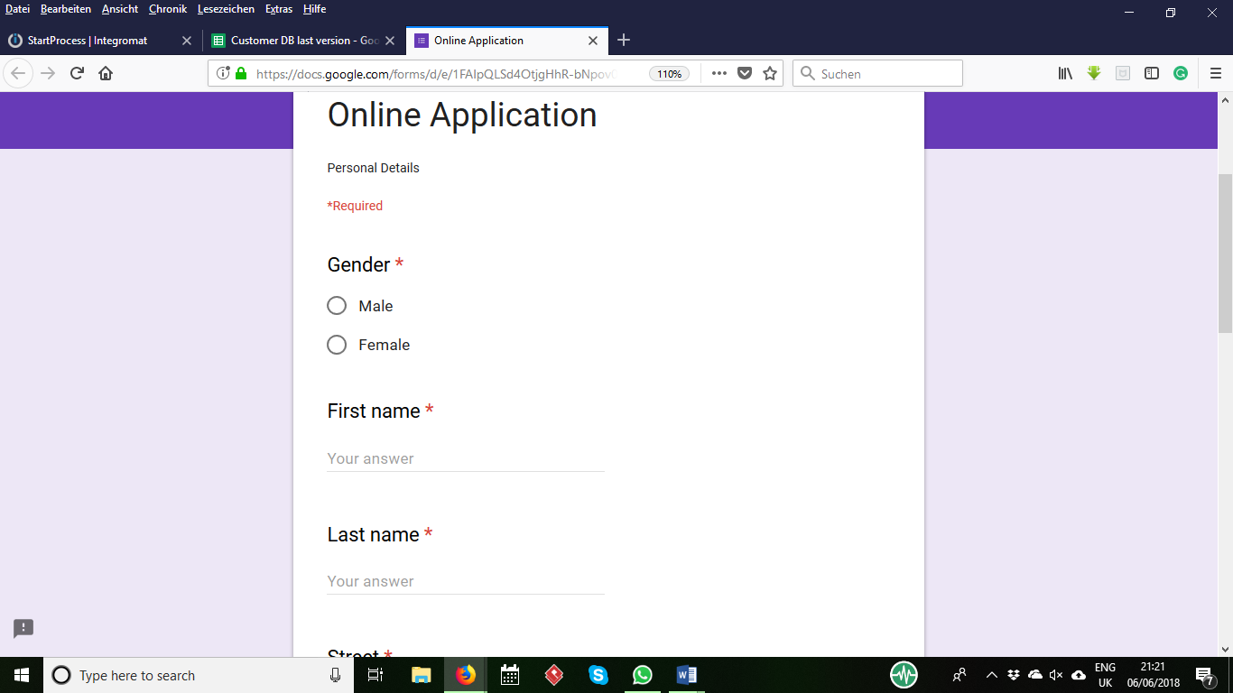

The data will be stored in customer database by submitting the Application form.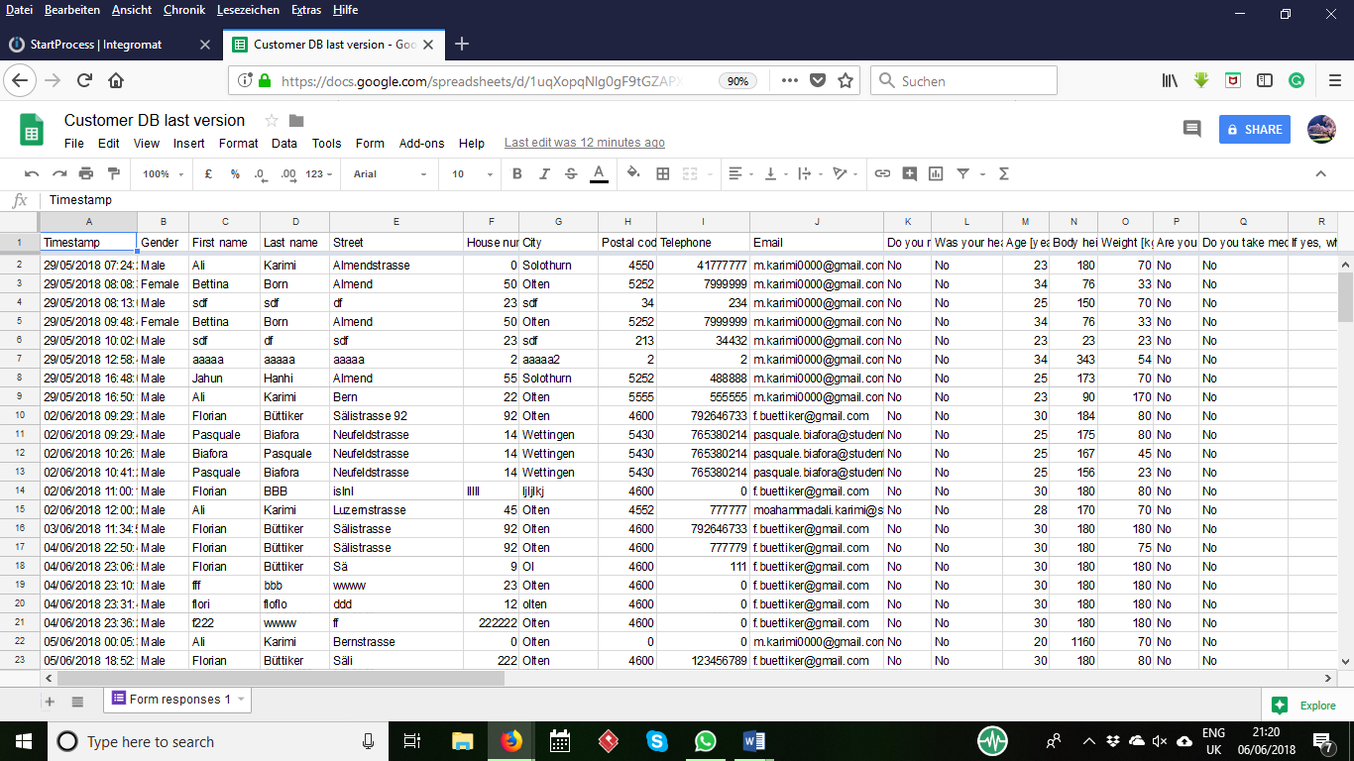

Data will be sent to Camunda’s engine (by the following scenario) from Integromat as a post request containing all necessary data for the application process and then the process starts automatically.

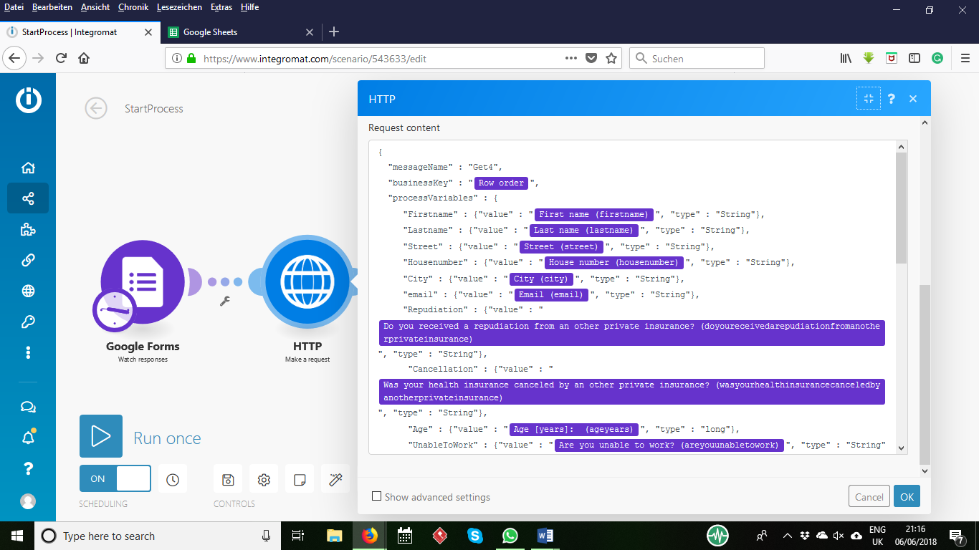

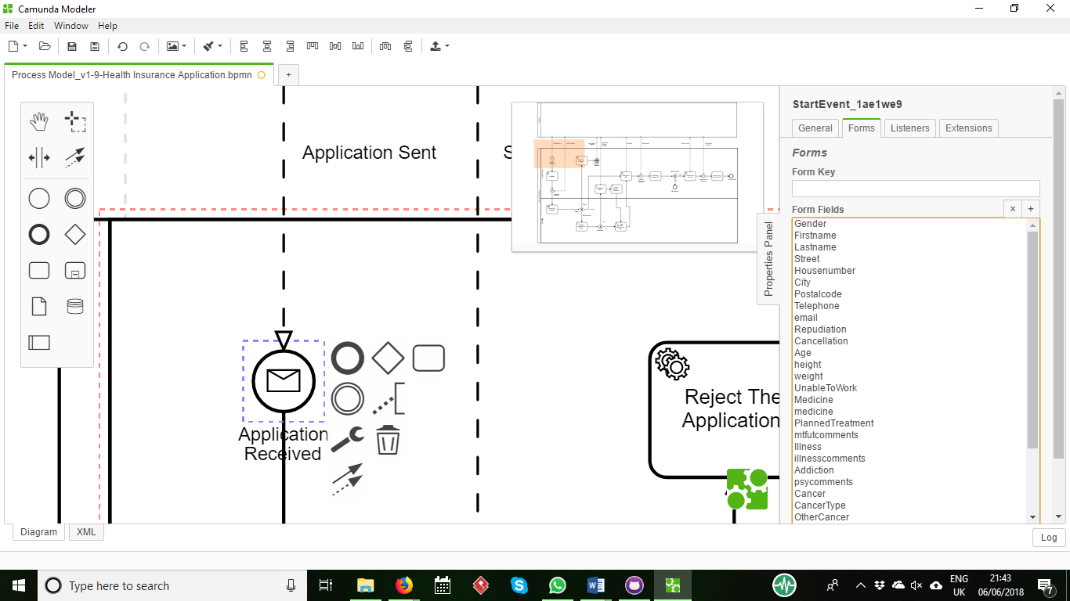

For sending verification mail, offer mail and contract to the customer a service task triggers the Integromat’s scenario which receives email, name and business key from the ongoing case in Camunda and sends an email containing a link for a specific purpose that will trigger next step of the process.

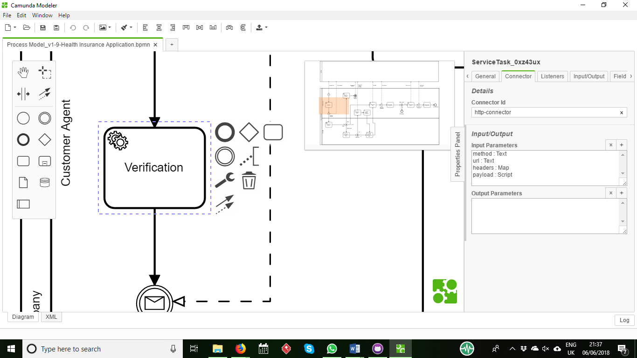

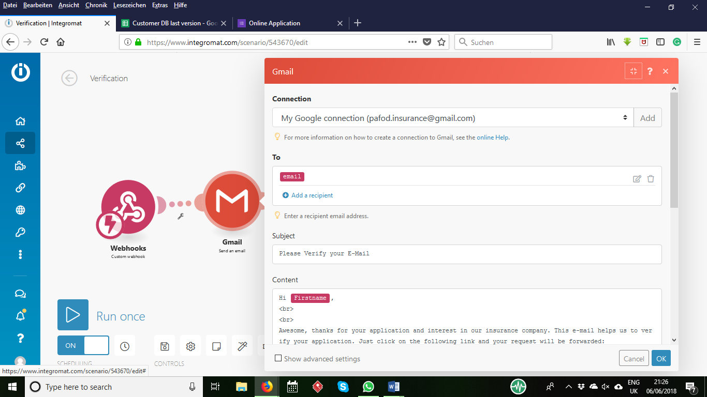

For verification, offer mail and signing contract customers receive a link to google form, by entering data to this form data will be saved in the specific database and a message will be sent to Camunda in form of a post request by the following scenario.

