Expense Tracker - Project Report
EXAMPLE REPORT. This shows the sections, level of detail and screenshots the Capstone agent expects. Write your own report for your own project; do not copy this one.

Problem Statement
People lose track of small everyday spending, so at the end of the month they cannot say where their money went. This project builds a small command-line program that records each expense with an amount, a category and a note, saves it to a file, and shows how much was spent in each category.
Requirements: (1) add an expense; (2) reject invalid input; (3) keep data between runs; (4) show totals per category; (5) include automated tests.

Approach
The program is split into three modules so each has one job:
- tracker.py - the rules: validates an expense and computes category and monthly totals. It never touches the disk, which makes it easy to test.
- storage.py - reads and writes the JSON file that holds the expenses.
- main.py - the command-line interface (argparse) that connects the two.
Design decisions: JSON was chosen over a database because the data is small and a plain file needs no setup. Amounts are rounded to two decimals and stored as numbers, and the category must come from a fixed list so the totals are not split by typos.

Code
Key parts of the source (the full code is in the zip). The code is pasted as text, not as a picture, so it can be read and reviewed.
src/tracker.py - validation:
def add_expense(expenses, amount, category, note="", when=None):
"""Validate and append one expense; returns the new record.

Raises ValueError for a non-positive amount or an unknown category so bad
data never reaches the saved file.
"""
amount = round(float(amount), 2)
if amount <= 0:
raise ValueError("Amount must be greater than zero.")
if category not in CATEGORIES:
raise ValueError(f"Category must be one of: {', '.join(CATEGORIES)}.")
record = {
"date": (when or date.today()).isoformat(),
"amount": amount,
"category": category,
"note": note.strip(),
}
expenses.append(record)
return record
src/tracker.py - totals per category:
def total_by_category(expenses):
"""Return {category: total}, largest first."""
totals = defaultdict(float)
for item in expenses:
totals[item["category"]] += item["amount"]
return dict(sorted(((k, round(v, 2)) for k, v in totals.items()), key=lambda pair: -pair[1]))

Output Screenshots
Each screenshot below is also saved in the zip under output_screenshots/.
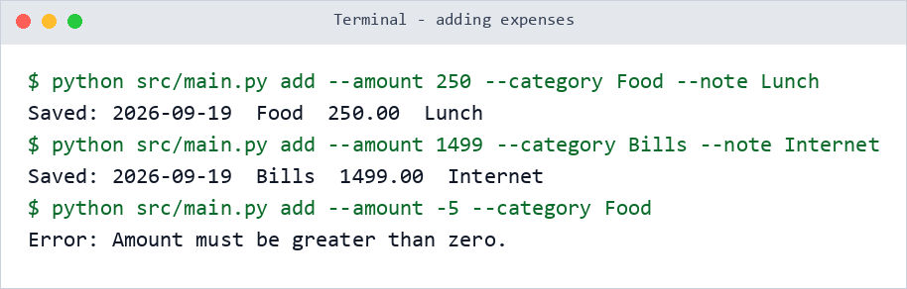
Figure 1: adding two expenses, and an invalid amount being rejected.
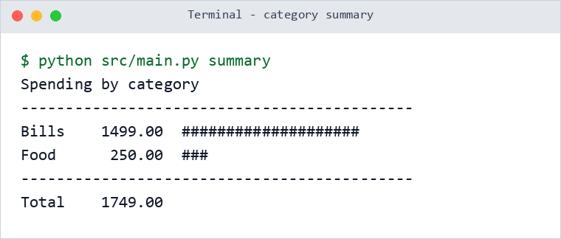
Figure 2: the per-category summary with totals and a text bar chart.
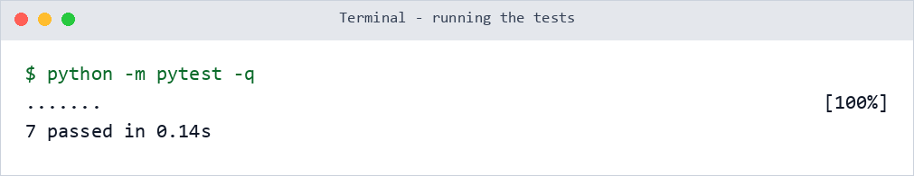
Figure 3: the automated tests all passing.

Conclusion
The program meets all five requirements: it records and validates expenses, keeps them between runs, summarises spending by category, and is covered by seven passing tests. What I learned: keeping the rules separate from file handling made the code simple to test.
Possible improvements: filter by date range, export to CSV, and a simple chart. Limitations: one user, and no editing or deleting of saved expenses yet.

