DIGICRM
On-Premises Deployment Specification
Infrastructure sizing, high availability and security for a Zambian commercial bank
Prepared for [Bank name], Lusaka, Zambia
Prepared by DigiDelight
Document version 1.0 — Draft for discussion
Date 28 September 2026
Classification Confidential
Sized for a 100-user phase 1. Figures are planning estimates based on the workload assumptions in Section 2 and will be validated during a pilot.
Contents
1. Summary 3
2. Workload assumptions 4
3. Application architecture 5
4. Environments and server sizing 7
5. Hardware and software cost estimate 9
6. Storage and database sizing 10
7. Network, security and compliance 11
8. High availability, backup and DR 12
9. AI, messaging and integrations 13
10. Software prerequisites, monitoring and open questions 14

1. Summary
We recommend starting with 100 named users on a small two-site footprint: 2 physical hosts in production and 1 at the DR site, which also runs UAT. Estimated hardware cost is USD 70k–95k landed in Zambia, or close to zero on the bank's existing virtualisation cluster.
Environment | VMs | vCPU | RAM | Disk
Production (primary DC) | 8 | 48 | 248 GB | ~5 TB
DR (secondary DC) | 3 | 24 | 128 GB | ~3.2 TB
UAT (on the DR host) | 2 | 8 | 32 GB | ~1 TB
Optional on-prem AI | 1 GPU server | 16 | 128 GB | 1 TB

The sizing covers 100 named users, 40 concurrent at peak and 500k customer records, with 5 years of data at 20% growth. All data and AI inference stays on bank premises.
The design grows by adding nodes, not by rebuilding. Up to about 300 users needs one more app VM; beyond that we move to clustered data services (see 4.5 Growth path).

2. Workload assumptions
Phase 1 starts with 100 named users, such as the SME and corporate banking teams plus a small contact-centre group. Please confirm or correct each figure. The sizing scales roughly in proportion to them.
Dimension | Year 1 | Year 5 (+20%/yr) | Notes
Named CRM users | 100 | 210 | RMs, branch managers, contact centre, marketing
Peak concurrent users | 40 | 85 | Month-end and campaign days, 08:00–17:00 CAT
Peak API requests | 6 req/s | 13 req/s | Staff UI plus integrations; ~150 ms median target
Contacts (individuals) | 500 k | 1 M | Loaded from core banking; nightly delta sync
Accounts (SME / corporate) | 30 k | 60 k
Opportunities / leads | 20 k/yr | 40 k/yr | Loans, cards, bancassurance, deposits
Activities (calls, meetings, notes, emails) | 1 M/yr | 2 M/yr
Support tickets | 50 k/yr | 100 k/yr | Email, web help centre, WhatsApp
Outbound messages (SMS, email, WhatsApp) | 1 M/month | 2 M/month | Peak 100 k in one campaign day
Automation / workflow runs | 200 k/month | 400 k/month | Event and schedule triggers
Core-banking sync | 500 k upserts/night | 1 M upserts/night | Runs 22:00–05:00
Attachments | 300 GB in year 1 | +200 GB/yr | KYC docs, ticket files, campaign assets
Web and chat analytics events | 10 M/yr | 20 M/yr | Only if the public site and app are tracked

Availability target: 99.5% in business hours. Planned maintenance happens in a Sunday window.

3. Application architecture
DigiCRM ships as Docker images. The components below match what runs in our current platform build, with no cloud services needed.
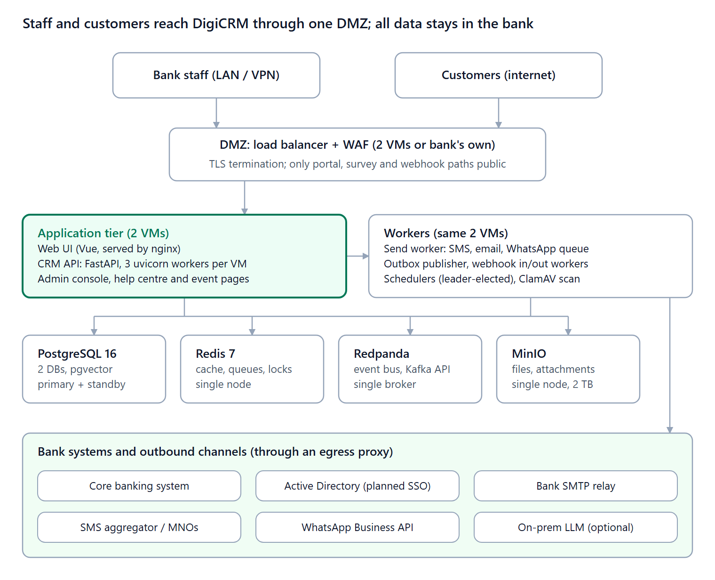
Figure 1 — DigiCRM on-premises architecture
The API and workers share the same four data stores. Only the workers and the Integration Hub call out of the bank, and they go through the bank's egress proxy.
Component | Role | Phase 1 (100 users) | When scaled up
Web UI | Vue single-page app served by nginx | On both app VMs | More app VMs
CRM API | FastAPI (Python 3.12). Each uvicorn worker uses ~0.8–1 GB RAM | 3 workers per app VM | More workers, then more VMs
Schedulers | Campaign, workflow and sync crons. A Postgres advisory lock runs them on exactly one worker | Leader-elected, no extra VM | Same
Send worker, outbox publisher, webhook workers | Outbound SMS/email/WhatsApp queue; events to Redpanda; provider callbacks | On the app VMs | Dedicated worker VMs
PostgreSQL 16 + pgvector | Two databases: catalog (tenant, config) and business (CRM data) | Primary + streaming standby | Patroni cluster, 3 nodes + report replica
PgBouncer | Connection pooling in front of Postgres | On each database VM | Same
Redis 7 | Cache, rate limits, send queue, locks | Single node, AOF persistence | Sentinel, 3 nodes
Redpanda | Event bus for automations and integrations | Single broker | 3 brokers
MinIO | S3-compatible storage for attachments, KYC files, assets | Single node, RAID disks, mirrored to DR | 4-node erasure set
ClamAV | Virus scan on every upload | On the app VMs | Same
Observability | Prometheus, Grafana, Loki, Alertmanager | 1 VM | 2 VMs

We deploy one tenant (the bank) on a single-tenant install. The SaaS admin console stays internal, for our support team and the bank's IT administrators.

4. Environments and server sizing
All 13 VMs fit on 3 physical hosts: 2 in production and 1 at DR. Alternatively they can run on the bank's existing VMware, Hyper-V or Proxmox cluster. OS: RHEL 9, Rocky Linux 9 or Ubuntu 24.04 LTS.

4.1 Production (primary DC)
Role | VMs | vCPU each | RAM each | Disk each | Runs
Load balancer / WAF | 2 | 2 | 4 GB | 50 GB | HAProxy + keepalived, or the bank's existing load balancer and WAF
App + workers | 2 | 8 | 32 GB | 200 GB | Web UI, CRM API (3 workers), send worker, outbox publisher, webhook workers, ClamAV
PostgreSQL | 2 | 8 | 64 GB | 1 TB SSD | Primary + streaming standby, PgBouncer, pgBackRest
Data services | 1 | 8 | 32 GB | 2 TB | Redis, Redpanda (single broker), MinIO (single node)
Monitoring + bastion | 1 | 4 | 16 GB | 500 GB | Prometheus, Grafana, Loki, Alertmanager, jump host, image registry
Total | 8 | 48 | 248 GB | ~5 TB

One of each pair runs on each host, so either host can fail. The surviving host carries the full load: it needs ~150 GB of its 256 GB RAM.

4.2 DR (secondary DC)
DR runs warm: the database streams continuously and MinIO mirrors files. The app VM is kept stopped and started on failover.
Role | VMs | vCPU each | RAM each | Disk each
App + workers | 1 | 8 | 32 GB | 200 GB
PostgreSQL replica | 1 | 8 | 64 GB | 1 TB SSD
Data services | 1 | 8 | 32 GB | 2 TB
Total | 3 | 24 | 128 GB | ~3.2 TB

4.3 UAT / pre-production
UAT runs on the DR host. During a real DR event it is shut down to free capacity.
Role | VMs | vCPU | RAM | Disk
App + data services | 1 | 4 | 16 GB | 500 GB
PostgreSQL | 1 | 4 | 16 GB | 500 GB
UAT holds masked production data. We never copy real customer PII into UAT without masking.

4.4 How the numbers were derived
- API: 40 concurrent users make ~6 req/s at peak. One uvicorn worker handles 8–12 req/s, so 6 workers give ~10× headroom. One app VM alone carries the full load.
- Memory: 3 API workers (~3 GB) plus send, outbox and webhook workers, ClamAV and headless Chromium use ~10 GB of the 32 GB.
- Database: the year-1 database (~30 GB) fits entirely in 64 GB RAM. Settings: shared_buffers 16 GB, effective_cache_size 48 GB, max_connections 200 behind PgBouncer.
- Sends: 100 k messages on a peak day are ~1 msg/s averaged, ~20 msg/s in a burst. The SMS gateway's throughput is the real limit.

4.5 Growth path
Growth | Change | Extra hardware (approx.)
Up to ~300 users | +1 app VM; host RAM to 384 GB | USD 5–10k
300–1,000 users | 3rd production host; 3-node Redis, Redpanda and MinIO; 3rd database node | USD 60–100k
1,000+ users | Full clustered layout: dedicated worker, database and storage nodes | Quoted on request

Each step adds VMs to the same architecture. No data migration or re-platforming is needed.

5. Hardware and software cost estimate
Hardware for production, DR and UAT comes to about USD 70k–95k landed in Zambia. If DigiCRM runs on the bank's existing virtualisation cluster, new hardware drops to USD 0–15k (backup storage at most).
Item | Qty | Config | Estimate (USD)
Production hosts | 2 | 1 × 32-core CPU, 256 GB RAM, 4 × 3.84 TB NVMe, 25 GbE | 32–40k
DR host (also runs UAT) | 1 | Same model | 16–20k
Backup storage (NAS, ~8 TB usable) | 1 |  | 5–8k
Networking | — | Bank's existing switches and firewall | 0–5k
Import, freight, reseller margin |  | +20–30% on hardware | 15–20k
Optional AI: GPU server | 1 | 1 × NVIDIA L40S 48 GB | +20–30k
Hardware total (landed, excl. AI) |  |  | ~70–95k

5.1 Yearly software
- OS: Rocky Linux or Ubuntu is free; RHEL is about USD 800–1,300 per server per year.
- Hypervisor: Proxmox or Hyper-V is low or no cost. VMware for 3 hosts is roughly USD 10k–30k a year under current Broadcom licensing.
- DigiCRM's own stack (PostgreSQL, Redis, Redpanda, MinIO, monitoring) has no licence fees.
These are list-price estimates for enterprise servers (Dell PowerEdge R760 / HPE DL380 Gen11 class) with 3-year next-business-day support, not supplier quotes. They exclude 16% VAT, which banks can often reclaim.

6. Storage and database sizing
The business database grows to about 170 GB by year 5, well inside the 1 TB SSD per database VM. Files reach about 1.1 TB, inside the 2 TB data-services disk.
Data | Row size (incl. indexes) | Year 1 | Year 5 (cumulative)
Contacts + accounts + custom fields | ~4 KB | 2 GB | 4 GB
Activities | ~2 KB | 2 GB | 15 GB
Message send log + delivery events | ~1 KB | 12 GB | 90 GB
Tickets + email threads | ~10 KB | 0.5 GB | 4 GB
Audit log and record history | ~0.5 KB | 1.5 GB | 11 GB
Analytics events (if enabled) | ~0.5 KB | 5 GB | 37 GB
AI embeddings (pgvector, 1,536 dims) | ~6 KB | 3 GB | 6 GB
Attachments (MinIO) |  | 300 GB | ~1.1 TB
Database total |  | ~26 GB | ~170 GB

6.1 Backup and retention
- Database: pgBackRest does a weekly full, daily differential and continuous WAL archiving. Point-in-time restore goes back 35 days. Backup store needs ~1 TB at year 5.
- Files: MinIO mirrors to DR, with versioning and 35-day retention of deleted objects.
- Long-term: a monthly full to the bank's tape or immutable backup (WORM) platform, kept for the bank's statutory period.
- Restore test: quarterly, restoring into UAT, with timings recorded against the RTO.
Retention of CRM records (activities, communications, KYC documents) should follow the bank's records policy. Zambian anti-money-laundering record keeping is commonly cited as 10 years; the bank's compliance team should confirm.

7. Network, security and compliance
The design keeps every customer record, file and AI prompt inside the bank's data centres in Zambia. That meets data-residency expectations without legal review of each cloud service.

7.1 Network zones
Zone | Contains | Inbound from | Outbound to
DMZ | Load balancers, WAF | Internet (443 only, public paths); bank LAN (443) | App tier (443)
Application | App and worker nodes | DMZ only | Data zone; egress proxy
Data | PostgreSQL, Redis, Redpanda, MinIO | Application zone only | DR site (replication)
Management | Bastion, registry, observability | Bank admin VLAN, with MFA | All zones (SSH, metrics)

Public paths are the help centre, survey and event pages, the chat widget and provider webhooks. All staff screens stay on the LAN or VPN, or the bank can keep the whole system internal.

7.2 Security controls
- TLS 1.2+ everywhere, with certificates from the bank's internal CA. Replication links between DCs are encrypted.
- Encryption at rest: LUKS or SAN encryption on database and MinIO volumes. Integration secrets are already encrypted in the application.
- Role-based access, record-level sharing and field security are built in. Audit logs go to the bank's SIEM via syslog or OpenTelemetry.
- Every upload is virus-scanned by ClamAV. Signatures update from an internal mirror.
- Container images are built by us, scanned (Trivy) and signed. They are then pushed to the bank's Harbor registry; production never pulls from the internet.
- Yearly penetration test by a bank-approved third party before go-live and after major releases.

7.3 Regulatory points to confirm with the bank
- Data Protection Act No. 3 of 2021: registration as data controller/processor, and limits on cross-border transfer. That matters for WhatsApp and any cloud AI.
- Bank of Zambia cyber and information risk guidelines, plus outsourcing rules: DigiCRM is a third-party system, so our support access needs a contract and audit rights.
- Anti-money-laundering record keeping: retention periods drive backup sizing.
These references are from general knowledge, not a legal review. The bank's compliance office should confirm the current versions.

8. High availability, backup and DR
Targets: no data loss for a database or host failure, with a few minutes of disruption. Up to 5 minutes of data loss and 2 hours to recover for a full site loss.
Failure | Handled by | RPO | RTO
One app VM | Load balancer health checks; scheduler lock moves to the other VM | 0 | < 30 s
Database primary | Promote the streaming standby (scripted); PgBouncer repointed | 0 | < 5 min
Redis, Redpanda or MinIO VM | Hypervisor restarts the VM on the other host; Redis AOF and disk data survive | ~1 s | < 10 min
One physical host | Surviving host runs all production VMs | 0 | < 10 min
Whole primary DC | Promote DR Postgres, switch DNS, start DR app VM | ≤ 5 min | ≤ 2 h (runbook)
Data corruption or bad release | pgBackRest point-in-time restore; image rollback from the registry | to the minute | 2–4 h

- The DR site should be at least 20 km from the primary, on a separate power grid feed. Between them we need ≥ 100 Mbps and < 20 ms latency.
- Load-shedding is a real risk in Zambia. Each DC needs UPS for ≥ 30 minutes plus generator backup. Postgres, Redis and MinIO disks need power-loss protection.
- DR failover is rehearsed twice a year, with the result reported to the bank's risk committee.

9. AI, messaging and integrations
Every DigiCRM integration works through an allow-listed egress proxy. The only ones that must leave the country are WhatsApp and any cloud AI the bank chooses to enable.
Integration | On-prem option | Leaves the bank? | Notes
Email out | Bank's SMTP relay (Exchange or Postfix) | Yes | Outlook 365 connector available if the bank uses M365
Email in (support tickets) | IMAP/Exchange mailbox | Yes | Known-contact-only ticket creation is supported
SMS | Local aggregator or MNO SMPP/HTTP APIs (MTN, Airtel, Zamtel) | To the carrier | Throughput is set by the carrier contract
WhatsApp | Meta WhatsApp Business API via a BSP | Yes: Meta's cloud | Needs a data-transfer assessment under the DPA
Core banking | Integration Hub connectors, nightly batch plus real-time webhooks | No | Read-only service account; the bank's ESB if one exists
AI features | Self-hosted model on GPU servers via our OpenAI-compatible provider | No | Or disable AI entirely; everything else still works
Enrichment (Apollo, Clearbit) | None on-prem | Yes | Recommend leaving these off for a bank
Staff sign-in | DigiCRM local accounts (password only) today | No | Gap: no SAML/OIDC/AD login and no staff MFA yet. Both are needed before go-live

9.1 On-prem AI (optional)
DigiCRM's assistant, AI drafting, summaries and AI tracking planner can call any OpenAI-compatible endpoint. On-prem that means vLLM serving an open-weight model.
Item | Spec
GPU server | 1 server with 1 × NVIDIA L40S 48 GB
CPU / RAM / disk | 16 cores, 128 GB RAM, 1 TB NVMe
Model class | An 8–30B-parameter instruction model (quantised) for chat and drafting, plus a small embedding model for pgvector search
Capacity | About 10 concurrent AI requests with a few seconds of latency. Plenty for 100 users
The bank should start with AI off. Turn it on per feature after a model-risk review.

10. Software prerequisites, monitoring and open questions
The stack is open source and needs no per-core licences, apart from the OS support the bank already buys.
Layer | Version | Licence
OS | RHEL 9 / Rocky 9 / Ubuntu 24.04 LTS | Bank's existing subscription
Container runtime | Docker Engine 27+ with Compose, or Kubernetes (RKE2 / OpenShift) if the bank already runs it | Open source
PostgreSQL | 16 with pgvector; PG18 once certified | PostgreSQL licence
PgBouncer, pgBackRest (Patroni + etcd when scaled) | Current stable | Open source
Redis | 7.x | See note below
Redpanda | Community edition | BSL; free for self-hosted use
MinIO | Current release | AGPL v3; commercial licence if the bank's legal team prefers
HAProxy / NGINX, ClamAV, Prometheus, Grafana, Loki, Tempo | Current stable | Open source

Redis 7.4 and later changed licence; we can pin 7.2 or use Valkey, a drop-in fork. Kubernetes is optional: our Compose files and Ansible are enough for this footprint, and they need fewer specialist skills to run.

10.1 Monitoring and operations
- Grafana dashboards and Alertmanager alerts cover API latency, error rate, queue depth, replication lag, disk and certificate expiry. Alerts go to the bank's NOC via email or SMS.
- Releases run blue/green on the app tier, with database migrations run first. Normal releases are monthly; security fixes within 72 hours.
- Support is a named L2/L3 team with remote access through the bank's PAM tool only, session-recorded.

