**KWAME NKRUMAH UNIVERSITY OF SCIENCE AND TECHNOLOGY, KUMASI**

**COLLEGE OF ENGINEERING**

**DEPARTMENT OF COMPUTER ENGINEERING**



**TOPIC: Design and Implementation of an Automated Egg Incubator**

**BY:**

**AKUDBILLA DANIEL** **GODFRED DOE  
 OWUSU AMPONSAH CLIFFORD**

**SUPERVISOR: Eur Ing. Benjamin Kommey**

**MAY 2021**

## **DECLARATION**

We hereby declare that during this project no known act of scholastic theft and plagiarism was committed. Consulted materials used during this project have been referenced accordingly.

Signature………………………………………………...……Date………………………… Akudbilla Daniel (Candidate)

Signature ………………………………………………...…… Date …………………………  
Godfred Doe (Candidate)

Signature ………………………………………………...…… Date …………………………  
Owusu Amponsah Clifford (Candidate)

Signature ………………………………………………...…… Date …………………………   
Eur. Ing Benjamin Kommey (Supervisor)

## **DEDICATION**

We dedicate this project to all who love poultry produce, our wonderful poultry farmers who work tirelessly to meet the poultry demands in our great country Ghana, our parents, and our able supervisor for their support. God bless you all.

# **ABSTRACT**

Poultry is a heavily consumed part of human delicacies. It is one of the most consumed agricultural produce in Ghana. The United States Department of Agriculture reported in 2017 that local supplies in Ghana is only about 25% which is 35,000 tons of the total poultry meat demands of the country. Because of this high demand, the problem necessitates efforts to maximize the yield of poultry production in the country. Relying on natural means of hatching eggs to increase poultry production is inefficient thus the need for technologies that will aid in maximizing the yield. Artificial means of solving this problem has brought about the invention of the incubator. Although this has helped in large scale incubation, incubators in the market are very expensive which makes Ghanaian poultry farmers find it difficult to purchase.

This project investigates the design and implementation of an affordable, automated incubator for local poultry farmers. The project is aimed at maintaining the optimum environmental conditions necessary for hatching eggs. These conditions: temperature, relative humidity, ventilation, regular positioning and turning of eggs are kept at their optimal values to efficiently increase the hatchability rate. This incubator operates automatically by limiting the involvement of humans to the system. The system automatically checks the temperature and humidity using the sensor whose result is sent to the microcontroller to control other parts of the system which includes, the heating element for increasing temperature, fan for distributing heat or humidity across incubator and motor for periodic turning of the eggs.

**Table of Contents**

**DECLARATION** ii

**DEDICATION** iii

**ABSTRACT** iv

**SECTION 1: INTRODUCTION** 1

**1.1 BACKGROUND TO THE STUDY** 1

**1.2 PROBLEM STATEMENT** 2

**1.3 PROJECT OBJECTIVES** 3

**1.4 SCOPE OF PROJECT** 3

**SECTION 2: LITERATURE REVIEW** 4

**2.1 Introduction** 4

**2.2 Related Work on the conditions necessary for Incubation** 6

***2.2.1 Effects of Relative humidity on Incubation.*** 6

***2.2.2 Effect of temperature on Incubation*** 9

***2.2.3 Effects if turning of eggs on incubation*** 12

***2.2.4 Effects on Ventilation on Egg Incubation*** 13

**2.3 Related Work on Artificial Incubation** 13

**SECTION 3: METHODS AND METHODOLOGY** 16

**3.1 System Architecture** 16

**3.2 HARDWARE SYSTEM BLOCK DIAGRAM** 18

**3.2.1 MICROCONTROLLER** 18

**3.2.2 SENSORS** 18

**3.2.3 RELAYS** 19

**3.2.4 WIRELESS MODULE** 19

**3.2.5 KEYPAD** 20

**3.2.6 POWER BUTTON** 20

**3.2.7 POWER SOURCE** 20

**3.2.8 ELECTRIC BULBS** 20

**3.2.9 ELETRIC MOTOR** 20

**3.2.10 ELECTRICAL FAN** 21

**3.3 SYSTEM WORKFLOW** 22

**3.3.1 MAIN FLOWCHART** 22

**3.3.2 SENSOR FLOWCHART** 23

**3.3.3 TIMING FLOWCHART** 24

SECTION 4: DESIGN AND IMPLEMENTATION 25

SECTION 5: TEST AND EVALUATION 26

SECTION 6: CONCLUSION 27

REFERENCES 28

APPENDIX 31

# **SECTION 1: INTRODUCTION**

Incubation is the process of keeping fertilized eggs warm in order to allow proper development of the embryos into chicks. Further, it is the management of a fertilized egg to ensure the satisfactory development of the embryo into a normal chick (Olaoye et al). This process may either be natural or artificial. In natural incubation, the brooder provides the required conditions for a relatively few eggs it lays by sitting on these eggs until they hatch. In the artificial incubation, temperature, humidity and ventilation are controlled in a chamber with a relatively large number of eggs until the embryos develop into normal chicks [1]. Artificial incubation as a technology, provides opportunity for farmers to produce chicks from eggs without the influence of the mother hen [4].

An incubator is a device with a chamber which is used for scientific incubation process in which temperature, humidity, ventilation and other factors are maintained at desirable levels for the purpose of hatching a relatively large number of eggs [1, 3]. In artificial incubation, the environmental conditions are controlled and maintained to be almost the same as in the natural incubation in which the brooder sits on the eggs and provides warmth and other suitable conditions necessary for the embryo to develop into a normal chick. The brooding bird provides warmth by contact with the eggs while in the artificial incubation, the eggs are surrounded with warm air. The heat required for the incubator is usually provided by coal, oil, gas or electricity (Olaoye et al).

The origin of the artificial incubation procedures is credited to both the Chinese and the Egyptians. The Chinese came up with a method in which the burned charcoal to supply heat to the incubator. The Egyptians constructed large brick walls which they heated with fire inside the rooms where the eggs were incubated.

## **1.1 BACKGROUND TO THE STUDY**

About 240,000mt of meat consisting of chicken, beef and others are currently imported annually, according to the Animal Production Directorate of the Ministry of Food and Agriculture (MOFA). This is to make up for the meat deficit, costing the country about USD375 million annually. Poultry meat is heavily consumed in Ghana. The national demand for poultry meat is about 400,000mt with a local production of just about 57,871mt. The country’s poultry meat importation is currently about 180,000mt (over USD 300 million annually) leaving a national demand shortfall of 162,129mt. It has been identified that broiler meat importation constitutes over 80 percent of the total meat imports into the country [6].

In the 1960s, the Government of Ghana (GOG) undertook an initiative to promote commercial poultry production. This resulted in the industry supplying about 95 percent of poultry meat and eggs in the country. Due to irregular supply of day-old chicks and outbreak of poultry diseases, growth was initially slow. Broiler production has experienced a steep decline from 80 percent in 2000 to 10 percent in 2010 according to GOG sources [5].

Considering the high poultry meat importation bill and the continuous decline in poultry production locally, the necessity arises to develop competitive and efficient means that will revitalize poultry farming and increase local production in order to reduce importation bills and to contribute to employment creation. Broiler meat production has been identified as the fastest means of reducing meat importation. The GOG in 2019 launched the Rearing for Food and Jobs (RFJ) initiative purposely for self-sufficiency in meat production [6]. About GH₵500 million (USD 87 million) has been invested to support broiler production revitalization according to Ghana’s Agricultural Development Bank [7].

Artificial incubation technologies must come into play if this broiler production revitalization exercise is to yield effective results. Depending on natural incubation has proven to be ineffective in meeting high demands. The national demand for poultry meat is high so it would be advisable to not depend on natural incubation in which relatively fewer chicks are produced. Artificial incubators are used to hatch a larger number of eggs at a time. This increases the supply of day-old chicks.

## **1.2 PROBLEM STATEMENT**

The most common method of incubation in Ghana is the natural incubation. Most poultry farmers depend on the natural incubation process. Brooders could lay more eggs when they are not incubating the few eggs they laid. These birds that could lay more eggs waste this period to hatch relatively fewer eggs. Importation of day-old chicks for commercial purpose is predominant since fewer day-old chicks are produced locally. Data showed that over 4.2 million stocks of day old chicks were imported annually around 2013. Ghana imports day old chicks from the European Union, USA and Brazil according to FAO reports [8].

Artificial incubators are not widely used in Ghana. They are used by a few major poultry organizations. These organizations however perform below their capacity [8]. The available incubators are mostly too expensive to be afforded by local farmers. Ghanaian poultry farmers can boost their production with efficient and affordable egg incubators. Brooders can also be maintained to continue laying eggs since they will not have to incubate eggs

## **1.3 PROJECT OBJECTIVES**

This project seeks to design and implement an automated egg incubator which is:

* Affordable to be purchased by local farmers
* Efficient with high hatchability rate
* Efficient with respect to energy consumption
* Durable in its mechanical construction
* Integrated with a mobile application to communicate important information.

## **1.4 SCOPE OF PROJECT**

The main focus of this project is to design and implement an automated egg incubator which is highly efficient with a high hatchability. This incubator should be affordable to local Ghanaian poultry farmers. The project aims to maintain temperature and relative humidity at optimum values within the incubator chamber in order to achieve a higher hatchability rate. The relationship between heat and temperature is used to model the system. The system is well ventilated and proper and periodic turning of eggs on all levels in the incubator chamber is ensured. Electricity is used to provide heat in the incubator by mean of electric bulbs. Temperature and humidity sensors are used to read temperature and humidity values respectively inside the incubator. These values are sent to a microcontroller which then coordinates other parts of the incubator to execute automated tasks. A mobile application is integrated with the incubator for communication of important information to the poultry farmer. This project however does not include work on determining egg fertility as early investigations carried out showed this contributes nothing to increasing the hatchability of fertile eggs, which the project aims to maximize.

# **SECTION 2: LITERATURE REVIEW**

# **2.1 Introduction**

According to [9] [10] an egg incubator is a device that creates the right conditions for an egg to develop and hatch successfully. An egg incubator is designed to recreate the role that the broody hen plays in nature. It means maintaining the right conditions necessary for fertile eggs to develop and hatch. In artificial incubation an Egg Incubator is used to provide the conditions that the brooder hen in nature gives to the eggs it broods on. These conditions given by the brooder hen needs to be reproduced to nearly the same levels for the fertile eggs in the incubator to develop and hatch.

To be able to rightly perform artificial incubation, the conditions that the brooder hen provides needs to be replicated in the incubator. The conditions that needs to be controlled to ensure proper incubation of a fertile are [11] [12]:

* Temperature
* Humidity
* Turning of Eggs
* Ventilation

**The process development from an egg to a chicken**

An egg will only be able to hatch in an incubator when it is fertile. Fertile eggs are eggs whose blastodisc turns into a blastoderm - the first stage of a developing embryo [13]. This means a fertile egg is an egg which is alive; this kind of egg contains living cells that can become a viable embryo and then a chick. A fertile egg is laid by a brooder hen which has mated with a rooster.  
During the period of mating, the rooster releases sperms into the duct of the hen which is used to fertilise the eggs to be laid by the hen. It is important to note that the sperms stored by the hen in its duct is used to fertilise many eggs that will be laid by the hen for up to two weeks.

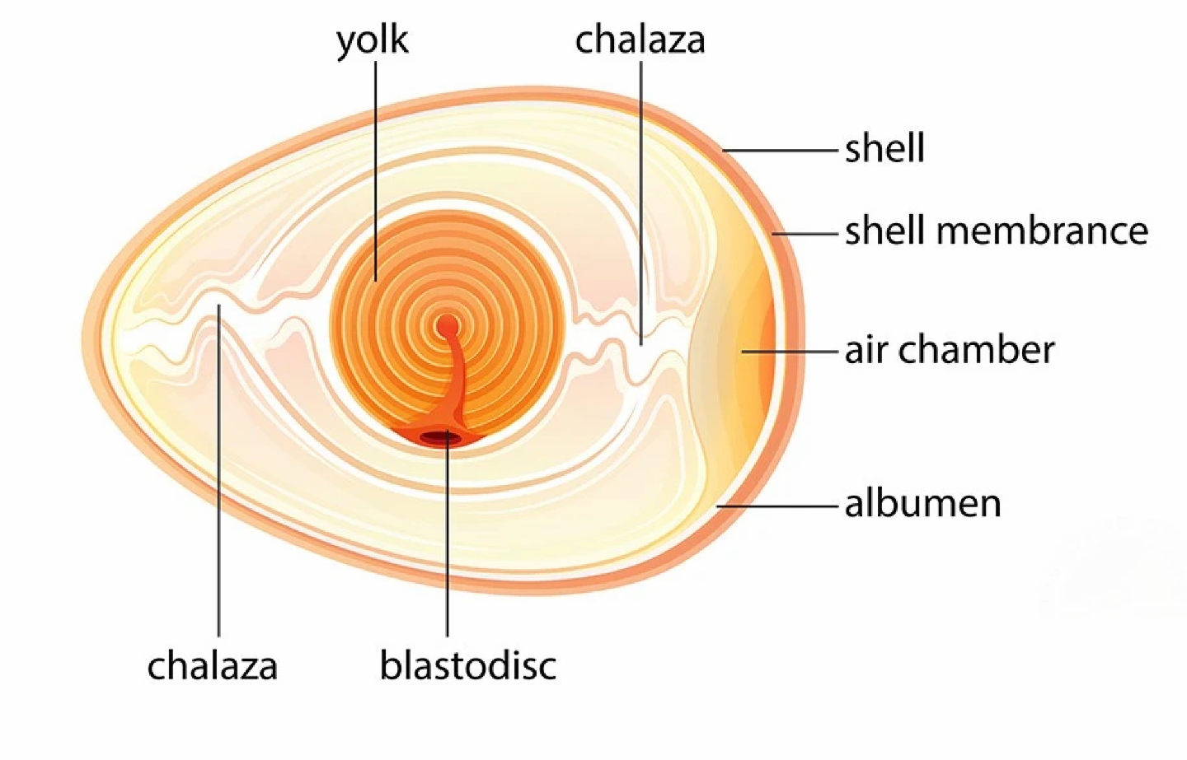

*Figure 2.1 Anatomy of fertilized egg [13]*

A fertilised egg is laid with embryonic development already started for chick development. This process stops when the right conditions necessary for development is not provided but resumes when a brooder hen or incubator provides the conditions required. The incubation process of the chick takes 21days to develop and hatch. The development process is affected daily by the incubation conditions because a simple glitch in temperature or humidity can compromise the success of the incubation of the chick.

Inside an incubator or when sat on by a hen the eggs resume development from just a layer of cells to a fully grown chick. The changes that the embryo goes through is remarkable. The image below shows the stages of formation of an embryo under incubation.

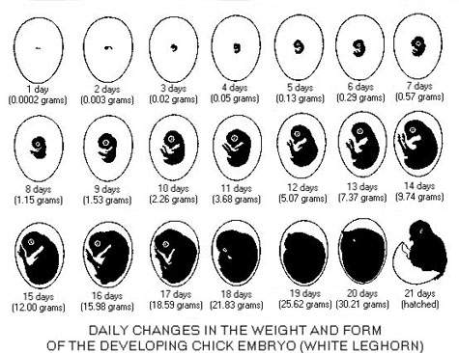

*Figure 2.2 Daily embryonic development of the chick under incubation [17]*

Day 1: Development of head and nervous system

Day 2-3: Development of the heart, nose, and legs

Day 4: Beginning of tongue development

Day 5: formation of reproductive organs and differentiation of sex

Day 6: beginning of beak

Day 7: beginning of feathers

Day 8: beginning of hardening of beak

Day 13: appearance of scales and claws

Day 14: embryo gets into position suitable for breaking shell

Day 16 - scales, claws and beak becoming firm and horny

Day 17 beak turns toward air cell

Day 19 - yolk sac begins to enter body cavity

Day 20-21 - yolk sac completely drawn into body cavity; embryo occupies practically all the space within the egg except the air cell and hatching. [17]

## **2.2 Related Work on the conditions necessary for Incubation**

### ***2.2.1 Effects of Relative humidity on Incubation.***

During incubation, a chicken egg loses a certain amount of weight because of water evaporation. This is essential to create an air cell sufficient to allow embryonic lung ventilation after internal pipping and a successful hatch. [23]

In broiler chicken eggs, the highest hatchability rate is reached when the diffusive water loss is about 12% to 14% at day 18 of incubation. Whereas, the embryonic mortality increases when the percentage of water loss is anywhere lower than 9.1% or higher that 18.5%, according to C. W. van der Pol et al [16]. The authors of [23] further stated that water vapor shortfalls H2O and gas exchange between internal egg and its environment, hence varying the relative humidity (RH) in an incubator helps to control water evaporation in the incubator. They also speculated that reducing the RH rises the egg’s water evaporation hence manipulating the embryonic temperature.

C. W. van der Pol et al [23] used a 47-weeks-old Roses 308 eggs which averagely weighed 64.9 g from range of 52.7 g to 79.7 g at day 0 of incubation. In this experiment, the authors maintained the EST at 37.8℃ throughout the process till day 20 when it was adjusted to 36.1℃, CO2 concentration was kept between 0.25% and 0.35%, and eggs were turned to an angle of 45° and then turned hourly by 90°. They stored the eggs at 18℃ for 5 days before incubation. Two incubators were used, one where relative humidity was maintained at 30 to 35% (low incubator RH) and the other at 55 to 60% (high incubator RH) from day 2 to day 21. From day 0 to day 2, RH was maintained at 55 to 60% for both incubators.

The authors of [23] then disclosed that in the first and second week, relative humidity did not affect embryonic mortality, hatch time, chick length, navel score, yolk free body mass(YFBM), residual yolk weight, or relative organ weights. Also, there was a higher egg weight loss from day 0 to day 18 (+3.0%), and lesser hatchability rate of fertile eggs (-2.9%) in the low incubator RH compared with the high incubator RH. The results of their work again showed that, in week 3, there was an increase in the embryonic mortality by 1.6% for the low incubator RH treatment (where water loss was 12%) compared with the high incubator RH treatment which water loss turned out to be 9.7%. For the low incubator RH treatment, RH was maintained at a relatively low level during the hatching process (40%, peaking at 55%) compared with the high incubator RH treatment, where RH was (55%, peaking at 70%). This caused of the difference in the embryonic mortality.

Figure 2.3 shows a result from C. W. van der Pol et al [23].

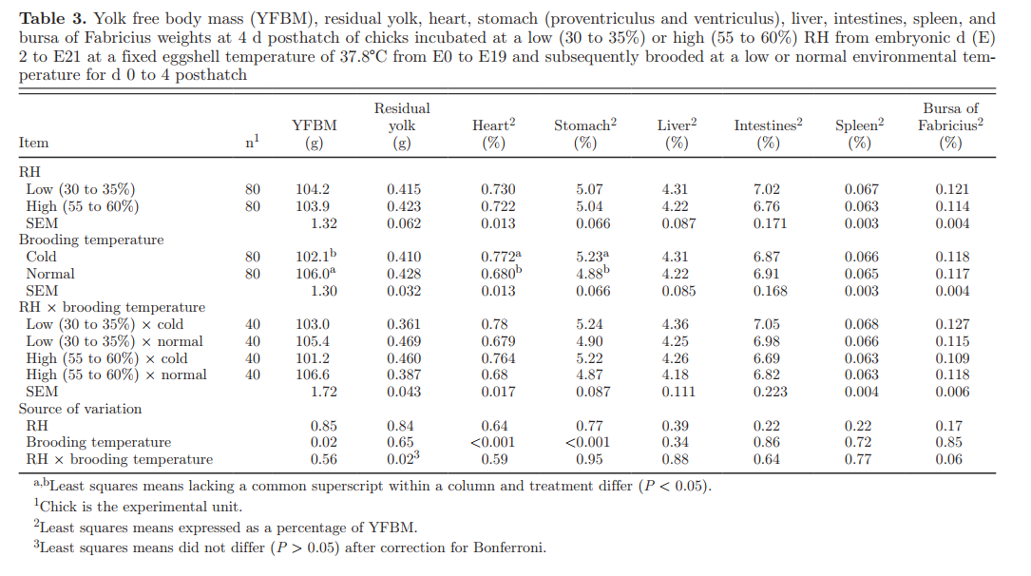

*Figure 2.3 Results found by the authors of [23]*

### ***2.2.2 Effect of temperature on Incubation***

Temperature is one of the physical factors that determine the success of incubation. Therefore, it is essential to determine and use a temperature that promotes the highest hatchability and the best hatchling quality. This temperature is known as the optimum incubation temperature [21]. In [21], they stated that the optimum incubation temperature of wild fowl eggs is within a wide range of values, varying from 33℃ to 39℃, whereas a narrower range of 37 ℃ to 38 ℃ is considered for that of domestic poultry.

The effect of incubation temperature on egg hatchability and hatchling quality may be related to its influence on incubation length and water loss during incubation. However, such effects depend on how long and how intense the shift from optimum temperature is. According to [21], an increase of 1 ℃  i.e. 38.8 ℃  above the optimum incubation temperature (37.8℃ ) starting at day 13 of incubation causes a significant reduction of the hatching rate of broiler eggs, whereas such effect is not observed when the temperature is reduced in 1 ℃  (36.8 ℃ ).

Incubation temperature correlates directly to the duration of in ovo development both in turkeys and broilers. The development is delayed in temperatures below the optimum incubation temperature and accelerated in temperatures above it. Such difference in embryo development rate as a result from changing the incubation temperature seems to explain body weight. [21]

Water loss is a normal process during incubation, [21] stated how too much water loss or too low water loss influences embryo development and mortality, and therefore hatchability. Incubation temperatures above the optimum cause excessive egg water loss (higher than 14%), leading to embryo mortality by dehydration. On the other hand, temperatures below the optimum decrease hatchability due to reduced water loss (< 12%), which causes an over-hydration of the embryo and an impairment of gas exchange. [21]

H. J. Wijnen et al [22] stated that incubation temperature affects embryonic development and consequently the neonatal chick quality. They also indicated that the neonatal chick quality also relates to later life performance. H. J. Wijnen et al [15] agree with Gener Tadeu Pereira et al [21] on the fact that maintaining the optimum incubation temperature (37.8℃) throughout the incubation process has been the best condition until they did their research.

In this research, the authors used eggs of a 44-weeks-old Ross 308 broiler breeder flock which they stored for 2 days at a storage temperature of 20℃ at a commercial hatchery (Lagerwey BV, Lunteren,the Netherlands). They weighed these eggs individually and divided them into 3 weight classes: 62.0 to 62.9 g, 63.0 to 63.9 g, and 64.0 to 64.9 g (156 eggs/weight class). They placed all the eggs in one incubator and warmed linearly in 14 hrs from storage temperature (20℃) to an EST of 37.8℃ before the start of the incubation. Immediately the temperature reached 37.8℃, they started counting the incubation days from this time. They monitored the EST by using 4 EST sensors (NTC Thermistors: type DC 95; Thermometrics, Somerset, UK), which were placed at the equator of 4 individual eggs. This temperature of 37.8℃ was maintained till day 7.

At day 7, they candled all the eggs and removed the infertile ones. Thereafter, they equally divided the eggs into 4 separate incubators (2 replicates/treatment group). Each incubator had 4 EST sensors, which were attached to 4 individual eggs as described above [22]. From day 7 until day 15, they maintained the temperature at 37.8℃ in 2 incubators and 38.9℃ in the other two.

At day 15, the eggs were candled again and the dead embryos were removed. They equally divided the eggs into 4 separate incubators (2 replicates/treatment group) again. This time, they maintained the EST at the optimum incubation temperature in two and maintained the EST at 36.7℃ for the other two. At day 18, they candled the eggs again and transferred them into a hatching baskets and placed them back into the incubators maintaining the temperature as it was.

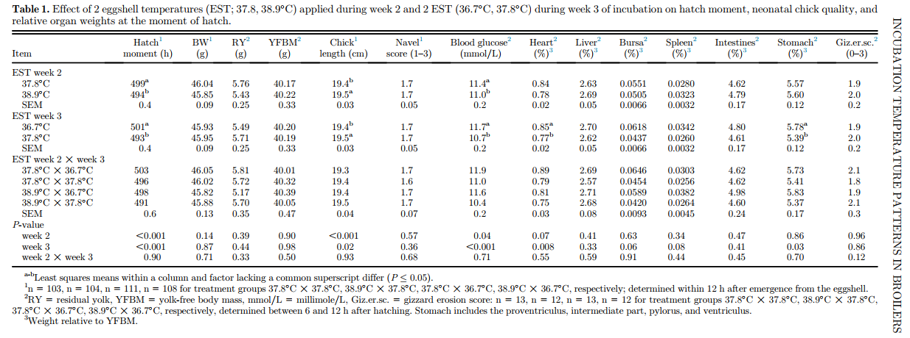

*Figure 2.3 shows the results from the authors in [22] work*

H. J. Wijnen et al [22] stated from the figure above that, a higher EST of 38.9℃ in week 2 resulted in a higher egg weight loss compared with a constant EST of 37.8℃ (10.3 vs. 9.7% ± 0.1 for 38.9℃ and 37.8℃, respectively; P < 0.001). Hatch moment was on average 5 hr. earlier when EST in week 2 was raised to 38.9℃ compared with a constant EST of 37.8℃ (P < 0.001;). Eggshell temperature in week 2 had no effect on hatchability (95.7% vs. 97.7% ± 0.4 for 38.9℃ and 37.8℃, respectively; P = 0.32). A lower EST of 36.7℃ in week 3 resulted in a 8 hr. later hatch moment (P<0.001) compared with an constant EST of 37.8C, but it had no effect on egg weight loss (9.9 vs. 10.1% 6 0.1 for 36.7℃ and 37.8℃, respectively; P = 0.17) and on hatchability (97.2 vs. 96.5% 6 0.4 for 37.8℃ and 36.7℃, respectively; P = 0.67). [22]

H. J. Wijnen et al [22] hypothesized that an incubation pattern consisting of a higher EST of 38.9℃ in the second week of incubation in combination with a lower EST of 36.7℃ in the last week of incubation would result in most optimal embryo development, neonatal chick quality, and subsequent broiler performance during grow-out compared with a constant EST of 37.8℃ throughout incubation.

Temperature is an essential part of the incubation process of eggs. In the development of the embryo of an egg, a temperature too high will cause rapid water loss from the egg cell which will make it wrinkle and die and temperature too low will inhibit the grow of embryonic cells since it will die of cold, this will stop the embryo of the egg from growing into a fully matured check. For this matter, the temperature in an incubator needs to be regulated to values that are optimal for the development of the embryo in the egg cell.

### ***2.2.3 Effects if turning of eggs on incubation***

According to [18] egg turning is a very important aspect of normal incubation process. This process is undertaken in the brooder hen when with its beak it turns the egg. They also found out that the importance of egg turning is very important in the development of eggs in incubation as it can help get a very high hatchability rate, this action of turning is especially very important during the first week of incubation. They found out that for effective operation eggs needs to be turned about 45o on both axis of rotation.

[18] worked on the importance of turning during incubation but did not tell how many times turning should be done, this is what [19] worked on. The aim of their study was to evaluate the effects of different number of times turning of eggs per day has on incubation efficiency parameters. Nine hundred sixty brown fertile eggs, with an average weight of 52.20 ± 0.85 g, from 38-week-old CJD (Carijó Pesadão) breeder hens were randomly divided into 4 treatments before incubation. Each treatment corresponded to a turning frequency, being 24 (control), 12, 6, or 3 times per day at an angle of 45° until day 18 of incubation.

The incubator was operated at an average temperature of 37.5 oC and relative humidity of 55%, during the first 18 days of incubation.

At day 18 (432 h of incubation), the eggs were weighed to calculate egg weight loss during incubation, and then, the setters were adjusted for the hatching period. From day 19 (456 h of incubation) on, the setters were operated at an average temperature of 36.6°C (97.88ºF) and a relative humidity of 65%(a high humidity to help soften egg shells to prepare for hatching). During this period, the number of chicks hatched, and their respective weights were recorded. After 21 D (504 h of incubation), the unhatched eggs were counted, opened, and evaluated to determine the amount of infertile eggs and the period of embryonic mortality, early (0–7 D), middle (8–18 D) and late (19–21 D).

The experiment monitored Turning frequency(number of turning per day), fertility(%), hatchability of set eggs (%), hatchability of fertile eggs (eggs), early dead (%),mid dead(%), late dead(%).

The results of their experiment using the parameters above is illustrated in the table below

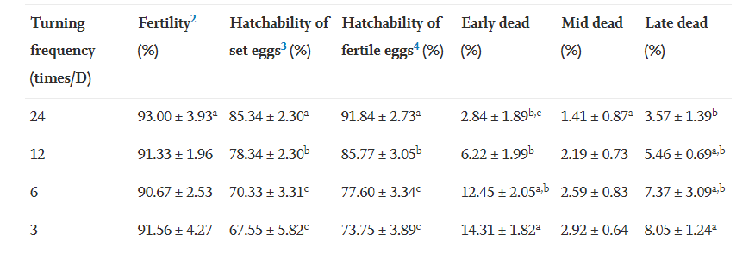

*Figure 2.4 Results found by the authors of [18]*

From the results above, it is seen that that the rate of hatchability of eggs increases with the number of times the eggs are turned in a day.

### ***2.2.4 Effects on Ventilation on Egg Incubation***

According to [20] since the egg living it means it will be respiring. This then implies that there will be exchange of carbon dioxide and oxygen to and from the shell of the air surrounding it inside the incubator. During the growth of the embryo, the egg nutrients need to be converted into body tissue, which requires O2 and produces CO2 in a more or less fixed ratio (Respiration Quotient or RQ-value). This O2 uptake and CO2 production is linearly related to the heat production of the embryo.

## **2.3 Related Work on Artificial Incubation**

The idea of Artificial incubation has always been practiced by human beings since the time of the Egyptian empire and Chinese Dynasties around 200BC [11]. During this time, the type of incubation used was manual which meant it was totally depended on human beings.

The application of incubation principles was a closely guarded secret, passed from one generation to the next. The proper temperature was judged by placing an incubating egg in one’s eye socket for accurate determination. Temperature changes were affected in the incubator by moving the eggs, by adding additional eggs to use the heat of embryological development of older eggs, and by regulating the flow of fresh air through the hatching area. Humidity was evidently not a problem as primitive incubators were in highly humid areas, and the heat source, often burning materials (cow dung), furnished water around the eggs. Turning was done as often as five times in a 24-hour period after the fourth day of incubation.  
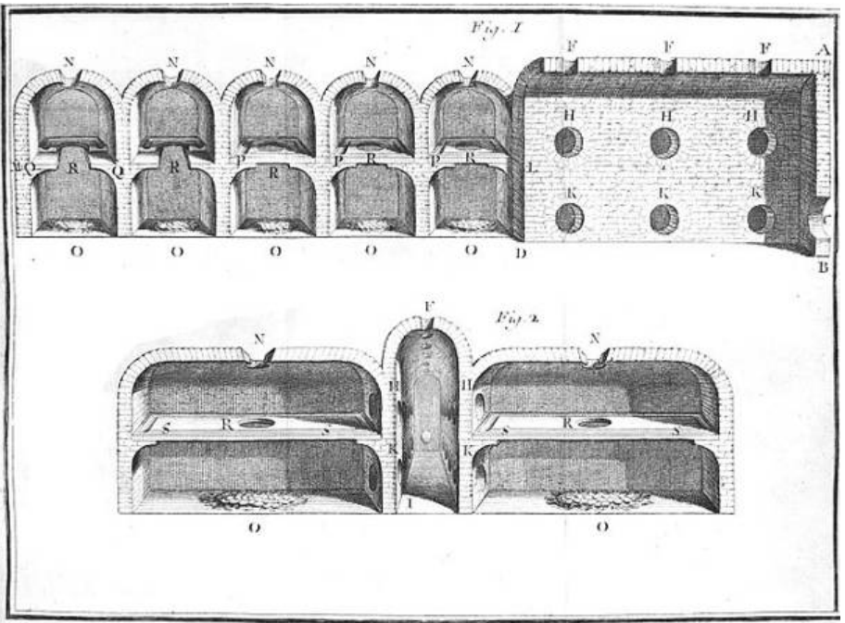*Figure 2.5: Scheme of an Egyptian Incubator by French entomologist René Antoine Ferchault de Réaumur*

This shows that artificial incubation of has been very well practiced by humans even by our ancient ancestors.

[20] Presented the development of an incubator system which automatically checks the temperature and humidity of the system using Arduino microcontroller interfaced and coded using LabView programming. Their system included important functions to hatch eggs and it performs candling to take out infertile eggs by using basic image recognition, and egg turning that employs crank-rocker mechanism and a hatching chamber. It revolved around fusing all the elements of egg incubation and turning it into one device. It functioned autonomously without having to be consistently check and adjusted to obtain optimal parameters. By using its monitoring features, the user can have real-time data of the day-to-day status of the incubator’s parameters. On the issue of candling, As a solution to the problem, an egg candling mechanism inside an incubator was incorporated and designed which in turn will reduce the time invested in candling and will detect undeveloped eggs and classifies it from the rest of developing eggs to avoid the contamination of the incubator due to the phenomena of exploding eggs and premature death of chicks due to mishandling of eggs.

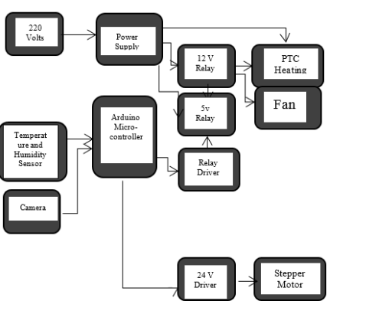

*Figure 2.6: Block diagram proposed by [20]*

The problem with this is that taking images of the eggs during candling requires the use of camera on each floor of the incubator (when a multistage incubator is used to hatch many eggs). The purchase of Cameras will drastically increase the cost of production of the incubator which is undesirable. Also, the hatch rate in using the proposed system was 69.44%, this hatch rate is very low considering the amount of cost that went into designing the system.

**SECTION 3: METHODS AND METHODOLOGY**

A system comprises of different functional units working together to achieve a common goal. Our system consists of different separate units which assembles to perform the function of smart incubation. This chapter presents the system architecture showing the big picture of our system. It also gives details about the system’s operation via the use of; the block diagram to illustrate the hardware operations, the flow chart to show the system logic and the use case diagram to show how a user interacts with software components of the system.

## **3.1 System Architecture**

As depicted in the figure 2.7 below, the system architecture provides the general overview of how the automated incubator system is intended to work. It outlines visually the operation of the system from the embedded system to the operations on the server side and the activities on the user’s mobile device. The system architecture has three main parts: smart incubator, the server, and the mobile application.

The smart incubator is the whole incubator with sensors, microcontroller and wireless communication modules. These components are grouped as a unit, making the hardware.  
The sensors are responsible for collecting the system essentials; temperature and relative humidity of the incubator chambers. The sensors read the temperature and relative humidity values and send these values to the microcontroller.  
The data received from the sensors is sent to the server via the wireless communication medium to be displayed to the user on the mobile application. The controller also sends this data to other hardware components like the Liquid Crystal Display (LCD) for display. With this data, the controller sets other working limits within which the incubator works optimally.

The wireless communication module is interfaced with the microcontroller to establish the communication channel between the incubator and the server. It aids in the seamless logging of data from the microcontroller to the server and from the server to the microcontroller.

The server is the point of communication between the incubator and the mobile application. The server acts as the data storage and exchange point between the hardware and mobile application. Data from the microcontroller is sent via the wireless communication medium to the server. The server saves this data and processes it into a format that can be sent to the mobile application. Likewise, the mobile application sends data to the server. This data is processed into a format readable by the microcontroller and sent to the smart incubator. The communication between the incubator to server, and server to mobile application is bidirectional.

The mobile application is the application that receives information from the incubator and present this to the user. It is assumed that the user is not always near the incubator but must monitor the incubator. The mobile application retrieves data sent from the incubator to server and makes this data available to the user. Via the mobile application a user is able to remotely control the activities of the smart incubator when it is deemed necessary.. This data is then sent to the microcontroller to use in regulating system parameters.

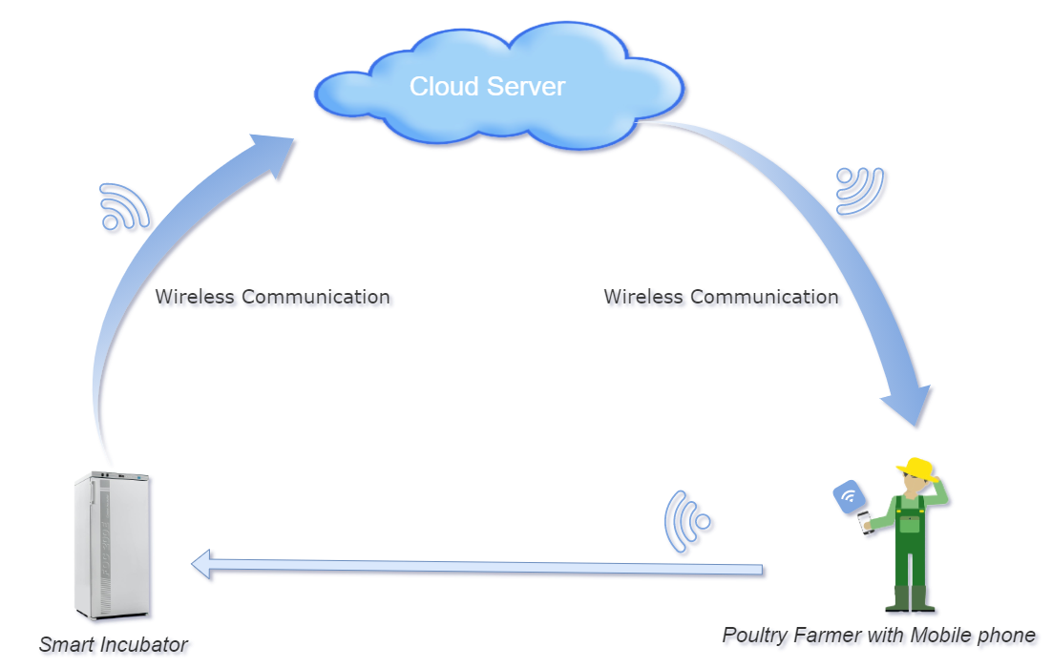

*Figure 3.1: System Architecture Diagram*

## **3.2 HARDWARE SYSTEM BLOCK DIAGRAM**

The block diagram is a diagram of a system in which the principal parts or functions are represented by blocks connected by lines that show the relationships of the blocks. The block diagram in Figure 3.2 below shows the various components that the incubator system consists. It show the various components as blocks connected to each other in a particular fashion which indicates the relation between these blocks. The main blocks in the block diagram of the incubator are described as below.

### **3.2.1 MICROCONTROLLER**

A microcontroller is an integrated circuit device used for controlling other portions of an electronic system, usually via a microprocessor unit, memory, and some peripherals. These devices are optimized for embedded applications that require both processing functionality and agile, responsive interaction with digital, analog, or electromechanical components.

The microcontroller is responsible for controlling and regulating other devices in the incubator. It controls how the incubator functions. The microcontroller processes the values read by the sensors (i.e. the temperature and humidity sensors) and send this values to be displayed by the LCD. Based on the limits set for temperature and humidity, the microcontroller connects and disconnects the relays connecting to the fan, motor or bulbs. The controller sends control signals to monitor the operation of the whole embedded structure. It also logs the data received to the server and this is made possible by the wireless module. The brain of operation of the incubator is integrated into the microcontroller.

### **3.2.2 SENSORS**

Electrical sensors are devices or integrated circuits that detects a specific physical parameter and converts it into an electrical signal. The output of an electrical sensor is processed and used to provide a measurement or to trigger an action. There are two types of sensors in the development of our incubator. These sensors are the temperature and humidity sensors. The sensors are transducers which are responsible for the reading of analog environmental conditions.

**3.2.2.1Temperature Sensor**

The temperature sensor is responsible for reading the temperature in the incubator chambers. This value is sent to the microcontroller to be used to control the operation of other components such as the electric bulbs and the electric fan which are responsible for the heating and even distribution of heat within the incubator. The value is also displayed on the liquid crystal display.

#### **3.2.2.2 Humidity Sensor**

The humidity sensor like the name suggests, reads the humidity within the chambers of the incubator. This value which is sent to the microcontroller, is processed and used to control the operation of the incubator. The humidity within which the incubator works to obtain optimal results is set. With the readings of the humidity sensor, the microcontroller regulates the heating and cooling elements to operate within the specified limits.

### **3.2.3 RELAYS**

A relay is an electrically operated switch. It consists of a set of input terminals for a single or multiple control signals, and a set of operating contact terminals. With the relays, the microcontroller is able to control power supply to some components. The input terminals of the relays are connected to the microcontroller. The signals from the microcontroller based on the temperature and humidity values recorded by the sensors are used to switch the relays on or off. When the relay is connected, power is supplied to the electric bulb, electric fan and electric motor. There are relays to which the fan, bulbs and motor are connected to. This enables cutting and supplying power to these devices on appropriate signals from the microcontroller to keep their operation within the optimal limits set.

### **3.2.4 WIRELESS MODULE**

The wireless module is in the design to enable the communication between the incubator and the server. The data processed by the microcontroller is sent to the cloud server to be relayed to the mobile application on the farmer’s mobile device. Likewise, data is sent from the mobile application to the server and then to the incubator. This communication in and out between the incubator and the server is made possible by the wireless module.

### **3.2.5 KEYPAD**

The incubator is made to be operated both automatically and manually. The keypad is in the system design to allow the user to key in essential parameters such as temperature and humidity limits. Any value that is meant to be entered to be sent to the microcontroller is made possible by the keypad on the incubator.

### **3.2.6 POWER BUTTON**

This is an electrical switch used to turn on and off the incubator. When the power source is connected, power is not supposed to be passed to the incubator to turn it on instantly. The power button enables the controlled supply of power to the incubator.

### **3.2.7 POWER SOURCE**

The incubator as an electrical device, requires an electrical energy to operate. The power source is necessary to supply the power needed by the incubator to operate. Every other electrical component attached to the incubator depends on this power source to operate.

### **3.2.8 ELECTRIC BULBS**

The incubation process requires heat for the embryo to develop. The heating in our incubator is provided by using electric bulbs. Since the temperature within the incubator must by regulated within a lower and a higher limit which is set, the electric bulbs are connected to a relay. When the incubator is heated to the higher limit, a control signal is issued by the microcontroller to cut power supply to the electric bulb. The reverse happens when the heat in the incubator reaches the lower limit.

### **3.2.9 ELETRIC MOTOR**

An electrical motor is an electro-mechanical device which converts electrical energy into mechanical energy. It produces rotational force from electricity. The eggs must constantly be turned to prevent the embryo from clinging to the surface of the shell. The electrical motor provides the means for us to turn the eggs in the incubator through a well-thought mechanism. The turning is done at regular intervals so the motor is connected to a relay to enable the regulation power supply to it.

### **3.2.10 ELECTRICAL FAN**

The electric fan aids in the even spread of the air in the incubator chamber. It helps to evenly distribute the heat in the incubator. At the same time, the fan increases the spread of the moisture which is provided by the water bowl as it blows over its surface. Heating is gradual due to the cooling effect of the fan and is even. Moisture content availability is increase, and the ventilation of the system is enhanced.

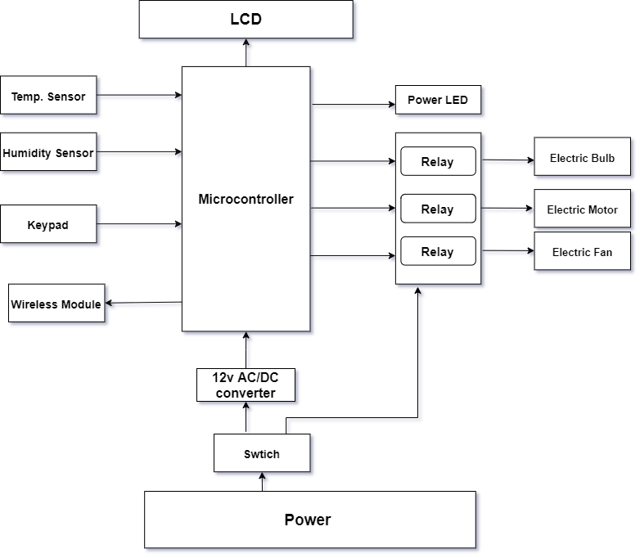

*Figure 3.2: Hardware System Block Diagram*

## **3.3 SYSTEM WORKFLOW**

The system workflow shows the sequential stages that the incubator system goes through to accomplish its desired purpose of hatching eggs. The phases of operations which the incubator follows is described in the workflow. The figures illustrated below give a graphical view of the workflow.

### **3.3.1 MAIN FLOWCHART**

The system workflow has been divided into two portions as illustrated in figure 3.3.1 below for the purpose of convenience and ease in showing the algorithm. The divisions are the sensor flowchart, which is shown in figure 3.3.2 and the timing flowchart, which is shown in figure 3.3.3.

At the start of the system by pressing a button, the power LED comes on indicating that the system is ready to operate. The timing and sensor operations are set to begin their flow.

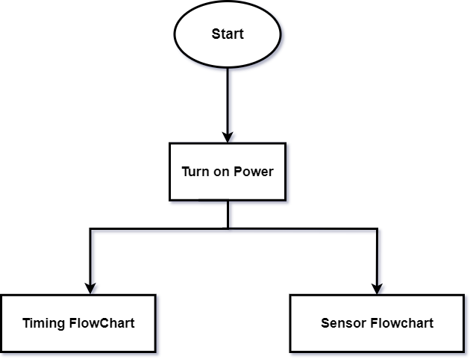

*Figure 3.3.1: Main Flowchart.*

### **3.3.2 SENSOR FLOWCHART**

The sensors, that is the temperature and humidity sensors gather the temperature and relative humidity of the ambient of the incubator respectively. The data collected is used by the microcontroller for logical decisions. If the temperature read is less than 37.8℃ **(**this value is for chicken eggs) the microcontroller issues a signal to turn on the bulb. This is to increase the temperature of the incubator chambers. Else if the temperature read is greater than 37.8℃ the microcontroller issues a signal to turn off the bulbs in other too reduce the heat in the incubator chamber.

The value of the relative humidity read is checked. If this value is less than 60%, then a message is sent to the user to add more water to the water pan in the incubator otherwise the relative humidity of the incubator chamber is fine. The data collected is then sent to the cloud for processing which is then retrieved by the user via a mobile device.

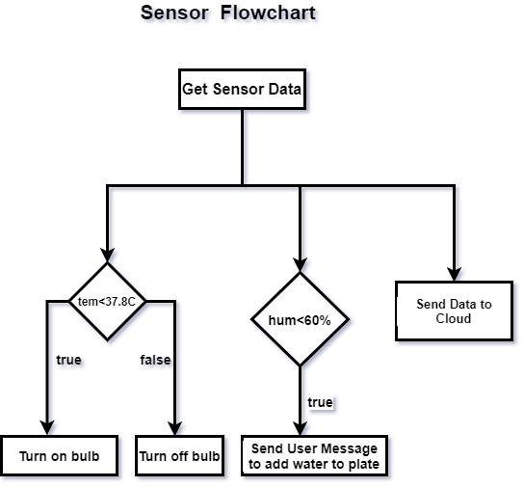

*Figure 3.3.2: Sensor Flowchart.*

### **3.3.3 TIMING FLOWCHART**

The number of days required for the incubation period is set. By default, this value is 21 days for chicken. The default value is what the microcontroller of the incubator is programmed with. A user who wishes to incubate a different type of eggs may set the days required for incubation. The user is able to set the day using the keypad or via the mobile application. The timer for turning is also set. By default, the eggs should be turned every hour as this yields the maximum hatchability.

The microcontroller checks if the timer value equals the turn time. If this is true, a command is issued for the eggs to be turned for some time. The timer is then reset and the process of checking and turning is repeated.

From the time the eggs are put into the incubator for incubation, the microcontroller starts to keep count of the days. The microcontroller checks if the day of incubation equals the incubation period set. While this is not true, all other processes in the incubator continue. When the incubation day equals the incubation period set, the fan is turned off and the incubation process is halted.

TIMING FLOWCHART

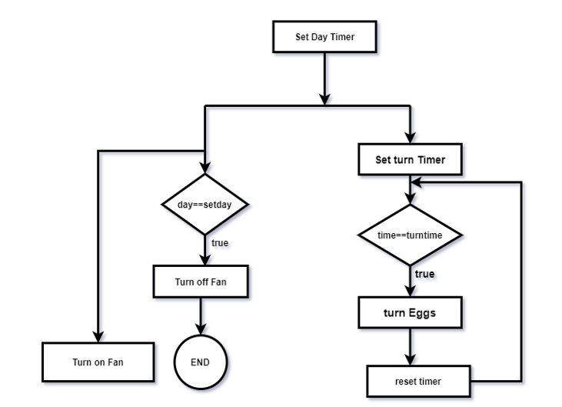

*Figure 3.3.3: Timing Flowchart.*

# SECTION 4: DESIGN AND IMPLEMENTATION

4.1 THE PHYSICAL INCABATOR STRUCTURE

# SECTION 5: TEST AND EVALUATION

# SECTION 6: CONCLUSION

# REFERENCES

1. Okpagu, P.E. & Nwosu, A.W. (2016). Development and Temperature Control of Smart Egg Incubator System for Various Types of Egg. European Journal of Engineering and Tehnology Vol. 4 No.2

2. Olaoye I.O., Lawal B.M., Ibrahim S.O. and Sanusi B.A. (May 2013). An Electrically Operated Incubator for Household. Greener Journal of Science and Technological Research, Vol. 3(5), pp. 160-165.

3. Umar A. B.1* , Lawal K.1 and Mukhtar M.1 and M. S. Adamu2 (2016). Construction of an Electrically-Operated Egg Incubator. International Journal of Modern Engineering Sciences, 5(1):1-18

4. Ajani Adegbenro Sunday1, Olusoji Amos Ogunbode2, Egbeyale Godwin Babatunde3, Adeniji Muyideen Olalekan4. Design and Construction of Automated Eggs Incubator for Small Scale Poultry Farmers. International Journal of Technical Research & Science, No.:2454-2024 (online)

5. Lawrence Yaw Kusi, Senyo Agbeblewu, Isaac Kwadwo Anim, Kwamena Minta Nyarku (2015). The Challenges and Prospects of the Commercial Poultry Industry in Ghana: A Synthesis of Literature. International Journal of Management Sciences, 5(6), 476-489.

6. MOFA.GOV.GH, [Online]. Available:

<https://www.mofa.gov.gh/site/media-centre/agricultural-articles/321-revamping-the-poultry-sector-in-ghana> [Accessed 04 12 2020]

7. PoultryWorld, [Online]. Available: <https://www.poultryworld.net/Meat/Articles/2020/5/Millions-invested-to-revive-Ghanas-poultry-sector-588246E/> [Accessed 04 12 2020]

8. Djang-Fordjour, H., Hamidu, J.A., Adomako, K. “Assessing Incubation and Performance Deficiencies to Boast Broiler Production.” American Research Journal of Agriculture, Volume 3, 2017; pp:1-6

9. Incubator Terminology Explained, Retrieved 14th December,2020 (SureHatch, 2020)

10. Poultry Incubation, Retrieved 14th December,2020 (Virtual Farm, 2018)

11. Dr. Elio Corti and Elly Vogelaar “The Oldest Hatcheries are Still in Use”

12. Harb, S. K., Y. A. Habbib, A. M. Kassem, And A. El Raies, “Energy consumption for poultry egg incubator to suit small farmer” in Egyptian Agriculture Research.

13. H. S. WILGUS3 AND W. W. SADLER “Incubation Factors Affecting Hatchability of Poultry Eggs”

14. Backyard Chicken Coops, [Online], (Smith, 2020)

15. The Poultry site, [online], (thepoultry site, 2009) Retrieved 14th December,2020

16. Gener Tadeu Pereira, Nakage ES, Cardozo JP, Effect of Temperature on Incubation Period, Embryonic Mortality, Hatch Rate, Egg Water Loss and Partridge Chick Weight (Rhynchotus rufescens)

17. Hill, M.A. (2020, December 19) Embryology Chicken Development. Retrieved from <https://embryology.med.unsw.edu.au/embryology/index.php/Chicken_Development>

18. Dr. Charles Deeming, The Role of Egg Turning during Incubation

19. Gabrielda S. Oliveira, Vinícius M.dos Santos, Effects of different egg turning frequencies on incubation efficiency parameters

19. Ventilation during incubation is a complex, retrieved 21st December ,2020 matter , <https://www.poultryworld.net/Eggs/Articles/2018/2/Ventilation-during-incubation-is-a-complex-matter-247936E/>

20. Lean Karlo S. Tolentinoa.b, Emmanuel Justine G. Enricoa, Ralph Lawrence M. ListancoDevelopment of Fertile Egg Detection and Incubation System Using Image Processing and Automatic Candling.

21. Effect of temperature on incubation period, embryonic mortality, hatch rate,  
egg water loss and partridge chick weight (Rhynchotus rufescens) by Gener Tadeu Pereira et al

22. Effects of incubation temperature pattern on broiler performance by H. J. Wijnen, R. Molenaar, et al

23. Effect of relative humidity during incubation at a set eggshell temperature and brooding temperature posthatch on embryonic mortality and chick quality by C. W. van der Pol et

Al

# APPENDIX