Digistoq MVP crackdown
Home:

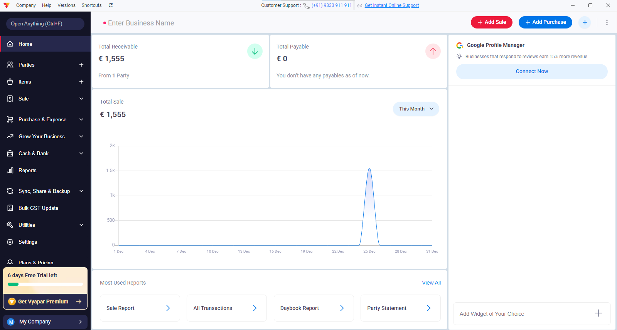

debit and credit with graph
quicklinks to corresponding reports tab
add sale button: for create sale invoice
add purchase button: for create purchase invoice (for own business)
the add purchase, sale buttons are sticky header for every screen ( dynamic )

…………………………………………………………………….

Party:

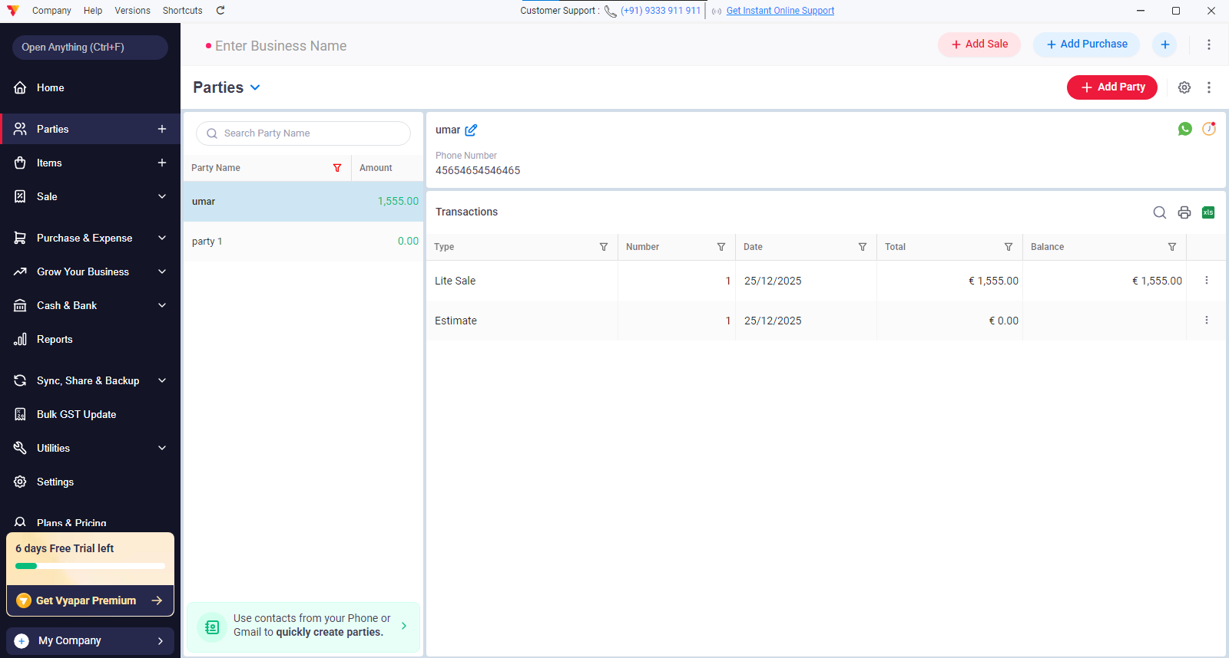

List of parties/customers on right hand.
Selected customer sale-transaction details on right
CTA button on right hand of a transaction contains:
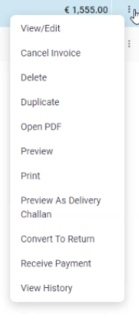
Where preview as delievery challan option contains:
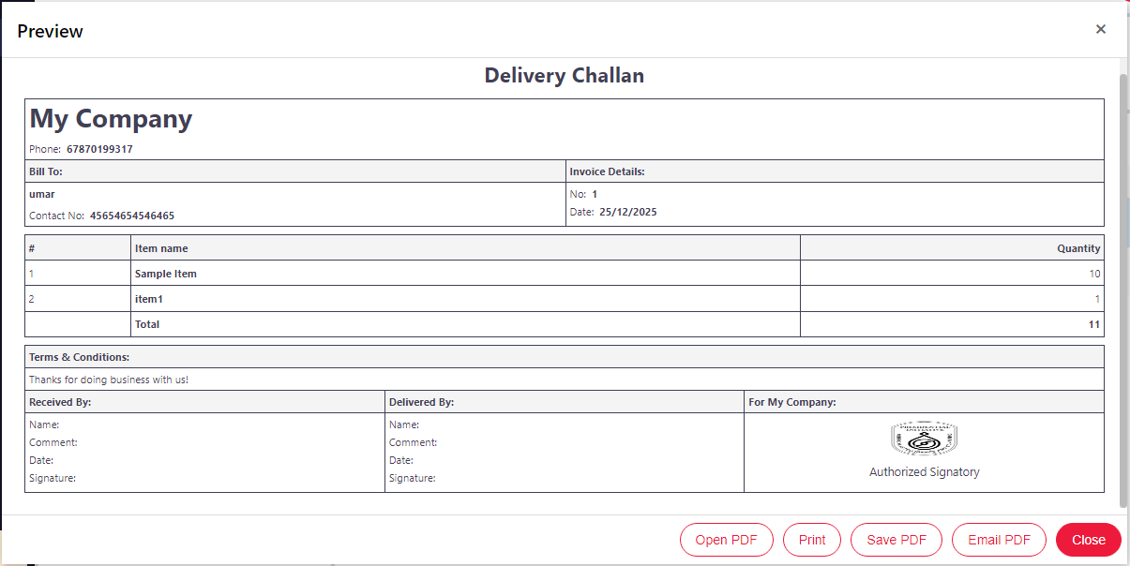

Party have add party section for adding customer details (creating new customer):

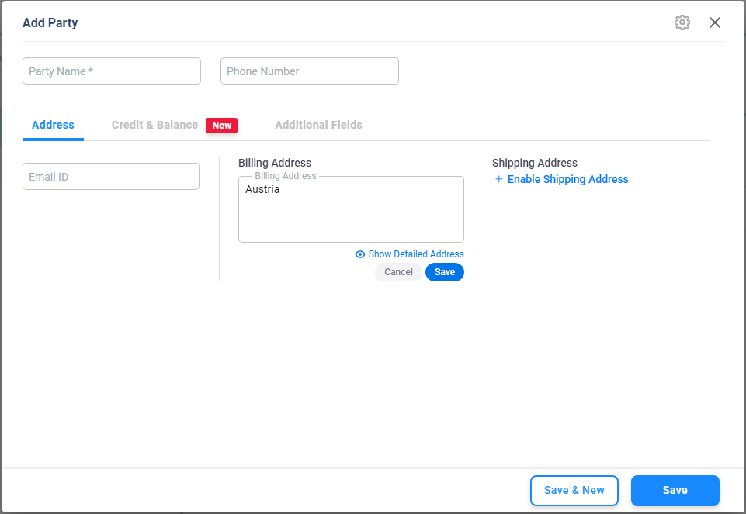

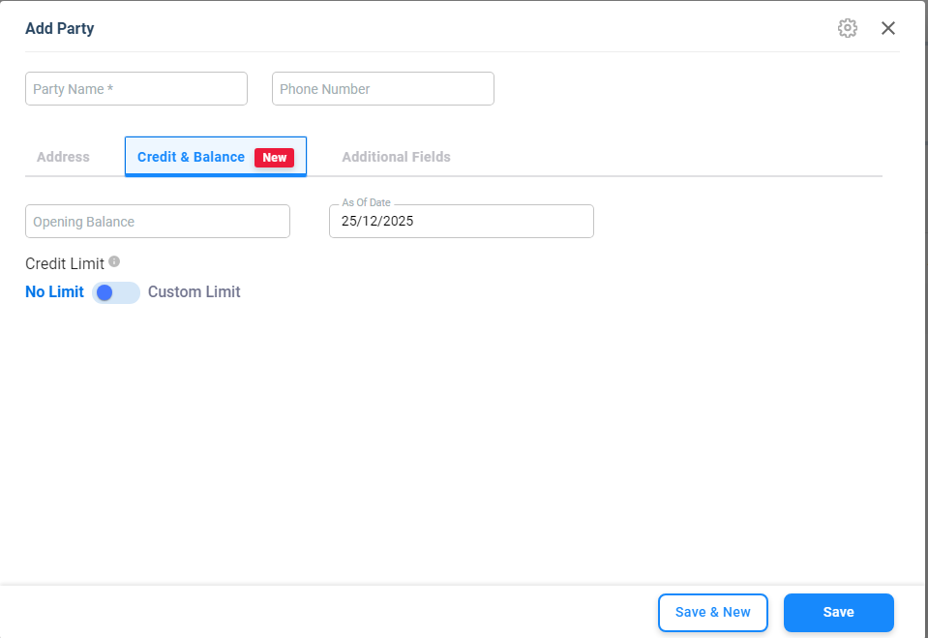

ITEMS:
Main screen:
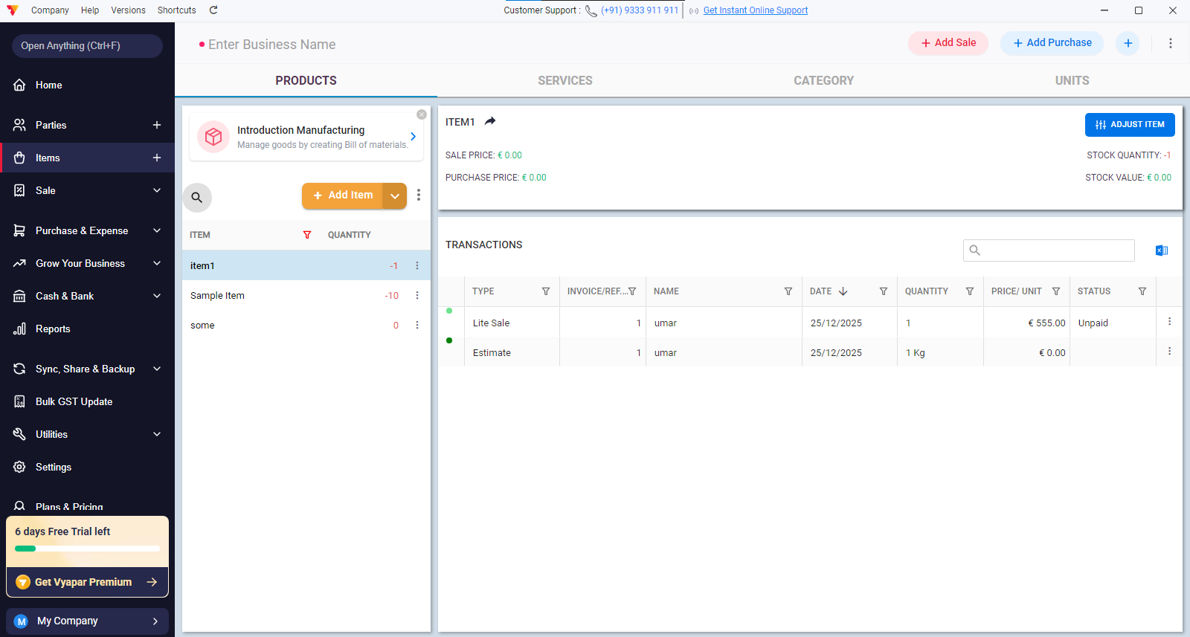

Add Item:

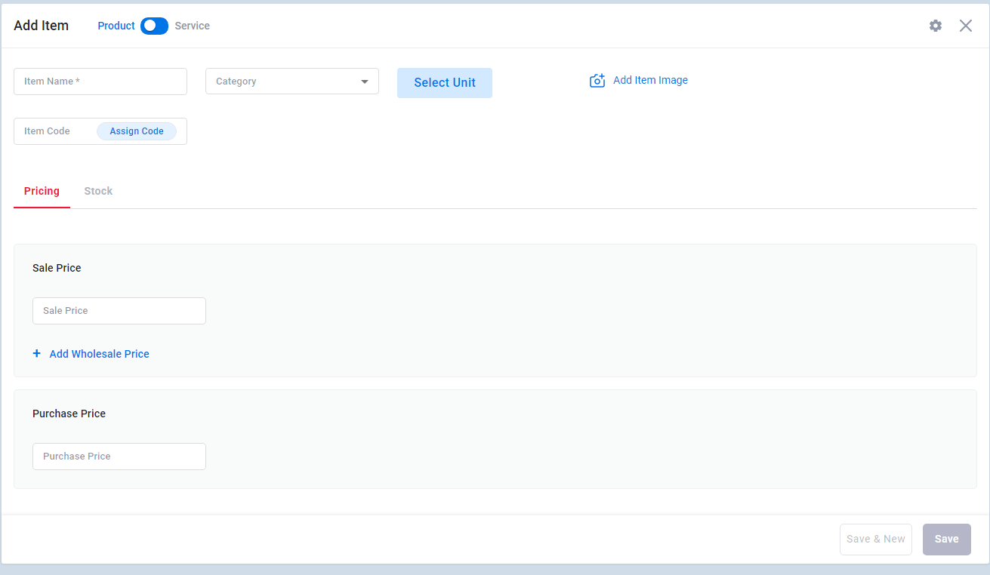

Add item button opens modal/popup.

The select unit button show:
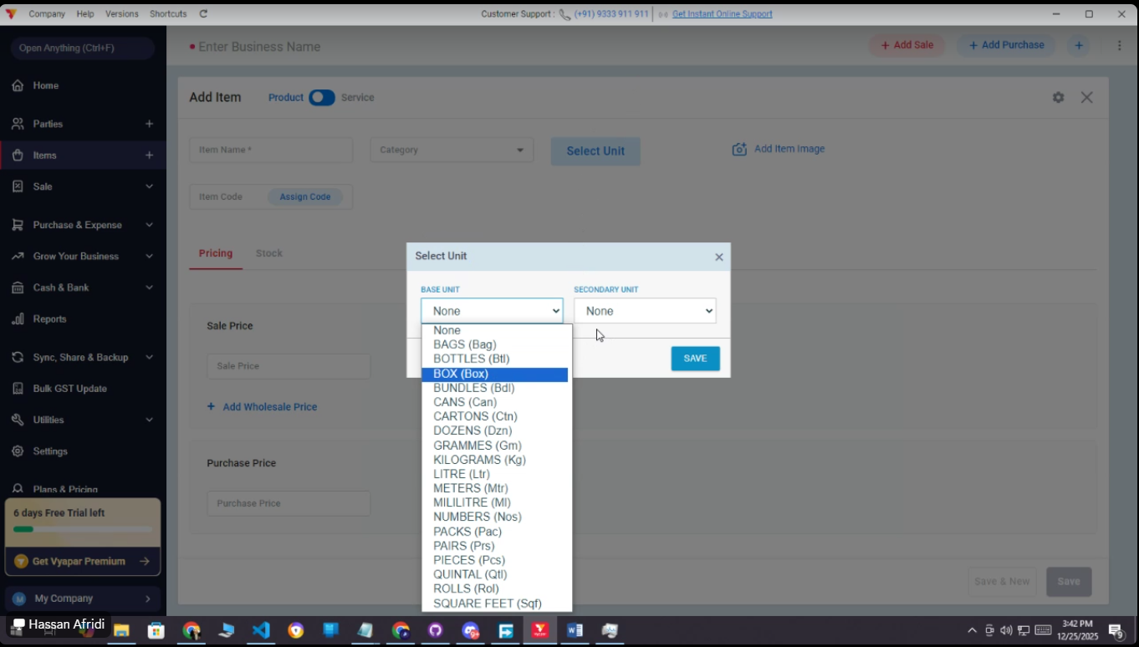

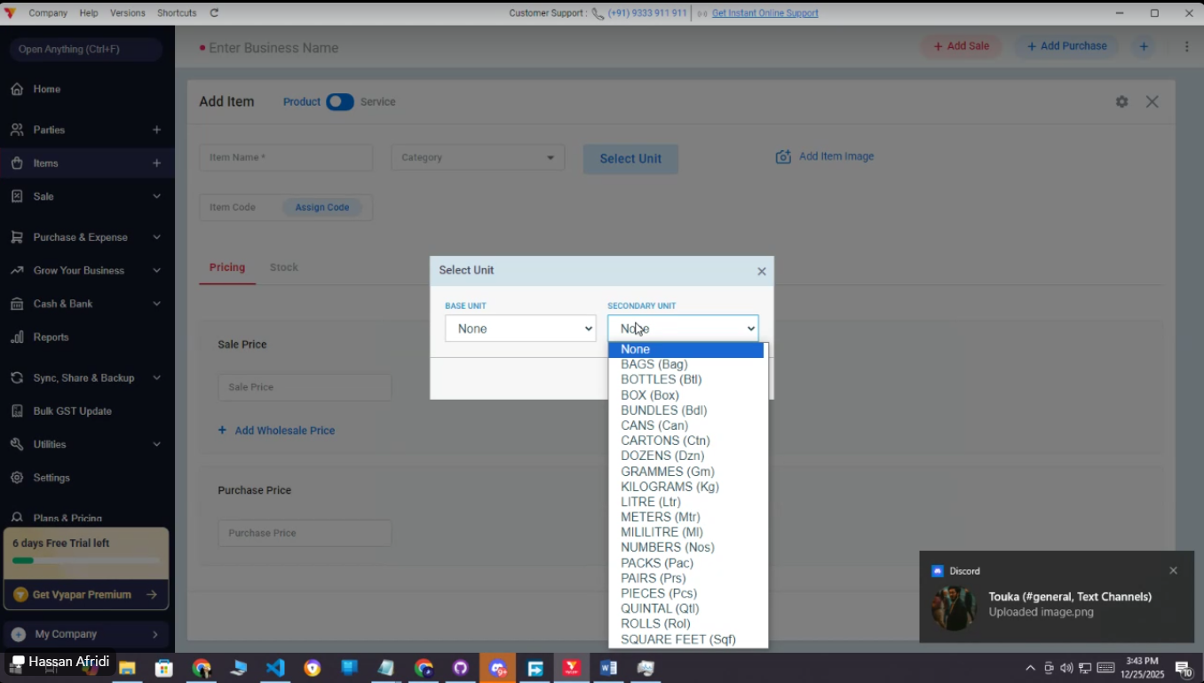

It contains 2 terms, pricing and stock with these fields:

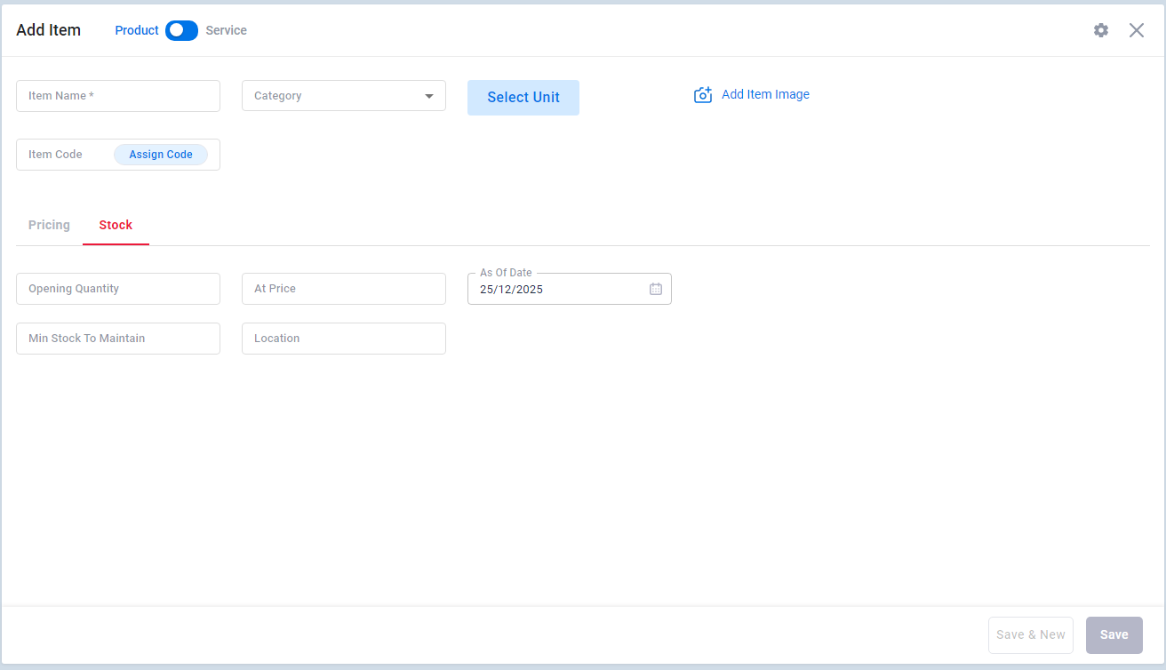

The items purchased have categories like credit or debit based payment done for items.

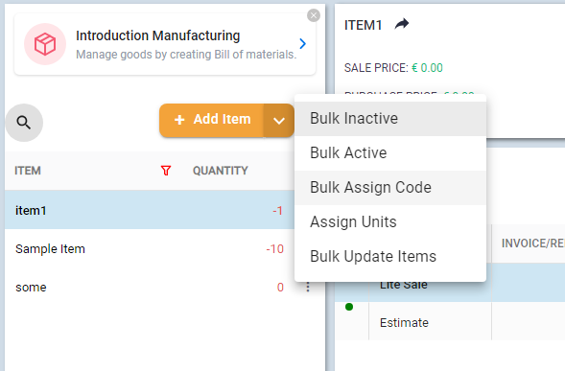

Category for items:

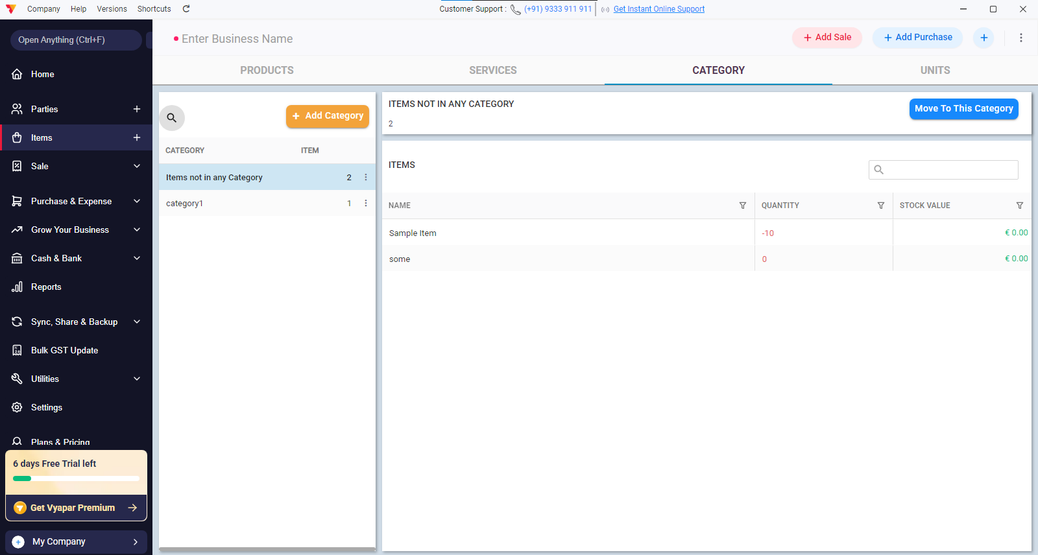

Categorical grouping for items

Sale:

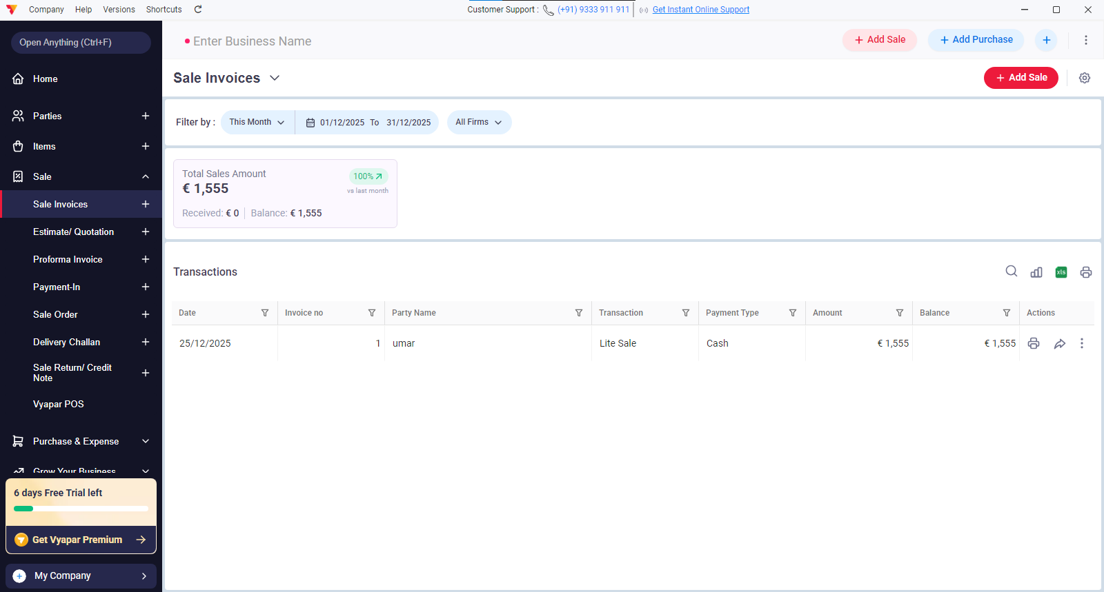

Add sale button open this modal:

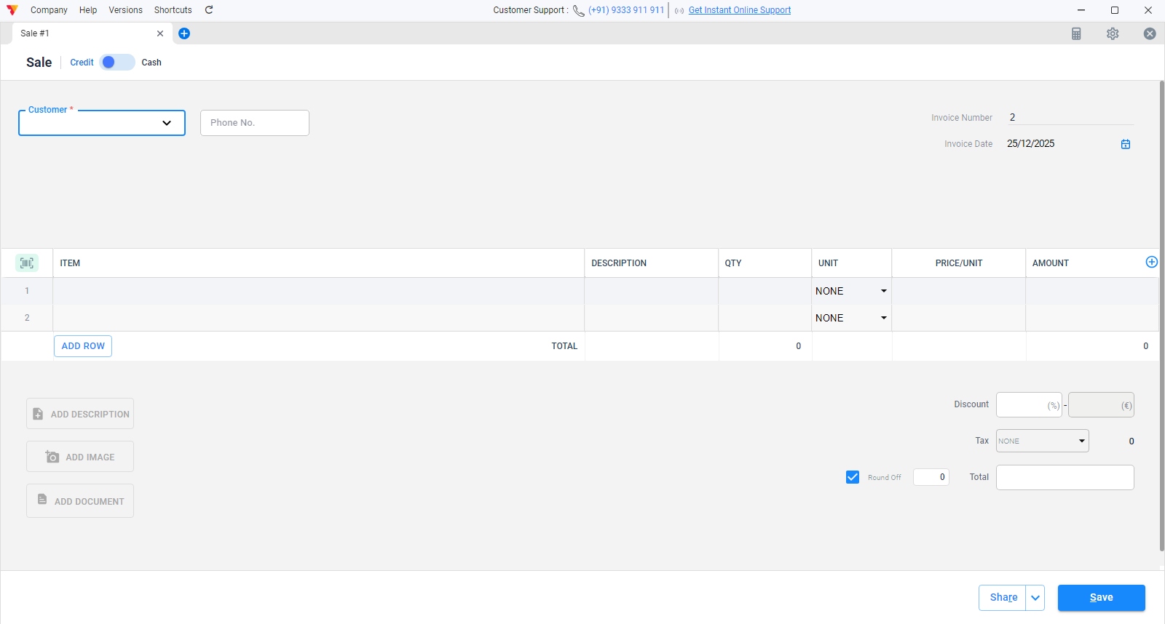

The estimate quotation menu open this :
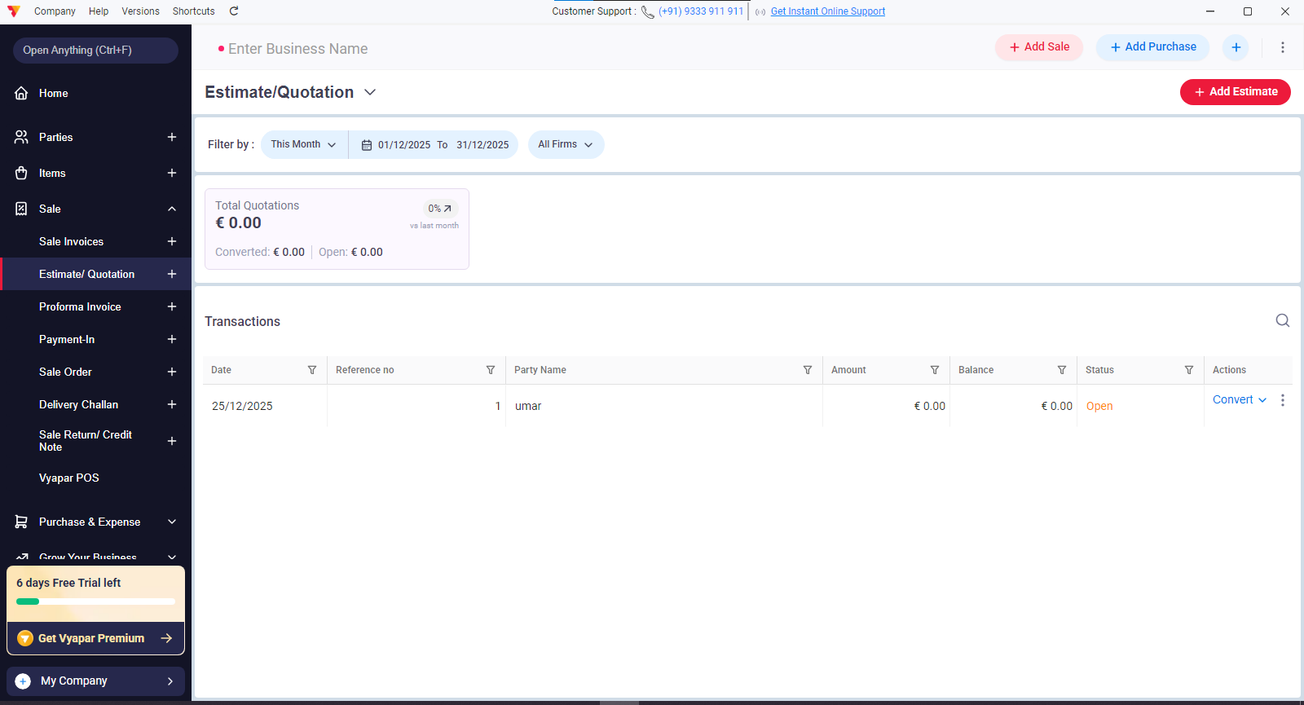

Add estimate button opens this popup:

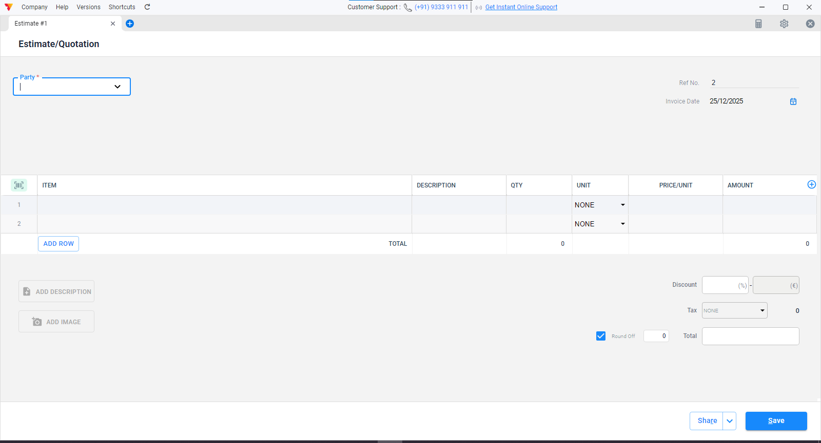

Payment-in sub menu goes here:

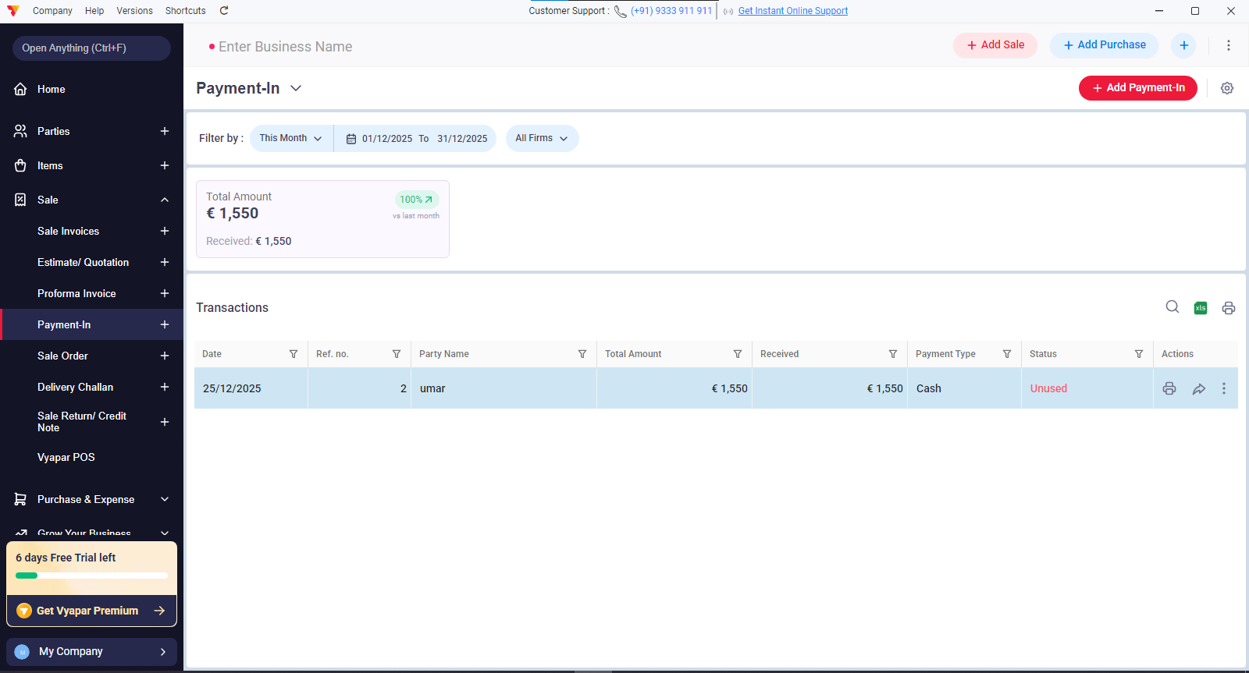

Add payment-in button open this modal:

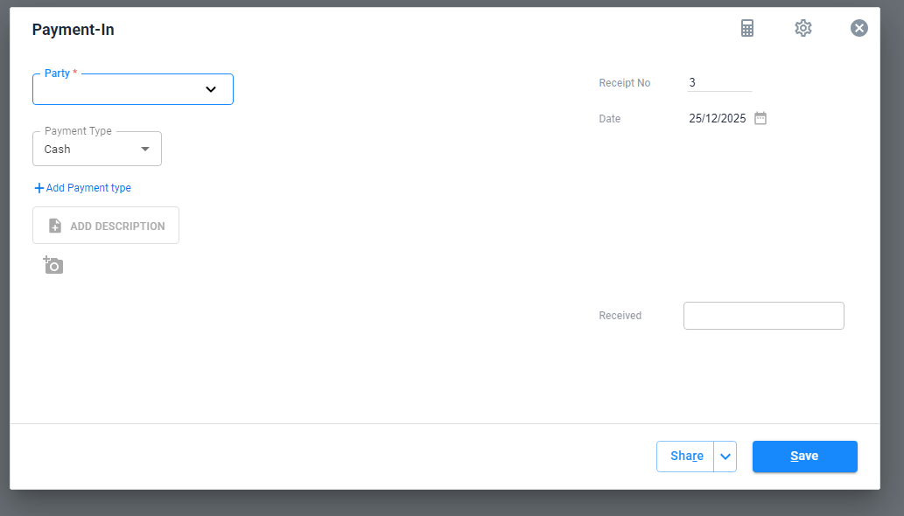

Sale return/ credit note sub menu:
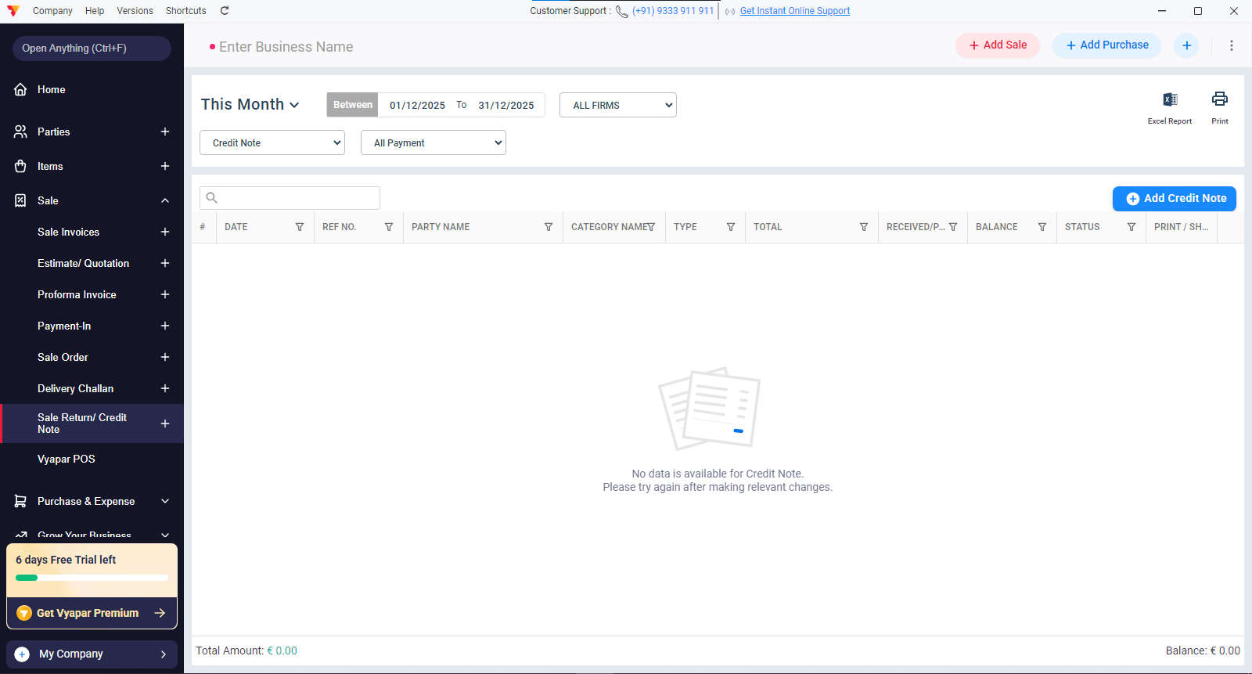

Add credit note buton opens this :

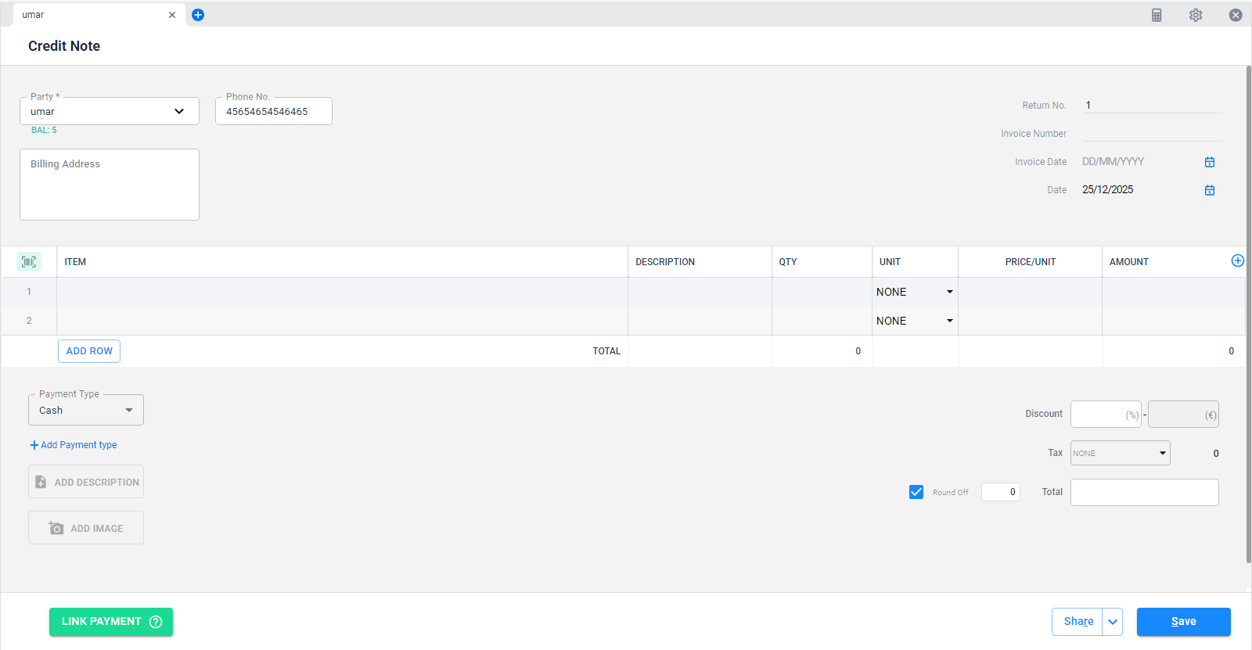

First dropdown on sale return/ credit note:
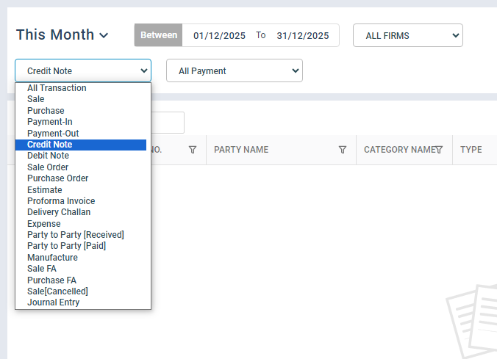

Purchase & expense:
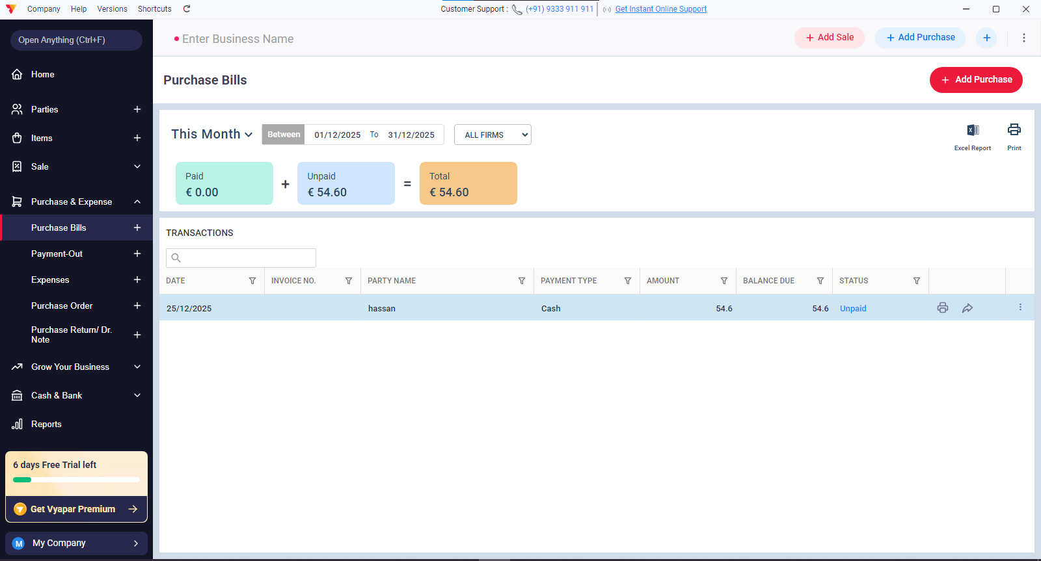

Add purchase button open this modal:

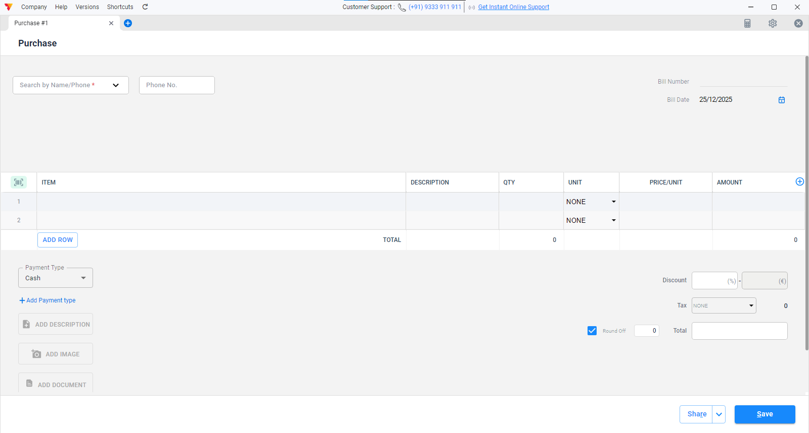

Payment-out sub menu shows this screen:

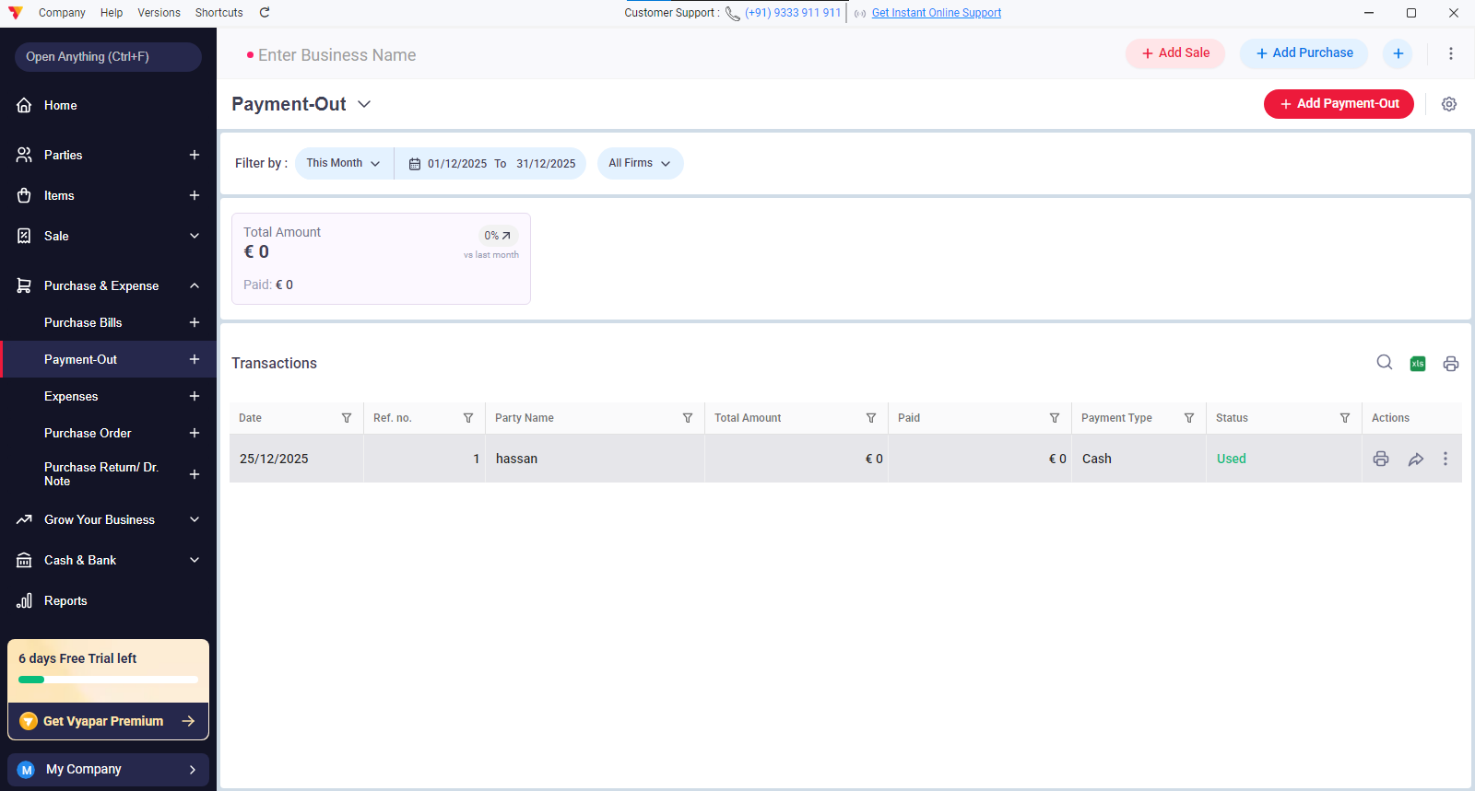

Add payment-out button shows this modal:
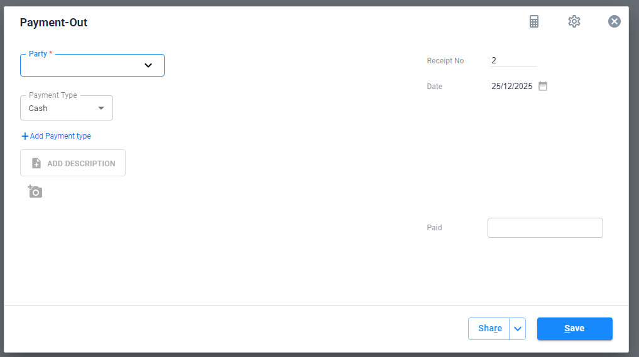

Expenses sub menu:
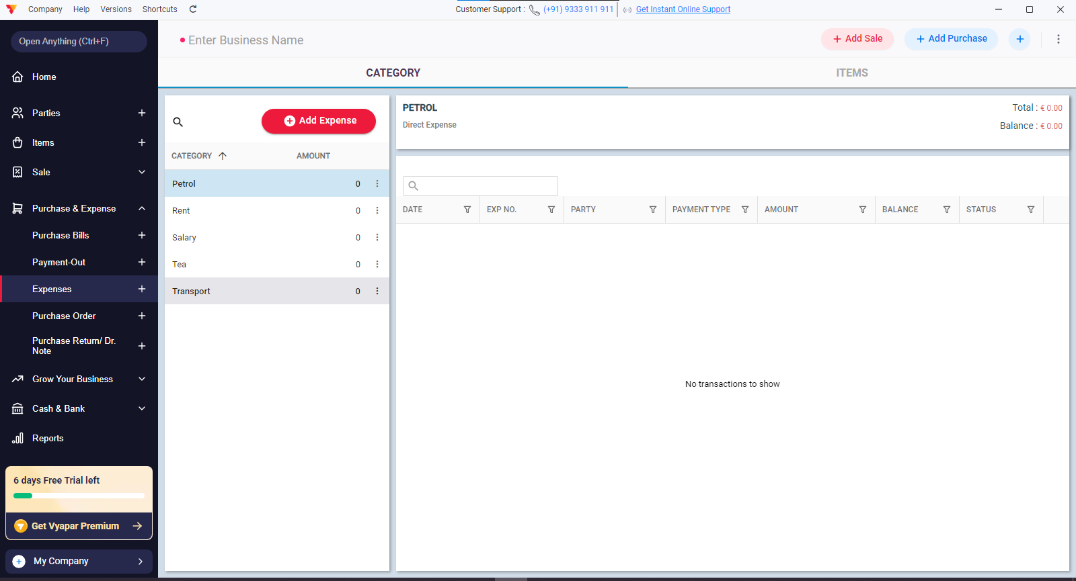

Add expenses button opens this modal:

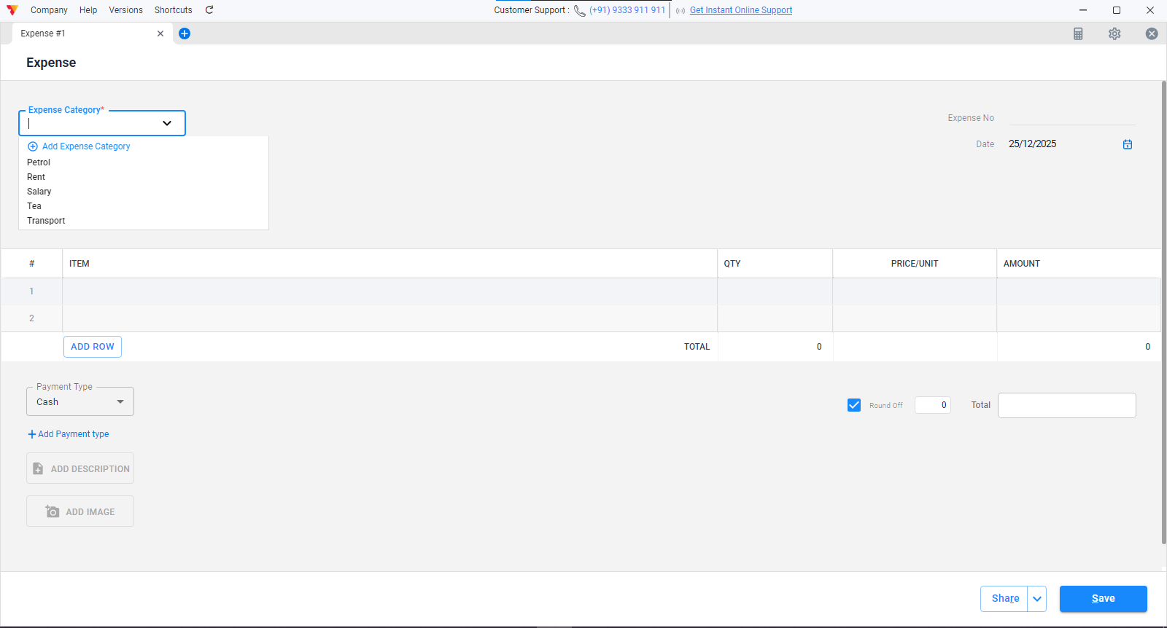

Cash & Bank:

Bank account sub menu:
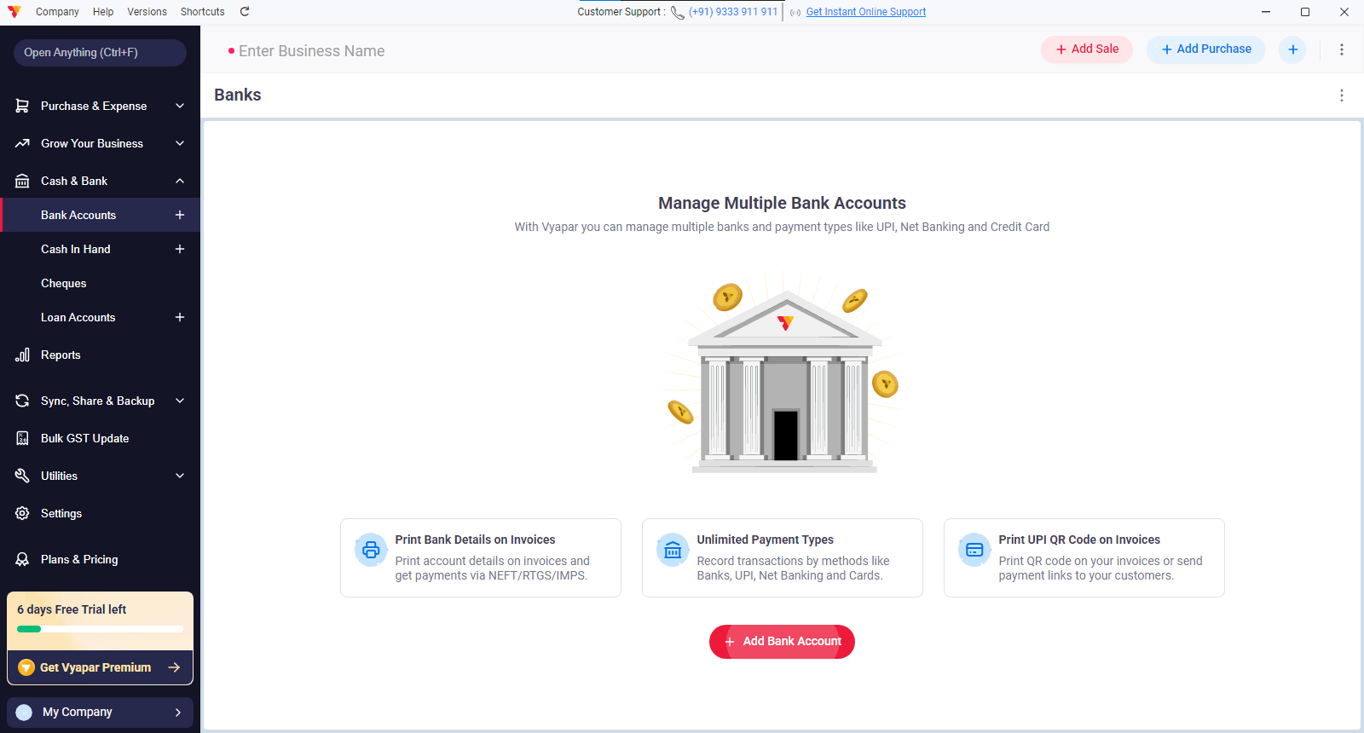

Cash in hand submenu:
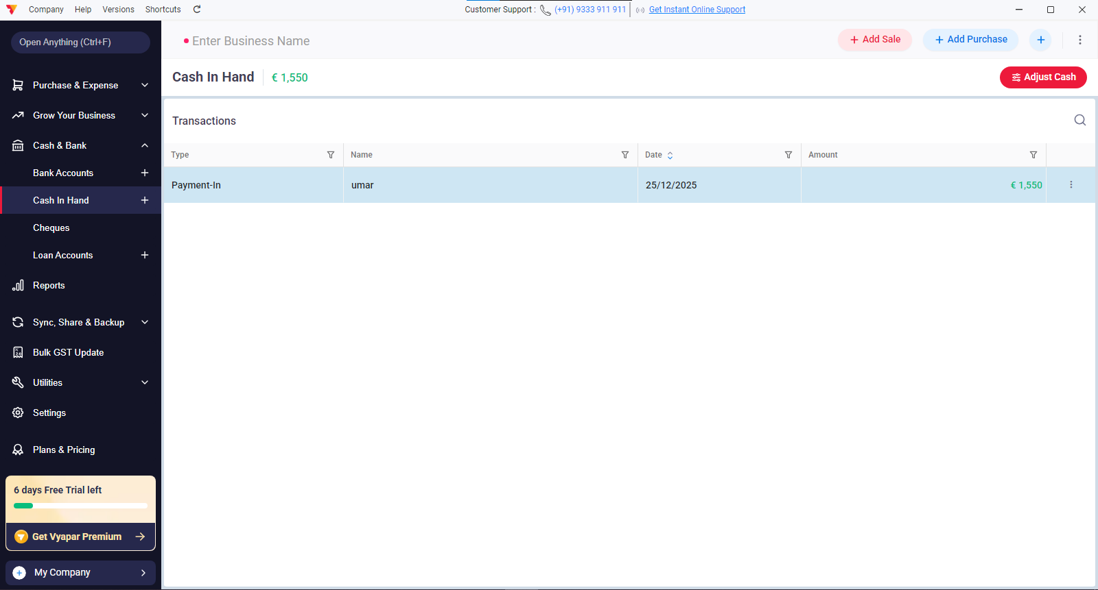

Add cash button modal on cash in hand:
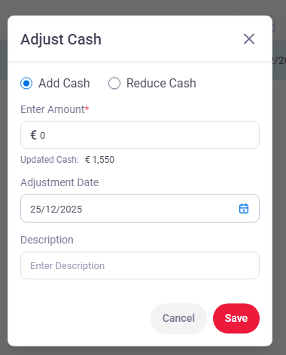

Cheques submenu:
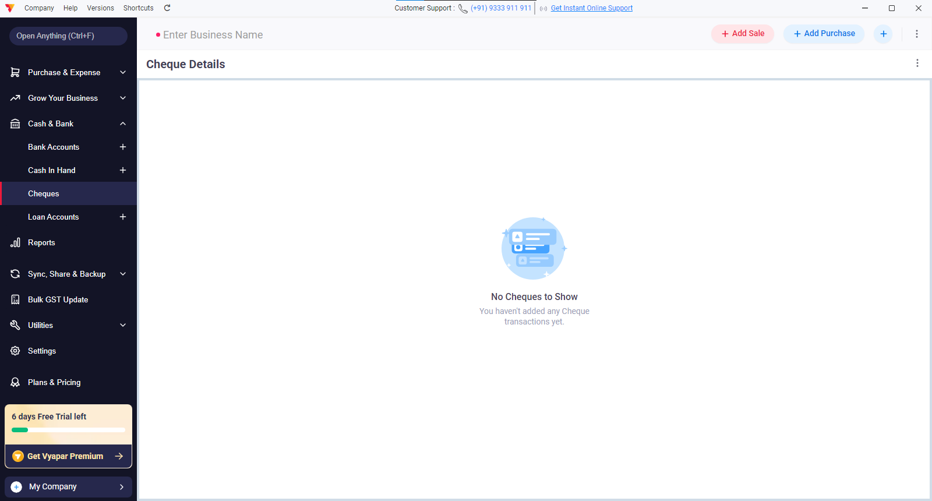

Loan accounts sub menu:

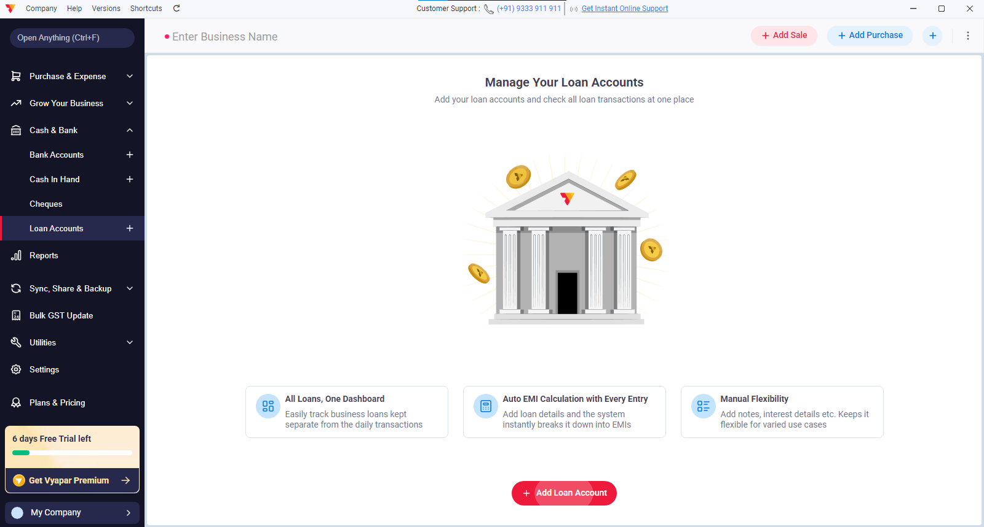

Add loan account button opens this modal:
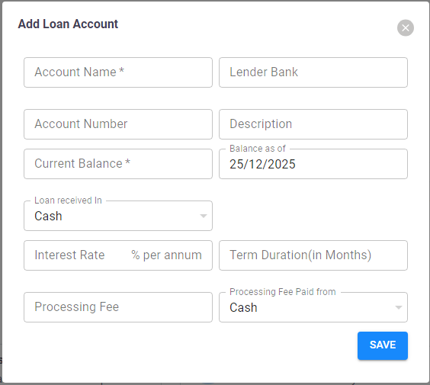

Reports:

Reports menu shows list of reports type:

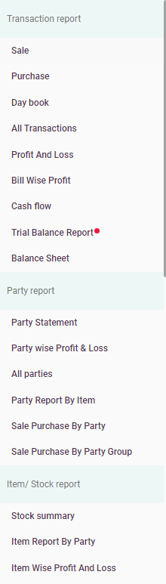
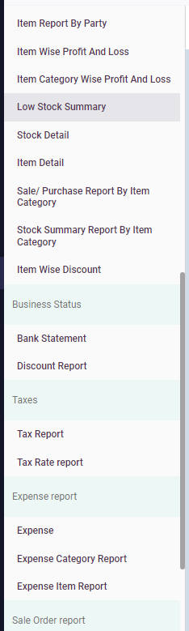
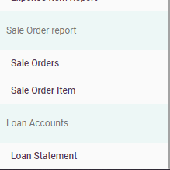

The main screen looks like this we have selected sale option:

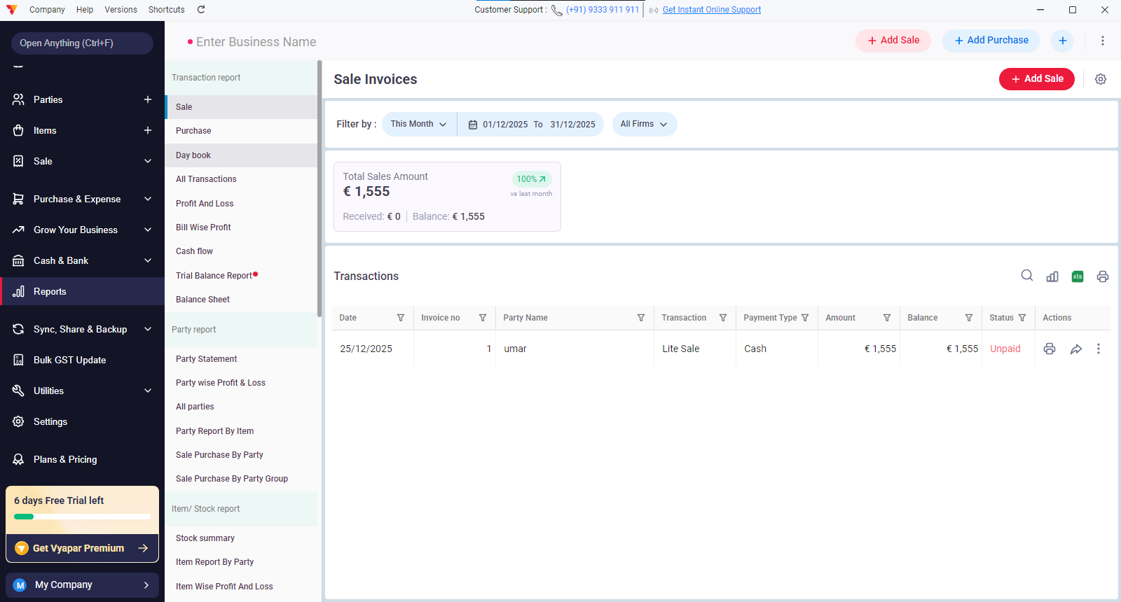

Same options can be applied to reports section as shown on sale menu on sidebar

Sync, Share & Backup:

Sync & share:
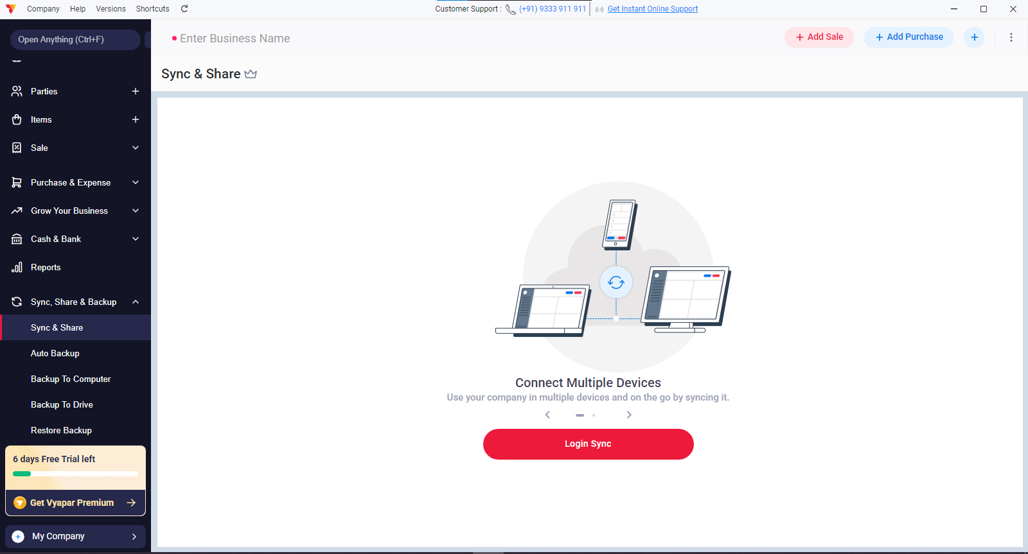

Backup to computer:
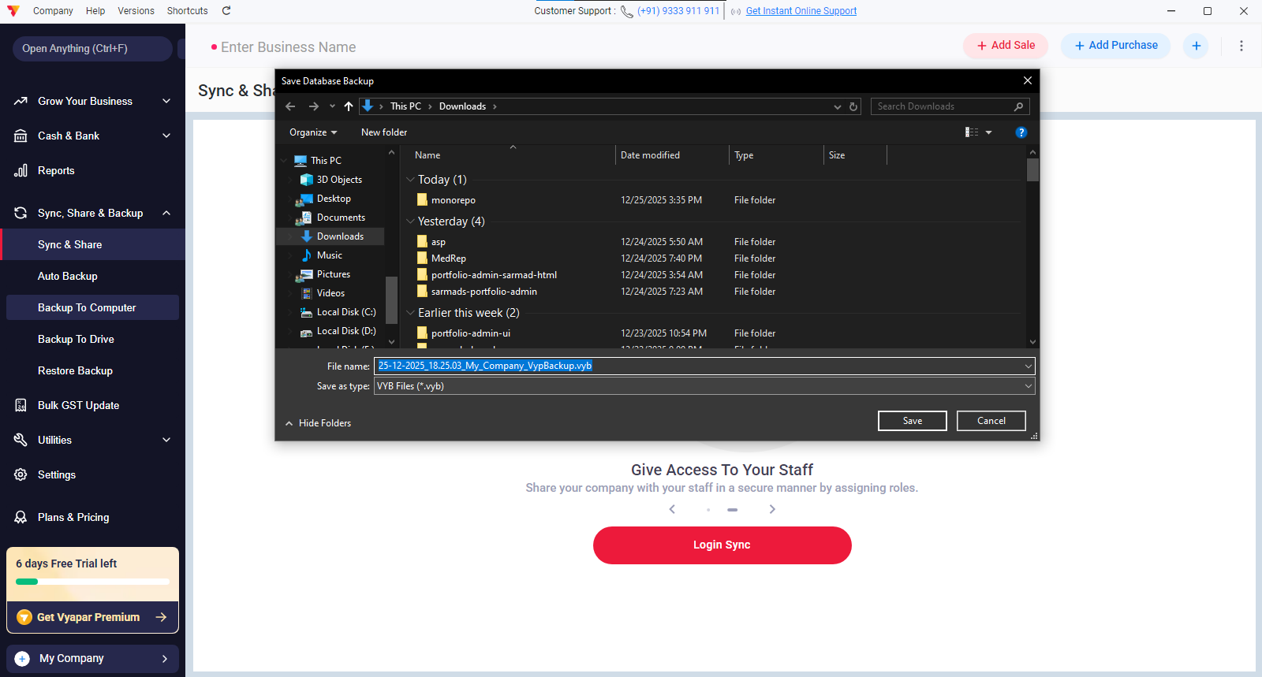

Backup to drive:
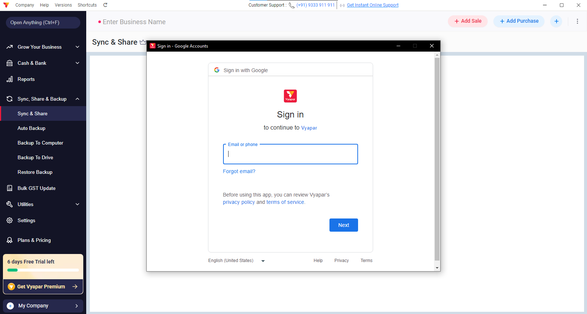

And restore from backup can restore backup from system saved backup .

Bulk GST Update:
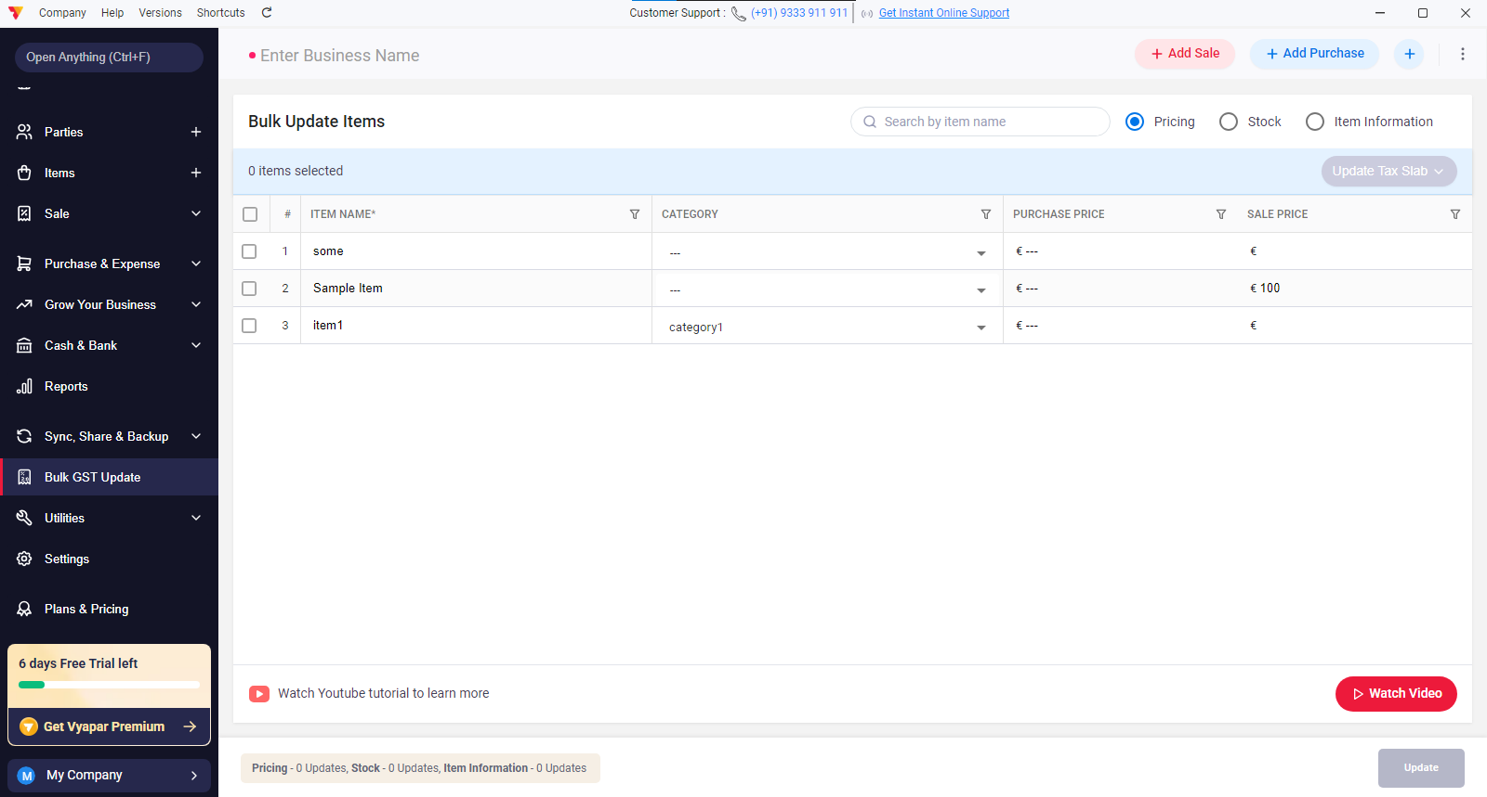

On this menu taxes can be update as per schedule change of taxes with updated dates.

Utilities:

Import items:
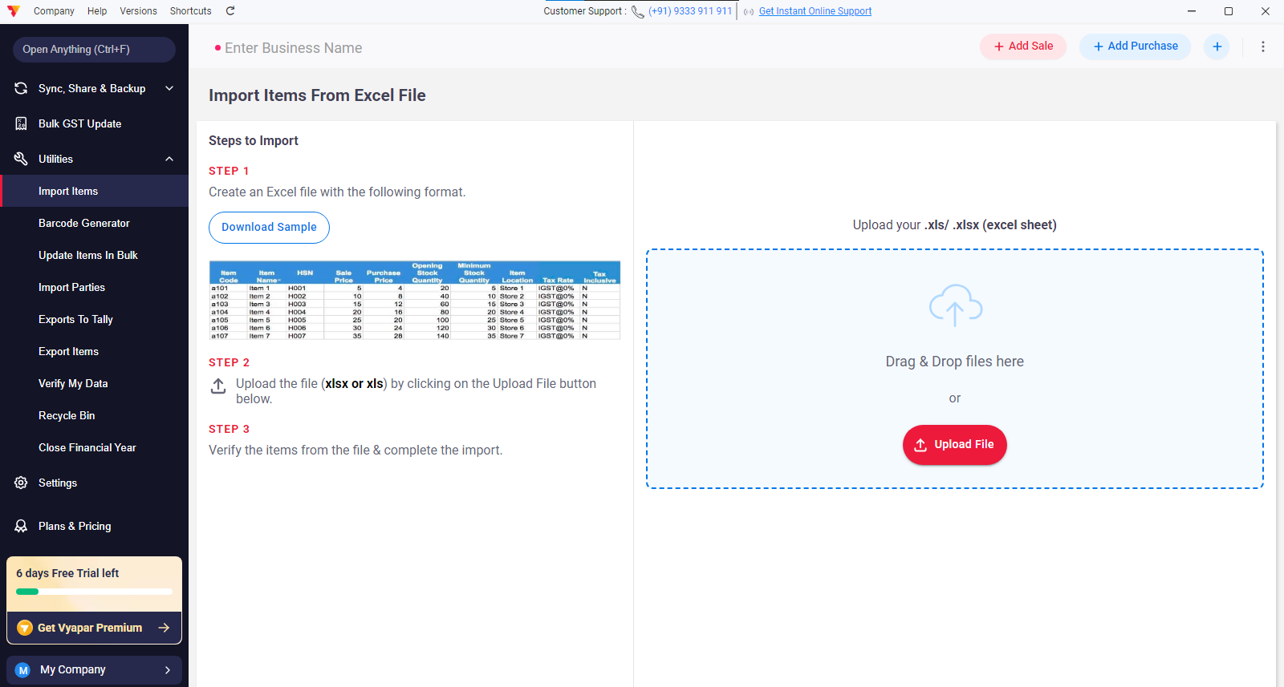

Predefined excel sheet as per user setting so user can add details in that template and import from that file items details.

Same for import parties.

Update items in Bulk :
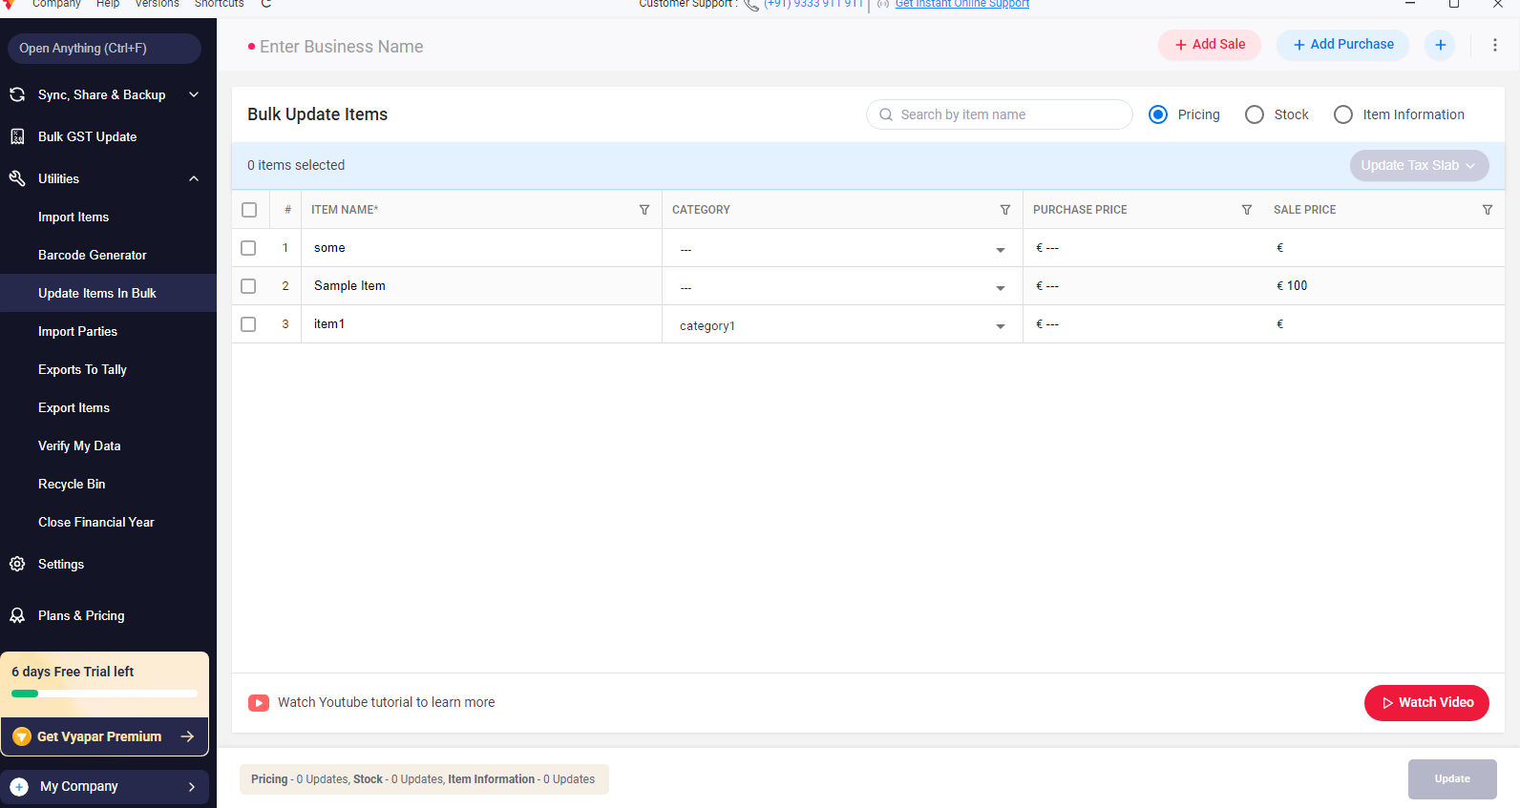

Export Items sub menu:

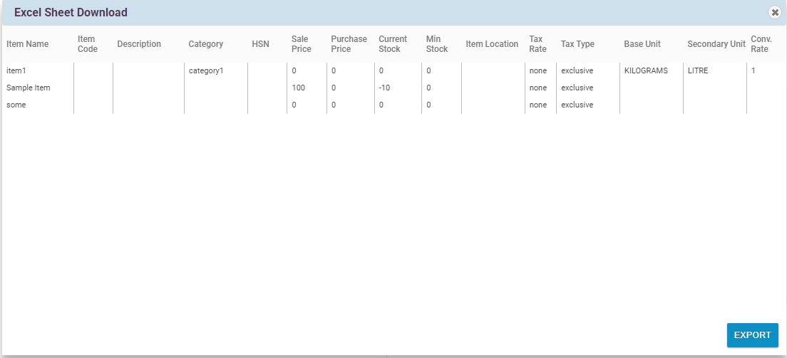

Opens this modal.

Recycle submenu:

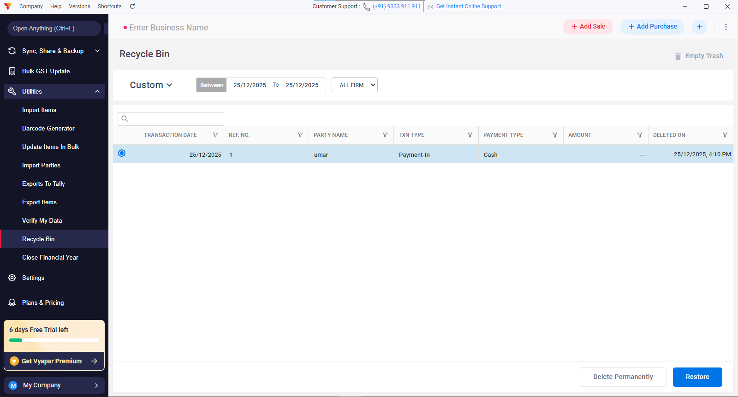

Any entry which is deleted first comes to recycle bin, with user permanently deletes its or restore them feature in it.

Close financial year submenu in utilities:

