GSA Agile Survey Responses
SurveyMonkey - https://www.surveymonkey.com/r/XVKFYXK

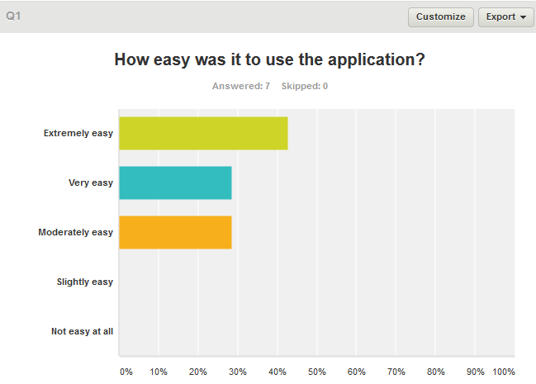
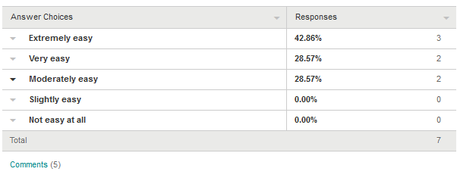

How easy was it to use the application? Why or Why Not?
Extremely easy
Very easy to use!
N/A
Moderately easy
The search detail need to be organized so that the fields that contain a lot of text are at the end of the page and the fields that are shorter are at the top of the page.
N/A
Very easy
Because it worked extremely well
I searched for my condition and my medications and found a wealth of information on multiple pages.

What improvements do you recommend while using Digicon's GSA Agile Challenge application?
Bug - when clicking on the paging the “>”button on the search page shows no search results. Please fix so the button will take user to last page of result. The “<” button also needs the same fix.
Can you have the search results detail page highlight the search terms? Can I choose fields to display on data grid when searching? Can a back to top button to be added after long fields to help with navigation? Can I have the ability to search in specific fields?
More help directions or tips.
No recommendations for improvements at this time.
none at the moment, however this is a ongoing growing application
Open-Ended Response
It would be nice to see manufacturer but not necessary.

Do you have any additional feedback?
no
No additional feedback.
None at this moment I thought the overall process and application was a huge step in doing things the right way
Nothing directly at this time.
Open-Ended Response
Please show the ID and Substance Name fields by default when accessing the search on a mobile device.
The application was very fast in presenting my search results and easy to use. Great app!

