

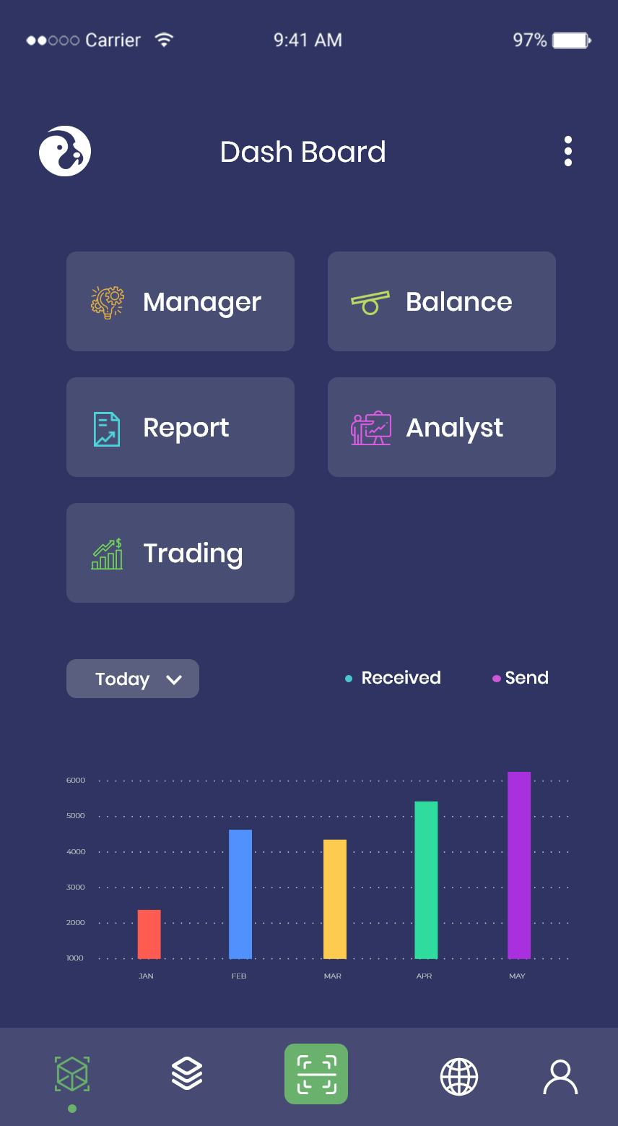





|  |
| --- |
| **Allow for a high volume of** |
| **The installation is risk-** |
| **Apps that are easy to use.** |
|  |

|  |  |
| --- | --- |
|  | **Best support and** |



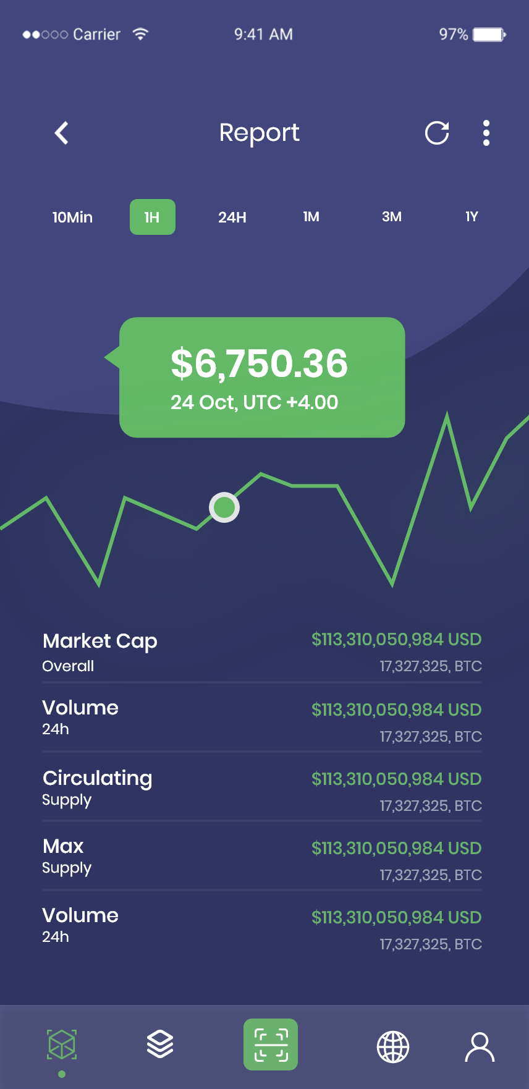





|  |  |
| --- | --- |
|  | **Immediate login is an option.** |
|  | You have to be quick or you'll be last." |
|  | Omninos believes in this concept |
|  | We provide users with a |
|  | They can instantly sync their email accounts and |
|  | **With a single click, you can trade** |
|  | The Groww similar platform is the epitome of convenience. Potential investors can buy and sell financial |
|  | This |
|  | ensures that they never miss an opportunity to invest in instruments |

|  |  |
| --- | --- |
|  | |
|  |  |
|  |  |

|  |
| --- |
|  |

fficient

|  |
| --- |
|  |





T WITH

ffectively.

Overview of our services and how they can

Share insights and best practices relevant to

APPOINTMENT

|  |
| --- |
|  |

|  |  |
| --- | --- |
|  | Tok and |
|  | Amazon and Gojek for a better understanding of our services. Our |

Social Contact

|  |
| --- |
| [](https://www.instagram.com/omninosinsta/) |

|  |
| --- |
| [](https://dribbble.com/iapp_omninos) |



Rishav kalsi

