Contents

Uploaded to GoogleDrive 1

TC5-3-Install-RTL-ARABIC-DEVELOPMENT-CANDIDATE-2.exe - Release Notes 2

Install TurboCASH-Arabic (RTL Support) 2

Scope of Tests and Debugging 2

MSSQL Database types 3

Firebird Database types 3

Reports and Document layout files 3

Reports in TurboCASH5-2 versus TurboCASH5-3 4

ARABIC - Firebird Sets of Books included in Install 4

4-ARABIC-TEST 5

ARABIC - TUTORIALS 5

CUSTOMISE-EMPTY-BOOKS 5

CUSTOMISE-EMPTY-BOOKS (TESTING) 6

AR-BANK-STATEMENTS 6

TC5-3-Install-RTL-ARABIC-DEVELOPMENT-CANDIDATE-1.exe - Release Notes 7

Resources 7

Arabic RTL- Reports and Document layout files 8

Arabic Reports 8

Document layout files - we cannot try to support both we just need an Arabic layout then 9

TurboCASH5-3-Aracic Install 9

TurboCASH5-3-Aracic Uninstall 14

# Uploaded to GoogleDrive

Arabic Install and Translations

* Arabic Development.chm

* Arabic-Install-notes.docx

* TC5-3-Install-RTL-ARABIC-DEVELOPMENT-CANDIDATE-2.exe

<https://drive.google.com/drive/folders/1kJwic44X6MqiEFGp3GmEWfAW9V5JMVGw?usp=sharing>

# TC5-3-Install-RTL-ARABIC-DEVELOPMENT-CANDIDATE-2.exe - Release Notes

**See - Arabic Development.chm -** Uploaded to GoogleDrive to view more detail and links to topics and screenshots, Known issues, etc.

Some Known issues may be replicated in other languages, such as Chinese, Croatian, Greek, Estonian, Lithuanian, Slovenian, Swedish, Thai, Turkish.

## Install TurboCASH-Arabic (RTL Support)

See - [Inno Setup Compiler - Arabic translations](hnd-topic://8e7fd7a5f011422d98ca88e899972fc6) -

Support for RTL added to Arabic.isl files.

**To Do** :

* Restructure sections of the Inno Setup Script (*.iss) files to fix the translations of untranslated text in the Install Wizard - This affects all languages.
* [name] in Arabic.isl file replaced with TurboCASH5-3-AR
* Switch Titlebar captions

See - [TurboCASH5-3-Arabic Install (RTL)](hnd-topic://b9e87d23f5cb425aa7782ae9bc570089)

See - [TurboCASH5-3-Arabic Install (LTR)](hnd-topic://9fce9bec44b14e33818d3e376f093bbd)

Made an Arabic install (for Jordan and United Arab Emirates) so we can custom the reports and document layout files from there.

## Scope of Tests and Debugging

**osFinancials5.1/TurboCASH5.1 version** = 5.1.0.236

**Installation file** = TC5-3-Install-RTL-ARABIC-DEVELOPMENT-CANDIDATE-2.exe

**Arabic Development Sources on GitHub** = [osfinancials-development/accounting-other-languages/arabic-accounting at main · Digidanosf/osfinancials-development · GitHub](https://github.com/Digidanosf/osfinancials-development/tree/main/accounting-other-languages/arabic-accounting)

This installation of Arabic is tested and debugged in both MSSQL and Firebird Database types.

**Known issues** - In addition to the Known issues section in the EngHelp.chm help file, some Known issues relating to Arabic Firebird databases is included in the Arabic Development.chm section. - See - [Known issues - Firebird 2.1 databases](hnd-topic://5a5202122dfd48d2b1f3220880166d7b).

### MSSQL Database types

osFinancials5.1.0.233/TurboCASH5.1.0.233 supports all MSSQL databases. For most languages, you need to set the Collation settings

For example, MSSQL - Arabic language settings change default set to “SQL_Latin1_General_CPI_CI_AS” to “Arabic_CI_AS”.

This will fix the display of Arabic text correctly on forms and in the MSSQL database columns in osFinancials/TurboCASH. See - [MSSQL databases](hnd-topic://236b63ea447747da84f1894e07771aa2).

### Firebird Database types

#### Supported Firebird version

osFinancials5.1.0.236/TurboCASH5.1.0.236 supports Firebird2.1 (ODS11.1) - Server Version - WI-V2.1.3.18185 Firebird 2.1.

The installation files of the Firebird 2.1 and FlameRobin is included in the installation folder of your osFinancials5.1/TurboCASH5.1.

Upgraded Firebird databases - All Firebird databases (Sets of Books) shipped with osFinancials5.1.0.233/TurboCASH5.1.0.233, including the download option from '*Let osFinancials/TurboCASH help you to Create a Set of Books?*' have been upgraded to Firebird2.1 (ODS11.1).

#### Unsupported Firebird versions

osFinancials5.1.0.236/TurboCASH5.1.0.236 currently does not support Firebird2.5 (ODS11.2) or Firebird3 or Firebird4.

When opening a Set of Books for a Firebird2.5 database, replicate this error '

Error connecting to C:\TCASH5-3-Arabic-2\Books\FB-128-HANDYMAN\books.fdb unsupported on-disk structure for file C:\TCASH5-3-ARABIC-2\BOOKS\FB-128-HANDYMAN\BOOKS.FDB; found 11.2, support 11.1

This error occurs when you're trying to open a database created with a **newer Firebird version** (11.2) using an **older Firebird 2.5 server** (which only supports up to ODS 11.1).

## Reports and Document layout files

***Reports and Document layout files support for RTL languages***

[NoBidi setting](hnd-topic://4cef1ed3fc2a4f39aba9ca30ad24d307) - The labels and expressions need to be set to FullBidi

Natural reading order for RTL languages - The labels and expressions need to be rearranged.

In the Arabic Development - TurboCASH5-3-Arabic install, the following reports and Document layout files have been adjusted accordingly:

* Reports
  + [Ledger analyser](hnd-topic://bb2bde416c8f428f9c13abe25e347b28) - Prints the Trial balance, Income statement, Budget reports with switched columns, adjusted for proper RTL alignment and text flow.
  + [T-account viewer](hnd-topic://5b591da22bde4ea0a456ed6737e8a69e) - Prints the transactions adjusted for proper RTL alignment and text flow.
  + Reports - Reports -> Ledger -> Listing - Prints the [Chart of accounts](hnd-topic://e01b1c62728446e796335d971537b620) adjusted for proper RTL alignment and text flow.
* Document layout files - [Arabic-Test-Invoice-Bank-TRN_906193.rep](hnd-topic://6dc8af899d164ad2be8cb1bc498cc756) - Adjusted for proper RTL alignment and text flow.

See - [RTL/LTR Report Switching](hnd-topic://fbfd0d68957149558d6415309d575b66) (In addition to the [Multi-language plugin](https://www.osfinancials.org/htmlhelp_eng/plugin-multi-language-accounts.html), this may be important for Debtor / Creditor preferred language if LTR for example is English.

### Reports in TurboCASH5-2 versus TurboCASH5-3

**Location** : '\plug_ins\reports\' folder.

Reports and document layout files shipped in TurboCASH5-2 releases will produce incorrect layout.

It is recommended that Reports and document layout files shipped in TurboCASH5-3 releases be used for tests and development. The following changes is included in Reports and document layout files shipped in TurboCASH5-3 releases:

* MSSQL and Firebird Database support is implemented and debugged in TurboCASH5-3
* Field length is adjusted to support 3-Digit up to 8-Digit main accounts. The objects, text, expressions on each report and document layout files were adjusted accordingly to:
  + Fix overlapping and untidy reports and document layout files in the TurboCASH/osFinancials language files.
  + Better support for specific requirements of Small to Large businesses and various Accounting Standards and Frameworks (GAAP, IFRS, Taxonomies, etc.)

## ARABIC - Firebird Sets of Books included in Install

**Location** : '\bin\ARABIC\' folder.

### 4-ARABIC-TEST

This is a 4-Digit main accounts Set of Books based on the Arabic translation of the 4-EN-UK-GENERIC Set of Books in the '\bin\4-DIGIT-BOOKS\4-EN-UK-GENERIC' folder. The [Multi-language plugin](https://www.osfinancials.org/htmlhelp_eng/plugin-multi-language-accounts.html) is not used.

**Needs review**

* Tax (VAT) accounts (Account code = 2400-000 not translated and localised for Arabic requirements. This generic Set of Books includes 4-digit main account and 3-digit sub-accounts, based on the United Kingdom (UK) Chart of Accounts. It incorporates specific UK terminology and includes Value Added Tax (VAT) - United Kingdom accounts based on the VAT Standard rate scheme.
* Error -303 may be produces in specific fields on forms.

### ARABIC - TUTORIALS

The following TUTORIALS (in the ('\bin\ARABIC\' folder) is based on the English tutorials ('\bin\Tutorials\ENGLISH' folder):

* **AR-HANDYMAN** - Includes the Accounts, Debtors, Creditors, Stock without any transactions.
* **AR-HANDYMAN-A** - Unposted [batch transactions](hnd-topic://2c28e60c6a5d4c148c36f54fcb94fda8) and documents.
* **AR-HANDYMAN-B** - Posted [batch transactions](hnd-topic://2c28e60c6a5d4c148c36f54fcb94fda8) and documents (Balances with English Tutorials). See - [Known issues - Calendar](hnd-topic://ecb15cea41fd45cb996ce928ec8aa6ce).
* **AR-HANDYMAN-A-BankImport** - Test the BankImport plugin with importing Bank statements in the ('\bin\ARABIC\AR-BANK-STATEMENTS folder):

**NOTE** : These Tutorials is based on the [Multi-language plugin](https://www.osfinancials.org/htmlhelp_eng/plugin-multi-language-accounts.html) and uses the following usernames and passwords in the lowercase:

* + **Arabic - RTL (Right-to-Left)** - Log in as an Arabic user (username and password = '**a**' )
  + **English - LTR (Left-to-Right)** - Log in as an English user (username and password = '**e**' )

### CUSTOMISE-EMPTY-BOOKS

The following Firebird database Sets of Books was included in TurboCASH5-3 (Release Candidate 9):

* CUSTOMISE-EMPTY-BOOKS-3X3-DIGITS
* CUSTOMISE-EMPTY-BOOKS-4X3-DIGITS
* CUSTOMISE-EMPTY-BOOKS-5X3-DIGITS
* CUSTOMISE-EMPTY-BOOKS-6X3-DIGITS
* CUSTOMISE-EMPTY-BOOKS-7X3-DIGITS
* CUSTOMISE-EMPTY-BOOKS-8X3-DIGITS

**NOTE** these Set of Books templates produces DymanicSQL -303 Errors in many fields on forms in osFinancials5.1.0.236/TurboCSH5.1.0.236.

### CUSTOMISE-EMPTY-BOOKS (TESTING)

To prevent these DymanicSQL -303 Errors, similar pre-configured database templates with expanded field sizes is created.

Added the following templates with larger field lengths by editing the values in the '\bin\SQL\FIREBIRD' folder to fix the Dynamic SQL error -303 errors.

* + TEST-CUSTOMISE-EMPTY-BOOKS-3X3-DIGITS
  + TEST-CUSTOMISE-EMPTY-BOOKS-4X3-DIGITS
  + TEST-CUSTOMISE-EMPTY-BOOKS-5X3-DIGITS
  + TEST-CUSTOMISE-EMPTY-BOOKS-6X3-DIGITS
  + TEST-CUSTOMISE-EMPTY-BOOKS-7X3-DIGITS
  + TEST-CUSTOMISE-EMPTY-BOOKS-8X3-DIGITS

This affects other languages such as Chinese, Croatian, Greek, Estonian, Lithuanian, Slovenian, Swedish, Thai, Turkish.

### AR-BANK-STATEMENTS

This folder includes the following sample [Bank statement files](hnd-topic://251a804a01464a98855f2d68450c6498) (used in the 'AR-HANDYMAN-A-BankImport' Set of Books) for the BankImport plugin:

* + 2025-03-Bank-Statement-ABC-Bank.ofc - English version of a Sample Bank statement used in English tutorials.
  + 2025-03-Bank-Statement-ABC-Bank-Arabic.ofc - Arabic translation of the '2025-03-Bank-Statement-ABC-Bank.ofc' file., with UTF-8 encoding. **NOTE** May need debugging and more tests.

**Language files translations and updates**

Languages -

* FIXED Typo in 27 English languages - Label id 2047 - Name -> Last name - Contacts - information for Debtors Creditors aligns with First name. (Also in Afrikaans).
* Arabic.dfm - Updated translations have been translated (up to 97%,), based on **Modern Standard Arabic (MSA)**.
* Outstanding translations - These translations is not available in the Arabic.dfm file and still need to be translated via the executable file for osFinancials/TurboCASH. See –
  + List of outstanding translations osFinancials Core on GitHub : <https://github.com/Digidanosf/osfinancials-development/tree/main/translations>
  + List of outstanding translations – Plugins on GiHub : <https://github.com/Digidanosf/osfinancials-development/tree/main/plugins-translations>

# TC5-3-Install-RTL-ARABIC-DEVELOPMENT-CANDIDATE-1.exe - Release Notes

## Resources

GitHub = [osfinancials-development/languages at main · Digidanosf/osfinancials-development · GitHub](https://github.com/Digidanosf/osfinancials-development/tree/main/languages)

## Arabic RTL- Reports and Document layout files

### Arabic Reports

This is an example of the expressions and objects in Reportman (Reports -> Ledger - > Listing) - to align with spreadsheets and the Arabic RTL natural reading order.

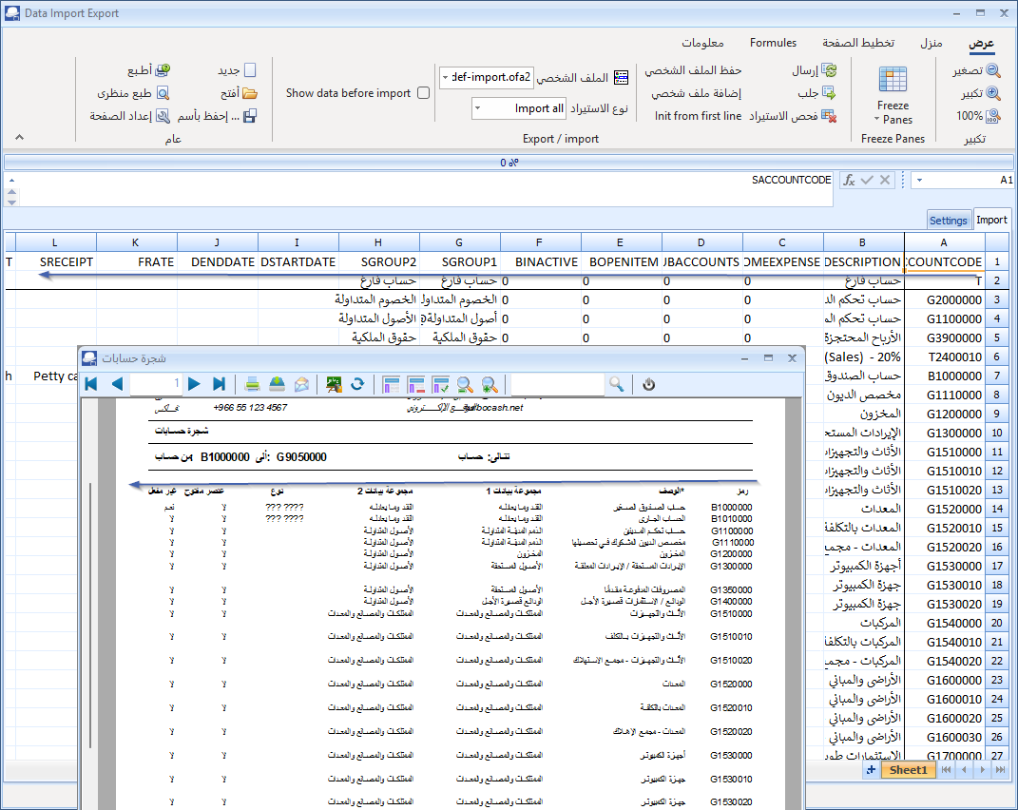

### Document layout files - we cannot try to support both we just need an Arabic layout then

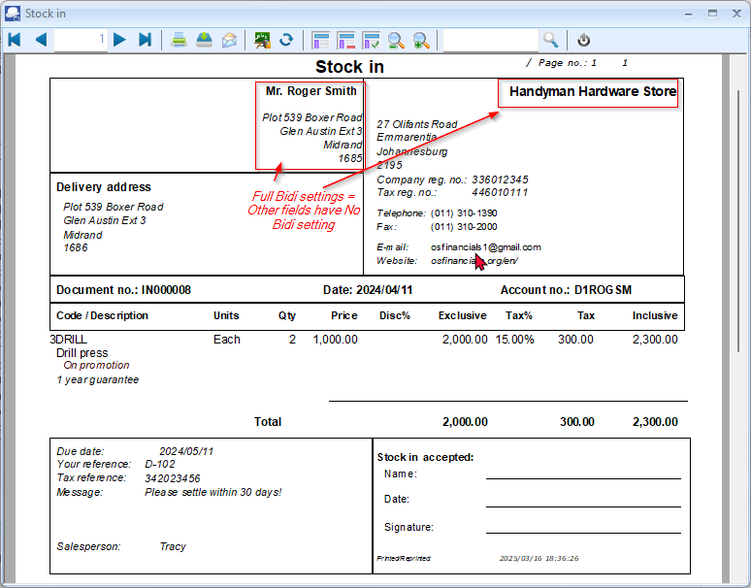

## TurboCASH5-3-Aracic Install

Made an Arabic install (for Jordan, Saudi Arabia and United Arab Emirates) so we can custom the reports and document layout files from there.

Added an ARABIC-TEST

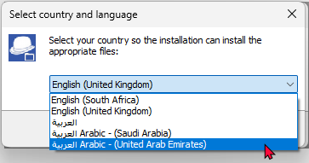

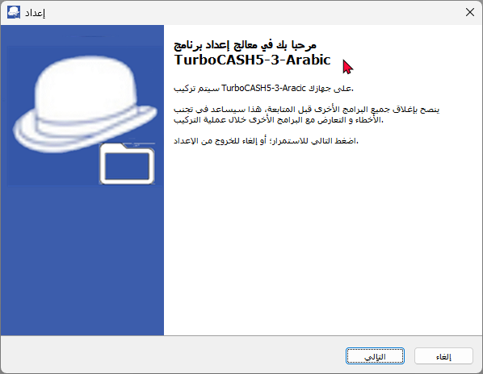

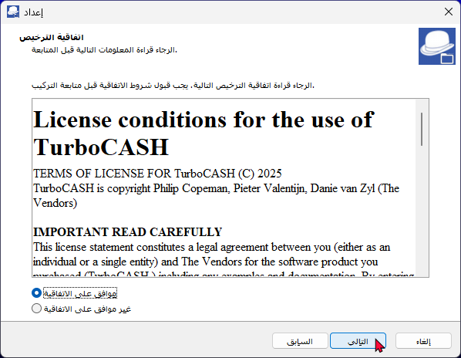

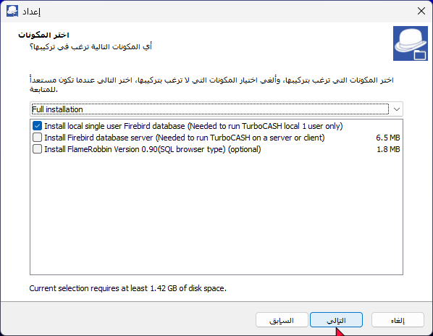

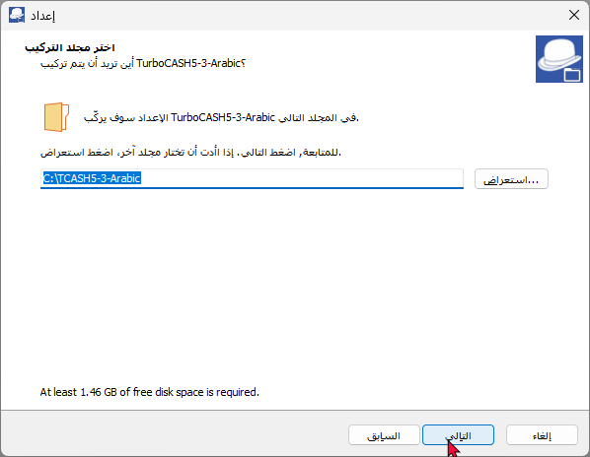

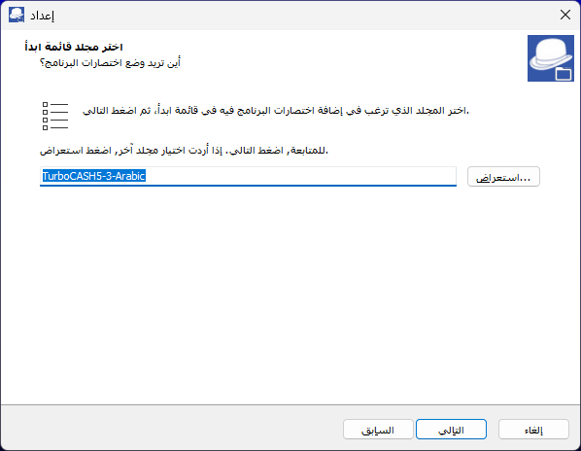

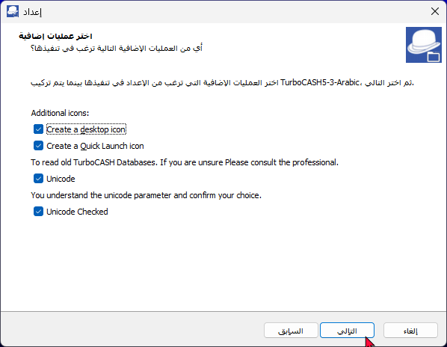

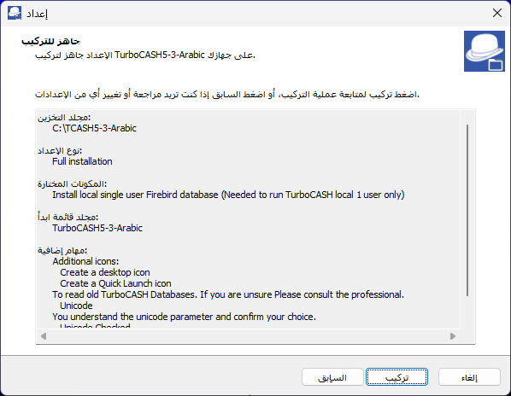

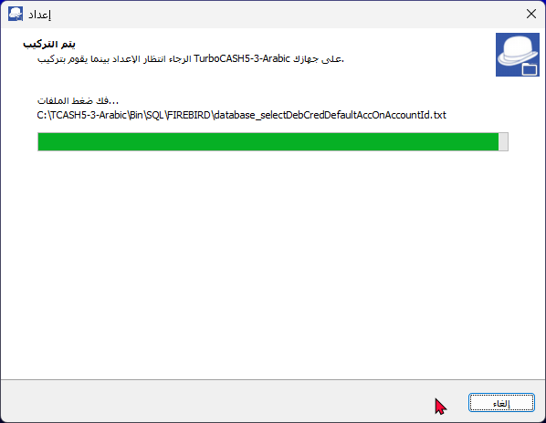

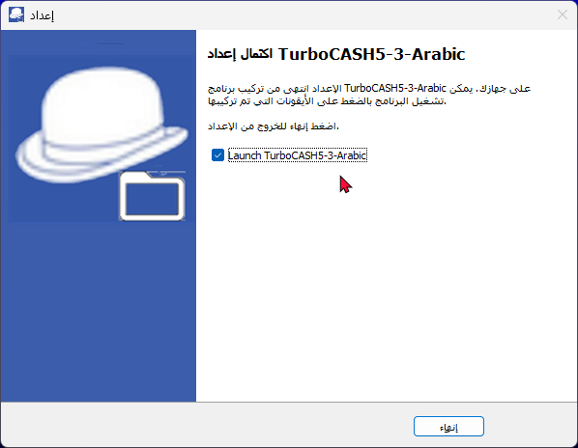

## TurboCASH5-3-Aracic Uninstall

