# Upgraded MSSQL Studio version 18 to Version 22

## MSSQL error – Print button on Setup -> Groups

GROUPDATA:Parameter 'GROUPTYPEID' not found

## Setup -> Documents

You may need to close Setup -> Documents and change sign in to a different language to make the options for each document type active again.

This is replicated in the Multi-language plugin.

Reopening the MSSQL with the same Username “Arabic” – Still inactive.

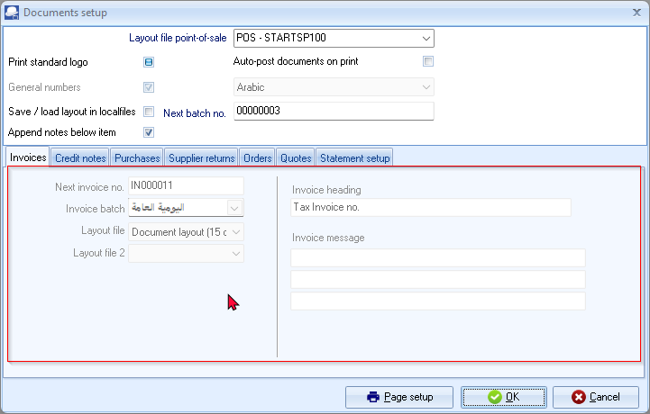

Reopening the MSSQL with a different Username “English” – Document setup is active.

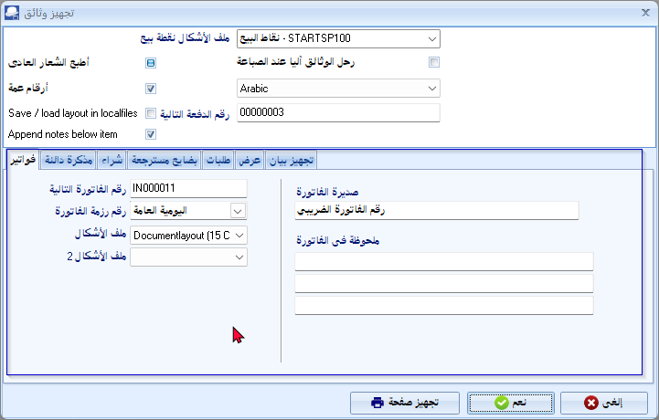

## Setup -> Batch types – Translations

The text entered in English and another language like Arabic is not readable – Need to select the test to read it.

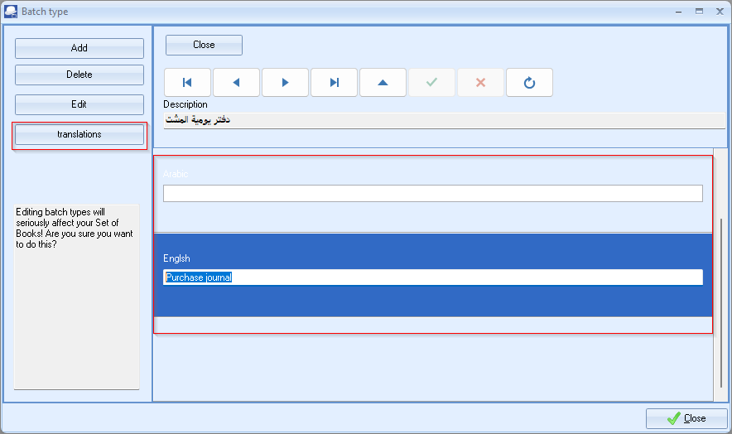

# Customise your own Set of Books - ;BIDIMODE=RTL in osf.ini or tcash.ini file

If the BIDIMODE in osf.ini or tcash.ini file, is commented out (; semi-colon removed) you may encounter errors resulting in an incorrect unusable database in both Firebird and MSSQL.

Dynamic SQL Error

SQL error code = -303

arithmetic exception, numeric overflow, or string truncation

**IMPORTANT** - Before using the Customise your own Set of Books option, make sure the BIDIMODE=RTL setting is commented (; semi-colon added). You may then create a custom correct database in both Firebird and MSSQL.

# MSSQL - Arabic language settings

After creating a Set of Books “Customise your own Set of Books”, and you open the MSSQL database, the Collation settings is by default set to “SQL_Latin1_General_CPI_CI_AS”.

This will result in the database displaying the Arabic text as “????????????” when you copy or enter Arabic text in basically all fields. Example of Setup -> Groups.

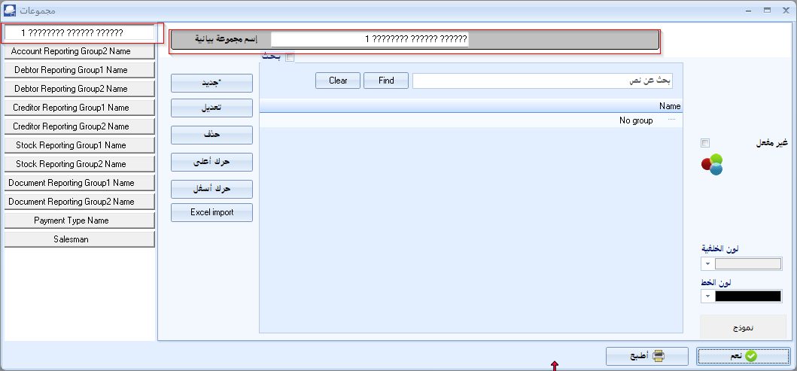

Close your Set of Books.

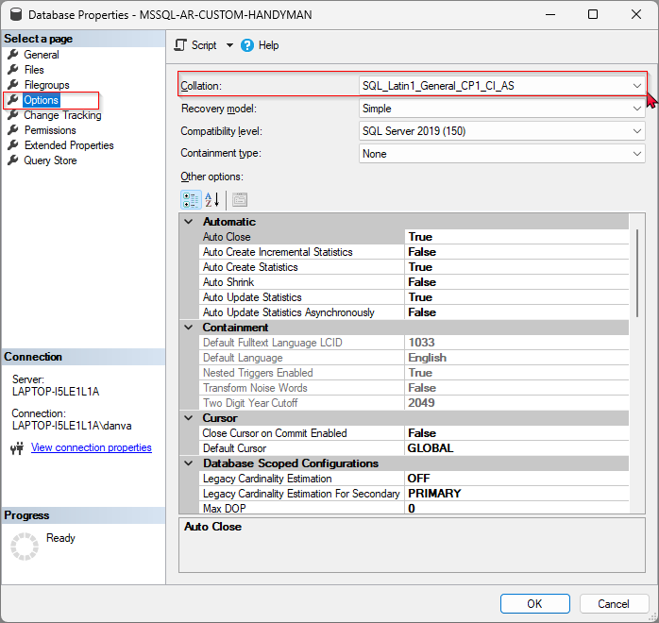

To Fix this, select the MSSQL database – and right-click to select Properties.

In the Database’s Properties, navigate to the Options.

In the “Collation” field, select the “Arabic_CI_AS” and click OK.

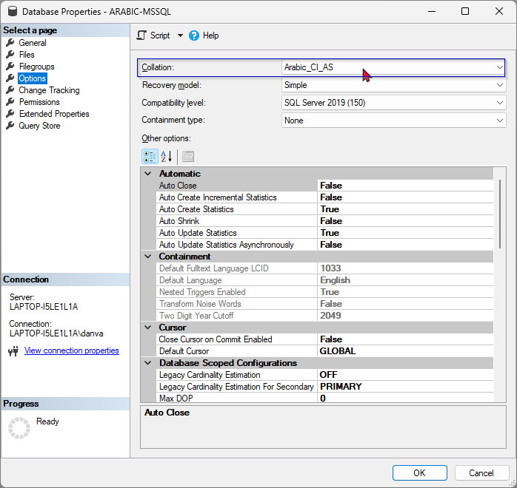

Open your Set of Books and the database displaying the correct Arabic text when you copy or enter Arabic text in basically all fields. Example of Setup -> Groups.

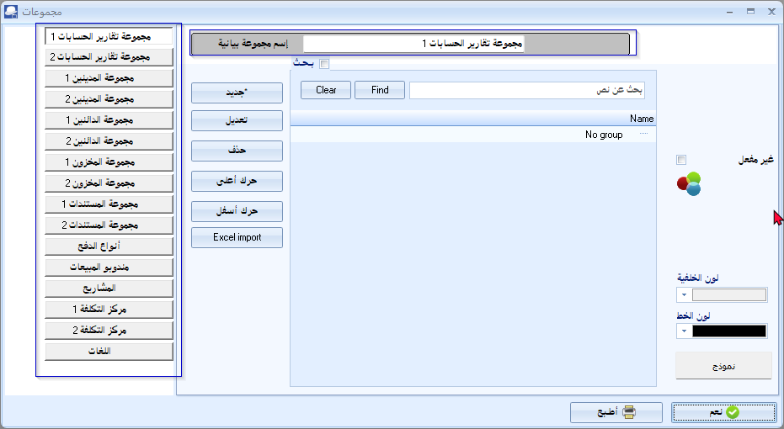

# Export / Import

## HANDYMAN tutorials

### Accounts

Spreadsheet Export and import accounts does not :

Import sub accounts. Need to delete and recreate sub accounts.

Similarly for VAT accounts need to delete and recreate. Need to concentrate on Tax percentages. The User reports -> Tax will point out if he percentages is reflecting the correct tax rates.

### Stock

Spreadsheet Export and import all stock items in Stock items (Default ribbon).

### Debtors

Txt files - Export and Import options (on Setup ribbon) and import all debtors.

### Creditors

Txt files - Export and Import options (on Setup ribbon) and import all creditors.

### Documents

Used the Document Export plugin to export (Documents -> Other -> Export) all documents (posted as well as unposted) for each document type as a TXF document:

invoives.txf

quotes.txf

purchases.txf

orders.txf

## Batches