# ARABIC – DEVELOPMENT – 2025

## Translations

### Language file

The Arabic.dfm language file have been translated, based on **Modern Standard Arabic (MSA)**.

### Outstanding translations

These translations is not available in the Arabic.dfm file and still need to be translated via the executable file for osFinancials/TurboCASH.

See –

* List of outstanding translations osFinancials Core on GitHub : <https://github.com/Digidanosf/osfinancials-development/tree/main/translations>
* List of outstanding translations – Plugins on GiHub : <https://github.com/Digidanosf/osfinancials-development/tree/main/plugins-translations>

### Arabic.dfm language file Labels not translated

## Arabic languages - RTL Install

The Arabic and other RTL (Right to Left languages) may need a separate install.

### Tcash.ini / osf.ini file

The setting can only be changed in the osf.ini or tcash.ini file.

To change the setting, you need to go to the root directory of the osFinancials5.1 or TurboCASH5-3.

;BIDIMODE=RTL

It is commented with a semi-colon. To change the setting, you need to remove the semi-colon.

### Language file Label ID 3738

In Tools -> Customise languages Label ID 3738 = LTR (Left to Right) Default for most countries.

Some countries and Languages that require RTL (Right to Left) Language and Interface support

need to change this LTR Left To Right (Label ID 3738) change the LTR with RTL (Right To Left).

# Firebird Databases vs MSSQOL Arabic Databases

## Firebird Databases – RTL display CORRECT

In Firebird databases, the osFinancials5.1/TurboCASH5-3 interface displays correct – See Screenshots

## MSSQL Databases – RTL display INCORRECT

In MSSQL databases, the osFinancials5.1/TurboCASH5-3 interface displays incorrect as LTR instead of RTL.

MSSQL Settings = Coalition is set to use an appropriate RTL collation (e.g., “ Arabic_CI_AS “ for Arabic.

### In MSSQL Database displays the labels in the LTR language. How do I set the database to support RTL

Firebird Databases -

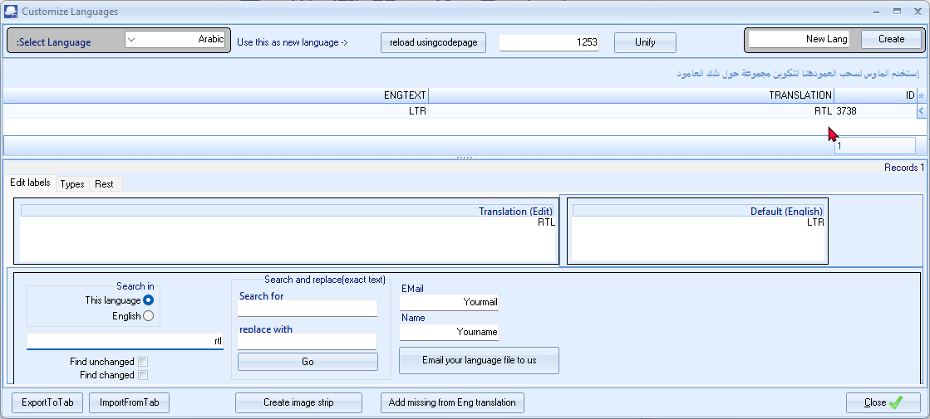

## Dynamic SQL Error code = -303

Dynamic SQL Error replicated in the following screens:

* Tools -> Customise languages **Types** tab
* Setup -> Groups (Reporting group name) The groups can be translated.
* Setup -> Stock information (Selling price 1, Selling price 2 and Selling price 3) fields (Can only exit the Stock information screen once you have changed it back to the English translation.
* Setup -> Batch types
* Setup -> Accounts - Bank accounts – Bank tab

*Dynamic SQL Error*

*SQL error code = -303*

*arithmetic exception, numeric overflow, or string truncation*

Types tab Can translate all items, except for the following

General ledger

Cannot enter or copy the translation of **General ledger** “**دفتر الأستاذ العام “**

**Ledger** = Can enter or copy the translation of **Ledger** “ **دفتر الأستاذ** “ a shorter Arabic text.

## FIXED - Format of Telephone and Fax numbers

Thank you for sharing this solution! The issue you’re describing is related to how **Right-to-Left (RTL)** text formatting interacts with special characters like the + sign in **osFinancials/TurboCASH**. By inserting a **Unicode control character** (specifically, the **Left-to-Right Mark (LRM)**), you can force the text to display correctly in **Left-to-Left (LTR)** order, which resolves the problem of the + sign being moved to the end.

**Step-by-Step Solution**

Here’s how to fix the issue using the **Left-to-Right Mark (LRM)**:

1. **Enter the Phone Number**:
   * Type the phone number in the correct format, e.g., +966 55 123 4567.
2. **Observe the Incorrect Display**:
   * If the number is displayed incorrectly as 4567 123 55 966+, proceed to the next step.
3. **Click Before the + Sign**:
   * Place the cursor immediately before the + sign.
4. **Right-Click and Insert LRM**:
   * Right-click to open the context menu.
   * Select **Insert Unicode Control Character** -> **LRM (Left-to-Right Mark)**.
5. **Verify the Correct Display**:
   * After inserting the LRM, the phone number should now display correctly as +966 55 123 4567.

**Why This Works**

* **RTL vs. LTR**:
  + Arabic text is written and displayed in **Right-to-Left (RTL)** order, but phone numbers (and other technical data) should follow **Left-to-Right (LTR)** order.
  + Without the LRM, the + sign is treated as part of the RTL text and moved to the end.
* **Left-to-Right Mark (LRM)**:
  + The LRM is a **Unicode control character** that forces the text to be displayed in **LTR** order, even in an RTL context.
  + By inserting the LRM before the + sign, you ensure that the phone number is displayed correctly.

**Example in osFinancials/TurboCASH**

Here’s how the process works in practice:

**Before Inserting LRM**

plaintext

Copy

4567 123 55 966+

**After Inserting LRM**

plaintext

Copy

+966 55 123 4567

**Additional Notes**

1. **Permanent Fix**:
   * If this issue occurs frequently, consider reporting it to the osFinancials/TurboCASH development team so they can implement a permanent fix.
2. **Alternative Workarounds**:
   * If inserting the LRM is not practical, you can omit the + sign and instruct users to add it manually when dialing internationally.
   * Example:

هاتف: 966 55 123 4567 أضف + قبل الرقم للاتصال الدولي

1. **Testing**:
   * Test the solution with different phone numbers to ensure consistency.

**Conclusion**

By inserting the **Left-to-Right Mark (LRM)** before the + sign, you can force osFinancials/TurboCASH to display the phone number correctly in **LTR** order. This is a simple and effective workaround for the RTL formatting issue.

# Arabic RTL Development up to 20 December 2021

## LTR - Interface (Default)

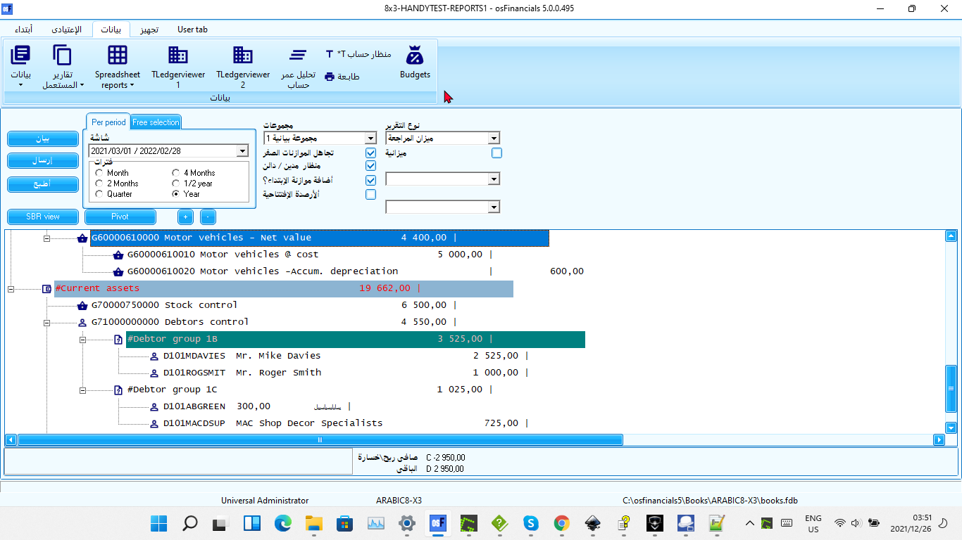

## RTL - Switch

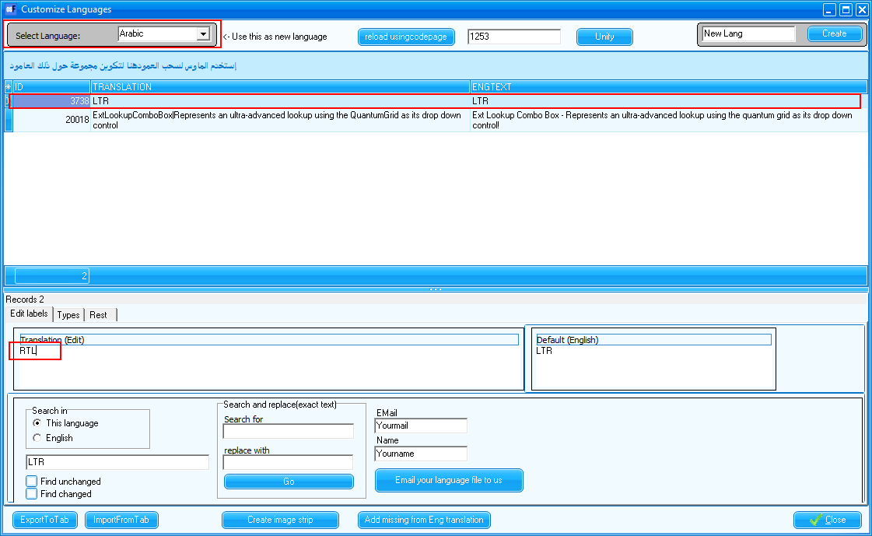

## RTL - Interface



**It is strongly recommended consulting with a qualified accounting professional or tax advisor in Arabic language and countries for tax regime and accounting standards for specific guidance on payroll accounting and tax requirements.** They can help you design a Chart of Accounts that meets your specific needs and complies with all applicable regulations.

## Arabic screens

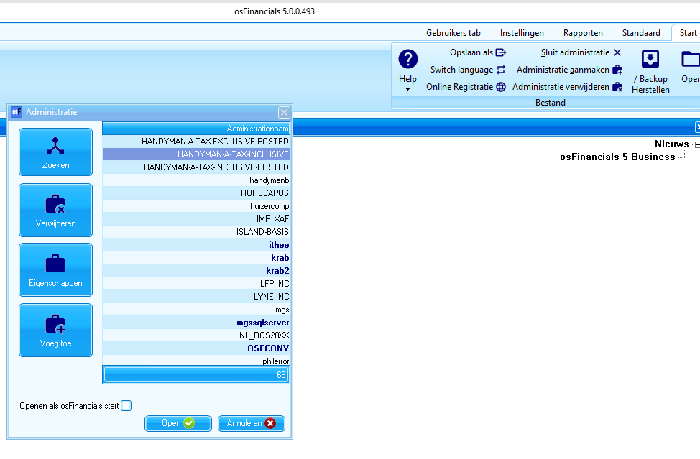

## FIXED ERRORS

### Widestring Errors – FIXED - December 2021

### Let osFinancials help to create a Set of Books (Default)

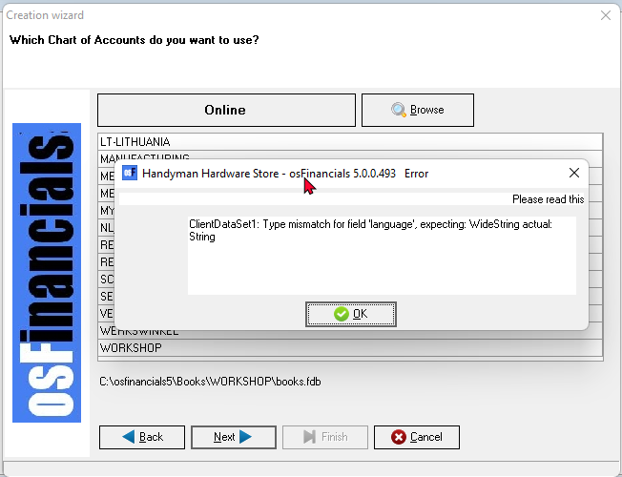

### Fixed - Export (Setup ribbon)

**Arabic**

