Contents

**Arabic languages - RTL Install** 1

Tcash.ini / osf.ini file 1

Language file Label ID 3738 1

Arabic languages - List of RTL (Right to Left) languages 1

The 12 right-to-left languages: 2

**Previous development - Jordan** 3

Fixed Missing Translations 3

Jordan Accounting resources 3

Jordan Tax rates 4

LTR - Interface (Default) 4

RTL - Switch 5

RTL - Interface 5

Arabic screens 6

Widestring Errors 6

Let osFinancials help to create a Set of Books (Default) 6

Fixed - Export (Setup ribbon) 7

Unicode context menu options of forms 8

**Arabic languages - RTL Install**

The Arabic and other RTL (Right to Left languages) may need a separate install.

## Tcash.ini / osf.ini file

The setting can only be changed in the osf.ini or tcash.ini file.

To change the setting, you need to go to the root directory of the osFinancials5.1 or TurboCASH5-3.

;BIDIMODE=RTL

It is commented with a semi-colon. To change the setting, you need to remove the semi-colon.

## Language file Label ID 3738

## Arabic languages - List of RTL (Right to Left) languages

In Tools -> Customise languages Label ID 3738 = LTR (Left to Right) Default for most countries.

Some countries and Languages that require RTL (Right to Left) Language and Interface support

need to change this LTR Left To Right (Label ID 3738) change the LTR with RTL (Right To Left).

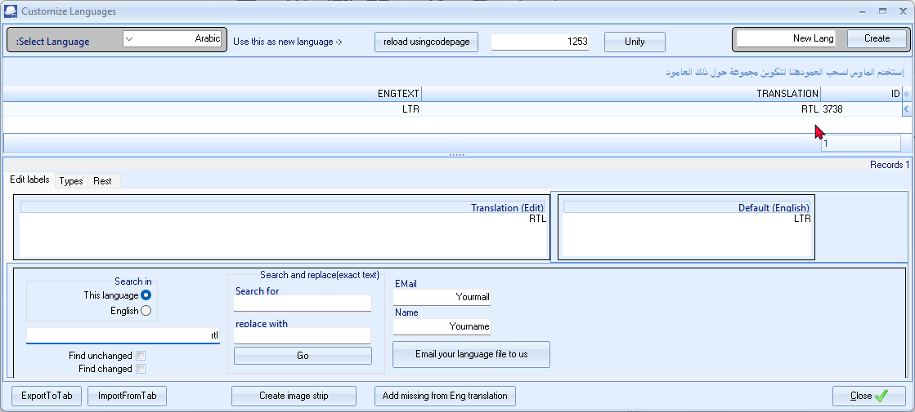

## The 12 right-to-left languages:

|  |  |
| --- | --- |
| ***Right-To-Left Languages*** | |
| *ISO Language Code* | *Language Name* |
| *ar* | *Arabic* |
| *arc* | *Aramaic* |
| *dv* | *Divehi* |
| *fa* | *Persian* |
| *ha* | *Hausa* |
| *he* | *Hebrew* |
| *khw* | *Khowar* |
| *ks* | *Kashmiri* |
| *ku* | *Kurdish* |
| *ps* | *Pashto* |
| *ur* | *Urdu* |
| *yi* | *Yiddish* |

**Previous development - Jordan**

one guy i have for 4 hours a day that is someone i think could be good in implementing osf/tc for his county. Thats the one doing the conversion now.

## Fixed Missing Translations

Its a arabic country and we are missing some translations.

Also we need a books for Jordan we need to see if we can find data on that

Also see Missing labels added from English - Language file records recon Added

|  |  |  |  |  |  |
| --- | --- | --- | --- | --- | --- |
| ***Language*** | ***Number of Records (build (292)*** | ***Labels added*** | ***New Number of records*** | ***Duplicate Labels removed*** | ***Comments*** |
| *Arabic* | *3805* | *Added 198 labels 3127 to 3324 + others* | *4012* | *3267        Selling price / Supplier stock code* |  |

Current labels 4033

Missing records should be fixed - only outstanding untranslated labels should need to be done +-1620 Labels to be translated

## Jordan Accounting resources

**Keywords**

Accounting regulation International Financial Reporting Standards Corporate governance Accounting practices Jordan

**Jordan accounting and tax, Jordan legal and compliance (healyconsultants.com)**

- <https://www.healyconsultants.com/jordan-company-registration/accounting-legal/> -

**Accounting Education and Accountancy Profession in Jordan: The Current Status and the Processes of Improvement**

- <https://iiste.org/Journals/index.php/RJFA/article/viewFile/7167/7380> -

**Evaluation of practical accounting education in Jordan**

- <https://www.emerald.com/insight/content/doi/10.1108/HEED-04-2021-0034/full/html> -

**Accounting courses in Jordan**

- <https://courses.laimoon.com/jordan/accounting-finance-and-banking/accounting> -

**International Federation of Accountants**

- <https://www.ifac.org/about-ifac/membership/country/jordan> -

**Financial Reporting Framework in Jordan**

- <https://www.iasplus.com/en/jurisdictions/asia/jordan> -

## Jordan Tax rates

Sales tax Threshold

Annual thresholds:

Goods - JOD50,000

Services - JOD30,000

Sales tax rates

Standard rate = 16%

Reduced rates are 0%, 4%,5% and 10%

Languages

Label ID 3738 = LTR (Left to Right) Default for most countries.

Some countries and Languages that require RTL (Right to Left) Language and Interface support

need to change this LTR Left To Right (Label ID 3738) change the LTR with RTL (Right To Left).

If that is RTL mode else not so we can switch language and get the right RTL for the language

Source - <https://lingohub.com/academy/best-practices/rtl-language-list> -

# LTR - Interface (Default)

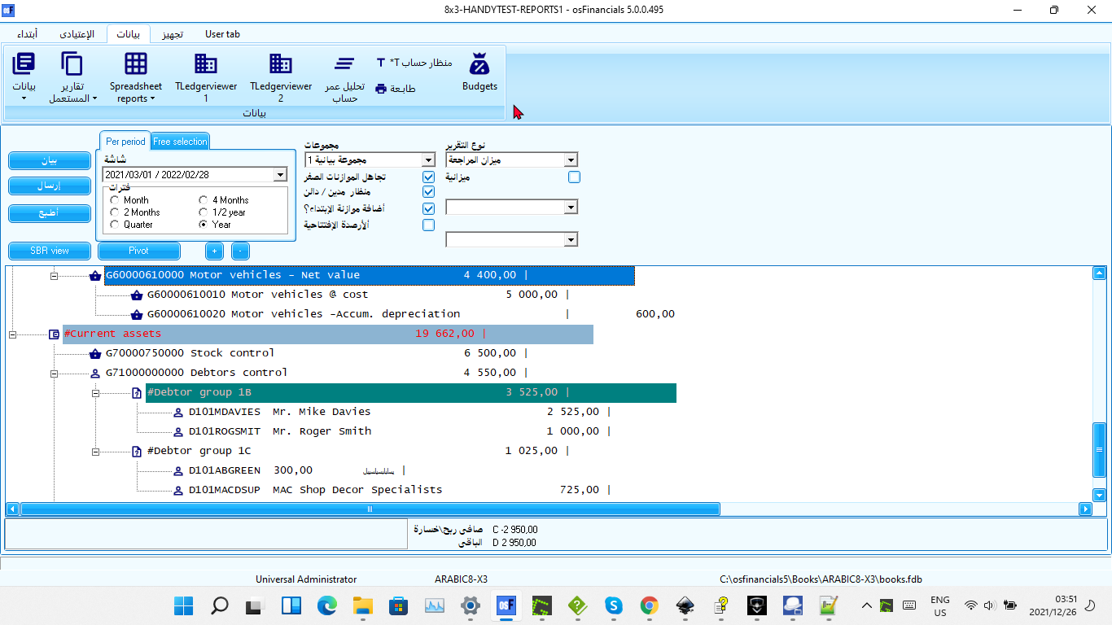

## RTL - Switch

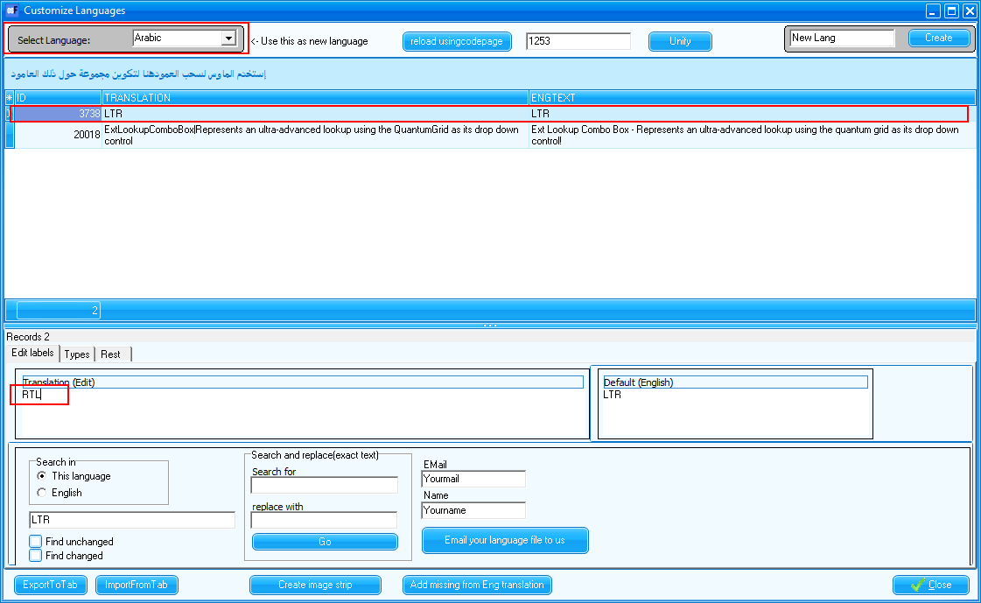

## RTL - Interface



**It is strongly recommended consulting with a qualified accounting professional or tax advisor in Arabic language and countries for tax regime and accounting standards for specific guidance on payroll accounting and tax requirements.** They can help you design a Chart of Accounts that meets your specific needs and complies with all applicable regulations.

## Arabic screens

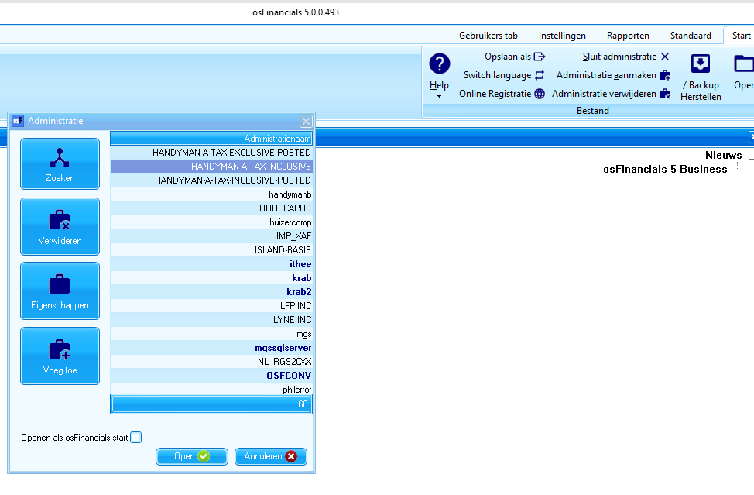

# Widestring Errors – FIXED - December 2021

## Let osFinancials help to create a Set of Books (Default)

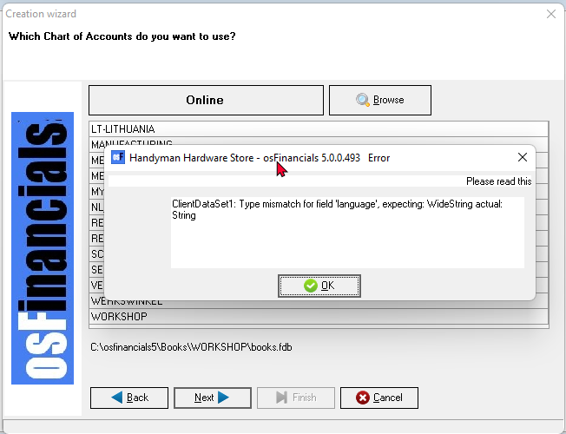

## Fixed - Export (Setup ribbon)

**Arabic**

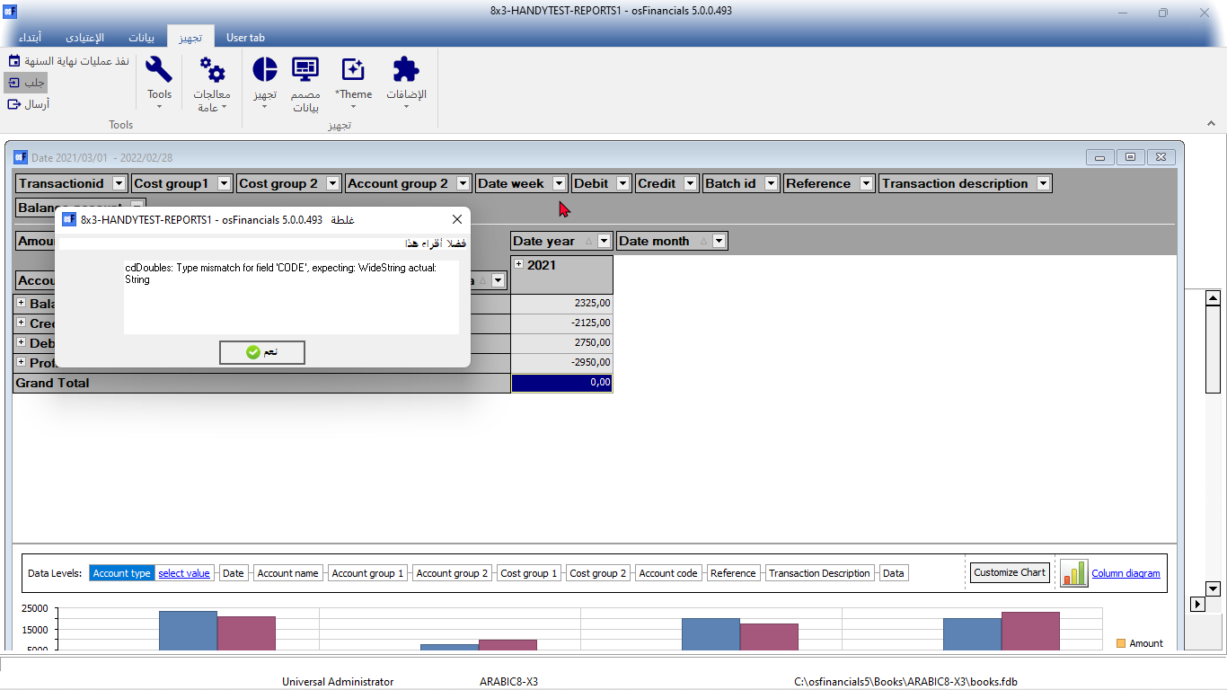

# Unicode context menu options of forms

In osFinancials5.1/TurboCASH5-3, the context menu on most fields in forms, such as [**Debtors**](hnd-topic://7ea26aa8109d4b06988600557f4bad1a), [Creditors](hnd-topic://e784edfabf87435991481c10dcee1e03), [Stock](hnd-topic://b63ce7792fbe4d239b1fe6a867815835) on the **Default** ribbon and [Accounts](hnd-topic://5fdf5282071941c289dc32354fd37707), [Groups](hnd-topic://1ac89184c1994c0a863dfdaed4e44fff) on the **Setup** menu, include the following context menu items related to Unicode (if Unicode is enabled).

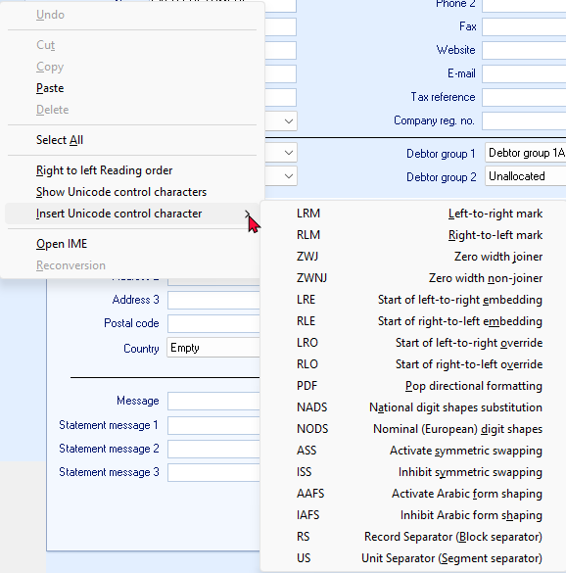

These context menu items in osFinancials5/TurboCASH5, specifically related to Unicode, provide advanced text formatting and control options when working with characters beyond the standard ASCII set. Let's break down what each option means and its function:

**1. Right to Left Reading Order**

* **Function:** This option controls the reading direction of the text. When enabled, the text in the field will be displayed and processed from right to left, which is essential for languages like Arabic and Hebrew.

**2. Show Unicode Control Characters**

* **Function:** This option displays invisible Unicode control characters that might be present in the text. These characters can affect text formatting and rendering, so visualizing them can help troubleshoot display issues.

**3. Insert Unicode Control Character**

* **Function:** This allows you to manually insert specific Unicode control characters into the text. These characters are used to fine-tune text direction, shaping, and rendering:
  + **LRM (Left-to-right Mark):** Forces the following characters to be displayed left-to-right.
  + **RLM (Right-to-left Mark):** Forces the following characters to be displayed right-to-left.
  + **ZWJ (Zero Width Joiner):** Connects two characters that might otherwise be separated.
  + **ZWNJ (Zero Width Non-Joiner):** Prevents two characters from being connected.
  + **LRE (Start of Left-to-right Embedding):** Starts a region of left-to-right text within right-to-left text.
  + **RLE (Start of Right-to-left Embedding):** Starts a region of right-to-left text within left-to-right text.
  + **LRO (Start of Left-to-right Override):** Overrides the current text direction and sets it to left-to-right.
  + **RLO (Start of Right-to-left Override):** Overrides the current text direction and sets it to right-to-left.
  + **PDF (Pop Directional Formatting):** Ends a region of embedded text direction.
  + **NADS (National Digit Shapes Substitution):** Uses the digit shapes specific to the current locale.
  + **NODS (Nominal (European) Digit Shapes):** Uses the standard European digit shapes (0-9).
  + **ASS (Activate Symmetric Swapping):** Enables symmetric swapping of characters, which can affect the appearance of certain characters.
  + **ISS (Inhibit Symmetric Swapping):** Disables symmetric swapping of characters.
  + **AAFS (Activate Arabic Form Shaping):** Enables shaping of Arabic characters based on their position in the word.
  + **IAFS (Inhibit Arabic Form Shaping):** Disables shaping of Arabic characters.
  + **RS (Record Separator):** A block separator character.
  + **US (Unit Separator):** A segment separator character.

**4. Open IME**

* **Function:** This opens the Input Method Editor (IME), a tool that allows you to input characters from languages that don't have direct keyboard mappings.

**5. Reconversion**

* **Function:** This option is specific to IMEs. It re-analyzes the input text and may suggest alternative conversions or corrections.

**In Summary**

These Unicode-related context menu items in osFinancials5/TurboCASH5 provide powerful tools for handling text in various languages and scripts. They allow you to control text direction, insert special characters, and fine-tune text rendering to ensure accurate and professional-looking results.