Table of Contents

**Chinese 4-CAS-GENERIC Set of Books Debug** 1

Inno Install script for Chinese 1

Folders that contain the tcash.ini files: 1

Innoscript language files: 1

Language : Chinese.dfm - Codepage setting 2

What is codepage 1253 and is it applicable to the China? 2

What is the Codepages for Chinese languages? 3

Display of Chinese characters on screens, forms / reports 3

Print Setup -> Groups and Ledger analyser 1/2 3

Setup menu 4

Setup -> Company Info 4

Setup -> Reporting dates 4

Chart of accounts 5

VAT GST/Sales tax in China 5

Organizing payroll accounts in China 5

Unicode context menu options of forms 7

**Chinese – Documents – Remarks**

Similar issues as in the Arabic Development.chm is produced in Documents

Remarks entered in Chinese, Arabic, etc. converts to ???????, etc.

Comments prints the Chinese text correctly.

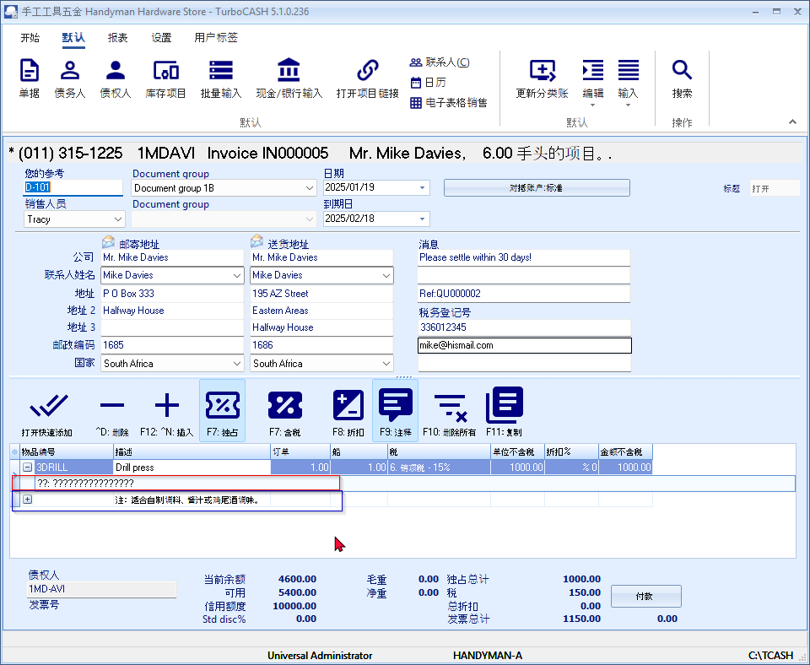

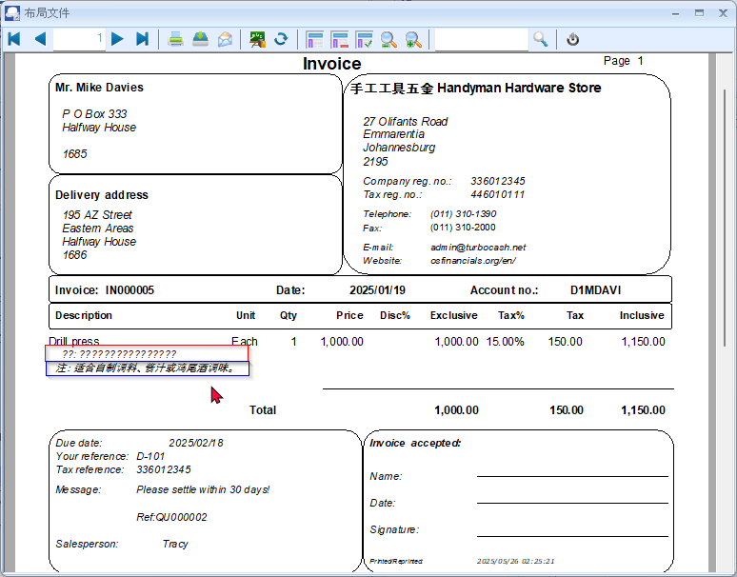

**Chinese 4-CAS-GENERIC Set of Books Debug**

Good job - Need to look at the following:

## Inno Install script for Chinese

Currently we have the following languages to install TurboCASH5

### Folders that contain the tcash.ini files:

chs- Chinese simplified

cht - Chinese traditional

### Innoscript language files:

ChineseSimp.isl

ChineseTrad.isl

Important to select the correct language folder and innoScript language files which is inline with the Chinese.dfm language file. Should it be Chinese simplified or Chinese traditional.

## Language : Chinese.dfm - Codepage setting

Language : Chinese.dfm - Codepage - Tools -> Customize Language

The default codepage is 1253

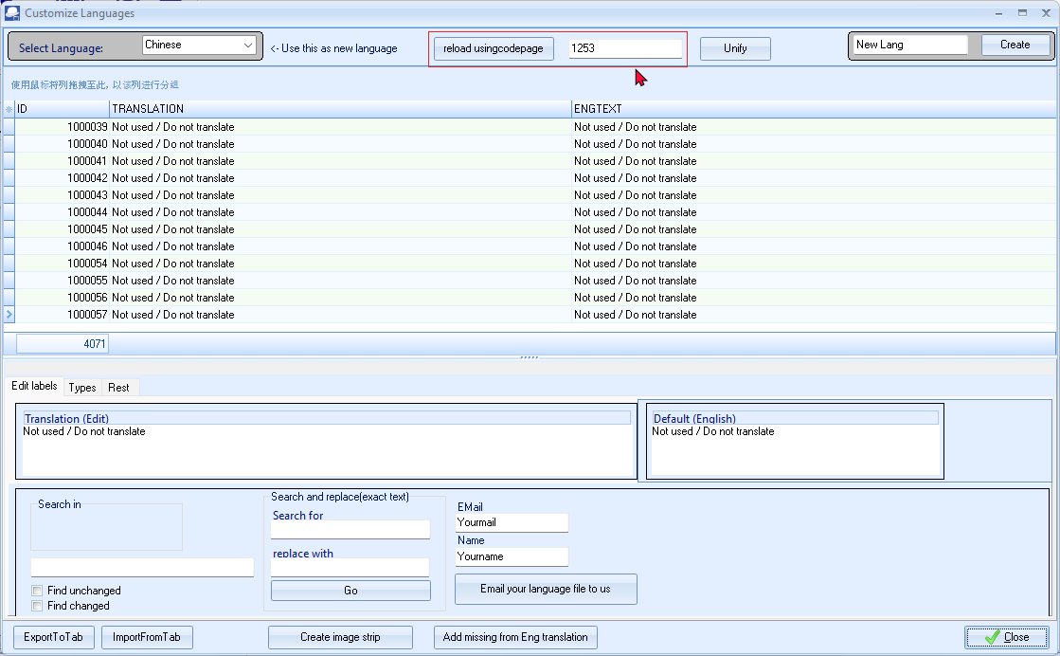

### What is codepage 1253 and is it applicable to the China?

**Codepage 1253 is specifically designed for the Greek language.**1 It's a character encoding standard used to represent text in the modern Greek alphabet, including accented letters, punctuation marks, and special symbols.2

**It is not applicable to the Chinese language.** Chinese languages (Simplified and Traditional) require different code pages, such as GB2312, GBK, GB18030 (for Simplified Chinese) and Big5, CNS 11643 (for Traditional Chinese).

**Key Points:**

* **Codepage 1253:** For modern Greek.3
* **Chinese Languages:** Use different code pages like GB2312, GBK, GB18030, Big5, and CNS 11643.
* **Unicode:** The preferred standard for modern systems, supporting all languages, including Chinese and Greek.

I hope this clarifies the distinction!

- <https://learn.microsoft.com/en-us/windows/win32/intl/code-page-identifiers> -

### What is the Codepages for Chinese languages?

The most common code pages for Chinese languages are:

* **Simplified Chinese:**
  + **GB2312:** A national standard for mainland China, covering a subset of simplified Chinese characters.
  + **GBK:** An extension of GB2312, supporting a larger set of characters.
  + **GB18030:** A more recent standard that includes a wider range of characters, including those used in minority languages in China.
* **Traditional Chinese:**
  + **Big5:** A widely used encoding for traditional Chinese, primarily in Taiwan and Hong Kong.
  + **CNS 11643:** A national standard for Taiwan, supporting a comprehensive set of traditional Chinese characters.

It's important to note that:

* **Unicode:** The preferred encoding for modern systems is Unicode (specifically UTF-8), which supports all languages and scripts.
* **Code pages are often legacy encodings.** While they may still be used in some older systems, Unicode is generally the recommended standard for new applications and data exchange.

## Display of Chinese characters on screens, forms / reports

### Print Setup -> Groups and Ledger analyser 1/2

Print button in Print Setup -> Groups seems to print correct Chinese characters, but in the Ledger analyser 1/2 it prints the characters with question marks ????

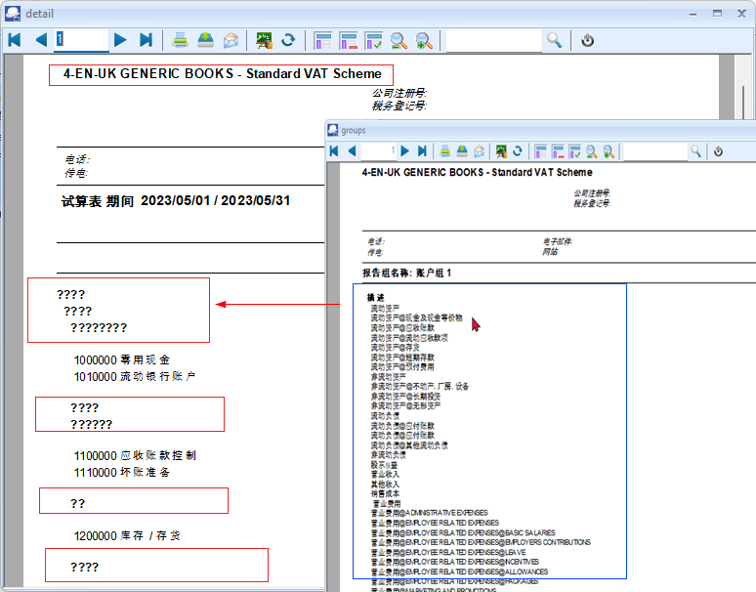

On the Accounts, Groups, etc. forms seems to display in the Chinese characters correctly.

## Setup menu

### Setup -> Company Info

Name of Set of Books refers to "4-EN-UK GENERIC BOOKS - Standard VAT Scheme"

### Setup -> Reporting dates

Reporting dates refer to January - to December - may need to be translated.

## Chart of accounts

### VAT GST/Sales tax in China

Currently the VAT in the Chart of Accounts is based on the UK VAT - Standards= cgeme reflecting tax percentages of 20%, etc.

The correct term for the sales tax in China is **Value Added Tax (VAT)**.1

See - <https://taxsummaries.pwc.com/quick-charts/value-added-tax-vat-rates> -

China has a multi-tiered VAT system with different rates:2

See - <https://wise.com/gb/vat/china> -

* **Standard Rate:** 13% (applies to most goods and services)3

See - <https://wise.com/gb/vat/china> -

* **Reduced Rates:** 9% and 6% (for specific goods and services like certain agricultural products, transportation, and some services)

**Note:** The specific VAT rates and their applicability can change, so it's essential to refer to the latest official information from the Chinese tax authorities for the most accurate and up-to-date details.

### Organizing payroll accounts in China

**Here's a possible structure for organizing payroll accounts in China, keeping in mind that specific requirements might vary:**

**I. Expense Accounts**

* **501000 Salaries Expense**
  + 501010 Basic Salary
  + 501020 Overtime Pay
  + 501030 Bonuses
  + 501040 Allowances (e.g., housing, transportation)
* **502000 Payroll Taxes Expense**
  + 502010 Pension Insurance - Employer Portion
  + 502020 Medical Insurance - Employer Portion
  + 502030 Unemployment Insurance - Employer Portion
  + 502040 Work Injury Insurance - Employer Portion
  + 502050 Maternity Insurance - Employer Portion
  + 502060 Housing Fund - Employer Portion
* **503000 Employee Benefits Expense**
  + 503010 Medical Insurance - Employee Portion
  + 503020 Housing Fund - Employee Portion
  + 503030 Other Employee Benefits (e.g., life insurance, meal subsidies)

**II. Balance Sheet Accounts**

* **211000 Accrued Salaries Payable**
* **212000 Payroll Taxes Payable**
  + 212010 Pension Insurance Payable
  + 212020 Medical Insurance Payable
  + 212030 Unemployment Insurance Payable
  + 212040 Work Injury Insurance Payable
  + 212050 Maternity Insurance Payable
  + 212060 Housing Fund Payable
* **213000 Withholding Taxes Payable**

**Key Considerations:**

* **Chart of Accounts Design:** This structure provides a basic framework. You should adapt it to your specific needs and the level of detail required for your accounting system.
* **Coding System:** Implement a consistent coding system (e.g., alphanumeric) for easy identification and reporting.
* **Internal Controls:** Establish strong internal controls to ensure accuracy and prevent fraud in payroll processing.1 See - [https://www.unit21.ai/fraud-aml-dictionary/payroll-fraud#:~:text=Strong%20internal%20controls%20that%20restrict,used%20to%20manage%20threats%20more](•%20https://www.unit21.ai/fraud-aml-dictionary/payroll-fraud#:~:text=Strong%20internal%20controls%20that%20restrict,used%20to%20manage%20threats%20more) -
* **Regular Reviews:** Regularly review and update your payroll account structure to reflect changes in regulations and business requirements.

**Disclaimer:** This information is for general guidance only and should not be considered professional accounting advice.

**It is strongly recommended consulting with a qualified accounting professional or tax advisor in China for specific guidance on payroll accounting and tax requirements.** They can help you design a Chart of Accounts that meets your specific needs and complies with all applicable regulations.

# Unicode context menu options of forms

In osFinancials5/TurboCASH5, the context menu on most fields in forms, such as [**Debtors**](hnd-topic://7ea26aa8109d4b06988600557f4bad1a), [Creditors](hnd-topic://e784edfabf87435991481c10dcee1e03), [Stock](hnd-topic://b63ce7792fbe4d239b1fe6a867815835) on the **Default** ribbon and [Accounts](hnd-topic://5fdf5282071941c289dc32354fd37707), [Groups](hnd-topic://1ac89184c1994c0a863dfdaed4e44fff) on the **Setup** menu, include the following context menu items related to Unicode (if Unicode is enabled).

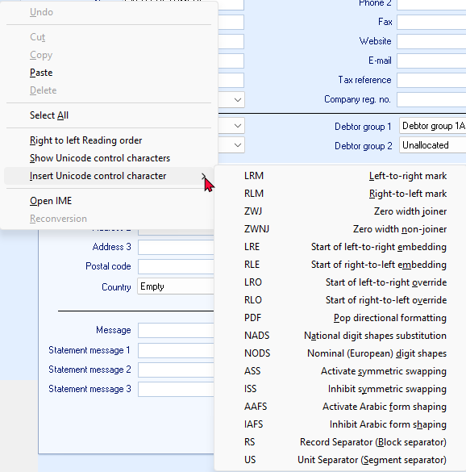

These context menu items in osFinancials5/TurboCASH5, specifically related to Unicode, provide advanced text formatting and control options when working with characters beyond the standard ASCII set. Let's break down what each option means and its function:

**1. Right to Left Reading Order**

* **Function:** This option controls the reading direction of the text. When enabled, the text in the field will be displayed and processed from right to left, which is essential for languages like Arabic and Hebrew.

**2. Show Unicode Control Characters**

* **Function:** This option displays invisible Unicode control characters that might be present in the text. These characters can affect text formatting and rendering, so visualizing them can help troubleshoot display issues.

**3. Insert Unicode Control Character**

* **Function:** This allows you to manually insert specific Unicode control characters into the text. These characters are used to fine-tune text direction, shaping, and rendering:
  + **LRM (Left-to-right Mark):** Forces the following characters to be displayed left-to-right.
  + **RLM (Right-to-left Mark):** Forces the following characters to be displayed right-to-left.
  + **ZWJ (Zero Width Joiner):** Connects two characters that might otherwise be separated.
  + **ZWNJ (Zero Width Non-Joiner):** Prevents two characters from being connected.
  + **LRE (Start of Left-to-right Embedding):** Starts a region of left-to-right text within right-to-left text.
  + **RLE (Start of Right-to-left Embedding):** Starts a region of right-to-left text within left-to-right text.
  + **LRO (Start of Left-to-right Override):** Overrides the current text direction and sets it to left-to-right.
  + **RLO (Start of Right-to-left Override):** Overrides the current text direction and sets it to right-to-left.
  + **PDF (Pop Directional Formatting):** Ends a region of embedded text direction.
  + **NADS (National Digit Shapes Substitution):** Uses the digit shapes specific to the current locale.
  + **NODS (Nominal (European) Digit Shapes):** Uses the standard European digit shapes (0-9).
  + **ASS (Activate Symmetric Swapping):** Enables symmetric swapping of characters, which can affect the appearance of certain characters.
  + **ISS (Inhibit Symmetric Swapping):** Disables symmetric swapping of characters.
  + **AAFS (Activate Arabic Form Shaping):** Enables shaping of Arabic characters based on their position in the word.
  + **IAFS (Inhibit Arabic Form Shaping):** Disables shaping of Arabic characters.
  + **RS (Record Separator):** A block separator character.
  + **US (Unit Separator):** A segment separator character.

**4. Open IME**

* **Function:** This opens the Input Method Editor (IME), a tool that allows you to input characters from languages that don't have direct keyboard mappings.

**5. Reconversion**

* **Function:** This option is specific to IMEs. It re-analyzes the input text and may suggest alternative conversions or corrections.

**In Summary**

These Unicode-related context menu items in osFinancials5/TurboCASH5 provide powerful tools for handling text in various languages and scripts. They allow you to control text direction, insert special characters, and fine-tune text rendering to ensure accurate and professional-looking results.