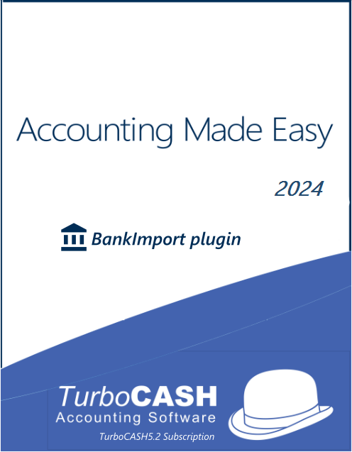

Accounting Made Easy with TurboCASH5 / osFinancials5: Tutorial and Reference Guide
- Bank Import Plugin -

Special thanks to : Pieter Valentijn (osFinancials)
Philip Copeman (TurboCASH)

Author : Dan van Zyl
© Copyright Pieter Valentijn , 2024
© Copyright Philip Copeman , 2024

All rights reserved.

This work is supplied in electronic eBook from. If you have not paid a licence for it, please purchase one. Each licence entitles the reader to print out one hard copy of this tutorial. If you have received a copy of this eBook and you do wish to print out a copy, please purchase further licences from the osFinancials Webshop.

WELCOME to TurboCASH
Thank you for choosing TurboCASH. This program is easy to use, but an exceptionally powerful accounting program. This program allows you to set up your accounting system quickly and then adjust it to according to your own requirements.
TurboCASH5 can be customised to accommodate virtually any business’ requirements. The program is so versatile, that, if your business expands and you change to another form of ownership, (e.g., from sole proprietor to partnership, close corporation or company) or even if need to you register or de-register for VAT/GST/Sales tax, TurboCASH5 can accommodate these changes with ease.
Starting a small business is a dream for many, but managing the finances can be quite challenging, especially if you are new to accounting. TurboCASH5 is an accounting software that simplifies your financial processes and management and gives you more time to focus on growing your business. This book will provide an in-depth review of TurboCASH5, including its features, benefits, and frequently asked questions.
The TurboCASH program runs locally, with data stored on your own computer. Unlike some cloud-based accounting systems, you have full control of your data.
TurboCASH also offers modular expansions and industry specific solutions using a variety of plugins available at our osFinancials webshop.
If you have never used TurboCASH5 before, time should be well spent doing the Handyman tutorial before launching into your own Set of Books.
In this tutorial, we will guide you through the basics of accounting and show you how to use TurboCASH to manage your business's finances. Whether you are new to accounting or have some experience, this tutorial is designed to help you become proficient in using TurboCASH for all your accounting needs.
We will start by introducing you to the TurboCASH software and its features. Then, we will walk you through the process of setting up your company's chart of accounts, creating transactions, processing sales and purchase documents and generating reports. This tutorial will also serve as a reference guide to TurboCASH.
By the end of this tutorial, you will have a solid understanding of the accounting process and be able to confidently use TurboCASH to manage your business's finances. So, let's get started!
When TurboCASH5 is set up correctly, you, as the user, will enjoy the benefits of increased financial control of your enterprise. Each business entity is different from the next. It is for this reason that the TurboCASH5 program was developed with built-in flexibility.

TurboCASH includes a comprehensive context-sensitive help file and a comprehensive online help in English and Afrikaans language:
Online Help:
English - osFinancials5 - Business Class - Online Help
Afrikaans - osFinancials5 - Besigheidsklas - Hulp in Afrikaans

 | Videos:  - - osFinancials - Videos  - - TurboCASH -Videos

 | Because TurboCASH5 can work in over 20 languages and in over 80 different tax regimes, there are many ways to set it up. The key to the TurboCASH5 program is in the setting up of the parameters.  Failure to setup the program correctly will yield incorrect results.  Fortunately you do not have to worry about this. If this is the first time that you are using the software then it is best to use the EXAMPLE set of books installed for your country rather than creating your own Set of Books. The fewer changes you make to this the better.
In our experience 95% of all TurboCASH5 problems are caused by:
- Inadequate setting up of the program
- Inadequate knowledge of the program
- Inadequate computer hardware
- Most of all - inaccurate data capture (finger problems!).
We call this the “GIGO” effect. Garbage In - Garbage Out.

HOW TO USE THIS BOOK
The book starts with a table of contents, which can be used as a quick reference to the relevant page(s). This is a step by step guide to performing all the actions associated with TurboCASH. In order to facilitate quick referencing, the table of contents is comprehensively numbered.
To access more detailed information, on any topic in this book, or on any other issue in the TurboCASH program, you may press the F1 key on your keyboard to access the Help files in TurboCASH.
A comprehensive online help in English and Afrikaans language:
Online Help:
English - osFinancials5 - Business Class - Online Help
Afrikaans - osFinancials5 - Besigheidsklas - Hulp in Afrikaans
To follow the tutorial Sets of Books, you need to click on the Open icon on the Start ribbon. On the “Set of Books” screen, click on the Browse icon and select the desired tutorial Set of Books that you wish to follow:
Accounting Made Easy - English tutorials
English tutorials (using the default payments and receipt batches for banking / cash transactions):
The following Set of Books based on this tutorial, are installed in the
“…\bin\Tutorials\ENGLISH\” folder:
- HANDYMAN – No transactions in batches and documents.
- HANDYMAN-A – Unposted transactions in batches and documents.
- HANDYMAN-B – All transactions in batches and documents have been posted (updated) to the ledger.
 | The following folders contains files which may be imported into batches:  - EXPORTED-BATCH-Delimited-File – Exported batch transactions using the “Write delimited file” option and may be imported into a batch using the “Delimited file import” option icon on batches.  - EXPORTED-BATCH-Spreadsheets – Exported batch transactions in the *.xlsx (Excel 2007-365) file format. These transaction files may be opened in the Spreadsheet import icon on batches, and imported into a selected batch.

Accounting Made Easy – BankImport Plugin - English tutorials
English tutorials (using the BankImport plugin for banking / cash transactions):
The following Set of Books based on this tutorial, are installed in the
“…\bin\Tutorials\BANK-IMPORT\” folder:
- HANDY-BANK – No transactions in batches and documents.
- HANDY-BANK-A – Unposted transactions in batches and documents, except the Payments and Receipt batches, which is cleared for the Bank account and the Petty cash.
- HANDY-BANK-B – All transactions in batches and documents, including the imported bank statement and processed Petty cash transactions have been posted (updated) to the ledger.
- HANDY-BANK-UNPOSTED-BANK-STATEMENT – All transactions, except the cash book transactions, have been posted (updated) to the ledger.
The sample Bank statement in the “…\bin\Tutorials\BANK-IMPORT\BANK-STATEMENTS” folder needs to be imported and Petty cash transactions needs to be processed).
Rekeningkunde Met Gemak – Afrikaanse handleiding
The following Set of Books based on the Afrikaans tutorial, Rekeningkunde met Gemak are installed in the
“…\bin\Tutorials\AFRIKAANS\” folder.
- NUTSMAN – No transactions in batches and documents.
- NUTSMAN-A – Unposted transactions in batches and documents.
- NUTSMAN-B – All transactions in batches and documents have been posted (updated) to the ledger.
To follow the Afrikaans tutorial, you need to click on the Browse icon and select these Sets of Books.
Cost centres
You may follow Cost centres in the English Help topic. The following Set of Books to configure and process transactions in batches and documents for cost centres and the reporting, are installed in the
“…\bin\Tutorials\COST-CENTRES\” folder:
- COST-CENTRES-A - All transactions in batches and documents is not yet posted (updated) to the ledger.
- COST-CENTRES-B - All transactions in batches and documents have been posted (updated) to the ledger.

Projects
You may follow Projects in the English Help topic.
The following Set of Books to configure and process transactions in batches and documents for projects and the reporting, are installed in the
“…\bin\Tutorials\PROJECTS\” folder:
- PROJECTS-A - All transactions in batches and documents is not yet posted (updated) to the ledger.
- PROJECTS-B - All transactions in batches and documents have been posted (updated) to the ledger.
This book is based on the Accounting Made Easy - English tutorials (using the default payments and receipt batches for banking / cash transactions) and is divided into the following modules:
- MODULE A – INTRODUCTION TO ACCOUNTING - A brief overview of accounting basics and accounting principles.
- MODULE B – INSTALLING, LAUNCHING AND REGISTERING TurboCASH - Installing, registering and launching with TurboCASH.
- MODULE C – WORKING IN TurboCASH - A reference guide to the TurboCASH5 program, interface, filters, features, etc.
- MODULE D – BACKUP AND RESTORE - Backing up and restoring your data in the event of mistakes or hardware failures.
- MODULE E – Creating a Set of Books and set up procedures, settings and configuration.
- MODULE F – SETTING UP ACCOUNTS - This is a work-through tutorial, providing “hands-on” knowledge to create / edit your chart of accounts, bank accounts, tax accounts, debtor and creditor accounts.
- MODULE G – CREATING / EDITING STOCK ITEMS - This is a work-through tutorial, providing “hands-on” knowledge to create / edit stock items to generate documents for purchases and sales of non trading stock items as well as trading stock items.
- MODULE H – ENTERING YOUR OPENING BALANCES - This is a work-through tutorial, providing “hands-on” knowledge to enter your opening balances.
- MODULE I – PROCESSING BATCH TRANSACTIONS - This is a work-through tutorial, providing “hands-on” knowledge to enter and process your daily transactions in batches. This will illustrate the transactions in the Purchase, Sales, as well as the repeating batches
Processing of cash book transactions in Payments, Receipt batches (which are linked to bank accounts) will be dealt with in MODULE L – PROCESSING CASH BOOK TRANSACTIONS WITH THE BANK IMPORT PLUGIN.
- MODULE J – PROCESSING DOCUMENTS – NON-TRADING STOCK - This is a work-through tutorial, providing “hands-on” knowledge to enter and process your daily transactions in the purchase and sales batches using documents for non trading stock items.
- MODULE K – PROCESSING DOCUMENTS – TRADING STOCK - This is a work-through tutorial, providing “hands-on” knowledge to enter and process your daily transactions in the purchase and sales batches using documents for trading stock items. If you do trade in stock items, you need to follow this MODULE.
- MODULE L – PROCESSING CASH BOOK TRANSACTIONS WITH THE BANK IMPORT PLUGIN - This is a working tutorial describing processing of cash book transactions and importing of transactions in bank statements using the Bank Import plugin. Petty cash transactions will also be dealt with in this module.
- MODULE M – CALENDAR / PLANNER - This is a working tutorial describing to schedule create repeating invoices for your debtors (customers) using the calendar. A new feature has been added where quotes for hours can be scheduled. Once these appointments are completed, quotes for hours may be converted to invoices.
- MODULE N – This is a working tutorial of how to enter budgets and to generate reports to view your budget figures. These budget figures are used as comparative figures on the budget performance report, income statement, trial balance, user reports, etc. compare your actual income and expenses against the budgeted figures.
- MODULE O – REPORTS - Available reports are listed and how to generate these reports. The reports from the tutorials are also included with each tutorial so that you may check your reports after having completed the tutorials. Pivot table grids are introduced based on the Trial balance.
- MODULE P – OPEN ITEM PROCESSING AND REPORTS - The basics and features of open item processing and reports for open item are outlined.
- MODULE Q – REPORTMAN - The Report designer interface and file structure of reports and layout files for printing documents are outlined.
- MODULE R – LIST OF SHORT-CUT KEYS - A list of the basic keyboard short-cuts for those users who prefers to use the keyboard instead of the mouse to get around TurboCASH.
The book has been structured in such a way that if you follow the step by step procedures, you will be able to run your company’s Set of Books with TurboCASH. The Chart of accounts represented in this book is a basic generalised one. It is up to you to expand and change the Chart of accounts as per your particular business requirements (for example, you may need an account called “Commissions Paid”).
Work as carefully and as accurately as possible, trying to find a mistake can be a nightmare.!
Unless you are familiar with TurboCASH, it is recommended that you work through the tutorials before starting to create your own personalised Set of Books.
As you work through the tutorials, screen shots have been supplied to ensure that you can see exactly what information to enter in which field. These are called “screen dumps”, and are appropriately placed in the text for your convenience.

The following icons have been placed on specific places throughout the documentation:
Press the F1 key when focussed on screens to get more help.
Note (Additional information)
Tip / Help
Important
Warning
 | Next step / Proceed
 | Plugins
 | Scale – Accounting equation - Debits = Credits
Videos - https://accounting.ning.com/videos
 | See – Read more
 | Delivery note

TABLE OF CONTENTS
MODULE A - INTRODUCTION TO ACCOUNTING 20
A.1- NEW TO ACCOUNTING AND TurboCASH 21
A.1.1- Hands-on Tutorials 21
A.1.2- Online Help - Documentation 22
A.2- ACCOUNTING BASICS 22
A.2.1- History of Accounting 22
A.2.2- Importance of Accounting 23
A.2.3- Accounting Principles 24
A.2.4- Accounting Process 25
A.2.5- DOUBLE-ENTRY ACCOUNTING SYSTEM - DEBITS AND CREDITS 26
A.2.5.1- What is the double-entry accounting system? 26
A.2.5.2- What are debits and credits? 27
A.2.6- ACCOUNTING CYCLE 28
A.2.6.1- Steps in the accounting cycle 28
A.2.6.2- Examples of how the accounting cycle is used in practice 29
A.2.7- TRANSACTION CYCLE 30
A.2.7.1- The transaction cycle in accounting 30
A.2.7.2- Transaction cycle and transactions 31
A.2.7.3- Examples of common business transactions in the transaction cycle 32
A.2.7.4- Transaction List - Debits and Credits 35
A.3- MAIN CLASSIFICATION OF ACCOUNTS / FINANCIAL CATEGORIES 35
A.3.1- Accounting equation - Income statement 36
A.3.2- Accounting equation - Balance sheet 37
A.3.3- Expanded accounting equation - Income statement and Balance sheet 38
A.4- GROUPS/CLASSIFICATION OF FINANCIAL CATEGORIES 38
A.4.1- Account groups - Financial categories - Income statement 38
A.4.2- Account groups - Financial categories - Balance sheet 39
A.5- CHARTS OF ACCOUNTS in TurboCASH 39
A.5.1- Income / Expense accounts - Chart of accounts 40
A.5.2- Balance sheet accounts - Chart of accounts 41
A.6- THE LEDGER 43
A.7- CONTROL ACCOUNTS 44
A.8- THE STRUCTURE OF TurboCASH 46
MODULE B - INSTALLING, LAUNCHING AND REGISTERING TurboCASH 48
B.1- HARDWARE AND SOFTWARE REQUIREMENTS 49
B.2- INSTALLING TurboCASH5 SINGLE-USER 50
B.3- Launching TurboCASH5 57
B.3.1- Opening a Set of Books 57
B.3.1.1- Sets of Books included in your TurboCASH5 installation 58
B.3.1.2- Additional Sets of Books (4-digit main accounts and 3 digit sub-accounts) 58
B.3.1.3- Available Sets of Books in the bin folder 59
B.4- STARTING TurboCASH5 60
B.5- SELECTING A LANGUAGE 62
B.6- OPENING SETS OF BOOKS 63
B.7- TUTORIALS 64
B.7.1- Accounting Made Easy - English tutorials 64
B.7.2- Accounting Made Easy – BankImport Plugin - English tutorials 65
B.7.3- Rekeningkunde Met Gemak – Afrikaanse handleiding 65
B.7.4- Cost centres 66
B.7.5- Projects 66
B.8- SELECTING A LANGUAGE 67
B.8.1- Changing language files 68
B.8.2- Changing language files for debtors / creditors 68
B.8.3- Customising language files (optional) 69
B.9- REGISTERING TurboCASH5 71
MODULE C - WORKING IN TurboCASH5 73
C.1- TurboCASH5 FEATURES 75
C.1.1- Get started easily 75
C.1.2- Multiple language support 75
C.1.3- Calendar / Planner 75
C.1.4- Debtors / Creditors 75
C.1.5- Full stock control 76
C.1.6- Batch processing 76
C.1.7- Document processing 76
C.1.8- Powerful comprehensive reporting 77
C.1.9- Export / Import 78
C.1.10- Export to spreadsheets 78
C.1.11- Additional features 78
C.2- NEW FEATURES IN TurboCASH5 Business Class 79
C.3- THE TurboCASH5 PROGRAM 82
C.3.1- RIBBONS AND MENUS 84
C.3.1.1- Start ribbon 84
C.3.1.2- Default ribbon 86
C.3.1.3- Reports ribbon 88
C.3.1.3.1- Reports menu 89
C.3.1.3.2- User reports menu 93
C.3.1.3.3- Spreadsheet reports menu 96
C.3.1.4- Setup ribbon 97
C.3.1.5- User tab ribbon 101
C.4- WORKING WITH TurboCASH5 RIBBONS AND SCREENS 102
C.4.1- Show / Hide ribbon options 102
C.4.2- Menu lists 102
C.4.3- Dock / Undock sections of screens 102
C.4.4- Dragging / Resizing sections of screens 102
C.5- FILTERS AND SEARCH FEATURES 103
C.5.1- Filter options in column headings 103
C.5.2- Custom filters 104
C.5.2.1- Make a custom filter 105
C.5.2.2- Conditions 105
C.5.2.3- Save custom filter files 106
C.5.2.4- Open custom filter files 107
C.6- LOOKUPS 107
C.6.1- Accounts lookup 107
C.6.2- Stock item lookup 108
C.6.3- Batches lookup 111
C.7- WORKING WITH OTHER WINDOWS / SCREENS 112
C.7.1- Minimise, restore and closing of programs or screens 112
C.7.2- Resizing of screens on your desktop 112
C.7.3- Accessing menu options using short-cut keys 113
C.8- NAVIGATION IN TurboCASH5 113
C.8.1- Yes / No, OK / Cancel, Back / Next and Finish buttons 113
C.8.2- Moving between fields on screens when entering data 113
C.8.3- Arrow keys 113
C.8.4- Drop-down lists 113
C.8.5- Tick boxes 114
C.9- GETTING HELP IN TurboCASH 114
MODULE D - BACKUP AND RESTORE A SET OF BOOKS 115
D.1- OPTIONS TO MAKE BACKUPS OF BOOKS 116
D.2- CREATING A BACKUP FILE ONTO A DISK OR HARD DRIVE 116
D.3- CREATING AN E-MAIL BACKUP FILE 119
D.4- RESTORING A SET OF BOOKS 119
MODULE E - CREATING A SET OF BOOKS AND SETUP 122
E.1- OPTIONS TO CREATE A SET OF BOOKS 124
E.1.1- Existing users with existing Sets of Books 124
E.1.2- Sets of Books (databases / templates) available for download 124
E.1.3- New Set of Books 125
E.1.4- New to Accounting and TurboCASH5 125
E.1.4.1- Tutorials - English 126
E.1.4.2- Tutorials - Afrikaans 126
E.1.4.3- Afrikaans - Books 126
E.1.4.4- English 127
E.1.4.4.1- English - Europe 127
E.1.4.4.2- English - Africa 127
E.1.4.4.3- English - USA 128
E.1.4.4.4- English - Canada 128
E.1.4.4.5- English - Oceania 128
E.1.4.4.6- English - Other 128
E.1.5- Spanish (Español)- South America 129
E.1.6- French - (Français) 130
E.2- Other Languages 131
E.2.1- Croatia 131
E.2.2- Estonia 131
E.2.3- Greek 131
E.2.4- Indonesia 131
E.2.5- Lithuania 132
E.2.6- Thai 132
E.2.7- Turkish 132
E.3- CREATE A SET OF BOOKS USING THE CREATION WIZARD 133
E.3.1- Create a Set of Books from an Existing Firebird Template 133
E.4- COMPLETING YOUR SETUP PROCEDURES 137
E.5- SETUP 138
E.5.1- Company info 138
E.5.2- Reporting dates (Periods) 140
E.5.3- Batch types 141
E.5.4- Groups 142
E.5.4.1- Account groups 142
E.5.4.2- Creditor groups 144
E.5.4.3- Debtor groups 144
E.5.4.4- Stock groups 144
E.5.4.5- Document groups 144
E.5.5- Documents setup 145
E.5.6- Stock information 148
E.5.7- Salespersons 149
E.5.8- Printer 150
E.5.9- Access control (Optional) 151
E.5.10- Setup menu 151
E.5.10.1- Financial categories 151
E.5.10.2- System parameters 153
E.5.10.3- Internet (Optional) 154
E.5.10.4- Currency (Optional) 154
E.5.10.5- Point-of-Sales (Optional) 154
E.5.10.6- Theme 155
MODULE F - SETTING UP ACCOUNTS 156
F.1- SETTING UP GENERAL LEDGER ACCOUNTS 158
F.1.1- PLANNING YOUR CHART OF ACCOUNTS 158
F.1.2- EDITING YOUR CHART OF ACCOUNTS 159
F.1.3- CREATING / EDITING BANK ACCOUNTS 164
F.1.3.1- Renaming an existing bank account 164
F.1.3.2- Creating a new bank account 165
F.2- CREATING / EDITING TAX ACCOUNTS 166
F.2.1- Tax Account Structure 167
F.2.2- Add Tax codes (Tax accounts) for a Tax type 167
F.3- CREDITOR (SUPPLIER) ACCOUNTS 169
F.3.1- CREATING / EDITING CREDITOR (SUPPLIER) ACCOUNTS 170
F.3.2- CREATING / EDITING CREDITOR (SUPPLIER) ACCOUNTS 171
F.3.3- CREATING A CREDITOR ACCOUNT FOR OPENING BALANCES 174
F.4- DEBTOR (CUSTOMER / CLIENT) ACCOUNTS 175
F.4.1- CREATING / EDITING DEBTOR (CUSTOMER / CLIENT) ACCOUNTS 176
F.4.2- CREATING A DEBTOR ACCOUNT FOR OPENING BALANCES 179
F.5- PRINTING LISTS OF ACCOUNTS, DEBTORS AND CREDITORS 180
F.5.1- PRINTING ACCOUNTS LISTING (CHART OF ACCOUNTS) 180
F.5.2- PRINTING DEBTOR LISTING 182
F.5.3- PRINTING CREDITOR LISTING 183
MODULE G - CREATING / EDITING STOCK ITEMS 186
G.1- INTRODUCTION 187
G.2- ADDING TAX CLASSES 188
G.2.1.1- Printing a report for Tax classes 190
G.2.1.2- Linking Tax classes to Stock items 191
G.3- SETTING UP A STOCK ITEM FOR FINANCIAL ENTRY 192
G.4- SETTING UP A STOCK ITEM FOR SALES (NO STOCK) 195
G.5- CREATING A TRADING STOCK ITEM 198
G.6- PRINTING STOCK ITEM LISTING 202
MODULE H - ENTERING YOUR OPENING BALANCES 203
H.1- ENTERING OPENING BALANCES 204
H.2- DEBTOR / CREDITOR ACCOUNTS FOR OPENING BALANCES 204
H.2.1- Creating a debtor account for opening balances 204
H.2.2- Creating a creditor account for opening balances 204
H.3- CAPTURING OPENING BALANCES 205
H.3.1- Capturing opening balances for general ledger accounts 206
H.3.2- Capturing opening balance for debtors (customers / clients) 213
H.3.3- Capturing opening balances for creditors (suppliers) 218
H.4- PRINTING A TRIAL BALANCE 224
MODULE I - PROCESSING BATCH TRANSACTIONS 227
I.1- PURCHASE AND SALES TRANSACTIONS – BATCHES OR DOCUMENTS 229
I.2- CAPTURING YOUR PURCHASES IN BATCHES 229
I.2.1- Entering supplier invoices (Purchase journal) 230
I.2.2- Updating supplier invoices to the ledger 233
I.2.3- T-Account view of transactions 234
I.3- CAPTURING YOUR SALES 236
I.3.1- Entering your sales invoices 236
I.3.2- Updating sales to the ledger 240
I.3.3- T-Account view of transactions 242
I.4- REPEATING TRANSACTIONS 244
I.4.1- Entering repeating transactions 245
I.4.2- Updating repeating transactions 247
I.4.3- T-Account view of transactions 249
MODULE J - PROCESSING DOCUMENT TRANSACTIONS - NON TRADING STOCK 251
J.1- SALES AND PURCHASES TRANSACTIONS 253
J.1.1- Purchases 253
J.1.2- Sales 254
J.2- DOCUMENTS / STOCK SETTING AND PARAMETERS 255
J.3- PROCESSING CREDITORS - ORDERS AND PURCHASES 256
J.3.1- Creating an order 257
J.3.2- Creating an order 258
J.3.3- Confirming / Converting an order to a purchase document 261
J.3.4- Creating a purchase document 263
J.3.4.1- Editing a purchase document confirmed from an order 263
J.3.4.2- Creating a new purchase document 265
J.3.5- Updating purchases to the ledger 268
J.3.6- T-Account view of transactions 269
J.4- PROCESSING DEBTORS - QUOTES AND INVOICES 271
J.4.1- Creating a quote 271
J.4.2- Confirming a quote - Converting a quote to an invoice 274
J.4.3- Creating an invoice 276
J.4.3.1- Editing an invoice confirmed from a quote 276
J.4.3.2- Creating a new invoice 278
J.4.4- Updating your invoices to the ledger 281
J.4.5- T-Account view of transactions 281
MODULE K - PROCESSING DOCUMENTS – TRADING STOCK 284
K.1- DOCUMENTS / STOCK SETTING AND PARAMETERS 285
K.2- BASICS OF TRADING STOCK 286
K.3- TAKING ON TRADING STOCK ITEMS 288
K.3.1- Entering opening quantities on hand and cost prices 288
K.3.2- Printing stock item listing reports 290
K.4- PROCESSING CREDITORS - ORDERS AND PURCHASES 292
K.4.1- Creating an order 292
K.4.2- Confirming / Converting an order to a purchase document 294
K.4.3- Creating a purchase document 296
K.4.3.1- Editing a purchase document confirmed from an order 296
K.4.3.2- Creating a new purchase document 298
K.4.4- Updating purchase documents to the ledger 301
K.4.5- T-Account view of transactions 302
K.5- PROCESSING DEBTORS - QUOTES AND INVOICES 304
K.5.1- Creating a quote 304
K.5.2- Confirming a quote - converting a quote to an invoice 306
K.5.3- Creating an invoice 308
K.5.3.1- Editing an invoice confirmed from a quote 308
K.5.3.2- Creating a new invoice 310
K.5.4- Updating your invoices to the ledger 312
K.5.5- T-Account view of transactions 313
MODULE L - PROCESSING CASH BOOK TRANSACTIONS WITH THE BANK IMPORT PLUGIN 317
L.1- OVERVIEW OF CASH BOOK TRANSACTIONS – IMPORT BANK STATEMENTS 319
L.1.1- Managing Bank statements 320
L.1.2- Managing Bank accounts and Bank References 321
L.1.3- Different ways of keeping track of your bank transactions 322
L.2- CONFIGURING YOUR CASH BOOK FOR IMPORT OF BANK STATEMENTS 323
L.2.1- Activating the Bank import plugin 323
L.2.2- Settings for the bank account batch 324
L.3- IMPORTING / PROCESSING YOUR BANK STATEMENTS 326
L.3.1- Change the name of the Batch entry 331
L.3.2- Allocating transactions to Ledgers / Debtors / Creditors 332
L.3.2.1- Account looked up by account name 333
L.3.2.2- The account looked up by searching for the corresponding document 334
L.3.2.3- The account looked up by searching for the Debtors / Creditors account 336
L.3.2.4- Account automatically selected as it is linked to the bank account number 337
L.3.3- Managing Bank Accounts and Account Bank References 338
L.3.3.1- Managing Bank links 339
L.3.3.2- Managing bank references with VAT (GST/Sales tax) 340
L.3.3.2.1- Account bank references - Details 341
L.3.3.3- Account bank references - List 341
L.3.3.4- Account bank references - Check 341
L.3.3.5- Account bank references - Batch entry - Match log tab 342
L.3.4- List the transactions in the batch. 342
L.3.5- Post (Update) the transactions to the ledger 343
L.3.6- T-ACCOUNT VIEW - TRANSACTIONS IMPORTED BANK STATEMENT 344
L.3.6.1- T-Account view of transactions in the Bank account 345
L.3.6.2- T-Account view of Receipt transactions in the Bank account 346
L.3.6.3- T-Account view of Payment transactions in the Bank account 347
L.3.6.4- Accounting equation 348
L.4- PETTY CASH PAYMENTS 348
L.4.1- Entering your petty cash payments 349
L.4.2- Posting the petty cash batch 353
L.4.3- T-Account view of transactions 354
MODULE M - CALENDAR / PLANNER 356
M.1- INTRODUCTION TO THE CALENDAR 357
M.2- REPEATING INVOICES 359
M.2.1- Processing Repeating Invoices 359
M.2.2- Access Processed Repeating Invoices 362
M.3- CREATING INVOICES FOR HOURS 363
M.4- CREATING INVOICES FOR DEBTOR APPOINTMENTS 366
M.5- REMINDERS 367
M.6- PRINTING A REPORT FOR EVENTS IN THE CALENDAR 368
M.7- CONTACTS 369
M.8- TASKS 370
MODULE N - BUDGETING 371
N.1- BUDGETING 372
N.2- PROCESSING BUDGET FIGURES 373
N.2.1- Entering Budget figures 373
N.2.2- Entering Budget figures for special events 375
N.2.3- Budgets tabs 377
N.2.3.1- Budgets - Transaction details tab 377
N.2.3.2- Budgets - Pivot tab 378
N.2.3.2.1- Default filter options 379
N.2.3.2.2- Change sequence add / remove Pivot grid fields 381
N.2.3.2.3- Filters 383
N.3- PRINTING BUDGET REPORTS 385
N.3.1- Printing budget listing reports 385
N.3.2- Printing budget listing report from the T-Account viewer 386
N.4- PRINTING BUDGET PERFORMANCE REPORTS 387
N.4.1- Printing the Budget vs actual report 388
N.4.2- Printing the Budget vs actual (3 Periods) report 390
MODULE O - REPORTS 393
O.1- INTRODUCTION TO REPORTS 395
O.2- OPTIONS TO PRINT REPORTS 395
O.2.1- Send to - Screen 396
O.2.2- Send to - Printer 398
O.2.3- Send to - File 398
O.2.4- Send to - E-mail 399
O.2.5- Send to - Fax 399
O.3- REPORTS IN THE LEDGER ANALYSER 399
O.3.1- Trial balance 403
O.3.2- Income statement 406
O.3.3- Balance sheet 408
O.4- PIVOT TABLES – Ledger analyser 1 / 2 410
O.4.1- Generating Pivot tables 411
O.4.2- Default filter options 413
O.4.3- Change sequence add / remove Pivot grid fields 416
O.4.3.1- Hide Pivot grid fields 416
O.4.3.2- Order (sequence) of columns 416
O.4.4- Filters 416
O.4.4.1- PivotGrid Field List 417
O.4.4.2- Show Prefilter Dialog 418
O.4.4.2.1- Save custom filter files 419
O.4.4.2.2- Open custom filter files 419
O.4.5- Customise the graphs 419
O.4.5.1- Graph types 419
O.4.5.2- Series 420
O.4.5.3- Data groups 420
O.4.5.4- Options 420
O.5- LEDGER REPORTS 421
O.6- DEBTOR REPORTS 421
O.7- CREDITOR REPORTS 422
O.8- BATCH REPORTS 422
O.8.1- Batch reports (Reports menu) 423
O.8.1.1- Batch transactions per period report 423
O.8.1.2- Batch type report – Documents 425
O.8.2- Batch reports for posted batches 428
O.9- TAX REPORTS 429
O.9.1- Tax per period report 431
O.9.2- Tax report - Reference / Document no. 434
O.9.3- Tax list debtor with tax id / Tax list creditor with tax id 437
O.10- REPORTS TO MANAGE AND ANALYSE DOCUMENTS, STOCK, SALES AND PURCHASES 438
O.10.1- Stock item reports 438
O.10.2- Document listing reports 439
O.10.3- Sales reports 439
O.10.4- Sales analysis reports 440
O.10.5- Purchases reports 440
O.10.6- Purchase analysis reports 441
O.11- SPREADSHEET REPORTS 442
O.11.1- Spreadsheet report – Debtors 442
O.11.2- Spreadsheet report – Creditors 443
O.11.3- Spreadsheet report – Transactions - Per period 444
O.11.4- Spreadsheet report – General ledger 446
O.11.4.1- Spreadsheet report – General ledger – Budget 446
O.11.4.1.1- Budget – Column balances – Reporting group 1 446
O.11.4.1.2- Column balances – This year 447
O.11.4.2- Spreadsheet report – General ledger (Transaction totals) 449
O.11.4.2.1- Column balances – Reporting group 1 449
O.11.4.2.2- Column balances - This year 450
O.11.5- Spreadsheet report – Sales analysis 452
O.11.5.1- Spreadsheet report – Stock movement 452
O.11.5.2- Spreadsheet report – Sales per period 453
MODULE P - OPEN ITEM PROCESSING AND REPORTS 454
P.1- INTRODUCTION TO OPEN ITEM PROCESSING 455
P.2- OPEN ITEM PROCESSING - FILTER / SELECT ACCOUNTS 456
P.2.1- Totals tab - Select / Filter accounts 457
P.2.2- Transactions tab 458
P.2.3- Unposted batches 459
P.2.4- Due tab 460
P.2.4.1- Current date as Date of ageing 461
P.2.4.2- Select Date of Ageing 462
P.3- OPEN ITEM PROCESSING - SELECTED ACCOUNTS 463
P.3.1- Selected account – Default view 463
P.3.2- Statement view 465
P.3.3- ADJUST PAYMENT DATES / RECEIVE PAYMENT 466
P.3.3.1- Adjust payment date 466
P.3.3.2- Receive payment 466
P.4- OPEN ITEM REPORTS 467
P.4.1- Open Item reports summary 467
P.4.1.1- Debtor reports 467
P.4.1.2- Creditor reports 467
P.4.2- Debtor transaction reports 467
P.4.3- Debtor age analysis reports 467
P.4.3.1- Balances detail 468
P.4.3.2- Balances detail history (Open item) 470
P.4.3.3- Transactions - Balances detail vs Balances detail (open item) reports 471
P.4.3.4- Show contact details option 472
P.4.4- Debtor statements 472
P.4.4.1- Debtor statements - Outstanding 473
P.4.4.2- Debtor statement vs Debtor statement – Outstanding 476
MODULE Q - REPORTMAN 477
Q.1- REPORTMAN INTERFACE 479
Q.2- REPORTS FILES AND FOLDERS 481
Q.2.1- Reports menu – File names and file structure 484
Q.2.2- Spreadsheet reports menu – File names and file structure 495
Q.2.3- User reports menu – File names and file structure 496
Q.3- User reports menu - Graphs - File names and file structure 496
Q.3.1- Graphs per week (TRN_906558) 497
Q.3.2- Graphs per month (TRN_906559) 499
Q.4- LAYOUT FILES 501
Q.4.1- Select layout files 502
Q.4.2- De-select layout files 502
Q.4.3- Customising document layout files 503
MODULE R - LIST OF SHORT-CUT KEYS 504
R.1- Function keys - TurboCASH5 main program 505
R.2- Alt + Other keys 505
R.3- Ctrl + Other keys 506
R.4- Function keys - Batch entry screens 506
R.5- Function keys - Document entry screens 506

INTRODUCTION TO ACCOUNTING
IN THIS MODULE
MODULE A - INTRODUCTION TO ACCOUNTING 20
A.1- NEW TO ACCOUNTING AND TurboCASH 21
A.1.1- Hands-on Tutorials 21
A.1.2- Online Help - Documentation 22
A.2- ACCOUNTING BASICS 22
A.2.1- History of Accounting 22
A.2.2- Importance of Accounting 23
A.2.3- Accounting Principles 24
A.2.4- Accounting Process 25
A.2.5- DOUBLE-ENTRY ACCOUNTING SYSTEM - DEBITS AND CREDITS 26
A.2.5.1- What is the double-entry accounting system? 26
A.2.5.2- What are debits and credits? 27
A.2.6- ACCOUNTING CYCLE 28
A.2.6.1- Steps in the accounting cycle 28
A.2.6.2- Examples of how the accounting cycle is used in practice 29
A.2.7- TRANSACTION CYCLE 30
A.2.7.1- The transaction cycle in accounting 30
A.2.7.2- Transaction cycle and transactions 31
A.2.7.3- Examples of common business transactions in the transaction cycle 32
A.2.7.4- Transaction List - Debits and Credits 35
A.3- MAIN CLASSIFICATION OF ACCOUNTS / FINANCIAL CATEGORIES 35
A.3.1- Accounting equation - Income statement 36
A.3.2- Accounting equation - Balance sheet 37
A.3.3- Expanded accounting equation - Income statement and Balance sheet 38
A.4- GROUPS/CLASSIFICATION OF FINANCIAL CATEGORIES 38
A.4.1- Account groups - Financial categories - Income statement 38
A.4.2- Account groups - Financial categories - Balance sheet 39
A.5- CHARTS OF ACCOUNTS in TurboCASH 39
A.5.1- Income / Expense accounts - Chart of accounts 40
A.5.2- Balance sheet accounts - Chart of accounts 41
A.6- THE LEDGER 43
A.7- CONTROL ACCOUNTS 44
A.8- THE STRUCTURE OF TurboCASH 46

NEW TO ACCOUNTING AND TurboCASH
Welcome to the world of accounting with TurboCASH accounting software! Whether you are starting a new business or taking over the financial management of an existing one, TurboCASH provides a powerful and easy-to-use accounting solution for your needs. With TurboCASH, you can easily manage your finances, keep track of transactions, generate reports, and more. This software is designed to simplify accounting tasks and provide accurate financial information to help you make informed decisions. As a beginner to accounting and TurboCASH, we will guide you through the basics of the software and help you get started on your journey towards financial management success.
TurboCASH accounting software can help you save time and reduce errors, allowing you to focus on other important aspects of your business. In this introduction, we will discuss the benefits of using TurboCASH accounting software and how it can help simplify your accounting tasks, even if you have little to no experience with accounting.
Hands-on Tutorials
TurboCASH5 installation includes tutorial Sets of Books in English and Afrikaans.
To open the tutorial Sets of Books, installed in the "bin / Tutorials" directory, you need to click on the Open icon on the Start ribbon. On the “Set of Books” screen, click on the Browse icon and select the desired tutorial Set of Books that you wish to follow.
In these tutorials, we will guide you through the basics of accounting and show you how to use TurboCASH to manage your business's finances. Whether you are new to accounting or have some experience, this tutorial is designed to help you become proficient in using TurboCASH for all your accounting needs.
We will start by introducing you to the TurboCASH software and its features. Then, we will walk you through the process of setting up your company's chart of accounts, creating transactions, processing sales and purchase documents and generating reports. This tutorial will also serve as a reference guide to TurboCASH.
By the end of this tutorial, you will have a solid understanding of the accounting process and be able to confidently use TurboCASH to manage your business's finances.

Online Help - Documentation
TurboCASH accounting software provides a comprehensive online help system in both English and Afrikaans. This help system is designed to assist users in understanding and navigating the TurboCASH accounting software, as well as to provide guidance on accounting principles and practices. Whether you are new to accounting or an experienced professional, the help system offers a wealth of information to help you get the most out of TurboCASH. With easy-to-follow instructions and detailed explanations, the help system is an invaluable resource for anyone using TurboCASH for their accounting needs.
ACCOUNTING BASICS
History of Accounting
The history of accounting dates back thousands of years, with the earliest known records of accounting practices dating back to ancient civilisations such as Mesopotamia and Egypt. These early accounting systems were primarily manual, involving the use of clay tablets, papyrus scrolls, and other primitive record-keeping methods.
In manual accounting systems, transactions were recorded by hand in a ledger or journal, and account balances were calculated manually using a pen and paper. This process was time-consuming and prone to errors, and it often required a team of trained accountants to manage a company's financial records.
With the advent of computers in the 20th century, accounting systems began to shift towards automation. The first computerized accounting systems were developed in the 1950s and 1960s, and they quickly gained popularity among businesses looking to streamline their financial processes.
During the 1980s and 1990s, accounting software became more sophisticated and widely available, making it easier for businesses to transition from manual bookkeeping to computerized accounting systems. The advantages of computerized accounting systems, such as increased efficiency, accuracy, and productivity, made them a popular choice among businesses of all sizes. As technology continued to advance, computerized accounting systems became even more powerful and customisable, allowing businesses to tailor their financial processes to their specific needs and requirements. Today, computerized accounting systems are the norm for most businesses, and they continue to evolve and improve with advances in technology.
Automated systems like accounting software can process large volumes of data quickly and accurately, which can help reduce the risk of errors that can occur when data is entered manually. This can save business owners and accountants a significant amount of time, allowing them to focus on other important tasks such as analysis, strategy, and decision-making. In addition, automated systems can also provide real-time insights into a company's financial health, allowing business owners to make informed decisions about their business.
One of the most significant advantages of computerized accounting systems is their ability to generate real-time financial reports, allowing businesses to make informed decisions based on up-to-date financial data. Additionally, computerized systems can help businesses stay compliant with tax laws and other financial regulations, reducing the risk of penalties or legal issues.
Overall, while manual accounting systems have a long and rich history, computerized accounting systems have revolutionized the way businesses manage their finances, making accounting faster, more accurate, and more accessible than ever before.
Importance of Accounting
Accounting is important for several reasons:
- Keeping track of financial transactions: Accounting provides a structured way to keep track of financial transactions such as sales, purchases, expenses, and revenues. Without accounting, it would be difficult to know how much money is coming in and going out of a business, making it hard to make informed decisions.
- Making informed decisions: Accounting provides the financial information necessary for making informed decisions. For example, a business owner can use financial statements to analyze their company's financial performance, identify areas of improvement, and make decisions that will improve the financial health of their business.
- Complying with regulations: Accounting is necessary for complying with tax laws and other regulations. Financial records must be kept in accordance with accounting principles and standards, which helps ensure that a business is in compliance with the law.
- Attracting investors: Investors are often interested in a company's financial performance before making a decision to invest. Accounting provides the necessary financial information to potential investors to make an informed decision about investing in a business.
- Facilitating communication: Accounting facilitates communication between different stakeholders in a business, such as managers, employees, investors, and lenders. Financial reports and statements provide a common language for stakeholders to understand a company's financial position and performance.
Overall, accounting is essential for the effective management of a business, compliance with regulations, making informed decisions, and attracting investors. Without accounting, it would be difficult to keep track of financial transactions, assess a company's financial performance, and communicate financial information to stakeholders.
Accounting Principles
Many accounting systems have been marketed as "easy-to-use," but their main function is to present financial reports or statements to investors, bank managers, creditors, and consultants in an understandable format. These reports provide crucial financial information that is essential for decision-making.
However, systems that take shortcuts and fail to comply with accounting principles often fail to communicate important financial information to accountants. Accountants have their own language, and if you are not familiar with it, accounting systems like TurboCASH may seem obscure at first. You don't need to be fluent in accounting language, but it's important to understand the basics.
TurboCASH is a system that is designed to comply with Generally Accepted Accounting Principles (GAAP) and International Financial Reporting Standards (IFRS). This means that the system is built to adhere to the standards and principles that are commonly accepted and adopted by accounting professionals worldwide.
Additionally, TurboCASH includes various steps and features that can help guide users in using the system properly, thereby reducing the need for extensive accounting knowledge.
There are several basic accounting principles that are followed by most accounting systems, including TurboCASH. These principles include:
- Accrual principle - This principle states that revenue and expenses should be recorded when they are earned or incurred, regardless of when payment is received or made.
- Consistency principle - This principle requires that accounting methods and procedures should be consistent from one period to another.
- Materiality principle - This principle states that insignificant amounts should be recorded in the simplest way possible, and only significant amounts should be given detailed treatment.
- Historical cost principle - This principle requires that assets be recorded at their original cost, regardless of their current market value.
- Going concern principle - This principle assumes that a business will continue to operate for the foreseeable future, allowing it to meet its obligations and commitments.
- Objectivity principle - This principle requires that financial transactions be recorded based on objective evidence, such as receipts, invoices, and bank statements.
By following these basic accounting principles, businesses can ensure that their financial information is accurate and reliable. While accounting may seem like a complex language at first, there are tools and resources available, such as TurboCASH, that can help simplify the process and minimise the need for extensive accounting knowledge.
Accounting Process
The accounting process is a set of steps that businesses and organisations follow to record, analyse, and report their financial transactions. It involves several stages, which typically include:
- Recording transactions: This is the first step in the accounting process, where all financial transactions are documented and recorded in the company's books as they occur. These transactions can include sales, purchases, expenses, and any other financial activity.
- Classifying transactions: After recording, the transactions are categorised into different accounts based on the type of transaction. Each transaction is classified according to the appropriate account in the chart of accounts. The chart of accounts is a list of all the accounts used by the business to record transactions.
- Posting transactions: Once the transactions are recorded and classified, they are then posted to the general ledger, which is a master record of all the company's accounts.
- Adjusting entries: At the end of the accounting period, adjusting entries are made to ensure that the financial statements accurately reflect the company's financial position. These entries may include accruals or deferrals of expenses or revenue.
- Preparing financial statements: Financial statements, such as the income statement and balance sheet, are then prepared to provide an overview of the company's financial position and performance.
- Closing the books: After the financial statements are prepared, the books are closed for the accounting period, and the cycle starts again for the next period.
Overall, a computerised accounting system can streamline the accounting process, provide accurate and timely financial information to stakeholders, including investors, creditors, and management, and improve the efficiency of the business.
Financial information is the summary of all this financial data into the following two basic reports:
- Income statement reflecting how well or poor the business or organisation has performed over a specific period.
- Balance sheet reflecting the business' financial position as at a specific date.
Additional summarised information with respect to certain items and budgets may also be necessary to determine performance or financial position. TurboCASH contains many of these reports and includes a report writer to supplement your own reports.

DOUBLE-ENTRY ACCOUNTING SYSTEM - DEBITS AND CREDITS
What is the double-entry accounting system?
The double-entry accounting system is a method of recording financial transactions that has been used for centuries by businesses, accountants, and bookkeepers. It is based on the principle that every financial transaction has two equal and opposite effects on the accounting equation, which must be recorded in two accounts.
Under the double-entry accounting system, every transaction is recorded in at least two accounts: a debit account and a credit account. Debits and credits must always balance, meaning that the total amount debited must equal the total amount credited.
For example, let's say that a company receives $1,000 in cash from a customer for a product sale. The double entry accounting system would record this transaction as follows:
- The company's Cash account is debited for $1,000, which increases the Cash balance.
- The company's Sales revenue account is credited for $1,000, which increases the Sales revenue balance.
In this example, the debits and credits are equal and balance each other out, which ensures that the company's accounting equation remains in balance.
ASSETS = CAPITAL +  LIABILITIES
The double entry accounting system is important because it provides a systematic and accurate way to record financial transactions and generate financial statements. It allows businesses to track their financial performance, monitor their cash flow, and make informed financial decisions based on reliable data.

What are debits and credits?
In accounting, there is a basic principle known as the "give and receive" principle. This means that in any transaction, there is a give and a receive, and that the two must be of equal value.
Business transactions are always written up or entered into two accounts. If you know where your left-hand side and right-hand side is, you already know something about accounting. A debit is always on your left-hand side and a credit is always on your right-hand side.
Debit | Credit
The account receiving the value is debited. | The account giving the value is credited.
The following example illustrates debits and credits:
On 1 March your business sells goods to the value of 100 to a customer, Tom on credit and issues a sales invoice for the transaction:
On 1 March the customer receives the goods to the value of 100 from the business.

On 1 March the business gives the goods to the value of 100 to the customer.

The customer account debit is debited and the sales account is credited.
What happens if the customer settles his account with the business on 20 March? Your business will issue a receipt of 100 as a source document.
On 20 March Tom gives the money to the value of 100 to the business.

On 20 March the business receives the money to the value of 100 from Tom.

You will debit the bank and credit the customer account.
Only transactions between the business and another entity (i.e. the purchasing of a computer for office use) should be recorded. Any personal transactions made by the owner of a company (i.e. the purchase of a computer for gaming at home) should not be entered. As a rule, the owner and the business are seen as two separate entities in the eyes of the law.
ACCOUNTING CYCLE
The accounting cycle is the process of recording, classifying, and summarizing financial transactions of a business to produce financial statements. It is a series of steps that business owners, book-keepers, accountants follow to ensure that the financial records of a business are accurate and complete. The accounting cycle usually takes place over a period of one year and can be broken down into several steps.
Steps in the accounting cycle
The steps in the accounting cycle:
- Recording Transactions: In this step, accountants record all financial transactions of a business in a journal, which is a chronological record of all transactions.
- Posting to Ledger: In this step, accountants transfer the information from the journal to the ledger, which is a book of accounts that provides a complete record of all financial transactions.
- Trial Balance: In this step, accountants prepare a trial balance by listing all the balances of the accounts in the ledger to ensure that debits equal credits.
- Adjusting Entries: In this step, accountants make adjusting entries to ensure that all revenues and expenses are recorded in the correct period.
- Adjusted Trial Balance: In this step, accountants prepare an adjusted trial balance to ensure that all adjusting entries are correctly recorded and that debits still equal credits.
- Financial Statements: In this step, accountants prepare financial statements, including the income statement, balance sheet, and cash flow statement, to report the financial performance of the business.
- Closing Entries: In this step, accountants make closing entries to close out temporary accounts, such as revenue and expense accounts, and transfer their balances to the retained earnings account.
- Post-Closing Trial Balance: In this step, accountants prepare a post-closing trial balance to ensure that all temporary accounts have been closed and that the accounting equation is in balance.

Examples of how the accounting cycle is used in practice
The accounting cycle is used in practice to ensure that financial records are accurate and complete. Here are some examples of how the accounting cycle is used in practice:
At the end of each accounting period, a company will go through the accounting cycle to produce financial statements, which are used by management, investors, and creditors to make financial decisions.
A company may also use the accounting cycle to reconcile bank statements and ensure that their cash balances are correct.
The accounting cycle is also used to prepare tax returns and ensure compliance with tax laws and regulations.
A company may use the accounting cycle to monitor and analyse its financial performance over time and identify areas for improvement.
In summary, the accounting cycle is a critical process for producing accurate financial records and ensuring that a company's financial statements are reliable. By understanding the steps of the accounting cycle, businesses can manage their finances effectively and make informed decisions.

TRANSACTION CYCLE
The transaction cycle in accounting
The transaction cycle in accounting refers to the process of recording financial transactions in a systematic manner. This process typically includes several steps:
- Identification: This step involves identifying the financial transactions that need to be recorded. Transactions can include purchases, sales, payments, receipts, and other financial activities.
- Recording: Once the transactions have been identified, they are recorded in a journal or a general ledger. This step involves recording the details of each transaction, such as the date, amount, and accounts involved.
- Posting: After the transactions have been recorded, they are posted to the appropriate accounts in the general ledger. This step involves transferring the information from the journal to the ledger accounts.
- Trial balance: A trial balance is prepared to ensure that the total debits equal the total credits. This step is important to identify any errors that may have been made during the recording or posting process.
- Adjusting entries: Adjusting entries are made to update the accounts for any items that were not recorded during the regular transaction cycle. Examples include depreciation, prepaid expenses, and accruals.
- Financial statements: Finally, financial statements are prepared to summarize the financial transactions for a specific period. These statements include the income statement and balance sheet. Financial information is the summary of all this financial data into the following two basic reports:
  - Income statement reflecting how well or poor the business or organisation has performed over a specific period.
  - Balance sheet reflecting the business or organisations financial position as at a specific date.
  - Additional summarised information with respect to certain items and budgets may also be necessary to determine performance or financial position. TurboCASH contains many of these reports and includes a report designer to supplement your own reports.
The transaction cycle is an important part of the accounting process as it ensures that all financial transactions are recorded accurately and in a timely manner.
Transaction cycle and transactions
Financial data is created through various business transactions, including investments by the owner, purchases of assets, payment of expenses, and sales of goods or services. These transactions impact the accounting equation, which is:
ASSETS = CAPITAL +  LIABILITIES
This equation must always remain balanced. If assets increase, either capital or liabilities must also increase, and if assets decrease, capital or liabilities must also decrease.
Each type of transaction affects the equation in a specific manner. For instance, when the owner invests cash, the bank account (asset) and capital increase. If the business purchases an asset with cash, the vehicle (asset) increases and the cash account (asset) decreases. When the business buys assets on credit, the asset account increases and the creditor account (liability) also increases.
In the same vein, if the business incurs expenses and pays for them with cash, the expense account increases and the cash account (asset) decreases. If expenses are incurred on credit, the expense account increases, and the creditor account (liability) also increases. If the business sells services or goods for cash, the cash account (asset) and the income (sales) account increase. When the business sells goods or services on credit, the debtor account (asset) increases, and the sales account (income) also increases.
It is essential to comprehend these basic transactions and their impacts on the accounting equation for effective financial management. This enables businesses to track their financial position and performance accurately and make informed decisions based on that information.

Examples of common business transactions in the transaction cycle
The following diagram provides a clear illustration of common transactions that occur in a business, involving various parties:

These basic transactions impact the accounting equation, and their effects is as follows:
- The owner invests in the business:
  - Owner invests cash: The business receives cash from the owner. The business then owes this amount to the owner, which is the owners interest in the business (Capital).
ASSETS = + CAPITAL
DEBIT : Bank account = CREDIT : Capital account
  - Owner invests assets: The business receives an asset e.g. a motor vehicle from the owner and it increases the business assets. On the other hand it also increases the owners interest in the business (Capital).
+ ASSETS = + CAPITAL
DEBIT : Vehicles Account = CREDIT : Capital account
- Purchase of assets:
  - Purchase of assets and pay cash: The business receives an asset e.g. a motor vehicle, stock; etc. from another party (the supplier) and it increases the business assets. On the other hand it also decreases the assets (cash in the bank).
+ ASSETS = - ASSETS
DEBIT : Vehicles Account = CREDIT : Bank account
  - Purchase assets on credit: The business receives an asset e.g. a motor vehicle, etc. from another party (the supplier) and it increases the business assets. On the other hand it also increases the liabilities towards the supplier, which will then be referred to as the creditor.
+ ASSETS = + LIABILITIES
DEBIT : Vehicles Account = CREDIT : Creditor's account

- Incur expenses:
  - Incur expenses and pay cash: The business receives the value of goods and services, which the business will consume or use up in the normal business activities, e.g. placing of an advertisement, fuel for the motor vehicle, etc. and it increases the business nominal accounts, the expense accounts. On the other hand it also decreases the assets (cash in the bank).
+ EXPENSES = - ASSETS
DEBIT : Advertisements Fuel and oil Account = CREDIT : Bank account
  - Incur expenses on credit: The business receives the value of goods and services, which the business will consume or use up in the normal business activities, e.g. placing of an advertisement, fuel for the motor vehicle, etc. and it increases the business nominal accounts, the expense accounts. On the other hand it also increases the liabilities towards the supplier, which will then be referred to as the creditor.
+ EXPENSES = + LIABILITIES
DEBIT : Advertisements Fuel and oil Account = CREDIT : Creditor's account
- Purchase of stock or goods for resale:
  - Purchase of stock or goods and pay cash: The business receives an asset (stock) from another party (the supplier) and it increases the business assets. On the other hand it also decreases the assets (cash in the bank).
+ ASSETS = - ASSETS
DEBIT : Stock, Purchase account = CREDIT : Bank account
  - Purchase of stock or goods on credit: The business receives an asset (stock) from another party (the supplier) and it increases the business assets. On the other hand it also increases the liabilities towards the supplier, which will then be referred to as the creditor.
+ ASSETS = + LIABILITIES
DEBIT : Stock, Purchase account = CREDIT : Creditor's account
- Sell services or goods:
  - Sell services for cash: The business receives an asset (cash) from another party (the customer) and it increases the business assets. On the other hand it also increases the nominal accounts (income).
+ ASSETS = + INCOME
DEBIT : Bank account = CREDIT : Sales account

  - Sell services on credit: The business receives an asset (debtor) from another party (the customer) and it increases the business assets. On the other hand it also increases the nominal accounts (income).
+ ASSETS = + INCOME
DEBIT : Debtor's account = CREDIT : Sales account
  - Sell trading stock for cash: The business gains an asset (cash) from another party (the customer) and it increases the business assets. On the other hand it also increases the nominal accounts (income). The business loses an asset (stock at cost price) and it decreases the business assets. On the other hand it also decreases the nominal accounts (cost of sales).
(Selling price of goods sold)
+ ASSETS = + INCOME
DEBIT : Bank account = CREDIT : Sales account
(Cost price of goods sold)
- COST OF SALES = - ASSETS
DEBIT : Cost of sales account = CREDIT : Stock Account
  - Sell stock on credit: The business gains an asset (debtor) from another party (the customer) and it increases the business assets. On the other hand it also increases the nominal accounts (income). The business loses an asset (stock at cost price) and it decreases the business assets. On the other hand it also decreases the nominal accounts (cost of sales).
(Selling price of goods sold)
+ ASSETS = + INCOME
DEBIT : Debtor's account = CREDIT : Sales account
(Cost price of goods sold)
- COST OF SALES = - ASSETS
DEBIT : Cost of sales account = CREDIT : Stock Account
- Receive cash from debtors: The business gains an asset (cash) from another party (the customer) and it increases the business assets. On the other hand it also decreases the business assets (debtors).
+ ASSETS = - ASSETS
DEBIT : Bank account = CREDIT : Debtor's account
- Payment of creditors: The business decreases a liability (creditor) with the money paid to the other party (the creditor) and it decreases the business assets (cash).
- LIABILITIES = - ASSETS
DEBIT : Creditor's account = CREDIT : Bank account

Understanding how these basic transactions affect the accounting equation is essential for proper financial management. It enables businesses to accurately track their financial position and performance, make informed decisions based on that information, and ensure that the accounting equation always remains balanced.
Transaction List - Debits and Credits
The following list of most commonly used transactions illustrates the debit and credit transactions on the double-entry accounting principle:
TRANSACTION | DEBIT | CREDIT
Capital - cash contribution |  Assets - Bank | Capital
Sales - cash | Assets - Bank | Income
Sales - credit |  Assets - Debtors | Income
Purchases - cash | Assets - applicable | Assets - Bank
Purchases - credit | Assets - applicable |  Liabilities - Creditors
Expenses - cash | Expenses - applicable | Assets - Bank
Expenses - credit | Expenses - applicable | Liabilities - Creditors
Debtors - receipts | Assets - Bank | Assets - Debtors
Creditors - payments | Liabilities - Creditors | Assets - Bank

MAIN CLASSIFICATION OF ACCOUNTS / FINANCIAL CATEGORIES
Financial data is created through various business transactions, including investments by the owner, purchases of assets, payment of expenses, and sales of goods or services. These transactions impact the accounting equation, which is:
ASSETS = CAPITAL + LIABILITIES
This equation must always remain balanced. If assets increase, either capital or liabilities must also increase, and if assets decrease, capital or liabilities must also decrease.
Assets refer to the resources that a company owns, such as cash, inventory, property, and equipment.
Liabilities, on the other hand, are the debts or obligations that a company owes to others, such as loans, accounts payable, and taxes.
Capital (equity) represents the residual interest in the assets of a company after deducting its liabilities. It includes the funds that the owners have invested in the company as well as the retained earnings.
The accounting equation is used to ensure that a company's financial statements are accurate and balanced. It is a useful tool for analysing a company's financial position and making important business decisions.
Accounting equation - Income statement
The income statement is a financial statement that shows all the income and expense accounts of a business, which are also called nominal accounts. It is divided into two main financial categories: income accounts and expense accounts. It consists of two basic financial categories:
Financial category | What do they tell us? | Examples of accounts
Income accounts  (Nominal accounts) | Income accounts represent the sources of income for the business. | Sales  Interest received
Expense accounts  (Nominal accounts) | On the other hand, expense accounts reflect the expenses incurred by the business in order to generate income. | Motor vehicle expenses  Rent  Telephone  Salaries and wages  Water and lights
The difference between the total of the income and the total of the expense accounts will reflect how much profit/loss the business made.
The profit is the return or remuneration the owner or owners of the business receives on their investment in the business. This difference (Profit / Loss) is transferred to the Balance sheet (Retained income / earnings account) as it will increase the owner / owners equity ( capital interest) in the business.
PROFIT = INCOME – EXPENSES

Accounting equation - Balance sheet
In accounting, the balance sheet typically reflects three main types of accounts: proprietary accounts, asset accounts, and liability accounts. These accounts provide a snapshot of the business's worth on a specific date, by showing the value of assets held (such as stock, motor vehicles, and machinery), monies owed, and the capital (equity) and loan accounts of the owners. The balance sheet is an important financial statement that provides a summary of a company's financial position, and helps stakeholders make informed decisions about investing, lending, and doing business with the company.
Financial category | What do they tell us? | Examples of accounts
Proprietary accounts | These accounts are used to enter all the personal transactions between the owner(s) of the business and themselves. This reflects how much the owner(s) has invested in the business and how much they have taken out of the business. | Capital  Drawings  Retained income / earnings
Asset accounts | These accounts will reflect all the assets owned by the business, which is used in the activities of the business. | Vehicles  Equipment  Furniture and fittings  Debtors  Bank  Petty cash  Trading stock
Liability accounts | These accounts will reflect all the liabilities of the business, to which the business owes money. | Loans  Bank overdrafts  Creditors
CAPITAL = ASSETS – LIABILITIES
The balance sheet reflects a list of all the assets that the business owns and a list of how these assets are financed. The balance sheet is nothing more than a list of the sources used to finance the assets of the business and a list of the assets, which were financed.
Owner's equity or interest in the business is the capital invested by the owner in the business. Capital and liabilities finance all assets the business has acquired and are also known as the “sources of financing” or “capital employed”. On the other hand, the assets that the business owns, is known as the “employment of capital”.

Expanded accounting equation - Income statement and Balance sheet
The expanded accounting equation takes into account the impact of all transactions on assets, liabilities, capital, income, and expenses. When sales are made, assets such as cash in the bank or accounts receivable increase, along with income. Conversely, expenses like advertising decrease assets, such as cash in the bank, or increase liabilities, like accounts payable. Income increases profit while expenses decrease profit.
Given that most transactions affect both the income statement and balance sheet, it's necessary to look at the full accounting equation. The expanded accounting equation is as follows
ASSETS + EXPENSES = INCOME + CAPITAL + LIABILITIES
DEBITS = CREDITS
GROUPS/CLASSIFICATION OF FINANCIAL CATEGORIES
In order to facilitate the generation proper reports, our template sets of books have been divided into financial categories, which may be further divided into account groups.
Account groups - Financial categories - Income statement
Each of the Income statement Financial categories (i.e. INCOME and EXPENSES), are further classified or grouped as follows:
FINANCIAL CATEGORY | REPORTING GROUPS FOR ACCOUNTS | DESCRIPTION | DR / CR
NET PROFIT | RETAINED INCOME | Income received is greater than incurred expenses. | CREDIT
/ NET LOSS |  | Incurred expenses are greater than income received. | DEBIT
INCOME | INCOME  OTHER INCOME | Revenue generated from the sale of goods and services.  Revenue from ventures and activities outside the “normal” | CREDIT  CREDIT
EXPENSES | EXPENSES | Incurred in the normal business activities to generate income. | DEBIT
RETAINED EARNINGS / INCOME, at the beginning of the financial year, the income/expense accounts are zeroed and the resulting balance transferred to the retained income account.
Income / Expense accounts created (in TurboCASH5) should be assigned to an appropriate reporting group and linked to a financial category in TurboCASH5 (INCOME or EXPENSES).
The Financial results influence the net worth of a business. A profit will increase the capital value of a business; the opposite is true for a loss.
Account groups - Financial categories - Balance sheet
Each of the Balance sheet Financial categories CAPITAL, ASSETS and LIABILITIES, are further classified or grouped as follows:
FINANCIAL CATEGORY | REPORTING GROUPS FOR ACCOUNTS | DESCRIPTION | DR / CR
CAPITAL | CAPITAL  MEMBERS' CONTRIBUTION  SHARE CAPITAL | The value of the owners’ equity.  Sole Proprietor or Partnership  Close Corporation  Companies | CREDIT
ASSETS | FIXED ASSETS  CURRENT ASSETS | Physical items with a value,  e.g. Land and buildings, Plant and machinery, Motor vehicles, Furniture and fittings, Computers, etc.  Cash in the Bank, Petty cash, and Value of the Debtors ledger, stock holding and prepaid expenses. | DEBIT
LIABILITIES | LONG-TERM LIABILITIES  CURRENT LIABILITIES | All amounts owed to third parties or financial obligations repayable normally more than one year.  All amounts owed by the business to Creditors, Taxes payable, accounts payable and provisions for expenses. | CREDIT
Each Balance sheet account type created in TurboCASH5 should be assigned to an appropriate REPORTING ACCOUNT GROUP and linked to a FINANCIAL CATEGORY in TurboCASH5 (CAPITAL, ASSETS or LIABILITIES).
CHARTS OF ACCOUNTS in TurboCASH
Sets of Books (templates) has already been installed, for use when you create your own Set of Books. All the necessary settings are already pre-set for your convenience.
In TurboCASH, the chart of accounts that is created or selected may be customised to suit your specific needs. All accounts in your chart of accounts must be linked to either a Balance sheet or Income statement category. It may be a good idea to print the Chart of accounts and to check that all the accounts necessary for your business appear. You may add/delete accounts to cater for your specific requirements.
In the “EN-SOUTHAFRICA” Set of Books, the chart of accounts (listed below) is split into the two parts i.e. Income statement accounts and Balance sheet accounts, for your convenience.
Income / Expense accounts - Chart of accounts
The first part reflects the Income / Expense type of accounts, which is reported on the Income statement:
NETT PROFIT / NET LOSS = INCOME – EXPENSES
Income statement Financial categories - (Income and Expenses):
Account | Description | Account group1 | Type
G010 | Sales | INCOME | Inc / Exp
G050 | Other Sales | INCOME | Inc / Exp
G060 | Bad Debts Recovered | OTHER INCOME | Inc / Exp
G065 | Cash Discount Received | OTHER INCOME | Inc / Exp
G070 | Interest Received | OTHER INCOME | Inc / Exp
G075 | Profit/Loss- Sale of Fixed assets | OTHER INCOME | Inc / Exp
G080 | Sundry Income | OTHER INCOME | Inc / Exp
G100 | Cost of sales | COST OF SALES | Inc / Exp
G180 | Delivery Charges | EXPENSES | Inc / Exp
G200 | Accountancy Fees | EXPENSES | Inc / Exp
G205 | Advertising | EXPENSES | Inc / Exp
G210 | Audit Fees | EXPENSES | Inc / Exp
G215 | Bad Debts Written-off | EXPENSES | Inc / Exp
G220 | Bank Charges | EXPENSES | Inc / Exp
G225 | Cleaning | EXPENSES | Inc / Exp
G230 | Commissions Paid | EXPENSES | Inc / Exp
G235 | Consultancy Fees | EXPENSES | Inc / Exp
G240 | Depreciation | EXPENSES | Inc / Exp
G245 | Entertainment | EXPENSES | Inc / Exp
G250 | Finance Charges | EXPENSES | Inc / Exp
G255 | Gifts and Donations | EXPENSES | Inc / Exp
G260 | Insurances | EXPENSES | Inc / Exp
G262 | Interest Paid | EXPENSES | Inc / Exp
G265 | Legal Fees | EXPENSES | Inc / Exp
G270 | Lights and Water | EXPENSES | Inc / Exp
G275 | Medical Expenses | EXPENSES | Inc / Exp
G280 | Motor Vehicle Expenses | EXPENSES | Inc / Exp
G280001 | Fuel | EXPENSES | Inc / Exp
G280005 | Motor Repairs | EXPENSES | Inc / Exp
G280010 | Motor Costs - Other | EXPENSES | Inc / Exp
G285 | Printing Postage and Stationery | EXPENSES | Inc / Exp
G290 | Rent Paid | EXPENSES | Inc / Exp
G295 | Repairs and Maintenance | EXPENSES | Inc / Exp
G300 | Salaries - Directors | EXPENSES | Inc / Exp
G305 | Salaries - Staff | EXPENSES | Inc / Exp
G310 | Salaries/Wages- Employers Contrib. | EXPENSES | Inc / Exp
G315 | Subscriptions | EXPENSES | Inc / Exp
G320 | Telephone and Fax | EXPENSES | Inc / Exp
G330 | Travelling Expenses | EXPENSES | Inc / Exp
Balance sheet accounts - Chart of accounts
The second part reflects the Balance sheet (Assets, Capital and Liabilities) type of accounts, which is reported on the Balance sheet:
CAPITAL = ASSETS – LIABILITIES
Balance sheet Accounts – Financial categories (Capital, Liabilities and Assets):
Account | Description | Account group1 | Type
G505 | SHARE CAPITAL | CAPITAL
G510 | RETAINED INCOME | CAPITAL | Retained Income
G550 | Long Term Loans | LONG TERM LIABILITIES
G560 | Installment Sale - Creditors | LONG TERM LIABILITIES
G600 | FURNITURE AND FITTINGS | FIXED ASSETS
G600010 | Furniture and Fittings at Cost | FIXED ASSETS
G600020 | Furniture/Fittings Accum. Deprec. | FIXED ASSETS
G610 | OFFICE EQUIPMENT | FIXED ASSETS
G610010 | Office Equipment at Cost | FIXED ASSETS
G610020 | Office Equipment Accum. Depreciation | FIXED ASSETS
G620 | MOTOR VEHICLES | FIXED ASSETS
G620010 | Motor Vehicles at Cost | FIXED ASSETS
G620020 | Motor Vehicles Accum. Depreciation | FIXED ASSETS
G700 | DEBTORS CONTROL ACCOUNT | CURRENT ASSETS | Debtors control
G730 | DEPOSITS PAID | CURRENT ASSETS
G740 | POS-Till Account | CURRENT ASSETS
G745 | POS-Cheque Payments Account | CURRENT ASSETS
G750 | STOCK CONTROL ACCOUNT | CURRENT ASSETS
B810 | CURRENT BANK ACCOUNT | CURRENT ASSETS | Bank account
B820 | PETTY CASH | CURRENT ASSETS | Bank account
G900 | CREDITORS CONTROL ACCOUNT | CURRENT LIABILITY | Creditors control
G920 | SALARIES CONTROL | CURRENT LIABILITY
G920001 | Salaries | CURRENT LIABILITY
G920005 | UIF Payable | CURRENT LIABILITY
G920010 | PAYE Payable | CURRENT LIABILITY
G920015 | Skills Development Levy | CURRENT LIABILITY
G950 | VAT CONTROL ACCOUNT | CURRENT LIABILITY
T950005 | Output (Sales) VAT 15% | CURRENT LIABILITY | Tax account
T950010 | Input VAT - Standard rate - 15% | CURRENT LIABILITY | Tax account
T950015 | Input VAT - Capital goods - 15% | CURRENT LIABILITY | Tax account
T950020 | Zero Rated VAT - 0% | CURRENT LIABILITY | Tax account
G950100 | VAT PAYMENT ACCOUNT | CURRENT LIABILITY
G999 | SUSPENSE ACCOUNT | CURRENT LIABILITY
The chart of accounts may be customised to suit your specific needs. You may change descriptions, add new accounts and sub-accounts. You may create up to 999 main accounts. For each of these main accounts you may also create up to 999 sub-accounts.
In a Set of Books consisting of a 4-Digit Main Accounts, you may create up to 9999 main accounts.
In a Set of books consisting of 5-digit main accounts, you may create up to 99999 main accounts.

THE LEDGER
The Ledger consists of the General ledger (Chart of accounts), the Debtor's ledger; the Creditor's ledger and the Stock ledger (if you are trading in Stock items). The ledger can be illustrated as follows:

- General ledger - consists of the Income and Expense accounts and Capital, Assets and Liabilities (Balance sheet) accounts.
It also includes a control account for the debtors, creditors and stock items.
- Debtor's ledger - consists of the individual debtor accounts. Each individual debtor's account contains the contact information, messages and accounting information.
The total outstanding balance of all the debtor accounts in the debtor's ledger is automatically updated and reported in the Debtor's control in the General ledger.
- Creditor's ledger - consists of the individual creditor accounts. Each individual creditor's account contains the contact information, messages and accounting information.
The total outstanding balance of all the creditor accounts in the creditor's ledger is automatically updated and reported in the Creditor's control account in the General ledger.
- Stock ledger - consists of the individual stock item records. Each individual stock item records contain specific information, such as quantities, cost prices, selling prices, units, re-order levels, etc. The total outstanding cost price value of all the stock item records in the stock ledger is automatically updated and reported in the Stock control account in the General ledger. It also includes a control account for the debtors, creditors and stock items.
The outstanding balances of the individual accounts and records in the Debtor's ledger, the Creditor's ledger and the Stock ledger is automatically updated and reported in the respective Control accounts in the General ledger.

CONTROL ACCOUNTS
Control accounts are used to keep track of the total amounts owed by debtors and owed to creditors, as well as the total value of stock items. Instead of creating individual ledger accounts for each debtor, creditor, and stock item, a single control account is created in the general ledger. The control account shows the total amounts owed by all debtors or owed to all creditors, and the total value of all stock items.
To keep track of individual debtor accounts, creditor accounts, and stock items, separate subsidiary ledgers are created for each. The subsidiary ledgers contain individual ledger accounts for each debtor, creditor, and stock item. The subsidiary ledgers are managed by the debtors clerk or the purchases department, who maintain the individual ledger accounts for each debtor, creditor, and stock item.
At the end of a period, the balances in the individual ledger accounts are totalled, and the total is compared to the balance in the corresponding control account in the general ledger. If the balances match, it means that all individual ledger accounts have been properly recorded and reconciled. The same principles apply to the purchases department.
Using control accounts and subsidiary ledgers allows for more efficient management of accounting records, especially in large business enterprises with many debtors, creditors, and stock items. It also enables effective credit control and debt collection.
Using control accounts and subsidiary ledgers allows for a more organised and efficient system of managing and storing information about debtors, creditors, and stock items. It also enables businesses to delegate the management of subsidiary ledgers to specific clerks or departments, allowing for greater control and oversight. The subsidiary ledgers and the general ledger can be illustrated as follows:

General ledger - The general ledger is a comprehensive record that includes your chart of accounts, income and expenses, capital, assets, and liabilities. The chart of accounts comprises control accounts for debtor accounts, creditor accounts, and stock items (inventory items) in the form of stock ledgers. The individual subsidiary ledgers, such as the debtor's ledger, creditor's ledger, and stock ledger, contain specific details. The subsidiary ledgers and the general ledger, is as follows:
- Debtor's control account – This account reflects the total amount owed by all the individual debtor accounts. The balance of the debtor’s control account must equal the total of the debtors’ list, which represents the amounts owed by the individual debtors obtained from the individual balances in the various subsidiary ledger accounts for each debtor. This subsidiary ledger is known as the debtors' ledger.
In the debtors' ledger, the transaction details and additional information regarding each debtor such as their personal and contact information, credit limit, terms, etc. may be stored. This debtors' ledger is also a register of each and every transaction that you and a specific debtor entered into.
- Creditor's control account – This account reflects the total amount owed to all the individual creditor accounts. The balance of the creditor’s control account must equal the total of the creditors list, which represents the amounts owed by the individual creditors obtained from the individual balances in the various subsidiary ledger accounts for each creditor. This subsidiary ledger is known as the creditors' ledger.
In the creditors' ledger, the transaction details and additional information regarding each creditor such as their personal and contact information, credit limit, terms, etc. may be stored. This creditors' ledger is also a register of each and every transaction that you and a specific creditor entered into.
-  Stock control account – This account reflects the total amount or value of all stock items. The balance of each of the individual stock item ledger accounts or records must equal the total of the stock item list, which represents the amounts or value of the individual stock items obtained from the individual balances in the various subsidiary ledger accounts for each stock item. This subsidiary ledger is known as the stock ledger.
In the stock ledger, the transaction details and additional information regarding each stock item such as the cost prices, selling prices, quantities, and location on the shelves, etc. may be stored. This stock ledger is also a register of each and every stock transaction, how many items are purchased, sold, etc.

THE STRUCTURE OF TurboCASH
TurboCASH is a software that is straightforward to set up and use. You only need to create a Set of Books once, add your master records, set some defaults, and begin processing your transactions. Whenever you need to manage your financial activities, you can generate, print, or export various reports.
The user interface of TurboCASH is designed to be user-friendly and intuitive, making it easy for users to perform most functions with just a few clicks and minimal typing. In certain fields, search facilities are available to help you select transaction details or report selection criteria quickly.
The financial data in TurboCASH is processed, stored, and reported on using a specific structure in the TurboCASH file system:
- Sets of Books
The TurboCASH file system consists of various components that are used to manage and monitor financial activities for different entities. You can create an unlimited number of Sets of Books, which are sets of computerized files used to enter, process, summarize, and report financial data for a business entity or organisation. Each Set of Books is stored in a separate directory or folder on your system, and the list of these Sets of Books is kept in the "books.fdb" file.
- Company info, defaults and settings
For each Set of Books, the entity's information and defaults or settings are stored. This information is reflected on reports, and the defaults or settings are used to enter, process, and report on the data.
- Accounting periods
The accounting periods are used to report on financial activities for a specific period. The financial year is divided into accounting periods, usually representing the calendar months. All transactions of an entity must be recorded in the accounting period in which they occurred. The accounting periods are used to generate reports on the transaction data, and TurboCASH stores the totals and other financial information for any number of years to allow for comparison between reports for this year and last year.
The "totals" table in TurboCASH stores the total amounts for each accounting period of the current year and the previous year. This table is used to cross-reference and ensure that the Set of Books is balanced. For each account, the total of the debits (positive numbers) and credits (negative numbers) for any given period must be equal to zero, as every transaction should have an equal amount debited and credited.

- Accounts
The chart of accounts is the core component of a Set of Books. This data is kept in the "accounts" table, and there are five types of accounts files specific to each type:
  - General ledger accounts - Assets, Capital, Liabilities, Income or Expense accounts.
  - Bank accounts - Cashbook payments and receipts batch.
  - Creditor accounts - Creditor contact information, remittance advice messages, credit limits, charge amounts, tax references, groups, etc.
  - Debtor accounts - Debtor contact information, statement messages, credit limits, charge amounts, interest percentage, tax references, groups, etc.
Tax accounts - Percentages for VAT/GST/Sales Tax and effective dates for which these percentages apply.
- Stock items
TurboCASH stores specific data of your stock items (inventory items / products) in the "stock" table, including codes, descriptions, selling prices, and barcodes, tax accounts, sales, cost of sales, and stock account information.
- Transactions
All transactions are entered in batches (journals) and documents, such as, invoices, credit notes, purchases and supplier returns), and these batches are posted to the ledger. The information of each transaction is kept in the "transact" table, including the batch type, date and period of the transaction, reference number, description, amount, tax amounts, account, and contra account.
- Documents
The details of documents such as invoices, credit notes, quotes, purchases, supplier returns, and orders are stored in various tables. These tables contain information about the inventory items and quantities as selected on the documents. When documents are updated or posted to the general ledger, TurboCASH will generate transactions and update the appropriate accounts with these transactions. This saves you the effort of unravelling the complex relationships between transactions.
INSTALLING, LAUNCHING AND REGISTERING TurboCASH

IN THIS MODULE
MODULE B - INSTALLING, LAUNCHING AND REGISTERING TurboCASH 48
B.1- HARDWARE AND SOFTWARE REQUIREMENTS 49
B.2- INSTALLING TurboCASH5 SINGLE-USER 50
B.3- Launching TurboCASH5 57
B.3.1- Opening a Set of Books 57
B.3.1.1- Sets of Books included in your TurboCASH5 installation 58
B.3.1.2- Additional Sets of Books (4-digit main accounts and 3 digit sub-accounts) 58
B.3.1.3- Available Sets of Books in the bin folder 59
B.4- STARTING TurboCASH5 60
B.5- SELECTING A LANGUAGE 62
B.6- OPENING SETS OF BOOKS 63
B.7- TUTORIALS 64
B.7.1- Accounting Made Easy - English tutorials 64
B.7.2- Accounting Made Easy – BankImport Plugin - English tutorials 65
B.7.3- Rekeningkunde Met Gemak – Afrikaanse handleiding 65
B.7.4- Cost centres 66
B.7.5- Projects 66
B.8- SELECTING A LANGUAGE 67
B.8.1- Changing language files 68
B.8.2- Changing language files for debtors / creditors 68
B.8.3- Customising language files (optional) 69
B.9- REGISTERING TurboCASH5 71

HARDWARE AND SOFTWARE REQUIREMENTS
In order to run TurboCASH5 you will need, as a minimum, the following system requirements:
- An IBM compatible computer running a 32-bit Microsoft Windows 98, Windows 2000, Windows ME, Windows NT, Windows XP, Vista, Windows 7, Windows 8, Windows 10 or Windows 11.
- 256 MB of RAM for a single user and 512 MB for a multi-user.
- Approximately 1 GB of Disk Storage space.
- SVGA / LCD / LED screen (1440 x 900 screen resolution or higher).
On devices with a 1366 x 768 screen resolution; or if you set your Display Settings of your system, to 1366 x 768); you may need to:
Collapse the ribbons (automatically hide the ribbons) when working in forms or screens such as Documents, Debtors, Creditors, Stock, etc.

or
Set the Ribbons to Tablet mode,
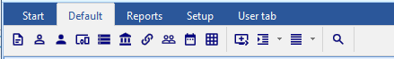
To do this, you need to set the style value to style=4 in the “colors.ini” file inside your theme folder:

Exit and Restart TurboCASH5.
- Microsoft Excel (Office) or other program which supports spreadsheets (e.g. LibreOffice, OpenOffice or UltraOffice) installed to save or export data and / or reports to spreadsheets.

- To print the “Budget vs actual” and “This year vs last year” reports, the “Customize Format – Numbers” of your Windows operating system number format needs to be set as follows:
- Decimal symbol - set to period ( . )
- Digit grouping symbol - set to comma ( , ) (If Digit grouping symbol is set to blank it does not print but produces an error.
Recent decreases in the cost of hardware have made even the simplest of modern devices, orders of magnitude better than older devices. It will run more securely on a better device. The costs saved by using an old device will soon be at risk given the time and effort that it will take to construct a Set of Books and re-enter the data.

INSTALLING TurboCASH5 SINGLE-USER
The TurboCASH5 installation process should only take a few minutes. During this process you may need to select a few options. The most important options, you may need to select is your country and language, reading and accepting the licence agreement.
TurboCASH5 should, by default, install in the TurboCASH5 directory (e.g. C : / TurboCASH5. If you choose to install TurboCASH5 in different directory or folder on your system, DO NOT install TurboCASH5 in any Program files directories.
If you wish to install TurboCASH5 on a device that has a Solid State Drive which is small, e.g. 32GB as the C: drive, you need to select the D: drive that is bigger in size.
This documentation will describe to do a standard installation to run TurboCASH5 locally on one computer for 1 user only.
- Multi-User installation and configuration will be dealt with in separate documentation.
- Multi-user is limited in this edition! You will need to buy a multi-user license.
After installing TurboCASH5, the following optional additional components, is included in the “installs” folder of the TurboCASH5 root installation directory:
- Firebird Version 2.1 - Advanced users may wish to download and install a later version of the discontinued downloads - Firebird version 2.5.9.
Later releases of Firebird Versions 3 and Versions 4 is currently not supported in TurboCASH5 databases (Sets of Books).
- FlameRobin Version 0.9.3 - Advanced users may wish to download and install a later version of FlameRobin (version 0.9.6) FlameRobin Database Admin software to manage and explore your TurboCASH5 databases (Sets of Books).

To install TurboCASH5 single-user:
- Once the TurboCASH5 installation file is downloaded, select the file and open it. The “Select country and language” screen is displayed:
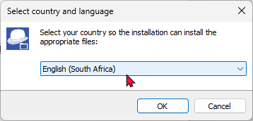
- Select your country and language. Click OK. The “Welcome to the TurboCASH5 Setup Wizard” screen is displayed:
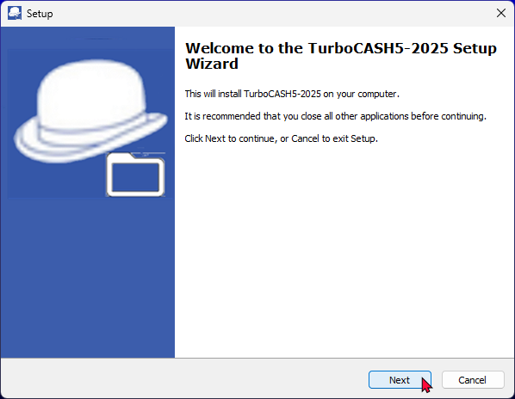
- Click Next. The “License Agreement” screen will be displayed.
- Please read the agreement carefully. If you agree with the terms and conditions of the license agreement, select the “I accept the agreement” option and click Next. The “Select Destination Location” screen is displayed:
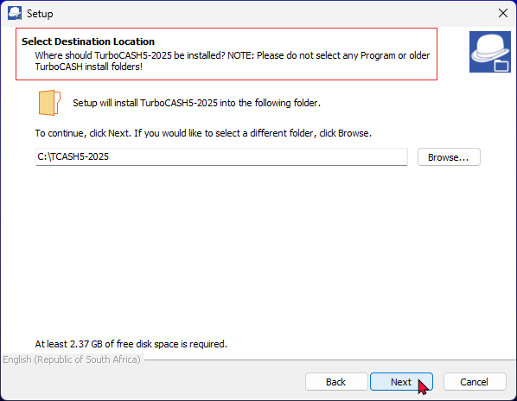
- The default path is TCASH5 on your system's default drive, (e.g. C:/TCASH5).
You may click on the Browse button to select any other folder than the default path where you wish to install TurboCASH5 on the “Browse For Folder” screen.
If you wish to install TurboCASH on a device that has a Solid State Drive which is small e.g. 32GB as the C: drive, you need to select the D: drive that is bigger in size.
You may over type this with your own description, if necessary. This will create an item on the Start → Programs menu list with items for TurboCASH5, Uninstall TurboCASH5 on your Windows™ Task bar.
- Once finished, click Next. The “Select Components” screen, is displayed:
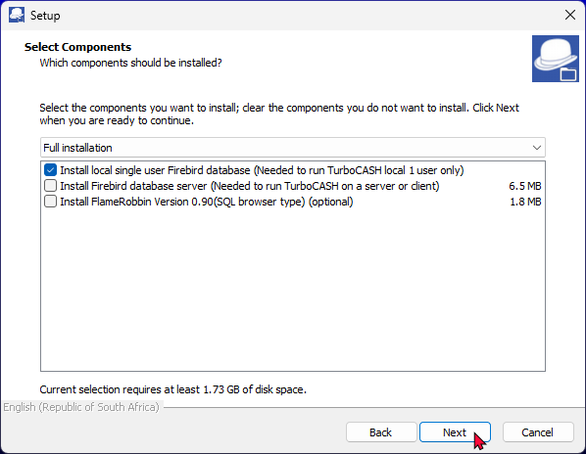
- A list of the components will be displayed. Select or deselect (remove the tick) for the following options, if necessary:
  - Install Firebird Database Server (Needed to run TurboCASH5 local 1 user only) - If you are installing TurboCASH5 for the first time, you need to make sure that this option is selected.
Select this option if you need to run TurboCASH5 locally for 1 user only.
  - Install Firebird Database Server (Needed to run TurboCASH5 on a server or client).
For the purpose of the single-user installation, do not select this option.
  - Install FlameRobin SQL Browser Type - (Optional) - This will install the FlameRobin Database Admin software to manage your TurboCASH5 databases (Sets of Books).
For the purpose of the single-user installation, do not select this option.
The FlameRobin software is used to browse, check and edit data. The installation of FlameRobin is optional and is not required to run TurboCASH5. The use of FlameRobin is not recommended for users which have insufficient knowledge and expertise.

- Once finished, selecting the components to be installed, click Next. The “Select Additional Tasks” screen is displayed:
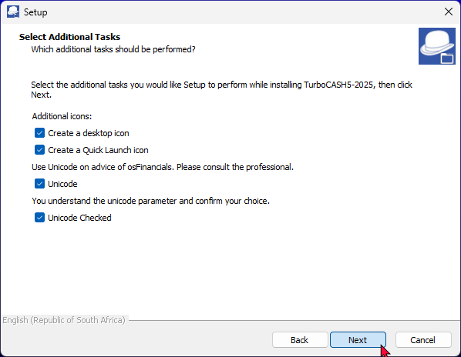
- By default no options are selected. Select the following options, if you wish them to be installed:
  - Create desktop icon - This will create an icon on your desktop from where you may start or launch the TurboCASH5 program.
  - Create Quick Launch icon - This will create an icon on your Quick Launch Toolbar on your Windows™ Task bar. You may then start or launch the TurboCASH5 program directly from the Quick Launch Toolbar.
  - Unicode settings - Select both the Unicode and Unicode Checked options. This will enable Unicode support.
We strongly advise consulting with a professional before enabling the Unicode setting. This ensures that you fully understand the implications and make an informed decision.
Unicode Checked - If this mandatory checkbox is not selected, a Runtime error message is displayed:
"Please check and confirm your unicode option."
To enable Unicode support (recommended for most users), both the “Unicode” and “Unicode Checked” tick boxes need to be selected. This option will set the nounicode=FALSE parameter in the tcash.ini file.
This is a very important setting, as this will determine the display of special characters in the TurboCASH5 interface, reports document layout files, etc. in most databases.

To disable Unicode support, the "Unicode" check box must not be selected. Only the "Unicode Checked" tick box needs to be selected. This option will set the nounicode=TRUE parameter in the tcash.ini file.
This setting is intended for users who require non-Unicode support.
This option will set the nounicode=TRUE parameter in the tcash.ini file.
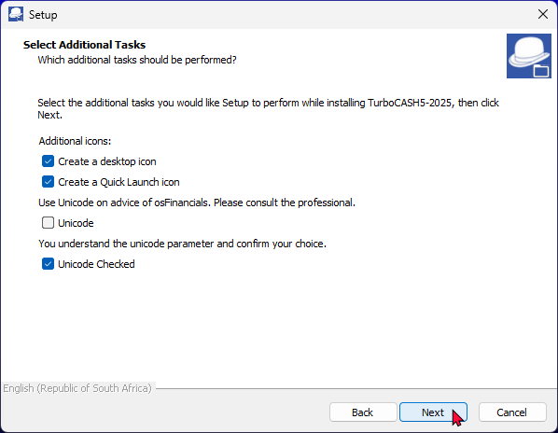
Using this setting, (Disable Unicode), the system relies on specific codepages to handle text. Some examples would be:
- French (Codepage 1252): Handles Western European characters, but may have limitations with special symbols unique to other languages.
- Spanish (Codepage 1252): Similar to French, it manages Spanish characters well but might struggle with characters from non-Western languages.
- Arabic (Codepage 1256): Supports Arabic characters effectively, but may not handle characters from Latin-based languages as efficiently.
In osFinancials5 and TurboCASH5, the codepage can be set in the Tools → Customise Language on the Setup ribbon.
If your Unicode settings, is incorrect, you may re-run the installation process.
Alternatively, you may locate the tcash.ini file in the TurboCASH5 installation directory and edit the nounicode=true and set it to nounicode=false, and vice versa. In this case you may need to close and restart TurboCASH5.

- Once finished, click Next. The “Ready to Install” screen is displayed:
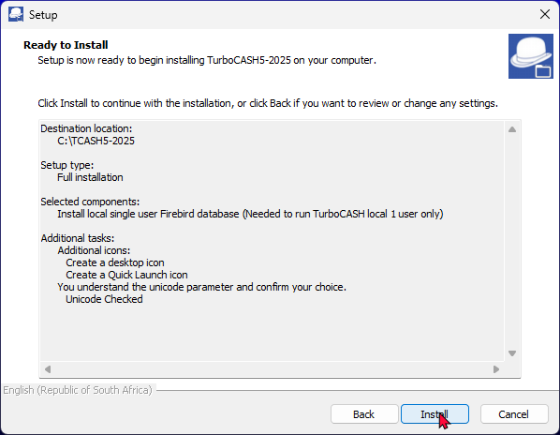
- Please check the following selections to be installed:
  - Destination location
  - Setup type
  - Selected components
  - Start Menu folder
  - Additional tasks (icons)
  - Unicode Settings
This is your last chance to change anything to be installed. If you are not satisfied with your selection, click on the Back buttons to select or deselect the necessary options.
Overwrite confirmation message:
A confirmation message will be displayed if you have installed TurboCASH5 over an existing (previous) TurboCASH installation. If you have worked (changed or added data) to the Set of Books (with the same Name as installed) and wish to retain the existing Set of Books, click No to retain your existing data. The Set of Books will not be replaced by the installation.
- If you click on the Yes button, the Set of Books will be replaced with the Set of Books in this installation.
- Click Install. The TurboCASH5 installation process will start. Once the TurboCASH5 installation process is finished, the “Completing the TurboCASH5-2025 Setup Wizard” screen is displayed:
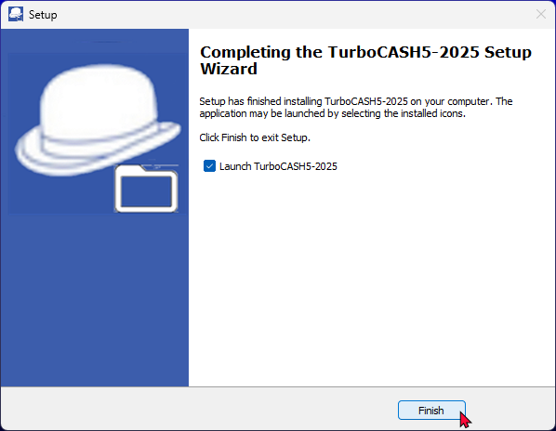
The following Components will not be listed, if it was not selected in the “Select Components” screen:
- Install Firebird
- Install FlameRobin SQL Browser Type
- If the Launch TurboCASH5 option is selected, the TurboCASH5 program will automatically be launched.
If you do not select this option (remove the tick), you may then launch or start TurboCASH5 from the following options (if selected or where specified): -
- Desktop icon.
- Quick Launch icon (on the Quick Launch Toolbar on your Windows™ Task bar).
- Start → Programs → TurboCASH5 menu from the Windows™ Start button.
- Once finished selecting or deselecting the necessary options, click Finish. The TurboCASH program will be started if you did not remove the tick on the Launch TurboCASH5 option.

Launching TurboCASH5
By default TurboCASH will be installed in the “Material-navy” theme, If the “Material” theme is displayed, you may select the “Material-navy” theme for the purposes of this documentation.
Opening a Set of Books
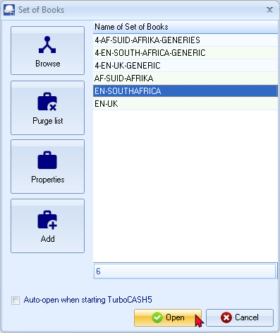
- The first screen which will display after TurboCASH5 is launched for the first time, is the “Set of Books” (to open a Set of Books) screen. By default, only the Set of Books will be installed for the country language selected in the “Select your country and language” when installing TurboCASH5.
The TurboCASH5 interface will display in the language linked to the selected Set of Books.
When opening a Set of Books, it will automatically load the language file. All screens, reports and layout files are translatable via the language files.
It will display the tax terminology for the selected country e.g. en-South-Africa will display VAT, af-Afrikaans will display BTW, en-Australia and en-New-Zealand will display GST, en-American will display Sales tax, etc.
Should a Set of Books be listed in a RED font colour, for example HELP-DEMO Set of Books, if TurboCASH5 is installed in a different “Destination Location”; other than the default option -
(e.g. C:\ TurboCASH5 ).
This Set of Books listed in a RED font colour may be removed.
To do this, right-click on the Cancel button, and select the “Delete not local (books this PC can not find)” option.
- Select your Set of Books and click OK.
Some languages may not display correctly if your system locale in the Regional and Language Settings option in the Control Panel of your system does not support the language and system locale (unicode).
English is the default (driver language file - used as the basis for translation, and to customise language files). For example, the en-American and the en-UK files contain specific label, text, currency and tax terminology for each country.
Should you select the incorrect language at this stage, you may change the language in the Switch language (Start ribbon).

Sets of Books included in your TurboCASH5 installation
Depending on your choice, only the Set of Books will be installed for the country language selected in the “Select your country and language” when installing TurboCASH5.
The TurboCASH5 interface will display in the language linked to the selected Set of Books.
When opening a Set of Books, it will automatically load the associated language file. All screens, reports and layout files are translatable via the language files.
It will display the tax terminology for the selected country e.g. en-South-Africa will display VAT, af-Afrikaans will display BTW, en-Australia and en-New-Zealand will display GST, english-usa (American) will display Sales tax, etc.
Books folder contains only the Set of Books will be installed for the country language selected in the “Select your country and language” when installing TurboCASH5.
Additional Sets of Books (4-digit main accounts and 3 digit sub-accounts)
In addition to this, we have included some sample Sets of Books based on the 4-digit main accounts (based on the 4-digit main accounts and 3 digit sub-accounts) Sets of Books, which supports longer description and data fields.
The following databases were created using the EMPTY-BOOKS-4X3-DIGITS Firebird Database type which supports longer descriptions:
- 4-EN-SOUTH-AFRICA-GENERIC: This generic Set of Books includes 4-digit main account and 3-digit sub-account codes, based on the South African Chart of Accounts. It incorporates specific South African terminology and includes the structure of South African VAT-accounts and VAT-codes, aligned with the VAT201-return.
- 4-AF-SUID-AFRIKA-GENERIES: This generic Set of Books includes 4-digit main account and 3-digit sub-account codes, based on the South African Chart of Accounts in Afrikaans. It incorporates specific South African terminology and includes the structure of South African VAT-accounts and VAT-codes, aligned with the Belasting op Toegevoegde Waarde (BTW) Suid-Afrika (Afrikaans) VAT201-return.
- 4-EN-UK-GENERIC: This generic Set of Books includes 4-digit main account and 3-digit sub-accounts, based on the United Kingdom (UK) Chart of Accounts. It incorporates specific UK terminology and includes Value Added Tax (VAT) - United Kingdom accounts based on the VAT Standard rate scheme. The VAT-account and VAT-codes structure in the Chart of Accounts is designed to match the various boxes on the UK VAT return. NOTE: Various schemes for VAT may be applicable for various scenarios.

Available Sets of Books in the bin folder
In addition to these Sets of Books installed in the “books” directory, included in your TurboCASH5 installation, you may click on the Browse button. In the “bin” folder, the following Sets of Books may be selected:
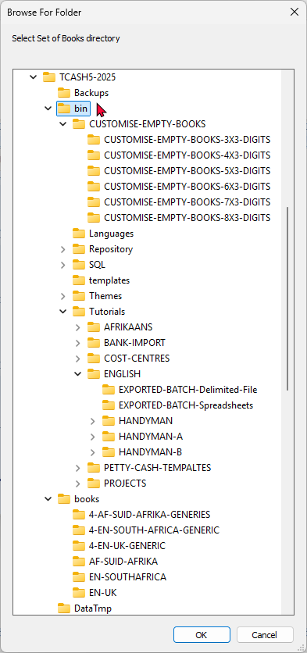
CUSTOMISE-EMPTY-BOOKS - The basic Empty Templates from 3-digit to 8- digit main accounts. It only consists of 3 required control accounts (debtors control, creditors control and Retained earnings) which you may select to build your own Set of Books from scratch. These Sets of Books allow for larger descriptions, etc, to accommodate Accounting standards (GAAP, IFRS full, IFRS for SME’s).
Repository - All the available Sets of Books, of which some Sets of Books, depending on your choice, for the country language selected in the “Select your country and language” when installing TurboCASH5, only the Set of Books will be installed. If your Set of Books is not installed (for the incorrect choice, you may select to open a different Set of Books.
Tutorials – The “Tutorials” folder, includes ENGLISH, BANK IMPORT, AFRIKAANS, COST-CENTRES, PROJECTS, etc, with accompanying Exported files which may be imported.

STARTING TurboCASH5
To start TurboCASH5:
- To start TurboCASH5 double-click on the  icon (if the “Create a desktop icon” option was selected on the “Additional tasks” screen in the “Setup” install screen).
Or select TurboCASH5 on the Windows Start button TurboCASH5,
The following progress screen will be displayed:
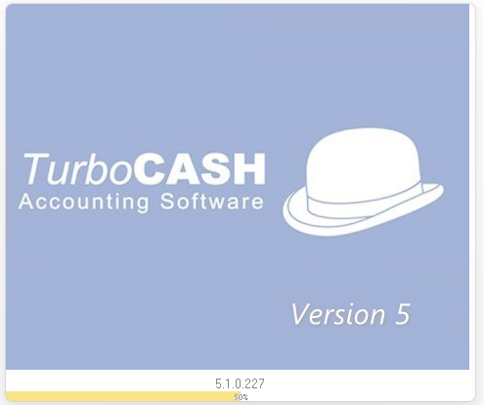
The TurboCASH5 program will be launched.
Unregistered version of TurboCASH5:
Each time an unregistered version of TurboCASH5 is launched, the following confirmation message is displayed:
“This software is limited to 500 transactions or 500 documents! Please register and buy a licence for TurboCASH5.
This copy of TurboCASH5 is not registered! Do you wish to register it now?”

Pin TurboCASH5to the Quick access area (Windows 11):
After installing TurboCASH5, the TurboCASH5 should be displayed in the Recently added list; or under O on the Start menu.
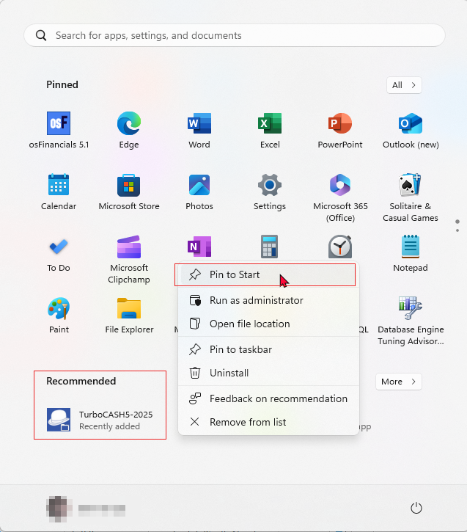
The TurboCASH5 icon should be displayed as Recommended or Recently added. On the TurboCASH5 icon, right-click and select Pin to Start.

- Once you have launched TurboCASH5, for the fist time (after installation), the first screen that will be launched is the select the “Choose a language” screen.

SELECTING A LANGUAGE
Once you have launched TurboCASH5, for the fist time (after installation), and the correct language is not displayed, you may change the language to your preferred language. To do this, go to the Switch language option on the Start ribbon.
On the “Choose a language” screen, select the language of your choice and click OK.
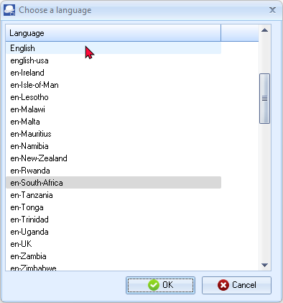
The TurboCASH5 interface will display in the language linked to the Set of Books of the country. Depending on the Set of Books, you open in TurboCASH5, the specific language linked to each Set of Books will, by default, be displayed in the TurboCASH5 interface.
Default languages have already been set for each Set of Books. (Setup → Access control on the Setup ribbon).
When opening a Set of Books, it will automatically load the language file. All screens, reports and layout files are translatable via the language files.
 | Some languages may not display correctly if your system locale in the Regional and Language Settings option in the Control Panel of your system may not support the language and system locale (unicode).
English is the default (driver language file – used as the basis for translation, and to Customise language files). For example, the American and the English files contain specific label, text, currency and tax terminology for each country.
Should you select the incorrect language at this stage, you may change the language in Switch language on the Start ribbon).

OPENING SETS OF BOOKS
After a new TurboCASH5 installation, the following Sets of Books will be available to open:
 |  | Set of Books name | Country | Language | Number of account digits
 |  | 4-AF-SUID-AFRIKA-GENERIES | South Africa | Afrikaans | 4-digit main account and 3-digit sub-accounts.
 |  | 4-EN-SOUTH-AFRICA-GENERIC | South Africa | English (South Africa) | 4-digit main account and 3-digit sub-accounts.
 |  | 4-EN-UK-GENERIC | United Kingdom | English (United Kingdom) | 4-digit main account and 3-digit sub-accounts.
 |  | EN-UK | United Kingdom | English (United Kingdom) | 3-digit main account and 3-digit sub-accounts.  Installed, by default in Most of the “Select you country and language” options when installing TurboCASH,
 | To display the interface of TurboCASH5 in the default "English" language, select these Sets of Books and click on the Open button. The Sets of Books will be displayed in TurboCASH interface and reports in the language, associated with the opened Set of Books.

At first only the items under the Start ribbon are active. Before you can select any of the menu options, you will need to “Open a Set of Books” (On the Start ribbon, select Open).

TUTORIALS
To follow these tutorials, you need to click on the Browse icon (on Open Set of Books screen) and select these Sets of Books.
When opening these English tutorials, the default English language file, will be initialised to display on the TurboCASH5 interface, reports and document layout files. The English language file refers to Tax instead of VAT/GST/Sales tax.
Should you wish to use the Tax terminology for your country, you may select the country specific English language file.
Accounting Made Easy - English tutorials
English tutorials (using the default payments and receipt batches for banking / cash transactions):
The following Set of Books based on this tutorial, are installed in the
“…\bin\Tutorials\ENGLISH\” folder:
- HANDYMAN – No transactions in batches and documents.
- HANDYMAN-A – Unposted transactions in batches and documents.
- HANDYMAN-B – All transactions in batches and documents have been posted (updated) to the ledger.
The following folders contains files which may be imported into batches:
- EXPORTED-BATCH-Delimited-File – Exported batch transactions using the “Write delimited file” option and may be imported into a batch using the “Delimited file import” option icon on batches.
- EXPORTED-BATCH-Spreadsheets – Exported batch transactions in the *.xlsx (Excel 2007-365) file format. These transaction files may be opened in the Spreadsheet import icon on batches, and imported into a selected batch.

Accounting Made Easy – BankImport Plugin - English tutorials
English tutorials (using the BankImport plugin for banking / cash transactions):
The following Set of Books based on this tutorial, are installed in the
“…\bin\Tutorials\BANK-IMPORT\” folder:
- HANDY-BANK – No transactions in batches and documents.
- HANDY-BANK-A – Unposted transactions in batches and documents, except the Payments and Receipt batches, which is cleared for the Bank account and the Petty cash.
- HANDY-BANK-B – All transactions in batches and documents, including the imported bank statement and processed Petty cash transactions have been posted (updated) to the ledger.
- HANDY-BANK-UNPOSTED-BANK-STATEMENT – All transactions, except the cash book transactions, have been posted (updated) to the ledger.
The sample Bank statement in the “…\bin\Tutorials\BANK-IMPORT\BANK-STATEMENTS” folder needs to be imported and Petty cash transactions needs to be processed).

Rekeningkunde Met Gemak – Afrikaanse handleiding
The following Set of Books based on the Afrikaans tutorial, Rekeningkunde met Gemak are installed in the “…\bin\Tutorials\AFRIKAANS\” folder.
- NUTSMAN – No transactions in batches and documents.
- NUTSMAN-A – Unposted transactions in batches and documents.
- NUTSMAN-B – All transactions in batches and documents have been posted (updated) to the ledger.
To follow the Afrikaans tutorial, you need to click on the Browse icon and select these Sets of Books.

Cost centres
You may follow Cost centres in the English Help topic. The following Set of Books to configure and process transactions in batches and documents for cost centres and the reporting, are installed in the “…\bin\Tutorials\COST-CENTRES\” folder:
- COST-CENTRES-A - All transactions in batches and documents is not yet posted (updated) to the ledger.
- COST-CENTRES-B - All transactions in batches and documents have been posted (updated) to the ledger.
Projects
You may follow Projects in the English Help topic. The following Set of Books to configure and process transactions in batches and documents for projects and the reporting, are installed in the “…\bin\Tutorials\PROJECTS\” folder:
- PROJECTS-A - All transactions in batches and documents is not yet posted (updated) to the ledger.
- PROJECTS-B - All transactions in batches and documents have been posted (updated) to the ledger.

SELECTING A LANGUAGE
The TurboCASH5 interface will display in the selected language (Switch language (Start ribbon). Depending on your country / language installation of TurboCASH5, the specific language / country language have already been set for each Set of Books. (Access control (Setup ribbon).
When opening a Set of Books for a specific country, it will automatically load the language file (containing specific currency and tax terminology). All screens, reports and layout files are translatable via the language files.
It will display the tax terminology for the selected country e.g. en-South-Africa will display VAT, af-Afrikaans will display BTW, en-Australia and en-New-Zealand will display GST, en-American will display Sales tax, etc.
List of the English language files which refers to country specific currency and Tax terminology:
English VAT |  | English GST |  | English Sales tax / Consumption Tax
 | en-Bangladesh |  | en-Australia |  | en-American (Sales tax)
 | en-Barbados |  | en-Belize |  | en-Tonga (Consumption tax)
 | en-Botswana |  | en-New-Zealand
 | en-Cameroon
 | en-Ireland
 | en-Isle-of-Man
 | en-Lesotho
 | en-Malawi
 | en-Malta
 | en-Mauritius
 | en-Namibia
 | en-Rwanda
 | en-South-Africa
 | en-Tanzania
 | en-Trinidad
 | en-Uganda
 | en-UK
 | en-Zambia
 | en-Zimbabwe
Changing language files
Should the incorrect language file and / or Tax terminology be displayed, you may set the language files in the following options:
To choose a language (global settin):
- On the Start ribbon, select Switch language.
- Select the language of your choice.
- Click OK.
Changing language files for debtors / creditors
Multiple language – Document layout files – Supports the automatic translation via the language files (Switch language (Start ribbon)) maintained in Tools→ Customise language menu (Setup ribbon).
Document layout files will be printed in the language set for debtor (customer / client) and creditor (supplier) accounts. Layout file 2 is also supported to print a copy of another layout file or a delivery note.
For example, in South Africa, the language that may be selected for English speaking debtors (customers / clients) and creditors (suppliers) is “en-South-Africa”, and for Afrikaans speaking debtors (customers / clients) and creditors (suppliers) is “Afrikaans”.
To set a language for a Debtor or Creditor:
- On the Default ribbon, select Debtors or Creditors.
- In the “Language” field, select the language for the debtor (customer / client) or creditor (supplier).
- Click Save. When printing documents for the debtor (customer / client) (invoices, credit notes and quotes), or documents for the creditor (supplier) (purchases, supplier returns and orders) it will print in the selected language.

Customising language files (optional)
You may edit or translate the existing labels or descriptions used in the TurboCASH5 to suit your specific needs or industry. You may also create or add a new language for a specific country or industry. You may also create or add a new language for a specific country or industry.
The following languages (87 countries / tax regimes), are available: Afrikaans, Arabic, English (25), Croatian (3), Español (13), Français (18), German, Greek (2), Indonesian, Italian, Lithuanian, Netherlands, Slovenian, Swedish, Swahili, Thai, Turkish (3), and Xhôsa, etc.
Language files are prefixed with the Language code followed by the Country name (e.g. en-Australia, en-UK, en-South Africa, etc.).
The names of the Sets of Books (stored in the “…\bin\Repository\” folder) are also (prefixed with the Language code followed by the Country name). Most of these Sets of Books are linked to the applicable language file (Setup → Access control (Setup ribbon)).
The language files are stored in the *.dfm file type. The language files are located in the “...\bin\Languages” directory, or other directory, where TurboCASH5 is installed. The default language for the country you have selected when installing TurboCASH5 will automatically be displayed when launching TurboCASH5 for the first time.
If a Set of Books is opened, it will load the language file (Setup → Access control (Setup ribbon)).
If this is not the correct language, you may select any of the available languages. To do this, access Switch language (Start ribbon).
Care must be taken to ensure that existing labels in the master language are not amended. You need to create a new name for the file you wish to edit.
You may at any time switch over to the master (English, Afrikaans or any other available language) in the Switch language (Start ribbon), and back again to your new customised language file.
If you have created or edited a language file, it is recommended that you need to save a copy of the language file somewhere else on your system, in the event of uninstalling and reinstalling TurboCASH5.

To create, edit or translate language labels or descriptions:
- On the Setup ribbon, select Tools → Customise language.
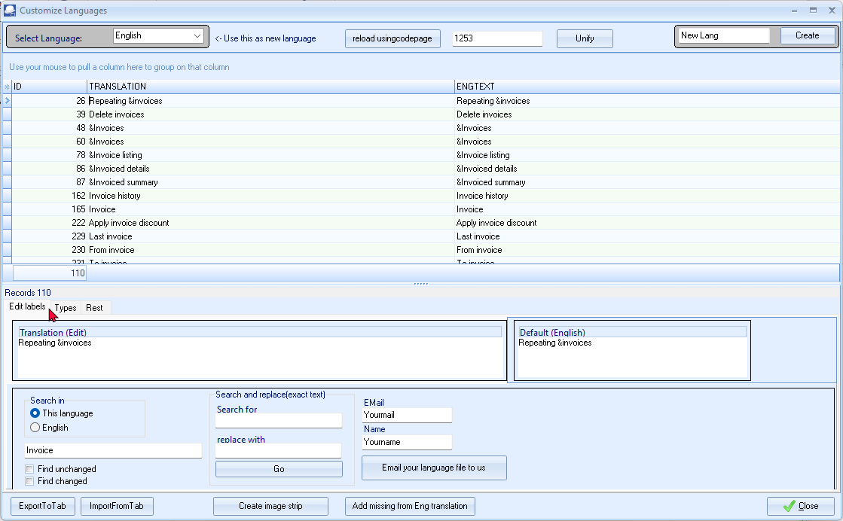
- Check in the “Select Language” field that the correct details is selected.
- In the “New Lang” field, Enter the name for your new language.
- Click Create.
- Edit or change the labels as necessary.
- Once finished creating or editing your language file, click E-mail your language file to us to send the language file to the TurboCASH5 developers. This will automatically launch your system’s default e-mail program and attach your language file in the e-mail message. The developers will then add your language file in the next TurboCASH5 release.
- Once finished, click Close.
It is strongly recommended that the label, which is edited or entered, is not longer than the “Default English” labels’ length. If your label is too long, it may cause some options in the program not to function or display properly. Do not use the Delete button to remove any of the existing edited labels.

Unify button – Do not click on the Unify button.
TurboCASH5 and TurboCASH5.2 share the same source.
The <@APPNAME@> is included in the language files. Language files can be used in both TurboCASH5 as well as TurboCASH5.
This will change the language labels from <@APPNAME@> to TurboCASH5 on the screens and will cause hyper-links <@APPURL@> to refer to incorrect websites.

REGISTERING TurboCASH5
Thank you for purchasing TurboCASH5 If you have purchased TurboCASH5, it is already pre-registered, until 31 March 2025. Included in the registered version of TurboCASH5 - Business Class:
TurboCASH5 Subscription - Process unlimited (more than 500) transactions and documents.

Bank import - Using this Bank Import Plug-in, you may import a valid bank statement file (downloaded from your online banking) saved on your system into a Bank Account (Cash book).
This BankImport Plugin will save you time, since you do not need to physically enter the transactions manually in the Payments Journal and Receipts Journal.
This plug-in uses Bank references to automatically allocate or link payments and deposits, receipts, other debits. credits, etc. to the correct accounts.
Documentation : Help file - Bank import plugin
Documentation : osFinancials website - Bank Import Plugin -
Documentation : osFinancials website - Bank Reconciliations Plugin -

Multi-workstation - Do you want to use osFinancials5 or TurboCASH5 with multiple users at the same time? That is possible with the Multi-workstation plugin. The number of users is unlimited, as long as the hardware sustains. To use the Multi-workstation a network with a shared folder is required.
Documentation : TurboCASH website - Multi User Installation -
Documentation : osFinancials website - osFinancials / TurboCASH multi user setup - Windows server.
Documentation : osFinancials website - Multi Werkplek (linux server) Plugin - Linux server (Dutch only).


Document E-mail Pro - With this plugin you can email your documents (invoices or quote). Each email you sent can get a different layout. For example: an invoice gets a different layout from a quote. You can create the email layout yourself. For that reason you decide what kind of email you will send.
It is also possible to send multiple examples of you documents at once. Therefore the document layout and email layout of the documents you want to send have to be the same.
It's even possible to send multiple document at the same time. Therefore the documents must be the same type (i.e. quote or invoice).
Documentation : Help file - Document email pro plugin -
Documentation : osFinancials website - Document email pro plugin -

Multimedia Pack - The multimedia plug-in is a versatile product. You can link files in different forms of TurboCASH5 or osFinancials5.
Examples are debtor, creditor, stock items and document groups. You can link an image to stock items or debtors but also link signed and scanned documents to debtors.
If you also have the email pro email send will also be linked to the document that was send and the debtor. This makes finding that email to the client with great ease. The outlook link plugin can scan through your outlook in and out box to see if there is email that uses the clients email address. If so it copies the email to the multimedia of that debtor / creditor.
Documentation : Help file - Multimedia plugin -
Documentation : osFinancials website - Multimedia plugin -

WORKING IN TurboCASH5

IN THIS MODULE
MODULE C - WORKING IN TurboCASH5 73
C.1- TurboCASH5 FEATURES 75
C.1.1- Get started easily 75
C.1.2- Multiple language support 75
C.1.3- Calendar / Planner 75
C.1.4- Debtors / Creditors 75
C.1.5- Full stock control 76
C.1.6- Batch processing 76
C.1.7- Document processing 76
C.1.8- Powerful comprehensive reporting 77
C.1.9- Export / Import 78
C.1.10- Export to spreadsheets 78
C.1.11- Additional features 78
C.2- NEW FEATURES IN TurboCASH5 Business Class 79
C.3- THE TurboCASH5 PROGRAM 82
C.3.1- RIBBONS AND MENUS 84
C.3.1.1- Start ribbon 84
C.3.1.2- Default ribbon 86
C.3.1.3- Reports ribbon 88
C.3.1.3.1- Reports menu 89
C.3.1.3.2- User reports menu 93
C.3.1.3.3- Spreadsheet reports menu 96
C.3.1.4- Setup ribbon 97
C.3.1.5- User tab ribbon 101
C.4- WORKING WITH TurboCASH5 RIBBONS AND SCREENS 102
C.4.1- Show / Hide ribbon options 102
C.4.2- Menu lists 102
C.4.3- Dock / Undock sections of screens 102
C.4.4- Dragging / Resizing sections of screens 102
C.5- FILTERS AND SEARCH FEATURES 103
C.5.1- Filter options in column headings 103
C.5.2- Custom filters 104
C.5.2.1- Make a custom filter 105
C.5.2.2- Conditions 105
C.5.2.3- Save custom filter files 106
C.5.2.4- Open custom filter files 107
C.6- LOOKUPS 107
C.6.1- Accounts lookup 107
C.6.2- Stock item lookup 108
C.6.3- Batches lookup 111
C.7- WORKING WITH OTHER WINDOWS / SCREENS 112
C.7.1- Minimise, restore and closing of programs or screens 112
C.7.2- Resizing of screens on your desktop 112
C.7.3- Accessing menu options using short-cut keys 113
C.8- NAVIGATION IN TurboCASH5 113
C.8.1- Yes / No, OK / Cancel, Back / Next and Finish buttons 113
C.8.2- Moving between fields on screens when entering data 113
C.8.3- Arrow keys 113
C.8.4- Drop-down lists 113
C.8.5- Tick boxes 114
C.9- GETTING HELP IN TurboCASH 114

TurboCASH5 FEATURES
The TurboCASH5 program is an exceptionally powerful accounting program yet easy to use. TurboCASH5 helps you to get started quickly and automates many time consuming processes.
Get started easily
- Easy step-by-step installation.
- Use our templates or create your own Set of Books. You may create a Set of Books and design your Chart of accounts to accommodate up to 8-digits main accounts and 3-digit sub-accounts.
- Comprehensive manuals, tutorials and Help system.
Multiple language support
Multiple language / Country specific – Can be installed in 87 Language / Country configurations. Some languages / countries are; Afrikaans, Arabic, English (25), Croatian (3), Español (13), Français (18), Hrvatski (3) German, Greek (2), Indonesian, Italian, Lithuanian, Netherlands, Portuguese (9) Slovenian, Swedish, Swahili, Thai, Turkish (3), and Xhôsa, etc.
 | Multiple Language Set of Books  This makes it possible for a multi-lingual country or an international company to work in different languages on the same set of books.
Calendar / Planner
- Create and manage general events (appointments) and events (appointments) for debtor (customer / client) and creditor (supplier) accounts.
- Schedule Repeating invoices.
- Create and manage appointments for hours (labour, consulting, etc.). This will generate Quotes which can be confirmed and converted when the appointment is completed.
- Print a list of events (appointments) for any period or date(s).
Debtors / Creditors
- Quick access to websites - Double-click on the “Website” field of debtor (customer / client) and creditor (supplier) accounts to directly visit the websites of debtor (customer / client) and creditor (supplier) accounts in your system's default web-browser.
- Quick access to e-mail - Double-click on the “E-mail” field of debtor (customer / client) and creditor (supplier) accounts to directly insert the e-mail address of debtor (customer / client) and creditor (supplier) accounts in your default e-mail program.
- Up to two (2) Reporting groups for debtor (customer / client) and creditor (supplier) accounts.
- Manage debtor (customer / client) accounts in nine (9) tabs (i.e. Delivery address, Accounting information, Contacts, Appointment, Documents, Transactions, Bank account, Backorders and Stock items tabs.
- Manage creditor (supplier) accounts in eight (8) tabs (i.e. Delivery address, Accounting information, Contacts, Appointment, Documents, Transactions, Bank account and Stock items tabs.
Full stock control
- Up to eleven (11) stock item types can be used to create (add), copy, stock items.
- Up to two (2) reporting groups for stock items.
- Financial entry stock type can be used to process invoices, from the ledger accounts.
Batch processing
- Repeating transactions.
- Cancel / Reverse posted batches.
- Abbreviation Definitions
- Generate multiple transactions (Charge amounts, Interest, Fixed amount, Debtors with balances less than a specified amount).
- Create receipts (Receipt batches).
- Receive payment - Open item. This will automatically generate transactions in the receipt batch and post it to the ledger.
- Creditors balance at date (Payments batches) – This will import the creditor (supplier) accounts balances into the payments batch).
Document processing
- Up to two (2) reporting groups for documents. These can be changed on the context menu.
- Salespersons – The salesperson can be changed on the context menu. Salespersons is added to purchase document layout files (i.e. Purchases, Supplier returns and Orders). This will indicate who processes orders, purchases and supplier return documents.
- Repeating invoices – Processed in the Edit menu or the Calendar (Default ribbon).
- Quotes can be generated from the Calendar / Planner and be converted to Invoices.
- Create documents from the context menu, for example, Convert invoices to quotes, Convert orders to purchases, Copy documents, Change account, etc.
- Documents supports abbreviations to auto-complete the “Description” fields in document lines.
- Change the sort sequence of transactions and / or comments on posted as well as unposted documents.
- Cancel / Reverse posted documents.
- Export / Import Documents.
- Clear / Reset a Set of Books and retain the documents as unposted.
Powerful comprehensive reporting
- Up to two (2) reporting groups for Accounts, Debtors, Creditors, Stock, Documents, Cost centres.
- Multi-year reporting periods / dates – All transaction reports can be printed for a period (Month, 2 Months, Quarter (3 Months), 4 Months, Half Year (6 Months) or Year) or specific date(s).
- Report footers – The Data source (i.e. full system path, name of the Set of Books), User (i.e. System user and TurboCASH5 user) as well as the date time stamp and page numbers are printed on the report footers.
- Ledger analyser
- Budget listing and Actual figures in the Trial balance, Income statement, Balance (Balance sheet) and Standard column balances reports.
- Budget vs Actual report.
- Column balances in the General ledger, Debtor's ledger and Creditor's ledger.
- T-Account viewer – Filter, Print and Export the transactions.
- Sales and Purchase analysis.
- Report designer - In addition to the reports, you may design your own customised user reports with the powerful Report designer. The Report designer allows you to write your own external reports and documents using the data in a Set of Books in TurboCASH5.
- Batch type reports – These may be printed from various options:
- Posted batches tab of “Batch entry” screen.
- Documents and Transactions tabs of debtor (customer / client) and creditor (supplier) accounts. Only the transactions applicable to the selected account will be listed.
Export / Import
The following supports export and import of Accounts, Debtors, Creditors, Stock, Documents and Posted batches.
Export to spreadsheets
The following can be exported to spreadsheets:
- Debtor (customer / client) accounts
- Creditor (supplier) accounts
- Documents
- Stock items
- Ledger analyser reports
- Budget listing and Actual figures in the Trial balance, Income / Expenses (Income statement), Balance (Balance sheet) and Standard column balances reports.
- Budget vs Actual report.
- Column balances in the General ledger, Debtor's ledger and Creditor's ledger.
- T-Account viewer – Transaction Reports - Filter, Print and Export the transactions.
The T-Account viewer may be launched from the T-Account viewer (Reports ribbon) or right-click (Show details).
These transactions may also be viewed, printed and exported for specific accounts from the following options:
- Ledger analyser – Selected account or reporting group.
- Search (F3) – Selected account or batch in the search results (double-click or right-click).
- Documents and Transactions tabs of debtor (customer / client) and creditor (supplier) accounts. Only the transactions applicable to the selected account will be listed.
Additional features
Supports the following features, if activated:
- Cost centres - Cost centre 1 and Cost centre 2 supports budgets.
- Projects – Support budgets.

NEW FEATURES IN TurboCASH5 Business Class
After years of development and support of osFinancials and TurboCASH we came to the conclusion the current model does not work. To break through this glass ceiling we are introducing "TurboCASH5 Business".

osFinancials4 / TurboCASH4 is free to use but if you want more out of your software then "osFinancials5 Business / TurboCASH 5 Business Class" is the version you want to use.

If you have less then 500 transactions / documents you can use this version free of charge. Above that we ask you for a contribution of 50 euro (excl.)/ 60 dollars per year.

If you have any subscription already like multi-user or retail POS, etc., the licence will also be included.
Included in the registered version of TurboCASH5 - Business Class:
TurboCASH5 Subscription - Process unlimited (more than 500) transactions and documents.
Bank import - Using this Bank Import Plug-in, you may import a valid bank statement file (downloaded from your online banking) saved on your system into a Bank account (Cash book).
This BankImport Plugin will save you time, since you do not need to physically enter the transactions manually in the Payments Journal and Receipts Journal.
This plug-in uses Bank references to automatically allocate or link payments and deposits, receipts, other debits. credits, etc. to the correct accounts.
Documentation : Help file - Bank import plugin
Documentation : osFinancials website - Bank Import Plugin -
Documentation : osFinancials website - Bank Reconciliations Plugin -
Multi-workstation - Do you want to use TurboCASH5 with multiple users at the same time? That is possible with the Multi-workstation plugin. The number of users is unlimited, as long as the hardware sustains. To use the Multi-workstation a network with a shared folder is required.
Documentation : TurboCASH website - Multi User Installation -
Documentation : osFinancials website - osFinancials / TurboCASH multi user setup - Windows server.
Documentation : osFinancials website - Multi Werkplek (linux server) Plugin - Linux server (Dutch only).
Document E-mail Pro - With this plugin you can email your documents (invoices or quote). Each email you sent can get a different layout. For example: an invoice gets a different layout from a quote. You can create the email layout yourself. For that reason you decide what kind of email you will send.
It is also possible to send multiple examples of you documents at once. Therefore the document layout and email layout of the documents you want to send have to be the same.
It's even possible to send multiple document at the same time. Therefore the documents must be the same type (i.e. quote or invoice).
Documentation : Help file - Document email pro plugin -
Documentation : osFinancials website - Document email pro plugin -
Multimedia Pack - The multimedia plug-in is a versatile product. You can link files in different forms of TurboCASH5 or osFinancials.
Examples are debtor, creditor, stock items and document groups. You can link an image to stock items or debtors but also link signed and scanned documents to debtors.
If you also have the email pro email send will also be linked to the document that was send and the debtor. This makes finding that email to the client with great ease. The outlook link plugin can scan through your outlook in and out box to see if there is email that uses the clients email address. If so it copies the email to the multimedia of that debtor / creditor.
Documentation : Help file - Multimedia plugin -
Documentation : osFinancials website - Multimedia plugin -

 | Budgets may be added, edited and / or imported (Budgets icon on the Reports ribbon).
 | Bulk time entries - See video on Bulk time entries  Bulk time entries may be added for selected debtors (customers / clients) accounts. For example, if a debtor (customer / client) books a training course or workshop for a week, you may schedule the appointments for every day of the week.  These bulk time entries will add the multiple appointments for a selected debtor (customer / client) account to the calendar as hours type events for selected dates and time slots.  Quotes can be created for these events. These quotes can be edited, if necessary and sent to the debtor (customer / client).  Once these appointments are completed, you may convert the quotes to invoices.
 | Spreadsheet reports and the power of Spreadsheets  - Spreadsheet sales (Default ribbon)  - Spreadsheet reports (Reports ribbon) - See video on Spreadsheet reports.
Spreadsheet Export / Import - See video on Improved Export/Import -
The Spreadsheet Export / Import spreadsheet feature allows to easily export data into spreadsheets, edit the data and import it.
Spreadsheet Export / Import is available in the following options:
Setup ribbon:
- Setup → Accounts
- Setup → Groups
- Import Accounts, Import Debtors/Creditors, Import Stock
Default ribbon:
- Batch entry (all batches)
- Edit → Repeating transactions
- Stock (Import / Export tab)
- Documents - Context menu – Documents → Spreadsheet import
 | Ledger analyser 1 and Ledger analyser 2  - Zoom in / Zoom out + / - buttons added to resize (increase / decrease the font) the reports (i.e. Trial balance, Balance sheet and Income statement) on screen.  - Pivot – View, filter and analyse your report on screen, view graphs, customise datasets and types of graphs.  - SBR view - Add SBR references for accounts and reporting groups in Setup → Accounts. Once the references are set, and generate reports on screen, click on the SBR view button, check, filter and copy to clipboard. Open your spreadsheet program, and copy the contents into your spreadsheet, save the data, etc.
Documents - Graph
Click on the Graph button to view the documents in a graph. Use the filter options on the Documents list screen, to view graphs for specific filtered results in documents.
 | See video on Themes. The values for the themes are set in the colors.ini file in the themes folder.  Material theme added and updated. This tutorial is based on the Material theme.
 | Age analysis - See video on new age analysis reporting and open item.  View and choose options for the new Age analysis report on screen and print it on the Reports ribbon and on the Open Item - Due tab (Default ribbon).
THE TurboCASH5 PROGRAM
The TurboCASH5 program is easy to use with a user-friendly graphical interface. When launching TurboCASH5 for the first time, the TurboCASH5 program will be displayed in the language selected when TurboCASH5 is launched for the first time.
For the purpose of this documentation, the images (screen shots) are displayed in the default English language.
Most of the program options can be easily accessed by one or more mouse-clicks or by pressing a few buttons on the keyboard.
TurboCASH5 offers many features and options. To enhance your effectiveness and efficiency to perform your tasks in the program, it is important that you can access the required options as quickly and effortlessly as possible.
Cllose / Exit TurboCASH5
Restore
Titlebar – Company name of the opened Set of Books / TurboCASH5 and version number
Minimise
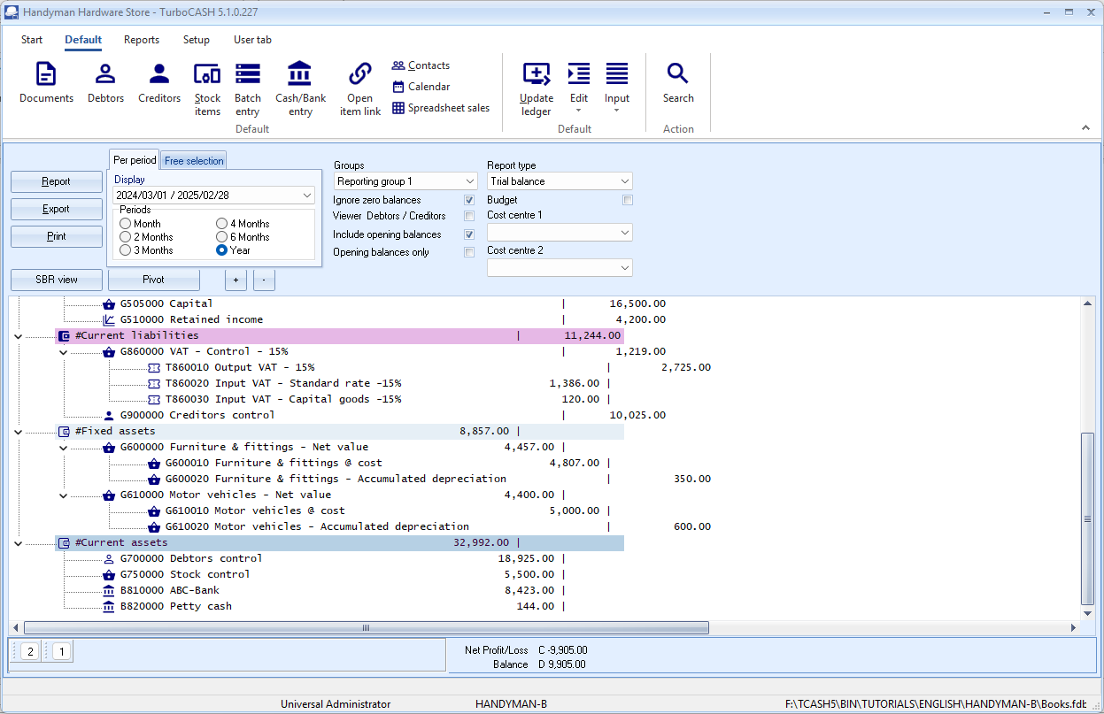
Username
Statusbar
Collapse / Expand (Pin) ribbon options
Ribbon tabs
Ribbon options
The file name of the opened Set of Books
Short-cuts to the last T-Account viewer and Pivot actions
The full path and name where the opened
Set of Books are stored.
The design of the TurboCASH5 user-interface (UI) offers you different options, which displays information and / or allows you to access the different features and options:
- Titlebar – Displays the Company name of the opened Set of Books and the version number of the TurboCASH5 program.
- Ribbons – The functions and features and utilities are grouped in five (5) ribbon tabs. These are:
  - Start – Open, Register (will be displayed until your TurboCASH5 is registered), Backup / Restore, Delete Set of Books, Create Set of Books, Save as (Set of Books), Close Set of Books, Switch language and Help (menu list).
  - Default – Documents, Debtor, Creditor, Stock items, Batch entry, Reconciliation, Open item link, Contacts, Calendar, Accounts, Update ledger, Edit (menu list), Input (menu list), Search, Workflow and Projects (if activated).
  - Reports – Reports (menu list), User reports (menu list), Ledger analyser 1, Ledger analyser 2, T-Account viewer, Printer and Report designer.
  - Setup – Company Info, Documents, Groups, Stock information, Reporting Dates, Access control, Batch types, Salesperson, Printer, Workflow setup, Setup (menu list), Report designer, Calculator, Import, Export and Tools (menu list).
  - User tab – This tab is by default not activated. The User tab is a quick menu to manage (customise) the menus, most frequently used. It can be grouped into up to six (6) groups. If users are added in the Access control (Setup ribbon), it will store the custom menus for each user. There are two (2) options to activate this tab, i.e.:
    - Auto learn – Tick this option to add the last accessed options to the User tab.
    - Edit – Add / Remove the options to be displayed in the User tab.
All options and menus on the Start, Default, Reports and Setup ribbon tabs, are available via a context menu.
You may right-click anywhere in the program (e.g. Ribbon bar, Statusbar, etc.) to access the main context menu.
- Statusbar – The following is displayed in the Status-bar:
  - User name – “Universal Administrator” will be displayed when a Set of Books with no users and passwords. If users and passwords were set in the Access control (Setup ribbon), it will display User and the user's name.
  - Name of the Set of Books – The name of the opened (active) Set of Books is displayed in the fourth section.
  - Path of the Set of Books – The full path of the opened Set of Books is displayed in the last section.
RIBBONS AND MENUS
Most of these program options are only accessible if a valid Set of Books are opened. If no Set of Books are opened, only the Start ribbon tab will be displayed. The Default, Reports, Setup and User tab ribbons will be inactive.
On the Start ribbon, the Open, Backup / Restore, Delete Set of Books, Create Set of Books and, Switch language options will be accessible.
You need to have a Set of Books opened to access the Register and Save as options.

Start ribbon
The Start ribbon is used to manage your sets of books, registration and language.
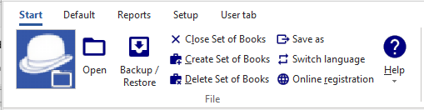
The following nine (9) options are available:
- Open - Open an existing Set of Books in any valid folder on the system.
- Backup / Restore - Create a backup file of your Set of Books. You may also restore the Set of Books from a valid backup file.
- Close Set of Books - The opened Set of Books will be closed. All other ribbon tabs will not be accessible.
- Create Set of Books - This option is used to create, copy or convert a Set of Books using the creation wizard. (TurboCASH5 allows you to create unlimited Sets of Books).
- Delete Set of Books - This option is used to permanently delete a Set of Books.
- Save as - This option is used to save an exact copy of the Set of Books.
- Switch language - The TurboCASH5 program will by default use the language selected after installing TurboCASH5. You may select a different language. The program interface, reports and layout files will by default be printed in this language.
You may set the language for a Set of Books in the “Language” field in Access control (Setup ribbon).
You may also set a language in the “Language” field for debtor (customer / client) accounts in Debtors (Default ribbon) and for creditor (supplier) accounts in Creditors (Default ribbon).
- Online registration - Register the TurboCASH5 program.

- Help - Access the help file, websites (forum, bug reporting, webshop), support details, etc. Access the following eight (8) options:
    - Help - Launch the TurboCASH5 Help system where you may locate topics on TurboCASH5. Context sensitive help has been implemented on most features.
    - Support - View contact information of TurboCASH5 or go to the support page via the Internet.
    - Show welcome - By default, the “Welcome to TurboCASH5” screen displays the website.
If the website is updated, new content will be displayed in the “Welcome to osFinancials5” screen.
    - Updates – Update the TurboCASH5 program.
    - Forum - Please visit our Forum to find solutions or to post comments, etc.
    - Webshop - Please visit our webshop.
    - Bug report - View, search and report any bugs.

Default ribbon
The Default ribbon is used to manage the following:
- Master files – Ledger accounts (chart of accounts), debtors, creditors, contacts, stock items, appointments, tasks, etc.
- Transactions - Processing of transactions in sales documents (i.e. invoices, credit notes and quotes) and purchase documents (i.e. purchases, supplier returns and orders), batches (journals), managing open item accounts (adjust payment dates and / or process receipts / remittance advice for payments and / or refunds, etc.).
- Periodic processing – Reconciliation, repeating transactions and invoices.
- Search – Search for data and print transactions and documents, etc.
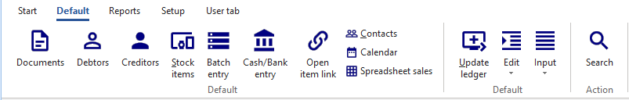

The following fourteen (14) options are available:
- Documents - Access, process and manage sales documents (i.e. invoices, credit notes and quotes) and purchase documents (i.e. purchases, supplier returns and orders).
- Debtors – Maintain (manage) debtor (customer / client) accounts. You may create, edit, delete and / or disable debtor (customer / client) accounts.
- Creditors - Maintain (manage) creditor (supplier) accounts. You may create, edit, delete and / or disable creditor (supplier) accounts.
- Stock items – Maintain (manage) stock (inventory) items. You may create, edit, delete and / or disable stock (inventory) items for eleven (11) stock item types. These are, Default, Sales, Sales (no stock), Purchases, Purchases (no stock), Financial entry, Option item, Option item (no stock), BOM (Bills of Materials), BOM (production) and Linked items.
- Batch entry - Enter and process transactions in batches.
- (Cash/Bank entry (Reconciliation) - Reconcile transactions in payment and receipt batches (linked to a bank account) with printed bank statements.
- Open item link – Process, edit, delete links for ledger accounts (income, expense, balance sheet, bank and tax), debtor (customer / client) and / or disable creditor (supplier) accounts set as Open item accounts. You may also adjust the payment dates for these accounts or process receipts / remittance advice for payments and / or refunds.
- Contacts - Maintain (manage) contact persons and print a list of contacts.
- Calendar - The calendar (planner) allows you to manage (schedule, add, edit, delete) events (general appointments, debtor appointments(up to 6 categories), creditor appointments, repeating invoices and to generate quotes / invoices for events). It also allows you to (add, edit and / or delete) contacts and tasks.
- Spreadsheet sales - The power of Spreadsheet sales and Spreadsheet reports is introduced in TurboCASH5.
See video on Spreadsheet reports and Spreadsheet sales.
- Update ledger - Update (post) sales documents (i.e. invoices and credit notes) and purchase documents (i.e. purchases and supplier returns) and batches to the ledger.
- Edit - Access the following four (4) options:
    - Backorders – Add, edit or delete backorders for stock items.
    - Repeating transactions - Enter and / or edit transactions in batches of a recurring nature.
    - Repeating invoices - Generate and process invoices of a recurring nature by selecting invoices to repeat from the invoice history.
    - Delete - Delete sales documents (i.e. invoices, credit notes and quotes) and purchase documents (i.e. purchases, supplier returns and orders).
- Input - Access the following options:
    - Confirm - Confirm and convert quotes to invoices and orders to purchases.
    - Adjust stock - Launch the Stock items (Default ribbon) as a separate floating screen.
    - Backorders - Add, edit and delete back orders for stock items.
    - Sales documents - Process / edit invoices, credit notes and quotes.
    - Purchase documents - Process / edit purchases, supplier returns and orders.
    - POS Invoice - Run and manage a point-of-sales shift and process point-of-sale invoices.
    - Checking for unposted items – Check for transactions in batches and documents which have not yet been posted (updated) to the ledger.
- Search - Launch the Investigator to search and filter for data in the Set of Books.

Reports ribbon
The Reports ribbon is used to access and print all reports, user reports and reports from the Ledger analyser 1 / 2 and T-Account viewer. It is also used to access the Printer (setup) and Report designer.
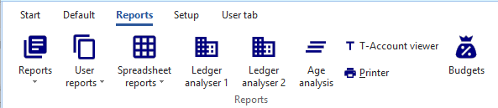
The following nine (9) options are available:
- Reports - List the reports in seventeen (17) menu items and groups.
- User reports - Any other reports that are under construction. Users may add their own reports in the ...\plug_ins\reports\userreports folder.
- Spreadsheet reports – These spreadsheet reports are stored in the ...\plug_ins\reports\excelreports folder. Selected reports will be opened in the powerful spreadsheet feature in TurboCASH5.
See video on Spreadsheet reports.
- Ledger analyser 1 - Trial balance, Income statement, Balance sheet, Standard column balances (column view of the Trial balance, Income statement and Balance sheet in one report), Budget versus actual, This year versus last year as well as Column balances.
- Ledger analyser 2 - The same reports are available as for the Ledger analyser 1, but it gives you another option to generate different views and reports.
- Age analysis - View and choose options for the new Age analysis report on screen and print it on the Reports ribbon and on the Open item – Due tab (Default ribbon).
- T-Account viewer - Analyse and print transactions for specific accounts, etc.
- Printer - Setup and configure the printers on your system.
- Budgets - This is a different option to enter and process Budgets than the process described in MODULE N – BUDGETING of this tutorial.

Reports menu
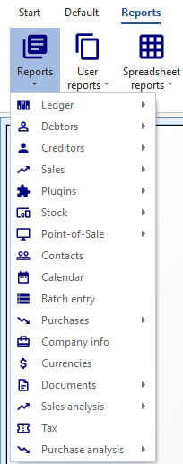
This menu lists all the standard reports, which are required to manage the information in a Set of Books. In addition to these standard reports, you may also create your own user or custom reports in the Report designer.
These reports that are stored in the ...\plug_ins\reports\systemreports folder.
If you are creating transactions from your stock file (processing documents - invoices, credit notes, purchases and supplier returns documents), you will need to view reports in the stock ledger, document listing, sales analysis, purchase analysis reports.
To access the reports menu:
- On the Reports ribbon, select Reports. A list of the seventeen (17) reports (groups of reports) will be listed.
- The summary of these reports, is as follows:
  - Ledger - The following reports are available to manage all the accounts in the general ledger:
    - Budget vs actual (3 periods) – Compare budget vs actual figures for any 3 periods.
    - Listing - List the General ledger accounts (Chart of accounts).
    - Transactions - Transactions, Transactions - Standard and Transactions - Extra details.
  - Debtors - The following reports are available to manage the accounts in the debtor's ledger:
    - Debtor statements - Debtor statements and Debtor statements – Outstanding.
    - Age analysis - The Debtor age analysis reports allows you to analyse the outstanding amounts your debtors (customers / clients) owes you in specified periods such as total, 30, 60 and 90 days, or more. These reports are essential for cash flow control. You may also wish to use this facility for credit control, to send reminders to your debtors (customers / clients), to optimise your cash flow management. These reports offers different options of views to support the details of debtor statements.
    - Listing - Contacts, Listing, List delivery address, List postal address, List details, Tax and company registration numbers and the Credit control listing (Credit limit vs current balance and available balances as at the date and time of printing).
    - Print labels - Postal and Delivery address labels.
    - Transactions - Transactions – Open item, Transactions - Standard and Transactions - Extra details.
  - Creditors - The following reports are available to manage the accounts in the creditor's ledger:
    - Creditor remittance advises – Remittance advises and Remittance advises – Outstanding.
    - Age analysis - The Creditor age analysis reports (Balances detail, Balances detail history (open item) and Balances) reports allows you to analyse the outstanding amounts you owe to your creditors (suppliers) in specified periods such as total, 30, 60 and 90 days, or more. These reports are essential for cash flow control. You may also wish to use this facility to schedule the payments to your creditors, to optimise your cash flow management. These reports offers different options of views to support the details of creditor remittance advices.
    - Listing - Contacts, Listing, List delivery address, List postal address or List details, Tax and company registration numbers and the Credit control listing (Credit limit vs current balance and available balances as at the date and time of printing) report.
    - Print labels - Postal and Delivery address labels.
    - Transactions - Transactions - Open item, Transactions - Standard and Transactions - Extra details.
  - Sales - Various reports are available to analyse your sales documents. Print Debtors, Sales and Items reports for Invoices, Credit notes and Quotes.
  - Plugins – Price agreement report for the Price agreement plugin.
  - Stock - The following reports are available to manage the stock items:
    - Reorder - Stock reorder report to list only those stock items that needs to be reordered. The Current stock levels report lists all the current stock levels.
    - Print barcodes – Print the Barcodes or the Yagoda barcodes.
    - Listing - Print lists of All selling prices (Selling price 1 / 2 / 3) and the Stock item listing (Quantities and Cost prices). You may select to print extra details for these reports. You may also print the Stock - Tax class listing report.
    - Backorder - Print a list of backorders.
    - Stock In / Out - The following two (2) reports:
      - Stock In / Out - Documents - Displays a summary of sales and purchase documents for each stock item. The “Show details” option will list and display the document dates and document numbers for each stock item.
      - Stock In / Out - Displays a list of the stock items and the quantities in and out as well as the total prices. The “Show details” option will list and display the document dates and document numbers for each stock item.
  - Point-of-Sale - Sales and Receipt reports for the plugin point-of-sale systems (if you purchased and use the HorecaPOS or RetailPOS point-of-sale systems).
  - Contacts - Lists the details of all your contacts.
To list only the contacts for debtor (customer / client) accounts, you need to print it in the Debtors → Listing - Contacts menu. To list only the contacts for creditor (supplier) accounts, you need to print it in the Creditors → listing - Contacts menu.
  - Calendar - Print the appointments (events) (i.e. Appointment, Debtor appointment, Creditor appointment and Hours) that was scheduled in the Calendar / Planner.
  - Batch entry - Print the transactions of posted invoices, credit notes purchase and supplier return documents as well as posted batch transactions (i.e. sales journal, purchase journal, payments journals, receipts journals, general journals, etc.).
  - Purchases - Various reports are available to analyse your purchase documents. Print Creditors, Purchases and Items reports for Purchase and Supplier return documents as well as Orders.
  - Company info –
    - Bank accounts - List of Banking details (for up to two (2) bank accounts) as entered in Company info (Setup ribbon).
    - Information – List of Lists the details of the following:
    - Document heading and messages (up to 3 lines) as entered in the Documents setup (Setup ribbon) for each of the Sales documents (i.e. Invoices, Credit notes and Quotes tabs) as well as Purchase documents (i.e. Purchases, Supplier returns and Orders tabs). This information is standard and will be printed on all documents.
    - Global statement message (up to 3 lines) as entered on the Statement setup tab on Documents setup (Setup ribbon). This information will print standard on all Statements (Reports → Debtors – Outstanding (Reports ribbon)). This is in addition to the specific messages (up to 4 lines) that can be entered in the Delivery address tab individual debtor accounts (Debtors - Default ribbon).

    - Selling price descriptions – The descriptions of Selling price 1, Selling price 2 and Selling price 3 as entered in the Selling price descriptions (Stock information (Setup ribbon).
    - Cost of Sales –
        - Create Cost of Sales -
          - Yes - Cost of Sales is activated.
          - No - Cost of Sales is not activated.
        - Average cost -
          - Yes – Average Cost of Sales is activated.
          - No – Latest Cost of Sales is activated.
  - Currencies – List of the Currencies added in Setup → Currencies (Setup ribbon). These currencies can be selected when processing documents, such as invoices, credit notes, purchases, supplier returns documents, orders and quotes.
  - Documents - Lists your documents, such as invoices, credit notes, purchases, supplier returns documents, orders and quotes or a selection of documents or for a selected period.
  - Sales analysis -
    - Sales documents for each document type (i.e. Invoices, Credit notes and Quotes) - You may print reports for five (5) reporting groups (i.e. Debtor group 1, Debtor group 2, Document group 1, Document group 2 and Salespersons).
    - Invoices and Credit notes - You may print reports for five (5) reporting groups (i.e. Creditor group 1, Creditor group 2, Document group 1, Document group 2 and Salespersons).
    - Sales per product - Stock group 1 and Stock group 2 are also available to analyse the sales (invoices) and returns (credit notes) of trading stock items (default stock type).
  - Tax - If you are registered as a VAT/GST/Sales tax vendor, you need to print and view reports for a specific period for all your Tax (VAT/GST/Sales tax) or for a specific tax code such as Input VAT/GST/Sales tax, Output VAT/GST/Sales tax, Zero-rated VAT/GST/Sales tax, etc.
  - Purchase analysis -
    - Purchase documents for each document type (i.e. Purchase, Supplier return documents and Orders) - You may print reports for five (5) reporting groups (i.e. Creditor group 1, Creditor group 2, Document group 1, Document group 2 and Salespersons).
    - Purchase and Supplier return documents - You may print reports for five (5) reporting groups (i.e. Creditor group 1, Creditor group 2, Document group 1, Document group 2 and Salespersons).
    - Purchases per product - Stock group 1 and Stock group 2 are also available to analyse the purchases and returns for trading stock items (default stock type).
User reports menu
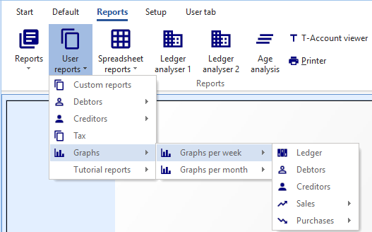
Any other reports that are under construction. Users may add their own reports in the ...\plug_ins\reports\userreports folder.
The following user reports are included in TurboCASH5:
- Custom reports – This is custom sales and purchase reports.
  - 2cred-sku-det - Lists the Purchase and Supplier return documents for a selected creditor (supplier).
  - 2deb-sku-det - Lists the Invoice and Credit note documents for a selected debtor (customer / client).
- Tax - List the Tax type accounts and the tax rates which is added / edited in Setup → Accounts (Setup ribbon).
- Debtors - Outstanding - “Due date” and “Debtors Outstanding at date” reports. These reports will list all the transactions before and on a selected period (date). It will list the details for each transaction (i.e. Reference No., Date, Due date, Debit, Credit and the accumulative balance for each of the debtor (customer / client) account.
- Creditors - Outstanding - “Due date” and “Creditors Outstanding at date” reports. These reports will list all the transactions before and on a selected period (date). It will list the details for each transaction (i.e. Reference No., Date, Due date, Debit, Credit and the accumulative balance for each of the creditor (supplier) account.
  - Sales - Graphs
    - Quotes per week - Quantities and Quotes per week - Turnover
    - Credit notes per week - Quantities and Credit notes per week - Turnover
    - Invoices per week - Quantities and Invoices per week - Turnover
  - Purchases - Graphs
    - Purchases per week - Quantities and Purchases per week - Cost
    - Supplier returns per week - Quantities and Supplier returns per week – Cost
    - Orders per week - Quantities and Orders per week - Cost
- Graphs -
  - Graphs per week -
    - Ledger - The "Graph - Profit / Loss per week" displays the Net Profit / Loss per week in a bar chart.
    - Debtors - The “Graph - Debtors per week” displays the debit and credit transaction totals of all debtor (customer / client) accounts per week in a bar chart.
    - Creditors - The “Graph - Creditors per week” displays the debit and credit transaction totals of all creditor (supplier) accounts per week in a bar chart.
    - Sales -
      - Quotes per week - Quantities and Quotes per week - Amount
      - Credit notes per week - Quantities and Credit notes per week - Amount
      - Invoices per week - Quantities and Invoices per week - Amount
      - Sales per week - Invoices minus Credit notes - Quantities and Invoices minus Credit notes – Amount
    - Purchases -
      - Purchases – Purchases minus Supplier returns - Quantities and Purchases minus Supplier returns per week - Amount
      - Supplier returns per week - Quantities and Supplier returns per week – Amount
      - Orders per week - Quantities and Orders per week – Amount
      - Purchases per period - Quantities and Purchases per week – Amount

  - Graphs per month -
    - Ledger - The "Graph - Profit / Loss per month" displays the Net Profit / Loss per week in a bar chart.
    - Debtors - The “Graph - Debtors per month” displays the debit and credit transaction totals of all debtor (customer / client) accounts per week in a bar chart.
    - Creditors - The “Graph - Creditors per month” displays the debit and credit transaction totals of all creditor (supplier) accounts per week in a bar chart.
    - Sales -
      - Quotes per month - Quantities and Quotes per month - Amount
      - Credit notes per month - Quantities and Credit notes per month - Amount
      - Invoices per month - Quantities and Invoices per month - Amount
      - Sales per month - Invoices minus Credit notes - Quantities and Invoices minus Credit notes - Amount
    - Purchases -
      - Purchases – Purchases minus Supplier returns - Quantities and Purchases minus Supplier returns per month - Amount
      - Supplier returns per week - Quantities and Supplier returns per month – Amount
      - Orders per week - Quantities and Orders per month – Amount
      - Purchases per period - Quantities and Purchases per month - Amount
- Tutorial reports - These are simple debtor listing and creditor listing reports added with Reportman.

Spreadsheet reports menu
These spreadsheet reports are stored in the ...\plug_ins\reports\excelreports folder.
See video on Spreadsheet reports.
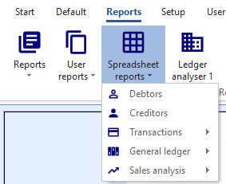
The following reports will be opened in the powerful spreadsheet feature in TurboCASH5:
- Debtors – The Debtors → Listing – List postal addresses report will be imported into the spreadsheet.
- Creditors – The Creditors → Listing – List postal addresses report will be imported into the spreadsheet.
- Transactions per period – The posted transactions in batches and documents for a selected period, will be imported into a spreadsheet.
- General ledger – Budget
  - Column balances this year – Reporting group 1 – The budget totals (for accounts linked to the Reporting group 1), will be imported into a spreadsheet.
  - Column balances this year – This year – The budget totals, will be imported into two (2) sheets in the spreadsheet:
    - Settings – The budget totals for each period in rows per period.
    - Column balances – The budget totals for each period in separate columns.
- General ledger (Transaction totals)
  - Column balances this year – Reporting group 1 – The totals of posted transactions in batches and documents (for accounts linked to the Reporting group 1), will be imported into a spreadsheet.
  - Column balances this year – This year Column balances will import the transaction totals in two (2) sheets in the spreadsheet:
    - Settings – The totals for each period in rows per period.
    - Column balances – The totals for each period in separate columns.
- Sales analysis
  - Stock movement – The totals in and out for the default stock type (i.e. trading stock) will be summarised in a spreadsheet.
  - Sales per period – The total sales amount, excluding as well as including tax (VAT/GST/ Sales tax), for each period will be listed in a spreadsheet.
Setup ribbon
The Setup ribbon tab is used to access the Setup and Tools.
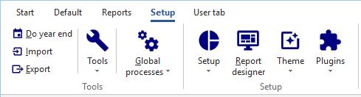
The options are grouped in the following nine (9) options:
- Do year end - This option allows you to close off all the nominal accounts (income and expense accounts) and transfer the balances for the financial year to the Retained earnings account. The start date and the reporting dates for the financial year will also be created for the new financial year.
- Import - Import accounts, debtors, creditors, documents and stock from specific file formats.
- Export - Export accounts, debtors, creditors, documents, stock and posted batches to specific file formats.
- Tools – Access the following five (5) options:
  - Blockchain -
See video on osFinancials and Blockchain.
  - Data integrity check - Run a Data integrity check and print a Data integrity check report.
  - Customise language - Customise (edit, change and translate) language files.
  - Close active forms - Close any open forms (e.g. “Documents, Debtors, Creditors, Stock items” screens, etc.)
  - Activate plugins - By default, no plugins is activated when TurboCASH5 is installed. This option allows you to activate / deactivate all plugins, registered plugins or specific plugins. The activated plugins will be added to the Plugins menu.
- Global processes - The following three (3) options are available:
  - Clear / Reset - This option allows you to clear all the transactions and balances in a Set of Books. This will clear or reset the Set of Books and delete all the transactions and balances. You may also select to retain all documents and set them to unposted.
  - Copy from a Set of Books - This option allows you to copy the data from a selected Set of Books into the active (open) Set of Books. This will replace all the data in the active Set of Books.
  - Reverse posted document / batch - This feature allows you to reverse or cancel the transactions in posted documents and batches.
    - Reverse posted batch (journal) - The transactions entered or imported in batches (journals) which are already updated (posted) to the ledger, may be reversed or cancelled. This option will cancel all the transactions already updated (posted) to the ledger, remove it from the transaction file, and import the transactions to the selected batch (journal).
You may then erase or delete the entire batch (journal) as well as the transactions, edit or correct the transactions, balance the batch, print the batch list and post it to the ledger.
    - Reverse posted document - The documents as well as any transactions generated by the documents (invoices and credit notes, purchase documents and supplier returns documents) when the documents were updated (posted) to the ledger, will be reversed or cancelled.
The selected reversed document will be available as an unposted document.
You may edit the document in Documents (Default ribbon) and then post (update) it to the ledger. If you do not need to update (post) the document to the ledger, you may delete the document in Edit → Documents menu (Default ribbon).
- Setup - Access the following seventeen (17) options:
  - Company info - Enter the company information (name, address telephone, fax numbers e-mail address) and registration numbers for the Company and VAT/GST/Sales tax, if applicable.
    - You also may to set the default tax method and output method for reports (to “screen, printer, file, e-mail” or “fax”).
    - Load your logo or picture, which you wish to be displayed on the documents.
    - Set the default currency format and date format in your Operating System.
  - Reporting dates - Set the start date of your financial year and the periods in a financial year. You may also close a specific period or year for posting transactions to the ledger.
  - Documents setup - Settings for sales documents (i.e. invoices, credit notes and quotes) and purchase documents (i.e. purchases, supplier returns and orders). Set the defaults for documents, such as the numbers, batch types, headings and messages and document layout files.
On the Statement setup tab, you may enter a global message to be printed on Debtor statements (Reports → Debtors → Debtor statement menu).
  - Accounts - Create, edit, delete general ledger accounts (income / expense, bank and tax accounts).
  - Groups - Set up to 2 Groups for Accounts, Debtors, Creditors, Stock items and Documents for printing reports.
  - Stock information - The following settings are available:
    - Default -
      - Selling prices - Enter (edit) the descriptions for up to 3 selling prices. You may set the default selling price 1 / 2 / 3 which will be used globally when processing documents.
      - Cost of sales - Set the parameters for Cost of sales (account, batch type, whether you will be using average cost or latest cost).
      - Documents setup - This also contains various settings when processing documents and / or working with stock.
    - Unit size - Specify the unit descriptions and sizes to be displayed in the “Stock item” screens and reports.
The unit description is implemented on the Test Invoice (LanguageID906190), Delivery note (no code) (LanguageID906181) and Delivery note (LanguageID906182) layout files.
Launch the Help file. - Copy this text “Add unit descriptions to layout files” to the Search tab and click on the List topics button.
Follow the steps (procedure) to add this to your own customised layout files.
    - Tax classes - Create, add, edit Tax classes (Account classes) to which you may select Input Tax codes, Output Tax codes, Sales, Cost of sales and Stock control accounts.
  - Batch types - Create or delete batch types or journals in which you wish to enter transactions. Batch types also need to be linked to sales documents (i.e. invoices and credit notes) and purchase documents (i.e. purchases and supplier returns) on Setup Documents.
  - Access control - Set the passwords, users and access to certain menus for each of your users.
  - Salesperson - Add or remove any salespersons, which will be processing sales documents (i.e. invoices, credit notes and quotes) and purchase documents (i.e. purchases, supplier returns and orders) or cashiers operating Point-of-Sale.
  - Financial categories - Link your Ledger Account groups to Assets, Capital, Expenses, Income or Liabilities.

  - System parameters - Select the indicators for debit and credit, number of decimals to be displayed on reports and documents as well as the number of decimals to be stored. You may also select to display the default system currency symbol.
Select 1 of 2 methods for reconciling bank statements with the transactions in your cash book (receipts and payments batches). If you have purchased the BankImport Plugin, you need to change the setting import the transactions from your bank statement and allocate these transactions to the accounts.
  - Internet - Configure your Internet, e-mail accounts to send reports, lists and documents via the internet or to configure a network server.
  - Countries – Add and manage the ISO CODE2 and ISO CODE3 as well as ICL CODES for each country.
  - Currencies - You may add / edit currencies and the exchange rates. When processing documents, you may select the currency. This will automatically calculate the prices for that currency.
  - Point-of-Sale - Set Point-of-Sale parameters, configure printers, peripherals, etc. for the standard point-of-sale system.
  - Workflow setup -
  - Printer - Select the default settings for printing reports and documents.
- Report designer - Edit existing reports and layout files for documents. You may also create and edit your own reports and layout files.
- Theme - Select the “Material, Classic, Blue, Glass, Silver, Soft-blue” or “VS2010” theme. If the “Classic, Blue, Glass, Silver, Soft-blue” or “VS2010” themes are selected, the icons in the “Classic” theme will be displayed. The “Material” theme is used for screen captures in this book.
- Plugins - By default, no plugins are listed on this menu. Only activated plugins will be listed.
Most of these plugins are licensed under commercial licenses. You need to purchase a license on which a registration code and instructions will be mailed to you to unlock the full features of these plugins.
Plugins needs to be registered in the Plugins → Tools→ Register plugins menu (Setup ribbon).

User tab ribbon
The User tab ribbon is a custom quick menu. It is used to manage user navigation in a Set of Books. You may select (tick) the “Auto-learn” feature to add the last accessed options in up to six (6) groups.
By default, when opening the Set of Books, the Default ribbon will be displayed.
If the User tab ribbon, is activated, the User tab ribbon will automatically be displayed when opening the Set of Books.
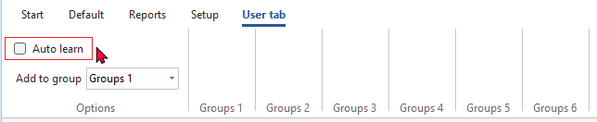
The user options are added to the User tab ribbon, using the Auto-learn - Select (tick) this option to automatically add your accessed functions (menu items) to the User tab ribbon.
The User tab ribbon may be edited and accessed in the User tab on Setup → Access control (Setup ribbon).

WORKING WITH TurboCASH5 RIBBONS AND SCREENS
Show / Hide ribbon options
Hide ribbon
You may need some extra space when working with, Documents, Stock, Debtors, Creditors, Ledger analyser, etc.
To “Auto hide” the ribbons options, double-click on any of the ribbon tabs. This will hide the options on the ribbon and only display the ribbon tabs and auto-resize (larger) the screens in TurboCASH5. You may then click on a ribbon tab to select and access the options. Once you have selected an option, the ribbon options will auto hide and only display the ribbon tabs.
Show ribbon
To “Show” the ribbon options and resize the screens (smaller), you may double-click on a ribbon tab.
Menu lists
You may right-click basically anywhere on the program to access menus (and sub-menus, where applicable) for each of the ribbon tabs.
Dock / Undock sections of screens
By default, all sections of screens are docked (maximised). If you see the following button on a screen, you may click to undock (maximise) resize a screen (or section of a screen) or to dock (minimise) the screen:
Dragging / Resizing sections of screens
When the mouse is moved over some areas of a screen, you may drag the area of the screen to resize it.


FILTERS AND SEARCH FEATURES
Filter options in column headings
The grid (implemented in TurboCASH5) is very powerful because of its sophisticated easy to use filter and sort features does this quicker than any other way. It has the ability to group, sort and filter any data column(s) on most screens in a Set of Books with only a view mouse clicks.
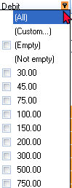
If you need to view or find specific data, there are various options available to locate and find your data.
Some of the options are:
- Sort - Click on a column heading to sort and list the data ascending or descending sequence. All the data is by default displayed ascending; from the smallest to the highest value (e.g. a-z or 0-9) according to the record number (e.g. line number in a batch, etc.) To change the sort order from ascending (e.g. a-z or 0-9) to descending (e.g. z-a or 9-0) select a column and click on it. If you click on it again it will change back to ascending sequence.
- Drag and drop columns - You may click on a column and drag it to the left or to the right to change the sequence your data is displayed on screens.
- Filter - Click in the arrow to list the data in a specific column. A list displaying the data, as well as an “All” option and a “Custom...” option in the selected column will be displayed. For example, if amounts are entered in a “Batch entry” screen, all the amounts will be listed. By adding a tick next to a specific amount, only transactions, matching that amount will be listed.
- Custom - You can easily build customised filters according to your needs. These filter files can be saved and opened for future use.

Custom filters
Once you have selected an option on a list, the your selection will be displayed at the bottom section of the “Batch entry” screen as follows:
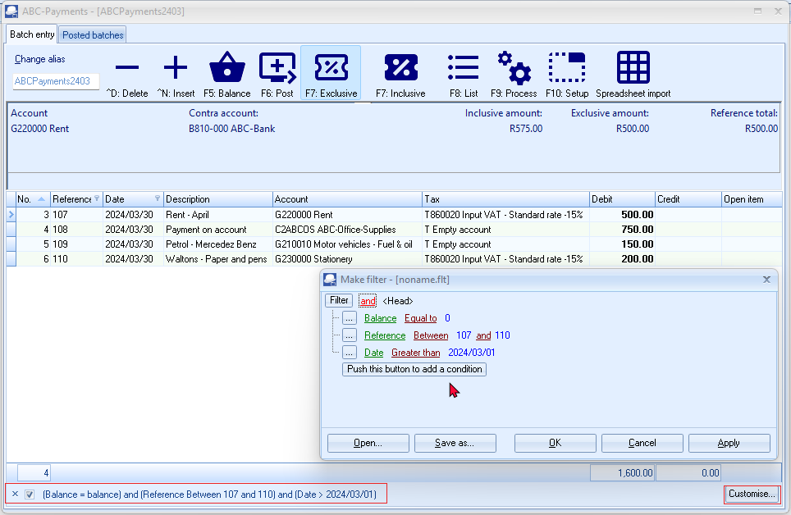
You may click on the “Customise...” option on a column list or click on the Customise button to:
- Make a filter (add or delete conditions and groups).
- Save a filter.
- Open a filter.
You may click on the filter icon where the filter is displayed, to select previous filters.

Make a custom filter
To make a filter:
- Click on the “Customise...” option on a column list or click on the Customise button.
- Select an operator (i.e. and, or, and not, or not).
- Click on the Filter button (or on the … button) and select one of the following options on the context menu:
- New condition – Create a new condition.
- New group – Create a new group.
- Delete row (If you click on the Filter button, you may delete all rows (conditions and groups)).
- Select a column from the list of available data applicable to the screen. In this example, the Date is selected.
- Select a filter condition. In this example, the Between is selected. Another field is opened to select another date.
- Once you have created your conditions or groups, click on the Apply button.
- Click OK to close and exit this “Make filter” screen.
Conditions
The values of conditions, is as follows:

- Equal to - list or display all values which is the same as the specified value.
- Not equal to - list or display all values which is not the same as the specified value.
- Less than - list or display all values smaller than the specified value.
- Less than or equal to - list or display all values smaller or equal to the specified value.
- Greater than - list or display all values greater than the specified value.
- Greater than or equal to - list or display all values greater or equal to the specified value.
- Like - list all values similar to the specified value.
- Not like - list all values not similar to the specified value
- Contains - list all values which contains (includes) the specified value.
- Does not contain - list all values which does not contain (excludes) the specified value.
- Begins with - list all values which does not contain (excludes) the specified value.
- Ends with - list all values which ends with the specified value.
- Is null - excludes any value entered, will not be listed or displayed.
- Is not null - is not zero - any value which is not equal to zero will be listed or displayed.
- Between - Specify specific values, etc. to include only matching values. (For example, between reference numbers 105 and 111 will exclude any lower numbers than 105 and higher numbers than 111).
- Not between - Specify specific values, etc. to exclude values. (For example, Not between reference numbers 105 and 111 will exclude these numbers and will list any lower numbers than 105 and higher numbers than 111).
- In - In a specified value.
- Not in - Not in a specified value.
If a Date for a column condition is selected, additional conditions will be available (i.e. is this month, is this year, is next 7 days, is next week, is next 14 days, is next two weeks, is next 30 days, is next month, is future, is this week, is yesterday, is today, is last 7 days, is last week, is last 14 days, is last two weeks, is last 30 days, is last month, is last year, is past, is this week, etc.

Save custom filter files
To save a custom filter file:
- Once you have sorted or filtered your data with the Make filter utility, click on the Save as... button. The “Save active filter as” screen will be displayed.
- Select a directory in which you wish to save the custom filter file.
- Enter a file name.
- Click on the Save button to save the Filter in a (*.flt) Filter File format. You may then at any later stage open the saved *.flt file.

Open custom filter files
To open a saved a custom filter file:
- Once you have sorted or filtered your data with the Make filter utility, click on the Open... button. The “Open saved filter as” screen will be displayed.
- Select a directory in which you have saved the custom filter file.
- Select a valid filter file.
- Click Open. The selected filter file's name will be displayed in the titlebar of the “Make filter” screen.

LOOKUPS
Accounts lookup
When the cursor is in various fields on a screen of the TurboCASH5 program, TurboCASH5 will display the lookup screen for that specific field. A lookup screen is basically a list of all the valid master records in a Set of Books from which you need to select one item from the list.
Some lookup screens contains all accounts. Other lookup screens lists only ledger accounts / only debtor accounts and / only creditor accounts.
Disabled or blocked accounts will be excluded from some lookups.
Debtor / Creditor accounts - “Account disabled” field selected (ticked) on “Accounting information” tab (Default ribbon).
Ledger accounts - "Status" field set to "Disabled". (Setup → Accounts on the Setup ribbon). For example;
- if a ledger account is disabled, it will not be listed on the Accounts lookup when processing transactions.
- if a Tax type account (Tax code) is disabled, the disabled accounts will not be available on the Tax lookup in batches.
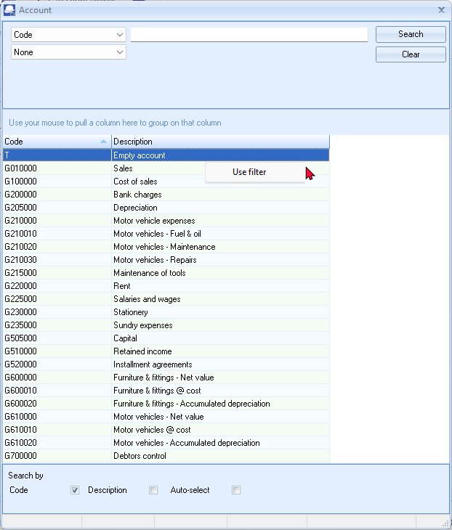
You may right-click on any area of the lookup to enable or disable the filter.
If the Use filter is enabled, the Use filter context menu will display a tick as follows - 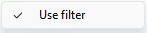
To disable the filter, click on the menu to remove the tick. If the filter is enabled, you may locate and select accounts, stock items, periods, etc. on the lookup screen with ease.
Stock item lookup
When processing documents you need to select the stock item in the document lines section. There are basically three (3) options to select stock items in any open / unposted document:
- Lookup - Click on the “Item no.” column of document line or when proceeding to a new line, the Lookup will automatically be launched. To edit / select an existing Item, you need to double-click on the selected item in the document line.
- Open fast add - The icon will launch the lookup as a part of the “Document entry” screen (replace the header section of the document). Once finished selecting stock items, you may click on the Close fast add icon.
You may enter a valid stock code, barcode or serial number and press the Enter key in the “Fast add item (stock code / barcode / serial)” field in the footer section of the “Document entry” screen. This will insert the stock transaction in the document line.
- Button lookup - This will launch a graphical image view of Stock group 1 and Stock images.

The default “Stock lookup” screen, is as follows:
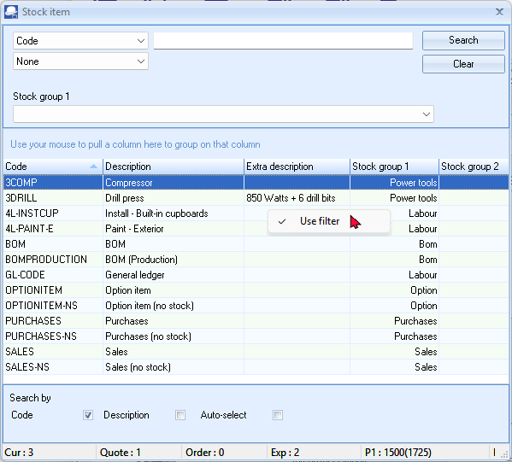
The values and fields, are as follows:
- Code - “Code” is the default option. You may select the “Description, Barcode, Description and Extra description” or “Code, Description and Extra description” option. This will allow you to enter any valid values for a stock item. If you click on the Search button, it will list only those stock items matching the value entered.
- Operator - None is the default. You may select an operator (i.e. and / or). These operators will add another field where you may enter values to filter the stock items. If you click on the Search button, it will list only those stock items matching the values entered in the first search values field and / or the values entered in the second search values field.
- Stock group 1 - You may select a stock group 1 (created / added in Groups - Stock group 1 (Setup ribbon) and linked to the stock item). This will only list those stock items linked to Stock group 1.
- Stock group 2 - You may select a stock group 2 (created / added in Groups - Stock group 2 (Setup ribbon) and linked to the stock item). This will only list those stock items linked to Stock group 2.
- Search by: Code, Description and Barcodes is the default options. If any of these are selected (ticked), it will change the sort sequence in which the stock items are listed.
The Auto-select tick box will only be displayed when the (right-click) is selected (ticked). The “Auto-select” option allows you to enter any keys to filter by stock code, description, barcode, etc.
- Statusbar - This bar is located right at the bottom of the lookup screen. It will display the following details for the selected stock item:
  - Cur: This displays the current actual quantities on hand for the selected stock item. This is the totals of the “Quantity on hand” field of the “Values” section on the Ledger tab of the Stock items (Default ribbon), (as updated by posted documents) PLUS any unposted purchase documents.
  - Quote: This displays the quantities of any open / unconfirmed quotes which have not yet been converted to invoices.
  - Order: This displays the quantities of any open / unconfirmed orders which have not yet been converted to purchase documents.
  - Exp: This displays the expected quantities on hand for the selected stock item. This is the current quantities on hand for the selected stock item. This is the totals of the “Quantity on hand” field of the “Values” section on the Ledger tab of the Stock items (Default ribbon) LESS the quantities of any open / unconfirmed quotes which have not yet been converted to invoices PLUS the quantities of any open / unconfirmed orders which have not yet been converted to purchase documents.
  - P1: This displays the “Selling price 1” field of the “Selling prices” section on the Ledger tab of the Stock items (Default ribbon). The price is displayed as exclusive of tax (VAT/GST/Sales tax) and the price is displayed as inclusive of tax (VAT/GST/Sales tax) between brackets.
  - P2: This displays the “Selling price 2” field of the “Selling prices” section on the Ledger tab of the Stock items (Default ribbon). The price is displayed as exclusive of tax (VAT/GST/Sales tax) and the price is displayed as inclusive of tax (VAT/GST/Sales tax) between brackets.
  - P3: This displays the “Selling price 3” field of the “Selling prices” section on the Ledger tab of the Stock items (Default ribbon). The price is displayed as exclusive of tax (VAT/GST/Sales tax) and the price is displayed as inclusive of tax (VAT/GST/Sales tax) between brackets.
  - LP: This displays the Latest cost (last cost price) field of the Values section on the Ledger tab of the Stock items (Default ribbon). The price is displayed as exclusive of tax (VAT/GST/Sales tax) and the price is displayed as inclusive of tax (VAT/GST/Sales tax) between brackets.

Batches lookup
The lookup in the “Batch entry” screen automatically filter the code or the description. When the Account or Tax columns are focused, you may type the code or description. In this example, the description is typed as “fu” and it lists only those accounts with the starting with the typed characters, e.g. Fuel & oil and Furniture...

The number of records matching your search characters will be displayed.
Your search characters entered will be displayed at the bottom of the lookup as well as above the column descriptions.
To resize the Account lookup list, you may simply click on the bottom right corner and drag the screen to the desired size.
Context menu (right-click) lookup on Batch entry screen:

You may right-click on a selected transaction to allocate a transaction to a debtor (customer / client) or creditor (supplier) account , or to copy and paste a contra account, reference or date from one transaction to other transaction(s)
You may configure the Account types to be included in the Account lookup. On the F10:Setup - Advanced tab, you may set the Account lookup type to:
- All (default) all account types,
- General ledger – All account types, except Debtors, Creditors.
- Debtors (only Debtor accounts),
- Creditors (only Creditor accounts).
- Open item – Only those General ledger, Debtor and Creditor accounts for which Open item is activated.
WORKING WITH OTHER WINDOWS / SCREENS
Minimise, restore and closing of programs or screens
The following similar buttons are found on the right side of the titlebar:
 – Minimise - Click on this button to minimise the program in the Windows Task bar.
 – Maximize - Click on this button to display the TurboCASH5 screens as a larger screen on your desktop. This button will change to the  Restore Down button. When you click on this button, the TurboCASH5 screens will be restored to its original size.
If the Restore button is displayed in a titlebar, you may double-click anywhere on the titlebar
to display the screen in the full size of your desktop and double-click again to return to it’s original size.
 – Close - This button will exit the TurboCASH5 screens. On the top right-hand corner TurboCASH5 program's titlebar, it will close or Exit TurboCASH5.
 | If no Set of Books are opened, the TurboCASH5 program will be closed.  If a Set of Books are opened, the following information message is displayed:  "TurboCASH5 would like to remind you that:  It is good practice to make regular backups and archive copies of your Sets of Books to prevent loss of data.  Do you wish to close TurboCASH5?"
Resizing of screens on your desktop
Pressing on the titlebar, will re-size TurboCASH5 to the full screen option. On the bottom left corner of the TurboCASH5 program will change to .
You may resize the screen to any size on your desktop by moving the mouse pointer to any place on the edge of the TurboCASH5 or window. When the mouse pointer changes to a double-sided arrow, click on the mouse and drag the edge of the screen to desired size.

Accessing menu options using short-cut keys
For your convenience, a list of the short-cut keys are listed in MODULE R at the end of this book.
NAVIGATION IN TurboCASH5
Yes / No, OK / Cancel, Back / Next and Finish buttons
These options may be selected with a mouse click, or, by pressing the key corresponding to the first letter of the command, e.g.:
Yes = Y or Enter
No = N or Esc
Next = N
Back = B
Cancel = C, etc.
Moving between fields on screens when entering data
Once data has been entered, pressing Tab or Enter, will shift the cursor to the next field, this can also be achieved by clicking with the mouse cursor. To move to the previous field, use the mouse or press the Shift and Tab keys simultaneously.
Arrow keys
Whenever a lookup is listed on your screen, and you need to select an account, use the mouse or the Up and Down keys to scroll through the accounts. To select the required account, click with your mouse or simply press the Enter key on your keyboard.
Drop-down lists
A Drop-down list is represented by a small block, with a down arrow or three dots (…) on the right-hand side of the respective field. By clicking on this button, a list will be displayed. Examples are reporting groups, selling prices, salespersons, etc.

Tick boxes
You will come across many fields where you have to place tick to select certain options. An example of a tick box, is as follows:
The Space bar on your keyboard allows you to toggle between a tick and a blank space in the tick box.
GETTING HELP IN TurboCASH
To access the help file, you have three (3) options:
- Press the F1 key on your keyboard for context sensitive help. On most screens, the relevant topic will be launched.
- Click on the Help → Help menu (Start ribbon).
- Online help – This is similar to the Help file included in the release. This help file may be updated from time to time as the existing documentation are improved and topics added.
Videos - https://accounting.ning.com/videos

BACKUP AND RESTORE A SET OF BOOKS

IN THIS MODULE
MODULE D - BACKUP AND RESTORE A SET OF BOOKS 115
D.1- OPTIONS TO MAKE BACKUPS OF BOOKS 116
D.2- CREATING A BACKUP FILE ONTO A DISK OR HARD DRIVE 116
D.3- CREATING AN E-MAIL BACKUP FILE 119
D.4- RESTORING A SET OF BOOKS 119

OPTIONS TO MAKE BACKUPS OF BOOKS
In addition to the Backup / Restore feature you may also create exact copies from existing sets of books, templates (installed in your “.../books” directory or other sets of books in the “.../bin/Repository” directory). The following options are available:
- Backup / Restore (Start ribbon).
- Save as (Start ribbon).
- Create Set of Books (“Copy from a Set of Books” option on the “Creation wizard”) (Start ribbon).
- Global processes → Copy from a Set of Books (Setup ribbon).
CREATING A BACKUP FILE ONTO A DISK OR HARD DRIVE
The Backup / Restore option will backup your data onto disk or your hard drive, or other selected location in a tcBackup.zip file. This option will to compress or zip the size of files contained in the backup file.
Backup files are used to Restore a Set of Books to the set of data from which the Backup file was created. Backups are copies of your data that you make on a regular basis.
The following options to create backup files, are available:
- Normal backup - All the files contained in the folder of the Set of Books, including images, pdf files (added with plugins such as the multimedia plugin, etc.) will be included in the backup file.
- Small backup (books) - Only one file, the database (e.g. books.fdb - for the firebird database), will be included in the backup. All other files will be excluded from the backup.
You will need backups:
- In case of file corruption, hardware failures and other errors.
- Send backup files via e-mail.
As a general rule, it is good practice to back up often, preferably upon closing the program. Backing up can be to an External hard drive, CD-ROM, USB-Drive, etc. Backing up to your hard disk is also a good practice but the best backup is not stored on your computer. (In case of a hard drive failure!!)

It is also recommended that you complete a BACKUP in the following instances:
- Prior to performing any major processes, such as Delete a Set of Books and Global processes (Clear / Reset Set of Books, Do year end, Copy from a Set of Books, Cancel / Reverse posted batches / documents, etc.).
- Old data on your previous version of TurboCASH5 or other accounting package prior to conversion to TurboCASH5.
- On a regular basis: Depending on your need and volume of work. The following minimum is recommended:
- 2 - 3 sets daily re-used weekly or every 3rd to 4th day.
- 2 weekly sets - re-used every 3rd week.
- 12 Monthly sets - done at the end of each month, and re-used each year.
- 1 set prior to year-end and kept permanent.
The very same backup disks or backup files on your hard drive are used to restore your data in your Set of Books. In this version of TurboCASH5, you may also restore a Set of Books from a valid Backup file stored on a Network Server, if a Network Server has been set up and configured on your system. If you do not make regular backups, you may have to re-enter thousands of transactions and general ledger, debtor, creditor and stock information.

To create a backup file:
- On the Start ribbon, select Backup / Restore. If a Set of Books is open on your system, TurboCASH5 will automatically close the Set of Books and the “Backup Set of Books” screen is displayed:
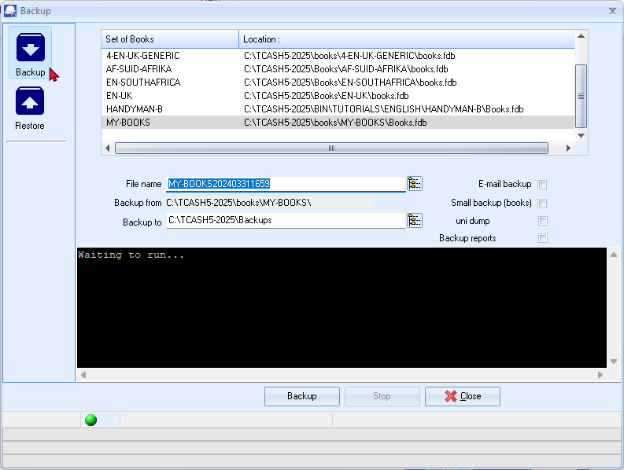
If no Set of Books are opened, the Restore button is automatically selected.
If a Set of Books are opened, the Backup button is automatically selected.
- Select the Backup option, if not already selected.
- Select the Set of Books you wish to backup.
- You may over type the Backup file name with a name of your own.
The date and time of your operating system is automatically inserted in the file name
(e.g. “MY-BOOKS202403311659”) after the default backup file name.
(In this example, the date and time format is YYYYMMDD, followed by the Hour and Minutes).
The format may differ if your operating system's short date style or format is set different.) It is recommended that this date and time not be over typed, if you enter a name for your backup file. You may then later select that file name to restore a Set of Books from.
- Select the drive or folder to backup to.
- Click on the Backup button to start the backup process. While the Backup process is running, the files are backed up from and added on your backup disk or location on your hard drive or network drive will be displayed.
- When the backup process is completed, an information message is displayed:
“The Backup process is completed!”
- Click OK and click Cancel on the “Backup Set of Books” screen. You may also press the Esc key on your keyboard to exit the “Backup Set of Books” screen.
CREATING AN E-MAIL BACKUP FILE
To use this option, your computer system must be properly set up and the Internet account with your Internet Service Provider. The process to create a backup file must be followed.
To send a backup file via e-mail:
- Select the E-mail backup option on the “Backup Set of Books” screen. When the backup process is finished, your e-mail program will automatically be launched.
- The e-mail address of TurboCASH5 will automatically be entered in this field. Should you wish to change it to a different e-mail address, (e.g. that of your auditor or consultant), you may enter a valid e-mail address to that field.
- Add a description to the subject if you wish (e.g. your company name).
- The file is automatically attached to the e-mail message. You may attach another document to the e-mail.
Your Internet Service Provider may limit your e-mail message (e.g. including attachments to 1.2MB). If the message is larger than the allowed message, your message may not reach the recipient and may be returned.
- Enter your message.
- Click on the Send button.
RESTORING A SET OF BOOKS
This option will restore your data for a specific Set of Books or your hard drive or in a valid folder on your system.
To restore a Set of Books from a backup, a valid backup (tcBackup.zip) file must exist.
If your data becomes corrupt for some reason, restoring from backup will fix this.
It will be necessary to re-enter all the data from the date of the last backup to the present. It can be seen that backing up often is a good habit that can potentially save a lot of work. If you do not make regular backups, you may have to re-enter thousands of transactions and general ledger, debtor, creditor and stock information.
It is also important to keep record of your backup disks or files or to label your backup disks to prevent restoring a Set of Books from an incorrect backup disk or file. It is recommended that you keep a record of which data is backed up and which is not, to prevent re-entering data that is already on your backup disks.
To restore a Set of Books:
- On the Start ribbon, select Backup / Restore. If a Set of Books is open on your system, TurboCASH5 will automatically close the Set of Books.
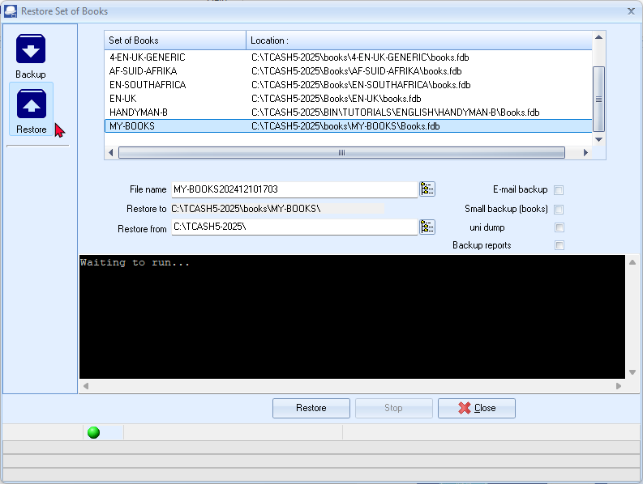
- Select the Restore option. The “Backup Set of Books” screen will change to the “Restore Set of Books” screen.
- Click on the icon next to the “File name” field and select the backup file on the “TurboCASH5 select backup file” screen.
The default backup path (drive or folder) for a Set of Books, is the installation folder of TurboCASH5, will be displayed.
You may select any other drive or folder on your system. You could also choose to Restore from your hard drive or any available drive on your network. TurboCASH5 also allows you to restore from an external hard drive, USB drive, a CD/DVD, provided that you have a CD/DVD writer installed on your system and the backup is correctly done.
- Click on the Restore button.

If you click on the Restore button, to overwrite an existing Set of Books, the following Warning message is displayed:
Restore from backup
New No
WARNING this will overwrite your current Set of Books! Are you sure you want to continue?“ This will seriously affect your Set of Books! Are you sure you want to clear this Set of Books?”
- If you are absolutely sure, click on the Yes button. Another warning message is displayed:
“This will seriously affect your Set of Books! Are you sure you want to clear this Set of Books?”
- If you are absolutely sure, tick the "I have read this instruction and understand the action!" field. The Yes and No buttons will be available on this screen.
- Click on the Yes button. The confirmation message is displayed:
"This will seriously affect your Set of Books! Are you sure you want to clear this Set of Books?"
- If you click on the No button, the process will be cancelled. Click on the Yes button, if you are absolutely sure. The information message is displayed:
"Your Set of Books will be restored in:
D:\TurboCASH5\books\MY-BOOKS\
Do you wish to continue?"
- Click on the Yes button, to start the restore process. If you click on the No button, the process will be cancelled. When the restore process is completed, an information screen will be displayed.
“The Restore process is completed!”
- Click OK and click Cancel on the “Backup Set of Books” screen. You may also press the Esc key to exit the “Backup Set of Books” screen.
CREATING A SET OF BOOKS AND SETUP

IN THIS MODULE
MODULE E - CREATING A SET OF BOOKS AND SETUP 122
E.1- OPTIONS TO CREATE A SET OF BOOKS 124
E.1.1- Existing users with existing Sets of Books 124
E.1.2- Sets of Books (databases / templates) available for download 124
E.1.3- New Set of Books 125
E.1.4- New to Accounting and TurboCASH5 125
E.1.4.1- Tutorials - English 126
E.1.4.2- Tutorials - Afrikaans 126
E.1.4.3- Afrikaans - Books 126
E.1.4.4- English 127
E.1.4.4.1- English - Europe 127
E.1.4.4.2- English - Africa 127
E.1.4.4.3- English - USA 128
E.1.4.4.4- English - Canada 128
E.1.4.4.5- English - Oceania 128
E.1.4.4.6- English - Other 128
E.1.5- Spanish (Español)- South America 129
E.1.6- French - (Français) 130
E.2- Other Languages 131
E.2.1- Croatia 131
E.2.2- Estonia 131
E.2.3- Greek 131
E.2.4- Indonesia 131
E.2.5- Lithuania 132
E.2.6- Thai 132
E.2.7- Turkish 132
E.3- CREATE A SET OF BOOKS USING THE CREATION WIZARD 133
E.3.1- Create a Set of Books from an Existing Firebird Template 133
E.4- COMPLETING YOUR SETUP PROCEDURES 137
E.5- SETUP 138
E.5.1- Company info 138
E.5.2- Reporting dates (Periods) 140
E.5.3- Batch types 141
E.5.4- Groups 142
E.5.4.1- Account groups 142
E.5.4.2- Creditor groups 144
E.5.4.3- Debtor groups 144
E.5.4.4- Stock groups 144
E.5.4.5- Document groups 144
E.5.5- Documents setup 145
E.5.6- Stock information 148
E.5.7- Salespersons 149
E.5.8- Printer 150
E.5.9- Access control (Optional) 151
E.5.10- Setup menu 151
E.5.10.1- Financial categories 151
E.5.10.2- System parameters 153
E.5.10.3- Internet (Optional) 154
E.5.10.4- Currency (Optional) 154
E.5.10.5- Point-of-Sales (Optional) 154
E.5.10.6- Theme 155

OPTIONS TO CREATE A SET OF BOOKS
Existing users with existing Sets of Books
TurboCASH4, TurboCASH5 (4.0.0.969), osFinancials4 (4.0.0.1093) Sets of Books do not need to be converted to TurboCASH5/osFinancials5.
You may copy the Sets of Books using File Explorer to the "books" directory of your TurboCASH5 installation.
You may also Restore a Set of Books from a valid Backup file in TurboCASH5.
Sets of Books (databases / templates) available for download
At first, after a new installation of TurboCASH5, only the following Sets of Books will be available:
 | Set of Books name | Country | Language | Number of account digits
 | 4-AF-SUID-AFRIKA-GENERIES | South Africa | Afrikaans | 4-digit main account and 3-digit sub-accounts.
 | 4-EN-SOUTH-AFRICA-GENERIC | South Africa | English (South Africa) | 4-digit main account and 3-digit sub-accounts.
 | 4-EN-UK-GENERIC | United Kingdom | English (United Kingdom) | 4-digit main account and 3-digit sub-accounts.
 | EN-UK | United Kingdom | English (United Kingdom) | 3-digit main account and 3-digit sub-accounts.  Installed, by default in Most of the “Select you country and language” options when installing TurboCASH,

To display the interface of TurboCASH5 in the default "English" language, select these Sets of Books and click on the Open button. The Sets of Books will be displayed in TurboCASH interface and reports in the language, associated with the opened Set of Books.
TurboCASH5 supports 79 different languages and tax regimes languages liked to 87 Sets of Books (databases) which may be downloaded and customised to meet your requirements.
New Set of Books
If you are new to TurboCASH5; or if you are looking for a Set of Books to customise for your own specific needs; you may select a Set of Books using the following options:
- On the Open Set of Books screen, click on the Browse icon and select a Set of Books from the “bin/Repository” folder.
- Download an existing template for your country and language from the Let TurboCASH5 help you to create a Set of Books - Download option. See a list of available Firebird Sets of Books and linked languages available as a free download. You may then Customise the Set of Books to meet your own requirements.
New to Accounting and TurboCASH5
Download Tutorials - Basic Tutorials is available from the Let TurboCASH5 help you to create a Set of Books - Download option.
A list of these Sets of Books linked to different languages, is as follows:
All Sets of Books (templates) is consists of a 3-digit main account and 3-digit sub accounts, except for the following Sets of Books (templates):
Books with 4-digit main account and 3 -digit-sub-accounts |  |  | Books with 5-digit main account and 3 -digit-sub-accounts
 |  | Language |  |  | Language
 | EN-CANADA-CORPORATION | en-Canada |  | EN-USA | english-usa
 | EN-CANADA-OTHER | en-Canada |  | EN-USA CALIFORNIA | english-usa
 | BE_Books (Belgium) | Nederlands
 | BTW21VOORBEELD_A_20XX | Nederlands
 | BTW09VOORBEELD_A_2019PLUS | Nederlands
6-digit main account and 3-digit sub-accounts
 | BTW_VOORBEELD_BELGIE | Nederlands
Tutorials - English
 | English | Linked language file | Comments
 | HANDYMAN | English | Set of Books with no transactions or documents
 | HANDYMAN-A | English | Unposted batches and documents
 | HANDYMAN-B | English | Posted batches and documents
South African users may set the language to en-SouthAfrica to display the correct terminology, e.g. VAT, instead of Tax, etc.
Tutorials - Afrikaans
 | Books name | Linked language file | Comments
 | NUTSMAN | Afrikaans | Set of Books with no transactions or documents
 | NUTSMAN-A | Afrikaans | Unposted batches and documents
 | NUTSMAN-B | Afrikaans | Posted batches and documents
Afrikaans - Books
 | Country (official name) | Books name | Linked language file
 | The Republic of South Africa | AF-SUID-AFRIKA | Afrikaans
BOERDERY
DIENS
KERK
MEDIES
VERVAARDIGING
WERKSWINKEL
English
English - Europe
 | Country (official name) | Books name | Linked language file
 | Ireland | EN-IRELAND | en-Ireland
 | The Isle of Man | EN-ISLEOFMAN | en-Isle-of-Man
 | The Republic of Malta | EN-MALTA | en-Malta
 | The United Kingdom of Great Britain and Northern Ireland | EN-UK | en-UK
 | Iceland | ICELAND-BASIS | en-UK

English - Africa
 | Country (official name) | Books name | Linked language file
 | The Republic of Botswana | EN-BOTSWANA | en-Botswana
 | The Republic of Cameroon | EN-CAMEROON | en-Cameroon
 | The Kingdom of Lesotho | EN-LESOTHO | en-Lesotho
 | The Republic of Malawi | EN-MALAWI | en-Malawi
 | The Republic of Malta | EN-MALTA | en-Malta
 | The Republic of Mauritius | EN-MAURITIUS | en-Mauritius
 | The Republic of Namibia | EN-NAMIBIA | en-Namibia
 | The Republic of Rwanda | EN-RWANDA | en-Rwanda
 | The Republic of South Africa | EN-SOUTHAFRICA | en-South-Africa
 | The United Republic of Tanzania | EN-TANZANIA | en-Tanzania
 | The Kingdom of Tonga | EN-TONGA | en-Tonga
 | The Republic of Trinidad and Tobago | EN-TRINIDADTOBAGO | en-Trinidad
 | The Republic of Uganda | EN-UGANDA | en-Uganda
 | The Republic of Zambia | EN-ZAMBIA | en-Zambia
 | The Republic of Zimbabwe | EN-ZIMBABWE | en-Zimbabwe
English - USA
 | Country (official name) | Books name | Linked language file
 | The United States of America | EN-US-CALIFORNIA | english-usa
 | The United States of America | EN-US-GENERIC | english-usa
 | The United States of America | EN-USA | english-usa
English - Canada
 | Country (official name) | Books name | Linked language file
 | Canada | EN-CANADA-CORPORATION | en-Canada
 | Canada | EN-CANADA-OTHER | en-Canada
English - Oceania
 | Country (official name) | Books name | Language file
 | The Commonwealth of Australia | EN-AUSTRALIA | Australia
 | New Zealand | EN-NEWZEALAND | en-New-Zealand
 | The Kingdom of Tonga | EN-TONGA | en-Tonga
English - Other
 | Books name | Linked language file
 | EN-INDUSTRIES  CHURCH  FARMING  MANUFACTURING  MEDICAL  PERSONAL  RESTAURANT  RETAIL  SCHOOL  SERVICE  WORKSHOP | English

Spanish (Español)- South America
 | Country (official name) | Books name | Linked language file
 | The Argentine Republic | ES-ARGENTINA | es-Argentina
 | The Republic of Chile | ES-CHILE | es-Chile
 | The Republic of Ecuador | ES-ECUADOR | es-Ecuador
 | The Republic of El Salvador | ES-ELSALVADOR | es-ElSalvador
 | The Republic of Honduras | ES-HONDURAS | es-Honduras
 | The United Mexican States | ES-MEXICO | es-Mexico
 | The Republic of Panamá | ES-PANAMA | es-Panama
 | The Republic of Paraguay | ES-PARAGUAY | es-Paraguay
 | The Republic of Perú | ES-PERU | es-Peru
 | The Oriental Republic of Uruguay | ES-URUGUAY | es-Uruguay
 | The Bolivarian Republic of Venezuela | ES-VENEZUELA | es-Venezuela

French - (Français)
Flag | Country (official name) | Books name | Linked language file
 | The French Republic | FR-BOOKS | Français
 | The French Republic | FR-FRANCE | Français
 | The Republic of Benin | FR-BENIN | fr-Benin
 | Burkina Faso | FR-BURKINAFASO | fr-Burkina
 | The Republic of Cameroon | FR-CAMEROUN | fr-Cameroun
 | The Central African Republic | FR-CENTRAFRICAINEREPUBLIQUE | fr-C-African-Rep
 | The Union of the Comoros | FR-COMORES | fr-Comores
 | The Gabonese Republic | FR-GABON | fr-Gabon
 | The Republic of Guinea | FR-GUINEE | fr-Guinee
 | The Republic of Haiti | FR-HAITI | fr-Haiti
 | The Republic of Mali | FR-MALI | fr-Mali
 | The Republic of Mauritius | FR-MAURICE | fr-Maurice
 | The Republic of the Niger | FR-NIGER | fr-Niger
 | The Democratic Republic of the Congo | FR-REPCONGO | fr-Rep-Congo
 | The Republic of Rwanda | FR-RWANDA | fr-Rwanda
 | The Republic of Senegal | FR-SENEGAL | fr-Senegal
 | The Republic of Chad | FR-TCHAD | fr-Tchad
 | The Republic of Vanuatu | FR-VANUATU | fr-Vanuatu

Other Languages
Croatia
 | Country (official name) | Books name | Language name
 | The Republic of Croatia | HR-CROATIAN-CONTOH_INA | Croatia
 | The Republic of Croatia | HR-CROATIAN-PERSONID | Croatia
 | Montenegro | HR-MONTENEGRO | Croatia
Estonia
 | Country (official name) | Books name | Language file
 | The Republic of Estonia | ET-ESTONIAN-2X | Est
 | The Republic of Estonia | ET-ESTONIAN-3X | Est
Greek
 | Country (official name) | Books name | Language file
 | The Republic of Cyprus | EL-CYPRUS | Greek
 | The Hellenic Republic | EL-GREECE | Greek
Indonesia
 | Country (official name) | Books name | Language name
 | The Republic of Indonesia | ID-INDONESIA-PRIBADI | Indonesia

Lithuania
 | Country (official name) | Books name | Language name
 | The Republic of Lithuania | LT-LITHUANIA | Lithuanian
Thai
 | Country (official name) | Books name | Language name
 | The Kingdom of Thailand | TH-THAILAND | Thai
Turkish
 | Country (official name) | Books name | Language name
 | The Republic of Turkey | TR-TURKEY | Turkish
In addition to the “Creation wizard” feature you may also create exact copies from existing sets of books, templates (installed in your “books” directory or other sets of books in the “.../bin/Repository” directory). The following options are available:
- Save as (Start ribbon).
- Create Set of Books (“Copy from a Set of Books” option on the “Creation wizard”) (Start ribbon).
- Global processes → Copy from a Set of Books (Setup ribbon).

CREATE A SET OF BOOKS USING THE CREATION WIZARD
To create a Set of Books only takes a few minutes. The “Creation wizard” will help you to create a new Set of Books.
Create a Set of Books from an Existing Firebird Template
To create a Set of Books:
- On the Start ribbon, select Create Set of Books. The “Creation wizard” is displayed giving you three (3) options to create a Set of Books.
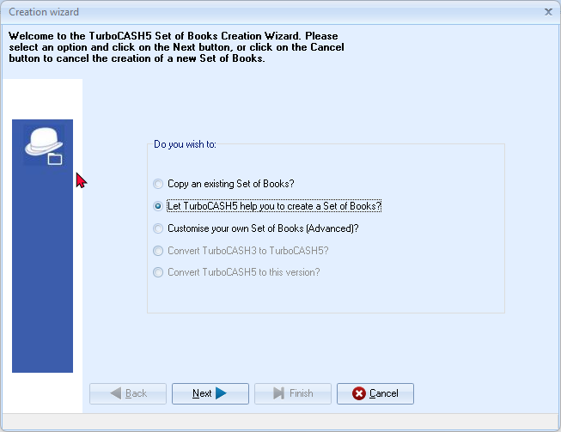
- Check that it is selected and click Next. On the next screen, (“Which Chart of Accounts you wish to use?”) you need to select a template (existing Set of Books).
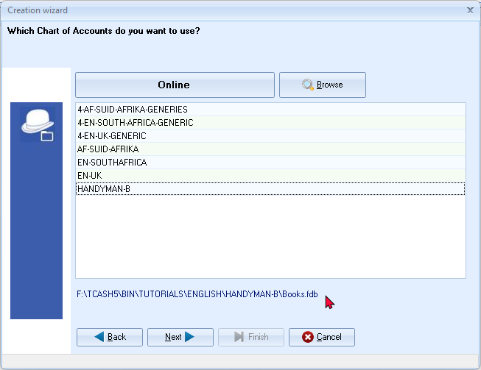
- The Download online - ”Which Chart of Accounts do you want to use?” will automatically be launched. 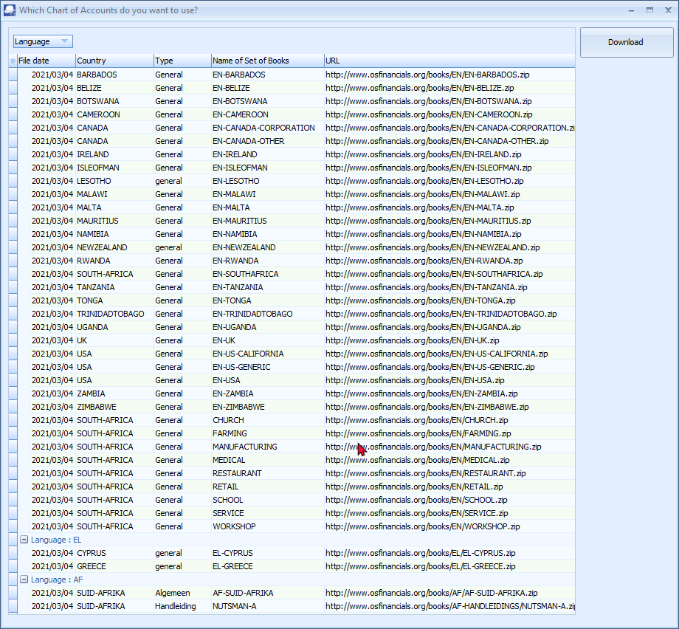
- If you do not wish to download a Set of Books from the osFinancials website at this stage you may close this screen.
You may access the “Download books” screen, when clicking on the Online button on the “Which Chart of Accounts you wish to use?” screen.
These downloadable books are updated for 2025.
Updated versions of these Sets of Books (except the Netherlands and Island) are included in the install of TurboCASH5..
If you wish to download a Set of Books from the osFinancials website, click on the Online button. You may select any of these templates (Firebird databases) for your country and language.
You need an Internet connection to download a Set of Books.
If you do not have Internet access, the download screen will automatically be closed.
- You may proceed to select a Set of Books as a template on which you wish to create your new Set of Books:
  - Select a Set of Books from the list.
  - Browse button - Click to select a Set of Books (Firebird database type) stored on your system. You may select a valid Set of Books from the following options:
  - Locate a Set of Books elsewhere on your system:
    - bin/Repository folder.
    - bin/Tutorials folder - Select any of the Tutorials Set of Books in ENGLISH, AFRIKAANS, Bank Import, etc.
    - bin/CUSTOMISE-EMPTY-BOOKS folder to select a basic empty Sets of Books consisting based on 3-digit, 4-digit, 5-digit, 6-digit, 7-digit and 8-digit main accounts with 3-digit-sub-accounts. This will allow you to build a Set of Books from scratch.
- Once you have selected your Chart of Accounts, click on the Next button.
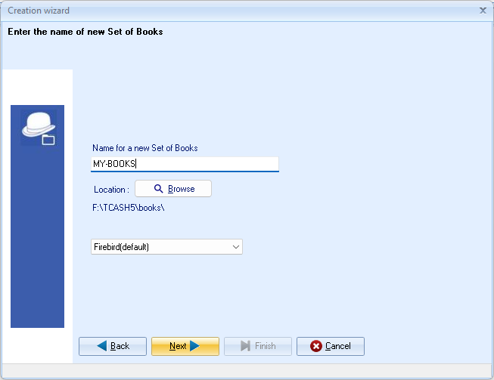
- Enter a “Name for a new Set of Books” and click on the Next button.
- The “Select Setup -> Company info you want to change” screen will be displayed:
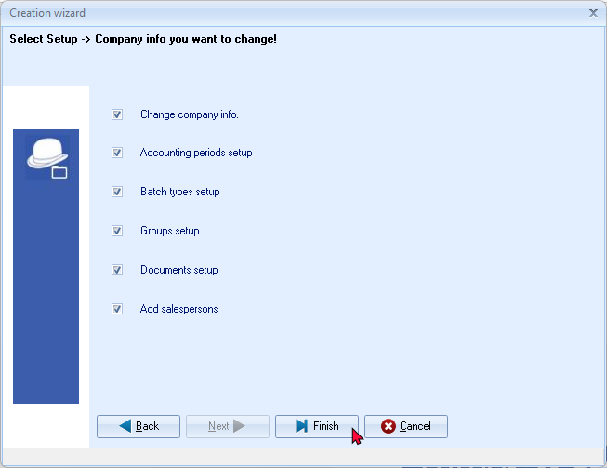
- By default, all options is selected. It is recommended that you keep all options selected to confirm or change the basic settings, if required.
- Click on the Finish button. A confirmation message will be displayed:
Are you sure you want to create the MY-BOOKS Set of Books?
- Click OK to confirm. The following screens from the Setup ribbon, as selected, will automatically be launched to enable you to set the basic information and defaults for the Set of Books:
- Company info (See – MODULE E.5.1)
- Reporting dates (See – MODULE E.5.2)
- Batch types (See – MODULE E.5.3)
- Groups (See – MODULE E.5.4)
- Documents setup (See – MODULE E.5.5)
- Stock information (See – MODULE E.5.6)
- Salespersons (See – MODULE E.5.7)
- Once you have confirmed and changed the various screens, where necessary, your Set of Books will be automatically be opened.

COMPLETING YOUR SETUP PROCEDURES
It is good practice to check all the available menus in Setup, before moving to the next step. This will take a few minutes of your time, but it will save you problems in future. We will therefore discuss the Setup menu options briefly. Before you may start with this process you need to Open your Set of Books.
To open your Set of Books:
- On the Start ribbon, select Open (Alt + O).
- Select the Set of Books, which you were creating, and click on the Open button.
SETUP
Company info
This option allows you to enter all your business' details such as the address, e-mail address, contact numbers, company and tax registration numbers. These will be displayed on all reports, statements and lists. You may also select the applicable Tax method, and the default output options for reports, statements and lists. It is also important to set the Windows default date and currency formats.
You may also load a logo picture to be displayed on your documents and / or statements. For documents you need to select to print the logo on documents.
To enter and set the company information and defaults:
- If the “Company info” screen is not automatically displayed, go to the Setup ribbon, and select Company info.
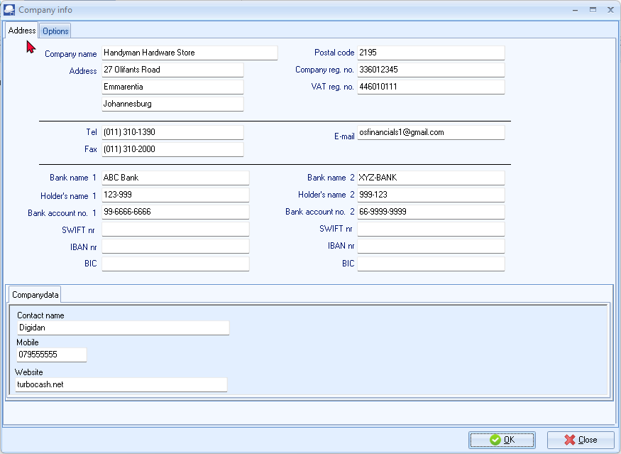
- Enter the relevant details of your company in the available fields.
Company reg. no.: | If you are registered as a company, a close corporation or a non-profit organisation, the relevant registration number must be.
Tax reg. no.: | If you are registered as a VAT/GST/Sales tax vendor, the VAT/GST/Sales tax registration number must be entered.
For the purpose of this manual, the relevant company details are already entered in the “HANDYMAN” Set of Books we have selected.
- Click on the Options button. The “Company info - Options” screen is displayed:
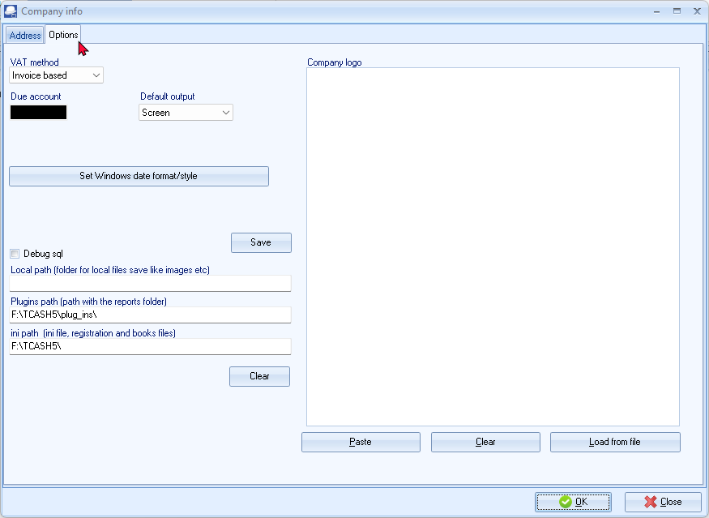
- The “Tax method” is by default set to “Invoice based”.
- Select your default output options for “screen, printer, file, fax” or “e-mail”. For the purpose of this tutorial, select “Screen”.
- Leave the “Company logo” blank, for the purpose of this tutorial.
If you have a company logo or picture, which includes the address, you may right-click on the Company logo to load the logo from a valid file format on your system.
This logo can be selected to display on documents (invoices, etc.) and statements.
- Click on the Set Windows date format/style button to set the date format of your operating system.
You may also click on the DateTime settings button on Setup → System parameters (Setup ribbon) to open the Regional and language settings in the Control Panel.
This option does not work on Linux or Apple operating systems. The settings for this, should be done via the specifics of that operating systems.
If the Set Windows date format/style button does not launch your operating system's (version of Windows™), Regional Settings, you need to open the Regional and language settings in the Control Panel to set the format of the Short date and the correct Currency symbol.

It is important to check your Windows date format, since this format will determine the format in which you will enter your dates for your transactions. It will also determine the format dates are displayed on screens and reports.
It will also determine the format in which your dates will be displayed in the lookup screens, screens, reports, debtor statements, etc.
The date for 1 March 2024 may be displayed in one of the following formats:
- YY/MM/DD - 24/03/01
- DD/MM/YY - 01/03/24
- YYYY/MM/DD - 2024/03/01
- DD/MM/YYYY - 01/03/2024
- The YYYY/MM/DD (2024/03/01) is the format, which is used in this tutorial.
- Click OK to save your changes.
Reporting dates (Periods)
To set the start of the financial year:
- If the “Reporting dates” screen is not automatically displayed, go to the Setup ribbon, and select Reporting dates.
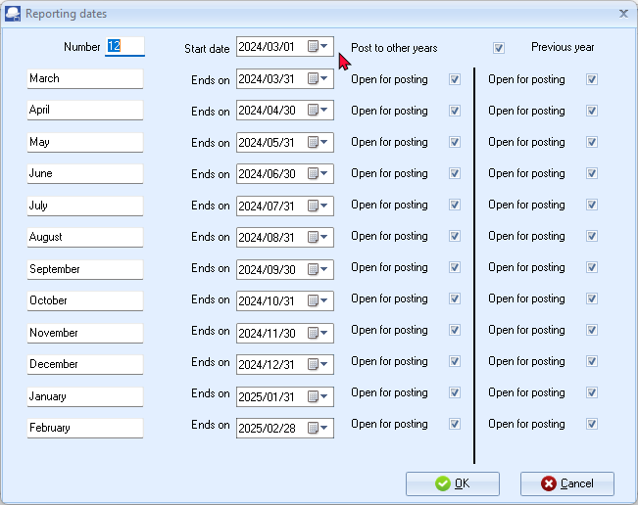
- Select the following options for the Set of Books:
  - Number - Number of reporting dates (financial periods) for which you can enter transactions and view reports. Usually the number 12 for each calendar month in a financial year is used.
  - Start date - The starting date of your financial year. For the purpose of this tutorial, it is set to “2024/03/01”.
  - Post to other years - If this box is not ticked, you will not be able to post any transactions, budgets, etc. to the financial year preceding the financial year entered in the “Start date” field.
  - Open for posting - If this box is not ticked, you will not be able to post any transactions, budgets, etc. to the financial period, which ends on the specified “Ends on” field.
  - Previous year – This option allows you to block posting to any closed financial years older than last year periods.
- Click OK.
Batch types
This option allows you to create batch to capture and enter your transactions. The Sales, Purchases, Receipts, Payments and General journal are standard defaults.
You can create any additional batches by adding them to this list. If you have more than one Bank account, you need to create a payments and receipts batch for each one. If you were initially short of batch types, you may enter additional batch types to accommodate your reporting requirements. These will not be retroactive, so thorough setting up is preferable.
Batch types | Lookup type | Contra account lookup type | Debit / Credit
Sales | Debtors | General ledger | Debit
Sales returns | General ledger | Debtors | Credit
Purchases | General ledger | Creditors | Credit
Purchase returns | Creditors | General ledger | Debit
Payments | All | All | Debit
Receipts | All | All | Credit
General journal | All | All | Allow both / Debit / Credit
You can also set the batch defaults to reduce incorrect capturing of transactions. For example, in a Sales journal, only debit entries may be entered. Batch defaults such as “contra accounts”, “contra account per line”, “inclusive” (of VAT/GST/Sales tax) or “exclusive” capture and increment reference numbers, and can only be set from within the batch.

To check and add batch types:
- If the “Batch types” screen is not automatically displayed, go to the Setup ribbon, and select Batch types.
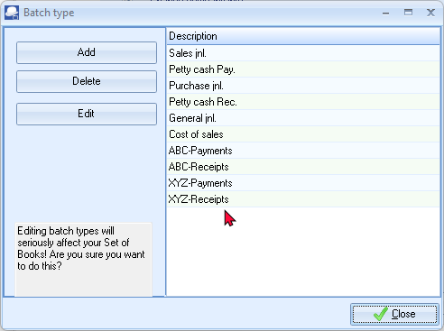
- Check that the basic batches “Petty cash Pay.” and “Petty cash Rec.” (for the Petty cash account) “Sales jnl., Purchase jnl.”, and “General jnl.” is added.
- If the “Payments jnl” and “Receipt jnl” (for the Current Bank account) is displayed, rename them to “ABC-Payments” and “ABC-Receipts”, for the purpose of this tutorial – (See – MODULE F.1.3.1).
You may click on the Edit button to set the options for this batch.
You may also click on the F10:Setup button on the “Batch entry” screen) Batch entry (Default ribbon).
- Click Close.
Groups
This option allows you to set up to 2 reporting groups for your general ledger accounts, debtors and creditors, stock and documents. These reporting groups will allow you to select the applicable reporting category within the available reporting groups. When you generate reports or documents, you may also select these groups to print reports or to filter for specific reporting groups.
For the purpose of this tutorial, the basic settings for reporting groups 1 are already set in the “HANDYMAN” Set of Books we have selected.
Account groups
This option allows you to set up to two (2) reporting groups for your general ledger accounts, debtors and creditors, stock and documents. These reporting groups will allow you to select the applicable reporting category within the available reporting groups.
When you generate reports or documents, you may also select on some of the “Report options / parameter” screens to generate reports or documents for specific reporting group(s).
To set the groups:
- If the “Groups” screen is not automatically displayed, go to the Setup ribbon, and select Groups.
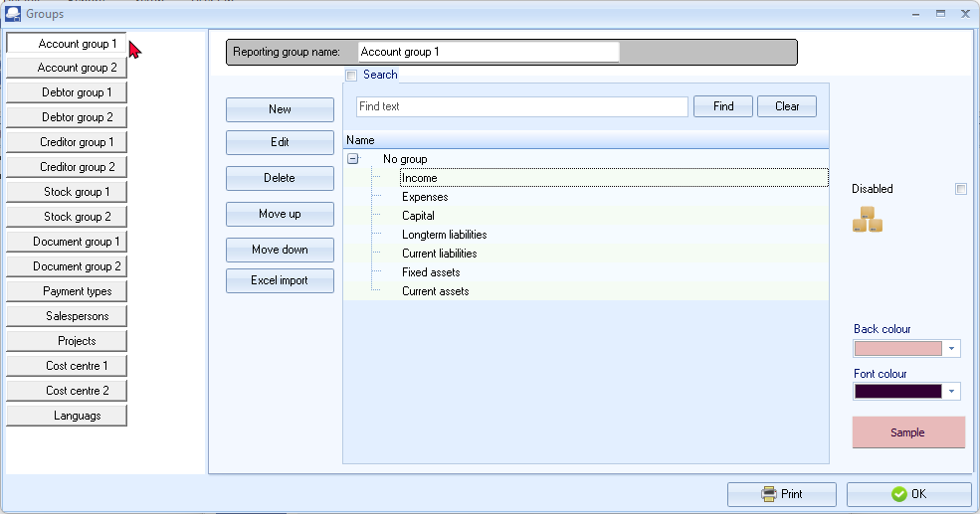
You may click on the Print button to print a list of the groups.
Select the groups and use the Move up and Move down buttons to change the sequence. For the purpose of the tutorial, move the groups to display Income, Cost of sales, Expenses, Capital, Longterm liabilities, Current liabilities, Fixed assets and Current assets, if necessary.
This will determine the sequence in which your Groups are listed on the Accounts (Setup ribbon) and on the Ledger analyser1 / 2 (Reports ribbon) is displayed, when Reporting group 1 is selected.
- Check the “Account groups” and click OK.
For the purpose of this tutorial, the basic settings for reporting groups 1 are already set in the “HANDYMAN” Set of Books we have selected.
You may set colours (Background and Font colours) to be displayed on the Ledger analyser.
To add colours for account groups:
- Click on the Back colour button and select the colour.
- Set the Font colour (necessary to store the colours).
- Click on the OK button of the “Color” window.

Creditor groups
To illustrate the colours on the “Creditors – List view” screen, add the following two (2) groups for Creditor group 1:
- Creditor group 1A
- Creditor group 1B
Set the Background and Font colours for these groups.
Debtor groups
To illustrate the colours on the “Debtors – List view” screen, add the following two (2) groups for Debtor group 1:
- Debtor group 1A
- Debtor group 1B
Set the Background and Font colours for these groups.
Stock groups
To illustrate the colours on the “Stock items – List view” screen, add the following two (2) groups for Stock group 1:
- Stock group 1A
- Stock group 1B
Set the Background and Font colours for these groups.
You may also add images for Stock group 1 to be displayed on the Button lookup, if activated on Stock information. (Setup ribbon).
Images may be added for each Stock item in the Images tab on the “Stock items” edit screen (Default ribbon).
Document groups
To illustrate the colours on the “Documents – List view” screen, add the following two (2) groups for Document group 1:
- Document group 1A
- Document group 1B
Set the Background and Font colours for these groups.
Documents setup
This option allows you to set up defaults for your documents. The defaults for all document numbers to begin with 000001 (prefixed by 2 alphabetical characters IN for Invoices, CR for Credit notes, PU for Purchase documents, SR for Supplier returns documents, OR for Orders and QU for Quotes), but you may change this to suit your needs. Thereafter the document numbers will automatically allocate the document numbers in the numerical sequence they were generated.
The default Batch types have been pre-set for each document type (i.e. Invoices, Credit notes, Purchases and Supplier returns).
You may also specify the heading, message for each document type.
By default, comments is inserted below a selected item. The option "Append notes below item" (Setup → Documents setup (Setup ribbon)) is added to set the preference if comments should be added before, or below (default option), a selected item when processing documents and printing comments on layout files.

The default "Append notes below item" setting is not selected. It will display on document lines and document layout files as follows:
- Comment
- Item
- Remark
The "Append notes below item" setting is TICKED (selected). It will display on document lines and document layout files as follows:
- Item
- Remark
- Comment

To set the defaults for documents:
- If the “Documents setup” screen is not automatically displayed, go to the Setup ribbon, and select Documents setup.
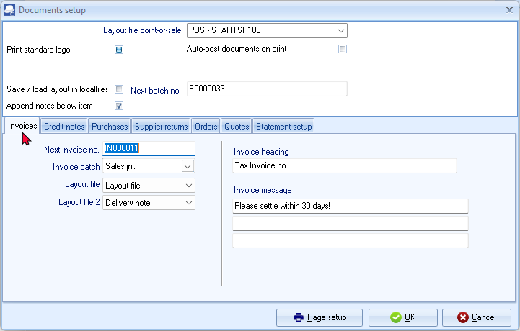
For the purpose of this tutorial, the relevant settings for documents are already set in the “HANDYMAN” Set of Books we have selected.
- Click on each of the tabs and check or change the following, if necessary:
Layout file point-of-sale: | - Leave as is.
Print standard logo: | - Remove tick.
Next batch no. | - Leave as is.
Auto-post on print: | - Leave blank.
Save / load layout in local files: | - Leave blank.
Append notes below item: | - Tick for the purposes of this tutorial. This will insert the comments below a selected stock item in the document lines, and print it below the stock item on layout files when printing documents.
Next invoice no.: | - For the purpose of this tutorial, all documents should start with 000001 prefixed by 2 characters (i.e. IN000001 for Invoices, CR000001 for Credit notes, PU000001 for Purchases, SR000001 for Supplier returns, OR000001 for Orders and QU000001 for Quotes).
Invoice batch: | - Select the “Sales jnl.” for Invoices.  - Select the “Sales jnl.” for Credit notes.  - Select the “Purchase jnl.” for Purchases.  - Select the “Purchase jnl.” for Supplier returns.  You cannot select a batch type for Orders and Quotes, since they need to be confirmed and cannot be posted (updated to the ledger).
Layout file: | - Select “Layout file” on the other tabs. These are the global default settings for each document type.
Layout file2 | - Leave blank.
Invoice heading: | - For the purpose of this tutorial, the headings are already set.
Invoice message: | - For the purpose of this tutorial, the messages for each of these documents are already entered.
- Click on the Statement setup tab to enter up to 3 Statement message lines to print globally on all Debtor statements (Reports → Debtors → Debtor statement menu (Reports ribbon).
- Click OK to save your changes and close / exit this screen.

Stock information
This option should be used if you need to generate sales documents (quotes, invoices and credit notes) and / or purchase documents (i.e. purchases, supplier returns and orders). The “Stock information” screen consists basically of five (5) sections (i.e. “Unit size, Selling prices, Cost of sales, Documents setup” and “Tax classes”).
To set the stock information and cost of sales parameters:
- If the “Stock information” screen is not automatically displayed, go to the Setup ribbon, and select Stock information.
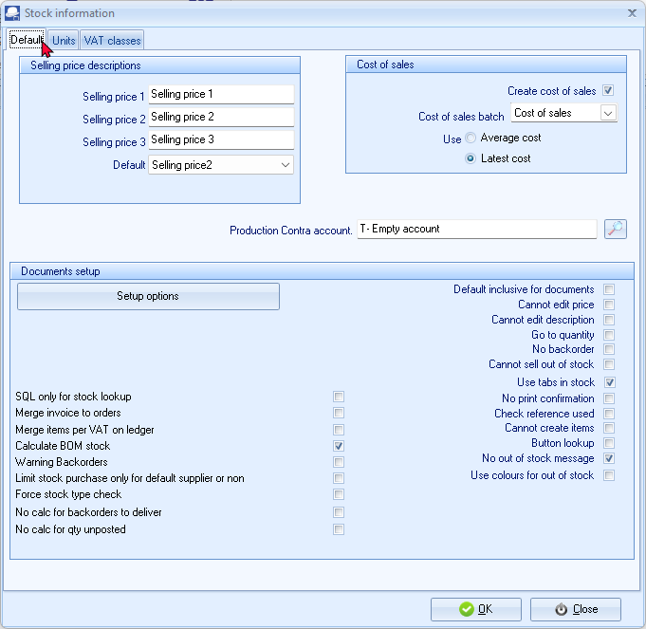
- Units - Check that “Each” and “Hours”, is displayed. If not; enter these and click on the Add button.
- Selling price descriptions –
- Selling price descriptions – The Default (Selling price 1, Selling price 2, Selling price 3) is displayed. You may over-type these with your own.
- Default – The default selling price as the global setting. Select Selling price 1 for the purpose of this tutorial.
You may set a different selling price for specific debtor (customer / client) accounts on the Debtors - Accounting information tab (Default ribbon).
- Cost of sales - settings – This is applicable to the Default (trading stock) stock type only. Select the following:
  - Create Cost of sales – Select (tick).
  - Cost of sales batch – Select the Cost of sales batch.
  - Use “Average cost” or “Latest cost” option. For the purpose of this tutorial, the “Average cost” option is selected.
This setting is very important for calculating the value of your stock. If you are not sure whether to use “average cost” or “latest cost”, please consult with your accountant. The value of your stock can affect your profit and loss figures.
- Documents setup – The rest of the options (tick boxes) are used to set and configure document processing. Deselect (remove the tick) for all these options; if necessary.
See – MODULE J.2 – SETTINGS / CUSTOMISE DOCUMENT PROCESSING – Setup stock information.
- Tax classes – You may add a Tax classes and link your Tax (VAT/GST/Sales tax) codes. You may select these Tax classes to link your stock items (products).
- Click OK to save your changes and close or exit this screen.

Salespersons
This option allows you to add / delete the salespersons, who sell your stock items or services. Salespersons may be selected on sales documents (quotes, invoices and credit notes).
You may select the default salesperson for each debtor account. When sales documents are generated and the debtor (customer / client) account is selected, the default salesperson will be displayed for the document or you may select any available salesperson.
This feature makes it easy to see who made the most sales or did not make target. It is also a useful tool if it is necessary to pay commission on those sales.
Salespersons may also be selected for purchase documents (i.e. purchases, supplier returns and orders). This allows you to see who handled the purchase document.

To check the salespersons:
Salespersons may also be added or deleted in the Groups (Salespersons) (Setup ribbon).
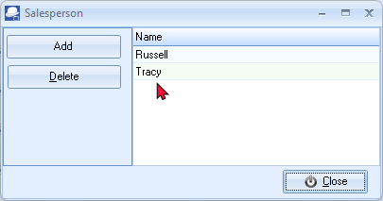
- If the “Salesperson” screen is not automatically displayed, go to the Setup ribbon, and select Salesperson.
- Check “Tracy” and “Russell” are displayed as salespersons.
- Click Close.
For the purpose of this tutorial, we have included Tracy and Russell as the salespersons.
To add a salesperson:
- Select the Salesperson on the Description list where you need to add a new Salesperson.
- Click on the Add button. An entry displaying “Change name” will be inserted above the selected Salesperson.
- Over-type the “Change name” on the list with the name for your Salesperson.
- Click on the Close button.
Printer
This option allows you to select the default printer. You may set and configure up to two (2) Reporting printers and Ticket printers and up to nine (9) user printers. Other printers that may be configured, are:
- Plain text printer
- Full plain text printer
- Character-based printer
- Graphics printer
It is recommended that you select the printer with which you intend to print most of your reports and / or documents.

Access control (Optional)
This option allows you to set the default language and security options for a specific Set of Books. User passwords and access levels may also be set. You may have as many users to work on a Set of Books as you wish. You may set differing passwords for each user, in order that they are enabled to perform only the function(s) assigned to them.
Multi-user plugin
This version of TurboCASH5, may be configured and set up a Network server for multi-users. To enable the full multi-user functionality, you need to purchase a multi-user license and register TurboCASH5 as a multi-user product.

Setup menu
Financial categories
This option allows you to link your available reporting groups (which you have already set up on the Account groups tab) to one of the Assets, Capital, Expenses, Income, or Liabilities categories. It is important to base this linkage, to the respective categories, on the accounting equation.
Once your reporting groups for Account groups 1 and / or 2 is added, you need to link each of these to a financial category (i.e. Assets, Capital, Expenses, Income or Liabilities).
It is important to base this linkage, to the respective categories, on the accounting equation. Please refer to MODULE A – INTRODUCTION TO ACCOUNTING for more information.
The following two (2) options are available to link the financial categories:
- Setup → Financial categories (Setup ribbon).
- Setup → Accounts (Setup ribbon).
To link groups to financial categories:
- On the Setup ribbon, select Setup → Accounts.
- Select Financial categories. The Groups as created on “Account groups” screen “Reporting group 1” will be listed in the “Accounts” screen:
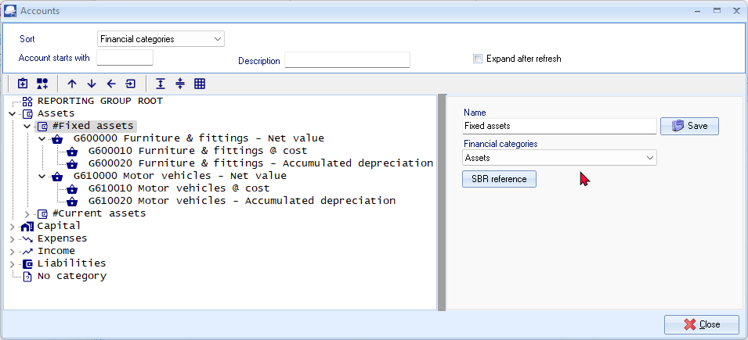
- Select a Group and select a Financial category (i.e. Assets, Capital, Expenses, Income or Liabilities) from the list.
- Click on the Save button to save your changes.
- Repeat the process for all the Account groups.
- Once finished with Reporting group 1, select Reporting group 2 and repeat the link process.
The Save button will only be displayed (next to the “Name” field of the Financial category), once any changes are made.
You need to click on the Save button to save the changes. If you do not do this, your changes will be lost.
Account groups - Reporting group 1 and 2 – The sequence in which the groups and accounts are listed, may be changed in Groups. (Setup ribbon) This is done by selecting the groups on the list and use the Move up or Move down buttons.
In this tutorial, we have created Accounts - Reporting groups 1 and 2 which is set to different sequences:
Reporting group 1 | Reporting group 2
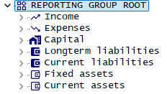 | 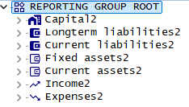
This will enable you to generate general ledger reports (i.e. Trial balance, Income statement, Balance sheet, Chart of accounts, to list accounts and balances to be listed according to Reporting group 1 or according to Reporting group 2 sequences.

System parameters
This option allows you various options to configure your Set of Books. These are:
- Report amounts with – This is not applicable to TurboCASH5.
- Data storage - Set the rounding of decimals or no rounding (real numbers).
- Reporting decimals -
- Number - Set the number of decimals to be displayed on screens, reports and documents. For most Sets of Books these should be set to “2”.
- Date/Time Settings - This will launch the “Regional and language” options in which you may configure or set the formats of your operating system. (See – Company info – Options in MODULE E.4.1).
- Use currency symbol - You may also select to display the default currency symbol of your Windows operating system on screens, reports and documents.
- Dutch text numbering - This setting is used when creating receipts from the “Create receipts” (F9:Process option in receipt batches) or the “Receive payment” option in Open item link (Default ribbon). For most languages, this option should not be selected. If you wish to create and print a receipt in the Dutch language, select this option. It will display (print) the number to words for the Dutch language correctly.
- Speed – Do not calculate batches - This is not applicable to TurboCASH5.
- Special settings -
- Show calendar - By default, this option is not selected. If you select (tick) this field, the Calendar will be the default view when opening the Set of Books.
- No warning unposted - This option is not applicable to TurboCASH5.
- Contra ref as account reference - By default, this option is not selected. This is the global settings for batches.
- Strict tax on account - By default, this option is not selected. This is the global settings for batches.
- Projects - By default the Projects feature is not enabled. If this option is selected, it will activate the Projects in Projects (Default ribbon).
- Default bank reconciliation method - by default, this option is selected (ticked). The bank transactions are manually entered from source documents in the Payments and Receipts batches. The bank reconciliation using the default method is discussed in this tutorial.
The Online Bank Plugin allows you to import the transactions from your bank statement and allocate these transactions to the accounts. This will be dealt with in separate documentation.

    - Enable Blockchain -
See video on osFinancials and Blockchain.
    - Enable auto set inactive debtor after x days unpaid – Not tested yet.
    - General ledger differences – You may create a general ledger account (Accounts (Setup ribbon)) and select that account in this field. If there any rounding differences, it will be posted to this account.
    - Log Level – “Off” is the default setting. It may be set up to level 7. You may print the log report in Access control (Setup ribbon).

Internet (Optional)
You to set your Internet in order to send reports, statements and lists to any person or institution by e-mail. You need to specify your e-mail's outgoing mail server as your Internet Service Provider has set up your e-mail account on your computer system. You may also test your e-mail server, and view the test log file from this option.
If you have set up any users on the system, the user's User ID and his/her e-mail address, that is logged on in the Set of Books and his/her e-mail address will be displayed in this screen.
This option will only be available to the users that have been granted access for “System setup” under Access control, but all users, with a valid e-mail address will be able to send reports, statements and lists on the Internet.
In this version of TurboCASH5, you may configure and set up a Network server. You may also update the data and transactions to the Network Server and restore a Set of Books from a remote Network sever.
Currency (Optional)
Multi-currency is implemented when processing documents. On the Setup → Currencies (Setup ribbon), you may add currencies. When processing documents, you may select the currency. The document layout files for sales documents (i.e. Quotes, Invoices and Credit notes), and / or purchase documents (i.e. Purchases, Supplier returns and Orders) will print in that currency.
Point-of-Sales (Optional)
Point-of-Sale can be set up if you are selling stock items. Improved security and access control has been added for users to access or start a Point-of-Sale session or shift. You may now link the salespersons (cashiers) added in the Salespersons (Setup ribbon) to users on the Others tab of the Access control (Setup ribbon). This feature will add more security when users access or start a Point-of-Sale invoicing session.
Theme
Users may change the appearance of the TurboCASH5 interface by selecting available themes on the Themes menu (Setup ribbon). Users may personalise their TurboCASH5 interface by selecting from available themes on the Themes menu (Setup ribbon) makes the experience more enjoyable and tailored to individual preferences.
You may choose between the “Classic, Material, Classic, Blue, Glass, Silver, Soft-blue” or “VS2010” themes.
If the “Classic,” or “VS2010” themes are selected, the icons in the “Classic” theme will be displayed.

In addition to the Material theme's black icons, you may select other coloured variants such as "Material-blue, Material-green, Material-maroon, Material-navy" or "Material-pink". Selecting a different theme from the Theme menu allows you to customize the interface to your preferences.
The “Material-navy” theme is used for screen captures in this book.
You may change the default Background1.jpg with your own image (photo, logo, products), etc.

SETTING UP ACCOUNTS

IN THIS MODULE
MODULE F - SETTING UP ACCOUNTS 156
F.1- SETTING UP GENERAL LEDGER ACCOUNTS 158
F.1.1- PLANNING YOUR CHART OF ACCOUNTS 158
F.1.2- EDITING YOUR CHART OF ACCOUNTS 159
F.1.3- CREATING / EDITING BANK ACCOUNTS 164
F.1.3.1- Renaming an existing bank account 164
F.1.3.2- Creating a new bank account 165
F.2- CREATING / EDITING TAX ACCOUNTS 166
F.2.1- Tax Account Structure 167
F.2.2- Add Tax codes (Tax accounts) for a Tax type 167
F.3- CREDITOR (SUPPLIER) ACCOUNTS 169
F.3.1- CREATING / EDITING CREDITOR (SUPPLIER) ACCOUNTS 170
F.3.2- CREATING / EDITING CREDITOR (SUPPLIER) ACCOUNTS 171
F.3.3- CREATING A CREDITOR ACCOUNT FOR OPENING BALANCES 174
F.4- DEBTOR (CUSTOMER / CLIENT) ACCOUNTS 175
F.4.1- CREATING / EDITING DEBTOR (CUSTOMER / CLIENT) ACCOUNTS 176
F.4.2- CREATING A DEBTOR ACCOUNT FOR OPENING BALANCES 179
F.5- PRINTING LISTS OF ACCOUNTS, DEBTORS AND CREDITORS 180
F.5.1- PRINTING ACCOUNTS LISTING (CHART OF ACCOUNTS) 180
F.5.2- PRINTING DEBTOR LISTING 182
F.5.3- PRINTING CREDITOR LISTING 183

SETTING UP GENERAL LEDGER ACCOUNTS
PLANNING YOUR CHART OF ACCOUNTS

Account type | Brief description of the Account type
Bank accounts | Bank accounts should be linked to a Receipts and Payment journal (batch).
General ledger accounts | Accounts are aligned to either an Income / Expense or Balance sheet type.  The Balance sheet account type, needs to include the following 3 control accounts;  - Retained earnings / income.  - Creditor's control account.  - Debtor's control account.
Tax accounts | Accounts containing the Tax percentages. These are the Output Tax and Input Tax codes.  These are country specific and should contain the VAT / GST / Sales tax terminology and codes as prescribed by the tax authority of your specific country.
Creditor (supplier) and debtor (customer / client) accounts, are created, edited or deleted from the Default ribbon.
Ribbon option | Brief description of the account type
Creditors | Creditor (supplier) accounts containing the details of the creditors, remittance advice messages, contacts, land terms. It also contains detail of processed transactions and a list of purchase documents (i.e. Purchases, Supplier returns and Orders).  The total of all individual accounts in the Creditor's ledger will be displayed as the Creditor's control account in the General ledger.
Debtors | Debtor (customer / client) accounts containing the details of the debtors, statement messages and terms. It also contains detail of processed transactions and a list of sales documents (i.e. Invoices, Credit notes, Quotes and Point-of-Sale invoices).  The total of all individual accounts in the Debtor's ledger will be displayed as the Debtor's control account in the General ledger.
Plan your chart of accounts according to the following guidelines:
- Increment each account number by either 5 or 10 to cater for future additions.
- If possible, list your accounts in alphabetical order.
- Group similar accounts in similar predefined ranges e.g. 600 - 699 for “Fixed assets”.
- List your accounts in the order in which you would like them reported.

TurboCASH5 allows for 999 main accounts. Each account may also have up to 999 sub-accounts. This should be enough for most businesses.
The Chart of accounts should be carefully planned so that the accounts fall in the required ranges.
Some Sets of Books may contain 4-digit main, and 5-digit main accounts. The option to “Customise your own Set of Books (Advanced)?” on the “Creation wizard” (Create Set of Books (Start ribbon)), allows you to create your own Set of Books from scratch. This will then ask you to specify the number of digits for accounts (from 3 to 8-digits). You need to enter the following 3 control accounts;
- Retained earnings / income.
- Creditor's control account.
- Debtor's control account.
The following ranges (based on the 3-digit main account codes) are an example that you should try to follow. It is NOT the Chart of accounts you will be using - it is merely a guide as to the ranges.
Description | Range | Group
Total chart | 001-999
Income | 001-099 | Income
Expenses | 200-499 | Expenses
Capital | 500-599 | Capital
Fixed assets | 600-699 | Fixed assets
Current assets | 700-899 | Current assets
Current liabilities | 900-999 | Current liabilities
Tax Codes for Tax main account | 850-860 | Current liabilities
Bank account + Positive balance | 810 | Current assets
Bank account – Negative balance (O/D) | 910 | Current liabilities
EDITING YOUR CHART OF ACCOUNTS
In the Setup → Accounts (Setup ribbon) you may create, edit, delete accounts (general ledger, bank and tax) as well as enter and edit budget figures for accounts.
When creating or editing accounts you need to link the accounts to Account groups 1 and / or Account group 2. These Account groups must be linked to Financial categories.
For the purpose of this tutorial, the Account groups, have already been created and linked to Financial categories.
The Setup → Accounts (Setup ribbon) allows you to create Reporting Groups and link these Account groups to Financial categories for the Balance sheet (i.e. Assets, Capital, Liabilities) and Financial categories for the Income statement (i.e. Income and Expenses).
In addition to this, you may create Account group 1 and / or Account group 2 in Setup → Groups (Setup ribbon) and link them to the Financial categories. These Account groups may also be linked to Financial categories in the Setup → Financial categories (Setup ribbon).
To create a new ledger account:
- On the Setup ribbon, select Setup → Accounts.
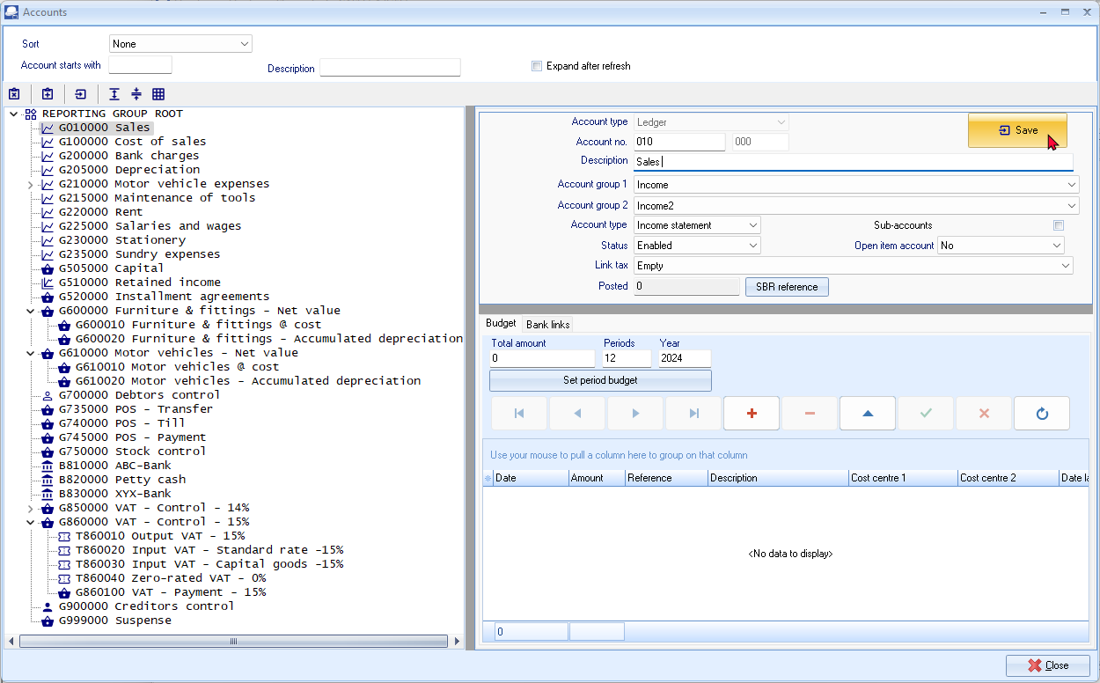
- You may filter and search for accounts and account groups as follows:
Search/Filter option | Description
Sort: | The default is “None”. - This will list all accounts according to the account number (code).  You may select to sort / list accounts according to Reporting group 1 or Reporting group 2 or Financial categories.
Account starts with: | Filter your accounts by entering the first digit of the account number (code). For example entering 2 will list only those account numbers starting with 2 (e.g. 200 to 299). To filter the list further, you may, for example, enter 21 to list only those accounts from 210 to 219.
Description: | Enter any character in the account description. Only those accounts containing that character will be listed (e.g. “B” will list all accounts containing the character “b”. By typing “BANK” in this field, only the accounts containing bank in the account description field will be listed.
Expand after refresh: | If this field is selected, the expanded list of accounts will be displayed (when clicking on the Refresh icon (or clicking on the “Refresh” option on the context menu).
The icons indicates the following:
Account groups | Financial categories
 | 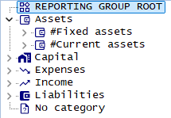
Account groups - Reporting group 1 and 2 – The sequence in which the groups and accounts are listed, may be changed in Groups. (Setup ribbon). This is done by selecting the groups on the list and use the Move up or Move down buttons.
In this tutorial, we have created Accounts - Reporting groups 1 and 2 which is set to different sequences:
Reporting group 1 | Reporting group 2
This will enable you to generate general ledger reports (i.e. Trial balance, Income statement, Balance sheet, Chart of accounts, to list accounts and balances to be listed according to Reporting group 1 or according to Reporting group 2 sequences.
Icons for accounts:
Icon | Account type | Reported on | Description
 | Income / Expense | Income statement | Income – Expenses = Net Profit / Loss
 | Assets / Liability | Balance sheet | What you own = Assets  What you owe to others = Liabilities
 | Bank | Balance sheet | Current assets
 | Tax | Balance sheet | Current liabilities (Output Tax – Input Tax)
 | Retained earnings / income | Balance sheet | Capital (Profit / Loss – Previous Years)
 | Debtor's control | Balance sheet | Debtor's control = Current assets
 | Creditor's control | Balance sheet | Creditor's control = Current liabilities

Processing Icons and Context menus:
Account groups
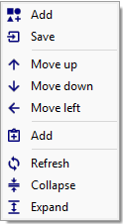  Add Group.  Save - Only activated, if any group financial category or account, is changed.  Delete - A selected Group / Account / Sub-account.  Move up - selected Group up 1 entry.  Move down - selected Group down 1 entry.  Move left selected Group to the left.  Add - new Account / Add new Sub-account.  Refresh the items on the Groups / Accounts list.  Collapse the expanded Groups / Accounts list.  Expand the short list of Accounts and Groups. | The Delete icon (option) will not be available for the following accounts:  - Accounts which has any transactions processed (posted). The “Posted” field display a value of more than 0.  - The Retained earnings / income account.  - The Delete icon (option) is available for Debtor's control and Creditor's control accounts. Trying to delete these control accounts, will produce an error message “You cannot delete a control account!”.
Accounts
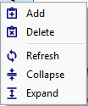
Add Account / Add Sub-account.
Delete a selected Account / Sub-account.
Save – Only available if an account is edited,
Refresh the items on the Groups / Accounts list.
Collapse the expanded Groups / Accounts list.
Expand the short list of Accounts and Groups.

Options to add, edit accounts:
Field | Description
Account type: | Select the following options:  - Ledger Income / Expense , Asset / Liability / Capital accounts, Retained earnings (Retained income), Debtor's control and Creditor's control accounts.  - Bank account will allow you to link a Payments and Receipts batch on the Bank tab.  - Tax will allow you to set the tax percentage for (VAT/GST/Sales tax) and specific tax settings.  This field may only be selected for a new account. For existing accounts; this field will be disabled.
Account number: | This consists of 2 parts. The first block is for the main account; and the second block for the sub-account.
Description: | The description for the account which will be used to lookup (select) accounts. This is also the description which will be displayed on reports.
Account group1: | This is used to group and classify the accounts on reports.
Account group2: | This is used to group and classify the accounts on reports.
Type: | Balance sheet accounts – (i.e. Capital, Liabilities and Assets) or Income statement accounts (i.e. Income or Expense).  Balance sheet accounts retains the balances of the previous financial year (opening balances).  Income statement accounts – these accounts are closed off during the Year-end process and the balance (Net Profit / Loss) is transferred to the Retained Earnings / Income account.
Sub-accounts: | Select this option to create a main account. Once this option is selected, you first need to click on the Save button before you are allowed to create sub-accounts for that main account. You may then create sub-accounts for this main account.  You will not be allowed to process (post) any transactions; or enter / edit any budget figures to the main account. All transactions and budget figures are entered on sub-accounts. The total of these individual sub-accounts will add up to the main account.  To delete a main account, you first need to delete all sub-accounts.
Status: | By default, all accounts are enabled (active). Once you have any transactions processed (posted) to an account, you may not delete the account.  You may then select the “Disabled” option to block a selected account or sub-account.  This will disable; or set the selected account's status to inactive. This will produce error messages to remind you that the account or sub-account is disabled, when trying to process (post) transactions to the disabled account or sub-account.
Open item account: | By default all accounts are set to “No”. If you select the “Yes” option, you may select to link (match) a receipt transaction to a debit transaction; or a payment transaction to a credit transaction, etc.  This feature is useful when, for example, you need to control specific payments to specific transactions and specific receipts to specific transactions.
Posted: | This field indicates the number of transactions processed (posted) for the selected account. Once any transactions have been processed (posted) (the value is more than 0), you will not be allowed to delete the account.
Link tax: | Link a Tax account to a ledger account. This will then be the default tax account when selecting the ledger account when processing transactions in the payments journal, receipts journal or other journals (batches).
Only the “Account type, Account number, Description, Group 1” and “Group 2” fields will be displayed for control accounts; i.e. Retained Income and for Debtor's control and Creditor's control.
The Save button will only be displayed (next to the “Description (Account name)” field), once any account is created or any field of an existing selected account is changed.
You need to click on the Save button to save the changes. If you do not do this, your changes will be lost.

CREATING / EDITING BANK ACCOUNTS
You will be using this option whenever you wish to create a new bank account, change the descriptions of an existing account, or to delete an existing account.
You may have more than one Bank account and wish to add this to your Chart of accounts. TurboCASH5 will have set up a Bank account for you in your selected template. (We have used account number “810-000 - Current Bank account”).
If you wish to add another Bank account remember that in planning your Chart of accounts you would like accounts of a similar nature to be grouped together.
Bank accounts must be linked to a unique Payments and Receipts batch.
Renaming an existing bank account
To rename an existing bank account:
- On the Setup ribbon, select Setup → Accounts.
- Select the “810-000 - Current Bank account” (Current assets - Reporting group), if not already displayed as “ABC – Bank”.
- Replace (over-type) “Current Bank account” with “ABC-Bank” in the “Description” field.
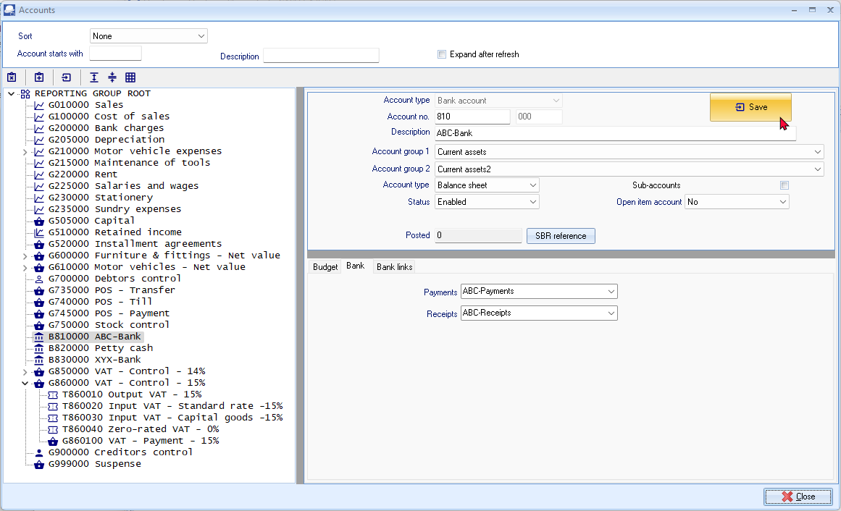
- Enter “ABC-Payments” and the “ABC-Receipts” batches.
- Click on the Save button.
It is recommended to type your own Payments and Receipts batch names in the Bank tab of the Bank account when creating a Bank account.
If you have edited the Payments jnl. and Receipts jnl. in Batch types (Setup ribbon), the descriptions would be available to select from the list (See – MODULE E.4.3). You may delete these Payments jnl. and Receipt jnl. in Batch types (Setup ribbon).
Creating a new bank account
To create a new bank account:
- On the Setup ribbon, select Setup → Accounts.
- Select the last Bank account (e.g. “B820000 - Petty cash”) (Current assets – Reporting group) and click on the Add:Account icon (or select the Add on the Context menu). An Entry for the new Ledger account is displayed as “B821000 - Account name” on the account list.
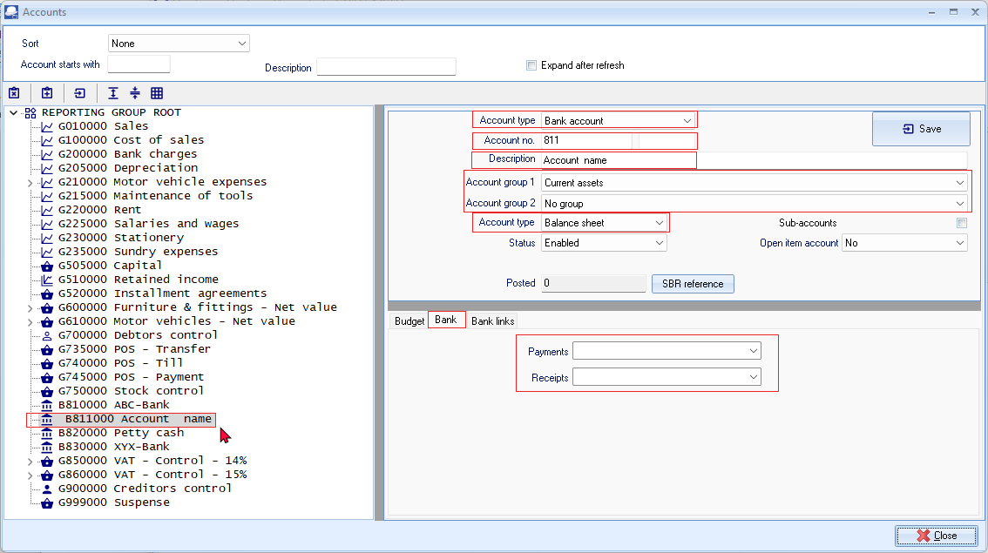
- Enter or select the following:
Account type: | - Select “Bank account”.
Account No.: | - Replace “821” with “830”.
Description: | - Replace “Account name” with “XYZ-Bank”.
Account group 1: | - Select “Current assets”.
Account group 2: | - Select “Current assets2”.
Type: | - See that “Balance sheet” is selected, since the Bank account needs to be reported on the Balance sheet.
Sub-accounts: | - Do not tick. You cannot create sub-accounts for bank accounts.
Status: | - “Enabled” (default) should be selected.
Open item account: | - “No” (default) should be selected.
Link Tax: | - “Empty” (default) should be selected.
- Click on the Bank tab.
- Enter “XYZ-Payments” and the “XYZ-Receipts” batches.
When saving the bank account, the “XYZ-Payments” and the “XYZ-Receipts” batches will automatically be created. You may edit these batches in the Batch types (Setup ribbon).
If the “Default bank reconciliation method” option is not selected (tick removed) on Setup → System parameters menu (Setup ribbon); the “Payments” and “Receipts batch” fields will be combined. You may then select either the Payments journal or the Receipts journal.
Once any transactions is posted (updated to the ledger) for a selected bank account; you cannot change the Payments or Receipts batches.
- Click on the Save button.
CREATING / EDITING TAX ACCOUNTS
You use this option whenever you wish to create a new tax account for VAT/GST/Sales tax where you have to charge a percentage of Tax on your sales (Output Tax) and may claim some percentage on your purchases (Input Tax).
Being registered for VAT/GST/Sales tax, you will have two basic accounts, i.e. Output Tax that is charged when selling services or goods (not trading stock), and Input Tax when you purchase from another registered VAT/GST/Sales tax vendor.
Within these Tax types you may need to create additional sub-accounts to accommodate the various classifications and / or tax percentages to assist you in completing your VAT/GST/Sales tax returns and make correct payments to the Tax authorities.
You use this option whenever you wish to create a new tax account for VAT/GST/Sales tax where you have to charge a percentage of Tax on your sales (Output Tax) and may claim some percentage on your purchases (Input Tax).
Being registered for VAT/GST/Sales tax, you will have two basic accounts, i.e. Output Tax that is charged when selling services or goods (not trading stock), and Input Tax when you purchase from another registered VAT/GST/Sales tax vendor.
Within these Tax types you may need to create additional sub-accounts to accommodate the various classifications and / or tax percentages to assist you in completing your VAT/GST/Sales tax returns and make correct payments to the Tax authorities.
Tax Account Structure
Basic Output Tax (VAT/GST/Sales tax and Input Tax (VAT/GST/Sales tax) accounts as sub-accounts of the Tax - Control account (in the Current liabilities account group) are already included in the templates.
The basic tax account structure, in the HANDYMAN Sets of Books, is as follows:
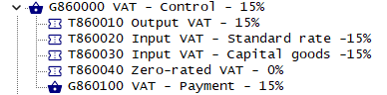
This tutorial is based on tax (VAT) at a rate of 15% for taxable transactions.

The Tax authorities may impose changes in the VAT (GST/Sales tax) rates. For example, in South Africa, the South African Revenue Services (SARS), changed the VAT rate from 14% to 15% on 1 April 2018.

Press F1 and Search for “Change Tax Rates” in the help. This will describe how to configure, manage and process transactions in TurboCASH5 to accommodate changes in the tax rates (i.e. VAT based on 14% tax for taxable transactions up to 31 March 2018 and 15% for taxable transactions as from 1 April 2018).

Add Tax codes (Tax accounts) for a Tax type
In this tutorial, the HANDYMAN, HANDYMAN-A and HANDYMAN-B Sets of Books includes both the VAT accounts for the VAT rate of 14% up to 31 March 2018, and VAT accounts for the VAT rate of 15% as from 1 April 2018.
All “Enabled” Tax / VAT codes are listed in the Tax lookup in the “Tax” column. Transactions are taxable at the VAT rate of 14% up to 31 March 2018, and transactions as from 1 April 2018 are taxable at the VAT rate of 15%.
This tutorial is based on tax (VAT) at a rate of 15% for taxable transactions. Since no taxable transactions, at a tax rate of 14%, is applicable in the financial year (i.e. 1 March 2024 to 28 February 2025), the Status of tax accounts and tax codes of 14%, is set to disabled.

Disabled tax (VAT) accounts will not be displayed in the Tax lookups when processing transactions in batches and documents.
To Add VAT accounts – Tax Sub accounts:
- On the Setup ribbon, select Setup → Accounts.
- Select the Tax Control Account (as in this case, “G860-000 VAT Control Account”) and click on the (Add:Account) icon (or select the Add on the Context menu). An entry for the new ledger account is displayed as “G860 000 Account name” on the Account list. The reason for this is that we need to create a Tax code, which is a Sub-account for the Tax main account (i.e. “VAT Control – 15% account”).
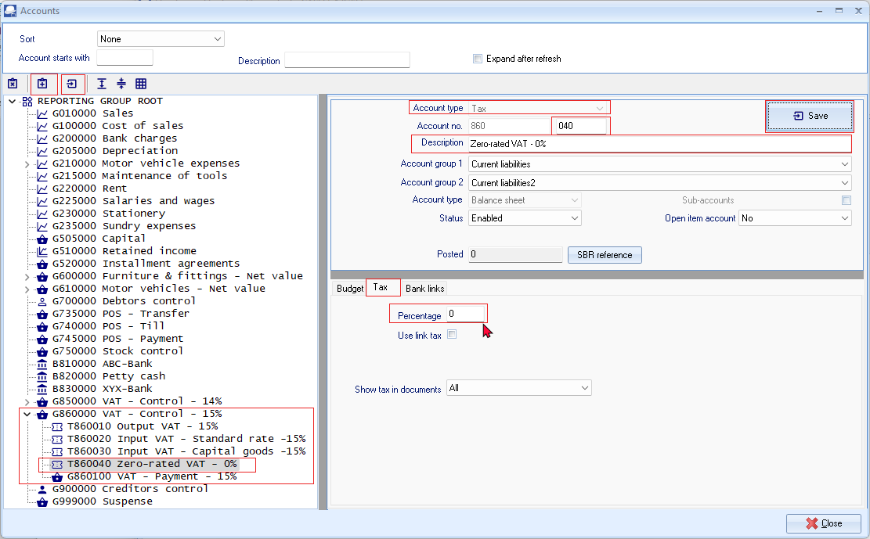
- Enter or select the following:
  - Account type - Select “Tax (VAT/GST/Sales tax)”.
  - Account no. - The Main account “860” is displayed and the sub accounts number field enter “040”.
  - Description - Replace “Account name” with “Zero-rated VAT – 0%”.
  - Account group 1 - If you have set up “Account group 1”, select your account group, e.g. “Current liabilities”. This is the Account group which is linked to the main account.
  - Account group 2 - If you have set up “Account group 2”, select your account group, e.g. “Current liabilities2”. This is the Account group which is linked to the main account.
  - Type - “Balance sheet” should be displayed. This field cannot be selected, since the main account is a Balance sheet type account.
  - Sub-accounts - This field cannot be selected, since this is a sub-account.
  - Status - “Enabled” (default) should be selected.
  - Open item account - “No” (default) should be selected.
  - Link tax - “Empty” (default) should be selected.
- Click on the Tax tab.
  - Percentage - Enter the percentage as “0”.
  - Use link tax - Do not select this option.
  - Show tax in documents - Leave the option as “All” for the purpose of this tutorial.
- Click on the Save button.
CREDITOR (SUPPLIER) ACCOUNTS
You will be using this option whenever you wish to create a new creditor (supplier) account, change the name, contact details addresses, messages, accounting information and terms of an existing account, or to delete an existing account.
To add a creditor (supplier) account, the only fields which is needed to fill in is the Creditor code and a description (account name (description)). The rest of the fields are optional.
It is recommended to enter as much information about creditor (supplier) as possible (and to keep it updated as regularly as possible).
You may read the “Working with Creditor accounts” section in the Help file and / or press the F1 key when focussed on the following eight (8) tabs:
- Delivery address - Delivery address, Address 2, Address 3, Postal code, Country, Message, Message 1, Message 2 and Message 3 and Layout files for purchase documents (i.e. Purchases, Supplier returns and Orders).
- Accounting information - Account disabled, Open item account, Due days (Payment date), Credit limit, Charge amount, Bank account (i.e. Bank account type, Bank account no., Bank name and Branch code), Use default account and Use default tax.
- Contacts - Any contacts linked to the creditor (supplier) account will be listed. You may also add, edit, delete and search for contacts. The “Auto-copy info” feature allows you to copy the searched contacts details, which may be edited if required.
Contacts may also be maintained (managed) in the in the Contacts and Calendar – Contacts (Default ribbon).
- Appointments - Any events or appointments have been scheduled in the Calendar (Default ribbon) for that creditor (supplier) account will be listed.
- Documents - Any Purchase, Supplier returns and / or Orders processed for the creditor (supplier) account will be listed on this tab. You may print these documents or a posted batches report for these documents.
- Transactions - Any debit and credit transactions (in batches and / or documents) posted (updated) to the ledger will be listed on this tab. You may print a posted batches report for these transactions or view and print the transactions in the T-Account viewer.
- Bank accounts – This is used for the BankImport Plugin.
- Stock items – This tab will list all the posted as well as unposted purchase documents (i.e. Purchases, Supplier returns and Orders) for the selected creditor (supplier) account.

CREATING / EDITING CREDITOR (SUPPLIER) ACCOUNTS
You will be using this option whenever you wish to create a new creditor (supplier) account, change the name, contact details addresses, messages, accounting information and terms of an existing account, or to delete an existing account.
To add a creditor (supplier) account, the only fields which is needed to fill in is the Creditor code and a description (account name (description)). The rest of the fields are optional.
It is recommended to enter as much information about creditor (supplier) as possible (and to keep it updated as regularly as possible).
You may read the “Working with Creditor accounts” section in the Help file and / or press the F1 key when focussed on the following eight (8) tabs:
- Delivery address - Delivery address, Address 2, Address 3, Postal code, Country, Message, Message 1, Message 2 and Message 3 and Layout files for purchase documents (i.e. Purchases, Supplier returns and Orders).
- Accounting information - Account disabled, Open item account, Due days (Payment date), Credit limit, Charge amount, Bank account (i.e. Bank account type, Bank account no., Bank name and Branch code), Use default account and Use default tax.
- Contacts - Any contacts linked to the creditor (supplier) account will be listed. You may also add, edit, delete and search for contacts. The “Auto-copy info” feature allows you to copy the searched contacts details, which may be edited if required.
Contacts may also be maintained (managed) in the in the Contacts and Calendar – Contacts (Default ribbon).
- Appointments - Any events or appointments have been scheduled in the Calendar (Default ribbon) for that creditor (supplier) account will be listed.
- Documents - Any Purchase, Supplier returns and / or Orders processed for the creditor (supplier) account will be listed on this tab. You may print these documents or a posted batches report for these documents.
- Transactions - Any debit and credit transactions (in batches and / or documents) posted (updated) to the ledger will be listed on this tab. You may print a posted batches report for these transactions or view and print the transactions in the T-Account viewer.
- Bank accounts – This is used for the BankImport Plugin.
- Stock items – This tab will list all the posted as well as unposted purchase documents (i.e. Purchases, Supplier returns and Orders) for the selected creditor (supplier) account.

CREATING / EDITING CREDITOR (SUPPLIER) ACCOUNTS
For this example, create one creditor, “A-ONE Suppliers”.
- If you have selected the HANDYMAN Set of Books, you may follow this procedure.
- If you have selected the HANDYMAN-A or HANDYMAN-B Set of Books, you can click on the Edit button to check the settings.
To create a new creditor (supplier) account:
- On the Default ribbon, select Creditors (F5).
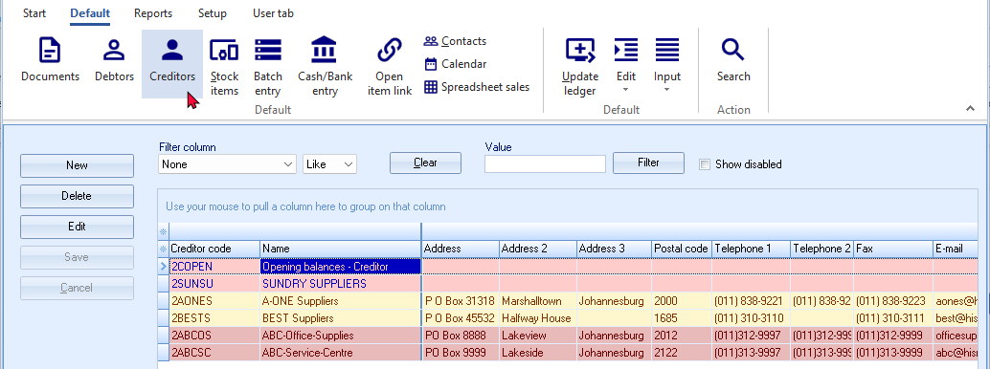
- To create a new account, click on the New button. If the new (blank) creditor account screen is launched, you may need to enter the details, as necessary. To edit a creditor account, select the account and click on the Edit button to check / edit the details.
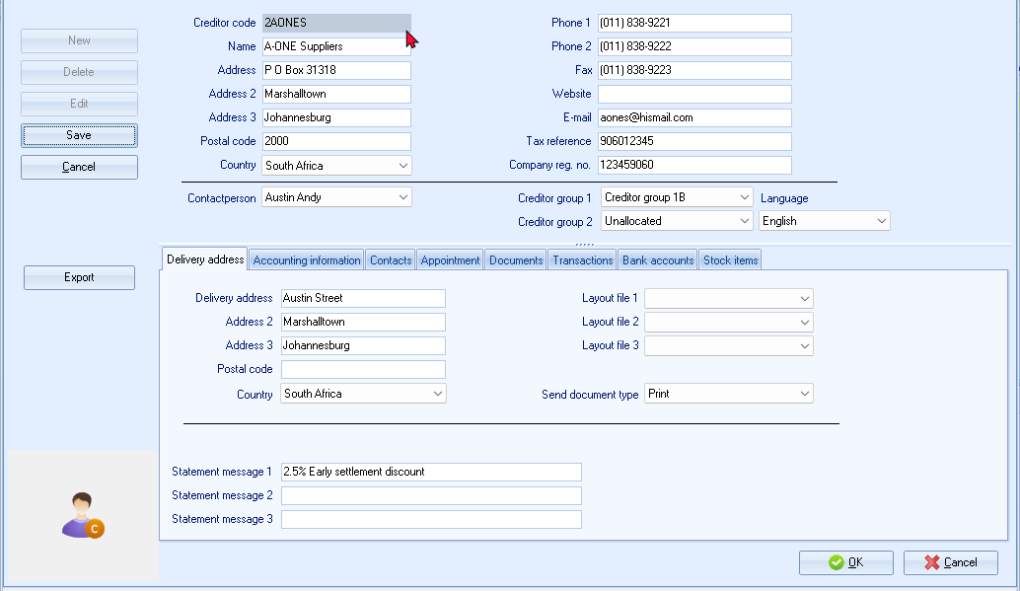
- Enter and / or select the following options:
Creditor code: | - Enter “2AONES” (or over-type with your own code) and press Enter.
  It is important to prefix the account code for creditors to start with 2 and debtors to start with 1.
  This will make it easier to select accounts, in some features, for example, selecting a Contra account in Batch setup.
Name: | - Enter “A-ONE Suppliers”
Address, Address 2, Address 3 and Postal code: | - Enter “PO Box 31318, Marshalltown, Johannesburg, 2000”
Country: | - Leave “Empty”.
Phone 1: | - Enter “(011) 838-9221”.
Phone 2: | - Enter “(011) 838-9222”.
Fax: | - Enter “(011) 838-9223”.
Website: | - Enter “osfinancials,org/en/”.
  You may double-click on the “Website” field to launch the web page of the creditor (supplier) in your operating system's default web browser.
E-mail: | - “aone@hismail.com”.
  You may double-click on the “E-mail” field to launch a blank e-mail message in your operating system's default e-mail program with the e-mail address of the creditor (supplier).
Tax reference: | - Enter “906012345”.
Company reg. no.: | - Enter “123459060”.
Contactperson: | No contact person will be available at this stage. You may click on the Contacts tab to create a contact person and enter the necessary contact information, if the contact has different Fax, Telephone numbers or an E-mail address as entered on the Creditor accounts default screen.  Should you already have entered a contact person in the Contacts or in the Calendar (Default ribbon), you may select the Contact person.
Creditor group 1: | - Select “Creditor group 1A”.
Creditor group 2: | - Leave “Unallocated”.
Language: | The default language when TurboCASH5 is launched for the first time will be selected.  You may select a different language; provided that your system's Regional and language settings supports the locale for the language.  If the language is selected, it will print translatable document layout files (purchases, supplier returns and orders) in the selected language of the creditor (supplier) account. - See – Multi-language accounts plugin topic in the Help file.
- Enter and / or select the following on the Delivery address tab:
Delivery address and Postal address: | - You may wish to enter the physical address of the creditor (supplier) if different from the postal address.
Layout file 1: | - Leave “Empty”.
Layout file 2: | - Leave “Empty”.
Layout file 3: | - Leave “Empty”.
Send document type: | - Leave as is on “Print”.
Statement message 1 / 2 / 3: | - You may enter the message to be displayed on the Remittance Advises, e.g. “Less 2.5% early settlement discount”.
Country: | - Leave “Empty”.
- Click on the Accounting information tab.
Account disabled: | - Do not tick.
Open item account: | - Leave blank.  - Read the explanation of open item accounting in Debtor receipts if you wish to change this option. If you leave this blank, the Balance will be brought forward when posting.
Due days | - Enter “30”. This is the number of days as agreed upon to pay the creditor (supplier).
Credit limit: | - Enter “12000”.
Charge amount: | - Leave blank.
Bank account type: | - Leave blank.
Bank account no.: | - Leave blank.
Bank name: | - Leave blank.
Use default account: | - Do not tick.
Use default tax: | - Do not tick
Debtor code: | - Leave blank.
- Click on the Save button. Confirm if you wish to “create this account?”
- Click on the Yes button.
CREATING A CREDITOR ACCOUNT FOR OPENING BALANCES
2COPEN - Opening balances – Creditor has already been created.
If you have selected the HANDYMAN Set of Books, you may follow this procedure.
If you have selected the HANDYMAN-A or HANDYMAN-B Set of Books, you can click on the Edit button to check the settings.
To create a new creditor account for opening balances:
- On the Default ribbon, select Creditors (F5). The “Creditor accounts” screen will displayed.
- Click on the New button. Enter “2COPEN” as the account code.
It is important to prefix the account code for creditors to start with 2 and debtors to start with 1.
This will make it easier to select accounts, in some features, for example, selecting a Contra account in Batch setup.
- Enter the Name for the Account (i.e. “Opening Balances – Creditor”).
- Select a Creditor group 1 (if created in Setup Creditor group1).
- Click on the Save button or OK button. A confirmation message, is displayed:
“Create this account?”
- Click on the Yes button.
One finished processing the opening balances, you may disable the Opening balances account (tick the “Disabled” field on the Accounting information tab).

DEBTOR (CUSTOMER / CLIENT) ACCOUNTS
You will be using this option whenever you wish to create a new debtor (customer / client) account, change the name, contact details addresses, messages, accounting information and terms of an existing account, or to delete an existing account.
To add a debtor (customer / client) account, the only fields which is needed to fill in is the Debtor code and a description (account name (description)). The rest of the fields are optional.
It is recommended to enter as much information about debtor (customer / client) as possible (and to keep it updated as regularly as possible).
You may read the “Working with Debtor accounts” section in the Help file and / or press the F1 key when focussed on the following nine (9) tabs:
- Delivery address - Delivery address, Address 2, Address 3, Postal code, Country, Message, Message 1, Message 2 and Message 3 and Layout files for sales documents (i.e. Quotes, Invoices and Credit notes).
- Accounting information - Account disabled, Open item account, Due days (Payment date), Credit limit, Charge amount, Customer discount percentage, Monthly interest percentage on overdue amounts, Selling prices, Bank account (i.e. Bank account type, Bank account no., Bank name and Branch code), Use default account and Use default tax.
- Contacts - Any contacts linked to the debtor (customer / client) account will be listed. You may also add, edit, delete and search for contacts. The “Auto-copy info” feature allows you to copy the searched contacts details, which may be edited if required.
Contacts may also be maintained (managed) in the in the Contacts and Calendar – Contacts (Default ribbon).
- Appointments - Any events or appointments have been scheduled in the Calendar (Default ribbon) for that debtor (customer / client) account will be listed.
- Documents - Any Invoices, Point-of-Sale Invoices, Credit notes and / or Quotes generated for the debtor (customer /client) account will be listed on this tab. You may print these documents or a posted batches report for these documents.
- Transactions - Any debit and credit transactions (in batches and / or documents) posted (updated) to the ledger will be listed on this tab. You may print a posted batches report for these transactions or view and print the transactions in the T-Account viewer.
- Bank accounts – This is used for the BankImport Plugin.
- Backorders – This tab will list all backorders for the debtor (customer / client) account.
- Stock items – This tab will list all the posted as well as unposted sales documents (i.e. Quotes, Invoices and Credit notes) for the selected debtor (customer / client) account.

CREATING / EDITING DEBTOR (CUSTOMER / CLIENT) ACCOUNTS
For this example, create a debtor (customer / client), “Mr. Mike Davies”.
If you have selected the HANDYMAN Set of Books, you may follow this procedure:
If you have selected the HANDYMAN-A or HANDYMAN-B Set of Books, you can click on the Edit button to check the settings.
To create a new debtor (customer / client) account:
- On the Default ribbon, select Debtors (F4). The “Debtor accounts” screen is displayed:
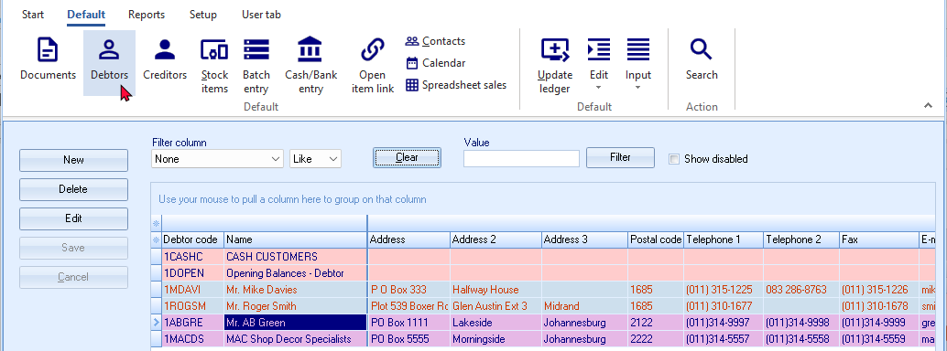
- To create a new account, click on the New button. If the new (blank) debtor account screen is launched, you may need to enter the details, as necessary. To edit a debtor account, select the account and click on the Edit button to check / edit the details.
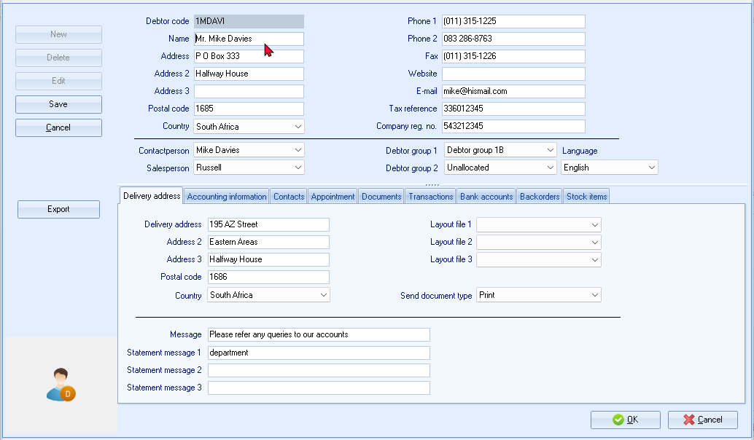
- Enter and / or select the following options:
Debtor code: | - Enter “1MDAVI” (or over-type with your own code) and press Enter.
  It is important to prefix the account code for creditors to start with 2 and debtors to start with 1.
  This will make it easier to select accounts, in some features, for example, selecting a Contra account in Batch setup.
Name: | - Enter “Mr. Mike Davies”.
Address, Address 2, Address 3 and Postal code: | - Enter “PO Box 333, Halfway House, 1685”.
Country: | - Leave “Empty”.
Phone 1: | - Enter “(011) 315-1225”.
Phone 2: | - Enter “083 286-8763”.
Fax: | - Enter “(011) 315-1226”
Website: | - Enter “osfinancials.org/en/”.
  You may double-click on the “Website” field to launch the web page of the debtor (customer / client) in your operating system's default web browser.
E-mail: | - “mike@hismailaccount.com”
  You may double-click on the “E-mail” field to launch a blank e-mail message in your operating system's default e-mail program with the e-mail address of the debtor (customer / client).
Tax reference: | - Enter “336012345”.
Company reg. no.: | - Enter “543212345”.
Contactperson: | No contact person will be available at this stage. You may click on the Contacts tab to create a contact person and enter the necessary contact information, if the contact has different Fax, Telephone numbers or an E-mail address as entered on the Debtor accounts default screen.  Should you already have entered a contact person in the Contacts or on the Calendar (Default ribbon), you may select the Contact person.
Salesperson: | - Select “Russell”.
Debtor group 1: | - Select “Debtor group 1B”.
Debtor group 2: | - Leave “Unallocated”.
Language: | The default language when TurboCASH5 is launched for the first time will be selected.  You may select a different language; provided that your system's Regional and language settings supports the locale for the language.  If the language is selected, it will print translatable document layout files (invoices, credit notes and quotes) in the selected language of the debtor (customer / client) account. - See – Multi-language accounts plugin topic in the Help file.
- Enter and / or select the following on the Delivery address tab:
Delivery address and Postal code: | - You may wish to enter the physical address of the debtor (customer / client); if different from the postal address.
Country: | - Leave “Empty”.
Layout file 1: | - Leave “Empty”.
Layout file 2: | - Leave “Empty”.
Layout file 3: | - Leave “Empty”.
Send document type: | - Leave as is on “Print”.
Statement message and Statement message 1 / 2 / 3: | - You may enter the message to be displayed on the Debtor statements, e.g. “Please refer any queries to our accounts department”.
- Click on the Accounting information tab.
Account disabled: | - Do not tick.
Open item account: | - Tick.  - Read the explanation of open item accounting in Debtor receipts if you wish to change this option. If you leave this blank, the Balance will be brought forward when posting.
Due days: | - Enter “30”. This is the number of days as agreed upon to to receive payment from the debtor (customer / client).
Credit limit: | - Enter “10000”.
Charge amount: | - Leave blank.
Customer discount: | - Leave blank.
Monthly interest on  overdue amounts: | - Leave blank.
Selling price: | - Select “Selling price 1”
Bank account type: | - Leave blank.
Bank account no.: | - Leave blank.
Bank name: | - Leave blank.
Use default account: | - Do not tick.
Use default tax: | - Do not tick
- Click on the Save button or OK button. Confirm if you wish to “create this account?”
- Click on the Yes button.
CREATING A DEBTOR ACCOUNT FOR OPENING BALANCES
1DOPEN - Opening Balances – Debtor has already been created.
If you have selected the HANDYMAN Set of Books, you may follow this procedure.
If you have selected the HANDYMAN-A or HANDYMAN-B Set of Books, you can click on the Edit button to check the settings.
To create a new debtor account for opening balances:
- On the Default ribbon, select Debtors (F4). The “Debtor accounts” screen will displayed.
- Click on the New button. Enter “1DOPEN” as the account code.
It is important to prefix the account code for creditors to start with 2 and debtors to start with 1.
This will make it easier to select accounts, in some features, for example, selecting a Contra account in Batch setup.
- Enter the Name for the Account (i.e. “Opening Balances – Debtor”).
- Select a Debtor group 1 (if created in Setup Debtor group1).
- Click on the Save button or OK button. Confirm if you wish to “create this account?”
- Click on the Yes button.
One finished processing the opening balances, you may disable the Opening balances account (tick the “Disabled” field on the Accounting information tab).
ONCE YOU HAVE ENTERED ALL YOUR DEBTORS (CUSTOMERS), CREDITORS (SUPPLIERS) AND ADDED THE EXTRA GENERAL LEDGER ACCOUNTS YOU NEED, YOU HAVE COMPLETED THE SET-UP AND CHART OF ACCOUNTS IN ORDER FOR TurboCASH5 TO RUN YOUR SET OF ACCOUNTS.

PRINTING LISTS OF ACCOUNTS, DEBTORS AND CREDITORS
We recommend that you print your Chart of accounts and Debtors and Creditors details to check that everything you have setup is, in fact, correct. In accounting it is best to follow the rule: check, recheck and check again. It is easier to find and fix any mistakes at this stage, rather than when you have captured transactions.
PRINTING ACCOUNTS LISTING (CHART OF ACCOUNTS)
To print a list of your accounts:
- On the Reports ribbon, select Reports → Ledger → Listing. 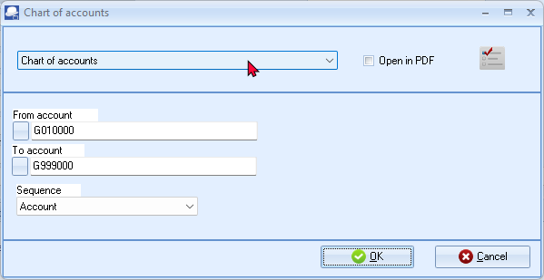
- Select the following options:
From account: | - Select the first account.
To account: | - Select the last account.
Sequence: | - Select “Account”, if not selected. You may also select “Description, Type, Reporting group1” or “Reporting group2”.
- Click OK to print your “Chart of accounts”.

The printed “Chart of accounts” (“Accounts” sequence), is as follows:
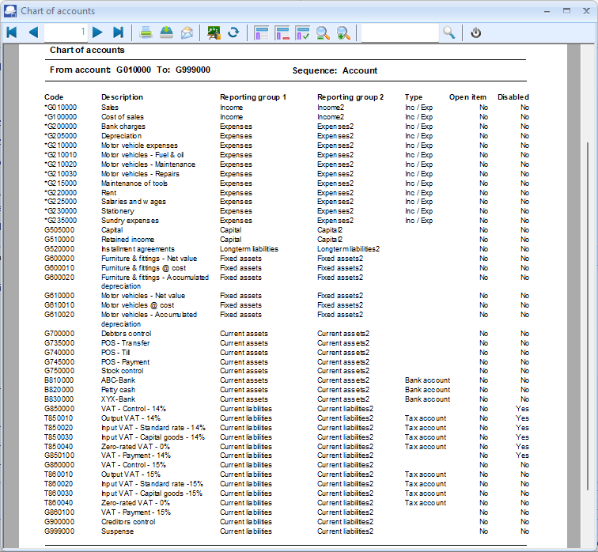
It is important to check that the VAT based on 14% tax for taxable transactions up to 31 March 2018 is replicated for the VAT based on 15% for taxable transactions as from 1 April 2018.

This tutorial is based on tax (VAT) at a rate of 15% for taxable transactions. Since no taxable transactions, at a tax rate of 14%, is applicable in the financial year (i.e. 1 March 2024 to 28 February 2025), the Status of tax accounts and tax codes of 14%, is disabled.
Check that all the reporting groups are correct and that all the types are correct. The following needs special attention i.e.
- Income and Expense account types should be prefixed with an asterisk e.g. *G010000"
- Bank account type should be "Bank account" - Code prefixed with a B and Bank account in the Type column.
- Tax (VAT/GST/Sales tax) sub-accounts type should be "Tax account" - Code prefixed with a T and Tax account in the Type column.

PRINTING DEBTOR LISTING
The Debtor listing allows you to print the following seven (7) reports:
- Contacts - This report will list the Name of the Contact, Telephone 1 / 2 and the debtor (customer / client) account code and name (description) linked to the contact.
- Listing - This report will list the Account code, Name of the Debtor (account description), Delivery address, Telephone 1 / 2, Fax, E-mail address and Website.
- List - Delivery address - This report will list the Account code, Name of the Debtor (account description), Delivery address, Telephone 1 / 2, Fax, E-mail address and Website.
- List - Postal address - This report will list the Account code, Name of the Debtor (account description), Postal address, Telephone 1 / 2, Fax, E-mail address and Website.
- List details - This report will display the Contact details, Registration details, Banking details, Reporting details, Accounting terms and information for each debtor (customer / client) account.
- Tax and company registration numbers - List the registration numbers as entered on the Debtor accounts (edit screen) (Default ribbon).
- Credit control listing - Credit limit vs current balance and available balances as at the date and time of printing.
To print a list of your debtors (customers / clients):
- On the Reports ribbon, select Reports → Debtors → Listing. The “Contacts” (default report) will be displayed.
- Select the “List details” report.
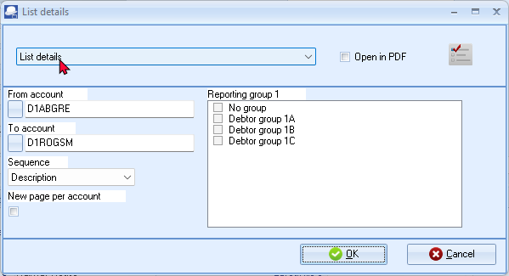

- Select the following options:
From account: | - Select the first account.
To account: | - Select the last account.
Reporting group 1 | - Do not tick. You may select to print only those accounts that are linked to specific Debtor group(s) 1.
Sequence: | - Select “Debtor code”. You may also select “Description, Reporting group1” or “Reporting group2”.
New page per account: | - Tick this option for this report.
- Click OK to print a list of your debtor (customer /client) accounts.
The “List details” report will display the following information:
- Contact details - Contactperson, Telephone 1 / 2, Fax, E-Mail, Website, Postal address, Delivery address and Language of the debtor (customer / client).
- Registration details - Company Registration number and Tax registration number.
- Banking details - Bank account type, Name of Bank account, Bank account number and Branch code.
- Reporting details - Reporting group 1 / 2, Layout file 1 (Invoices), Layout file 2 (Credit notes) and Layout file 3 (Quotes). If no layout files are selected, the documents will be printed for the global settings in Documents setup (Setup ribbon).
- Accounting terms and information - Statement message, Credit limit, Monthly interest rate, Customer discount rate, Due days (payment terms), account settings (i.e. Open item / Balance B/F), Account disabled, Default selling price and Salesperson.
PRINTING CREDITOR LISTING
The Creditor listing allows you to print the following seven (7) reports:
- Contacts - This report will list the Name of the Contact, Telephone 1 / 2 and the creditor (supplier) account code and name (description) linked to the contact.
- Listing - This report will list the Account code, Name of the Creditor (account description), Delivery address, Telephone 1 / 2, Fax, E-mail address and Website.
- List - Delivery address - This report will list the Account code, Name of the Creditor (account description), Delivery address, Telephone 1 / 2, Fax, E-mail address and Website.
- List - Postal address - This report will list the Account code, Name of the Creditor (account description), Postal address, Telephone 1 / 2, Fax, E-mail address and Website.
- List details - This report will display the Contact details, Registration details, Banking details, Reporting details, Accounting terms and information for each creditor (supplier account).
- Tax and company registration numbers - List the Registration numbers as entered on the Creditor accounts (edit screen) (Default ribbon).
- Credit control listing - Credit limit vs current balance and available balances as at the date and time of printing.
To print a list of your creditors (suppliers):
- On the Reports ribbon, select Reports → Creditors → Listing. The “Contacts” screen will be displayed.
- Select the “List details” report.
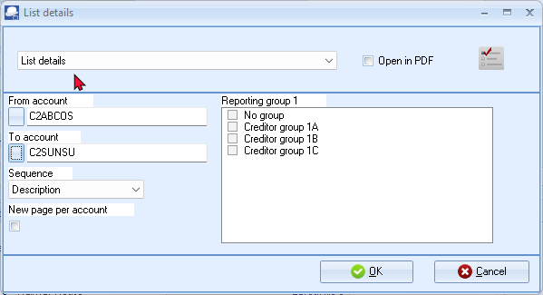
- Select the following options:
From account: | - Select the first account.
To account: | - Select the last account.
Reporting group 1 | - Do not tick. You may select to print only those accounts that are linked to specific Creditor group(s) 1.
Sequence: | - Select “Creditor code”. You may also select “Description, Reporting group1” or “Reporting group2”.
New page per account: | - Tick this option for this report.
- Click OK to print a list of your creditor (supplier) accounts.

The “List details” report will display the following information:
- Contact details - Contactperson, Telephone 1 / 2, Fax, E-Mail, Website, Postal address, Delivery address and Language of the creditor (supplier).
- Registration details - Company Registration number and Tax registration number.
- Banking details - Bank account type, Name of Bank account, Bank account number and Branch code.
- Reporting details - Reporting group 1 / 2, Layout file 1 (Purchases), Layout file 2 (Supplier returns) and Layout file 3 (Orders). If no layout files are selected, the documents will be printed for the global settings in Documents setup (Setup ribbon).
- Accounting terms and information - Statement message, Credit limit, Due days (payment terms), account settings (i.e. Open item / Balance B/F) and Account disabled.
YOU ARE NOW READY TO ENTER YOUR OPENING BALANCES AND TO PROCESS TRANSACTIONS.

CREATING / EDITING STOCK ITEMS

IN THIS MODULE
MODULE G - CREATING / EDITING STOCK ITEMS 186
G.1- INTRODUCTION 187
G.2- ADDING TAX CLASSES 188
G.2.1.1- Printing a report for Tax classes 190
G.2.1.2- Linking Tax classes to Stock items 191
G.3- SETTING UP A STOCK ITEM FOR FINANCIAL ENTRY 192
G.4- SETTING UP A STOCK ITEM FOR SALES (NO STOCK) 195
G.5- CREATING A TRADING STOCK ITEM 198
G.6- PRINTING STOCK ITEM LISTING 202

INTRODUCTION
In the HANDYMAN TURORIALS Set of Books, we have included eleven (11) Stock items. The following Stock item types are used in this tutorial:
- Default (Trading stock): These Stock items are for retail industries which purchase stock items for resale.
For the purpose of this tutorial, we will be purchasing and selling Compressors and Drill Presses. - (See MODULE K).
- Financial entry: This Stock item type allows you to select a General ledger account. This may be used for services or any other purchase or sales which is not trading stock items.
For the purpose of this tutorial, orders and purchase documents are used for purchases of non trading stock, (e.g. service and fitting of tyres on a delivery van as well as installing of office equipment). - (See – MODULE J.3). This will illustrate similar transactions than in the Purchase journal. - (See – MODULE I.2).
- Sales (no stock): – Used for selling of non-trading stock – Need to select a Sales account only and an Output Tax (VAT / GST / Sales tax) account.
For the purpose of this tutorial, quotes and invoices are used for selling of non-trading stock, (e.g. service and fitting of shelves). - (See – MODULE J.4). This will illustrate similar transactions than in the Sales journal. - (See – MODULE I.3).
You may create, add, copy, delete and / or disable up to eleven (11) stock item types.
You may read the “Working with Stock” section in the Help file and / or press the F1 key when focussed on the following stock item’s “Type” fields:
- Default – Used for trading stock – Need to select the Sales, Cost of sales and Stock control accounts. It can also be linked to the Input and Output Tax accounts. For the purpose of this tutorial, we will be using two (2) trading stock items (i.e. Compressor and a Drill press).
- Sales – Used for non-trading stock – Need to select a Sales account only. It can only be linked to the Output Tax account.
- Sales (no stock) – Used for non-trading stock – Need to select a Sales account only. It can only be linked to the Output Tax account.
- Purchases – Used for non-trading stock – Need to select the Cost of sales and the Stock control or Purchase account. It can only be linked to the Input Tax account. No Selling prices can be entered.
- Purchases (no stock) – Used for non-trading stock – Need to select the Cost of sales and the Stock control or Purchase account. It can only be linked to the Input Tax account. No Selling prices can be entered.

- Financial entry – Cannot select the Sales, Cost of sales and Stock control accounts. This allows you to select a ledger account on the Accounts lookup when processing documents. Once you select this stock item type when processing documents, the Accounts lookup will be displayed. You may then select any general ledger account on the Accounts lookup. You need to select the Input as well as Output Tax accounts for this stock type. The Selling prices may also be entered.
You need to create a financial entry stock item for each Tax Type (different rates).
- Option item – This stock type allows items that are a combination of options (like colour and size) options can be defined in Stock information. (Setup ribbon). These options are then linked to the Options Stock type (Stock items on the Options tab (Default ribbon)). When processing documents, the available options (options list) will be launched from the “Quantity” fields when selecting documents.
- Option item (no stock) – This is similar to the Option item with stock, but does not allow every entry to have a sales price, cost price, quantity and minimum stock level. This will also be used in generating purchases on supplier 1.
- BOM – Bill of Materials – allows you to add other stock items or products consisting of various other stock items (components) and / or some services, etc. to the BOM list. The BOM stock item is the finished product. You may only select the Sales account and the Output Tax account. For trading stock, the cost of sales and stock control accounts are controlled via the default stock items linked to the BOM item. An example would be the components (Stock items) of a computer system which are used to make the complete system, which is then sold as a finished product.
- BOM (Production) – This is similar to the BOM stock type. It has a feature where you may assemble (specify the quantities) of finished items or disassemble a specified quantity of finished items.
- Linked item - To be advised.

ADDING TAX CLASSES
This option allows you to create and maintain account / tax classes. Tax classes are a set of five (5) accounts which are linked to the Ledger tab of the “Stock item” screen (Default ribbon) for a selected stock item.
When a stock item is linked to a tax class, it will disable the Lookup button on the Ledger tab of the “Stock item” screen (Default ribbon) for a selected stock item. It will automatically set the Input and Output Tax accounts, Sales account, Cost of sales accounts without having to select them for each stock item.
You need to create tax classes for each of your tax codes applicable to stock items. For the purpose of this tutorial, we create a Tax class – Standard rate. If you have Stock items applicable to, for example, Zero-rated Tax (VAT / GST / Sales tax), you need to create them.
To set stock tax classes:
- On the Setup ribbon, select Stock information.
- Click on the Tax classes tab.
If “English” as the default language is used, Tax classes will be displayed.
If you have selected, “en-South-Africa” the Tax classes description, will reflect VAT classes.
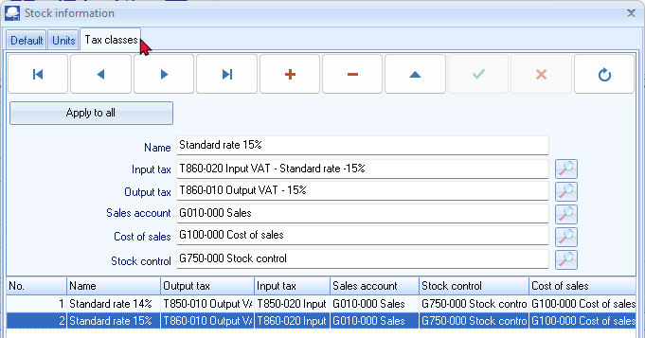
- Select the existing Tax class and add 14% to the Name field, if not reflected.
- Click  to save the changes.
- Click  to add a new Tax class.
- Enter the Name (description) e.g. Standard rate 15% for the tax class.
- Select the following accounts:
    - Input Tax - Select the Input Tax account (860-020).
    - Output Tax - Select the Output Tax account (860-010).
    - Sales account - Select the Sales account (010-000).
    - Cost of sales - Select the Cost of sales account (100-000).
    - Stock control - Select the Stock control account (750-000).
- Click to save the changes.
- Click OK to close the “Stock information” screen.

Printing a report for Tax classes
When a stock item is linked to a tax class, it will disable the Lookup button on the Ledger tab of the Stock items screen (Default ribbon) for a selected stock item. It will automatically set the Input tax and Output tax, Sales, Cost of sales and Stock control account fields without having to select them for each stock item.
To print Stock item listing - Tax classes reports:
- On the Reports ribbon, select Reports → Stock → Stock item listing.
- Select "Tax classes" report.
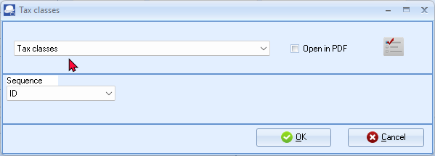
- Select the Sequence (i.e. “ID” (record Id) or “Description”) for the sequence to list the tax classes.
- Click OK.
An example of the Stock item listing - “Tax class - Listing” report, is as follows:
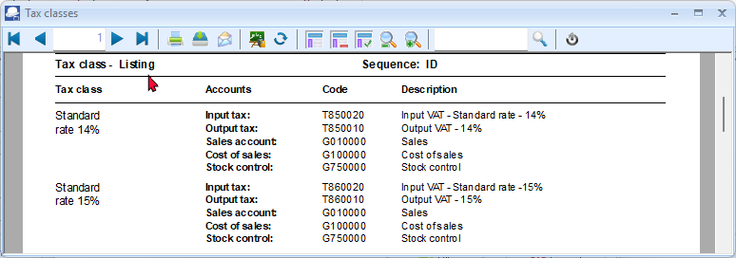
The next step is to link the accounts to the stock items.

Linking Tax classes to Stock items
To link stock class accounts to stock items:
- On the Default ribbon, select Stock items.
- Select a Stock item.
- Click on the Ledger tab.
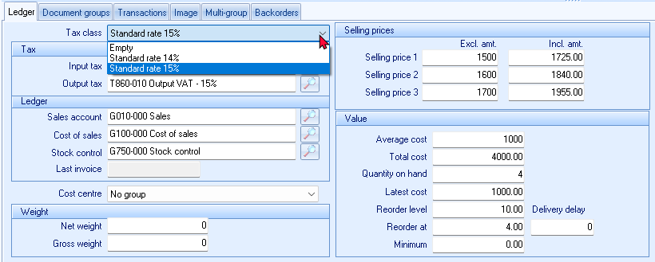
- Tax class, select “Standard rate 15%”.
- Click on the Save button. The inclusive amount will automatically be updated with the new tax rate.
- Repeat the process for all the stock items.
You may also change the tax classes on the grid view. In this example, the Tax class column was dragged from the Right to the Left.
Select the Stock item and Tax class Standard rate 15% and click on the Save button.
Repeat the process for all the stock items.
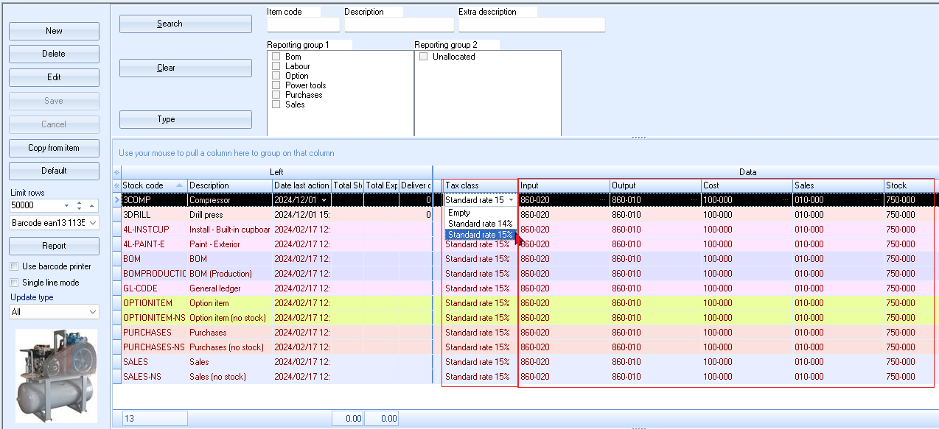
SETTING UP A STOCK ITEM FOR FINANCIAL ENTRY
When a Financial entry stock item type is selected, when processing documents, the Accounts lookup will be displayed. You may then select any general ledger account on the Accounts lookup.
Examples of accounts that may be selected on documents:
- Sales documents (i.e. Invoices, Credit notes and Quotes)
  - Income accounts - Selling miscellaneous services and goods not trading stock.
- Purchase documents (i.e. Purchases, Supplier returns and Orders)
  - Expense accounts - e.g. Purchasing of Stationery (Consumables)
  - Asset accounts – Purchasing of Fixed assets
To set up a stock item for financial entry:
- On the Default ribbon, select Stock items (F12).
- Click on the New button. A blank “Stock item” screen will be displayed.
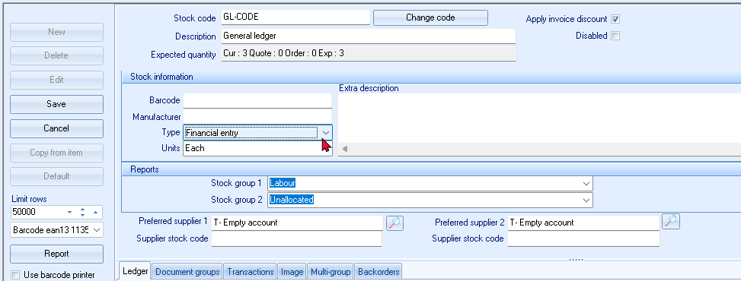
- Enter and / or select the following options:
  - Main
Option | Description
Stock code: | - Enter a stock code. For the purpose of this tutorial, “GL-CODE” was entered.
Description: | - For the purpose of this tutorial, “General ledger” was entered.
Disabled: | - Leave blank.
Apply invoice discount: | - Leave blank.
Expected quantity: | - Field disabled – The values in this field should be 0 at this stage.
  - Stock information
Option | Description
Barcode: | - Leave blank.
Manufacturer: | - Leave blank.
Extra description: | - Leave blank.
Type: | - Default is the standard Stock item type. Select “Financial entry”. This will disable the “Sales, Cost of sales” and “Stock control” accounts as well as the “Latest invoice” fields.
Unit size: | - Click on this field and select “Each”.
  - Reports
Option | Description
Stock group 1: | - Select “Labour”.
Stock group 2: | - Leave blank.
  - Preferred suppliers
Option | Description
Preferred supplier 1: | - Leave blank.
Supplier stock code: | - Leave blank.
Preferred supplier 2: | - Leave blank.
Supplier stock code: | - Leave blank.
- Click on the Ledger tab; if not displayed by default.
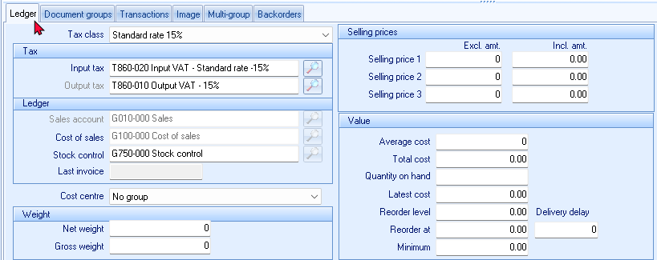
- Select and / or enter the following options:

  - Tax class / Tax / Ledger
Option | Description
Tax class: | - Select “Standard rate 15%” – It will automatically link:  - Input Tax to “T860-020 Input VAT – Standard rate - 15%”  - Output Tax to “T860-010 Output VAT - 15%”  - Sales account to “G010-000 Sales” (disabled)  - Cost of sales to ”G100-000 Cost of sales” (disabled)  - Stock control to “G750-000 Stock control”
Last invoice: | - Option inactive. The date of the last purchase or other document generated on which the service Stock item was selected. This field will not display any date if it is a new item, or if no Stock items have been selected on any documents.
  - Cost centre / Weight
Option | Description
Cost centre: | - Disabled.
Nett weight: | - Leave blank.
Gross weight: | - Leave blank.
  - Selling prices
Option | Description
Selling price 1: | - Leave blank.
Selling price 2: | - Leave blank.
Selling price 3: | - Leave blank.
  - Value
Option | Description
Average cost: | - Leave blank.
Total cost: | - Leave blank.
Quantity on hand: | - Leave blank.
Latest cost: | - Leave blank.
Re-order level: | - Leave blank.
Reorder at: | - Leave blank.
Minimum: | - Leave blank.
- Click on the Save button to save changes.
SETTING UP A STOCK ITEM FOR SALES (NO STOCK)
The disabled and inactive options for the Sales (no stock) Stock item type is the same. If you select this Sales or the Sales (no stock) Stock item type on an invoice or a credit note, no Cost of sales transactions would be generated. You will also not be allowed to specify the re-order level and select the Cost of sales, Stock control and Input Tax accounts.
Should you need to generate invoices and credit notes to customers (debtors / clients) for services, fees, charges or other sales which is not trading stock, you may create a Sales or Sales (no stock) Stock item type. You may generate invoices and credit notes for these non trading Stock items only or add these item codes to an invoice or credit note containing physical Stock items.
Some examples where you would create a Sales or Sales (no stock) Stock item type, is the following:
- Invoicing services such as labour, consulting fees, etc.
- Invoicing carting fees, delivery fees, other charges, etc.
For the purpose of this tutorial, we will be selling 2 services (i.e. Install - Built-in cupboards and Paint Exterior (outside of houses)) at 500.00 per hour to our debtors / clients).
The “Sales (no stock)” Stock item type is already created and added in the HANDYMAN, HANDYMAN-A or HANDYMAN-B Sets of Books.
You may select the “Sales (no stock)” Stock item type and click on the Copy from item and only need to change a few details for the new services item.
To set up a stock item for sales (no stock) for services:
- On the Default ribbon, select Stock items (F12).
- Select the “Sales (no stock)”.
- Click on the Copy from item button. The “Stock item” screen with all the data as entered in the original “Stock item” screen (except the Stock code) is displayed:
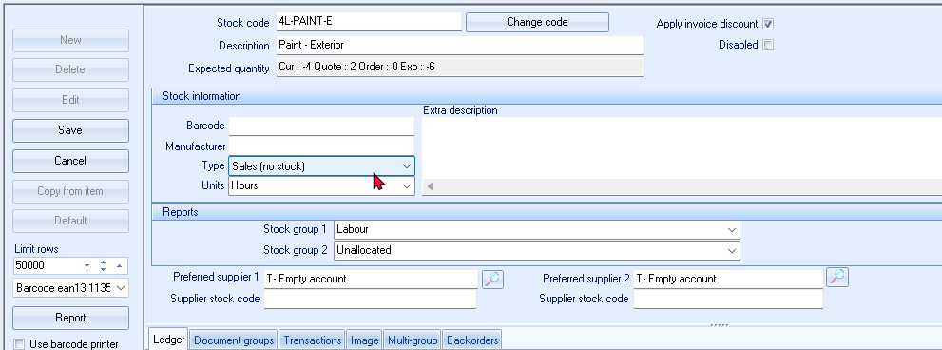
- Enter and / or select the following:
  - Main
Option | Description
Stock code: | - Enter “4L-PAINT-E”.
Description: | - Enter “Paint Exterior”.
Disabled: | - Leave blank.
Apply invoice discount: | - Leave as is.
  - Stock information
Option | Description
Barcode: | - Leave blank.
Manufacturer: | - Leave blank.
Extra description: | - Leave blank.
Type: | - Default is the standard Stock item type. Select “Sales (no stock)”. This will disable the “Input Tax, Cost of sales” and “Stock control” accounts as well “Last invoice” fields.
Unit size: | - Click on this field and select “Hours”.
  - Reports
Option | Description
Stock group 1: | - Select “Labour”.
Stock group 2: | - Leave blank.
  - Preferred suppliers
Option | Description
Preferred supplier 1: | - Leave blank.
Supplier stock code: | - Leave blank.
Preferred supplier 2: | - Leave blank.
Supplier stock code: | - Leave blank.

- Click on the Ledger tab; if not displayed by default.
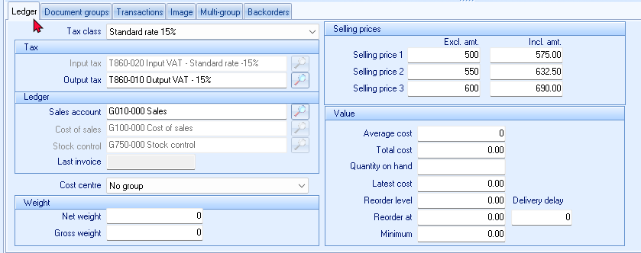
- Select and / or enter the following options:
  - Tax class / Tax / Ledger
Option | Description
Tax class: | - Select “Standard rate 15%” – It will automatically link:  - Input Tax to “T860-020 Input VAT – Standard rate – 15%” (disabled)  - Output Tax to “T860-010 Output VAT - 15%”  - Sales account to “G010-000 Sales”  - Cost of sales to ”G100-000 Cost of sales” (disabled)  - Stock control to “G750-000 Stock control” (disabled)
Last invoice: | - Option inactive. The date of the last purchase or other document generated on which the service Stock item was selected. This field will not display any date if it is a new item, or if no Stock items have been selected on any documents.
  - Cost centre / Weight
Option | Description
Cost centre: | - Disabled.
Nett weight: | - Leave blank.
Gross weight: | - Leave blank.
  - Selling prices
Option | Description
Selling price 1: | - Enter “500” exclusive or “575.00” as inclusive of VAT/GST/Sales tax.
Selling price 2: | - Enter “550” exclusive or “632.50” as inclusive of VAT/GST/Sales tax.
Selling price 3: | - Enter “600” exclusive or “690.00” as inclusive of VAT/GST/Sales tax.

  - Value
Option | Description
Average cost: | - Leave blank.
Total cost: | - Leave blank.
Quantity on hand: | - Leave blank.
Latest cost: | - Leave blank.
Re-order level: | - Leave blank.
Reorder at: | - Leave blank.
Minimum: | - Leave blank.
- Click on the Save button to save changes.
Select the Paint Exterior “4L-PAINT-E” Stock item and click on the Copy from item button.
- Enter “4L-INSTCUP” as the stock code.
- Enter “Install - Built-in cupboards” in the “Description” field.
- All other fields and the selling prices should be the same as for the Paint Exterior Stock item.
- Click on the Save button.

CREATING A TRADING STOCK ITEM
The Default Stock item type is used for Trading stock items. The Cost of sales settings for these are important as these may have an impact on your gross profit.
For the purpose of this tutorial, we will be selling 2 items, i.e. compressors drill presses:

For this example, we will create one stock item, “Drill press”.
If you have selected the HANDYMAN Set of Books, you may follow this procedure.
If you have selected the HANDYMAN-A or HANDYMAN-B Set of Books, you can click on the Edit button to check the settings.
To create and edit stock items:
- On the Default ribbon, select Stock items (F12). The “Stock item” screen is displayed.
- Click on the New button. A blank “Stock item” screen will be displayed. “Default” is the standard “Stock item type”.
- Check that “Default” is selected for the purpose of this tutorial.
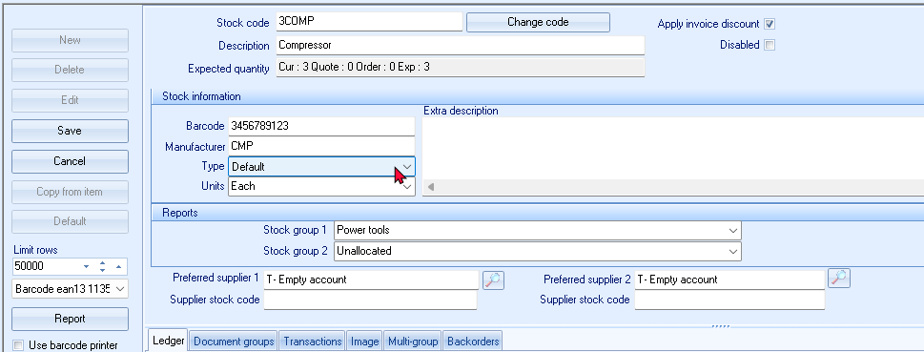
- Enter and /or select the following options:
  - Main
Option | Description
Stock code: | - Enter “3DRILL”.
Description: | - Enter “Drill press”.
Disabled: | - Leave blank.
Apply invoice discount: | - Leave blank.
Expected quantity: | - Field disabled – The values in this field should be 0 at this stage.
  - Stock information
Option | Description
Barcode: | - Enter “1234567890”.
Manufacturer: | - Enter “Bosch”.
Extra description: | - Enter “850 Watts + 6 drill bits”.
Type: | - Default is the standard Stock item type. Check that “Default” is selected for the purpose of this tutorial.
Unit size: | - Click on this field and select “Each”.

  - Reports
Option | Description
Stock group 1: | - Select “Power tools”.
Stock group 2: | - Leave blank.
  - Preferred suppliers
Option | Description
Preferred supplier 1: | - Leave blank.
Supplier stock code: | - Leave blank.
Preferred supplier 2: | - Leave blank.
Supplier stock code: | - Leave blank.
- Click on the Ledger tab; if not displayed by default.
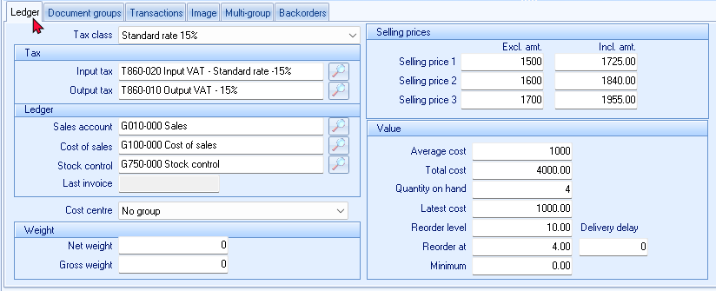
Stock can be categorised into groups by the prefix of the code. The Sales, Cost of sales and Stock accounts can also be split into sub-accounts per stock category.
Each stock item can then be linked to the appropriate Sales, Cost of sales and Stock sub-account for its particular category.
Each stock item can be linked to different tax types catering for varied VAT/GST/Sales tax rates.
- Select and / or enter the following options:
  - Tax class / Tax / Ledger
Option | Description
Tax class: | - Select “Standard rate 15%” – It will automatically link:  - Input Tax to “T860-020 Input VAT – Standard rate - 15%”  - Output Tax to “T860-010 Output VAT - 15%”  - Sales account to “G010-000 Sales”  - Cost of sales to ”G100-000 Cost of sales”  - Stock control to “G750-000 Stock control”
Last invoice: | - Option inactive. The date of the last purchase or other document generated on which the service Stock item was selected. This field will not display any date if it is a new item, or if no Stock items have been selected on any documents.
  - Cost centre / Weight
Option | Description
Cost centre: | - Disabled.
Nett weight: | - Leave blank.
Gross weight: | - Leave blank.
  - Selling prices
Option | Description
Selling price 1: | - Enter “1000” exclusive or “1150” as inclusive of VAT/GST/Sales tax.
Selling price 2: | - Enter “1100” exclusive or “1265” as inclusive of VAT/GST/Sales tax.
Selling price 3: | - Enter “1200” exclusive or “1380” as inclusive of VAT/GST/Sales tax.
  - Value
Option | Description
Average cost: | - Leave blank.
Total cost: | - Leave blank.
Quantity on hand: | - Leave blank.
Latest cost: | - Leave blank. We will enter the Cost price when we do the Stock take-on (entering Quantities on hand and Cost prices).
Re-order level: | - Enter “10”.
Reorder at: | - Enter “5”.
Minimum: | - Enter “4”.
- Click on the Save button to save changes.

PRINTING STOCK ITEM LISTING
To print a stock item listing report:
- On the Reports ribbon, select Reports → Stock → Stock item listing. The “All selling prices” report options will be displayed.
- Select the “Stock item listing” from the list of reports.
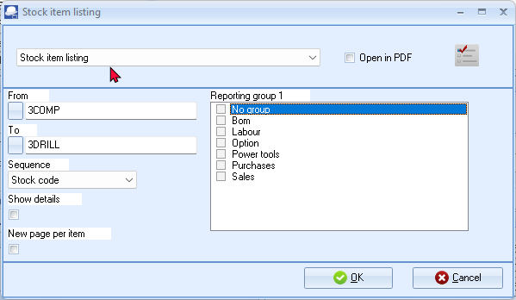
- Select the following options:
From: | - Select the first Stock item i.e. “3COMP” on the list.
To: | - Select the last Stock item i.e. “SALES-NS” on the list.
Show details: | - Select to view additional details for the stock items.
Reporting group 1: | - Leave blank.
Show details: | - Leave blank.
New page per account: | - Leave blank.
- Click on the OK button.
If you click on the “Power tools” Stock group 1 only these 2 items linked to “Power tools” Stock group 1 (i.e. Compressor and Drill press) should be displayed.
It is good practice to retrieve a detailed report to check that you have entered all the details and information correctly. To view additional information, select the “Show details” option. This will list the Extra description, Manufacturer, Unit size, Net and Gross weight, Selling prices 1 / 2 / 3, Barcode and Reporting group 1 / 2.
It is also recommended that the All selling prices Stock item listing report is printed to check your selling prices, before you start invoicing.

ENTERING YOUR OPENING BALANCES

IN THIS MODULE
MODULE H - ENTERING YOUR OPENING BALANCES 203
H.1- ENTERING OPENING BALANCES 204
H.2- DEBTOR / CREDITOR ACCOUNTS FOR OPENING BALANCES 204
H.2.1- Creating a debtor account for opening balances 204
H.2.2- Creating a creditor account for opening balances 204
H.3- CAPTURING OPENING BALANCES 205
H.3.1- Capturing opening balances for general ledger accounts 206
H.3.2- Capturing opening balance for debtors (customers / clients) 213
H.3.3- Capturing opening balances for creditors (suppliers) 218
H.4- PRINTING A TRIAL BALANCE 224

ENTERING OPENING BALANCES
FOR THIS TUTORIAL; WE WILL USE THE HANDYMAN SET OF BOOKS.
TO BEGIN THE TUTORIAL PLEASE GO TO THE MAIN SPEED TOOLBAR - CLICK ON THE OPEN ICON AND SELECT THE “HANDYMAN” SET OF BOOKS.
(It is in the “.../bin/Tutorials/EN-TUTORIALS” directory on your system).
We advise you to follow this tutorial carefully when setting up your new Set of Books, expanding on the Chart of accounts, adding your debtors and creditors to suit your particular company.
You may start to use TurboCASH5 at any point (not necessarily the same day as you start your business). You will, possibly, need to enter the balances for all your existing ledger accounts from your manual Set of Books. These balances are called opening balances. It is advisable to enter your opening balances at the time of setting up the system.
Opening balances are obtained from your latest trial balance or balance sheet. If your company has been running for some time, it is a good idea to enter the balance sheet or trial balance figures from the previous year into the system. For example, if your financial year starts on 2024/03/01, enter your opening balances into the system using the date 2024/02/29. This will give you a prior year to this year comparison.
If you enter your trial balance figures from your previous financial year, TurboCASH5 will calculate your net profit/loss, putting it to the Retained income account. (It will not carry the expense figures over to the current year.)
If you do not enter any opening balances, your set of accounts will not be complete. However, if it is a brand new business you are starting, it will obviously not be necessary to enter any opening balances, as you will not have any.
The opening balances are captured in the General journal.

DEBTOR / CREDITOR ACCOUNTS FOR OPENING BALANCES
Creating a debtor account for opening balances
See – MODULE F.4.2.
Creating a creditor account for opening balances
See – MODULE F.3.2.
CAPTURING OPENING BALANCES
If you have started to use TurboCASH5, and you already have balances in a hand system or any other computerised accounting system, you need to enter the balances from your previous accounting system.
For the purpose of this tutorial, the following examples will be used to illustrate the opening balances:
General ledger : The Trial balance:
 | Control accounts:  Individual balances needs to be taken on separately for the following Control accounts:  - Debtor's control (G700).  - Creditor's control (G900).  - Stock control (G750)  Control accounts in the General ledger must always be in balance with the total of the sub-ledgers.
Debtor's ledger : The balances of the individual Debtor accounts:
 | Debtor's ledger:  Individual balances may be taken on for the following:  - Outstanding amount.  - Each period separately.  Each period separately will allow you to use the Ageing feature.
Creditor's ledger : The balances of the individual Creditor accounts:
 | Creditor's ledger:  Individual balances may be taken on for the following:  - Outstanding amount.  - Each period separately.  Each period separately will allow you to use the Ageing feature.

Stock ledger: The balances (Quantities and Cost prices) of the individual Stock items:
Stock ledger:
Only the total value (cost price of stock) is entered as the opening balance of your stock items.

The opening balances for your trading stock items (Default stock type) must be entered for each individual stock item - you cannot simply enter the total from the trial balance. You need to inform the program of the quantities on hand and the cost prices for each stock item. See – MODULE K.3.

The value of each stock item, is calculated, by multiplying the quantities on hand by the cost price. After all the quantities and cost prices of your stock items are entered, the total value of all stock items should be equal to the control figure (stock control account), as per your financial statements.
Capturing opening balances for general ledger accounts
To enter opening balances from your trial balance:
- On the Default ribbon, select Batch entry (F2).
- Select General jnl., and click on the Open button.
- Enter the alias (batch name) in the “Change alias” field. In this example, enter ''OpenBalances'' to indicate that the Opening balances was entered in this General jnl. batch.
The alias option allows you to identify a batch by a unique name. You will be able to select the batch by alias or batch name if you need to reverse the posted batch or import a posted batch.
- Click on the F10:Setup icon to set your batch up. The “Options for this batch” screen is displayed:
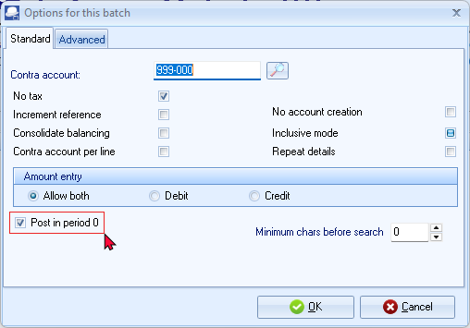
The first time you enter transactions in a General journal, you should set it up according to your requirements. This should be done for each journal, but only need to be done once, unless your requirements change.
- Set up the General journal as follows:
Contra account: | Select the contra account for the batch (i.e. the account to which balancing entries will be generated).  - Click on the Lookup button and select the suspense account, i.e. “999 - Suspense Account”.
No tax: | - Select this option, as no VAT/GST/Sales tax (Output VAT/GST/Sales Tax and Input VAT/GST/Sales tax) is applicable to the opening balance transactions.
Increment reference: | - If you tick this field, the reference number will be incremented by 1 on each subsequent line. DO NOT tick this option.
Consolidate balancing: | - If you tick this field, all balancing entries will be consolidated into 1 entry, if you have used an account more than once. As for the take-on of opening balances, it is NOT necessary to tick this option, since you will be entering both debits and credits from your Trial balance. It is not necessary to balance the batch.
Contra account per line: | - If you tick this field, TurboCASH5 will ask to allocate a contra account for each transaction. As this will be a batch in which you wish to enter both debits and credits DO NOT tick this field.
Inclusive mode: | - If you tick this field, all amounts are expected to be entered as inclusive of VAT/GST/Sales tax. Tick this option.
Repeat details: | - If you tick this field, the detail entered in the Description column will be repeated (duplicated) on each subsequent line. Tick this option to repeat the details for the next transactions.
Amount entry: | - Set to “Allow both”, since you will enter amounts in both the debit and credit column.
Post in period 0: | - Tick this option.  If you do not tick this option, you will not be allowed to post to the Retained earnings / income account. An error message (similar to this error message “This batch does not validate! Line JNL1 Opening balance - Take-on retained income must be adjusted in opening balance batch! See F10 in batch for setup.” will be produced.
- Click on the Advanced tab.
- Leave all fields blank, and make sure that the default option, “Account lookup type”, is set to “All” and the “Contra account lookup type” is set to “General ledger”.
- Click OK.

- Capture the first transaction as follows:
Reference: JNL1
Date: 2024/02/29
Description: Opening balance - Take-on
Account: Select - “G505 Capital”
Amount: 11,500.00 CR
Use the same reference number, date and details for all the entries.
Tax
Since No tax (VAT/GST/Sales tax) is applicable, to the opening balance transactions in this tutorial, we have selected to hide the Tax column in the Setup options or this batch.
- Repeat as above for capturing the rest of the Trial balance. After capturing the Trial balance, the transactions should reflect as follows:
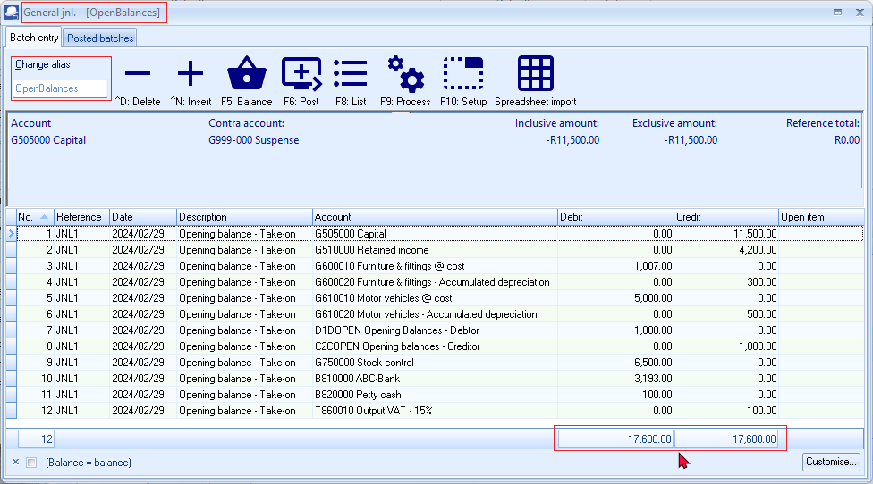
If you are not selling trading stock:
When entering the opening balance for the Stock control account (Account number G750-000), you may use the Suspense Account (Account number G999-000), for the purpose of this tutorial.
When entering the opening balance for the Debtor's control account (Account number G700-000), you will not be allowed to select the Debtor's control account.
The same applies to the Creditor's control account (Account number G900-000).
The reason for this is that you cannot post any transactions to the Debtor's control account in the General ledger.
You need to select the individual Debtor accounts in the Debtor's ledger, to take on each individual Debtor's opening balance. When posting the transactions for the opening balances in the General journal, the Debtor's control account in the General ledger will automatically be updated with the total of all the individual transactions posted to the Debtor's ledger.
It is not necessary to "balance" your batch, as your Trial balance should already be in balance.
You will note that there is an amount indicating the difference between the debit and credit entries at the end of the Debit amount column.
This amount (and the Reference total at the top right corner) should reflect a zero after entering all your transactions.
- Click on the F8:List icon to print a list of the transactions in the batch. The batch list is displayed as follows:
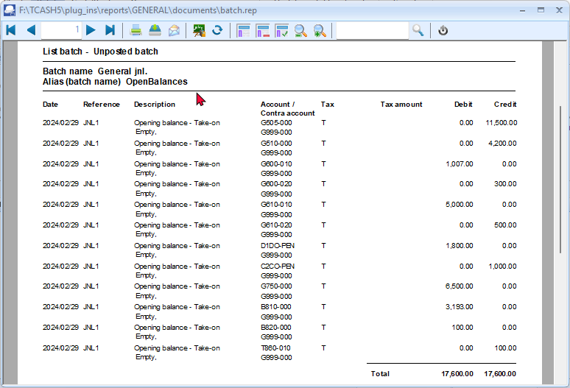
It is recommended that the source document (e.g. trial balance or balance sheet and income statement, etc.) be attached to this List of the transactions (take-on of opening balances) and that it be retained for record and audit purposes.

Print a Trial balance for unposted batches
You may print a Trial balance of unposted batches journals. To do this, press the F2-key and right-click on the Batch entry selection screen and select "Trail balance" from the context menu. A confirmation screen will be displayed:
"Unposted only?"
Click Yes and the Trial balance for unposted batches (journals) will be launched:
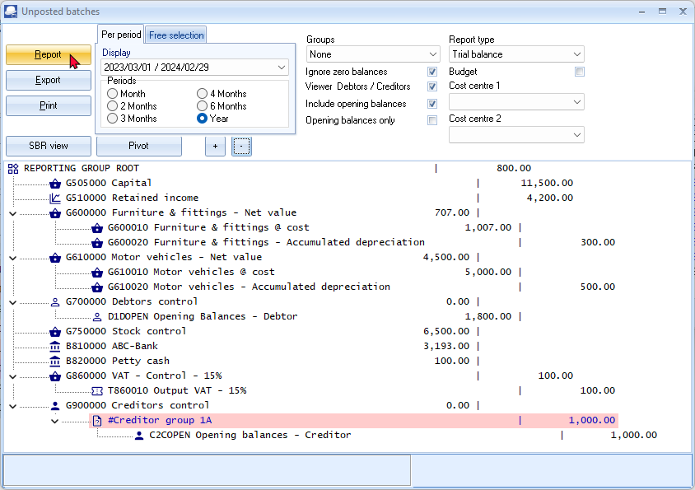
NOTE: Initially, the Print button will not be displayed. To display the Print button, go to the "Report type" and re-select the "Trial balance.
You may print the Trial balance for unposted batches.

An example of the Trial balance for the opening balances not updated (posted) to the ledger should display as follows:
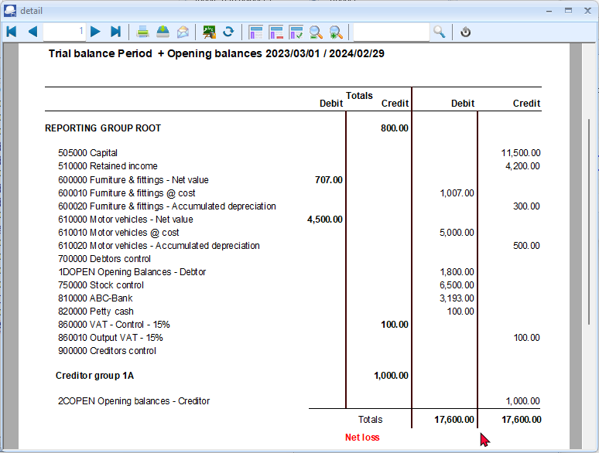
- Click on the F6:Post icon. A confirmation message is displayed:
“Do you want to continue posting?
Batch contains transactions posting to last year!”
- Click on the Yes button. A confirmation message is displayed:
“Do you wish to post on the retained earnings account?”
- Click on the Yes button to continue posting. The transactions will be posted (updated to the ledger).
Confirmation: Post to last year
If you click on the No button, the transactions will not be posted.
Confirmation: Retained earnings
- If you have not ticked the “Opening Balances – This year” field on the F10: Setup Standard tab, you will not be allowed to post to the Retained earnings / income account.
- If you click on the No button, the transactions will not be posted.
Leap years:
If a leap year is, for example, February 2024, the transactions are entered and posted on 29 February 2024.
The “Opening balances” account should have a zero balance after balances were debited and credited to the accounts as entered in the Opening balances batch.
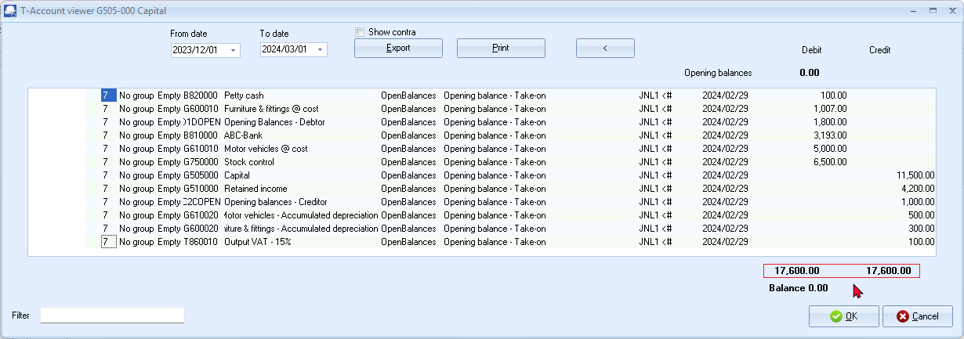

Capturing opening balance for debtors (customers / clients)
To enter opening balances for your debtor accounts:
- On the Default ribbon, select Batch entry (F2).
- Select General jnl., and click on the Open button.
- Enter the alias (batch name) in the “Change alias” field. In this example, enter ''D-OpenBalances'' to indicate that the opening balances for debtor (customer / client) accounts was entered in this General journal batch.
- Click on the F10:Setup icon to set your batch up. The “Options for this batch” screen will be displayed. The settings are basically the same as for the opening balances of the General ledger account. Change the batch settings as follows:
- Standard tab – Select the “Contra account” - “D1DO-PEN Opening balances – Debtors” and set “Amount entry” to “Debit”.
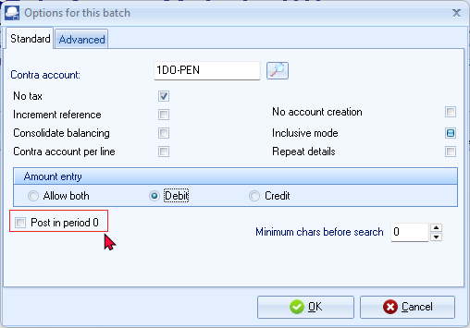
The tick in the “Post in period 0” field must not be selected (not ticked) for opening balances for debtors (customers / clients).
Should you need to enter a debtor opening balance with a credit amount, you may simply enter a negative (minus sign) before the amount. This will transfer the negative amount in the Debit column to the Credit column.

- Advanced tab – Set the “Account lookup type” and “Contra account lookup type” both to “Debtors”.
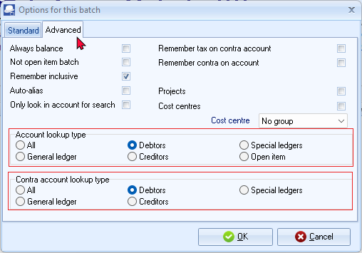
- Once setup, click on the OK button.
- Enter the following transactions:
The Opening Balances – Debtor account should reflect the total of all Debtor accounts (in the Debtor's control account). You only need to list (select) the individual debtor accounts and enter their balances.
You may enter only the total outstanding balance (i.e. 1,800.00 as per this example) as at 29 February 2024 for each debtor account (2 entries).
If you wish to optimise the ageing feature, you may enter the balances for each debtor account as at the end of each period, e.g. 29 February 2024 – 1,100.00, 31 January 2024 – 400.00 and 31 December 2023 – 300.00.

- After entering the individual balances, for each period, the transactions should be displayed as follows:
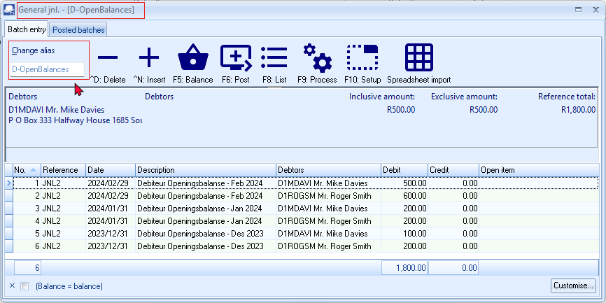
- Click on the F5: Balance icon. Balancing entries, for each period (i.e. Feb2024, Jan2024 and Dec2023), are generated as follows:
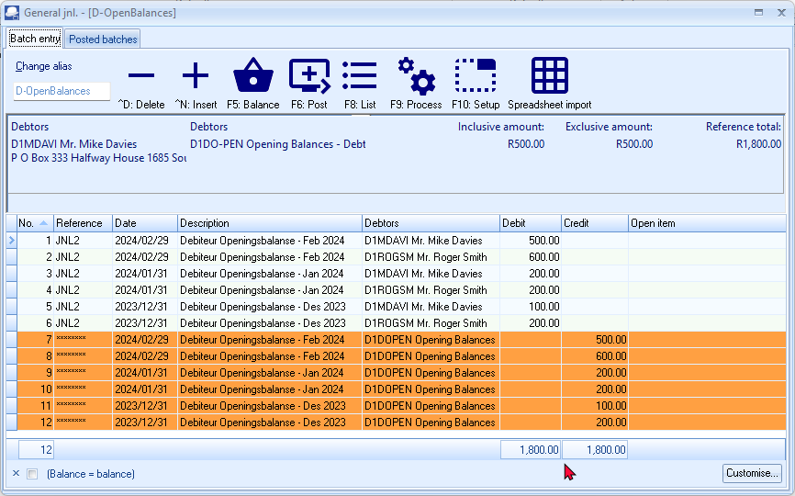
You may click on the F9: Process icon and select the “Totals per period” option. This will list the totals of the Debit entries and the Credit entries for each period. The difference should be zero.
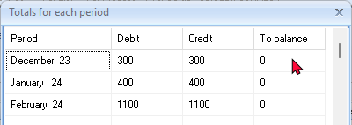

- Click on the F8:List icon to print a list of the transactions in the batch. The batch list is displayed as follows:
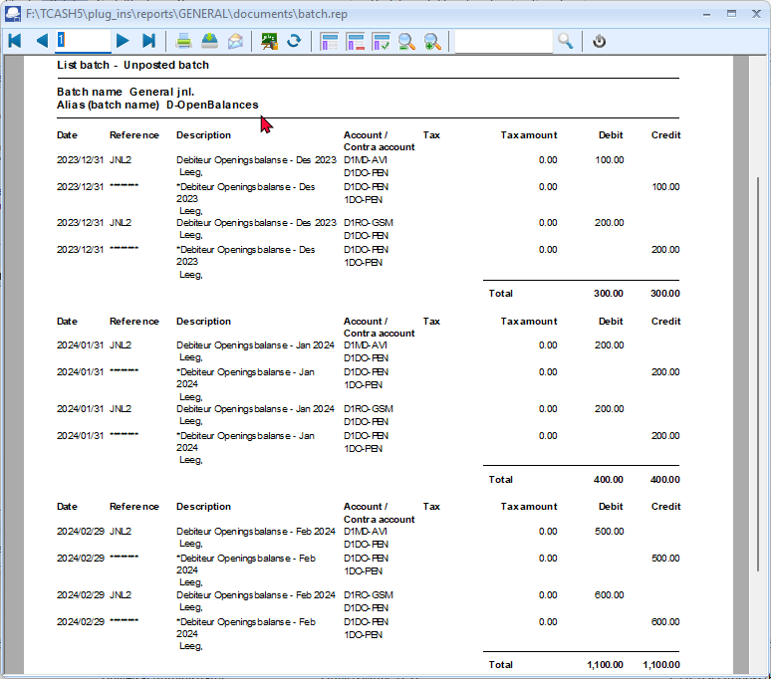
It is recommended that the source document (e.g. trial balance or balance sheet and income statement, etc.) be attached to this List of the transactions (take-on of opening balances) and that it be retained for record and audit purposes.
- Click on the F6: Post icon. A confirmation message is displayed:
“Do you want to continue posting?
Batch contains transactions posting to last year!”
- Click on the Yes button to post the entries and update the transactions to the ledger.

The “Opening balances – Debtor” account should have a zero balance after balances were debited to the individual debtor (customer / client) accounts.
Click on the Print button.
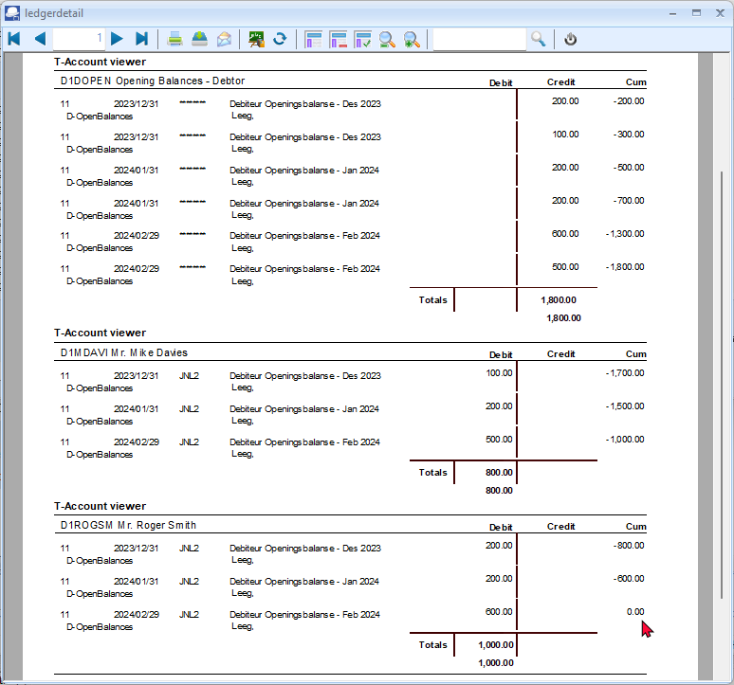

The “Debtor age analysis – Balances detail” report for March 30, 2024 (Reports → Debtors → Age analysis menu (Reports ribbon)) should display the totals for each period as follows:
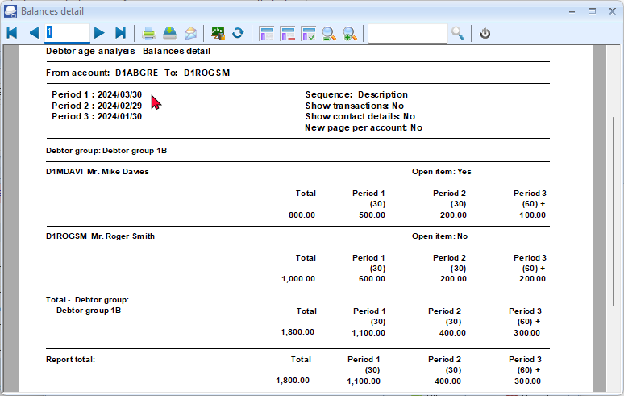

Capturing opening balances for creditors (suppliers)
To enter opening balances for your creditor accounts:
- On the Default ribbon, select Batch entry (F2).
- Select General jnl., and click on the Open button.
- Enter the alias (batch name) in the “Change alias” field. In this example, enter ''C-OpenBalances'' to indicate that the opening balances for creditor (supplier) accounts was entered in this General journal batch.
- Click on the F10:Setup icon to set your batch up. The “Options for this batch” screen will be displayed. The settings are basically the same as for the opening balances of the General ledger account. Change the batch settings as follows:
- Standard tab – Select the “Contra account” - “Opening balances – Creditors” and set “Amount entry” to “Credit”.
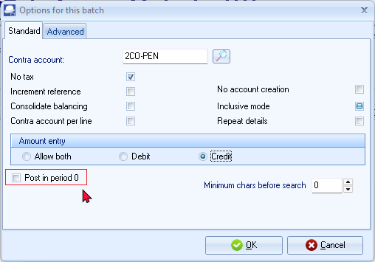
The tick in the “Post in period 0” field must not be selected (not ticked) for opening balances for creditors (suppliers).
Should you need to enter a creditor opening balance with a debit amount, you may simply enter a negative (minus sign) before the amount. This will transfer the negative amount in the Credit column to the Debit column.
- Advanced tab – Set the “Account lookup type” and “Contra account lookup type” both to “Creditors”.
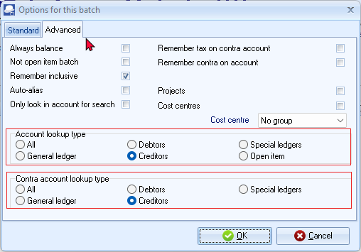
- Once setup, click on the OK button.
- Enter the following transactions:
The Opening Balances – Creditor account should reflect the total of all Creditor accounts (in the Creditor's control account). You only need to list (select) the individual creditor accounts and enter their balances.
You may enter only the total outstanding balance (i.e. 1,000.00 as per this example) as at 29 February 2024 for each creditor account (2 entries).
If you wish to optimise the ageing feature, you may enter the balances for each creditor account as at the end of each period, e.g. 29 February 2024 – 500.00, 31 January 2024 – 300.00 and 31 December 2023 – 200.00.
- After entering the individual balances, for each period, the transactions should be displayed as follows:
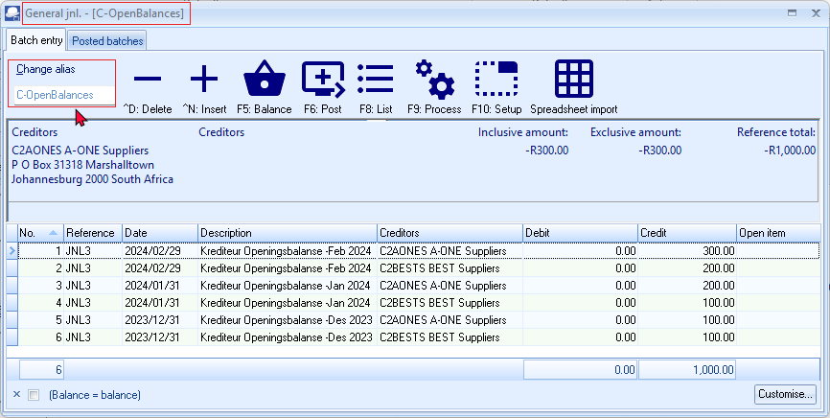
- Click on the F5: Balance icon. Balancing entries, for each period (i.e. Feb2024, Jan2024 and Dec2023), are generated as follows:
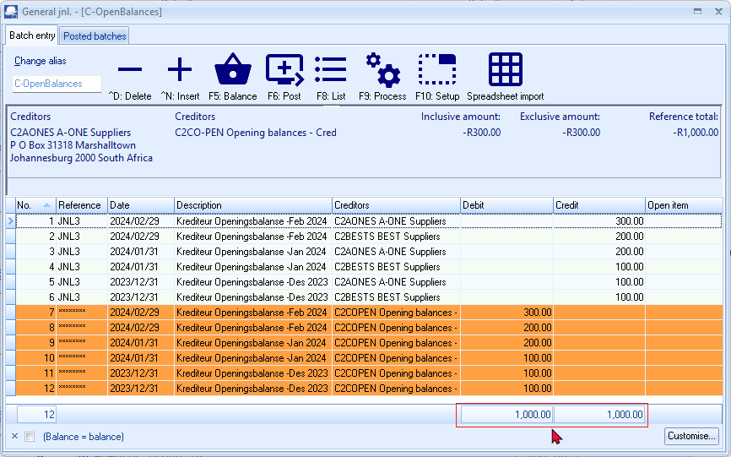
You may click on the F9: Process icon and select the “Totals per period” option. This will list the totals of the Debit entries and the Credit entries for each period. The difference should be zero. 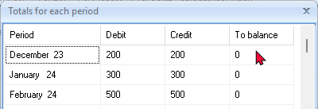
- Click on the F8:List icon to print a list of the transactions in the batch. The batch list is displayed as follows:
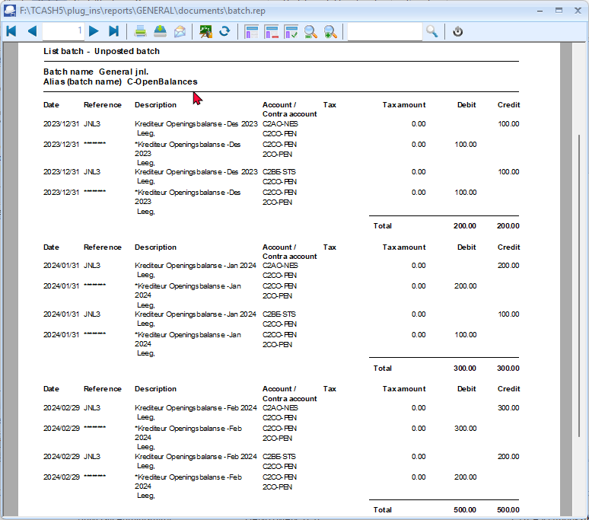
It is recommended that the source document (e.g. trial balance or balance sheet and income statement, etc.) be attached to this List of the transactions (take-on of opening balances) and that it be retained for record and audit purposes.
- Click on the F6: Post icon. A confirmation message is displayed:
“Do you want to continue posting? Batch contains transactions posting to last year!”
- Click on the Yes button to post the entries and update the transactions to the ledger.

The “Opening balances – Creditor” account should have a zero balance after balances were credited to the individual creditor (supplier) accounts.
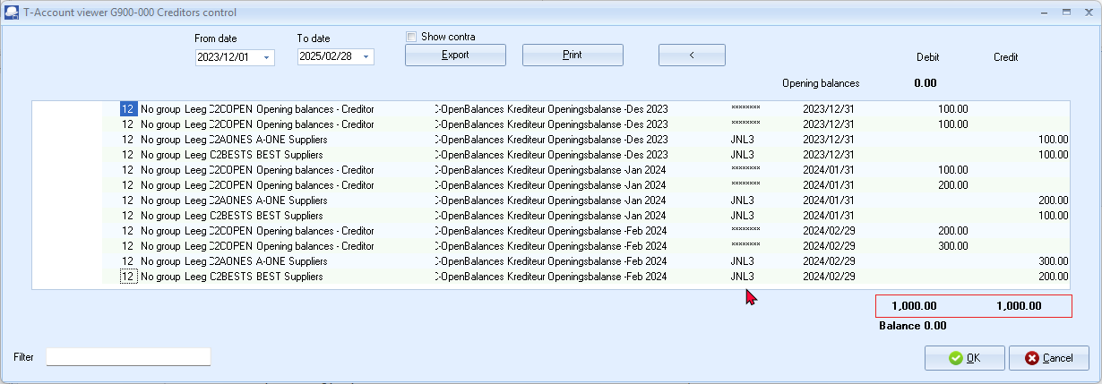
Click on the Print button.
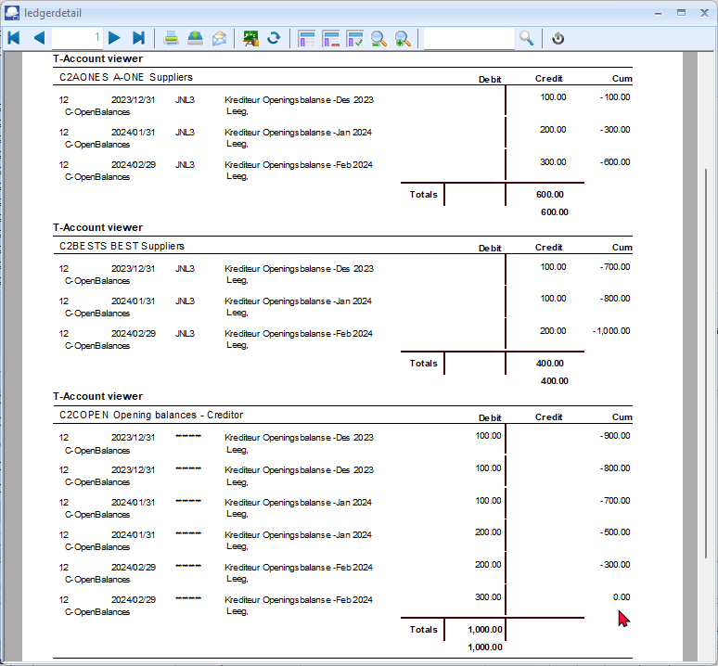

The “Creditor age analysis – Balances detail” report for March 30, 2024 (Reports → Creditors → Age analysis menu (Reports ribbon)) should display the totals for each period as follows:
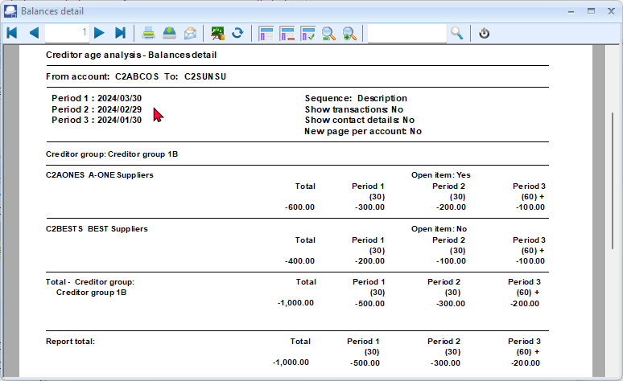

PRINTING A TRIAL BALANCE
It is good practice to print a Trial balance in TurboCASH5 at this point and check it with the Trail Balance of your previous accounting records from which you have entered your transactions.
It is recommended that this printed Trial balance be retained with your working papers and the previous trial balance for record and audit purposes.
To print a trial balance from the Ledger analyser:
- On the Reports ribbon, select Ledger analyser 1 or 2.
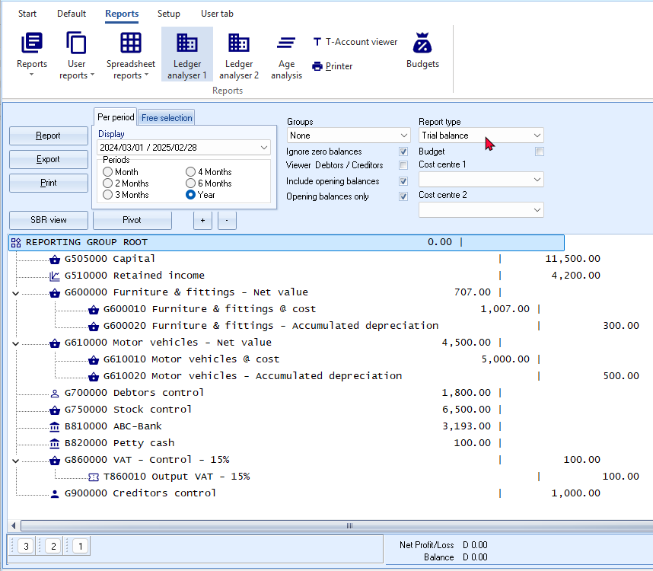
If you need to check the individual balances of the Debtor's accounts in the Debtor's control account (G700), you need to generate Debtor's age analysis report.
If you need to check the individual balances of the Creditor's accounts in the Creditor's control account (G900), you need to generate Creditor's age analysis report.
If you need to check the opening balances of the individual stock items in the Stock control account, you need to generate a Stock item listing report.
- Select the following:
    - Periods – On the default “Per period” tab, select “Year” and Period “2024/03/01-2025/02/28”.
    - Report type – Select “Trial balance”.
    - Reporting group – The following options are available:
      - None – Select this option. This will list the accounts according to the Account code (account number).
      - Reporting group 1 – This will list the accounts according to the Account Group 1 (Groups - Account group1) (Setup ribbon).
      - Reporting group 2 – This will list the accounts according to the Account Group 2 (Groups (Account group2) (Setup ribbon).
    - Ignore zero balances – Tick – This will list only those accounts for which opening balances was entered.
    - Viewer Debtors / Creditors – If this option is not ticked, it will list only the balances of the Debtor's control account and the Creditor's control account.
Tick this option to show the break down of the Debtor accounts in the Debtor's control account and the break down of the Creditor accounts in the Creditor's control account.
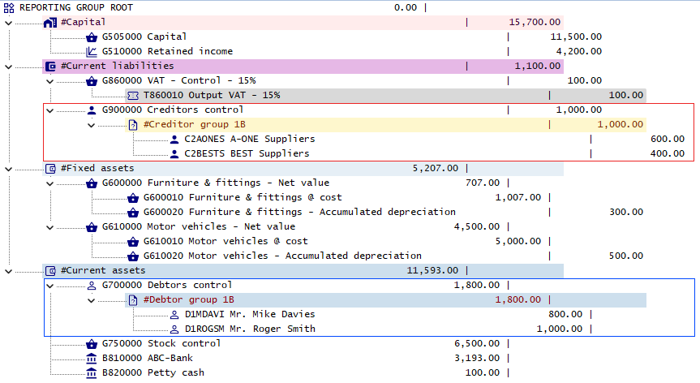

    - Include opening balances – Tick this option to include the opening balances.
    - Opening balances only – Tick this option to include only the opening balances.
If any transactions is posted for the selected period, you need to tick this option to list only the accounts for which opening balances have been entered.
You may leave this option blank, if no other transactions are entered and posted for the selected period.
- Click on the Report button. You may change the sequences, and click on the Print button to print the trial balance.

An example of the “Trial balance” (account code sequence), is as follows:
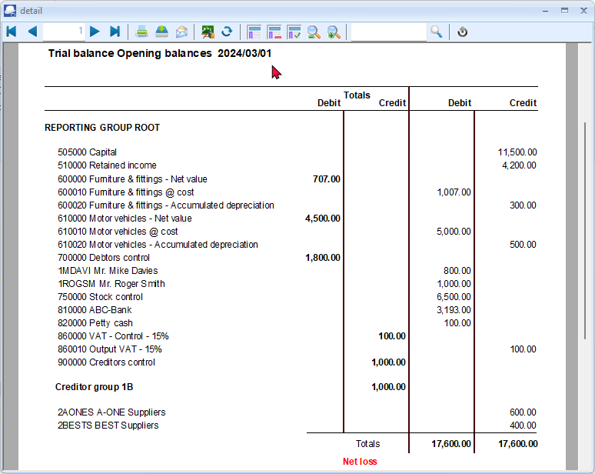
The totals should balance with the previous financial year. Check that the totals are in balance and that the correct balances correspond with the balances on your source trial balance.
AT THIS POINT YOU HAVE COMPLETED YOUR SETUP, CHARTED YOUR ACCOUNTS, CAPTURED YOUR DEBTORS AND CREDITORS; AND ENTERED YOUR OPENING BALANCES INTO TurboCASH5.

PROCESSING BATCH TRANSACTIONS

IN THIS MODULE
MODULE I - PROCESSING BATCH TRANSACTIONS 227
I.1- PURCHASE AND SALES TRANSACTIONS – BATCHES OR DOCUMENTS 229
I.2- CAPTURING YOUR PURCHASES IN BATCHES 229
I.2.1- Entering supplier invoices (Purchase journal) 230
I.2.2- Updating supplier invoices to the ledger 233
I.2.3- T-Account view of transactions 234
I.3- CAPTURING YOUR SALES 236
I.3.1- Entering your sales invoices 236
I.3.2- Updating sales to the ledger 240
I.3.3- T-Account view of transactions 242
I.4- REPEATING TRANSACTIONS 244
I.4.1- Entering repeating transactions 245
I.4.2- Updating repeating transactions 247
I.4.3- T-Account view of transactions 249

PURCHASE AND SALES TRANSACTIONS – BATCHES OR DOCUMENTS
If you generate documents from your stock item code file in TurboCASH5, transactions will automatically be generated when documents are updated or posted to the ledger as follows:
- Sales documents (Invoices and Credit notes) in the Sales journal (as linked to the “Batch type” field of the Invoices and Credit notes tabs in Documents setup (Setup ribbon).
- Purchase documents (Purchases and Supplier returns) in the Purchase journal (as linked to the “Batch type” field of the Purchases and Supplier returns tabs in Documents setup (Setup ribbon).
In addition to the Sales and Purchase journals for transactions generated by documents, you also need to enter transactions in other batches (journals) (i.e. Payments Jnl, Receipts Jnl, Petty cash Jnl, General Jnl, etc.). These are the ‘books of prime entry’ in which you need to capture payments, receipts, opening balances, etc. and post or update it to the ledger.

CAPTURING YOUR PURCHASES IN BATCHES
You need to capture all the supplier invoices you have received for purchases on credit, from your creditors (suppliers).
In addition to the Purchase journal in the Batch entry mode, you may also use the Document entry to create Purchases using the following stock item types:
- Financial entry – Use the Accounts lookup to select General ledger accounts.
- Sales (no stock) – Create a Stock item for services only (e.g. consulting, labour, etc.)
Purchases are also usually linked to the Purchase journal in the Documents setup (Purchases tab) (Setup ribbon).
Using the Document entry, Purchases may be printed by TurboCASH5, which will generate similar transactions as the Purchase journal batch entry as discussed here.
You may also create, print orders and convert these to Purchase documents.
For the purpose of this tutorial, the similar transactions as in the Purchases Batch are also replicated for Purchase documents – See – MODULE J.3.
Entering supplier invoices (Purchase journal)
To enter purchase transactions:
- On the Default ribbon, select Batch entry (F2).
- Select the Purchase Jnl and click on the Open button.
If no contra account is displayed on the “Batch type selection” screen, you need to set up the options for the batch. If you have not yet set the Purchase journal, or if your requirements should change, click on the F10:Setup icon.
If you have a few supplier credit notes, you may enter a negative (minus sign), followed by the amount in the credit column. These amounts will be transferred to the debit column.
If you have many supplier credit notes to capture, you need to set the amount entry to debit in the F10:Setup – Standard tab for the Purchase journal, before entering supplier credit notes in the Purchase journal. Alternatively, you may enter the supplier credit notes in the Purchase returns journal.
- Enter the alias (batch name) in the “Change alias” field. In this example, enter ''Purchases2403'' to indicate that the Purchases for March 2024 was entered in this Purchase batch.
This will help you if you wish to identify a specific batch to generate a batch type report, or if you wish to export posted batches to a file.
- Click on the F10:Setup icon to set your batch up. The “Options for this batch” screen is displayed:
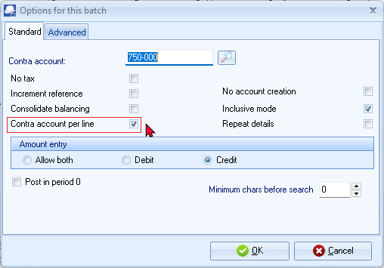

- Set up the Purchase journal as follows:
Contra account: | - Click on the Lookup button and select “750-000 - Stock control”.
No tax: | - Leave blank.
Increment reference: | - Leave blank.
Consolidate balancing: | - Leave blank.
Contra account per line: | - Tick.
No account creation: | - By default, this option is not selected. If you select an account, which does not exist, TurboCASH will ask you to create a new account. If you select this option you will not be allowed to create a new account. You need to exit the batch and create the required account.
Inclusive mode: | - Tick.
Repeat details: | - Leave blank.
Amount entry: | - Tick on “Credit”.
Post in period 0: | - Leave blank.
- Once set up; click on the Advanced tab.
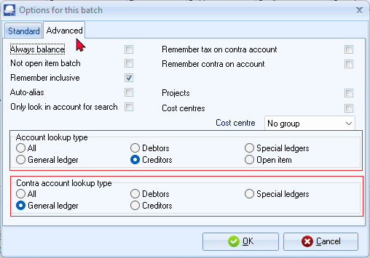
- Select the “Creditors” option for the “Account lookup type”, since you only need to select “Creditor” accounts when you enter transactions for purchases on credit to creditor (supplier) accounts.
- Set the “Contra account lookup type” may be set to “General ledger”, since you need to select the ledger account for each purchase.
- Once set up; click on the OK button.
- Enter the following supplier invoices in the Purchase journal:


- Enter and / or select the following:
  - Reference - Enter the purchase or other applicable number you allocate to the supplier invoice.
  - Date - Enter or select the date of the transaction.
  - Description - Enter a brief description for the transaction.
  - Account - Select the creditor account.
  - Contra account - Select the account to be debited with the credit purchase (expense or asset).
  - Tax - Select the applicable Input Tax account for the expense or purchase.
This is only applicable if Input VAT/GST/Sales tax is allowed on a transaction, and if you are registered as a VAT/GST/Sales tax Vendor. If no VAT/GST/Sales tax is applicable to the transaction, select the No tax code.
You may also select to hide the Tax column, and lookup in the F10:Setup – Standard tab for the Purchase journal, if no VAT/GST/Sales tax is applicable to all transactions in this batch; or if you are not registered as a VAT/GST/Sales tax Vendor.
  - Amount - Enter the amount of the transaction (Inclusive or Exclusive of VAT/GST/Sales tax) in the Credit amount column.
- After entering the supplier invoices in the Purchase journal, the transactions should be displayed as follows:
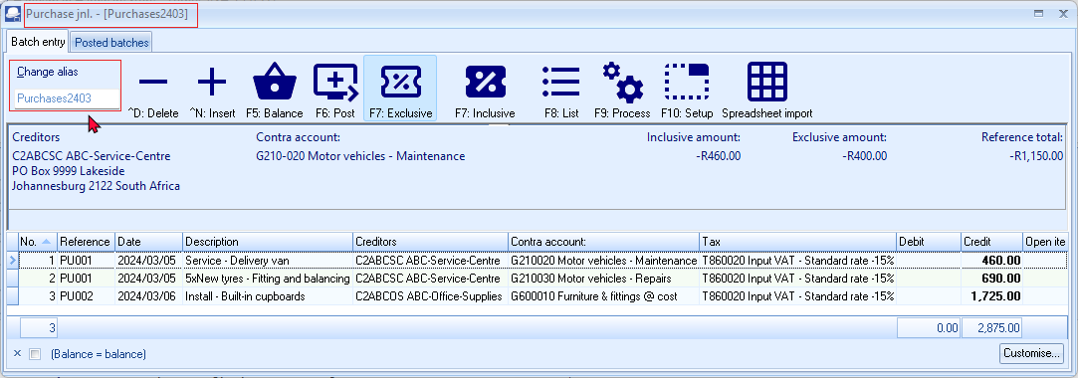
You have now captured all your supplier invoices for the month and may proceed with posting.
Updating supplier invoices to the ledger
Once you have completed entering these supplier invoices, and you are sure they are correct, you may proceed to finalise the batch. The recommended process, is as follows:
- Click on the F5:Balance icon to balance the batch.
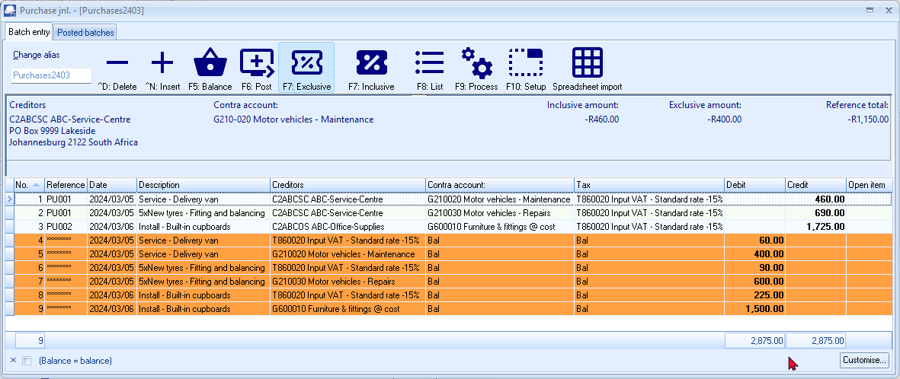
- Click on the F8:List icon to list the batch. 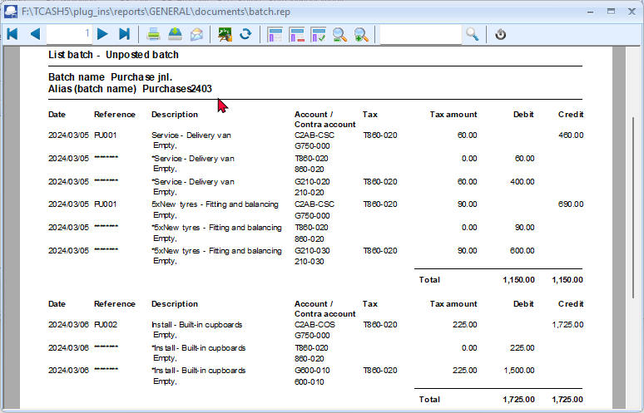
It is a good idea to list the batch, and check the entries on the batch thoroughly. If there are any errors, you may edit the batch, before posting the batch.
- Click on the F6:Post icon to post (update) the batch to the ledger.
It is not necessary to post (update) the transactions at the end of each day. You may add and / or post the transactions on a daily, or weekly basis, or at the end of a month. When you have entered a few transactions, you may close or exit the batch. The data will not be lost.
T-Account view of transactions
All processed (posted) transactions will be accumulated in the Ledger analyser. There are various ways in which the transactions may be viewed, printed, exported and analysed.
To access the T-Account view of the transactions:
- On the Reports ribbon, select Ledger analyser 1 or Ledger analyser 2.
- Select “Trial balance” report type and click on the Report button.
- On the “Trial balance”, select the “Creditor control” account.
- Double-click on the selected account; or right-click and select Show details on the context menu.
- Click on the following to get specific views of transactions:
- Batch id (e.g. 3 automatically generated). This will list only the transactions for a specific batch (journal).
- Account code (e.g. G210-020 Maintenance, G210-030 Repairs, G610-010 Furniture and fittings, T860-020 Input VAT/GST/Sales tax-Standard rate - 15%, C2ABCOS ABC-Office Supplies, C2ABCSC ABC-Service Centre). This will list the transactions for a specific account.
- Date – This will list the transactions for a specific date. If you double-click on a date, the “From date” and “To date” will be changed to the selected date.
After posting the transactions in the Purchase journal, the transactions should display as follows in the T-Account viewer:
Batch view
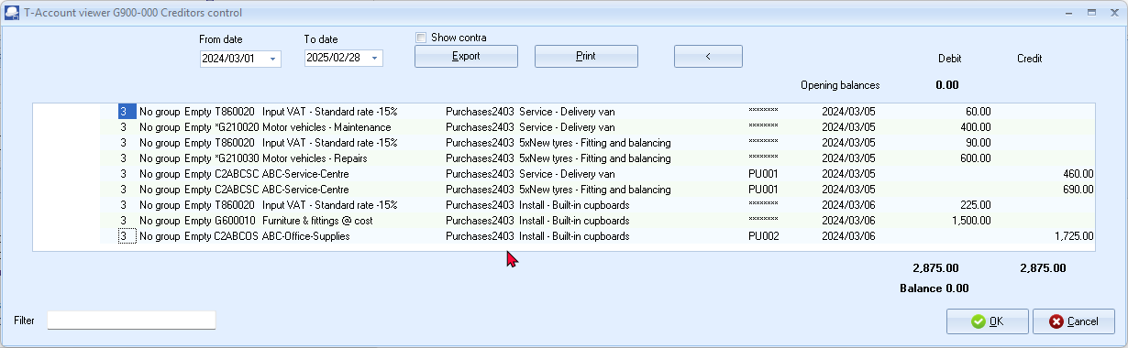

Account view
Accounts in the Creditor’s ledger:
ABC-Service-Centre

ABC-Office-Supplies

Accounts in the General ledger:
Motor vehicles - Maintenance

Motor vehicles - Repairs

Furniture and fittings @ cost

Input Tax – Standard rate - 15%

Debits = Credits
Debit transactions in the General ledger (i.e. Purchases Furniture + Expenses + Input Tax (VAT/GST/Sales Tax) accounts).
=
Credit transactions in the Creditor's ledger (i.e. individual Creditor accounts).

CAPTURING YOUR SALES
In addition to the Sales journal in the Batch entry mode, you may also use the Document entry to create Invoices using the following stock item types:
- Financial entry – Use the Accounts lookup to select General ledger accounts.
- Sales (no stock) – Create a Stock item for services only (e.g. consulting, labour, etc.)
Sales are also usually linked to the Sales journal in the Documents (Invoices tab) (Setup ribbon).
Using the Document entry, Invoices may be printed by TurboCASH5, which will generate similar transactions as the Sales journal batch entry as discussed here. Using the documents feature to record sales transactions in the Sales journal, you do not have to write out hand written invoices as in this example.
You may also create, print quotes and convert these to Invoices.
For the purpose of this tutorial, the similar transactions as in the Sales batch are also replicated for Invoices – (See – MODULE J.4).

Entering your sales invoices
You need to capture the invoices you have manually issued for sales to your debtors (customers).
For the purpose of the sales journal in this tutorial, assume that you will be writing out your invoices manually. You simply need to capture the details such as the invoice number, date of the invoice, details of the services or goods sold, the amount and VAT/GST/Sales tax (if you are registered as a VAT/GST/Sales tax vendor) in the Sales journal.
The hand written invoices in this MODULE are only applicable to the selling of services and items, which does not constitute your trading stock items to debtors (customers / clients). In this case, you need to manually produce hand-written invoices, which are captured in the Sales journal.

Capture the following four hand-written invoices:




To enter your sales transactions:
- On the Default ribbon, select Batch entry (F2).
- Select the Sales Jnl and click on the Open button.
- Enter the alias (batch name) in the “Change alias” field. In this example, enter ''Sales2403'' to indicate that the Sales for March 2024 was entered in this Sales batch.
This will help you if you wish to identify a specific batch to generate a batch type report, or if you wish to export posted batches to a file.
- Click on the F10:Setup icon to set your batch up. The “Options for this batch” screen is displayed:
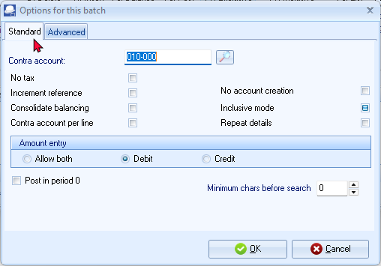
- Set up the Sales journal as follows:
Contra account: | - Click on the Lookup button and select “010-000 - Sales”.
No tax: | - Leave blank.
Increment reference: | - Tick.
Consolidate balancing: | - Leave blank.
Contra account per line: | - Leave blank.
No account creation: | - By default, this option is not selected. If you select an account, which does not exist, TurboCASH will ask you to create a new account. If you select this option you will not be allowed to create a new account. You need to exit the batch and create the required account.
Inclusive mode: | - Tick.
Repeat details: | - Leave blank.
Amount entry: | - Tick on “Debit”.
Post in period 0: | - Leave blank.
- Once set up; click on the Advanced tab.
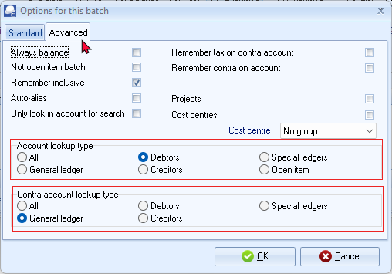
- Select the “Debtors” option for the “Account lookup type”, since you only need to select “Debtor” accounts when you enter transactions for sales on credit to debtors (customer / client) accounts.
- Select the “Debtors” option for the “Contra account lookup type”, to “General ledger”.
- Once set up; click on the OK button.
If you wish to allocate different transactions to different sales accounts, setup one contra account per line.
- You are now ready to capture the first invoice.
Reference: INV001
Date: 2024/03/07
Description: Paint - Exterior
Account: D1AB-GRE (Mr. AB Green)
Tax: Output VAT/GST/Sales tax - 15%
Amount: 1,150.00 DR (Ensure that the F7:Inclusive icon is reflecting the Inclusive mode)
- After capturing your first invoice, the “Batch entry” screen for the Sales journal should reflect as follows:
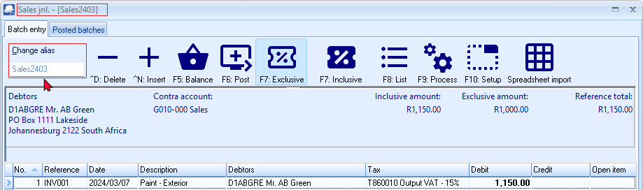
“F7: Inclusive” icon - Amounts in the normal or regular font indicate that it is entered Inclusive of VAT/GST/Sales tax.
If the “F7: Exclusive” icon is selected, the amounts are entered as Exclusive if VAT/GST/Sales tax and will be displayed in the bold font.
- Capture the other 3 invoices in the same way.
Reference: | INV002 | INV003 | INV004
Date: | 2024/03/09 | 2024/03/10 | 2024/03/12
Description: | Install - Built-in cupboard | Paint - Exterior | Install - Built-in cupboard
Account: | MAC Shop Decor Specialists | Mr. AB Green | Mr. Mike Davies
Tax: | Output Tax - 15% | Output Tax - 15% | Output Tax - 15%
Amount: | 1,725.00 DR (Inclusive) | 1,150.00 DR (Inclusive) | 1,725.00 DR (Inclusive)

- After capturing all your invoices, the “Batch entry” screen for the Sales journal, should reflect as follows:
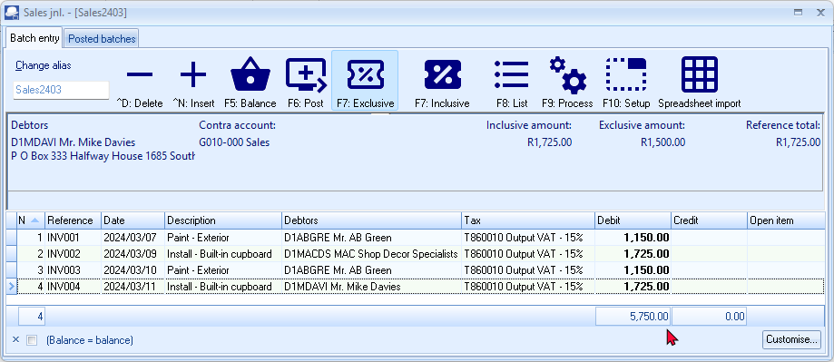
You have now captured all your sales invoices for the month and may proceed with posting.

Updating sales to the ledger
Once you have completed entering these invoices, and you are sure they are correct, you may proceed to finalise the batch. The recommended process, is as follows:
- Click on the F5:Balance icon. The balancing entries should reflect as follows:
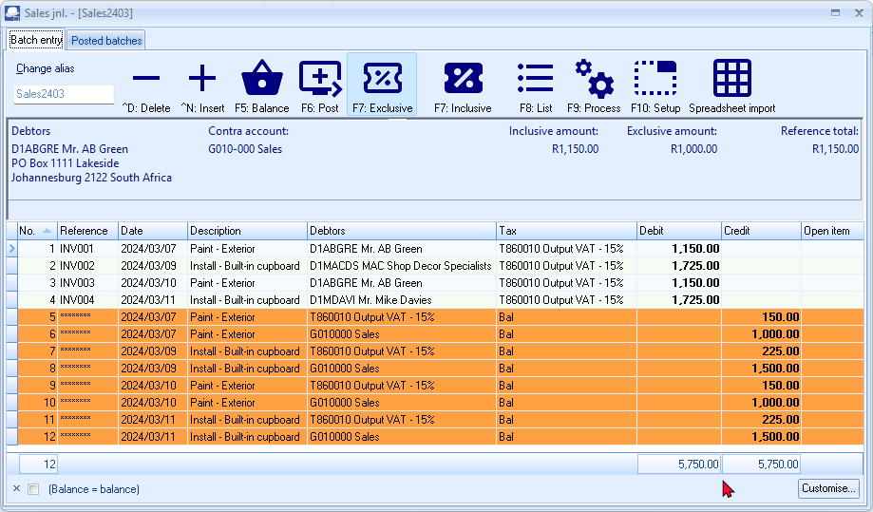
- Click on the F8:List icon to print a list of the transactions in the batch.
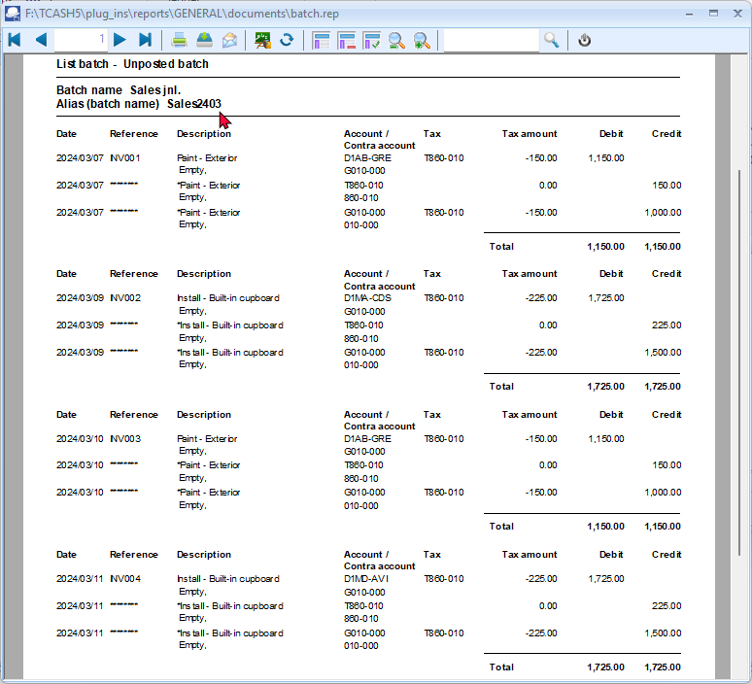
It is recommended that the source documents (e.g. sales invoices, etc.) be attached to this List of the transactions and that it be retained for record and audit purposes.
- Click on the F6:Post icon to post (update) the batch to the ledger.

T-Account view of transactions
All processed (posted) transactions will be accumulated in the Ledger analyser. There are various ways in which the transactions may be viewed, printed, exported and analysed.
To access the T-Account view of the transactions:
- On the Reports ribbon, select Ledger analyser 1 or Ledger analyser 2.
- Select “Trial balance” report type and click on the Report button.
- On the “Trial balance”, select the “Sales” account or the “Debtors control” account.
- Double-click on the selected account; or right-click and select Show details on the context menu.
- Click on the following to get specific views of transactions:
- Batch id (e.g. 4 automatically generated). This will list only the transactions for a specific batch (journal).
- Account code (e.g. G010-000 Sales, T860-010 Output VAT/GST/Sales tax - 15%, D1MD-AVI Mr. Mike Davies, D1AB-GRE Mr. AB Green, DMA-SDS MAC Shop Decor Specialists). This will list the transactions for a selected account.
- Date – This will list the transactions for a specific date. If you double-click on a date, the “From date” and “To date” will be changed to the selected date.
After posting the transactions in the Sales journal, the transactions should display as follows in the T-Account viewer:
Batch view
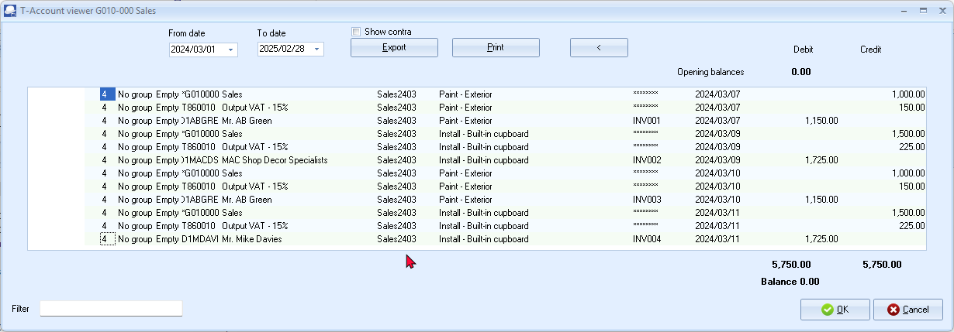

Account view
Accounts in the Debtor’s ledger:
Mr. AB Green

MAC Shop Decor Specialist

Mr. Mike Davies

Accounts in the General ledger:
Sales

Output Tax - 15%

Debits = Credits
Debit transactions in the Debtor’s ledger (i.e. individual Debtor accounts)
=
Credit transactions in the General ledger (i.e. Sales and Output Tax (VAT/GST/Sales tax) accounts).

REPEATING TRANSACTIONS
TurboCASH5 has a Repeating Transactions feature available to enable you to enter transactions, which occur on a periodic basis. They may be weekly, monthly, quarterly or annually, etc.
You may enter the transactions once and, when due, copy them into the normal batch, edit (if amounts have changed), delete or add an entry. This feature will save you lots of time. You may identify those transactions in your business and enter them in this feature.
A few examples of these entries are:
- For entry in the General journal or alternative batch type.
  - Depreciation of fixed assets
  - Payroll Journals or integration
- For entry in the Payments journal
  - Debit orders to third parties.
- For entry in the Receipts journal
  - Debit orders from third parties
Repeating transactions may be processed via the following options:
- Edit → Repeating transactions (Default ribbon) – Enter the transactions once in the “Repeating batch entry” screen. You may then Import the transactions into the normal “Batch entry” screen using the “Repeating transactions” option on the F9:Process (”Process the batch”) list.
- Import a posted batch option on the F9:Process options - Batch entry (Default ribbon). Once you have entered and posted a normal batch, you may import the batch, edit it, as required, and then post it.
For the purpose of this tutorial, assume that you will write-off some depreciation on your fixed assets. Enter the following entries for your depreciation on 2024/03/31:
Furniture and fittings: 50.00 per month.
Motor vehicles: Mercedes-Benz 75.00 per month.
Motor vehicles: Delivery van 25.00 per month.

Entering repeating transactions
To enter repeating transactions:
- On the Default ribbon, select Edit → Repeating transactions.
- Select the General jnl. batch type and click on the Open button.
To indicate that you have selected a Repeating Batch or Journal, note the following:
- ***Repeating transactions*** is displayed after the name of the batch type.
- No alias for the batch will be displayed in the screen heading (titlebar).
- The alias will not be saved, as only one Repeating transactions batch can be set for a specific batch type.
- Click on the F10:Setup icon to set your batch up. The “Options for this batch” screen is displayed:
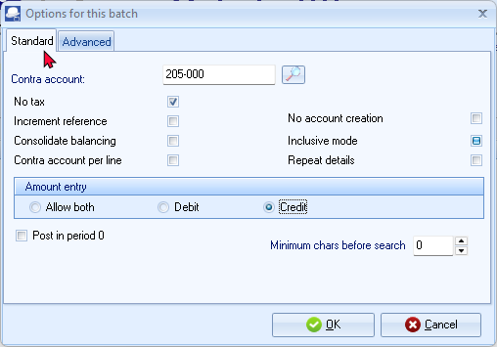
- Set up the repeating transactions General journal for depreciation transactions as follows:
Contra account: | - Click on the Lookup button and select - “205-000 - Depreciation”.
No tax: | - Tick.
Increment reference: | - Leave blank.
Consolidate balancing: | - Leave blank.
Contra account per line: | - Leave blank.
No account creation: | - By default, this option is not selected. If you select an account, which does not exist, TurboCASH will ask you to create a new account. If you select this option you will not be allowed to create a new account. You need to exit the batch and create the required account.
Inclusive mode: | - Tick.
Repeat details: | - Tick.
Amount entry: | - Tick on “Credit”.
Post in period 0: | - Leave blank.
- Once setup; click on the Advanced tab.
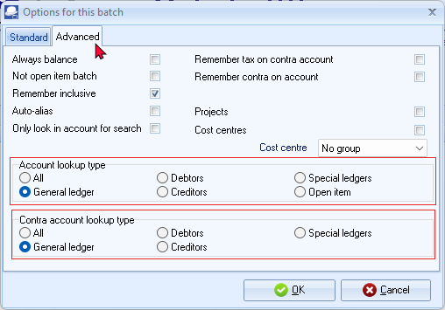
- Select the “General ledger” option for both the “Account lookup type” and “Contra account lookup type”, since you do not need to select “Debtor” or “Creditor” accounts when you enter transactions for depreciation.
- Once setup; click on the OK button.
- You are now ready to capture your repeating transactions.
Ref. no. | Date | Description | Account | Credit
DE2403 | 2024/03/31 | Depreciation-Furniture and Fittings | 600-020 Furniture and fittings - Accumulated depreciation | 50.00
DE2403 | 2024/03/31 | Depreciation-Motor vehicles-Merc | 610-020 Motor vehicles - Accumulated depreciation | 75.00
DE2403 | 2024/03/31 | Depreciation-Motor vehicles-Delivery van | 610-020 Motor vehicles - Accumulated depreciation | 25.00
- The repeating transactions for “General journal” screen should reflect as follows:
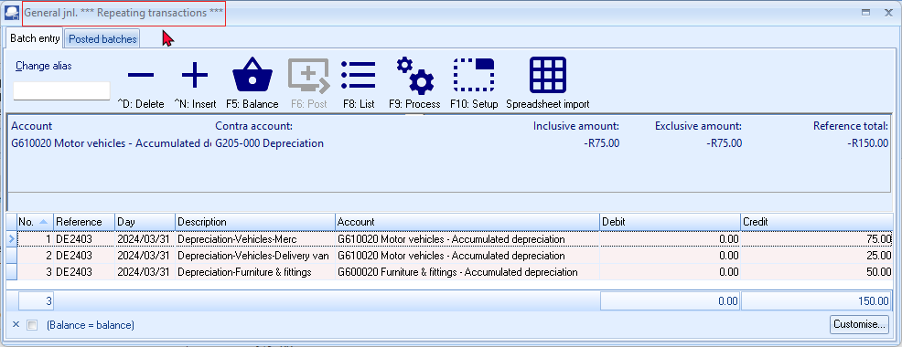
The Contra account – cannot be changed in the Repeating transactions batch entry screen. Once you have imported the transactions into a normal batch, you need to select the Contra account in the F10:Setup of the normal batch entry screen.
- Click on the F5:Balance icon. Balancing entries will be generated to the Depreciation Contra account.
- Click on the F8:List icon to print a list of the transactions in the batch.
You may wish to print the list of repeating transactions for record purposes.
The Batch list will not display an alias (batch name); since you cannot change the alias.
The alias for a normal batch (journal) will be displayed as (for example in this case) Alias (batch name): General jnl..
The F9:Post icon will be inactive, since you cannot post or update repeating transactions entered in the Edit → Repeating transactions menu to the ledger.
- Press the Esc key to exit this repeating batch.
Updating repeating transactions
To post or update the repeating transactions batch:
- On the Default ribbon, select Batch entry (F2).
- Select the General jnl. and click on the Open button.
- Click on the F9:Process icon. The “Process the batch” screen will be displayed.
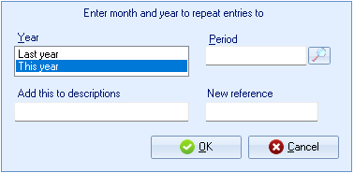
- Select the “Repeating transactions” option and click on the OK button. The following screen on the “Batch entry” screen, will be displayed:
If you enter a reference number into the “New Reference” field, the reference numbers will not be incremented.

The reference number entered, will apply to all repeating transactions which will be imported or generated into the batch.
- Select and / or enter the following options:
Year: | - Select “This year”.
Period: | - Select “March 2024”.
Add this to descriptions: | - Leave blank, for the purpose of this tutorial.
New reference: | - Leave blank, for the purpose of this tutorial.
- Click on the OK button. All the transactions you have entered in the repeating batch entry for the General journal will be imported (copied) into the normal batch.
- Enter the alias (batch name) in the “Change alias” field. In this example, enter ''Depreciate2403'' to indicate that the Depreciation transactions for March 2024 was entered in this General journal batch.
The alias option allows you to identify a batch by a unique name. You will be able to select the batch by alias or batch name if you need to reverse the posted batch, import a posted batch or print a posted batch from the Batches tab of the Batch entry – Posted batches - Details tab.
- Click on the F5:Balance icon to re-balance the batch.
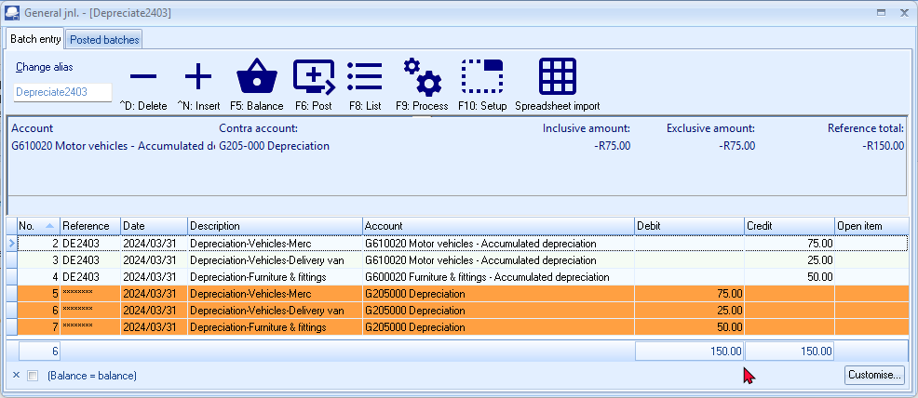
Always check that the amounts are the same before posting this batch. For instance if you have sold your Mercedes-Benz, you may need to delete the entry for the next months.
If you have purchased new assets you may change the amount or add a new entry.
You may do it on this screen, but it is recommended that you edit your repeating transactions in the Edit → Repeating transactions menu (Default ribbon) to avoid having to change the same issues every time you wish to update a repeating batch.
- If the batch is not balanced or in balance, click on the F5:Balance icon to balance the batch.
- Click on the F8:List icon to print a list of the transactions in the batch.
It is recommended that the source documents (e.g. working papers, calculation of depreciation, etc.) be attached to this List of the transactions and that it be retained for record and audit purposes.
- Once you are satisfied that all the entries are correct, click on the F6:Post icon.

T-Account view of transactions
All processed (posted) transactions will be accumulated in the Ledger analyser. There are various ways in which the transactions may be viewed, exported and analysed.
To access the T-Account view of the transactions:
- On the Reports ribbon, select Ledger analyser 1 or Ledger analyser 2.
- Select “Trial balance” report type and click on the Report button.
- On the “Trial balance”, select the “G205-000 Depreciation” account.
- Double-click on the selected account; or right-click and select Show details on the context menu.
- Click on the following to get specific views of transactions:
- Batch id (e.g. 14 automatically generated). This will list only the transactions for a specific batch (journal).
- Account code (e.g. G205-000 Depreciation, G600-020 Furniture and fittings - Accumulated Depreciation, G610-020 Motor vehicles - Accumulated depreciation). This will list the transactions for a specific account.
- Date – This will list the transactions for a specific date. If you double-click on a date, the “From date” and “To date” will be changed to the selected date.
After posting the transactions in the Depreciation transactions in the General journal, the transactions should display as follows in the T-Account viewer:
Batch view
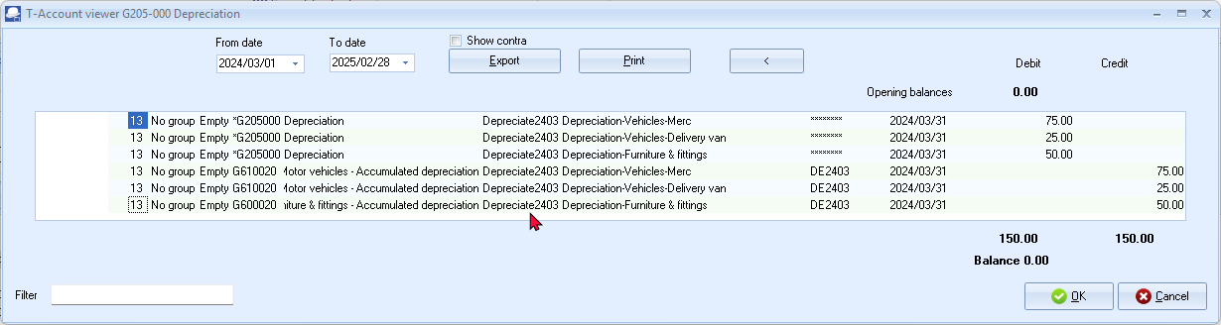

Account view
Debit transactions in the General ledger:
Depreciation
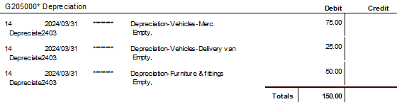
Credit transactions in the General ledger:
Furniture and fittings - Accumulated depreciation
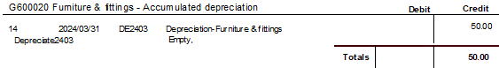
Motor vehicles - Accumulated depreciation
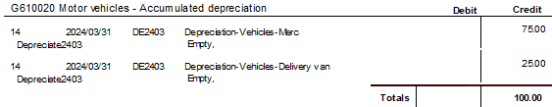
Debits = Credits
Debit transactions (i.e. Depreciation expense account)
=
Depreciation Account for each Fixed Asset (e.g. for Furniture and fittings and Motor vehicles)).

PROCESSING DOCUMENT TRANSACTIONS - NON TRADING STOCK

IN THIS MODULE
MODULE J - PROCESSING DOCUMENT TRANSACTIONS - NON TRADING STOCK 251
J.1- SALES AND PURCHASES TRANSACTIONS 253
J.1.1- Purchases 253
J.1.2- Sales 254
J.2- DOCUMENTS / STOCK SETTING AND PARAMETERS 255
J.3- PROCESSING CREDITORS - ORDERS AND PURCHASES 256
J.3.1- Creating an order 257
J.3.2- Creating an order 258
J.3.3- Confirming / Converting an order to a purchase document 261
J.3.4- Creating a purchase document 263
J.3.4.1- Editing a purchase document confirmed from an order 263
J.3.4.2- Creating a new purchase document 265
J.3.5- Updating purchases to the ledger 268
J.3.6- T-Account view of transactions 269
J.4- PROCESSING DEBTORS - QUOTES AND INVOICES 271
J.4.1- Creating a quote 271
J.4.2- Confirming a quote - Converting a quote to an invoice 274
J.4.3- Creating an invoice 276
J.4.3.1- Editing an invoice confirmed from a quote 276
J.4.3.2- Creating a new invoice 278
J.4.4- Updating your invoices to the ledger 281
J.4.5- T-Account view of transactions 281

SALES AND PURCHASES TRANSACTIONS
The Purchases and Sales of Trading stock items (Default) stock type are dealt with in MODULE K.
Purchases
The following options are available to enter Purchase transactions:
- Batch entry – Hand-written purchases and supplier returns (supplier credit notes) may be entered in the Purchase Jnl.
These are dealt with in MODULE I.2.
- Documents – If you wish to generate purchase documents (i.e. Purchases, Supplier returns and Orders), you may enter transactions in Documents (Default ribbon). To do this, you need to create stock item codes for the following stock types:
    - Financial entry – You only need to set the Tax accounts (Input and Output Tax accounts). When selecting this item, it will allow you to select the general ledger account on the Accounts lookup. Purchase prices may also be maintained for the Financial entry stock item type.
For the purpose of this tutorial, we will be purchasing services (i.e. Tyres and Service to Delivery Van and Installation of Office Equipment from creditors (suppliers).
- Purchases (no stock) – Pre-set the Input Tax account and pre-set purchase (expense / asset) account as well as purchase / cost prices.
- Purchases – This is similar to the Purchases (no stock) stock type. - It will also allow you to keep track of stock item quantities, etc. by updating the stock transaction table.
Purchases could also be used for any purchases other than trading stock. Non-trading stock items could be captured through the Batch entry - Purchase journal (Default ribbon). These may now be entered using the different stock types. An example of a non-stock item could be the purchase of consumables such as stationery, etc.

Sales
The following options are available to enter Sales transactions:
- Batch entry – Hand-written invoices and credit notes may be entered in the Sales Jnl.
These are dealt with in MODULE I.3.
- Documents – If you wish to generate sales documents (i.e. Invoices, Credit notes and Quotes), via TurboCASH5, you may enter transactions in Documents (Default ribbon). To do this, you need to create stock item codes for the following stock types:
- Financial entry – You only need to set the Tax accounts (Input and Output Tax accounts). When selecting this item, it will allow you to select the general ledger account on the Accounts lookup. Selling prices may also be maintained for the Financial entry stock item type.
- Sales (no stock) – Pre-set the Output Tax account and Sales account as well as selling prices.
For the purpose of this tutorial, we will be selling 2 services (i.e. Install - Built-in cupboards and Paint - Exterior (outside of houses)) at 500.00 per hour to our debtors / clients).
- Sales – This is similar to the Sales (no stock) stock type. It will also allow you to keep track of stock item quantities, etc. by updating the stock transaction table.
Invoices could also be used for any sales other than trading stock. Non-trading stock items could be captured through the Batch entry - Sales journal (Default ribbon). These may now be entered using the different stock types. An example of a non-stock item could be the sale of old or obsolete furniture, which your business does not use any longer.

DOCUMENTS / STOCK SETTING AND PARAMETERS
It is important that the required accounts and settings be absolutely correct before you proceed with purchasing and selling of stock items in a Set of Books. If this is not done, you may find incorrect results in TurboCASH5. For example, the Cost of sales transactions may not be generated when documents are posted to the ledger or the cost of sales may be calculated at average cost in stead of latest cost, etc.
Setup of Documents is a once-off process:
- Setup → Documents setup (Setup ribbon) – Check document numbers, messages, set layout files, etc. - (See – MODULE E.4.5).
- Setup → Groups (Setup ribbon) – Add the Cost of sales reporting group under Account group 1 (Reporting group 1). Add Reporting groups 1 and 2 for Document groups and Stock group 1 /2, where applicable. - (See – MODULE E.4.4).
- Setup → Salesperson (Setup ribbon) – Add Salespersons. - (See – MODULE E.4.7).
- Setup → Batch types – Add Cost of sales Batch (only to be used with Cost of sales settings for the Default Stock type). - (See – MODULE E4.3).
- Setup → Stock information (Setup ribbon) – Unit prices, Selling price descriptions, Default selling price. - (See – MODULE E.4.6).
- Setup → Accounts (Setup ribbon) – Create a Cost of sales account for Trading stock. - (See – MODULE F.1).
- Creditors (Default ribbon) – Create a Sundry Supplier account. - (See – MODULE F.3).
- Debtors (Default ribbon) – Create a Cash Customer and Linking Debtors to a Salesperson. - (See – MODULE F.4).
You may print a Company information (Reports → Company info – Information) report to check the selling price descriptions. This report will also display the default headings and messages that will print on document layout files (i.e. Invoices, Quotes, Credit notes, Purchases, Supplier returns and Orders).
Your Set of Books should be set up to process documents for the purchase and selling of stock items.

PROCESSING CREDITORS - ORDERS AND PURCHASES
The similar Purchase transactions may be entered in the normal “Batch entry” screens as above (See – MODULE I.2). Using the batch option, will not generate any purchase documents (i.e. Orders, Purchase documents and / or Supplier return documents). These documents need to be manually written in purchased stationery.
Using the Documents option, the transactions in the Purchase journal will automatically be generated and these documents will be automatically be generated via the layout files as set in as follows:
- Global Settings – As selected on the “Layout file” fields of Documents setup (Purchases, Supplier returns and Orders tabs) (Setup ribbon).
- Creditor (Supplier) Specific Settings – As selected on the “Layout file” fields of the Creditors - Delivery address tab) (Default ribbon) – (“Layout file 1” = Purchases, “Layout file 2” = Supplier returns and “Layout file 3”= Orders fields).
- The Default setting on the layout file should always revert to the Global settings unless another layout file have been set for a specific creditor (supplier) account. In addition to these two (2) settings layout files may be changed or other formats may be selected as follows:
    - Documents (Default ribbon) – Sidebar for Purchase document types (i.e. Purchases, Supplier returns and / or Orders).
    - Creditors – Documents tab (Default ribbon) of a selected creditor (supplier) account.
Purchase documents must be used for trading stock items. Please refer to MODULE K of this tutorial.
The transactions will automatically be generated when documents are updated or posted to the ledger. It will automatically generate and update (post) the transactions to the ledger in the batch types as set (linked) in the Setup → Documents setup (Setup ribbon) - Purchases and Supplier returns tabs.

Creating an order
The similar Purchase transactions may be entered in the normal “Batch entry” screens as above (See – MODULE I.2). Using the batch option, will not generate any purchase documents (i.e. Orders, Purchase documents and / or Supplier return documents). These documents need to be manually written in purchased stationery.
Using the Documents option, the transactions in the Purchase journal will automatically be generated and these documents will be automatically be generated via the layout files as set in as follows:
- Global Settings – As selected on the “Layout file” fields of Documents setup (Purchases, Supplier returns and Orders tabs) (Setup ribbon).
- Creditor (Supplier) Specific Settings – As selected on the “Layout file” fields of the Creditors - Delivery address tab) (Default ribbon) – (“Layout file 1” = Purchases, “Layout file 2” = Supplier returns and “Layout file 3”= Orders fields).
- The Default setting on the layout file should always revert to the Global settings unless another layout file have been set for a specific creditor (supplier) account. In addition to these two (2) settings layout files may be changed or other formats may be selected as follows:
    - Documents (Default ribbon) – Sidebar for Purchase document types (i.e. Purchases, Supplier returns and / or Orders).
    - Creditors – Documents tab (Default ribbon) of a selected creditor (supplier) account.
Purchase documents must be used for trading stock items. Please refer to MODULE K of this tutorial.
The transactions will automatically be generated when documents are updated or posted to the ledger. It will automatically generate and update (post) the transactions to the ledger in the batch types as set (linked) in the Setup → Documents setup (Setup ribbon) - Purchases and Supplier returns tabs.

Creating an order
You may need to place an order with any of your creditors (suppliers). When the Goods are received you may confirm the order against the actual goods received and the original order. You will do this by converting the Order to a Purchase document.
Orders cannot be updated (posted) to the ledger and it generates no transactions. But, once the Order has been converted to a Purchase document, it can be updated (posted) to the ledger.
Order the following services and goods (NON-TRADING STOCK ITEMS) from ABC-Service Centre:
ORDER: OR000001 - 2024/03/01
ABC-Service-Centre
Service - Delivery van 400.00
5 x New Tyres - Fitting and balancing 600.00
Total 1,000.00
Input Tax - 15% 150.00
Total 1,150.00
To create an order:
- On the Default ribbon, select Documents (F6).
- Select “Orders” in the “Documents” field; if “Orders” is not selected.
- Click on the New button. The “Creditor accounts” screen is displayed:
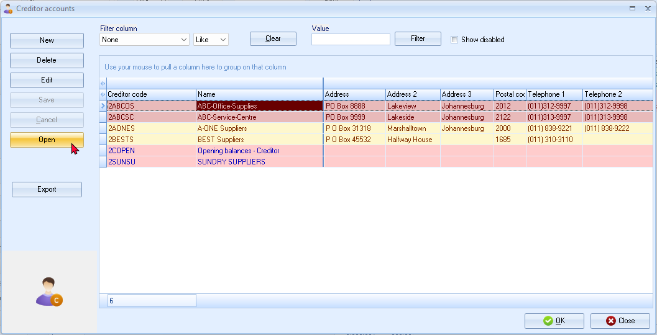
- Select the Creditor (supplier) account (“ABC-Service-Centre”).
- Click on the Open or OK button. The screen for “Orders” is displayed:

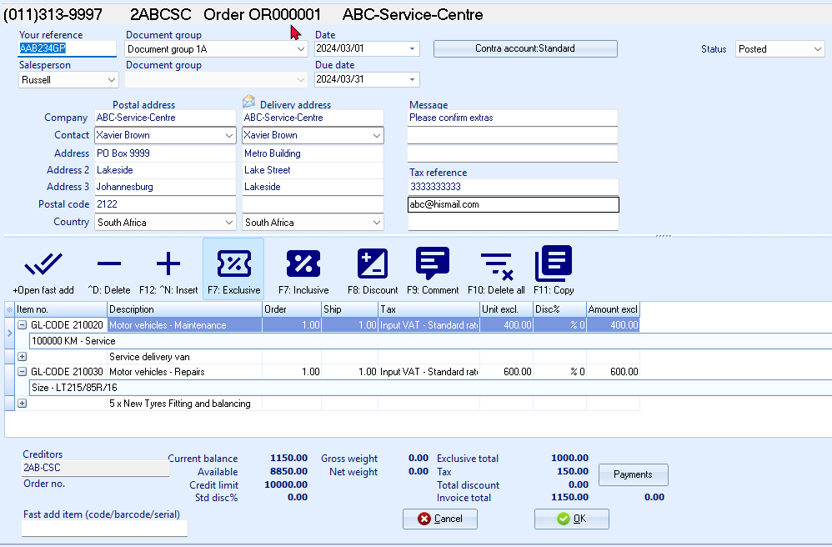
- Enter and / or select the following options:
Your reference: | - Enter “AAB234GP” as the registration number of the vehicle.  This will allow you to track down the vehicle's history when entering the registration number in the Search (Investigator) on the Default ribbon. All documents matching that registration number will be listed.
Salesperson: | - Select “Russell”. Salespersons are optional for orders. This field is to show who handled the order.
Document group 1/2: | - Select “Document group 1A”.  - Document group 2 cannot be selected as Groups are not added for Document group 2 in Groups. (Setup ribbon)
Date: | - Select “2024/03/01”, for the purpose of this tutorial. By default, the system date will be displayed.
Due date: | - This date will be automatically be calculated. It is the “Date” plus the number of days set in the Accounting information tab of the selected creditor account.
Messages: | - The messages as entered in Setup documents for the Orders document type will be displayed in the Message lines 1 to 3 fields. You may edit this, as necessary.
 | - Press the Enter key until you get to the transaction details (document lines).
Item no.: | - Select “GL-CODE”.  The “Accounts lookup” screen will be displayed.  - Select the Account “G210-020 - Motor vehicles - Maintenance” for the Servicing of delivery van. The description of the selected account is displayed. You may over-type this.
Order / Ship: | - The default quantity is “1”. Leave as is.
Amount: | - Enter the Unit price 400,00 (Exclusive of VAT/GST/Sales tax, if the F7:Exclusive icon is active - or 460,00 Inclusive of VAT/GST/Sales, Tax if the F7:Inclusive icon is active).
Comments: | - For the purpose of this tutorial, click on the F9:Comment icon or press the F9 key. Enter “Service delivery van“ and click on the OK button.
Remarks: | - You may click on the + icon (or right-click to select “Expand” option on the context menu) of a selected item to add a remark (additional information), which will print on document layout files. Enter “100000 KM - Service”, as in this example.
Item no. (next item): | - Select “GL-CODE”.  The “Accounts lookup” screen will be displayed.  - Select the Account “G210-030 - Motor vehicles - Repairs” for 5 x new tyres fitting and balancing. The description of the selected account is displayed. You may over-type this.
Order / Ship: | - The default quantity is “1”. Leave as is.
Amount: | - Enter the Unit price 600,00 (Exclusive of VAT/GST/Sales tax, if the F7:Exclusive icon is active - or 690,00 Inclusive of VAT/GST/Sales, Tax if the F7:Inclusive icon is active).
Comments: | - For the purpose of this tutorial, click on the F9:Comment icon or press the F9 key. Enter “5 x New Tyres Fitting and balancing“ and click OK.
Remarks: | - You may click on the + icon (or right-click to select “Expand” option on the context menu) of a selected item to add a remark (additional information), which will print on document layout files. Enter “Size – LT215/85R/16”, as in this example.
- Click on the OK button. A confirmation message is displayed:
“Do you wish to print this order?”
- Click on the Yes button to print the order.

An example of the printed order, is as follows:
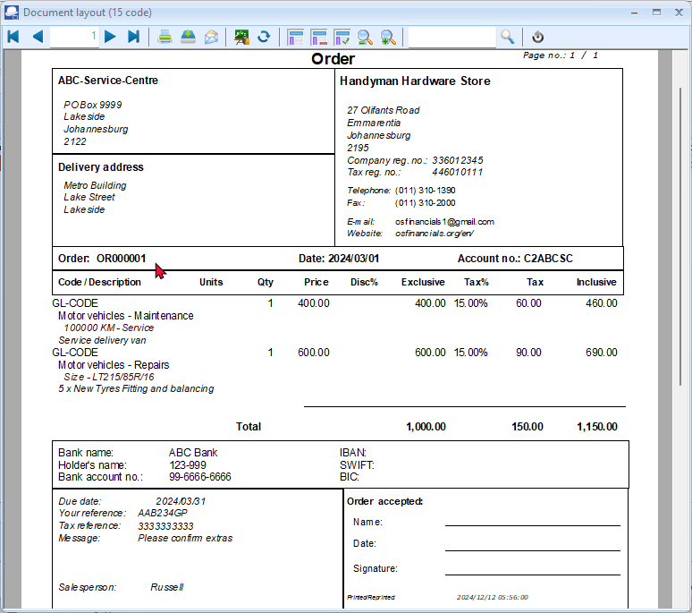
In addition to the comments, the remarks will be displayed in a shade of dark red font.

Confirming / Converting an order to a purchase document
We have already placed an order with our ABC-Service-Centre - and the delivery van are fixed (serviced and 5 new tyres have been fitted and balanced) on 14 March 2024. The order needs to be checked and converted into a Purchase document.
Convert invoice to order
If you have already created invoices (whether they are updated to the ledger (posted) or not), you may convert the Invoice to an Order. To do this, select the Invoice on the documents list and right-click and select the “Documents → Convert invoice to order” option from the context menu.
You may then edit the order and convert it to a purchase document.
To convert an order to a purchase document:
You may also convert Orders to Purchase documents from the Input → Confirm (Default ribbon).
- Access the “Orders” in the “Documents” field; if “Orders” is not selected.
- Select the order to convert and right-click.
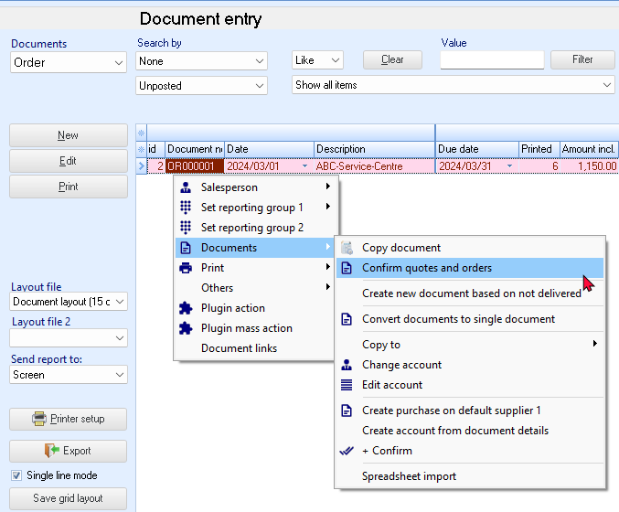
- On the context menu, select the “Confirm quotes and orders” option. A confirmation screen will be displayed.
“Do you wish to continue?”
- Click on the Yes button to proceed. Another confirmation screen will be displayed.
“Do you wish to delete this Order?”
- Click on the No button not to delete the order.
If you click on the Yes button, the order will be deleted from the “Orders” list of the “Document entry” screen.
Should you click on the No button the order will still be available on the “Orders” list of the “Document entry” screen. You may then Copy the order, change the account, edit the quantities, amounts, etc. before converting it to a purchase document.
You may delete Orders in Edit → Delete → Documents (Default ribbon).

Creating a purchase document
Once an Order is converted to a Purchase document, it must be checked to see that the correct stock was received. When we access the Purchase documents screen from the Documents → Purchases menu (Default ribbon) and the Creditor is selected, all available unposted Purchase documents for that supplier are listed.
Editing a purchase document confirmed from an order
To edit a purchase document converted from an order:
- On the Default ribbon, select Documents (F6).
- Select “Purchases” in the “Documents” field; if “Purchases” is not selected.
The Purchase document, listed on the “Document entry” screen, was automatically created when you have confirmed and converted the Order to a Purchase document.
- Select the Purchase document on the list and click on the Edit button. The screen for Purchases is displayed:
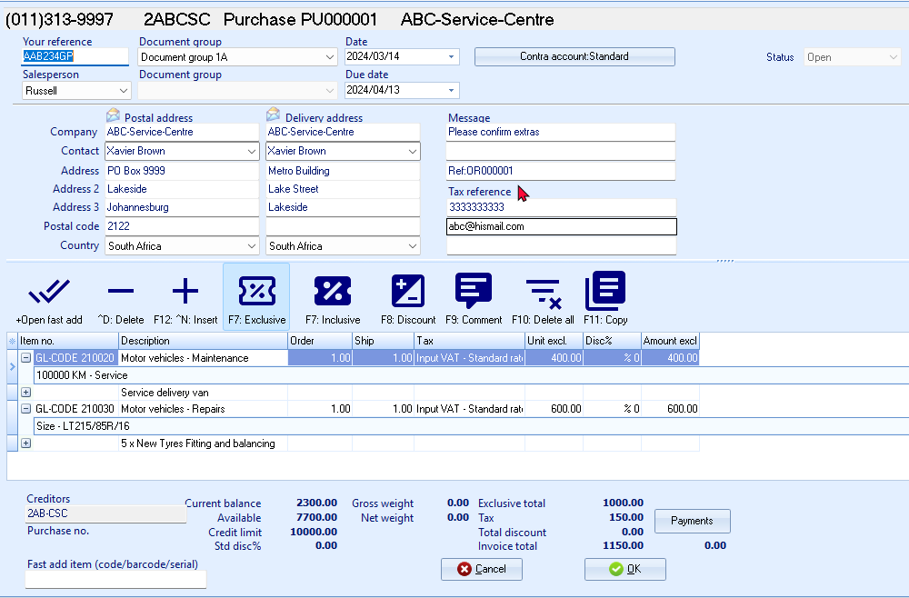
The Order number “OR000001”, which was converted to this Purchase document, is displayed in the very last line in the “Message” field.

- Enter and / or select the following options:
Your reference: | - Check that “AAB234GP” is displayed.
Date: | - The system date should be displayed. Select “2024/03/14”, as it is the date on which the order was fulfilled.  This is the date on which the Order need to be converted to a Purchase document).
Due date: | - This date will be automatically be calculated. It is the “Date” plus the number of days set in the Accounting information tab of the selected creditor account.
Message: | - The messages as entered in Setup documents for the Purchases document type will be displayed in the Message lines 1 to 3 fields. You may edit this, if necessary.
- The items and details of the order will be displayed on the respective fields. Check the details and that the purchase price is correct. You may edit it, if necessary.
- Click on the OK button. A confirmation screen will be displayed.
“Do you wish to print this purchase?”
- Click on the Yes button.
An example of the printed purchase document, is as follows:
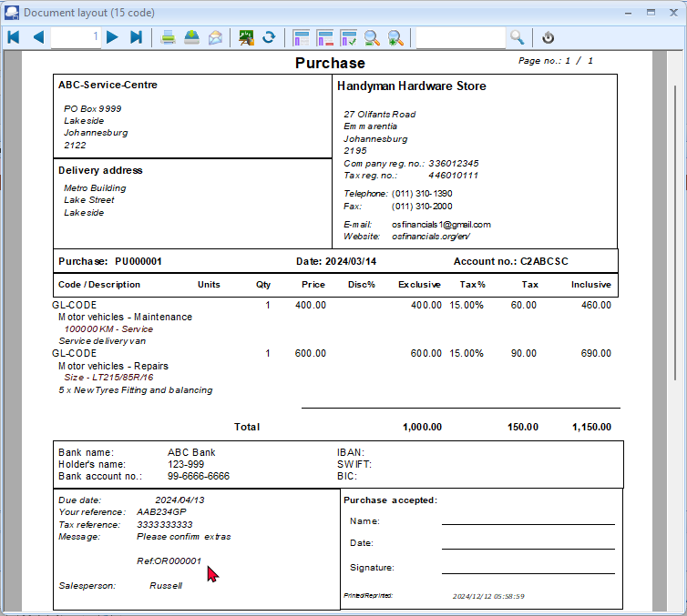
In addition to the comments, the remarks will be displayed in a shade of dark red font.
The Order number “OR000001”, which was converted to this Purchase document, is displayed in the third line in the “Message” section.
You are now ready to enter the rest of your Purchases.
Creating a new purchase document
We have also purchased the following services:
PU000002 - 2024/03/15
Invoice IN0014 from
ABC-Office-Supplies
Installation of office equipment 1,500.00
Input Tax – 15% 225.00
Total 1,725.00
To create a new purchase document:
- On the Default ribbon, select Documents (F6).
- Select “Purchases” in the “Documents” field; if “Purchases” is not displayed.
- Click on the New button.
Only select “New” when you are actually creating a new Purchase document. Remember that you will only be able to edit Purchase documents as long as they have not yet been updated to the ledger.
The “Creditor accounts” screen is displayed:
- Select the Creditor (supplier) account (“ABC-Office Supplies”).
- Click on the Open or OK button. The screen for “Purchases” is displayed:
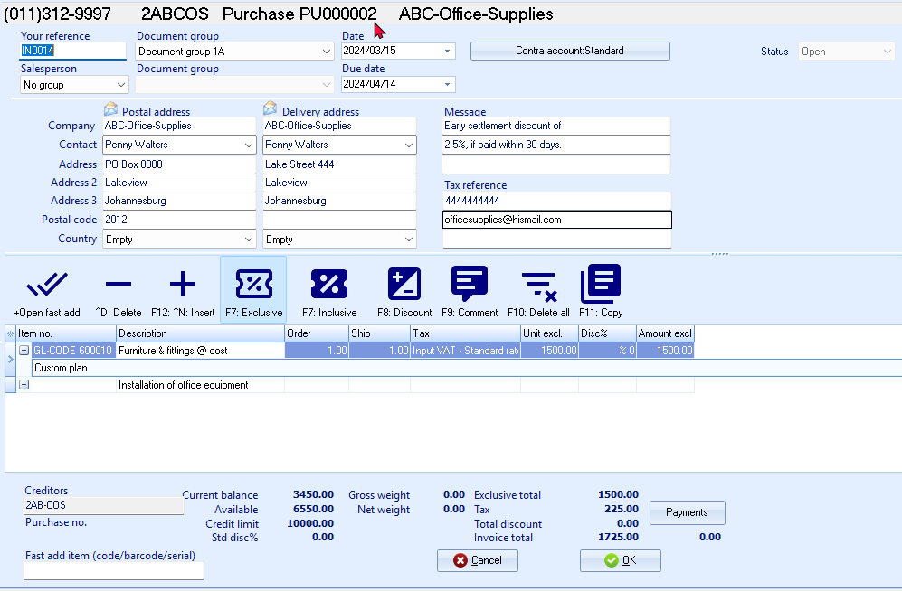
- Enter and / or select the following options:
Your reference: | - Enter “IN0014” as the reference of the creditor.
Salesperson: | - Select “Tracy”. Salespersons are optional for purchases. This field is to show who handled the purchase.
Document group 1/2: | - Select “Document group 1A”.  - Document group 2 cannot be selected as Groups are not added for Document group 2 in Groups (Setup ribbon).
Date: | - Select “2024/03/15”.
Due date: | - This date will be automatically be calculated. It is the “Date” plus the number of days set in the Accounting information tab of the selected creditor account.
Message: | - The messages as entered in Setup documents for the Purchases document type will be displayed in the Message lines 1 to 3 fields. You may edit this, as necessary.
 | - Press the Enter key until you get to the transaction details (document lines).
Item no: | - Select the account “G600-010 – Furniture and fittings @ cost” for the Installation of office equipment. The description of the selected account is displayed. You may edit this, as necessary.
Order / Ship: | - Enter “1”.
Tax: | - The default Input Tax account for the stock item will be displayed. Confirm that it is correct by pressing the Enter key.
Unit excl. | - Enter the Unit price (“1,500.00” - Exclusive of VAT/GST/Sales tax, if the F7:Exclusive icon is active - or “1,725.00” - Inclusive of VAT/GST/Sales, Tax if the F7:Inclusive icon is active).
Discount: | - Press the Enter key to keep it at the default 0% discount rate.
Comment: | - Click on the F9:Comment icon or press the F9 key. Enter “Installation of office equipment“ and click on the OK button.
Remarks: | - You may click on the + icon (or right-click to select “Expand” option on the context menu) of a selected item to add a remark (additional information), which will print on document layout files. Enter “Custom plan”, as in this example.
- Click on the OK button. A confirmation screen will be displayed.
“Do you wish to print this purchase?”
- Click on the No button.

Updating purchases to the ledger
Since we have not added users, and selected the “Auto-post documents on print” option on the Documents setup (See – MODULE E.4.5) we need to post the invoices manually.
To post or update your purchases:
- On the Default ribbon, select Update ledger (F3). The “Update Invoice” screen will be displayed.
- Select “Purchases” and its name will change to “Update purchases” - listing all your unposted purchases.
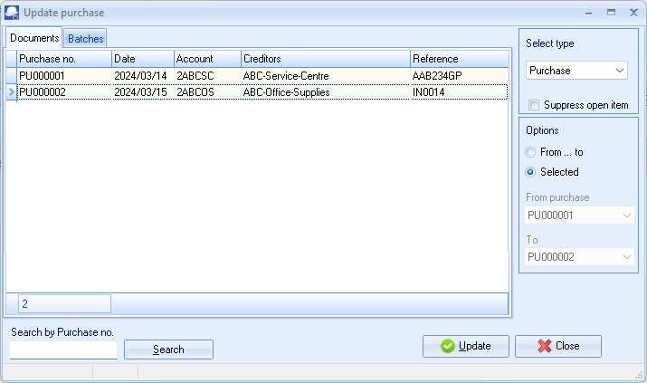
Purchases in rows with a cream or peach background (i.e. PU000001), have been printed.
Purchases in rows with a blue background (i.e. PU000002), have not yet been printed.
- Click on the “From... to” field and select -
From purchase: PU000001
To: PU000002
- Click on the Update button. TurboCASH5 will generate the Purchases journal and update the stock, creditors and Input VAT/GST/Sales tax. The transactions is as follows:
DR Expense / Asset Purchase account
DR VAT/GST/Sales tax (net amount)
CR Creditor (total amount)

T-Account view of transactions
All processed (posted) transactions will be accumulated in the Ledger analyser. There are various ways in which the transactions may be viewed, printed, exported and analysed.
To access the T-Account view of the transactions:
- On the Reports ribbon, select Ledger analyser 1 or Ledger analyser 2.
- Select “Trial balance” report type and click on the Report button.
- On the “Trial balance”, select the “Creditors control” account.
- Double-click on the selected account; or right-click and select Show details on the context menu.
- Click on the following to get specific views of transactions:
- Batch id (e.g. 27 or 28 automatically generated). This will list only the transactions for a specific batch (journal).
- Account code (e.g. G210-020 Maintenance, G210-030 Repairs, T860-020 Input Tax – Standard rate – 15% account, C2AB-CSC ABC-Service Centre). This will list the transactions for a specific account.
- Date – This will list the transactions for a specific date. If you double-click on a date, the “From date” and “To date” will be changed to the selected date.
After posting the Purchase documents, the transactions should display as follows in the T-Account viewer:
Batch view
Batch 27 – PU000001 – ABC-Service-Centre
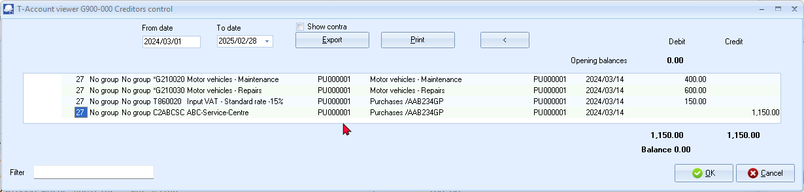
Batch 28 – PU000002 – ABC-Office-Supplies
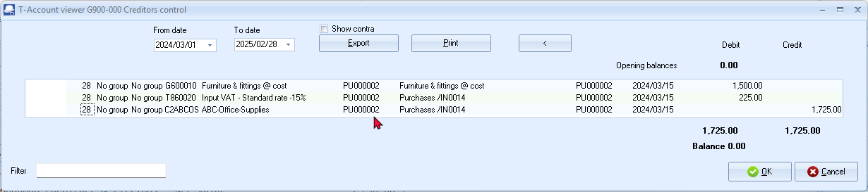

Account view
Accounts in the Creditor’s ledger:
ABC-Service-Centre
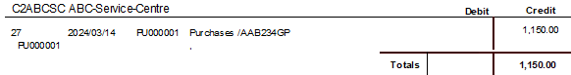
ABC-Office-Supplies
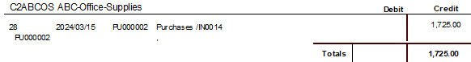
Accounts in the General ledger:
Furniture and fittings @ cost
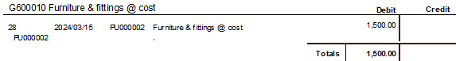
Motor vehicle – Maintenance
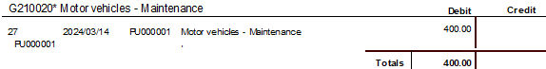
Motor vehicle - Repairs
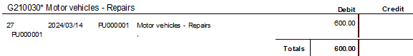
Input Tax – Standard rate – 15 %
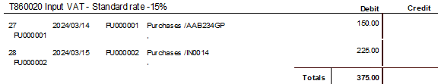
Debits = Credits
Debit transactions in the Expenses (i.e. Maintenance and Repairs) and Fixed assets accounts (i.e. Furniture and fittings @ cost) and Input Tax (VAT/GST/Sales tax).
=
Credit transactions in the Creditor’s ledger (i.e. individual Creditor accounts).

PROCESSING DEBTORS - QUOTES AND INVOICES
The similar Sales transactions may be entered in the normal “Batch entry” screens as above (See – MODULE I.3). Using the batch option, will not generate any sales documents (i.e. Quotes, Invoices and / or Credit notes). These documents need to be manually written in purchased stationery.
Using the Documents option, the transactions in the Sales journal will automatically be generated and these documents will be automatically be generated via the layout files as set in as follows:
- Global Settings – As selected on the “Layout file” fields of Setup → Documents setup (Invoices, Credit notes and Quotes tabs) (Setup ribbon).
- Debtor (customer / client) Specific settings – As selected on the Layout fields of the Debtors - Delivery address tab) (Default ribbon) – (“Layout file 1” = Invoices, “Layout file 2” = Credit notes and “Layout file 3”= Quotes fields).
- The Default setting on the Layout file should always revert to the Global settings unless another layout file have been set for a specific debtor (customer / client) account. In addition to these two (2) settings layout files may be changed or other formats may be selected as follows:
        - Documents (Default ribbon) – Sidebar for Sales document types (i.e. Invoices, Credit notes and / or Quotes).
        - Debtors – Documents tab (Default ribbon) of a selected debtor (customer / client) account.
Sales documents must be used for trading stock items. Please refer to MODULE K of this tutorial.
Creating a quote
Your debtors (customers / clients) may ask you for a quotation on your products for various reasons. TurboCASH5 allows you to create a quote on the system. When the debtor (customer / client) accepts the quote, you may confirm the Quote and Convert it to an Invoice.
Note will not be able update the Quotation to the ledger and it generates no transactions. But once the Quote has been converted to an Invoice, it can be updated or posted to the ledger.
On 1 March 2024 Mr. AB Green asked for a quote for painting outside of his house.
To create a quote:
- On the Default ribbon, select Documents (F6).
- Select “Quotes” in the “Documents” field; if “Quotes” is not selected.
- Click on the New button.
Only select “New” when you are actually creating a new invoice. Remember that you will only be able to edit invoice as long as they have not yet been updated to the ledger.
- The “Debtor accounts” screen is displayed:
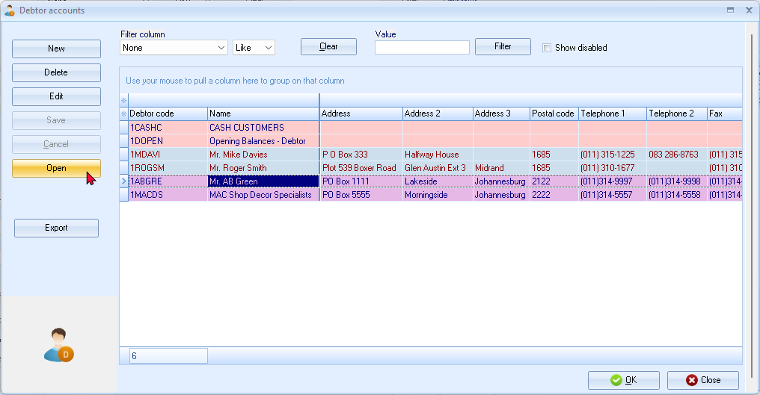
- Select the Debtor (customer / client) account (“Mr. AB Green”).
- Click on the Open or OK button.
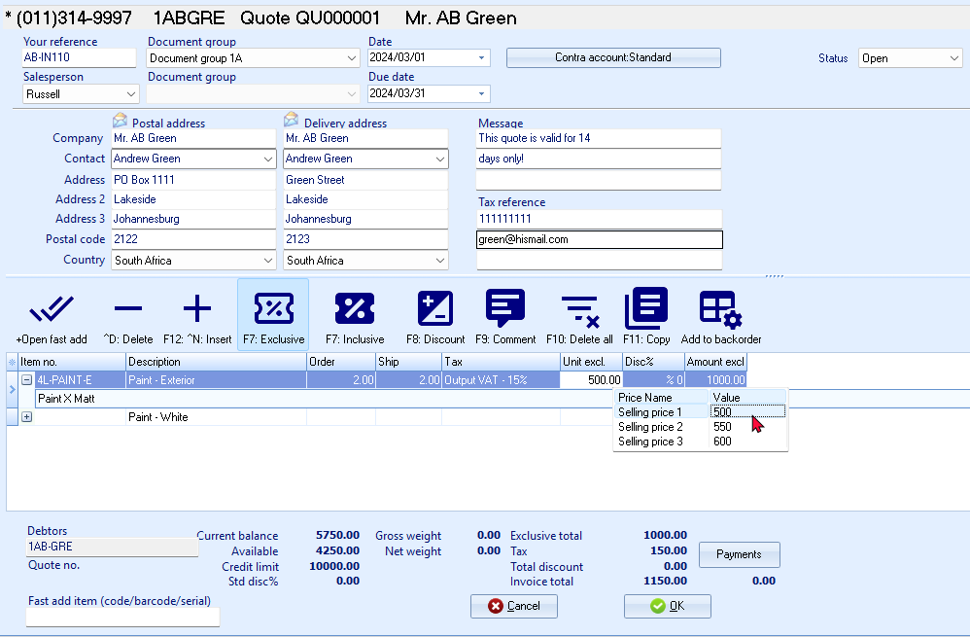

- Enter and / or select the following options:
Your reference: | - Leave blank.
Salesperson: | - Select “Russell”; if not already selected. As Russell was set as the default salesperson, his name should automatically be displayed. (You may select any other salesperson if Russell is not doing this quote).
Document group 1/2: | - Select “Document group 1A”.  - Document group 2 cannot be selected as Groups are not added for Document group 2 in Groups. (Setup ribbon).
Date: | - Select “2024/03/01”.
Due date: | - This date will be automatically be calculated. It is the “Date” plus the number of days set in the Accounting information tab of the selected debtor account.
Message: | - The messages as entered in Setup documents for the Quotes document type will be displayed in the Message lines 1 to 3 fields. You may edit this, as necessary.
 | - Press the Enter key until you get to the transaction details (document lines).
Item no.: | - Select “4L-PAINT-E”. The description, Quantity (default 1), Output Tax account, Unit selling price (Exclusive of VAT/GST/Sales tax if the F7:Exclusive icon is active - or Inclusive of VAT/GST/Sales tax if the F7:Inclusive icon is active) will be displayed.  - The default selling price for the Debtor account will be displayed. Make sure that Selling price 1 (i.e. “500”) is selected for the purpose of this tutorial.
Quantity: | - The default quantity is displayed as “1”. Enter “2” as the quote is for 2 hours.
Tax: | - The default Output Tax account for the stock item will be displayed. When the cursor is in this field, the Tax accounts lookup will be displayed. Confirm that it is correct by pressing the Enter key.
Discount: | - Press the Enter key to keep it at the default 0% discount rate.
F9:Comment: | - Click on the F9:Comment icon.
 | - Enter “Paint - White” as a comment and click OK.
Remarks: | - You may click on the + icon (or right-click to select “Expand” option on the context menu) of a selected item to add a remark (additional information), which will print on document layout files. Enter “Paint X Matt”, as in this example.
- Click on the OK button. A confirmation screen will be displayed.
“Do you wish to print this quote?”
- Click on the Yes button.
An example of the printed quote, is as follows:
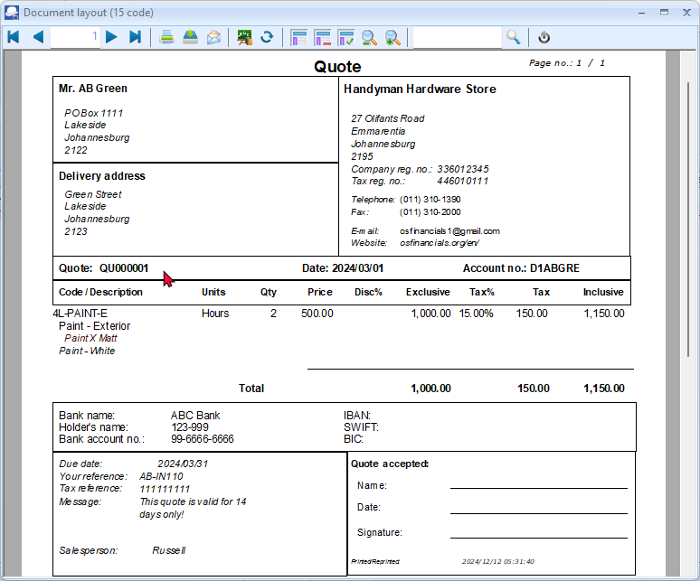
In addition to the comments, the remarks will be displayed in a shade of dark red font.

Confirming a quote - Converting a quote to an invoice
On 13 March 2024, Mr. AB Green confirms that he wishes to repair his roof as quoted on 1 March 2024. We need to check or confirm the quote and convert it to an invoice.
To convert a quote to an invoice:
You may also convert quotes to invoices from the Input → Confirm (Default ribbon).
- Access “Quotes” in the “Documents” field; if “Quotes” is not selected.
- Select the quote to convert and right-click.
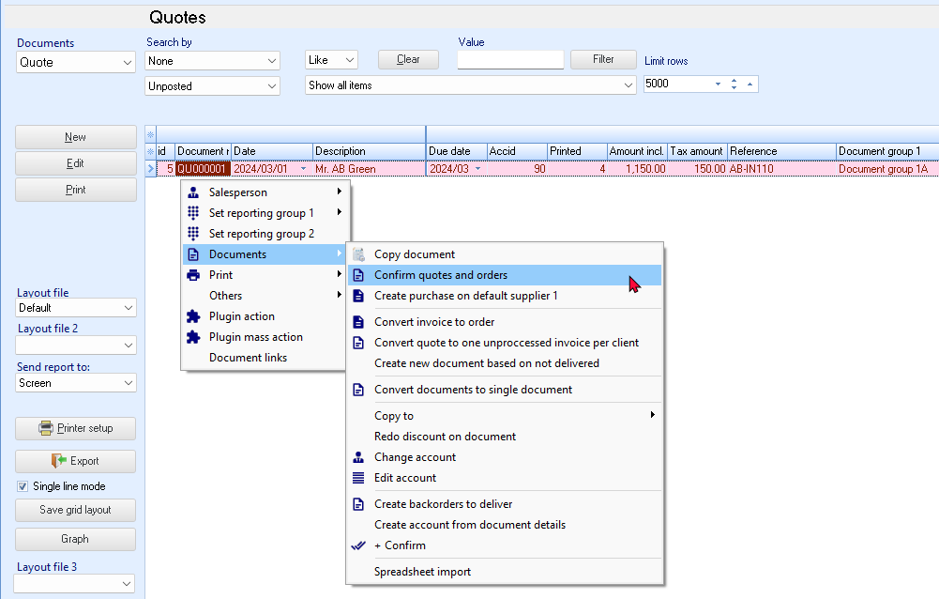
- On the context menu, select the “Confirm quotes and orders” option. A confirmation screen will be displayed.
“Do you wish to continue?”
- Click on the Yes button to proceed. Another confirmation screen will be displayed.
“Do you wish to delete this Quote?”
- Click on the No button not to delete the quote.
If you click on the Yes button, the quote will be deleted from the quotes list of the “Document entry” screen.
Should you click on the No button the quote will still be available on the quote list of the “Document entry” screen. You may then Copy the quote, change the account, edit the account, etc. before converting it to an invoice.
You may delete Quotes in Edit → Delete → Documents (Default ribbon).

- Click on the Yes button to proceed. An information message is displayed:
“Document(s) created!
IN000001 D1ABGRE Mr. AB Green”
- Click on the OK button to close the information message.
- Access the “Invoices” screen and edit the converted invoice, if necessary.
Creating an invoice
Once a Quote is converted to an Invoice, check that all the items on the quote are accepted. When accessing the Invoice documents screen from the Documents - Invoices (Default ribbon) and the debtor (customer / client) is selected, all available unposted Invoices for that debtor (customer / client) are listed.
Editing an invoice confirmed from a quote
To edit an invoice converted from a quote:
- On the Default ribbon, select Documents (F6).
- Select “Invoices” in the “Documents” field; if “Invoices” is not selected.
The Invoice, listed on the “Document entry” screen, was automatically created when you have confirmed and converted the quote to an invoice.
- Select the invoice on the list and click on the Edit button.
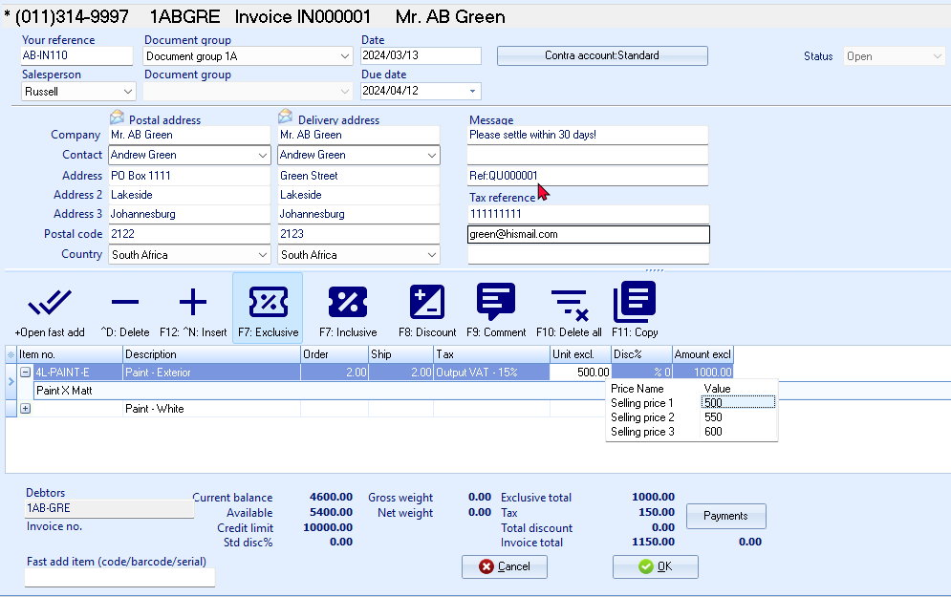
The Quote number “QU000001”, which was converted to this Invoice, is displayed in the very last line in the “Message” field.
- Enter and / or select the following options:
Your reference: | - Enter “AB-IN110” as the reference supplied by Mr. AB Green.
Salesperson: | - Check that “Russell” is displayed.
Date: | - The system date should be displayed, as it is the date on which the quote was converted to an invoice. For the purposes of this tutorial, select “2024/03/13”.
Due date: | - This date will be automatically be calculated. It is the “Date” plus the number of days set in the Accounting information tab of the selected debtor account.
Message: | - The messages as entered in Setup documents for the Invoice and Quotes document types will be displayed in the Message lines 1 to 3 fields. You may edit this, as necessary.
- The items and details of the quote will be displayed on the respective fields. Check the quantity and selling price for the paint and the hours is correct. You may edit it, if necessary.
The quantity ordered is the number of stock items the customer requested. The quantity shipped is the number of items actually supplied. If the quantity ordered and the quantity shipped are not the same, the difference will appear on the back order report.

- Click on the OK button. A confirmation screen will be displayed.
“Do you wish to print this invoice?”
- Click on the Yes button. An example of the printed invoice, is as follows:
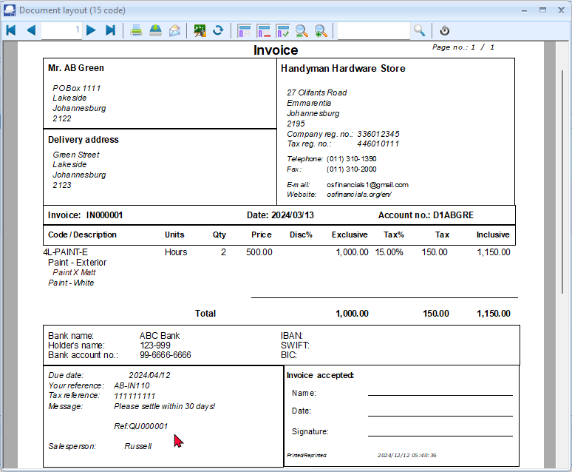
In addition to the comments, the remarks will be displayed in a shade of dark red font.
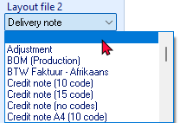
If you need to print a Delivery note, you may select the Delivery note. In this tutorial, the Delivery note layout file, will automatically be printed after the invoice is printed.
To turn-off (disable) the Delivery notes, select the blank line in the “Layout file 2” field.
Creating a new invoice
Enter the rest of your sales:
Salesperson - Tracy | Salesperson - Russell | Salesperson - Tracy
2024/03/14 Invoice IN000002 | 2024/03/15 Invoice IN000003 | 2024/03/16 Invoice IN000004
To: MAC Shop Decor Specialists | To: Mr. AB Green | To: Mr. Mike Davies
Reference: IB-101 | Reference: PH-101 | Reference: IB-102
Comment: 3 White cupboards with 6 drawers | Comment: Paint - Green | Comment: Install 6 cupboards
Install - Built-in cupboard 1,500.00 | Paint outside of house  2 hours 1,000.00 | Install - Built-in cupboard 1,500.00
Output Tax - 15% 225.00 | Output Tax - 15% 150.00 | Output Tax - 15% 225.00
Total 1,725.00 | Total 1,150.00 | Total 1,725.00
To create a new invoice:
- On the Default ribbon, select Documents (F6).
- Select “Invoices” in the “Documents” field; if “Invoices” is not selected.
- Click on the New button. The “Debtor accounts” screen is displayed:
- Select the Debtor (customer / client) account (“MAC Shop Decor Specialists”).
- Click on the Open or OK button.
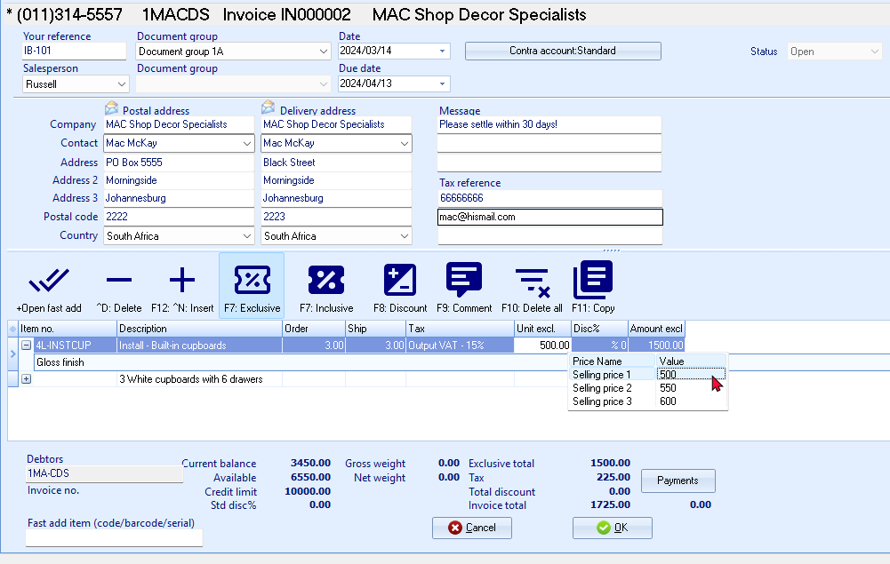
If you would like to include a longer description than the description field, you can press the F9 key for a comment and type in a comment on that line.
- Enter and / or select the following options:
Your reference: | - Enter “IB-101”.
Salesperson: | - Select “Russell”; if not already displayed.
Document group 1/2: | - Select “Document group 1A”.  - Document group 2 cannot be selected as Groups are not added for Document group 2 in Groups. (Setup ribbon).
Date: | - Select “2024/03/14”.
Due date: | - This date will be automatically be calculated. It is the “Date” plus the number of days set in the Accounting information tab of the selected debtor account.
Message: | - The messages as entered in Setup documents for the Invoices document type will be displayed in the Message lines 1 to 3 fields. You may edit this, as necessary.
 | - Press the Enter key until you get to the transaction details (document lines).
Item no.: | - Select “Sales (no stock)”. The description, Quantity (default 1), Tax account, Unit selling price (Exclusive of VAT/GST/Sales tax if the F7:Exclusive icon is active - or Inclusive of VAT/GST/Sales tax if the F7:Inclusive icon is active) will be displayed.
Order / Ship: | - Enter “3”.
Tax: | - The default Output Tax account for the stock item will be displayed. When the cursor is in this field, the Tax accounts lookup will be displayed. Confirm that it is correct by pressing the Enter key.
Discount: | - Press the Enter key to keep it at the default 0% discount rate.
- Click on the OK button. A confirmation screen will be displayed.
“Do you wish to print this invoice?”
- Click on the Yes button.
- Enter your sales to create invoices IN000003 and IN000004.
Once you have completed all your invoices, check to see that you are:
- Selling to the right person.
- Selling at the right date.
- Selling the right item requested.
- Selling the right quantity requested.
- Selling at the right price.
- Selling at the correct Tax rate.
Once all your invoices are correct, you may post or update them to the ledger.

Updating your invoices to the ledger
Since we have not added users, and selected the “Auto-post documents on print” option on the Documents setup (See – MODULE E.4.5) we need to post the invoices manually.
Check all your Invoices to see that they are correct and have been updated to the ledger, before you update the Invoices to the ledger.
To post or update your invoices:
- On the Default ribbon, select Update ledger (F3).
- Invoices are displayed by default - listing all your unposted invoices. If not, select “Invoices”.
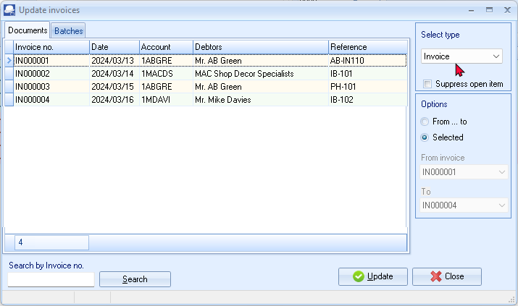
Invoices in rows with a cream or peach background (i.e. IN000001 and IN000003), have been printed.
Invoices in rows with a blue background (i.e. IN000002 and IN000004), have not yet been printed.
- Click on the “From... to” field and select -
From invoice: IN000001
To: IN000004
- Click on the Update button. TurboCASH5 will generate the Sales journal and update the Sales, Debtors, Output VAT/GST/Sales tax and Stock. The transactions is as follows:
DR Debtor (total amount)
CR Sales (net amount - selling price)
CR VAT/GST/Sales tax (net amount)
T-Account view of transactions
All processed (posted) transactions will be accumulated in the Ledger analyser. There are various ways in which the transactions may be viewed, printed, exported and analysed.
To access the T-Account view of the transactions:
- On the Reports ribbon, select Ledger analyser 1 or Ledger analyser 2.
- Select “Trial balance” report type and click on the Report button.
- On the “Trial balance”, select the “Sales” account or the “Debtors control” account.
- Double-click on the selected account; or right-click and select Show details on the context menu.
- Click on the following to get specific views of transactions:
- Batch id (e.g. 15, 16, 17 or 18 automatically generated). This will list only the transactions for a specific batch (journal).
- Account code (e.g. G010-000 Sales, T860-010 Output Tax - 15%, D1AB-GRE Mr. AB Green). This will list the transactions for a specific account.
- Date – This will list the transactions for a specific date. If you double-click on a date, the “From date” and “To date” will be changed to the selected date.
After posting the Invoices, the transactions should display as follows in the T-Account viewer:
Batch view
Batch 15 – IN000001
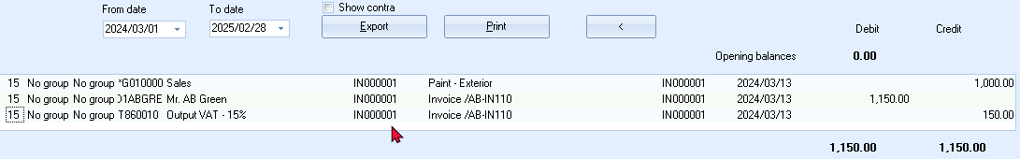
Batch 16 – IN000002
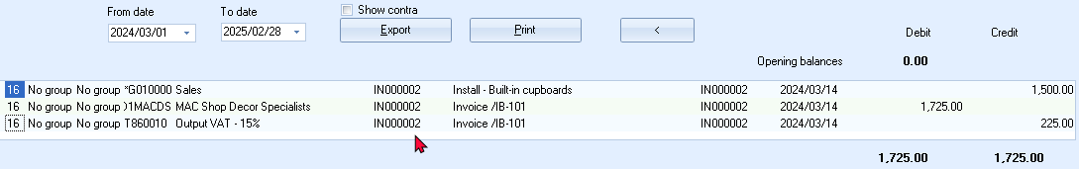
Batch 17 – IN000003
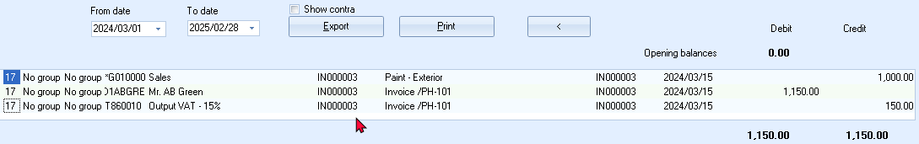
Batch 18 – IN000004
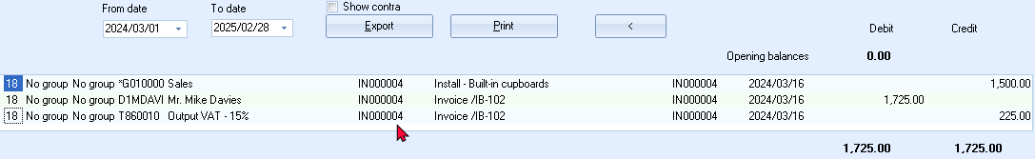

Account view
Accounts in the Debtor’s ledger:
Mr. AB Green
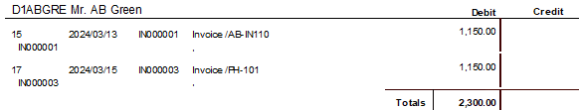
Mr. Mike Davies
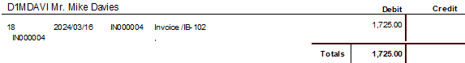
MAC Shop Decor Specialists
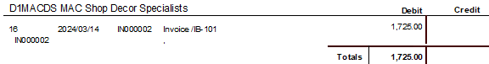
Accounts in the General ledger:
Sales
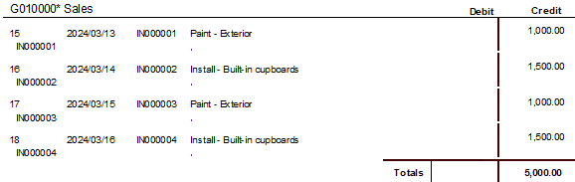
Output Tax - 15%
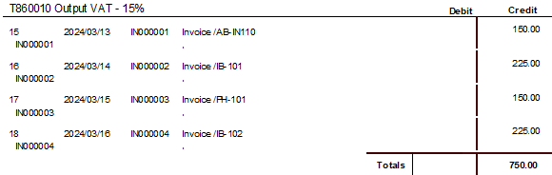
Debits = Credits
Debit transactions in the Debtor’s ledger (i.e. individual Debtor accounts).
=
Credit transactions in the General ledger (i.e. Sales and Output Tax (VAT/GST/Sales tax accounts)).

PROCESSING DOCUMENTS – TRADING STOCK

IN THIS MODULE
MODULE K - PROCESSING DOCUMENTS – TRADING STOCK 284
K.1- DOCUMENTS / STOCK SETTING AND PARAMETERS 285
K.2- BASICS OF TRADING STOCK 286
K.3- TAKING ON TRADING STOCK ITEMS 288
K.3.1- Entering opening quantities on hand and cost prices 288
K.3.2- Printing stock item listing reports 290
K.4- PROCESSING CREDITORS - ORDERS AND PURCHASES 292
K.4.1- Creating an order 292
K.4.2- Confirming / Converting an order to a purchase document 294
K.4.3- Creating a purchase document 296
K.4.3.1- Editing a purchase document confirmed from an order 296
K.4.3.2- Creating a new purchase document 298
K.4.4- Updating purchase documents to the ledger 301
K.4.5- T-Account view of transactions 302
K.5- PROCESSING DEBTORS - QUOTES AND INVOICES 304
K.5.1- Creating a quote 304
K.5.2- Confirming a quote - converting a quote to an invoice 306
K.5.3- Creating an invoice 308
K.5.3.1- Editing an invoice confirmed from a quote 308
K.5.3.2- Creating a new invoice 310
K.5.4- Updating your invoices to the ledger 312
K.5.5- T-Account view of transactions 313

DOCUMENTS / STOCK SETTING AND PARAMETERS
It is important that the required accounts and settings be absolutely correct before you proceed with purchasing and selling of stock items in a Set of Books. If this is not done, you may find incorrect results in TurboCASH5. For example, the Cost of sales transactions may not be generated when documents are posted to the ledger or the cost of sales may be calculated at average cost in stead of latest cost, etc.
Setup of Documents is a once-off process:
- Setup → Documents setup (Setup ribbon) – Check document numbers, messages, set layout files, etc. - (See – MODULE E.4.5).
- Setup → Groups (Setup ribbon) – Add the Cost of sales reporting group under Account group 1 (Reporting group 1). Also add Reporting groups 1 and 2 for Document groups and Stock group 1 /2, where applicable. - (See – MODULE E.4.4).
- Setup → Salesperson (Setup ribbon) – Add Salespersons. - (See – MODULE E.4.7).
- Setup → Batch types (Setup ribbon) – Add Cost of sales batch (only to be used with Cost of sales settings for the Default Stock type). - (See – MODULE E.4.3).
- Setup → Stock information (Setup ribbon) – Unit prices, Selling price descriptions, Default selling price.
For the purpose of this tutorial, we need to activate and set the cost of sales parameters, if the Cost of sales were not set correctly when you created your Set of Books. - (See – MODULE E.4.6).
You also have the option of ticking “use average cost” - if you wish you may leave this field not ticked in which case, “latest cost” will be used for calculating the value of your stock. Consult with your accountant as to which method you should use. The value of your stock can affect your profit and loss figures.
- Setup → Accounts (Setup ribbon) – Create a Cost of sales account for Trading stock. - (See – MODULE F.1).
- Creditors (Default ribbon) – Create a Sundry supplier account. - (See – MODULE F.3).
- Debtors (Default ribbon) – Create a Cash customer and Linking Debtors to a Salesperson. - (See – MODULE F.4).
You may print a Company information (Reports → Company info – Information) report to check the Cost of Sales settings (Average cost or Latest cost) Selling price descriptions. This report will also display the default headings and messages that will print on document layout files (i.e. Invoices, Quotes, Credit notes, Purchases, Supplier returns and Orders).
Your Set of Books should be set up to process documents for the purchase and selling of trading stock items.

BASICS OF TRADING STOCK
Before you start with this MODULE in the Tutorial, you need to be absolutely sure that all settings for Stock items, Cost of sales and Documents are correct.
Please refer to (See – MODULE E.4.6) - Setup Stock information (with particular attention to Cost of sales).

When you first set up TurboCASH, it is important that you either enter a purchase or do a stock take-on for each stock item, before entering any invoices. By doing this you are giving TurboCASH the cost price of the stock item.
The cost price is used to update the Cost of sales and Stock accounts, when an invoice is created. Therefore, if TurboCASH does not have a cost price, the cost of sales account will be updated with a zero amount. This will cause your gross profit to be over inflated.
It is important that the required accounts and settings be absolutely correct before you proceed with purchasing and selling of trading stock items in a Set of Books.
If this is not done, you may find incorrect results in TurboCASH. For example, the Cost of sales transactions may not be generated when documents are posted to the ledger or the cost of sales may be calculated at average cost in stead of latest cost, etc.

If you generate documents from your stock item code file in TurboCASH, transactions will automatically be generated when documents are updated or posted to the ledger as follows:
- Sales documents (Invoices and Credit notes) in the Sales journal (as linked to the “Batch type” field of the Invoices and Credit notes tabs in Documents setup (Setup ribbon).
- Purchase documents (Purchases and Supplier returns) in the Purchase journal (as linked to the “Batch type” field of the Purchases and Supplier returns tabs in Documents setup (Setup ribbon).
The transactions for the Default (Trading stock) stock type, is as follows:
Trading stock items (Default stock type)
Purchases (Purchase journal) | Invoices (Sales journal)
DR - Stock item (net cost price - Input Tax excluded)  DR - Input Tax (% of purchase price)  CR - Creditor (full amount - Input Tax included) | DR - Debtor (full amount - Output Tax included)  CR - Sales (selling price - Output Tax excluded)  CR - Output Tax (% of selling price)
 | Cost of sales journal
DR - Cost of sales (cost price)
CR - Stock (cost price)
The transactions for Supplier returns (Credit notes received from creditors (suppliers)) are exactly the opposite than those of purchase documents (Invoices received from creditors (suppliers)).
The transactions for Credit notes (issued to debtors (customers / clients)) are exactly the opposite than those of Invoices.
Trading stock items (Default stock type)
Supplier returns (Purchase returns journal) | Credit notes (Sales returns journal)
DR - Creditor (full amount - Input Tax included)  CR - Stock item (cost price - Input Tax excluded)  CR - Input Tax (% of purchase price) | DR - Sales (selling price - Output Tax excluded)  DR - Output Tax (% of selling price)  CR - Debtor (full amount - Output Tax included)
 | Cost of sales journal
DR - Stock (cost price)
CR - Cost of sales (cost price)
All other stock types (excluding the Bills of Materials (BOM) stock type), have no cost of sales transactions.
The Bills of Materials (BOM) and the Bills of Materials (Production) (BOM (Production)) stock types, are usually linked to trading stock items (components).

TAKING ON TRADING STOCK ITEMS
The opening balances for your stock items must be entered for each individual stock item - you cannot simply enter the total from the trial balance. You need to inform the program of the quantities on hand and the cost prices for each stock item.
TurboCASH will calculate the value of each stock item by multiplying the quantities on hand by the cost price. After all the quantities and cost prices of your stock items are entered, the total value of all stock items should be equal to the control figure (stock control account), as per your financial statements.
Entering opening quantities on hand and cost prices
In practice you would now do a stock take and inform TurboCASH as to the numbers of each item you have in stock. Unless your opening balances are actually entered into the system, TurboCASH would never know how many items you had in stock to start with. For the purpose of this tutorial, we have 5 drill presses and 4 compressors to take on.
Example: List of stock items in the Stock ledger, is as follows:
Only the total value (cost price of stock) is entered as the opening balance of your stock items.

To take on opening balances for your stock items:
- On the Default ribbon, select Stock items (F12).
- Click on the Advanced mode button. The Advanced mode button's caption will change to Default.
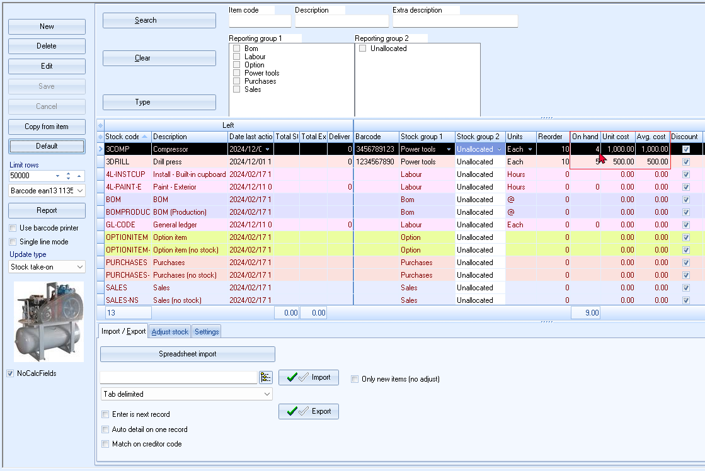
- Select the Stock take-on the “Update type” field (on the sidebar).
You may click on any column heading and drag it. For example, to enter the Average cost (in the “Avg Cost” column), simply click on the column heading and drag it next to the “On Hand” column.
You may select (tick) the “Power tools” in Reporting group 1, and click on the Search button to list only the stock items linked to “Power tools”.
- Select “COMPRESSOR” to take on the compressors. Enter “4” for the Quantity on hand (in the “On hand” column) and “1000” for the Average cost (in the “Avg. cost” column).
- Select the stock code for the “DRILL PRESS” to take on the drills. Enter “5” for the Quantity on hand (in the “On hand” column) and “500” for the Average cost (in the “Avg. cost” column).
- Click on the Save button.

Printing stock item listing reports
To print a stock item listing report:
- On the Reports ribbon, select Reports → Stock → Stock item listing. The “All selling prices” report options will be displayed.
- Select the “Stock item listing” from the list of reports.
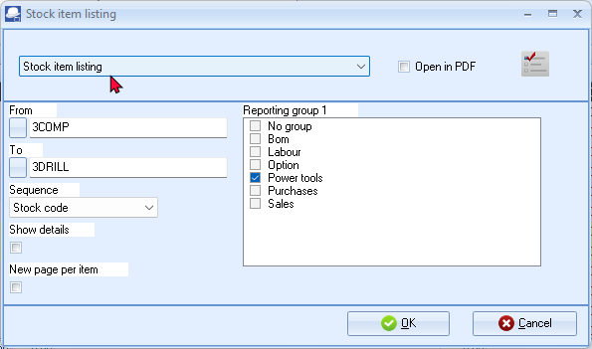
- Select the following options:
From: | - Select the Stock item i.e. “3COMP” on the list.
To: | - Select the Stock item i.e. “3DRILL.” on the list.
Reporting group 1: | - Click on the “Power tools” tick box to view only those Stock items linked to this Stock group1. You may also remove the tick to view all items, if the last Stock item is selected.
Show details: | - Leave blank.
New page per item: | - Leave blank.
- Click on the OK button.

The report is displayed as follows:
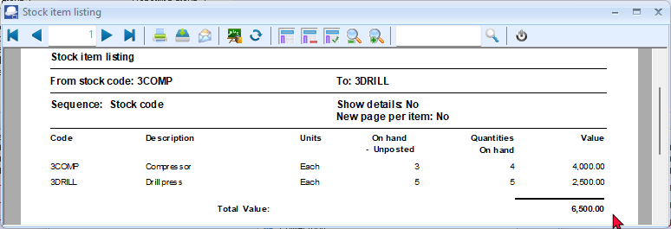
You should have 6,500.00 of Stock on hand. This amount should balance with the stock records and the stock control account in your previous accounting records.
It is recommended that the source document (e.g. stock item list, etc.) be attached to this Stock item List (take-on of opening balances) and that it be retained for record and audit purposes.
This report only reflect the Quantities and value at cost price (Quantity x Cost price as in this case the number and amount entered in the “Avg. cost” column for the Stock items).
It is good practice to retrieve a detailed report to check that you have entered all the details and information correctly. To view additional information, select the “Show details” option. This will list the Extra description, Manufacturer, Unit size, Net and Gross weight, Selling prices 1 / 2 / 3, Barcode, Reporting group 1 / 2 and preferred supplier 1 / 2.
It is also recommended that the All selling prices Stock item listing report is printed to check your selling prices, before you start invoicing.
- After viewing the report, click on the Close button to close the report preview screen.

PROCESSING CREDITORS - ORDERS AND PURCHASES
The transactions will automatically be generated when purchase documents are updated or posted to the ledger. It will automatically generate and update (post) the transactions to the ledger in the batch types as set (linked) in the Documents setup (Setup ribbon) - Purchases and Supplier returns tabs.
Creating an order
You may need to place an order with any of your creditors (suppliers).
When the Goods are received (or services are rendered), you may confirm the order against the actual goods / services received.
Orders cannot be updated (posted) to the ledger and it generates no transactions. But, once the Order has been converted to a Purchase document, it can be updated (posted) to the ledger.
Order 3 x Drill presses from A-ONE Suppliers:
ORDER: OR000001 - 2024/04/01
A-ONE Suppliers
3 Drill presses at 1,500.00
Input Tax - 15% 225.00
Total 1,725.00
To create an order:
- On the Default ribbon, select Documents (F6).
- Select “Orders” in the “Documents” field; if “Orders” is not selected.
- Click on the New button. The “Creditor accounts” screen is displayed:
- Select the Creditor account (“A-ONE Suppliers”).
- Click on the Open or OK button.
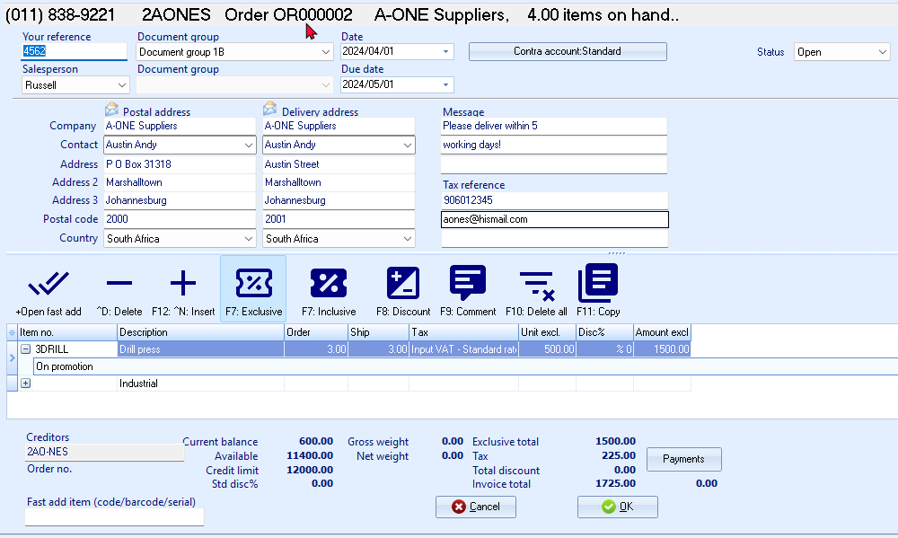
- Enter and / or select the following options:
Your reference: | - Enter “4562” as the reference for the order.
Salesperson: | - Select “Russell”. Salespersons are optional for orders. This field is to show who handled the order.
Document group 1/2: | - Select “Document group 1B”.  - Document group 2 cannot be selected as Groups are not added for Document group 2 in Groups (Setup ribbon).
Date: | - Select “2024/04/01”.
Due date: | - This date will be automatically be calculated. It is the “Date” plus the number of days set in the Accounting information tab of the selected creditor account.
Message: | - The messages as entered in Setup documents for the Orders document type will be displayed in the Message lines 1 to 3 fields. You may edit this as necessary.
 | - Press the Enter key until you get to the transaction details (document lines).
Item no.: | - Select “3DRILL”. The description, Quantity (default 1), Tax account, Unit Purchase or Cost price (Exclusive of VAT/GST/Sales tax if the F7:Exclusive icon is active - or Inclusive of VAT/GST/Sales tax if the F7:Inclusive icon is active) will be displayed.
Order / Ship: | - Enter “3” as the quantity in the “Order” and “Ship” fields.
Tax: | - The default Input Tax account for the stock item will be displayed. When the cursor is in this field, the Tax accounts lookup will be displayed. Confirm that it is correct by pressing the Enter key.
Discount: | - Press the Enter key to keep it at the default 0% discount rate.
Comments: | - Click on the F9:Comment icon. Enter “Industrial”, as in this example.
Remarks: | - You may click on the + icon (or right-click to select “Expand” option on the context menu) of a selected item to add a remark (additional information), which will print on document layout files. Enter “On promotion”, as in this example.
- Click on the OK button. A confirmation screen will be displayed.
“Do you wish to print this order?”
- Click on the Yes button. An example of the printed order, is as follows:
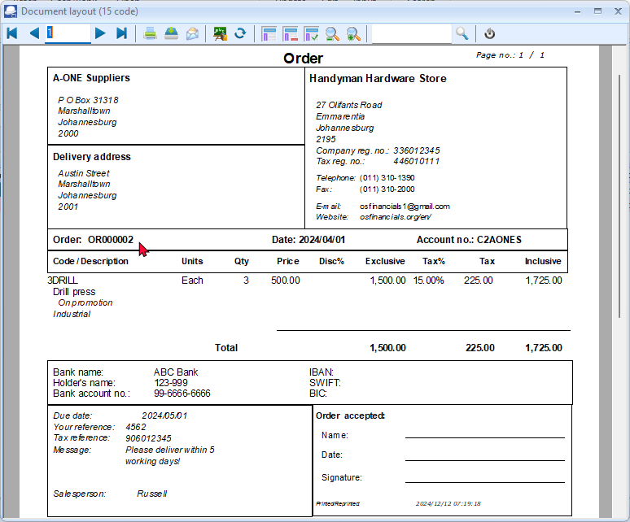
In addition to the comments, the remarks will be displayed in a shade of dark red font.
Confirming / Converting an order to a purchase document
We have already placed an order with our A-ONE Suppliers - and the three drills are received on 7 April 2024. The order needs to be checked and converted into a Purchase document or a Goods received note.
If you have already created invoices (whether they are updated to the ledger (posted) or not), you may convert the Invoice to an Order. To do this, select the Invoice on the documents list and right-click and select the “Documents → Convert invoice to order” option from the context menu.
You may then edit the order and convert it to a purchase document.
To convert an order to a purchase document:
You may also convert Orders to Purchase documents from the Input → Confirm (Default ribbon).
- Access “Orders” in the “Documents” field; if “Orders” is not selected.
- Select the order to convert and right-click.
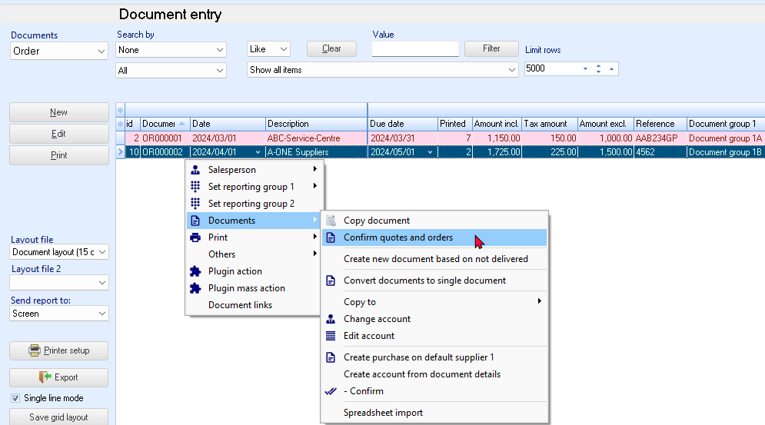
- Right-click and select the “Confirm quotes and orders” option on the context menu. A confirmation screen will be displayed.
“Do you wish to continue?”
- Click on the Yes button to proceed. Another confirmation screen will be displayed.
“Do you wish to delete this Order?”
- Click on the No button not to delete the order.
If you click on the Yes button, the order will be deleted from the “Orders” list of the “Document entry” screen.
Should you click on the No button the order will still be available on the Orders list of the “Document entry” screen. You may then Copy the order, change the account, edit the account, etc. before converting it to a purchase document.
You may delete Orders in Edit → Delete → Documents (Default ribbon).
Creating a purchase document
Once an Order is converted to a Purchase document (Goods received note), it must be checked to see that the correct stock was received.
Editing a purchase document confirmed from an order
To edit a purchase document converted from an order:
- On the Default ribbon, select Documents (F6).
- Select “Purchases” in the “Documents” field; if “Purchases” is not selected.
The purchase document, listed on the “Document entry” screen, was automatically created when you have confirmed and converted the order to a purchase document.
- Select the purchase document on the list and click on the Edit button.
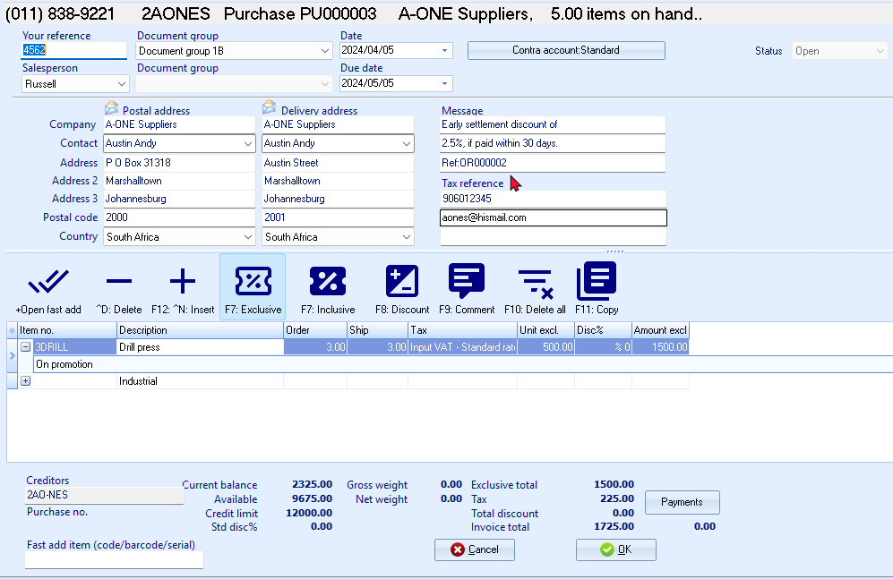
The order number “OR000002”, which was converted to this purchase document, is displayed in the very last line in the “Message” field.
- Enter and / or select the following options:
Your reference: | - Enter “4562” as the reference of the creditor.
Date: | - 2024/04/05 (should be displayed, as it is the date on which the order was converted to a purchase document).
Due date: | - This date will be automatically be calculated. It is the “Date” plus the number of days set in the Accounting information tab of the selected creditor account.
Message: | - Message for Purchase document and Order document will be merged into the message lines. Edit the message lines as necessary.  The order which was confirmed and converted to this purchase document e.g. “Ref: OR000002” is added to message line 3.
- The items and details of the order will be displayed on the respective fields. Check the 3 drills and the purchase or cost price is correct. You may edit it, if necessary.
- Click on the OK button. A confirmation screen will be displayed.
“Do you wish to print this purchase?”
- Click on the Yes button. An example of the printed purchase, is as follows:
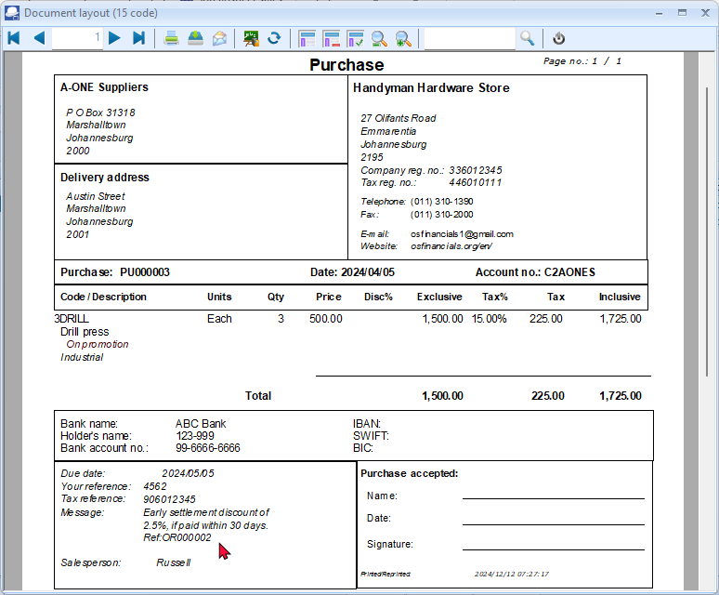
In addition to the comments, the remarks will be displayed in a shade of dark red font.
The order which was confirmed and converted to this purchase document e.g. “Ref: OR000002” is added to message line 3.
You are now ready to enter the rest of your purchases.

Creating a new purchase document
We have also purchased two (2) compressors:
PU000004 - 2024/04/06
Invoice 3532 from
BEST Suppliers
2 Compressor 2,000.00
Input Tax - 15% 300.00
Total 2,300.00
To create a new purchase document:
- On the Default ribbon, select Documents (F6).
- Select “Purchases” in the “Documents” field; if “Purchases” is not displayed.
- Click on the New button. The “Creditor accounts” screen is displayed:
- Select the Creditor account (“BEST Suppliers”).
- Click on the Open or OK button.
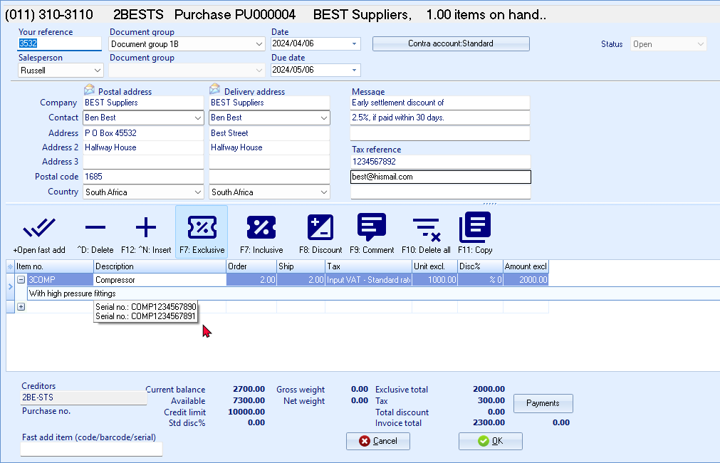
- Enter and / or select the following options:
Your reference: | - Enter “3532” as the reference of the creditor.
Salesperson: | - Select “Russell”. Salespersons are optional for purchases. This field is to show who handled the purchase.
Document group 1/2: | - Select “Document group 1A”.  - Document group 2 cannot be selected as Groups are not added for Document group 2 in Groups (Setup ribbon).
Date: | - Select “2024/04/06”.
Due date: | - This date will be automatically be calculated. It is the “Date” plus the number of days set in the Accounting information tab of the selected creditor account.
Message: | - The messages as entered in Setup documents for the Purchase document type will be displayed in the Message lines 1 to 3 fields. You may edit this as necessary.
 | - Press the Enter key until you get to the transaction details (document lines).
Item no.: | - Select “3COMP”. The description, Quantity (default 1), Tax account, Unit price (Exclusive of VAT/GST/Sales tax if the F7:Exclusive icon is active - or Inclusive of VAT/GST/Sales tax if the F7:Inclusive icon is active) will be displayed.
Quantity: | - Enter “2”.
Tax: | - The default Input Tax account for the stock item will be displayed. When the cursor is in this field, the Tax accounts lookup will be displayed. Confirm that it is correct by pressing the Enter key.
Discount: | - Press the Enter key to keep it at the default 0% discount rate.
Comments: | - Click on the F9:Comment icon. Enter “Serial no.: COMP1234567890” and Serial no.: COMP1234567891”, as in this example.
Remarks: | - You may click on the + icon (or right-click to select “Expand” option on the context menu) of a selected item to add a remark (additional information), which will print on document layout files. Enter “With high pressure fittings”, as in this example.
- Click on the OK button. A confirmation screen will be displayed.
“Do you wish to print this purchase?”
- Click on the Yes button.
TurboCASH5 defaults to an average costing basis. Please ask your accountant whether to use this option or to check the “Use latest cost” option.

Updating purchase documents to the ledger
Since we have not selected the “Auto-post documents on print” option on the Documents setup (See – MODULE E.4.5) we need to post the purchases manually.
To post or update your purchases:
- On the Default ribbon, select Update ledger (F3). The “Update Invoice” screen will be displayed.
- Select “Purchases” and its name will change to “Update purchases” - listing all your unposted purchases.
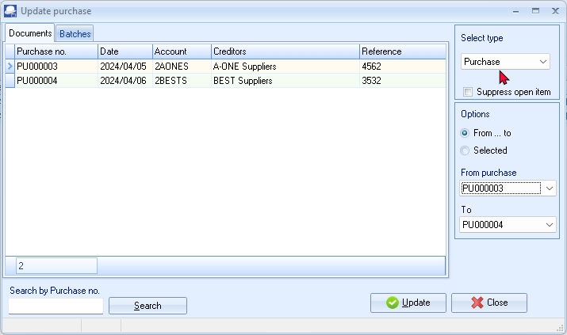
Purchases in rows with a cream or peach background (i.e. PU000003) have been printed.
Purchases in rows with a blue background (i.e. PU000004), have not yet been printed.
- Click on the “From... to” field and select -
From purchase: PU000003
To: PU000004
- Click on the Update button. TurboCASH5 will generate the Purchases Journal, and update the stock, creditors and Input VAT/GST/Sales tax. The transactions is as follows:
DR Stock (net amount)
DR VAT/GST/Sales tax (net amount)
CR Creditor (total amount)

T-Account view of transactions
All processed (posted) transactions will be accumulated in the Ledger analyser. There are various ways in which the transactions may be viewed, printed, exported and analysed.
To access the T-Account view of the transactions:
- On the Reports ribbon, select Ledger analyser 1 or Ledger analyser 2.
- Select “Trial balance” report type and click on the Report button.
- On the “Trial balance”, select the “Creditors control” account.
- Double-click on the selected account; or right-click and select Show details on the context menu.
- Click on the following to get specific views of transactions:
- Batch id (e.g. 29 or 30 automatically generated). This will list only the transactions for a specific batch (journal).
- Account code (e.g. G750-000 Stock control, T860-020 Input Tax – Standard rate - 15%, C2AO-NES A-ONE Suppliers). This will list the transactions for a specific account.
- Date – This will list the transactions for a specific date. If you double-click on a date, the “From date” and “To date” will be changed to the selected date.
After posting the Purchase documents, the transactions should display as follows in the T-Account viewer:
Batch view
Batch 30 – PU000003 – A-ONE Suppliers
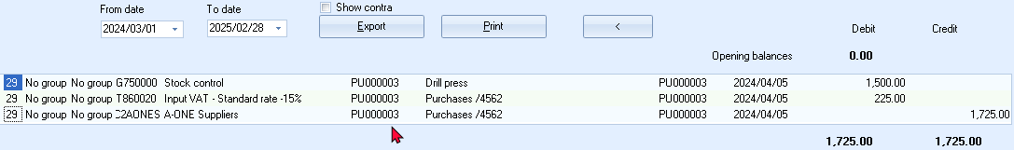
Batch 30 – PU000004 – BEST Suppliers
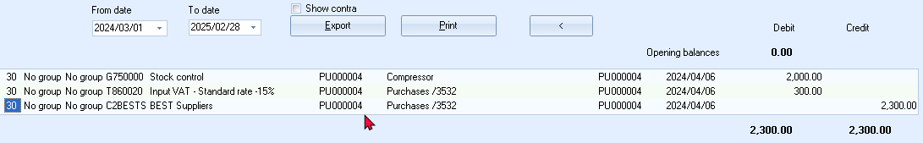

Account view
Accounts in the Creditor’s ledger:
A-One Suppliers
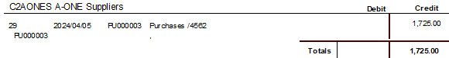
BEST Suppliers
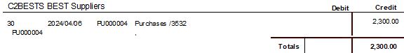
Accounts in the General ledger:
Stock control
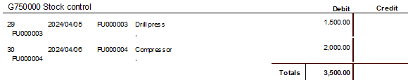
Input Tax – Standard rate 15%
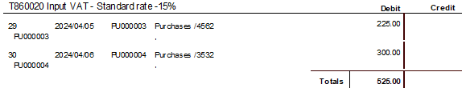
Debits = Credits
Debit transactions in the Stock control account (i.e. Stock ledger) and Input Tax (VAT/GST/Sales tax)
=
Credit transactions in the Creditor’s ledger (i.e. individual Creditor accounts)

PROCESSING DEBTORS - QUOTES AND INVOICES
If you are selling stock to a customer or debtor, it is best to create an Invoice using the Documents – Invoices and not in the Batch entry - Sales Journal. By creating an Invoice TurboCASH will automatically write up your Sales journal for you, credit the stock, credit the Output VAT/GST/Sales tax and debit the debtor.
Invoices could also be used for any sales other than stock. Non-stock items could be captured through the Batch entry - Sales journal (Default ribbon). An example of a non-stock item could be the sale of old or obsolete furniture, which your business does not use any longer.
Creating a quote
Your Debtors or Customers may ask you for a quotation on your products for various reasons. TurboCASH5 allows you to create a quote on the system. When the Debtor or Customer accepts the quote, you may confirm the Quote and Convert it to an Invoice. You will not be able update the Quotation to the ledger, since it generates no transactions. But once the Quote has been converted to an Invoice, it can be updated or posted to the ledger.
On 1 April 2024 Mr. Davies asked for a quote on a drill press.
To create a quote:
- On the Default ribbon, select Documents (F6).
- Select “Quotes” in the “Documents” field; if “Quotes” is not displayed.
- Click on the New button. The “Debtor accounts” screen is displayed:
- Select the Debtor account (“Mr. Mike Davies”)
- Click on the Open or OK button.
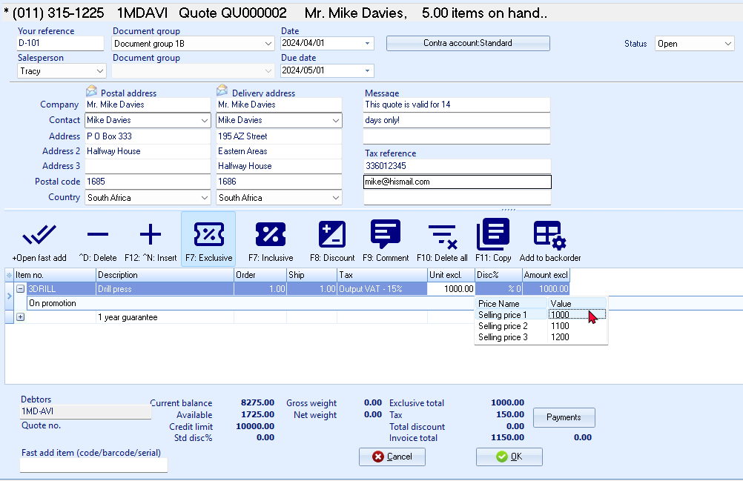
- Enter and / or select the following options:
Your reference: | - Leave blank.
Salesperson: | - Select “Tracy”; if not already selected. As Russell was set as the default salesperson, his name should automatically be displayed. (You may select any other salesperson if Tracy is not doing this quote).
Document group 1/2: | - Select “Document group 1B”.  - Document group 2 cannot be selected as Groups are not added for Document group 2 in Groups.(Setup ribbon).
Date: | - Select “2024/04/01”.
Due date: | - This date will be automatically be calculated. It is the “Date” plus the number of days set in the Accounting information tab of the selected debtor account.
Message: | - Message for Invoice and Quote will be merged into the message lines. Edit the message lines as necessary.
 | - Press the Enter key until you get to the transaction details (document lines).
Item no.: | - Select “3DRILL”. The description, Quantity (default 1), Output Tax account, Unit selling price (Exclusive of VAT/GST/Sales tax if the F7:Exclusive icon is active - or Inclusive of VAT/GST/Sales tax if the F7:Inclusive icon is active) will be displayed.  - The default selling price for the Debtor account will be displayed. Make sure that Selling price 1 is selected for the purpose of this tutorial.
Quantity: | - Confirm “1”.
Tax: | - The default Output Tax account for the stock item will be displayed. When the cursor is in this field, the Tax accounts lookup will be displayed. Confirm that it is correct by pressing the Enter key.
Discount: | - Press the Enter key to keep it at the default 0% discount rate.
Comments: | - Click on the F9:Comment icon. Enter “1 year guarantee”, as in this example.
Remarks: | - You may click on the + icon (or right-click to select “Expand” option on the context menu) of a selected item to add a remark (additional information), which will print on document layout files. Enter “On promotion”, as in this example.
- Click on the OK button. A confirmation screen will be displayed.
“Do you wish to print this quote?”
- Click on the Yes button.

Confirming a quote - converting a quote to an invoice
On 7 April 2024, Mr. Davies confirms that he wishes to take the Drill press as quoted on 1 April 2024. We need to check or confirm the quote and convert it to an invoice.
To convert a quote to an invoice:
You may also convert Orders to Purchase documents from the Input → Confirm (Default ribbon).
- Access “Quotes” in the “Documents” field; if “Quotes” is not selected.
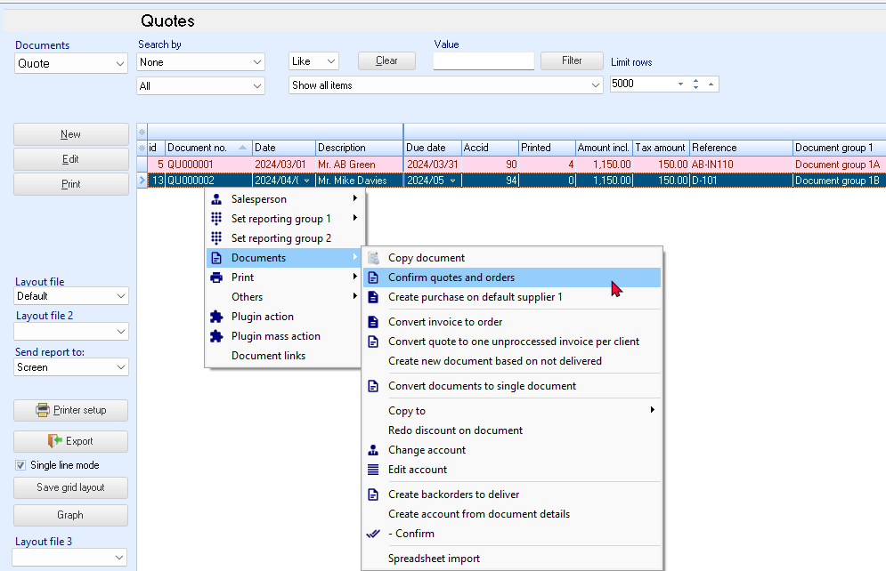
- Select the quote to convert and right-click.
- On the context menu, select the “Confirm quotes and orders” option. A confirmation screen will be displayed.
“Do you wish to continue?”
- Click on the Yes button to proceed. Another confirmation screen will be displayed.
“Do you wish to delete this Quote?”
- Click on the No button not to delete the quote.
You may delete Quotes in Edit → Delete → Documents (Default ribbon).
If you click on the Yes button, the quote will be deleted from the Quotes list of the “Document entry” screen.
Should you click on the No button the quote will still be available on the “Quotes” list of the “Document entry” screen. You may then Copy the quote, change the account, edit the account, etc. before converting it to an invoice.
- An information message is displayed:
“Document(s) created IN000005 D1MD-AVI Mr. Mike Davies”
- Click on the OK button to close this screen.
- Access the “Quotes” screen and edit the converted invoice, if necessary.
Creating an invoice
Once a Quote is converted to an Invoice, check that all the items on the quote are accepted. When accessing the Invoice documents screen from the Documents - Invoices (Default ribbon) and the debtor (customer / client) is selected, all available unposted Invoices for that debtor (customer / client) are listed.
Editing an invoice confirmed from a quote
To edit an invoice converted from a quote:
- On the Default ribbon, select Documents (F6).
- Select “Invoices” in the “Documents” field; if “Invoices” is not selected.
The Invoice, listed on the “Document entry” screen, was automatically created when you have confirmed and converted the quote to an invoice.
- Select the Invoice on the list and click on the Edit button. The screen for “Invoice entry” is displayed:
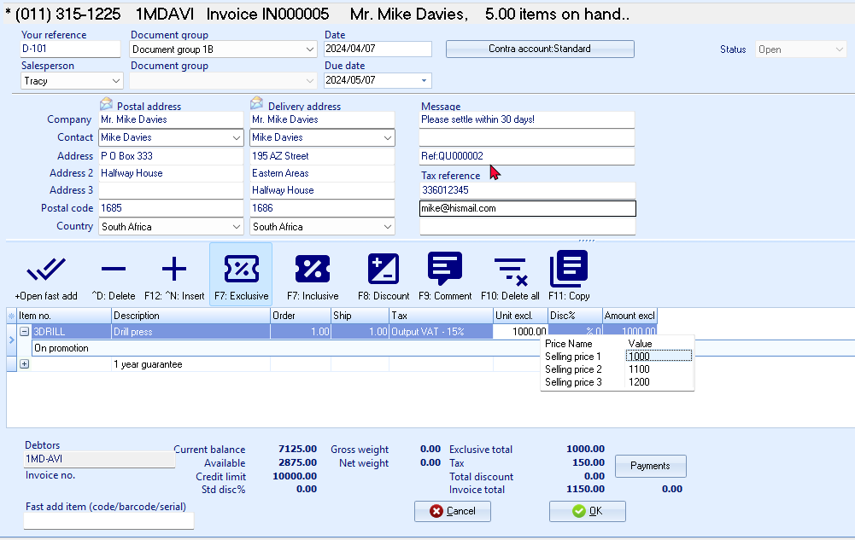
The quote number “QU000002”, which was converted to this invoice, is displayed in the very last line in the “Message” field.

- Enter and / or select the following options:
Your reference: | - Enter “D-101” as the reference number.
Salesperson: | - Check that “Tracy” is displayed.
Date: | - “2024/04/07” (should be displayed, as it is the date on which the quote was converted to an invoice).
Due date: | - This date will be automatically be calculated. It is the “Date” plus the number of days set in the Accounting information tab of the selected debtor account.
Message: | - The messages as entered in Setup documents for the Invoices and Quotes document types will be displayed in the Message lines 1 to 3 fields. You may edit this as necessary.  The quote which was confirmed and converted to this invoice e.g. “Ref: QU000002” is added to message line 3.
 | - Press the Enter key until you get to the transaction details (document lines).
Comments: | - Click on the F9:Comment icon. Enter “1 year guarantee”, as in this example.
Remarks: | - You may click on the + icon (or right-click to select “Expand” option on the context menu) of a selected item to add a remark (additional information), which will print on document layout files. Enter “On promotion, as in this example.
- The items and details of the quote will be displayed on the respective fields. Check the quantity and selling price for the drill is correct. You may edit it, if necessary.
The quantity ordered is the number of stock items the customer requested. The quantity shipped is the number of items actually supplied. If the quantity ordered and the quantity shipped are not the same, the difference will appear on the back order report.
- Click on the OK button. A confirmation screen will be displayed.
“Do you wish to print this invoice?”
- Click on the Yes button.
You are now ready to enter the rest of your invoices.

Creating a new invoice
Enter the rest of your Sales:
Salesperson - Tracy | Salesperson - Russell | Salesperson - Tracy
2024/04/09  Invoice IN000006 | 2024/04/10  Invoice IN000007 | 2024/04/11  Invoice IN000008
To: Mr. Smith | To: Mr. Davies | To: Mr. Smith
2 Compressors 3,000.00 | 1 Compressor 1,500.00 | 2 Drill presses 2,000.00
Output Tax – 15% 450.00 | Output Tax – 15% 225.00 | Output Tax – 15% 300.00
Total 3,450.00 | Total 1,725.00 | Total 2,300.00
To create a new invoice:
- On the Default ribbon, select Documents (F6).
- Select “Invoices” in the “Documents” field; if “Invoices” is not selected.
- Click on the New button. The “Debtor accounts” screen is displayed:
- Select the Debtor account (“Mr. Roger Smith”).
- Click on the Open or OK button.
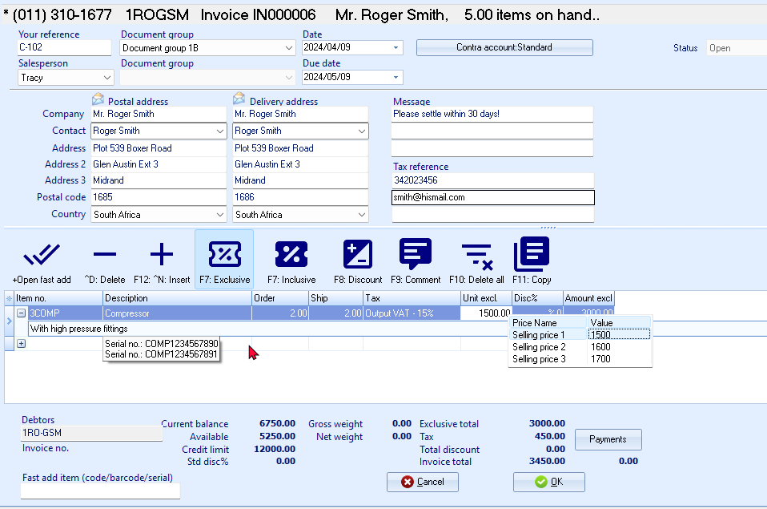
If you would like to include a longer description than the description field allows you can press the F9 key for a comment and type in a comment on that line.
- Enter and / or select the following options:
Your reference: | - Enter “C-102” as the reference for the debtor.
Salesperson: | - Select “Tracy”; if not already displayed.
Document group 1/2: | - Select “Document group 1B”.  - Document group 2 cannot be selected as Groups are not added for Document group 2 in Groups.(Setup ribbon).
Date: | - Select “2024/04/09”.
Due date: | - This date will be automatically be calculated. It is the “Date” plus the number of days set in the Accounting information tab of the selected debtor account.
Message: | - The messages as entered in Setup documents for the Invoices document type will be displayed in the Message lines 1 to 3 fields. You may edit this as necessary.
 | - Press the Enter key until you get to the transaction details (document lines).
Item no.: | - Select “3COMP”. The description, Quantity (default 1), Tax account, Unit selling price (Exclusive of VAT/GST/Sales tax if the F7:Exclusive icon is active - or Inclusive of VAT/GST/Sales tax if the F7:Inclusive icon is active) will be displayed.
Tax: | - The default Output Tax account for the stock item will be displayed. When the cursor is in this field, the Tax accounts lookup will be displayed. Confirm that it is correct by pressing the Enter key.
Discount: | - Press the Enter key to keep it at the default 0% discount rate.
Comments: | - Click on the F9:Comment icon. Enter “Serial no.: COMP1234567890” and “Serial no.: COMP1234567891”, as in this example.
Remarks: | - You may click on the + icon (or right-click to select “Expand” option on the context menu) of a selected item to add a remark (additional information), which will print on document layout files. Enter “With high pressure fittings”, as in this example.
- Click on the OK button. A confirmation screen will be displayed.
“Do you wish to print this invoice?”
- Click on the Yes button.
- Enter your sales to create invoices IN000007 and IN000008.
Once you have completed all your invoices, check to see that you are:
- Selling to the right person.
- Selling at the right date.
- Selling the right item requested.
- Selling the right quantity requested.
- Selling at the right price.
- Selling at the correct Tax rate.

Updating your invoices to the ledger
Since we have not added users, and selected the “Auto-post documents on print” option on the Documents setup (See – MODULE E.4.5) we need to post the invoices manually.
Check all your Incoices to see that they are correct and have been updated to the ledger, before you update the Invoices to the ledger.
To post or update your invoices:
- On the Default ribbon, select Update ledger (F3).
- Invoices are displayed by default - listing all your unposted invoices. If not, select “Invoices”.
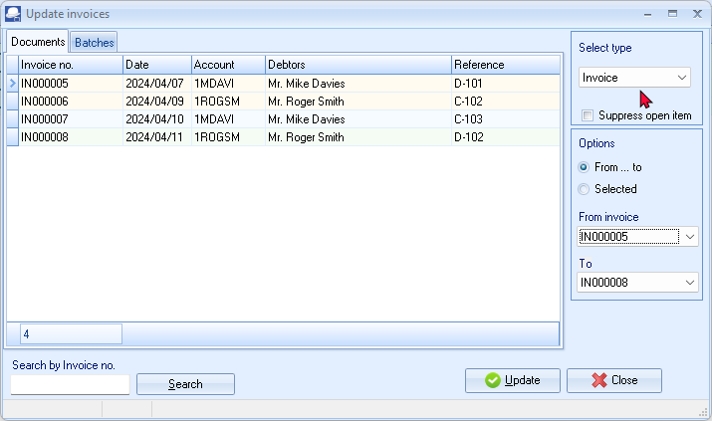
Invoices in rows with a cream background (i.e. IN000005 and IN000006), have been printed.
Invoices in rows with a blue or peach background (i.e. IN000007 and IN000008), have not yet been printed.
- Click on the “From... to” field and select -
From invoice: IN000005
To: IN000008
- Click on the Update button. TurboCASH5 will automatically write up your Sales journal. It will control Sales, Cost of sales, Output VAT/GST/Sales tax and Stock.
The following journals are passed:
DR Debtor (total amount)
CR Sales (net amount - selling price)
CR VAT/GST/Sales tax (net amount)
DR Cost of sales (cost price)
CR Stock (cost price)
T-Account view of transactions
All processed (posted) transactions will be accumulated in the Ledger analyser. There are various ways in which the transactions may be viewed, printed, exported and analysed.

To access the T-Account view of the transactions:
- On the Reports ribbon, select Ledger analyser 1 or Ledger analyser 2.
- Select “Trial balance” report type and click on the Report button.
- On the “Trial balance”, select the “Sales” account or the “Debtors control” account.
- Double-click on the selected account; or right-click and select Show details on the context menu.
- Click on the following to get specific views of transactions:
- Batch id (e.g. 19, 21, 23 or 25 for Sales transactions automatically generated). This will list only the transactions for a specific batch (journal).
If the Cost of sales is activated, TurboCASH will generate the following 2 batches for each Invoice:
- Sales batch – This is the journal (batch type) linked to the Invoices in Documents setup (Setup ribbon) (e.g. Batch id 19, 21, 23 and 25).
- Cost of sales batch – This journal (batch type) selected on Stock information (Setup ribbon). The Cost of sales account is selected on the Ledger tab for Stock items (e.g. Batch id 20, 22, 24 and 26).
- Account code (e.g. G100-000 Cost of sales account, G750-000 Stock control, T860-010 Output Tax -15%, D1MD-AVI Mr. Mike Davies). This will list the transactions for a specific account.
- Date – This will list the transactions for a specific date. If you double-click on a date, the “From date” and “To date” will be changed to the selected date.
After posting the Invoices, the transactions should display as follows in the T-Account viewer:
Batch view
Sales (Selling prices)
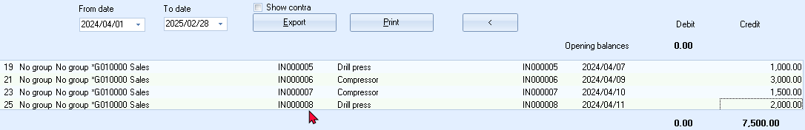
Cost of sales (Cost prices)
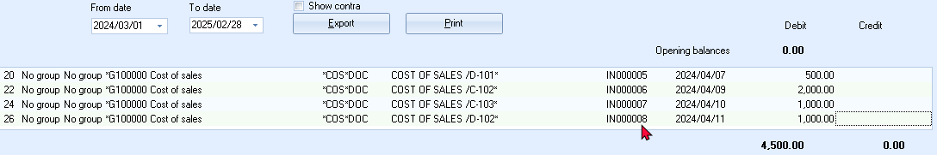
TurboCASH calculates Cost of sales according to either Average cost or Latest cost, depending on your selection on Stock information. (Setup ribbon).
Cost prices and Quantities are determined by the following:
- Opening stock balances entered.
- Purchase documents posted (updated).
If the Cost of sales is activated, TurboCASH will generate the following 2 batches for each Invoice:
- Sales batch – This is the journal (batch type) linked to the Invoices in Documents setup (Setup ribbon).
- Cost of sales batch – This journal (batch type) selected on Stock information (Setup ribbon).

Account view (Selling prices)
Accounts in the Debtor’s ledger:
Mr. Mike Davies
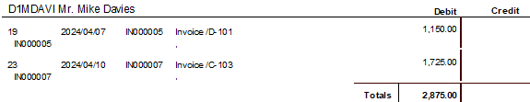
Mr. Roger Smith
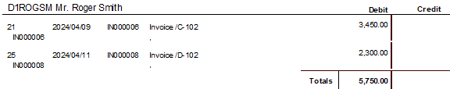
Accounts in the General ledger:
Sales
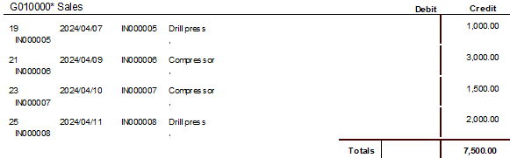
Output Tax – 15%
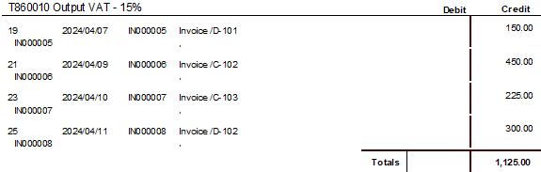
Debits = Credits
Debit transactions in the Debtor’s ledger (i.e. individual Debtor accounts).
=
Credit transactions in the General ledger (i.e. Sales and Output Tax (VAT/GST/Sales tax) Accounts).

The Cost of sales transactions are not applicable to those Stock types dealt with in MODULE J.
Account view – Cost of sales (Cost prices)
Accounts in the General ledger:
Cost of sales
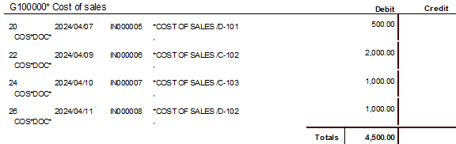
Stock control
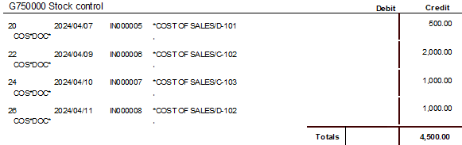
Debits = Credits
Debit transactions in the Cost of sales account
=
Credit transactions in the Stock control account (i.e. Stock ledger).

Any quantities and cost prices will automatically be updated for all stock items on the invoices.

PROCESSING CASH BOOK TRANSACTIONS WITH THE BANK IMPORT PLUGIN

IN THIS MODULE
MODULE L - PROCESSING CASH BOOK TRANSACTIONS WITH THE BANK IMPORT PLUGIN 317
L.1- OVERVIEW OF CASH BOOK TRANSACTIONS – IMPORT BANK STATEMENTS 319
L.1.1- Managing Bank statements 320
L.1.2- Managing Bank accounts and Bank References 321
L.1.3- Different ways of keeping track of your bank transactions 322
L.2- CONFIGURING YOUR CASH BOOK FOR IMPORT OF BANK STATEMENTS 323
L.2.1- Activating the Bank import plugin 323
L.2.2- Settings for the bank account batch 324
L.3- IMPORTING / PROCESSING YOUR BANK STATEMENTS 326
L.3.1- Change the name of the Batch entry 331
L.3.2- Allocating transactions to Ledgers / Debtors / Creditors 332
L.3.2.1- Account looked up by account name 333
L.3.2.2- The account looked up by searching for the corresponding document 334
L.3.2.3- The account looked up by searching for the Debtors / Creditors account 336
L.3.2.4- Account automatically selected as it is linked to the bank account number 337
L.3.3- Managing Bank Accounts and Account Bank References 338
L.3.3.1- Managing Bank links 339
L.3.3.2- Managing bank references with VAT (GST/Sales tax) 340
L.3.3.2.1- Account bank references - Details 341
L.3.3.3- Account bank references - List 341
L.3.3.4- Account bank references - Check 341
L.3.3.5- Account bank references - Batch entry - Match log tab 342
L.3.4- List the transactions in the batch. 342
L.3.5- Post (Update) the transactions to the ledger 343
L.3.6- T-ACCOUNT VIEW - TRANSACTIONS IMPORTED BANK STATEMENT 344
L.3.6.1- T-Account view of transactions in the Bank account 345
L.3.6.2- T-Account view of Receipt transactions in the Bank account 346
L.3.6.3- T-Account view of Payment transactions in the Bank account 347
L.3.6.4- Accounting equation 348
L.4- PETTY CASH PAYMENTS 348
L.4.1- Entering your petty cash payments 349
L.4.2- Posting the petty cash batch 353
L.4.3- T-Account view of transactions 354

OVERVIEW OF CASH BOOK TRANSACTIONS – IMPORT BANK STATEMENTS
The BankImport Plugin is bundled with the TurboCASH5-Subscription.
Using this BankImport Plugin, you may import a valid bank statement file (downloaded from your online banking) saved on your system into a Bank account (Cash book).
This BankImport Plugin will save you time, since you do not need to physically enter the transactions manually in the Payments and Receipts batch.
This plug-in supports:
- References to automatically allocate or link payments and deposits, receipts, other debits. credits, etc. to the correct accounts.
- Debtors (customers / clients) bank accounts is used for the automatic receipts for debit orders, etc.
- Creditors (suppliers) bank accounts is used for the automatic payments to manage the payments to suppliers, etc.
You may download bank statements for more than one bank account; credit card statements; etc.; provided that:
- You are registered for online banking at your bank or financial institution.
- Have created separate Bank, Credit Card accounts, etc. which is linked to its own Payments and Receipt Journals).
Once you have imported your bank statement (downloaded and saved on your system), the transactions on your bank statement will be imported (by a few mouse clicks) into the Payments and Receipts batch of your bank account as follows:
- Debit transactions (payments, bank charges, interest paid, debit orders, electronic payments, etc.).
- Credit transactions (receipts, interest received, electronic payments (receipts), debit orders, etc.).
Once this is done; you need to do the following simple process:
- Select the Account code and Tax account; if applicable to a payments transaction.
- Select the Account code and Tax account; if applicable to a receipts transaction.
You may also use the Context menu to locate select and search for a specific transaction, debtor (customer), creditor (supplier), or a general ledger account.
If any debtor (customer), creditor (supplier), or a general ledger account is set as an open item account, you may link specific debit transactions to specific credit transactions (and vice versa); e.g.:
- Payment transactions – link to specific credit transactions (e.g. Purchase documents, Purchase batch, etc.).
- Receipt transactions – link to specific debit transactions (e.g. Invoices, Sales batch, etc.).
This will display the Outstanding amount for each transaction, etc.
You may also select and link a part of a payment / receipt and / or one payment / receipt to more than one outstanding transactions.
You may also link an account to a specific debtor (customer), creditor (supplier) or a general ledger account to allow the correct automatic linking (allocation (selection of accounts)) during the next bank statement import.
Managing Bank statements
Before you can use this BankImport Plugin, you need to download your Bank Statement from your financial institution and save it in a valid file format.
When downloading a bank statement; from your bank or financial institution; you may need to:
- Sequence to list your transactions, e.g. Date, Amount or Description.
- Select the correct start and end dates, for your requirements.
You may download bank statements for more than one bank account; credit card statements; etc.; provided that:
- You are registered for online banking at your bank or financial institution.
- Have a created separate Bank, Credit card accounts, etc. which is linked to its own Payments and Receipt journals).
If you have created and use the Petty Cash account as a Bank Account, you may still enter the transactions manually, if required.

Managing Bank accounts and Bank References
When Bank statements are imported, it will automatically import all transactions into the Batch entry screen (combined Payments and Receipts batch). You need to allocate the transactions to the correct accounts, as the bank statement does not know which accounts in TurboCASH is matched to items on the bank statement.
TurboCASH allows you to manage these references to specific accounts. When importing a bank statement, and the account links are correct, it will automatically allocate the bank statement transactions to the correct accounts.
When importing statements and these are not linked, e.g. new receipts, payments, etc., these will then be set to Empty in the Accounts column of the Bank accounts Batch entry screen.
To automate the process for allocating (selecting accounts) to an imported bank statement, please take note of the following settings:
General ledger accounts
- Bank references – This needs to be correctly entered on the Bank Links tab. If this is correctly entered (edited), it will match the references as imported from bank statements.
- Tax (VAT / GST / Sales Tax) - If you are registered as a VAT / GST / Sales Tax Vendor, and VAT is applicable to the specific account, you need to link that account to the correct Input or Output Tax (VAT / GST / Sales Tax) account.
Debtor (customer) accounts
- Bank references - This needs to be correctly entered on the Bank accounts tab. If this is correctly entered (edited), it will match the references as imported from bank statements.
- Bank accounts – The Banking details for the Debtor (customer / client) account needs to be correctly maintained on the Accounting information tab of the Debtor account. This may be used to manage debit orders, refund debtors, etc. via the automated payments system. BIC (Bank Identifier Code) and IBAN (International Bank Account Number) accounts are also supported.
Creditor (supplier) accounts
- Bank references - This needs to be correctly entered on the Bank accounts tab. If this is correctly entered (edited), it will match the references as imported from bank statements.
- Bank accounts – The Banking details of the creditor (supplier) account needs to be correctly maintained on the Accounting information tab. This may be used to pay creditors (suppliers) via the automated payments system. BIC (Bank Identifier Code) and IBAN (International Bank Account Number) accounts are also supported.
Different ways of keeping track of your bank transactions
You can keep track of your bank bookings in different ways. The 2 most common ones, is:
- Statement method, where you make your bookings per statement from the bank.
Benefits :
- You have a good check of the balances: the final amounts on the statement.
Cons :
    - The bank balances are not "up to date", you always fall behind "today" depending on the shear frequency.
    - It is possible that there are 2 statements with the same date
    - In the download, you will always download all bookings from that date
    - These "extra" bookings must be deleted either before importing, or immediately after the import in the screen for assigning the reference
- Date method, in which you record the bookings by date.
Benefits :
- The bank balances are "up to date", you are one day behind today.
- No corrections on downloads, with bookings of the same date appearing on 2 statements.
Cons :
- None as far as known.
Enter cash / bank details according to the "statement method"
You prepare statement no. 1 to verify the data.
You now have 2 options for entering the transactions:
- You can download the statement and process it electronically via electronic banking.
- You can enter the statement manually.

CONFIGURING YOUR CASH BOOK FOR IMPORT OF BANK STATEMENTS
Activating the Bank import plugin
To enable this feature, you first need to deselect (remove the tick) on the “Default bank reconciliation” setting.
This will change the “Bank account recon options screen” and the “Batch entry” screens and combine the Payments and Receipts batch entry screens into one screen.
To activate the Bank import plugin:
- Go to the Setup ribbon and select Setup → System parameters.
- Deselect (remove the tick) on the “Default bank reconciliation” to activate this plugin.
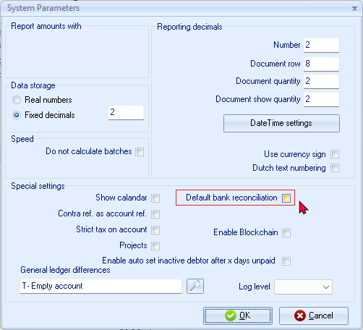
- Click OK. This will save your setting.

Settings for the bank account batch
Firstly, you will need to check and confirm the settings of the “Bank entry” batch. This is a once-off process unless your requirement change.
To check and confirm the settings for the Bank entry batch:
- Go to the Default ribbon and select Cash/Bank entry. The “Bank account recon options” screen is displayed:
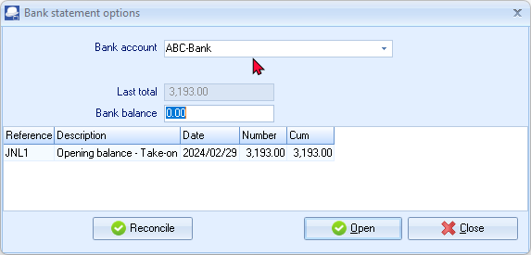
- Select the “Bank account” into which you need to import your bank statement.
- For the purposes of this tutorial, select “ABC – Bank”.
- Click Open. The “Batch entry” screen, is displayed, as follows:
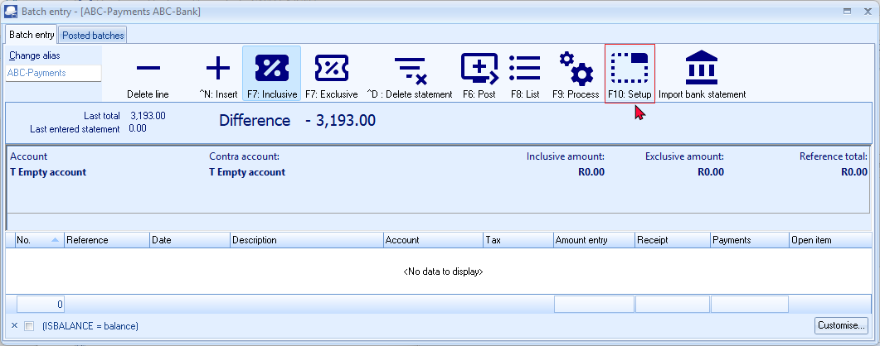

- Click F10: Setup. The “Options for this batch” - “Standard” tab is displayed:
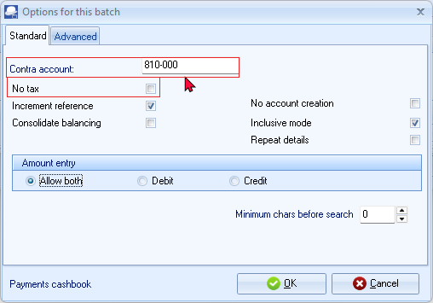
- Check the following items:
  - The “Contra account” is the Account code (number) of your bank account in your ledger.
  - The check mark "No tax” should be 'off'. If you are not registered as a VAT (GST/Sales tax) vendor you may select (tick) this option.
- Then click on the "Advanced" tab and accept the settings as below.
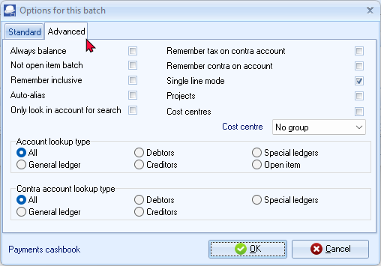
- Click on OK. if the settings are selected correctly. This will save your options and close the “Options for this batch” screen.

IMPORTING / PROCESSING YOUR BANK STATEMENTS
Now all settings are checked/set correctly, transactions can be imported with the bank import plug-in.
To import your bank statement:
- On the Default ribbon and select Cash/Bank entry. The “Bank account recon options” screen is displayed:
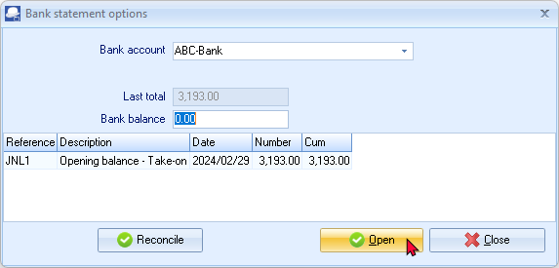
- Select the “Bank account” into which you need to import your bank statement. For the purposes of this tutorial, select “ABC – Bank”.
- Click Open. The “Batch entry” screen, is displayed, as follows:
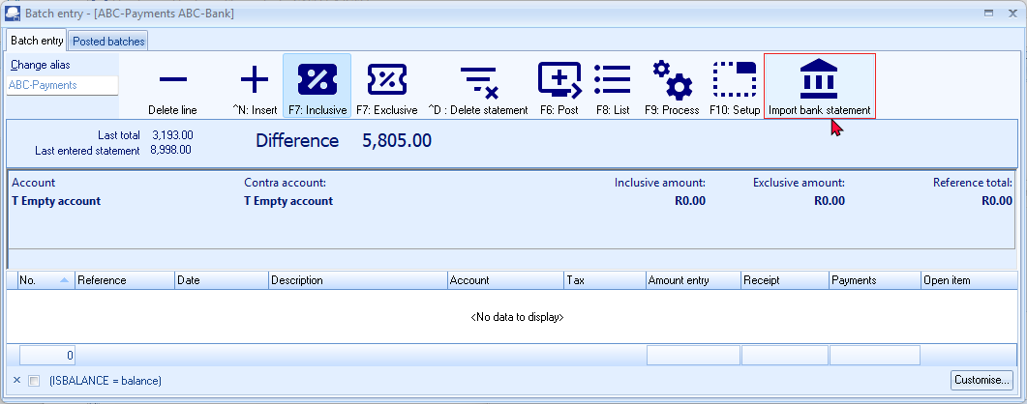

- Click on the Import bank statement icon. The “Import bank statement” screen is displayed:
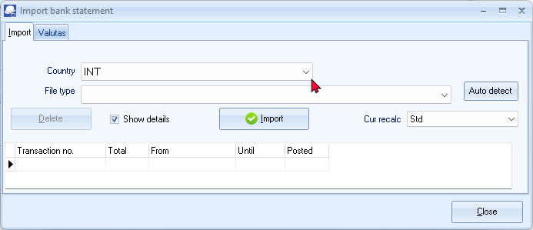
- Select a file format. Select a Country (i.e. NL = Netherlands, BE = Belgium, UK = United Kingdom, SP = Spain, USA = United States of America, or FR = France) to list the available file formats supported for a specific country.
See - Supported bank import file formats in the Help file.
- For the purposes of this tutorial, select “INT” as the Country the “INT-OFC / OFX standaard 2” file format.
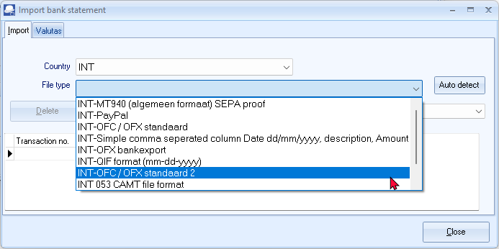
- Then click on "Import".
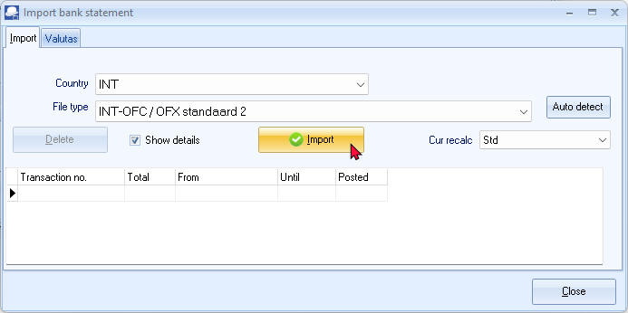
- Select the “Show Details” option. If the “Show Details” is not selected (not ticked), the “Check” screen will not be launched.
- The “Open” screen is displayed. Select the correct bank statement saved on your system.
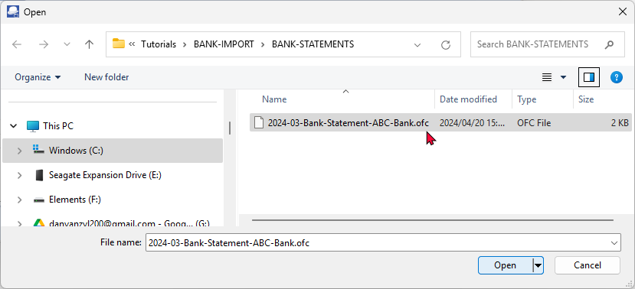
An example bank statement “2024-03-Bank-Statement--ABC-Bank.ofc” is located in the “...\bin\Tutorials\BANK-IMPORT\BANK-STATEMENTS” folder.
- Select the “2024-03-Bank-Statement--ABC-Bank.ofc” file (“Open Financial Connectivity” file format) “and click on Open. The transactions included in the Bank statement file will be listed in the “Check” screen.
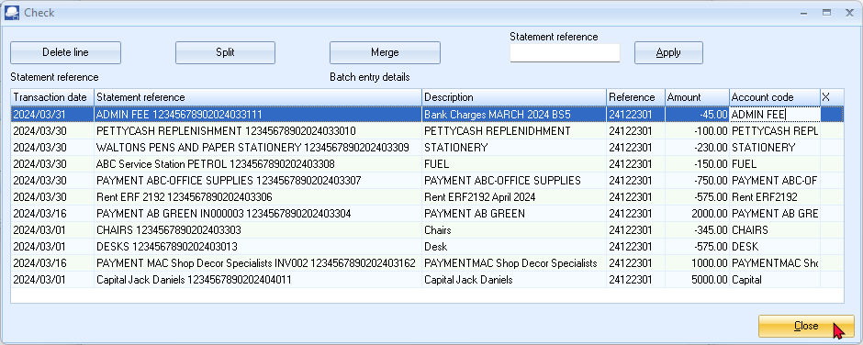
- Check here if the transactions are correct.
If a transaction is incorrect, this can be removed with the Delete line button.
If a line is yellow, there is a change this transaction has already been imported into a previous import.
Check these transactions carefully!
Options on the “Check” screen:
- Delete line - This removes a line with is selected. For example, if it has been imported before.
- Split - With this button, an amount can be split, for example, if one amount has been paid, but there are two Tax rates (VAT / GST / Sales tax) or one payment is made for more than one items, which need to be allocated to different accounts.
- Merge - With this button amounts can be merged, for example if two payments are actually for one invoice or need to be allocated to one account.
- Statement reference - The reference is entered here, so that the payment can easily be retrieved later. Entering the statement reference it is not necessary, but you may need to enter for your specific requirements.
- Apply - With the Apply button, the reference is adjusted.
- If all transactions on the imported bank statement is correct, click on Close. The “Import bank statement” screen will list the imported bank statements.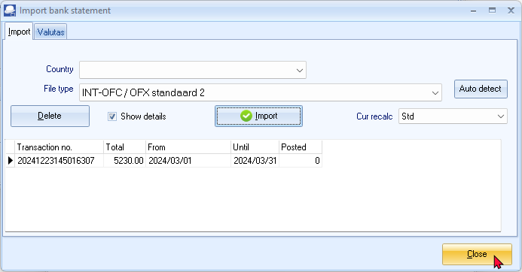
The details displayed on the “Import Bank Statement” screen is as follows:
- Transaction no. – This will be the transaction number generated and would consist basically of the date yyyy/mm/dd format; followed a time stamp and a reference number. This may differ from your operating system's regional and date settings.
- Total – This is the net value Credit (Deposits / Receipts) minus the Debit (Payments) amounts. If the Credit (Deposits / Receipts) is more than the Debit (Payments) this will display a positive amount. Should the Debit (Payments be more than the Credit (Deposits / Receipts) this amount should be displayed as a negative (“ -”) amount.
- From – The start date as selected while downloading (exporting) the bank statement from your bank or financial institution.
- Until – The end date until when transactions would be included in the downloaded (exported bank statement).
- Posted – The default value is “0”. This means that the transactions have not yet been posted (updated to the ledger). Once you have allocated (selected) Accounts and / or Tax accounts (where applicable) a value of “1” as posted (processed) will be displayed.
- Colors – The colour of the font for this line will change from black to blue if transactions have been processed and / or posted.
If the bank reconciliation is done, the font colour will change to green.
- Click Close again to close the “Import bank statement” screen. The bank statement transactions is imported into the “Batch entry” screen for the selected bank account, is as follows:
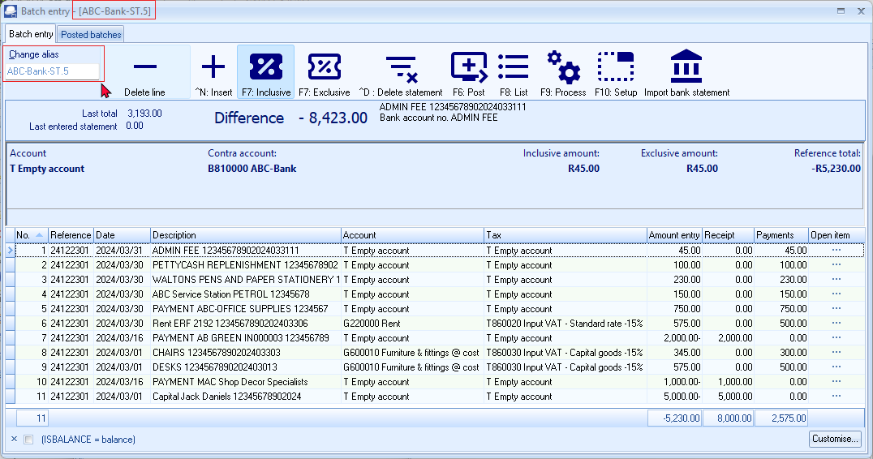
The F5: Balance icon is not available on the “Batch entry” screen for the imported transactions form your bank statements.
Balancing entries will automatically be generated for the imported transactions form your bank statements when you post (update) the imported bank statement transactions to the ledger.
The F5: Balance icon is not available on the “Batch entry” screen for the imported transactions form your bank statements.
Balancing entries will automatically be generated for the imported transactions form your bank statements when you post (update) the imported bank statement transactions to the ledger.

Change the name of the Batch entry
Change the name of the batch (alias) (i.e. “ABC-Payments”) of the Batch. In this example, “ABC-Bank-St.5” is entered in the “Change alias” field. This will identify the specific Bank statement for which bank is processed in the specific batch.

Allocating transactions to Ledgers / Debtors / Creditors
In the next step each transaction must be specified with an account (debtor / creditor / ledger) which belongs to the transaction.
This account can be allocated in the account column. There are different ways to link a transaction to an account.
- The account is looked up by account name.
- The account is looked up by looking up the corresponding document.
- The account is looked up by looking for a debtor or creditor account.
- The account is entered automatically, because it is linked to the (bank) account number (i.e. the debtor is entered because the debtor himself and his / her bank account are linked).
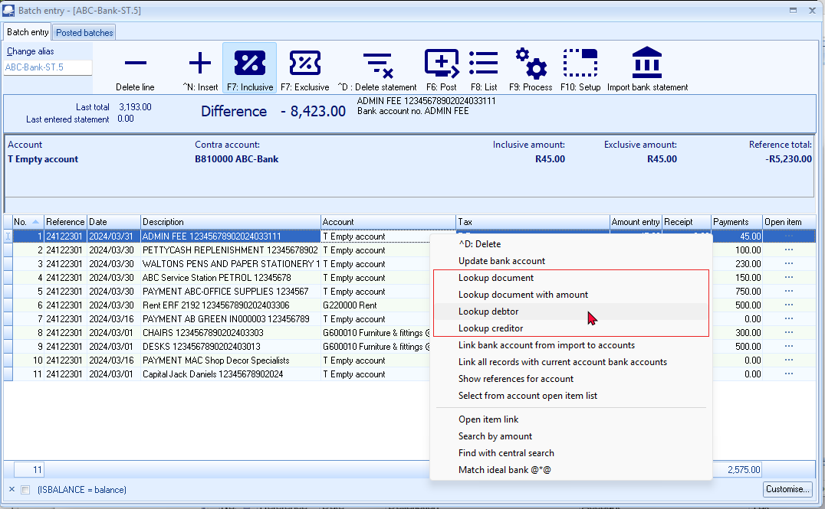

Account looked up by account name
The details on a bank statement will be available in the batch entry screen for the bank account. These details will be displayed, for each selected transaction, in the following options of the batch entry screen:
- Underneath the icons the descriptions as entered or processed by the bank.
- Description column.
These descriptions or details provide an important guide to identify and select the correct applicable account.
To allocate an account to a transaction by name:
- Select a transaction.
- Click on the Account column and enter a few characters of the descriptions. In this example, “ba” is entered. All the accounts containing “ba” is listed.
- Select “Bank charges”.
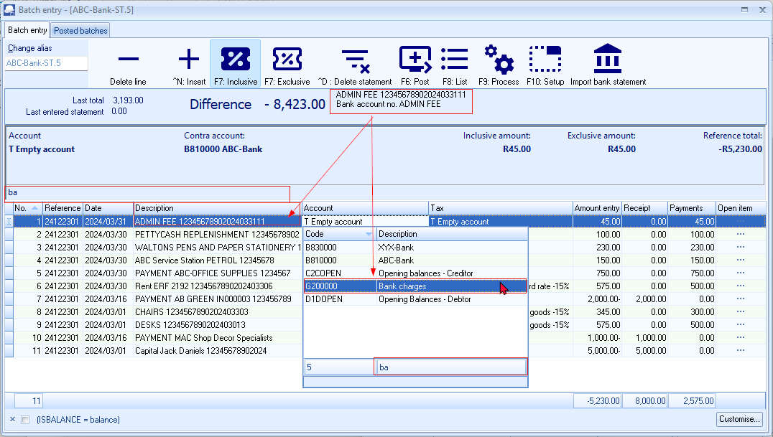

The account looked up by searching for the corresponding document
This way of allocating account to the transaction is only possible if there is a document (invoice / quote / credit note / purchase / purchase return / order).
If the transaction belongs to a journal entry, this option cannot be used.
To allocate an account to a transaction by document number:
- Select a transaction. In this example, “IN000003” is selected. The details from the imported bank statement displays 2 key details. You can now choose to select either “Document lookup”, “Document lookup with amount” or “Lookup debtor”.
- Right-click on the transaction line and select “Document lookup” or “Lookup document with amount” on the context menu. The document entry listing all invoices will be listed.
- Select “IN000003” for “Mr. AB Green”.
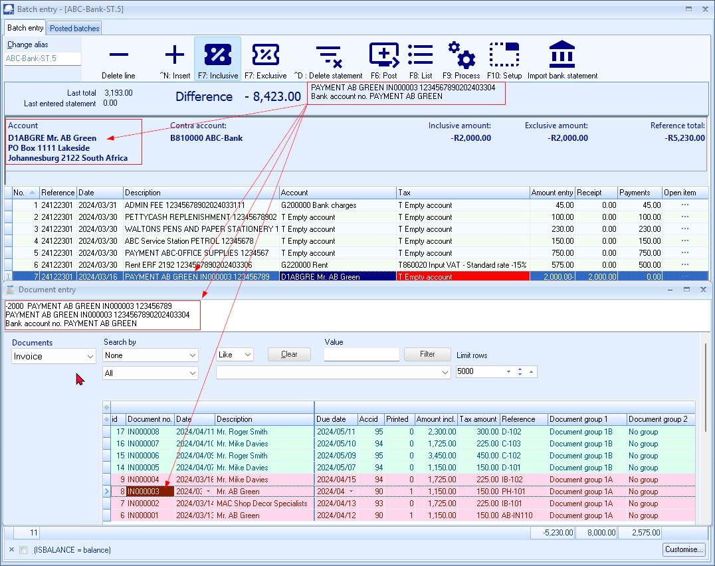
In the "Lookup document" or “Lookup document with amount".
With the first option, the “Document entry” screen will be opened and the correct document can be searched for.
With the second option, “Lookup document with amount", a document with a corresponding amount will be searched for.
Double-click to transfer the selected “Document” to the “Batch entry” screen.
You may use the filter options, to filter for a specific document. If the document you are searching for is still unposted, it will not be listed if “Posted” is selected. You may then select “All or “Unposted” options to list unposted documents.
With the double-click, the “Open item selection” screen will automatically be launched (if the Debtor account is set as an “Open item” account). In the example of “Mr. AB Green”, the transaction can be directly linked (matched) to the specific invoice.
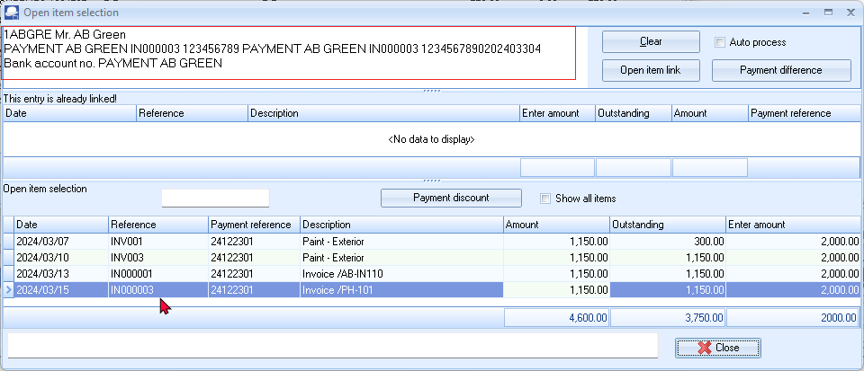
The payment details and the invoice, (i.e. invoice “IN000003”) is displayed. Since the 2,000.00 payment is more than the payment, you can select to link other outstanding invoices, e.g. “INV001” (Batch entry invoice) for the balance of the payment received.

The account looked up by searching for the Debtors / Creditors account
If a debtor or creditor name is in the details of the batch entry screen, you may select from the context menu to lookup a debtor or creditor account.
To allocate an account to a transaction by creditor account:
- Select a transaction. In this example, “PAYMENT ABC-OFFICE SUPPLIES” is selected.
- Right-click on the transaction line and select “Lookup creditor” on the context menu. The “Creditor accounts” listing all creditors (suppliers) will be listed.
- Select “ABC-Office supplies”.
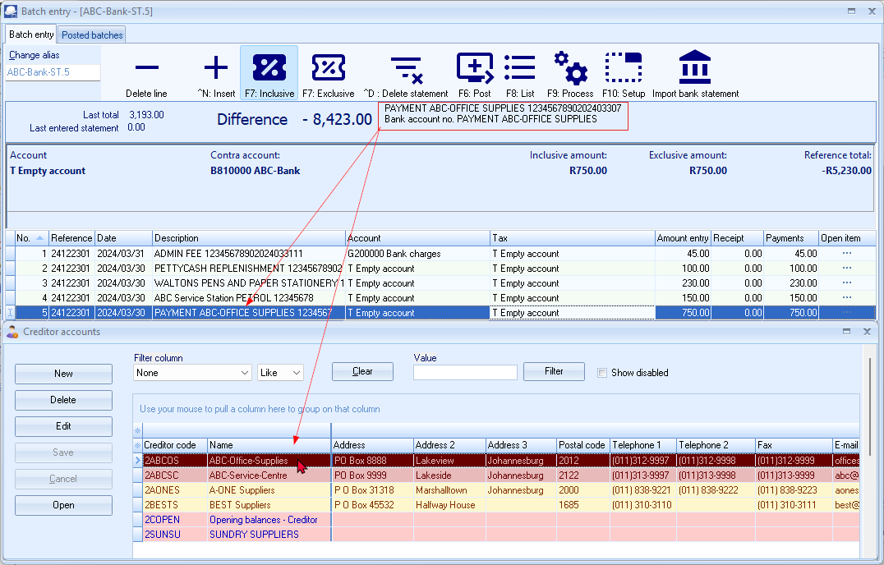
- Double-click to transfer the selected creditor account to the batch entry screen. With the double-click, the “Open item selection” screen will automatically be opened (if the Creditor account is set as an “Open item” account. In the example of “ABC-Office Supplies”, the payment transaction can be linked (matched) to the batch transactions or documents.
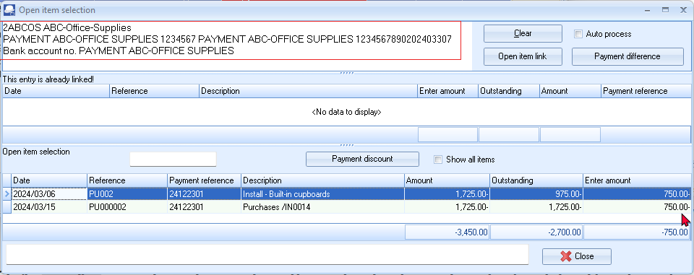
- Select “PU002” (batch purchase) as the purchase transaction, for which this payment was made.
- Press the Enter key and the linked transaction will updated in the “Batch entry” screen.
Account automatically selected as it is linked to the bank account number
It is also possible to link an account number to debtors/creditor/ledger account.
With this, transactions in the bank import are directly linked to the correct account. This linking can be done in several ways:
- If the number of the bank account of a debtor or creditor is known, this can be entered into the details of the relevant debtor/ledger/creditor.
The transactions with the same bank account number entered for the debtor / creditor will be linked to the correct account in the "Account" column.
- It is also possible to link a bank account from a transaction. Stand on a transaction. The account (debtor, creditor or ledger) must be entered here for the first time.
Then click the right mouse button and choose "Link bank account". With the next transaction from this account, the account will be filled in automatically.

Managing Bank Accounts and Account Bank References
When Bank statements are imported, it will automatically import all transactions into the Batch entry screen (combined Payments and Receipts journal). You need to allocate the transactions to the correct accounts, as the bank statement does not know which accounts in TurboCASH is matched to items on the bank statement.
TurboCASH allows you to manage these references to specific accounts. When importing a bank statement, and the account links are correct, it will automatically allocate the bank statement transactions to the correct accounts.
When importing statements and these are not linked, e.g. new receipts, payments, etc., these will then be set to "Empty" in the Accounts column of the Bank accounts Batch entry screen.
To automate the process for allocating (selecting accounts) to an imported bank statement, please take not of the following settings:
General ledger accounts
- Bank References – This needs to be correctly entered on the Bank links tab. If this is correctly entered (edited), it will match the references as imported from bank statements.
- Tax (VAT / GST / Sales Tax) - If you are registered as a VAT / GST / Sales Tax Vendor, and VAT is applicable to the specific account, you need to link that account to the correct Input or Output Tax (VAT / GST / Sales Tax) account.
Debtor accounts
- Bank references - This needs to be correctly entered on the Bank accounts tab. If this is correctly entered (edited), it will match the references as imported from bank statements.
- Bank accounts – The Banking details for the Debtor (customer / client) account needs to be correctly maintained on the Accounting information tab of the Debtor account. This may be used to manage debit orders, refund debtors, etc. via the automated payments system. BIC (Bank Identifier Code) and IBAN (International Bank Account Number) accounts are also supported.
Creditor accounts
- Bank references - This needs to be correctly entered on the Bank accounts tab. If this is correctly entered (edited), it will match the references as imported from bank statements.
- Bank accounts – The Banking details of the creditor (supplier / vendor) account needs to be correctly maintained on the Accounting information tab. This may be used to pay creditors (suppliers) via the automated payments system. BIC (Bank Identifier Code) and IBAN (International Bank Account Number) accounts are also supported.
Managing Bank links
If there is already a reference on the Bank links tab for ledger accounts and on the Bank accounts tab for debtor accounts and creditor accounts that exactly matches the reference field of the bank statement, the transactions from the imported bank statement will automatically be allocated against the correct accounts.
This information will be displayed on the Match log tab of the journal.
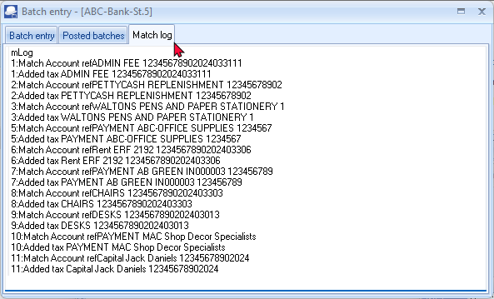
In this example, the transactions listed in the Match log tab, indicates that the imported transactions in lines 6, 8 and 9, is matched.
This means that the bank references in the the "Account code" column on the "Import bank statement - Check" screen, matches the existing references on the Bank links tab for these ledger accounts.

Managing bank references with VAT (GST/Sales tax)
If a matching "References" is entered in the Bank links tab of a ledger account, and there is an exact match on the bank reference on an imported bank statement, the account will be allocated to the correct account in the "Account"column of the "Batch entry" screen,
If VAT (GST/Sales tax) is applicable to transactions included in the import file of the bank statement, you need to link a Tax code from the "Link tax" list. This will ensure that the tax-code will be allocated to the correct account in the "Tax"column of the "Batch entry" screen.
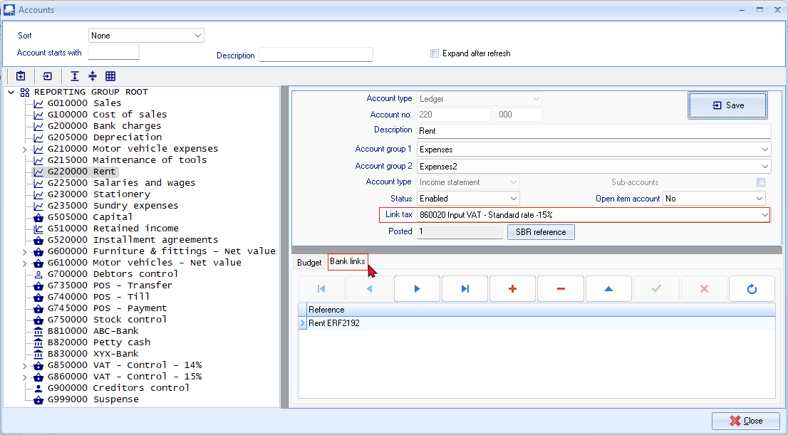
This setup streamlines the process of reconciling bank transactions by automating the allocation of transactions based on predefined references and tax codes, reducing manual effort and potential errors. It's a helpful feature for businesses dealing with a large volume of transactions and complex tax requirements.

Account bank references - Details
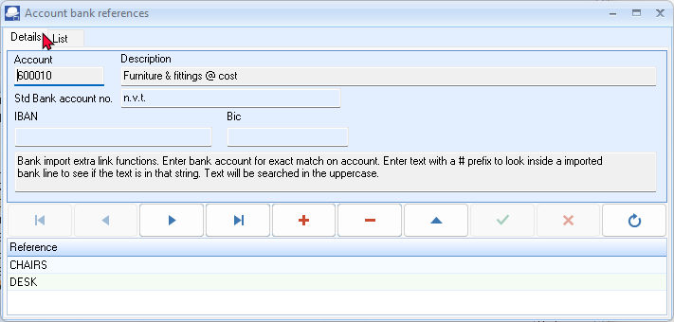
Account bank references - List
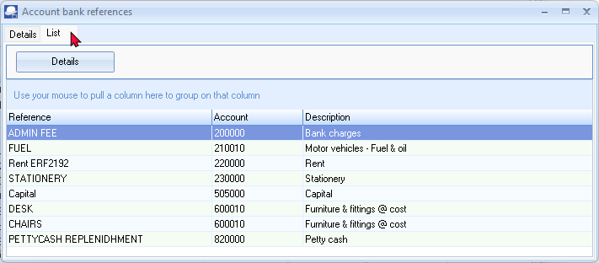
Account bank references - Check
Account bank references - Batch entry - Match log tab
List the transactions in the batch.
Click on the F8: List icon to print a list of the imported and allocated transactions in the unposted bank account batch.
Page 1 -
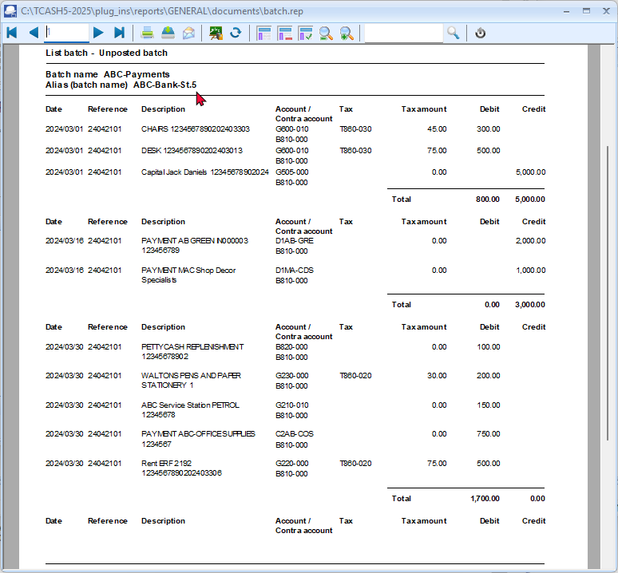

Page 2-
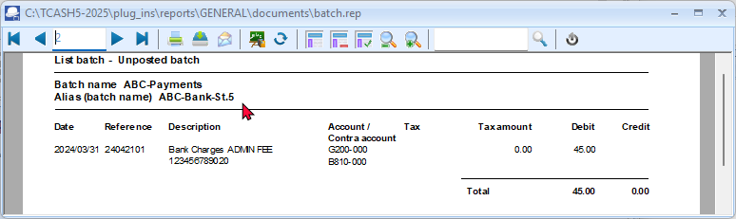
It is a good idea to list the batch, and check the entries on the batch thoroughly. If there are any errors, you may edit the batch, before posting the batch.

Post (Update) the transactions to the ledger
If all the transactions are correctly allocated to the correct accounts, the imported bank transactions can be posted (updated) to the ledger.
To post (update) the imported bank statement transactions to the ledger:
- Click on the F6: Post icon.
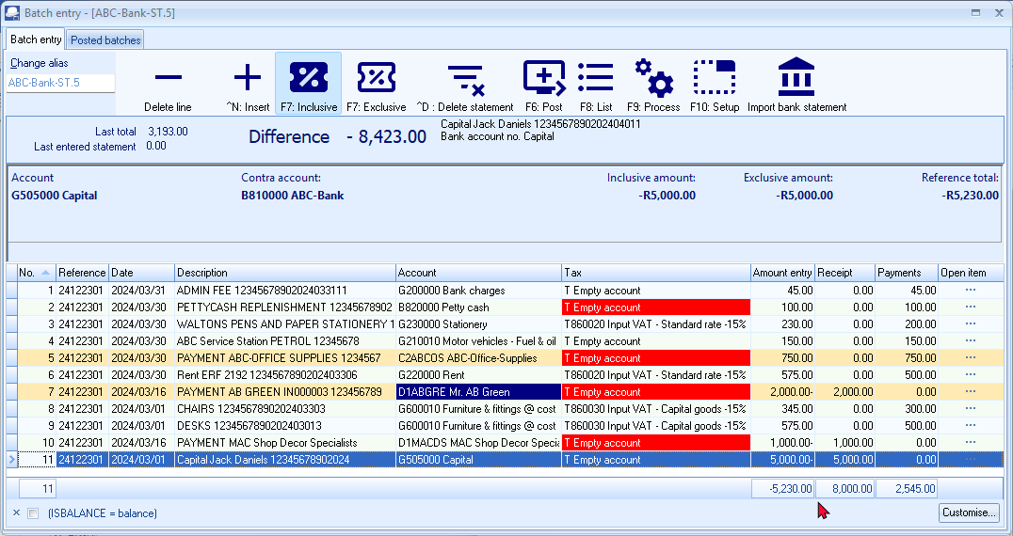
The F5: Balance icon is not available on the “Batch entry” screen for the imported transactions form your bank statements.
Balancing entries will automatically be generated for the imported transactions form your bank statements when you post (update) the imported bank statement transactions to the ledger.
- The following confirmation message will be displayed, since you are allocating a transaction to another bank account:
“You are putting cash from a bank/cash directly to a bank/cash account! Do you wish to continue?
Line : 24042001 PETTYCASH REPLENISHMENT 12345678902 810000 ABC - Bank to 820000 Petty cash”
- Click OK on the confirmation message. Posting the transactions will automatically generate the necessary balancing entries. The “Batch entry” screen will automatically be closed. The “Bank account recon options” screen is displayed:
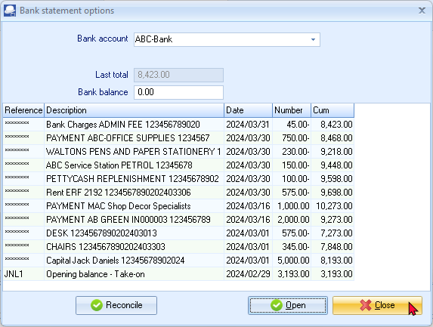
- All the imported and processed bank statement transactions, which are posted (updated) to the ledger, will be listed.
- Click Close.

T-ACCOUNT VIEW - TRANSACTIONS IMPORTED BANK STATEMENT
All processed (posted) transactions will be accumulated in the Ledger analyser. There are various ways in which the transactions may be viewed, printed, exported and analysed.
To access the T-Account view of the transactions:
- On the Reports ribbon, select Ledger analyser 1 or Ledger analyser 2.
- Select “Trial balance” report type and click on the Report button.
- On the “Trial balance”, select the “B810-000 ABC – Bank” account.
- Double-click on the selected account; or right-click and select Show details on the context menu.
- Click on the following to get specific views of transactions:
- Batch id (e.g. 11 automatically generated). This will list only the transactions for a specific batch (journal).
- Account code (e.g. G505-000 Capital account, B810-000 ABC - Bank, D1AB-GRE Mr. AB Green, D1MA-CDS MAC Shop Decor Specialists), etc. This will list the transactions for a specific account.
- Date – This will list the transactions for a specific date. If you double-click on a date, the “From date” and “To date” will be changed to the selected date.
T-Account view of transactions in the Bank account
After posting the transactions in the Receipts journal, the transactions should display as follows in the T-Account viewer:
Batch view
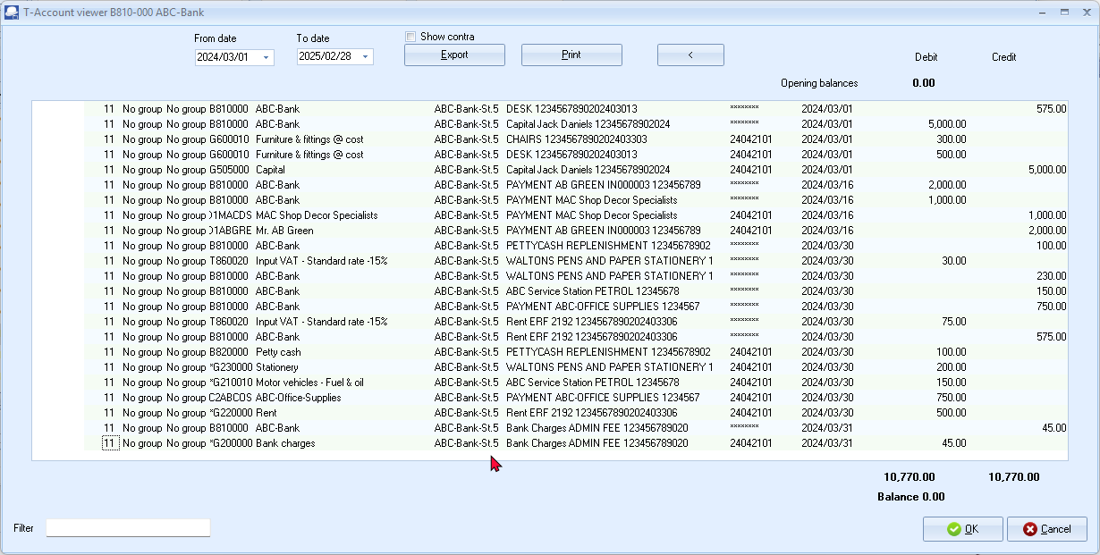
Show contra – You may select (tick) this option to view the Contra account code and account description in the first two (2) columns of the T-Account viewer. This will not print on the T-account viewer report, but will be included in the Exported file (which you can open in a spreadsheet).

BANK ACCOUNT - Account view
ABC – Bank
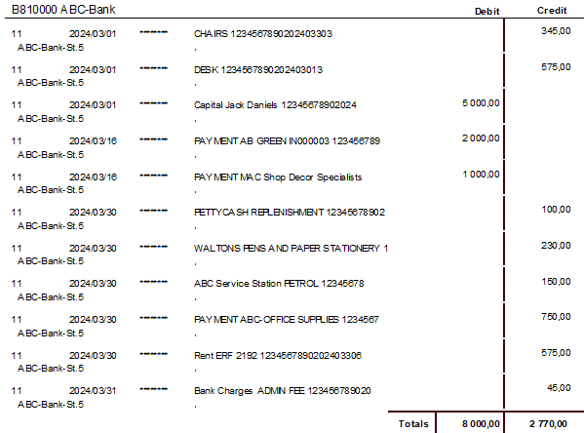
T-Account view of Receipt transactions in the Bank account
The credit transactions in the “Amount entry” column and “Receipt” column of the “Batch entry” screen for the “ABC-Bank” is as follows:
RECEIPT TRANSACTIONS – Account view
Credit transactions in the Debtor’s ledger:
Mr. AB Green
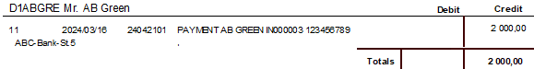
MAC Shop Decor Specialists
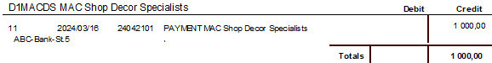
Credit transactions in the General ledger:
Capital
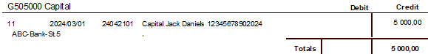

T-Account view of Payment transactions in the Bank account
The debit transactions in the “Amount entry” column and “Payment” column of the “Batch entry” screen for the “ABC-Bank” is as follows:
PAYMENT TRANSACTIONS – Account view
Debit transactions in the Creditor’s ledger:
ABC-Office-Supplies
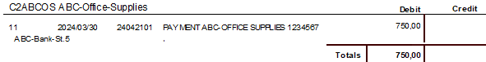
Debit transactions in the General ledger:
Furniture and fittings @ cost
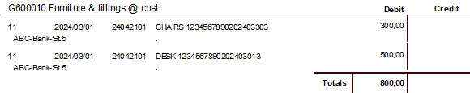
Bank charges
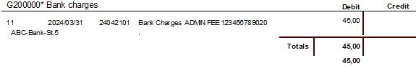
Motor vehicles - Fuel and oil
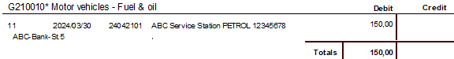
Rent
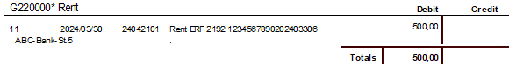
Stationery
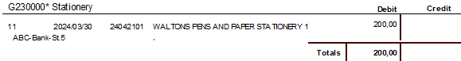
Petty cash
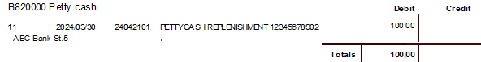
Input Tax – Standard rate - 15%
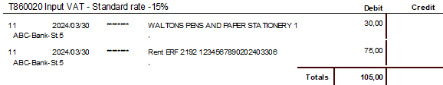
Input Tax – Capital goods - 15%
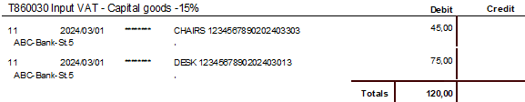
Accounting equation
RECEIPTS
Debits = Credits
Debit transactions in the General ledger (i.e . Bank account).
=
Credit transactions in the General ledger (i.e. Capital account) + Debtor’s ledger (i.e. individual Debtor accounts).
PAYMENTS
Debits = Credits
Debit transactions in the General ledger (i.e. Petty cash + Furniture and fittings + Expenses + Tax (Input VAT/GST/Sales tax)) and Creditor's ledger (i.e. individual Creditor accounts.
=
Credit transactions (i.e. payment transactions from the Bank account).

PETTY CASH PAYMENTS
Since the Petty Cash account is included in the templates of TurboCASH as a Bank account type. It is recommended that Petty Cash accounts should be added or created as a Bank account type. Once the Bank Import plugin is activated, the Petty cash payments batch and receipts batch will be combined into one “Batch entry” screen.
Petty cash payments should be used as a bank account. If it is used as a normal General ledger – Balance sheet Account, it could cause problems on the Tax Reports (Input VAT/GST/Sales tax).
You may also reconcile your Petty cash Payments and Receipt Batches. See MODULE L – BANK RECONCILIATION.

Entering your petty cash payments
There are basically two (2) ways to capture the petty cash transactions:
- Enter the transactions manually from your petty cash slips or petty cash vouchers.
- Importing the transactions from a petty cash register as a Comma Separated Value (*.csv) file as a delimited file import.
For the purpose of this tutorial, we assume that you have paid the following expenses from your petty cash:

To enter your petty cash payment transactions:
- On the Default ribbon, select Cash / Bank entry.
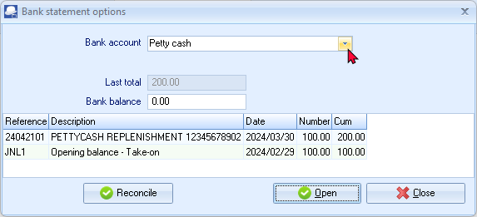
- Select the Petty cash as the “Bank account” and click Open.
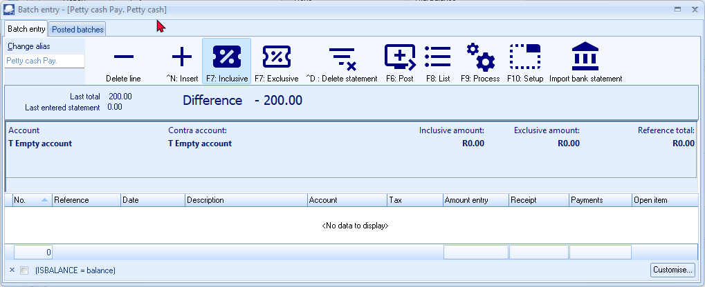
- Enter the alias (batch name) in the “Change alias” field. In this example, enter ''Petty cash2403'' to indicate that the Petty cash of March 2024 was entered in this Petty cash payments batch.
The alias option allows you to identify a batch by a unique name. You will be able to select the batch by alias or batch name if you need to reverse the posted batch or import a posted batch.
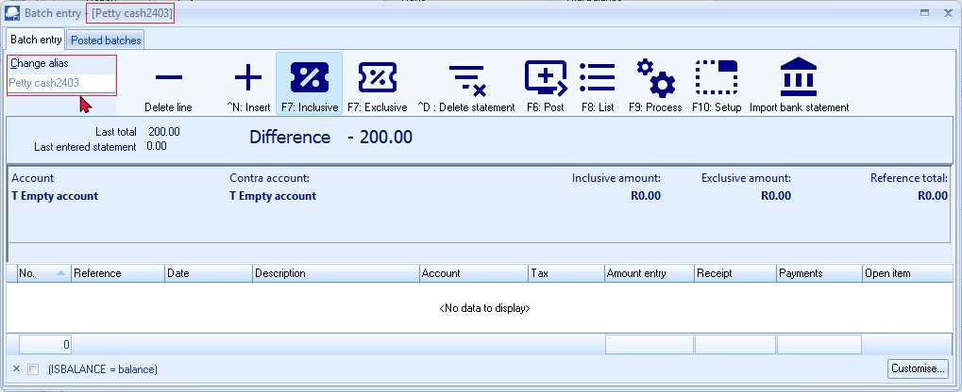
- Click on the F10:Setup icon to set your batch up. This is a once-off action, unless your requirements change. The “Options for this batch” screen is displayed:
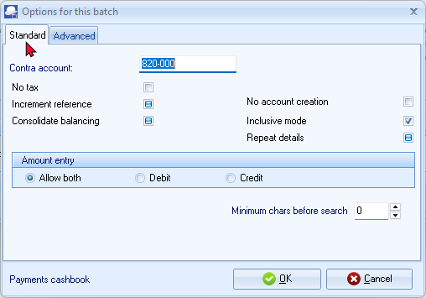
The contra account is by default set to the Bank account.
You cannot change this in the Payments journal or Petty cash Payments journal.
- Set up the Petty cash payments journal as follows:
No tax: | - Leave blank for the purpose of this tutorial. You may at a later stage select this option, if there are no tax (Input VAT/GST/Sales tax) applicable to all the transactions you need to enter in this batch.
Increment reference: | - Tick.
Consolidate balancing: | - Leave blank.
Inclusive mode: | - Tick.
Repeat details: | - Leave blank.
Amount entry: | - Cannot change this at this stage. This is set to “Allow Both”. You need to enter payments in the Debit column of the Petty cash Payments batch.
- Once setup; click on the Advanced tab.
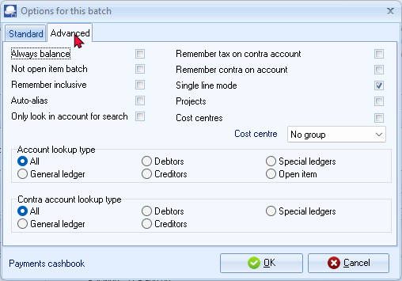
Leave all fields blank, and make sure that the default option, “Account lookup type”, is set to “All” for this exercise.
- Once setup; click OK. You are now ready to record your first petty cash payment.
- Capture your petty cash vouchers from your petty cash voucher book or from your requisitions. Use your petty cash voucher number as the reference number.
Ref. no. | Date | Description | Account | Tax | Amount
PCV001 | 2024/03/31 | Paper - Waltons | Stationery | Input Tax - 15% | 46.00
PCV002 | 2024/03/31 | Fix puncture - ABC Service Station | Repairs | No tax | 10.00
- You are now ready to capture your first petty cash voucher.
Reference: PCV001
Date: 2024/03/31
Description: Waltons - Paper
Account: G230-000 - Stationery
Tax: Input VAT/GST/Sales tax - Standard goods - 15%
Amount: 46.00 DR
- You are now ready to capture your second petty cash voucher.
Reference: PCV002
Date: 2024/03/31
Description: ABC-Service Station - Fix puncture
Account: G210-030 Repairs (motor vehicles)
Tax: No tax
Amount: 10.00 DR
- After capturing your first two petty cash payment vouchers, the Petty cash payments journal is displayed as follows:
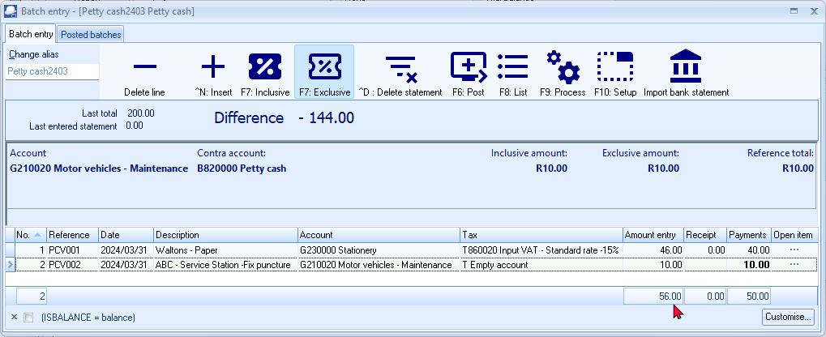
The F5: Balance icon is not available on the “Batch entry” screen for the imported transactions form your bank statements.
Balancing entries will automatically be generated for the imported transactions form your bank statements when you post (update) the imported bank statement transactions to the ledger.

Posting the petty cash batch
Once you have completed entering these petty cash payments, and you are sure they are correct, you may proceed to finalise the batch. The recommended process, is as follows:
- Click on the F8:List icon to print a list of the transactions in the batch.
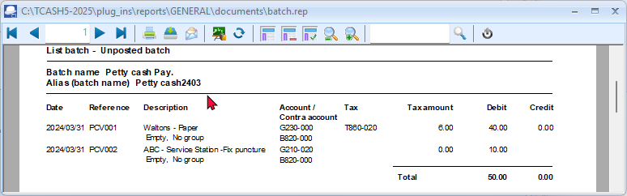
It is recommended that the source documents (e.g. petty cash vouchers and / or invoices, slips, etc. received from suppliers, etc.) be attached to this List of the transactions and that it be retained for record and audit purposes.
- Click on the F6:Post icon to post (update) the batch to the ledger. Posting the transactions will automatically generate the necessary balancing entries. The “Batch entry” screen will automatically be closed. The “Bank statement options” screen is displayed:
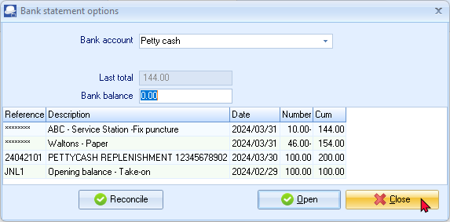
- All the imported and processed bank statement transactions, which are posted (updated) to the ledger, will be listed.
- Click Close.

T-Account view of transactions
All processed (posted) transactions will be accumulated in the Ledger analyser. There are various ways in which the transactions may be viewed, exported and analysed.
To access the T-Account view of the transactions:
- On the Reports ribbon, select Ledger analyser 1 or Ledger analyser 2.
- Select “Trial balance” report type and click on the Report button.
- On the “Trial balance”, select the “B820-000 Petty cash” account.
- Double-click on the selected account; or right-click and select Show details on the context menu.
- Click on the following to get specific views of transactions:
- Batch id (e.g. 32 automatically generated). This will list only the transactions for a specific batch (journal).
- Account code (e.g. B820-000 Petty cash, G210-020 Maintenance G230-000 Stationery, T860-020 Input Tax Standard - 15%). This will list the transactions for a specific account.
- Date – This will list the transactions for a specific date. If you double-click on a date, the “From date” and “To date” will be changed to the selected date.
After posting the transactions in the Petty cash journal, the transactions should display as follows in the T-Account viewer:
Batch view
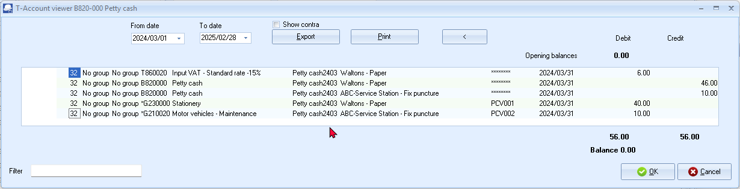
Show contra – You may select (tick) this option to view the Contra account code and account description in the first two (2) columns of the T-Account viewer. This will not print on the T-account viewer report, but will be included in the Exported file (which you can open in a spreadsheet).

Account view
Debit transactions in the General ledger:
Motor vehicles - Maintenance
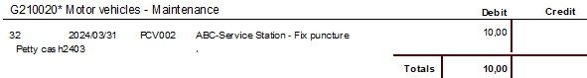
Stationery
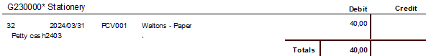
Input VAT – Standard rate - 15%
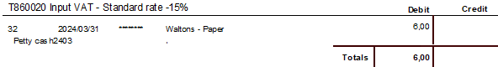
Credit transactions in the General ledger
Petty cash
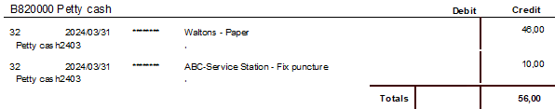
Debits = Credits
Debit transactions (i.e. Expenses + Tax (Input VAT/GST/Sales tax)).
=
Credit transactions (i.e. payment transactions from the Petty cash account).

CALENDAR / PLANNER

IN THIS MODULE
MODULE M - CALENDAR / PLANNER 356
M.1- INTRODUCTION TO THE CALENDAR 357
M.2- REPEATING INVOICES 359
M.2.1- Processing Repeating Invoices 359
M.2.2- Access Processed Repeating Invoices 362
M.3- CREATING INVOICES FOR HOURS 363
M.4- CREATING INVOICES FOR DEBTOR APPOINTMENTS 366
M.5- REMINDERS 367
M.6- PRINTING A REPORT FOR EVENTS IN THE CALENDAR 368
M.7- CONTACTS 369
M.8- TASKS 370

INTRODUCTION TO THE CALENDAR
In TurboCASH5, you may use the Calendar to perform various actions. For example, you may record appointments with your debtors (customers) and creditors (suppliers), set and process repeating documents (Invoices and Purchases). This will allow you to optimise your planning and generate Invoices for hours registered with your debtors (customers / clients).
In addition to this, you may also add any tasks, events and manage your contacts.
You may set the reminder, to allow a pop up screen to remind you of these actions well in advance.
You may then click in the Open item button of the “Reminder” screen to perform this action, as scheduled.
If the Reminder was not activated; or if you wish to adjust the reminder, select the “Event”, and select the “Edit event...” option on the context menu.
To launch the calendar and add an event:
- On the Default ribbon, select Calendar.
You may set the Calendar to launch by default when opening a Set of Books. To do this; select the “Show calendar“ option on Setup → System parameters (Setup ribbon).
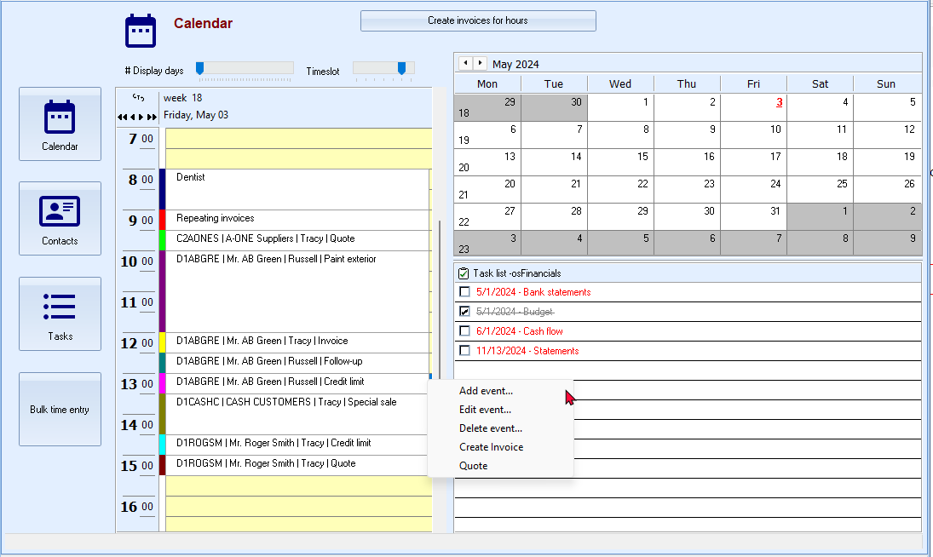
These events in the Calendar are available on 2024/05/03 in HANDY-BANK-IMPORT-B Set of Books.

The context menu (right-click) allows you to select the following:
- Add event – create new appointments for creditors (suppliers) or for debtor (customer / client) appointments (up to six (6) categories). You may also generate documents (Repeating invoices or Quotes “Hours”).
- Edit event – Edit / change or reschedule any of these events.
- Delete event – Permanently delete / remove a selected event.
- Create Invoice – Create invoices for any of the six (6) categories of debtor (customer / client) appointments.
- Quote – Create a quotes for any of the six (6) categories of debtor (customer / client) appointments.
Multi-User Calendar Plugin may also be purchased for Multi-user versions.
- Select a date and right-click on a time slot. On the context menu, select the “Add event...” option. The “Untitled – Event” screen is displayed:

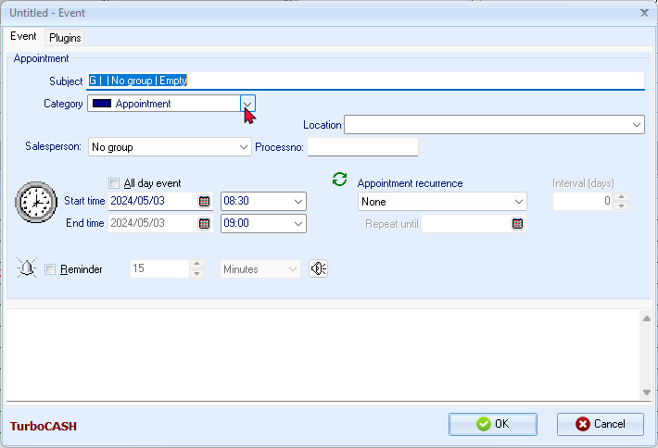
- To register (create) an appointment; you need to select one of the categories to use the different functions. The categories, are as follows:
Category | Description / Function
Appointment | This allows you to create general appointments and set reminders for these appointments (events).
Repeating invoices | This allows you to set repeating invoices for debtors (customers / clients). You may create repeating invoices for a specific debtor or a debtor group.
Debtor appointment (up to six (6) categories) | This allows you to set appointments (events) for debtors (customers / clients). You may also add notes, etc. and set reminders. You may create up to 6 categories of appointments for your debtors (customers / clients).
Creditor appointment | This allows you to set appointments (events) for creditors (suppliers). You may also add notes, etc. and set reminders.
Hours | You may use the hours to create invoices for a debtor (customer / client).
For the purpose of this tutorial, the Invoices for hours and Repeating invoices will be discussed here.
Debtor appointments - All events for the six (6) categories are listed in the Appointment tab for a selected debtor (customer / client) account.
Creditor appointments - All events are listed in the Appointment tab for a selected creditor (supplier) account.
REPEATING INVOICES
Should you need to invoice a debtor (customer / client) or specific debtors (customers / clients) on a regular basis (e.g. monthly, etc.), you may use the “Repeating invoices” category to schedule and process the repeating invoices with a few mouse-clicks.
Processing Repeating Invoices
Once the Repeating invoices is scheduled, you need to reopen the Repeating invoices event to process the repeating invoices.
To set repeating invoices:
- Select a date and right-click on a time slot. On the context menu, select the “Add event...” option. The “Untitled – Event” screen will be displayed.
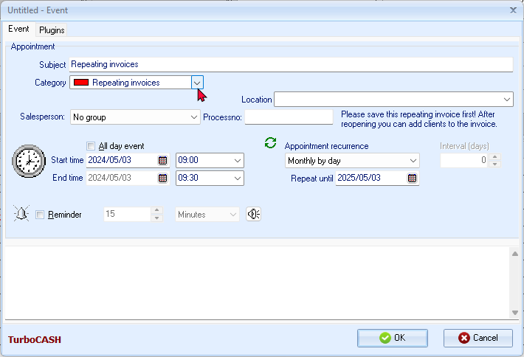

- On the “Untitled Event” screen, enter and / or select the following:
Subject: | - Leave blank. If you click on the OK button, “Repeating invoices” will be displayed in the “Subject” field.
Category: | - Select “Repeating invoices”.
Salesperson: | - Select “Russell” as the salesperson.
All day event: | - Leave blank.
Start time: | - Select “2024/05/03”. This is the date and time as selected on the Calendar from where the “Untitled - Event” screen was launched. If this date is not correct, you may select the correct date.
End time: | - Field disabled.
Appointment recurrence: | - Select “Monthly by day”.
Repeat until: | - The default will be one year as from the “Start time”.
Reminder: | - Leave blank. You may activate it and set the “Minutes, Hours” or “Days” to remind you in advance to process repeating invoices.
- Click on the OK button to register and save the “Repeating invoices – Event”.
- Reopen the “Repeating invoices – Event” to add your debtors (customers / clients). The Repeating invoice tab will be added to the “Repeating invoices – Event” screen. Click on the Repeating invoice tab.
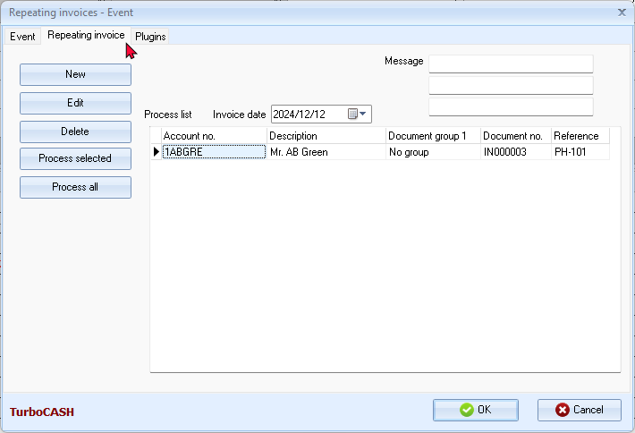

- The options, is as follows:
  - You may enter a Message (up to 3 lines) to display on the invoice. This message will be displayed on the “Message” fields in the “Document entry” screen's header section and will be printed on the printed invoice.
  - Select the Invoice date “2024/05/03”; if not correct. This is the date on which, the invoice(s) will be created.
- Click on the New button.
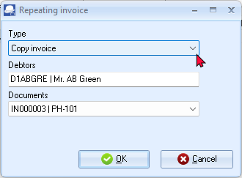
- Select the following options:
Type: | - Select “Copy invoice” (default option).
Debtor: | - Select “Mr. AB Green”.
Documents: | - Select “IN000003”.
If you select the “Copy invoice to group 1” option as the “Type”, you may to select a specific Debtor reporting group 1.
- Click on the OK button. The details of the debtor will be listed in the Process list.
- Click on the Process selected button. Once the process is finished, a confirmation message is displayed:
“Document(s) created!”
- Click on the OK button.
- Click on the OK button of the Repeating invoices – Event (e.g. “Monthly Invoices”) screen.

Access Processed Repeating Invoices
Click on the Documents – Invoices. The Invoice will be created as “IN000009”, as per this example. The Invoice will be added as an unposted document. Edit the Invoice, if necessary.
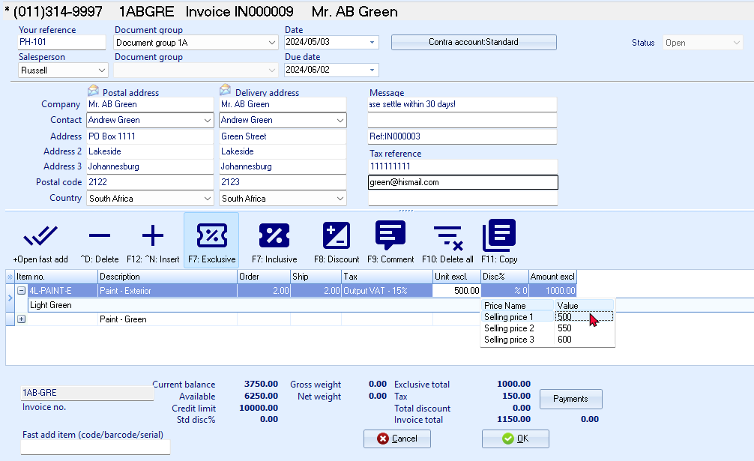
Message line 1 / Message line 2: The Message as entered in the Documents setup – Invoices screen may be duplicated. You may edit these message fields as necessary.
- Message line 3: Ref: IN000003” is the source invoice selected for the repeating invoice.
Comments and remarks: The comments and remarks, if included in the source invoice, will also be included. You may edit these message fields as necessary.
This Invoice may then be viewed on the “Document entry” screen as Unposted.
You may also view and print the Invoice on the Documents tab of the Debtor account (Default ribbon).
Once the Invoice is posted (updated to the ledger), it will be listed as a debit transaction on the Transactions tab of the “Debtor account”.
The Repeating invoice – Event will be displayed in Red colour on the time slot of the scheduled day. The Day in the calendar will also be underlined and displayed in a Red font.

CREATING INVOICES FOR HOURS
The Calendar (Planner) allows you to schedule appointments with debtors (customers / clients) and generate quotes for appointments / services rendered. This combines your electronic dairy with the quotes and invoicing features in TurboCASH5.
You may then send them the quote for the time. Once the appointment is finished / completed, you may convert the quote to an invoice and edit it before posting the invoice to the ledger.
For example, if you have scheduled a 3 hour appointment, and it took only 2 hours, you may edit the invoice (converted quote) change the number of hours from 3 to 2 hours.
To create invoices for hours:
- Select a date and right-click on a time slot. On the context menu, select the “Add event...” option. The “Untitled – Event” screen will be displayed.
- Select the “Hours” category. A field “Hours” will be added to the “Untitled – Event” screen.
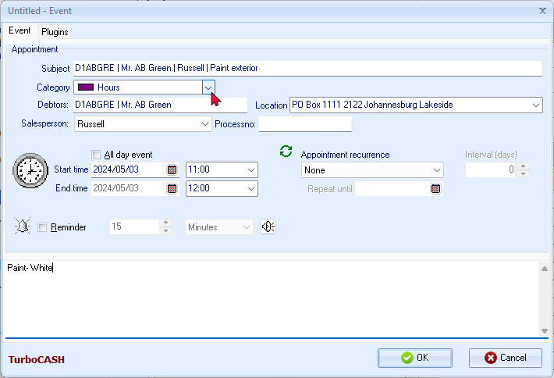
- Click on the “Hours” field and select a debtor (customer / client) account.
- Select “Russell” as the salesperson.
The Debtor code, description and name of the salesperson (and Description, e.g. “Paint exterior”, if entered in the “Subject” field), will automatically be inserted in the “Subject” field.
- Select the “Start time” and “End time” for the appointment. If this is event is for the whole day, you may tick the “All day event” field.
Appointment recurrence should be “None”. Trying to select any of the recurring options will display an “Error Hours cannot be repeated”.
- Stock item - You may select a default stock item (product) for this Appointment.
- Notes - You may enter notes about this appointment. In this example, “Paint exterior – White” is entered.
- Click on the OK button to register the event and add it to the Calendar. This event will be may be viewed and if the reminder was set, you will be reminded of the event.
- When ready to process the quote, click on the Create invoices for hours button.
The “Hours between date” screen is displayed:
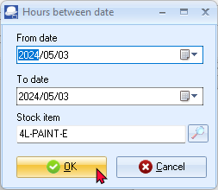
- Select the dates “From date” and “To date”.
- Select the Stock item.
- Click on the OK button. The Quotes will be generated. Once the process is finished, an information message is displayed:
“Quote(s) generated!”
- Click on the OK button.
- Click on the Documents - Quotes. The Quote should be created as “QU000003”, as per this example.
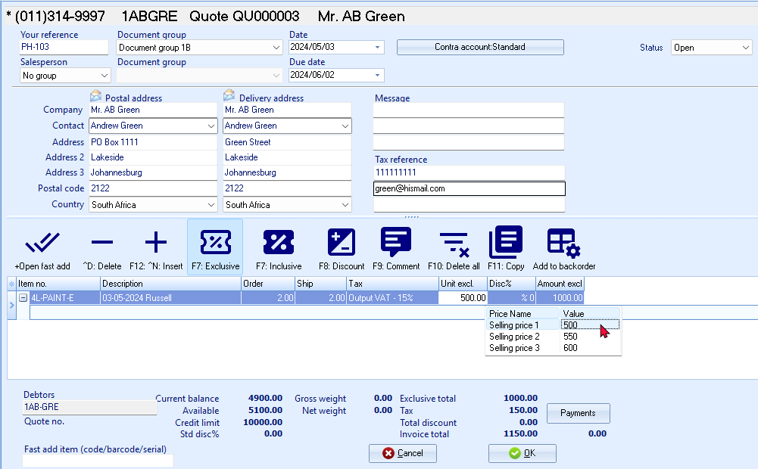
- Edit the Quote, if necessary. You may print these quotes and send them to your debtor (customer / client). The quantity is the number of hours as scheduled for this Hours appointment. In this example, “2” hours is the number of hours scheduled for this event and “1,000.00”, is the selling price of the stock item for 2 hours.
Message lines 1 to Message line 3:
These message lines will be blank.
The standard quote message as entered in Documents setup – Quotes will not be included in this quote.
You may enter the messages, as necessary.
Comments and remarks:
You may enter the comments and remarks, as necessary.
This Quote may then be viewed on the “Document entry” screen as Unposted (not converted to an invoice).
You may also view and print the quote on the Documents tab of the Debtor account (Default ribbon).
Once the quote is is converted to an invoice and the invoice is posted (updated to the ledger), it will be listed as a debit transaction on the Transactions tab of the Debtor account.
The Hours – Event will be displayed in Magenta colour on the time slot of the scheduled day. The Day in the calendar will also be underlined and displayed in a Red font.

CREATING INVOICES FOR DEBTOR APPOINTMENTS
You may also create invoices for any of the six (6) categories of appointments scheduled with debtors (customers / clients).
You may also create invoices for Creditor appointments.
To create invoices for debtor (customer / client) appointments:
- On the Calendar, select any of the six (6) categories of debtor appointments and right-click.
- On the context menu, select the “Create Invoice” option. A new “Invoice entry” screen, displaying all the information and details for the debtor (customer / client) account will be displayed.
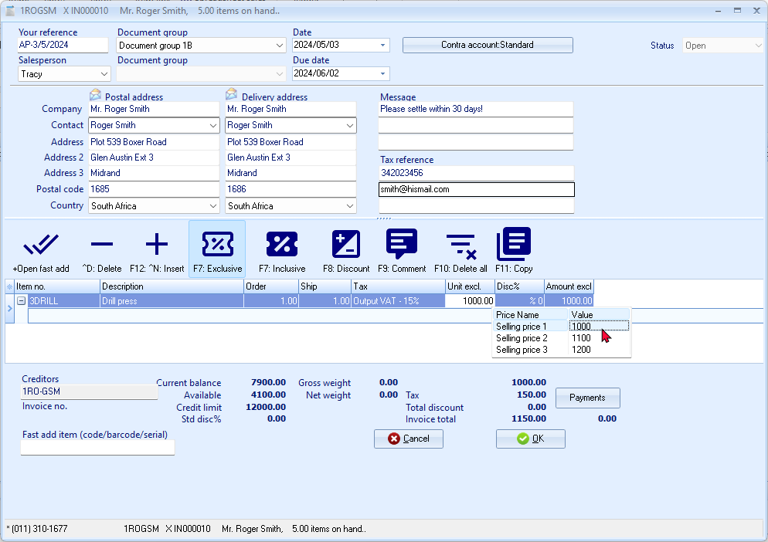
- Enter and / or select the following options:
Your reference: | - Enter “AP-3/5/2024” for reference to the appointment.
Salesperson: | - Select “Tracy”; if not already displayed.
Document group 1/2: | - Select “Document group 1B”.  - Document group 2 cannot be selected as Groups are not added for Document group 2 in Groups (Setup ribbon).
Date: | - The system date will be displayed. Select “2024/05/03” for the purpose of this tutorial.
Due date: | - This date will be automatically be calculated. It is the “Date” plus the number of days set in the Accounting information tab of the selected debtor account.
Message: | - The message as entered in Documents setup – Invoice will be included in this invoice.
 | - Press the Enter key until you get to the invoice details screen (skip the “Address, Delivery address” and “Message” fields).
Item no.: | - Select “Drill press”. The description, Quantity (default 1), Tax account, Unit selling price (Exclusive of VAT/GST/Sales tax if the F7:Exclusive icon is active - or Inclusive of VAT/GST/Sales tax if the F7:Inclusive icon is active) will be displayed.
Order / Ship (Quantities): | - Leave at the default “1” for 1 drill press.
Tax: | - The default Output Tax account for the stock item will be displayed. Confirm that it is correct by pressing the Enter key.
Discount: | - Press the Enter key to keep it at the default 0% discount rate.
- Click on the OK button. A confirmation screen will be displayed.
“Do you wish to print this invoice?”
- Click on the Yes button.
REMINDERS
The “Reminder” screen is automatically launched at the intervals set (if the Reminder is activated).
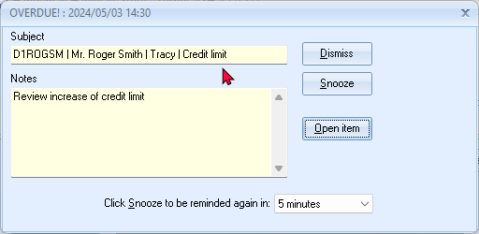
If the date and / or time is in the past (earlier than your system's date), the header OVERDUE! and the date end time of the event will be displayed.
The options to manage the reminder of an event or appointment are:
- Dismiss - Click to turn the Reminder option for the event or appointment off. You may later, at any time select the event or appointment and edit it to turn the reminder on.
- Snooze - Click to be reminded later. You may also adjust the time intervals to be reminded later, e.g. 5, 10, 15, 30, 45 minutes, 1 to 8 hours, 1 to 6 days or 1 week, before clicking on this button.
- Open item - Click to edit the event or appointment. You may finalise or reschedule the appointment. You may also deactivate or activate the reminder again.
PRINTING A REPORT FOR EVENTS IN THE CALENDAR
The “Hours” report for the entries in the Calendar will display a list of all the appointment types for a selected period or selected date(s).
Repeating invoices will not be included in this report.
To print the calendar report:
- On the Reports ribbon, select Reports → Calendar. The “Hours” screen is displayed:
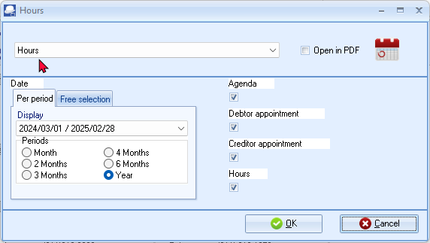
- Select the Categories for the Appointments (events) to include in this report.
- Select the periods on the Per period tab or date(s) on the Free selection tab.
- Click on the OK button. An example of the “Calendar - Hours” report, is as follows:
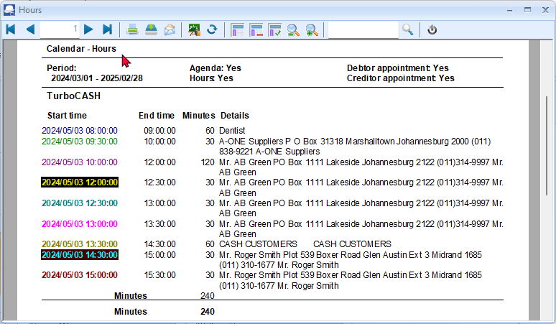
CONTACTS
Lists all contacts for debtors (customers / clients) as well as contacts for creditors (suppliers).
You may add, edit and or delete contacts in the Calendar.
Contacts can also be added, edited or deleted using the following options on the Default ribbon:
- Contacts
- Debtors – Contacts tab.
- Creditors – Contacts tab.
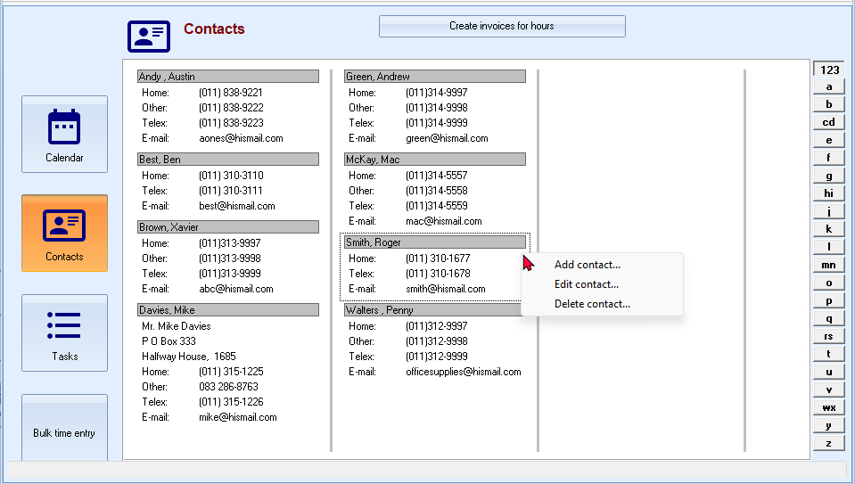
Reports for contacts can be printed in the following options on the Reports ribbon:
- Reports → Contacts - Lists all contacts for debtors (customers / clients) as well as contacts for creditors (suppliers).
- Reports → Debtors → Listing - Lists only contacts for debtors (customers / clients).
- Reports → Creditors → Listing - Lists only contacts for creditors (suppliers).

TASKS
You may add, edit, or delete tasks (to do list), and set a completion date when the tasks should be completed. You may also add some notes to each task to remind you of additional steps, procedures, phone numbers, etc.
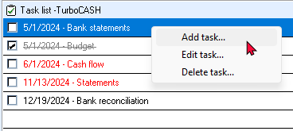
All tasks (excluding the deleted tasks, will display as follows:
- Future tasks - If tasks have not yet reached its completion date, these tasks will be displayed in a grey font.
- Expired tasks - Will display in a red font colour.
- Tasks marked as completed - The field is ticked and the task displays a stripe through it. The task will also be displayed in a grey font.

BUDGETING
IN THIS MODULE
MODULE N - BUDGETING 371
N.1- BUDGETING 372
N.2- PROCESSING BUDGET FIGURES 373
N.2.1- Entering Budget figures 373
N.2.2- Entering Budget figures for special events 375
N.2.3- Budgets tabs 377
N.2.3.1- Budgets - Transaction details tab 377
N.2.3.2- Budgets - Pivot tab 378
N.2.3.2.1- Default filter options 379
N.2.3.2.2- Change sequence add / remove Pivot grid fields 381
N.2.3.2.3- Filters 383
N.3- PRINTING BUDGET REPORTS 385
N.3.1- Printing budget listing reports 385
N.3.2- Printing budget listing report from the T-Account viewer 386
N.4- PRINTING BUDGET PERFORMANCE REPORTS 387
N.4.1- Printing the Budget vs actual report 388
N.4.2- Printing the Budget vs actual (3 Periods) report 390

BUDGETING
The budget feature is used to enter and edit budget figures in TurboCASH5, which can be compared with actual income and expenses. Budgets are a guide as to what you want to achieve; for instance what income you expect to generate (sales forecasts and income from other sources) and a plan for your expenses you need to incur to achieve that income. Budget figures can be flexible so as to take into account seasonal trends in business.
Budget figures can be added for all accounts, except the following accounts:
- Main accounts – Budget figures need to be entered for each sub-account.
- Debtor's control account – Need to enter Credit Limits for each debtor (customer / client) account on the Accounting information tab (Debtors (Default ribbon)).
- Creditor's control account – Need to enter Credit Limits for each creditor (supplier) account on the Accounting information tab (Creditors (Default ribbon)).
Budget figures can be added for the following features (extra columns will be available in the Budget tab of the Setup → Accounts (Setup ribbon):
- Cost centres – Cost centre 1 and 2 added in Setup → Groups - Cost centre 1 / 2.
- Projects – Projects added in the Setup → Groups – Projects, and if activated.
Budget figures are displayed on the following options and / or reports:
- Ledger analyser (Reports ribbon).
- User reports – If User reports were designed to print budget figures.
For the purpose of this tutorial, we need to enter the following budget:
ACCOUNT ALLOCATION | DESCRIPTION | ANNUAL | MONTHLY
010-000 | Sales | -120 000 | -10 000
100-000 | Cost of sales | 48 000 | 4 000
GROSS PROFIT |  | 72 000 | 6 000
200-000 | Bank charges | 480 | 40
205-000 | Depreciation | 600 | 50
210-010 | Fuel and oil | 1 200 | 100
210-020 | Maintenance | 1 800 | 150
210-030 | Repairs | 2 400 | 200
220-000 | Rent | 6 600 | 550
225-000 | Salaries and Wages | 6 000 | 500
230-000 | Stationery | 120 | 10
TOTAL EXPENSES |  | 19 200 | 1 600
NET PROFIT |  | -52 800 | -4 400

The net profit need not be entered, as it will automatically be calculated.
PROCESSING BUDGET FIGURES
Budget figures may also be entered in the Setup → Accounts (Setup ribbon) as in TurboCASH4.
In TurboCASH5, Budgets may be added, edited and / or imported (Budgets icon on the Reports ribbon).
Entering Budget figures
To enter your budget figures:
- On the Reports ribbon, select Budgets.
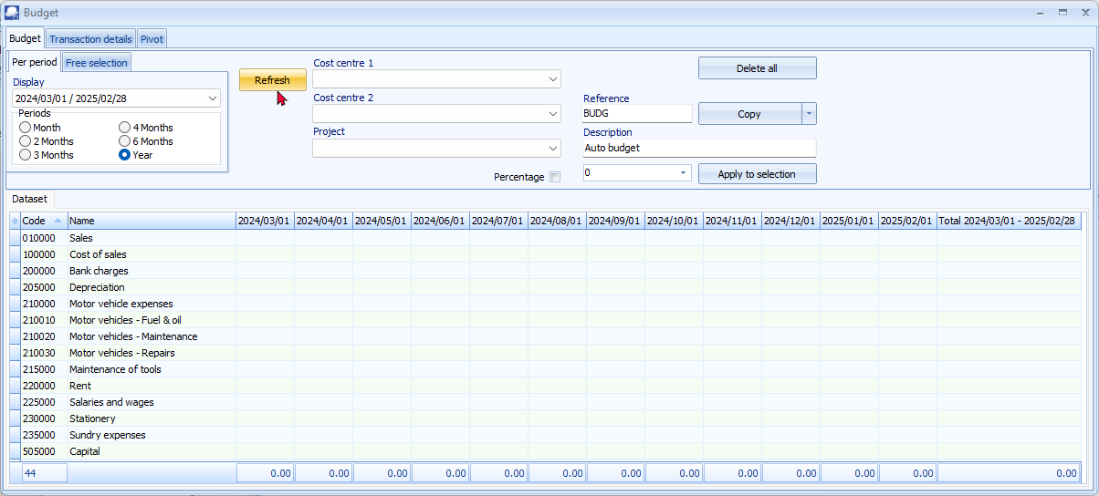
- Period – Select the period “Year” (i.e. “2024/03/01” to “2025/02/28) to enter your budget figures for the selected period.
- Click on the Refresh button. This will list all the existing ledger accounts in your “Chart of accounts” (existing as added, edited in the Setup → Accounts (Setup ribbon)), in the Account code sequence.
If you already have existing budget figures in the previous year, you may use the “Copy – From Budget Previous year” option.
If you have already posted transactions in batches and documents in the previous year, you may use the “Copy – From Actual Previous year” option to use the transaction totals as basis for your budget.
- Reference – The default is “BUDG”. You may enter your own reference, up to 15-characters, in this field. For the purposes, of this tutorial, enter “BUDGET”.
- Description – The default is “Auto budget”. Enter “Budget 2024/2025”.
- Select the first account, i.e. “Sales” and enter the monthly budget amount, i.e. –10,000 in die amount field (before the Apply to selection button) in.
The “ - “ (minus sign), added before the amount, indicates a credit budget amount. For a debit budget amount, add the amount without the “ - “ (minus sign).
- Select the months for which you need to add the budget figures.
To select multiple periods, press the “Shift” key on your keyboard and click on the periods to select the months.
- Click on the Apply to selection button. A confirmation message is displayed:
“Add amount to selection?”
- Click Yes to add the monthly budget figures to the selected months.
- Repeat this process to add your budget figures.
- After adding your budget figures for the accounts in this tutorial, the “Budgets” screen should display as follows:
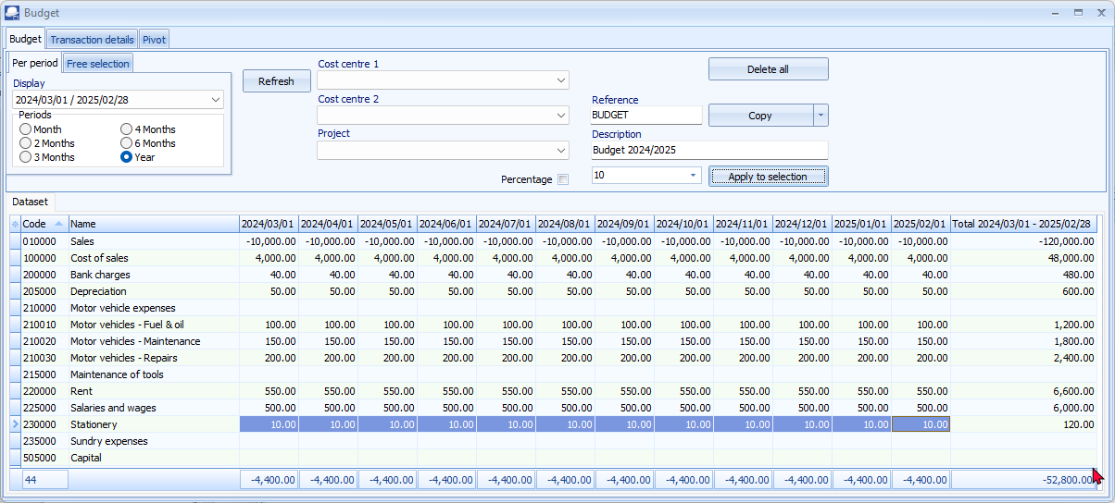
Do not enter any budget figures for the main accounts.
In this example, Budget figures were not entered for the Main account “Motor vehicle expenses”, but for each sub-account.
- After finishing to process your budget figures, you may click on the Transaction details tab or Pivot tab view and explore the generated budget figures.

Entering Budget figures for special events
On 1 May 2024 we need to budget 5,000.00 extra sales for a special promotion. You may enter budget figures for specific dates and / or periods to accommodate, for example, special events, fluctuations and business patterns.
To enter budget figures for special events:
- On the Reports ribbon, select Budgets.
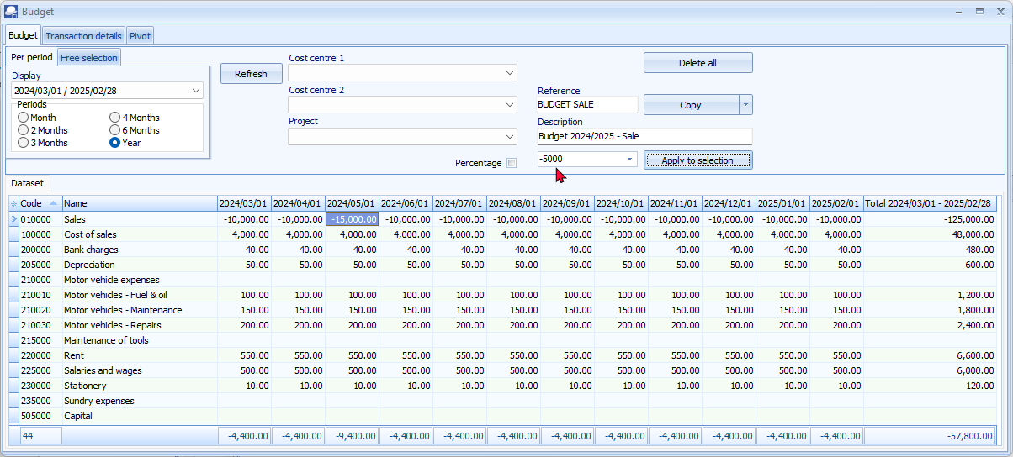
- Period – Select the period “Year” (i.e. “2024/03/01” to “2025/02/28”) to enter your budget figures for the selected period.
- Click on the Refresh button. This will list all the existing ledger accounts in your “Chart of accounts” (existing as added, edited in the Setup → Accounts (Setup ribbon)), in the Account code sequence.
- Select the “Sales” account and the month “2024/05/01” - May 2024.
- Reference – The default or previous reference entered, will be displayed, for example, “BUDGET”. Enter “SALE“ to indicate that it is a sales event that is scheduled for May 2024; or that took place in May 2024.
- Description – The description as previously entered, is “Budget 2024/2025”. Enter “Budget May 2024 - Sale”.

- Only enter the additional amount with which you need to increase the budget for May 2024. To increase the existing amount for May 2024 from –10,000 to –15000, only enter
–5000 in the amount field (before the Apply to selection button).
The “ - “ (minus sign), added before the amount, indicates a credit budget amount. For a debit budget amount, add the amount without the “ - “ (minus sign).
In the case of Sales and trading stock items, is applicable, you may need to change the “Cost of of sales” account.
- Click on the Apply to selection button. A confirmation message is displayed:
“Add amount to selection?”
- Click Yes to save the increased budget figure for May 2024.

Budgets tabs
After finishing to process your budget figures, you may click on the Transaction details tab or Pivot tab view and explore the generated budget transactions.
Budgets - Transaction details tab
The Transaction details tab lists all the accounts and periods for which budget figures were entered or edited.
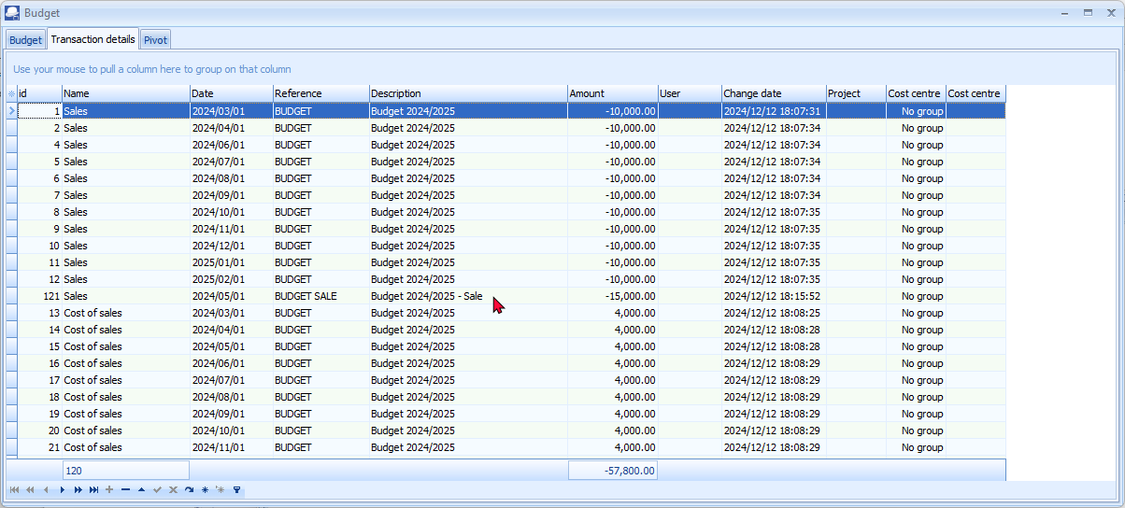
In this example we added budget figures for only 10 Income and Expense accounts. The budgeted total profit is -57,800. Should you add any budget figures for Balance sheet account types, this total of the amount column will not reflect the net profit or loss figure.

In this example, we added budget figures for 10 accounts for 12 months each. The total number of budget transactions records is 120.

Budgets - Pivot tab
The Pivot tab, by default, summarises the budget totals for the Income and Expense (Income statement) accounts and Capital, Assets and Liabilities (Balance sheet) accounts for which budget figures were entered for the selected period or dates.
You may use the Pivot to group filter, drill down and focus or zoom in on specific groups, accounts, periods, etc. to get different views of the budget.
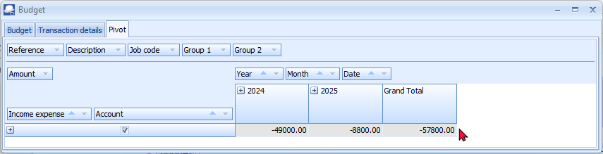
Click on the icon to list the budget totals for the accounts. The icon will change to list totals for each account for which budget figures are entered. The “Expand all” year view, is as follows:
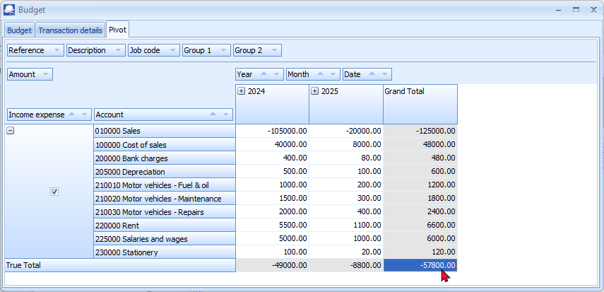
You may right-click and select the “Select all” option on the context menu.

The “Expand all” month view, is as follows:
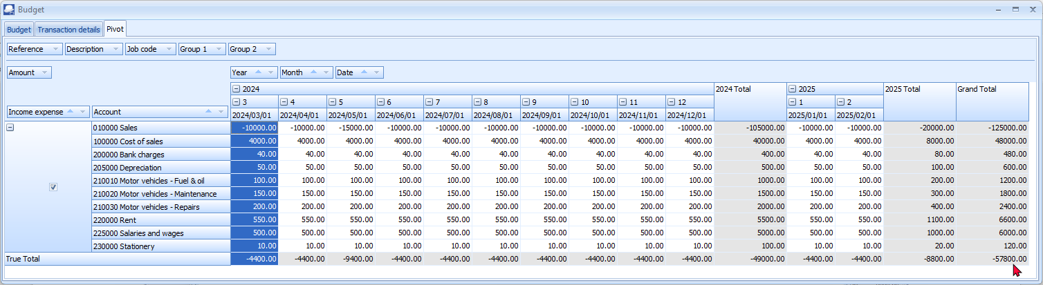

Default filter options
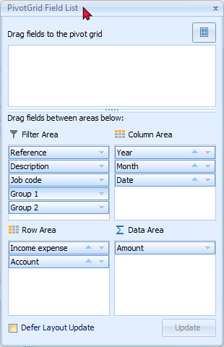
The default filter options, which may be selected as needed, is structured on the Pivot screen in four (4) areas, “Filter Area, Column Area, Row Area” and “Data Area”.
Filter Area:
- Reference - The default Reference "BUDG" or your reference as entered on the options section of the Budget tab. Select the available reference(s) on the list as filter options, as required.
- Description - The default Description "Auto budget" or your description as entered on the options section of the Budget tab. Select the available description(s) on the list as filter options, as required.
- Job code - (Projects) - If budgets were entered or processed for Projects, the project code(s) may be selected as filter options.
- Group 1 - If budgets were entered for Cost centres (Cost centre 1), the Cost centres for Cost centre 1 may be selected as filter options.
- Group 2 - If budgets were entered for Cost centres (Cost centre 2), the Cost centres for Cost centre 2 may be selected as filter options.

Data Area:
- Amount - The total debit amounts a credit amounts (prefixed by a - (minus sign)) will be listed. Select the available amount(s) on the list as filter options, as required.
Row Area:
- Income expense - The options is as follows:
  - True = Income and Expense (Income statement) accounts. The totals of the Income and Expense (Income statement) accounts will be displayed as True Total.
  - False = Capital, Assets and Liabilities (Balance sheet) accounts. The totals of the Capital, Assets and Liabilities (Balance sheet) accounts will be displayed as False Total. Since no Budget figures for these account types were entered in this example, the “False” grouping will not be available.
- Account - All accounts will be listed by Account code and description. Select the available account(s) on the list as filter options, as required.
Column Area:
- Year - The budget totals will be listed for each calendar year. For example, if your financial year starts on 1 January 2024 and ends on 31 December 2024, only one (1) financial year will be listed, i.e. 2024.
In this example the financial year starts on 1 March 2024 and ends on 28 February 2025, the totals will be listed for 2024 and 2025. Select the year on the list as filter options, as required.
- Month - Period 0 to 12 will be listed if your Reporting dates are set for a 12 periods (Setup → Reporting dates (Setup ribbon), the period numbers will be listed. Select the period (month) on the list as filter options, as required.
- Date - All the dates for the selected period or dates selected on the options section of the Budget tab, will be listed. Select the available date(s) on the list as filter options, as required.
You may right-click to launch a context menu, and select the available options applicable to the area of the screen, for example, Collapse, Expand, Sort options, etc.

Change sequence add / remove Pivot grid fields

Hide Pivot grid fields
Select a Pivot grid field, right-click, and select “Hide” on the context menu. The selected Pivot grid field will be removed from the grid. For example, if you do not use Projects, you may click on the “Job code” pivot grid field, and select “Hide” on the context menu to remove “Job code” from the Pivot Filter Area.
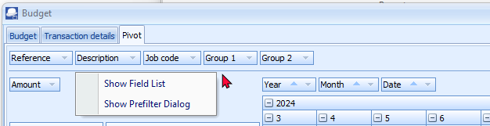
If you do not use Cost centres, you may hide “Group 1” for Cost centre 1 and select the “Hide” option on the context menu. To hide Cost centre 2, you may repeat the process for “Group 2” to hide Cost centre 2.
The removed Pivot grid fields will not be displayed on the “Filter area” of the Pivot grid, but will be added to a list in the “Drag fields to the pivot grid” on the “PivotGrid Field List” screen.

Add removed Pivot grid fields
If a Pivot grid field is removed accidentally, you may add the Pivot grid field again.
To do this, right-click on the “Filter Area” and select the “Show Field List option. This will launch the “PivotGrid Field List” screen. The hidden (removed) Pivot grid fields will be listed in the “Drag fields to the pivot grid” list. Select the field and drag it to the “Filter Area” list.
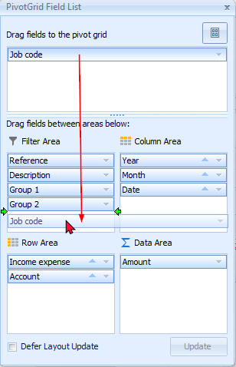
Order (sequence) of columns
To arrange the sequence of Pivot grid fields, you may select a Pivot grid field, right-click, and select the following options from the “Order” option of the context menu:
- Move to Beginning - Move to the first Pivot grid field.
- Move to End - Move to the last Pivot grid field.
- Move Left - Move the selected Pivot grid field before the previous Pivot grid field to the left.
- Move Right - Move the selected Pivot grid field after the next Pivot grid field to the right.
You may use your mouse to drag a selected Pivot grid field to the right or left to your required position.
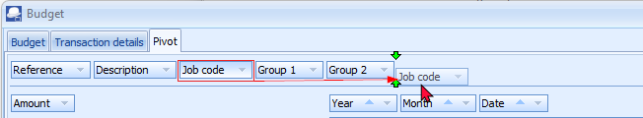

Filters
Right-click on the “Filter Area, Data Area” or “Column Area” to access the "Show Field List" or the "Show Prefilter Dialog" options.
PivotGrid Field List
The “PivotGrid Field List” screen consists of the following sections:
Drag fields to the pivot grid:
This lists the available Pivot grid fields not displayed on the default Pivot table view; or any hidden (removed) Pivot grid fields.
Areas on the Pivot table:
You select an available field on the list and add them to the four (4) areas (i.e. Data Area, Filter Area, Column Area or the Row Area) of the Pivot table.

Show Prefilter Dialog
The "Prefilter Dialog" allows you to create custom filters for the Pivot table.
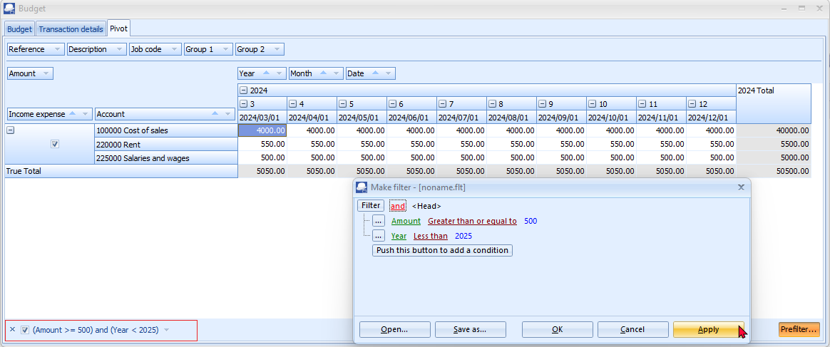
In this example, the filter “Reference” used is “BUDGET”. This excludes the Sales account for Month 5 (May 2024) since a different Reference was added.
By default all data applicable to a column “Pivot grid field” is included in the initial launch of the Pivot table based on your report options.
You may click on the filter list icon of a selected “Pivot grid field” to remove the tick to exclude that specific data on the list from the Pivot table. For example, the “Pivot grid field” for “Account” is as follows:
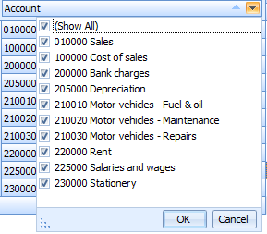

Save custom filter files
To save a custom filter file:
- Once you have sorted or filtered your data with the “Make filter” screen, click on the Save as... button. The “Save active filter as” screen will be displayed.
- Select a directory in which you wish to save the custom filter file.
- Enter a file name.
- Click on the Save button to save the Filter in a (*.flt) Filter File format. You may then at any later stage open the saved *.flt file.
Open custom filter files
To open a saved a custom filter file:
- Once you have sorted or filtered your data with the “Make filter” screen, click on the Open... button. The “Open saved filter as” screen will be displayed.
- Select a directory in which you have saved the custom filter file.
- Select a valid filter file.
- Click Open. The selected filter file's name will be displayed in the titlebar of the “Make filter” screen.

PRINTING BUDGET REPORTS
Once any budget figures are entered or edited (and saved) (Setup → Accounts (Setup ribbon)), these figures will automatically be updated to the applicable accounts and will be available in the Ledger analyser and any reports which supports budget figures.
Budgets may be viewed, printed and / or exported from the following options:
- T-Account analyser 1 / 2.
- Budget option for the Trial balance, Income statement, Balance sheet and Standard column balances.
- Budget vs actual.
- T-account viewer (Budget listing).
- Budget vs actual (3 periods) (Reports ribbon - Reports → Ledger → Budget).
Printing budget listing reports
This option, if selected, will list only the budget figures (Budget listing) in the Trial balance, Income statement, Balance sheet and Standard column balances report types.
To view and analyse budget listing:
- On the Reports ribbon, select Ledger analyser 1.
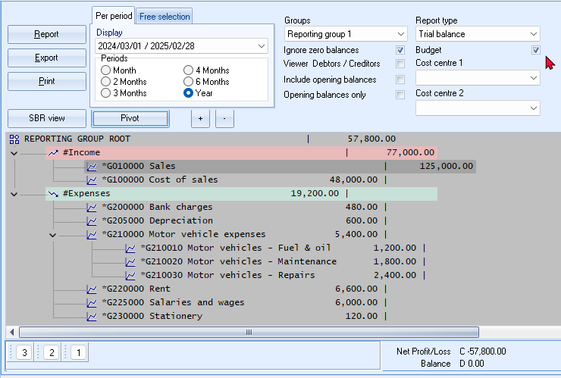
- Select the “Budget” option (tick). This option is available for the “Income statement, Trial balance, Balance sheet” and “Standard column balances” report type.
- Select the period from 2024/03/01 to 2025/02/28 to view the annual budget figures.
To view the budget figures for a specific month (e.g. March 2024); select the period from 2024/03/01 to 2024/03/31.
- You may select the Groups. “None” will list the accounts according to the Account code. You may select “Reporting group 1” or “Reporting group 2”. In this example, “Reporting group 1” is selected.
- Click on the Report button to refresh and generate the budget figures.
To view the budget figures for sub-accounts, e.g. click on the + icon next to G210-000 Motor vehicle expenses. This will display the figures for each sub-account.
- Click on the Print button.
An example of the “Income statement”, listing the budget for the financial year, is as follows:
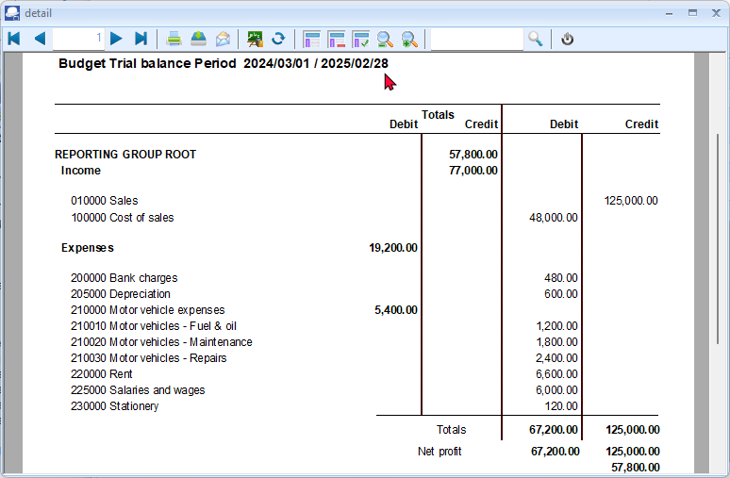
If any of these budget figures need some adjustment, go to Budgets on the Reports ribbon, select the applicable accounts and edit or enter the necessary figures.
You may also edit or enter the necessary figures on the Setup → Accounts (Setup ribbon).
Printing budget listing report from the T-Account viewer
To print a list of budgets in the T-Account viewer:
- If the Budget option is selected on the Trial balance, Income statement, Balance sheet and Standard column balances report types in the Ledger analyser 1 or 2, you may right-click and click on the Show details option. This will display the budget figures in the T-Account viewer.
- Select the dates (e.g. from “2024/03/01 to 2025/02/28”) to include in the budget figures, if necessary.
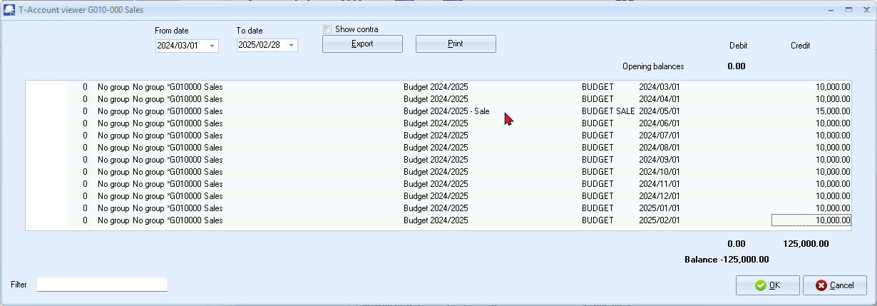
The Batch number for budgets will be indicated as “0” (zero).
- Click on the Print button. You may also click on the Export button to export the budget figures to a spreadsheet.
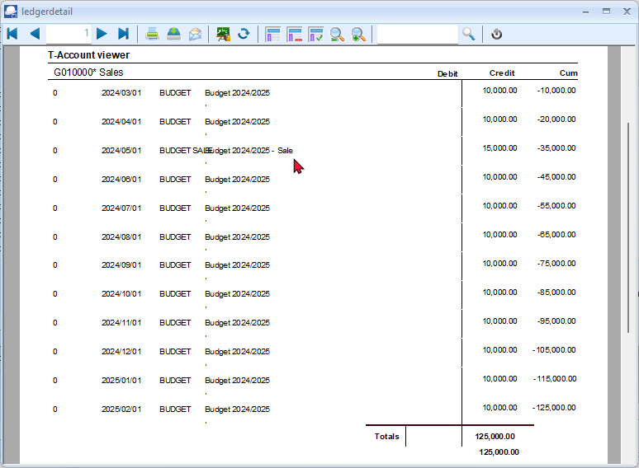

PRINTING BUDGET PERFORMANCE REPORTS
The following two (2) reports are available to print budget vs actual figures:
- Budget vs actual report (Ledger analyser 1 / 2).
- Budget vs actual (3 periods) report (Reports → Ledger → Budget (Reports ribbon).
Printing the Budget vs actual report
This report will display the following:
- Trial balance – The actual figures on the Trial balance - totals of transactions as posted (updated to the ledger) in batches (journals), sales documents (i.e. Invoices, Point-of-Sale Invoices and Credit notes) and purchase documents (i.e. Purchases and Supplier returns).
- Budget – Once any budget figures are entered or edited (and saved), these figures will automatically be updated to the applicable accounts and will be available in the Ledger analyser and any reports which supports budget figures.
- Difference – The difference amount actual trial Trial balance vs the Budget figures.
- Percentage – The difference expressed as a percentage.
To print a budget vs actual report:
- On the Reports ribbon, select Ledger analyser 1 or 2.
- Select the “Budget vs actual” report type. This option is available for the Income / Expenses, Trial balance and Balance sheet report type.
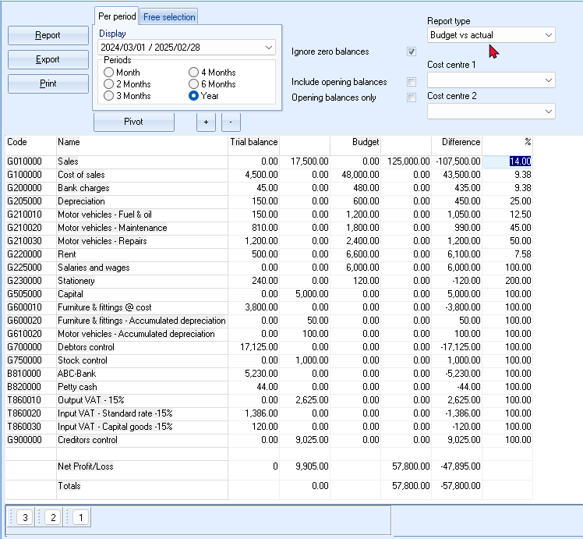
- To view the annual budget figures; select “Year” and the period from 2024/03/01 to 2025/02/28.
Select the period from 2024/03/01 to 2024/03/31 to view the budget figures for a specific period, e.g. “March 2024”.
- Click on the Report button to refresh and generate the budget figures.
- If any of these budget figures need some adjustment, click on the Setup → Accounts (Setup ribbon); select the applicable accounts and edit or enter the necessary figures.
- Click on the Print button. The “budgetvssimple.rep” parameters screen will be displayed.
- Click OK.
An example of the printed “Budget vs actual” report, is as follows:
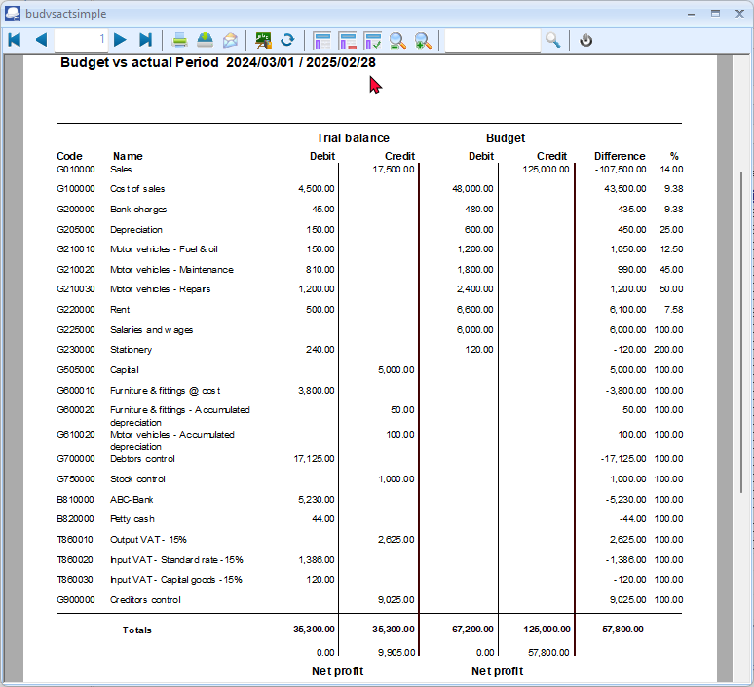

Printing the Budget vs actual (3 Periods) report
The Budget vs Actual (realisation - 3 periods) report lists the Income and Expense account balances and budget figures for three (3) periods as comparative figures.
Only the transactions in documents and batches which are posted (updated) to the ledger will be included in this report.
Budget figures are entered and edited in the Setup → Accounts (Setup ribbon).
If you have activated Cost centres and have entered the budget figures for Cost centres, you may select (tick) the Cost centres to print this report for your Cost centres.
To print a Budget vs actual (3 periods) report:
- On the Reports ribbon, select Reports → Ledger → Budget.
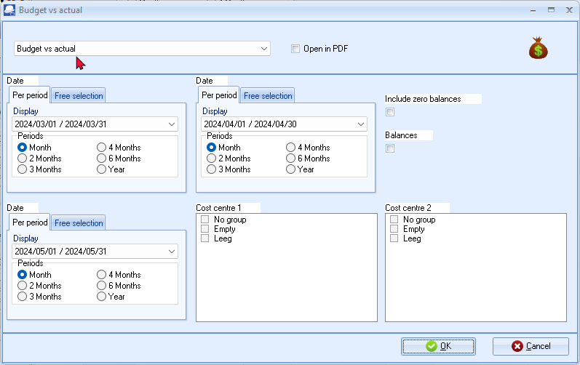
- Select the following options:
  - Period - Select up to three (3) periods on the Per period tabs. You may click on the Free selection tab to select a specific date or a range of dates to include balances and budget figures in the report.
  - Include zero balances - If this option is not selected (not ticked), it will list only the expense and income accounts which has balances and / or budget figures. Tick this option to include all accounts including those with no actual transactions and / or budget figures).
  - Balances - If this option is not selected (not ticked), it will list the expense and income accounts which has balances and / or budget figures. If you tick this option to show only the actual transactions totals and / or budget totals of expense and income accounts for the selected period or dates.
  - Cost centre 1 - Will be listed if you have activated Cost centres and created Cost centre 1 (Groups (Setup ribbon)). You may select any of these Cost centres, to include in the report.
  - Cost centre 2 - Will be listed if you have activated Cost centres and created Cost centre 2 (Groups (Setup ribbon)). You may select any of these Cost centres, to include in the report.
- Click on the OK button.
The “Budget vs actual (realisation - 3 periods)” report, should be displayed as follows:
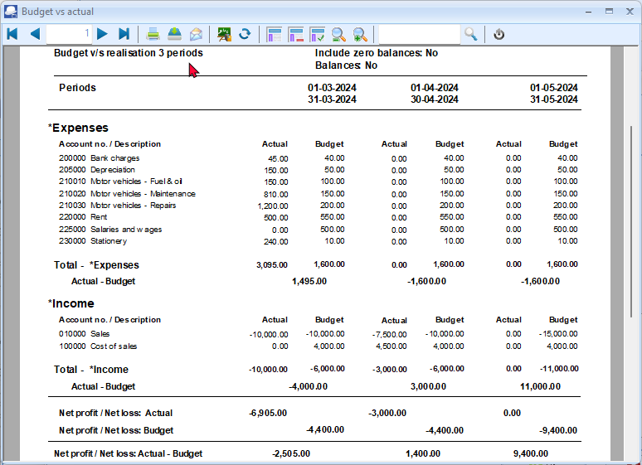
The details, is as follows:
- Header section - Report name and Periods as selected on the Periods in the “Report options / parameters” screen.
- Expenses - A list of the accounts (created as Income and Expense account type and linked to the Expenses group / financial category). If the “Include zero balances” field is selected (ticked), all expense accounts will be listed (including those accounts with no actual transactions and or budget figures. If the “Balances” field is selected (ticked), only the “Total - *Expenses” will be displayed.
- Income - A list of the accounts (created as Income and Expense account type and linked to the Income group / financial category). If the “Include zero balances” field is selected (ticked), all income accounts will be listed (including those accounts with no actual transactions and or budget figures). If the “Balances” field is selected (ticked), only the “Total - *Income” will be displayed.
- Totals -
  - Net Profit / Net Loss: Actual - This is the total of the Expenses less the Income totals for posted batches and documents. A negative figure indicates a Net Profit and a positive figure displays a Net Loss for the selected periods (dates).
  - Net Profit / Net Loss: Budget - This is the total of the Expenses less the Income totals for the budget figures as entered / edited (Setup → Accounts (Setup ribbon)). A negative figure indicates a Net Profit and a positive figure displays a Net Loss for the selected periods (dates).
  - Net Profit / Net Loss: Actual - Budget - This is the total of the Net Profit / Net Loss: Actual less the Net Profit / Net Loss: Budget totals. A negative figure indicates that the posted batches and documents exceeds (overspend) the budget figures for the selected periods (dates). A positive figure indicates that the posted batches and documents is less than the budget figures (available) for the selected periods (dates).

REPORTS

IN THIS MODULE
MODULE O - REPORTS 393
O.1- INTRODUCTION TO REPORTS 395
O.2- OPTIONS TO PRINT REPORTS 395
O.2.1- Send to - Screen 396
O.2.2- Send to - Printer 398
O.2.3- Send to - File 398
O.2.4- Send to - E-mail 399
O.2.5- Send to - Fax 399
O.3- REPORTS IN THE LEDGER ANALYSER 399
O.3.1- Trial balance 404
O.3.2- Income statement 407
O.3.3- Balance sheet 408
O.4- PIVOT TABLES – Ledger analyser 1 / 2 411
O.4.1- Generating Pivot tables 411
O.4.2- Default filter options 413
O.4.3- Change sequence add / remove Pivot grid fields 416
O.4.3.1- Hide Pivot grid fields 416
O.4.3.2- Order (sequence) of columns 416
O.4.4- Filters 416
O.4.4.1- PivotGrid Field List 417
O.4.4.2- Show Prefilter Dialog 418
O.4.4.2.1- Save custom filter files 419
O.4.4.2.2- Open custom filter files 419
O.4.5- Customise the graphs 419
O.4.5.1- Graph types 419
O.4.5.2- Series 420
O.4.5.3- Data groups 420
O.4.5.4- Options 420
O.5- LEDGER REPORTS 421
O.6- DEBTOR REPORTS 421
O.7- CREDITOR REPORTS 422
O.8- BATCH REPORTS 422
O.8.1- Batch reports (Reports menu) 423
O.8.1.1- Batch transactions per period report 423
O.8.1.2- Batch type report – Documents 425
O.8.2- Batch reports for posted batches 428
O.9- TAX REPORTS 429
O.9.1- Tax per period report 431
O.9.2- Tax report - Reference / Document no. 434
O.9.3- Tax list debtor with tax id / Tax list creditor with tax id 437
O.10- REPORTS TO MANAGE AND ANALYSE DOCUMENTS, STOCK, SALES AND PURCHASES 438
O.10.1- Stock item reports 438
O.10.2- Document listing reports 439
O.10.3- Sales reports 439
O.10.4- Sales analysis reports 440
O.10.5- Purchases reports 440
O.10.6- Purchase analysis reports 441
O.11- SPREADSHEET REPORTS 442
O.11.1- Spreadsheet report – Debtors 442
O.11.2- Spreadsheet report – Creditors 443
O.11.3- Spreadsheet report – Transactions - Per period 444
O.11.4- Spreadsheet report – General ledger 446
O.11.4.1- Spreadsheet report – General ledger – Budget 446
O.11.4.1.1- Budget – Column balances – Reporting group 1 446
O.11.4.1.2- Column balances – This year 447
O.11.4.2- Spreadsheet report – General ledger (Transaction totals) 449
O.11.4.2.1- Column balances – Reporting group 1 449
O.11.4.2.2- Column balances - This year 450
O.11.5- Spreadsheet report – Sales analysis 452
O.11.5.1- Spreadsheet report – Stock movement 452
O.11.5.2- Spreadsheet report – Sales per period 453

INTRODUCTION TO REPORTS
TurboCASH5 allows you to generate a wide range of standard reports, each with various options to select. These reports are an exceptionally powerful tool for use in managing and controlling all aspects of your business. Reports are grouped into the various types. All reports are generated on the Reports ribbon.
OPTIONS TO PRINT REPORTS
As the principles to generate reports are basically the same on all report option / parameter screens, it is a good idea to discuss the output media ("Send report to") in this MODULE. To print a report, click on the Reports ribbon and select the specific report you wish to print. You can generate these any of these reports on the following mediums:
Send report to | Brief description
Screen | Displays the report on your screen, from where you can page and scroll through the report. You may also print the report or save it after you have previewed it.
Printer | Prints the report directly to the printer specified in the Printer icon (Setup ribbon).
File | TurboCASH5 Report Export utility allows you to Save the report in a directory and in certain formats, you specify.
E-mail | Send the report over the Internet as an e-mail message.
Fax | Send the report as a Fax to a specified recipient.

Send to - Screen
If the “Send to screen” option is selected, the “Reportman preview” screen is displayed when printing reports and documents.
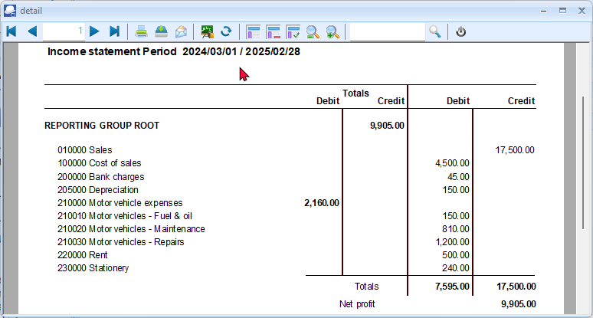
The icons are grouped into five (5) sections (i.e. Navigation, Output, Settings, Zoom and Search) and the Close button. These icons are as follows:
- Navigation -
    - First (Home) – Goes to the first page of the report.
    - Previous (Page up) – Goes to the previous page of the report.
    - Page number – Displays the page number of the page in the “Report preview” screen. You may enter a specific page number and hit the Enter key on your keyboard to jump to that specific page.
    - Next page (Page down) – Goes to the next page of the report.
    - Last page (End) – Goes to the last page of the report.
- Output -
    - Print (Ctrl+P) – This will launch the “Print” screen. You may select another printer (than your system's default printer), select a specific page and change the number of copies, if necessary.
    - Save (Ctrl+S) – This will launch the “Save Metafile as” screen. On this screen, you need to do the following where necessary:

        - Select the directory (folder) where you need to save this file, if necessary.
        - Enter a file name.
        - Select a file type if another file type than the default file type (PDF file – Compressed) is required. The following Report meta file types are available:
 | - | *.rpmf | Report Metafile
 |  | *.pdf | PDF file – Compressed
 | - | *.pdf | PDF file – Uncompressed (default)
 | - | *.xls | Excel file
 | - | *.xls | Excel file (one sheet)
 | - | *.txt | Text file
 | - | *.bmp | Bitmap file
 | - | *.html | Html file
 | - | *.html | Html file (single)
 | - | *.svg | Scalable Vector Graphics file
 | - | *.csv | Comma Separated Value file
 | - | *.txt | Custom Text file
 | - | *.rpmf | Executable Meta file uncompressed
 | - | *.exe | Executable meta file
Microsoft Excel (Office), LibreOffice, OpenOffice or Ultra Office required to save reports (Save report as a meta file report from the “Reportman Print preview” screen) to an Excel spreadsheet or Excel (one sheet) spreadsheet (*.xls).
    - E-mail (Ctrl+E) – This will generate a Portable Document Format (pdf) file. It will also launch a blank E-mail message (using your system's default e-mail program) and insert the report (or document) as an attachment.
The name of the report (or document) is automatically generated (for example, REPC526.pdf). It will also automatically be inserted in the “Subject” field and displayed in the titlebar of the e-mail message.
It is recommended that you add your own sensible subject to this in the “Subject” field. You still need to select a recipient (and other recipients, if necessary) and type a message before clicking on the Send button.
- Settings -
    - Show report page setup (F11) – This will display a “Dialog” screen on which you may do the “Page setup, Print setup” and “Options” (i.e. select the “Preferred save format”).
    - Show report parameters (F12)- This is the selection or options screen, on which you may select the options to include or exclude data in the report.
Should the report have no report parameters (when it prints directly when you click on the Print button of the “Reportman” screen), the report has no options to change. This icon will then be inactive.
If the report has an active Report parameters icon, you may click on it to change the report parameters. This will change the content of the report.
- Zoom -
    - Shows the report in real size (F6) – This will display the report in the actual size when it is printed.
    - Adjusting the paper to fit the window width (F7) – The report will be stretched to fit the entire Preview window. If you resize the report (e.g. click on the Maximize button or on the Restore down button of the “Reportman preview” screen's titlebar), it will automatically be resized.
    - Scale to full page (F8) – This will display the full page (length and with) in the window.
    - Zooms out the view (- numeric keypad) – Each click will reduce the size.
    - Zooms in the view (+numeric keypad) – Each click will increase the size.
- Search (Ctrl+F3) -
Enter text, numbers, amounts, special characters, etc. to find the matching results in the report.
To close the “Reportman preview” screen, click on the Close button. Alternatively, click on the Close button of the “Reportman preview” screen's titlebar.
Send to - Printer
If you have selected the "Send report to" Printer option and you click on the OK button, the report will be printed automatically by the printer you have selected in the Printer icon (Setup ribbon), without having a chance to preview the report. For all the other report output options, you cannot select the number of copies, since they will only be generated in 1 copy.
Send to - File
If you have selected the "Send report to" File option and you click on the OK button, the very same “TurboCASH5 Report Export” screen as discussed above will be displayed. You will not be able to preview the report before you can save it.

Send to - E-mail
If you have selected the "Send report to" E-mail option and you click on the OK button, the “Sending E-mail and Fax report “screen will be displayed. Your e-mail should already be set up in the Setup → Internet (Setup ribbon). Enter the subject and select the e-mail address from your address book and click on the Send button.
Send to - Fax
If you have selected the "Send report to" Fax option and you click on the OK button, the “Sending E-mail and Fax report” screen will be displayed. Your Fax drivers should already be set up in your Windows operating system.
In addition to these reports, which you can use, you also have the further option as to export these reports or data in these reports via the Export utility to further analyse your data in spreadsheets, word processing, presentation programs, etc. You can use the reports and exported data to draft powerful presentations, business plans, etc.
REPORTS IN THE LEDGER ANALYSER
All processed (posted) transactions will be accumulated in the Ledger analyser. There are various ways in which the transactions may be viewed, exported and analysed.
The options, is as follows:
- Transactions and balances – These are the balances of transactions as posted (updated to the ledger) in batches (journals), sales documents (i.e. Invoices, Point-of-Sale Invoices and Credit notes) and purchase documents (i.e. Purchases and Supplier returns).
There are six (6) report types, which may be selected (i.e. Trial balance, Income statement, Balance sheet, Standard column balances, Budget vs actual and This year vs last year) which may be printed and exported to spreadsheets.
In addition to this, there are 6 report types which may be exported to spreadsheets (i.e. Column balances, Column balances Debit/Credit, Column balances debtor, Column balances creditor, Column balances debtor Debit/Credit, and Column balances creditor Debit/Credit.)
- Budget – Budget figures as entered in the Setup → Accounts (Setup ribbon). This option, if selected, will list only the budget figures (Budget listing) in the Trial balance, Income statement, Balance sheet and Standard column balances report types. The Budget vs Actual is the budget performance report. It will list and compare the budget figures versus the actual posted (updated) transactions.
- T-Account viewer – You may select a specific account, group, etc. to view the transactions in the T-Account viewer. To do this, right-click on a selected account, and select the “Show details” option on the context menu.
The T-Account viewer may also be selected on the T-Account viewer (Reports ribbon). When launching it from the Reports ribbon, you may select the following:
- Account – Select a specific account.
- From date and To date – Select a specific date or a range of dates to view data.
You may click on the following to get specific views of transactions:
- Batch id (e.g. 3,4,8, etc. automatically generated). This will list only the transactions for a specific batch (journal).
- Account code (e.g. G010000 Sales, B810000 ABC - Bank, T860010 Input VAT/GST/Sales tax, etc.). This will list the transactions for a specific account.
- Date – This will list the transactions for a specific date. If you double-click on a date, the “From date” and “To date” will be changed to the selected date.
To print reports in the Ledger analyser:
- On the Reports ribbon, select Ledger analyser 1 / 2.
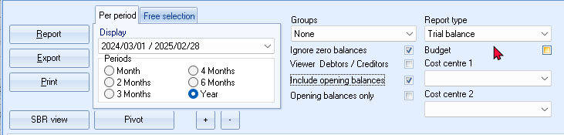
Ledger analyser 1 and Ledger analyser 2 Features implemented in TurboCASH5:
- SBR view - Add SBR references for accounts and reporting groups in Setup → Accounts. Once the references are set, and generate reports on screen, click on the SBR view button, check, filter and copy to clipboard. Open your spreadsheet program, and copy the contents into your spreadsheet, save the data, etc.
- Pivot – View, filter and analyse your report on screen, view graphs, customise datasets and types of graphs.
- Zoom in / Zoom out + / - buttons added to resize (increase / decrease the font) the reports (i.e. Trial balance, Balance sheet and Income statement) on screen.

- Select the following options:
Option | Description
Report type: | - Trial balance – List of all accounts in the chart of accounts. This will include:  - - Income / Expense;  - - Asset / Liability / Capital accounts;  - - Retained earnings / income;  - - Debtor's control; and  - - Creditor's control accounts.  - Income / Expenses – List only those accounts which is reported on the Income statement.  - Balance sheet – List only those Accounts, which is reported in the Balance sheet. This will include:  - - Asset / Liability / Capital accounts;  - - Retained earnings / income;  - - Debtor's control; and  - - Creditor's control accounts).  - Standard column balances – Lists the debit and credit account balances in the Trial balance and the Income statement and Balance sheet accounts in separate columns.  - Budget vs actual – Lists the budget figures entered in the Setup → Accounts (Setup ribbon) versus the actual totals of all transactions in posted batches and documents.  - This year vs last year – This will list the actual totals of all transactions in posted batches and documents in this year periods versus the actual totals of all transactions in posted batches and documents posted to last year periods (previous financial years).  - Column balances – Lists all accounts in a spreadsheet view. These are the Accounts reported in the Trial balance (this includes both the accounts reported in the Trial balance, Income statement and Balance sheet).  - Column balances debtors – Lists the balances of all accounts which is created and maintained in the Debtors (Default ribbon) in a spreadsheet view. The total of these accounts are reported in the Debtor's control account on the Trial balance and the Balance sheet.  - Column balances creditors – Lists all accounts which is created and maintained in the Creditors (Default ribbon) in a spreadsheet view. The total of these accounts are reported in the Creditor's control account on the Trial balance and the Balance sheet.  - Column balances D/C – Lists all debit and credit account balances in a spreadsheet view. These are the Accounts reported in the Trial balance (this includes both the accounts reported in the Trial balance, Income statement and Balance sheet).  - Column balances debtors D/C – Lists the debit and credit account balances of all accounts which is created and maintained in the Debtors (Default ribbon) in a spreadsheet view. The total of these accounts are reported in the Debtor's control account on the Trial balance and the Balance sheet.  - Column balances creditors D/C – Lists all debit and credit account balances which is created and maintained in the Creditors (Default ribbon) in a spreadsheet view. The total of these accounts are reported in the Creditor's control account on the Trial balance and the Balance sheet.
Budget: | This will list all accounts for which budget figures were entered (and / or edited) in the Setup → Accounts (Setup ribbon) or Budgets (Reports ribbon).  This option is only available for the “Income statement, Trial balance, Balance sheet” and “Standard column balances” report type.
Cost centre 1 / 2: | The Cost centres (2 Groups) will only be available, if Cost centres are added in Setup → Groups (Setup ribbon); and if activated.
Groups: | Select one of the following options:  - None – This is the default. This will list all accounts for the selected Report type according to the Account numbers (codes) in numerical order.  - Reporting group 1 – Lists all accounts according to the Account reporting group 1 as created in Groups (Setup ribbon).  - Reporting group 2 – Lists all accounts according to the Account reporting group 2 as created in Groups (Setup ribbon).  Reporting group 1 and 2 – The sequence in which the groups and accounts are listed, may be changed in Groups. (Setup ribbon).  This is done by selecting the groups on the list and use the Move up or Move down buttons.
Period: | Select “Per period” or “Free selection”  - Per period – Select a period (Month, 2 Months, 3 Months, 4 Months, 6 Months or Year.  - Free selection – You may select or enter any date or dates.
From:  To: | The periods will automatically filter and display the periods matching the selected option in the “Per period” radio selection options.  On the “Free selection” tab, you may select any date or dates in the “From date” and “To date” fields.
Ignore zero balances: | If this field is not selected, all accounts will be listed for the selected reports type. If you select (tick) this field; only those accounts with balances will be included in the report.
Include opening balances: | If this option is selected (ticked), it will include the opening balances of those accounts which have opening balances. If this option is not selected; the opening balances will not be included in the report.
Opening balances only: | If the “Include opening balances” option is not selected; this option will not be displayed. If this option is available; you may select (tick) this option to include only the opening balances. All other balances will then be ignored.
Report button: | This will generate the report as per your selection of the report parameters.
Export button: | This will export the report to a comma separated value (*.csv) file format. The exported data will automatically be opened in your system's default spreadsheet (if configured) e.g. Excel.
Print button: | Click to print the report.
- Select a group or account and right-click on it. On the context menu, select the “Show details” option. This will launch the T-Account viewer.
The T-Account viewer may also be selected on the T-Account viewer (Reports ribbon).
How to print the trial balance, income statement and balance sheet are discussed in detail. It is a good idea to look through each report, making sure that you understand it.

Trial balance
The Trial balance will reflect all your accounts (Setup → Accounts (Setup ribbon)), which were created as Balance and Income / Expenses type for the Ledger, Bank and Tax account types.
To print a trial balance:
- On the Reports ribbon, select Ledger analyser 1 or Ledger analyser 2.
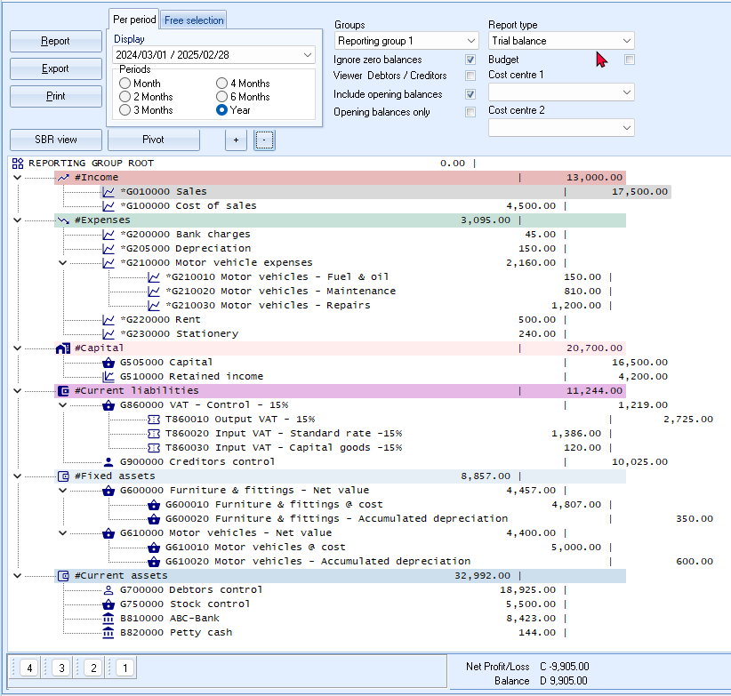
- Select the following options:
Report type: | - Select “Trial balance”.
Per period: | - Click on the “Year” option and select “2024/03/01 – 2025/02/28”.  You may also click on the Free selection tab and enter, or select the dates in the “From date” and “To date” fields.
Groups: | - Select Reporting group 1.
Ignore zero balances: | - Select (“tick”) this option, to list only the accounts with balances.  If this option is not selected (“not ticked”), all accounts listed in your chart of accounts will be displayed and balances will be listed.
Viewer Debtors / Creditors | - Select (“tick”) this field to list the totals of the individual Debtor and Creditor accounts.  If this option is not selected (not “ticked”), the Trial balance will list only the totals of the Debtor's and Creditor's control accounts.
Include opening balances: | - Select (“tick”) this option, to list the opening balances, as well as the balances of the accounts, entered for the selected period.  If this option is not selected (not “ticked”), the opening balances entered in MODULE H will be excluded in the report.
Opening balances only: | - Do not select (“tick”) this option, to list only the balances of the accounts we have entered for the selected period.  If this option is selected (“ticked”), only the opening balances entered in MODULE H will be included in the report.
- Click on the Report button.
- Click on the Print button. An example of the printed “Trial balance”, is as follows:
Page 1 -
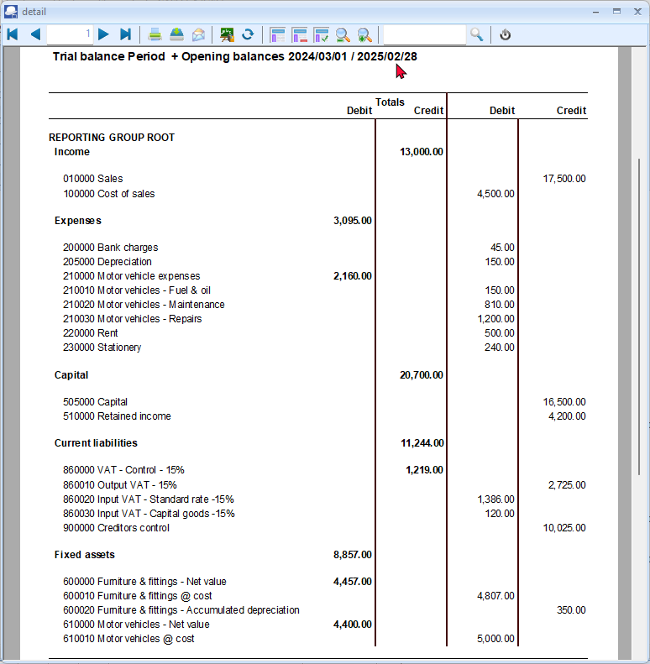

Page 2 -
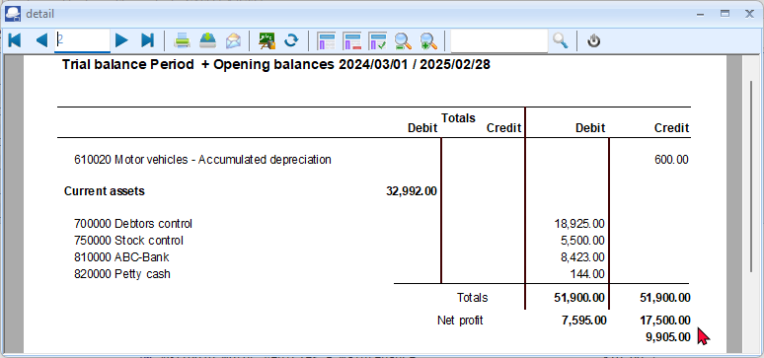
The net profit should be as follows if the following MODULES are completed and posted:
MODULE A–J and MODULE L -“Month - 2024/03/01 – 2024/03/31” 6,905.00
MODULE A–K and MODULE L -“Year - 2024/03/01 – 2025/02/28” 9,905.00
The Cost of sales were introduced in this tutorial in MODULE K – April 2024. It will therefore not be included in March 2024. It should be included if the report is printed to include April 2024.
In this tutorial, a Net profit should be printed.
Should you make a Net loss, the Net profit label will change to Net loss and will be displayed in a Red font colour on the screen, as well as the printed report in the “Reportman preview” screen.

Income statement
The Income and Expenses report will reflect all your accounts (Setup → Accounts (Setup ribbon)), which were created as Income / Expenses type for the Ledger account type.
To print an income statement:
- On the Reports ribbon, select Ledger analyser 1 or Ledger analyser 2.
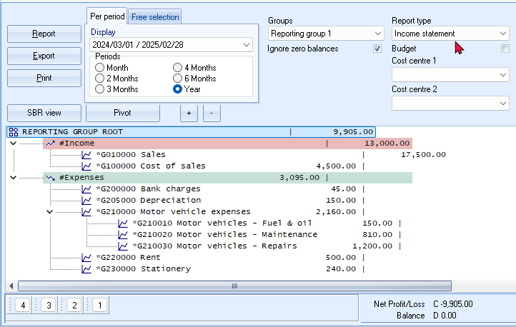
- Select the following options:
Report type: | - Select “Income statement”.
Per period: | - Click on the “Year” option and select “2024/03/01 – 2025/02/28”.  You may also click on the Free selection tab and enter, or select the dates in the “From date” and “To date” fields.
Groups: | - Select Reporting group 1.
Ignore zero balances: | - Select (“tick”) this option, to list only the accounts with balances.  If this option is not selected (“not ticked”), all Income and Expense accounts listed in your chart of accounts will be displayed and balances will be listed.
- Click on the Report button.
- Click on the Print button.

An example of the printed “Income statement”, is as follows:
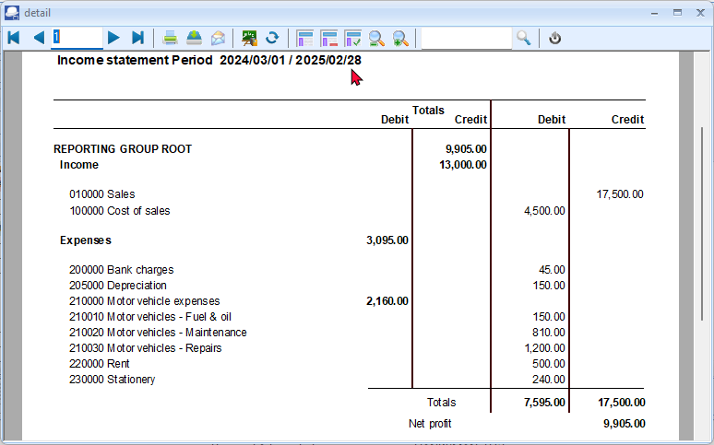
The net profit should be as follows if the following MODULES are completed and posted:
MODULE A–J and MODULE L -“Month - 2024/03/01 – 2024/03/31” 6,905.00
MODULE A–K and MODULE L -“Year - 2024/03/01 – 2025/02/28” 9,905.00

Balance sheet
The Balance sheet will reflect all your accounts (Setup → Accounts (Setup ribbon)), which were created as Balance type for the Ledger, Bank and Tax account types.
To print a balance sheet:
- On the Reports ribbon, select Ledger analyser 1 or Ledger analyser 2.
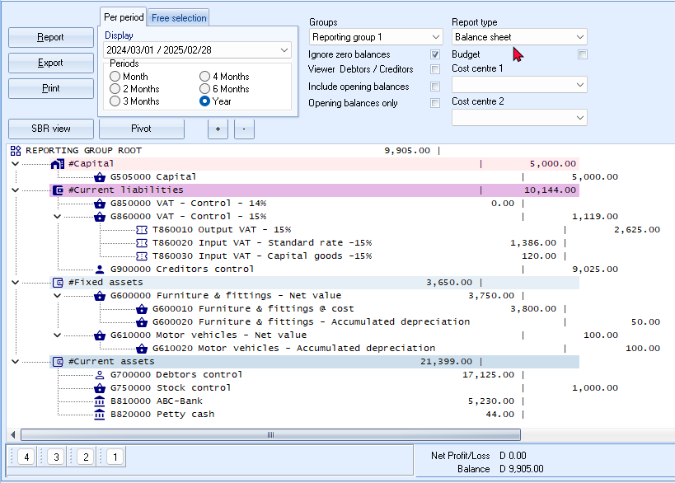
- Select the following options:
Report type: | - Select “Balance sheet”.
Per period: | - Click on the “Year” option and select “2024/03/01 – 2025/02/28”.  You may also click on the Free selection tab and enter, or select the dates in the “From date” and “To date” fields.
Groups: | - Select Reporting group 1.
Ignore zero balances: | - Select (“tick”) this option, to list only the accounts with balances.  If this option is not selected (“not ticked”), all Balance sheet accounts listed in your chart of accounts will be displayed and balances will be listed.
Viewer Debtors / Creditors | If this option is not selected (not “ticked”), the Balance sheet will list only the totals of the Debtor's and Creditor's control accounts.  - Select (“tick”) this field to list the totals of the individual Debtor and Creditor accounts.
Include opening balances: | - Select (“tick”) this option, to list the opening balances, as well as the balances of the accounts, entered for the selected period.  - If this option is not selected (not “ticked”), the opening balances entered in MODULE H will be excluded in the report.
Opening balances only: | - Do not select (“tick”) this option, to list only the balances of the accounts we have entered for the selected period.  If this option is selected (“ticked”), only the opening balances entered in MODULE H will be included in the report.
- Click on the Report button.
- Click on the Print button. An example of the printed “Balance sheet”, is as follows:
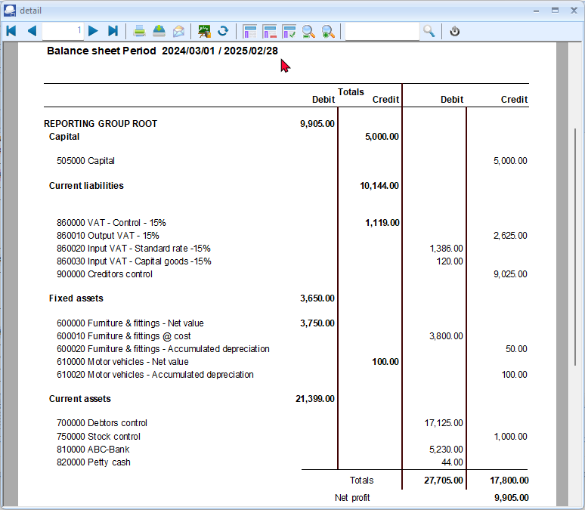
The net profit should be as follows if the following MODULES are completed and posted:
MODULE A–J and MODULE L -“Month - 2024/03/01 – 2024/03/31” 6,905.00
MODULE A–K and MODULE L -“Year - 2024/03/01 – 2025/02/28” 9,905.00
The Cost of sales were introduced in this tutorial in MODULE K – April 2024. It will therefore not be included in March 2024. It should be included if the report is printed to include April 2024.
In this tutorial, Net profit should be printed.
Should you make a Net loss, the Net profit label will change to Net loss and will be displayed in a Red font colour on the screen, as well as the printed report in the “Reportman preview” screen.

PIVOT TABLES – Ledger analyser 1 / 2
View and analyse your reports in the Ledger analyser 1 / Ledger analyser 2 and Budgets (accessed from the Reports ribbon) on screen, view graphs, filter, drill down, customise datasets and types of graphs.
The pivot table will summarise the totals of your transactions and / or budgets, for the selected periods or dates.
Generating Pivot tables
To view the Trial balance figures in the Pivot table in the Ledger analyser:
- On the T -Ledger analyser 1 or Ledger analyser 2, select the Income statement, Trial balance or Balance sheet report type. In this example, the “Trial balance” is selected.
- Select the Period or dates on the Free selection tab. In this example, the “2 Months” from “1 March 2024” to “30 April 2024” is selected.
- Click on the Report button.
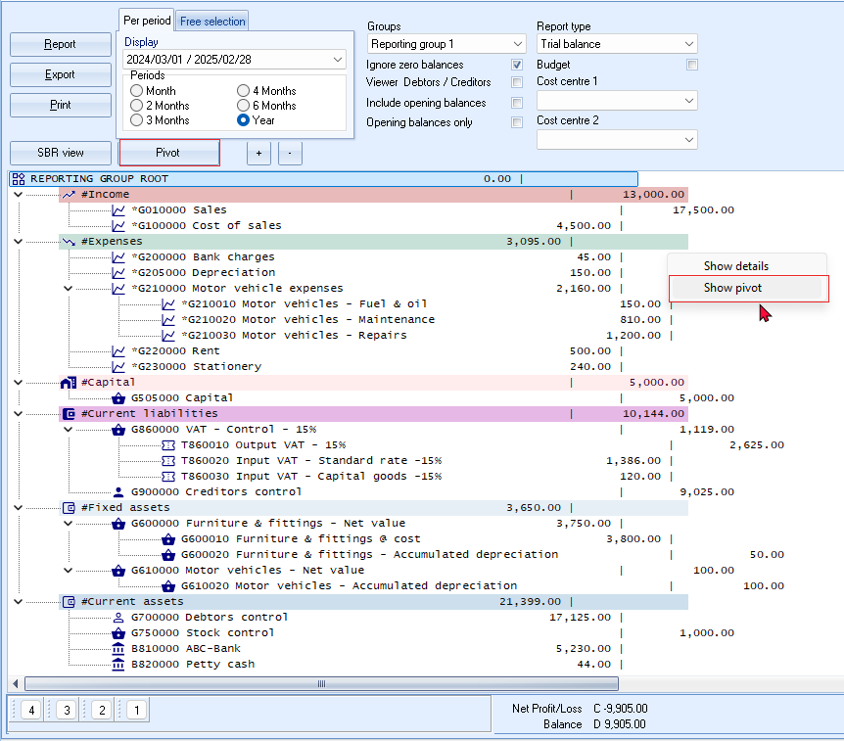
- Click on the Pivot button. The “Trial balance” figures for the selected period is displayed:
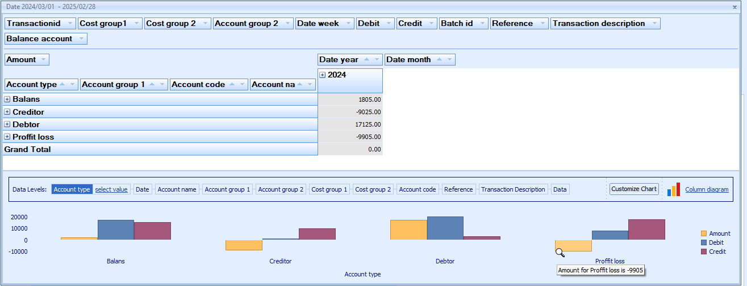
You may click on any graph to display the graph for the next available data level fields.
The cursor will be displayed as a magnifying glass and move to the next dataset. In this example, "Account type" is selected.
Move over graph area will display the values, e.g. "Profit / Loss - Credit is 17500" and “Amount for profit loss is -9905”.
- Click on the icon to Profit loss to list the totals for the Income and Expense account types (e.g. Income and Expenses financial categories) for the selected period or dates. The icon will change to list totals for each financial category (i.e. Income and Expenses).
You may right-click to launch the context menu, and select the following options: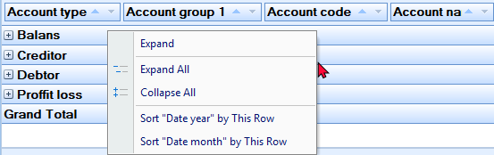
- Once the available columns are expanded, the Pivot table for the “Trial balance”, according to the selected options, should be displayed as follows:
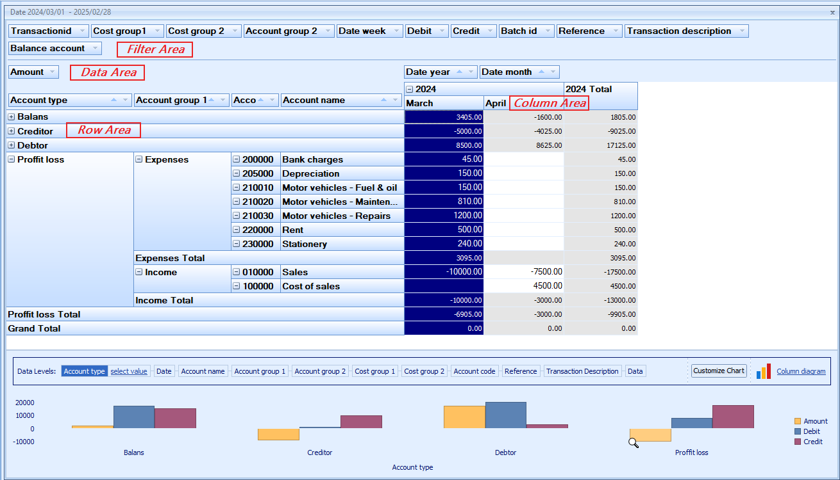
Default filter options
The default filter options, which may be selected as needed, is structured on the Pivot screen in four (4) areas, "Filter Area, Column Area, Row Area" and "Data Area". The filter options is as follows:
Filter Area:
- Transaction id – The transaction id is automatically generated for posted transactions in batches and documents.
- Cost group 1 – If Cost centres 1 is selected in batch transactions and selected on documents, the Cost centres for Cost centre 1 will be listed.
- Cost group 2 – If Cost centres 2 is selected in batch transactions and selected on documents, the Cost centres for Cost centre 2 will be listed.
- Account group 2 – The groups set for Account group 2 in Setup → Groups (Setup ribbon) and linked to Accounting group 2 in Setup → Accounts (Setup ribbon).

- Date week – The number of the week (from 1 to 53) for a calendar year.
In this example, March 2024 and April 2024 will be listed as week 9 to 14. Week 1 to 8 is for January 2024 and February 2024, which is not included in this Financial year
(1 March 2024 to 28 February 2025) as no transactions were posted in this period.
- Debit – The debit amounts.
- Credit - The credit amounts.
- Batch id – The batch id is auto generated for posted transactions in batches and documents.
- Reference – The “Reference” is as follows:
  - Documents – Document number as generated when creating documents.
In this tutorial and most database templates, the document numbers are prefixed with alpha characters, i.e. IN000001 = Invoices, CR000001 = Credit notes, PU000001 = Purchases and SR000001 = Supplier returns.
  - Batches – The reference as entered the “Reference” column of Batch entry screens.
The reference of Balancing entries in batches is indicated with eight (8) asterisks “********”.
- Transaction description -
  - Documents – The document type (i.e. Invoice, Credit note, Purchase and Supplier returns) and the reference as entered in the “Your reference” field on “Document entry” screens, will be listed.
COST OF SALES/Your reference – These are the Cost of Sales transactions generated for Invoices and Credit notes on which the stock items, default stock item type and other stock item types supporting cost of sales, were processed.
  - Batches – The description of the transaction entered in the “Description” column of Batch entry screens.
- Balance account – The values, are as follows:
  - 0 = Income and Expense (Income statement) accounts.
  - 1 = Ledger accounts set as Balance sheet account type. These Capital, Assets and Liabilities accounts are reported on the Balance sheet.
Data Area:
- Amount - The total debit amounts will be listed. Credit amounts (prefixed by a - (minus sign)) will be listed.

Row Area:
- Account type – Lists all account types for the “Trial balance”, and is as follows:
  - Balans – Lists all accounts linked to the “Balance sheet” in the “Account type” field of Setup → Accounts (Setup ribbon). The “Balance sheet” accounts which is linked to the “Capital”, “Assets” and “Liabilities” financial categories will be listed.
  - Creditor – Lists the creditor (supplier) accounts.
  - Debtor – Lists the debtor (customer / client) accounts.
  - Proffit / Loss – Lists all accounts linked to the “Income statement” in the “Account type” field of Setup → Accounts (Setup ribbon). The options is as follows:
    - Income – The “Income statement” accounts which are linked to the “Income” financial category will be listed.
    - Expenses – The “Income statement” accounts which are linked to the “Expenses” financial category will be listed.
  - Account group1 – List the Groups 1 linked to accounts added in Setup → Groups (Setup ribbon) as follows:
    - Balans - Balance sheet accounts linked to Account group 1.
    - Creditor – Creditor accounts linked to Creditor group 1.
    - Debtor – Debtor accounts linked to Debtor group 1.
    - Proffit / Loss – Income and Expense accounts linked to Account group 1.
  - Account code – All accounts will be listed by Account code.
  - Account name – The description (name of the account).
Column Area:
- Date year – The transaction totals will be displayed only for the year which was selected on the “Per period” tab of the Ledger analyser options. In this example only 2024 will be listed, since March 2024 and April 2024 were selected.
If a full financial year, for example, 1 March 2024 to 28 February 2025 is selected and transactions were processed for January 2024 and February 2024, the 2024 and 2025 years will be available.
The transaction totals will be listed for each calendar year. For example, if your financial year starts on 1 January 2024 and ends on 31 December 2024, only one (1) financial year will be listed, e.g. 2024.
In this example, the financial year starts on 1 March 2024 and ends on 28 February 2025, the totals will only be listed for 2024. Since no transactions is posted for January 2024 and February 2024, the 2024 year will not be available at this stage.
- Date month – The transaction totals will be displayed only for the months which was selected on the “Per period” tab of the Ledger analyser options. In this example, only March and April will be listed, since March 2024 and April 2024 were selected.
Change sequence add / remove Pivot grid fields
Hide Pivot grid fields
Select a Pivot grid field, right-click, and select “Hide” on the context menu. The selected Pivot grid field will be removed from the grid and added to the “PivotGrid Field List”. For example, if you do not use Cost centres, you may hide “Cost group 1” and “Cost group 2”.
Order (sequence) of columns
You may select a Pivot grid field, right-click, and select the following options from the “Order” option on the context menu:
- Move to Beginning - Move to the first Pivot grid field.
- Move to End - Move to the last Pivot grid field.
- Move Left - Move the selected Pivot grid field before the previous Pivot grid field to the left.
- Move Right - Move the selected Pivot grid field after the next Pivot grid field to the right.
You may use your mouse to drag a selected Pivot grid field to the right or left to your required position.
Filters
Right-click to access the "Show Field List" or the "Show Prefilter Dialog" options.
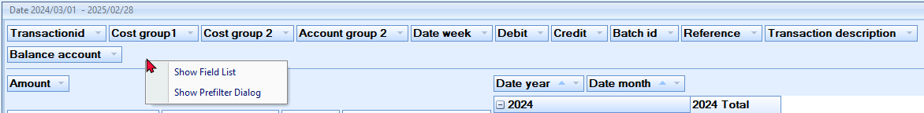

PivotGrid Field List
The “PivotGrid Field List” lists the available Pivot grid fields not displayed on the default Pivot table view. You select an available field on the list and add them to the four (4) areas (i.e. “Data Area”, “Filter Area”, “Column Area” or the “Row Area”) of the Pivot table.
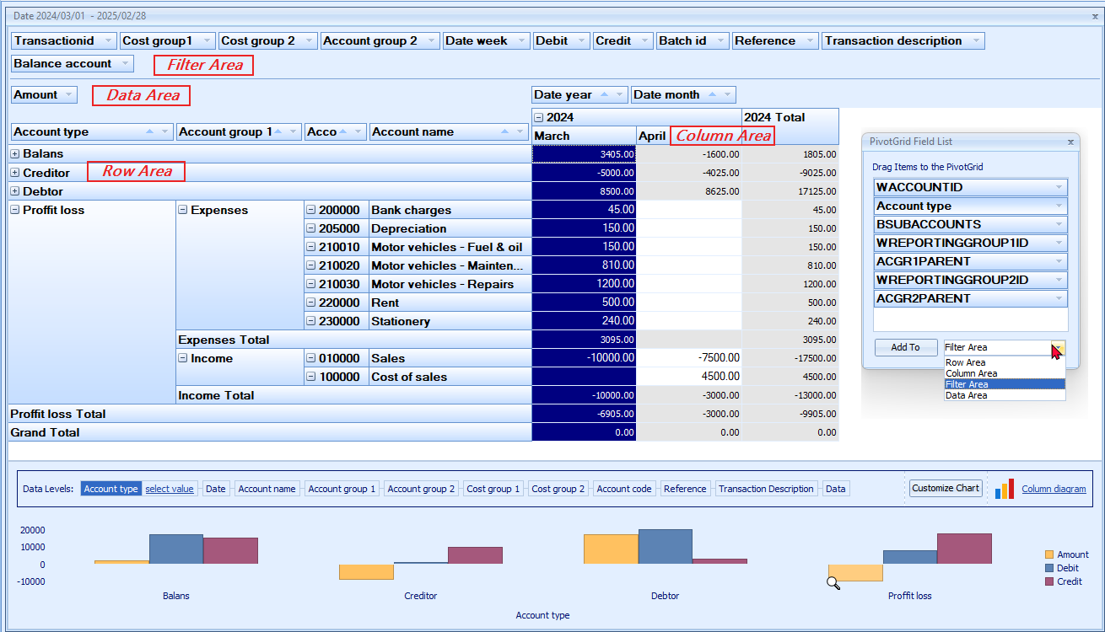

Show Prefilter Dialog
The "Prefilter Dialog" allows you to create custom filters for the Pivot table.
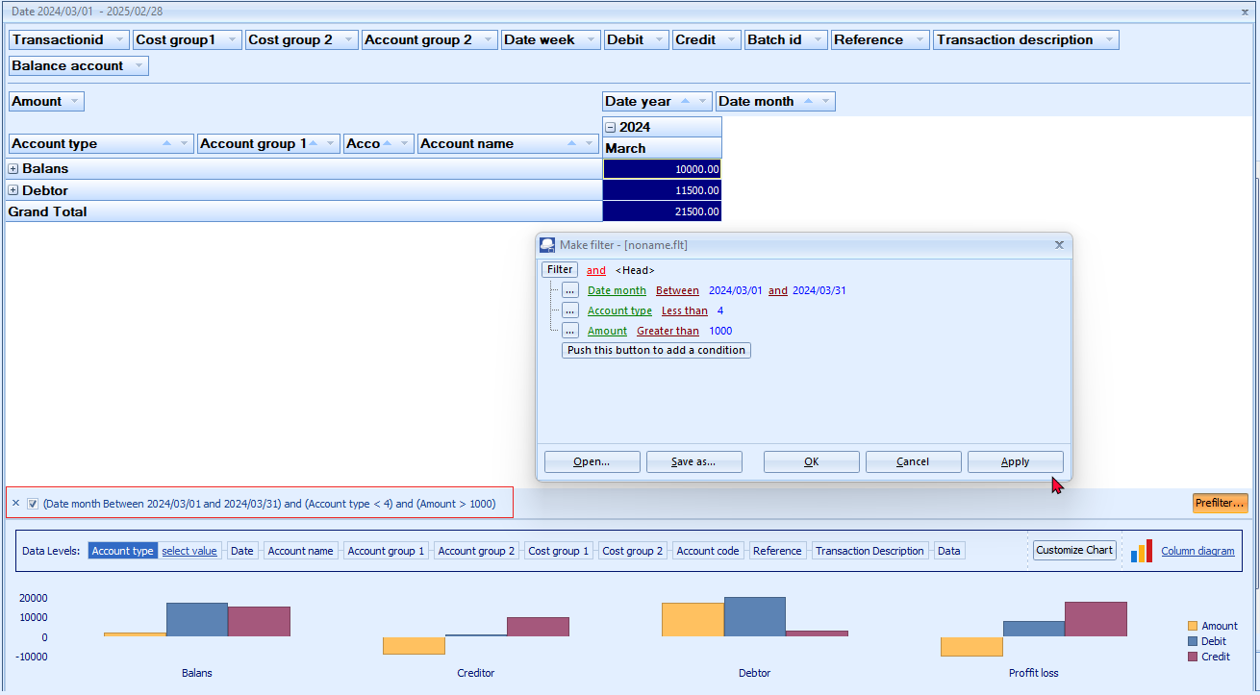
By default all data applicable to a column “Pivot grid field” is included in the initial launch of the Pivot table based on your report options.
You may click on the filter icon of a selected “Pivot grid field” to remove the tick to exclude that specific data on the list from the Pivot table.

Save custom filter files
To save a custom filter file:
- Once you have sorted or filtered your data with the “Make filter” screen, click on the Save as... button. The “Save active filter as” screen will be displayed.
- Select a directory in which you wish to save the custom filter file.
- Enter a file name.
- Click on the Save button to save the Filter in a (*.flt) Filter File format. You may then at any later stage open the saved *.flt file.
Open custom filter files
To open a saved a custom filter file:
- Once you have sorted or filtered your data with the “Make filter” screen, click on the Open... button. The “Open saved filter as” screen will be displayed.
- Select a directory in which you have saved the custom filter file.
- Select a valid filter file.
- Click Open. The selected filter file's name will be displayed in the titlebar of the “Make filter” screen.
Customise the graphs
Graph types
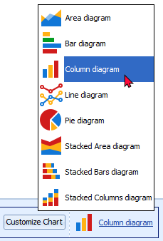
The default chart diagram is the “Column diagram”. You may select the one of the following diagrams to view the graph.

Series
By default, the “Amount” and “Debit” and “Credit” is displayed.
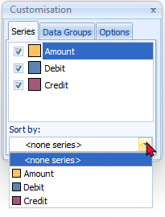
You may remove the tick of the series or add a tick to a series. For example, if you wish to see only the “Debit” and “Credit” amounts, leave these as ticked; and if you do not wish to view the “Amount”, remove the tick.
Sort by: select the options in the series to change the sequence in which the data in the graph will be displayed.

Data groups
Data groups is empty.
Options
You may change the default values for the “Legend, Title, Toolbox” and “Other (Value Hints)“ according to your requirements.

LEDGER REPORTS
The following reports are available to manage all the accounts in the general ledger:
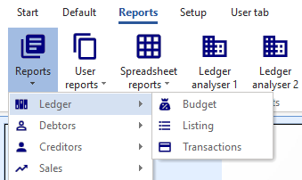
- Budget – Budget vs actual (3 periods) This report lists the Income and Expense account balances and budget figures for three (3) periods as comparative figures.
- Listing - List the General ledger accounts (Chart of accounts).
- Transactions - Transactions, Transactions - Standard and Transactions - Extra details.

DEBTOR REPORTS
The following reports are available to manage the accounts in the debtor's ledger:
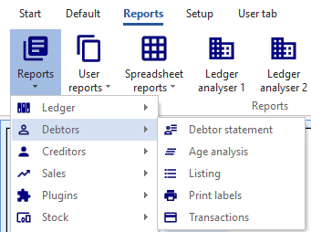
- Debtor statement - Debtor statements and Debtor statements – Outstanding.
- Age analysis - The Debtor age analysis provides the "Balances detail, Balances detail history (open item)" and "Balances" reports allows you to analyse the outstanding amounts your debtors (customers / clients) owes you in specified periods such as total, 30, 60 and 90 days, or more. These reports are essential for cash flow control. You may also wish to use this feature for credit control, to send reminders to your debtors (customers / clients), to optimise your cash flow management. These reports offers different options of views to support the details of debtor statements.
- Listing - Contacts, Listing, List delivery address, List postal address or List details, Tax and company registration numbers and the Credit control listing (Credit limit vs current balance and available balances as at the date and time of printing) report.
- Print labels - Postal and delivery address labels.
- Transactions - Transactions - Open item, Transactions - Standard and Transactions - Extra details.

CREDITOR REPORTS
The following reports are available to manage the accounts in the creditor's ledger:
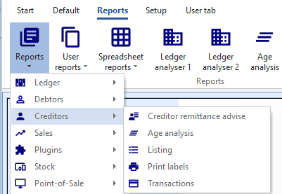
- Creditor remittance advice - Remittance advise and Remittance advise – Outstanding.
- Age analysis - The Creditor age analysis provides the "Balances detail, Balances detail history (open item)" and "Balances" reports allows you to analyse the outstanding amounts you owe to your creditors (suppliers) in specified periods such as total, 30, 60 and 90 days, or more. These reports are essential for cash flow control. You may also wish to use this facility to schedule the payments to your creditors, to optimise your cash flow management. These reports offers different options of views to support the details of creditor remittance advises.
- Listing - Contacts, Listing, List delivery address, List postal address or List details, Tax and company registration numbers and the Credit control listing (Credit limit vs current balance and available balances as at the date and time of printing) report.
- Print labels - Postal and Delivery address labels.
- Transactions - Transactions - Open item, Transactions - Standard and Transactions - Extra details.
BATCH REPORTS
Batch reports for unposted batches may be printed from the F8:List option on the “Batch entry” screens.
Once a batch or a document is posted (updated), batch reports may be printed from the following options:
- Reports → Batch entry menu (Reports ribbon).
- Batch entry – Posted batches tab (Setup ribbon).
- Reverse posted batch/document – Details tab – (Tools → Global processes menu (Setup ribbon)).

Batch reports (Reports menu)
The following two (2) reports are available:
- Batch transactions per period – Print the transactions of posted invoices, credit notes, purchase and supplier return documents as well as posted batch transactions (i.e. sales journal, purchase journal, payments journals, receipts journals, general journals, etc.) for a specific selected period and for a selected batch type.
- Batch type report – Documents - Print the transactions of all posted invoices, credit notes, purchase and supplier return documents for a specific selected period.
Batch transactions per period report
Print the transactions of posted invoices, credit notes, purchase and supplier return documents as well as posted batch transactions (i.e. sales journal, purchase journal, payments journals, receipts journals, general journals, etc.) for a specific selected period and for a selected batch type.
To print a batch transactions per period report:
- On the Reports ribbon, select Reports → Batch entry. Documents (listing the batch transactions generated by documents only) is by default displayed.
- Select “Batch transactions per period” report.
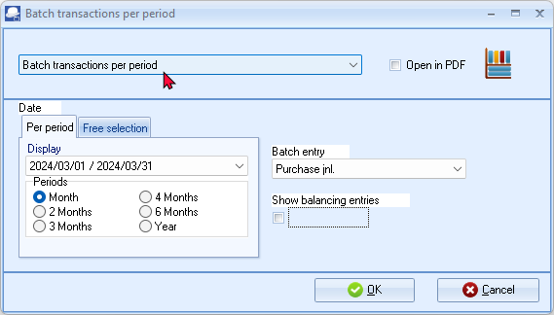
- Select the following options:
Per period: | - Tick on “Month” and select “2024/03/01 - 2024/03/31”
Batch entry: | - Select “Purchase jnl.”
Show balancing entries: | - Leave blank. By default, this option is not selected. It will only list the transactions entered into batches and / or the totals of documents and totals for each amount column. If this option is selected, it will list all the balancing entries.
- Click OK.
An example of the “Batch transactions per period” for the “Purchase jnl.” (“Show balancing entries” not selected) report, is as follows:
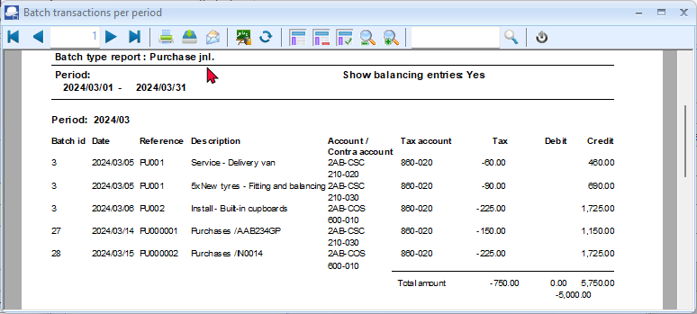
An example of the “Batch transactions per period” for the “Purchase jnl.” (“Show balancing entries” selected) report, is as follows:
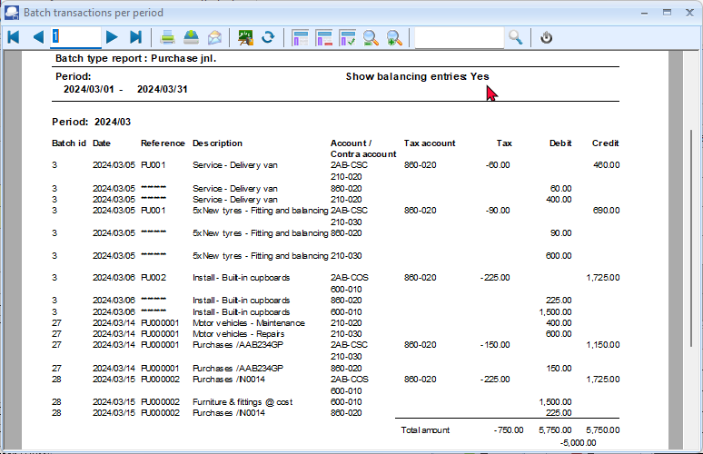
This report will list the following:
- Batch id. - The batch id or number as automatically generated.
- Date – Date of the transaction.
- Alias – In the case of documents, the document number will be listed. In the case of batch transactions, the Alias as entered on each “Batch entry” screens will be displayed. If no Alias is entered on “Batch entry” screens, the Alias (Batch name) will be the same as the Batch type).
- Account – The account which was selected for documents or in the Account lookup on “Batch entry” screens.
- Contra account - The account which was selected as the Contra account on the F10:Setup on “Batch entry” screens.
- Tax account column – Tax account code.
- Debit column – Debit transaction amount.
- Credit column – Credit transaction amount.

Batch type report – Documents
Print the transactions of all posted invoices, credit notes, purchase and supplier return documents for a specific selected period.
To print a batch type report - documents report:
- On the Reports ribbon, select Reports → Batch entry. “Documents” (listing the batch transactions generated by documents only) is by default displayed.
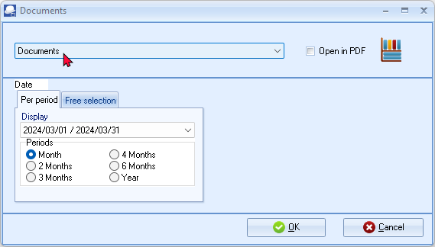
- Select “Month” and select “2024/03/01 - 2024/03/31”
- Click OK.
An example of the “Batch type report – Documents”, is as follows:
Page 1 -
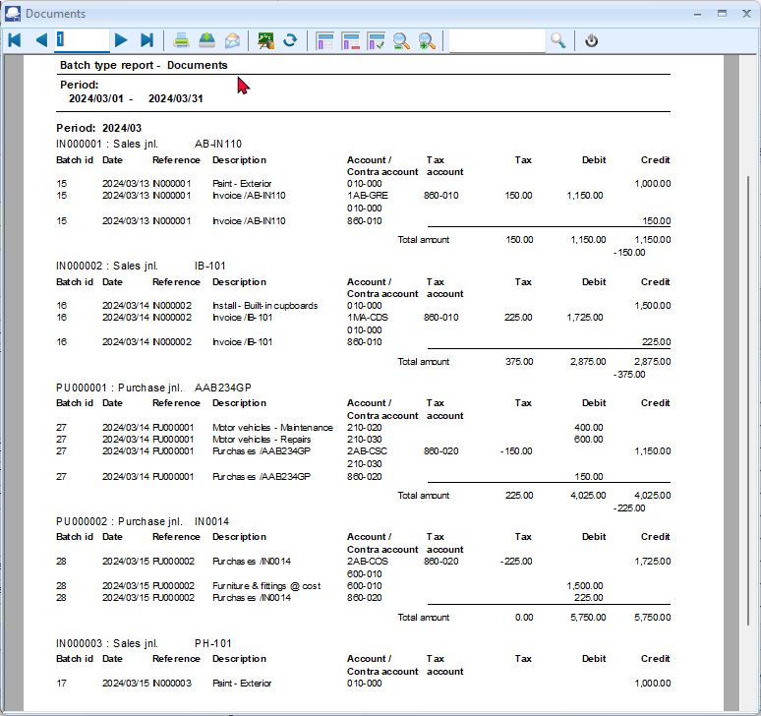
Page 2 -
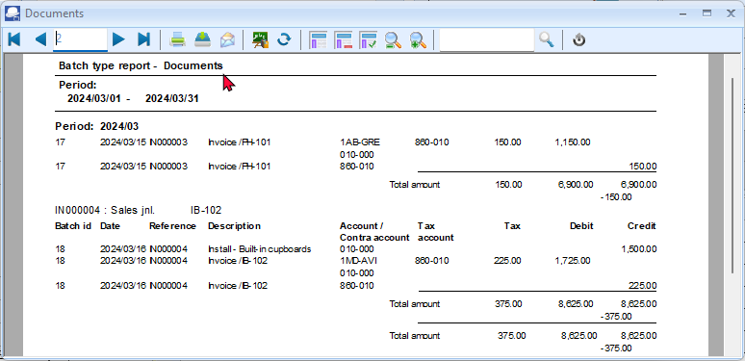

This report will list the following:
- Document heading – Document number, Batch type and Reference (as entered in the “Your reference” field of “Document entry” screens).
- Transaction details -
  - Batch id. – The batch id or number as automatically generated.
  - Date – Date of the transaction.
  - Reference – The document number will be listed.
  - Description – Document number / Your reference (as entered in the “Your reference” field of “Document entry” screens).
  - Account – The account which was selected for documents.
  - Contra account – The account for the document type.
  - Tax account column – Tax account code.
  - Tax – Tax amount.
  - Debit column – Debit transaction amount.
  - Credit column – Credit transaction amount.
- Total amount – This amount is the accumulative sum of all document transactions.
The total in the Tax column, is the accumulative total of all Output tax on sales documents (Invoices and Credit notes) minus the accumulative total of all Input tax for purchase documents (Purchases and Supplier returns).

Batch reports for posted batches
If you have entered the aliases (batch name), it will be easy to identify and view or print the correct batch transactions.
For example, if “OpenBalances, DopenBalances, COpenBalances” and “Depreciate2403” were not entered in the “Change Alias” field of the General journal, these four (4) batches would have been displayed as “General jnl”. As per this example, it is easy to identify the batches as Opening Balances for the General ledger (BatchID7), Debtor Opening Balances (BatchID12, Creditor Opening Balances (BatchID13 or Depreciation for “March 2024” (BatchID14).
To print a posted batch report:
- Select the Batch type (F2) and select the General jnl (as per example).
- Click on the Posted batches tab. The “Batch entry” screen, will display as follows:
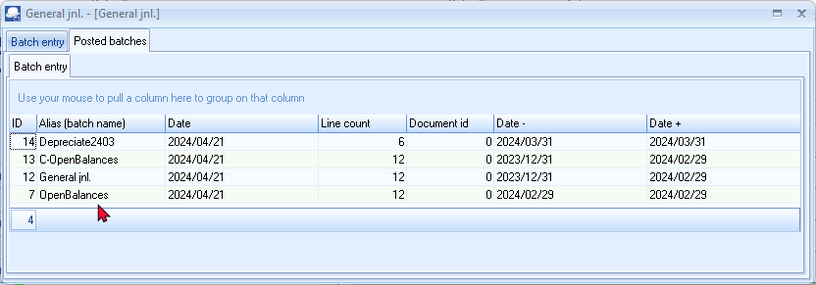
- Double-click on a selected batch. The transactions for the selected batch will be listed.
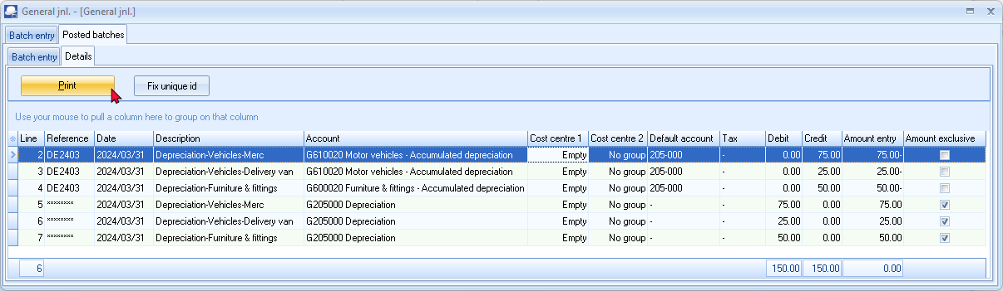
- Click on the Print button to print the Posted batch transactions.

An example of the printed “Posted batch type report” (for the selected batch), is as follows:
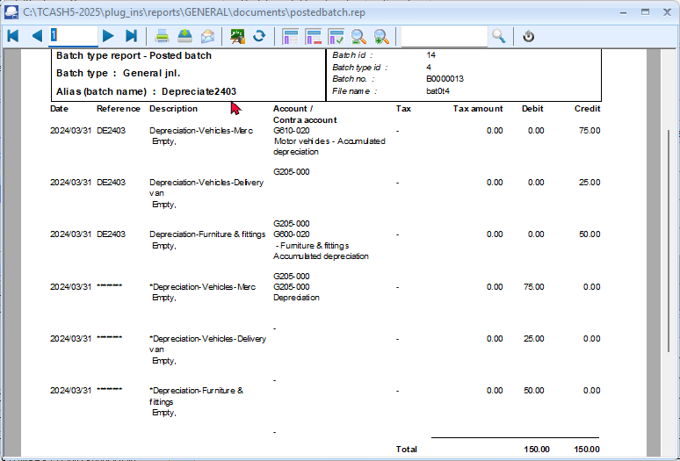

TAX REPORTS
The Tax report (Reports → Tax menu) does not include the Sales batch. It only includes Sales documents (i.e. Invoices and Credit notes). Transactions on other Batch types may cause similar errors.

The reason for this, is the “Consolidate balancing” option on the Standard tab of the F10:Setup on the “Batch entry” screen. When setting up the batch and the “Consolidate balancing” option is selected (ticked) if Tax is enabled in a batch, the following Information message is displayed:
“Consolidating lines and using tax will mess up your tax report!
Please make sure you do not use tax or do not consolidate lines”
Click on the OK button and click on the F10:Setup icon and deselect (remove the tick from the “Consolidate balancing” field on the Standard tab of the “Options for this batch” screen.
Balance the Batch again.
Before you print tax reports to submit your Tax (VAT/GST/Sales tax) returns, you need to post (update) all batch transactions and documents (i.e. invoices, credit notes, purchase and supplier return documents) for the tax period.

The following tax reports are available:
- Tax per period report – This report is used to complete the Tax (VAT/GST/Sales tax) returns. It will list a summary of the Output tax less the Input tax and the total tax payable / refundable.
- Tax report - Reference / Document no. - This report will list the details of accounts and transactions of all posted (updated) batch and document transactions, on which Tax (VAT/GST/Sales tax is applicable. It will display the Tax code and description as well as the contra accounts for each transaction.
- Tax list debtor with tax id - This report will list a total exclusive of tax, tax amount and inclusive amount of tax) for the Invoices less Credit notes for debtor (customer) accounts for selected period(s) or date(s). It will also display the Company and Tax registration numbers for each for debtor (customer) accounts.
- Tax list creditor with tax id - This report will list a total exclusive of tax, tax amount and inclusive amount of tax) for the Purchase documents less Supplier returns for creditor (supplier) accounts for selected period(s) or date(s). It will also display the Company and Tax registration numbers for each for creditor (supplier) accounts.
The Tax excluded and Tax amount in the Report total of the Tax report - Reference / Document no. report, should balance with the Total - Output tax – Input tax of the Tax per period report, if the same periods are selected.
It is recommended that these tax reports are printed and archived (PDF) for record and audit purposes.

Tax per period report
To print tax per period reports:
- On the Reports ribbon, select Reports → Tax.
- Select the Tax per period report. The “Tax list debtor with tax id” report is the default report.
- Select the “Tax per period” report.
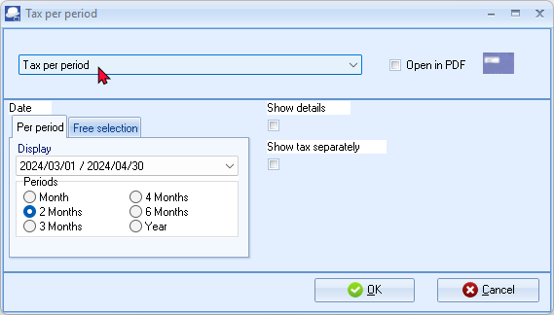
- Select the following:
Per period: | - Tick on “2 Months” and select “2024/03/01 / 2024/04/30”.
Show details: | - Leave blank. By default, this option is not selected. It will only list the totals exclusive of Tax (VAT/GST/Sales tax) for each tax code.  If this option is selected, it will list all transactions and documents including the account code, account description, country and tax reference of the debtor or creditor account (if applicable).
Show tax separately: | - Leave blank. By default, this option is not selected. If this option is selected, each tax code will print on a new page. It is recommended, that this option should only be selected, when the “Show details” option is selected.
For the purpose of this tutorial, we assume that our tax registration certificate indicates that we need to pay Tax (VAT/GST/Sales tax) every 2 months.
- Click OK.

An example of the “Tax per period” (no details) report, is as follows:
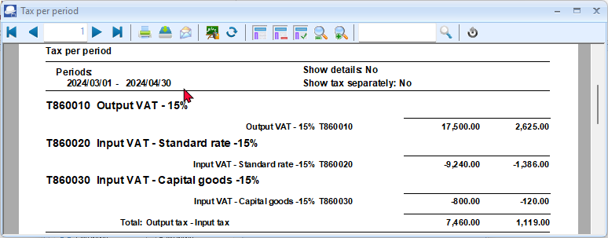
It is recommended that the details should also be printed and saved for record purposes.
It is important to print the details to check the details of your transactions.
The detailed tax report (“Show details” and “Show tax separately” options selected) for the same period, is as follows:
Page 1 – Output VAT - 15%
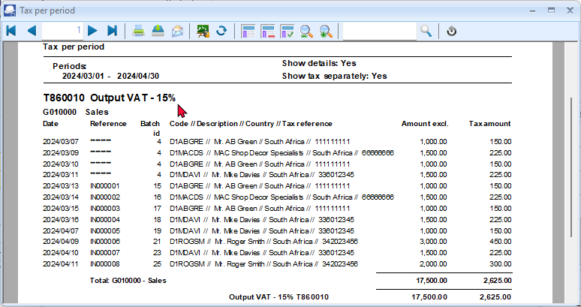

Page 2 – Input VAT – Standard rate -15%
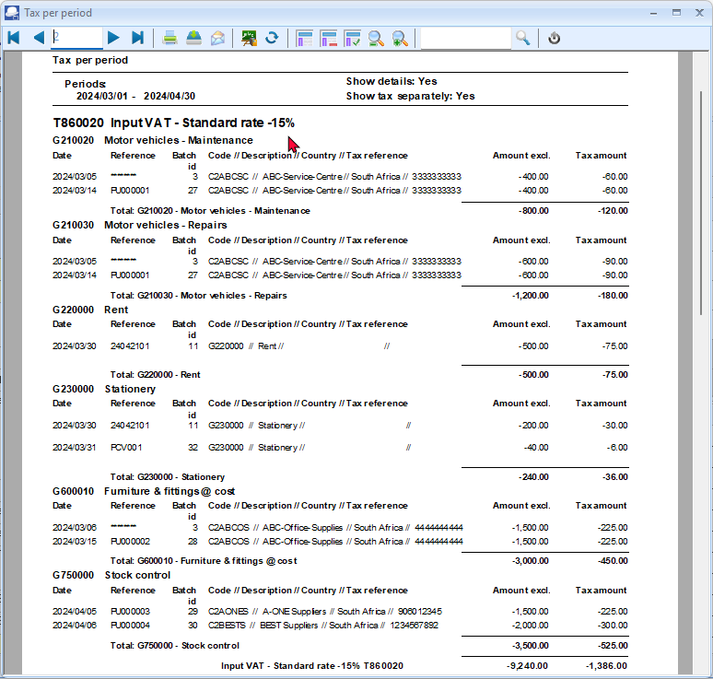
Page 3 – Input VAT – Capital goods - 15%
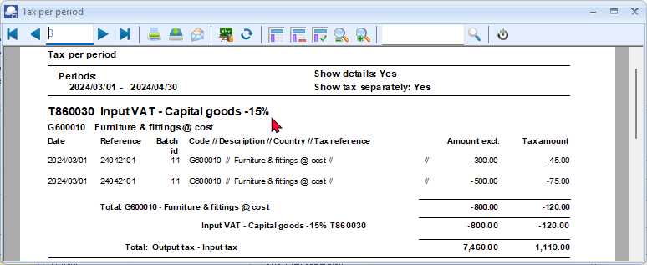
The Tax excluded and Tax amount in the Report total of the Tax report - Reference / Document no. report, should balance with the Total - Output tax – Input tax of the Tax per period report, if the same periods are selected.

Tax report - Reference / Document no.
This report will list the details of accounts and transactions of all posted (updated) batch and document transactions, on which Tax (VAT/GST/Sales tax is applicable. It will display the Tax code and description as well as the contra accounts for each transaction. If the same periods is selected as on the Tax per period report, the Exclusive and Tax amount totals should balance.
To print tax list debtor with tax id reports:
- On the Reports ribbon, select Reports → Tax.
- Select the Tax per period report. The “Tax list debtor with tax id” report is the default report.
- Select the “Tax report – Reference / Document no.” report.
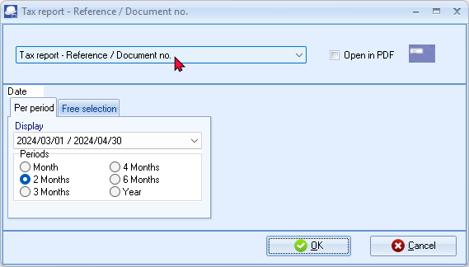
- Select the following on “2 Months” and select “2024/03/01 / 2024/04/30”.
For the purpose of this tutorial, we assume that our tax registration certificate indicates that we need to pay Tax (VAT/GST/Sales tax) every 2 months.
- Click OK.

An example of the “Tax report – Reference / Document no.” report, is as follows:
Page 1 -
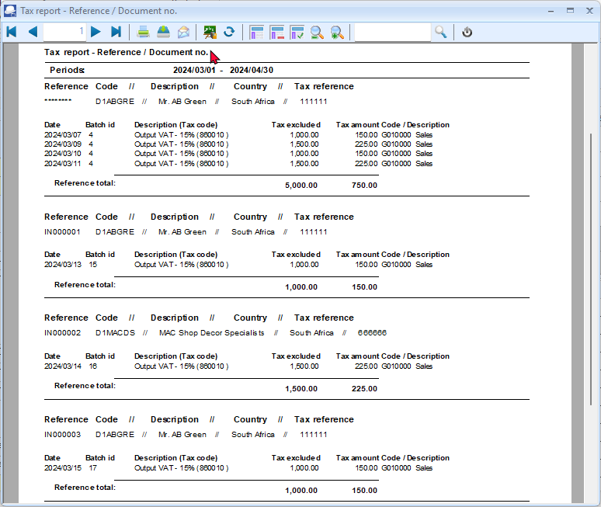
Page 5 – (Last page) Totals
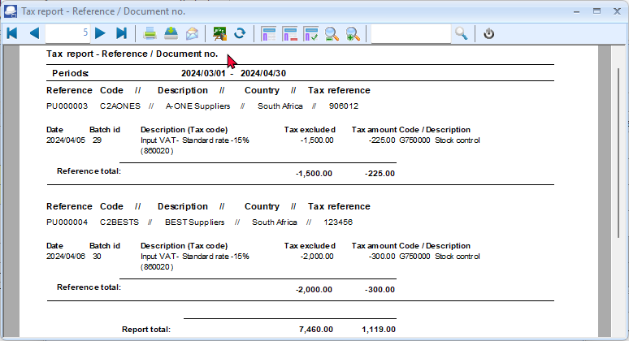

Once again, the Tax excluded and Tax amount in the Report total of the Tax report - Reference / Document no. report, should balance with the Total - Output tax – Input tax of the Tax per period report, if the same periods are selected.
This report will list the following for each transaction on which Tax (VAT/GST/Sales tax) is applicable:
- Reference and account detail -
  - Reference – Document number or reference as entered in batches.
Balancing entries in batches are indicated as ******** eight (8) asterisks.
  - Code – Account code
  - Description – Name of the account.
  - Country – The name of the country, if selected on debtor (customer) and creditor (supplier) accounts).
  - Tax reference – Tax reference number, if entered on debtor (customer) or creditor (supplier) accounts).
- Transactions detail –
  - Date – Date of the transaction.
  - Batch id. - The batch id (number) as automatically generated.
  - Description – Tax account and tax code.
  - Tax excluded – Amount of the transaction exclusive of Tax (VAT/GST/Sales tax)
  - Tax amount – Tax amount for the transaction.
  - Code / Description – Contra account code and account name (description).

Tax list debtor with tax id / Tax list creditor with tax id
The following two (2) reports will list the totals of documents for selected periods (as well as the registration numbers):
- Tax list debtor with tax id - This report will list a total exclusive of tax, tax amount and inclusive amount of tax) for the Invoices less Credit notes for debtor (customer) accounts for selected period(s) or date(s). It will also display the Company and Tax registration numbers for each for debtor (customer) accounts.
- Tax list creditor with tax id - This report will list a total exclusive of tax, tax amount and inclusive amount of tax) for the Purchase documents less Supplier returns for creditor (supplier) accounts for selected period(s) or date(s). It will also display the Company and Tax registration numbers for each for creditor (supplier) accounts.
To print tax list debtor with tax id reports:
- On the Reports ribbon, select Reports → Tax.
- Select the Tax per period report. The “Tax list debtor with tax id” is the default report.
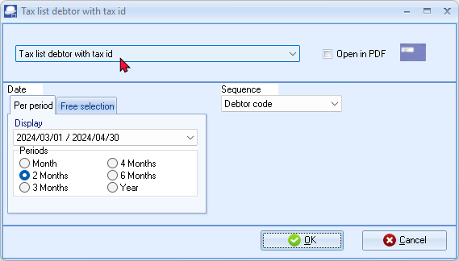
- To print the similar report for creditors, select the “Tax list creditor with tax id” report.
- Select the following:
Per period: | - Tick on “2 Months” and select “2024/03/01 / 2024/04/30”.
Sequence: | - Select “Debtor code”
For the purpose of this tutorial, we assume that our tax registration certificate indicates that we need to pay Tax (VAT/GST/Sales tax) every 2 months.
- Click OK.

An example of the “Tax list debtor with tax id” report, is as follows:
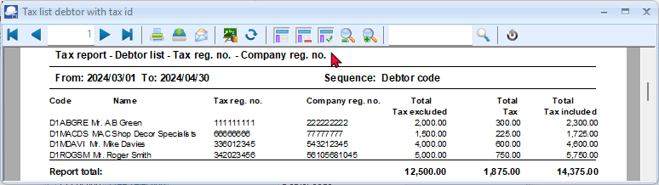
REPORTS TO MANAGE AND ANALYSE DOCUMENTS, STOCK, SALES AND PURCHASES
A range of reports are available on the Reports menu to manage, analyse and control your stock items, sales and purchases. You may generate these reports to see how the transactions in this tutorial will be displayed in the reports.
Stock item reports
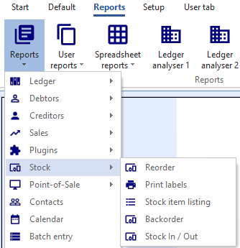
The following reports are available to manage the stock items:
- Reorder - Stock Reorder Report to list only those stock items that needs to be reordered. The Current Stock Levels lists all the current stock levels.
- Print labels – Print the Barcode or the Yagoda barcodes.
- Stock item listing - Print lists of All selling prices report (Selling price 1 / 2 /3), and the Stock item listing report listing the Quantities Cost prices. A list of Tax classes may also be printed. You may select to print extra details for these reports.
- Backorder – Print a list of any stock items that are on backorder.
- Stock In / Out - The following two (2) reports:
  - Stock In / Out - Documents - Displays a summary of sales and purchase documents for each stock item. The “Show details” option will list and display the document dates and document numbers for each stock item.
  - Stock In / Out - Displays a list of the stock items and the quantities in and out as well as the total prices. The “Show details” option will list and display the document dates and document numbers for each stock item.
Document listing reports
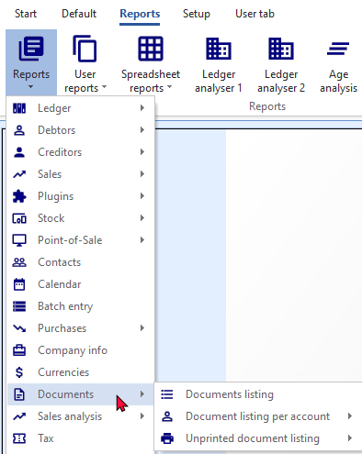
The following reports are available to print lists of documents:
- Document listing – Select Invoices, Credit notes, Quotes, Purchases, Supplier returns and Orders.
- Document listing per account
  - Sales documents – Select to list only posted or unposted Invoices or Credit notes or unconfirmed / open / confirmed Quotes.
  - Purchase documents – Select to list only posted or unposted Purchases or Supplier returns or unconfirmed / open / confirmed Orders.
- Unprinted document listing – This is similar to the Document listing per account reports. It will list all documents which have not yet been printed for each debtor (customer / client) account.
Sales reports
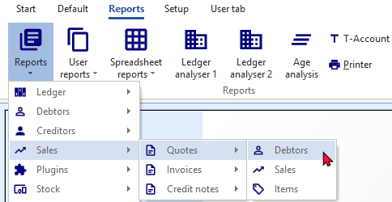
Various reports are available on the Reports → Sales menu to analyse each of the sales documents (i.e. Quotes, Invoices and Credit notes). The reports for Invoices are as follows:
- Debtors – Debtors – Invoices per period – Quantities.
- Sales – Invoices per period – Quantities and Invoices per period – Turnover.
- Items - Items per period.

Sales analysis reports
Various reports are available on the Reports → Sales analysis menu to analyse sales documents.
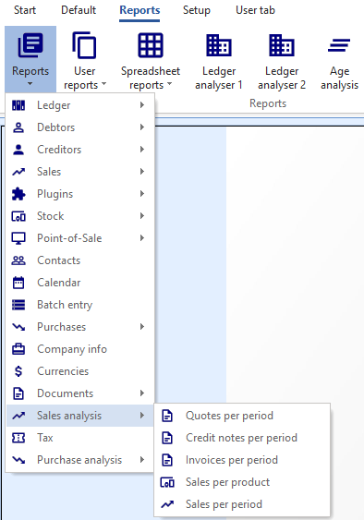
Five (5) reporting groups (i.e. Debtor group 1, Debtor group 2, Document group 1, Document group 2 and Salespersons):
- Sales per period – This will list both the transaction details of posted invoices and credit notes for a selected period or date(s).
- Invoices per period – This will list the transaction details of posted invoices only for a selected period or date(s).
- Credit notes per period – This will list the transaction details of posted credit notes only for a selected period or date(s).
- Quotes per period – This will list the transaction details of confirmed (posted) quotes only for a selected period or date(s).
Sales per product - Stock group 1 and Stock group 2 are also available to analyse the sales and returns of trading stock items (default stock type).
Purchases reports
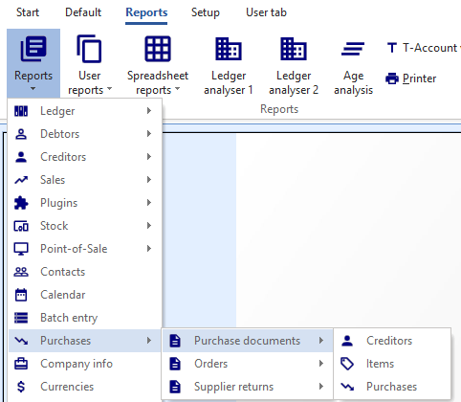
Various reports are available on the Reports → Purchases menu to analyse each of the sales documents (i.e. Purchases, Supplier returns and Orders). The reports for Purchases are as follows:
- Creditors – Creditors – Purchases per period – Quantities
- Purchases – Purchases per period – Quantities and Purchases per period – Cost.
- Items - Items per period.

Purchase analysis reports
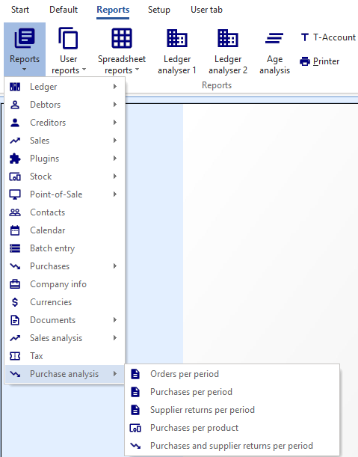
Various reports are available on the Reports → Purchase analysis menu to analyse purchase documents.
Five (5) reporting groups (i.e. Creditor group 1, Creditor group 2, Document group 1, Document group 2 and Salespersons):
- Purchases and supplier returns per period – This will list both the transaction details of posted purchases and supplier returns for a selected period or date(s).
- Purchases per period – This will list the transaction details of posted purchases only for a selected period or date(s).
- Supplier returns per period – This will list the transaction details of posted supplier returns only for a selected period or date(s).
- Orders per period – This will list the transaction details of confirmed (posted) orders only for a selected period or date(s).
Purchases per product - Stock group 1 and Stock group 2 are also available to analyse the purchases and supplier returns of trading stock items (default stock type).

SPREADSHEET REPORTS
These spreadsheet reports are stored in the “ ...\plug_ins\reports\excelreports “ folder -
See video on Spreadsheet reports.
The internal file names of Spreadsheet reports are displayed in the status bar (below the Sheet tabs) of each spreadsheet report.
Please refer to MODULE Q2.2 – Spreadsheet reports menu – File names and file structure for the internal file names of Spreadsheet reports.
These spreadsheet reports will be briefly discussed.
Spreadsheet report – Debtors
The Spreadsheet report - Debtors will list all the debtor (customer / client) accounts in a spreadsheet.
The data in this spreadsheet is similar to the Debtor listing - "List postal addresses" report (Reports → Debtors → Listing (Reports ribbon)).
To import the debtor (customer / client) accounts:
- On the Reports ribbon, select Spreadsheet reports → Debtors.
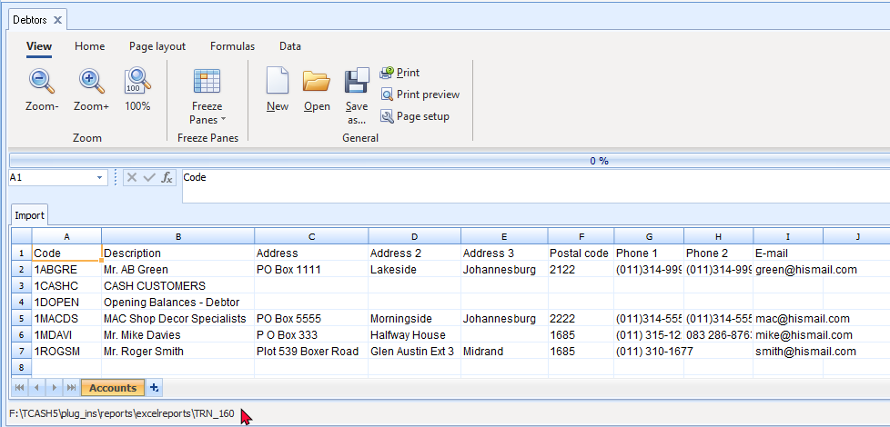

Spreadsheet report – Creditors
The Spreadsheet report - Creditors will list all the creditor (supplier) accounts in a spreadsheet.
The data in this spreadsheet is similar to the Creditor listing - "List postal addresses" report (Reports → Creditors → Listing (Reports ribbon)).
To import the creditor (supplier) accounts:
- On the Reports ribbon, select Spreadsheet reports → Creditors.
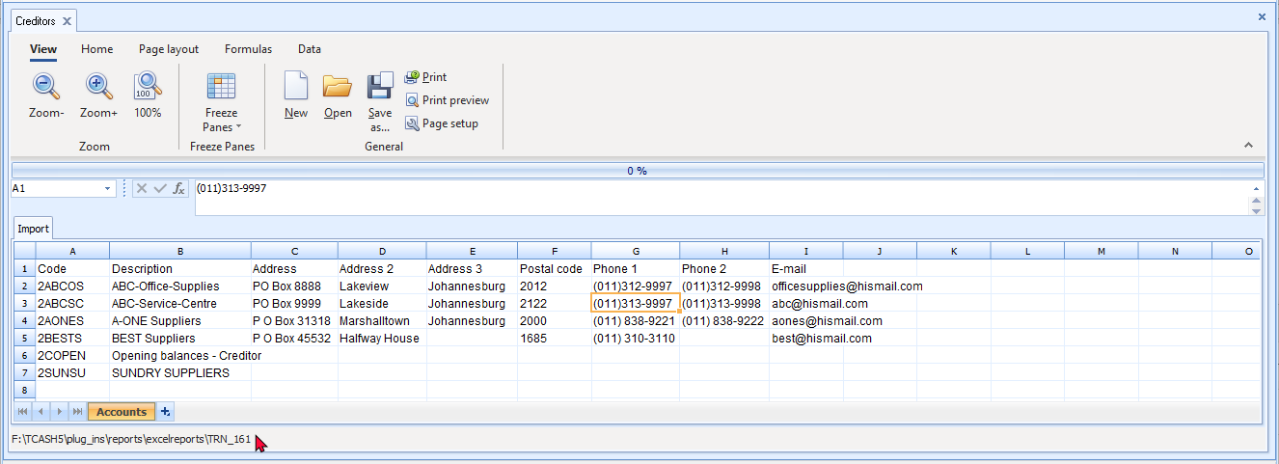

Spreadsheet report – Transactions - Per period
You may import the transactions in batches and documents (i.e. sales documents (Invoices and Credit notes) and purchase documents (Purchases and Supplier returns)), which have been posted (updated) to the ledger, for a selected period.
To import posted transactions into a spreadsheet:
- On the Reports ribbon, select Spreadsheet reports → Transactions → Per period.
- On the parameters ("params")" screen, select the period or date(s) and click OK. The transactions for the selected period or dates (in this example “Year - 2024/03/01 to 2025/02/28”) will be listed in the spreadsheet:
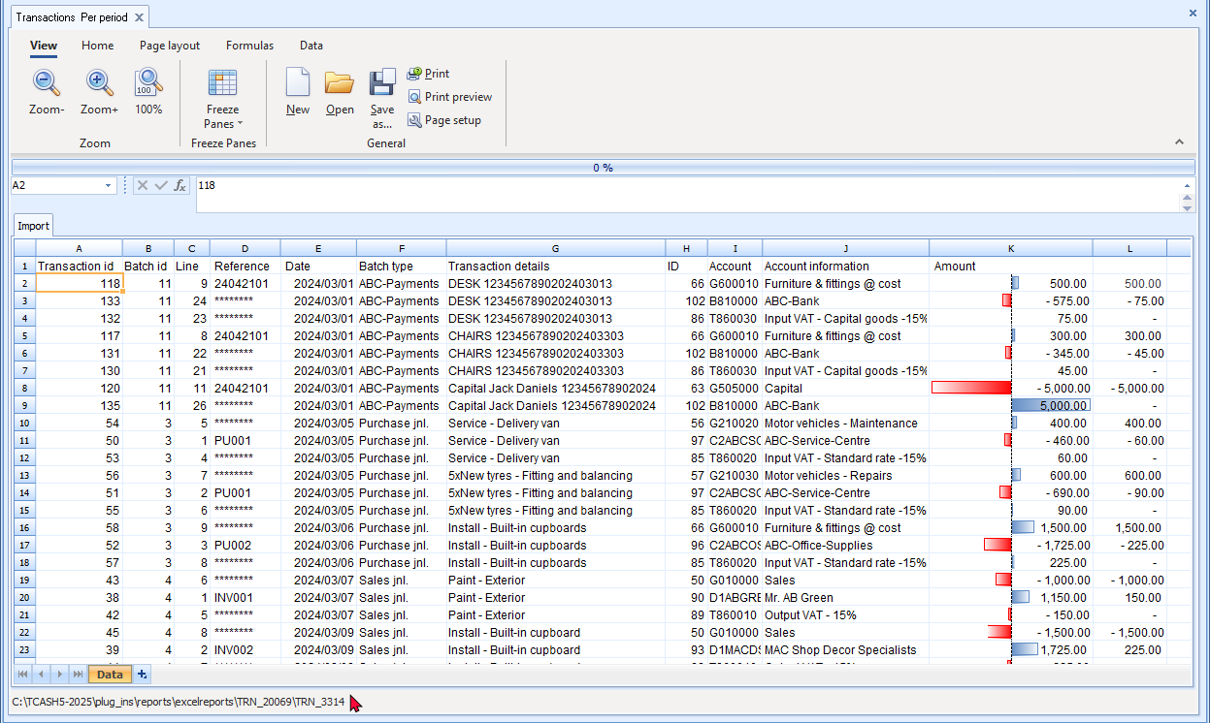
This spreadsheet will list the transaction details in the following columns:
- A - Transaction id - The ID of the transaction which was automatically created when the batch or the document was posted (updated) to the ledger.
- B - Batch id - The ID of the batch which was automatically created when the batch or the document was posted (updated) to the ledger.
- C - Line - The line number for each transaction in a batch or transaction generated in documents.
- D - Reference - In the case of batch transactions, the reference as entered for each transaction in the "Reference" column in “Batch entry” screens will be displayed. Balancing transactions in batches will be displayed with eight (8) asterisks (e.g. "********").
In the case of documents, the document number for Invoices, Credit notes, Purchases and Supplier returns will be listed.
- E - Date - The date of the transaction. The date as entered in the "Date" column of "Batch entry" screens. In the case of documents, it will display the date on which a document was generated.
- F - Batch type - In the case of batch transactions, the name of the Batch type will be displayed. No aliases will be displayed as entered on each “Batch entry” screen.
In the case of documents, it will display the name of the Batch type as linked to each document type in the Setup → Documents setup screen for each document type.
- G - Transaction details - The description of the transaction as entered in the "Description" column of batches. In the case of documents, it is the document type description (i.e. Invoice, Credit note, Purchase or Supplier returns) and the reference number (as entered in the "Your reference" field of documents.
- H - ID - The ID of the account applicable to each transaction.
- I - Account - The Account code or number applicable to each transaction.
Prefixed character in the account code indicates the account type:
G = General ledger
B = Bank account
C= Creditor
D = Debtor
T = Tax
- J - Account information - The name (description) of the account applicable to the transaction.
- K - Amount - The amount of the transaction. If Tax (VAT/GST/Sales tax) is applicable to a transaction, three (3) transactions should be listed:
- Tax inclusive – The full amount of the transaction, including Tax.
- Tax exclusive – The amount of the transaction, excluding Tax.
- Tax amount – Only the tax amount applicable to the transaction.
- L - The cumulative amounts for each transaction. After taking the contra accounts into consideration, the cumulative total for each transaction, should reflect zero.

Spreadsheet report – General ledger
Spreadsheet report – General ledger – Budget
Reports for Budgets may also be printed on the Reports → Ledger → Budget menu; or on the Budget listing reports on Ledger analyser 1 or Ledger analyser 2 selecting the "Budget" option.
Budget – Column balances – Reporting group 1
You may import the budget totals (for accounts linked to the Reporting group 1), which have been added or edited on the Budget tab for selected accounts in Setup → Accounts (Setup ribbon) or on the Budgets icon (Reports ribbon), into a spreadsheet.
To import budget totals for reporting group 1 into a spreadsheet:
On the Reports ribbon, select Spreadsheet reports → General ledger → Budget → Column balances → Reporting group 1. The budget totals linked to the Reporting group 1 (Account group 1) will be listed in the spreadsheet:
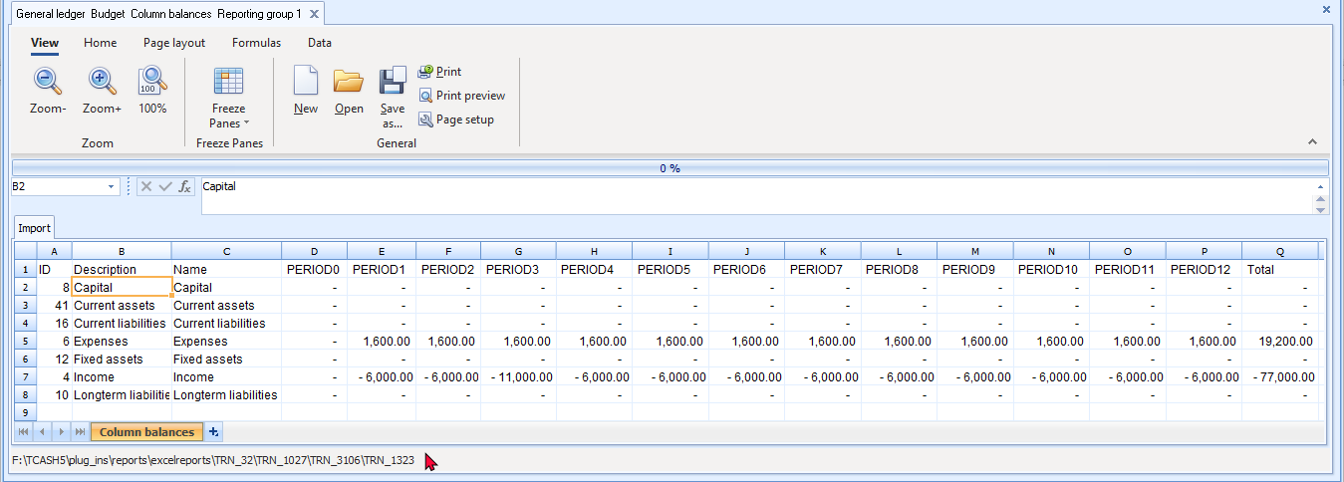
This spreadsheet will summarise the total of the budget figures for each Account group 1 (Reporting group 1) in the following columns:
- Period 0 (Opening Last Year) - The totals of the opening budget totals for the previous year.
- Periods 1 to 12 - The totals of budget figures entered in the respective periods for this year.
- Total - Total for each period (Period 1 -12) plus Period 0.

Column balances – This year
You may import the budget totals, which have been added or edited on the Budget tab for selected accounts in Setup → Accounts (Setup ribbon) or on the Budgets icon (Reports ribbon), into a spreadsheet.
The budget totals, will be imported into two (2) sheets in the spreadsheet:
- Settings – The budget totals for each period in rows per period.
- Column balances – The budget totals for each period, listed per account, in separate columns.
To import a budget for This year into a spreadsheet:
- On the Reports ribbon, select Spreadsheet reports → General ledger → Budget → Column balances → This year. The budget totals for each of this year periods will be listed in the "Settings" sheet of the spreadsheet:
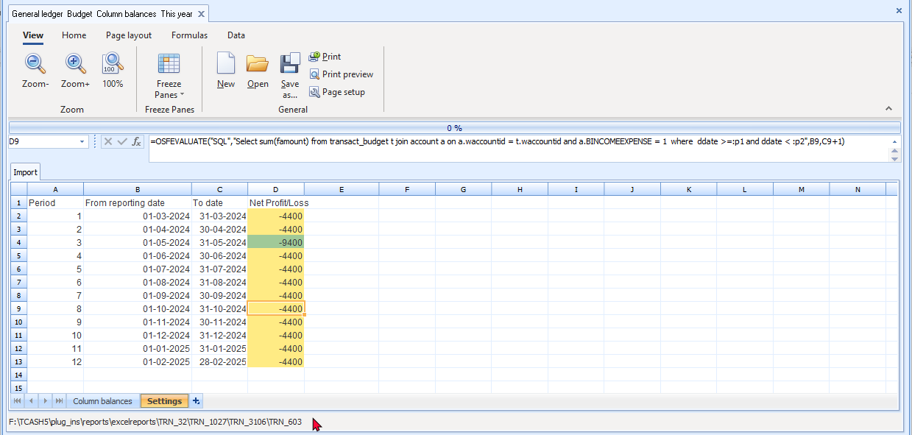

- To view the budget figures for each account, click on the "Column balances" sheet of the spreadsheet:
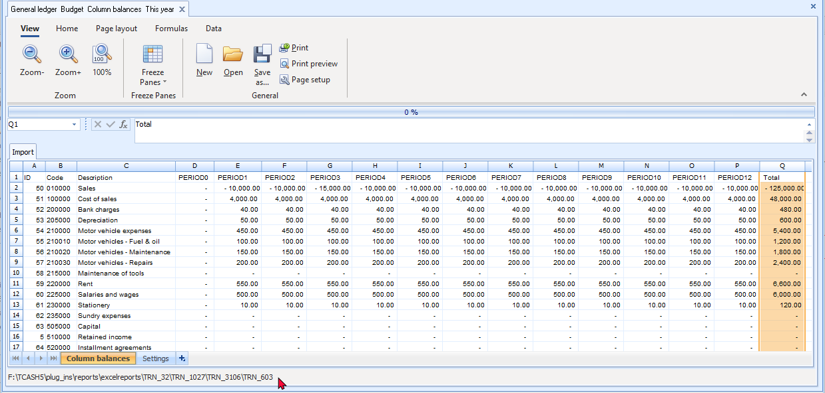
This spreadsheet lists the totals for the main account as well as sub-accounts. In this example, note the following:
210000 - Motor vehicle expenses - main account = 450.00 - The total of the following sub-accounts:
210010 - Motor vehicles - Fuel and oil - sub account = 100.00
210020 - Motor vehicles - Maintenance - sub account = 150.00
210030 - Motor vehicles - Repairs - sub account = 200.00
The "Column balances" sheet of the spreadsheet will summarise the total of the budget figures for each general ledger account in the following columns:
- Period 0 (Opening Last Year) - The totals of the opening budget totals for the previous year.
- Periods 1 to 12 - The totals of budget figures entered in the respective periods for this year.
- Total - Total for each period (Period 1 -12) plus Period 0.

Spreadsheet report – General ledger (Transaction totals)
Column balances – Reporting group 1
You may import the transaction totals (for accounts linked to the Reporting group 1), which have been posted (updated) to the ledger, into a spreadsheet.
To import posted transactions for reporting group 1 into a spreadsheet:
On the Reports ribbon, select Spreadsheet reports → General ledger → Column balances → Reporting group 1. The transaction totals linked to the Reporting group 1 (Account group 1) will be listed in the spreadsheet:
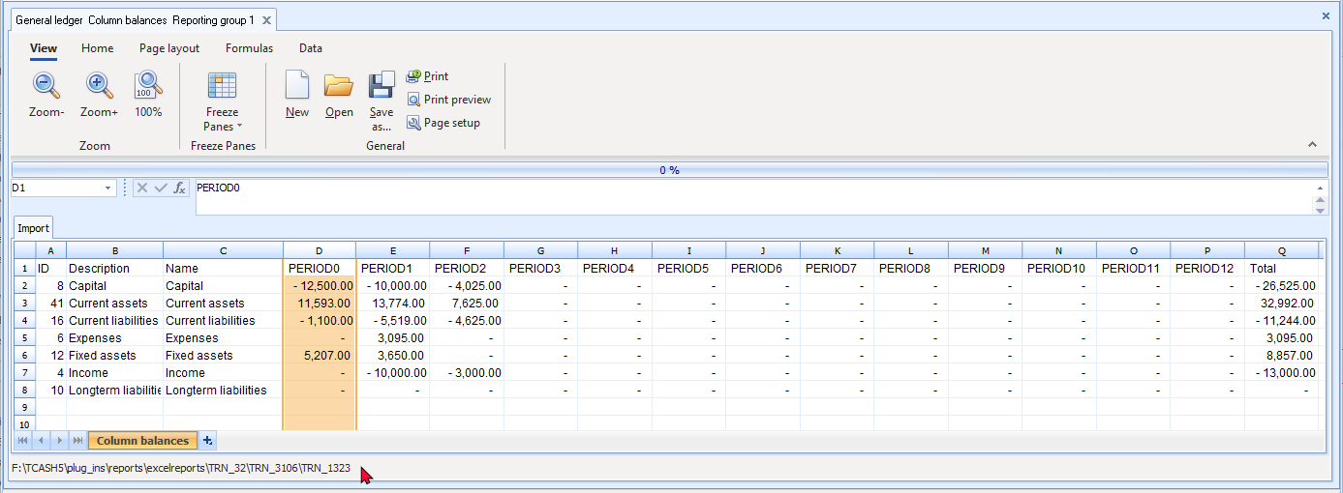

Column balances - This year
You may import the transaction totals, which have been posted (updated) to the ledger, into a spreadsheet.
This year Column balances will import the transaction totals in two (2) sheets in the spreadsheet:
- Settings – The totals for each period in rows per period.
- Column balances – The totals for each period, listed per account, in separate columns.
To import posted transactions for This year into a spreadsheet:
- On the Reports ribbon, select Spreadsheet reports → General ledger → Column balances → This year. The transaction totals for each of this year periods will be listed in the "Settings" sheet of the spreadsheet:
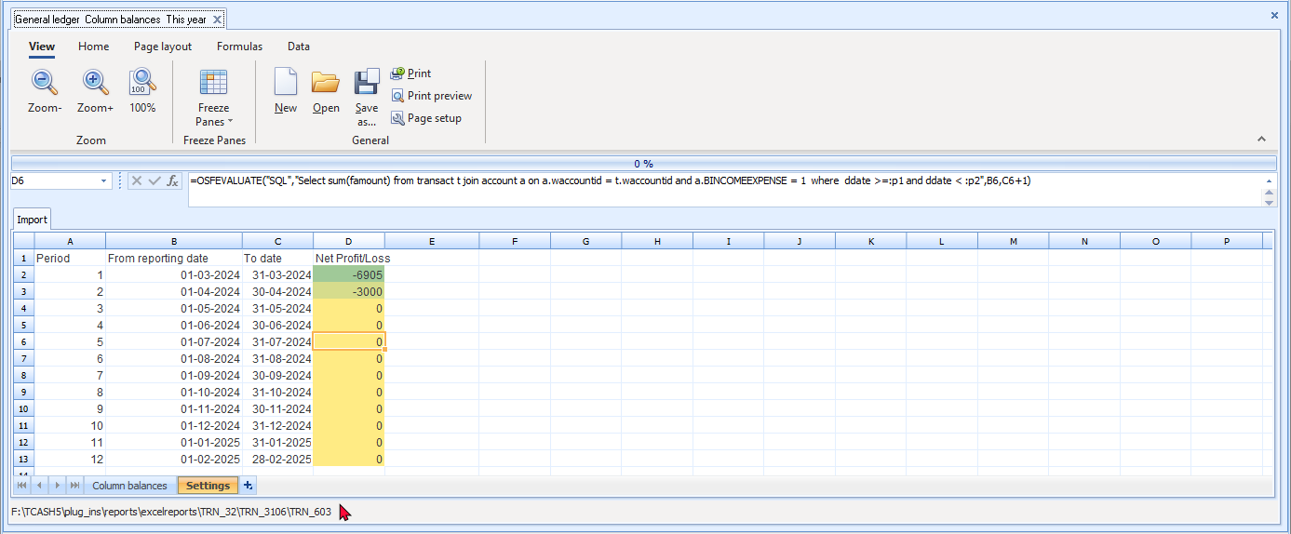

- To view the transaction totals for each account, click on the "Column balances" sheet of the spreadsheet:
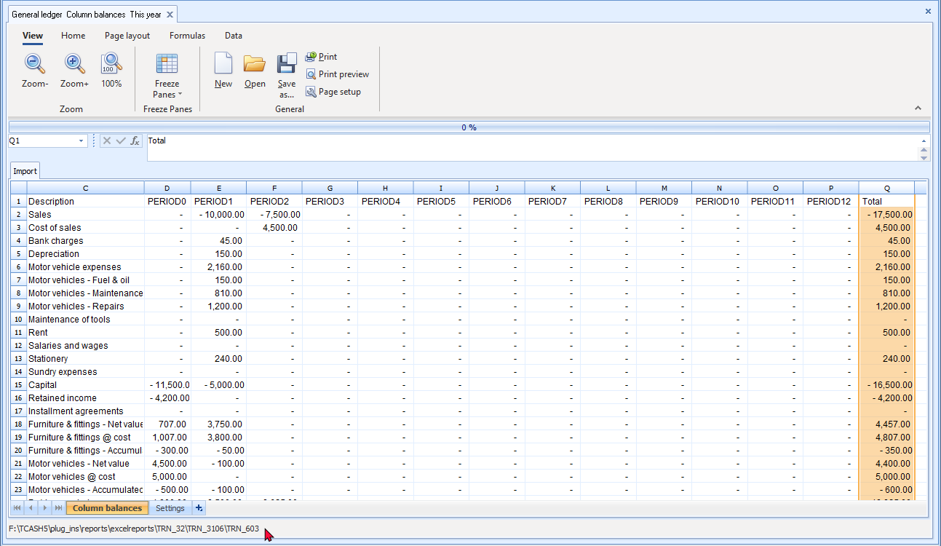
This spreadsheet lists the totals for the main account as well as sub-accounts. In this example (period for full year), note the following:
210000 - Motor vehicle expenses - main account = 2,160.00 - The total of the following sub-accounts:
210010 - Motor vehicles - Fuel and oil - sub account = 150.00
210020 - Motor vehicles - Maintenance - sub account = 810.00
210030 - Motor vehicles - Repairs - sub account = 1,200.00
The "Column balances" sheet of the spreadsheet will summarise the total of the posted transactions for each general ledger account in the following columns:
- Period 0 (Opening Last Year) - The totals of the opening balance totals for the previous year.
- Periods 1 to 12 - The totals of the posted transactions in the respective periods for this year.
- Total - Total for each period (Period 1 -12) plus Period 0.

Spreadsheet report – Sales analysis
Spreadsheet report – Stock movement
The Spreadsheet - Stock movement report will list the total stock quantities for each stock item in and out for the selected period.
The data in this spreadsheet is similar to the "Stock In / Out" report (Reports → Stock items → Stock In / Out - (Reports ribbon)).
The following will be included in the spreadsheet:
- Only documents (i.e. invoices, credit notes, purchase and supplier return documents) which is posted (updated to the ledger) will be included.
- Only the default stock type (trading stock items (Stock item type = 0)) will be included.
The following will be excluded from the spreadsheet:
- All the other ten (10) stock types (e.g. Sales, Sales (no stock), Purchases, Purchases (no stock), Financial entry, Option item, Option item (no stock), BOM, BOM (Production) and Linked item) will be excluded in the spreadsheet import.
To import Stock movements (Stock In / Out) into a spreadsheet:
- On the Reports ribbon, select Spreadsheet reports → Sales analysis → Stock movement.
- On the parameters ("Params") screen, select the period and click OK. The total quantities for each stock item will be listed in the spreadsheet:
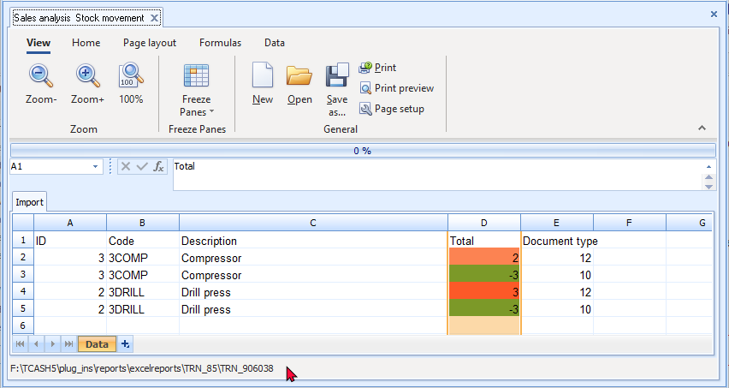

The Document type in column, E is as follows:
10 - Invoice
11 - Credit note
12 - Purchase
13 - Supplier return
14 - Quote
15 - Order
16 - Adjustment
Quotes and Orders will be excluded in the spreadsheet import.
Spreadsheet report – Sales per period
The Spreadsheet - Stock - Sales per period report will list the total sales amount excluding as well as including tax (VAT/GST/ Sales tax) for each of the selected periods.
To import Sales per period into a spreadsheet:
- On the Reports ribbon, select Spreadsheet reports → Sales analysis → Sales per period.
- On the parameters ("Params") screen, select the period and click OK. The total sales amount, excluding as well as including tax (VAT/GST/ Sales tax), for each period will be listed in the spreadsheet:
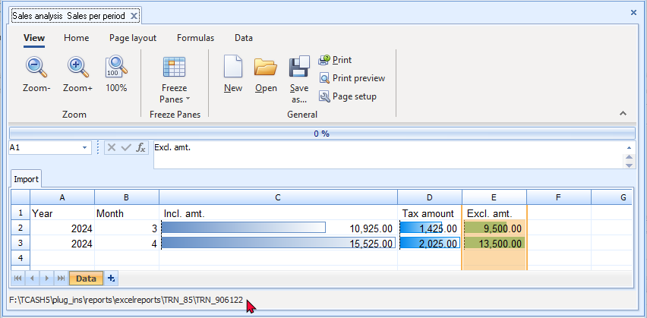
Month (Column B) - This is the number of the month in the Calendar year, e.g.:
3 = March
4 = April
5 = May, etc.

OPEN ITEM PROCESSING AND REPORTS

IN THIS MODULE
MODULE P - OPEN ITEM PROCESSING AND REPORTS 454
P.1- INTRODUCTION TO OPEN ITEM PROCESSING 455
P.2- OPEN ITEM PROCESSING - FILTER / SELECT ACCOUNTS 456
P.2.1- Totals tab - Select / Filter accounts 457
P.2.2- Transactions tab 458
P.2.3- Unposted batches 459
P.2.4- Due tab 460
P.2.4.1- Current date as Date of ageing 461
P.2.4.2- Select Date of Ageing 462
P.3- OPEN ITEM PROCESSING - SELECTED ACCOUNTS 463
P.3.1- Selected account – Default view 463
P.3.2- Statement view 465
P.3.3- ADJUST PAYMENT DATES / RECEIVE PAYMENT 466
P.3.3.1- Adjust payment date 466
P.3.3.2- Receive payment 466
P.4- OPEN ITEM REPORTS 467
P.4.1- Open Item reports summary 467
P.4.1.1- Debtor reports 467
P.4.1.2- Creditor reports 467
P.4.2- Debtor transaction reports 467
P.4.3- Debtor age analysis reports 467
P.4.3.1- Balances detail 468
P.4.3.2- Balances detail history (Open item) 470
P.4.3.3- Transactions - Balances detail vs Balances detail (open item) reports 471
P.4.3.4- Show contact details option 472
P.4.4- Debtor statements 472
P.4.4.1- Debtor statements - Outstanding 473
P.4.4.2- Debtor statement vs Debtor statement – Outstanding 476

INTRODUCTION TO OPEN ITEM PROCESSING
TurboCASH allows two basic methods of age processing of Debtor and Creditor transactions. These age type processing methods are:
- Balance brought forward -
    - Debtor (customer) accounts - The credit transactions (payments received, debtor allowances, credit notes or any other credit transaction) are allocated to the oldest outstanding debit transaction (opening balances, invoices, etc.) amount.
    - Creditor (supplier) accounts - The debit transactions (payments made to creditors, creditor allowances or supplier returns documents or any other debit transaction) are allocated to the oldest outstanding credit transaction (opening balances, purchases, etc.) amount.
- Open item -
    - Debtor (customer) accounts - Open item is by default not activated. To activate Open item processing for a debtor (customer) account, select (tick) the “Open item” field on the Accounting information tab of a selected debtor (customer) account.
The credit transactions (payments received, debtor allowances, credit notes or any other credit transaction) may be linked to any selected outstanding debit transaction (opening balances, invoices, etc.) amount.
    - Creditor (supplier) accounts - Open item is by default not activated. To activate Open item processing for a creditor (supplier) account, select (tick) the “Open item” field on the Accounting information tab of a selected creditor (supplier) account.
The debit transactions (payments made to creditors, creditor allowances or supplier return documents or any other debit transaction) may be linked to any selected outstanding credit transaction (opening balances, purchases, etc.) amount.
    - General ledger accounts - Setup → Accounts (Setup ribbon) “Open item account” field – Default is No. You may set it to Yes.
The “Open item account” option is not available for the Retained earnings / income, Debtor's control and Creditor's control accounts.
You may link debit transactions to credit transactions or credit transactions to debit transactions.
Open item linking relates debit transactions posted to an account to credit transactions which are posted to the same account.
TurboCASH stores two amounts for transactions to open-item accounts; the amount of the transaction as well as an "outstanding amount".
When you process the receipts journal and enter the amount for an Open item debtor, the “Open item selection” screen will be displayed, where you may select to link a receipt to a specific transaction or outstanding amount.
When you process the payments journal and enter the amount for an Open item creditor, the “Open item selection” screen will be displayed, where you may select to link a payment to a specific transaction or outstanding amount.
You may also edit or unlink the existing links, or even convert a specific account to the “Balance brought forward” method, where any payment or receipt will be set off against the oldest outstanding amount.

OPEN ITEM PROCESSING - FILTER / SELECT ACCOUNTS
There are various options to filter and manage the details, totals and transactions of open item accounts. To access the Open item link feature, click on the Open item link icon (Default ribbon).
There are four (4) tabs, i.e. Totals, Transactions, Unposted batches and Due tabs to manage open item accounts.
The Due tab may also be accessed from the Age analysis icon on the Reports ribbon.
Totals tab - Select / Filter accounts
To edit open item links:
- On the Default ribbon, click on the Open item link icon. The Totals tab will be displayed.
- Click on the Filter button to list all those accounts, for which Open item, is activated and for which transactions are posted.
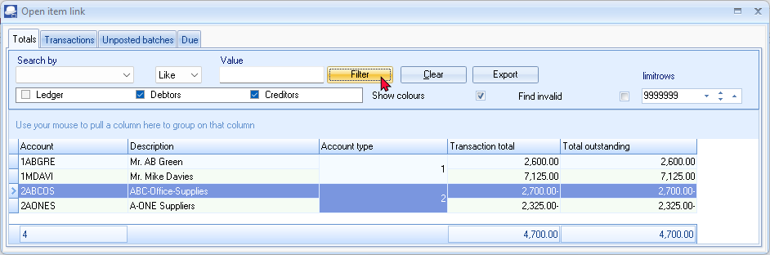
- If an account is in blue rows, the accounts have no outstanding or unlinked transactions.
Accounts displayed in red, indicates that there may be transactions which is not linked. These accounts may need some actions in the Open item link processing. 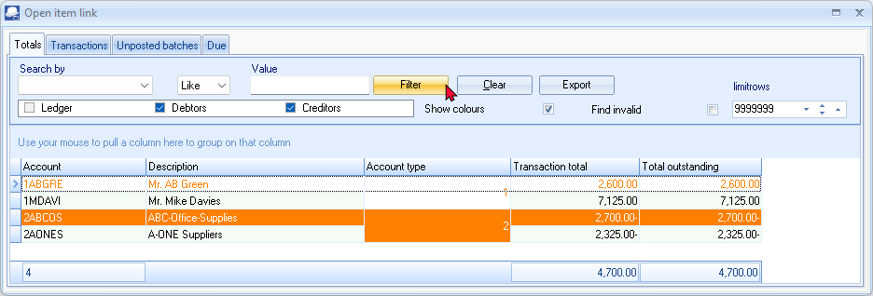
- Filter options - You may select (tick) or deselect (remove the tick) to list only Ledger, Debtors or Creditor accounts.
Account type
1 - Debtor accounts - Open item account field selected (ticked) in Debtors - Accounting information tab.
2 - Creditor accounts - Open item account field selected (ticked) in Creditors - Accounting information tab
0 - General ledger - Open item account field set to Yes in Accounts.
3 - Bank accounts - Open item account field set to Yes in Accounts.
4 - Tax accounts - Open item account field set to Yes in the Accounts.
Transactions tab
The Transactions tab will list the transactions for open item accounts.
All transactions “Open transactions only” not selected:
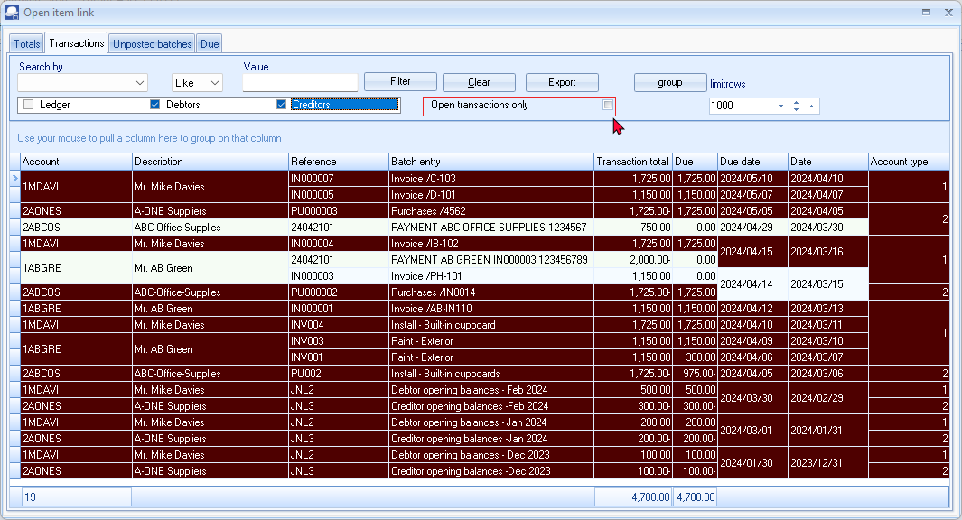
Only outstanding transactions “Open transactions only” selected:
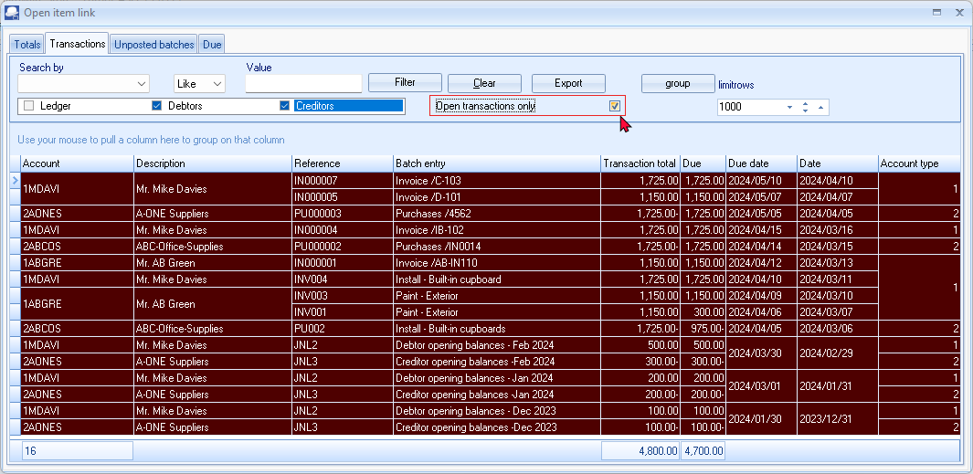
Filter options:
- Search by - Select any of the column headings and an operator (e.g. Like (default), =, <, >, <=, =>, or <> ) and enter a value. Click on the Filter button. Only those transactions matching your specified values will be listed. To clear the values, click on the Clear button.
- Account type - Select (tick) or deselect (remove the tick) to list the accounts for the selected account type(s) (Ledger, Debtors or Creditors).
- Open transactions only - By default, this option is not selected and will list all transactions, including those with a 0.00 balance. If this field is ticked, it will list only those transactions with a value of more than 0.00 in the "Due" column.
- Group - Click on the group button to group the transactions on the list by "Month, From today, By date" and "By year".
You may also drag columns to the "Use your mouse to pull a column here to group on that column" row.
- Limit rows - 200 rows is the default number of rows or transactions to be listed. The number of rows may be specified (decreased or increased).
- Export - This button will create an “Export.txt” (Text files), which you may change the name and folder and save it. A Comma separated (CSV) file format is also available. Exported files can be used in a spreadsheet.
Unposted batches
The Unposted batches tab will list all transactions linked to open item accounts (i.e. ledger, debtors and creditors) in batches, which have not yet been posted (updated) to the ledger.
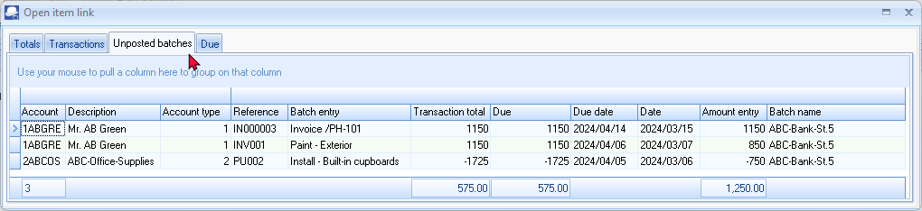
If any transactions are processed for open item accounts, and is not linked, these transactions will not be listed on the Unposted batches tab.
When processing transactions in batches and an open item account is selected, the “Open item selection” screen list all the outstanding transaction. For example, if a payment is received, you may select to link the receipt to outstanding amount(s) in batches as well as documents.
If a transaction in unposted batches is linked to outstanding amounts in the “Open item selection” screen the transaction line will be displayed in a yellow background.
You may remove linked transactions (right-click on selected transaction(s)) and select Remove on the context menu. A confirmation message "Continue action Unlink transaction?" will be displayed. Click Yes to remove the link. This will clear the links in the unposted “Batch entry” screen.

To link transactions in the Receipts batch and Payments batch, you may refer to:
- Module L.3.2.2 – The account looked up by searching for the corresponding document
- Module L.3.2.3 – The account looked up by searching for the Debtors / Creditors account
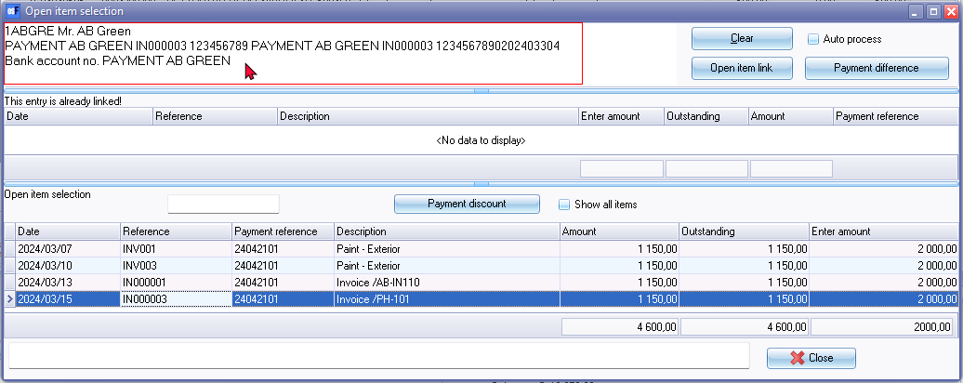
Due tab
The Due tab allows you to generate and print an age analysis “Open item – Due report”. You may select the account type, Ledger, Debtor and / or Creditor accounts.
The Due tab may also be accessed from the Age analysis icon on the Reports ribbon.

In this tutorial, based on HANDY-BANK, HANDY-BANK-A and HANDYBANK-B books, only two debtor accounts (i.e. “AB Green” and “Mike Davies”) and two creditor accounts (i.e. “ABC Office Supplies” and “A-One Suppliers”), are set as Open item on the “Accounting information” tab.


Current date as Date of ageing
In this example, the “Debtor” accounts is selected. Date of ageing the “Date” option is selected. The “Date of ageing” is set to “Current date”.
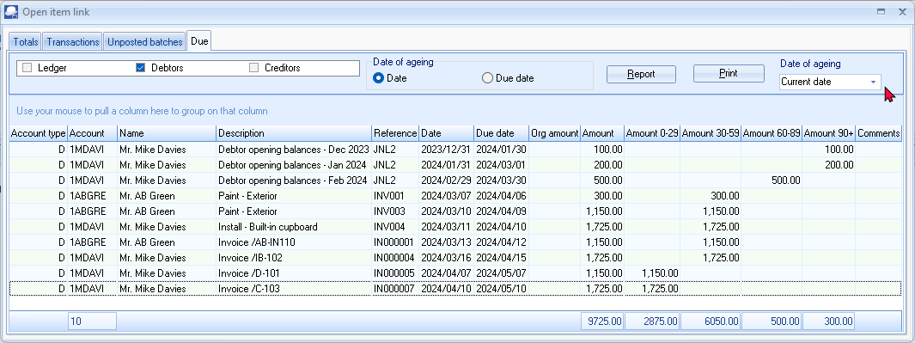
Click on the Report button. Only the debtor accounts set as Open item will be listed. It will list the Amount outstanding for each transaction (i.e. invoice, etc.) in 0-29, 30-59, 60-89 days and more than 90 days.
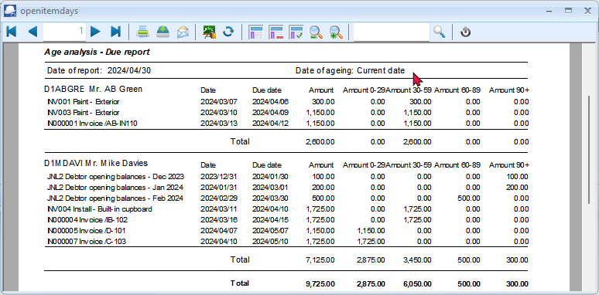
Only the transactions with outstanding amounts will be listed.
In Mr. AB Green’s case INV001 and the Deposit of 2,000.00 will not be listed.
In respect of INV001, only the outstanding amount of 300.00 will be listed.
See – To link transactions in the Receipts batch and Payments batch, you may refer to:
Module L.3.2.2 – The account looked up by searching for the corresponding document
Mr. AB Green paid 2,000.00 (1,150.00 for IN000001 and 850.00 for INV001), -
- Deposit 31031101 – 2,000.00 - Outstanding amount = 0.00
- Invoice IN000001 – 1,150.00 - Outstanding amount = 0.00
- Invoice INV001 – 1,150.00 - Outstanding amount = 300.00 (Invoice amount 1,150.00 less 850.00 partial settlement = 300.00).
Select Date of Ageing
If a Date of Ageing is selected, the accounts, which is not set as Open item (Balance brought forward accounts) will be added to the report.
Select the account type, e.g. “Debtor”.
Select the “Date of ageing”.
Click on the Report button to generate the report.
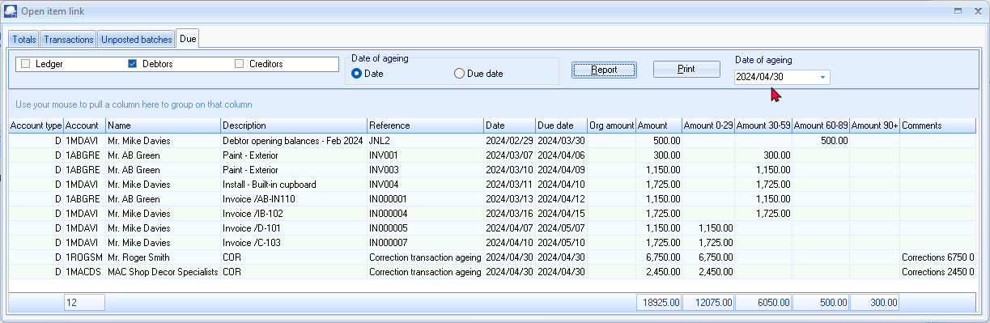
Click on the Print button to print the “Age analysis – Due” report.
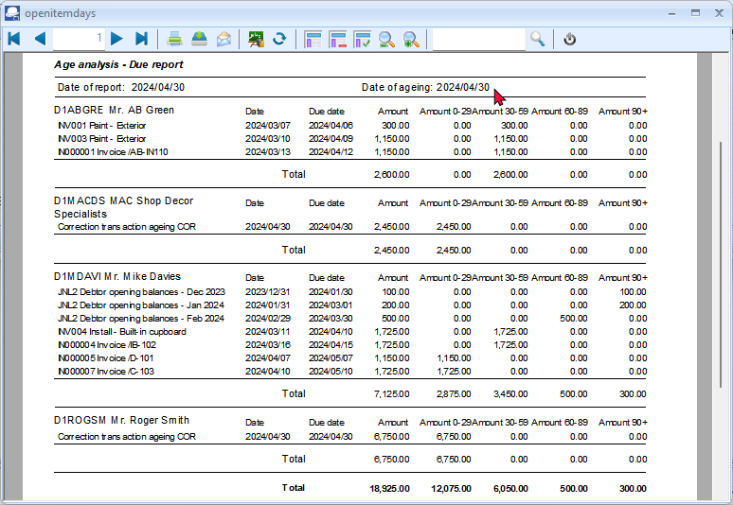
The Balance brought forward accounts (i.e. Mac Shop Decor and Mr. Roger Smith is not set as Open item accounts) will be included in this report.
The transaction details will not be available and is displayed as “Correction transaction ageing COR”. This will add Non-Open item account balances”.
OPEN ITEM PROCESSING - SELECTED ACCOUNTS
After selecting and double-click on a selected account on the Totals or Transactions or Unposted batches tabs, the “Open item link” screen for the selected account will be displayed.
Since the Creditor – Open item processing is basically similar to the Debtor open item processing, the Creditor open item processing will not be discussed in this tutorial.
Selected account – Default view
If no transactions are linked for the open item debtor (customer / client) account, all the transactions will be listed.
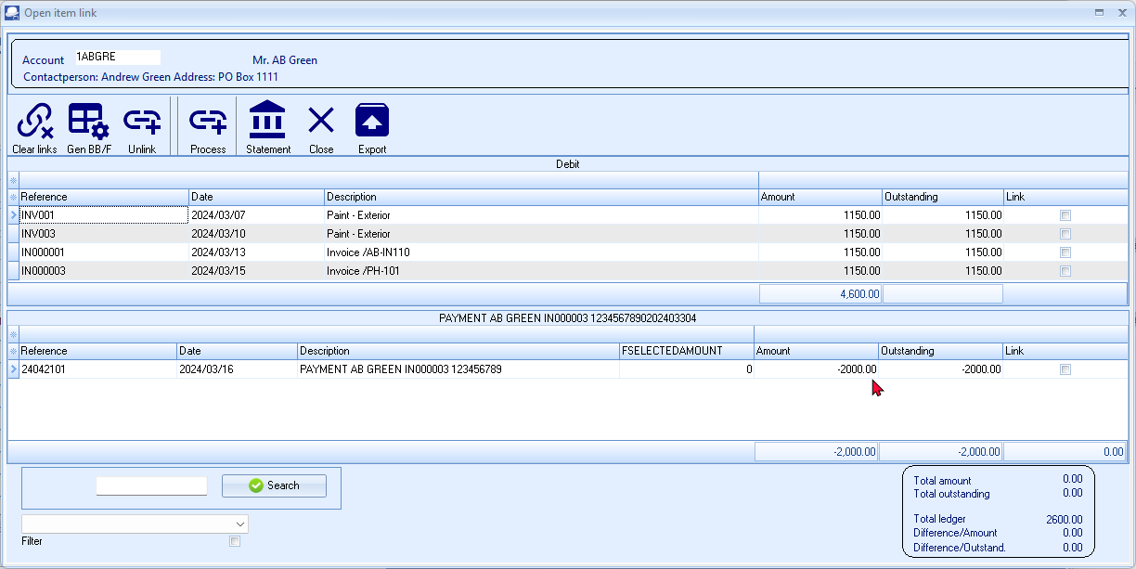
If the payment received transactions are linked for the open item debtor account, only the transactions with outstanding amounts will be listed.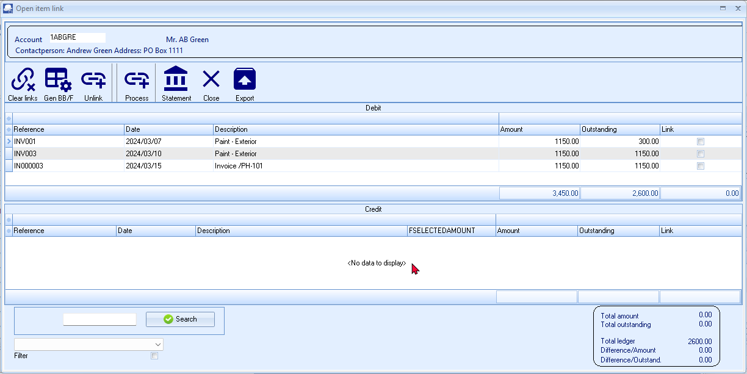
See – To link transactions in the Receipts batch and Payments batch, you may refer to:
Module L.3.2.2 – The account looked up by searching for the corresponding document
Mr. AB Green paid 2,000.00 (1,150.00 for IN000001 and 850.00 for INV001) -
- Deposit 31031101 – 2,000.00 - Outstanding amount = 0.00
- Invoice IN000001 – 1,150.00 - Outstanding amount = 0.00
- Invoice INV001 – 1,150.00 - Outstanding amount = 300.00 (Invoice amount 1,150.00 less 850.00 partial settlement = 300.00).
The following icons are available to process and manage Open item links:
- Clear links - This option will clear the open item links for a selected debtor or creditor account.
- Gen BB/F - This option will clear all the open item links, and generate the ageing as balance brought forward account for a selected debtor or creditor account.
- Unlink - This option allows you to unlink a selected transaction (a receipt or credit note, which is linked to an invoice in the case or a debtor, or a payment pr supplier return linked to a purchase transaction in the case of a creditor).
- Process - Select (tick) the debit and credit transaction(s) to be linked. You then need to click on the Process icon. A screen “Enter amount” may be displayed on which you need to over-type the amount, if necessary.
Any linked transaction(s) will be removed from the debit or credit sections of the “Open item link” screen.
- Statement - Click to view the selected debtor or creditor account in a statement layout with the ageing labels (e.g. Current, 30 days, 60 days, etc.).
- Export – This will export the transactions in a Text (Export.txt) file or a Comma separated value (Export.csv) file.
- Close – The “Open item link” screen will be closed for the selected account.
Statement view
If you click on the Statement icon, it will list all the transactions, including those transactions with a 0.00 balance, as well as any outstanding amount(s) which is not the same value as in the Amount column.
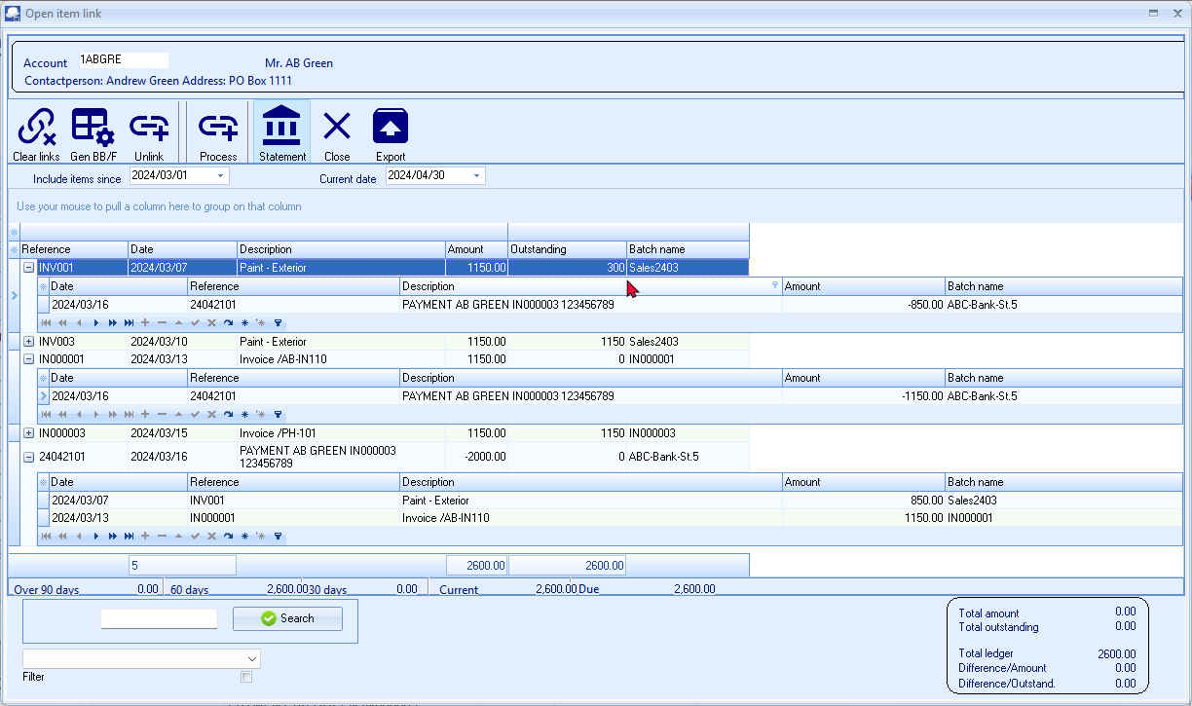
Select the dates “Include items since” and the “Current date” to view the transactions for specific dates or periods.
Select a transaction (with Outstanding amounts of 0.00 or any outstanding amount which is not the same as the Amount (transaction amount). If you click on the + icon, the details of the linked transaction(s) will be displayed.
See – To link transactions in the Receipts batch and Payments batch, you may refer to:
Module L.3.2.2 – The account looked up by searching for the corresponding document
Mr. AB Green paid 2,000.00 (1,150.00 for IN000001 and 850.00 for INV001), -
- Deposit 31031101 – 2,000.00 - Outstanding amount = 0.00
- Invoice IN000001 – 1,150.00 - Outstanding amount = 0.00
- Invoice INV001 – 1,150.00 - Outstanding amount = 300.00 (Invoice amount 1,150.00 less 850.00 partial settlement = 300.00).

ADJUST PAYMENT DATES / RECEIVE PAYMENT
On the context menu for a selected transaction on the “Transactions” tab, you may select to change the payment date or to receive a payment.
Adjust payment date
The Payment date (due date) is automatically calculated by adding the number of days (entered in the “Due date” field on the Accounting information tab of Debtor/ Creditor accounts) to the date of the document (i.e. invoices, credit notes, purchase and supplier return documents) and the transaction dates entered in batches.
Receive payment
The Receive payment feature, will automatically generate the transactions to the receipts batch for a selected transaction and print a combined receipt / payment advise (if selected). The transaction will automatically be posted updated to the ledger.

OPEN ITEM REPORTS
Open Item reports summary
Debtor reports
The following reports for Open item processing is available on the Reports menu:
- Debtors → Age analysis – Balances detail history (open item)
- Debtors → Outstanding – Debtor statements – Outstanding
The following reports for Open item processing is available on the User reports menu:
- Debtors → Outstanding – Due date
- Debtors → Outstanding – Outstanding at date
Creditor reports
The following reports for Open item processing is available on the Reports menu:
- Creditors → Age analysis – Balances detail history (open item)
- Creditors → Outstanding – Creditor remittance advice – Outstanding
The following reports for Open item processing is available on the User reports menu:
- Creditors → Outstanding – Due at date
- Creditors → Outstanding – Outstanding at date
Since the Creditor – Open item reports is basically similar to the Debtor open item reports, the Creditor open item processing will not be discussed in this tutorial.
Debtor transaction reports
Debtors → Transactions – Transaction list – Open item
Debtor age analysis reports
You may need to analyse your debtors (customers / clients) accounts on a regular basis. It is recommended that the age analysis reports are printed after all batches and documents are posted (updated).
Balances detail
The Debtors → Age analysis → Balances detail report will list - All the Debit and Credit transactions (irrespective of Open item transactions processed (Credit transactions linked to Debit transactions)).
To print debtor age analysis details reports:
- On the Reports ribbon, select Reports → Debtors → Age analysis. The Balances detail report options is displayed:
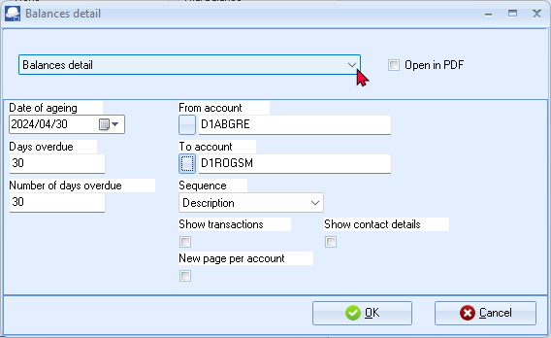
- Enter or select the following:
Date of ageing: | - Select the date i.e. “2024/04/30”.
Days overdue: | - Enter “30”.
Number of days overdue: | - Enter “30”.
From account: | - Select the first account on the list.
To account: | - Select the last account on the list.
Sequence: | - Select “Description”.
Show transactions: | - Leave blank. Only the totals will be printed. To print the transactions, you may select this option.
Show contact details: | - Leave blank.
New page per account: | - Leave blank.
- Click OK.

An example of the “Debtor age analysis – Balances detail” report, is as follows:
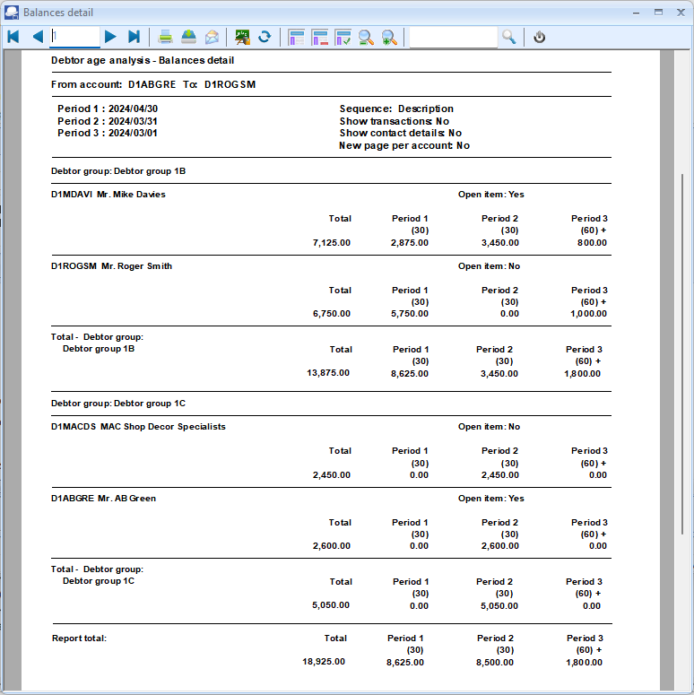

Balances detail history (Open item)
This report is basically similar to the Balances detail report. The balances detail (Open item) report will list all the transactions as well as the Outstanding amount. It will list the details of transactions linked (e.g. fully paid invoices) with an outstanding amount of 0.00.
To print debtor age analysis detail history (open item) reports:
- On the Reports ribbon, select Reports → Debtors → Age analysis. The Balances detail report options will be displayed.
- Select the Balances detail history (open item) report.
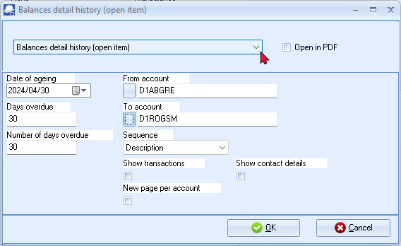
- Enter or select the following:
Date of ageing: | - Select the date i.e. “2024/04/30”.
Days overdue: | - Enter “30”.
Number of days overdue: | - Enter “30”.
From account: | - Select the first account on the list.
To account: | - Select the last account on the list.
Sequence: | - Select “Debtor code”.
Show transactions: | - Leave blank. Only the totals will be printed. To print the transactions, you may select this option.
Show contact details: | - Leave blank.
New page per account: | - Leave blank.
- Click OK.

Transactions - Balances detail vs Balances detail (open item) reports
Balances detail report – Transactions
All the Debit and Credit transactions will be listed (irrespective of Open item transactions processed (Credit transactions linked to Debit transactions).
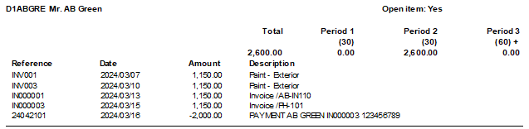
Balances detail history (open item) report – Transactions
All the Debit and Credit transactions will be listed. The outstanding amounts will be displayed including 0.00 for transaction that is fully settled.
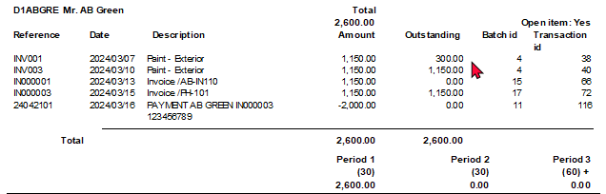
See – To link transactions in the Receipts batch and Payments batch, you may refer to:
Module L.3.2.2 – The account looked up by searching for the corresponding document
Mr. AB Green paid 2,000.00 (1,150.00 for IN000001 and 850.00 for INV001), -
- Deposit 31031101 – 2,000.00 - Outstanding amount = 0.00
- Invoice IN000001 – 1,150.00 - Outstanding amount = 0.00
- Invoice INV001 – 1,150.00 - Outstanding amount = 300.00 (Invoice amount 1,150.00 less 850.00 partial settlement = 300.00).

Show contact details option
You may select the “Show contact details” option to view the details for each debtor included in the report.
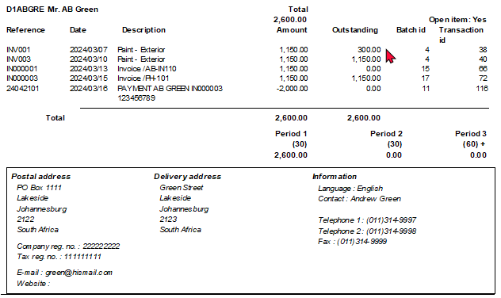

Debtor statements
You may send debtor statements to your debtors (customers / clients) on a regular basis. It is recommended that the statements are printed after all batches and documents are posted (updated). The following two (2) debtor statements may be printed:
- Debtor statements – All the Debit and Credit transactions are listed (irrespective of Open item transactions processed (Credit transactions linked to Debit transactions)).
- Debtor statements – Outstanding – Only the outstanding Debit and Credit transactions are listed.
Debtor statements - Outstanding
To print debtor statements:
- On the Reports ribbon, select Reports → Debtors → Debtor statement. Debtor statement (default report) will automatically be selected. This default debtor statement will print all transactions debits and credits.
- Select the Debtor statement – Outstanding report to print only the outstanding amounts of transactions not linked in Open item processing.
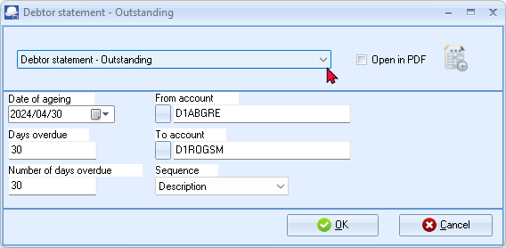
- Enter or select the following:
Date of ageing: | - Select the date i.e. “2024/04/30”.
Days overdue: | - Enter “30”.
Number of days overdue: | - Enter “30”.
From account: | - Select the first account on the list.
To account: | - Select the last account on the list.
Sequence: | - Select “Description”.
- Click OK.

An example of the “Debtor statement - Outstanding”, is as follows:
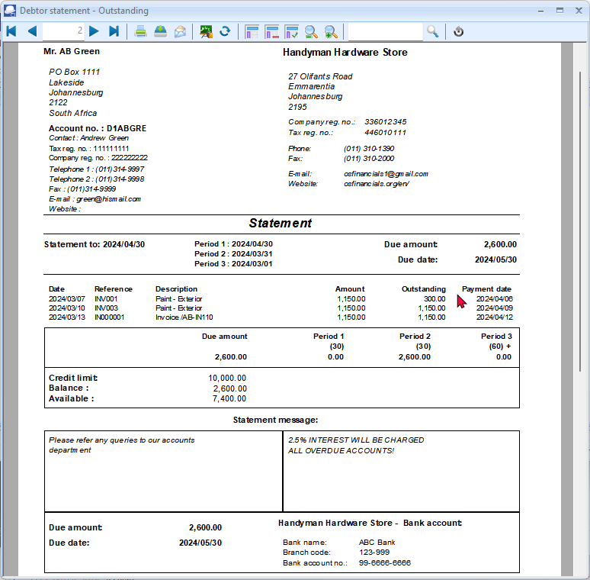
The information, is as follows:
- Header (Left) - Debtor information as entered / edited on the debtor account - Debtors (Default ribbon).
- Header (Right) - Company information as entered / edited on Setup → Company info (Setup ribbon).
If the Company logo is loaded in the “Options” screen of Setup → Company info (Setup ribbon), the logo will be displayed instead of the Company name, Address (4 lines) and Telephone and Fax numbers.
- Statement to - The date as entered (selected) on the “parameters” screen. The periods number of days specified on the “parameters” screen is displayed. The outstanding totals for each period is displayed as a summary for the periods at the end of the transaction section.
- Transactions - This displays the date, reference, description and amount for each transaction. The payment date for each transaction is the date of the transaction plus the number of days entered in the “Due days” field on the Accounting information tab of the debtor account.
- Credit limit - The amount as entered in the “Credit limit” field on the Accounting information tab of the debtor account. The Balance at is the current balance of the debtor account of all posted transactions and documents as at the date of printing of the Debtor statements. The Available amount is calculated the Credit limit less the Balance at amount as at the date of printing of the Debtor statements.
- Statement message - This consists of two (2) sections:
  - Statement message (Left) - Up to three (3) lines as entered on the Delivery address tab of the debtor account.
  - Statement message (Right) - Up to three (3) lines as entered on the Statement setup tab on the Documents setup (Setup ribbon).
- Due amount, Due date and Banking details - The amount payable and the date on which the payment is due. The Banking details (Bank account 1 ) as entered on Company info (Setup ribbon) will be displayed on the Debtor statement.
The Banking details (as entered in the Company info (Setup ribbon) is not available in Creditor remittance advices.

Debtor statement vs Debtor statement – Outstanding
Debtor statement - All the Debit and Credit transactions are listed (irrespective of Open item transactions processed (Credit transactions linked to Debit transactions)).
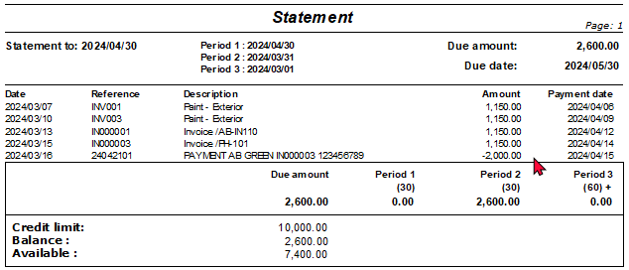
Debtor statement – Outstanding – Only the outstanding Debit and Credit transactions are listed.
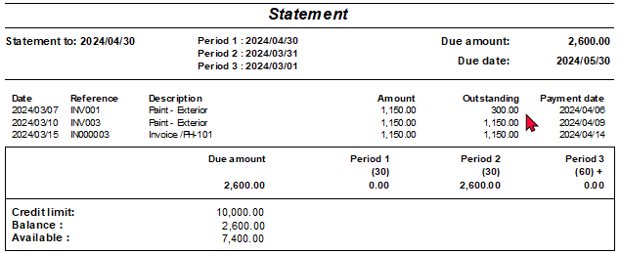
See – To link transactions in the Receipts batch and Payments batch, you may refer to:
Module L.3.2.2 – The account looked up by searching for the corresponding document
Mr. AB Green paid 2,000.00 (1,150.00 for IN000001 and 850.00 for INV001), -
- Deposit 31031101 – 2,000.00 - Outstanding amount = 0.00
- Invoice IN000001 – 1,150.00 - Outstanding amount = 0.00
- Invoice INV001 – 1,150.00 - Outstanding amount = 300.00 (Invoice amount 1,150.00 less 850.00 partial settlement = 300.00).

REPORTMAN
IN THIS MODULE
MODULE Q - REPORTMAN 477
Q.1- REPORTMAN INTERFACE 479
Q.2- REPORTS FILES AND FOLDERS 481
Q.2.1- Reports menu – File names and file structure 484
Q.2.2- Spreadsheet reports menu – File names and file structure 495
Q.2.3- User reports menu – File names and file structure 496
Q.3- User reports menu - Graphs - File names and file structure 496
Q.3.1- Graphs per week (TRN_906558) 497
Q.3.2- Graphs per month (TRN_906559) 499
Q.4- LAYOUT FILES 501
Q.4.1- Select layout files 502
Q.4.2- De-select layout files 502
Q.4.3- Customising document layout files 503

REPORTMAN INTERFACE
All document layout files and reports are installed and stored in the ...\plug_ins\reports folder of your installation directory.
To access the Report designer:
Select the Report designer on the Setup ribbon. The “Report designer” will list all layout files and report folders as follows:
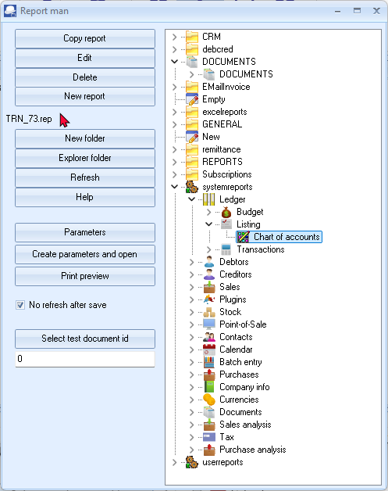
The buttons and options, is as follows:
- Copy report – If you need to edit a layout file or report, you need to select a file. If you click on a report or layout file, and you click on the Copy report button, it will create an exact copy (e.g. Copy of Reportname) of the report *.rep and the parameters *.dfm (if the report has parameters) file(s).
It is recommended that you do not edit an existing layout file or report, but create a copy and edit the copy until you get the required results.
You may then rename the report. If you have any customised reports, you may create folders in the ...\plug_ins\reports\userreports\ folder and copy your reports to your folder. These reports may then be accessed from User reports (Reports ribbon).
Document layout files cannot be printed from any other folder than the ...\plug_ins\reports\DOCUMENTS\DOCUMENTS folder.
- Edit – Launches the “Report manager designer” screen, where you may edit an existing report or layout file or create or edit a new report or layout file.
- Delete – This will delete a selected layout file or report (*.rep) file (and the parameter (*.dfm) file, if applicable).
Please make sure that the correct report is selected. Deleting the incorrect report, the report will be permanently lost.
- New report – This will launch a blank report with no datasets using the ...\plug_ins\reports\New.rep template file. When you save the New.rep file, it will save it as New.rep in the folder in which the New report button was clicked on.
You may click on the New.rep and click again to rename the report.
If the New.rep is in the “Reportman designer” screen, you may use the File → Save as menu to save the report with your own name.
- New folder – This will create a New folder in the selected folder. You need to double-click to rename the New folder.
- Explorer folder - If a report is selected it and you click on this button, the folder containing that report will be launched in Windows Explorer or your system's default file browser.
- Refresh - This will refresh the display (list of folders and files) in the “Reportman” screen.
The “No refresh after save” option is by default selected (ticked). If this ticked is removed, it will automatically refresh the “Reportman” screen when a report or layout file is selected. This may slow down your system.
- Help - This button is inactive. The off-line Reportman help can be accessed from the .../plug_ins/reportman/doc/indexes.html file in the TurboCASH5 installation directory.
You may access the online help at http://reportman.sourceforge.net/
If you focus on a specific area of the “Reportman designer” screen, a “?” will be added to the cursor, it will launch the specific topic at sourceforge (e.g. http://reportman.sourceforge.net/doc/refcommon.html).
- Parameters - If a report has parameters, and you click on the Parameters button, the “Parameters” screen for the selected report will be launched.
- Create parameters and open – This will launch the “Reportmanager designer” screen on which you may edit the parameters (Report → Parameter definition menu) and Datasets (Report → Data access configuration menu).
If a report has no parameters and you click on this button, it will display an error message, e.g.
"No params found. create one first “...\plug_ins\reports\userreports\Custom Reports\New.dfm"
You then need to close this message and click on the Parameters button to create parameters. If you find another report with similar parameters, you may copy the parameter *.dfm file to the folder of your report and rename it to the name of your report.
You then need to edit the parameters and report.
- Preview - Click to preview a document layout file or a report. If a report has parameters, it will launch the report “parameters” screen on which you may select the options to preview the data in the report.
While editing a document layout file or a report, you may click on the Preview icon of the Report manager designer screen.
- Select test document id - If you click on the Preview button if document layout files (in the ...\plug_ins\reports\DOCUMENTS\DOCUMENTS folder) are selected the last document processed or printed will be previewed. If you click on this button you may select any other posted or unposted document to preview.

REPORTS FILES AND FOLDERS
All document layout files and reports are installed and stored in the ...\plug_ins\reports folder of your installation directory.
When launching the Report designer, all report folders are displayed as follows:
The directories (folders and files are as follows):
- Document printing – All the layout files for printing documents are stored in the ...\plug_ins\reports\DOCUMENTS\DOCUMENTS folder.
Press the F1 key and search (Search titles only) for layout files. See “Layout files for Sales documents” and “Layout files for Purchase documents”.
Press the F1 key and search (Search titles only) for “Working with Reportman”. This will introduce you to the Reportman interface and to customise document layout files.
- Reports (Reports ribbon) – These reports are stored in the ...\plug_ins\reports\systemreports\ folder.
- User reports (Reports ribbon) – These reports are stored in the userreports folder. Users are encouraged to create and / or edit existing reports, but it is recommended that these be copied and stored in the ...\plug_ins\reports\userreports\ folder.
- Spreadsheet reports (Reports ribbon) - These reports are stored in the ...\plug_ins\reports\excelreports\ folder. These reports will be opened in the powerful spreadsheet component.
See video on Spreadsheet reports.
- Ledger analyser and Reports → T-Account viewer (Reports ribbon) – Seven (7) reports are stored in the ...\plug_ins\reports\GENERAL\ledgerview folder. These are:
    - budgetvsactsimple – Budget vs actual and This year vs last year reports.
    - colbal – Not used.
    - colbalopen – Not used.
    - colbalopenonly – Not used.
    - colbalsimple – Standard column balances report.
    - detail – Trial balance, Income statement and the Balance sheet.
    - ledgerdetail – Print button on the T-Account viewer prints the T-Account viewer report.
- Reports generated from inside the TurboCASH5 program on various screens are stored in the ...\plug_ins\reports\GENERAL\documents folder. These are:
    - Batch processing - Batch entry (F2) (Default ribbon):
      - abbreviations – Abbreviation definitions as set in the Batch entry – F9:Process option (Default ribbon). If you click on the Print button of the Abbreviation screen, a list of Abbreviation definitions will be printed. The abbreviations listed on this report, may be used to automatically fill the description column in the document lines when processing documents (invoices, credit notes, quotes, purchases, supplier returns and orders).
      - batch – Batch Listing on the Batch entry – F8:List – This will print a list of all transactions in an unposted batch.
      - postedbatch - Batch Listing on the Batch entry – Posted batches – Details tab – Print button - This will print a list of all transactions in a posted batch.
      - paycreditor - Prints the Creditor payments report when clicking on the Print button in the “Payments Debtors / Creditors” option (Batch entry – F9:Process).
      - paydebtor – Prints the Debtor payments report when clicking on the Print button in the “Receive Payments / Creditors” option (Batch entry – F9:Process).
      - receipt – Prints a receipt if the “Create receipt” option is selected for Receipt batches in the Batch entry – F9:Process (and if the “Print” option is ticked).
      - recon – Prints the Bank reconciliation report when clicking on the Report icon of the Reconcile bank (Reconciliation (Default ribbon)).
    - Documents (Documents (F6)) (Default ribbon):
      - barcodes – Context menu - Quick link to print the barcodes of the stock items selected on documents.
      - labels - Context menu - Quick link to print the postal address labels (and Contact name) of the debtors (customers / clients) selected on sales documents or creditors (suppliers) selected on purchase documents.
      - labelsdelivery – Not implemented yet. This is similar than the labels report, but should print delivery addresses in stead of postal addresses.
    - Point-of-Sales (Standard) - Input → POS Invoice (Ctrl + F6) (Default ribbon):
      - oldpossales – This sales report prints from the Process - Reports or Cashup option on the POS Invoicing screen.
      - oldposcashup - This cashup report prints from the Process - Reports or Cashup option on the Input → POS Invoicing screen (Default ribbon).
    - Others
      - datacheck – Prints the Data integrity check report from the Tools → Data integrity check menu (Setup ribbon).
      - groups – Prints the list of the Account group 1 / 2, Debtor group 1 / 2, Creditor group 1 / 2, Stock group 1 / 2, Document group 1 / 2, etc. when clicking on the Print button of a selected group on Setup → Groups (Setup ribbon).
      - payments – Prints a Receipts / Payments advise when the Receive payment context menu option is selected (and the “Print” option is ticked) on the Open item link - Transactions tab (Default ribbon) or on the “Open item link” screen for a debtor (customer / client) or creditor (supplier) account.
      - Userlog – Prints the Userlog report when clicking on the Log report button on the Setup → Access control (Setup ribbon).
- REPORTS
    - CREDITOR – (Default – Creditors (F5) menu) – Selected creditor label (Postal address) and Selected creditor delivery label (Delivery address). Print when you right-click on a selected creditor (supplier) account from the list.
    - DEBTOR – (Default – Debtors (F4) menu) – Selected debtor label (Postal address) and Selected debtor delivery label (Delivery address). Print when you right-click on a selected debtor (customer / client) account from the list.
    - STOCK – (Default – Stock items (F12) menu) – Barcode and Yagoda barcode. Print when you right-click on a selected stock item or stock items from the list.
    - PROJECTS – If projects have been activated and transactions have been entered in batches and documents, you may print five (5) reports (i.e. Transactions, Hours, Stock items, Statements and the Total report). Budgets can also be entered for Projects, but it needs to be added to these reports.
    - HORECAPOS – This folder contains the reports for the HORECAPOS and RETAILPOS Plugins.
    - SUBSCRIPT – This folder contains the Subscriptions report. (See the Subscriptions folder – This folder contains the report, emailtemplates, layouts and Sql for the Subscriptions Plugin).
    - REPORTS FOLDER (Discontinued Reports) - The BATCHREPORT, CONTACTS, COSTCENTER, GL and TAX folders contains old reports not used in TurboCASH5.
- Folders and reports for Plugins
    - EmailInvoice and debcred folders are used for the E-MailPro Plugin
    - parcel – This is not used at this stage – It is reserved for a Send Parcel Plugin.
    - remittance – This contains the list report, emailtemplates and layouts for the Reminders Plugin.
    - Subscriptions – This folder contains the report, emailtemplates, layouts and Sql for the Subscriptions Plugin.

Reports menu – File names and file structure
The reports on the Reports menu is stored in the “...\plug_ins\reports\systemreports” folder.
When printing reports using the “Material” theme, the icons in the “Material” theme folder will be displayed in menus and the icons in the “Classic” theme folder will be displayed on the report parameters screens and in Reportman.
For your convenience, a list of the file names and structure of the reports in the Reports menu (Reports ribbon), is as follows:
Folder /  Menu | Sub-folder1  Menu item | Sub-folder2  Sub-menu | Internal folder name /  Report name | Internal report name | Classic  theme | Material  theme
Ledger |  |  | TRN_1372 |  | 
 | Budget |  | TRN_1027 |  | 
 |  |  | Budget vs actual (3 periods) | TRN_3372
 | Listing |  | TRN_66 |  |  | 
 |  |  | Chart of Accounts | TRN_73
 | Transactions |  | TRN_74 |  | 
 |  |  | Transactions | TRN_74
 |  |  | Transactions - Standard | TRN_906110
 |  |  | Transactions - Extra details | TRN_906111
Debtors |  |  | TRN_160 |  | 
 | Debtor statement |  | TRN_1090 |  | 
 |  |  | Debtor Statements | TRN_1090
 |  |  | Debtors statement - Outstanding | TRN_906552
 | Age analysis |  | TRN_65 |  | 
 |  |  | Balances detail | TRN_906142
 |  |  | Balances detail history (open item) | TRN_906143
 |  |  | Balances | TRN_906147
 | Listing |  | TRN_66
 |  |  | Contacts | TRN_2876
 |  |  | Listing | TRN_66
 |  |  | List delivery address | TRN_906138
 |  |  | List postal address | TRN_906139
 |  |  | List details | TRN_906140
 |  |  | Credit control listing (Credit limit vs Current balance) | TRN_906338
 |  |  | Tax and Company registration numbers | TRN_906339
 | Print labels |  | TRN_68 |  |  | 
 |  |  | Delivery address labels | TRN_906064
 |  |  | Postal address labels | TRN_906137
 | Transactions |  | TRN_74
 |  |  | Transactions | TRN_74
 |  |  | Transaction list - Open item | TRN_906061
 |  |  | Transactions - Standard | TRN_906106
 |  |  | Transactions - Extra details | TRN_906107
 |  |  | Transaction list | TRN_906440
Creditors |  |  | TRN_161 |  | 
 | Creditor remittance advises |  | TRN_1089
 |  |  | Creditor remittance advise | TRN_1089
 |  |  | Creditor remittance advise - Outstanding | TRN_906551
 | Age analysis |  | TRN_65
 |  |  | Balances detail | TRN_906142
 |  |  | Balances detail history (open item) | TRN_906143
 |  |  | Balances | TRN_906147
 | Listing |  | TRN_66
 |  |  | Contacts | TRN_2876
 |  |  | Listing | TRN_66
 |  |  | List delivery address | TRN_906138
 |  |  | List postal address | TRN_906139
 |  |  | List details | TRN_906140
 |  |  | Credit control listing (Credit limit vs Current balance) | TRN_906338
 |  |  | Tax and Company registration numbers | TRN_906339
 | Print labels |  | TRN_68
 |  |  | Delivery address labels | TRN_906064
 |  |  | Postal address labels | TRN_906137
 | Transactions |  | TRN_74
 |  |  | Transactions | TRN_74
 |  |  | Transaction list - Open item | TRN_906061
 |  |  | Transactions - Standard | TRN_906108
 |  |  | Transactions - Extra details | TRN_906109
 |  |  | Transaction list | TRN_906440
Sales |  |  | TRN_1792 |  | 
 | Quotes |  | TRN_1870 |  | 
 |  | Debtors | TRN_160
 |  |  | Quotes per period - Quantities | TRN_906315
 |  | Sales | TRN_1792
 |  |  | Quotes per period - Quantities | TRN_906315
 |  | Items | TRN_2052 |  | 
 |  |  | Items per period | TRN_906115
 | Invoices |  | TRN_300 |  | 
 |  | Debtors | TRN_160
 |  |  | Invoices per period - Quantities | TRN_906155
 |  | Sales | TRN_1792
 |  |  | Invoices per period - Quantities | TRN_906155
 |  | Items | TRN_2052
 |  |  | Items per period | TRN_906115
 | Credit notes |  | TRN_47 |  | 
 |  | Debtors | TRN_160
 |  |  | Credit notes per period - Quantities | TRN_906311
 |  | Sales | TRN_1792
 |  |  | Credit notes per period - Quantities | TRN_906311
 |  | Items | TRN_2052
 |  |  | Items per period | TRN_906115
Plugins |  |  | TRN_1805 |  |  | 
 | Price agreement |  | TRN_3380 |  | 
 |  |  | Debtor – Price agreement | TRN_906035
 |  |  | Creditor – Price agreement | TRN_906088
 | Location-Serials-Batches |  | TRN_3398 |  | 
 |  |  | On hand | TRN_1777
 |  |  | Stock movement | TRN_906038
 |  |  | Outdated batch | TRN_906554
 |  |  | Batch bought from supplier | TRN_906555
 |  |  | Batch sold to customer | TRN_906556
Stock |  |  | TRN_1999 |  | 
 | Reorder |  | TRN_1778
 |  |  | Reorder report | TRN_83
 |  |  | Current stock levels | TRN_906268
 | Print labels |  | TRN_68
 |  |  | Barcode | TRN_1774
 |  |  | Yagoda barcode | TRN_906040
 | Stock item listing |  | TRN_84
 |  |  | All selling prices | TRN_1056
 |  |  | Tax classes | TRN_3465
 |  |  | Stock item listing | TRN_84
 | Backorder |  | TRN_906050
 |  |  | Backorder | TRN_906050
 | Stock In / Out |  | TRN_906112
 |  |  | Stock In / Out - Documents | TRN_38
 |  |  | Stock In / Out | TRN_906112
Point-of-Sale |  |  | TRN_2200 |  | 
 | Standard |  | TRN_1990
 |  |  | Sales | TRN_1792
 |  |  | Receipts | TRN_182
 | Cash slip printer |  | TRN_906160
 |  |  | Sales | TRN_1792
 |  |  | Receipts | TRN_182
Contacts |  |  | TRN_2876 |  |  | 
 |  |  | Contacts | TRN_2876
Calendar |  |  | TRN_2879 |  | 
 |  |  | Hours | TRN_2330
Batch entry |  |  | TRN_298 |  |  | 
 |  |  | Documents | TRN_38
 |  |  | Batch transactions per period | TRN_906141
Purchases |  |  | TRN_49 |  | 
 | Purchase documents |  | TRN_1269 |  |  | 
 |  | Creditors | TRN_161
 |  |  | Purchases per period - Quantities | TRN_906150
 |  | Items | TRN_2052
 |  |  | Items per period | TRN_906115
 |  | Purchases | TRN_302
 |  |  | Purchases per period - Quantities | TRN_906150
 | Orders |  | TRN_1871
 |  | Creditors | TRN_161
 |  |  | Orders per period - Quantities | TRN_906317
 |  | Items | TRN_2052
 |  |  | Items per period | TRN_906115
 |  | Purchases | TRN_302
 |  |  | Orders per period - Quantities | TRN_906317
 | Supplier returns |  | TRN_303 |  | 
 |  | Creditors | TRN_161
 |  |  | Supplier returns per period - Quantities | TRN_906313
 |  | Items | TRN_2052
 |  |  | Items per period | TRN_906115
 |  | Purchases | TRN_302
 |  |  | Supplier returns per period - Quantities | TRN_906313
Company info |  |  | TRN_320 |  | 
 |  |  | Bank accounts | TRN_183
 |  |  | Information | TRN_629
Currencies |  |  | TRN_3470 |  | 
 |  |  | Currencies | TRN_3470
Documents |  |  | TRN_38 |  | 
 | Document listing |  | TRN_45
 |  |  | Document listing | TRN_45
 | Document listing per account |  | TRN_906161
 |  | Sales documents | TRN_1268
 |  |  | Invoices | TRN_300
 |  |  | Quotes | TRN_418
 |  |  | Credit notes | TRN_706
 |  | Purchase documents | TRN_1269
 |  |  | Purchases | TRN_302
 |  |  | Supplier returns | TRN_303
 |  |  | Orders | TRN_798
 | Unprinted document listing |  | TRN_906162
 |  | Sales documents | TRN_1268
 |  |  | Invoices | TRN_300
 |  |  | Quotes | TRN_418
 |  |  | Credit notes | TRN_706
 |  | Purchase documents | TRN_1269
 |  |  | Purchases | TRN_302
 |  |  | Supplier returns | TRN_303
 |  |  | Orders | TRN_798
Sales analysis |  |  | TRN_85
 | Quotes per period |  | TRN_3568
 |  |  | Quotes per period - Debtor group1 | TRN_906301
 |  |  | Quotes per period - Debtor group2 | TRN_906302
 |  |  | Quotes per period - Document group1 | TRN_906303
 |  |  | Quotes per period - Document group2 | TRN_906304
 |  |  | Quotes per period - Salesperson | TRN_906305
 | Invoices per period |  | TRN_3570
 |  |  | Invoices per period - Debtor group1 | TRN_906157
 |  |  | Invoices per period - Debtor group2 | TRN_906158
 |  |  | Invoices per period - Document group1 | TRN_906159
 |  |  | Invoices per period - Document group2 | TRN_906165
 |  |  | Invoices per period - Salesperson | TRN_906166
 | Credit notes per period |  | TRN_3569
 |  |  | Credit notes per period-Debtor group1 | TRN_906291
 |  |  | Credit notes per period-Debtor group2 | TRN_906292
 |  |  | Credit notes per period-Document group1 | TRN_906293
 |  |  | Credit notes per period-Document group2 | TRN_906294
 |  |  | Credit notes per period-Salesperson | TRN_906295
 | Sales per product |  | TRN_3571
 |  |  | Sales per product - Stock group1 | TRN_906174
 |  |  | Sales per product - Stock group2 | TRN_906175
 | Sales per period |  | TRN_906122
 |  |  | Sales per period - Debtor group1 | TRN_906332
 |  |  | Sales per period - Debtor group2 | TRN_906333
 |  |  | Sales per period - Document group1 | TRN_906334
 |  |  | Sales per period - Document group2 | TRN_906335
 |  |  | Sales per period - Salesperson | TRN_906336
Tax |  |  | TRN_906020 |  | 
 |  |  | Transactions | TRN_20069
 |  |  | Tax list debtor with tax id | TRN_3675
 |  |  | Tax per period | TRN_906105
 |  |  | Tax report – Reference / Document no. | TRN_906550
 |  |  | Tax list creditor with tax id | TRN_906553
Purchase analysis |  |  | TRN_977
 | Orders per period |  | TRN_3572
 |  |  | Orders per period - Creditor group1 | TRN_906306
 |  |  | Orders per period - Creditor group2 | TRN_906307
 |  |  | Orders per period - Document group1 | TRN_906308
 |  |  | Orders per period - Document group2 | TRN_906309
 |  |  | Orders per period - Salesperson | TRN_906310
 | Purchases per period |  | TRN_3573
 |  |  | Purchases per period - Creditor group1 | TRN_906152
 |  |  | Purchases per period - Creditor group2 | TRN_906153
 |  |  | Purchases per period - Document group1 | TRN_906154
 |  |  | Purchases per period - Document group2 | TRN_906163
 |  |  | Purchases per period - Salesperson | TRN_906164
 | Supplier returns per period |  | TRN_3574
 |  |  | Supplier returns per period - Creditor group 1 | TRN_906296
 |  |  | Supplier returns per period - Creditor group 2 | TRN_906297
 |  |  | Supplier returns per period - Document group 1 | TRN_906298
 |  |  | Supplier returns per period - Document group 2 | TRN_906299
 |  |  | Supplier returns per period - Salesperson | TRN_906300
 | Purchases per product |  | TRN_3575
 |  |  | Purchases per product - Stock group1 | TRN_906172
 |  |  | Purchases per product - Stock group2 | TRN_906173
 | Purchases and Supplier returns per period |  | TRN_906337
 |  |  | Purchases documents per period - Creditor group1 | TRN_906327
 |  |  | Purchases documents per period - Creditor group2 | TRN_906328
 |  |  | Purchases documents per period - Document group1 | TRN_906329
 |  |  | Purchases documents per period - Document group2 | TRN_906330
 |  |  | Purchases documents per period - Salesperson | TRN_906331

Spreadsheet reports menu – File names and file structure
These spreadsheet reports are stored in the “...\plug_ins\reports\excelreports” folder.
See video on Spreadsheet reports.
Selected reports will be opened in the powerful spreadsheet feature in TurboCASH5.
When printing reports using the “Material” theme, the icons in the “Material” theme folder will be displayed in menus and the icons in the “Classic” theme folder will be displayed on the report parameters screens and in Reportman.
For your convenience, a list of the file names and structure of the reports in the Spreadsheet reports menu (Reports ribbon) is as follows:
Menu item | Sub-menu item 1 | Sub-menu item 2 | Internal folder name | Classic  theme | Material  theme
Debtors |  |  | TRN_160
Creditors |  |  | TRN_161
Transactions |  |  | TRN_20069
 | Per period |  | TRN_3314 |  | 
General ledger |  |  | TRN_32
 | Budget |  | TRN_1027
 |  | This year | TRN_603
 |  | Reporting group 1 | TRN_1323 | 
 | Column balances |  | TRN_3106 | 
 |  | This year | TRN_603
 |  | Reporting group 1 | TRN_1323
Sales analysis |  |  | TRN_85
 | Stock movement |  | TRN_906038
 | Sales per period |  | TRN_906122

User reports menu – File names and file structure
These user reports are stored in the “...\plug_ins\reports\userreports” folder, These user reports are not included in the TurboCASH5 installation, but is included in the TurboCASH5 installation.
When printing reports using the “Material” theme, the icons in the “Material” theme folder will be displayed in menus and the icons in the “Classic” theme folder will be displayed on the report parameters screens and in Reportman.
For your convenience, a list of the file names and structure of the reports in the User reports menu (Reports ribbon) is as follows:
Menu item | Sub-menu item | Internal folder name /  Report name | Internal report name | Classic  theme | Material  theme
Custom reports
 |  |  | 2cred-sku-det
 |  |  | 2deb-sku-det
Tax |  | TRN_906583 | Tax codes – Tax rates
Debtors |  | TRN_160
 | Outstanding | TRN_947 |  | 
 |  | Due date | TRN_2222
 |  | Debtors Outstanding at date | TRN_906104
Creditors |  | TRN_161
 | Outstanding | TRN_947
 |  | Due date | TRN_2222
 |  | Creditors Outstanding at date | TRN_906103
Tutorial reports

User reports menu - Graphs - File names and file structure
In addition to the Graphs per week range of reports, the Graphs per month, range of reports is introduced. All graphs is structured in the User reports -> Graphs (TRN_906557) menu on the Reports ribbon.
Graphs per week (TRN_906558)
Menu item | Sub-menu item 1 | Internal folder name /  Report name | Internal report name | Classic  theme | Material  theme
Ledger | TRN_1372
 |  | Graph - Profit Loss per week | TRN_906169.rep
Debtors | TRN_160
 |  | Graph - Debtors per week | TRN_906168.rep
Creditors | TRN_161
 |  | Graph - Creditors per week | TRN_906167.rep
Sales | TRN_1792
 | Quotes per period | TRN_3568
 |  | Graph - Quotes per week - Quantities | TRN_906323.rep
 |  | Graph - Quotes per week - Amount | TRN_906324.rep
 | Credit notes per period | TRN_3569
 |  | Graph - Credit notes per week - Quantities | TRN_906319.rep
 |  | Graph - Credit notes per week - Amount | TRN_906320.rep
 | Invoices per period | TRN-3570
 |  | Graph - Invoices per week - Quantities | TRN_906170.rep
 |  | Graph - Invoices per week - Amount | TRN_906171.rep
 | Sales per period | TRN_906122
 |  | Graph - Invoices - Credit notes per week - Quantities | TRN_906579.rep
 |  | Graph - Invoices - Credit notes per week - Amount | TRN_906580.rep
Purchases |  | TRN_302
 | Purchases
 |  | Graph - Purchases - Supplier returns per week - Quantities | TRN_906581
 |  | Graph - Purchases - Supplier returns per week - Amount | TRN_906582
 | Orders per period
 |  | Graph - Orders per week - Quantities | TRN_906325.rep
 |  | Graph - Orders per week - Amount | TRN_906326.rep
 | Supplier returns per period
 |  | Graph - Supplier returns per week - Quantities | TRN_906321.rep
 |  | Graph - Supplier returns per week - Amount | TRN_906322.rep
 | Purchases per period
 |  | Graph - Purchases per week - Quantities | TRN_906289.rep
 |  | Graph - Purchases per week - Amount | TRN_906290.rep
Graphs per month (TRN_906559)
Menu item | Sub-menu item 1 | Internal folder name /  Report name | Internal report name | Classic  theme | Material  theme
Ledger | TRN_1372
 |  | Graph - Profit Loss per month | TRN_906560.rep
Debtors | TRN_160
 |  | Graph - Debtors per month | TRN_906561.rep
Creditors | TRN_161
 |  | Graph - Creditors per month | TRN_906562.rep
Sales | TRN_1792
 | Quotes per period | TRN_3568
 |  | Graph - Quotes per month - Quantities | TRN_906563.rep
 |  | Graph - Quotes per month - Amount | TRN_906564.rep
 | Credit notes per period | TRN_3569
 |  | Graph - Credit notes per month - Quantities | TRN_906565.rep
 |  | Graph - Credit notes per month - Amount | TRN_906566.rep
 | Invoices per period | TRN-3570
 |  | Graph - Invoices per month - Quantities | TRN_906567.rep
 |  | Graph - Invoices per month - Amount | TRN_906568.rep
 | Sales per period | TRN_906122
 |  | Graph - Invoices - Credit notes per month - Quantities | TRN_906569.rep
 |  | Graph - Invoices - Credit notes per month - Amount | TRN_906570.rep
Purchases |  | TRN_302
 | Purchases
 |  | Graph - Purchases - Supplier returns per month - Quantities | TRN_906571.rep
 |  | Graph - Purchases - Supplier returns per month - Amount | TRN_906572.rep
 | Orders per period
 |  | Graph - Orders per month - Quantities | TRN_906574.rep
 |  | Graph - Orders per month - Amount | TRN_906573.rep
 | Supplier returns per period
 |  | Graph - Supplier returns per month - Quantities | TRN_906576.rep
 |  | Graph - Supplier returns per month - Amount | TRN_906575.rep
 | Purchases per period
 |  | Graph - Purchases per month - Quantities | TRN_906578.rep
 |  | Graph - Purchases per month - Amount | TRN_906577.rep

LAYOUT FILES
The default layout file (“Layout file (TRN_1910)”) is already set in most Set of Books templates which may be downloaded. This document layout file is translatable via the selected language of each Set of Books. When a document is printed, it will display the correct information for the specific document type, i.e.;
- Sales documents – Quotes, Invoices and Credit notes.
- Purchase documents – Orders, Purchases and Supplier returns.
To assist in choosing a layout file for your own needs, you may view some screenshots of document layout files:
- Preview of available translatable document layout file samples.
- Preview of available document layout file samples in the Dutch language.
Layout files are stored in the ...\plug_ins\reports\DOCUMENTS\DOCUMENTS directory.
You may use the Report designer (accessed on the Setup ribbon). to design your own layout files or copy any existing layout file and customise it for your own specific requirements.
Layout files have been designed to be displayed in the Language file (Switch language (Start ribbon)). If you change the language, the layout file will be displayed in the selected language.
Should the correct tax terminology (e.g. Sales tax, VAT, GST) not be displayed on layout files, you need to select the correct language / country file.

Select layout files
The layout files selected for each document type on the Setup → Documents setup (Setup ribbon) are the global default layout files that will be used to print documents. You may select up to two (2) Layout files for each document type (i.e. Quotes, Invoices, Credit notes, Orders, Purchases and Supplier returns).
Layout file 2 is optional. If layout file 2 is selected, it will print Layout file 2 document after the first layout file.
The first Layout file is required (global setting) and will serve as the default option for printing document layout files (for example, if "Default" is selected in the “Layout file" field for Documents.
Specific layout files may also be selected on the Default ribbon for:
- Debtors - Delivery address tab - Each debtor (customer / client) account by selecting a different layout file in the Layout file 1 (Invoices), Layout file 2 (Credit notes), Layout file 3 (Quotes).
- Creditors - Delivery address tab - Each creditor (supplier / vendor) account by selecting a different layout file in the Layout file 1 (Purchases), Layout file 2 (Supplier return), Layout file 3 (Orders).
The global settings will be over-ruled.
If you need to print Delivery notes, you may select Delivery note layout file in “Layout file 2”, This will print directly after a document is printed.
De-select layout files
In addition to these settings, you may also select a different layout file when printing documents on the "Layout file" fields of the following options (Default ribbon):
  - Documents - Selection screen (Print button) - You may select up to four (4) layout files. If you have selected a layout file for Layout file 2, Layout file 3 and/or Layout file 4, and you no longer want to print these layout files, you can select the blank option.
  - Debtors (Documents tab)
  - Creditors (Documents tab)

Customising document layout files
You select a layout file and customise a copy layout file of the layout file to meet your specific needs.

Before changing a layout file, it is recommended that you select your report, and click on the Copy report button (on the "Report man" screen). It will create a Copy of your layout file.
If you have customised a layout file, save it with a different name. This will prevent loosing your layout file, being over-written by reinstalling or installing TurboCASH5.

Layout files are stored in the "...\plug_ins\reports\DOCUMENTS\DOCUMENTS" directory. These may be edited using the Reportman (Report designer accessed from Setup ribbon).
We have included an example invoice which is not translatable via the language files.
The "Tutorial-Invoice" may be used to customise your own invoice for beginners to the Report designer.

LIST OF SHORT-CUT KEYS

IN THIS MODULE
MODULE R - LIST OF SHORT-CUT KEYS 504
R.1- Function keys - TurboCASH5 main program 505
R.2- Alt + Other keys 505
R.3- Ctrl + Other keys 506
R.4- Function keys - Batch entry screens 506
R.5- Function keys - Document entry screens 506

Function keys - TurboCASH5 main program
Key | Description | Menu (Ribbon) | Function
F1 | Help | Help → Help (Start) | Access the Help file.
F2 | Batch entry | Batch entry (Default) | Enter transactions in your respective batch types.
F3 | Update ledger | Update ledger (Default) | Update invoices, credit notes, purchases and supplier returns.
F4 | Debtors | Debtors (Default) | To create, edit, delete creditor (supplier) accounts.
F5 | Creditors | Creditors (Default) | To create, edit, delete debtor (customer / client) accounts.
F6 | Invoices | Documents (Default) | The Invoicing screen will be displayed on which you may start processing invoices. You may also select to process any of the following documents:  - Credit notes  - Purchases  - Supplier returns  - Quotes  - Orders  The last accessed Document type will be launched (if the Set of Books is not re-opened).
F10 | Creation wizard | Create Set of Books (Start) | Launches the Creation wizard screen on which you may select an option to create, copy, or convert a Set of Books.
F12 | Stock items | Stock items (Default) | Maintain stock items.

Alt + Other keys
Key | Description | Menu (Ribbon) | Function
F2 | Cash/Bank entry | Cash/Bank entry (Default) | Import transactions from bank statements (if the Bank import plugin is activated.  Do a bank reconciliation and to print the bank reconciliation report.
F3 | Documents | Documents (Default) | When processing documents, it will focus on the Quantity ship field.
O | Open | Open (Start) | Open a Set of Books.
Q | Exit TurboCASH5 | Exit TurboCASH5 (Click icon top-right corner on the titlebar of the TurboCASH5 program. | Exit TurboCASH5.

Ctrl + Other keys
Key | Description | Menu (Ribbon) | Function
F3 | Documents | Documents (Default) | When processing documents, it will focus on the Fast add item (code/barcode/serial) field. Press then scan.
F5 | Company Info | Setup → Company Info (Setup) | Enter or edit information regarding the company and to set defaults for the company.
F6 | POS Invoice | Input → POS Invoice (Default) | To start processing Point-of-Sale invoices.
L | Open item link | Open item link (Default) | Options to link receipts to specific invoices for debtors and payments for creditors to certain supplier invoices or purchases.  Open item link processing are also available for general ledger accounts.

Function keys - Batch entry screens
Key | Description | Function
F5 | Balance | Balance the batch
F6 | Post | Post the batch
F7 | Exclusive / Inclusive | Enter VAT/GST/Sales tax Exclusive or Inclusive
F8 | List | List the batch
F9 | Process | Process the batch
F10 | Setup | Setup entry defaults for the batch.

Function keys - Document entry screens
Key | Description | Function
F7 | Exclusive / Inclusive | Enter VAT/GST/Sales tax Exclusive or Inclusive
F8 | Discount | To enter discount
F9 | Comment | Insert a comment.
F10 | Delete all | Delete all the transactions and comments entered in the document.
F11 | Copy | Copy the transactions from a selected invoice.
F12 | Delete line | Delete selected transaction(s) and / or comment(s) entered in the document.

