Table of Contents
Overview of Greek Translation Display Issues 2
1. Issue Persistence 2
2. Localization Status 2
3. Technical Conclusion 2
Greek Translations Display Issues - Explanation 2
Technical Diagnosis: Grid Header Display Issue 3
Suggested Fix Strategy: The Application-Level Override 3
ToDo: Updated Greek Language File Reviews & Consistency 3
1. Greece Terminology & Compliance 3
2. Cyprus Terminology & Compliance 4
Understanding nounicode=FALSE 4
Diagnosis: Hard-Coded or Different String Source 5
1. Grid and List Headers are Hard-Coded (Most Likely) 5
2. Database/System Metadata Overrides 5
Recommended Next Step 5
osFinancials/TurboCASH - Greek Language 5
Translation Steps for Grids and Dropdowns 6
1. Dropdown/List Options (System Lookups) 6
2. Grid Column Headers (Account Names / Stock Fields) 6
3. Report/Document Designer (Advanced) 6
Unique to the Greek translation (greek.dfm or equivalent) not replicated in other translations 7
Common Formatting Errors in .DFM Files 7
Example of an error: 7
Example of correct syntax: 7
Recommended Action 7
Recommended Tool: Notepad++ 8
1. Checking and Converting File Encoding 8
2. Syntax Validation and Error Spotting 8
Check specific sections of your greek.dfm file for possible errors 8
Encoding and Your Issue 8
1. The BOM Problem 8
2. Character Sets (Legacy) 8
Recommended Test Strategy 9
Step 1: Convert to Standard UTF-8 (Highest Likelihood Fix) 9
Step 2: Test Legacy Encoding (If UTF-8 Fails) 9
Technical Diagnosis: Grid Header Display Issue 9
Greek Translations Display Issues - Screenshots 10
osFinancials4.0.0.1093 / TurboCASH5-5.0.0.969 10
Updated translations 10
Tests to Fix the Language display issues 10
ToDo - Updated Greek language file reviews corrections 10
Abbreviations and UI constraints 10
Charts of Accounts 10
Language 10
Reports 11
Spreadsheets (Reports ribbon) 12
OLDER Screenshots 12
osFinancials4.0.0.1093 / TurboCASH5-5.0.0.969 12
osFinancials5.1.0.249 / TurboCASH5-3 13

Overview of Greek Translation Display Issues

1. Issue Persistence
The core display problem (blank or corrupted characters in grid headers and dropdowns) is not related to the completeness of the translation. The issue is replicated:
- In the original, partially translated Greek.dfm file (shipped with the software, dated 2020/05/08).
- In the updated Greek language file which contains all 4072 translated labels.

2. Localization Status
The updated translation is complete, having all 4072 user interface (UI) labels translated into Greek. This rules out missing translations as the source of the display issue.

3. Technical Conclusion
Since the issue persists across both versions of the file, the problem is not a simple translation error or incompleteness, but a fundamental conflict in how specific software components (like the cxGrid for columns/lists) read the file encoding compared to the rest of the UI.
Working Elements | Failing Elements | Root Cause Diagnosis
Menus, Forms, Reports | Grid Headers, Dropdowns/Lists | Encoding/Component Mismatch (The grid component is likely failing to properly process the UTF-8 Greek characters).

Greek Translations Display Issues - Explanation
This is a very comprehensive summary of your localization challenges in osFinancials/TurboCASH. The information you've gathered strongly points toward a specific technical conflict, and your planned work items are logical next steps once the core display issue is resolved.
Let's address the translation display issue first, as it blocks everything else, and then outline a plan for your remaining tasks.

Technical Diagnosis: Grid Header Display Issue
The persistent problem—Greek menus/forms working, but grid column headers being blank or showing only non-alphabetic characters—is a classic component-level encoding failure.
The Crucial Clue: Blank Grid Headers
- Menus/Forms Work: Confirms that the main program can read the UTF-8 Greek strings from the language file and display them using Windows' Unicode capabilities.
- Grid Headers are Blank/Corrupted: Confirms that the specific grid component (likely an older, third-party component like a DevExpress cxGrid which the change log mentions) is failing to parse the UTF-8 data.
- The Component is Reading Something: The fact that brackets and slashes are displayed, but Greek characters are not, means the component is trying to read the string but skips or discards the actual Greek character bytes because it is expecting a different encoding (like Windows-1253) that cannot decode UTF-8 data correctly.
Since you've confirmed your file is saved as UTF-8 and the legacy encoding tests corrupted the text, you need a solution that forces the grid component to use Unicode.

Suggested Fix Strategy: The Application-Level Override
Since the language file itself is correct (UTF-8) and the overall program supports Unicode, the fix must be in the application's configuration to tell the specific grid component to use the right encoding.
- Re-Check tcash.ini or osf.ini and Environment: Even if you have nounicode=FALSE, there might be an explicit "Locale" or "Codepage" setting in your tcash.ini or system registry that needs to be manually set to Greek or 1253 to correctly initialize the legacy components. Look for any setting related to Language, Locale, or Codepage. NOTE: The default codepage
- Focus on Component Source: The grid headers are almost certainly NOT in the main language file, even though you are translating them. They are likely pulled from a separate metadata table in the database. Even if the text is in your spreadsheet export, the grid component is trying to display the database field header which may be blank or untranslated.
- Action: Go to the database's metadata editor (if available) or the most advanced "Customize Grid" screen and try to manually enter the Greek text there.

ToDo: Updated Greek Language File Reviews & Consistency
Once the display issue is resolved, you can proceed with your planned translation review:

1. Greece Terminology & Compliance
Area | Focus | Notes
Abbreviations | Finalize use of Αρ. for "No." and other concise forms (as previously reviewed) to meet UI constraints.
Inconsistencies | Review translations for consistency with Greek Accounting Standards (GAS) and local tax compliance terms. | Check key accounting terms like Πελάτες (Customers), Προμηθευτές (Suppliers), Λογιστικό Σχέδιο (Chart of Accounts), etc.

2. Cyprus Terminology & Compliance
Area | Focus | Notes
Greek Consistency | Ensure Greek terminology aligns with Cyprus's accounting standards. There are subtle differences from Greece (e.g., VAT terminology).
Turkish Translation | A Turkish translation is required for official use in Cyprus (Northern Cyprus). This will be a completely separate language file and will need dedicated review by a professional familiar with Cypriot Turkish commercial terms.

Your next immediate step should be the most targeted search on the technical display issue.

Understanding nounicode=FALSE
The setting nounicode=FALSE in the tcash.ini file (or osf.ini) (or often just tcash.ini or similar configuration file for osFinancials/TurboCASH) is crucial for displaying Greek (and most other non-Latin) characters correctly.
Here is what the setting means and why it's important for your localization issue:
Setting | Value | Meaning
nounicode | FALSE | Disables the "No Unicode" mode, meaning Unicode support is ENABLED by the application.
- Unicode: Unicode is the industry standard for the consistent encoding, representation, and handling of text expressed in most of the world's writing systems, including the Greek alphabet.
- Impact: When set to FALSE (enabling Unicode), the program uses the modern, global standard to handle text strings. This is necessary for:
  - Accurate Display: Ensuring that Greek characters (e.g., Αυτός, κώδικας) display correctly instead of being corrupted symbols (like ???? or garbage characters).
  - Database Interaction: Properly saving and retrieving Greek text from the database without corruption.
Importance to Your Problem
You mentioned that your menus and forms display Greek correctly, but the grid headers and dropdowns do not.
- The fact that your menus work strongly suggests that nounicode=FALSE is already active and working for the main UI strings (which are likely read from the primary language file).
- If your grid headers and dropdowns are still failing, the issue is almost certainly not this setting, but the source of the strings (as previously discussed—they are pulled from untranslated metadata in the database, not the Unicode-enabled language file).
In short: Keep nounicode=FALSE active. It is the correct setting for Greek localization. Your focus should remain on translating the specific metadata tables inside the application (Types, Groups, Account Descriptions, etc.).

Diagnosis: Hard-Coded or Different String Source
Common issue encountered in software localization, especially when working with financial/ERP systems like osFinancials/TurboCASH.
The problem you describe—where menus and forms display Greek correctly, but grid column headers and drop-down lists/list options remain in English (or the default language)—strongly suggests a discrepancy in where the system retrieves its text strings.
The most probable causes for this behavior are:

1. Grid and List Headers are Hard-Coded (Most Likely)
- Explanation: The main UI elements (ribbons, menus) are successfully reading the translated strings from your Greek language file. However, the text for grid column headers and list options is often hard-coded into the underlying application code (e.g., inside the form or grid component definition) or stored in a different location (like a database or a separate configuration file) that is not accessible by your primary localization mechanism.
- Resolution: You would need to determine the specific source for these grid and list strings. If they are hard-coded, they will need to be manually exposed as translatable strings within your language file structure.

2. Database/System Metadata Overrides
- Explanation: In accounting software, many data presentation elements are dynamic.
- Column Headers: These often correspond directly to field names stored in the database's metadata, not the language file.
- List/Dropdown Options: These often retrieve values from lookup tables (e.g., a list of "Document Types," "Payment Terms," or "Accounts") that are stored in the database.
- Resolution: You must translate these strings within the application's configuration or database. Look for configuration tables or screens related to:
- Field/Column Aliases: A place where you can provide a user-friendly translation for a database column name.
- System Lookup Tables: Screens for translating static lists of items (e.g., the "Types table" you mentioned in your saved instructions).

Recommended Next Step
Since this is highly application-specific (osFinancials/TurboCASH):
- Check the Grid/Column Customization: Within the program, look for an option to "Customize Columns," "Grid Settings," or "Field Names." If you can rename the column headers there, you can enter the Greek translation manually, or this feature may point you to the correct language source.
- Check Lookup Table Translations: Verify that the Greek translations for any options appearing in the drop-down lists (e.g., VAT rates, terms) are correctly entered in the relevant configuration screens and not just your main language file.

osFinancials/TurboCASH - Greek Language
Search for documentation that specifically addresses localization issues with grid headers and drop-downs in osFinancials/TurboCASH.
The search results confirm the initial diagnosis: grid headers and dropdown options often retrieve their strings from sources other than the main language file, which is why your menu translations work but your data-centric element translations do not.
Here are the specific areas you need to check and update in your osFinancials/TurboCASH administration screens:

Translation Steps for Grids and Dropdowns
To fix the Greek translations not displaying in your grid column headers and list options, you must check the system's configuration tables (often referred to as 'Types,' 'Groups,' or 'Accounts') where this metadata is stored.

1. Dropdown/List Options (System Lookups)
The most critical step is to manually translate the descriptions for any items that populate drop-down menus (like document types, account groups, etc.).
- Location: Setup → Tools → Customise Language menu.
- Action:
  - Click on the "Types" tab (this aligns with your saved instruction about document types).
  - Select the Greek Language (el-GR).
  - Enter the correct Greek Name and Description for each Type (e.g., Invoice, Credit Note, Purchase, etc.).
  - Repeat this process for the "Groups" tab (Account Group 1 / 2) if you are seeing English account group names in dropdowns.
  - Repeat this process for "Batch Types" (Go to Setup → Batch Types menu and click the Translations button).

2. Grid Column Headers (Account Names / Stock Fields)
If the column headers are names of accounts, stock fields, or customer/supplier fields, they are likely translated within the respective master file screen:
- Chart of Accounts (Ledger):
  - Go to Setup → Accounts menu.
  - Double-click on the top-bar (below the 'Accounts' titlebar) to enable the "Translations" tab when selecting an account.
  - Select an Account (e.g., 'Sales') and use the Translations tab to enter the Greek description.
- Stock Item/Customer/Supplier Descriptions:
  - Select the item/account and click Edit (or double-click).
  - Look for a "Languages" tab or "Translations" tab within that edit screen to translate the Name/Description fields that may be used as column headers.

3. Report/Document Designer (Advanced)
If the column headers are part of a specific on-screen report view or document list, the source might be the report definition itself.
- Location: Report designer (Setup ribbon)
- Action: If the above steps fail, you may need to check the report definition files (.RMFactuur etc.) using the Report Designer, as these files contain the labels used in report columns, which sometimes bleed into the UI grids.
In summary, the problem is not your Greek language file itself, but that the system is pulling those specific strings from a different, untranslated configuration or database table. Focus on step 1 and 2 first.

Unique to the Greek translation (greek.dfm or equivalent) not replicated in other translations
If the issue is unique to the Greek translation (greek.dfm or equivalent) and does not occur in other translations (French, Spanish, Arabic), the problem is very likely an error in the Greek file's formatting or syntax.

Common Formatting Errors in .DFM Files
Localization files used by software (especially those based on frameworks like Delphi/Lazarus, which use .DFM files) are very sensitive to syntax. A single error can cause the program to stop reading the file for certain components.
Here are the most common formatting errors that would cause text to load partially (menus/forms) but fail completely for components like grids and drop-downs:
- Encoding Mismatch: Although you confirmed nounicode=FALSE, the file itself might have been saved with the wrong character encoding (e.g., ANSI instead of UTF-8). While the basic menu text might be read, the complex characters needed for Greek in certain components might fail.
- Incorrect Quoting or Brackets: A missing single quote ('), an unbalanced bracket ([, ]), or a missing semicolon at the end of a string entry will cause the file parser to stop or skip the subsequent component definitions. Since grids and list components are often defined later in the file structure, an early error prevents them from loading their localized text.

Example of an error:
object TButton1
Caption = 'Αποθήκευση
end // Missing closing quote

Example of correct syntax:
object TButton1
Caption = 'Αποθήκευση'
end
Unhandled Special Characters: If you copied and pasted any special characters or non-standard ASCII characters into the .DFM file (outside of the standard Greek text), the parser might crash when it encounters them.

Recommended Action
- Validate File Syntax: Compare the structure of your working French/Spanish/Arabic files with your Greek file (greek.dfm). Pay close attention to the lines immediately preceding where the grid/dropdown definitions would begin in the file. Look for missing quotes or misplaced brackets.
- Verify Encoding: Open the greek.dfm file in a robust text editor (like Notepad++, VS Code, or Sublime Text) and ensure it is explicitly saved as UTF-8 or the specific encoding required by osFinancials/TurboCASH.
- Cross-Check with English: Ensure the Greek file has translations for all the component names that correspond to the grids and lists. If a translation for a grid component is missing or corrupted, the system falls back to the default language.
Since the other languages work, fixing the syntax or encoding in the greek.dfm is the most direct solution to get those elements to load their strings.

Recommended Tool: Notepad++
Using Notepad++ for verifying the syntax and encoding of your greek.dfm file. It's a highly capable and widely used tool for working with localization files.
Notepad++ is an excellent, free text editor that can specifically help you check for the issues common to .DFM files:

1. Checking and Converting File Encoding
Open your greek.dfm file in Notepad++.
- Go to the Encoding menu.
- Ensure the file is set to the correct encoding (likely UTF-8 or UTF-8-BOM) and convert it if necessary. If the other language files (French, Spanish) are using a different encoding that works, use that one for Greek as well for consistency.

2. Syntax Validation and Error Spotting
Notepad++ can help you spot missing quotes or brackets. The program often uses syntax highlighting to visually distinguish strings (text inside quotes) from keywords, making it easier to see if a quote or bracket is missing, which would affect the rest of the file.
Compare Section Definitions: Manually scan the structure of the Greek file and compare it to a working file (like the French or Spanish one). Look for any place where an object definition is missing its closing end statement, or where a Caption = '...' line is missing its final apostrophe (').
If you find and fix a syntax error or a bad encoding, the grid headers and dropdowns should start pulling their translations correctly, assuming those strings are indeed in the greek.dfm file.

Check specific sections of your greek.dfm file for possible errors
Greek exported the translation file using the ExportToTab in TurboCASH and opened it in Notepad++ . The Encoding is set to UTF-8-BOM by default and not to UTF-8. Other options is available in Encoding - Character sets -> Greek -> ISO 8859-7 , ISO 737 , ISO 869 and Windows-1253
That's helpful diagnostic information! The difference between UTF-8-BOM and UTF-8 could absolutely be the source of your issue, especially with older or specific software components like the grid control (which is often a different technology than the menu/form components).

Encoding and Your Issue

1. The BOM Problem
- UTF-8-BOM (Byte Order Mark) adds an invisible sequence of bytes (EF BB BF) at the very beginning of the file.
- UTF-8 (without BOM) does not.
Some components, particularly when dealing with plain text data sources (which grid headers and list components sometimes treat their string data as), can interpret the BOM as data instead of an encoding marker. This corruption could cause the system to: a. Fail to find the start of the strings for the grid/list components. b. Fall back to the default language (English) for that specific component.

2. Character Sets (Legacy)
The other options you listed (ISO-8859-7, Windows-1253) are single-byte, non-Unicode encodings specific to the Greek language.
- Windows-1253 is the standard used for Greek text in older Windows environments.
- ISO-8859-7 is a similar standard used in other environments.
If your older grid components are configured to expect text using one of these legacy encodings instead of the modern Unicode (UTF-8) that the rest of the application uses, the translation will fail.

Recommended Test Strategy
Since you are using modern software (osFinancials/TurboCASH) that supports multiple languages, UTF-8 is generally the correct standard. You should try converting your file to standard UTF-8 first, as this often resolves BOM-related parsing issues.

Step 1: Convert to Standard UTF-8 (Highest Likelihood Fix)
In Notepad++, open your Greek translation file.
- Go to the Encoding menu.
- Select "Convert to UTF-8" (Do not select "Convert to UTF-8 BOM").
- Save the file.
- Test the application (re-import/reload the Greek translation).

Step 2: Test Legacy Encoding (If UTF-8 Fails)
If converting to UTF-8 still doesn't fix the grid and dropdown issues, it suggests those components are stuck in a legacy mode. This is less ideal, as it may break other things, but it's worth a test:
- In Notepad++, open your Greek translation file.
- Go to the Encoding menu.
- Select "Character sets" → "Greek" → "Windows-1253".
- Save the file and test the application.
Start with Step 1 (Convert to UTF-8). This is the cleanest fix that maintains Unicode compatibility while removing the problematic BOM.

Technical Diagnosis: Grid Header Display Issue
The persistent problem—Greek menus/forms working, but grid column headers being blank or showing only non-alphabetic characters—is a classic component-level encoding failure.
The Crucial Clue: Blank Grid Headers
- Menus/Forms Work: Confirms that the main program can read the UTF-8 Greek strings from the language file and display them using Windows' Unicode capabilities.
- Grid Headers are Blank/Corrupted: Confirms that the specific grid component (likely an older, third-party component like a DevExpress cxGrid which the change log mentions) is failing to parse the UTF-8 data.
- The Component is Reading Something: The fact that brackets and slashes are displayed, but Greek characters are not, means the component is trying to read the string but skips or discards the actual Greek character bytes because it is expecting a different encoding (like Windows-1253) that cannot decode UTF-8 data correctly.
Since you've confirmed your file is saved as UTF-8 and the legacy encoding tests corrupted the text, you need a solution that forces the grid component to use Unicode.

Greek Translations Display Issues - Screenshots
This issue is not replicated in all other languages.
Display issues replicated in older versions

osFinancials4.0.0.1093 / TurboCASH5-5.0.0.969
- Grids Columns are displaying good
- Drop-down lists does not display Greek translated items (only brackets and numerals and forward slashes)
Replicated in the original Greek.dfm language file with timestamp of 2020/05/08 time 12:25 shipped with older versions of osFinancials/TurboCASH.

Updated translations
All 4072 labels is translated in the Greek language file
Replicated similar issues in the Updated Greek language file as in the original partially translated Greek.dfm language file with timestamp of 2020/05/08 time 12:25 shipped with older versions of osFinancials/TurboCASH.

Tests to Fix the Language display issues
Greek exported the translation file using the ExportToTab in TurboCASH and opened it in Notepad++ . The Encoding is set to UTF-8-BOM by default and not to UTF-8. Other options is available in Encoding - Character sets -> Greek -> ISO 8859-7 , ISO 737 , ISO 869 and Windows-1253
I have done the Step 1: Convert to Standard UTF-8 (Highest Likelihood Fix) using UTF-8 but still replicate the same display issues. In Notepad++ when changing Step 2: "Character sets" → "Greek" → "Windows-1253". The Greek text displays funny incorrect text in translations.

ToDo - Updated Greek language file reviews corrections

Abbreviations and UI constraints
- Greece - Review translated translations for Inconsistencies (plural/singular, etc.) Greek terminology and accounting standards in Greece and tax compliance.
- Cyprus - Review translated translations for Inconsistencies (plural/singular, etc.) Greek terminology and accounting standards in Cyprus and tax compliance.
For Cyprus a Turkish translation is required and may need to sort out the Greek terminology and accounting standards in Cyprus and tax compliance.

Charts of Accounts
Once these translations is sorted, we need to update or rebuild a new Chart of Accounts - based on the CUSTOM-EMPTY-BOOKS templates which fixes the Dynamic SQL Error-303 for field lengths.
- EL-GREECE - The current Firebird Sets of Books does not meet the accounting standards for Greece GAS.
- EL-CYPRUS - The current Firebird Sets of Books does not meet the accounting standards for Cypus.

Language
In osFinancials5.1.0.249 and TurboCASH5-3 the displays most of the UI on ribbons, Menus and forms correctly. But in drop-down lists and options in the interface the translations is not displayed correctly on the following options:
- Grid table columns headers -
  - These are blank. Only normal characters like brackets, slashes is displayed.
  - Columns Sort - displays correctly when click on the * to view the sort options and to hide or show columns (Also need to expand according to data lengths.
- Ledger analyser 1 / 2 - The Greek translated text appears to be correct in the Headers and Columns in the Exported spreadsheet file
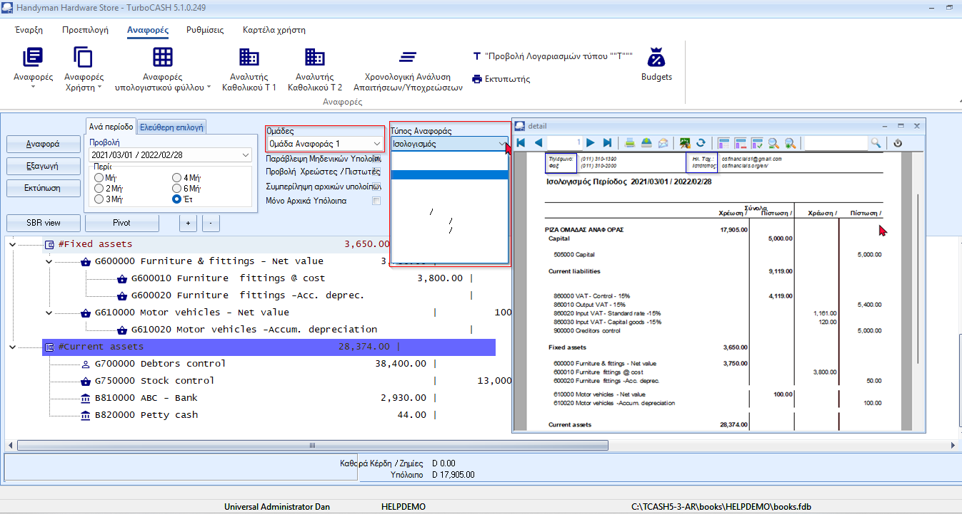

Reports
Various reports were printed and the translations displays correctly in reports (Reportman), etc.
Spreadsheets
Export T Account viewer
The Greek translated text appears to be correct in the Headers and Columns in the Exported spreadsheet file

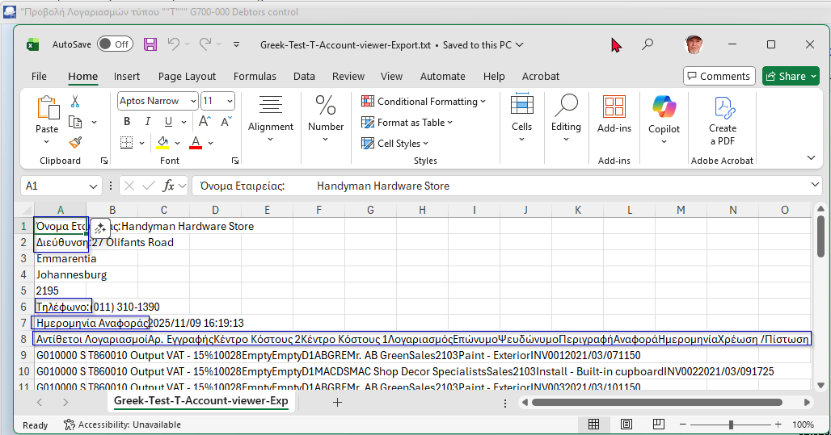

Spreadsheets (Reports ribbon)
The Greek translated text appears to be correct in the Headers and Columns in the Exported spreadsheet file
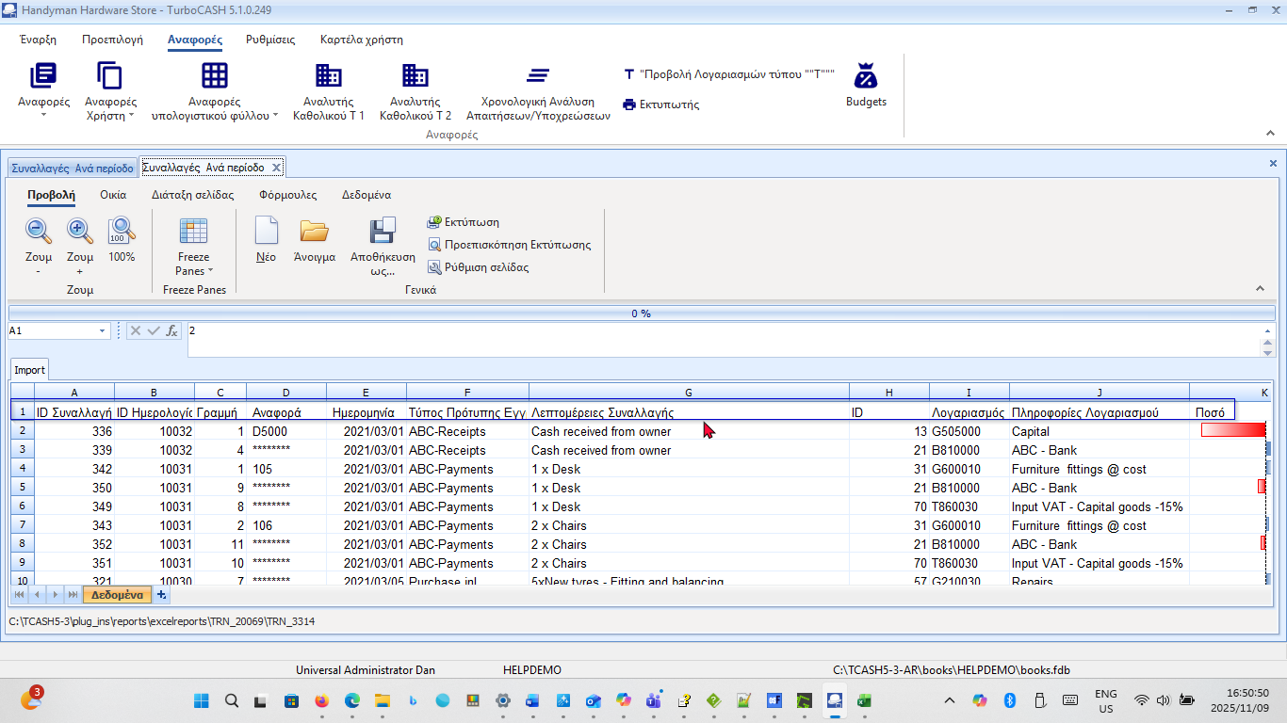

OLDER Screenshots
Original, partially translated Greek.dfm file (shipped with the software, dated 2020/05/08)
Display issues replicated in older versions

osFinancials4.0.0.1093 / TurboCASH5-5.0.0.969
Grids are displaying in Columns
Drop-down lists does not display Greek translated items (only brackets and numerals and forward slashes)
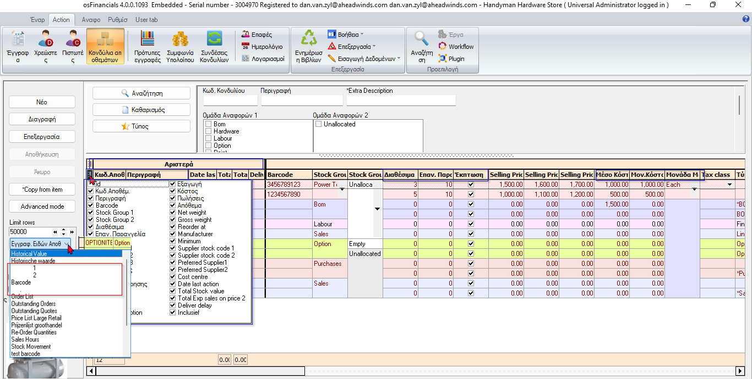

osFinancials5.1.0.249 / TurboCASH5-3
