Table of Contents
UI Constraints 2
CHECKED Plugins - OK 3
HandyTools 3
HandyTools - Countries tab 3
HandyTools - Corrections tab 4
HandyTools - Ledger transactions tab 4
HandyTools - MSG tab 5
HandyTools - Remove tab 5
HandyTools - Run SQL tab 6
HandyTools - Stock tab 6
Android connector 7
Server 7
Offline 7
Email Pro 8
Email pro Setup 8
Email pro - Settings tab 9
Email pro - Free text tab 9
Multimedia 10
Subscriptions 11
Subscriptions - Browse 11
Process subscriptions 11
Price Agreement 11
Price agreement (Setup) 11
Price agreement - Stock 12
Price agreement - Debtors / Creditors 12
Remittance 12
Remittance - Setup 12
Remittance - List 13
Activa 13
Activa - List 13
Activa - Details 13
Activa - Reports 14
Charter 14
Charter - Default ribbon 14
Charter - Stock tab 15
Charter - Debtors tab 15
Charter - Creditors tab (AV ERROR) 15
HorecaPOS 16
HorecaPOS - Setup 16
General tab 16
setup point printer 17
Print setup tab 17
Buttons tab 18
HorecaPOS - Main 19
Horecapos - Order 20
Horecapos - Settings 20
RetailPOS 21
RetailPOS - Setup - General tab 21
RetailPOS - Setup - Images and reports tab 21
setup point printer 22
Print setup tab 23
RetailPOS -Order 23
RetailPOS - setup 24
RetailPOS - Reports 24
POSDisplay 25
Quick Order 25
Aanmaken tab 26
XMLAuditFile 26
Dutch Tax plugin 27
Certificate setup 27
Drop down lists in all tabs - Auto expand 27

UI Constraints - Plugins
The updated font in osFinancials 5.1.0.253 improves UI rendering and multi-language support, fixing grid and drop-down issues for complex scripts via Unicode.
In osFinancials5.1.0.253 it fixes the Comprehensive Language Support by changing the default Unicode font
- Fixed Display Issues: The change specifically resolves the incorrect display on Grids and drop-down lists in Greek.
- Enhanced Multi-Language Support: It provides better support for all other complex scripts and character sets, including Turkish, Thai, Russian, Chinese, and many others, which rely heavily on Unicode for correct rendering.
In the English.dfm language source file, the new font causes UI constraints in the osFinancials/TurboCASH Interface in the default English source translations.
Other translations the default English source is used to contain translations within that length to avoid UI constraints, especially for languages where translations are longer than the original English text.
Reports remain unaffected due to Reportman's default fonts.

CHECKED Plugins - OK
- StockCheck - Some Dutch text but needs translations
- Location-Serials-Batches
- DrillDown
- SQL Browser
- CCV PIN - OK - Dutch only
- POSPoints OK - Including tabs on Debtors and Stock items
- Customer on hold - OK
- Belchishe BTW Aangifte - OK
- Office Pro - OK Dutch only

HandyTools
This plugin causes UI constraints in the Fixed untranslatable items and in translatable labels. When the ALTFONT is set to False, these untranslatable and translated labels used to fit in these buttons, etc.
When the ALTFONT=TRUE, it fixes the UI and rendering in all languages and specifically Greek (grids and drop-down lists) and other languages such as Thai, Turkish, Vietnamese, etc.

HandyTools - Countries tab
Display of Åland Islands displayd as �land Islands in Setup -> Countries
Display issues also replicated in Debtor accounts/Creditor accounts and in Documents on Country lists.
Also replicated in the Dutch Tax Plugin - Landen koppeling tab
NOTE The Swedish.dfm Language file also uses these characters like ' Å ' and seems to display correctly in the UI.

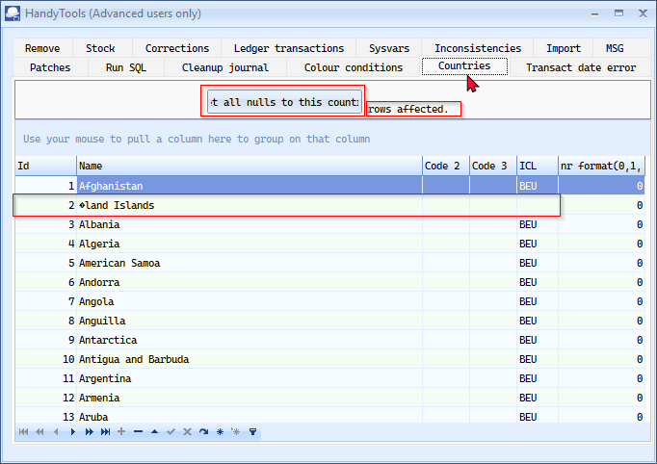

HandyTools - Corrections tab
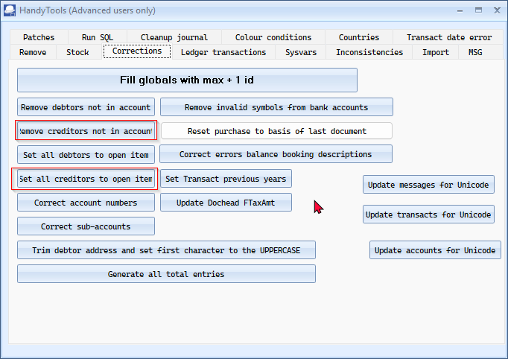

HandyTools - Ledger transactions tab
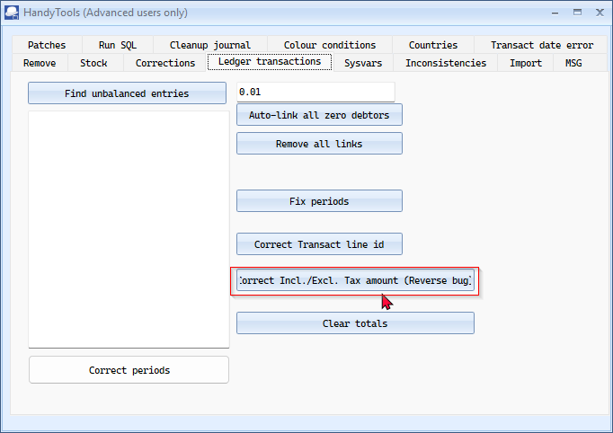

HandyTools - MSG tab
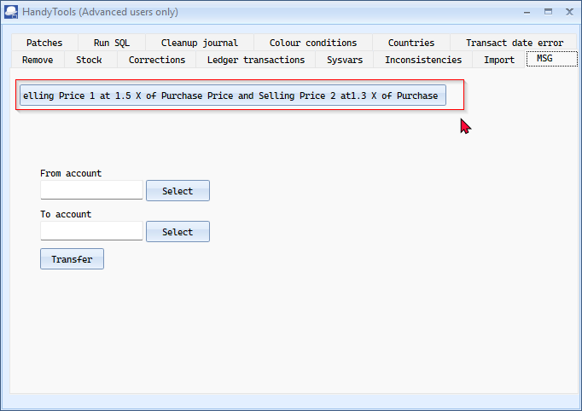

HandyTools - Remove tab
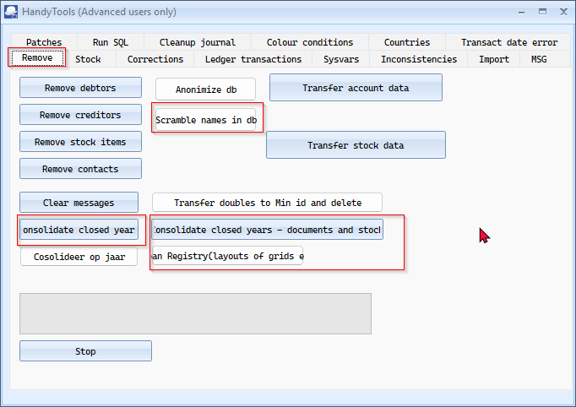

HandyTools - Run SQL tab
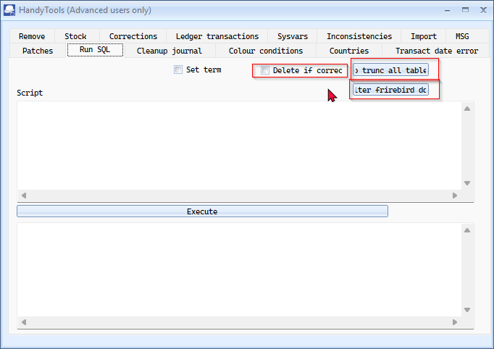

HandyTools - Stock tab
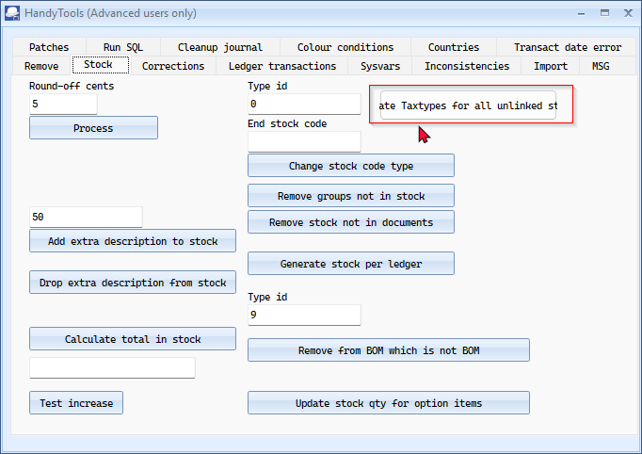

Android connector

Server
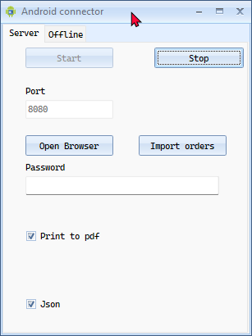

Offline
createdata button
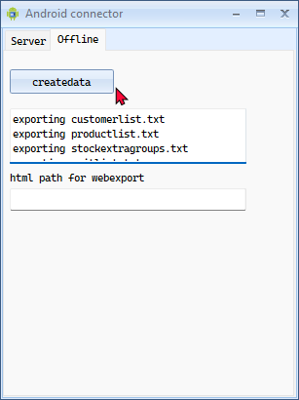
Works - ' Server is running!!! ' in Browser

Email Pro

Email pro Setup
Limit HTML on type (prefix with 1... - Cuts-off
Test e-mail UI constraints in most translations
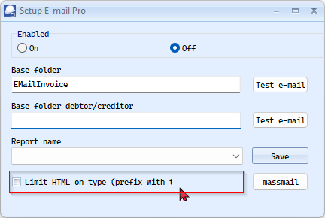

Email pro - Settings tab
Setup wizzard - typo
Send receipt notification - Cutts-off
Sign Certificate ' g ' looks like ' o '
Buttons
- Find certificate
- show current sql
- ... gen text from html
UBL setting - Drop-down list - Auto expand
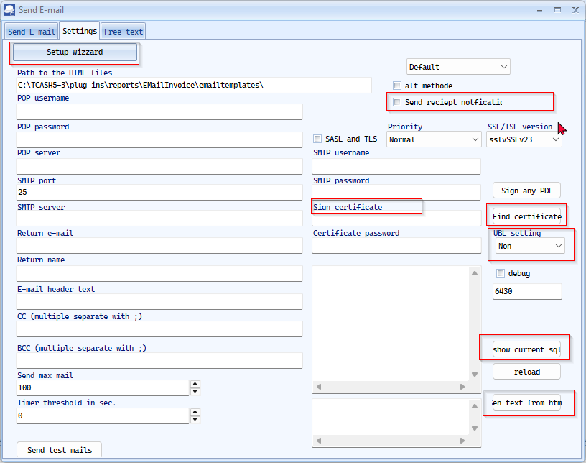

Email pro - Free text tab
Setup wizzard - typo - Setup wizzard visible but disabled not launching
Buttons
- Preview in browser
- Test E-mail to Extra CC
- Extra attachment
Column heading - Datetime
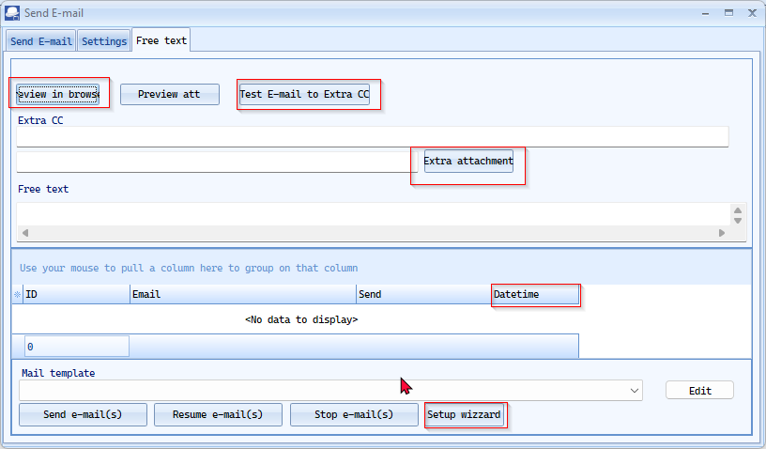

Multimedia
Search - Multimedia on Default ribbon - OK
Multimedia tabs on Debtors / Creditors / Stock - OK
Documents - OK
Multimedia Setup button cuts text off
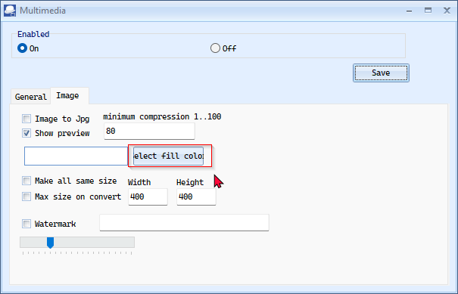

Subscriptions

Subscriptions - Browse
Process subscriptions (not in line with other options)
Enable tick-box + Reference
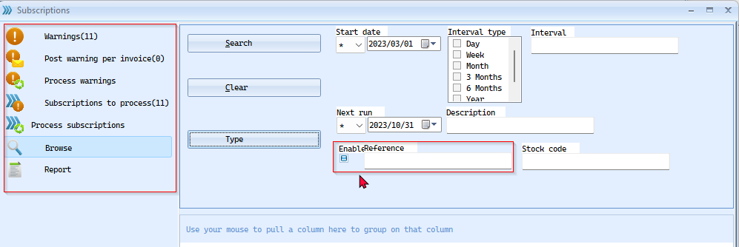

Process subscriptions
Process selected - Drop-down list - Auto expand
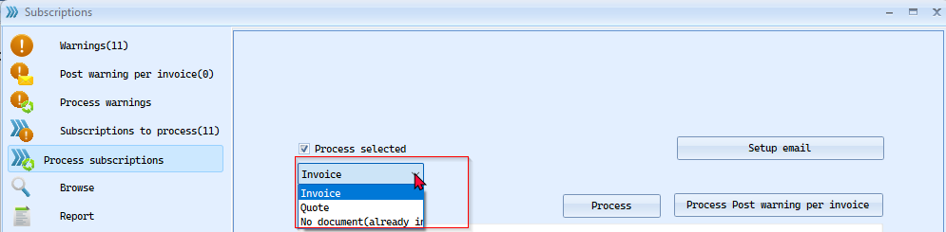

Price Agreement

Price agreement (Setup)
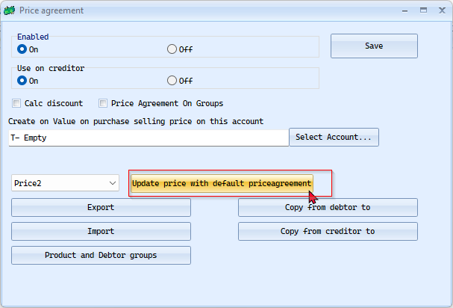

Price agreement - Stock
Radio buttons
Average cost = Avg. cost looks like ava cost
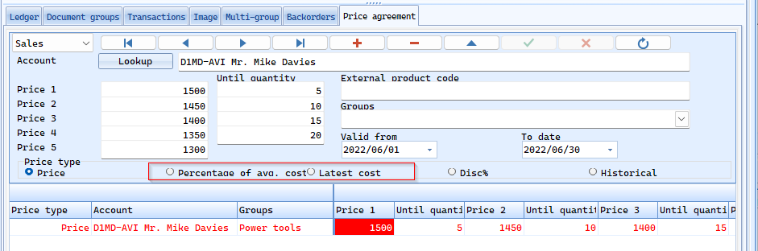

Price agreement - Debtors / Creditors
Not fully displayed - Radio buttons
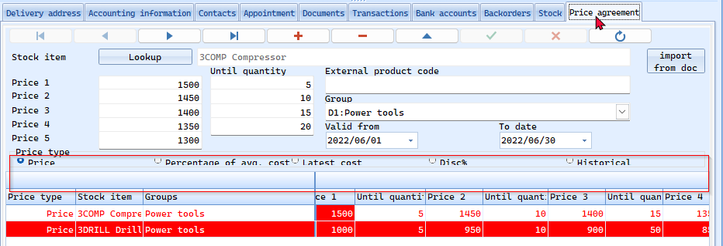

Remittance

Remittance - Setup
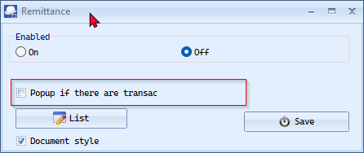

Remittance - List
Print selectie button
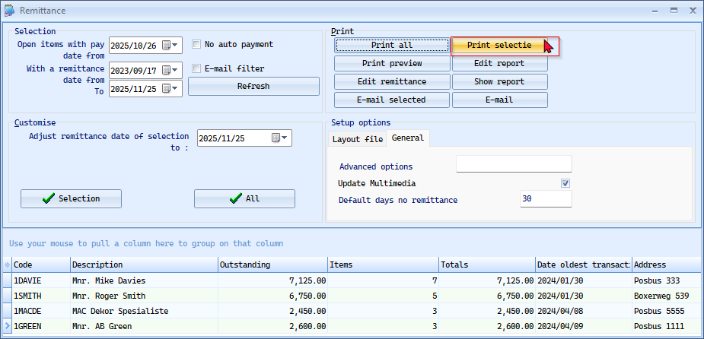

Activa

Activa - List
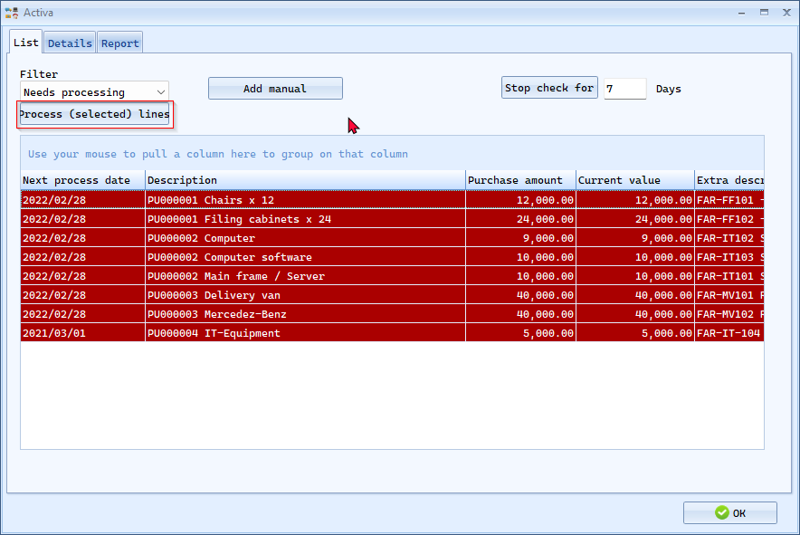

Activa - Details
OK

Activa - Reports
Drop-down lists - Auto expand
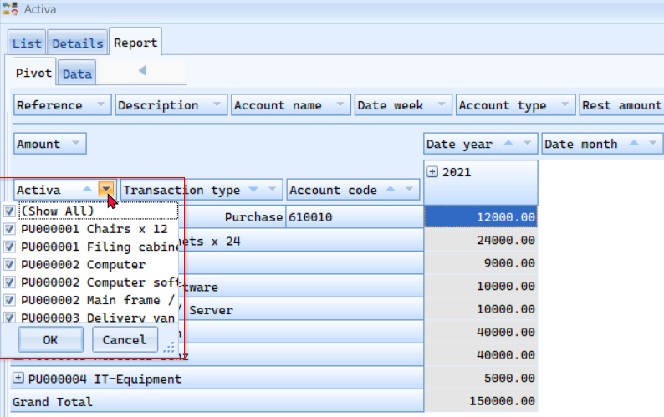

Charter
Setup OK

Charter - Default ribbon
Type - Drop-down-lists - Auto expand (also on tabs - Stock - Debtors - Creditors)
Save as image button
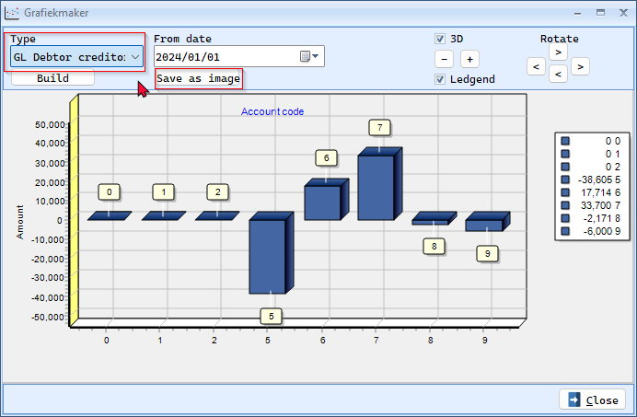

Charter - Stock tab
Type - Drop-down-lists - Auto expand (also on tabs - Stock - Debtors - Creditors)
Save as image button
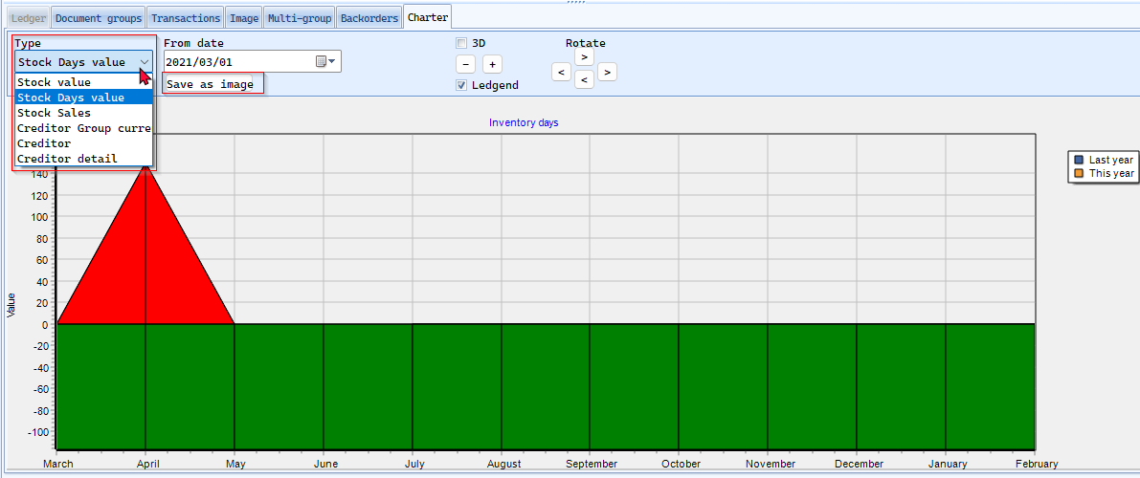

Charter - Debtors tab
Type - Drop-down-lists - Auto expand (also on tabs - Stock - Debtors - Creditors)
Save as image button
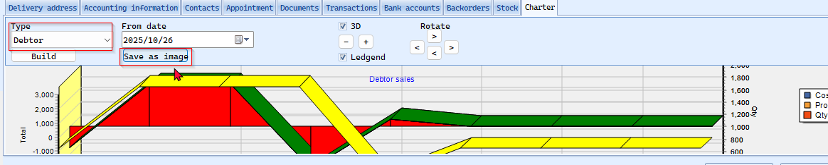

Charter - Creditors tab (AV ERROR)
Type - Drop-down-lists - Auto expand (also on tabs - Stock - Debtors - Creditors)
Save as image button
ACCESS VIOLATION ERROR
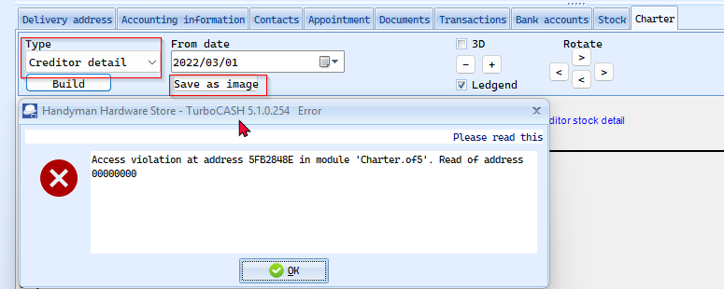

HorecaPOS

HorecaPOS - Setup
The Paymentstypes tab seems OK.

General tab
Drop-down list - Auto expand
- User can edit Qty for
- Move table layout
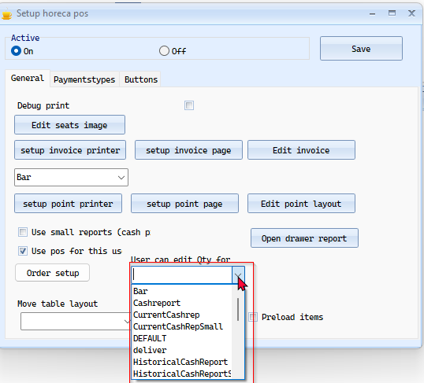

setup point printer
Page margins
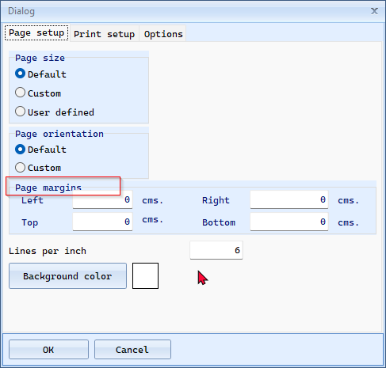

Print setup tab
Similar to Print setup in osFinancials core -
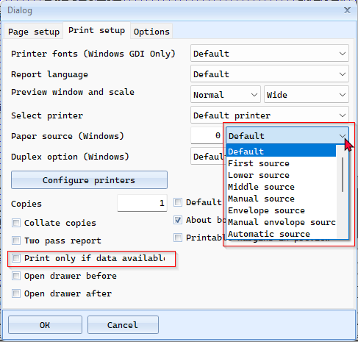

Buttons tab
Text color free seat - button cuts-off
Other button seems a bit tight
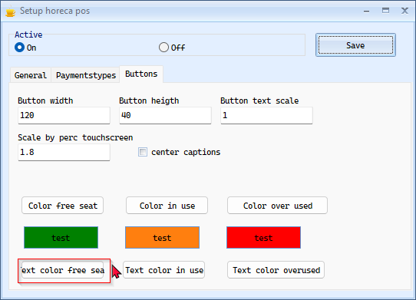

HorecaPOS - Main
Buttons
- Table overview
- Telephonic order
Columns - White Font color - not clearly visible
Totals of grid - Yellow Font color - not clearly visible 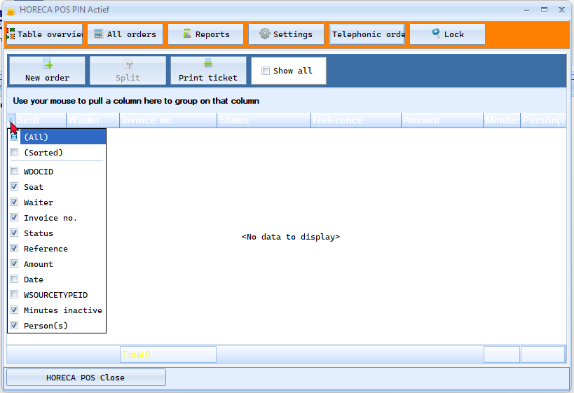

Horecapos - Order
Text cut-off
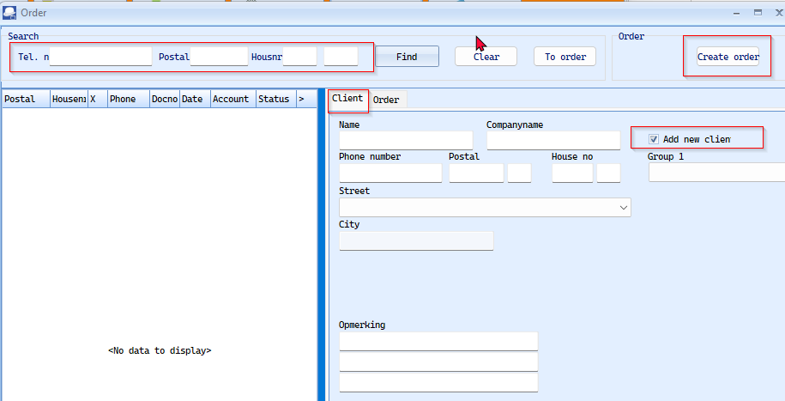

Horecapos - Settings
Text cut-off
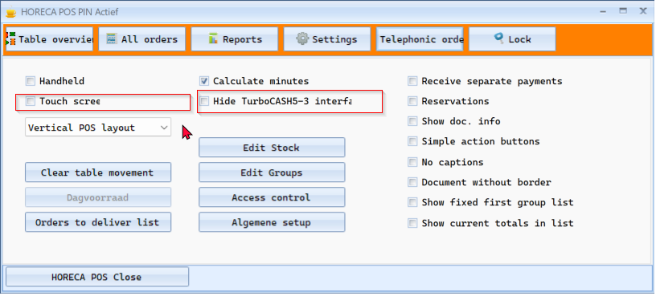

RetailPOS

RetailPOS - Setup - General tab
Labels cut-off
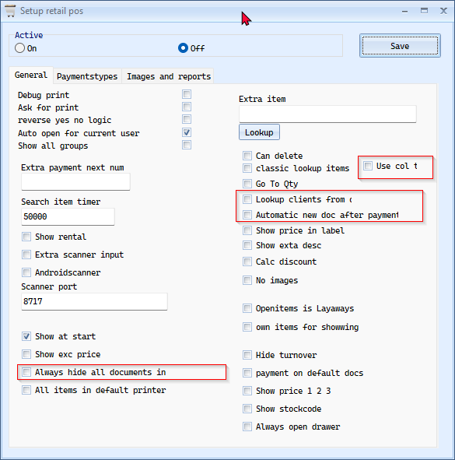

RetailPOS - Setup - Images and reports tab
Labels cut-off
Similar issues with the setup point printer as in HORECAPOS
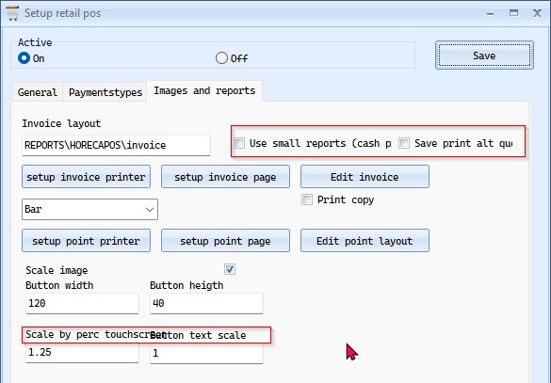

setup point printer
Page margins

Print setup tab
Similar to Print setup in osFinancials core -

RetailPOS -Order
Document groups button - cut-off
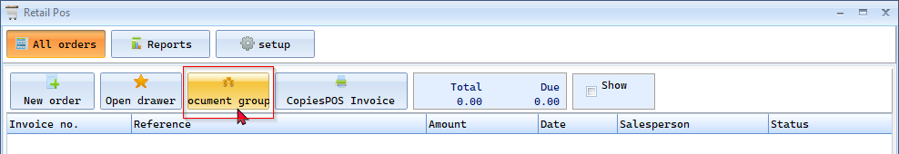

RetailPOS - setup
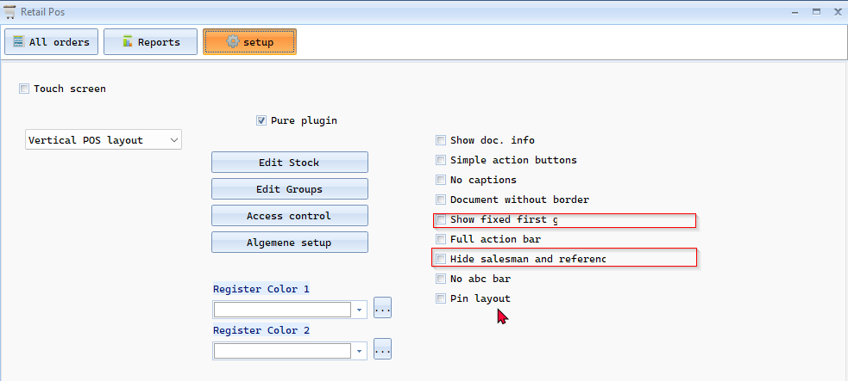

RetailPOS - Reports
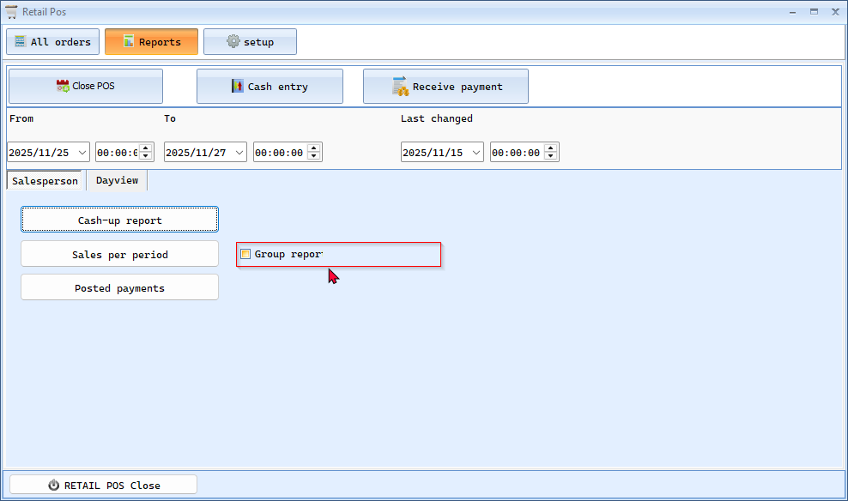

POSDisplay
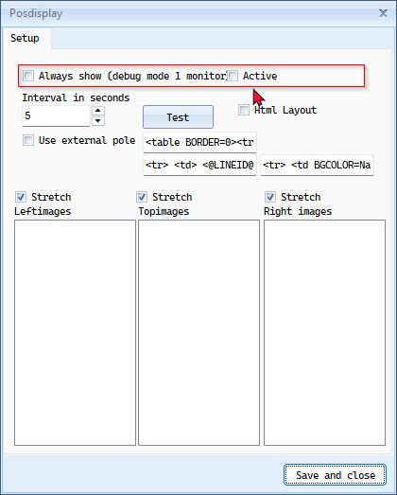

Quick Order
Some Dutch text but needs translations
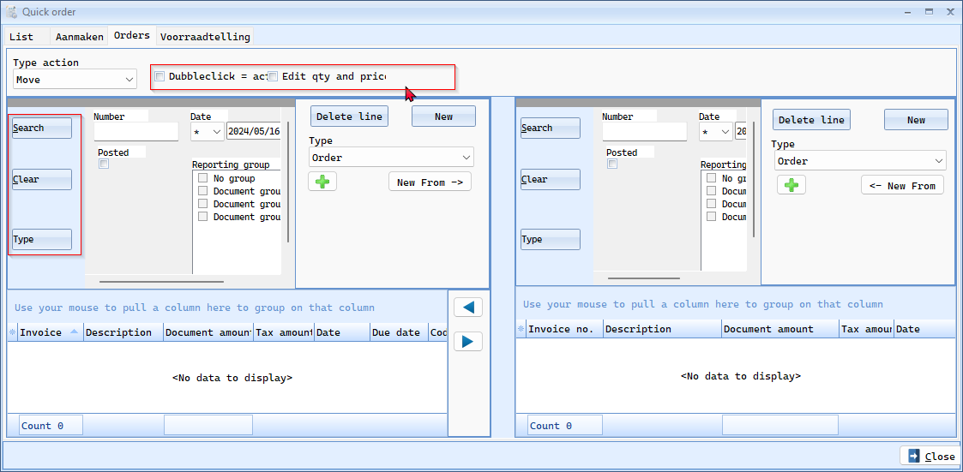

Aanmaken tab
Genereer document(en) button cuts off
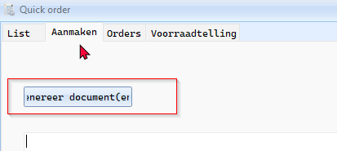

XMLAuditFile
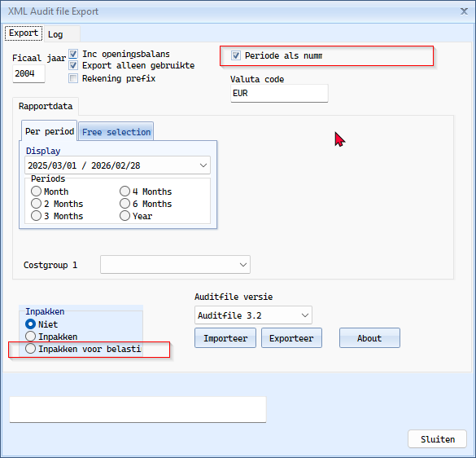

Dutch Tax plugin

Certificate setup
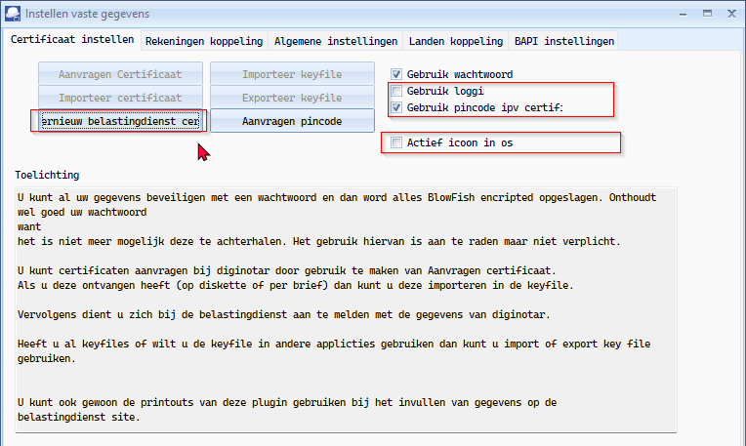

Drop down lists in all tabs - Auto expand

