Table of Contents
osFinancials5.1.0.260 - Known issues 1
Multi-Language Display Status & Technical Constraints 1
General Language Display Status 1
Turkish Screenshot 2
Greek Screenshot 2
Status of Developer Tools 2
Flame Robin: OK - No encrypted language display detected. 3
SQL Browser: OK - No encrypted language display detected. 4
Critical Technical/Error Issue 4
Database Constraint Observation 7

osFinancials5.1.0.260 - Known issues

Multi-Language Display Status & Technical Constraints
This document reviews the display status of language translations across the user interface (UI) and documents specific rendering or technical constraints found in the application.

General Language Display Status
The language display is functioning correctly across all UI elements for the majority (all 19) of supported languages.
Known UI Display Issues (Only in Setup -> Batch types - translations)
Specific rendering issues have been identified in the following languages:
Language | UI Element | Issue Description
Turkish | Batch type - Translations form | Character rendering inconsistency:  When a record is selected, the translation displays correctly as Satış defteri.  When the record is not selected, the 'ş' character is dropped, displaying as Satı defteri.
Greek | Batch type - Translations form | Translation is not displayed correctly in the list view. The correct text only appears if the record is selected (highlighted).

Turkish Screenshot
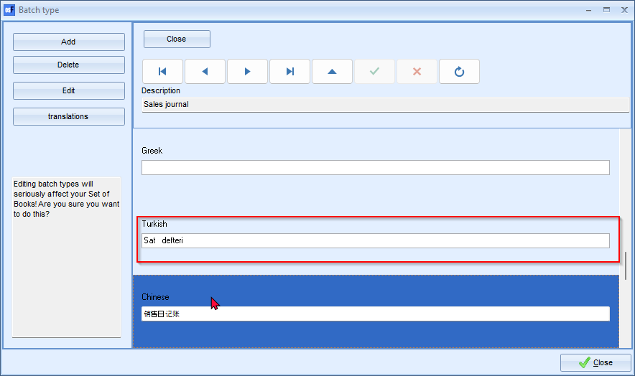

Greek Screenshot
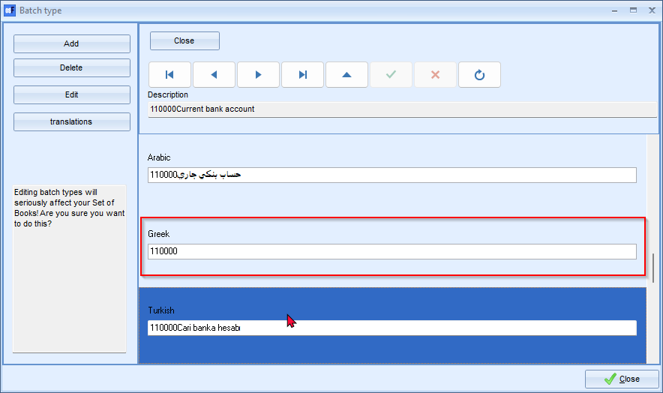

Status of Developer Tools
The following tools display language data correctly with no known rendering issues:

Flame Robin: OK - No encrypted language display detected.
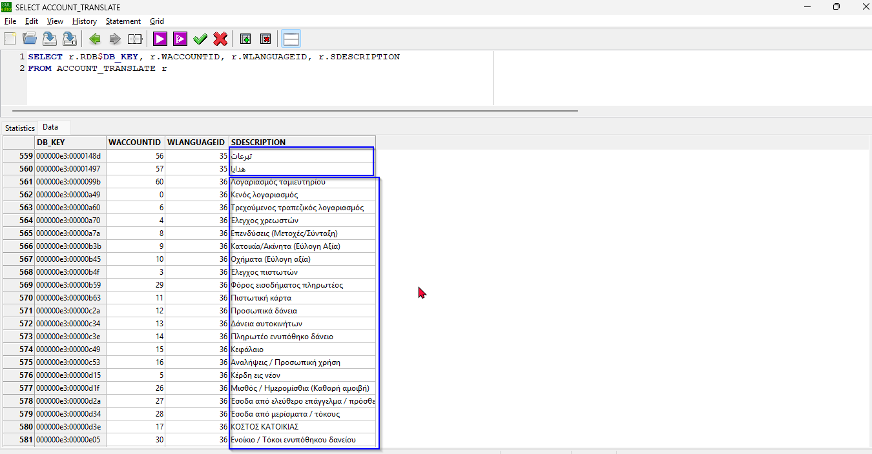

SQL Browser: OK - No encrypted language display detected.
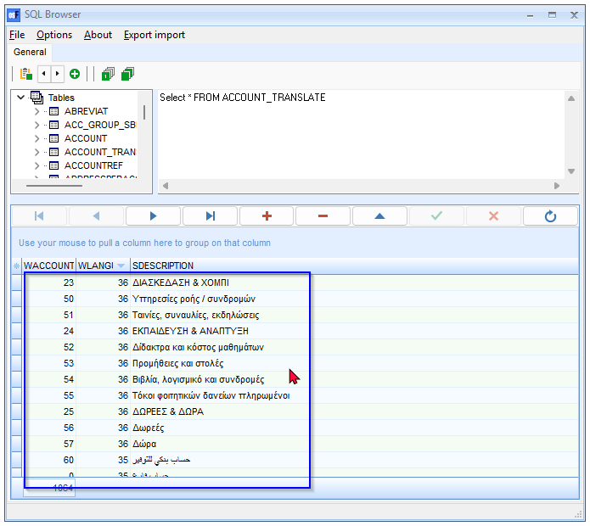

Critical Technical/Error Issue
- Dynamic SQL Error: A 303 error related to dynamic SQL execution has only been found when the application language is set to Greek.
  - Observation: In all 18 other languages, no problems were encountered. For the Greek translation, the Dynamic SQL error was not replicated when using shorter text. This strongly suggests the error is triggered by the string length or specific characters in the longer Greek translation.
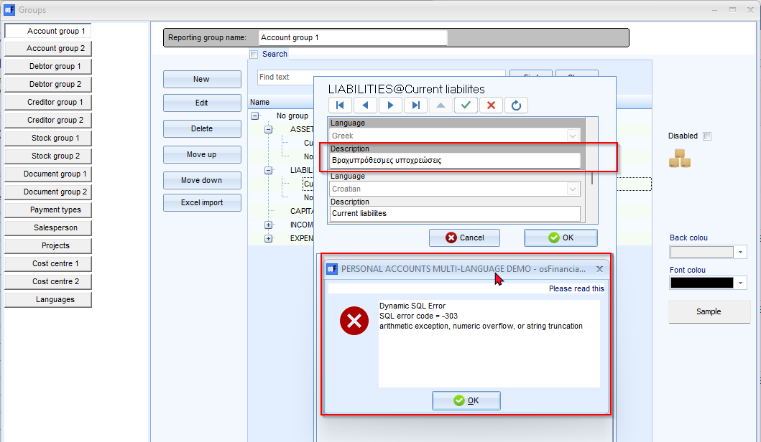
The SDESCRIPTION VARCHAR in the GROUPS_DESCRIPTIONS column is (50)
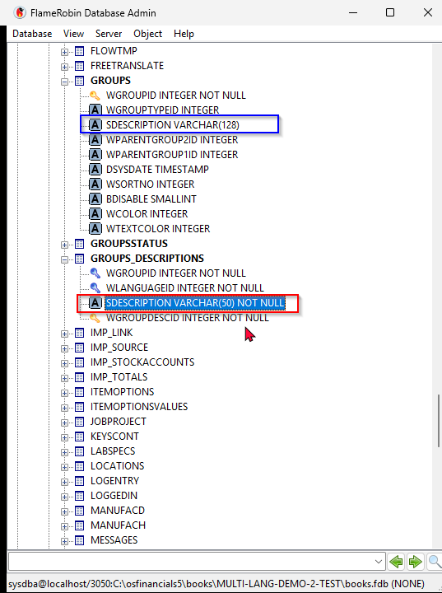
ALTER TABLE GROUPS_DESCRIPTIONS
ALTER COLUMN SDESCRIPTION VARCHAR(255);
Cannot Channge the Description column width to 128 or 255 Characters
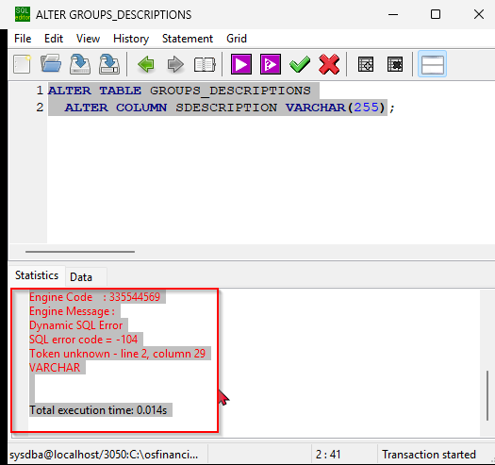

Database Constraint Observation
The current field width for the language description column is a major constraint that prevents future expansion:
- Field: SDESCRIPTION column in the GROUPS_DESCRIPTIONS table.
- Current Specification: VARCHAR(50).
- Problem: Attempting to alter the column width to a larger size (e.g., VARCHAR(128) or VARCHAR(255)) via the command ALTER COLUMN SDESCRIPTION VARCHAR(255) is currently failing. This restriction must be resolved to accommodate longer translations in the future.

