Table of Contents
osFinancials5.1.0.286 – UI-Design – Checkbox alignment - Outstanding 1
UI Design [ ] Checkboxes fixed in osFinancials5.1.0.286 1
Incorrect aligned 'Text [ ]' Alignment of Checkboxes fixed in osFinancials5.1.0.286 3
Backup/Restore (both options) 3
Budget 3
Setup -> Stock info 4
Setup -> Data parameters 6
Setup -> POS 7
Setup -> POS - Peripherals - Drawer 7
Setup -> POS - Pole display tab 8
Lookups 9
Stock items 10
Debtors / Creditors 11
Plugins - UI-Checkbox Alignment 12
Bank import plugin 12
Plugin - External system links -> Export for websites ERROR 12
Plugin - Pont-of-Sale -> RetailPOS Application Error 12
Plugin - Tools -> Webimport/Export ERROR 12
Plugin - Tools -> HandyTools (Advance users only) - Transact date error tab 13
Plugin - External system links -> Send package (Setup) 13
Plugin - Financial tools -> Belgische BTW aangifte) - Tax account lookup 14
Plugins - Pont-of-Sale - HORECAPOS 15
Plugins - Stock plugins -> Quick order 15
UI Design – UI Modernization 16

osFinancials5.1.0.286 – UI-Design – Checkbox alignment - Outstanding

UI Design [ ] Checkboxes fixed in osFinancials5.1.0.286
Corrected '[ ] Text' Alignment of Checkboxes fixed in osFinancials5.1.0.286
Open Set of Books
Registration
User tab
Bank recon (old)
Open item
Calendar (all options/appointments)
Setup -> Accounts
Setup -> Documents
Setup -> Reporting dates
Setup -> Access control
Setup -> Printer
Setup - Export
Setup - Import
Tools -> Customize languages
Tools -> Data integrity check
Global processes -> Reverse posted document
Input -> Confirm (Quotes and Orders)
Stock items (Advanced mode tabs - Import / Export + Adjust stock tabs)
Central Search
Ledger analyser
T-Ledger analyser
Age analysis (Reports ribbon)
Batch setup (Standard and Advanced tabs)

Incorrect aligned 'Text [ ]' Alignment of Checkboxes fixed in osFinancials5.1.0.286

Backup/Restore (both options)
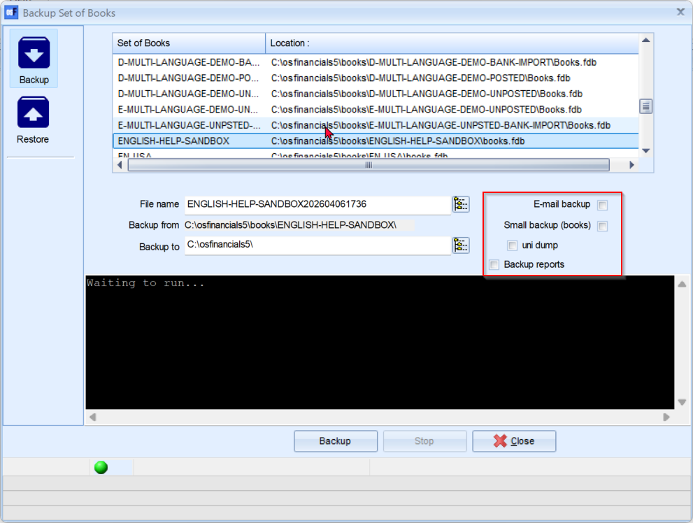

Budget
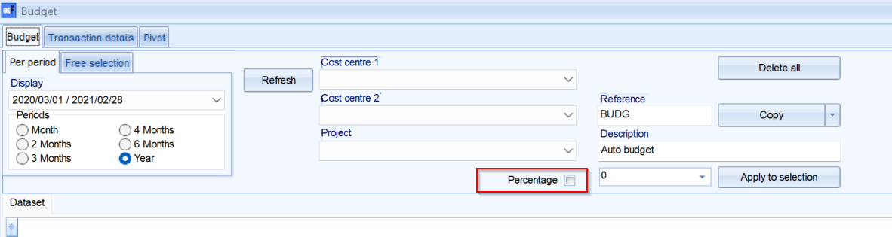

Setup -> Stock info
NOTE: The alignment in columns could follow the logic of the Batch Setup screens F10: Setup screens
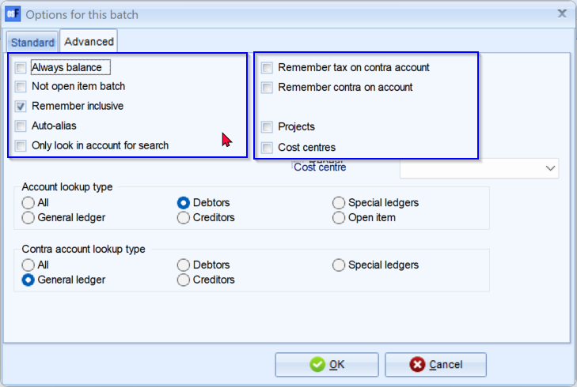
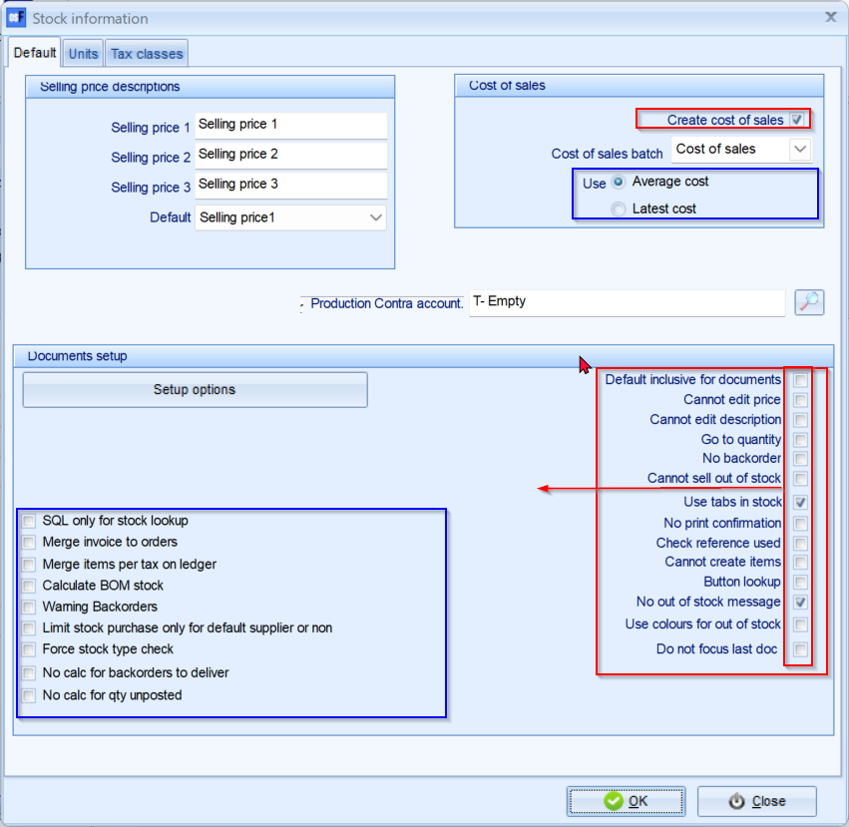

Setup -> Data parameters
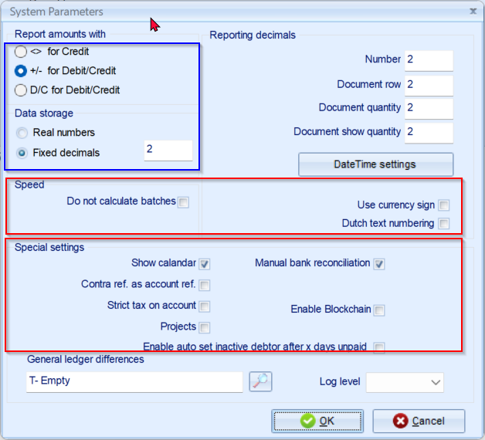

Setup -> POS
Radio buttons - move to left

Setup -> POS - Peripherals - Drawer
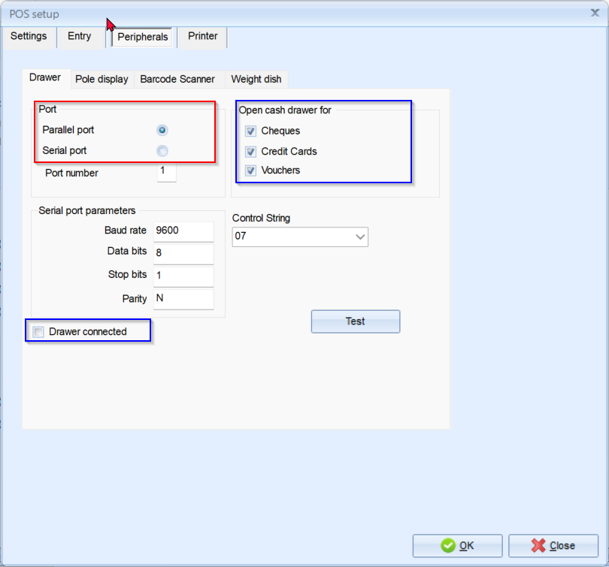

Setup -> POS - Pole display tab
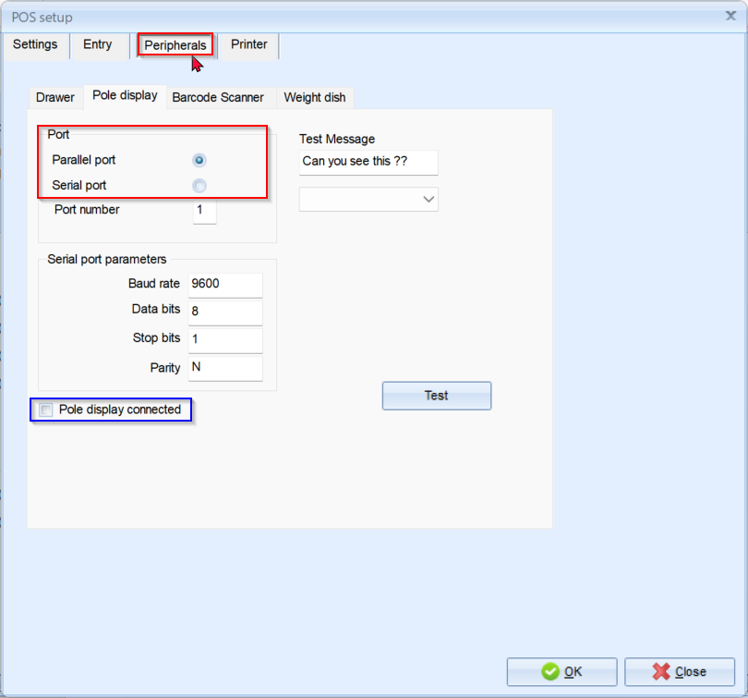

Lookups
Setup -> Stock info - Select production account and all lookups in reports, etc. is incorrectly aligned to 'Text [ ]' in Search by fields.
Also incorrect in Select Stock item lookup screens
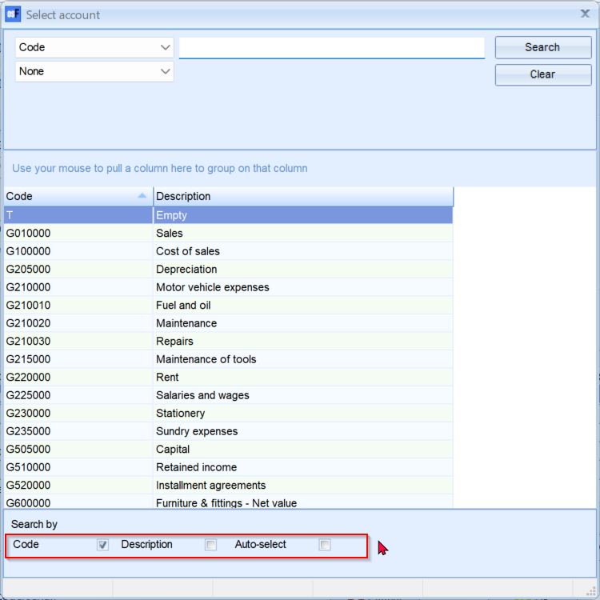
NOTE - Fast add item in documents is correctly aligned as '[ ] Text' in Search by fields.
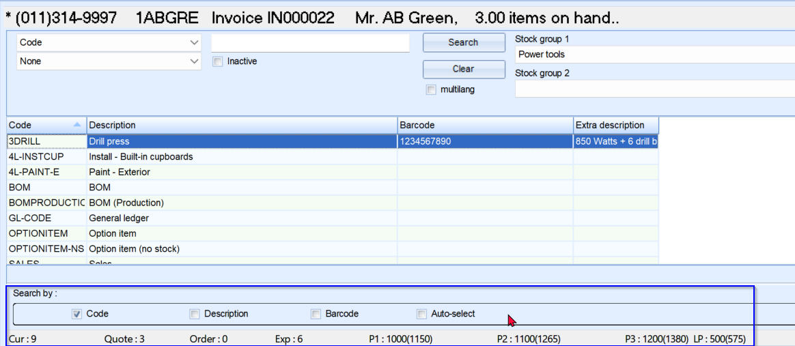

Stock items
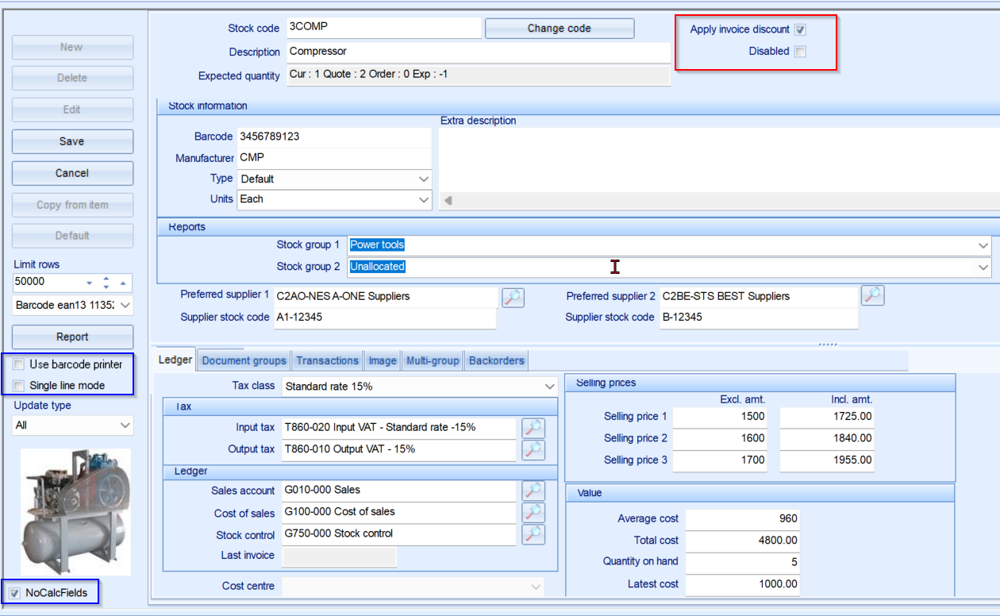

Debtors / Creditors
Debtors - Accounting information tab / Creditors - Accounting information tab
Account disabled
Open item account
Use default tax account
Use default tax
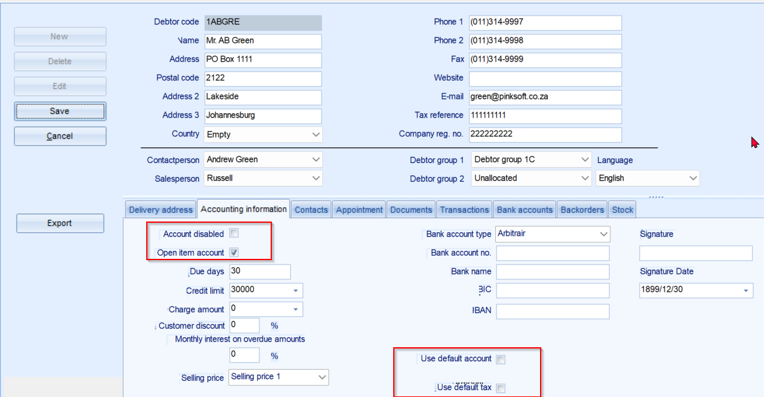

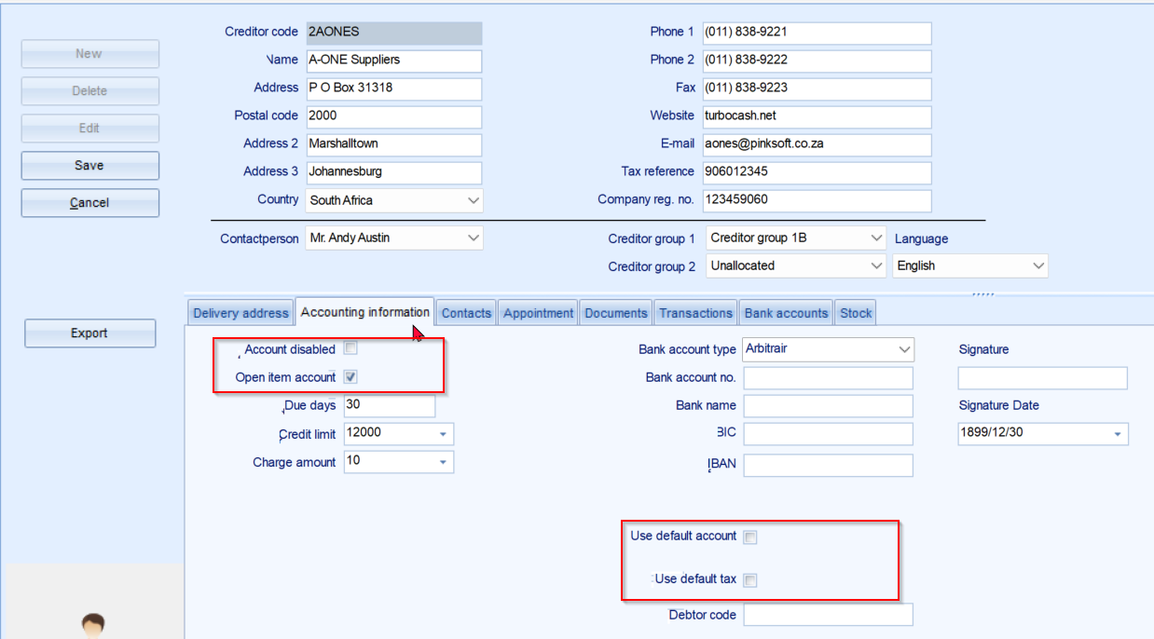

Plugins - UI-Checkbox Alignment

Bank import plugin
Icons on Black background icons
Batch setup - Standard - 'Contra account' label may be aligned to before the lookup box so it can end anchor there and stretch to the left
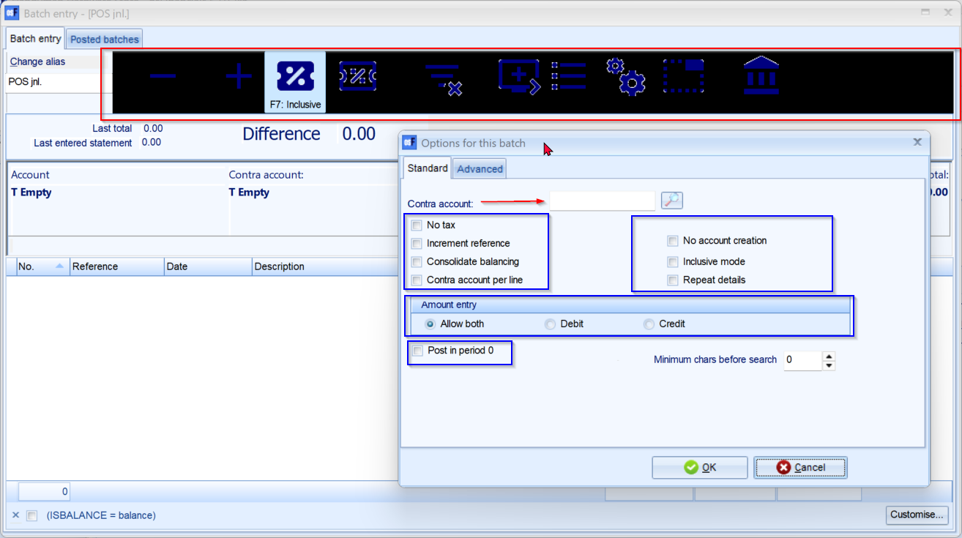

Plugin - External system links -> Export for websites ERROR
'List index out of bounds (0). TList<System.Classes.TCollectionItem> is empty'

Plugin - Pont-of-Sale -> RetailPOS Application Error
---------------------------
Application Error
---------------------------
Exception EUniError in module unidac290.bpl at 0000D894.
unsuccessful metadata update
key size exceeds implementation restriction for index "IDX_POSTALCODE_STRUNI".
---------------------------

Plugin - Tools -> Webimport/Export ERROR
ERROR
'Import export folder not found!
C:\osfinancials5\importdefs\FXMLEXPORT'
Created a folder in the root of the osFinancials5 installation folder and still replicate this Error
Created folder 'C:\osfinancials5\importdefs\FMXMLEXPORT' then it could launch.

Plugin - Tools -> HandyTools (Advance users only) - Transact date error tab
'qDocBatch: Type mismatch for field 'SDESCRIPTION', expecting: String actual: WideString'
NOTE MADE the osFinancials5.1.0.286 crash
Had to use Task manager to End Task

Plugin - External system links -> Send package (Setup)
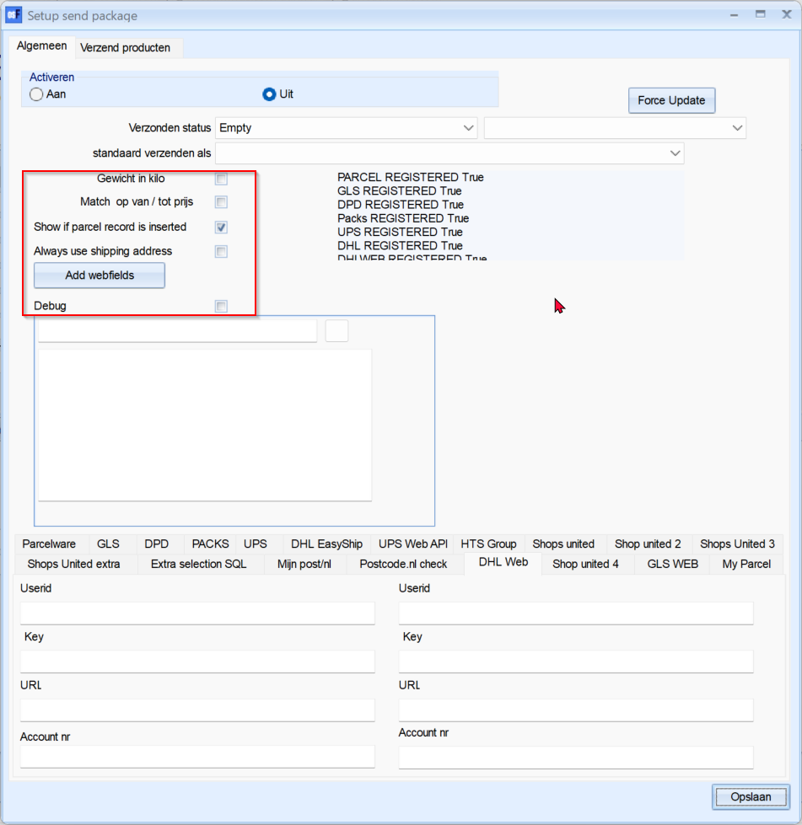

Plugin - Financial tools -> Belgische BTW aangifte) - Tax account lookup
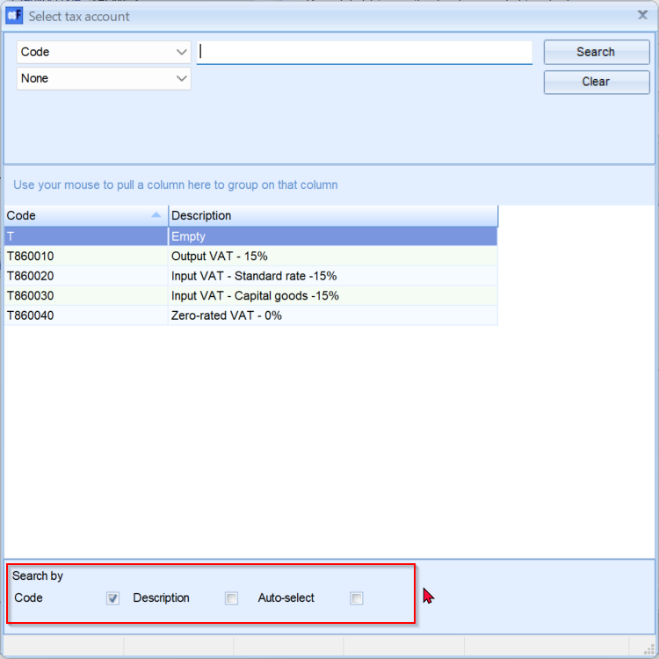

Plugins - Pont-of-Sale - HORECAPOS
Font colors on grid is loo light - difficult to read
Telephonic order button (UI constraint)
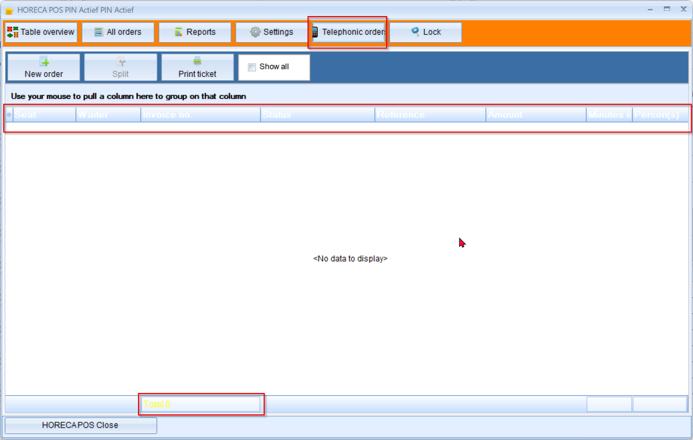

Plugins - Stock plugins -> Quick order
Centre alignment of buttons (Search , Clear , Type)
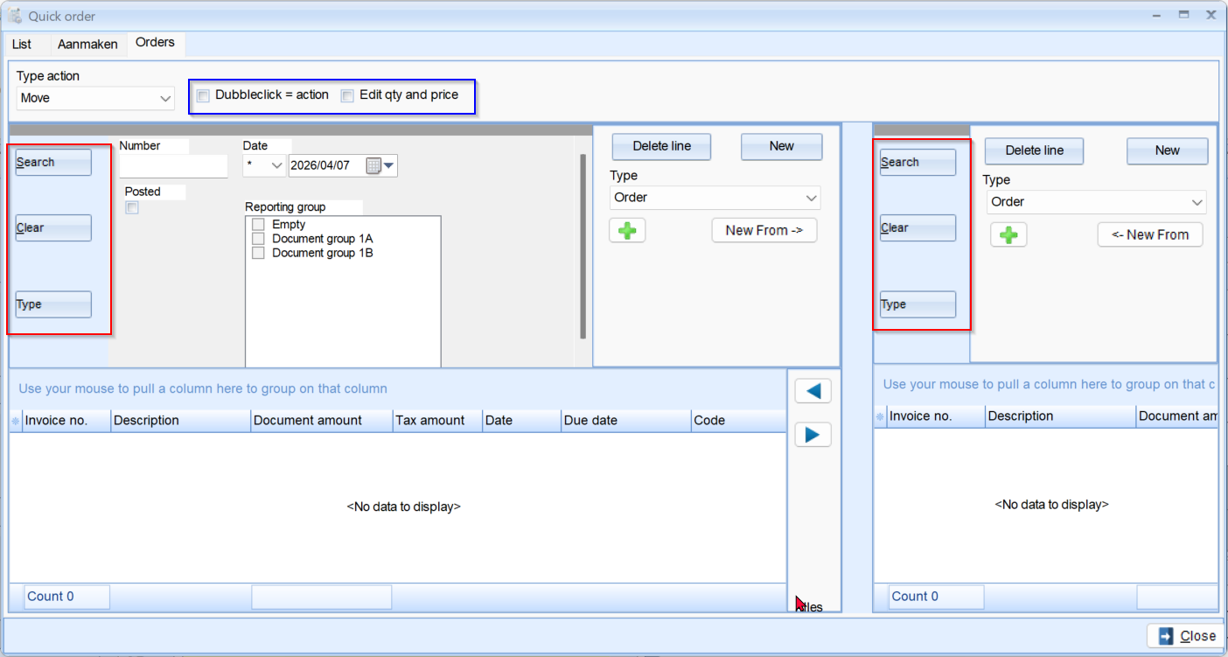

UI Design – UI Modernization
