Table of Contents
osFinancials5 – RTL Reports / document layout files 1
RTL - Ledger analyser 1
Page Headers 2
Report Footers 3
Printed Invoice - osFinancials/TurboCASH 5

osFinancials5 – RTL Reports / document layout files

Technical Proposal: RTL Implementation for Reports and Document Layouts

Overview
To provide full Right-to-Left (RTL) support for <@APPNAME@> (osFinancials5 / TurboCASH5), a dedicated directory structure is required for report templates. Current limitations within the Reportman engine prevent consistent programmatic mirroring of Left-to-Right (LTR) reports into RTL formats without compromising visual integrity.

Problem Statement
- BiDi Limitations: Reportman does not natively support an automatic BiDi (Bidirectional) mode for reports stored in the standard plugins/reports folder.
- Rendering Issues: While the NoBidi setting within Reportman can force LTR text and expressions to display in an RTL sequence, it often results in broken alignments, incorrect padding, and unnecessary spaces.
- Manual Alignment Requirement: Proper RTL rendering requires manual adjustment of every object—including static text labels, expressions, and data fields—to ensure the layout follows the correct right-sided orientation.
- Directory Constraints: It is not feasible to host both LTR and RTL versions of the same report within the single .../plugins/reports directory without causing conflict or rendering errors.

Proposed Solution: The 'reports-rtl' Directory Switch
We will implement a directory mirroring strategy to allow for custom-aligned RTL reports:
- Directory Creation: A secondary folder, .../plugins/reports-rtl, will be created to mirror the standard reports folder. This directory will host the manually adjusted .rep and document layout files.
- Logic Trigger (LabelID 3738): When a user opens a Set of Books associated with an RTL language (defined via LabelID 3738 in the language file), the system will:
  - Update the BIDIMODE=RTL setting in the osf.ini or tcash.ini file.
  - Apply a global mirror to the <@APPNAME@> user interface.
  - Automatic Path Switch: Dynamically switch the report source path from .../plugins/reports to .../plugins/reports-rtl.

Implementation Progress
A pilot project is underway to manually re-align and verify the following reports and document layout files for RTL compliance:
- Report Headers and Footers
- Ledger -> Listing (Chart of Accounts)
- Ledger Analyser
- T-Account Viewer
- Standard Document Layout Files (Invoices, Quotes, etc.)

Visual Representation: RTL Ledger View (Arabic)
The following illustrates the intended alignment for the RTL-specific templates:
[Right-to-Left Arabic View]
──────────────────────────────────────────────────────────────────────────
┌───────────┬───────────┬───────────┬───────────────────────┬────────────┐
│ دائن │ مدين │ المرجع │ وصف الحساب │ الرمز │
│ (Credit) │ (Debit) │ (Ref) │ (Description) │ (Code) │
├───────────┼───────────┼───────────┼───────────────────────┼────────────┤
│ 5,000.00 │ │ INV-2025 │ رأس المال │ G505000 │
│ │ │ │ Capital │ │
├───────────┼───────────┼───────────┼───────────────────────┼────────────┤
│ │ 3,000.00 │ DEP-01 │ البنك │ B810000 │
│ │ │ │ Bank │ │
├───────────┼───────────┼───────────┼───────────────────────┼────────────┤
│ 5,000.00 │ 3,000.00 │ │ المجموع │ │
│ │ │ │ Total │ │
├───────────┼───────────┼───────────┼───────────────────────┼────────────┤
│ 2,000.00 │ │ │ الرصيد (دائن) │ │
│ │ │ │ Balance (Credit) │ │
└───────────┴───────────┴───────────┴───────────────────────┴────────────┘

EXAMPLE SCREENSHOTS

RTL - Document layout files

RTL - Ledger analyser

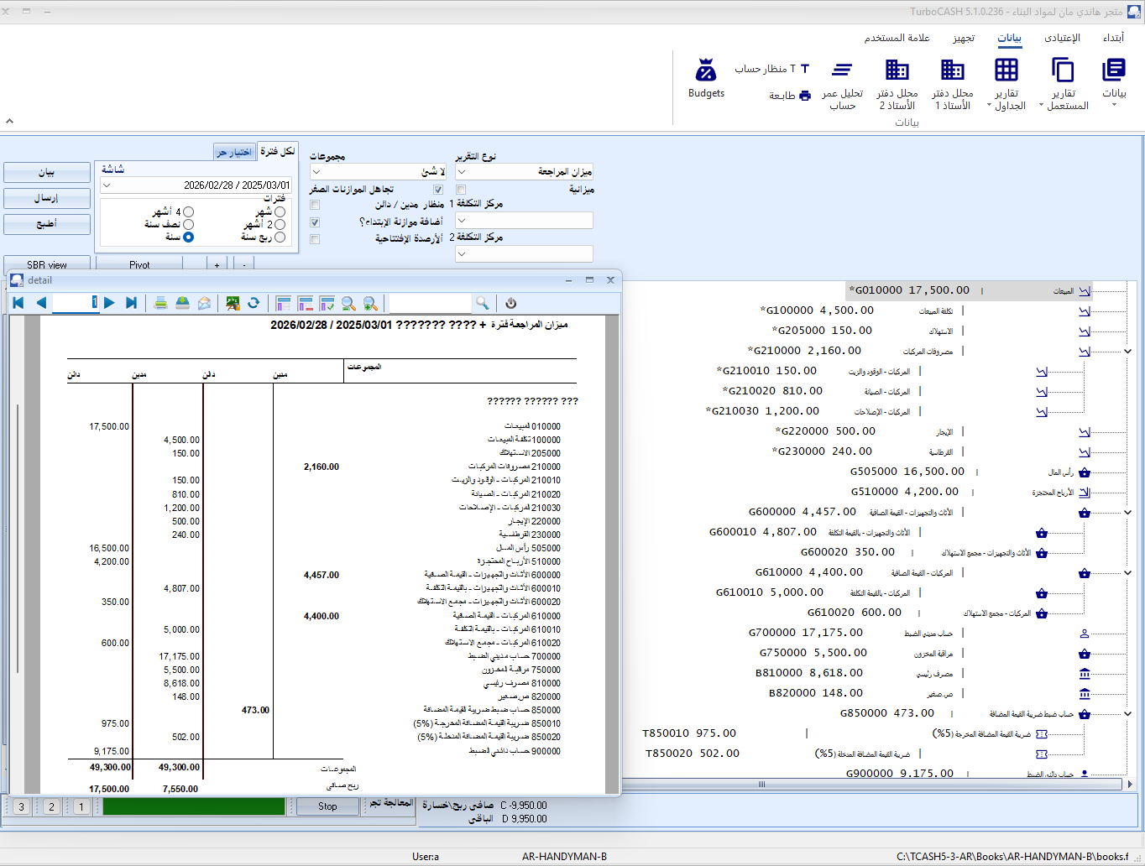

Page Headers and Footers

Page Headers
Example - Arabic Translation - Page Header
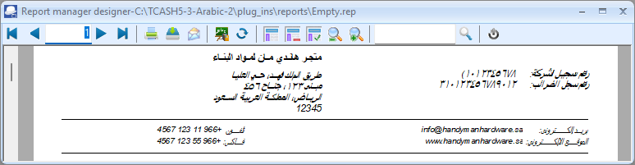
In Arabic, the company information included in the page header of a report typically consists of the following details:
- Company Name (اسم الشركة)
- Company Address (عنوان الشركة)
- Contact Information (معلومات الاتصال) – This may include phone numbers, email, and website.
- Tax or Registration Number (الرقم الضريبي أو رقم التسجيل)
- Logo (شعار الشركة) – Optional, but commonly included.
Example of Company Information in Arabic (Page Header)
Here’s an example of how the company information might look in Arabic:
اسم الشركة: شركة التقنية المحدودة
عنوان الشركة: الرياض، المملكة العربية السعودية، شارع الملك فهد، صندوق بريد ١٢٣٤٥
معلومات الاتصال:
- هاتف: ٠١١٢٣٤٥٦٧٨
- البريد الإلكتروني: info@techcompany.com
- الموقع الإلكتروني: www.techcompany.com
الرقم الضريبي: ٣١٢٣٤٥٦٧٨٩٠١٢
How to Structure This in a Report Header
If you're designing a report layout, you can structure the company information in the header as follows:
plaintext
اسم الشركة: شركة التقنية المحدودة
عنوان الشركة: الرياض، المملكة العربية السعودية، شارع الملك فهد، صندوق بريد ١٢٣٤٥
معلومات الاتصال:
هاتف: ٠١١٢٣٤٥٦٧٨ | البريد الإلكتروني: info@techcompany.com | الموقع الإلكتروني: www.techcompany.com
الرقم الضريبي: ٣١٢٣٤٥٦٧٨٩٠١٢
Key Notes for Implementation
- Right-to-Left (RTL) Alignment:
  - Ensure the header is aligned to the right for Arabic text.
  - Use an Arabic-supported font (e.g., "Arial", "Times New Roman", or "Tahoma").
- Dynamic Data:
  - Replace static text (e.g., company name, address) with dynamic fields (e.g., [CompanyName], [CompanyAddress]) if the data is pulled from a database or system.
- Logo:
  - If you include a logo, place it on the left side of the header (opposite to the Arabic text alignment).
- Spacing and Formatting:
  - Use proper spacing and formatting to ensure the header looks clean and professional.
Example Output in a Report Header
Here’s how the company information might appear in the header of a report:
شركة التقنية المحدودة
الرياض، المملكة العربية السعودية، شارع الملك فهد، صندوق بريد ١٢٣٤٥
هاتف: ٠١١٢٣٤٥٦٧٨ | البريد الإلكتروني: info@techcompany.com | الموقع الإلكتروني: www.techcompany.com
الرقم الضريبي: ٣١٢٣٤٥٦٧٨٩٠١٢

This structure ensures that all necessary company information is clearly displayed in the report header, adhering to Arabic language conventions.

Report Footers
Example - Arabic Translation - Page Footer
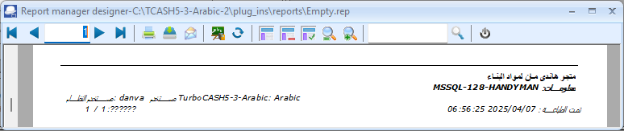
Page Footer Layout in Arabic
Below is the structure for the footer in Arabic, with placeholders for dynamic data (e.g., company name, path, user, date, and page numbers):
1. Company Name (اسم الشركة)
- Display only on the first page for multi-page reports.
- Example:
plaintext
إذا كان رقم الصفحة = 1:
تذييل الصفحة: اسم الشركة: [CompanyName]
2. Data Path (مسار البيانات)
- Display the full path where the Set of Books is stored.
- Example:
plaintext
تذييل الصفحة: مسار البيانات: [DataPath]
3. System User and osFinancials/TurboCASH User (المستخدم)
- Display the operating system user and the osFinancials/TurboCASH user.
- Example:
plaintext
تذييل الصفحة: تم الطباعة بواسطة: [SystemUser] ([osFinancialsUser])
4. Date Stamp (تاريخ ووقت الطباعة)
- Display the system date and time when the report was printed.
- Example:
plaintext
تذييل الصفحة: تاريخ ووقت الطباعة: [SystemDate] [SystemTime]
5. Page Number and Last Page Number (رقم الصفحة)
- Display the current page number and the total number of pages.
- Example:
plaintext
تذييل الصفحة: الصفحة [PageNumber] من [LastPageNumber]
Combined Footer in Arabic
Here’s how you can combine all the elements into a single footer layout in Arabic:
plaintext
إذا كان رقم الصفحة = 1:
تذييل الصفحة: اسم الشركة: [CompanyName]
ENDIF

تذييل الصفحة: مسار البيانات: [DataPath]
تذييل الصفحة: تم الطباعة بواسطة: [SystemUser] ([osFinancialsUser])
تذييل الصفحة: تاريخ ووقت الطباعة: [SystemDate] [SystemTime]
تذييل الصفحة: الصفحة [PageNumber] من [LastPageNumber]

Implementation Notes
- Right-to-Left (RTL) Alignment:
  - Ensure the report layout is set to RTL alignment for Arabic text.
  - Most reporting tools (e.g., Crystal Reports, SSRS, or others) support RTL layouts.
- Variables:
  - Replace placeholders like [CompanyName], [DataPath], [SystemUser], [osFinancialsUser], [SystemDate], [SystemTime], [PageNumber], and [LastPageNumber] with actual dynamic data from your system.
- Font:
  - Use an Arabic-supported font (e.g., "Arial", "Times New Roman", or "Tahoma") to ensure proper rendering of Arabic text.
- Testing:
  - Preview the report to ensure the footer appears correctly on all pages.
  - Verify that the conditional logic for the company name works as expected.
Example Output
Here’s how the footer might look in Arabic:
- First Page:
اسم الشركة: شركة تجارية مثال
مسار البيانات: C:\Data\Company\SetOfBooks
تم الطباعة بواسطة: أحمد (مستخدم osFinancials)
تاريخ ووقت الطباعة: ٢٠٢٣-١٠-٠٥ ١٠:٣٠ ص
الصفحة ١ من ١٠
- Subsequent Pages:
مسار البيانات: C:\Data\Company\SetOfBooks
تم الطباعة بواسطة: أحمد (مستخدم osFinancials)
تاريخ ووقت الطباعة: ٢٠٢٣-١٠-٠٥ ١٠:٣٠ ص
الصفحة ٢ من ١٠
By following this structure, you can create a professional and functional Arabic layout for your reports.
Page Footers = The Standard Data in the Page footers
On the "Empty.rep" as well as all reports on the Reports menu and User reports menu; except on Document layout files and Debtor statements as well as on Creditor remittance advises, is as follows:
- Company name – In the case of multi page reports, where the company details (on Page header) is only printed on the first page of a report.
- The data path – The full path (location and folders) in which the Set of Books is stored on your system or network.
- System user of your Operating system and the osFinancials user / TurboCASH user set in Setup → Access control (Setup ribbon) who printed the report.
- Date stamp – System date and time the report is printed.
Page number and last page number to indicate the expected number of pages. "

Printed Invoice - osFinancials/TurboCASH
An Arabic printed invoice in osFinancials/TurboCASH is
In Reportman (Report designer) each of the labels for text and expressions, the NoBidi (default setting) needs to be set to FullBidi Mode on the Text tab.
This will be change the Arabic text in text labels and included in expressions to print in the Right to left (RTL) format. For example. if an Arabic text label includes a colon it will automatically change to display after the Arabic label (instead of before).
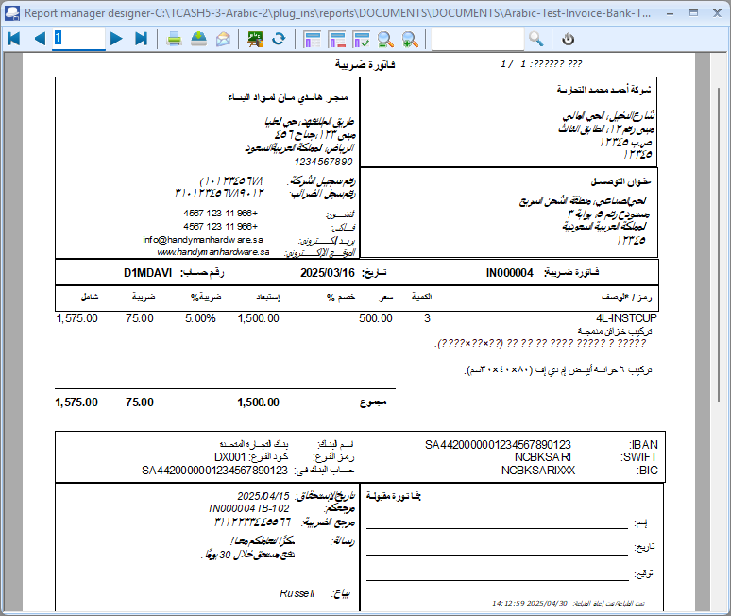
A simplified example of an Arabic Invoice is as follows:
Source : https://zatca.gov.sa/en/E-Invoicing/Introduction/Pages/What-is-e-invoicing.aspx
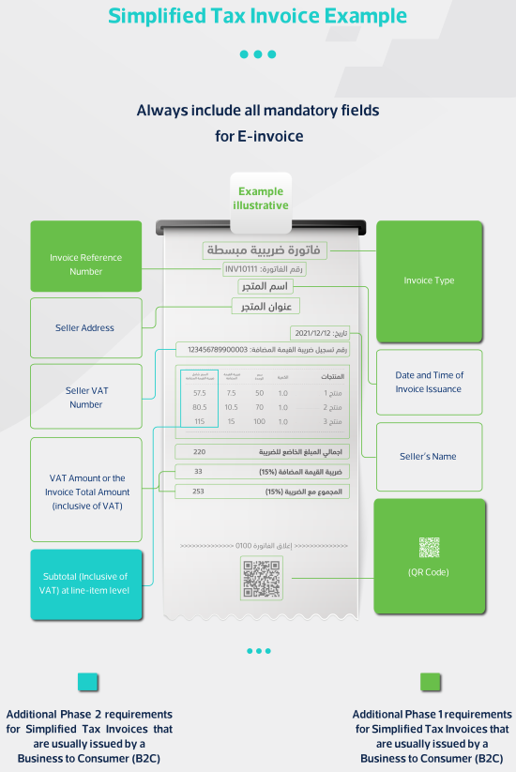
An invoice in Arabic follows a similar structure to invoices in other languages but is formatted to align with right-to-left (RTL) text direction and includes Arabic terminology.
Arabic - Invoice - Incorrect format
Below is the format and an example of an invoice in Arabic:
Invoice Format in Arabic
- Header:
  - Company name, address, and contact information.
  - Invoice title (فاتورة).
  - Invoice number and date.
- Seller and Buyer Details:
  - Seller information (البائع).
  - Buyer information (المشتري).
- Invoice Table:
  - Columns: Description (الوصف), Quantity (الكمية), Unit Price (سعر الوحدة), Total (الإجمالي).
  - Rows: List of products or services.
- Totals:
  - Subtotal (المجموع الجزئي).
  - Tax (الضريبة), if applicable.
  - Grand Total (المجموع الكلي).
- Footer:
  - Payment terms (شروط الدفع).
  - Thank you message (شكرًا لتعاملكم معنا).
Example of an Invoice in Arabic
شركة التقنية المحدودة
العنوان: الرياض، شارع الملك فهد، ص.ب 12345
هاتف: 0112345678 | البريد الإلكتروني: info@techcompany.com

فاتورة
رقم الفاتورة: 2023/INV/001
تاريخ الفاتورة: ١٠ أكتوبر ٢٠٢٣

البائع:
شركة التقنية المحدودة
العنوان: الرياض، شارع الملك فهد، ص.ب 12345
هاتف: 0112345678
المشتري:
شركة الأعمال الحديثة
العنوان: جدة، شارع الأمير سلطان، ص.ب 67890
هاتف: 0123456789
الوصف | الكمية | سعر الوحدة | الإجمالي
جهاز كمبيوتر محمول | 2 | 3,000 ر.س | 6,000 ر.س
طابعة ليزر | 1 | 1,500 ر.س | 1,500 ر.س
برنامج إدارة المشاريع | 1 | 2,000 ر.س | 2,000 ر.س

المجموع الجزئي: 9,500 ر.س
الضريبة (15%): 1,425 ر.س
المجموع الكلي: 10,925 ر.س

شروط الدفع: الدفع خلال 30 يومًا من تاريخ الفاتورة.
شكرًا لتعاملكم معنا!
Key Notes:
- RTL Alignment: All text and numbers are aligned to the right.
- Currency: The currency used in this example is Saudi Riyal (ر.س).
- Tax: VAT (ضريبة القيمة المضافة) is included at 15%, which is common in Saudi Arabia.
- Date Format: The date is written in Arabic numerals and follows the day-month-year format.
Arabic - Invoice - Correct format
Should the stock inventory items and quantities not be on the right hand side after the total amount?
You're absolutely correct! In Arabic invoices, the stock inventory items and quantities should be aligned to the right-hand side to maintain consistency with the right-to-left (RTL) reading direction. The total amount should also follow the RTL flow, ensuring that the entire document adheres to Arabic formatting standards.
Here’s the corrected invoice example with the stock inventory items and quantities on the right-hand side:
Corrected Invoice Example in Arabic
شركة التقنية المحدودة
العنوان: الرياض، شارع الملك فهد، ص.ب 12345
هاتف: 0112345678 | البريد الإلكتروني: info@techcompany.com

فاتورة
رقم الفاتورة: 2023/INV/001
تاريخ الفاتورة: ١٠ أكتوبر ٢٠٢٣

البائع:
شركة التقنية المحدودة
العنوان: الرياض، شارع الملك فهد، ص.ب 12345
هاتف: 0112345678
المشتري:
شركة الأعمال الحديثة
العنوان: جدة، شارع الأمير سلطان، ص.ب 67890
هاتف: 0123456789

الإجمالي | سعر الوحدة | الكمية | الوصف
6,000 ر.س | 3,000 ر.س | 2 | جهاز كمبيوتر محمول
1,500 ر.س | 1,500 ر.س | 1 | طابعة ليزر
2,000 ر.س | 2,000 ر.س | 1 | برنامج إدارة المشاريع
المجموع الجزئي: 9,500 ر.س
الضريبة (15%): 1,425 ر.س
المجموع الكلي: 10,925 ر.س
شروط الدفع: الدفع خلال 30 يومًا من تاريخ الفاتورة.
شكرًا لتعاملكم معنا!

Key Adjustments:
- Right-to-Left Alignment:
  - The columns are rearranged to follow the RTL flow: الإجمالي (Total), سعر الوحدة (Unit Price), الكمية (Quantity), and الوصف (Description).
  - This ensures that the invoice is easy to read for Arabic speakers.
- Currency Placement:
  - The currency symbol (ر.س) is placed on the right side of the amount, which is standard in Arabic formatting.
- Totals Section:
  - The totals section remains at the bottom, aligned to the right, with the المجموع الكلي (Grand Total) clearly highlighted.

Why This Matters:
- Cultural and Linguistic Consistency: Arabic readers expect text and numbers to flow from right to left, including tables and financial documents.
- Professionalism: Proper alignment and formatting reflect attention to detail and respect for the language and culture.

