Table of Contents
Translations 2
Completed translations 2
Translation Guidelines 2
Outstanding translations 2
Resources for Translations/Localizations 2
UI Constraints 3
CHECKED - OK 3
FIXED 3
FIXED - Creation wizard - 3
FIXED - Debtors / Creditors - Statement message LabelID 200 3
Customise Languages 4
Register 5
Debtor / Creditor 6
Debtors/Creditors - Transactions tab 6
Contacts 7
Contacts - Main tab - Initials 7
Contacts - Telephone tab - Freefields 1 - 9 7
Stock 8
Stock grid 8
Import / Export tab 8
Adjust stock tab 8
Stock - Main form 9
Stock- Ledger tab 9
Stock - Backorder 10
Setup - Stock Information 10
Documents - Enter discount 11
Update ledger / Delete documents 11
Setup = > Accounts 12
Accounts setup main 12
SBR References 12
Ledger analyser 13
Calendar 14
Calendar - Events 14
Calendar - Outlook syncronizer 14
Documents setup 15
Reporting dates - Setup 16
Access Control Setup 17
Setup -> Access control - Documents tab 17
Setup -> Access control - Others tab 17
Import 17
Data type to import 17
process cuts-off 18
POS Setup 18
Open Item link 19
Printer Setup Dialog 20
Setup -> Printer or Reportman File -> Page setup 20
Print setup tab 20
Reportman 21
Internet setup 21
Data Integrity Check 22
Countries 23
Central Search – Investigator (Default ribbon) 24

Translations

Completed translations
The 4072 Current labels are translated in most languages.
Language files on GitHub: osfinancials-development/languages at main · Digidanosf/osfinancials-development · GitHub

Translation Guidelines
Translation Guidelines on GitHub: osfinancials-development/localization-translation-guidelines at main · Digidanosf/osfinancials-development · GitHub

Outstanding translations
List of Outstanding translations on GitHub:
- osFinancials core: osfinancials-development/translations at main · Digidanosf/osfinancials-development · GitHub
- osFinancials Plugins: osfinancials-development/plugins-translations at main · Digidanosf/osfinancials-development · GitHub

Resources for Translations/Localizations
Recourses on GitHub for Arabic, Chinese, French, German, Greek, Italian, South African, Spanish, Turkish, Vietnamese accounting.
Other languages such as Croation, Estonian, Slovenian, Swedish, Thai, etc. will be added to this repository.
Other languages on GitHub: osfinancials-development/accounting-other-languages at main · Digidanosf/osfinancials-development · GitHub

UI Constraints
The updated font in osFinancials 5.1.0.253 improves UI rendering and multi-language support, fixing grid and drop-down issues for complex scripts via Unicode.
In osFinancials5.1.0.253 it fixes the Comprehensive Language Support by changing the default Unicode font
- Fixed Display Issues: The change specifically resolves the incorrect display on Grids and drop-down lists in Greek.
- Enhanced Multi-Language Support: It provides better support for all other complex scripts and character sets, including Turkish, Thai, Russian, Chinese, and many others, which rely heavily on Unicode for correct rendering.
In the English.dfm language source file, the new font causes UI constraints in the osFinancials/TurboCASH Interface in the default English source translations.
Other translations the default English source is used to contain translations within that length to avoid UI constraints, especially for languages where translations are longer than the original English text.
Reports remain unaffected due to Reportman's default fonts.

CHECKED - OK
- Bank reconciliation
- Blockchain
- Projects
- Cost Centres

FIXED

FIXED - Creation wizard -
2033 Change company info. => Change company info => Removed the period for consistency with the Setup -> Company info menu item

FIXED - Debtors / Creditors - Statement message LabelID 200
The Problem: Context Overlap
The term "Statement message" is contextually accurate for Debtors (Customer Accounts) but incorrect for Creditors (Supplier Accounts), where the correct business term is "Remittance message."
The Constraint:
The application uses a single LabelID (200) for the field in both contexts. Therefore, a single translation must serve both purposes.
The Solution:
Your fix to use the generic term "Message" is the optimal resolution under this constraint.
- It is accurate for both contexts.
- It is neutral and does not introduce business logic that doesn't belong to one of the user groups.
- It is concise, helping with UI layout.
Ideal Future Solution:
A more robust technical solution would be for the application to use two separate LabelIDs:
- One for "Statement Message" (Debtors)
- One for "Remittance Message" (Creditors)
This would allow for precise, context-specific translations. Until then, "Message" is the correct and professional compromise.
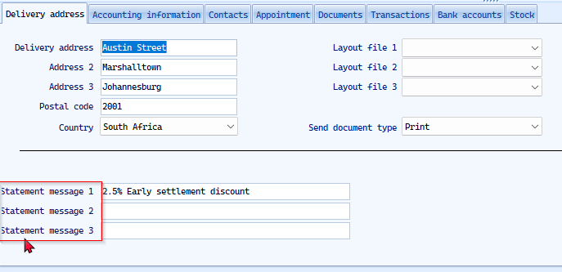

Customise Languages
Id missing from Eng translation button
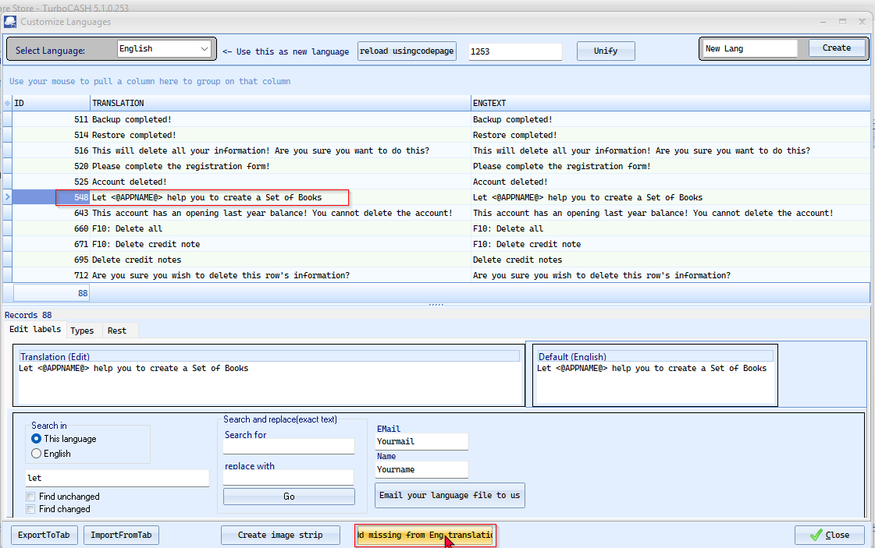
Default option 'Let TurboCASH5-3 help you to create a Set of Books' Last 7 characters cut-off.
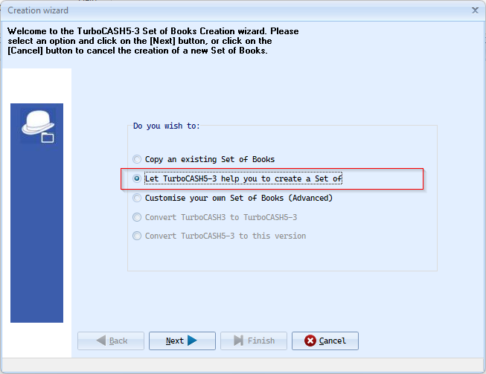

Register
'...you agree to the terms and conditions' overlapping with 'Show license' button
Help us on this function
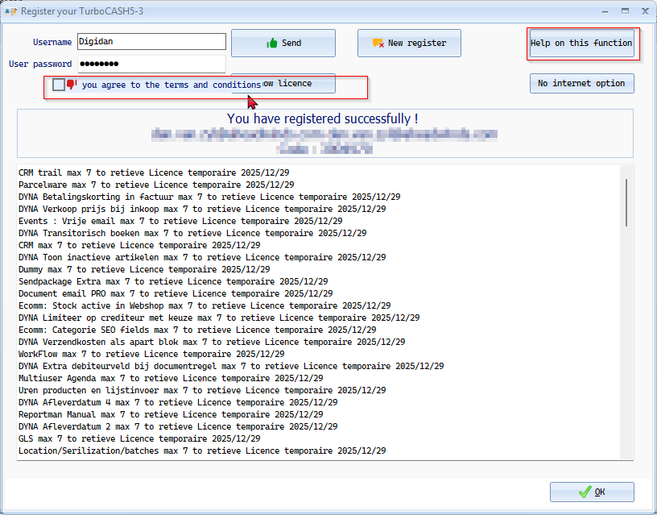

Debtor / Creditor

Debtors/Creditors - Transactions tab
Show transactions button 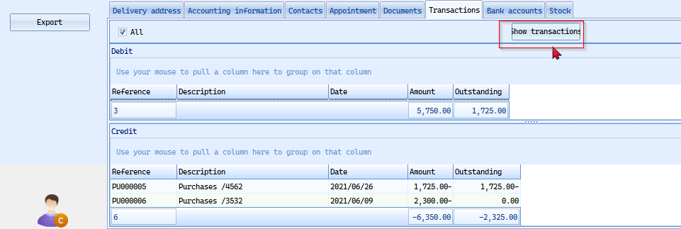

Contacts

Contacts - Main tab - Initials
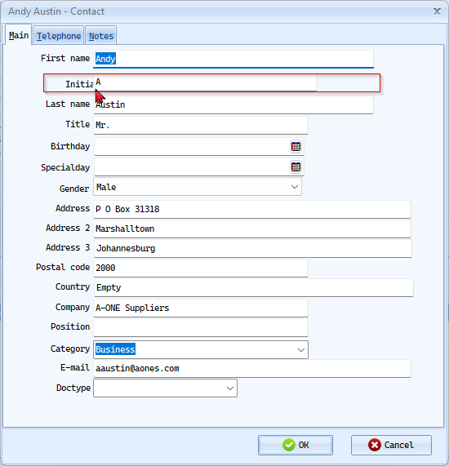

Contacts - Telephone tab - Freefields 1 - 9
NOTE Freefields 7 - Missing
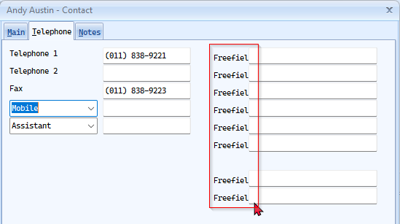

Stock

Stock grid

Import / Export tab
Tick boxes cut off text
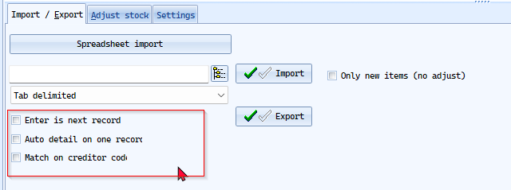

Adjust stock tab
Use transaction
Stock order calculation - button
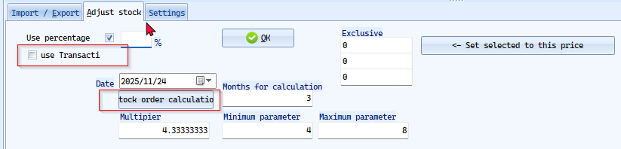

Stock - Main form
Stock code
Preferred supplier 1
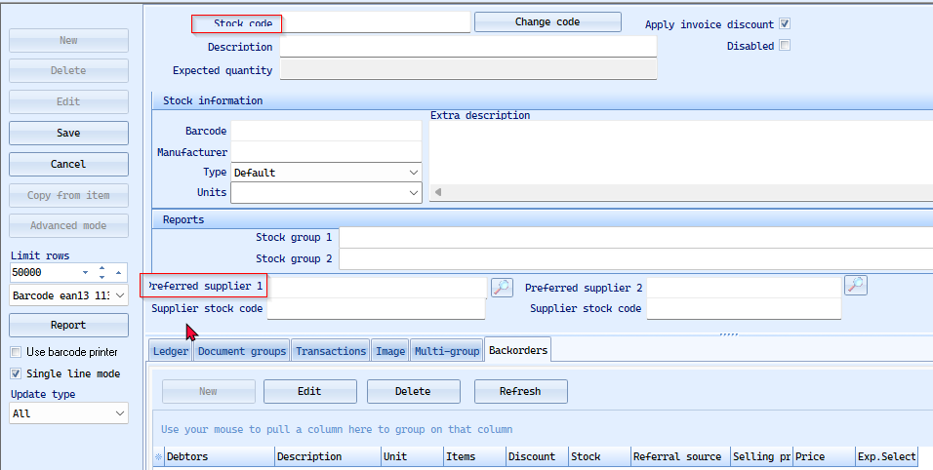

Stock- Ledger tab
Delivery delay
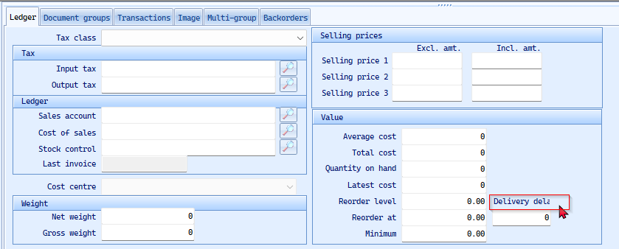

Stock - Backorder
Exp. Selected = Exp. hardcoded and not translatable
Exp. Probably an abbreviation for 'Expected'
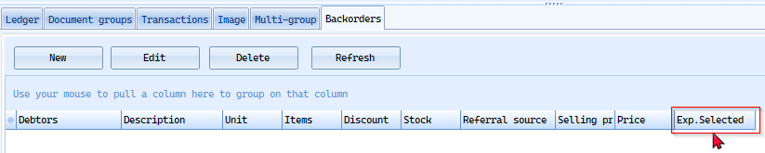

Setup - Stock Information
UI Constraint in Drop-down lists
- Default - Selling price descriptions
- Cost of Sales batch (Can enter up to 100 characters - but when selecting a batch from here but only 15 Characters visible).
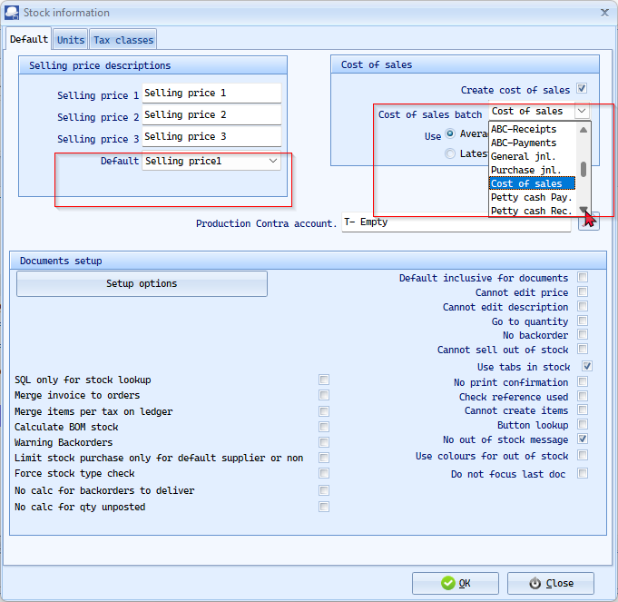

Documents - Enter discount
Enter overall discount
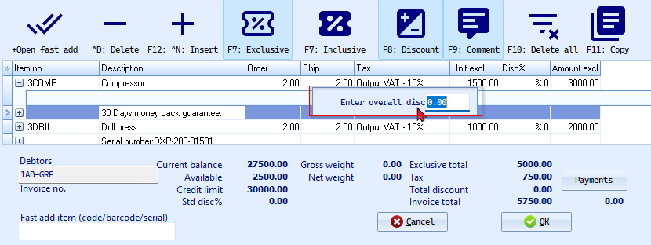

Update ledger / Delete documents
Suppress open item
From ... to (Also replicated in Delete douments)
Select type - Drop down lists - Auto expand
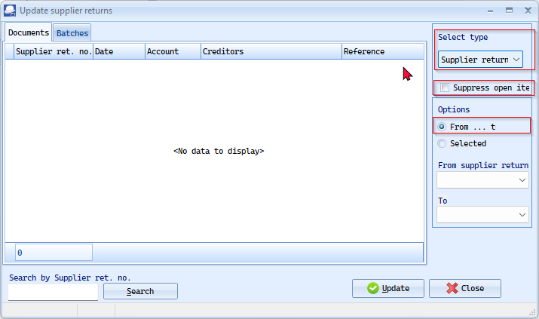

Setup = > Accounts

Accounts setup main
- Account stars with
- Description
- Account group 1 / 2 and other drop-down lists Auto expand
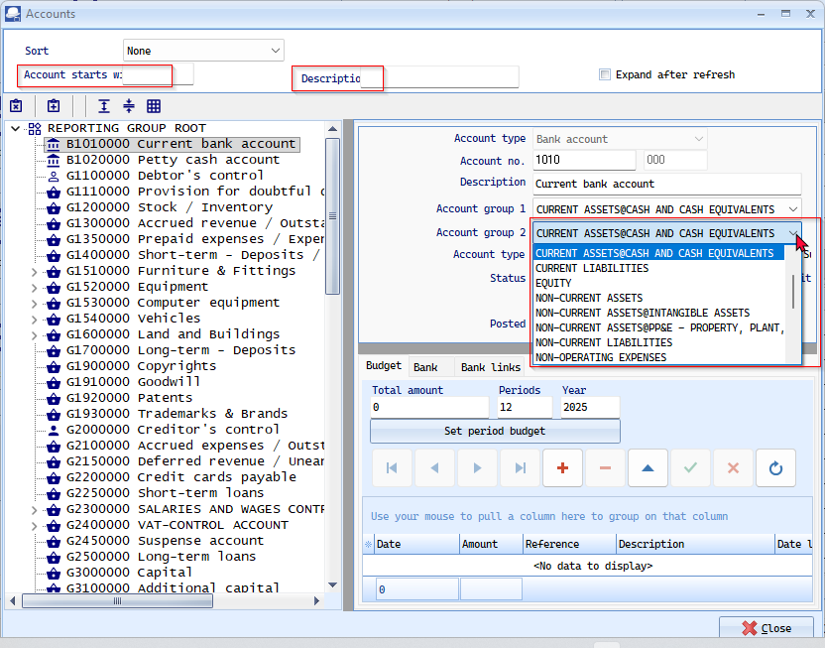

SBR References
Select from list - button
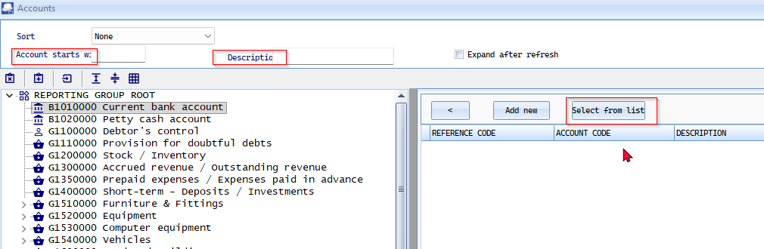

Ledger analyser
Viewer Debtors / Creditors = Looks like this is a combo hard-coded translation (extra space between Viewer and Debtors / Creditors) NOTE this is not in the language 'Debtors / Creditors' and cannot be edited to remove the spaces before and afther the slash ' / '
Drop-down lists - Auto expand
- Report type -
- Groups -
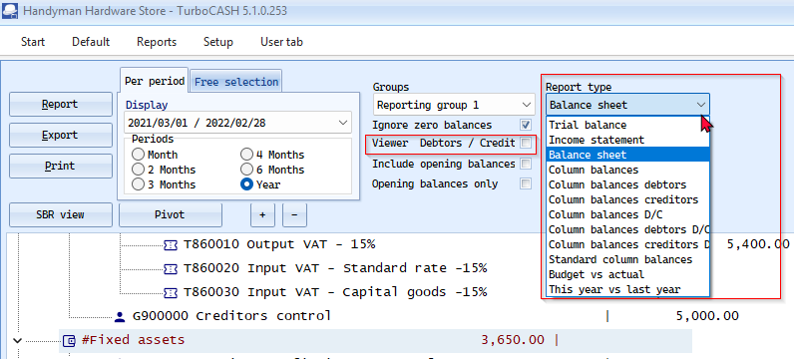

Calendar

Calendar - Events
- Start time
- Processno:
- Stock item : Drop-down list needs Auto expand
- On Repeating Invoices Label ID 2880 cuts off' clients to the invoice.'
2880 Please save this repeating invoice first! After reopening you can add clients to the invoice. Please save this repeating invoice first! After reopening you can add clients to the invoice.
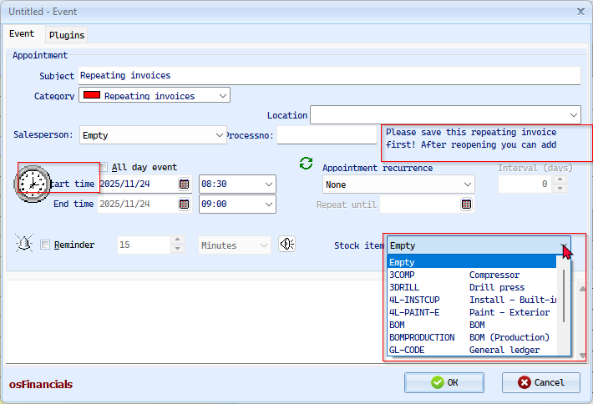

Calendar - Outlook syncronizer
From reporting date ... To date
243 From reporting date From reporting date
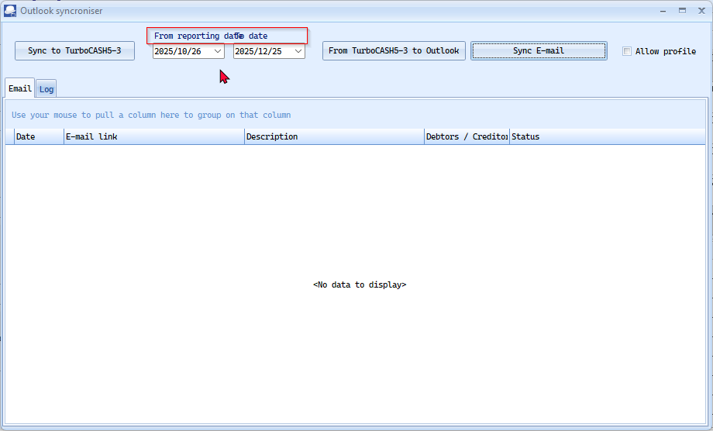

Documents setup
Save load layout in lo... Maybe there is an overlap with Next journal no.
Next journal no. OK but generally on The Supplier returns tab it causes UI constraints across most translations.
Drop-down lists - Auto expand for all documents type tabs
- Invoice journal NOTE : By default at current only 18 characters is visible and users may enter up to 100 characters
- Layout file + Layout file 2 + Layout file Point of sale NOTE: These Drop-down lists - Auto expand are critical as this makes it difficult to select the correct files at Setup - It is great in Debtors/Creditors/Documents
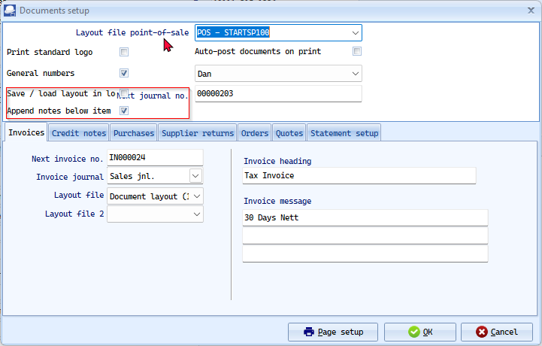
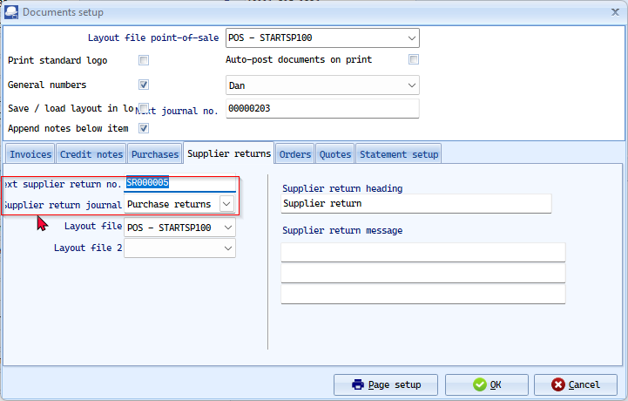

Reporting dates - Setup
Open for posting - too clode to tichbox ' g ' is not displaying properly.
Battle to get sensible translations in the Open for posting tick boxes - UI constraints.
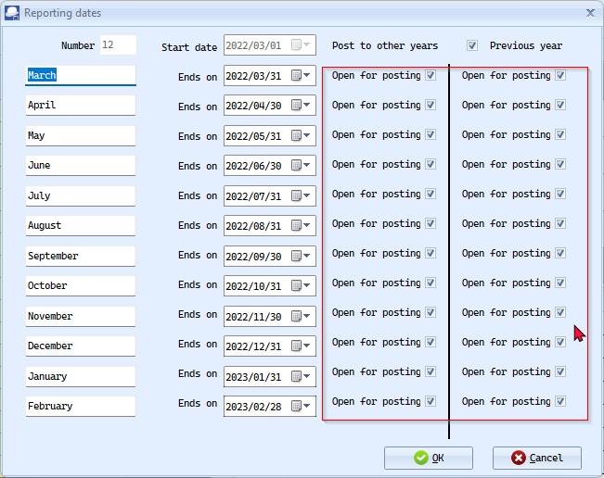

Access Control Setup

Setup -> Access control - Documents tab
Interval (sec.)
Stock access type
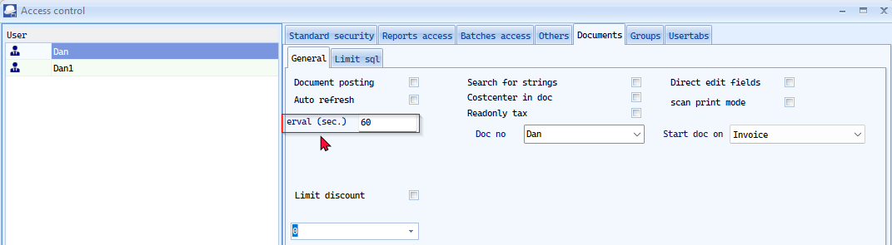

Setup -> Access control - Others tab
Custom limitation
Stock access type
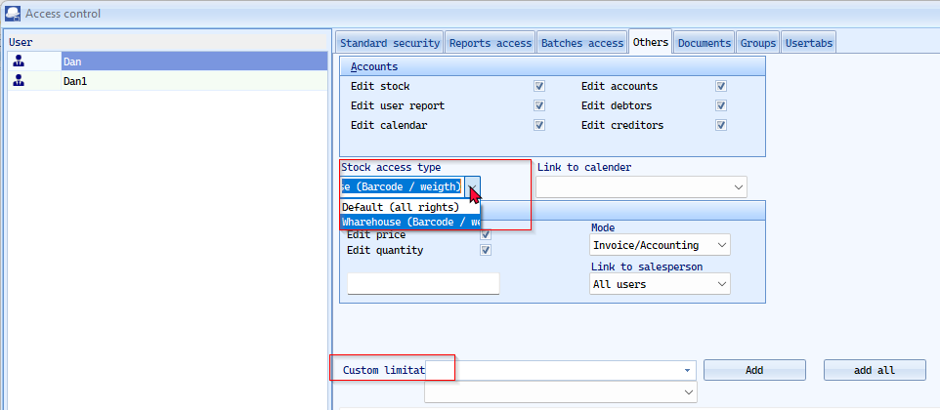

Import

Data type to import
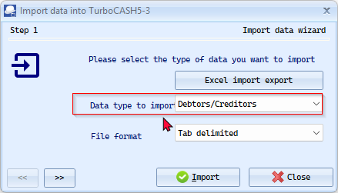

process cuts-off
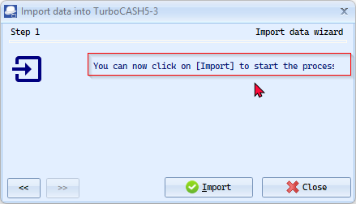

POS Setup
Fast switch salesperson
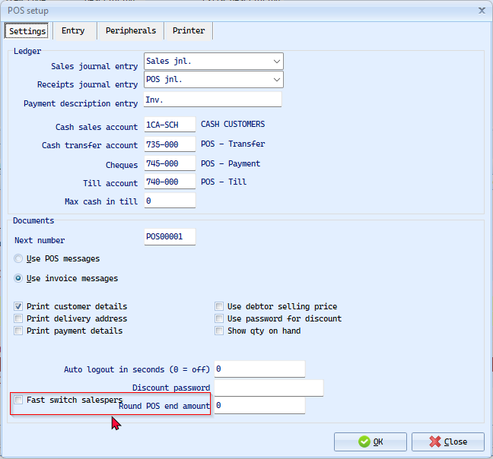

Open Item link
Include items since + Current date
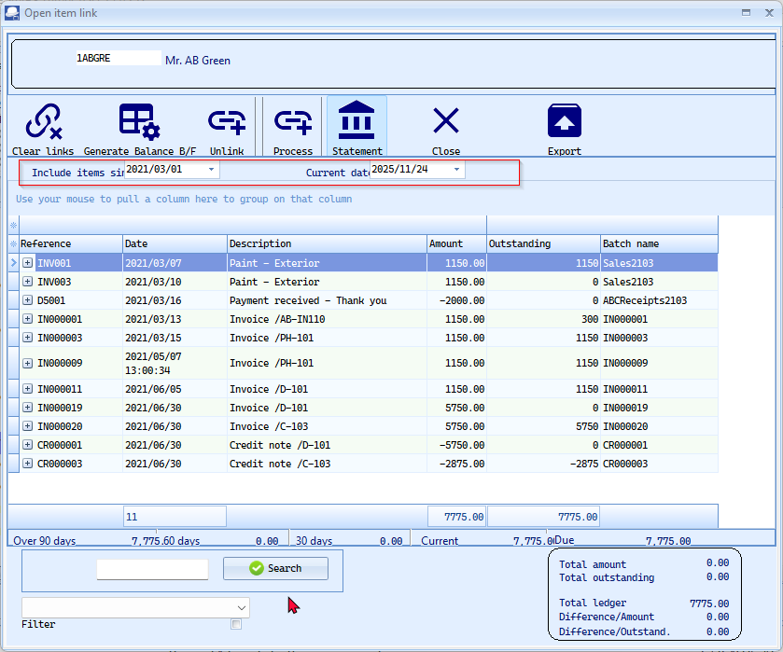

Printer Setup Dialog

Setup -> Printer or Reportman File -> Page setup
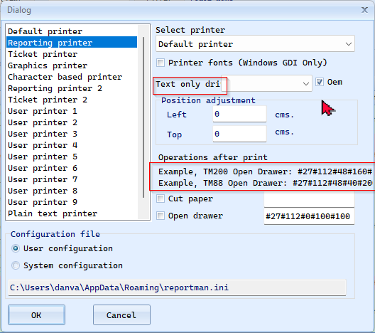

Print setup tab
Print only if data available
Paper source (Windows) - Drop-down list - auto expand
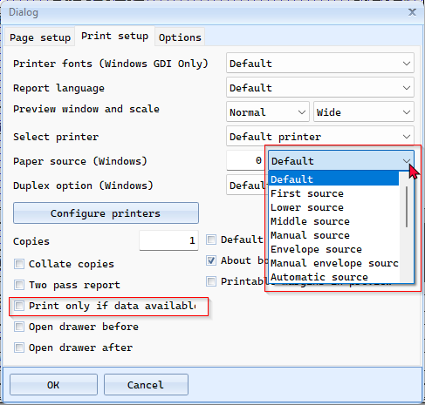

Reportman
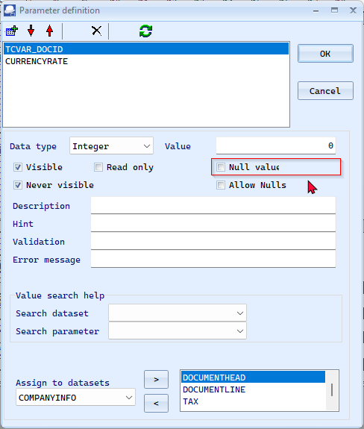

Internet setup
Outgoing mail server identification
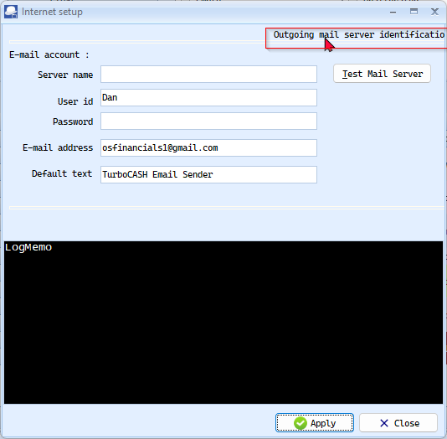

Data Integrity Check
Recalc totals button
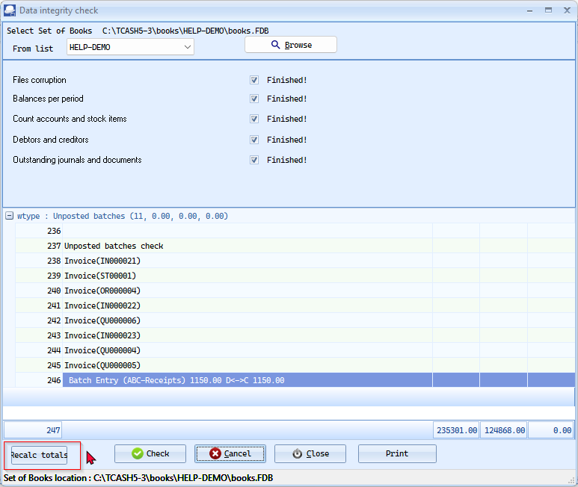

Countries
Display of Åland Islands displayd as �land Islands in Setup -> Countries
Display issues also replicated in Debtor accounts/Creditor accounts and in Documents on Country lists.
NOTE The Swedish.dfm Language file also uses these characters like ' Å ' and seems to display correctly in the UI.
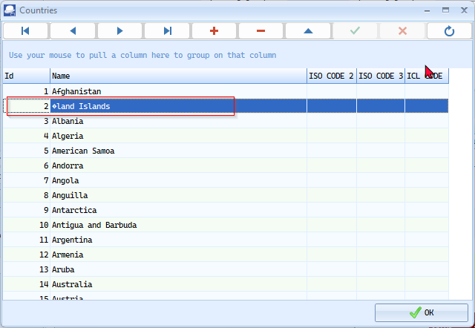
This is a classic and important issue in localization and software sorting.
Yes, the name "Åland Islands" starts with a special character: the letter Å (A with a ring).
This character has specific handling rules:
Sorting & Alphabetization
How "Åland" is sorted depends on the language and system:
- In Swedish and Finnish (the relevant languages): The letter Å is a distinct letter that comes at the very end of the alphabet, after Z.
Example order: ... W, X, Y, Z, Å, Ä, Ö.
- In International/English contexts: It is often treated as if it were a simple "A" and sorted accordingly (Aaland, Åland, Albania...). This is technically incorrect but common in systems not designed for Nordic languages.
- In simple code: It may be sorted based on its Unicode value, which can place it before 'A' or in a group of special characters, leading to incorrect results.
Implications for Your Language File
This is critical for your localization checklist, especially under the "UI Constraints" and "Data Sorting" sections.
- UI Display: You must ensure the application's font supports the Å character. If it doesn't, it may display as a square, question mark, or other placeholder (�).
- Dropdown Lists & Filters: If you have a list of countries, "Åland Islands" will not appear under 'A' if the sorting is correctly implemented for Swedish/Finnish. Users must look for it at the end of the list.
- Database & Searching: Search functionality should be configured to treat "Aaland" (an old English spelling) and "Åland" as equivalent to be user-friendly.

Central Search – Investigator (Default ribbon)
F4:Details icon
Search tip - Font white hard to read on screen - Text or translation cuts off
