Table of Contents

**Reports fixed - osFinancials5.1.0.127** 1

**Reports not included in osFinancials5.1.0.127 update install** 2

**Reports Fixed after osFinancials5.1.0.127 update install** 2

***systemreports (Fixes to be updated)*** 2

***Alignment headings and detail - Debtors listing*** 2

***Alignment headings and detail - Creditors listing*** 3

***Stock - In/Out - Show details - Overlapping labels*** 3

***Documents - Document listing - Overlapping labels*** 5

***Tax - Tax per period*** 7

**Reports fixed - osFinancials5.1.0.127**

These updated reports were included in theosFinancials5.1.0.127 update installation. These Reports were retested in both Firebird database types and in MSSQL database types in osFinancials5.1.0.127. The following reports were updated and fixed.

1. **systemreports** - Fixed some adjustments to text (labels expressions) and data expressions were made in about 7 reports.
   1. **Reports → Debtors → Listing** **- List delivery address**
   2. **Reports → Debtors → Listing** - **List postal address**
   3. **Reports → Creditors → Listing - List delivery address**
   4. **Reports → Creditors → Listing - List postal address**
   5. **Reports → Stock → Stock In / Out - Stock in / Out**
   6. **Reports → Documents → Document listing**
   7. **Reports → Tax - Tax per period**
2. **REPORTS/STOCK - Sidebar reports - Stock movement** - This report prints similar data to the "*Voorraad verloop*" report
   * Renamed text report name to LANG_906038 to be translatable via the language files. Added report name "*Stock movement - Average cost - Grid*" in Header section.
   * Total print on Page 2 and Total - Data type = Currency as " ##,###,###,##0.00" in Detail of Group section (e.g. 1,000.00) - Set the Group footer data type for the Total (e.g. 1000.00) to display similar than the Detail report section.
3. **excelreports** - **Spreadsheet reports → Sales analysis → Sales per period** - Fixed - Error in Firebird databases to be updated. **Location** : …\plug_ins\reports\excelreports\TRN_85\TRN_906122/trn1296.sql

**Reports not included in osFinancials5.1.0.127 update install**

The following reports were fixed in osFinancials5.1.0.109 update but in osFinancials5.1.0.127 update install:

1. **DOCUMENTS/DOCUMENTS** - Document layout files updated to fix overlapping labels, remarks, etc. Standardised the Company and Tax registration numbers before contact details, etc.
2. **userreports** - Reports in the user reports menu Restructured and fixed overlapping labels, etc.

**Reports Fixed after osFinancials5.1.0.127 update install**

1. **Reminders / Remittace plugin** - **Location** : *...\plug_ins\reports\remittance* - **Fixed** overlapping labels Auto Expand / Auto Contract and word wrap settings. **Fixed MSSQL error in doctype layouts**  - MSSQL Error DOCUMENTREGEL Dataset

*DOCUMENTREGEL:Incorrect syntax near '|'.*

1. **Subscriptions plugin** - Reports in 2 different locations, it is:
   1. **Reports** - **Location** *: ...\plug_ins\reports\REPORTS\SUBSCRIPT* - Fixed overlapping labels Auto Expand / Auto Contract and word wrap settings.
   2. **layouts** -
      * **English** layout - **Location** : ...\plug_ins\reports\Subscriptions\en\layouts\default.rep
      * **Netherlands** layout - **Location** : ...\plug_ins\reports\Subscriptions\nl\layouts\default.rep
2. CRM plugin - **Location** : ...\plug_ins\reports\CRM\ - Not updated - Need to activate and configure the CRM plugin before any reports could be printed. - MSSQL Errors in

*"DOCUMENTHEAD:Incorrect syntax near '|'."*

***systemreports (Fixes to be updated)***

**osf.ini file** : " ***nounocode=true*** " setting prints in Firebird database types and MSSQL database types.

These systemreports have been updated and included in osFinancials5.1.0.109.

Retested in osFinancials5.1.0.127 on **Reports** menu (systemreports folder) some minor fixes regarding overlapping labels and consistency in 7 reports were fixed -

***Alignment headings and detail - Debtors listing***

**Reports → Debtors → Listing** **- List delivery address** - Location : ...\plug_ins\reports\systemreports\TRN_160\TRN_66\TRN_906138.rep

**Reports → Debtors → Listing** - **List postal address** - **Location** : ...\plug_ins\reports\systemreports\TRN_160\TRN_66\TRN_906139.rep

***Alignment headings and detail - Creditors listing***

**Reports → Creditors → Listing - List delivery address** - Location : ...\plug_ins\reports\systemreports\TRN_161\TRN_66\TRN_906138.rep

**Reports** → **Creditors → Listing - List postal address** - **Location** : ...\plug_ins\reports\systemreports\TRN_161\TRN_66\TRN_906139.rep

***Stock - In/Out - Show details - Overlapping labels***

**Reports → Stock → Stock In / Out - Stock in / Out**

**Location** : ...\plug_ins\reports\systemreports\TRN_1999\TRN_906112

**Before fix**

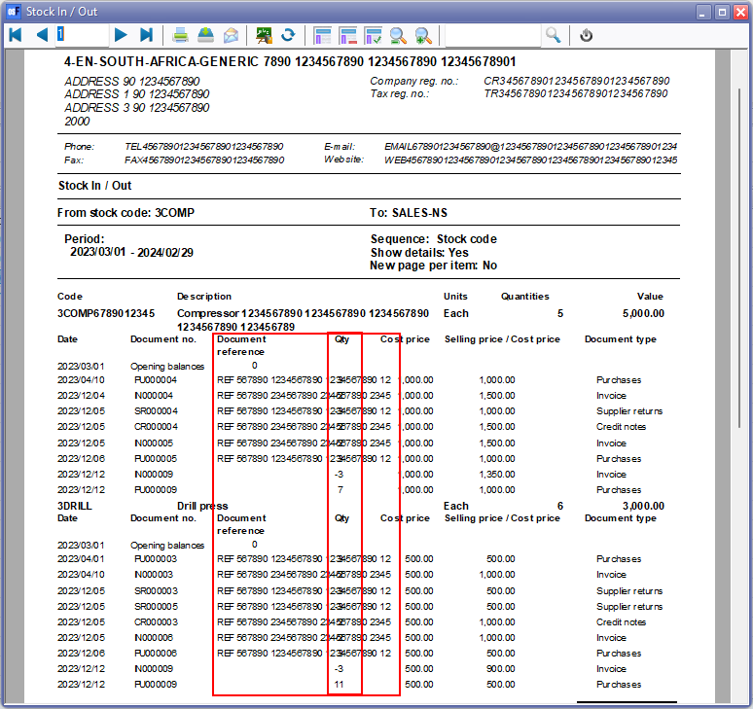

**After fix**

Moved Quantity, Cost price, Selling price / Cost price and Document type to right

Added line break in Selling price / Cost price expression

Set Auto expand/ Auto Contract and Word wrap

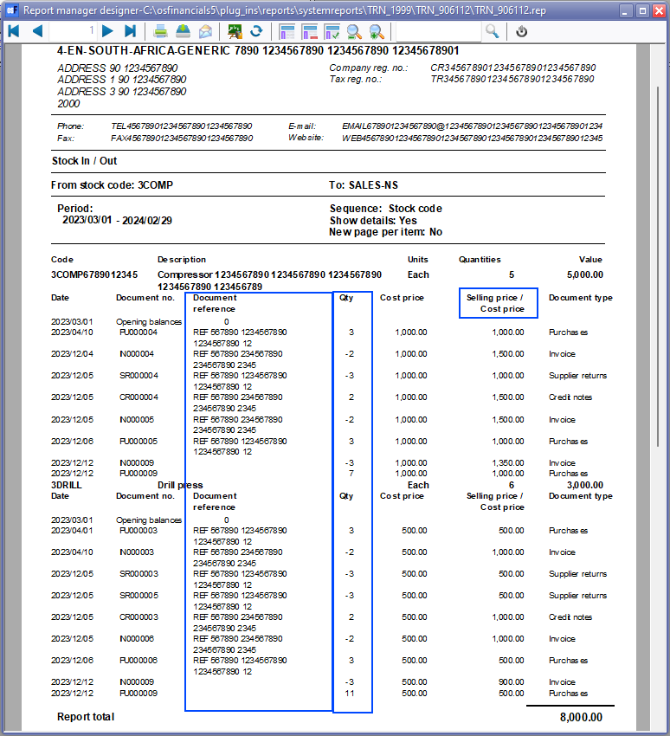

***Documents - Document listing - Overlapping labels***

**Reports → Documents → Document listing**

**Location** : ...\plug_ins\reports\systemreports\TRN_38\TRN_45\TRN_45.rep

**Before fix**

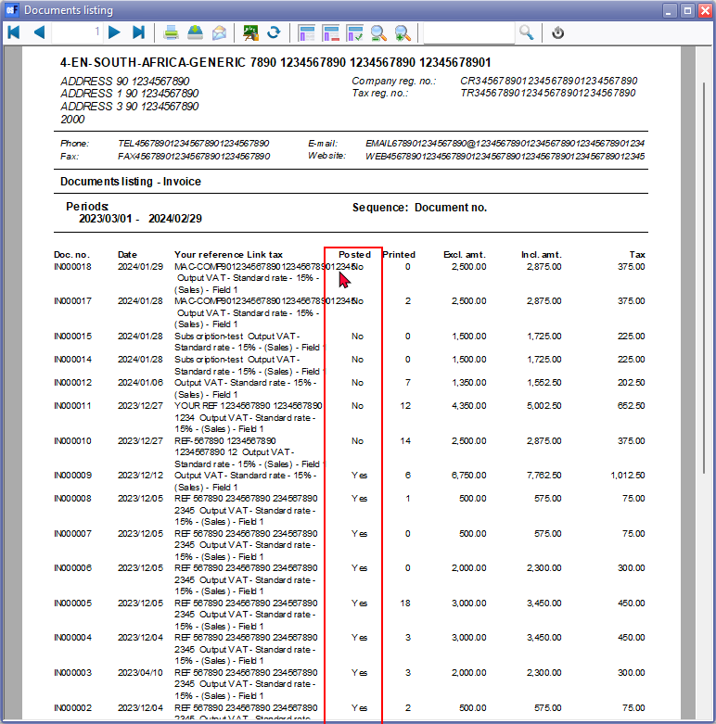

**After fix**

Added // in descriptions and expressions Your reference Link tax - to Your reference // Link tax

This is to be consistent with other tax reports (e.g. Tax - Transactions and Tax report - Reference / Document no.) and easier on the eye to separate the fields.

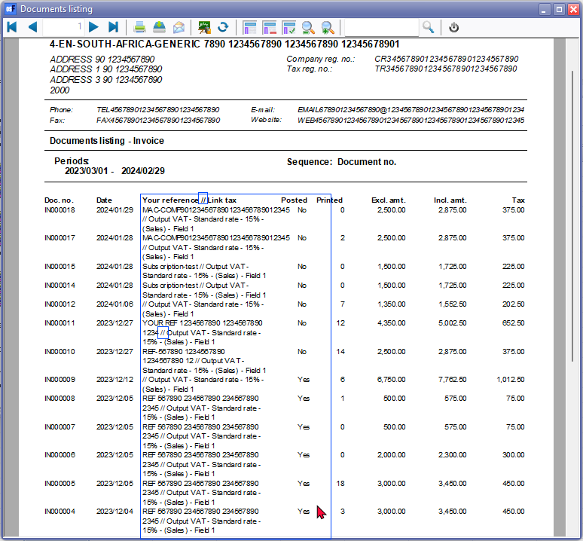

***Tax - Tax per period***

**Reports → Tax - Tax per period**

**Location** : .../plug_ins\reports\systemreports\TRN_906020\TRN_906020

**Before fix**

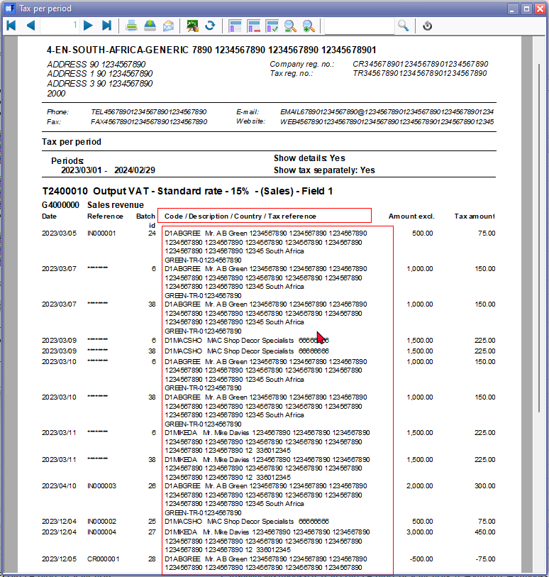

**After fix**

Added // in descriptions and expressions Code / Description Country / Tax reference - to Your reference // Link tax

This is to be consistent with other tax reports (e.g. Tax - Transactions and Tax report - Reference / Document no.) and easier on the eye to separate the fields.

