Table of Contents

*FIXED* ***Links*** *- Help Project file for next update* 2

**Links to Manuals on from osFinancials shop** 3

**Missing in osFinancials.org webshop** 3

*Checklist for Fixing and Updating Links on osFinancials Website* 4

***CRM*** 4

***PAIN/SEPA Incasso Export*** 4

***Aanmaning / Reminders*** 4

***Activa*** 5

***Document emailpro*** 5

***e-Commerce*** 5

***Multi workstation*** 5

***Multimedia Pack*** 5

***Plugin bundle 1*** 6

***Plugin bundle II*** 6

***Rest of links*** 7

***Plugin bundel Charities*** 7

*Manual links on Plugins shop cause errors in some Web browsers* 9

***Notes and screenshots*** 9

***Example CRM webshop Webpage - start with https://*** 10

***Example CRM Webpage - Link to Manual start with http:// - Error in Manuals link on Microsoft Edge*** 10

***Example CRM Webpage - Link to Manual start with http:// - Manuals link in Chrome refers to "Not secure" but Manuals page loads.*** 11

**Plugins menu structure** 11

***Document plugins*** 12

***External system links*** 13

***Financial tools*** 13

***Generic plugins (Plugins menu)*** 14

***Other Generic plugins (Other)*** 14

***DYNABREG*** 17

Register plugins 17

# *FIXED* ***Links*** *- Help Project file for next update*

Updating and fixing links in the osFinancials and TurboCASH documentation to ensure compatibility across different web browsers, particularly addressing issues with Microsoft Edge. Here’s a summary of the key points and actions taken:

**Key Points:**

**HTTP Links Compatibility Issues**:

Some links in the osFinancials documentation were using http://, which caused compatibility issues in certain browsers, including Microsoft Edge.

These http:// links were leading to Error 404 issues in some cases.

**HTTPS Links**:

The osFinancials webshop pages, which use https://, load correctly in most browsers.

The goal was to ensure all links in the documentation use https:// to avoid these issues.

**osFinancials Documentation Updates**:

Fixed and updated about 400 links in the HelpnDoc project files, changing them from boehoudpakket to osfinancials.org. in osFinancials online help and Help.chm files:

**English** - <https://www.osfinancials.org/htmlhelp_eng/welcome.html>

**Afrikaans** - <https://www.osfinancials.org/htmlhelp_af/welcome.html>

This update will be reflected in the next EngHelp.chm file and HTML Online Help files.

**Current Documentation Issues**:

The current English and Afrikaans online help files (<https://www.osfinancials.org/htmlhelp_eng/welcome.html> and <https://www.osfinancials.org/htmlhelp_af/welcome.html>) were causing Error 404 issues in some browsers due to incorrect links.

These issues will be fixed in the next round of updates.

**TurboCASH Documentation not updated**:

Given that the current TurboCASH documentation cannot be updated at this stage, the focus should be on ensuring that correct links are included in future documentation releases.

* There are several versions of TurboCASH online documentation, including:
* TurboCASH5 (4.0.0.969) Online Help: <https://www.turbocash.net/TC5HELP/EngHelp.html>
* TurboCASH5.1 - USA - Online Help: <https://www.turbocash.net/TC5HelpUSA/EngHelp.html>
* TurboCASH5.1 - Afrikaans - Online Help: <https://www.turbocash.net/TC5AFRHulp/EngHelp.html>
* TurboCASH 4 (838) - 2021: <https://www.turbocash.net/TC4Help/EngHelp.html>

**Next Steps:**

**Finalize Updates**: Complete the final round of updates to ensure all links are correctly pointing to https:// and fix any remaining Error 404 issues.

**Test Across Browsers**: Thoroughly test the updated documentation across different web browsers, including Microsoft Edge, to ensure compatibility.

**Deploy Updated Documentation**: Once testing is complete, deploy the updated EngHelp.chm file and HTML Online Help files to the osFinancials and TurboCASH websites.

By addressing these issues, you're ensuring that users have a smoother experience accessing the documentation, regardless of the browser they use.

**Links to Manuals on from osFinancials shop**

Checks and links reported in period 18 to 22 September 2024.

Links scenario - <https://www.osfinancials.org/en/webshop>

# *Outstanding issues to Fix in osFinancials documentation*

## *Missing in osFinancials.org webshop*

The osFinancials / TurboCASH Online products was on boekoukdpakket webshop is not available on osfinincials.org/webshop

**Online Account -** <http://www.osf-boekhoudpakket-administratie.nl/index.php/en/webshop/online-accounting/online-account>

**Online Extra Set of Books** - <http://www.osf-boekhoudpakket-administratie.nl/index.php/en/webshop/online-accounting/-online-extra-set-of-books>

**Online Account with Plugin Bundle** - <http://www.osf-boekhoudpakket-administratie.nl/index.php/en/webshop/online-accounting/online-account-with-plugin-bundle>

These boekhoudpakket links causes Error404 issues.

***osFinancials / TurboCASH Online***

|  |  |
| --- | --- |
|  | ***osFinancials / TurboCASH Online***  *Experience ultimate convenience and flexibility with our osFinancials/TurboCASH Online offerings:* |

1. **Online Account**:- Manual - Shop - 14 Days trial, 6 months account or year account - Gain 24/7 access to your osFinancials/TurboCASH Set of Books hosted on our servers. Whether you're at the office or at home, manage your administration effortlessly. Collaborate with your accountant or co-workers with ease, and utilize Open Office for added versatility. Plus, enjoy ample 1 GB of disk space with the option to expand as needed. With flexible subscription options and straightforward invoicing, it's never been easier to stay on top of your finances. It's only possible to access your set of books with one session at the time. If you want multi user access, than you can buy "addition nodes".
2. **Online Extra Set of Books**: Manual - Shop - Depending on the number of the Sets of Books ordered. Expand your online toolkit with additional Sets of Books tailored to your needs. Choose the number of sets required and enjoy seamless access to your finances anytime, anywhere.
3. **Online Account with Plugin Bundle**: Manual - Shop - 14 Days trial, 6 months account or year account. Elevate your online experience with our Plugin Bundle, adding even more functionality to your osFinancials/TurboCASH Set of Books. Enjoy all the benefits of our Online Account offering, plus access to a suite of plugins to enhance your financial management capabilities. Customize your subscription to fit your needs, with multi-user access options available for seamless collaboration.

## *OfficePro / Bookkeeping Pro*

In osFinancials on the **Plugins -> Financial tools -> Office** menu is listed. This will launch the “*Office pro setup and process*” screen.

But on the <https://www.osfinancials.org/en/webshop> links to Bookkeeping pro <https://www.osfinancials.org/en/webshop/branch-specific-solutions/bookkeeping-pro> , Bookkeeping pro is listed.

# *Checklist for Fixing and Updating Links on osFinancials Website*

The detailed checklist is comprehensive and should effectively assist the web admin in finding, fixing, and updating broken links on the osFinancials website. Here’s a refined version of your checklist, organized for clarity and efficiency:

**General Recommendations**:

* **HTTPS**: Ensure all links are using HTTPS to provide a secure connection.
* **Consistency**: Maintain consistency in the language and region of the shop links based on the user's preference.
* **Content Review:** Regularly review the content for broken or insecure links and update them promptly.

By addressing these issues, you can improve the user experience and ensure that all links on your website are secure and functional.

**Additional Steps:**

**Automate Link Checking**:

Use tools like [W3C Link Checker](https://validator.w3.org/checklink) or [Dr. Link Check](https://www.drlinkcheck.com/) (Limits to subscription) to automate the process of finding broken links.

**Regular Audits**:

Schedule regular audits of the website to ensure that all links remain functional and secure.

**Documentation**:

Maintain a log of all changes made to the links, including the old and new URLs. This will help in tracking changes and ensuring consistency.

By following this checklist, the web admin can systematically identify, fix, and update broken links on the osFinancials website, ensuring a smooth and error-free user experience.

## ***CRM***

**Shop link - CRM (Customer Relations Management) -** [**https://www.osfinancials.org/en/webshop/debtor-creditor-control/crm-(customer-relations-managament)**](https://www.osfinancials.org/en/webshop/debtor-creditor-control/crm-(customer-relations-managament))

* **Manual** (English) **Incorrect** - <http://www.osf-boekhoudpakket-administratie.nl/index.php/en/plugin-manuals/425-crm-customer-relations-management-plugin> (Not secure)
  + **Manual** (English) - **Correct link** - <https://www.osfinancials.org/en/plugin-manuals/425-crm-customer-relations-management-plugin>
* **Typos** :
* Manageament -> Management
* Click herer -> Click here

## [***PAIN/SEPA Incasso Export***](https://www.osfinancials.org/en/webshop/debtor-creditor-control/pain/sepa-incasso-export)

**Shop link - Page404 Error** : <https://www.osfinancials.org/en/webshop/debtor-creditor-control/pain/sepa-incasso-export>

**Shop link** (English) - <https://www.osfinancials.org/en/webshop/debtor-creditor-control/iban-import-export>

**NOTE** : Not sure if it is the same product.

## ***Aanmaning / Reminders***

**Shop Link** - <https://www.osfinancials.org/en/webshop/debtor-creditor-control/remittance-plugin>

* **Manual** tab - The manual is in Dutch only - [Click here](http://www.osf-boekhoudpakket-administratie.nl/index.php/nl/handleidingen-plugins/475-aanmaningen-plugin)to go to the Dutch manual. -
* <http://www.osf-boekhoudpakket-administratie.nl/index.php/nl/handleidingen-plugins/475-aanmaningen-plugin> **- Not secure** 
  + **Manual** (Dutch) **- Correct link -** <https://www.osfinancials.org/nl/handleidingen-plugins/475-aanmaningen-plugin>
  + **Manual** (English) - **Correct link for** - <https://www.osfinancials.org/en/plugin-manuals/545-remittance-plugin>
  + **Online Help documentation** – Added next update to Help documentation – Retesting, Debugging and update Help documentation

## ***Activa***

**Shop link** - <https://www.osfinancials.org/en/webshop/most-sold/depreciation-plug-in>

* **Manual tab** (English) **- Not secure link** - <http://www.osf-boekhoudpakket-administratie.nl/index.php/en/plugin-manuals/514-activa-plugin>
  + **Correct link to Manual** - <https://www.osfinancials.org/en/plugin-manuals/514-activa-plugin>
  + **Online Help documentation -** <https://www.osfinancials.org/htmlhelp_eng/activa-plugin.html>

## ***Document emailpro***

**Shop link** - <https://www.osfinancials.org/en/webshop/most-sold/document-email-pro-plugin>

* **Manual tab** (English) - **Not secure link** - <http://www.osf-boekhoudpakket-administratie.nl/index.php/en/plugin-manuals/171-document-email-pro>
  + **Manual** (English) - **Correct link** - <https://www.osfinancials.org/en/plugin-manuals/171-document-email-pro>
  + **Online Help documentation** - <https://www.osfinancials.org/htmlhelp_eng/plugin-document-mailpro.html>

## ***e-Commerce***

**Shop link** - <https://www.osfinancials.org/en/webshop/e-commerce/e-commerce-plugin>

* **Manual tab** (English) **- Not secure link** - <http://www.osf-boekhoudpakket-administratie.nl/index.php/en/plugin-manuals/74-e-commerce-plugin-user-guide2>
  + **Manual** (English) **- Correct link** - <https://www.osfinancials.org/en/plugin-manuals/74-e-commerce-plugin-user-guide2>

## ***Multi workstation***

**Shop link** - <https://www.osfinancials.org/en/webshop/most-sold/multi-workstation>

* **Manual tab** (English) - **Not secure link** (Windows) - <http://www.osf-boekhoudpakket-administratie.nl/index.php/en/plugin-manuals/521-multiuser-installation-windows>
  + **Manual** Windows (English) - **Correct link** - <https://www.osfinancials.org/en/plugin-manuals/521-multiuser-installation-windows>
* **Manual tab Not secure link** (Linux) - <http://www.osf-boekhoudpakket-administratie.nl/index.php/nl/handleidingen-plugins/458-multi-werkplek-linux-server-plugin>
  + **Manual** Linux (English) - **Correct link** - <https://www.osfinancials.org/en/plugin-manuals/547-multiuser-linux-server-install>

## ***Multimedia Pack***

**Shop link** - <https://www.osfinancials.org/en/webshop/most-sold/multimedia-pack>

* **Manual tab Not secure link** - <http://www.osf-boekhoudpakket-administratie.nl/index.php/en/plugin-manuals/522-multimedia-plugin>
  + **Manual** (English) - **Correct link** - <http://www.osf-boekhoudpakket-administratie.nl/en/plugin-manuals/522-multimedia-plugin>

## ***Plugin bundle 1***

* **Shop link** (English) - <https://www.osfinancials.org/en/webshop/bundels/plugin-bundle-i> - Dutch shop links launched from English shop

A collection of plugins for osFinancials.

* [Bank import](https://www.osfinancials.org/index.php/nl/webwinkel/veel-verkochte-artikelen/bankimport-plug-in) -
  + **Shop link (Dutch) -** <https://www.osfinancials.org/index.php/nl/webwinkel/veel-verkochte-artikelen/bankimport-plug-in>
    - **Shop link** (English) **- Correct link** - <https://www.osfinancials.org/en/webshop/best-sellers/bankimport-plugin>
  + **Manual** (Dutch) - **Error404** - <http://www.osf-boekhoudpakket-administratie.nl/index.php/nl/handleidingen-plugins/71-bankimport-plugin>
  + **Video YouTube** - <https://www.youtube.com/watch?v=2O5NgJiGO5Q>
    - **Manual 1** (English) - **Correct link** - <https://www.osfinancials.org/en/plugin-manuals/428-bank-import-plugin>
    - **Manual 2** (English) **- Incorrect link -** <https://www.osfinancials.org/en/plugin-manuals/512-bank-reconciliations-plugin>
* [Remittance](https://www.osfinancials.org/index.php/nl/webwinkel/debiteur-crediteur-beheer/aanmaningen-plug-in) -
  + **Shop link** (Dutch) **- Link to Dutch shop** - <https://www.osfinancials.org/index.php/nl/webwinkel/debiteur-crediteur-beheer/aanmaningen-plug-in>
    - **Shop link** (English) - <https://www.osfinancials.org/en/webshop/debtor-creditor-control/remittance-plugin>
  + **Manual Dutch link – Error404** - <http://www.osf-boekhoudpakket-administratie.nl/index.php/nl/handleidingen-plugins/475-aanmaningen-plugin>
    - **Manual English** - <https://www.osfinancials.org/en/plugin-manuals/545-remittance-plugin>
* [XML-audit](https://www.osfinancials.org/index.php/nl/webwinkel/administratie-kantoren/xml-audit-file) - **Plugin for the Dutch market**
  + **Shop link** (Dutch) - <https://www.osfinancials.org/index.php/nl/webwinkel/administratie-kantoren/xml-audit-file>
    - **Shop link** (English)- <https://www.osfinancials.org/en/webshop/accountancy/xml-audit-file>
  + **Manual link** (Dutch) **- Error404** - <http://www.osf-boekhoudpakket-administratie.nl/index.php/nl/handleidingen-plugins/460-xml-audit-financieel-plugin>
    - **Manual (**Dutch) **- Correct link** - <https://www.osfinancials.org/nl/handleidingen-plugins/460-xml-audit-financieel-plugin>
  + **Manual English -** Not available

## ***Plugin bundle II***

**Shop link** (English) - <https://www.osfinancials.org/en/webshop/most-sold/plugin-bundle-ii> - Dutch shop links launched from English shop

The plug-in bundle includes the following plugins:

* [Bankimport](http://www.osf-boekhoudpakket-administratie.nl/index.php/en/webshop/best-sellers/bankimport-plug-in)
  + **Shop link** (English) **- Incorrect link - Error404** - <http://www.osf-boekhoudpakket-administratie.nl/index.php/en/webshop/best-sellers/bankimport-plug-in> - Not secure
    - **Shop link** (English) **- Correct link** - <https://www.osfinancials.org/en/webshop/most-sold/bankimport-plugin>
  + Within Manuals Online manuals, there may be links in the content that causes error404 errors pr Not secure webpages. For example, in **English Shop - Correct link** - <https://www.osfinancials.org/en/webshop/most-sold/bankimport-plugin>

Content “Order trial of full version of then [bankimport plug in](https://www.osfinancials.org/index.php/en/webshop/best-sellers/bankimport-plug-in) “ causes Error 404 or Webpage not secure issues.

* [Documenten e-mail pro](http://www.osf-boekhoudpakket-administratie.nl/index.php/en/webshop/best-sellers/document-email-pro-plugin) -
  + **Shop link** (English) - **Incorrect link** - <http://www.osf-boekhoudpakket-administratie.nl/index.php/en/webshop/best-sellers/document-email-pro-plugin> - Not secure
    - **Shop link** (English)- **Correct link** - <https://www.osfinancials.org/en/webshop/best-sellers/document-email-pro-plugin>
  + **Manual** (English) **- Incorrect link** - <http://www.osf-boekhoudpakket-administratie.nl/index.php/en/plugin-manuals/171-document-email-pro>
    - Manual (English) - **Correct link** - <https://www.osfinancials.org/en/plugin-manuals/171-document-email-pro>
* [Multi workstation](http://www.osf-boekhoudpakket-administratie.nl/index.php/en/webshop/best-sellers/multi-workstation) (This plugin has an annual fee)
  + **Shop link** - **Incorrect link** - <http://www.osf-boekhoudpakket-administratie.nl/index.php/en/webshop/best-sellers/multi-workstation> - Not secure
    - **Shop link** (English)- **Correct link** - <https://www.osfinancials.org/en/webshop/most-sold/multi-workstation>
  + Manual - **Incorrect link** - Multiuser install Windows - <http://www.osf-boekhoudpakket-administratie.nl/index.php/en/plugin-manuals/521-multiuser-installation-windows> - Not secure
    - Manual - **Correct link** - Multiuser install Windows - <https://www.osfinancials.org/en/plugin-manuals/547-multiuser-linux-server-install>
  + Manual - **Incorrect link** - Multiuser install linux - <http://www.osf-boekhoudpakket-administratie.nl/index.php/nl/handleidingen-plugins/458-multi-werkplek-linux-server-plugin> - Not secure
    - **Manual - Correct link** - Multiuser install Windows - <https://www.osfinancials.org/en/plugin-manuals/521-multiuser-installation-windows>
* [A pick of 2 Dynareg plugins](http://www.osf-boekhoudpakket-administratie.nl/index.php/en/webshop/small-adjusments) -
  + **Shop link** - **Incorrect link** - <http://www.osf-boekhoudpakket-administratie.nl/index.php/en/webshop/small-adjusments> - Not secure
    - **Shop link** - **Correct link** - <https://www.osfinancials.org/en/webshop/small-adjusments>

# ***Rest of links***

Continue the same process for other plugin bundles, ensuring all links are checked and corrected. Busy to chavk the rest of the links from <https://www.osfinancials.org/en/webshop>

## ***Plugin bundel Charities***

**Shop link** - <https://www.osfinancials.org/en/webshop/bundels/plugin-bundel-charities> - Dutch shop links launched from English shop

“We are well-disposed towards charities / foundations / associations. For them we have got a special plugin bundle”. Links to Dutch shop instead of English shop while the Plugin bundel Charities is launched from the English shop -

The bundle comes with:

* [Bank import](https://www.osfinancials.org/index.php/nl/webwinkel/veel-verkochte-artikelen/bankimport-plug-in) -
* [subscriptions](https://www.osfinancials.org/index.php/nl/webwinkel/branchgerichte-oplossingen/abonnementen-plug-in) -
* [E-mail document pro](https://www.osfinancials.org/index.php/nl/webwinkel/email/document-email-pro-plug-in) -
* [Multi work station](https://www.osfinancials.org/index.php/nl/webwinkel/meest-verkocht/multiuser-mutliwerkplek) -
* [Free fields](https://www.osfinancials.org/index.php/nl/webwinkel/meest-verkocht/freefields-plug-in) -
* [Multimedia](https://www.osfinancials.org/index.php/nl/webwinkel/meest-verkocht/multimedia-plug-in) -
* [XML-audit](https://www.osfinancials.org/index.php/nl/webwinkel/administratie-kantoren/xml-audit-file) –
  + **Shop link** (Dutch) - <https://www.osfinancials.org/index.php/nl/webwinkel/administratie-kantoren/xml-audit-file>
    - **Shop link** (English)- <https://www.osfinancials.org/en/webshop/accountancy/xml-audit-file>
  + **Manual link** (Dutch) **- Error404** - <http://www.osf-boekhoudpakket-administratie.nl/index.php/nl/handleidingen-plugins/460-xml-audit-financieel-plugin>
    - **Manual (**Dutch) **- Correct link** - <https://www.osfinancials.org/nl/handleidingen-plugins/460-xml-audit-financieel-plugin>
  + **Manual English -** Not available
* [PAIN incasso](https://www.osfinancials.org/index.php/nl/webwinkel/debiteur-crediteur-beheer/pain-incasso-export-%28osfinancials%29) -
  + **Manual link Error404** - <https://www.osfinancials.org/index.php/nl/webwinkel/debiteur-crediteur-beheer/pain-incasso-export-%28osfinancials%29>
  + **English Correct link Error404** - <https://www.osfinancials.org/en/webshop/debtor-creditor-control/pain/sepa-incasso-export>
* [Depreciation and writeoff assit managment](https://www.osfinancials.org/index.php/nl/webwinkel/meest-verkocht/activa-plug-in) -
  + **Typo** - Assit managment should read Asset management
  + **Shop link** (Dutch) - Currently pointing at Dutch shop while the Plugin bundel Charities is launched from the English shop - <https://www.osfinancials.org/index.php/nl/webwinkel/meest-verkocht/activa-plug-in>
    - **Shop link** (English)- <https://www.osfinancials.org/en/webshop/most-sold/depreciation-plug-in>
  + **Manual link** (Dutch)- <http://www.osf-boekhoudpakket-administratie.nl/index.php/nl/handleidingen-plugins/70-activa-plugin>
    - **Manual link** (English)- <https://www.osfinancials.org/en/plugin-manuals/514-activa-plugin>
    - **Online Help documentation -** <https://www.osfinancials.org/htmlhelp_eng/activa-plugin.html>
* [Budgets](https://www.osfinancials.org/index.php/en/webshop/industry-specific/budget-plugin) - Shop link - <https://www.osfinancials.org/index.php/en/webshop/industry-specific/budget-plugin>
  + **Incorrect Link to manual** - <http://www.osf-boekhoudpakket-administratie.nl/index.php/en/plugin-manuals/529-budget-plugin>
    - **Correct link to manual** - <https://www.osfinancials.org/en/plugin-manuals/529-budget-plugin>
  + **NOTE :** Budgets is included n the osFinancials Business Class subscription - See Online Help documentation - <https://www.osfinancials.org/htmlhelp_eng/budgets-reports-ribbon.html>

# *Manual links on Plugins shop cause errors in some Web browsers*

refers to - osf-boekhoudpakket

Microsoft Edge Web browser Launch the webshop

On the CRM Shop page - links to The Shop (https://www.osfinancials.org/index.php/en/webshop/industry-specific/crm-%28customer-relations-managament%29} but links from the **Manual** tab to the boekhoudpaket webpage (not secure - Maybe the certificate has expired (http://www.osf-boekhoudpakket-administratie.nl/index.php/en/plugin-manuals/425-crm-customer-relations-management-plugin)

Error 404

Category not found

* Please try one of the following pages:
* If difficulties persist, please contact the System Administrator of this site and report the error below.
  + info@osf-boekhoudpakket-administratie.nl

Page from this link displays correct on can load Firefox and Chrome Web browsers but not in MS Edge - Edge or other browsers may block the manuals page)

***Notes and screenshots***

It appears that you're experiencing difficulties accessing links to various Manuals on the osFinancials shop website, particularly those originating from the osf-boekhoudpakket webpages. This issue is specific to Microsoft Edge, where you encounter a 404 error (Category not found) when attempting to access these manuals. In contrast, these links load correctly in Firefox and Chrome web browsers.

The issue seems to be related to the fact that the manuals webpage links start with http://, which may cause compatibility problems in certain web browsers, including Microsoft Edge. In contrast, the osFinancials webshop pages, which start with https://, load correctly in most web browsers.

Other users might also encounter similar issues depending on their browser settings. It's recommended to check and adjust your browser settings or use an alternative browser like Firefox or Chrome as a temporary workaround.

***Example CRM webshop Webpage - start with https://***

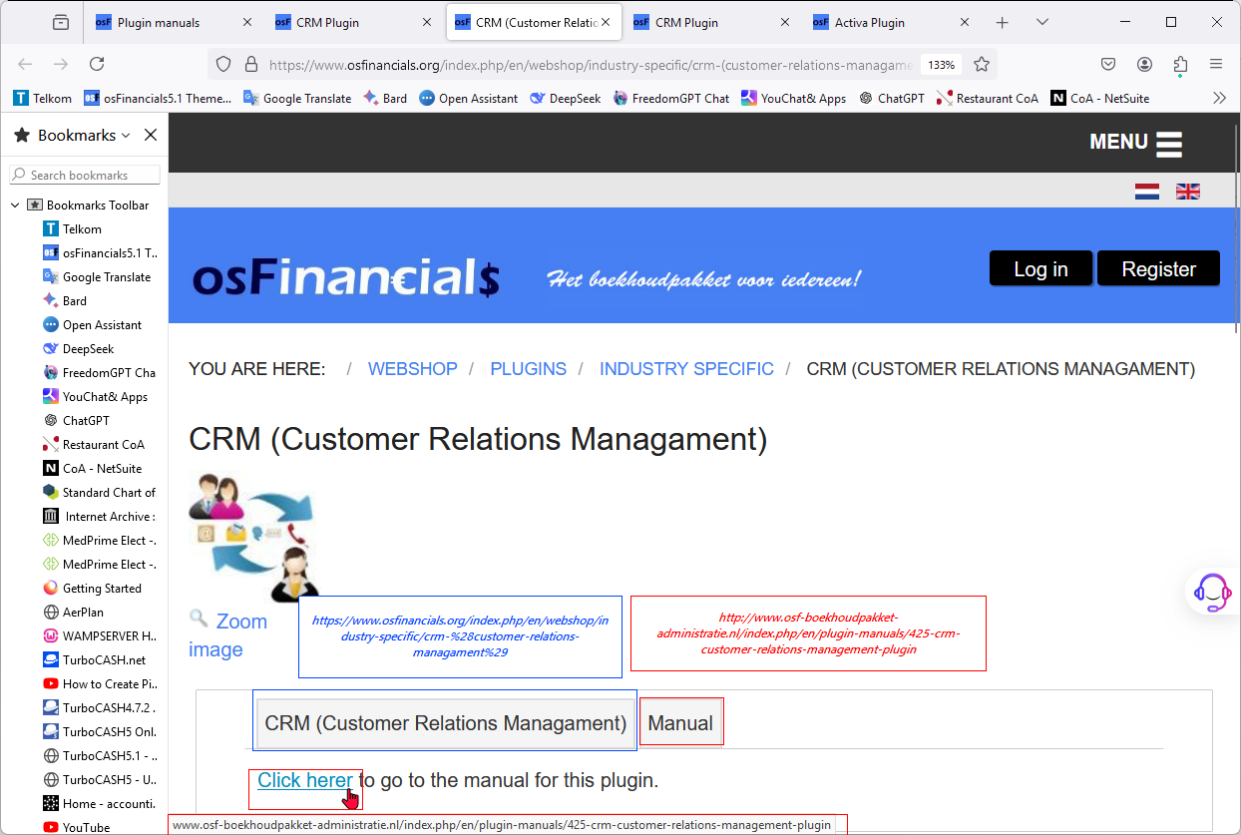

***Example CRM Webpage - Link to Manual start with http:// - Error in Manuals link on Microsoft Edge***

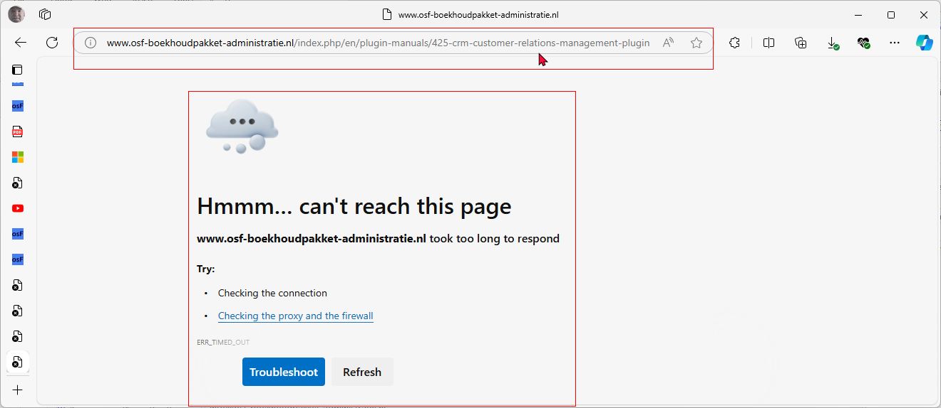

***Example CRM Webpage - Link to Manual start with http:// - Manuals link in Chrome refers to "Not secure" but Manuals page loads.***

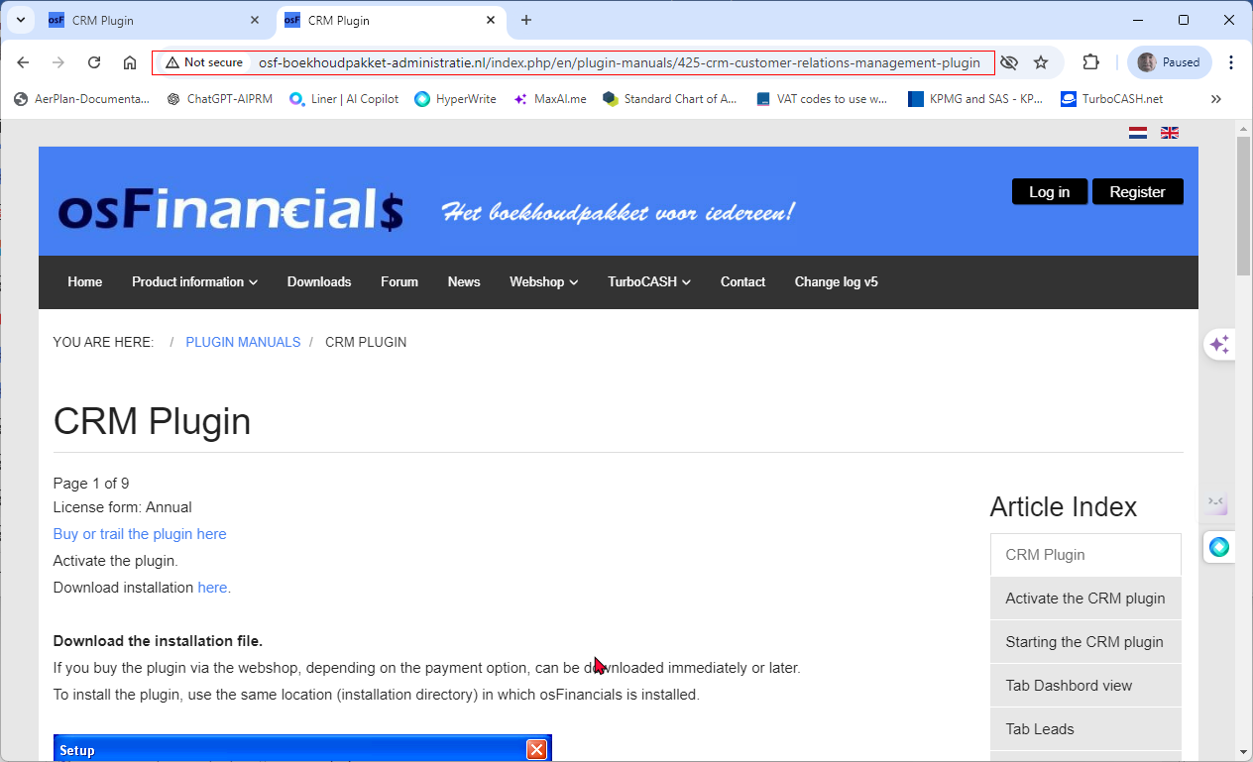

Example CRM Webpage - Link to Manual start with http:// - Manuals link in Firefox refers to "Connection is not secure" but Manuals page loads.

osFinancials.org - Broken links

https://www.osfinancials.org/en/webshop/most-sold/bankimport-plug-in

launched from webshop link from https://www.osfinancials.org/en/plugin-manuals/171-document-email-pro - "To work with the document email pro, the plugin needs to be activated. There are two ways of activating the document email pr plug-in. You can get a trial version of the plugin *or* you can buy a licence. For getting a trail or a licence you have to go to our web shop. If you have purchased a licence or requested for a trail you can collect the licence codes immediately. Follow the steps of the manual Plugin activation to retrieve your licence codes."

Documentation for Plugins

**Plugins menu structure**

On the **Setup** ribbon, select **Plugins**.

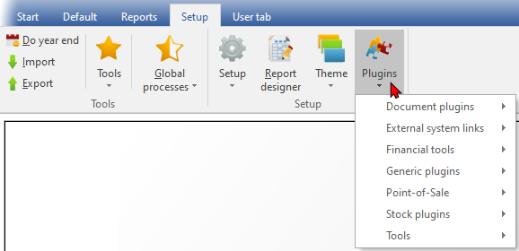

When all Plugins are activated from the **Tools → Activate plugins** option on the **Setup** ribbon, the Plugins menu is structured and grouped into seven categories: Document plugins, External system links, Financial tools, Generic plugins, Point-of-Sale, Stock plugins, and Tools.

***Document plugins***

|  |  |  |  |  |
| --- | --- | --- | --- | --- |
|  | ***Plugin name*** | ***External links / License*** | ***Bugs / Known issues*** | ***Translations*** |
|  | *Document EMail Pro Plugin* | *Manual - Shop - Licence : Once-off - This Plugin is included in the osFinancials5 subscription.* | *Known issues* | *Outstanding* |
|  | *Document Export / Import plugin* | *Manual - Shop - Licence: Once-off* | *Known issues* | *Outstanding* |
|  | *Subscriptions plugin* | *Manual - Shop - Licence : Annual fee* | *Known issues* | *Outstanding* |
|  | *Price agreement plugin* | *Manual - Shop - Licence : Once-off license -* | *-* | *Outstanding* |

***External system links***

|  |  |  |  |  |
| --- | --- | --- | --- | --- |
|  | ***Plugin name*** | ***External links / License*** | ***Bugs / Known issues*** | ***Translations*** |
|  | *E-Commerce Plugin -* | *E-Commerce manual - osCommerce manual - Shop - Licence : Annual license* | *N/A* |  |
|  | *Mijnwinkel Plugin /*  *MyShop* | *Manual - Shop - Licence : Once-off* | *N/A* |  |
|  | *Web Export Plugin* | *Manual - Shop - Licence : Once-off* | *N/A* |  |
|  | *Postalcode / tax id / reg. no. lookup Plugin - (Postal Code / Tax ID / Registration Number Lookup) -* | *Shop - Licence :* | *N/A* | *Supported language: Netherlands* |
|  | *Promeetec Export Plugin* | *Shop - Licence : Annual subscription.* | *N/A* | *Supported language: Netherlands* |
|  | *Send Package Plugin* | *Manual - Shop - Licence : Once-off -* |  |  |

***Financial tools***

|  |  |  |  |  |
| --- | --- | --- | --- | --- |
|  | ***Plugin name*** | ***External links / License*** | ***Bugs / Known issues*** | ***Translations*** |
|  | *Activa plugin* | *Manual - Shop - Licence : Once-off* | *Known issues* | *Outstanding* |
|  | *Charter plugin* | *Manual - Shop - Licence : Once-off* | *Known issues* | *Outstanding* |
|  |  |  | *Known issues* |  |
|  |  |  | *Known issues* |  |

***Generic plugins***

***Generic plugins (Plugins menu)***

|  |  |  |  |  |
| --- | --- | --- | --- | --- |
|  | ***Plugin name*** | ***External links / License*** | ***Bugs / Known issues*** | ***Translations*** |
|  | *CRM - Customer Relations Management* | *Manual -* Shop *- Licence : Annual license* |  | *Outstanding* |
|  | *Freefields plugin* | *Manual - Shop - Licence : Once-off* |  | *Outstanding* |
|  | *Multi-User Calendar (Agenda)* | *Manual - Shop - Licence : Once-off* |  | *Outstanding* |
|  | *Multimedia* | *- Manual - Shop - Licence : Once-off* |  | *Outstanding* |

***Other Generic plugins (Other)***

|  |  |  |  |  |
| --- | --- | --- | --- | --- |
|  | ***Plugin name*** | ***External links / License*** | ***Bugs / Known issues*** | ***Translations*** |
|  | *Multi Media Pack* | *Manual - Shop - Licence: Once-off -Documentation : osFinancials website - Multimedia plugin -* |  |  |
|  | *Paperless Office Multimedia Plugin* | *Manual - Shop - Licence: Once-off -* |  |  |

***Point-of-Sale***

|  |  |  |  |  |
| --- | --- | --- | --- | --- |
|  | ***Plugin name*** | ***External links / License*** | ***Bugs / Known issues*** | ***Translations*** |
|  | ***CCV Pin*** *- PIN* | *Shop -* ***Licence*** *:* |  | *Supported language: Netherlands* |
|  | ***Customer on hold*** | *Manual - Shop -* ***Licence*** *: Once-off* |  |  |
|  | ***HORECAPOS*** *-See* | *Shop -* ***Licence*** *: Annual subscription - The HORECAPOS Plugin is sold with the support contract and multi-user plugin for free.*  *See - Video of the latest version(Dutch) Video of an older version(Dutch) .* |  |  |
|  | ***HorecaPOS addition quantity on hand adjustment*** | *Manual - Shop - Annual subscription* |  |  |
|  | ***POSDisplay******Plugin*** | *Manual - Shop -* ***Licence*** *: Once-off* |  |  |
|  | ***POS Points - Customer loyalty points*** *-* | *Manual - Shop -* ***Licence****: Once-off* |  |  |
|  | ***RetailPOS*** *-* | *Manual - Shop -* ***Licence****: Annual subscription* |  |  |

***Stock plugins***

|  |  |  |  |  |
| --- | --- | --- | --- | --- |
|  | ***Plugin name*** | ***External links / License*** | ***Bugs / Known issues*** | ***Translations*** |
|  | *Localisation-Batches-Serials* | *Manual - Shop - Licence: Once-off* |  | *Outstanding* |
|  | *Stock check / Stock correction* | *Manual - Shop - Licence: Once-off* |  | *Outstanding* |
|  | *Quick Order* | *Manual - Shop - Licence: Once-off* |  | *Outstanding* |

***Tools***

|  |  |  |  |  |
| --- | --- | --- | --- | --- |
|  | ***Plugin name*** | ***External links / License*** | ***Bugs / Known issues*** | ***Translations*** |
|  | *AndroidConnector* | *Install manual - App manual - Shop - Licence: Once-off* |  |  |
|  | *FileandXML Export Import* | *Manual - Shop - Licence: Once-off* |  |  |
|  | *Export / Import* | *Manual - Shop - Licence: Once-off* |  |  |
|  | *HandyTools* | *Licence : Free.*  *Caution: Make backups of your Set of Books before use* |  | *Outstanding* |
|  | *Reportman* | *Manual - Licence : Free.*  *Accessible from the Report designer icon on the* ***Setup*** *ribbon* |  | *Outstanding* |
|  | *SQLBrowser* | *Manual - Shop - Licence : Once-off* |  | *Outstanding* |

***DYNABREG***

# Register plugins

**Register plugins** - When you have purchased a plugin and you have received the registration code, you need to enter and add the codes to "*Register the plugins*"-screen.