Table of Contents

**Subscription reports** 1

**NEW : Reports → Subscriptions - Added in osFinancials5.1.0.193** 1

**Subscription plugins layouts** 3

***English layout*** 3

***Netherlands layout*** 4

**Subscriptions plugin reports** 5

***Subscriptions - Reporting group 1*** 6

***Subscriptions - Reporting group 2*** 7

***Subscriptions*** 8

***Subscriptions list*** 9

**Subscription reports**

**NEW : Reports → Subscriptions - Added in osFinancials5.1.0.193**

**Menu access** : Debtors grid - Context menu - **Reports → Subscriptions**

**Location** : ...\plug_ins\reports\REPORTS\DEBTOR\reports\TRN_9061000.rep – Subscriptions

Location on GitHub : [osfinancials-development/reports/plug_ins/reports/REPORTS/DEBTOR/reports/LANG_901000.rep at main · Digidanosf/osfinancials-development · GitHub](https://github.com/Digidanosf/osfinancials-development/blob/main/reports/plug_ins/reports/REPORTS/DEBTOR/reports/LANG_901000.rep)

**FIXED**

Translated "*Bedrag*" Static text label TrPExpression19 to include customer language translation Amount Incl. LabelID 651.

*CUSTOM('GETTEXTLANG',651,'Amount Incl.',0,0,0)*

On this report, these amounts prints **inclusive of Tax (VAT/GST/Sales tax),** while on other **Subscription reports** (i.e. "Reporting group1, Reporting group 2, Subscriptions and Subscription list" in the .../plug_ins\reports\REPORTS\SUBSCRIPT folder, the Amounts are printed **exclusive of Tax (VAT/GST/Sales tax)**.

**Added** Label for Total LabelID 960 to be consistent with other Subscription reports.

**Added Report name on print output** : Subscriptions

**Wordwrap setting** true to print longer data for Debtor account name in databases with larger fields in some databases.

**Report Header** - Standardised Header in line with other reports to accommodate larger field lengths in databases overlapping text.

**Report Footer** - Standardised Footer in line with other reports to accommodate larger field lengths in databases overlapping text.

**Report footer was not printing** - Setup page - Two-pass report setting.

**Display format** : Expression amount format Amount was set to 0.00 – Changed to ###,###,##0.00 to be consistent with document layout files and other reports in the systemreports folder (accessible from Reports menu and userreports folder accessible from the User reports menu on **Reports** ribbon), etc.

This will also support the required Windows Number format setting when you click on the **Print** button of the “Budget vs actual” and “This year vs last year” reports.

**Before Fixes**

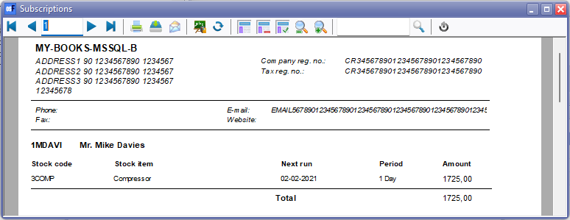

**After Fixes**

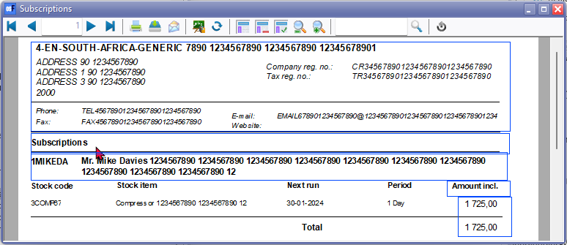

**Subscription plugins layouts**

***English layout***

**Location** : ...\plug_ins\reports\Subscriptions\en\layouts\default.rep

**Location on GitHub** : [osfinancials-development/reports/plug_ins/reports/Subscriptions/en/layouts/default.rep at main · Digidanosf/osfinancials-development · GitHub](https://github.com/Digidanosf/osfinancials-development/blob/main/reports/plug_ins/reports/Subscriptions/en/layouts/default.rep)

**Before fix**

**'n Foto wat teks, skerm, nommer bevat

Beskrywing outomaties gegenereer**

**After fix**

**'n Foto wat teks, elektronika, skermskoot, skerm bevat

Beskrywing outomaties gegenereer**

***Netherlands layout***

**Location** : ...\plug_ins\reports\Subscriptions\nl\layouts\default.rep

**Location on GitHub** : [osfinancials-development/reports/plug_ins/reports/Subscriptions/nl/layouts/default.rep at main · Digidanosf/osfinancials-development · GitHub](https://github.com/Digidanosf/osfinancials-development/blob/main/reports/plug_ins/reports/Subscriptions/nl/layouts/default.rep)

**Before fix**

**'n Foto wat teks, skerm, nommer bevat

Beskrywing outomaties gegenereer**

**After fix**

**'n Foto wat teks, elektronika, skermskoot, skerm bevat

Beskrywing outomaties gegenereer**

**Subscriptions plugin reports**

**Location** : ...\plug_ins\reports\REPORTS\SUBSCRIPT

Location on GitHub : [osfinancials-development/reports/plug_ins/reports/REPORTS/SUBSCRIPT at main · Digidanosf/osfinancials-development · GitHub](https://github.com/Digidanosf/osfinancials-development/tree/main/reports/plug_ins/reports/REPORTS/SUBSCRIPT)

**Report print options** :

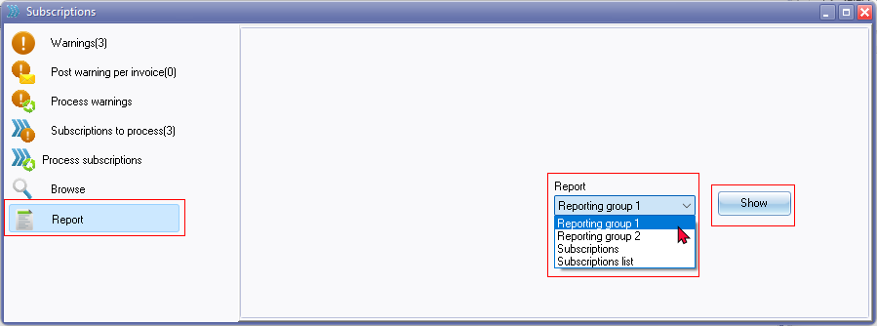

Report names added to output print

|  |  |  |
| --- | --- | --- |
| ***Report language ID*** | ***Report name*** | ***Added report name to output*** |
| *LANG_1323* | *Reporting group 1* | *Subscriptions - Reporting group 1* |
| *LANG_1325* | *Reporting group 2* | *Subscriptions - Reporting group 2* |
| *LANG_901000* | *Subscriptions* | *Subscriptions* |
| *LANG_901001* | *Subscriptions list* | *Subscriptions list* |

Headers and Footers - Standardised with Empty.rep and all reports

* Headers updated - COMPANYDATA dataset to include Website
* Footers - Two pass report setting

Added **Report headings** on report output

**Display format** : Expression amount format Amount was set to 0.00 – Changed to ###,###,##0.00 to be consistent with document layout files and other reports in the systemreports folder (accessible from Reports menu and userreports folder accessible from the User reports menu on **Reports** ribbon), etc.

This will also support the required Windows Number format setting when you click on the **Print** button of the “Budget vs actual” and “This year vs last year” reports.

***Subscriptions - Reporting group 1***

**Before fix**

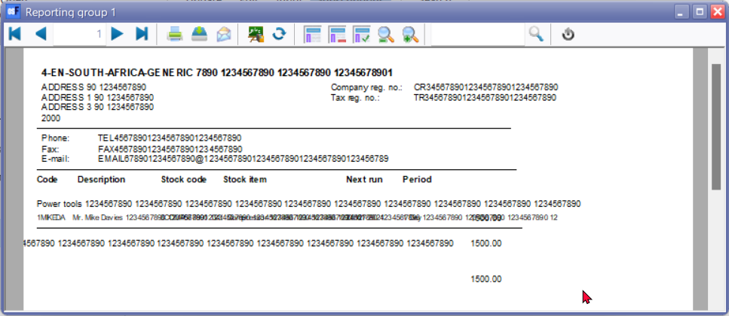

**After fix**

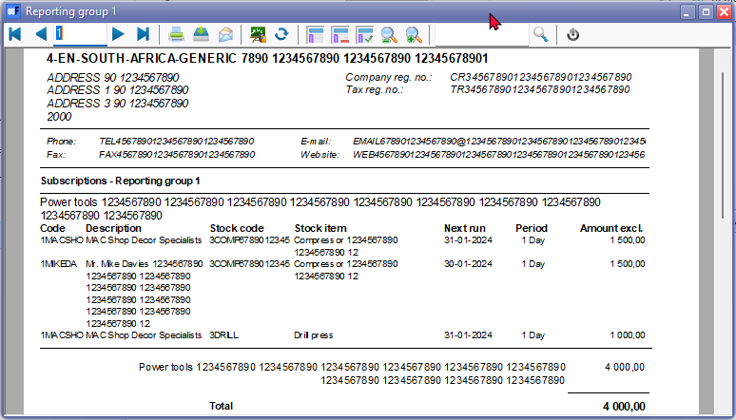

***Subscriptions - Reporting group 2***

**Before fix**

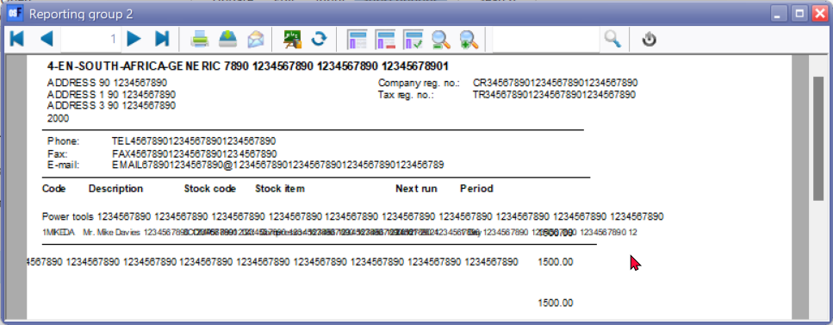

**After fix**

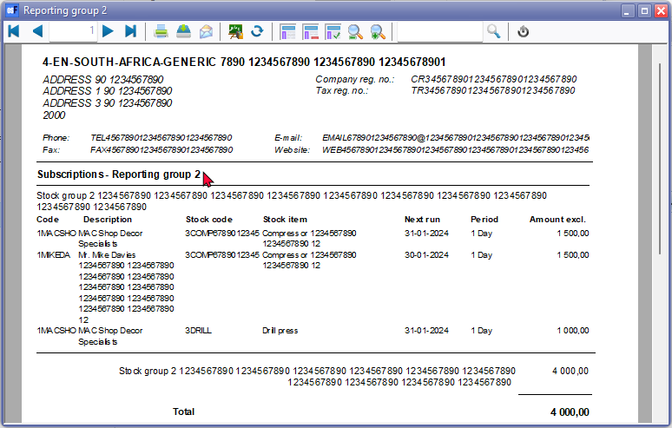

***Subscriptions***

**Before fix**

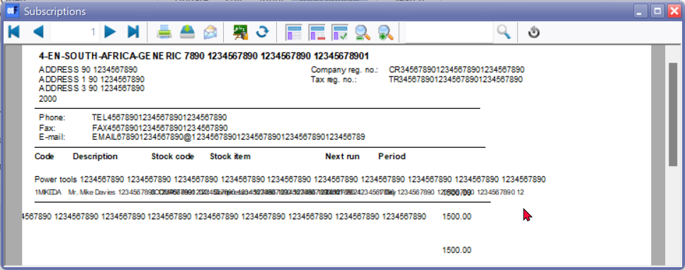

**After fix**

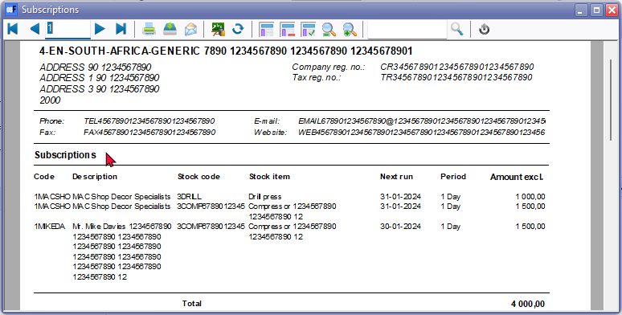

***Subscriptions list***

**Before fix** 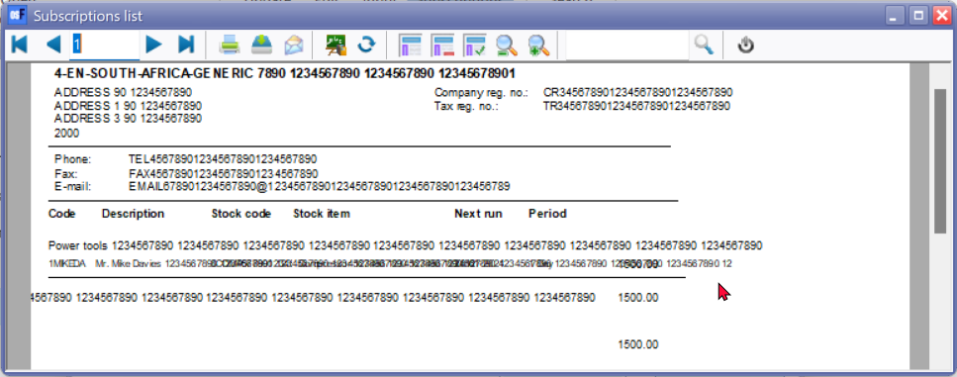

**After fix**

