Table of Contents

**Links to Manuals on from osFinancials shop** 1

***Manual links on Plugins shop cause errors in some Web browsers*** 1

***Notes and screenshots*** 2

***Example CRM webshop Webpage - start with https://*** 2

***Example CRM Webpage - Link to Manual start with http:// - Error in Manuals link on Microsoft Edge*** 3

***Example CRM Webpage - Link to Manual start with http:// - Manuals link in Chrome refers to "Not secure" but Manuals page loads.*** 3

**Plugins menu structure** 4

***Document plugins*** 4

***External system links*** 5

***Financial tools*** 6

***Generic plugins (Plugins menu)*** 6

***Other Generic plugins (Other)*** 6

***DYNABREG*** 9

Register plugins 9

**Links to Manuals on from osFinancials shop**

***Manual links on Plugins shop cause errors in some Web browsers***

refers to - osf-boekhoudpakket

Microsoft Edge Web browser Launch the webshop

On the CRM Shop page - links to The Shop (https://www.osfinancials.org/index.php/en/webshop/industry-specific/crm-%28customer-relations-managament%29} but links from the **Manual** tab to the boekhoudpaket webpage (not secure - Maybe the certificate has expired (http://www.osf-boekhoudpakket-administratie.nl/index.php/en/plugin-manuals/425-crm-customer-relations-management-plugin)

Error 404

Category not found

* Please try one of the following pages:
* If difficulties persist, please contact the System Administrator of this site and report the error below.
  + info@osf-boekhoudpakket-administratie.nl

Page from this link displays correct on can load Firefox and Chrome Web browsers but not in MS Edge - Edge or other browsers may block the manuals page)

***Notes and screenshots***

It appears that you're experiencing difficulties accessing links to various Manuals on the osFinancials shop website, particularly those originating from the osf-boekhoudpakket webpages. This issue is specific to Microsoft Edge, where you encounter a 404 error (Category not found) when attempting to access these manuals. In contrast, these links load correctly in Firefox and Chrome web browsers.

The issue seems to be related to the fact that the manuals webpage links start with http://, which may cause compatibility problems in certain web browsers, including Microsoft Edge. In contrast, the osFinancials webshop pages, which start with https://, load correctly in most web browsers.

Other users might also encounter similar issues depending on their browser settings. It's recommended to check and adjust your browser settings or use an alternative browser like Firefox or Chrome as a temporary workaround.

***Example CRM webshop Webpage - start with https://***

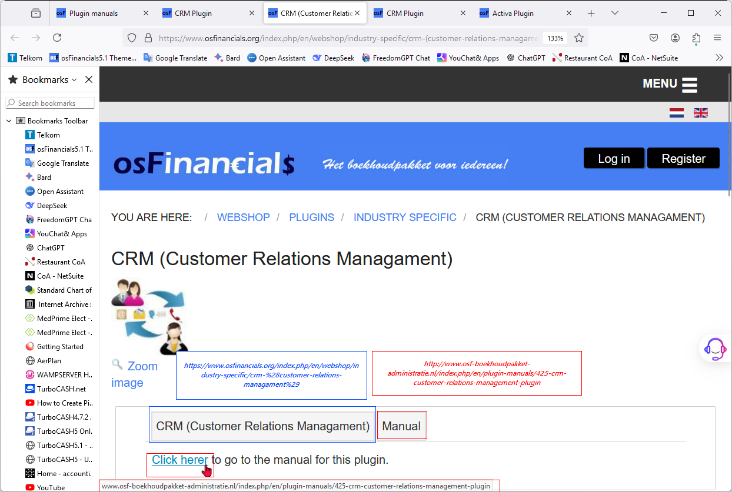

***Example CRM Webpage - Link to Manual start with http:// - Error in Manuals link on Microsoft Edge***

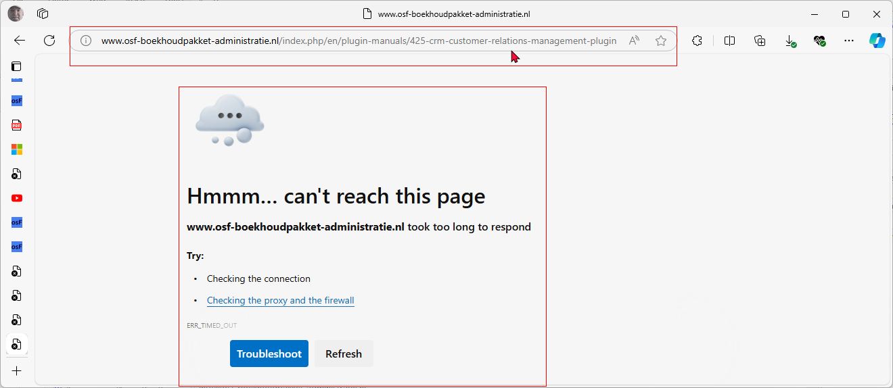

***Example CRM Webpage - Link to Manual start with http:// - Manuals link in Chrome refers to "Not secure" but Manuals page loads.***

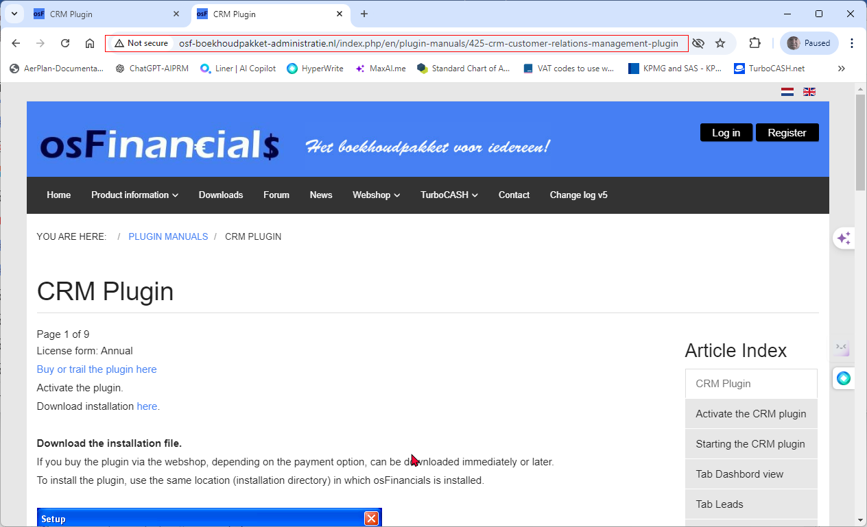

Example CRM Webpage - Link to Manual start with http:// - Manuals link in Firefox refers to "Connection is not secure" but Manuals page loads.

osFinancials.org - Broken links

https://www.osfinancials.org/en/webshop/most-sold/bankimport-plug-in

launched from webshop link from https://www.osfinancials.org/en/plugin-manuals/171-document-email-pro - "To work with the document email pro, the plugin needs to be activated. There are two ways of activating the document email pr plug-in. You can get a trial version of the plugin *or* you can buy a licence. For getting a trail or a licence you have to go to our web shop. If you have purchased a licence or requested for a trail you can collect the licence codes immediately. Follow the steps of the manual Plugin activation to retrieve your licence codes."

Documentation for Plugins

**Plugins menu structure**

On the **Setup** ribbon, select **Plugins**.

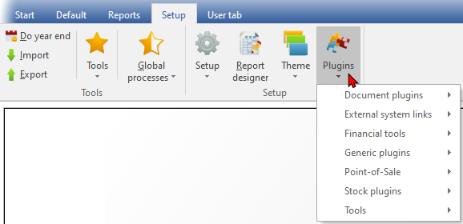

When all Plugins are activated from the **Tools → Activate plugins** option on the **Setup** ribbon, the Plugins menu is structured and grouped into seven categories: Document plugins, External system links, Financial tools, Generic plugins, Point-of-Sale, Stock plugins, and Tools.

***Document plugins***

|  |  |  |  |  |
| --- | --- | --- | --- | --- |
|  | ***Plugin name*** | ***External links / License*** | ***Bugs / Known issues*** | ***Translations*** |
|  | *Document EMail Pro Plugin* | *Manual - Shop - Licence : Once-off - This Plugin is included in the osFinancials5 subscription.* | *Known issues* | *Outstanding* |
|  | *Document Export / Import plugin* | *Manual - Shop - Licence: Once-off* | *Known issues* | *Outstanding* |
|  | *Subscriptions plugin* | *Manual - Shop - Licence : Annual fee* | *Known issues* | *Outstanding* |
|  | *Price agreement plugin* | *Manual - Shop - Licence : Once-off license -* | *-* | *Outstanding* |

***External system links***

|  |  |  |  |  |
| --- | --- | --- | --- | --- |
|  | ***Plugin name*** | ***External links / License*** | ***Bugs / Known issues*** | ***Translations*** |
|  | *E-Commerce Plugin -* | *E-Commerce manual - osCommerce manual - Shop - Licence : Annual license* | *N/A* |  |
|  | *Mijnwinkel Plugin /*  *MyShop* | *Manual - Shop - Licence : Once-off* | *N/A* |  |
|  | *Web Export Plugin* | *Manual - Shop - Licence : Once-off* | *N/A* |  |
|  | *Postalcode / tax id / reg. no. lookup Plugin - (Postal Code / Tax ID / Registration Number Lookup) -* | *Shop - Licence :* | *N/A* | *Supported language: Netherlands* |
|  | *Promeetec Export Plugin* | *Shop - Licence : Annual subscription.* | *N/A* | *Supported language: Netherlands* |
|  | *Send Package Plugin* | *Manual - Shop - Licence : Once-off -* |  |  |

***Financial tools***

|  |  |  |  |  |
| --- | --- | --- | --- | --- |
|  | ***Plugin name*** | ***External links / License*** | ***Bugs / Known issues*** | ***Translations*** |
|  | *Activa plugin* | *Manual - Shop - Licence : Once-off* | *Known issues* | *Outstanding* |
|  | *Charter plugin* | *Manual - Shop - Licence : Once-off* | *Known issues* | *Outstanding* |
|  |  |  | *Known issues* |  |
|  |  |  | *Known issues* |  |

***Generic plugins***

***Generic plugins (Plugins menu)***

|  |  |  |  |  |
| --- | --- | --- | --- | --- |
|  | ***Plugin name*** | ***External links / License*** | ***Bugs / Known issues*** | ***Translations*** |
|  | *CRM - Customer Relations Management* | *Manual -* Shop *- Licence : Annual license* |  | *Outstanding* |
|  | *Freefields plugin* | *Manual - Shop - Licence : Once-off* |  | *Outstanding* |
|  | *Multi-User Calendar (Agenda)* | *Manual - Shop - Licence : Once-off* |  | *Outstanding* |
|  | *Multimedia* | *- Manual - Shop - Licence : Once-off* |  | *Outstanding* |

***Other Generic plugins (Other)***

|  |  |  |  |  |
| --- | --- | --- | --- | --- |
|  | ***Plugin name*** | ***External links / License*** | ***Bugs / Known issues*** | ***Translations*** |
|  | *Multi Media Pack* | *Manual - Shop - Licence: Once-off -Documentation : osFinancials website - Multimedia plugin -* |  |  |
|  | *Paperless Office Multimedia Plugin* | *Manual - Shop - Licence: Once-off -* |  |  |

***Point-of-Sale***

|  |  |  |  |  |
| --- | --- | --- | --- | --- |
|  | ***Plugin name*** | ***External links / License*** | ***Bugs / Known issues*** | ***Translations*** |
|  | ***CCV Pin*** *- PIN* | *Shop -* ***Licence*** *:* |  | *Supported language: Netherlands* |
|  | ***Customer on hold*** | *Manual - Shop -* ***Licence*** *: Once-off* |  |  |
|  | ***HORECAPOS*** *-See* | *Shop -* ***Licence*** *: Annual subscription - The HORECAPOS Plugin is sold with the support contract and multi-user plugin for free.*  *See - Video of the latest version(Dutch) Video of an older version(Dutch) .* |  |  |
|  | ***HorecaPOS addition quantity on hand adjustment*** | *Manual - Shop - Annual subscription* |  |  |
|  | ***POSDisplay******Plugin*** | *Manual - Shop -* ***Licence*** *: Once-off* |  |  |
|  | ***POS Points - Customer loyalty points*** *-* | *Manual - Shop -* ***Licence****: Once-off* |  |  |
|  | ***RetailPOS*** *-* | *Manual - Shop -* ***Licence****: Annual subscription* |  |  |

***Stock plugins***

|  |  |  |  |  |
| --- | --- | --- | --- | --- |
|  | ***Plugin name*** | ***External links / License*** | ***Bugs / Known issues*** | ***Translations*** |
|  | *Localisation-Batches-Serials* | *Manual - Shop - Licence: Once-off* |  | *Outstanding* |
|  | *Stock check / Stock correction* | *Manual - Shop - Licence: Once-off* |  | *Outstanding* |
|  | *Quick Order* | *Manual - Shop - Licence: Once-off* |  | *Outstanding* |

***Tools***

|  |  |  |  |  |
| --- | --- | --- | --- | --- |
|  | ***Plugin name*** | ***External links / License*** | ***Bugs / Known issues*** | ***Translations*** |
|  | *AndroidConnector* | *Install manual - App manual - Shop - Licence: Once-off* |  |  |
|  | *FileandXML Export Import* | *Manual - Shop - Licence: Once-off* |  |  |
|  | *Export / Import* | *Manual - Shop - Licence: Once-off* |  |  |
|  | *HandyTools* | *Licence : Free.*  *Caution: Make backups of your Set of Books before use* |  | *Outstanding* |
|  | *Reportman* | *Manual - Licence : Free.*  *Accessible from the Report designer icon on the* ***Setup*** *ribbon* |  | *Outstanding* |
|  | *SQLBrowser* | *Manual - Shop - Licence : Once-off* |  | *Outstanding* |

***DYNABREG***

# Register plugins

**Register plugins** - When you have purchased a plugin and you have received the registration code, you need to enter and add the codes to "*Register the plugins*"-screen.