Table of Contents

**FIXED – REPORTS/STOCK - osFinancials5.1.0.127 / osFinancials5.1.0.189 Update install** 1

***STOCK - Sidebar reports - Stock movement*** 1

**FIXED – REPORTS/STOCK - osFinancials5.1.0.127 / osFinancials5.1.0.189 Update install**

These updated reports were included in theosFinancials5.1.0.127/ osFinancials5.1.0.189 update installation. These Reports were retested in both Firebird database types and in MSSQL database types in osFinancials5.1.0.127/ osFinancials5.1.0.189.

***STOCK - Sidebar reports - Stock movement***

**Stock movement** report (Stock turnover)

Renamed text report name to LANG_906038 to be translatable via the language files. Added report name "*Stock movement - Average cost - Grid*" in Header section.

Total print on Page 2 and Total - Data type = Currency as " ##,###,###,##0.00" in Detail of Group section (e.g. 1,000.00) - Set the Group footer data type for the Total (e.g. 1000.00) to display similar than the Detail report section.

**Location** : ...\plug_ins\reports\REPORTS\STOCK\Stock Movement.rep **New location** : ...\plug_ins\reports\REPORTS\STOCK\LANG_906038.rep with translated file name.

**Fixed** - Total print on Page 2

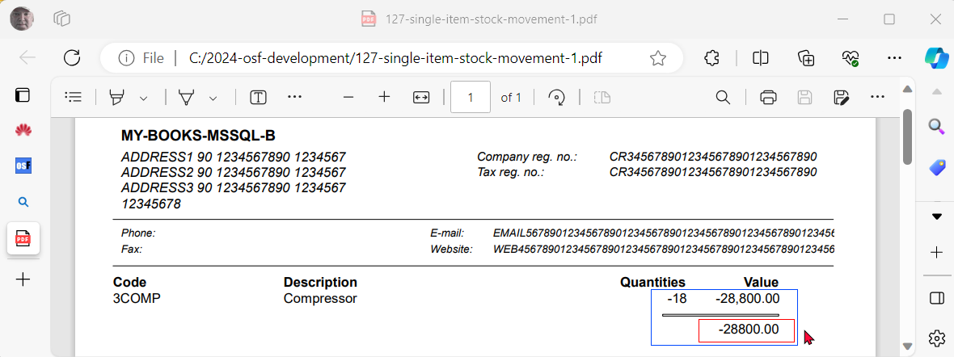

**Fixed 2** - Total - Data type = Currency as " ##,###,###,##0.00" in Detail of Group section (e.g. 1,000.00) - Set the Group footer data type for the Total (e.g. 1000.00) to display similar than the Detail report section.