Table of Contents

**Firebird Errors** 1

**Reports fixed - osFinancials5.1.0.127** 1

**Reports not included in osFinancials5.1.0.127 update install** 2

**Reports Fixed after osFinancials5.1.0.127 update install** 2

**FIXED - Details** 2

***excelreports*** 2

***systemreports (Fixes to be updated)*** 3

***Alignment headings and detail - Debtors listing*** 3

***Alignment headings and detail - Creditors listing*** 3

***Stock - In/Out - Show details - Overlapping labels*** 4

***Documents - Document listing - Overlapping labels*** 5

***Tax - Tax per period*** 7

***STOCK - Sidebar reports -*** 9

***STOCK - Sidebar reports - Stock movement*** 9

**FIXED – systemreports - osFinancials5.1.0.127 / osFinancials5.1.0.189 Update install**

These updated reports were included in theosFinancials5.1.0.127 update installation. These Reports were retested in both Firebird database types and in MSSQL database types in osFinancials5.1.0.127. The following reports were updated and fixed.

1. **systemreports** - Fixed some adjustments to text (labels expressions) and data expressions were made in about 7 reports.
   1. **Reports → Debtors → Listing** **- List delivery address**
   2. **Reports → Debtors → Listing** - **List postal address**
   3. **Reports → Creditors → Listing - List delivery address**
   4. **Reports → Creditors → Listing - List postal address**
   5. **Reports → Stock → Stock In / Out - Stock in / Out**
   6. **Reports → Documents → Document listing**
   7. **Reports → Tax - Tax per period**

***systemreports (Fixes to be updated)***

**osf.ini file** : " ***nounocode=true*** " setting prints in Firebird database types and MSSQL database types.

These systemreports have been updated and included in osFinancials5.1.0.109.

Retested in osFinancials5.1.0.127 / osFinancials5.1.0.189 Update installon **Reports** menu (systemreports folder) some minor fixes regarding overlapping labels and consistency in 7 reports were fixed -

***Alignment headings and detail - Debtors listing***

**Reports → Debtors → Listing** **- List delivery address** - Location : ...\plug_ins\reports\systemreports\TRN_160\TRN_66\TRN_906138.rep

**Reports → Debtors → Listing** - **List postal address** - **Location** : ...\plug_ins\reports\systemreports\TRN_160\TRN_66\TRN_906139.rep

***Alignment headings and detail - Creditors listing***

**Reports → Creditors → Listing - List delivery address** - Location : ...\plug_ins\reports\systemreports\TRN_161\TRN_66\TRN_906138.rep

**Reports** → **Creditors → Listing - List postal address** - **Location** : ...\plug_ins\reports\systemreports\TRN_161\TRN_66\TRN_906139.rep

***Stock - In/Out - Show details - Overlapping labels***

**Reports → Stock → Stock In / Out - Stock in / Out**

**Location** : ...\plug_ins\reports\systemreports\TRN_1999\TRN_906112

**Before fix**

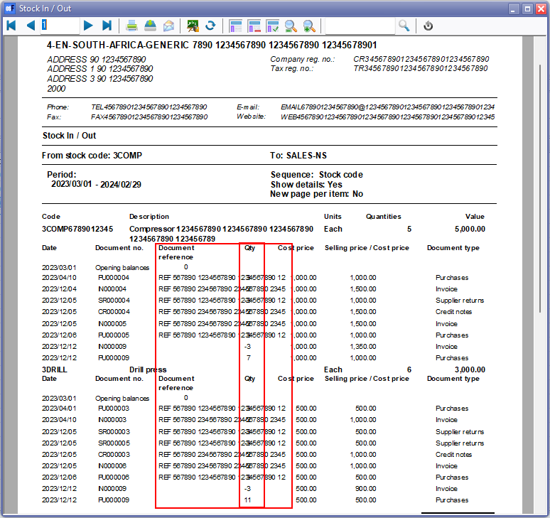

**After fix**

Moved Quantity, Cost price, Selling price / Cost price and Document type to right

Added line break in Selling price / Cost price expression

Set Auto expand/ Auto Contract and Word wrap

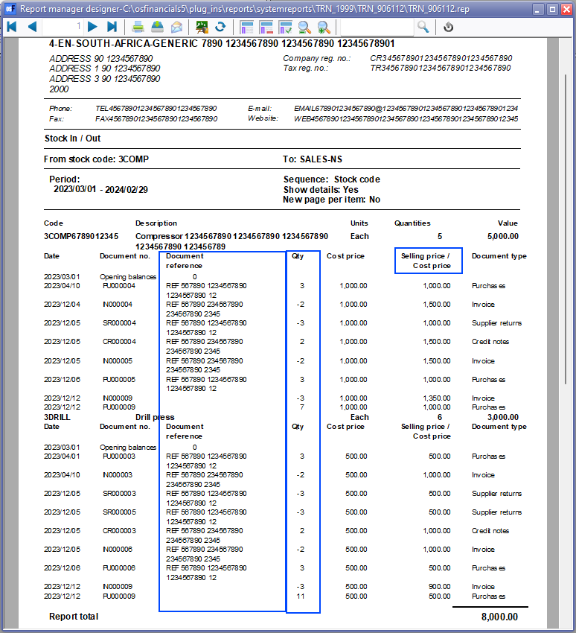

***Documents - Document listing - Overlapping labels***

**Reports → Documents → Document listing**

**Location** : ...\plug_ins\reports\systemreports\TRN_38\TRN_45\TRN_45.rep

**Before fix**

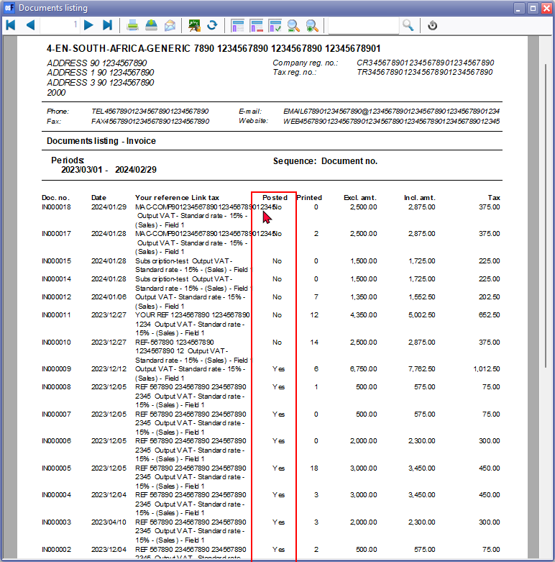

**After fix**

Added // in descriptions and expressions Your reference Link tax - to Your reference // Link tax

This is to be consistent with other tax reports (e.g. Tax - Transactions and Tax report - Reference / Document no.) and easier on the eye to separate the fields.

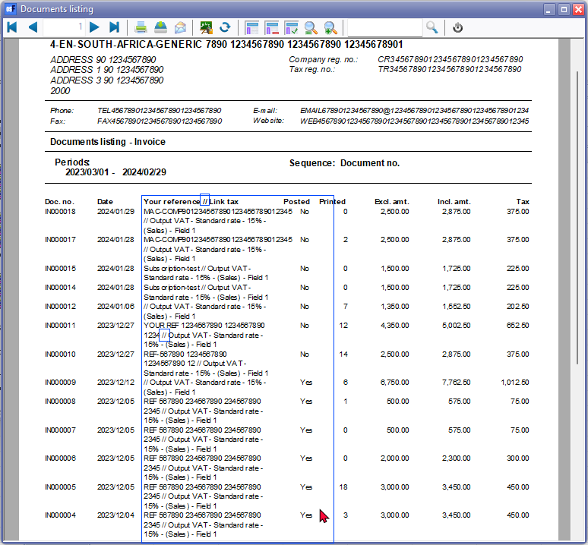

***Tax - Tax per period***

**Reports → Tax - Tax per period**

**Location** : .../plug_ins\reports\systemreports\TRN_906020\TRN_906020

**Before fix**

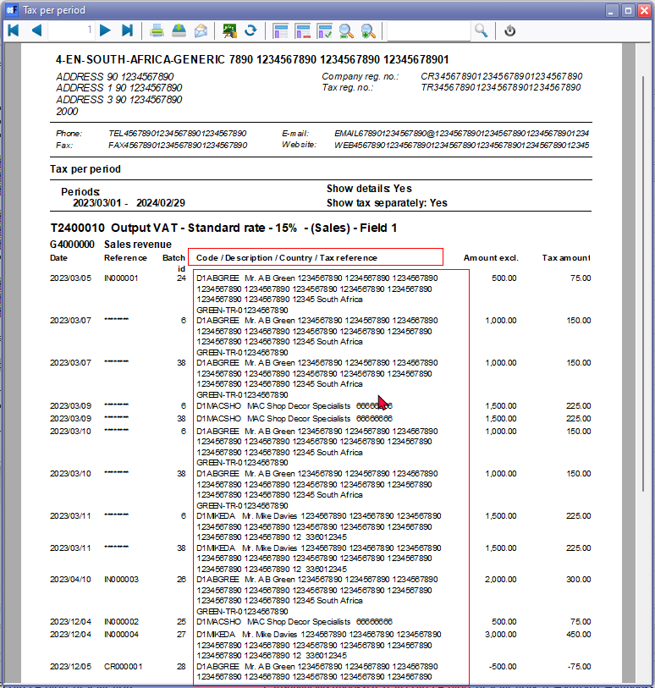

**After fix**

Added // in descriptions and expressions Code / Description Country / Tax reference - to Your reference // Link tax

This is to be consistent with other tax reports (e.g. Tax - Transactions and Tax report - Reference / Document no.) and easier on the eye to separate the fields.

