Table of Contents

**Installing - TurboCASH5-3/TurboCASH5-2025** 1

Important Note for Existing TurboCASH Users : Installing TurboCASH 5-3 / TurboCASH 5-2025 1

**Install *Turbo*CASH5 single-user** 1

**Installing - TurboCASH5-3/TurboCASH5-2025**

# Important Note for Existing TurboCASH Users : Installing TurboCASH 5-3 / TurboCASH 5-2025

If you are currently using a previous version of TurboCASH (e.g., TurboCASH3, TurboCASH4, TurboCASH 4.0.0.969, TurboCASH5, or TurboCASH5-2), it's crucial to understand that TurboCASH 5-3 and TurboCASH 5-2025 are *not* updates. They are entirely new versions. Therefore, you **must not** install them in the same directory as your existing TurboCASH installation.

Installing the new versions in the same directory as an older version can lead to errors. For instance, If you install TurboCASH5-3 or TurboCASH5-2025, in an existing directory in which TurboCASH5 4.0.0.969 is installed, you might encounter errors such as:

“Application Error  
Exception EReadError in module rtl150.bpl at 00074FF4.  
Error reading TGlobalDataObject.Registration.PluginsChecksum: Property PluginsChecksum”

To avoid such issues, please choose a different installation directory for TurboCASH 5-3 or TurboCASH 5-2025.

Installing TurboCASH 5-3 or 5-2025 into *any* existing TurboCASH folder (like TCASH, TurboCASH5, TurboCASH5-2, or any other) is likely to cause problems. The core issue is that these are completely new versions, not updates, and they need their own clean installation space. Trying to mix them with older files will almost certainly lead to conflicts and errors.

|  |  |
| --- | --- |
|  | *When installing TurboCASH 5-3 or TurboCASH 5-2025 into an existing folder, you may see the following warning message:*  ***Folder Exists*** *The folder: C:\TCASH5 already exists. Would you like to install to that folder anyway?*  *If you click* ***Yes****, you may encounter problems.*  ***It is strongly recommended that you click "No" and choose a different installation directory.*** *Installing into an existing TurboCASH folder (even if it's for a seemingly related version) can lead to software conflicts and errors. These TurboCASH 5-3 or TurboCASH 5-2025 are new versions are not updates and require a clean installation.* |

**Install *Turbo*CASH5 single-user**

|  |  |
| --- | --- |
|  | *The TurboCASH5 should, by default, install in the TurboCASH5 directory (e.g. C : / TurboCASH5. If you choose to install TurboCASH5-3 in different directory or folder on your system,* ***DO NOT*** *install TurboCASH5 in any Program files directories.*  *If you wish to install TurboCASH5 on a device that has a Solid State Drive which is small, e.g. 32GB as the C: drive, you need to select the D: drive that is bigger in size.* |
|  | *This documentation will describe to do a standard installation to run TurboCASH5 locally on one computer for 1 user only.*   * *Multi-User installation and configuration will be dealt with in separate documentation.* * *Multi-user is limited in this edition! You will need to buy a multi-user license.* |

After installing TurboCASH5-3, the following optional additional components, is included in the “*installs*” folder of the TurboCASH5-3 root installation directory:

* **Firebird Version 2.1** - Advanced users may wish to download and install a later version of the discontinued downloads - [Firebird version 2.5.9](https://firebirdsql.org/en/discontinued-versions/).

|  |  |
| --- | --- |
|  | *Later releases of Firebird Versions 3 and Versions 4 is currently not supported in TurboCASH5-3 databases (Sets of Books).* |

* **FlameRobin Version 0.9.3** - Advanced users may wish to download and install a later version of [FlameRobin](http://www.flamerobin.org/) (version 0.9.6) FlameRobin Database Admin software to manage and explore your TurboCASH5-3 databases (Sets of Books).

**To install *Turbo*CASH5 single-user:**

1. Once the TurboCASH5-3 installation file is downloaded, select the file and open it. The “*Select country and language*” screen is displayed:

1. Select your country and language. Click **OK**. The “*Welcome to the TurboCASH5-3 Setup Wizard”* screen is displayed:

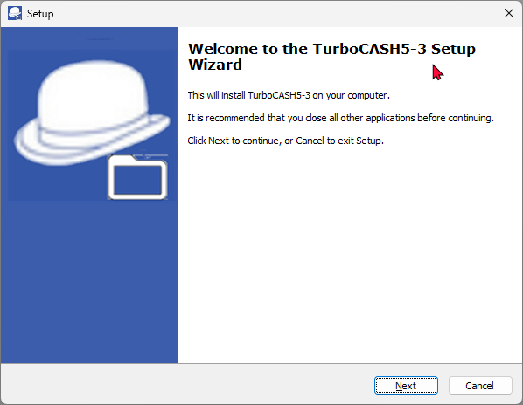

1. Click **Next**. The “*License Agreement*” screen will be displayed.
2. Please read the agreement carefully. If you agree with the terms and conditions of the license agreement, select the “*I accept the agreement*” option and click **Next**. The “*Select Destination Location*” screen is displayed:   
   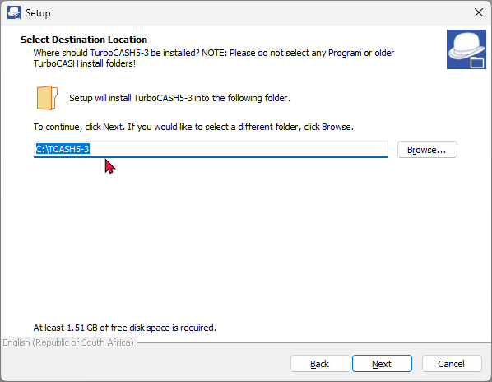
3. The default path is TCASH5-3 on your system's default drive, (e.g. C:/TCASH5-3).

|  |  |
| --- | --- |
|  | *When installing TurboCASH 5-3 into an existing folder, you may see the following warning message:*  ***Folder Exists*** *The folder: C:\TCASH5 already exists. Would you like to install to that folder anyway?*  *If you click* ***Yes****, you may encounter problems.*  ***It is strongly recommended that you click "No" and choose a different installation directory.*** *Installing into an existing TurboCASH folder (even if it's for a seemingly related version) can lead to software conflicts and errors. These TurboCASH5-3 is a new version is not an update and require a clean installation.* |
|  | *You may click on the Browse button to select any other folder than the default path where you wish to install TurboCASH5 on the “Browse For Folder” screen.*  *If you wish to install TurboCASH on a device that has a Solid State Drive which is small e.g. 32GB as the C: drive, you need to select the D: drive that is bigger in size.* |
|  | *You may over type this with your own description, if necessary. This will create an item on the* ***Start → Programs*** *menu list with items for TurboCASH5-3, Uninstall TurboCASH5-3 on your Windows™ Task bar.* |

1. Once finished, click **Next**. The “*Select Components*” screen, is displayed:  
   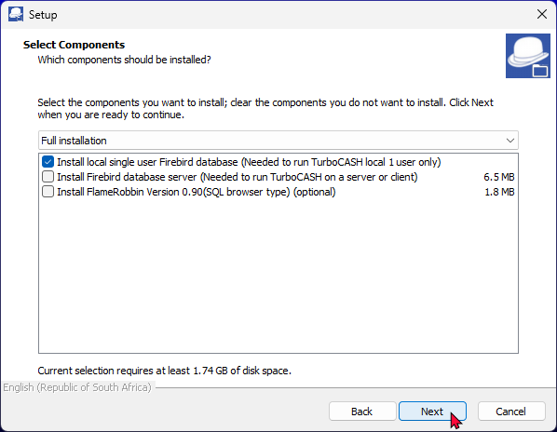
2. A list of the components will be displayed. Select or deselect (remove the tick) for the following options, if necessary:
   1. **Install Firebird Database Server** (Needed to run *Turbo*CASH5 local 1 user only) - If you are installing *Turbo*CASH5 for the first time, you need to make sure that this option is selected.

|  |  |
| --- | --- |
|  | *Select this option if you need to run TurboCASH5 locally for 1 user only.* |

* 1. **Install Firebird Database Server** (Needed to run *Turbo*CASH5 on a server or client).

|  |  |
| --- | --- |
|  | *For the purpose of the single-user installation, do not select this option.* |

* 1. **Install FlameRobin SQL Browser Type** - (Optional) - This will install the FlameRobin Database Admin software to manage your *Turbo*CASH5-3 databases (Sets of Books).

|  |  |
| --- | --- |
|  | *For the purpose of the single-user installation, do not select this option.* |
|  | *The FlameRobin software is used to browse, check and edit data. The installation of FlameRobin is optional and is not required to run TurboCASH5-3. The use of FlameRobin is not recommended for users which have insufficient knowledge and expertise.* |

1. Once finished, selecting the components to be installed, click **Next**. The “*Select Additional Tasks*” screen is displayed:

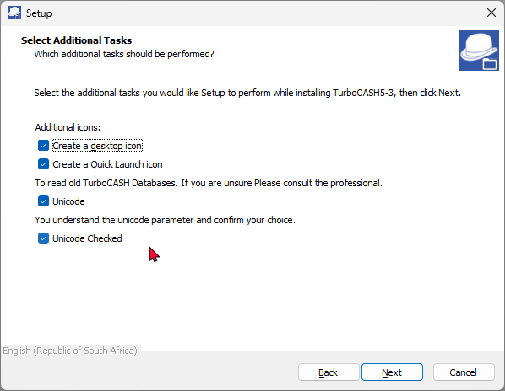

1. By default no options are selected. Select the following options, if you wish them to be installed:
   1. **Create desktop icon** - This will create an icon on your desktop from where you may start or launch the *Turbo*CASH5 program.
   2. **Create Quick Launch icon** - This will create an icon on your Quick Launch Toolbar on your Windows™ Task bar. You may then start or launch the *Turbo*CASH5 program directly from the Quick Launch Toolbar.
   3. **Unicode settings** - Select both the "*Unicode*" and "*Unicode Checked*" options. This will enable Unicode support.

|  |  |  |  |
| --- | --- | --- | --- |
|  | | | *We strongly advise consulting with a professional before enabling the Unicode setting. This ensures that you fully understand the implications and make an informed decision.* |
|  | | | *Unicode Checked - If this mandatory checkbox is not selected, a Runtime error message is displayed:*  *"Please check and confirm your unicode option."* |
|  | | | *To enable Unicode support (recommended for most users), both the “Unicode” and “Unicode Checked” tick boxes need to be selected. This option will set the* ***nounicode=FALSE*** *parameter in the tcash.ini file.*  *This is a very important setting, as this will determine the display of special characters in the TurboCASH5 interface, reports document layout files, etc. in most databases.* |
|  | | | *To Disable Unicode support option, the “Unicode” check box must not be selected. Only the “Unicode Checked” tick box need to be selected.*  *This setting is intended for users who require non-Unicode support. This option will set the* ***nounicode=TRUE*** *parameter in the tcash.ini file.*    *Using this setting, (Disable Unicode), the system relies on specific codepages to handle text. Some examples would be:*   * *French (Codepage 1252): Handles Western European characters, but may have limitations with special symbols unique to other languages.* * *Spanish (Codepage 1252): Similar to French, it manages Spanish characters well but might struggle with characters from non-Western languages.* * *Arabic (Codepage 1256): Supports Arabic characters effectively, but may not handle characters from Latin-based languages as efficiently.*   *In TurboCASH5-3, the codepage cannot be set in the* ***Tools → Customise language*** *on the* ***Setup*** *ribbon.* | |
|  | | | *If your Unicode settings, is incorrect, you may re-run the installation process.*  *Alternatively, you may locate the tcash.ini file in the TurboCASH5 installation directory and edit the* ***nounicode=true*** *and set it to* ***nounicode=false****, and vice versa. In this case you may need to close and restart TurboCASH5-3.* | | |

1. Once finished, click **Next**. The “*Ready to Install*” screen is displayed:

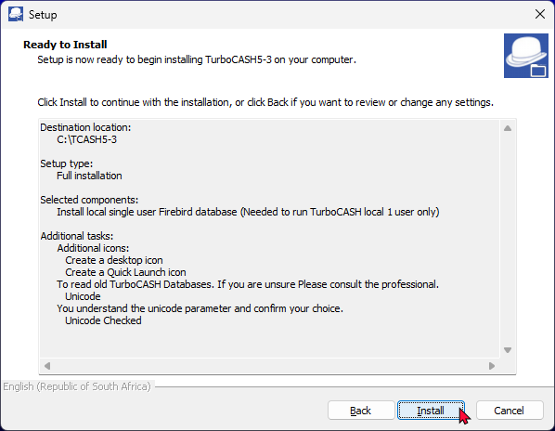

1. Please check the following selections to be installed:
   1. Destination location
   2. Setup type
   3. Selected components
   4. Start Menu folder
   5. Additional tasks (icons)
   6. Unicode Settings

|  |  |
| --- | --- |
|  | *This is your last chance to change anything to be installed. If you are not satisfied with your selection, click on the* ***Back*** *buttons to select or deselect the necessary options.* |
|  | ***Overwrite confirmation message****:*  *A confirmation message will be displayed if you have installed TurboCASH5 over an existing (previous) TurboCASH installation. If you have worked (changed or added data) to the Set of Books (with the same Name as installed) and wish to retain the existing Set of Books, click* ***No*** *to retain your existing data. The Set of Books will not be replaced by the installation.* |

1. If you click on the **Yes** button, the Set of Books will be replaced with the Set of Books in this installation.
2. Click **Install**. The *Turbo*CASH5-3 installation process will start. Once the *Turbo*CASH5-3 installation process is finished, the “*Completing the TurboCASH5-3 Setup Wizard*” screen is displayed:

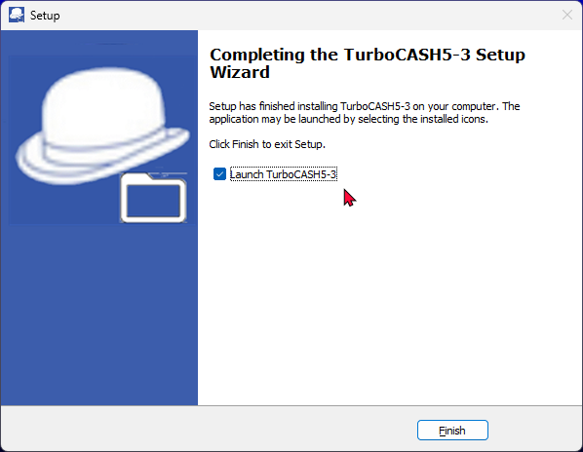

|  |  |
| --- | --- |
|  | *The following Components will not be listed, if it was not selected in the “Select Components” screen:*   * *Install Firebird* * *Install FlameRobin SQL Browser Type* |

1. If the **Launch *Turbo*CASH5-3** option is selected, the *Turbo*CASH5 program will automatically be launched.

|  |  |
| --- | --- |
|  | *If you do not select this option (remove the tick), you may then launch or start TurboCASH5 from the following options (if selected or where specified): -*   * *Desktop icon.* * *Quick Launch icon (on the Quick Launch Toolbar on your Windows™ Task bar).* * ***Start → Programs → TurboCASH5-3*** *menu from the Windows™* ***Start*** *button.* |

1. Once finished selecting or deselecting the necessary options, click **Finish**. The *Turbo*CASH program will be started if you did not remove the tick on the "*Launch TurboCASH5-3*" option.