Table of Contents

**Unicode install and nounicode setting** 2

***nounicode=FALSE*** 2

***nounicode=TRUE*** 2

**nounicode=True setting** 3

***MSSQL Database – Open Set of Books – nounicode=TRUE*** 3

***Reports Outstanding - MSSQL database- nounicode=TRUE*** 4

***Plugins - MSSQL database- nounicode=true*** 4

***Subscriptions MSSQL Error*** 4

**Firebird databases nounicode=TRUE** 5

***Setup Countries - Displays incorrect character " �land Islands "*** 5

***Setup → Countries*** 5

***Currencies*** 5

***Default setting nounicode=TRUE in the osf.ini file, this replicate the error not displaying correctly*** 6

**Plugins Multimedia** 8

**Firebird Database - nounicode=FALSE** 9

**Unicode install and nounicode setting**

***nounicode=FALSE***

If you check both the Unicode and Unicode Check tick-boxes, the Unicode setting will be set as false in the osf.ini file:

*nounicode=false*

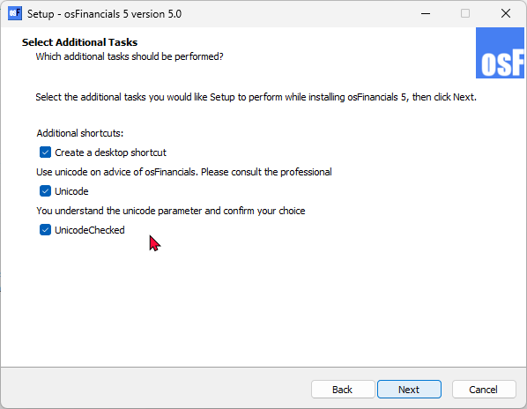

This will cause the MSSQL error, when opening a Set of Books (MSSQL database type).

***nounicode=TRUE***

If you do not check the **Unicode** checkbox (leave blank) and only select (tick) the **Unicode Checked** tick-box, the Unicode setting will be set as false in the osf.ini file:

*nounicode=true*

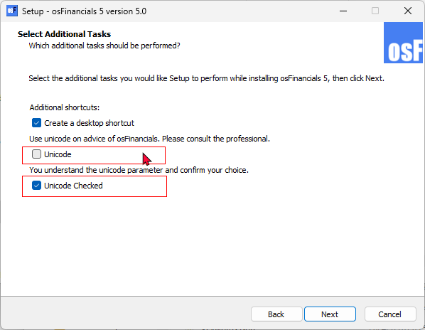

This will resolve the MSSQL error, when opening a Set of Books (MSSQL database type). Can open all Set of Books (MSSQL database type).

**nounicode=True setting**

***MSSQL Database – Open Set of Books – nounicode=TRUE***

Can open Sets of Books in Firebird and MSSQL databases. This solves the issue with Opening a Set of Books error if **nounicode=FALSE**.

*"Invalid object name 'OPREPORT'."*

Unicode setting needs to be set to **nounicode=TRUE**.

Replicates the error in osf5.1.0.227 with the Install **nounicode=FALSE** setting =

*"Invalid object name 'OPREPORT'."*

Cannot open MSSQL all books in both in osFinancials5.1.0.227 and in osFinancials5.1.0.189. This error has to do with the **nounicode=FALSE** setting is set to false in the osf.ini file.

*nounicode=false.*

Changing the **nounicode=TRUE** setting in the osf.ini file to true, then all MSSQL Sets of Books can be opened:

*nounicode=true*

In osFinancials5.1.0.227, the Unicode settings is implemented in the install. Instead of editing the Unicode settings in the osf.ini file using a text editor, you can set the Unicode settings in the install.

***Reports Outstanding - MSSQL database- nounicode=TRUE***

All reports and layout files including spreadsheet reports, seems to print fine and neatly except for the following 4 reports:

1. **systemreports -Stock in / out**

**Location** : ...\plug_ins\reports\systemreports\TRN_1999\TRN_906112 (Stock in / out)

1. **REPORTS/STOCK -Stock sidebar reports - Historical value**

**Location** : ...\plug_ins\reports\REPORTS\STOCK\LANG_906031 (Historical value)

1. **userreports - Debtors - Outstanding at date**

Location : plug_ins\reports\userreports\TRN_160\TRN_947\TRN_906104 - Debtors outstanding at date

1. **userreports - Creditors - Outstanding at date**

Location : plug_ins\reports\userreports\TRN_161\TRN_947\TRN_906103 - Creditors outstanding at date

***Plugins - MSSQL database- nounicode=true***

***Subscriptions MSSQL Error***

*Operand type clash: date is incompatible with int*

**Firebird databases nounicode=TRUE**

**Retested:**

All reports seems to print fine and neat.

Display errors when data is entered in some screens and reports

If the **nounicode=TRUE** setting is set to true - it also produces incorrect display of data in some screens and reports.

***Setup Countries - Displays incorrect character " �land Islands "***

Replicated in osF5.1.100 since osFinancials5.1.0.16 displayed incorrectly, since unicode was introduced.

If the default setting " **nounicode=true** " is in the osf.ini file, this replicate the error not displaying correctly.

If the default unicode setting in the osf.ini file is changed to " ;**nounicode=true** " is uncommented or set to false **nounicode=false** in the osf.ini file, these settings does not change the display of " **�land Islands** ".

**�land Islands** Displays incorrect character irrespective of unicode settings

***Setup → Countries***

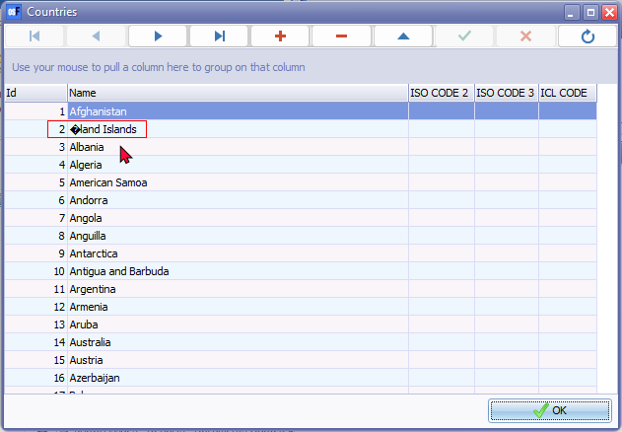

Last version was displaying correctly = Build 453

***Currencies***

Replicated in osF5.1.100 since osFinancials5.1.0.16 displayed incorrectly, since unicode was introduced.

To use Currencies in osFinancials5 you need to change the osf.ini file

Only works correctly if **nounicode=FALSE** in the osf.ini file.

If the default setting **nounicode=TRUE** in the osf.ini file, this replicate the error not displaying correctly.

***Default setting nounicode=TRUE in the osf.ini file, this replicate the error not displaying correctly***

Euro sign - € - (Alt+0128) Initially it displays correctly, but when the record is saved, it displays a | pipe symbol in the Currency screen.

When printing a report the Euro sign - € id incorrectly displayed as **�** character.

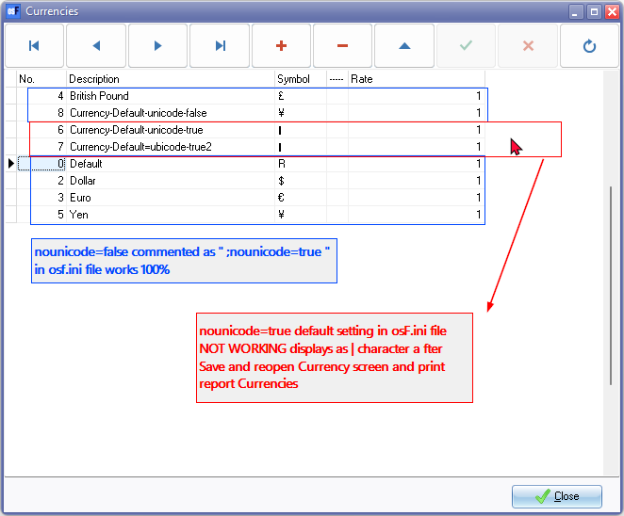

**See -** [Alt Code Shortcuts for Currency Symbols](https://www.webnots.com/alt-code-shortcuts-for-currency-symbols/) - List of Alt+Numeric keys for generating theCurrencies in the various countries. Example Works if the Alt+0165 for Yen, etc.

To display currencies correctly in Currencies setup and print the Currency report correctly in you need to change the osf.ini file.

**nounicode=TRUE**  setting set it to false **nounicode=FALSE** in the osf.ini file

After changing it back to the default setting **nounicode=FALSE** in the osf.ini file, The error is not replicated and is displayed correctly correctly in **Setup → Currencies** and **Reports → Currencies** report or on document layout files.

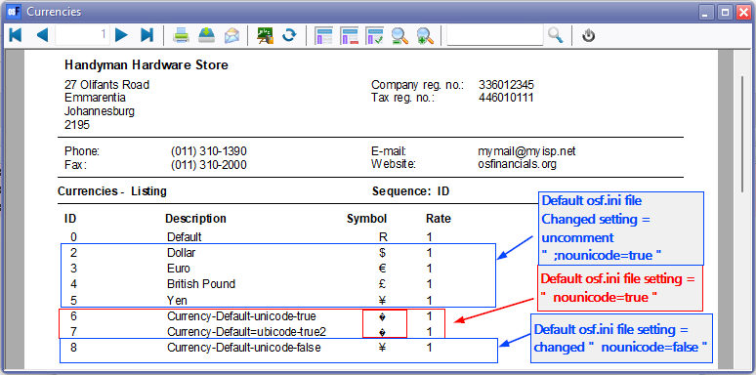

**Layout file incorrect**

If the default setting **nounicode=TRUE** in the osf.ini file, this replicate the error not displaying currency symbol correctly.

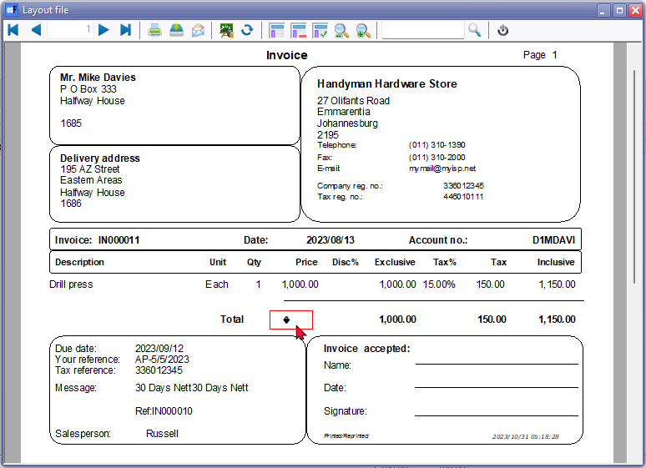

**Layout file correct**

Only works correctly if **nounicode=TRUE** is set to false **nounicode=FALSE** in the osf.ini file.

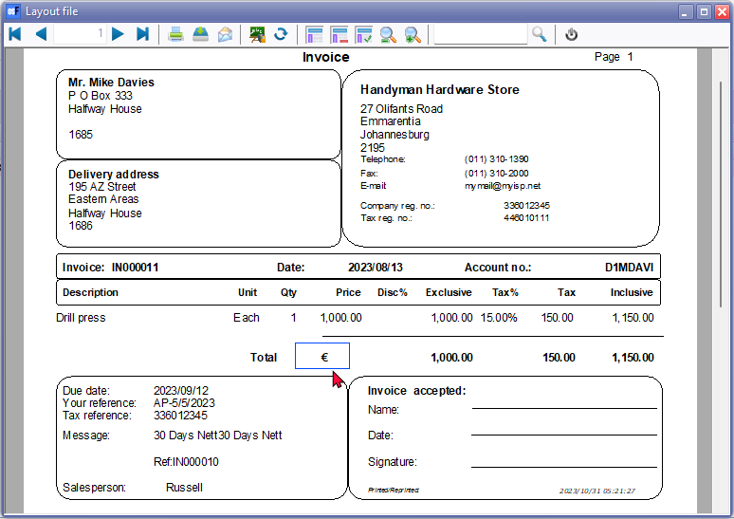

Was correct in osFinancials5 (Build 453)

**Plugins Multimedia**

Character input ë (Alt+137) displays correctly for added multimedia files in File explorer in the Windows system. When file is added in the Plugins, e.g. Multimedia, the file names displays incorrect characters in the fields loaded in the when **nounicode=TRUE**

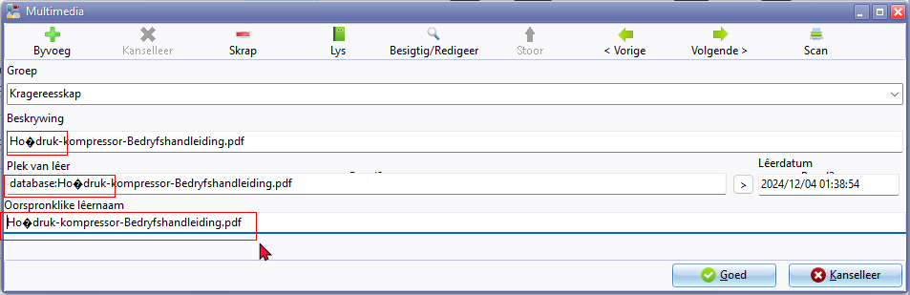

**Firebird Database - nounicode=FALSE**

If the **nounicode=FALSE** it does not replicate the errors found in when the nounicode=TRUE

MSSQL databases cannot open in the MSSQL Server. To open and work in MSSQL databases, the Unicode setting must be set to **nounicode=TRUE**

In Firebird databases the Unicode setting must be set to **nounicode=FALSE**

**Retested**:

* **Reports** : All reports and document layout files including spreadsheet reports print correctly and looks neat.
* **Screens** : Currencies is fixed but not Countries
* **Plugins** : Displays correctly

Character input ë (Alt+137) displays correctly for added multimedia files in File explorer in the Windows system. When file is added in the Plugins, e.g. Multimedia, the file names displays correct characters in the fields loaded in the when **nounicode=FALSE**

