Table of Contents

**osFinancials5.1.0.127 - Known issues** 1

**Search (Central search) Description Inaccuracies** 1

**Document type descriptions is correct** 3

***BOM (Production) Document groups / Transactions tabs*** 3

***BOM (Production) Document Groups Tab*** 3

***BOM (Production) Transactions Tab*** 3

***Viewing Posted Documents for BOM (Production) Items*** 4

***Opening a Posted document*** 4

***Identifying the Document type*** 4

***Print a Posted document*** 4

***Viewing BOM (Production) Transactions*** 8

***Example : Ledger transactions - BOM (Production) Contra account*** 8

***Example : Batch type report - Posted batch - BOM (Production) Batch transactions*** 9

***Example : Batch type report - Posted batch report - Disassemble transactions*** 10

**T-Account viewer** 11

**osFinancials5.1.0.127 - Known issues**

**Search (Central search) Description Inaccuracies**

To locate specific assemble or disassemble transactions or document numbers:

* Search for keywords such as "*assemble*", "*disassemble*", or document numbers starting with "*SA*".
* In the search results, double-click on the "*Batch*" type to display the transactions in the **T-Account viewer**.
* To print a document, double-click on a document for the "*Document*" type.

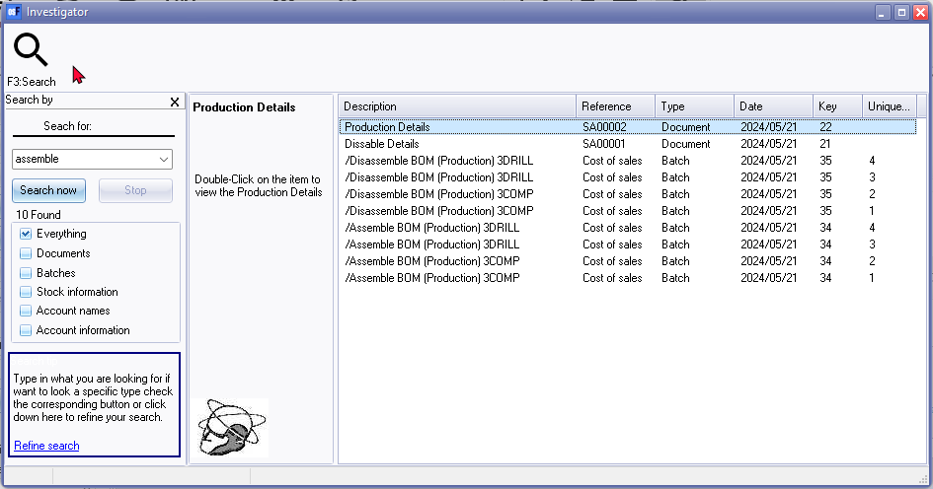

**NOTE**: On the **Search** (central search), the "*Description*" column for the "*Document*" type, is indicated as follows:

* **Dissable Details** - Should be "*Production Details*" since the document e.g. "*SA00001*" is created using the "*Assemble*" option. The document type is listed as "*Assemble*" on the **Document groups** and **Transactions** tabs of the stock item for the BOM (Production) stock item type.
* **Production Details** - Should be "*Disassemble Details*" since the document e.g. "*SA00002*" is created using the "*Disassemble*" option. The document type is listed as "*Disassemble*" on the **Document groups** and **Transactions** tabs of the stock item for the BOM (Production) stock item type.

**Search Description Inaccuracy:**

* Central Search shows "*Dissable Details*" for "Assemble" documents (e.g., "SA00001"). This should be *"Production Details*".
* Conversely, "*Production Details*" are shown for "*Disassemble*" documents (e.g., "SA00002"). This should be "*Disassemble Details*".

**Correct Descriptions:**

* "*Assemble*" documents: Use "*Production Details*".
* "*Disassemble*" documents: Use "*Disassemble Details*".

These descriptions are consistent with the document types listed on the stock item's "Document groups" and "Transactions" tabs (BOM (Production) stock item type).

**Document type descriptions is correct**

***BOM (Production) Document groups / Transactions tabs***

The "*Assemble*" and "*Disassemble*" functions for BOM (Production) items create posted documents. These transactions will be listed under the **Document groups** tab and the **Transactions** tab.

Documents generated by these functions will have a **document prefix "*SA*"** (e.g., "*SA00001*"), using a similar 7-digit format.

***BOM (Production) Document Groups Tab***

The Document Groups tab for BOM (Production) stock items shows documents related to assembly and disassembly. These documents are automatically posted when you perform the Assemble and Disassemble actions.

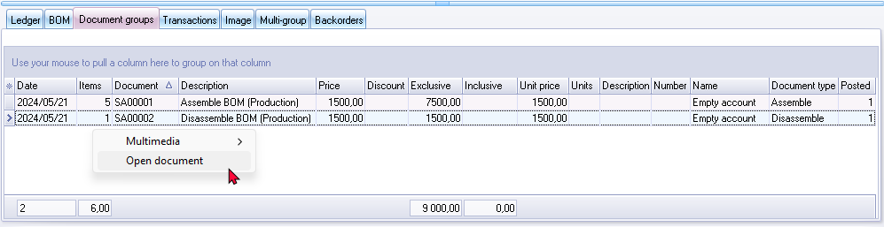

On the **Document groups** tab, you can:

* **Print a document**: Double-click on the document to print it.
* **Open a posted document**: Right-click on the document and select "*Open document*" from the context menu.

***BOM (Production) Transactions Tab***

The **Transactions** tab includes posted documents generated by the assembly and disassembly of BOM (Production) items.

'n Foto wat teks, skermskoot, nommer, lyn bevat

Beskrywing outomaties gegenereer

On the **Transactions** tab, you can:

* **Open a posted document**: Right-click on the document and select "Open document" from the context menu.

By following these instructions, you can efficiently manage and review the documents and transactions related to the assembly and disassembly of BOM (Production) items.

***Viewing Posted Documents for BOM (Production) Items***

***Opening a Posted document***

On the **BOM (Production) Document groups** and **Transactions** tabs, you can open posted documents generated by the "*Assemble*" and "*Disassemble*" functions as follows:

1. **Right-click** on the desired document.
2. Select **"Open document"** from the context menu.

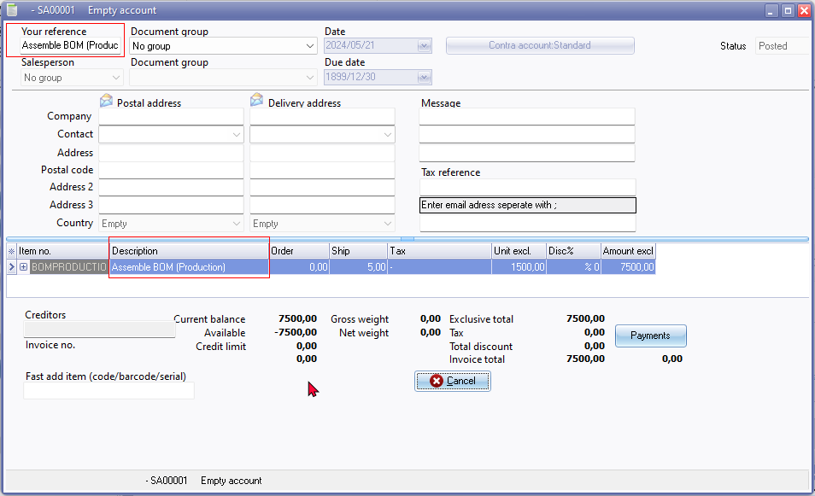

***Identifying the Document type***

* The **"***Your reference***"** field and the **"***Description***"** column in the posted document will indicate whether the document was generated using the "*Assemble*" or "*Disassemble*" options for BOM (Production) items.
* Documents generated by these functions will have a **document prefix "SA"** (e.g., "SA00001"), using a similar 7-digit format.

By using these steps, you can easily access and identify the specific documents related to the assembly and disassembly of BOM (Production) items.

***Print a Posted document***

You may print selected posted document generated by the "*Assemble*" and "*Disassemble*" of BOM (Production) items from the following options:

* **BOM (Production)** - **Document groups** tab : (Double-click to print).
* **Search** (central search) : Locate these posted document generated by the "*Assemble*" and "*Disassemble*" of BOM (Production) items. (Double-click to print).

'n Foto wat teks, skermskoot, skerm, nommer bevat

Beskrywing outomaties gegenereer

The "*POS Tax Invoice*" will print the correct document number, but will print the system date and time stamp of your operating system and not the actual transaction date.

|  |  |
| --- | --- |
|  | *The default document layout file which will be used to print documents generated by the "Assemble" and "Disassemble" of BOM (Production) items, is the "Layout file point-of-sale" selected in* ***Setup → Documents setup****.*  ***WARNING****: Point-of-sale document layouts might not be ideal for printing "Assemble" and "Disassemble" documents for BOM (Production) item types due to:*   * ***Date****: POS invoices show your system's date, not the actual processing date.* * ***Document Name****: Might say "POS Tax Invoice" instead of something relevant.* * ***Footer****: Contains data like cashup amounts, not relevant for BOM operations.*   ***Recommendation****: Select a different document layout file for BOM (Production) transactions (****Setup → Documents setup****).*    ***NOTE****: Selecting the document layout files, which supports the "TYPES.SDESCRIPTION" document name from the "TYPES" table, will print the document name as "Delivery note" for "Assemble" option and "Remittance" for "Disassemble" option. Selecting the following document layout files, will replicate the document names:*   * *Layout file - (TRN_1910)* * *Document layout - (TRN_3174)* * *Document layout (15codes) - (TRN_906277)* * *NO-TAX Layout file - (TRN_906589)* * *NO-TAX Document layout - (TRN_906590)* * *NO-TAX Document layout (15codes) - (TRN_906591)*   ***Recommendation****: You may select the* ***BOM (Production) Layout file*** *(TRN_3266)* ***for the Stock item type*** *to print layout files generated during "Assembly" or "Disassembly".*  ***Document prefix****: "****SA****" (e.g., "SA00001"), with a similar 7-digit format.*  ***Example*** *: Assemble*  *'n Foto wat teks, skermskoot, skerm, nommer bevat  Beskrywing outomaties gegenereer*  ***Example*** *: Disassemble* |

***Viewing BOM (Production) Transactions***

The transactions generated by assembling and disassembling BOM (Production) items are posted to the "BOM (Production) Contra account" as configured in **Setup → Stock Information**.

These transactions are recorded in the ledger and can be viewed through various reports and tools. Here’s how you can view, print, and export these transactions:

1. **Reports Menu**: To view these transactions, navigate to the **Reports** menu and select **Reports → Ledger → Transactions**. You can choose from the following reports:
   * **Transactions**
   * **Transactions - Standard**
   * **Transactions - Extra details**
2. **Batch entry: Cost of Sales journal**: Open the **Batch entry** (**F2**) and select Cost of Sales journal. In the Cost of Sales journal, click on the posted batches tab and select the batch. You can print the transactions in the "*Batch type report - Posted batch*".
3. **T-Account Viewer**: Access the **T-Account viewer** and select the "*BOM (Production) Contra account*". This allows you to view, print, and export the transactions.
4. **Ledger Analyser**: Alternatively, you can print a **Trial Balance** in **Ledger Analyser 1** or **Ledger Analyser 2**. Double-click on the desired account or use the "*Show details*" option from the context menu to view detailed transactions.
5. **Central Search**: To locate specific assemble or disassemble transactions or document numbers. In the search results, double-click on the Batch type to display the transactions in the T-Account viewer.

***Example : Ledger transactions - BOM (Production) Contra account***

***'n Foto wat teks, nommer, lyn, skermskoot bevat

Beskrywing outomaties gegenereer***

|  |  |
| --- | --- |
|  | *BOM (Production) - Assemble and Disassemble options will automatically generate transactions, which is posted to the ledger.*  *The Document no. for a BOM (Production) - Assemble and Disassemble options is automatically generated as a seven-digit number (consisting of a prefix* ***SA*** *followed by 5 numerical digits).*  *The Document type is "Assemble" or "Disassemble"* |

***Example : Batch type report - Posted batch - BOM (Production) Batch transactions***

Open the **Batch entry** (**F2**) and select Cost of Sales journal. In the Cost of Sales journal, click on the posted batches tab and select the batch.

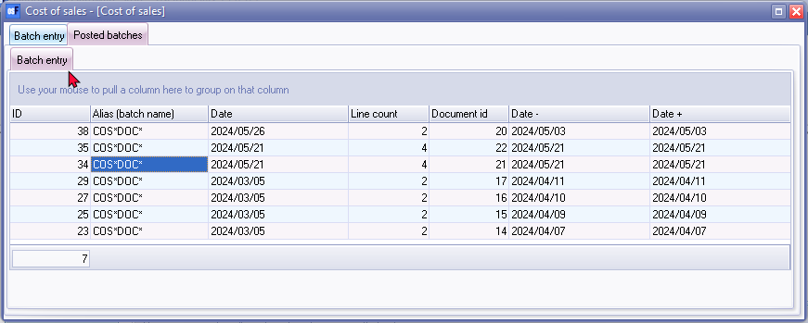

Click the Print button to print the transactions in the "*Batch type report - Posted batch*".

'n Foto wat teks, skermskoot, nommer, lyn bevat

Beskrywing outomaties gegenereer

***Example : Batch type report - Posted batch report - Assemble transactions***

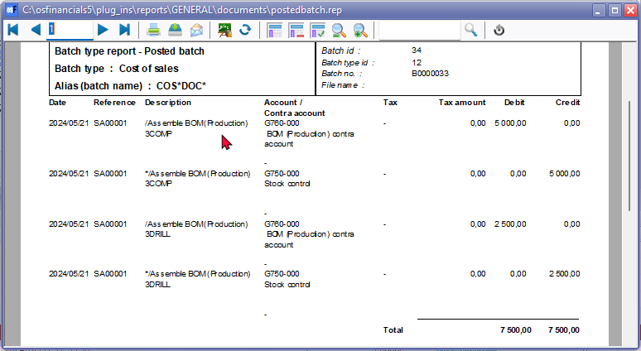

***Example : Batch type report - Posted batch report - Disassemble transactions***

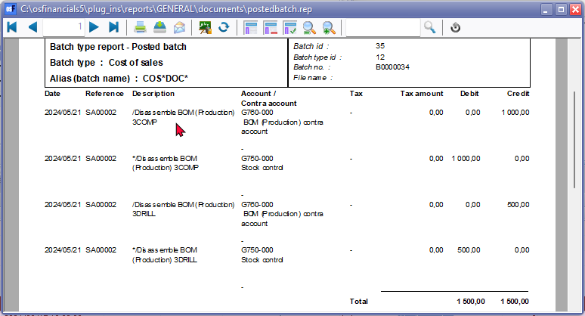

**T-Account viewer**

In addition to the transaction reports on the **Reports** menu; you may view, print and export transactions in the T-Account viewer from the following options.

* **T- Account viewer** : On the reports menu, select the **T-Account viewer** icon and select the "*BOM (Production) Contra account*".
* Alternatively, you may print a Trial balance in the **Ledger analyser 1 / Ledger analyser 2** and double-click or use the "*Show details*" option on the context menu.

'n Foto wat teks, skermskoot, nommer bevat

Beskrywing outomaties gegenereer

You may filter the transactions by batch number, e,g, "*34*" or "*35*".

Click on the **Print** button to print a T-account view of the transactions.

'n Foto wat teks, skermskoot, skerm, nommer bevat

Beskrywing outomaties gegenereer

Should you wish to export these transactions to a spreadsheet click **Export**. If you need to include Contra accounts, in your spreadsheet, select the "*Show contra*" option