Table of Contents

**osFinancials5.1.0.189 - Known issues** 1

**Cost centres - Access Violation errors** 1

***Balance sheet*** 1

**osFinancials5.1.0.189 - Known issues**

**Cost centres - Access Violation errors**

***Balance sheet***

*Access violation at address 78168283 in module 'rtl290.bpl'. Read of address 00000008*

Income statement produces similar Access violation errors, but less frequent.

Changing the [System settings - Number format](hnd-topic://b90761e9ae304dfd87680f7045a646f0) solves the Type conversion error in the Budget vs actual report on the Ledger analyser.

*Type conversion error 'Val':Expression TRpExpression46*

It also solves issue with the � character (printed in stead of a space in the [System settings - Number format](hnd-topic://b90761e9ae304dfd87680f7045a646f0) of the Standard column balances report on the Ledger analyser.

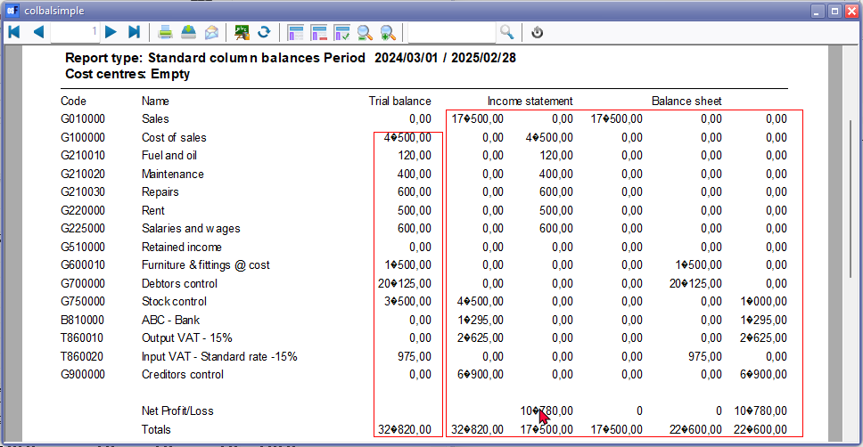

It does not resolve the Access violations in the Balance Sheet and Income statement when the [System settings - Number format](hnd-topic://b90761e9ae304dfd87680f7045a646f0) solves the Type conversion error in the Budget vs actual report on the Ledger analyser is fixed.

*Type conversion error 'Val':Expression TRpExpression46*

**Save metafile as - Excel (one sheet)**

Error replicated in all reports in the Save metafile as - Excel (one sheet) option on the Reportman preview screen.

*Unable to set the HorizontalAlignment property of the Range class*