Table of Contents

**osFinancials5.1.0.189 - Known issues – Email Reports** 1

**Email icon on the Print preview Reportman screen** 1

**Report behind interface** 1

Email icon Email reports – Using the Email setup and Free text tab (like EmailPro) 2

E Email icon Email reports – Using the Email (EmailPro plugin – Not activated) 2

**osFinancials5.1.0.189 - Known issues – Email Reports**

**Email icon on the Print preview Reportman screen**

**Report behind interface**

Cannot access the printed report - Need to close osfinancials5 using the task manager.

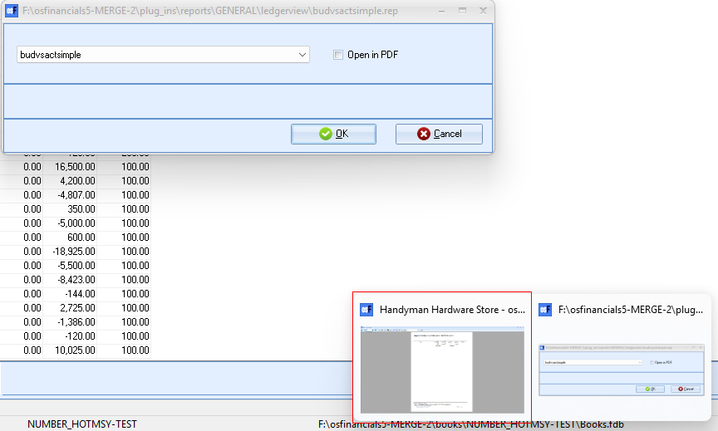

# Email icon Email reports – Using the Email setup and Free text tab (like EmailPro)

If the E-mail pro plugin is activated, and you print reports, the Email settings and Free text tabs will be launched.

## Print reports

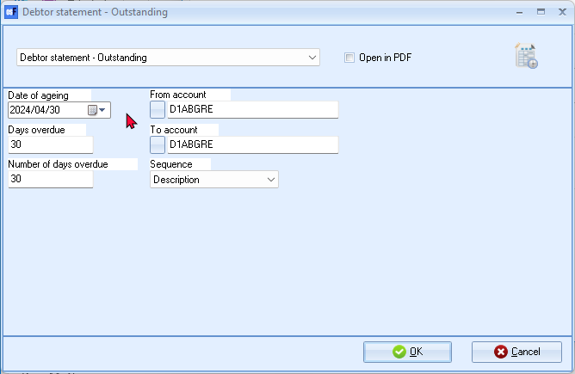

Print reposts to screen, and click on the email icon on the Reportman - Preview screen.

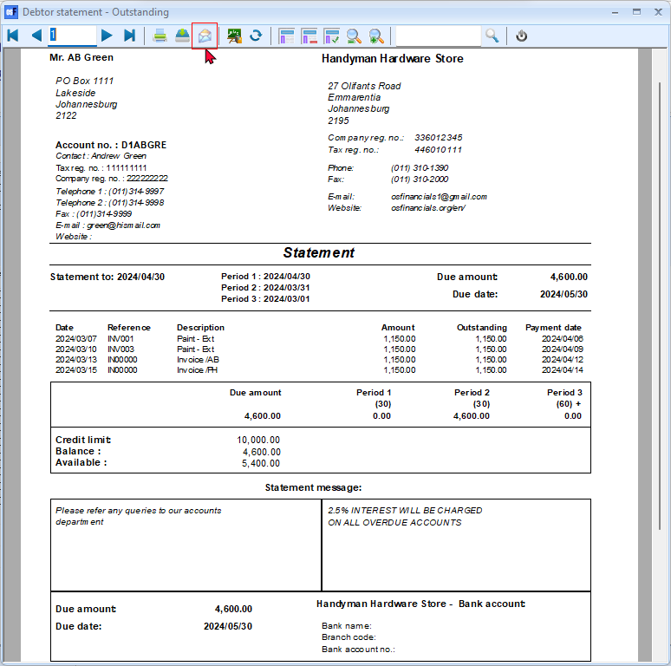

The Email free text tab and Settings tab (similar than the E-mail pro plugin) will be launched:

## Settings tab

You need to configure your email settings on the **Settings** tab. This will only be required once in a Set of Books, unless you have changed your email account from your ISP.

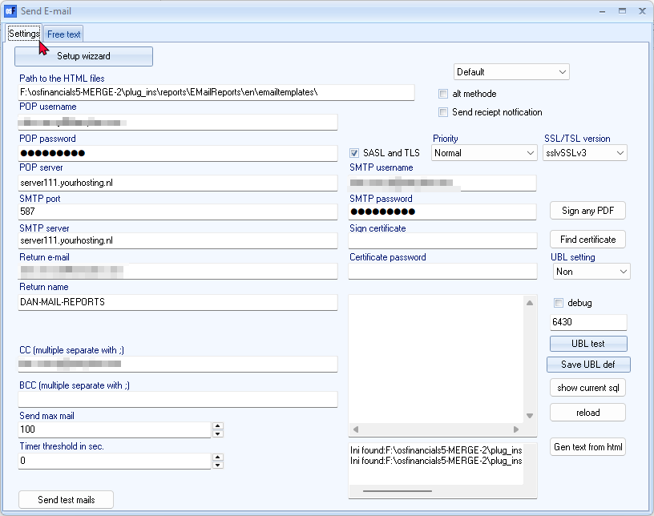

Path to Html Files: Selecting the folder and copy the full path in this field.

## Free text tab

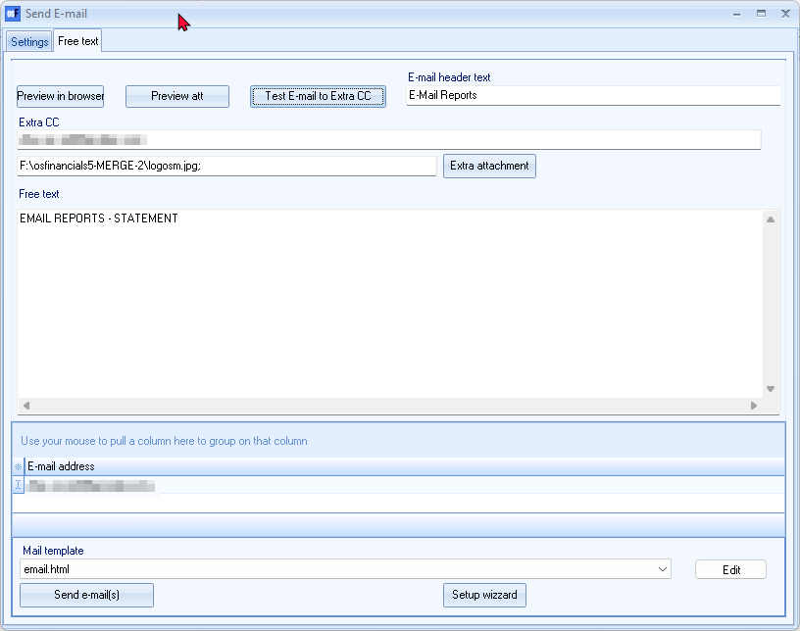

Preview in Browser

Preview attachment

Test E-mail to Extra

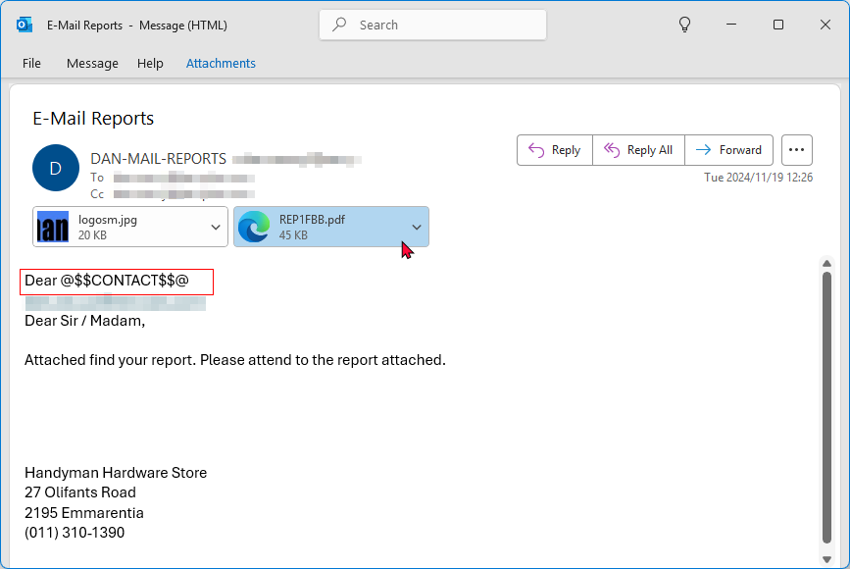

Attacmment Prints all accounts instead of the selected account

E Email icon Email reports – Using the Email (EmailPro plugin – Not activated)

Print report to screen



On the Reportman – Preview screen, click Email icon



The Enter e-mail address, screen will by default display the [info@osfinancials.org](mailto:info@osfinancials.org) email address.

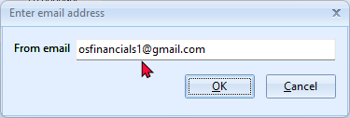

You may enter a valid email address to the recipient.

Click OK. To confirm the email address entered, a similar “Enter email address” as entered before, will be displayed.

Click OK.

Your systems default Email app or program ill automatically be launched.

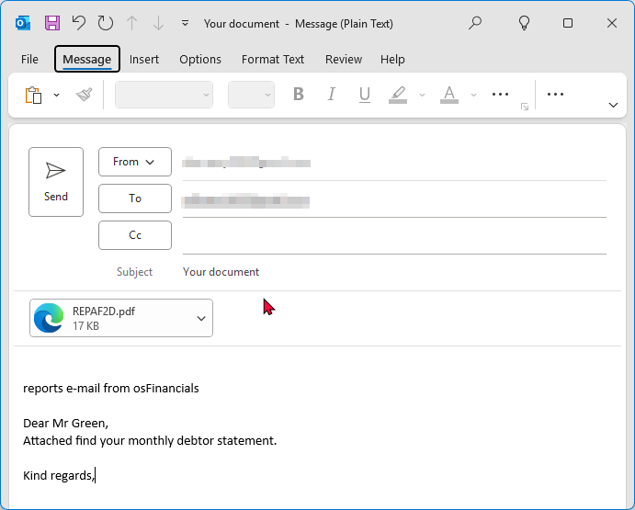

The Email to your recipient will be displayed as follows:

* **Subject** : Your document. Replace this with your own as necessary.
* **Message** : The message will include “*reports e-mail from osFinancials*”. You may enter a message intended for your recipient as necessary.
* **Attachment** : The report will be attached to the Email. The report name is automatically generated as a (*.pdf) document.

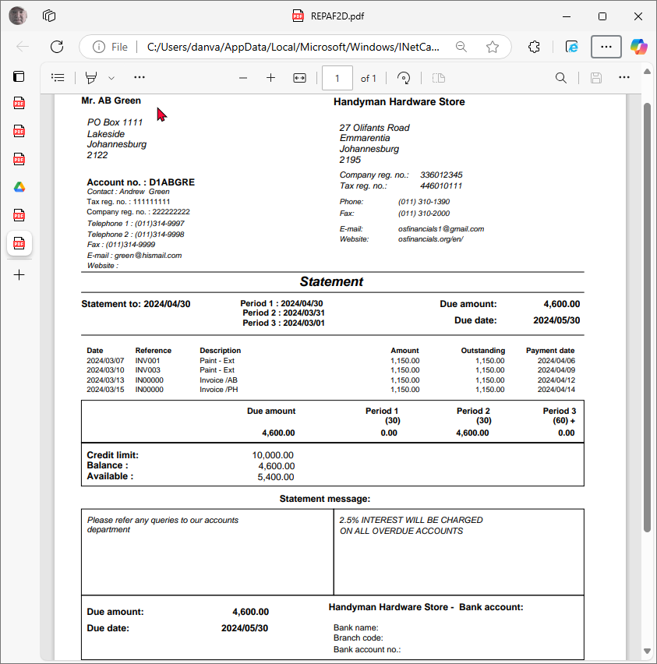

Once you have entered the Subject and Messages, you may hit the **Send** button.

To send your email message successfully, you may first need to configure you email and Test Mail Server. To do this go to Setup -> Internet (Setup ribbon

