Table of Contents

**osFinancials5.1.0.189 - Known issues - Confirmation Messages** 1

**Calendar - Delete process repeating invoices** 1

**Debtors / Creditors tab - Delete contact - No confirmation message** 2

**Change Reporting groups 1 / Reporting group 2** 2

**osFinancials5.1.0.189 - Known issues - Confirmation Messages**

**Calendar - Delete process repeating invoices**

No delete confirmation message

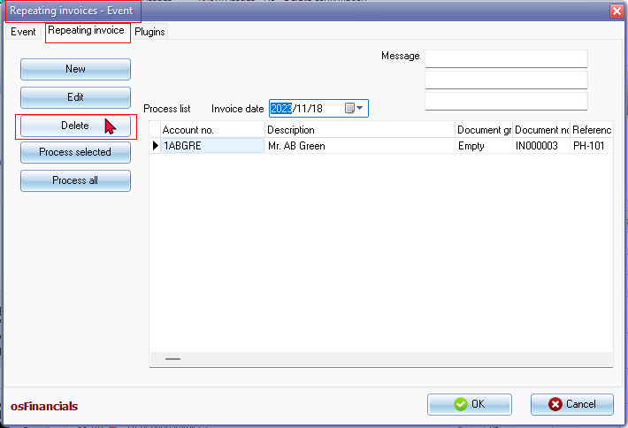

Click on Delete button and the item is removed from the "*Process list*".

**NOTE**

For events there is a confirmation message to delete the event

*Delete "Repeating invoices" from your schedule?  
This operation cannot be undone!*

**Debtors / Creditors tab - Delete contact - No confirmation message**

Click Delete button and gone is the contact

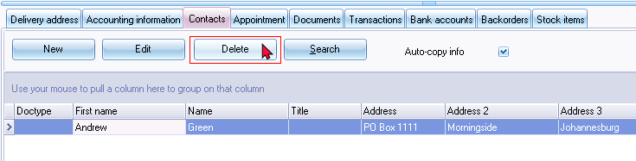

**NOTE**

On Contacts screen (**Default** ribbon) the Delete confirmation message is displayed:

*Do you want to delete this contactperson?*

On **Calendar - Contacts** screen the Delete confirmation message is displayed:

*Delete Ben Best from your list of contacts?  
This operation cannot be undone!*

**Change Reporting groups 1 / Reporting group 2**

Change Reporting groups 1 / Reporting group 2 for **Debtors** / **Creditors** and **Documents** no confirmation message is displayed from the context menu options on the grid.

Using the context menu on **Stock items** Change Reporting groups 1 / Reporting group 2 a confirmation message is displayed e.g.:

*Set reporting group 2*