Table of Contents

**osFinancials5.1.0.189 - Known issues** 1

**Number format for printing reports** 1

**If the number format is correctly set** 1

**Batch - Process - Create receipts - Decimal symbol – Add Comma** 2

Number format 123,456.00 5

**Number format – Digit separator / Decimal symbol Settings** 7

**osFinancials5.1.0.189 - Known issues**

**Number format for printing reports**

**If the number format is correctly set**

The following reports are fixed:

* Budget vs actual / This year vs last year errors fixed - Changing the **System settings - Number format** solves the Type conversion error in the Budget vs actual report on the Ledger analyser.

Type conversion error 'Val':Expression TRpExpression46

* **Standard column balances** – Prints an incorrect character - It also solves issue with the � character (printed instead of a space in the **System settings - Number format** of the Standard column balances report on the Ledger analyser.

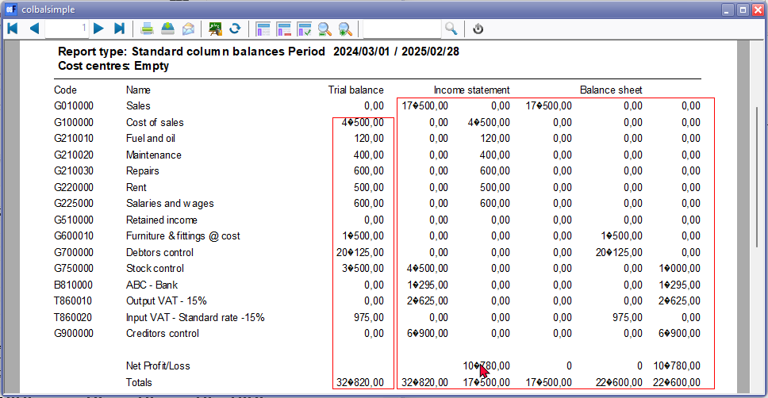

* **Spreadsheets Export** - Amounts (Exclusive / Inclusive / Tax) – Amounts columns are blank – If the **System settings - Number format** is changed, it is populated with the correct figures.

**Batch - Process - Create receipts - Decimal symbol – Add Comma**

Launched from Receipts batch – Create receipts – F9: Process

[**Create receipts**](hnd-topic://eeb9546e031d4e61810f9252d15a2847) option in receipt batches - **"R*eceipts options*"** screen.

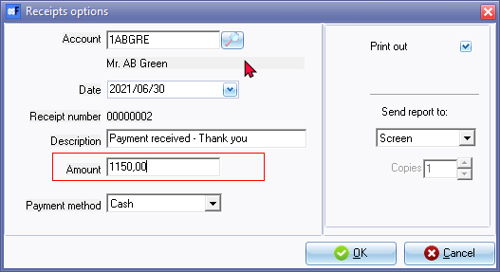

**Amount** - Enter the amount in figures. You may enter up to Nine billion, nine hundred and ninety nine million, nine hundred and ninety nine thousand nine hundred and ninety nine (Rands, Euros, Pounds or Dollars) and ninety nine cents in this field (9,999,999,999.99).

|  |  |
| --- | --- |
|  | *If your system's digit separator is set to a comma and your system's Decimal symbol is set to a period, do not enter a comma as the decimal separator.*  *If a comma is used as a digit separator, it will print and generate the transaction amount as 115,000.00 instead of 1,150.00.* |

An example of the **printed "*Receipt*",** is as follows:

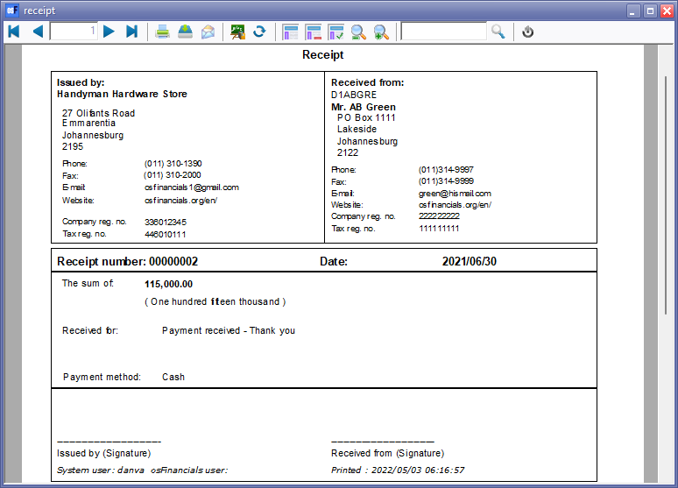

**Receipt batch transactions**

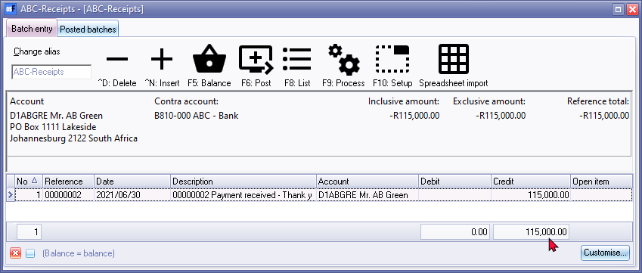

**Number format – Digit separator / Decimal symbol – Spreadsheets**

Spreadsheet import - Document entry - context menu - **Documents → Spreadsheet import**

## Number format 123,456.00

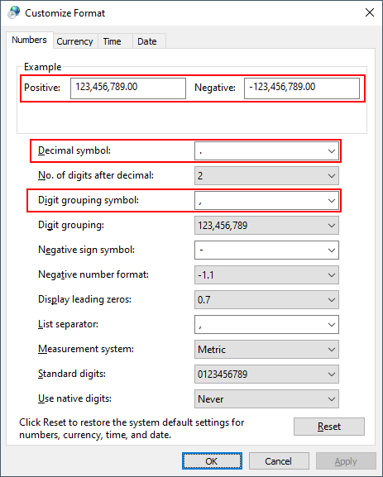

If the number format is set to Decimal symbol is set to a period (full stop) and the digit separator as a comma, as in the example of the "*Customize Format*" screen, the file exports and imports correct in most of the options.

Spreadsheet import - Document entry - context menu - **Documents → Spreadsheet import**

When an Export file is created based on the 123,456.00 number format, and the Export file is opened in the "*Data Import Export*" using the Spreadsheet import option, the amounts columns is blank.

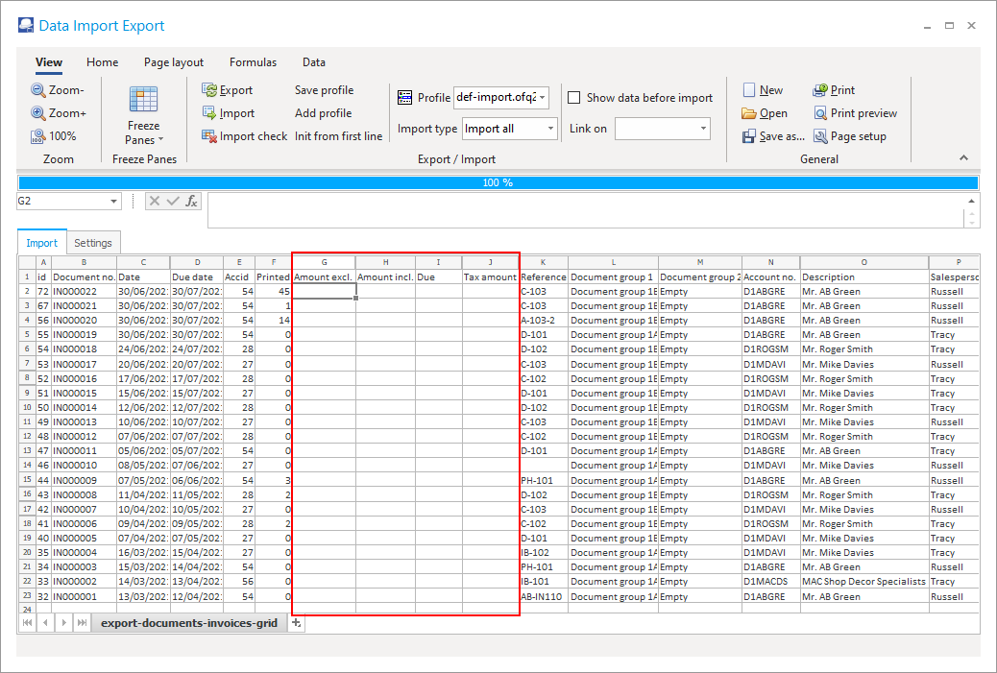

## Number format 123456,00

When an Export file is created based on the 123 456,00 number format, and the Export file is opened in the "*Data Import Export*" using the Spreadsheet import option, the amounts columns is correct.

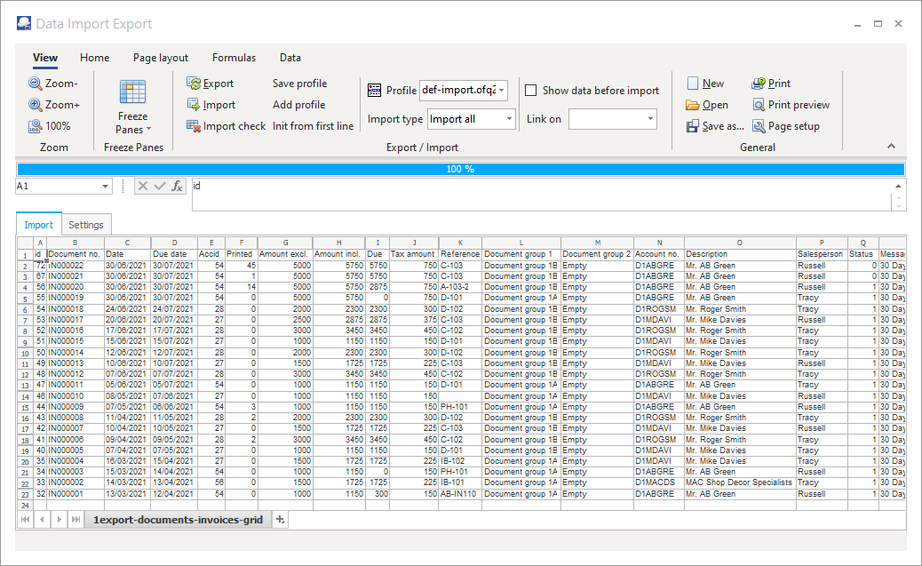

**Number format – Digit separator / Decimal symbol Settings**

You may need to set the number format of your operating system to print all reports.

When printing the “[*Budget vs actual*](hnd-topic://eab88643155749b6841d56fff9323adc)” and “[*This year vs last year*](hnd-topic://3205c8adc3f04243ad34f3af4fe2ec8f)” reports, you may encounter the following error message:

*"Type conversion error 'Val':Expression TRpExpression46"*

|  |  |
| --- | --- |
|  | *Batch processing options -* [***Create receipts***](hnd-topic://eeb9546e031d4e61810f9252d15a2847) *(Receipt batches) option - If your system's digit separator is set to a comma and your system's Decimal symbol is set to a period, do not enter a comma as the decimal separator in the "Amount" field.*  *For example, if an amount of 1150,00 is entered using a comma as a digit separator, it will print and generate the transaction amount as 115,000.00 instead of 1,150.00.* |

The “*Customize Format - Numbers*” of your Windows operating system number format needs to be set as follows:

* Decimal symbol - set to period ( . )
* Digit grouping symbol - set to comma ( , ) (If Digit grouping symbol is set to blank it does not print but produces an error.

|  |  |  |
| --- | --- | --- |
|  | *The Region and Language settings of your operating system should launch if you click on the* ***Setup → Company info - Options - Set Windows date format/style*** *button on the* ***Setup*** *ribbon.* | |
|  | | *This is a global setting for all Sets of Books on your operating system.* |

**To change the number format of your operating system:**

1. In any active (opened) Set of Books, select **Setup → System parameters** (**Setup** ribbon).

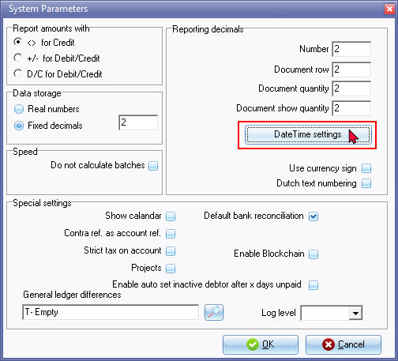

1. On the "*System Parameters*" click on the **DateTime settings** button.

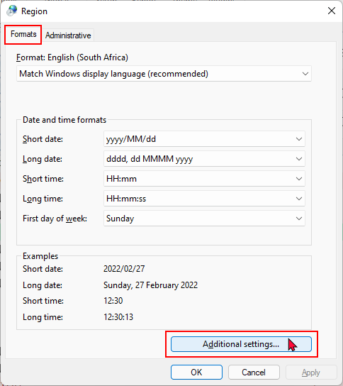

1. On the **Formats** tab,click on the **Additional settings ...** button.

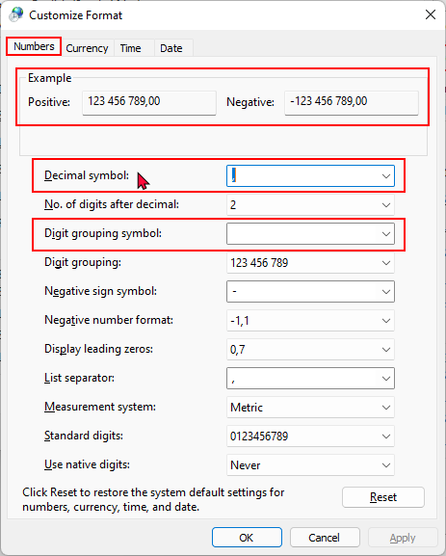

1. On the **Numbers** tab, the default settings (as per new installation of Windows or on some new devices), the settings that need to be changed is as follows:
   * Decimal symbol set to period ( . )
   * Digit grouping symbol set to comma ( , )

|  |  |
| --- | --- |
|  | *If Digit grouping symbol is set to blank; and when you click on the* ***Print*** *button of the “*[*Budget vs actual*](hnd-topic://eab88643155749b6841d56fff9323adc)*” and “*[*This year vs last year*](hnd-topic://3205c8adc3f04243ad34f3af4fe2ec8f)*” reports; it does not print but produces same error; i.e.*  *“Type conversion error 'Val':Expression TrpExpression46”* |

1. After changing the number formats, the "*Example*" on the **Numbers** tab of the "*Customize Format*" screen, should display as follows:

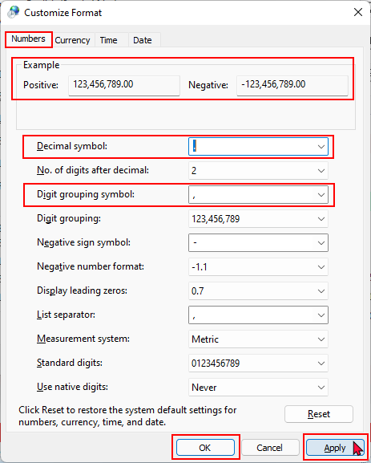

1. Click on the **Apply** and **OK** buttons of the "*Customize Format*" - **Numbers** tab, as well as the "*Region*" - **Formats** screen.

You may need to exit (close) osFinancials5 / TurboCASH5 for these changes to be updated when generating and printing reports.