Table of Contents

**Dynareg - Limit by Creditor with selection list plugin** 1

**Dynareg - Limit by Creditor with selection list plugin**

|  |  |
| --- | --- |
|  | ***Dynareg Limit by Creditor with selection list plugin*** *- Shop -* ***Licence*** *: Once-off license -*  ***Enable*** *: "Voorraad - Limiteer crediteur met keuze"* |

The "*Dynareg Limit by Creditor with selection list*" plugin for osFinancials5 offer an enhancement to the stock lookup screen by introducing an additional field for selecting a creditor (supplier) account.

When processing purchase documents (purchases, supplier returns and orders) and you select a stock item or product to include in a document, the stock lookup will, by default, list all of your stock items or products.

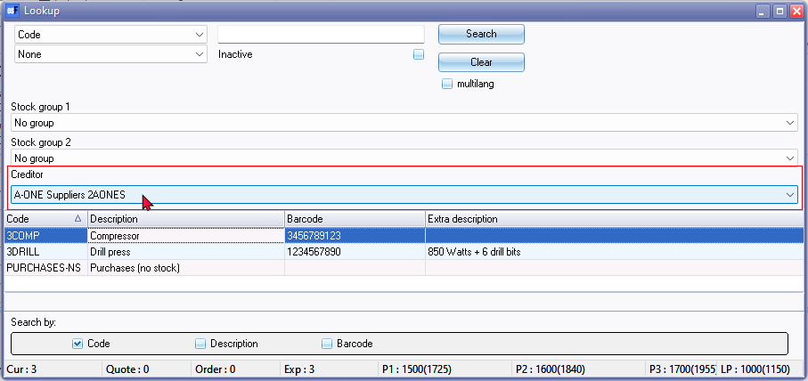

If you have linked stock items to supplier code, you may select the creditor account to list only those stock items linked to the supplier.

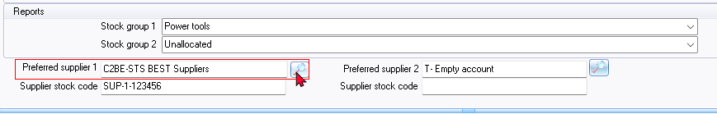

This feature can be particularly beneficial for businesses that deal with multiple suppliers and want to track their stock items based on the supplier from whom they were purchased.

By adding this extra field, users can easily filter and view stock items based on their respective suppliers, providing a more organised and efficient way to manage inventory. This capability can be especially useful for businesses that need to monitor stock levels, reorder products, or analyse purchasing patterns on a supplier-by-supplier basis.

Overall, the plugin seems is a practical addition to osFinancials5, enhancing its functionality and usability for businesses that rely on managing stock items from multiple creditors or suppliers.