Table of Contents

**Dynareg Plugins** 1

**Activation of Dynareg Plugins** 1

**Dynareg Plugins**

The Dynareg Plugins can be accessed from the **Plugins** menu under the **Setup** ribbon, provided they are activated in the **Tools → Activate plugins** menu. This collection comprises additional plugins for documents, e-commerce, bank import, free fields stock, document layouts, and Free POS (Standard POS). These plugins are available for purchase from our online shop and can be enabled accordingly.

**Activation of Dynareg Plugins**

Once you have purchased plugins from our shop, follow these steps to enable them:

1. Navigate to **Plugins → Tools → DYNADBREG**.

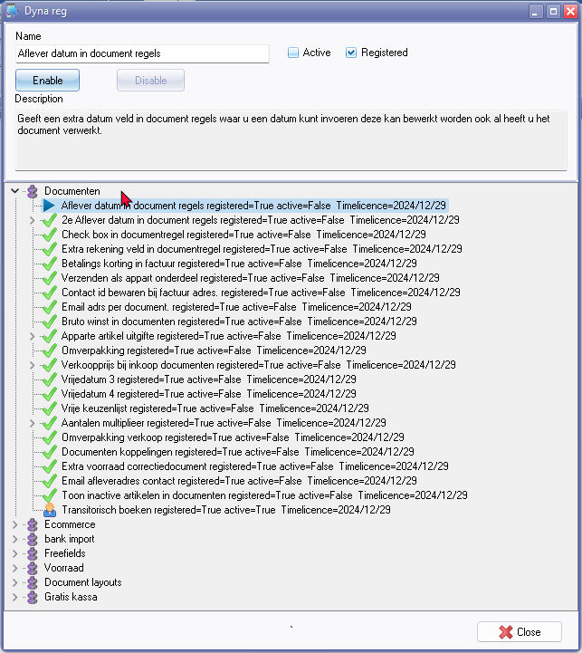

1. Select the desired option and click the **Enable** button. A confirmation message will appear.

*"Add new item?"*

1. Click **OK**. Another confirmation message will appear.

*"Script executed!"*

1. Click **OK**.
2. Click **Close** and reopen the Set of Books for this plugin to take effect.

For more information and to purchase plugins, visit: osFinancials Webshop - Small Adjustments.